

+ Fifth Sunday after Epiphany
February 8, 2026



St. Andrew Lutheran Church
304 Morewood Ave.
Pittsburgh, PA 15213
St_andrewELCA@verizon.net
www.standrewpittsburgh.org

+ Fifth Sunday after Epiphany
Order for Worship

Light shines in darkness for the upright, the psalmist sings.
Isaiah declares that when we loose the bonds of injustice and share our bread with the hungry, the light breaks forth like the dawn. In another passage from the Sermon on the Mount, Jesus, the light of the world, calls his followers to let the light of their good works shine before others. Through Baptism we are sent into the world to shine with the light of Christ.

Welcome to St. Andrew!
- St. Andrew welcomes all who are seeking a place of healing, wholeness, and acceptance in a nurturing and faith-forming spiritual home. We are striving toward racial equity worldwide
and we seek to honor the lived experience of all individuals regardless of background. Our community embraces people of all ages, ethnicities, cultures, abilities, sexual orientations,
gender identities and expressions, and family constellations. Come and See!
- Worship Services are live-streamed to multiple online platforms. By attending worship, you agree that your image and voice may be broadcast.
- Everyone is invited to make a name tag at the black bookcase in the back of the worship space if they would like. There are stickers indicating pronouns on the bookcase if you would like to include them on your name tag.
- A nursery is available through the doors at the left side of the sanctuary and across from the doorway to the Social Hall. Look for a purple-colored room.
- Children are invited to attend Little Church – Big Faith, a Bible lesson and activity, during worship (after the Prayer of the Day). The group returns to the worship space for the liturgy of Holy Communion.
- Worship “toolkits” to help children engage with the service, along with “busy bags” for younger children, are available in the bookcase at the back of the sanctuary. Please feel free to take one to use with/for your children.
- Holy Communion is served with bread (gluten-free available) and wine or grape juice. The presiding minister will distribute the bread (host). Please consume this and then pick up an empty glass from the tray. The Communion Assistant will pour wine or grape juice into your glass. Please step to the side to consume the wine or grape juice. Feel free to kneel at the altar for prayer and reflection. As you return to your pew, glasses may be returned to the empty trays on either side of the center section.
- A restroom is available on the main level of the church, through the doors to the Social Hall and to the right in the main office.

Abbreviations
P: Pastor/Presiding Minister ELW: Evangelical Lutheran Worship hymnal
A: Assisting Minister ACS: All Creation Sings hymnal
L: Lector W&P: Worship & Praise hymnal
C: Congregation

Musical Offering

Each week, different people from the congregation make an offering of pre-service music, with singing or instrumentation, to help the assembly focus and pray in preparation for worship.

Welcome

Prelude Make Me a Channel of Your Peace arr. Holstein

Gathering
The Holy Spirit calls us together as the people of God

Please rise as you are able. All may make the sign of the cross,
the sign that is marked at Baptism, as the presiding minister begins.

Confession and Forgiveness

P: Blessed be the holy Trinity, ☩ one God,
the fountain of living water, the rock who gave us birth,
our light and our salvation.
C: Amen.

P: Let us confess our sin in the presence of God and of one another.

Silence is kept for reflection.

P: Most merciful God,
C: we confess that we are captive to sin and cannot free ourselves.
We have sinned against you in thought, word, and deed,
by what we have done and by what we have left undone.
We have not loved you with our whole heart;
we have not loved our neighbors as ourselves.
For the sake of your Son, Jesus Christ, have mercy on us.
Forgive us, renew us, and lead us,
so that we may delight in your will and follow in your ways,
to the glory of your holy name. Amen.

P: By water and the Holy Spirit God gives you a new birth,
and through the death and resurrection of ☩ Jesus Christ, God forgives you all your sins.
The God of mercy strengthen you in all goodness and keep you in eternal life.
C: Amen.

Gathering Hymn Gather Us In ELW 532

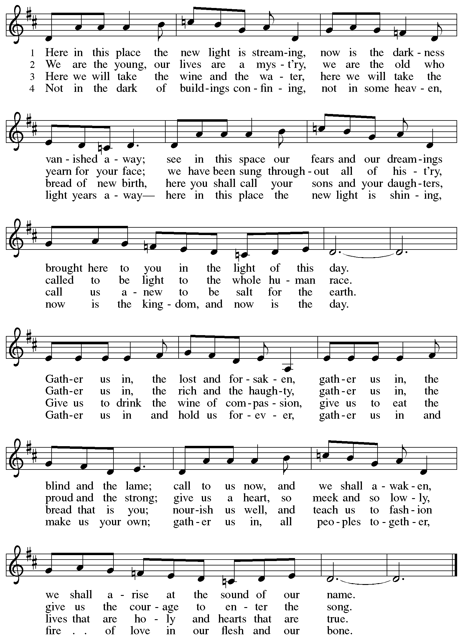
Greeting

P: The grace of our Lord Jesus Christ, the love of God,
and the communion of the Holy Spirit be with you all.
C: And also with you.

Hymn of Praise ACS p. 31

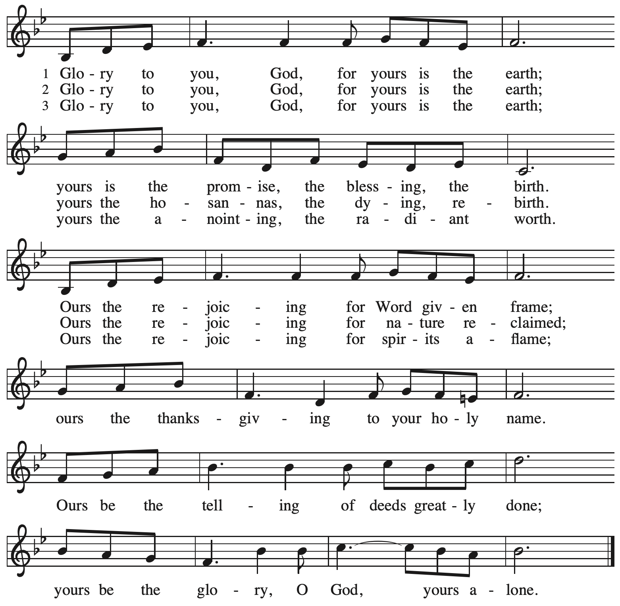

Prayer of the Day

P: The Lord be with you.
C: And also with you.
P: Lord God, with endless mercy you receive the prayers of all who call upon you.
By your Spirit show us the things we ought to do, and give us the grace and power to do them, through Jesus Christ, our Savior and Lord.
C: Amen.

Please be seated.
Children are invited to join the adult leader(s) at the side door for Little Church – Big Faith.
We ask that an additional adult from the congregation attend with the children.

Word
God speaks to us in Scripture reading, preaching, and song

First Reading – Isaiah 58: 1-9a [9b-12]

¹ Shout out; do not hold back!
Lift up your voice like a trumpet!
Announce to my people their rebellion,
to the house of Jacob their sins.
² Yet day after day they seek me
and delight to know my ways,
as if they were a nation that practiced righteousness
and did not forsake the ordinance of their God;
they ask of me righteous judgments;
they want God on their side.
³ “Why do we fast, but you do not see?
Why humble ourselves, but you do not notice?”
Look, you serve your own interest on your fast day
and oppress all your workers.
⁴ You fast only to quarrel and to fight
and to strike with a wicked fist.
Such fasting as you do today
will not make your voice heard on high.
⁵ Is such the fast that I choose,
a day to humble oneself?
Is it to bow down the head like a bulrush
and to lie in sackcloth and ashes?
Will you call this a fast,
a day acceptable to the Lord?
⁶ Is not this the fast that I choose:
to loose the bonds of injustice,
to undo the straps of the yoke,
to let the oppressed go free,
and to break every yoke?

⁷ Is it not to share your bread with the hungry
and bring the homeless poor into your house;
when you see the naked, to cover them
and not to hide yourself from your own kin?
⁸ Then your light shall break forth like the dawn,
and your healing shall spring up quickly;
your vindicator shall go before you;
the glory of the Lord shall be your rear guard.
^{9a} Then you shall call, and the Lord will answer;
you shall cry for help, and the Lord will say, “Here I am.”

[ ^{9b} If you remove the yoke from among you,
the pointing of the finger, the speaking of evil,
¹⁰ if you offer your food to the hungry
and satisfy the needs of the afflicted,
then your light shall rise in the darkness
and your gloom be like the noonday.
¹¹ The Lord will guide you continually
and satisfy your needs in parched places
and make your bones strong,
and you shall be like a watered garden,
like a spring of water
whose waters never fail.
¹² Your ancient ruins shall be rebuilt;
you shall raise up the foundations of many generations;
you shall be called the repairer of the breach,
the restorer of streets to live in. ]

L: Word of God, word of life.
C: Thanks be to God.

Psalm 112: 1-9 [10]

The psalm will be sung responsively, led by the cantor, with the congregation singing the verses in bold type and joining in the refrain.

Psalm Tone

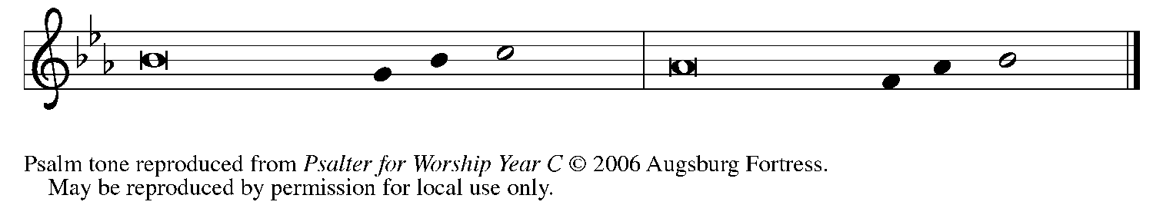

Psalm Refrain

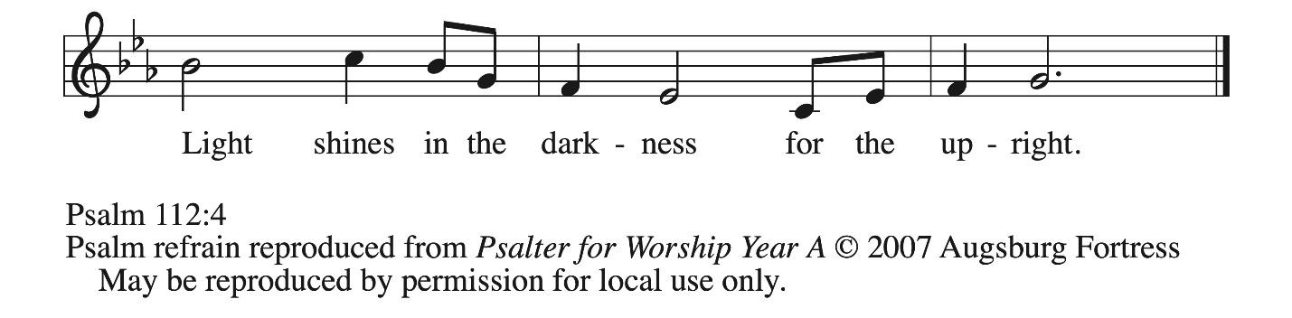

¹ Hallelujah! Happy are they who | fear the Lord
and have great delight in | God’s commandments!
² Their descendants will be mighty | in the land;
the generation of the upright | will be blessed.
³ Wealth and riches will be | in their house,
and their righteousness will | last forever.
⁴ Light shines in the darkness | for the upright;
the righteous are merciful and full | of compassion. R
⁵ It is good for them to be gener- | ous in lending
and to manage their af- | fairs with justice.
⁶ For they will nev- | er be shaken;
the righteous will be kept in everlast- | ing remembrance.
⁷ They will not be afraid of any | evil rumors;
their heart is steadfast, trusting | in the Lord.
⁸ Their heart is established and | will not shrink,
until they see their desire up- | on their enemies.
⁹ They have given freely to the poor, and their righteousness stands | fast forever;
they will hold up their | head with honor.
[ ¹⁰ The wicked will see it and be angry; they will gnash their teeth and | pine away;
the desires of the wick- | ed will perish. R ]
Second Reading – 1 Corinthians 2: 1-12 [13-16]

¹ When I came to you, kindred, I did not come proclaiming the testimony of God to you with superior speech or wisdom. ² For I decided to know nothing among you except Jesus Christ and him crucified. ³ And I came to you in weakness and in fear and in much trembling. ⁴ My speech and my proclamation were made not with persuasive words of wisdom but with a demonstration of the Spirit and of power, ⁵ so that your faith might rest not on human wisdom but on the power of God.
⁶ Yet among the mature we do speak wisdom, though it is not a wisdom of this age or of the rulers of this age, who are being destroyed. ⁷ But we speak God’s wisdom, a hidden mystery, which God decreed before the ages for our glory ⁸ and which none of the rulers of this age understood, for if they had, they would not have crucified the Lord of glory.
⁹ But, as it is written,
“What no eye has seen, nor ear heard,
nor the human heart conceived,
what God has prepared for those who love God”—
¹⁰ God has revealed to us through the Spirit, for the Spirit searches everything, even the depths of God. ¹¹ For what human knows what is truly human except the human spirit that is within? So also no one comprehends what is truly God’s except the Spirit of God. ¹² Now we have received not the spirit of the world but the Spirit that is from God, so that we may understand the gifts bestowed on us by God. [¹³ And we speak of these things in words not taught by human wisdom but taught by the Spirit, interpreting spiritual things to those who are spiritual.
¹⁴ Those who are unspiritual do not receive the gifts of God’s Spirit, for they are foolishness to them, and they are unable to understand them because they are spiritually discerned. ¹⁵ Those who are spiritual discern all things, and they are themselves subject to no one else’s scrutiny.
¹⁶ “For who has known the mind of the Lord
so as to instruct him?”
But we have the mind of Christ. ]

L: Word of God, word of life.
C: Thanks be to God.

Please rise as you are able.

Gospel Acclamation ACS p. 33

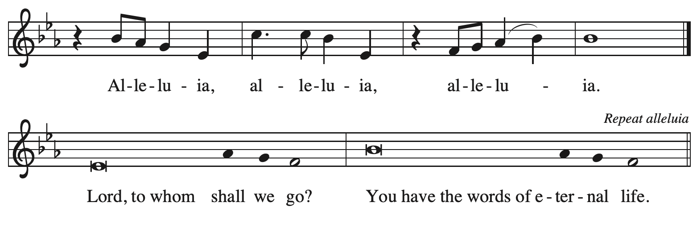

Gospel – Matthew 5: 13-20

P: The holy Gospel according to St. Matthew.
C: Glory to you, O Lord.

[Jesus said:] ¹³ “You are the salt of the earth, but if salt has lost its taste, how can its saltiness be restored? It is no longer good for anything but is thrown out and trampled under foot.
¹⁴ “You are the light of the world. A city built on a hill cannot be hid. ¹⁵ People do not light a lamp and put it under the bushel basket; rather, they put it on the lampstand, and it gives light to all in the house. ¹⁶ In the same way, let your light shine before others, so that they may see your good works and give glory to your Father in heaven.
¹⁷ “Do not think that I have come to abolish the Law or the Prophets; I have come not to abolish but to fulfill. ¹⁸ For truly I tell you, until heaven and earth pass away, not one letter, not one stroke of a letter, will pass from the law until all is accomplished. ¹⁹ Therefore, whoever breaks one of the least of these commandments and teaches others to do the same will be called least in the kingdom of heaven, but whoever does them and teaches them will be called great in the kingdom of heaven. ²⁰ For I tell you, unless your righteousness exceeds that of the scribes and Pharisees, you will never enter the kingdom of heaven.”

P: The Gospel of the Lord.
C: Praise to you, O Christ.

Please be seated.

Sermon

A time of silence for prayer and reflection follows the sermon.
When the hymn of the day begins, please rise as you are able.



Hymn of the Day Bring Forth the Kingdom W&P 22

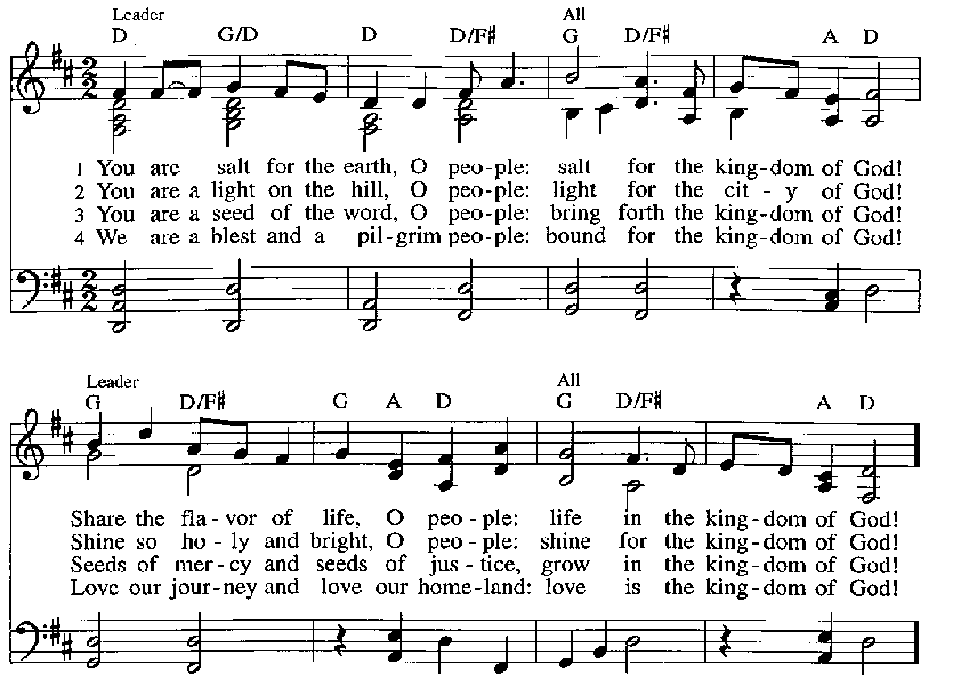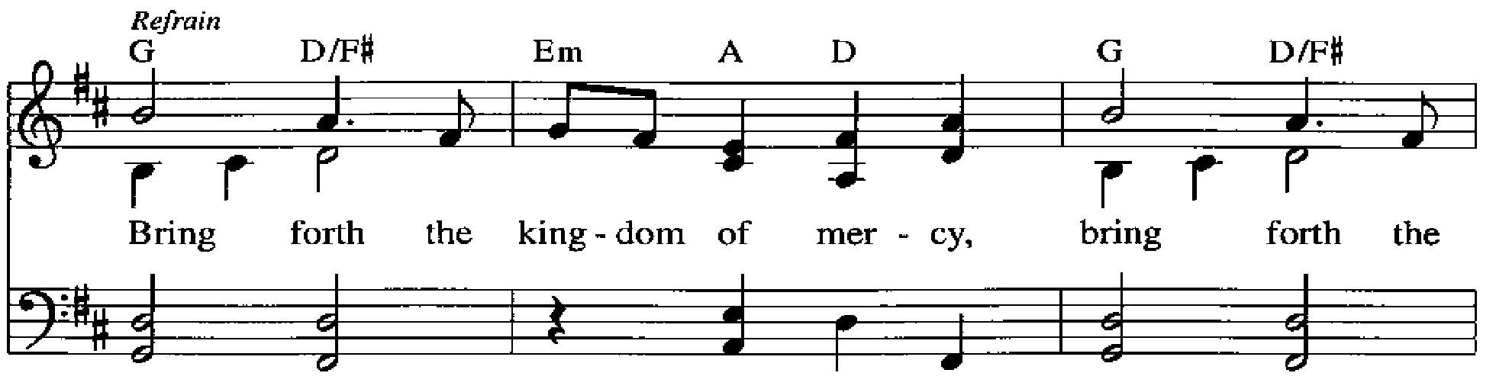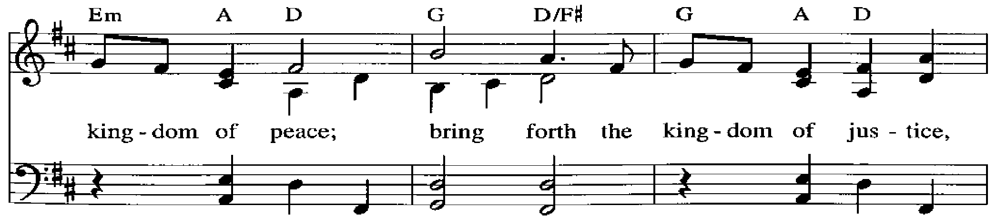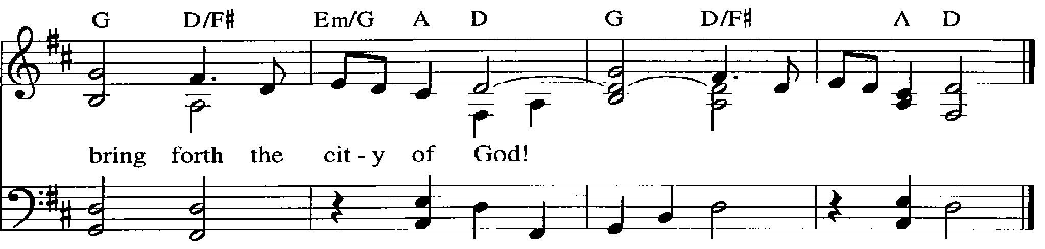
Apostles’ Creed

C: I believe in God, the Father almighty,
creator of heaven and earth.

I believe in Jesus Christ, God’s only Son, our Lord,
who was conceived by the Holy Spirit,
born of the virgin Mary,
suffered under Pontius Pilate,
was crucified, died, and was buried;
he descended to the dead.*
On the third day he rose again;
he ascended into heaven,
he is seated at the right hand of the Father,
and he will come to judge the living and the dead.

I believe in the Holy Spirit,
the holy catholic church,
the communion of saints,
the forgiveness of sins,
the resurrection of the body,
and the life everlasting. Amen.

*Or, “he descended into hell,” another translation of this text in widespread use.

Please be seated.

Prayers of the People

A: As God’s beloved children united in Christ, let us pray for the church,
the world, and the whole human community.

After each petition
A: Merciful God,
C: receive our prayer.

The presiding minister concludes the prayers
P: Confident that the Holy Spirit receives our prayers and answers us,
we commend all for whom we pray to your lovingkindness, O God,
revealed to us through Jesus Christ our Savior.
C: Amen.

Peace

The presiding minister and the assembly greet one another in the peace of the risen Christ.
P: The peace of Christ be with you always.
C: And also with you.

The people may greet those around them with a sign of Christ’s peace and may say
Peace be with you or similar words. Please be mindful that not everyone will be comfortable with sharing the peace, so please seek consent before shaking hands or hugging.
Other possible ways to share the peace include a simple bow with the verbal greeting of peace, or simply a verbal expression of peace.

When the greetings of peace have concluded, please be seated.



Meal
God feeds us with the presence of Jesus Christ

Offering

We offer ourselves, our gifts, and our faithful service to God.
As the offering is gathered for the mission of the church, including the care of those in need,
the table is set for Holy Communion.

There are laminated giving cards in the pew racks that feature a QR code for anyone who would like to give online. Those who give using the QR code, as well as those who give regularly online or through their bank are encouraged to place the laminated card in the plate as an expression of your offering.

Offertory Music My Faith Looks Up to Thee arr. Edstrom

As the gifts are brought forward for presentation, please rise as you are able.

Offertory Song God of the Fertile Fields ACS 1063
v. 1, 3

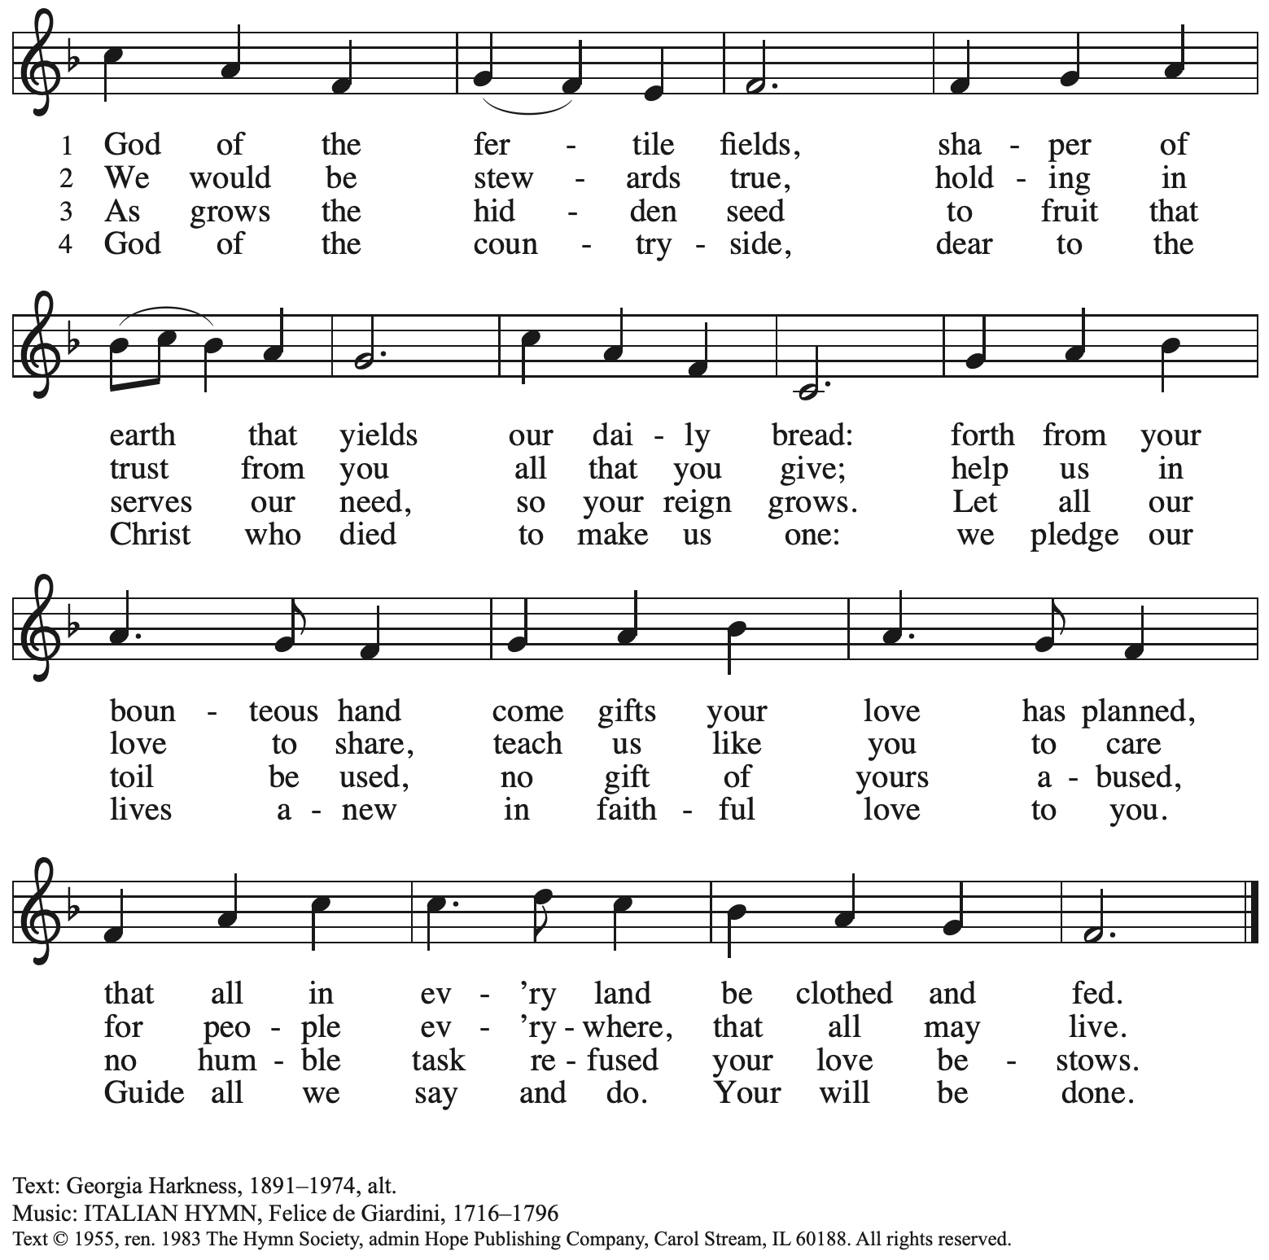
Reprinted with permission under One License.net # A-722139.

Offertory Prayer

A: Let us pray.
God of goodness and growth,
C: all creation is yours, and your faithfulness is sure.
Word and water, wine and bread: these are signs of your abundant grace.

Receive the gifts we bring, and nourish us to proclaim your abiding love
in our communities and in the world,
through Jesus Christ, our strength and our song.
Amen.

Dialogue

P: The Lord be with you.
C: And also with you.

P: Lift up your hearts.
C: We lift them to the Lord.

P: Let us give thanks to the Lord our God.
C: It is right to give our thanks and praise.

Preface (Spoken by the presiding minister)

P: It is indeed right, our duty and our joy,
that we should at all times and in all places
give thanks and praise to you, almighty and merciful God,
through our Savior Jesus Christ;
who on this day overcame death and the grave,
and by his glorious resurrection opened to us the way of everlasting life.
And so, with all the choirs of angels,
with the church on earth and the hosts of heaven,
we praise your name and join their unending hymn:

Sanctus ACS p. 36

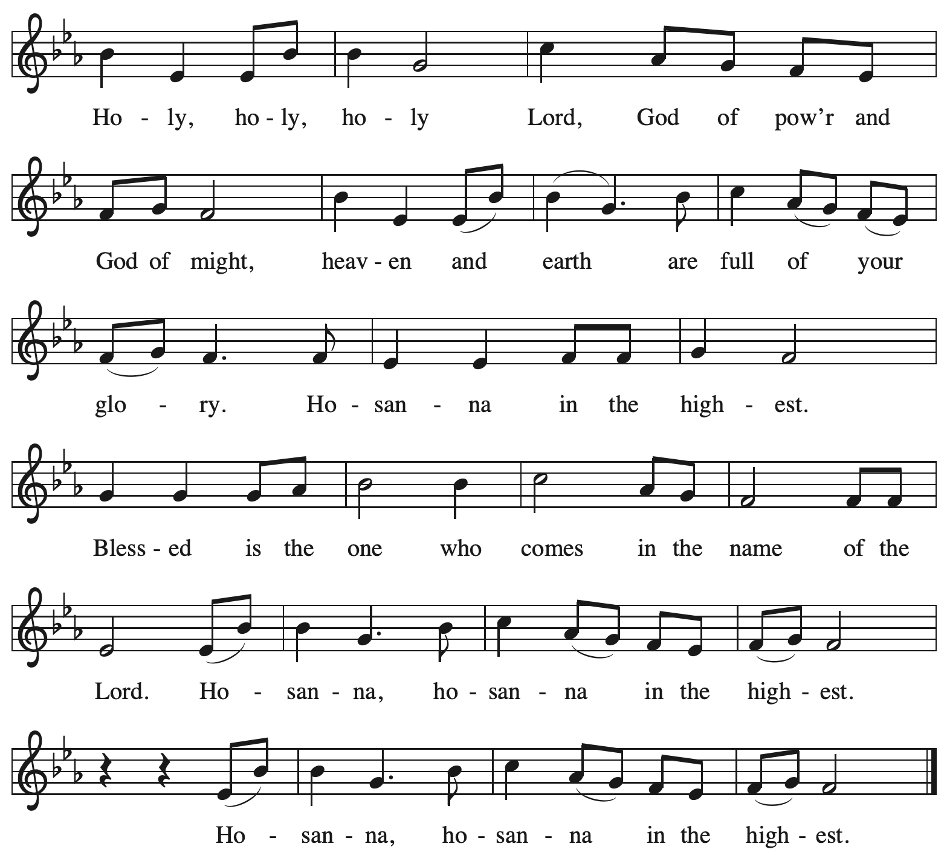

Eucharistic Prayer

P: Holy God, mighty and merciful, your peoples praise you, saying:
Your mercy endures forever.
C: Your mercy endures forever.

P: By your promise …
… the colors of your love and faithfulness.
Your mercy endures forever.
C: Your mercy endures forever.

P: By your promise …
… and calling them to be a light to the nations.
Your mercy endures forever.
C: Your mercy endures forever.

P: By your promise …
… Do this for the remembrance of me.

With this bread and cup
we remember his life laid down and lifted up
as we proclaim the mystery of faith:
C: Christ has died. Christ is risen. Christ will come again.

P: Send your Holy Spirit upon us …
… in your Spirit, now and forever.
C: Amen.

Lord’s Prayer

P: Gathered as one by the Holy Spirit, let us pray using the words our Savior taught us.
C: Our Father in heaven,
hallowed be your name,
your kingdom come,
your will be done,
on earth as in heaven.
Give us today our daily bread.
Forgive us our sins
as we forgive those
who sin against us.
Save us from the time of trial
and deliver us from evil.
For the kingdom, the power,
and the glory are yours,
now and forever. Amen.

Fraction and Invitation

P: Here is the Lamb of God who takes away the sin of the world.
Come to the table, taste and see.

Agnus Dei / Lamb of God ACS p. 40

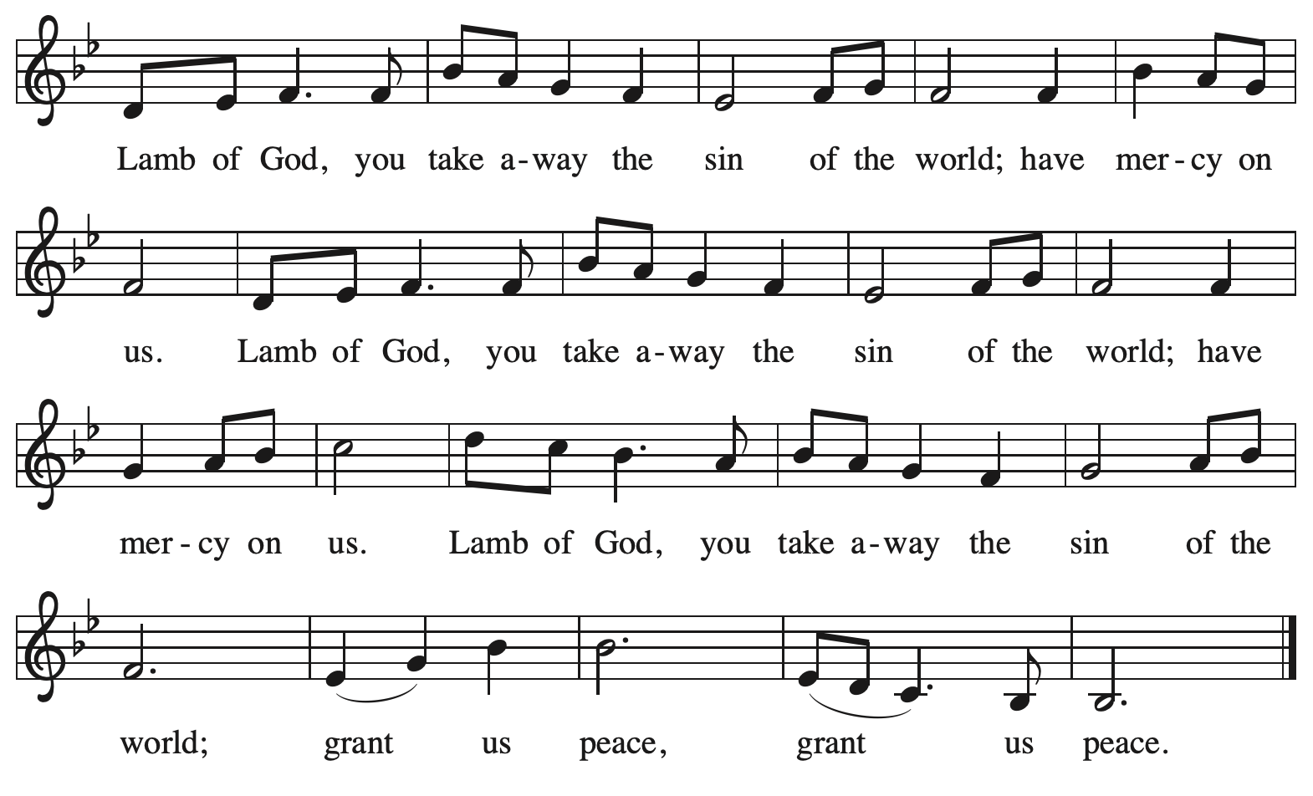

Please be seated.

Holy Communion

- All who seek God and desire a deeper and stronger life in Christ are welcome to receive Holy Communion.
- Worshipers from the pulpit side will proceed forward first, followed by the center section, and then the lectern side.
- Please inform an usher if you would like the ministers to bring Communion to you.
- Holy Communion will be served with bread and wine (amber) or grape juice (purple).
- The presiding minister will first distribute the bread (host) to each communicant. Please indicate if you require a gluten-free host.
- Once you have consumed the bread, please pick up an empty glass from the tray next to the presiding minister. The Communion Assistant will pour wine or grape juice into your glass.
- Please step to the side to consume the wine or grape juice.
- Feel free to kneel at the altar rail for prayer after receiving the sacrament.
- As you return to your pew, glasses may be returned to the empty tray on the side of the center section.
- A blessing will be provided for anyone who does not yet receive the sacrament.
- All are invited to join in singing the hymns during Holy Communion.

Hymns during Holy Communion
Draw Us In the Spirit’s Tether ELW 470

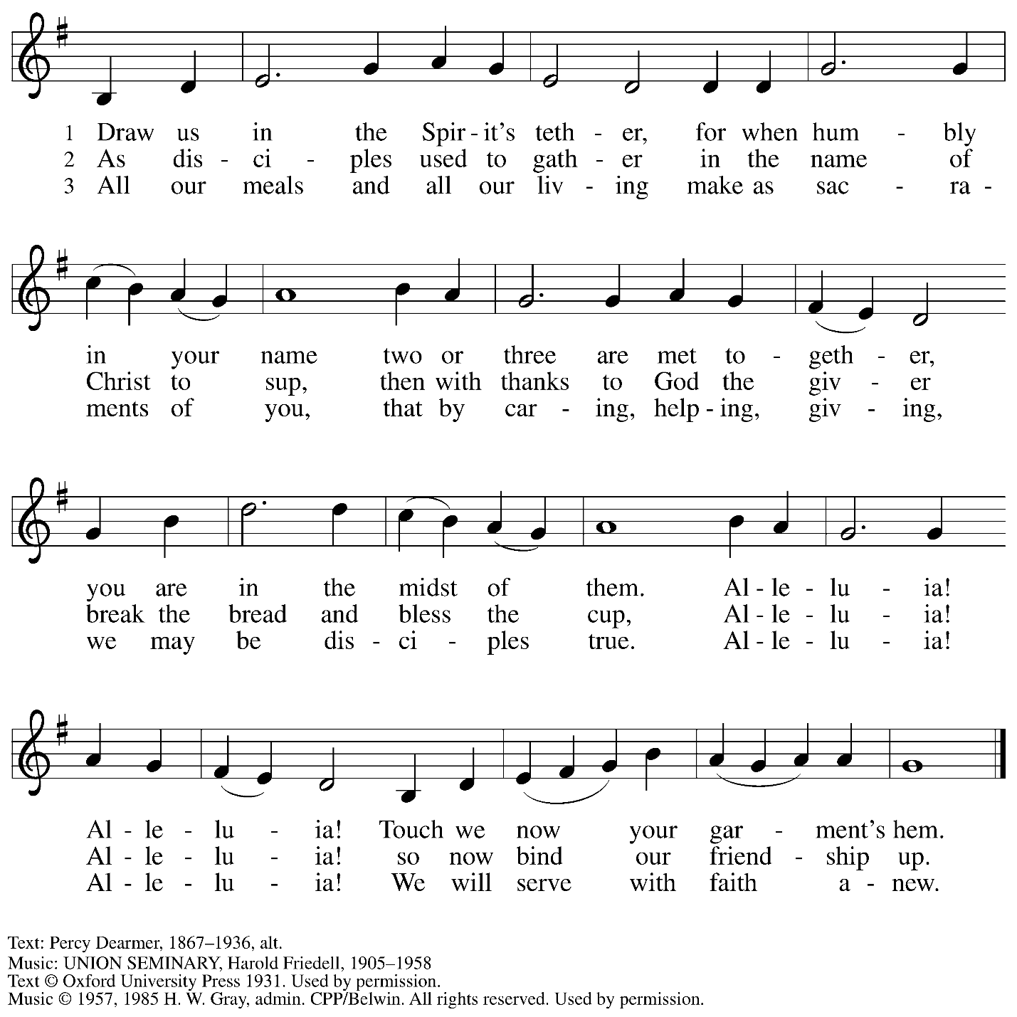
Reprinted under OneLicense.net # A-722139.

Hymns during Holy Communion
Holy Spirit, Ever Dwelling ELW 582

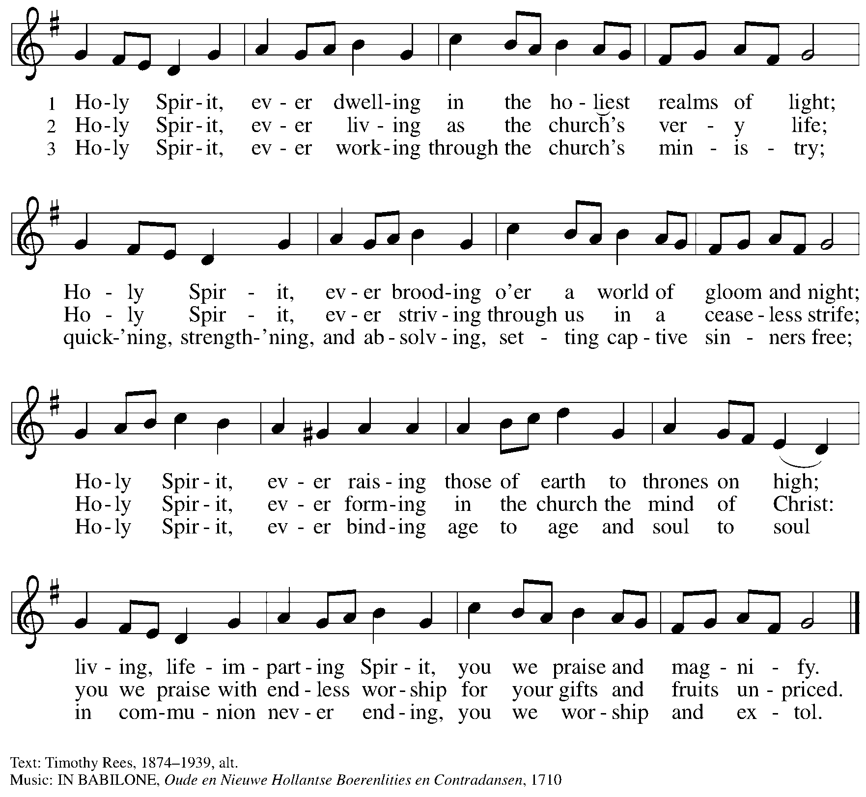

Hymns during Holy Communion
Let Streams of Living Justice ELW 710

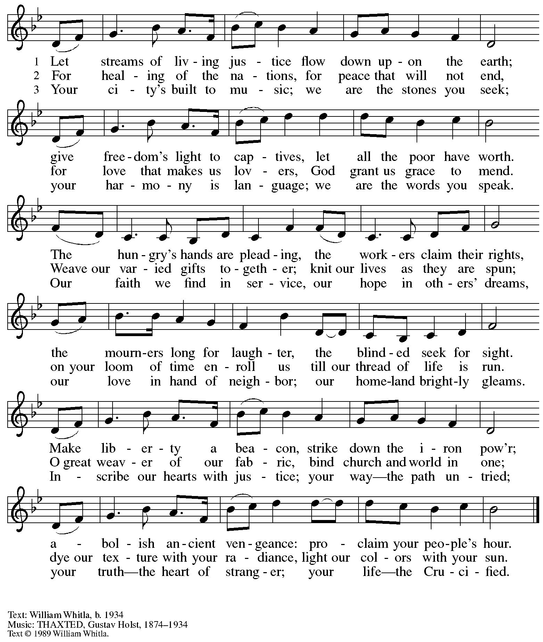
All rights reserved. Reprinted with permission of the hymnwriter.

When all have returned to their places, please rise as you are able.

Blessing

P: The body and blood of our Lord Jesus Christ strengthen you and keep you in his grace.
C: Amen.

Prayer

A: Let us pray.
We thank you, O God, that you have strengthened our hearts through this feast of life
and salvation. Shine the light of Christ on our path, that we may do justice, love kindness,
and walk humbly with you, now and forever.
C: Amen.

Please be seated.

Sending
God blesses us and sends us in mission to the world

Announcements

Please rise as you are able.

Benediction

P: The Lord bless you and keep you.
The Lord’s face shine upon you with grace and mercy.
The Lord look upon you with favor and ☩ give you peace.
C: Amen.

Sending Hymn Following page

Dismissal

A: Go in peace. Serve the Lord.
C: Thanks be to God!

Postlude

Sending Hymn This Little Light of Mine ELW 677

1 This little light of mine, I'm gonna let it shine;
this little light of mine, I'm gonna let it shine;
this little light of mine, I'm gonna let it shine,
let it shine, let it shine, let it shine.

2 Ev'rywhere I go, I'm gonna let it shine;
ev'rywhere I go, I'm gonna let it shine;
ev'rywhere I go, I'm gonna let it shine,
let it shine, let it shine, let it shine.

3 Jesus gave it to me, I'm gonna let it shine;
Jesus gave it to me, I'm gonna let it shine;
Jesus gave it to me, I'm gonna let it shine,
let it shine, let it shine, let it shine.

Text: African American spiritual. Music: THIS JOY, African American spiritual; arr. Horace Clarence Boyer, b. 1935. Arr. © Horace Clarence Boyer, admin. Augsburg Fortress. Reprinted with permission under OneLicense.net #A-722139.

Serving in Worship Today

Altar Care Beverley Chapman
Assisting Minister Lindsay Baxter
Audio Visual Ministers Saritta Dave Rollinson
Cajón Lindsay Wilson
Cantor C.E. Pino
Lector Colleen Cooke
Minister of Music Laura Reynolds
Presiding Minister The Rev. Ross Carmichael

Liturgy and Hymnody Acknowledgements

From SundaysandSeasons.com. Copyright © 2026 Augsburg Fortress. All rights reserved. Reprinted under OneLicense.net # A-722139.
Used by permission of Augsburg Fortress.

The Scripture readings contained herein are from New Revised Standard Version Updated Edition of the Bible © 2021 National Council of Churches of Christ in the United States of America. Used by permission. All rights reserved worldwide.

Gather Us In – Text: Marty Haugen, b. 1950. Music: GATHER US IN, Marty Haugen. Text and music © 1982 GIA Publications, Inc., 7404 S. Mason Ave., Chicago, IL 60638. www.giamusic.com. 800.442.3358. All rights reserved. Reprinted with permission under OneLicense.net # A-722139.

Bring Forth the Kingdom – Text: Marty Haugen, b. 1950. Music: BRING FORTH THE KINGDOM, Marty Haugen. Text and music © GIA Publications, Inc., 7404 S. Mason Ave., Chicago, IL 60638. www.giamusic.com. 800.442.3358. All rights reserved. Reprinted with permission under OneLicense.net # A-722139.

Please use the QR code below to link to St. Andrew’s Announcements online!



St. Andrew Lutheran Church Announcements
February 8th, 2026

- Welcome to Worship at St. Andrew on the Fifth Sunday after Epiphany! – We are thankful you are here, and we offer a special welcome to all visitors and guests who are here for the first time! A nursery is available through the door to the left of the worship space and across the social hall (look for a purple room). Little Church – Big Faith, a Bible lesson and activity for children up to sixth grade, will take place after the prayer of the day. There are also worship “toolkits” to help children engage with worship and “busy bags” for younger children available in the bookcase at the back of the sanctuary. Please feel free to take one to use with/for your children.
- Worship Committee Meeting Today, February 8th, after Worship
- Noisy Offering Next Sunday During Worship – On the third Sunday of each month, St. Andrew’s children lead the congregation in a Noisy Offering, in which people are invited to throw their change into buckets that the children carry around the church and bring forward as an additional offering. Each month’s Noisy Offering supports a local, national, or international church-related or otherwise charitable organization. This month’s offering will benefit Casa San Jose in their mission to connect, support, and advocate with and for the Latino Community towards their vision of a Pittsburgh region that celebrates culture, welcomes immigrants, and embraces inclusion, dignity, and respect. You can learn more about their programs by visiting their website here: https://casasanjose.org/.
- Bible Book Club, Wednesday, February 11th at 7:00 p.m. – Bible Book Club will meet weekly on Wednesdays at 7:00 p.m. All are welcome to participate. The group will be reading the Gospel of Mark along with The Gospel of Mark: A Beginner’s Guide to the Good News by Dr. Amy-Jill Levine. Here are the details on the book from one site: (https://www.cokesbury.com/The-Gospel-of-Mark-6?select=862810). You can join the Zoom call by clicking the link here: https://us02web.zoom.us/j/83196175976?pwd=ejdPOUYrTk4xVFdsdlhHUVJ1L3k2Zz09.
- Liturgy of Burning of the Palms and Burying the Alleluia Outside after Worship Next Sunday, February 15th – After next Sunday’s sending from worship, we will have a brief outdoor liturgy of the burning of the palms and the burying of the alleluia in preparation for Lent. Please go through the social hall to the back office door and up the ramp to the parking lot.
- Pancake Brunch after Burning of the Palms – Traditionally on Shrove Tuesday, the day before Ash Wednesday, Christians would clear out all the rich and fatty foods from their cupboards in preparation for the season of Lent and its spiritual discipline of fasting. Following this custom, St. Andrew used to hold a pancake dinner on Shrove Tuesday, but we have not done so since before the pandemic. Last year we re-introduced the spirit of Shrove Tuesday after worship on Transfiguration Sunday, and we will do so again this year on February 15th. After the liturgy for the burning of the palms, all are invited to a pancake brunch in the social hall. The hospitality committee will provide pancake mix (with gluten), sausage (non-vegan), gluten-free cupcakes and cookies, butter, syrup, coffee and tea. We ask people of the congregation to bring fruit, breakfast juices, and other gluten-free breakfast items. We hope you will join in these activities as we prepare for the season of Lent, beginning on Ash Wednesday, February 18th.
- Save the Date: Pysanky Ukrainian Egg Lenten Meditation Workshop, Saturday, February 28th, 10:00 a.m. - 3:00 p.m. – Jimmi Kocher-Hillmer is experienced in the practice of Ukrainian Egg Making as a meditational and devotional practice. He has offered to once again lead a workshop this Lent for people of the congregation. Please save February 28th from 10:00 a.m. to 3:00 p.m. on your calendars for this meaningful and fun opportunity! Please contact Jimmi for registration at 412-621-2472 or jimotha@yahoo.com. Registration is limited.
- Invitation to Prayer Team – St. Andrew maintains a list of weekly prayer concerns sent by email to members of the congregation who have opted in. Our prayer team’s email is prayerteam@standrewpittsburgh.org. We will keep names on the list for a maximum of four weeks unless otherwise requested. Thank you for your ministry of prayer!
- Records Update – St. Andrew is updating our records with information from newer attendees, as well as offering current members the opportunity to include information to be used within the congregation to acknowledge celebrations, milestones, and prayers. Please fill out the form at: https://forms.gle/kKvp19UozuRrhhaV7.
- Coffee Hour Signups – If you would like to participate and would like information about the duties, please sign up using the following form: https://www.signupgenius.com/go/5080B4AAFAF2CABF85-47069030-coffee#/.

