

+ First Sunday in Lent
February 22, 2026



St. Andrew Lutheran Church
304 Morewood Ave.
Pittsburgh, PA 15213
St_andrewELCA@verizon.net
www.standrewpittsburgh.org

+ First Sunday in Lent
Order for Worship

Today’s Gospel tells of Jesus’ temptation in the desert.
His forty-day fast becomes the basis for our Lenten pilgrimage.
In the early church, Lent was a time of preparation for those seeking Baptism at the Easter Vigil.
This catechetical focus on the meaning of faith is at the heart of our Lenten journey
to the baptismal waters of Easter. Hungry for God’s mercy,
we receive the bread of life to nourish us for the days ahead.

Welcome to St. Andrew!
- St. Andrew welcomes all who are seeking a place of healing, wholeness, and acceptance in a nurturing and faith-forming spiritual home. We are striving toward racial equity worldwide
and we seek to honor the lived experience of all individuals regardless of background. Our community embraces people of all ages, ethnicities, cultures, abilities, sexual orientations,
gender identities and expressions, and family constellations. Come and See!
- Worship Services are live-streamed to multiple online platforms. By attending worship, you agree that your image and voice may be broadcast.
- Everyone is invited to make a name tag at the black bookcase in the back of the worship space if they would like. There are stickers indicating pronouns on the bookcase if you would like to include them on your name tag.
- A nursery is available through the doors at the left side of the sanctuary and across from the doorway to the Social Hall. Look for a purple-colored room.
- Children are invited to attend Little Church – Big Faith, a Bible lesson and activity, during worship (after the Prayer of the Day). The group returns to the worship space for the liturgy of Holy Communion.
- Worship “toolkits” to help children engage with the service, along with “busy bags” for younger children, are available in the bookcase at the back of the sanctuary. Please feel free to take one to use with/for your children.
- Holy Communion is served with bread (gluten-free available) and wine or grape juice. The presiding minister will distribute the bread (host). Please consume this and then pick up an empty glass from the tray. The Communion Assistant will pour wine or grape juice into your glass. Please step to the side to consume the wine or grape juice. Feel free to kneel at the altar for prayer and reflection. As you return to your pew, glasses may be returned to the empty trays on either side of the center section.
- A restroom is available on the main level of the church, through the doors to the Social Hall and to the right in the main office.

Abbreviations
P: Pastor/Presiding Minister ELW: Evangelical Lutheran Worship hymnal
A: Assisting Minister ACS: All Creation Sings hymnal
L: Lector HFW: Hymns for Worship
C: Congregation
Musical Offering

Each week, different people from the congregation make an offering of pre-service music, with singing or instrumentation, to help the assembly focus and pray in preparation for worship.

Welcome

Prelude Jesus, Keep Me Near the Cross arr. Carter

Gathering
The Holy Spirit calls us together as the people of God

Please rise as you are able. All may make the sign of the cross,
the sign that is marked at Baptism, as the presiding minister begins.

Confession and Forgiveness

P: Blessed be the holy Trinity, ☩ one God,
who forgives all our sin, whose mercy endures forever.
C: Amen.

P: Let us confess our sin before God, who removes our guilt
and blots out all offenses.

Silence is kept for reflection.

P: Gracious God,
C: have mercy on us according to your steadfast love.

P: For seeking worldly delights that deceive us and dishonor you:
Gracious God,
C: have mercy on us according to your steadfast love.

P: For desiring self-reliance instead of hungering for your word:
Gracious God,
C: have mercy on us according to your steadfast love.

P: For failing to recognize your coming reign,
and for hindering the work of the Spirit: Gracious God,
C: have mercy on us according to your steadfast love.

P: For drawing from the well of self-serving ambition,
and for disdaining the living water Christ offers: Gracious God,
C: have mercy on us according to your steadfast love.

P: For disregarding voices from the margins,
and for distrusting signs of your healing and hope in the world:
Gracious God,
C: have mercy on us according to your steadfast love.

P: For dwelling in tombs of self-pity and discontent,
and for disregarding Christ’s call to come forth to life:
Gracious God,
C: have mercy on us according to your steadfast love.

P: God’s steadfast love, grace, and forgiveness abound.
Through faith, the free gift of God,
you have been clothed in the righteousness of Christ.
In the name of ☩ Jesus Christ, your sins are forgiven.
The Spirit of the One who raised Christ from the dead dwells in you,
pours love into your hearts, and gives you life and peace.
C: Amen.

Gathering Hymn Bless Now, O God, the Journey ELW 346

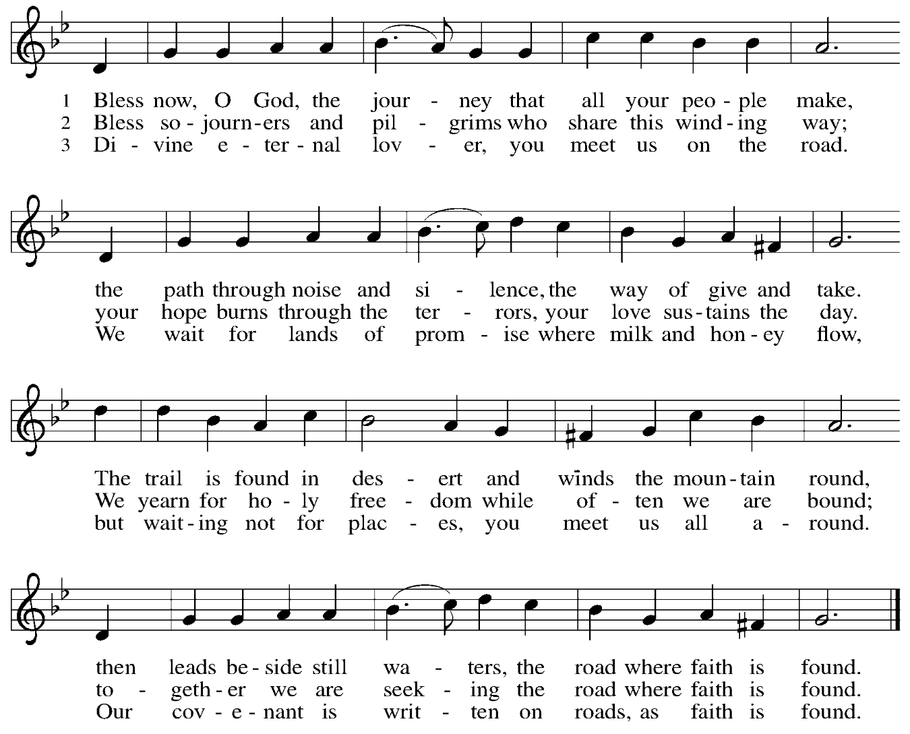

Greeting

P: The grace of our Lord Jesus Christ, the love of God,
and the communion of the Holy Spirit be with you all.
C: And also with you.

Kyrie ELW p. 193
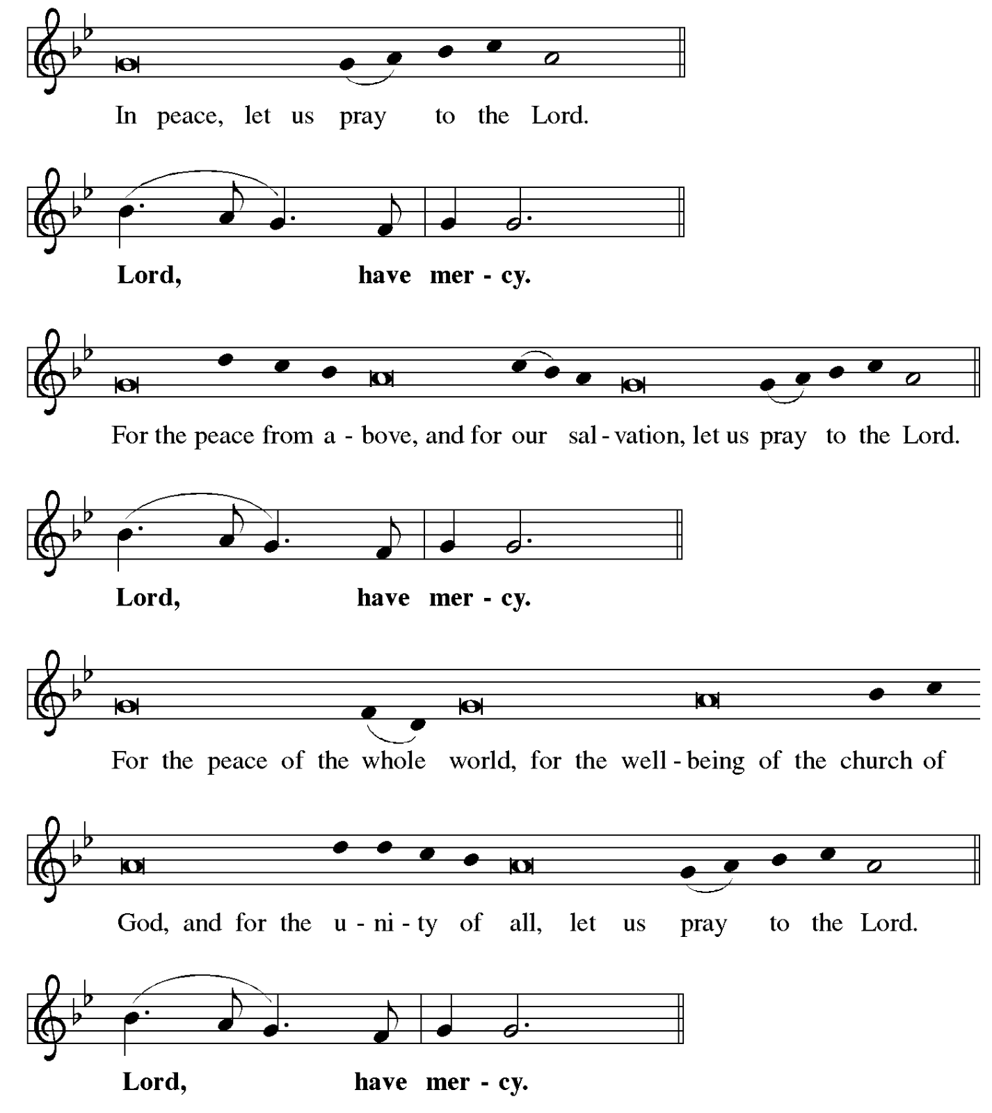
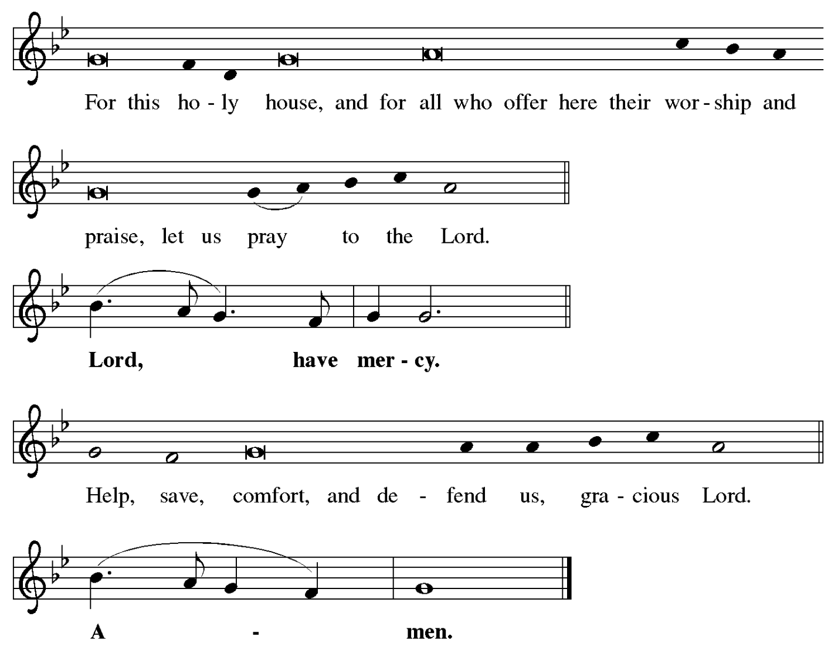

Prayer of the Day

P: The Lord be with you.
C: And also with you.

P: Lord God, our strength, the struggle between good and evil rages within and around us,
and the devil and all the forces that defy you tempt us with empty promises.
Keep us steadfast in your word, and when we fall, raise us again
and restore us through your Son, Jesus Christ, our Savior and Lord,
who lives and reigns with you and the Holy Spirit, one God, now and forever.
C: Amen.

Please be seated.
Children are invited to join the adult leader(s) at the side door for Little Church – Big Faith.
We ask that an additional adult from the congregation attend with the children.

Wrod
God speaks to us in Scripture reading, preaching, and song

First Reading – Genesis 2: 15-17, 3: 1-7

¹⁵ The Lord God took the man and put him in the garden of Eden to till it and keep it. ¹⁶ And the Lord God commanded the man, “You may freely eat of every tree of the garden, ¹⁷ but of the tree of the knowledge of good and evil you shall not eat, for in the day that you eat of it you shall die.”
^{3:1} Now the serpent was more crafty than any other wild animal that the Lord God had made. He said to the woman, “Did God say, ‘You shall not eat from any tree in the garden’?” ² The woman said to the serpent, “We may eat of the fruit of the trees in the garden, ³ but God said, ‘You shall not eat of the fruit of the tree that is in the middle of the garden, nor shall you touch it, or you shall die.’ ” ⁴ But the serpent said to the woman, “You will not die, ⁵ for God knows that when you eat of it your eyes will be opened, and you will be like God, knowing good and evil.” ⁶ So when the woman saw that the tree was good for food and that it was a delight to the eyes and that the tree was to be desired to make one wise, she took of its fruit and ate, and she also gave some to her husband, who was with her, and he ate. ⁷ Then the eyes of both were opened, and they knew that they were naked, and they sewed fig leaves together and made loincloths for themselves.

L: Word of God, word of life.
C: Thanks be to God.

Psalm 32

The psalm will be sung responsively, led by the cantor, with the congregation singing the verses in bold type and joining in the refrain.

Psalm Tone
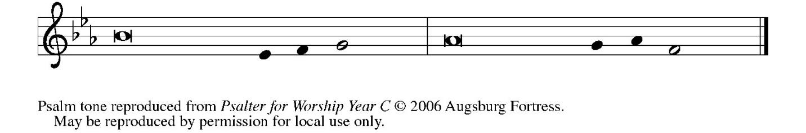

Psalm Refrain
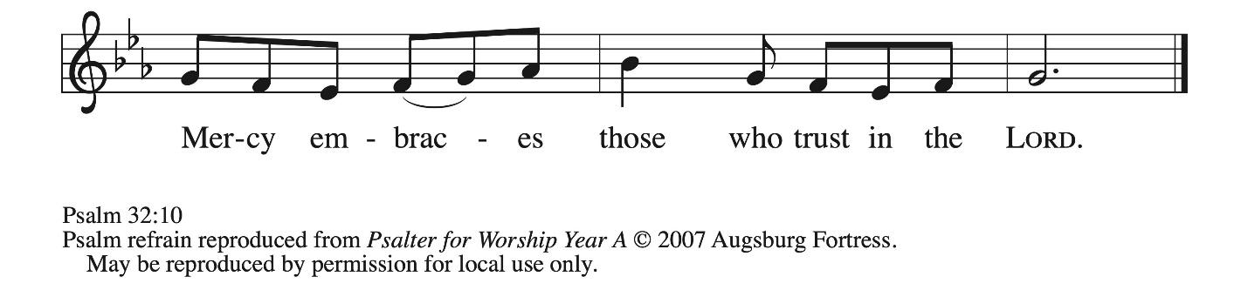
¹ Happy are they whose transgressions | are forgiven,
and whose sin is | put away!
² Happy are they to whom the Lord im- | putes no guilt,
and in whose spirit there | is no guile!
³ While I held my tongue, my bones with- | ered away,
because of my groaning | all day long.
⁴ For your hand was heavy upon me | day and night;
my moisture was dried up as in the | heat of summer. R
⁵ Then I acknowledged my sin to you, and did not con- | ceal my guilt.
I said, “I will confess my transgressions to the Lord.” Then you forgave me the guilt | of my sin.
⁶ Therefore all the faithful will make their prayers to you in | time of trouble;
when the great waters overflow, they | shall not reach them.
⁷ You are my hiding-place; you preserve | me from trouble;
you surround me with shouts | of deliverance.
⁸ “I will instruct you and teach you in the way that | you should go;
I will guide you | with my eye. R
⁹ Do not be like horse or mule, which have no | understanding;
who must be fitted with bit and bridle, or else they will | not stay near you.”
¹⁰ Great are the tribulations | of the wicked;
but mercy embraces those who trust | in the Lord.
¹¹ Be glad, you righteous, and rejoice | in the Lord;
shout for joy, all who are | true of heart. R

Second Reading – Romans 5: 12-19

¹² Just as sin came into the world through one man, and death came through sin, and so death spread to all because all have sinned ¹³ for sin was indeed in the world before the law, but sin is not reckoned when there is no law. ¹⁴ Yet death reigned from Adam to Moses, even over those who did not sin in the likeness of Adam, who is a pattern of the one who was to come.
¹⁵ But the free gift is not like the trespass. For if the many died through the one man’s trespass, much more surely have the grace of God and the gift in the grace of the one man, Jesus Christ, abounded for the many. ¹⁶ And the gift is not like the effect of the one man’s sin. For the judgment following one trespass brought condemnation, but the gift following many trespasses brings justification. ¹⁷ If, because of the one man’s trespass, death reigned through that one,
much more surely will those who receive the abundance of grace and the gift of righteousness reign in life through the one man, Jesus Christ.
¹⁸ Therefore just as one man’s trespass led to condemnation for all, so one man’s act of righteousness leads to justification and life for all. ¹⁹ For just as through the one man’s disobedience the many were made sinners, so through the one man’s obedience the many will be made righteous.

L: Word of God, word of life.
C: Thanks be to God.

Please rise as you are able.
Gospel Verse ELW p. 198

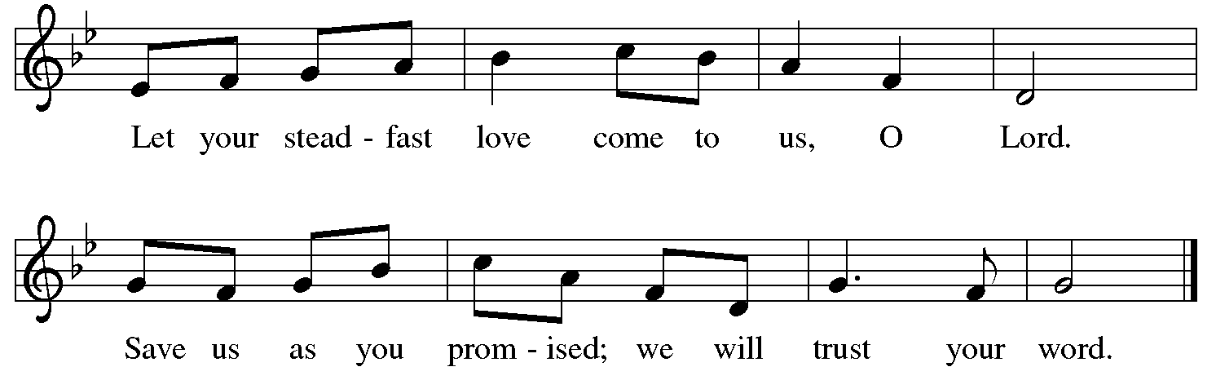

Gospel – Matthew 4: 1-11

P: The holy Gospel according to St. Matthew.
C: Glory to you, O Lord.

¹ Jesus was led up by the Spirit into the wilderness to be tested by the devil. ² He fasted forty days and forty nights, and afterward he was famished. ³ The tempter came and said to him, “If you are the Son of God, command these stones to become loaves of bread.” ⁴ But he answered, “It is written,
‘One does not live by bread alone,
but by every word that comes from the mouth of God.’ ”
⁵ Then the devil took him to the holy city and placed him on the pinnacle of the temple, ⁶ saying to him, “If you are the Son of God, throw yourself down, for it is written,
‘God will command God’s angels concerning you,’
and ‘On their hands they will bear you up,
so that you will not dash your foot against a stone.’ ”
⁷ Jesus said to him, “Again it is written, ‘Do not put the Lord your God to the test.’ ”
⁸ Again, the devil took him to a very high mountain and showed him all the kingdoms of the world and their glory, ⁹ and he said to him, “All these I will give you, if you will fall down and worship me.” ¹⁰ Then Jesus said to him, “Away with you, Satan! for it is written,
‘Worship the Lord your God,
and serve only God.’ ”
¹¹ Then the devil left him, and suddenly angels came and waited on him.

P: The Gospel of the Lord.
C: Praise to you, O Christ.

Please be seated.

Sermon

A time of silence for prayer and reflection follows the sermon.
When the hymn of the day begins, please rise as you are able.

Hymn of the Day O Lord, throughout These Forty Days ELW 319

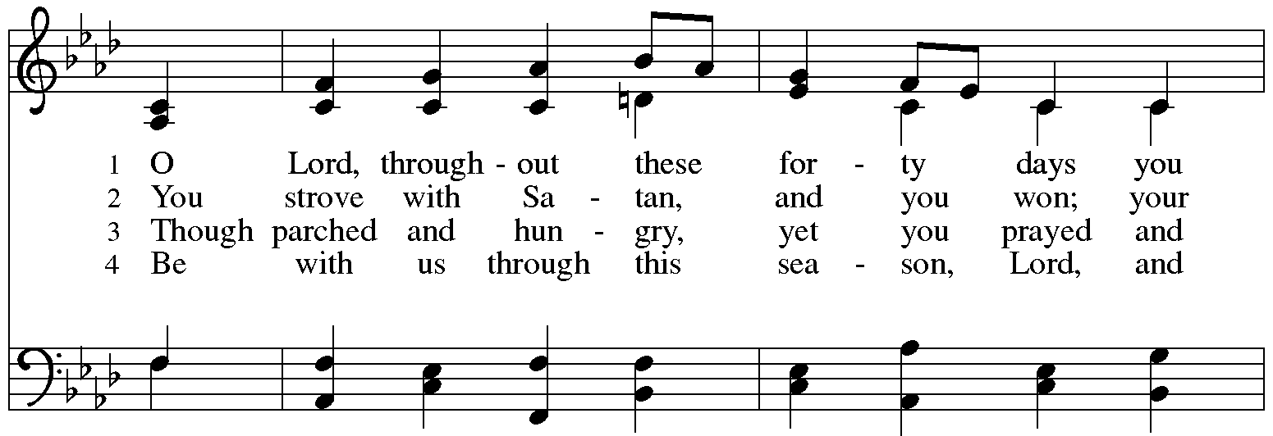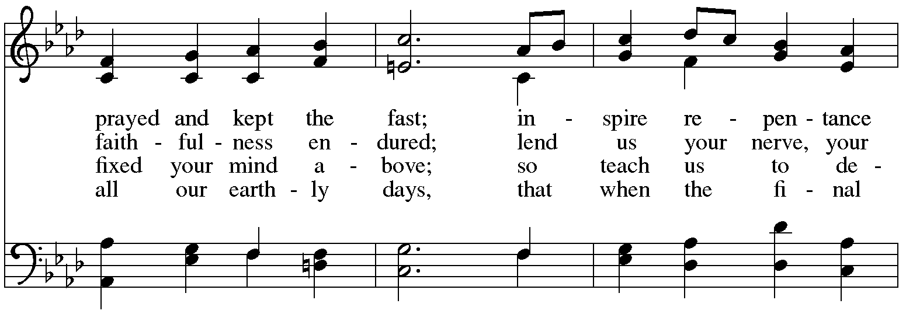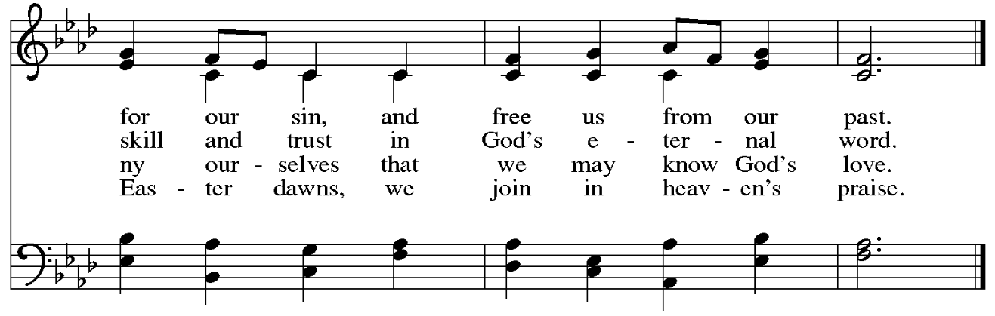

Apostles’ Creed

C: I believe in God, the Father almighty,
creator of heaven and earth.

C: I believe in Jesus Christ, God’s only Son, our Lord,
who was conceived by the Holy Spirit,
born of the virgin Mary,
suffered under Pontius Pilate,
was crucified, died, and was buried;
he descended to the dead.*
On the third day he rose again;
he ascended into heaven,
he is seated at the right hand of the Father,
and he will come to judge the living and the dead.

I believe in the Holy Spirit,
the holy catholic church,
the communion of saints,
the forgiveness of sins,
the resurrection of the body,
and the life everlasting. Amen.

*Or, “he descended into hell,” another translation of this text in widespread use.

Prayers of the People

A: As God’s beloved children united in Christ, let us pray for the church,
the world, and the whole human community.

After each petition
A: Merciful God,
C: receive our prayer.

P: Confident that the Holy Spirit receives our prayers and answers us,
we commend all for whom we pray to your lovingkindness, O God,
revealed to us through Jesus Christ our Savior.
C: Amen.

Peace

The presiding minister and the assembly greet one another in the peace of the risen Christ.
P: The peace of Christ be with you always.
C: And also with you.

The people may greet those around them with a sign of Christ’s peace and may say
Peace be with you or similar words. Please be mindful that not everyone will be comfortable with sharing the peace, so please seek consent before shaking hands or hugging.
Other possible ways to share the peace include a simple bow with the verbal greeting of peace, or simply a verbal expression of peace.

When the greetings of peace have concluded, please be seated.

Meal
God feeds us with the presence of Jesus Christ

Offering

We offer ourselves, our gifts, and our faithful service to God.
As the offering is gathered for the mission of the church, including the care of those in need,
the table is set for Holy Communion.

There are laminated giving cards in the pew racks that feature a QR code for anyone who would like to give online. Those who give using the QR code, as well as those who give regularly online or through their bank are encouraged to place the laminated card in the plate as an expression of your offering.

Offertory Music I Want Jesus to Walk with Me arr. Giamanco

As the gifts are brought forward for presentation, please rise as you are able.

Offertory Song Create in Me a Clean Heart ELW 186

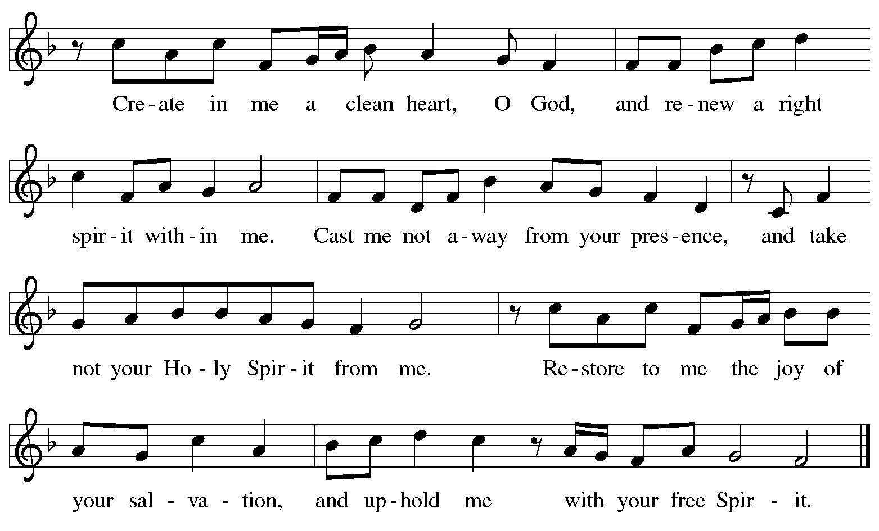

Offertory Prayer

A: Let us pray.
God our provider,
C: have not fed us with bread alone,
but with words of grace and life.
Bless us and these your gifts,
which we receive from your bounty,
through Jesus Christ our Lord.
Amen.

Dialogue ELW p. 199

P: The Lord be with you.
C: And also with you.

P: Lift up your hearts.
C: We lift them to the Lord.

P: Let us give thanks to the Lord our God.
C: It is right to give our thanks and praise.

Preface (Spoken by the presiding minister)

P: It is indeed right, our duty and our joy,
that we should at all times and in all places
give thanks and praise to you, almighty and merciful God,
through our Savior Jesus Christ.
You call your people to cleanse their hearts
and prepare with joy for the paschal feast,
that, renewed in the gift of Baptism,
we may come to the fullness of your grace.
And so, with all the choirs of angels,
with the church on earth and the hosts of heaven,
we praise your name and join their unending hymn:

Sanctus ELW p. 200

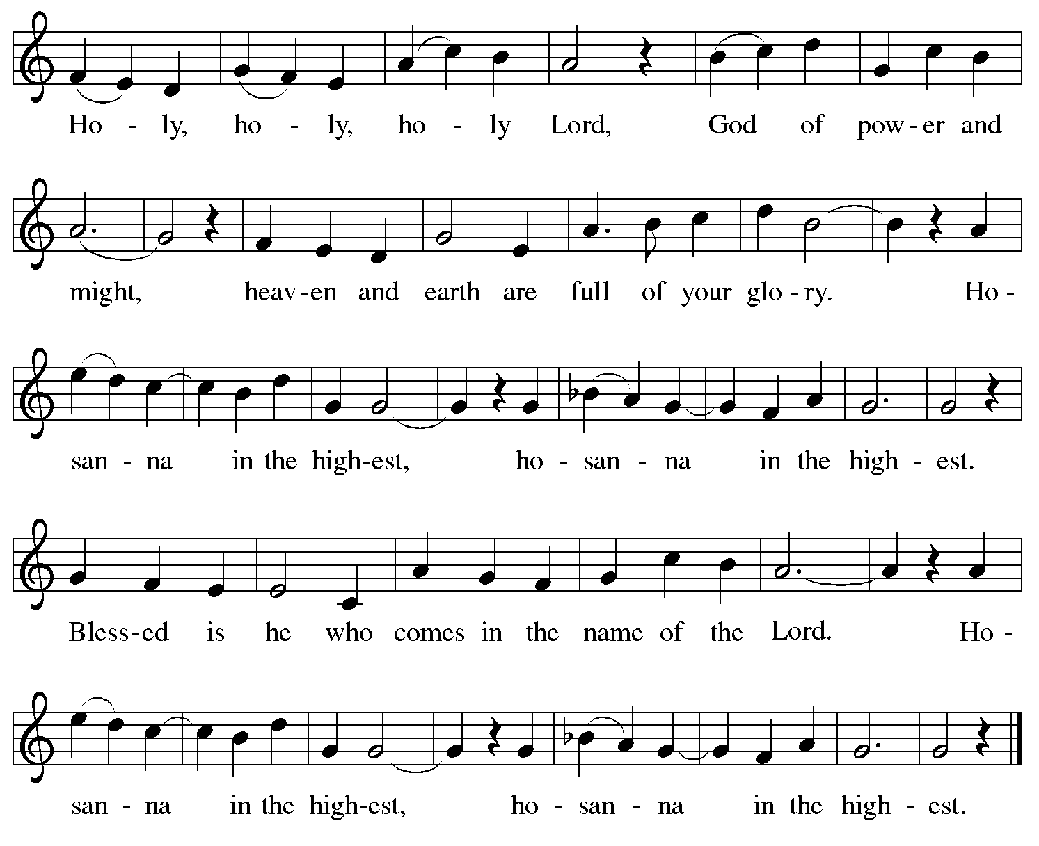

Eucharistic Prayer

P: Blessed are you, O God of the universe …
… Do this for the remembrance of me.

With this bread and cup
we remember our Lord’s passover from death to life
as we proclaim the mystery of faith:
C: Christ has died. Christ is risen. Christ will come again.

P: O God of resurrection and new life …
… Grace our table with your presence.
C: Come, Holy Spirit.

P: Reveal yourself to us in the breaking of the bread …
… Send us forth, burning with justice, peace, and love.
C: Come, Holy Spirit.

P: With your holy ones of all times and places …
… we praise you, O God, blessed and holy Trinity,
now and forever.
C: Amen.

Lord’s Prayer

P: Gathered as one by the Holy Spirit, let us pray as Jesus taught us.
C: Our Father in heaven,
hallowed be your name,
your kingdom come,
your will be done,
on earth as in heaven.
Give us today our daily bread.
Forgive us our sins
as we forgive those
who sin against us.
Save us from the time of trial
and deliver us from evil.
For the kingdom, the power,
and the glory are yours,
now and forever. Amen.

Fraction and Invitation



Agnus Dei / Lamb of God ELW p. 200

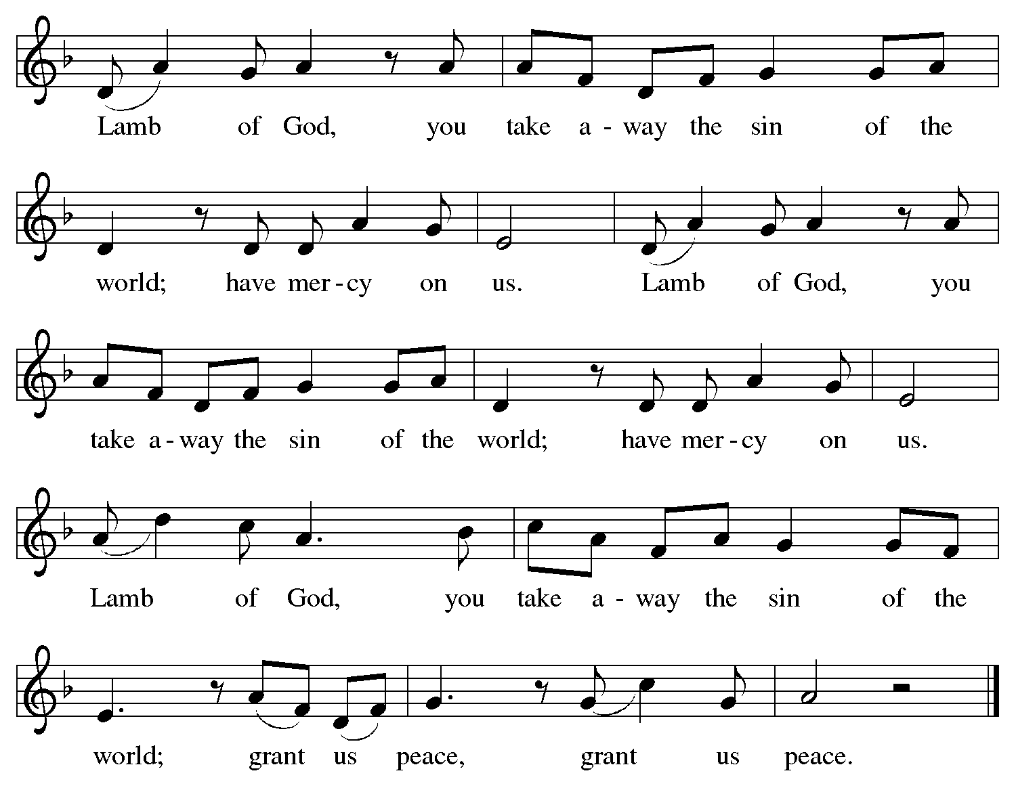

Please be seated.

Holy Communion

- All who seek God and desire a deeper and stronger life in Christ are welcome to receive Holy Communion.
- Worshipers from the pulpit side will proceed forward first, followed by the center section, and then the lectern side.
- Please inform an usher if you would like the ministers to bring Communion to you.
- Holy Communion will be served with bread and wine (amber) or grape juice (purple).
- The presiding minister will first distribute the bread (host) to each communicant. Please indicate if you require a gluten-free host.
- Once you have consumed the bread, please pick up an empty glass from the tray next to the presiding minister. The Communion Assistant will pour wine or grape juice into your glass.
- Please step to the side to consume the wine or grape juice.
- Feel free to kneel at the altar rail for prayer after receiving the sacrament.
- As you return to your pew, glasses may be returned to the empty tray on the side of the center section.
- A blessing will be provided for anyone who does not yet receive the sacrament.
- All are invited to join in singing the hymns during Holy Communion.

Hymns during Holy Communion
Oh Love, How Deep ELW 322
v. 1-4

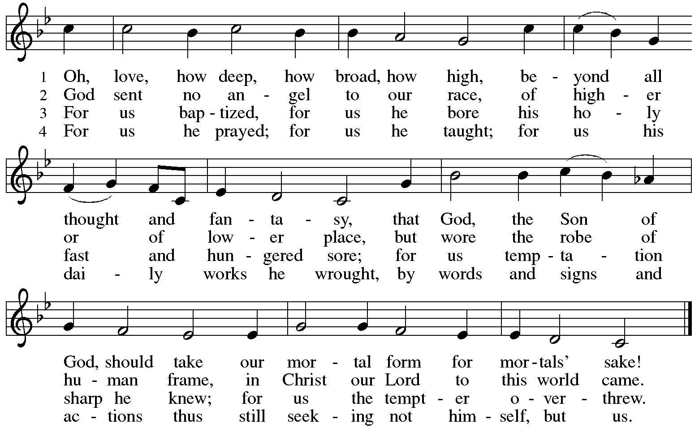



Hymns during Holy Communion
As Your Spirit in the Desert ACS 923

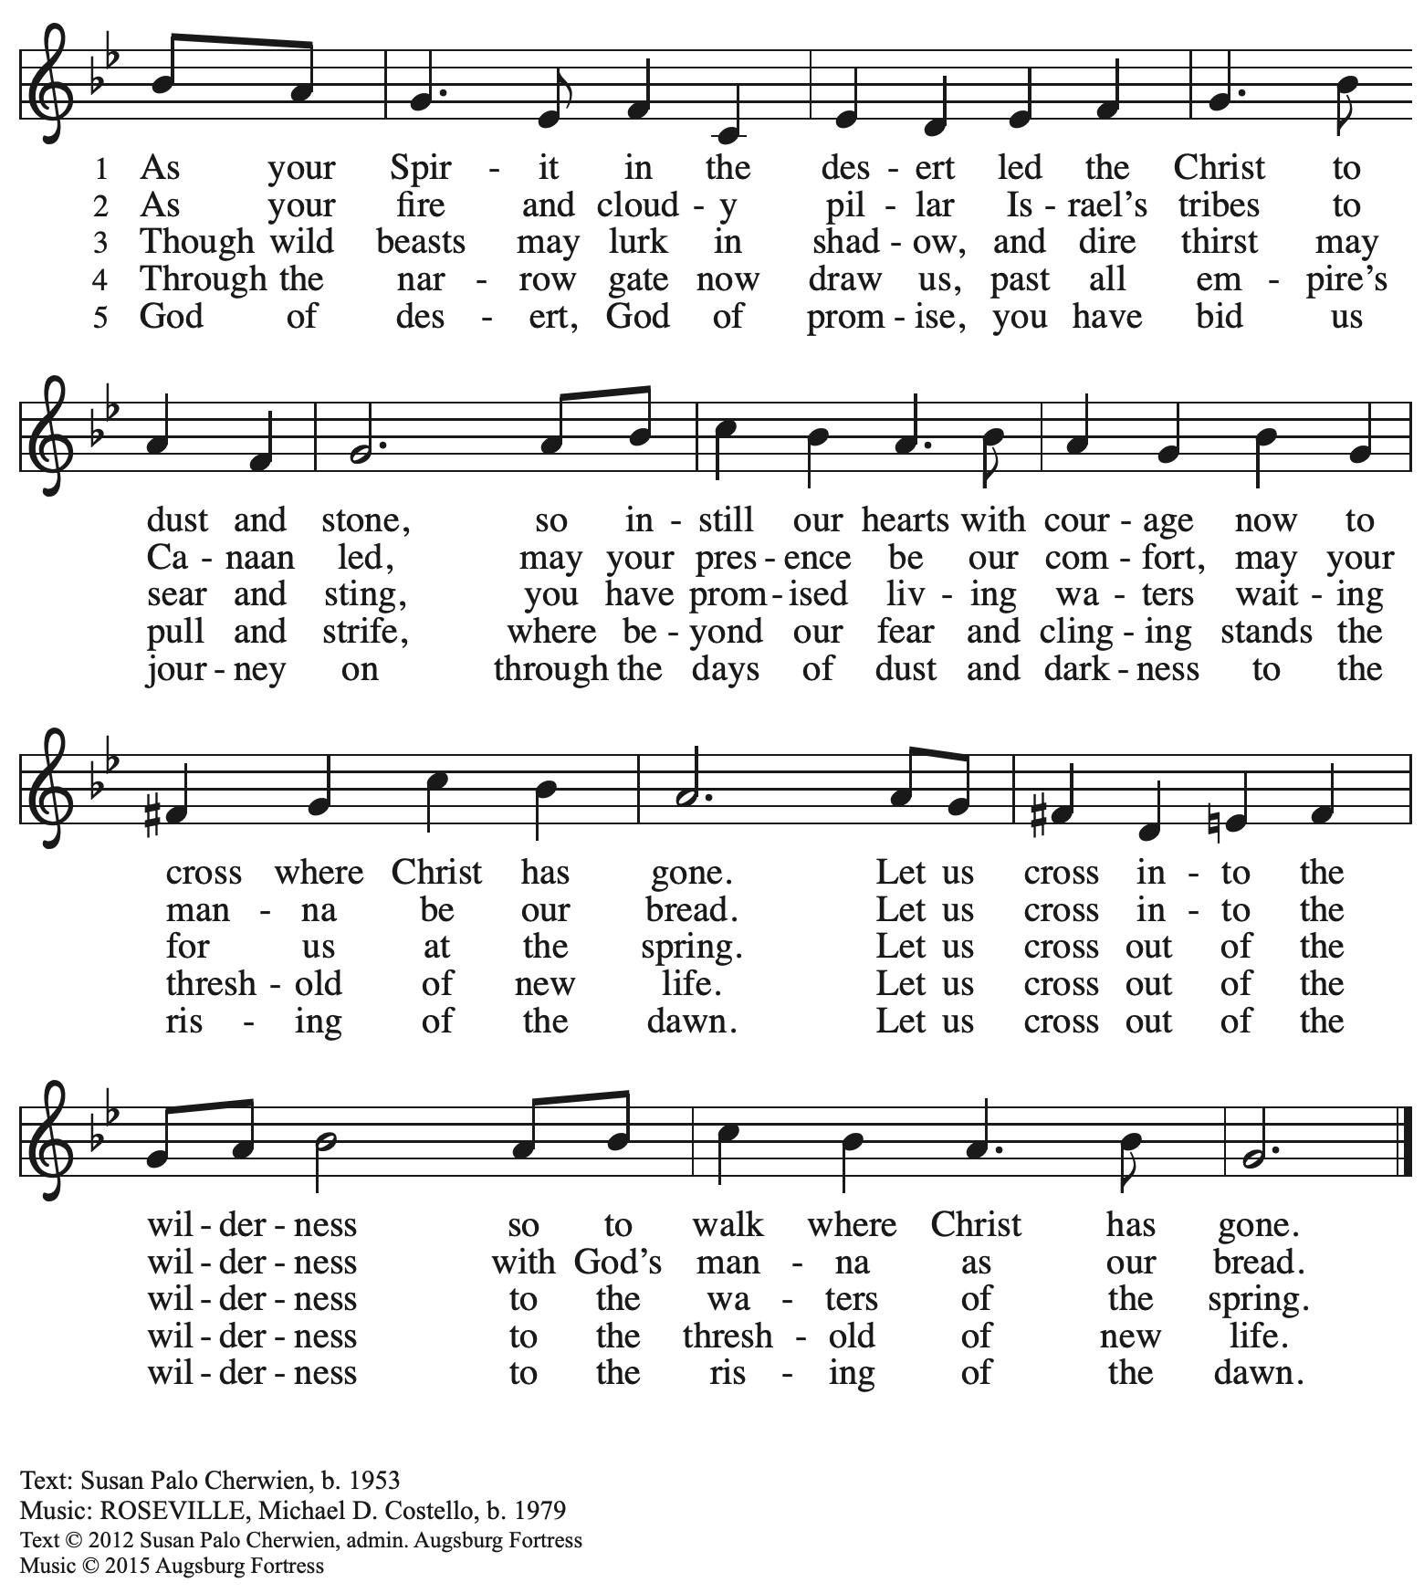
All rights reserved. Reprinted with permission under OneLicense.net # A-722139.

Hymns during Holy Communion
I Need Thee Every Hour HFW 549

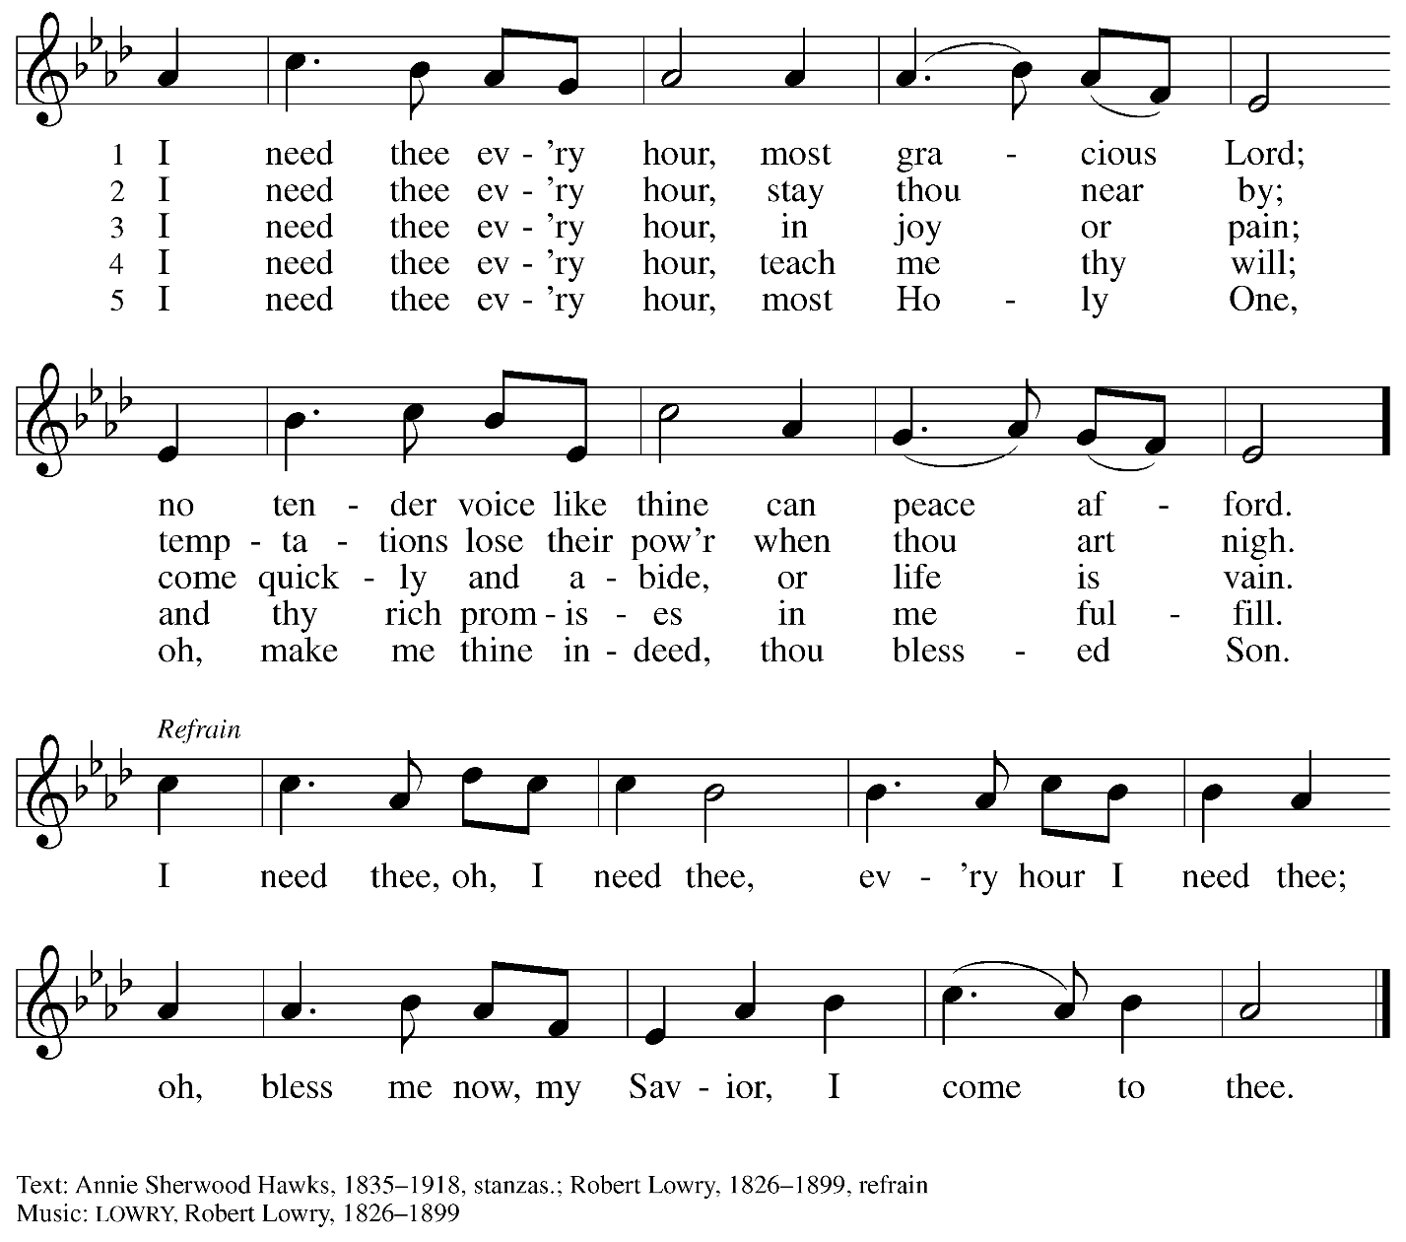

Hymns during Holy Communion
Lord, Keep Us Steadfast in Your Word ELW 517

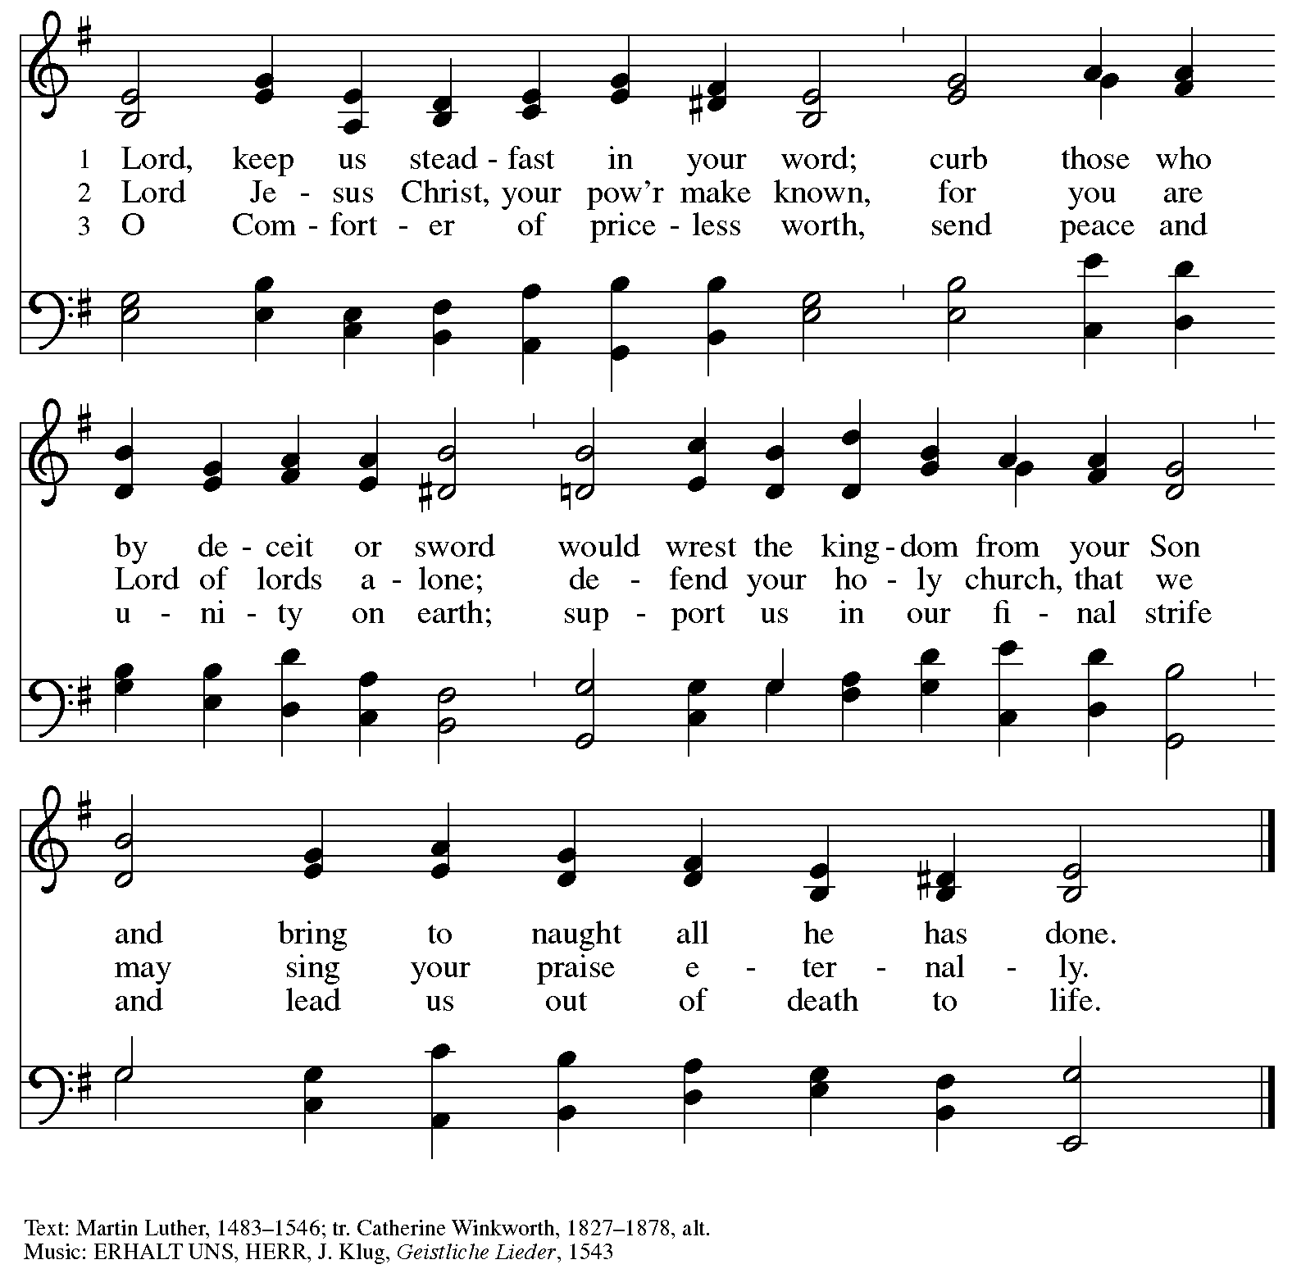

When all have returned to their places, please rise as you are able.

Blessing

P: The body and blood of our Lord Jesus Christ strengthen you and keep you in his grace.
C: Amen.

Prayer

A: Let us pray.
Compassionate God, you have fed us with the bread of heaven.
Sustain us in our Lenten pilgrimage: may our fasting be hunger for justice;
our alms, a making of peace; and our prayer, the song of grateful hearts, through Jesus Christ, our Savior and Lord.
C: Amen.

Please be seated.

Sending
God blesses us and sends us in mission to the world

Announcements

Please rise as you are able.

Benediction

P: Receive the blessing of the holy Trinity:
God, who calls all things into existence,
Jesus Christ, who redeems us,
and the Holy Spirit, whose breath sustains creation,
☩ bless you and keep you, now and forever.
C: Amen.

Sending Hymn Following page

Dismissal

A: Go in peace. Love and serve your neighbor.
C: Thanks be to God

Postlude

Sending Hymn Guide Me Ever, Great Redeemer ELW 618

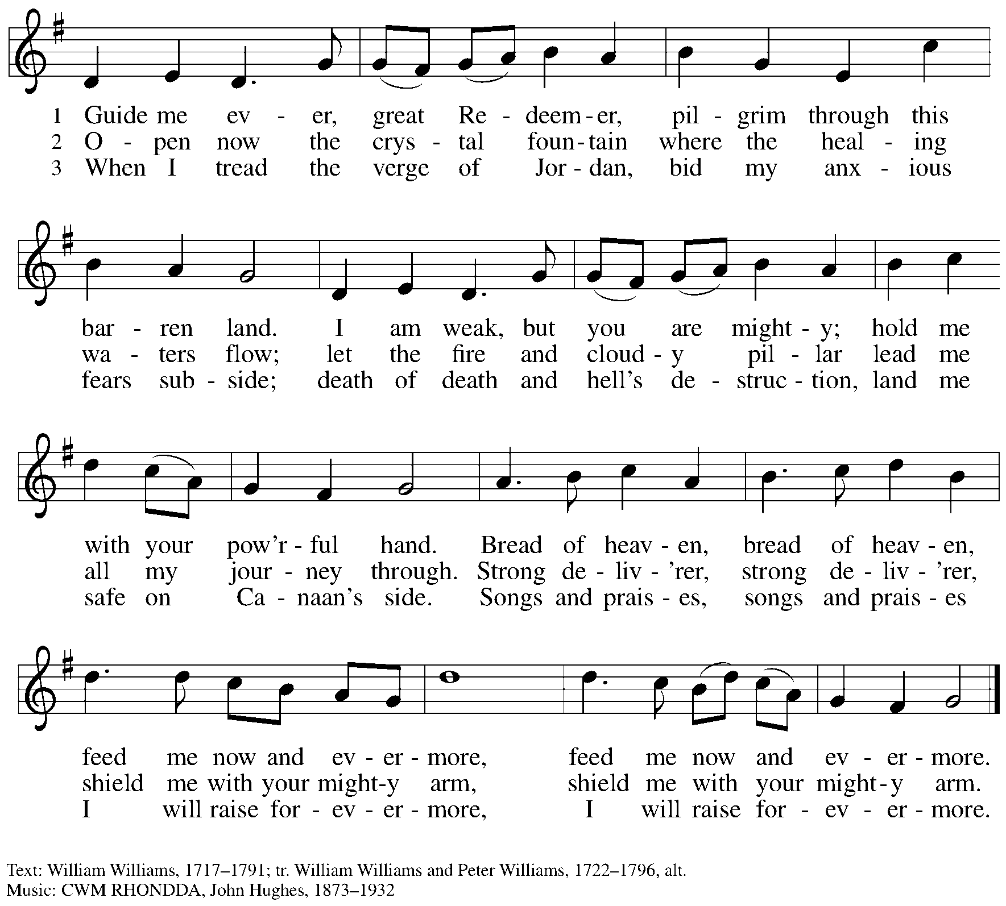

Serving in Worship Today

Altar Care Beverley Chapman
AV Ministers Kristen Asplin
Tyler Rietze
Assisting Minister Kathy Hays
Cantor Jered Stratton
Lector Pat Taylor
Minister of Music Laura Reynolds
Presiding Minister The Rev. Ross Carmichael

Liturgy and Hymnody Acknowledgements

From SundaysandSeasons.com. Copyright © 2026 Augsburg Fortress. All rights reserved. Reprinted under OneLicense.net # A-722139.
Used by permission of Augsburg Fortress.

The Scripture readings contained herein are from New Revised Standard Version Updated Edition of the Bible © 2021 National Council of Churches of Christ in the United States of America. Used by permission. All rights reserved worldwide.
Bless Now, O God, the Journey – Text: Sylvia G. Dunstan, 1955-1993. Music: LANGLOFFAN, Welsh tune, 19th cent. Text © 1991 Gia Publications, Inc., 7404 S. Mason Ave., Chicago, IL 60638. www.giamusic.com. 800.442.3358. All rights reserved. Reprinted with permission under OneLicense.net # A-722139.

O Lord, throughout These Forty Days – Text: based on Claudia F. Hernaman, 1838-1898; para. Gilbert E. Doan, Jr., b. 1930. Music: CONSOLATION, A. Davisson, Kentucky Harmony, 1816; arr. Theodore A. Beck, 1929-2003. Text © 1978 Lutheran Book of Worship, admin. Augsburg Fortress. Arr. © 1969 Concordia Publishing House. All rights reserved. Reprinted with permission under OneLicense.net # A-722139.

Create in Me a Clean Heart – Music: Richard W. Hillert, b. 1923. Music © 1978 Lutheran Book of Worship, admin. Augsburg Fortress. All rights reserved. Reprinted with permission under OneLicense.net # A-722139.

Please use the QR code below to link to St. Andrew’s Announcements online!



St. Andrew Lutheran Church Announcements
February 22nd, 2026

- Welcome to Worship at St. Andrew on the First Sunday in Lent – We are thankful you are here, and we offer a special welcome to all visitors and guests who are here for the first time! A nursery is available through the door to the left of the worship space and across the social hall (look for a purple room). There are also worship “toolkits” to help children engage with worship and “busy bags” for younger children available in the bookcase at the back of the sanctuary. Please feel free to take one to use with/for your children. All are invited to stay for coffee and other drinks, food, and conversation in the Social Hall (through the side door at the left of the worship space) after the service.
- Growing in Faith Together - Group for People New to St. Andrew, Today, February 22nd, after Worship – This gathering is intended for people who are relatively new to St. Andrew, whether you are preparing to join the congregation by transfer or Affirmation of Baptism, or would just like to meet more people and learn about the congregation. Jeff Denlinger and Kelly Spanninger will serve as facilitators and will be happy to answer any questions.
- Bible Book Club, Wednesday, February 25th at 7:00 p.m. – Bible Book Club will meet weekly on Wednesdays at 7:00 p.m. All are welcome to participate. The group will be reading the Gospel of Mark along with The Gospel of Mark: A Beginner’s Guide to the Good News by Dr. Amy-Jill Levine. Here are the details on the book from one site: (https://www.cokesbury.com/The-Gospel-of-Mark-6?select=862810). You can join the Zoom call by going to: https://us02web.zoom.us/j/83196175976?pwd=ejdPOUYrTk4xVFdsdlhHUVJ1L3k2Zz09.
- Pysanky Ukrainian Egg Lenten Meditation Workshop, Saturday, February 28th, 10:00 a.m. - 3:00 p.m. – Jimmi Kocher-Hillmer is experienced in the practice of Ukrainian Egg Making as a meditational and devotional practice. He has offered to once again lead a workshop this Lent for people of the congregation. Please save February 28th, from 10:00 a.m. to 3:00 p.m. on your calendars for this meaningful and fun opportunity! Please contact Jimmi for registration at 412-621-2472 or jimotha@yahoo.com. Registration is limited.
- Congregational Meeting, Sunday, March 1st, after Worship – St. Andrew's next meeting of the congregation will be held after worship on Sunday, March 1st. This will be our annual opportunity to receive reports from leadership, including the year-end financial reports from the previous year. We will also update the congregation on the progress of the building project and the capital campaign. Thank you for your continuing support and for your contributions to the ministry of St. Andrew in 2025 (and now 2026)!
- Monthly Reparations Offering Next Week, Sunday, March 1st, during Worship – In Luke’s Gospel, Jesus tells a story about a compassionate Samaritan, suggesting that God’s people are called to work for healing and restoration for our neighbors, regardless of who or what caused them harm. In light of this, St. Andrew has made a commitment to reparations in regard to African American spiritual songs used in our worship. The text and music of most hymns is attributed to specific authors, with copyrights in place, usage reported, and royalties paid to those whose works are featured in worship. With African American spirituals, this is not possible. In response to many years of such uncredited use, St. Andrew invites the congregation to give a reparations offering. Funds received in worship will be donated to our siblings at Bethel AME Church, whose land and building were taken from them in the 1950s, to fund their development in the Hill District.
- Produce Distribution Supplemental Food of the Month – St. Andrew is collecting supplemental food each month to accompany our produce distribution. For February, we ask for donations of dried lentils and beans. There are collection boxes at the back of the worship space and social hall.
- Produce Distribution, First and Third Tuesday Each Month, March 3rd and 17th from 5:30-6:30 p.m. – St. Andrew partners with Greater Pittsburgh Community Food Bank to serve as a distribution site for fresh produce on the first and third Tuesday of every month. We invite people of the congregation to help with the distribution from 5:30 p.m. – 6:30 p.m. and/or to help with unloading and setup during the day between 10:00 a.m. and 1:00 p.m.

- Artificial Intelligence: Tool, Idol, Other, a Public Talk – February 26th, 8:00 p.m. – Join the Lutheran University in this public talk given by Dr. Noreen Herzfeld at the Lutheran University Center (LUC) on February 26th, at 8:00 p.m. The address is 4515 Forbes Avenue in Pittsburgh, PA. Dr. Herzfeld is both a computer scientist and a theologian, an especially relevant voice in these times. The talk is open to all, and students are encouraged to attend.
- Lenten Blessing and Resources – As ReconcilingWorks continues to strive to support you and your faith community in deepening and expanding the welcome, inclusion, and celebration of people of all sexual orientations, gender identities, and gender expressions, and commit to racial equity/anti-racism, they have shared this brand-new free Lenten devotional "Of Justice, Liberation, and Flourishing." Lent draws us into a holy tension between humility and public faithfulness; Lent sharpens our moral attention. You can access the devotional here: https://www.reconcilingworks.org/wp-content/uploads/2026/02/Lenten-Devotional-from-ReconcilingWorks.pdf
- “Christ in Our Home” Booklets Available – “Christ in Our Home” is a quarterly devotional resource that encourages readers to live out their faith daily. Each reflective reading is accompanied by a daily scripture reference and prayer for the day. The January-March booklets are available at the entrances. Please feel free to take one home!
- Coffee Hour Signups – St. Andrew provides hospitality during a coffee hour after worship each Sunday. If you would like to participate and would like information about the duties of setting up, please sign up using the following form: https://www.signupgenius.com/go/5080B4AAFAF2CABF85-47069030-coffee#/.

