

+ Second Sunday in Lent
March 1, 2026



St. Andrew Lutheran Church
304 Morewood Ave.
Pittsburgh, PA 15213
St_andrewELCA@verizon.net
www.standrewpittsburgh.org

+ Second Sunday in Lent
Order for Worship

During Lent the church journeys with all those around the world who will be baptized at the Easter Vigil. In today’s Gospel, Jesus tells Nicodemus that he must be born of water and Spirit. At the font we are given a new birth as children of God. As God made a covenant with Abraham, in Baptism God promises to raise us up with Christ to new life.
From worship we are sent forth to proclaim God’s love for all the world.

Welcome to St. Andrew!
- St. Andrew welcomes all who are seeking a place of healing, wholeness, and acceptance in a nurturing and faith-forming spiritual home. We are striving toward racial equity worldwide
and we seek to honor the lived experience of all individuals regardless of background. Our community embraces people of all ages, ethnicities, cultures, abilities, sexual orientations,
gender identities and expressions, and family constellations. Come and See!
- Worship Services are live-streamed to multiple online platforms. By attending worship, you agree that your image and voice may be broadcast.
- Everyone is invited to make a name tag at the black bookcase in the back of the worship space if they would like. There are stickers indicating pronouns on the bookcase if you would like to include them on your name tag.
- A nursery is available through the doors at the left side of the sanctuary and across from the doorway to the Social Hall. Look for a purple-colored room.
- Children are invited to attend Little Church – Big Faith, a Bible lesson and activity, during worship (after the Prayer of the Day). The group returns to the worship space for the liturgy of Holy Communion.
- Worship “toolkits” to help children engage with the service, along with “busy bags” for younger children, are available in the bookcase at the back of the sanctuary. Please feel free to take one to use with/for your children.
- Holy Communion is served with bread (gluten-free available) and wine or grape juice. The presiding minister will distribute the bread (host). Please consume this and then pick up an empty glass from the tray. The Communion Assistant will pour wine or grape juice into your glass. Please step to the side to consume the wine or grape juice. Feel free to kneel at the altar for prayer and reflection. As you return to your pew, glasses may be returned to the empty trays on either side of the center section.
- A restroom is available on the main level of the church, through the doors to the Social Hall and to the right in the main office.

Abbreviations
P: Pastor/Presiding Minister ELW: Evangelical Lutheran Worship hymnal
A: Assisting Minister ACS: All Creation Sings hymnal
L: Lector LBW: Lutheran Book of Worship
C: Congregation

Musical Offering

Each week, different people from the congregation make an offering of pre-service music, with singing or instrumentation, to help the assembly focus and pray in preparation for worship.

Welcome

Prelude How Long, O Lord? arr. Raabe

Gathering
The Holy Spirit calls us together as the people of God

Please rise as you are able. All may make the sign of the cross,
the sign that is marked at Baptism, as the presiding minister begins.

Confession and Forgiveness

P: Blessed be the holy Trinity, ☩ one God,
who forgives all our sin, whose mercy endures forever.
C: Amen.

P: Let us confess our sin before God, who removes our guilt
and blots out all offenses.

Silence is kept for reflection.

P: Gracious God,
C: have mercy on us according to your steadfast love.

P: For seeking worldly delights that deceive us and dishonor you:
Gracious God,
C: have mercy on us according to your steadfast love.

P: For desiring self-reliance instead of hungering for your word:
Gracious God,
C: have mercy on us according to your steadfast love.

P: For failing to recognize your coming reign,
and for hindering the work of the Spirit: Gracious God,
C: have mercy on us according to your steadfast love.

P: For drawing from the well of self-serving ambition,
and for disdaining the living water Christ offers: Gracious God,
C: have mercy on us according to your steadfast love.

P: For disregarding voices from the margins,
and for distrusting signs of your healing and hope in the world:
Gracious God,
C: have mercy on us according to your steadfast love.

P: For dwelling in tombs of self-pity and discontent,
and for disregarding Christ’s call to come forth to life:
Gracious God,
C: have mercy on us according to your steadfast love.

P: God’s steadfast love, grace, and forgiveness abound.
Through faith, the free gift of God,
you have been clothed in the righteousness of Christ.
In the name of ☩ Jesus Christ, your sins are forgiven.
The Spirit of the One who raised Christ from the dead dwells in you,
pours love into your hearts, and gives you life and peace.
C: Amen.

Gathering Hymn Restore in Us, O God ELW 328

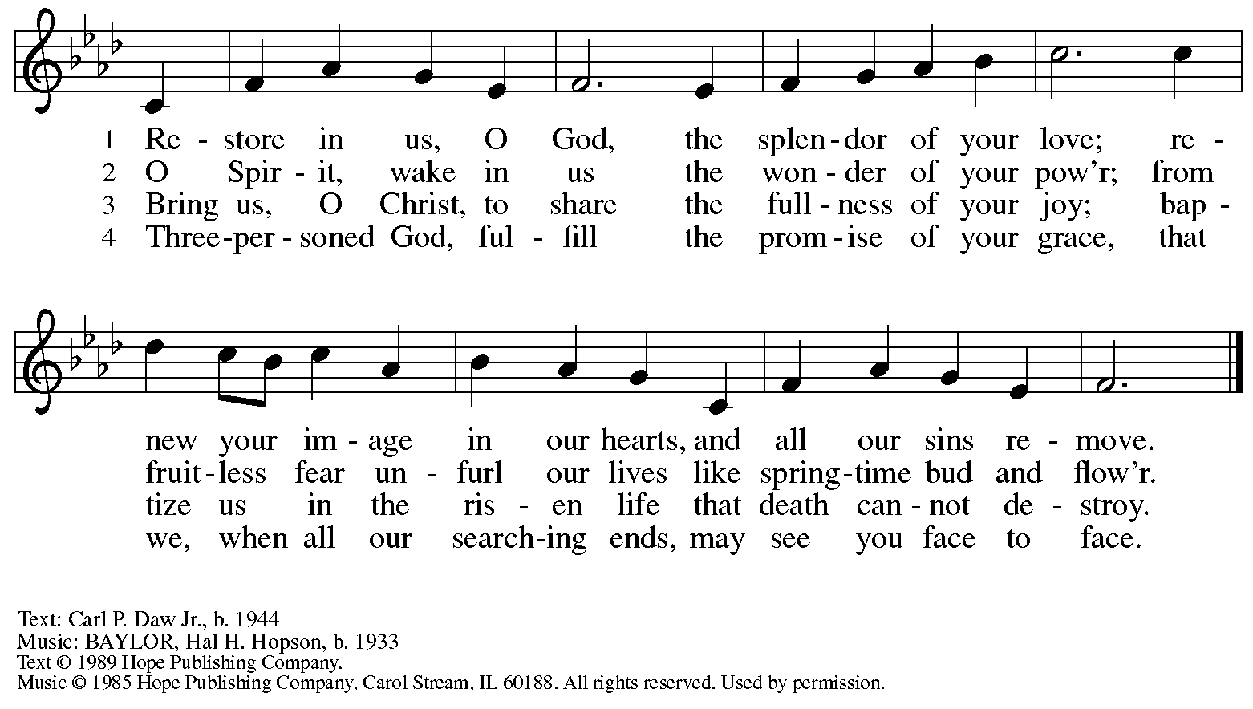
Reprinted under OneLicense.net # A-722139.

Greeting

P: The grace of our Lord Jesus Christ, the love of God,
and the communion of the Holy Spirit be with you all.
C: And also with you.

Kyrie Kyrie Hartung

This week’s Kyrie will be sung by the choir.

Prayer of the Day

P: The Lord be with you.
C: And also with you.

P: O God, our leader and guide, in the waters of Baptism you bring us to new birth
to live as your children. Strengthen our faith in your promises,
that by your Spirit we may lift up your life to all the world through your Son, Jesus Christ,
our Savior and Lord, who lives and reigns with you and the Holy Spirit,
one God, now and forever.
C: Amen.

Please be seated.
Children are invited to join the adult leader(s) at the side door for Little Church – Big Faith.
We ask that an additional adult from the congregation attend with the children.

Word
God speaks to us in Scripture reading, preaching, and song

First Reading – Genesis 12: 1-4a

¹ The Lord said to Abram, “Go from your country and your kindred and your father’s house to the land that I will show you. ² I will make of you a great nation, and I will bless you and make your name great, so that you will be a blessing. ³ I will bless those who bless you, and the one who curses you I will curse, and in you all the families of the earth shall be blessed.”
^{4a} So Abram went, as the Lord had told him, and Lot went with him.

L: Word of God, word of life.
C: Thanks be to God.

Psalm 121

The psalm will be sung responsively, led by the cantor, with the congregation singing the verses in bold type and joining in the refrain.

Psalm Tone

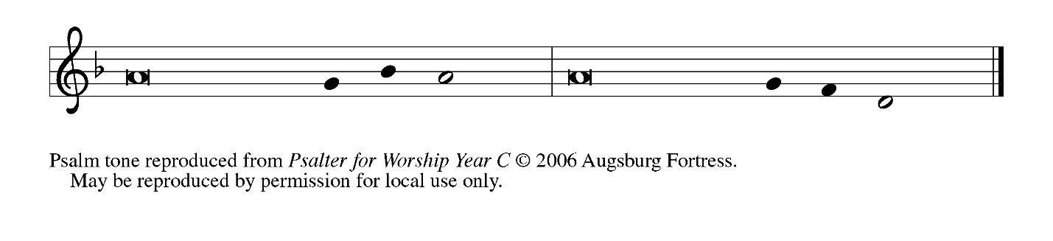
Psalm Refrain

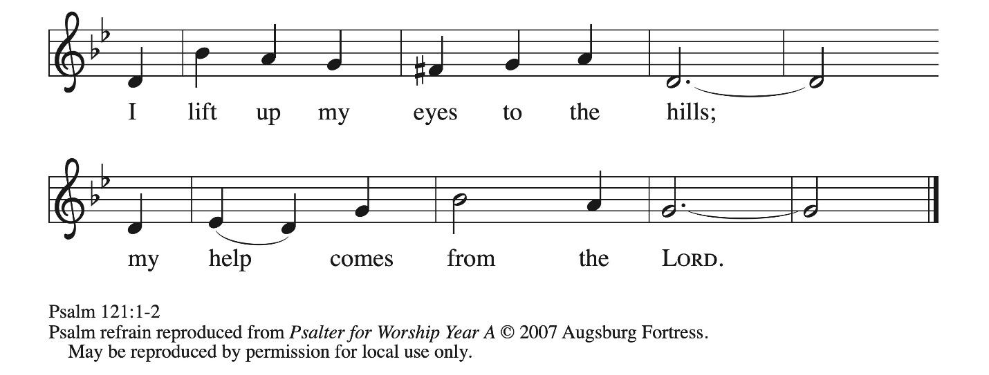
¹ I lift up my eyes | to the hills;
from where is my | help to come?
² My help comes | from the Lord,
the maker of heav- | en and earth.
³ The Lord will not let your | foot be moved
nor will the one who watches over you | fall asleep.
⁴ Behold, the keep- | er of Israel
will neither slum- | ber nor sleep; R
⁵ the Lord watches | over you;
the Lord is your shade at | your right hand;
⁶ the sun will not strike | you by day,
nor the | moon by night.
⁷ The Lord will preserve you | from all evil
and will | keep your life.
⁸ The Lord will watch over your going out and your | coming in,
from this time forth for- | evermore. R

Second Reading – Romans 4: 1-5, 13-17

¹ What then are we to say was gained by Abraham, our ancestor according to the flesh? ² For if Abraham was justified by works, he has something to boast about, but not before God. ³ For what does the scripture say? “Abraham believed God, and it was reckoned to him as righteousness.” ⁴ Now to one who works, wages are not reckoned as a gift but as something due. ⁵ But to one who does not work but trusts the one who justifies the ungodly, such faith is reckoned as righteousness.
¹³ For the promise that he would inherit the world did not come to Abraham or to his descendants through the law but through the righteousness of faith. ¹⁴ For if it is the adherents of the law who are to be the heirs, faith is null and the promise is void. ¹⁵ For the law brings wrath, but where there is no law, neither is there transgression.
¹⁶ For this reason the promise depends on faith, in order that it may rest on grace, so that it may be guaranteed to all his descendants, not only to the adherents of the law but also to those who share the faith of Abraham (who is the father of all of us, ¹⁷ as it is written, “I have made you the father of many nations”), in the presence of the God in whom he believed, who gives life to the dead and calls into existence the things that do not exist.

L: Word of God, word of life.
C: Thanks be to God.

Please rise as you are able.

Gospel Verse ELW p. 198

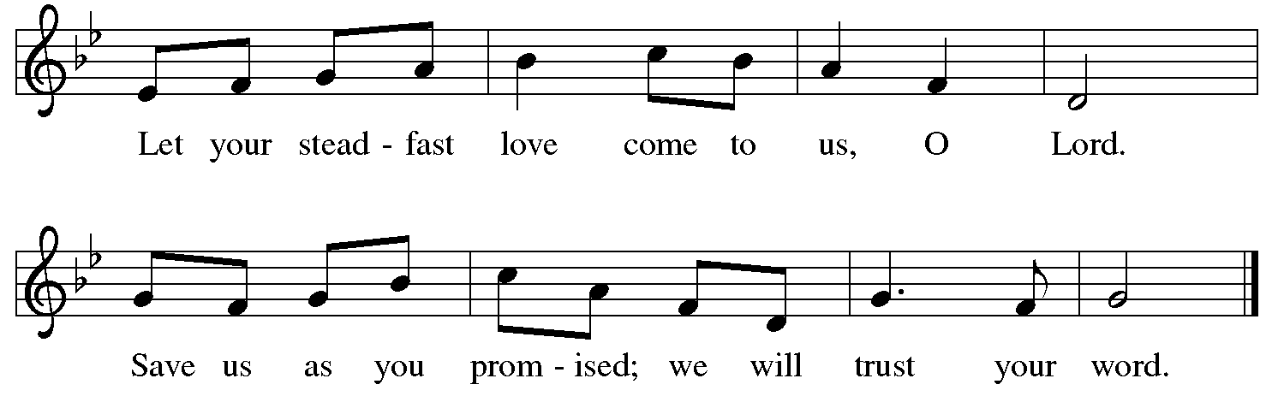

Gospel – John 3: 1-17

P: The holy Gospel according to St. John.
C: Glory to you, O Lord.

¹ Now there was a Pharisee named Nicodemus, a leader of the Jews. ² He came to Jesus by night and said to him, “Rabbi, we know that you are a teacher who has come from God, for no one can do these signs that you do unless God is with that person.” ³ Jesus answered him, “Very truly, I tell you, no one can see the kingdom of God without being born from above.” ⁴ Nicodemus said to him, “How can anyone be born after having grown old? Can one enter a second time into the mother’s womb and be born?” ⁵ Jesus answered, “Very truly, I tell you, no one can enter the kingdom of God without being born of water and Spirit. ⁶ What is born of the flesh is flesh, and what is born of the Spirit is spirit. ⁷ Do not be astonished that I said to you, ‘You must be born from above.’ ⁸ The wind blows where it chooses, and you hear the sound of it, but you do not know where it comes from or where it goes. So it is with everyone who is born of the Spirit.” ⁹ Nicodemus said to him, “How can these things be?” ¹⁰ Jesus answered him, “Are you the teacher of Israel, and yet you do not understand these things?
¹¹ “Very truly, I tell you, we speak of what we know and testify to what we have seen, yet you do not receive our testimony. ¹² If I have told you about earthly things and you do not believe, how can you believe if I tell you about heavenly things? ¹³ No one has ascended into heaven except the one who descended from heaven, the Son of Man. ¹⁴ And just as Moses lifted up the serpent in the wilderness, so must the Son of Man be lifted up, ¹⁵ that whoever believes in him may have eternal life.
¹⁶ “For God so loved the world that he gave his only Son, so that everyone who believes in him may not perish but may have eternal life.
¹⁷ “Indeed, God did not send the Son into the world to condemn the world but in order that the world might be saved through him.”

P: The Gospel of the Lord.
C: Praise to you, O Christ.

Please be seated.

Sermon

A time of silence for prayer and reflection follows the sermon.



When the hymn of the day begins, please rise as you are able.

Hymn of the Day God Loved the World ELW 323

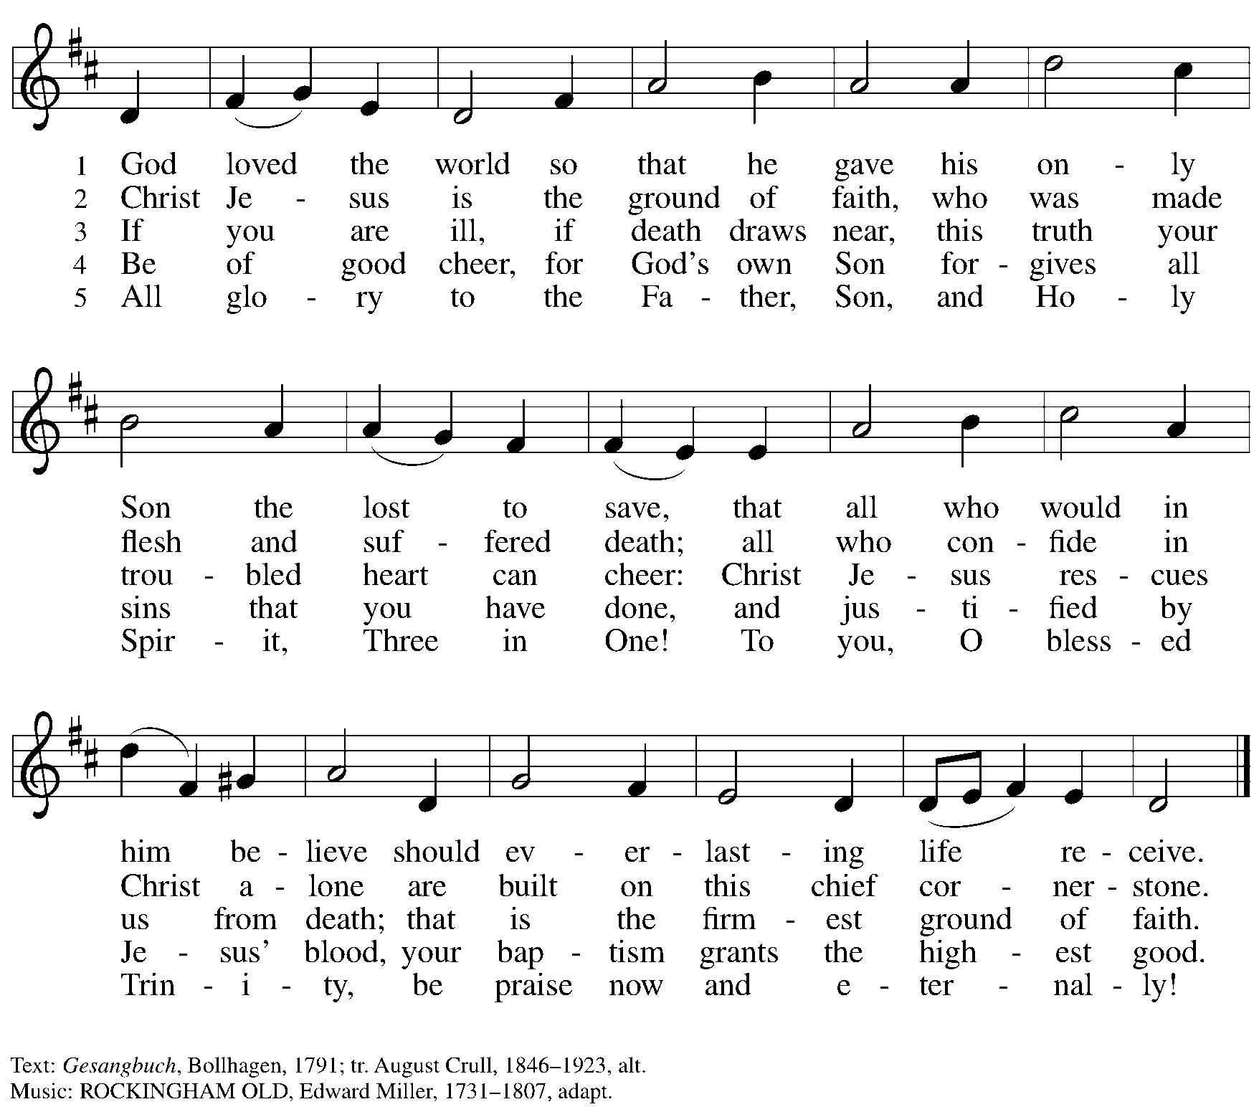

Apostles’ Creed

C: I believe in God, the Father almighty,
creator of heaven and earth.

C: I believe in Jesus Christ, God’s only Son, our Lord,
who was conceived by the Holy Spirit,
born of the virgin Mary,
suffered under Pontius Pilate,
was crucified, died, and was buried;
he descended to the dead.*
On the third day he rose again;
he ascended into heaven,
he is seated at the right hand of the Father,
and he will come to judge the living and the dead.

I believe in the Holy Spirit,
the holy catholic church,
the communion of saints,
the forgiveness of sins,
the resurrection of the body,
and the life everlasting. Amen.

*Or, “he descended into hell,” another translation of this text in widespread use.

Prayers of the People

A: Reconciled by God’s mercy and sustained by God’s presence,
let us pray for the world and its needs.

After each petition
A: Merciful God,
C: receive our prayer.

P: Receive our prayers, O God, through Jesus Christ, our strength and salvation.
C: Amen.

Peace

The presiding minister and the assembly greet one another in the peace of the risen Christ.
P: The peace of Christ be with you always.
C: And also with you.

The people may greet those around them with a sign of Christ’s peace and may say
Peace be with you or similar words. Please be mindful that not everyone will be comfortable with sharing the peace, so please seek consent before shaking hands or hugging.
Other possible ways to share the peace include a simple bow with the verbal greeting of peace, or simply a verbal expression of peace.

When the greetings of peace have concluded, please be seated.

Meal
God feeds us with the presence of Jesus Christ



Offering

We offer ourselves, our gifts, and our faithful service to God.
As the offering is gathered for the mission of the church, including the care of those in need,
the table is set for Holy Communion.

There are laminated giving cards in the pew racks that feature a QR code for anyone who would like to give online. Those who give using the QR code, as well as those who give regularly online or through their bank are encouraged to place the laminated card in the plate as an expression of your offering.

Reparations Offering

On the first Sunday of each month, St. Andrew invites people of the congregation to give a second offering for a reparations fund in acknowledgment of St. Andrew’s use of African American spiritual songs in our worship services. Please see the note in the announcements for more information.

Offertory Music Abba, Abba, Hear Us arr. Moore

As the gifts are brought forward for presentation, please rise as you are able.

Offertory Song Create in Me a Clean Heart ELW 186

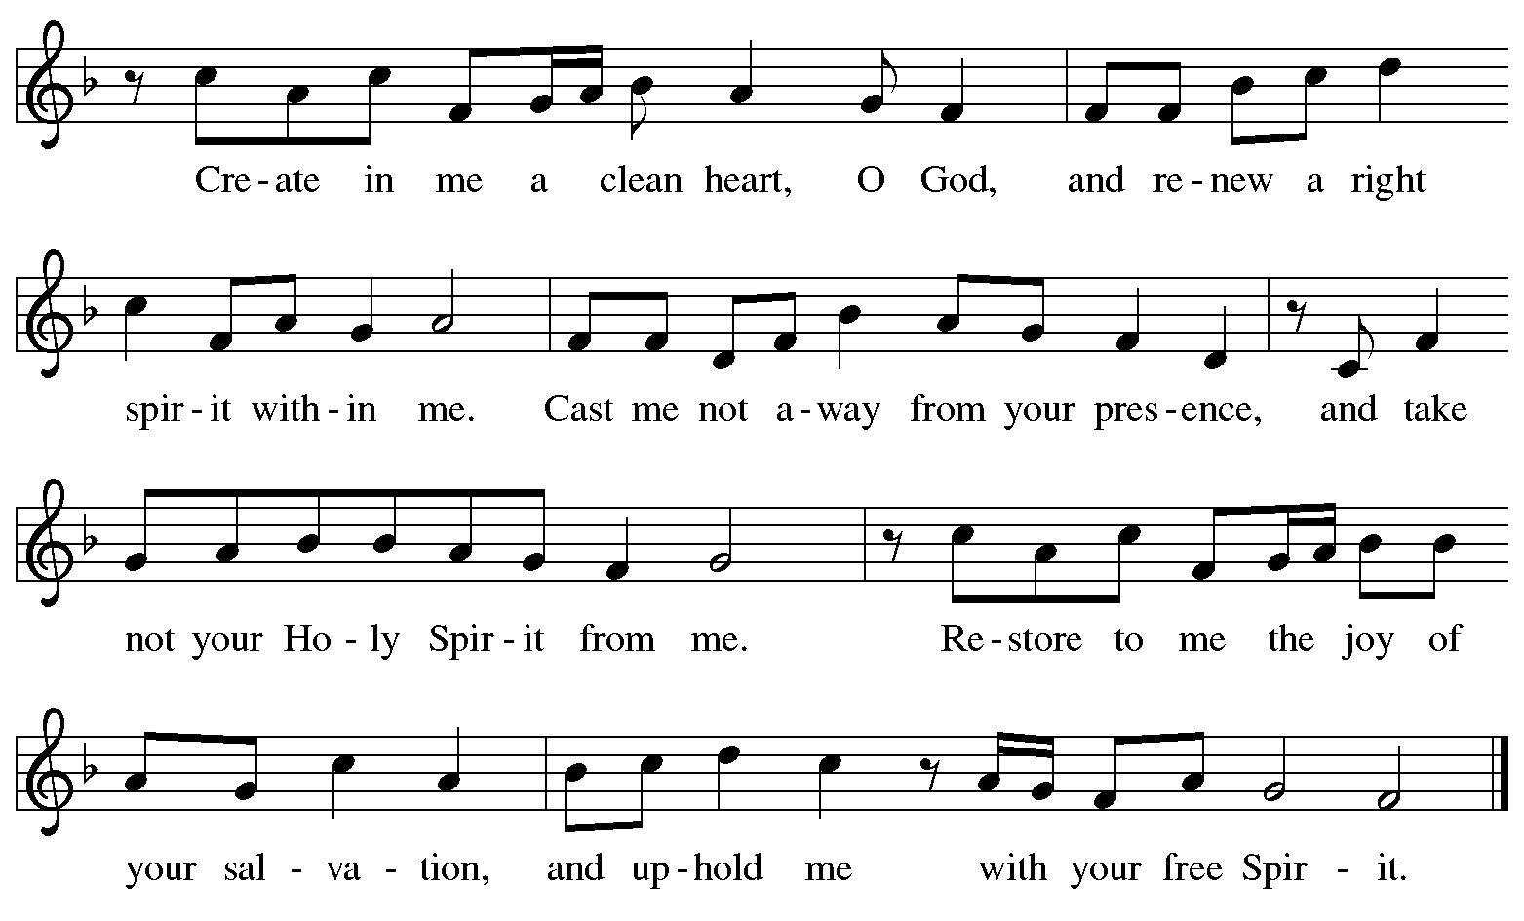
All rights reserved. Reprinted with permission under One License.net # A-722139.

Offertory Prayer

A: Let us pray.
God our provider,
C: have not fed us with bread alone, but with words of grace and life.
Bless us and these your gifts, which we receive from your bounty,
through Jesus Christ our Lord.
Amen.

Dialogue ELW p. 199

P: The Lord be with you.
C: And also with you.

P: Lift up your hearts.
C: We lift them to the Lord.

P: Let us give thanks to the Lord our God.
C: It is right to give our thanks and praise.

Preface (Spoken by the presiding minister)

P: It is indeed right, our duty and our joy,
that we should at all times and in all places
give thanks and praise to you, almighty and merciful God,
through our Savior Jesus Christ.
You call your people to cleanse their hearts
and prepare with joy for the paschal feast,
that, renewed in the gift of Baptism,
we may come to the fullness of your grace.
And so, with all the choirs of angels,
with the church on earth and the hosts of heaven,
we praise your name and join their unending hymn:

Sanctus ELW p. 200
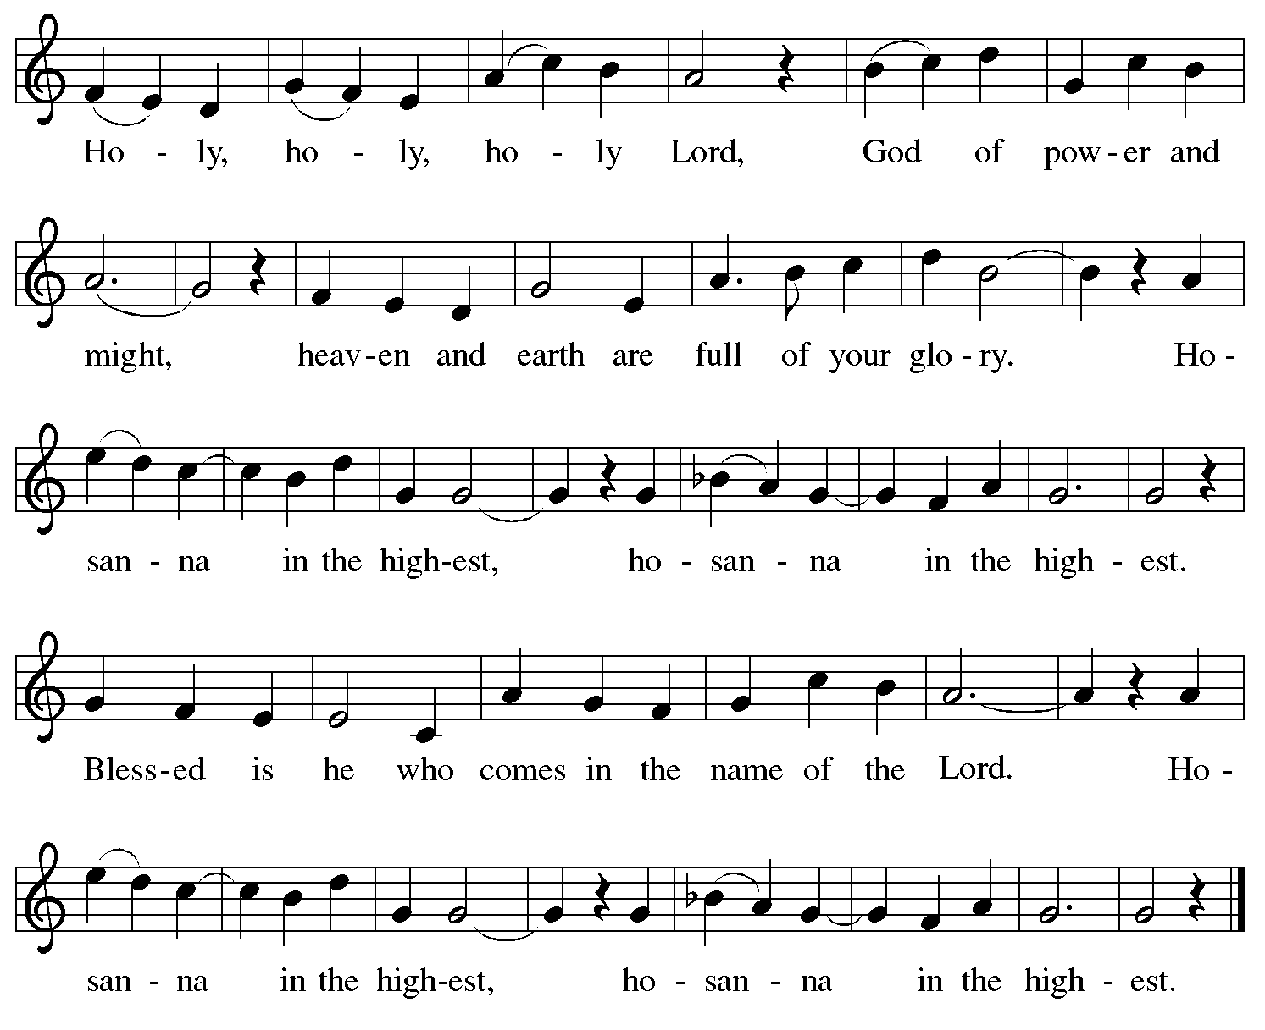
Eucharistic Prayer

P: Blessed are you, O God of the universe …
… Do this for the remembrance of me.

With this bread and cup
we remember our Lord’s passover from death to life
as we proclaim the mystery of faith:
C: Christ has died. Christ is risen. Christ will come again.

P: O God of resurrection and new life …
… Grace our table with your presence.
C: Come, Holy Spirit.

P: Reveal yourself to us in the breaking of the bread …
… Send us forth, burning with justice, peace, and love.
C: Come, Holy Spirit.

P: With your holy ones of all times and places …
… we praise you, O God, blessed and holy Trinity,
now and forever.
C: Amen.

Lord’s Prayer

P: Gathered as one by the Holy Spirit, let us pray as Jesus taught us.
C: Our Father in heaven,
hallowed be your name,
your kingdom come,
your will be done,
on earth as in heaven.
Give us today our daily bread.
Forgive us our sins
as we forgive those
who sin against us.
Save us from the time of trial
and deliver us from evil.
For the kingdom, the power,
and the glory are yours,
now and forever. Amen.

Fraction and Invitation

Agnus Dei / Lamb of God ELW p. 200

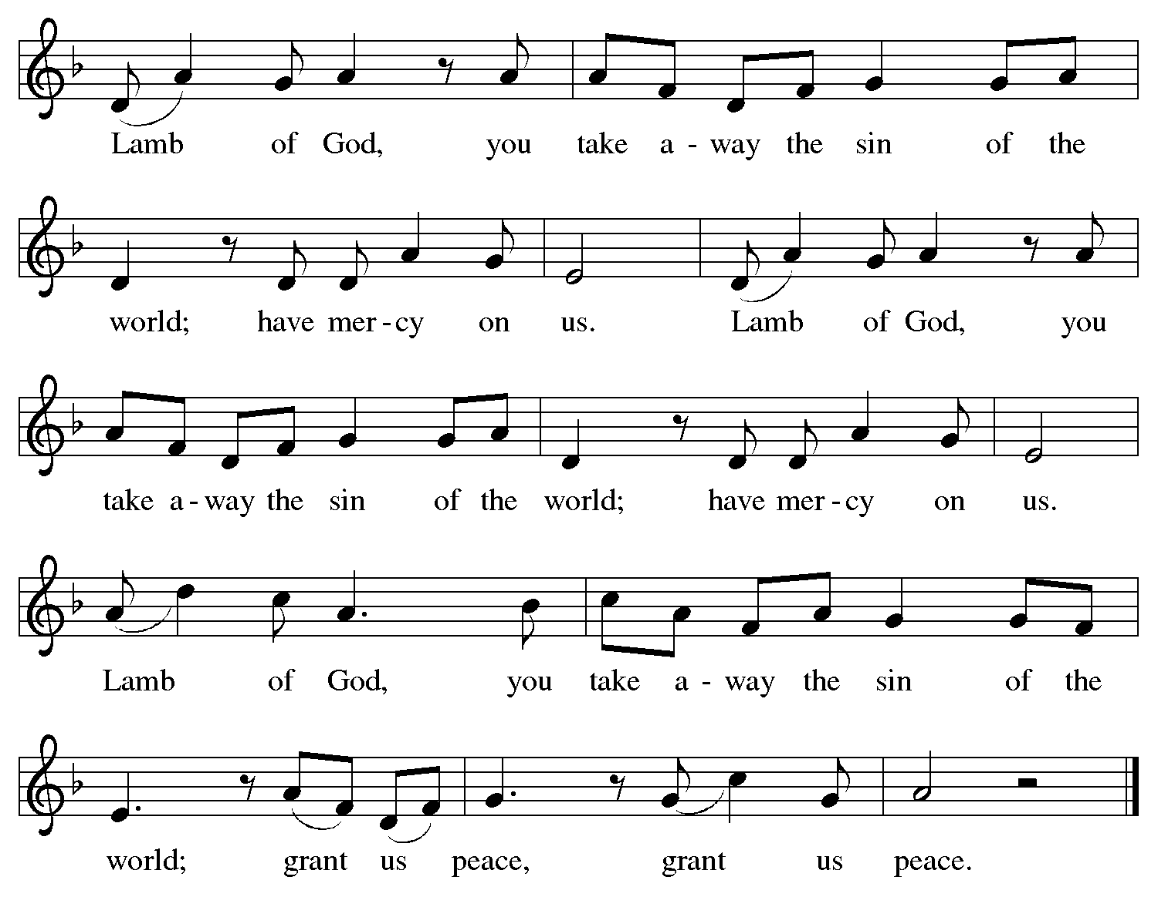

Please be seated.

Holy Communion

- All who seek God and desire a deeper and stronger life in Christ are welcome to receive Holy Communion.
- Worshipers from the pulpit side will proceed forward first, followed by the center section, and then the lectern side.
- Please inform an usher if you would like the ministers to bring Communion to you.
- Holy Communion will be served with bread and wine (amber) or grape juice (purple).
- The presiding minister will first distribute the bread (host) to each communicant. Please indicate if you require a gluten-free host.
- Once you have consumed the bread, please pick up an empty glass from the tray next to the presiding minister. The Communion Assistant will pour wine or grape juice into your glass.
- Please step to the side to consume the wine or grape juice.
- Feel free to kneel at the altar rail for prayer after receiving the sacrament.
- As you return to your pew, glasses may be returned to the empty tray on the side of the center section.
- A blessing will be provided for anyone who does not yet receive the sacrament.
- All are invited to join in singing the hymns during Holy Communion.

Hymns during Holy Communion
Mothering God, You Gave Me Birth ELW 735

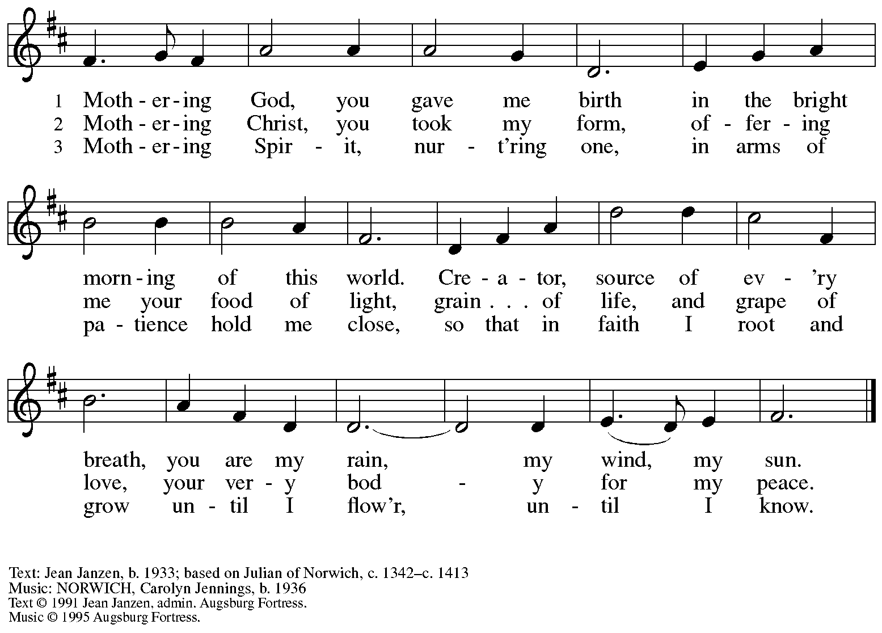
All rights reserved. Reprinted with permission under OneLicense.net # A-722319.

Hymns during Holy Communion

We Are Baptized in Christ Jesus ELW 451

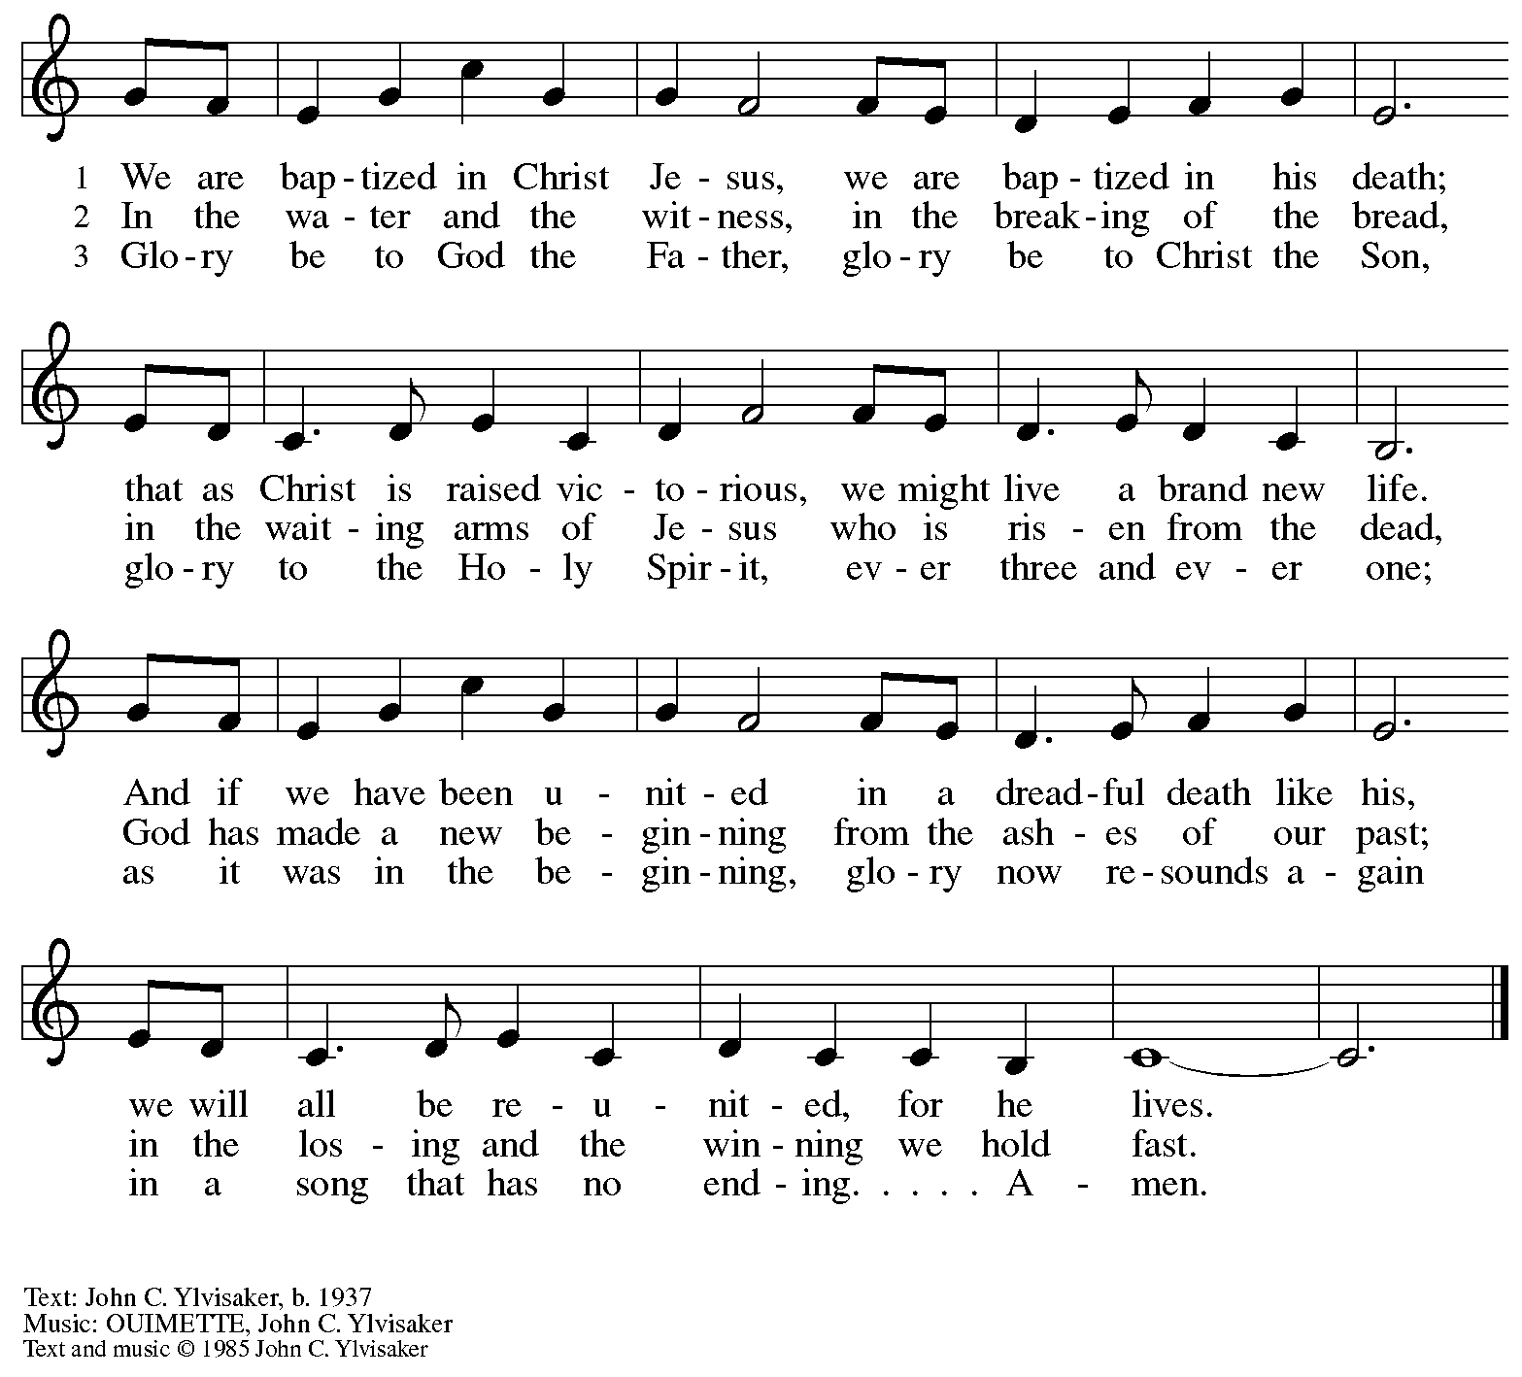
All rights reserved. Reprinted with permission under OneLicense.net # A-722139.

Hymns during Holy Communion
Bread of Life from Heaven ELW 474

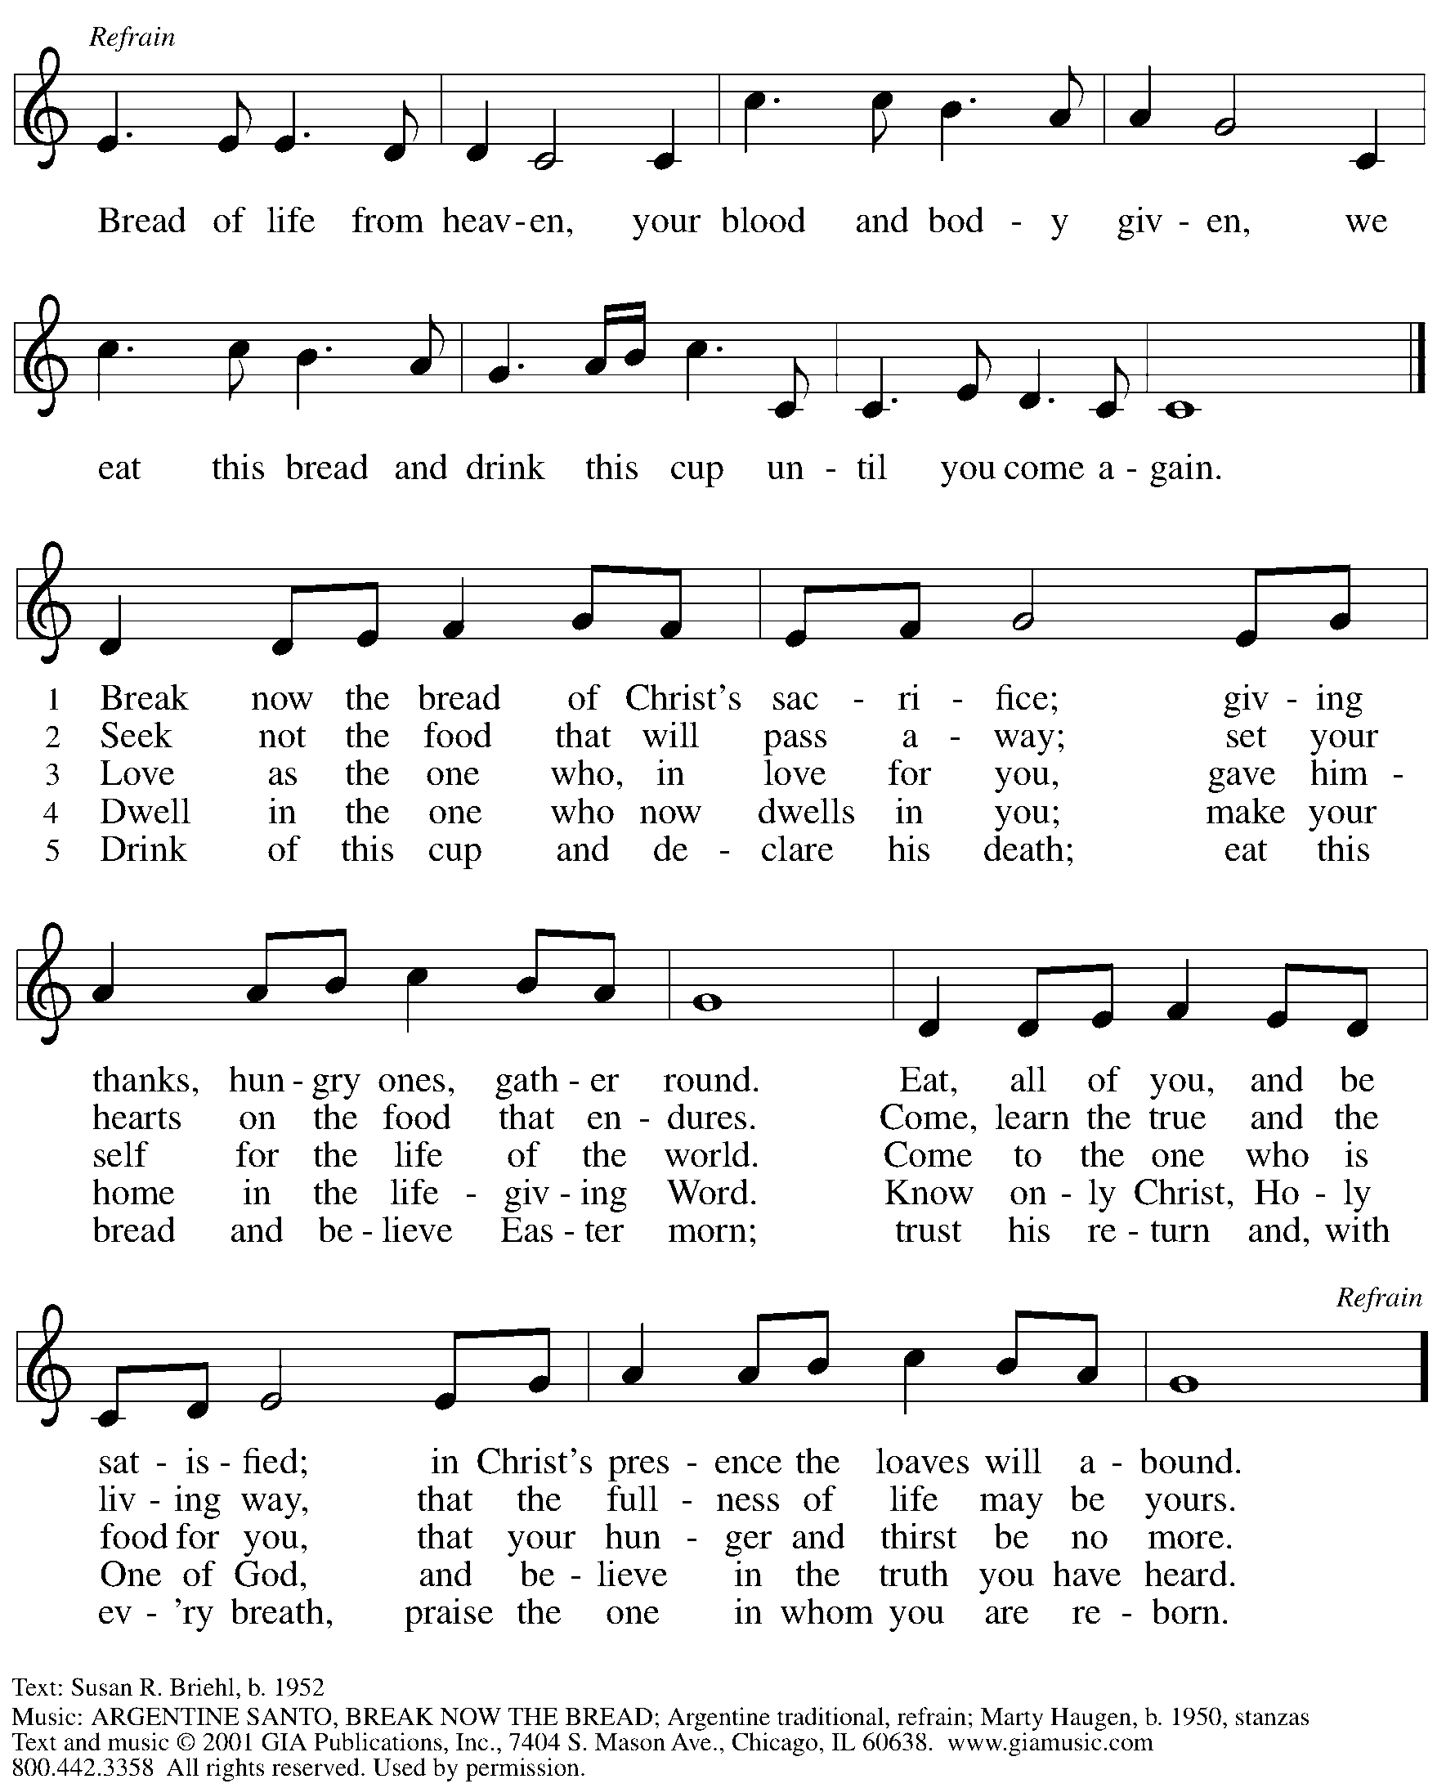
Reprinted with permission under OneLicense.net # A-722139.

Hymns during Holy Communion
What Wondrous Love Is This LBW 385

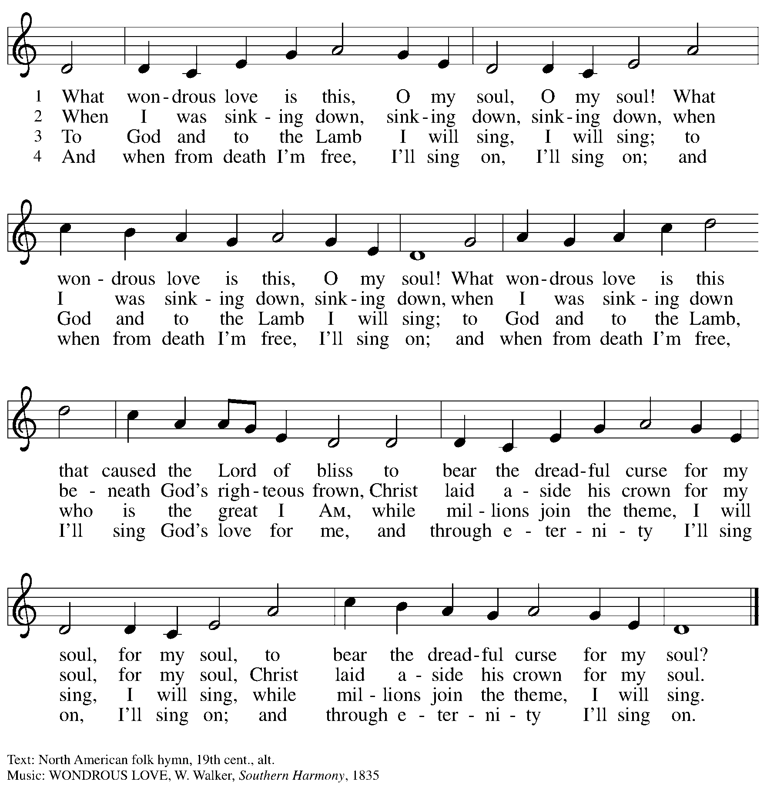

When all have returned to their places, please rise as you are able.

Blessing

P: The body and blood of our Lord Jesus Christ strengthen you and keep you in his grace.
C: Amen.

Prayer

A: Let us pray.
Compassionate God, you have fed us with the bread of heaven.
Sustain us in our Lenten pilgrimage: may our fasting be hunger for justice;
our alms, a making of peace; and our prayer, the song of grateful hearts, through Jesus Christ, our Savior and Lord.
C: Amen.

Please be seated.

Sending
God blesses us and sends us in mission to the world

Announcements

Please rise as you are able.

Benediction

P: Receive the blessing of the holy Trinity:
God, who calls all things into existence,
Jesus Christ, who redeems us,
and the Holy Spirit, whose breath sustains creation,
☩ bless you and keep you, now and forever.
C: Amen.

Sending Hymn Following page

Dismissal

A: Go in peace. Love and serve your neighbor.
C: Thanks be to God

Postlude

Sending Hymn Baptized and Set Free ELW 453

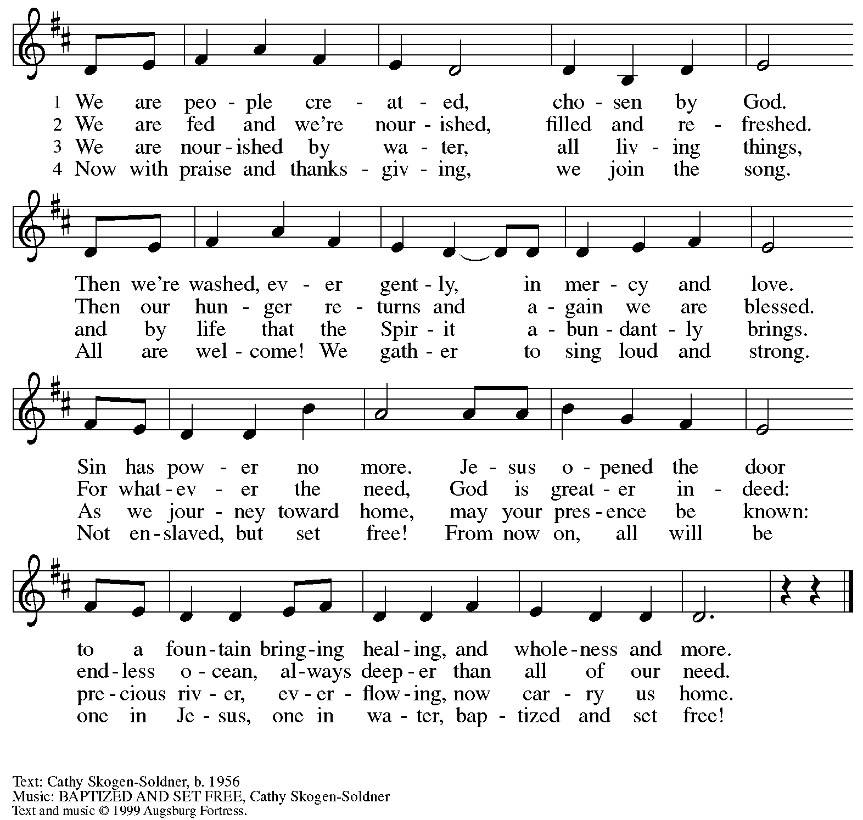
All rights reserved. Reprinted with permission under OneLicense.net # A-722139.

Serving in Worship Today

Altar Care Christy Ruhe
Assisting Minister Colleen Cooke
AV Ministers Tim Jones
Joseph Paetz
Cantor Richard Krug
Lector Michael Chapman
Minister of Music Laura Reynolds
Presiding Minister The Rev. Ross Carmichael

Liturgy and Hymnody Acknowledgements

From SundaysandSeasons.com. Copyright © 2026 Augsburg Fortress. All rights reserved. Reprinted under OneLicense.net # A-722139.
Used by permission of Augsburg Fortress.

The Scripture readings contained herein are from New Revised Standard Version Updated Edition of the Bible © 2021 National Council of Churches of Christ in the United States of America. Used by permission. All rights reserved worldwide.

Please use the QR code below to link to St. Andrew’s Announcements online!



St. Andrew Lutheran Church Announcements
March 1st, 2026

- Welcome to Worship at St. Andrew on the Second Sunday in Lent – We are thankful you are here, and we offer a special welcome to all visitors and guests who are here for the first time! A nursery is available through the door to the left of the worship space and across the social hall (look for a purple room). There are also worship “toolkits” to help children engage with worship and “busy bags” for younger children available in the bookcase at the back of the sanctuary. Please feel free to take one to use with/for your children. All are invited to stay for coffee and other drinks, food, and conversation in the social hall (through the side door at the left of the worship space) after the service.
- Monthly Reparations Offering Today, March 1st, during Worship – In Luke’s Gospel, Jesus tells a story about a compassionate Samaritan, suggesting that God’s people are called to work for healing and restoration for our neighbors, regardless of who or what caused them harm. In light of this, St. Andrew has made a commitment to reparations in regard to African American spiritual songs used in our worship. The text and music of most hymns is attributed to specific authors, with copyrights in place, usage reported, and royalties paid to those whose works are featured in worship. With African American spirituals, this is not possible. In response to many years of such uncredited use, St. Andrew invites the congregation to give a reparations offering. Funds received in worship will be donated to our siblings at Bethel AME Church, whose land and building were taken from them in the 1950s, to fund their development in the Hill District.
- Congregational Meeting Today, March 1st, after Worship – St. Andrew will meet as a congregation after worship today. This is our annual opportunity to receive reports from leadership, including the year-end financial reports from the previous year. We will also update the congregation on the progress of the building project and the capital campaign. Thank you for your continuing support and for your contributions to the ministry of St. Andrew in 2025 (and now 2026)!
- Growing in Faith Together Will Not Meet Today, March 1st, Due to the Congregational Meeting – The group will resume meeting next Sunday, March 8th.
- Produce Distribution Supplemental Food of the Month – St. Andrew is collecting supplemental food each month to accompany our produce distribution. For March, we ask for donations of rice. There are collection boxes at the back of the worship space and social hall.
- Produce Distribution, First and Third Tuesday Each Month, March 3rd and 17th from 5:30-6:30 p.m. – St. Andrew partners with Greater Pittsburgh Community Food Bank to serve as a distribution site for fresh produce on the first and third Tuesday of every month. We invite people of the congregation to help with the distribution from 5:30 p.m. – 6:30 p.m. and/or to help with unloading and setup during the day between 10:00 a.m. and 1:00 p.m.
- Bible Book Club, Wednesday, March 4th at 7:00 p.m. – Bible Book Club will meet weekly on Wednesdays at 7:00 p.m. All are welcome to participate. The group will be reading the Gospel of Mark along with The Gospel of Mark: A Beginner’s Guide to the Good News by Dr. Amy-Jill Levine. Here are the details on the book from one site: (https://www.cokesbury.com/The-Gospel-of-Mark-6?select=862810). You can join the Zoom call by going to: https://us02web.zoom.us/j/83196175976?pwd=ejdPOUYrTk4xVFdsdlhHUVJ1L3k2Zz09.
- Lenten Blessing and Resources – As ReconcilingWorks continues to strive to support you and your faith community in deepening and expanding the welcome, inclusion, and celebration of people of all sexual orientations, gender identities, and gender expressions, and commit to racial equity/anti-racism, they have shared this brand-new free Lenten devotional "of Justice, Liberation, and Flourishing." Lent draws us into a holy tension between humility and public faithfulness; Lent sharpens our moral attention. You can access the devotional here: https://www.reconcilingworks.org/wp-content/uploads/2026/02/Lenten-Devotional-from-ReconcilingWorks.pdf
- “Christ in Our Home” Booklets Available – “Christ in Our Home” is a quarterly devotional resource that encourages readers to live out their faith daily. Each reflective reading is accompanied by a daily scripture reference and prayer for the day. The January-March booklets are available at the entrances. Please feel free to take one home!
- Coffee Hour Signups – St. Andrew provides hospitality during a coffee hour after worship each Sunday. If you would like to participate and would like information about the duties of setting up, please sign up using the following form: https://www.signupgenius.com/go/5080B4AAFAF2CABF85-47069030-coffee#/.

Flowers for Easter

St. Andrew will be ordering Lilies (6 inch, five bloom - $8.25 each)
Tulips (8 inch - $9.00 each))
Daffodils (6 inch - $5.50 each)
to decorate the worship space for Easter Sunday, April 5th,
and the Easter season.
If you would like to sponsor or dedicate flowers, please complete this form
and submit it at the desk in the main office or through the Sunday offering plates.
Please submit payment with order - Checks may be made payable to:
St. Andrew Lutheran Church
Order by Sunday, March 29th.

Name __________________________________________
In Honor of __________________________________________
In Memory of __________________________________________
In Appreciation/Love for __________________________________________

Number of Lilies ________
Number of Tulips ________
Number of Daffodils ________

