

+ Transfiguration of our Lord
February 15, 2026



St. Andrew Lutheran Church
304 Morewood Ave.
Pittsburgh, PA 15213
St_andrewELCA@verizon.net
www.standrewpittsburgh.org

+ Transfiguration of our Lord
Order for Worship

Today’s festival is a bridge between the Advent-Christmas-Epiphany cycle that comes to a close today and the Lent-Easter cycle that begins in several days. On a high mountain Jesus is revealed as God’s beloved Son, echoing the words at his baptism. This vision of glory sustains us as Jesus faces his impending death in Jerusalem. We turn this week to Ash Wednesday and our yearly baptismal journey from Lent to Easter. Some churches put aside the alleluia at the conclusion of today’s liturgy. This word of joy will be omitted during the penitential season of Lent and will be sung again at Easter.

Welcome to St. Andrew!
- St. Andrew welcomes all who are seeking a place of healing, wholeness, and acceptance in a nurturing and faith-forming spiritual home. We are striving toward racial equity worldwide
and we seek to honor the lived experience of all individuals regardless of background. Our community embraces people of all ages, ethnicities, cultures, abilities, sexual orientations,
gender identities and expressions, and family constellations. Come and See!
- Worship Services are live-streamed to multiple online platforms. By attending worship, you agree that your image and voice may be broadcast.
- Everyone is invited to make a name tag at the black bookcase in the back of the worship space if they would like. There are stickers indicating pronouns on the bookcase if you would like to include them on your name tag.
- A nursery is available through the doors at the left side of the sanctuary and across from the doorway to the Social Hall. Look for a purple-colored room.
- Children are invited to attend Little Church – Big Faith, a Bible lesson and activity, during worship (after the Prayer of the Day). The group returns to the worship space for the liturgy of Holy Communion.
- Worship “toolkits” to help children engage with the service, along with “busy bags” for younger children, are available in the bookcase at the back of the sanctuary. Please feel free to take one to use with/for your children.
- Holy Communion is served with bread (gluten-free available) and wine or grape juice. The presiding minister will distribute the bread (host). Please consume this and then pick up an empty glass from the tray. The Communion Assistant will pour wine or grape juice into your glass. Please step to the side to consume the wine or grape juice. Feel free to kneel at the altar for prayer and reflection. As you return to your pew, glasses may be returned to the empty trays on either side of the center section.
- A restroom is available on the main level of the church, through the doors to the Social Hall and to the right in the main office.

Abbreviations
P: Pastor/Presiding Minister ELW: Evangelical Lutheran Worship hymnal
A: Assisting Minister ACS: All Creation Sings hymnal
L: Lector
C: Congregation

Musical Offering

Each week, different people from the congregation make an offering of pre-service music, with singing or instrumentation, to help the assembly focus and pray in preparation for worship.

Welcome

Prelude

Gathering
The Holy Spirit calls us together as the people of God

Please rise as you are able. All may make the sign of the cross,
the sign that is marked at Baptism, as the presiding minister begins.

Thanksgiving for Baptism

P: Blessed be the holy Trinity, ☩ one God,
the fountain of living water, the rock who gave us birth,
our light and our salvation.
C: Amen.

P: Joined to Christ in the waters of Baptism, we are clothed with God’s mercy and forgiveness.
Let us give thanks for the gift of Baptism.

Water is poured into the font, and the presiding minister begins the thanksgiving.

P: We give you thanks, O God,
for in the beginning you created us in your image and placed us in a well-watered garden.
In the desert, you promised pools of water for the parched, and you gave us water from the rock. When we did not know the way, you sent the Good Shepherd to lead us to still waters.
At the cross, you washed us from Jesus’ wounded side, and on this day,
you shower us again with the water of life.

We praise you for your salvation through water, for the water in this font,
for the waters of the Allegheny, Monongahela, and Ohio rivers,
and for all water everywhere.

Bathe us in your forgiveness, grace, and love.
Satisfy all who thirst, and give us the life only you can give.

To you be given honor and praise through Jesus Christ, our living water,
in the unity of the Holy Spirit, now and forever.
C: Amen.

Gathering Hymn How Good, Lord, to Be Here! ELW 315

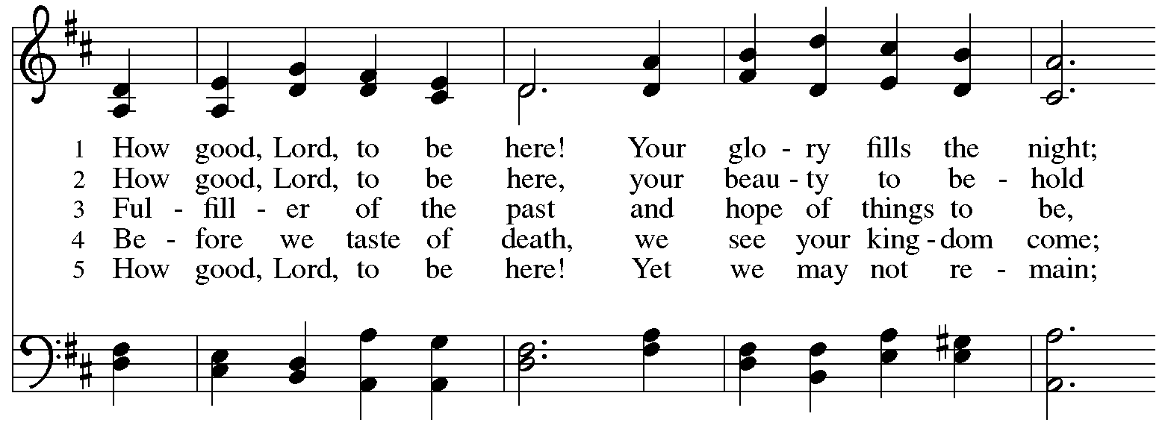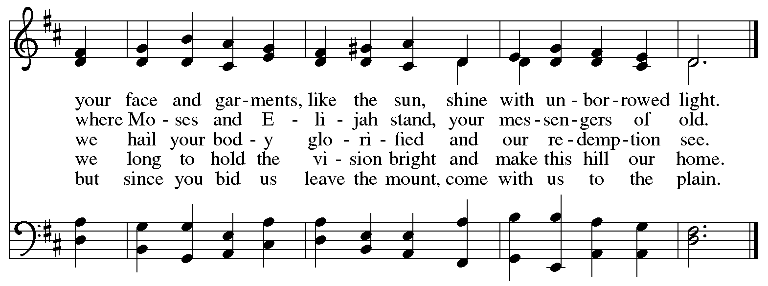

Greeting

P: The grace of our Lord Jesus Christ, the love of God,
and the communion of the Holy Spirit be with you all.
C: And also with you.

Kyrie ACS p. 31

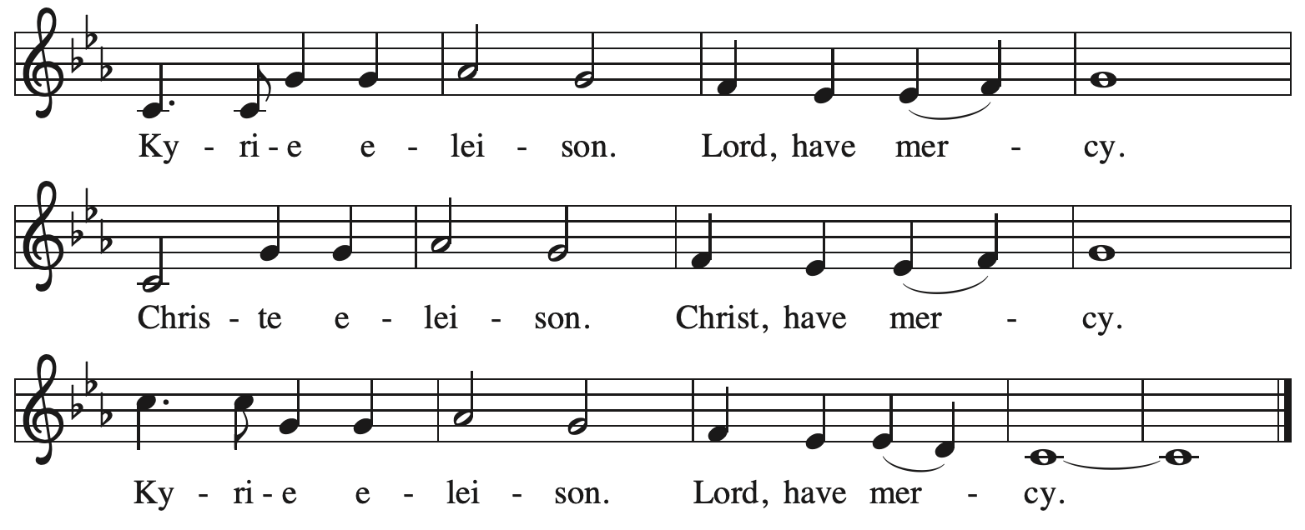

Hymn of Praise ACS p. 31
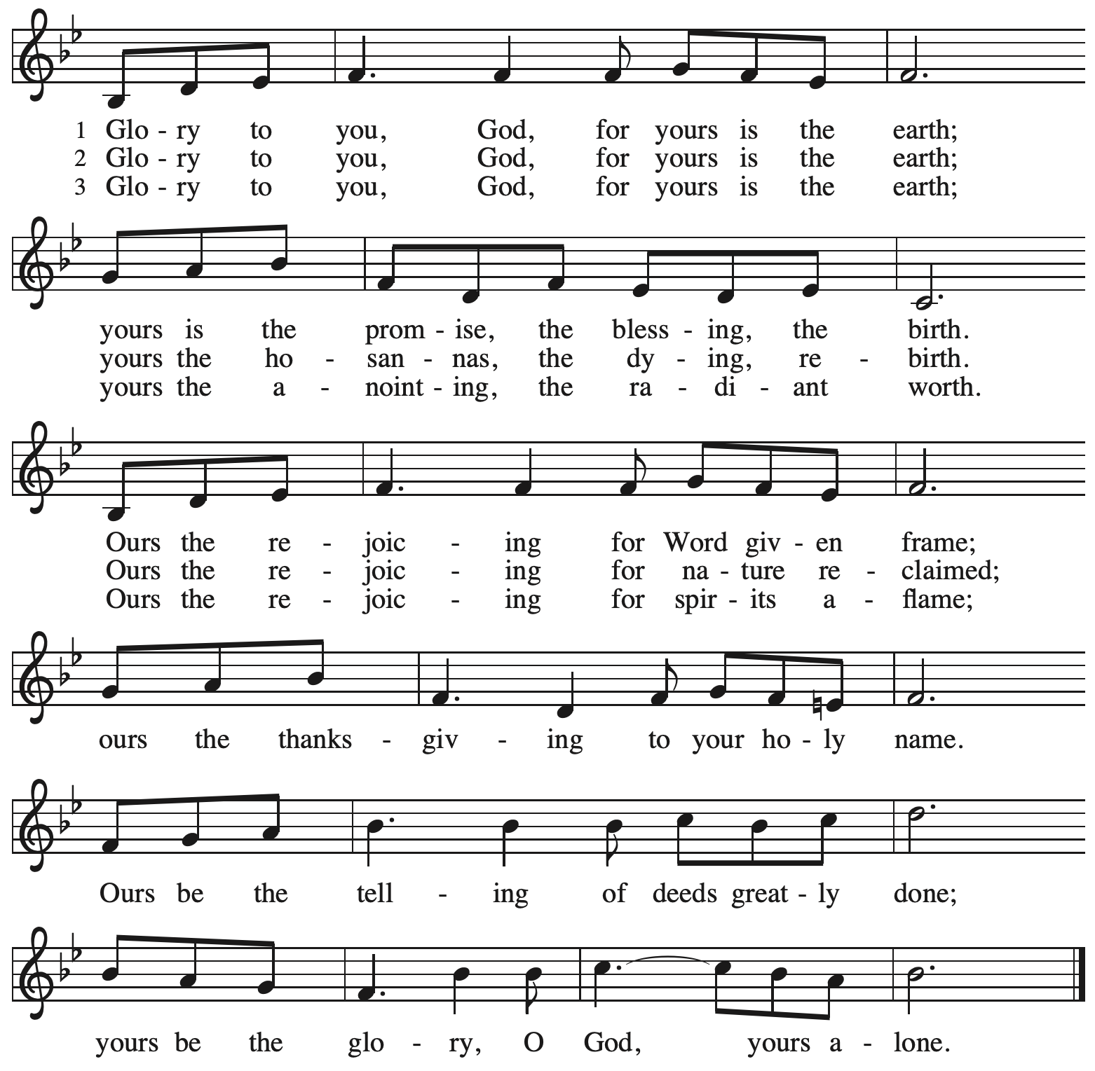
Prayer of the Day

P: The Lord be with you.
C: And also with you.

P: O God, in the transfiguration of your Son you confirmed the mysteries of the faith
by the witness of Moses and Elijah, and in the voice from the bright cloud
declaring Jesus your beloved Son, you foreshadowed our adoption as your children.
Make us heirs with Christ of your glory, and bring us to enjoy its fullness, through Jesus Christ, our Savior and Lord, who lives and reigns with you and the Holy Spirit,
one God, now and forever.
C: Amen.

Please be seated.
Children are invited to join the adult leader(s) at the side door for Little Church – Big Faith.
We ask that an additional adult from the congregation attend with the children.

Word
God speaks to us in Scripture reading, preaching, and song

First Reading – Exodus 24: 12-18

¹² The Lord said to Moses, “Come up to me on the mountain and wait there; I will give you the tablets of stone, with the law and the commandment, which I have written for their instruction.”
¹³ So Moses set out with his assistant Joshua, and Moses went up onto the mountain of God.
¹⁴ To the elders he had said, “Wait here for us, until we come back to you. Look, Aaron and Hur are with you; whoever has a dispute may go to them.”
¹⁵ Then Moses went up on the mountain, and the cloud covered the mountain. ¹⁶ The glory of the Lord settled on Mount Sinai, and the cloud covered it for six days; on the seventh day the Lord called to Moses out of the cloud. ¹⁷ Now the appearance of the glory of the Lord was like a devouring fire on the top of the mountain in the sight of the Israelites. ¹⁸ Moses entered the cloud and went up on the mountain. Moses was on the mountain for forty days and forty nights.

L: Word of God, word of life.
C: Thanks be to God.

Psalm 2

The psalm will be sung responsively, led by the cantor, with the congregation singing the verses in bold type and joining in the refrain.

Psalm Tone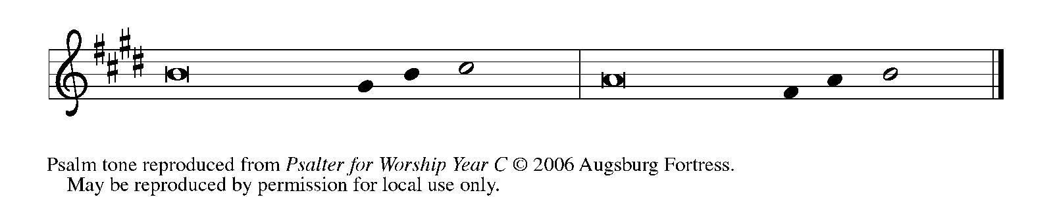

Psalm Refrain

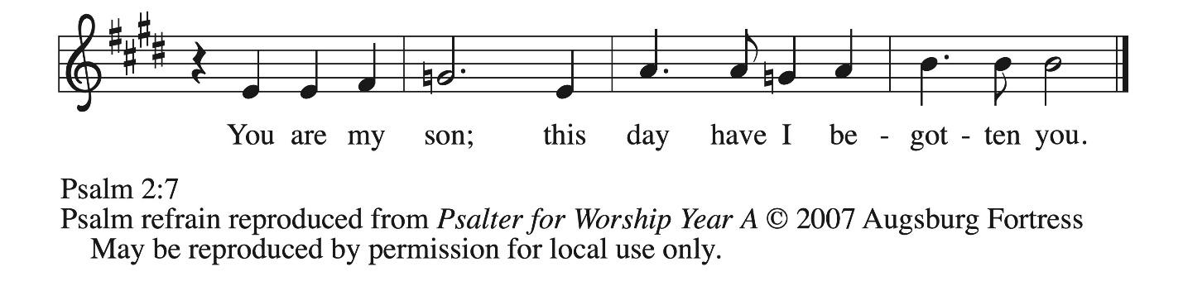

¹ Why are the nations | in an uproar?
Why do the peoples mutter | empty threats?
² Why do the kings of the earth rise up in revolt, and the princes | plot together,
against the Lord and against the | Lord’s anointed?
³ “Let us break their | yoke,” they say;
“let us cast off their | bonds from us.”
⁴ God whose throne is in heav- | en is laughing;
the Lord holds them | in derision. R
⁵ Then in wrath God | speaks to them,
and in rage fills | them with terror.
⁶ “As for me, I have anoint- | ed my king
upon Zion, my | holy mountain.”
⁷ Let me announce the decree | of the Lord,
who said to me, “You are my son; this day have I be- | gotten you.
⁸ Ask of me, and I will give you the nations for | your inheritance
and the ends of the earth for | your possession. R
⁹ You shall crush them with an | iron rod
and shatter them like a | piece of pottery.”
¹⁰ And now, you | kings, be wise;
be warned, you rulers | of the earth.
¹¹ Submit to the | Lord with fear,
and with trembling | bow in worship;
¹² lest the Lord be angry, and you perish in a sudden | blaze of wrath.
Happy are all who take ref- | uge in God! R

Second Reading – 2 Peter 1: 16-21

¹⁶ We did not follow cleverly devised myths when we made known to you the power and coming of our Lord Jesus Christ, but we had been eyewitnesses of his majesty. ¹⁷ For he received honor and glory from God the Father when that voice was conveyed to him by the Majestic Glory, saying, “This is my Son, my Beloved, with whom I am well pleased.” ¹⁸ We ourselves heard this voice come from heaven, while we were with him on the holy mountain.
¹⁹ So we have the prophetic message more fully confirmed. You will do well to be attentive to this as to a lamp shining in a dark place, until the day dawns and the morning star rises in your hearts. ²⁰ First of all you must understand this, that no prophecy of scripture is a matter of one’s own interpretation, ²¹ because no prophecy ever came by human will, but people moved by the Holy Spirit spoke from God.

L: Word of God, word of life.
C: Thanks be to God.

Please rise as you are able.

Gospel Acclamation ACS p. 33

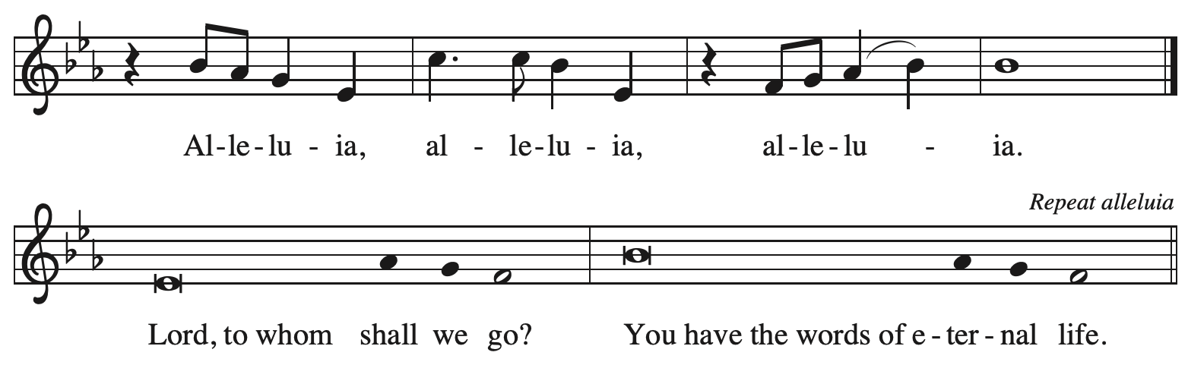

Gospel – Matthew 17: 1-9

P: The holy Gospel according to St. Matthew.
C: Glory to you, O Lord.

¹ Six days later, Jesus took with him Peter and James and his brother John and led them up a high mountain, by themselves. ² And he was transfigured before them, and his face shone like the sun, and his clothes became bright as light. ³ Suddenly there appeared to them Moses and Elijah, talking with him. ⁴ Then Peter said to Jesus, “Lord, it is good for us to be here; if you wish, I will set up three tents here, one for you, one for Moses, and one for Elijah.” ⁵ While he was still speaking, suddenly a bright cloud overshadowed them, and a voice from the cloud said, “This is my Son, the Beloved; with him I am well pleased; listen to him!” ⁶ When the disciples heard this, they fell to the ground and were overcome by fear. ⁷ But Jesus came and touched them, saying,
“Get up and do not be afraid.” ⁸ And when they raised their eyes, they saw no one except Jesus himself alone.
⁹ As they were coming down the mountain, Jesus ordered them, “Tell no one about the vision until after the Son of Humanity has been raised from the dead.”

P: The Gospel of the Lord.
C: Praise to you, O Christ.

Please be seated.

Sermon

A time of silence for prayer and reflection follows the sermon.
When the hymn of the day begins, please rise as you are able.

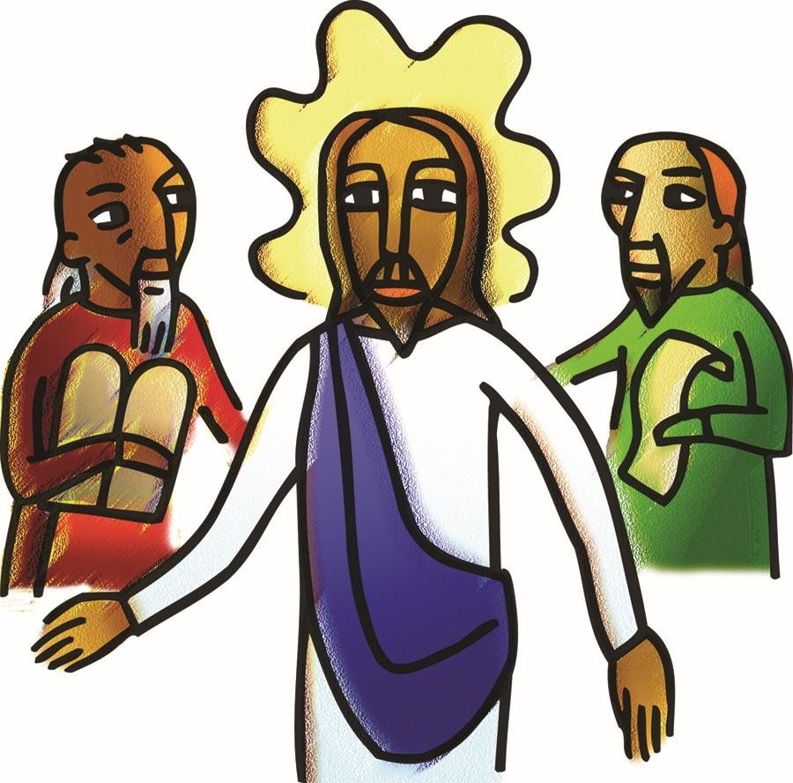

Hymn of the Day Jesus on the Mountain Peak ELW 317

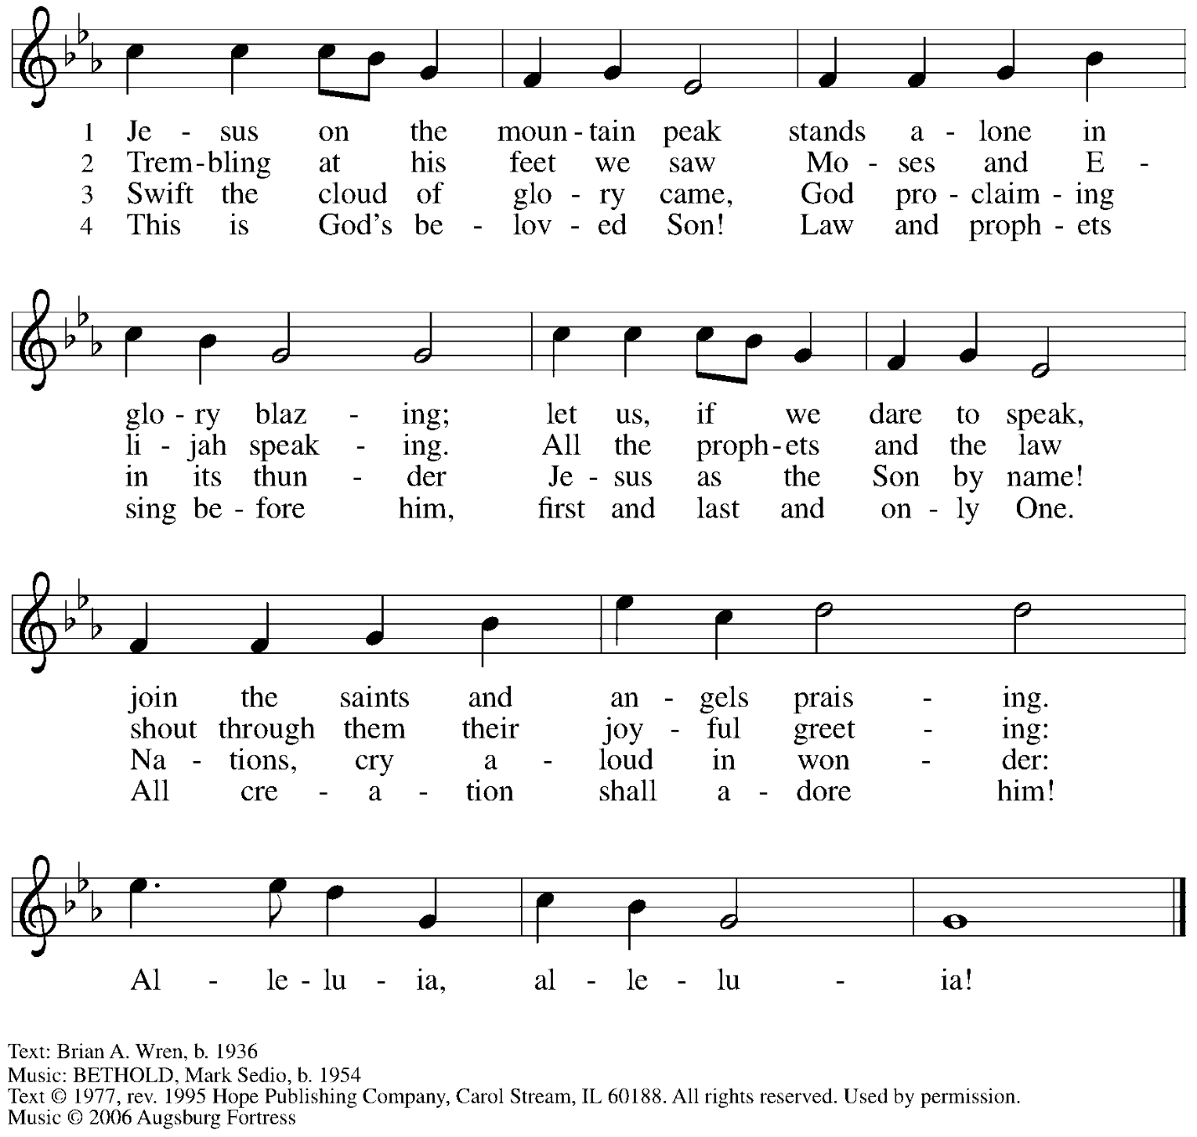
All rights reserved. Reprinted with permission under OneLicense.net # A-722139.

Nicene Creed

C: We believe in one God,
the Father, the Almighty,
maker of heaven and earth,
of all that is, seen and unseen.

We believe in one Lord, Jesus Christ,
the only Son of God,
eternally begotten of the Father,
God from God, Light from Light,
true God from true God,
begotten, not made,
of one Being with the Father;
through him all things were made.
For us and for our salvation
he came down from heaven,
was incarnate of the Holy Spirit and the virgin Mary
and became truly human.
For our sake he was crucified under Pontius Pilate;
he suffered death and was buried.
On the third day he rose again
in accordance with the scriptures;
he ascended into heaven
and is seated at the right hand of the Father.
He will come again in glory to judge the living and the dead,
and his kingdom will have no end.

We believe in the Holy Spirit, the Lord, the giver of life,
who proceeds from the Father and the Son,*
who with the Father and the Son is worshiped and glorified,
who has spoken through the prophets.
We believe in one holy catholic and apostolic church.
We acknowledge one baptism for the forgiveness of sins.
We look for the resurrection of the dead,
and the life of the world to come. Amen.

*Or, “who proceeds from the Father.” The phrase “and the Son” is a later addition to the creed.

Prayers of the People

A: As God’s beloved children united in Christ, let us pray for the church,
the world, and the whole human community.

After each petition
A: Merciful God,
C: receive our prayer.

The presiding minister concludes the prayers
P: Confident that the Holy Spirit receives our prayers and answers us,
we commend all for whom we pray to your lovingkindness, O God,
revealed to us through Jesus Christ our Savior.
C: Amen.

Peace

The presiding minister and the assembly greet one another in the peace of the risen Christ.
P: The peace of Christ be with you always.
C: And also with you.

The people may greet those around them with a sign of Christ’s peace and may say
Peace be with you or similar words. Please be mindful that not everyone will be comfortable with sharing the peace, so please seek consent before shaking hands or hugging.
Other possible ways to share the peace include a simple bow with the verbal greeting of peace, or simply a verbal expression of peace.

When the greetings of peace have concluded, please be seated.

Meal
God feeds us with the presence of Jesus Christ

Offering

We offer ourselves, our gifts, and our faithful service to God.
As the offering is gathered for the mission of the church, including the care of those in need,
the table is set for Holy Communion.

There are laminated giving cards in the pew racks that feature a QR code for anyone who would like to give online. Those who give using the QR code, as well as those who give regularly online or through their bank are encouraged to place the laminated card in the plate as an expression of your offering.

Noisy Offering

St. Andrew’s children lead the congregation in a special offering. As they carry buckets around the sanctuary, people of the congregation are invited to throw in their change as an offering. This month’s Noisy Offering will support Casa San Jose in their mission to connect, support and advocate with and for the Latino community of greater Pittsburgh.

Offertory Music

As the gifts are brought forward for presentation, please rise as you are able.

Offertory Song God of the Fertile Fields ACS 1063
v. 1, 3

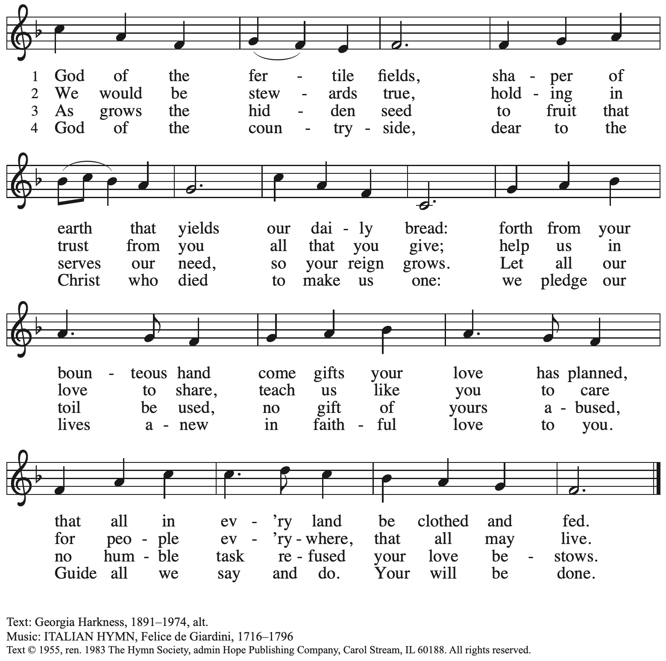
Reprinted with permission under One License.net # A-722139.

Offertory Prayer

A: Let us pray.
God of goodness and growth,
C: all creation is yours, and your faithfulness is sure.
Word and water, wine and bread: these are signs of your abundant grace.

Receive the gifts we bring, and nourish us to proclaim your abiding love
in our communities and in the world,
through Jesus Christ, our strength and our song.
Amen.

Dialogue

P: The Lord be with you.
C: And also with you.

P: Lift up your hearts.
C: We lift them to the Lord.

P: Let us give thanks to the Lord our God.
C: It is right to give our thanks and praise.

Preface (Spoken by the presiding minister)

P: It is indeed right, our duty and our joy,
that we should at all times and in all places
give thanks and praise to you, almighty and merciful God,
through our Savior Jesus Christ;
who, sharing our life,
lived among us to reveal your glory and love,
that our darkness should give way to your own brilliant light.
And so, with all the choirs of angels,
with the church on earth and the hosts of heaven,
we praise your name and join their unending hymn:

Sanctus ACS p. 36

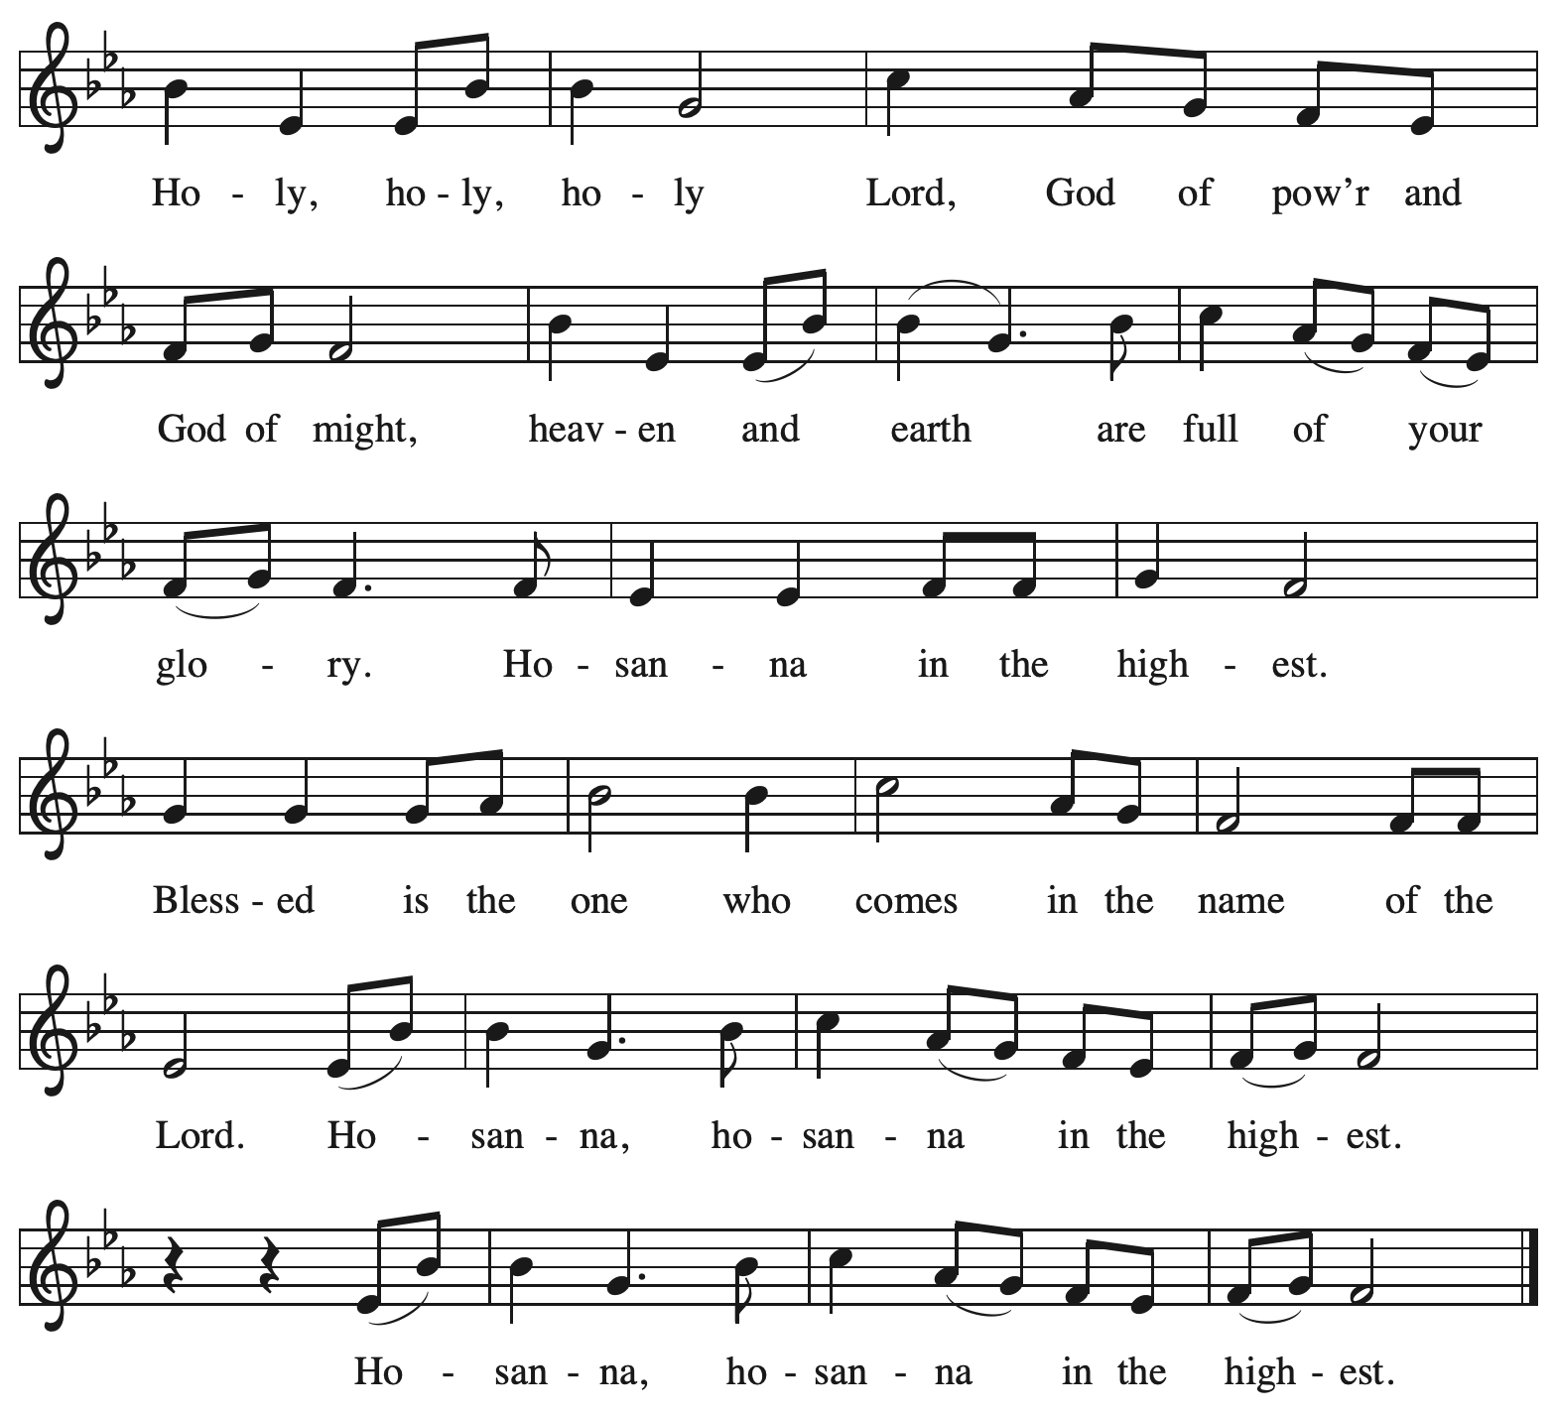

Eucharistic Prayer

P: Holy God, mighty and merciful, your peoples praise you, saying:
Your mercy endures forever.
C: Your mercy endures forever.

P: By your promise …
… the colors of your love and faithfulness.
Your mercy endures forever.
C: Your mercy endures forever.

P: By your promise …
… and calling them to be a light to the nations.
Your mercy endures forever.
C: Your mercy endures forever.

P: By your promise …
… Do this for the remembrance of me.

With this bread and cup
we remember his life laid down and lifted up
as we proclaim the mystery of faith:
C: Christ has died. Christ is risen. Christ will come again.

P: Send your Holy Spirit upon us …
… in your Spirit, now and forever.
C: Amen.

Lord’s Prayer

P: Gathered as one by the Holy Spirit, let us pray using the words our Savior taught us.
C: Our Father in heaven,
hallowed be your name,
your kingdom come,
your will be done,
on earth as in heaven.
Give us today our daily bread.
Forgive us our sins
as we forgive those
who sin against us.
Save us from the time of trial
and deliver us from evil.
For the kingdom, the power,
and the glory are yours,
now and forever. Amen.

Fraction and Invitation

P: Here is the Lamb of God who takes away the sin of the world.
Come to the table, taste and see.

Agnus Dei / Lamb of God ACS p. 40

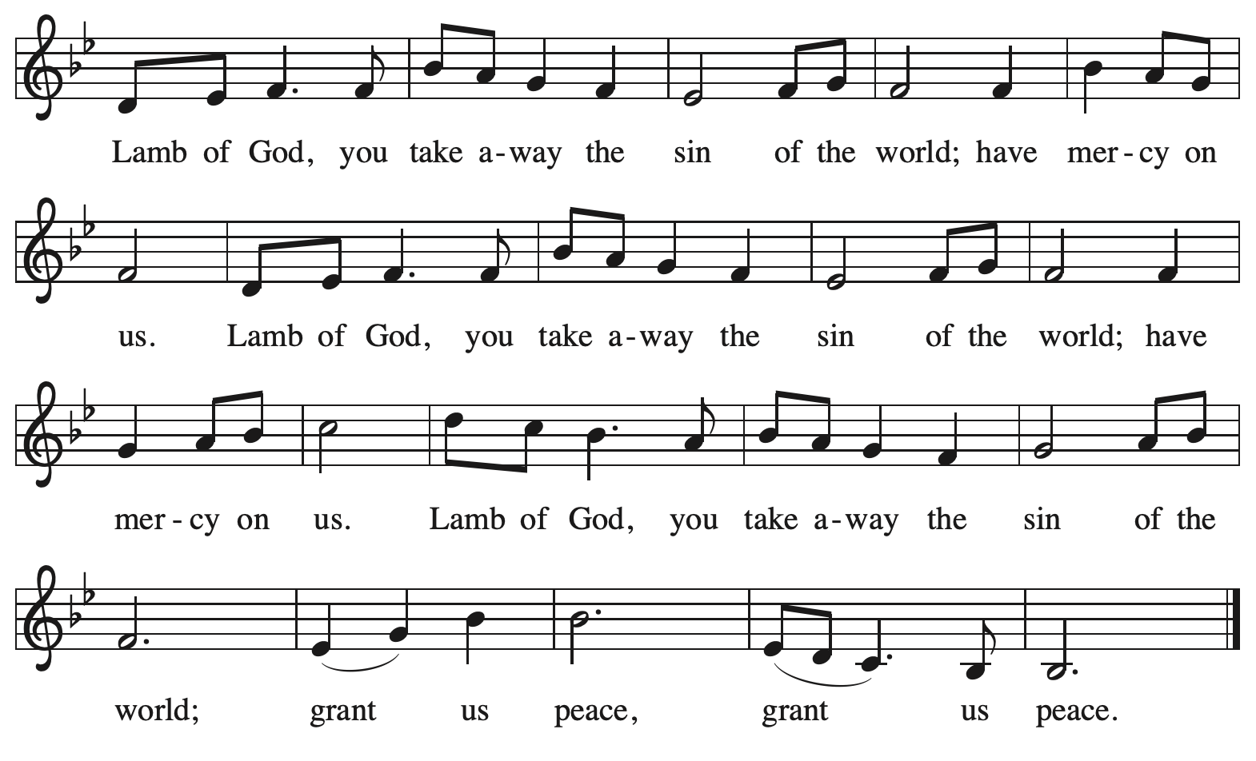

Please be seated.

Holy Communion

- All who seek God and desire a deeper and stronger life in Christ are welcome to receive Holy Communion.
- Worshipers from the pulpit side will proceed forward first, followed by the center section, and then the lectern side.
- Please inform an usher if you would like the ministers to bring Communion to you.
- Holy Communion will be served with bread and wine (amber) or grape juice (purple).
- The presiding minister will first distribute the bread (host) to each communicant. Please indicate if you require a gluten-free host.
- Once you have consumed the bread, please pick up an empty glass from the tray next to the presiding minister. The Communion Assistant will pour wine or grape juice into your glass.
- Please step to the side to consume the wine or grape juice.
- Feel free to kneel at the altar rail for prayer after receiving the sacrament.
- As you return to your pew, glasses may be returned to the empty tray on the side of the center section.
- A blessing will be provided for anyone who does not yet receive the sacrament.
- All are invited to join in singing the hymns during Holy Communion.

Hymns during Holy Communion
Let All Mortal Flesh Keep Silence ELW 490

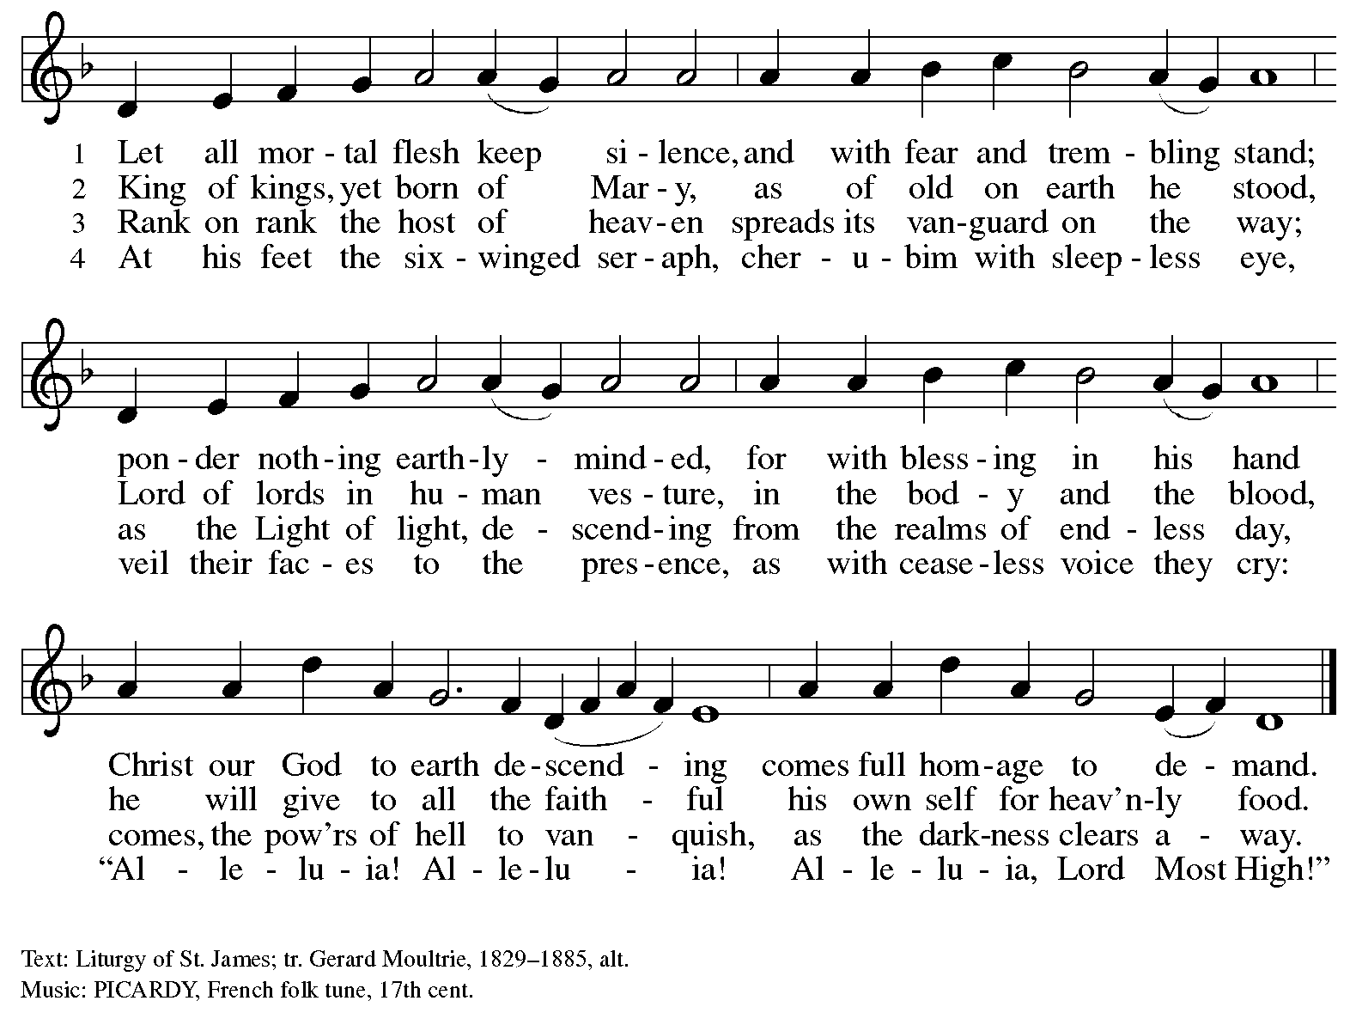

Hymns during Holy Communion
Let Us Break Bread Together ELW 471

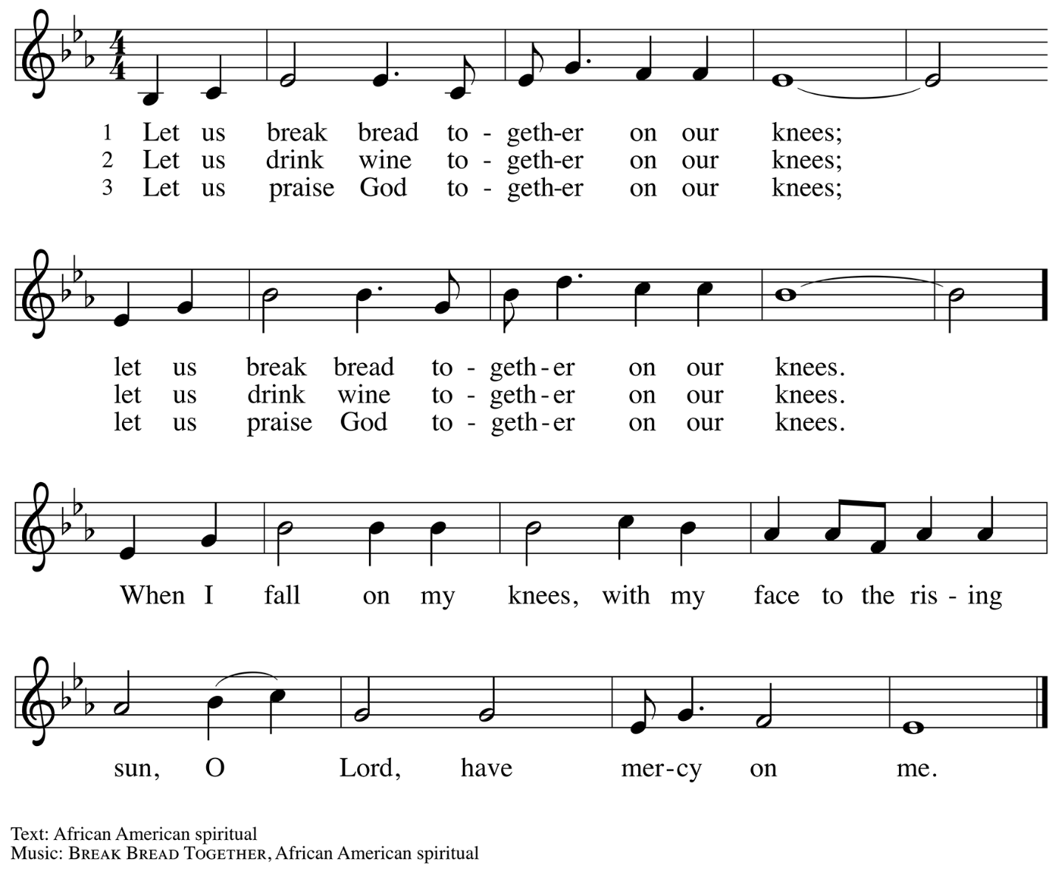

Hymns during Holy Communion
Beautiful Savior ELW 838

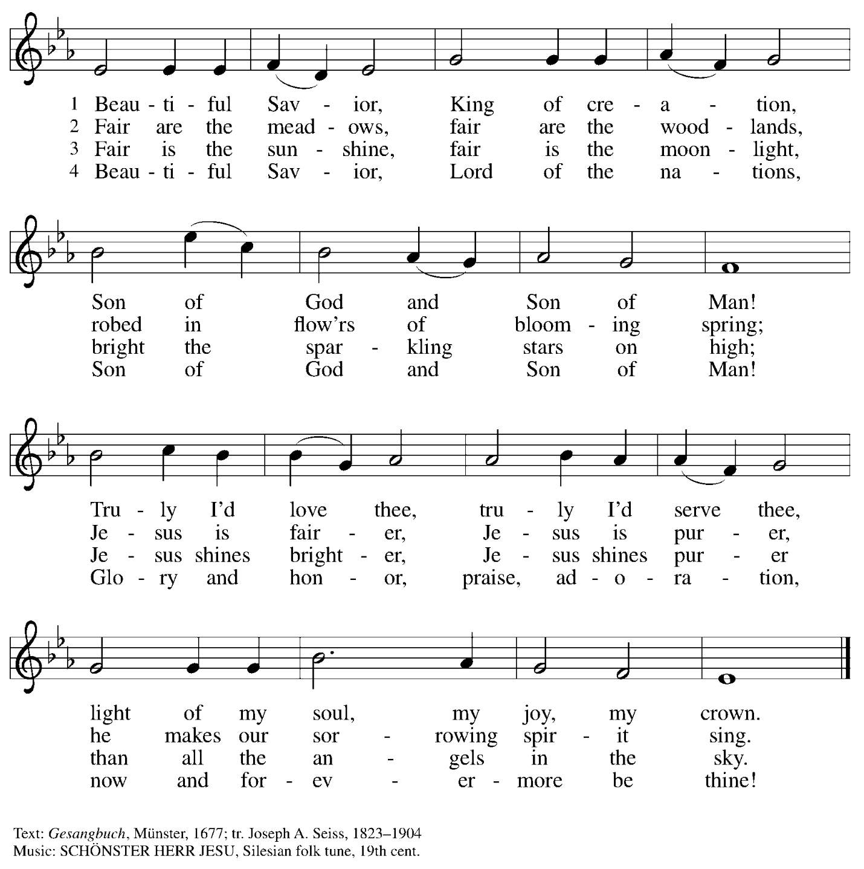

When all have returned to their places, please rise as you are able.

Blessing

P: The body and blood of our Lord Jesus Christ strengthen you and keep you in his grace.
C: Amen.

Prayer

A: Let us pray.
We thank you, O God, that you have strengthened our hearts through this feast of life
and salvation. Shine the light of Christ on our path, that we may do justice, love kindness,
and walk humbly with you, now and forever.
C: Amen.

Please be seated.

Sending
God blesses us and sends us in mission to the world

Announcements

Please rise as you are able.

Benediction

P: The Lord bless you and keep you.
The Lord’s face shine upon you with grace and mercy.
The Lord look upon you with favor and ☩ give you peace.
C: Amen.

Sending Hymn Following page

Dismissal

A: Go in peace. Serve the Lord.
C: Thanks be to God!

Postlude

Sending Hymn Alleluia, Song of Gladness ELW 318

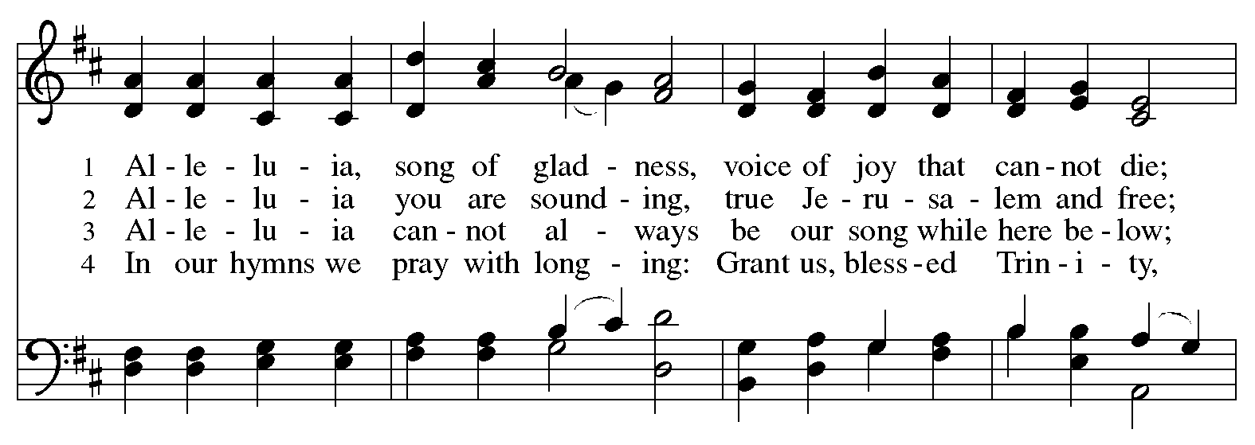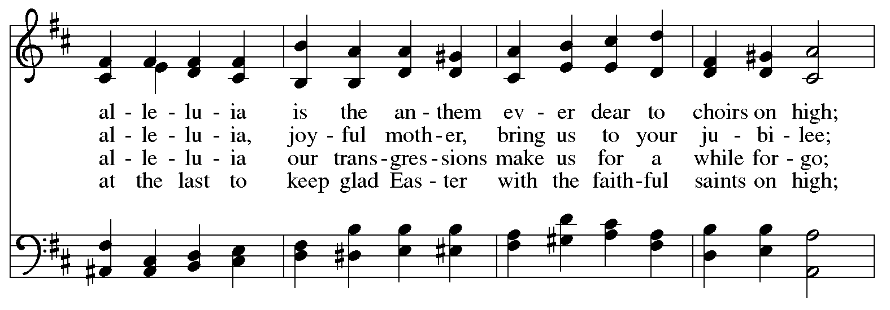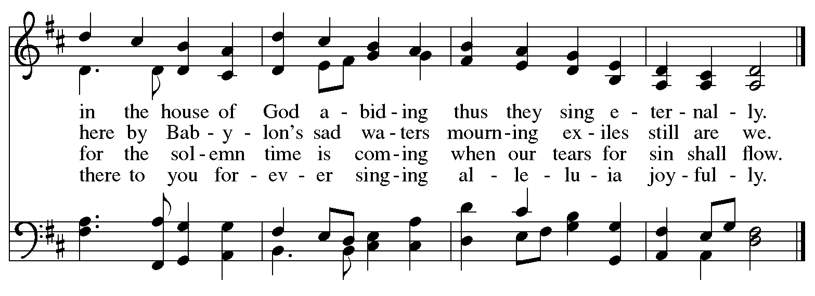

Serving in Worship Today

Altar Care Christy Ruhe
Assisting Minister Jimmi Kocher-Hillmer
Audio Visual Ministers Jason Galyardt
Jered Stratton
Cantor David Rollinson
Lector Kelly Spanninger
Pianist Jeff Denlinger
Preaching and Presiding Minister The Rev. Peter D. Asplin

Liturgy and Hymnody Acknowledgements

From SundaysandSeasons.com. Copyright © 2026 Augsburg Fortress. All rights reserved. Reprinted under OneLicense.net # A-722139.
Used by permission of Augsburg Fortress.

The Scripture readings contained herein are from New Revised Standard Version Updated Edition of the Bible © 2021 National Council of Churches of Christ in the United States of America. Used by permission. All rights reserved worldwide.

Please use the QR code below to link to St. Andrew’s Announcements online!



St. Andrew Lutheran Church Announcements
February 15th, 2026

- Welcome to Worship at St. Andrew as We Observe + The Transfiguration of our Lord! – We are thankful you are here, and we offer a special welcome to all visitors and guests who are here for the first time! A nursery is available through the door to the left of the worship space and across the social hall (look for a purple room). There are also worship “toolkits” to help children engage with worship and “busy bags” for younger children available in the bookcase at the back of the sanctuary. Please feel free to take one to use with/for your children.
- Thank You, Pastor Peter Asplin! – Today’s preaching and presiding minister is The Rev. Peter D. Asplin, Assistant to the Bishop of the Southwestern Pennsylvania Synod. We thank Pastor Peter, who is also a member of St. Andrew, for his leadership and proclamation of the Gospel in worship today!
- Thank You, Jeff Denlinger! – Thank you to Jeff Denlinger who is leading the worship of the congregation on piano today!
- Noisy Offering Today During Worship – On the third Sunday of each month, St. Andrew’s children lead the congregation in a Noisy Offering, in which people are invited to throw their change into buckets that the children carry around the church and bring forward as an additional offering. Each month’s Noisy Offering supports a local, national, or international church-related or otherwise charitable organization. This month’s offering will benefit Casa San Jose in their mission to connect, support, and advocate with and for the Latino Community towards their vision of a Pittsburgh region that celebrates culture, welcomes immigrants, and embraces inclusion, dignity, and respect. You can learn more about their programs by visiting their website here: https://casasanjose.org/. The children’s choir will be singing a song from Veggie Tales entitled, "God Is Bigger” after the offering.
- Liturgy of Burning of the Palms and Burying the Alleluia Outside after Worship – After today’s sending from worship, we will have a brief outdoor liturgy for the burning of the palms and the burying of the alleluia in preparation for Lent. Please go through the social hall to the back office door and up the ramp to the parking lot.
- Pancake Brunch after Burning of the Palms – Traditionally on Shrove Tuesday, the day before Ash Wednesday, Christians would clear out all the rich and fatty foods from their cupboards in preparation for the season of Lent and its spiritual discipline of fasting. Following this custom, St. Andrew used to hold a pancake dinner on Shrove Tuesday, but we have not done so since before the pandemic. Last year we re-introduced the spirit of Shrove Tuesday after worship on Transfiguration Sunday, and we will do so again this year on February 15th. After the liturgy for the burning of the palms, all are invited to a pancake brunch in the social hall. The hospitality committee will provide pancake mix (with gluten), sausage (non-vegan), gluten-free cupcakes and cookies, butter, syrup, coffee and tea. We ask people of the congregation to bring fruit, breakfast juices, and other gluten-free breakfast items. We hope you will join in these activities as we prepare for the season of Lent, beginning on Ash Wednesday, February 18th.
- Save the Date: Pysanky Ukrainian Egg Lenten Meditation Workshop, Saturday, February 28th, 10:00 a.m. - 3:00 p.m. – Jimmi Kocher-Hillmer is experienced in the practice of Ukrainian Egg Making as a meditational and devotional practice. He has offered to once again lead a workshop this Lent for people of the congregation. Please save February 28th from 10:00 a.m. to 3:00 p.m. on your calendars for this meaningful and fun opportunity! Please contact Jimmi for registration at 412-621-2472 or jimotha@yahoo.com. Registration is limited.
- Congregational Meeting, Sunday, March 1st, after Worship – St. Andrew's next meeting of the congregation will be held after worship on Sunday, March 1st. This will be our annual opportunity to receive reports from leadership, including the year-end financial reports from the previous year. We will also update the congregation on the progress of the building project and the capital campaign. Thank you for your continuing support and for your contributions to the ministry of St. Andrew in 2025 (and now 2026)!
- Invitation to Prayer Team – St. Andrew maintains a list of weekly prayer concerns sent by email to members of the congregation who have opted in. Our prayer team’s email is prayerteam@standrewpittsburgh.org. We will keep names on the list for a maximum of four weeks unless otherwise requested. Thank you for your ministry of prayer!
- Records Update – St. Andrew is updating our records with information from newer attendees, as well as offering current members the opportunity to include information to be used within the congregation to acknowledge celebrations, milestones, and prayers. Please fill out the form at: https://forms.gle/kKvp19UozuRrhhaV7.
- Coffee Hour Signups – If you would like to participate and would like information about the duties, please sign up using the following form: https://www.signupgenius.com/go/5080B4AAFAF2CABF85-47069030-coffee#/.

