

+ Third Sunday in Lent
March 8, 2026



St. Andrew Lutheran Church
304 Morewood Ave.
Pittsburgh, PA 15213
St_andrewELCA@verizon.net
www.standrewpittsburgh.org

+ Third Sunday in Lent
Order for Worship

In today’s Gospel a Samaritan woman asks Jesus for water, a possible image of our thirst for God. Jesus offers living water, a sign of God’s grace flowing from the waters of Baptism.
The early church used this Gospel and those of the next two Sundays to deepen baptismal reflection during the final days of preparation for Baptism at Easter. As we move toward the resurrection feast, Christ comes among us in Word, bath, and meal – offering us the life-giving water of God’s mercy and forgiveness.

Welcome to St. Andrew!
- St. Andrew welcomes all who are seeking a place of healing, wholeness, and acceptance in a nurturing and faith-forming spiritual home. We are striving toward racial equity worldwide
and we seek to honor the lived experience of all individuals regardless of background. Our community embraces people of all ages, ethnicities, cultures, abilities, sexual orientations,
gender identities and expressions, and family constellations. Come and See!
- Worship Services are live-streamed to multiple online platforms. By attending worship, you agree that your image and voice may be broadcast.
- Everyone is invited to make a name tag at the black bookcase in the back of the worship space if they would like. There are stickers indicating pronouns on the bookcase if you would like to include them on your name tag.
- A nursery is available through the doors at the left side of the sanctuary and across from the doorway to the Social Hall. Look for a purple-colored room.
- Children are invited to attend Little Church – Big Faith, a Bible lesson and activity, during worship (after the Prayer of the Day). The group returns to the worship space for the liturgy of Holy Communion.
- Worship “toolkits” to help children engage with the service, along with “busy bags” for younger children, are available in the bookcase at the back of the sanctuary. Please feel free to take one to use with/for your children.
- Holy Communion is served with bread (gluten-free available) and wine or grape juice. The presiding minister will distribute the bread (host). Please consume this and then pick up an empty glass from the tray. The Communion Assistant will pour wine or grape juice into your glass. Please step to the side to consume the wine or grape juice. Feel free to kneel at the altar for prayer and reflection. As you return to your pew, glasses may be returned to the empty trays on either side of the center section.
- A restroom is available on the main level of the church, through the doors to the Social Hall and to the right in the main office.

Abbreviations
P: Pastor/Presiding Minister ELW: Evangelical Lutheran Worship hymnal
A: Assisting Minister ACS: All Creation Sings hymnal
L: Lector
C: Congregation
Musical Offering

Each week, different people from the congregation make an offering of pre-service music, with singing or instrumentation, to help the assembly focus and pray in preparation for worship.

Welcome

Prelude My Faith Looks Up to Thee arr. Raabe

Gathering
The Holy Spirit calls us together as the people of God

Please rise as you are able. All may make the sign of the cross,
the sign that is marked at Baptism, as the presiding minister begins.

Confession and Forgiveness

P: Blessed be the holy Trinity, ☩ one God,
who forgives all our sin, whose mercy endures forever.
C: Amen.

P: Let us confess our sin before God, who removes our guilt
and blots out all offenses.

Silence is kept for reflection.

P: Gracious God,
C: have mercy on us according to your steadfast love.

P: For seeking worldly delights that deceive us and dishonor you:
Gracious God,
C: have mercy on us according to your steadfast love.

P: For desiring self-reliance instead of hungering for your word:
Gracious God,
C: have mercy on us according to your steadfast love.

P: For failing to recognize your coming reign,
and for hindering the work of the Spirit: Gracious God,
C: have mercy on us according to your steadfast love.

P: For drawing from the well of self-serving ambition,
and for disdaining the living water Christ offers: Gracious God,
C: have mercy on us according to your steadfast love.
P: For disregarding voices from the margins,
and for distrusting signs of your healing and hope in the world:
Gracious God,
C: have mercy on us according to your steadfast love.

P: For dwelling in tombs of self-pity and discontent,
and for disregarding Christ’s call to come forth to life:
Gracious God,
C: have mercy on us according to your steadfast love.

P: God’s steadfast love, grace, and forgiveness abound.
Through faith, the free gift of God,
you have been clothed in the righteousness of Christ.
In the name of ☩ Jesus Christ, your sins are forgiven.
The Spirit of the One who raised Christ from the dead dwells in you,
pours love into your hearts, and gives you life and peace.
C: Amen.

Gathering Hymn As the Deer Runs to the River ELW 331

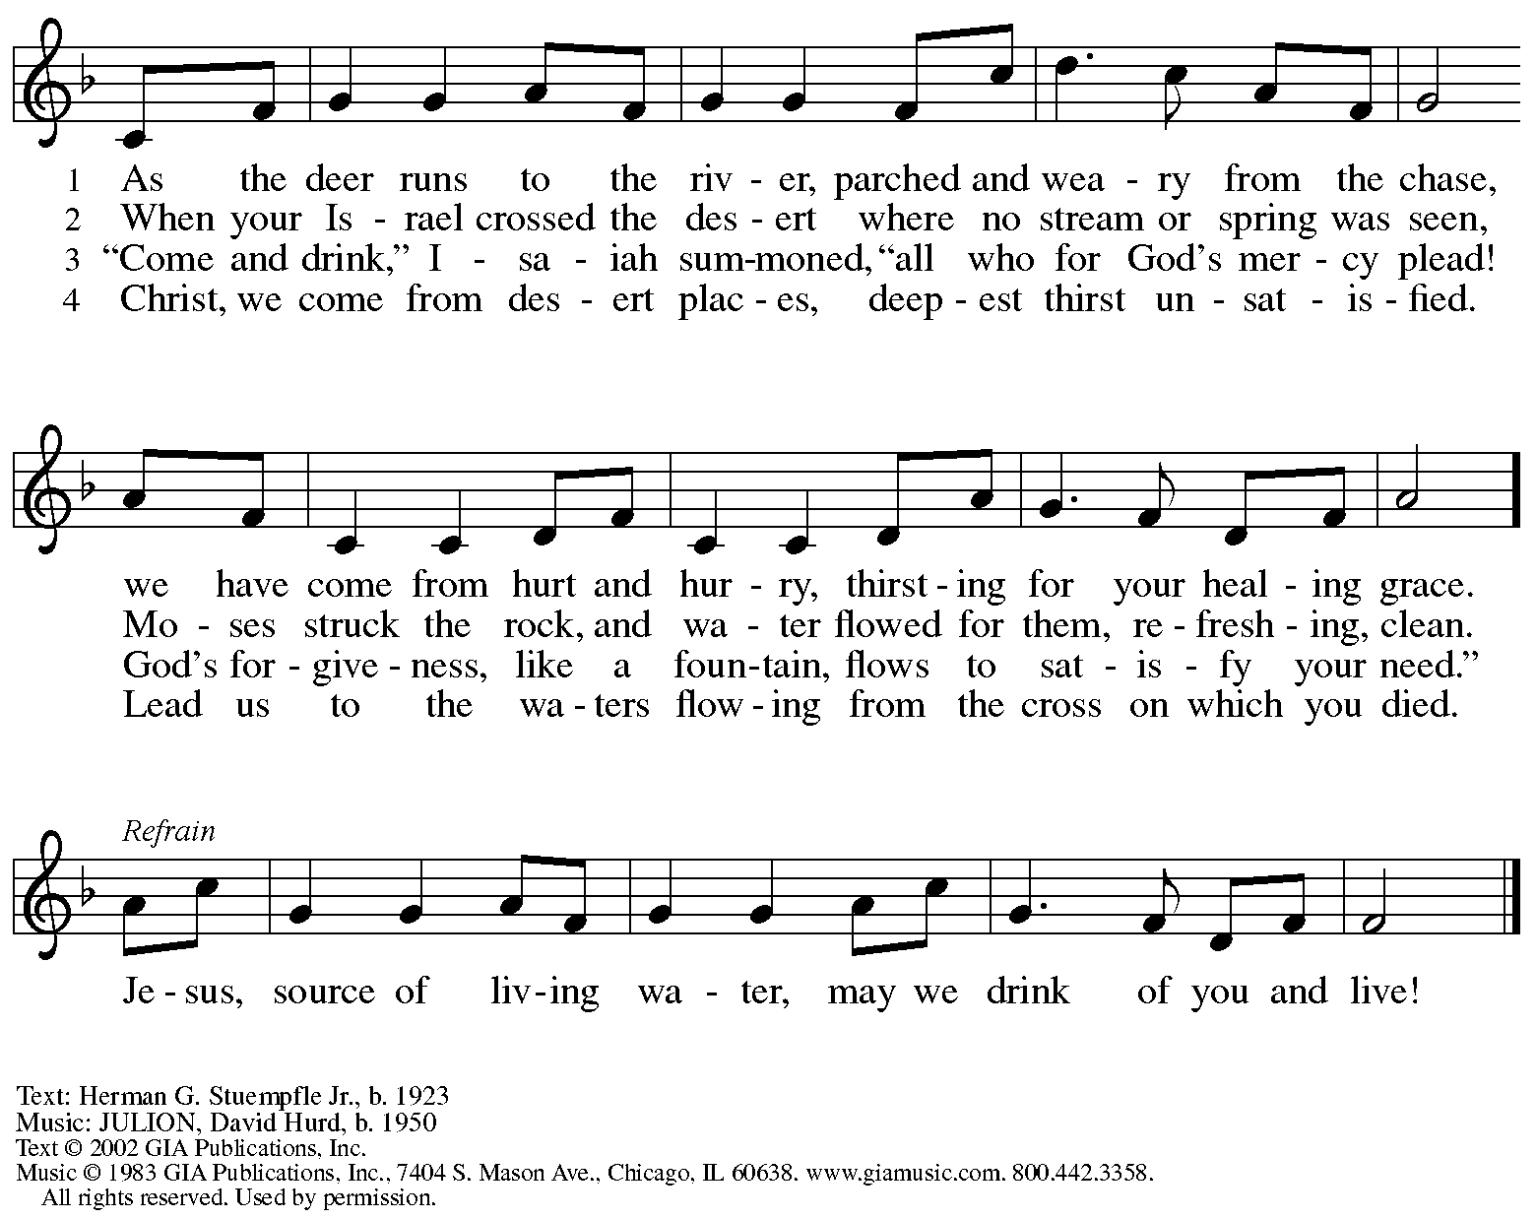
Reprinted under OneLicense.net # A-722139.
Greeting

P: The grace of our Lord Jesus Christ, the love of God,
and the communion of the Holy Spirit be with you all.
C: And also with you.

Kyrie ELW p. 193

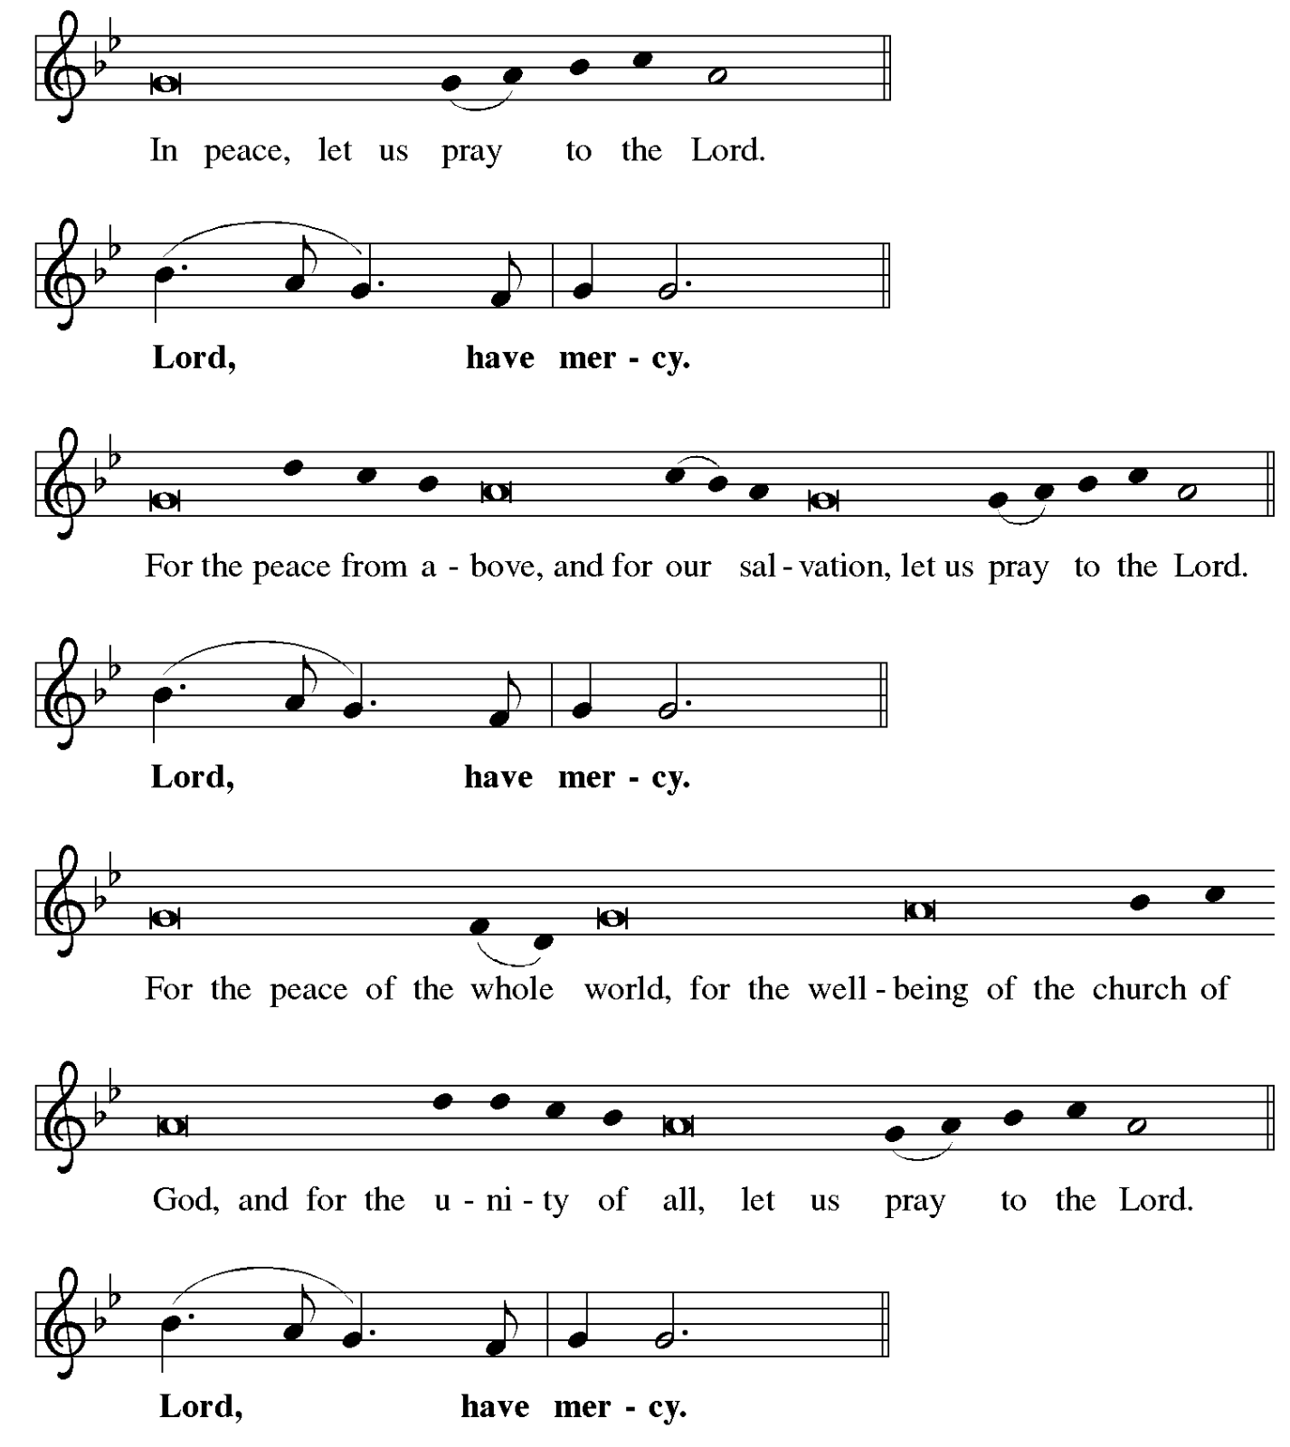
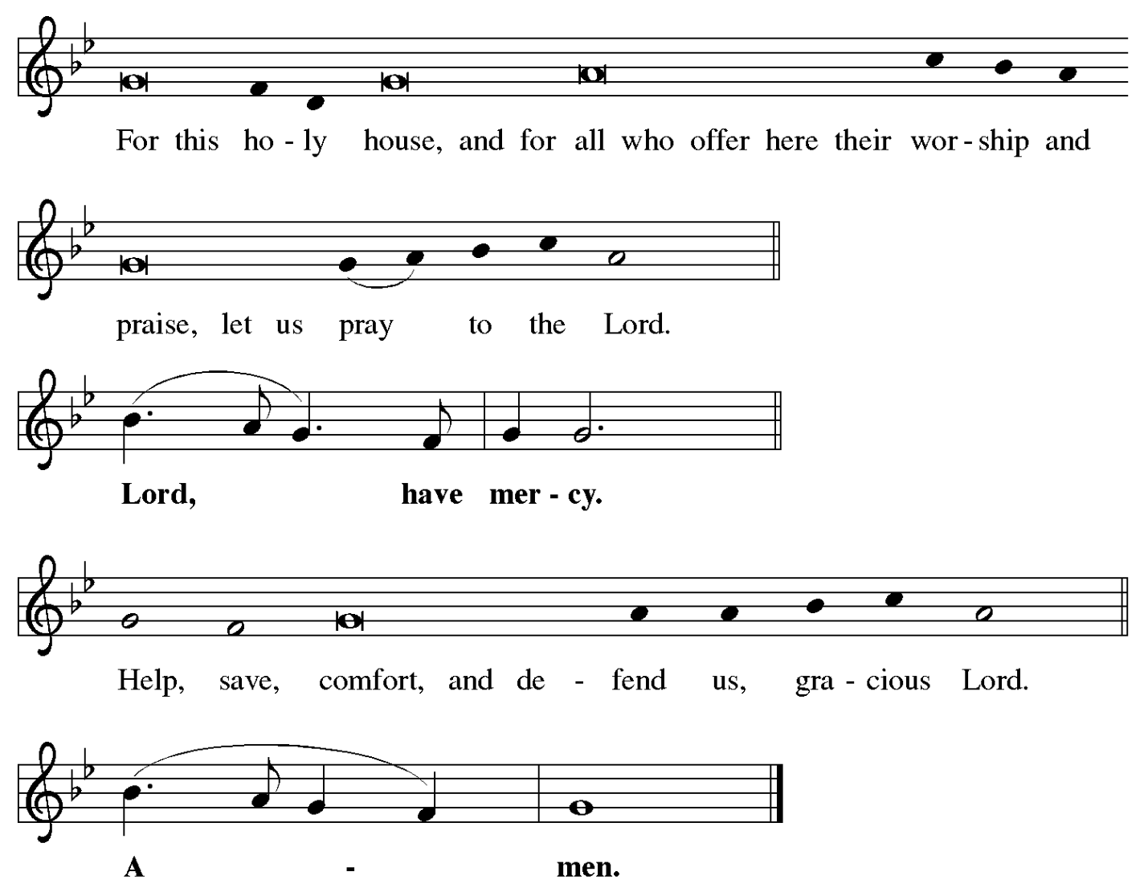

Prayer of the Day

P: The Lord be with you.
C: And also with you.

P: Merciful God, the fountain of living water, you quench our thirst and wash away our sin.
Give us this water always. Bring us to drink from the well that flows with the beauty of your truth through Jesus Christ, our Savior and Lord, who lives and reigns with you and the Holy Spirit, one God, now and forever.
C: Amen.

Please be seated.
Children are invited to join the adult leader(s) at the side door for Little Church – Big Faith.
We ask that an additional adult from the congregation attend with the children.

Word
God speaks to us in Scripture reading, preaching, and song

First Reading – Exodus 17: 1-7

¹ From the wilderness of Sin the whole congregation of the Israelites journeyed by stages, as the Lord commanded. They camped at Rephidim, but there was no water for the people to drink. ² The people quarreled with Moses and said, “Give us water to drink.” Moses said to them, “Why do you quarrel with me? Why do you test the Lord?” ³ But the people thirsted there for water, and the people complained against Moses and said, “Why did you bring us out of Egypt, to kill us and our children and livestock with thirst?” ⁴ So Moses cried out to the Lord, “What shall I do for this people? They are almost ready to stone me.” ⁵ The Lord said to Moses, “Go on ahead of the people and take some of the elders of Israel with you; take in your hand the staff with which you struck the Nile and go. ⁶ I will be standing there in front of you on the rock at Horeb. Strike the rock, and water will come out of it, so that the people may drink.” Moses did so, in the sight of the elders of Israel. ⁷ He called the place Massah and Meribah, because the Israelites quarreled and tested the Lord, saying, “Is the Lord among us or not?”

L: Word of God, word of life.
C: Thanks be to God.

Psalm 95

The psalm will be sung responsively, led by the cantor, with the congregation singing the verses in bold type and joining in the refrain.

Psalm Tone

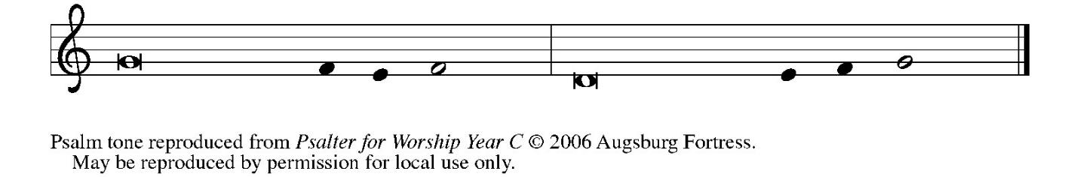

Psalm Refrain

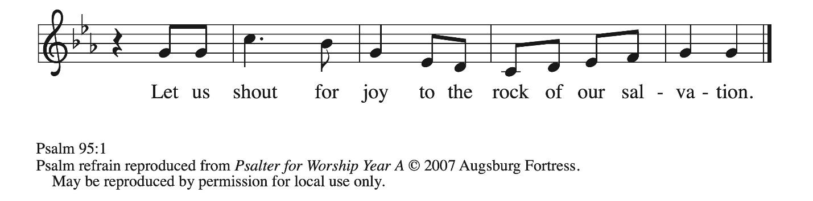

¹ Come, let us sing | to the Lord;
let us shout for joy to the rock of | our salvation.
² Let us come before God’s presence | with thanksgiving
and raise a loud shout to the | Lord with psalms.
³ For you, Lord, | are a great God,
and a great ruler a- | bove all gods.
⁴ In your hand are the caverns | of the earth;
the heights of the hills are | also yours.
⁵ The sea is yours, | for you made it,
and your hands have molded | the dry land.
⁶ Come, let us worship | and bow down,
let us kneel before the | Lord our maker. R
⁷ For the Lord is our God, and we are the people of God’s pasture and the sheep | of God’s hand.
Oh, that today you would | hear God’s voice!
⁸ “Harden | not your hearts,
as at Meribah, as on that day at Massah | in the desert.
⁹ There your ancestors | tested me,
they put me to the test, though they had | seen my works.
¹⁰ Forty years I loathed that gener- | ation, saying,
‘The heart of this people goes astray; they do not | know my ways.’
¹¹ Indeed I swore | in my anger,
‘They shall never come | to my rest.’ ” R

Second Reading – Romans 5: 1-11

¹ Since we are justified by faith, we have peace with God through our Lord Jesus Christ,
² through whom we have obtained access to this grace in which we stand, and we boast in our hope of sharing the glory of God. ³ And not only that, but we also boast in our afflictions, knowing that affliction produces endurance, ⁴ and endurance produces character, and character produces hope, ⁵ and hope does not put us to shame, because God’s love has been poured into our hearts through the Holy Spirit that has been given to us.
⁶ For while we were still weak, at the right time Christ died for the ungodly. ⁷ Indeed, rarely will anyone die for a righteous person—though perhaps for a good person someone might actually dare to die. ⁸ But God proves God’s love for us in that while we still were sinners Christ died for us. ⁹ Much more surely, therefore, since we have now been justified by his blood, will we be saved through him from the wrath of God. ¹⁰ For if while we were enemies we were reconciled to God through the death of God’s Son, much more surely, having been reconciled, will we be saved by his life. ¹¹ But more than that, we even boast in God through our Lord Jesus Christ, through whom we have now received reconciliation.

L: Word of God, word of life.
C: Thanks be to God.

Please rise as you are able.

Gospel Verse ELW p. 198

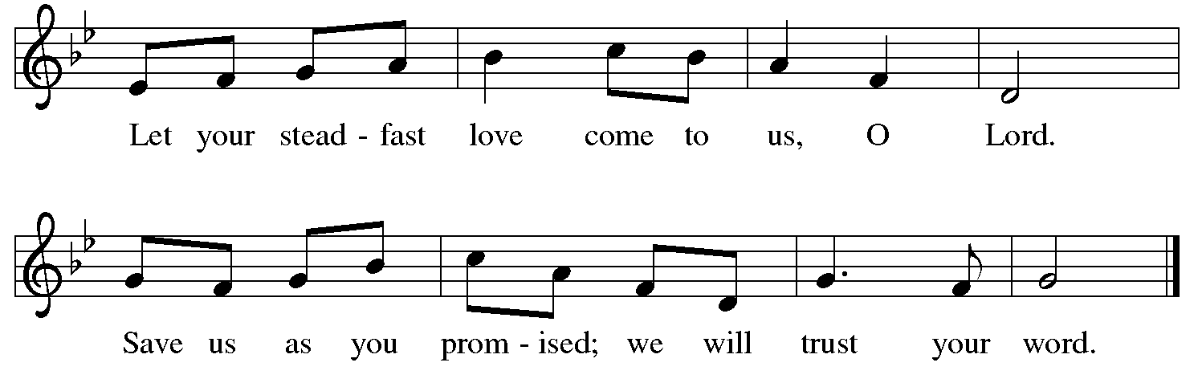

Gospel – John 4: 5-42

P: The holy Gospel according to St. John.
C: Glory to you, O Lord.

⁵ [Jesus] came to a Samaritan city called Sychar, near the plot of ground that Jacob had given to his son Joseph.⁶ Jacob’s well was there, and Jesus, tired out by his journey, was sitting by the well. It was about noon.
⁷ A Samaritan woman came to draw water, and Jesus said to her, “Give me a drink.”
⁸ (His disciples had gone to the city to buy food.) ⁹ The Samaritan woman said to him, “How is it that you, a Jew, ask a drink of me, a woman of Samaria?” (Jews do not share things in common with Samaritans.) ¹⁰ Jesus answered her, “If you knew the gift of God and who it is that is saying to you, ‘Give me a drink,’ you would have asked him, and he would have given you living water.” ¹¹ The woman said to him, “Sir, you have no bucket, and the well is deep. Where do you get that living water? ¹² Are you greater than our ancestor Jacob, who gave us the well and with his sons and his flocks drank from it?” ¹³ Jesus said to her, “Everyone who drinks of this water will be thirsty again, ¹⁴ but those who drink of the water that I will give them will never be thirsty. The water that I will give will become in them a spring of water gushing up to eternal life.” ¹⁵ The woman said to him, “Sir, give me this water, so that I may never be thirsty or have to keep coming here to draw water.”
¹⁶ Jesus said to her, “Go, call your husband, and come back.” ¹⁷ The woman answered him, “I have no husband.” Jesus said to her, “You are right in saying, ‘I have no husband,’ ¹⁸ for you have had five husbands, and the one you have now is not your husband. What you have said is true!” ¹⁹ The woman said to him, “Sir, I see that you are a prophet. ²⁰ Our ancestors worshiped on this mountain, but you say that the place where people must worship is in Jerusalem.” ²¹ Jesus said to her, “Woman, believe me, the hour is coming when you will worship the Father neither on this mountain nor in Jerusalem. ²² You worship what you do not know; we worship what we know, for salvation is from the Jews. ²³ But the hour is coming and is now here when the true worshipers will worship the Father in spirit and truth, for the Father seeks such as these to worship him. ²⁴ God is spirit, and those who worship God must worship in spirit and truth.” ²⁵ The woman said to him, “I know that Messiah is coming” (who is called Christ).

“When he comes, he will proclaim all things to us.” ²⁶ Jesus said to her, “I am he, the one who is speaking to you.”
²⁷ Just then his disciples came. They were astonished that he was speaking with a woman, but no one said, “What do you want?” or, “Why are you speaking with her?” ²⁸ Then the woman left her water jar and went back to the city. She said to the people, ²⁹ “Come and see a man who told me everything I have ever done! He cannot be the Messiah, can he?” ³⁰ They left the city and were on their way to him.
³¹ Meanwhile the disciples were urging him, “Rabbi, eat something.” ³² But he said to them, “I have food to eat that you do not know about.” ³³ So the disciples said to one another, “Surely no one has brought him something to eat?” ³⁴ Jesus said to them, “My food is to do the will of the one who sent me and to complete God’s work. ³⁵ Do you not say, ‘Four months more, then comes the harvest’? But I tell you, look around you, and see how the fields are ripe for harvesting. ³⁶ The reaper is already receiving wages and is gathering fruit for eternal life, so that sower and reaper may rejoice together. ³⁷ For here the saying holds true, ‘One sows and another reaps.’ ³⁸ I sent you to reap that for which you did not labor. Others have labored, and you have entered into their labor.”
³⁹ Many Samaritans from that city believed in him because of the woman’s testimony, “He told me everything I have ever done.” ⁴⁰ So when the Samaritans came to him, they asked him to stay with them, and he stayed there two days. ⁴¹ And many more believed because of his word.
⁴² They said to the woman, “It is no longer because of what you said that we believe, for we have heard for ourselves, and we know that this is truly the Savior of the world.”

P: The Gospel of the Lord.
C: Praise to you, O Christ.

Please be seated.

Sermon

A time of silence for prayer and reflection follows the sermon.
When the hymn of the day begins, please rise as you are able.



Hymn of the Day Come to Me, All Pilgrims Thirsty ELW 777

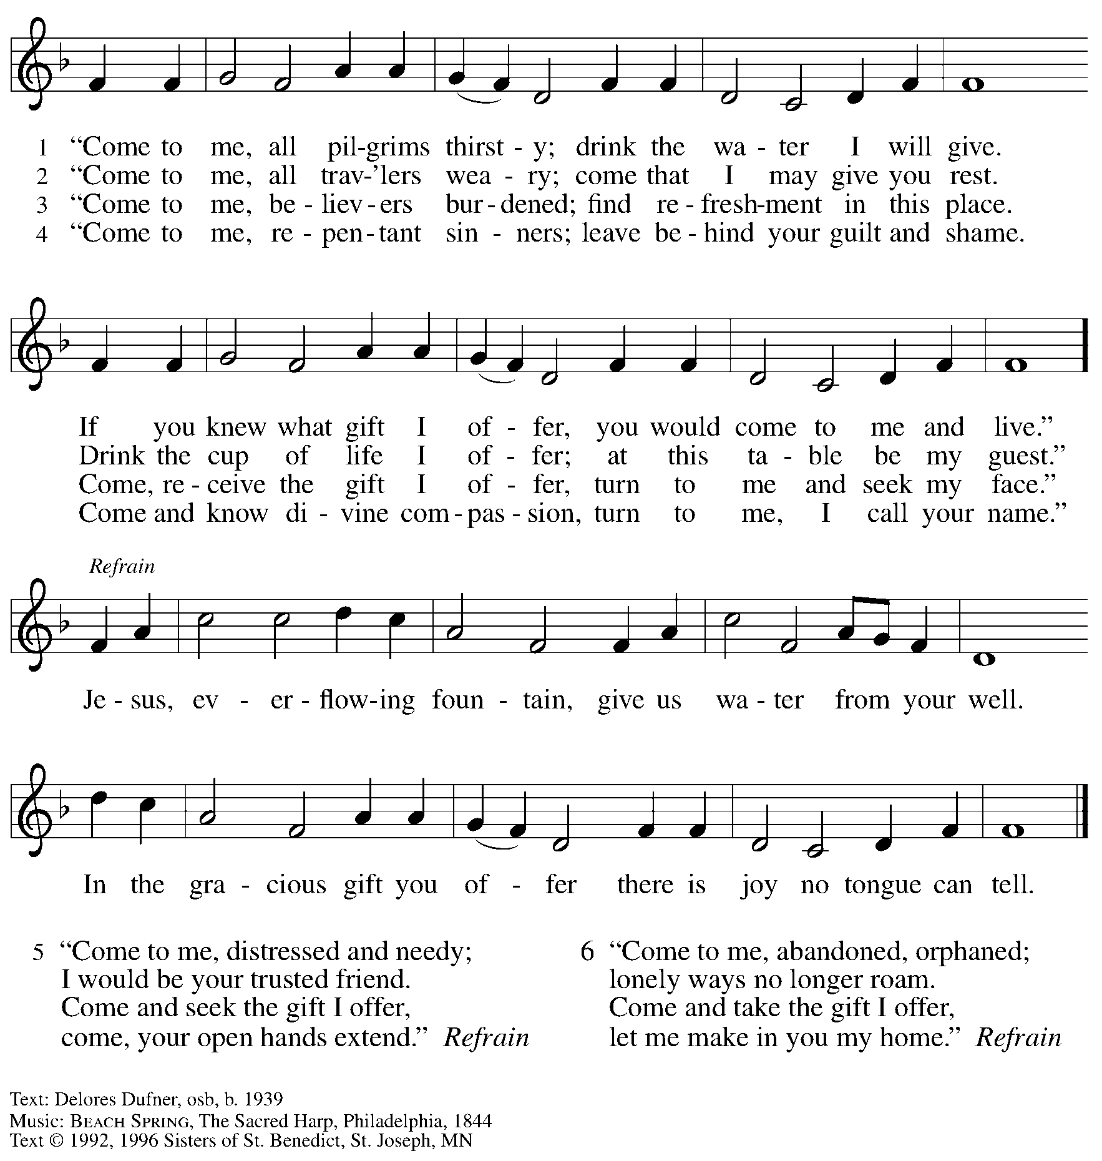
Copyright held by Liturgical Press, P.O. Box 7500, Collegeville, MN 56321. All rights reserved. Reprinted with permission under OneLicense.net # A-722139.

Apostles’ Creed

C: I believe in God, the Father almighty,
creator of heaven and earth.

C: I believe in Jesus Christ, God’s only Son, our Lord,
who was conceived by the Holy Spirit,
born of the virgin Mary,
suffered under Pontius Pilate,
was crucified, died, and was buried;
he descended to the dead.*
On the third day he rose again;
he ascended into heaven,
he is seated at the right hand of the Father,
and he will come to judge the living and the dead.

I believe in the Holy Spirit,
the holy catholic church,
the communion of saints,
the forgiveness of sins,
the resurrection of the body,
and the life everlasting. Amen.

*Or, “he descended into hell,” another translation of this text in widespread use.

Prayers of the People

A: Reconciled by God’s mercy and sustained by God’s presence,
let us pray for the world and its needs.

After each petition
A: Merciful God,
C: receive our prayer.

P: Receive our prayers, O God, through Jesus Christ, our strength and salvation.
C: Amen.
Peace

The presiding minister and the assembly greet one another in the peace of the risen Christ.
P: The peace of Christ be with you always.
C: And also with you.

The people may greet those around them with a sign of Christ’s peace and may say
Peace be with you or similar words. Please be mindful that not everyone will be comfortable with sharing the peace, so please seek consent before shaking hands or hugging.
Other possible ways to share the peace include a simple bow with the verbal greeting of peace, or simply a verbal expression of peace.
When the greetings of peace have concluded, please be seated.



Meal
God feeds us with the presence of Jesus Christ

Offering

We offer ourselves, our gifts, and our faithful service to God.
As the offering is gathered for the mission of the church, including the care of those in need,
the table is set for Holy Communion.

There are laminated giving cards in the pew racks that feature a QR code for anyone who would like to give online. Those who give using the QR code, as well as those who give regularly online or through their bank are encouraged to place the laminated card in the plate as an expression of your offering.

Offertory Music Lament Alan Hovhaness
Clarinet - M. Mangano

As the gifts are brought forward for presentation, please rise as you are able.

Offertory Song Create in Me a Clean Heart ELW 186

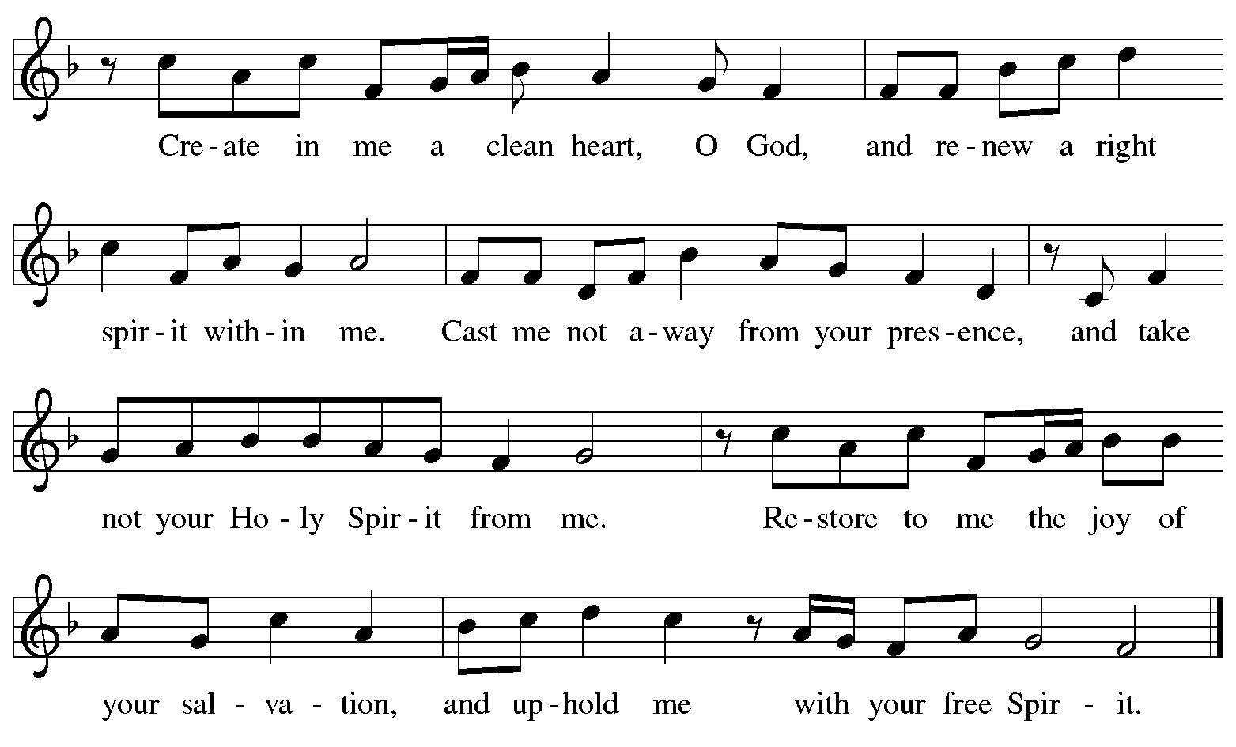
Reprinted with permission under One License.net # A-722139.

Offertory Prayer

A: Let us pray.
God our provider,
C: have not fed us with bread alone, but with words of grace and life.
Bless us and these your gifts, which we receive from your bounty,
through Jesus Christ our Lord. Amen.

Dialogue ELW p. 199

P: The Lord be with you.
C: And also with you.

P: Lift up your hearts.
C: We lift them to the Lord.

P: Let us give thanks to the Lord our God.
C: It is right to give our thanks and praise.

Preface (Spoken by the presiding minister)

P: It is indeed right, our duty and our joy,
that we should at all times and in all places
give thanks and praise to you, almighty and merciful God,
through our Savior Jesus Christ.
You call your people to cleanse their hearts
and prepare with joy for the paschal feast,
that, renewed in the gift of Baptism,
we may come to the fullness of your grace.
And so, with all the choirs of angels,
with the church on earth and the hosts of heaven,
we praise your name and join their unending hymn:

Sanctus ELW p. 200

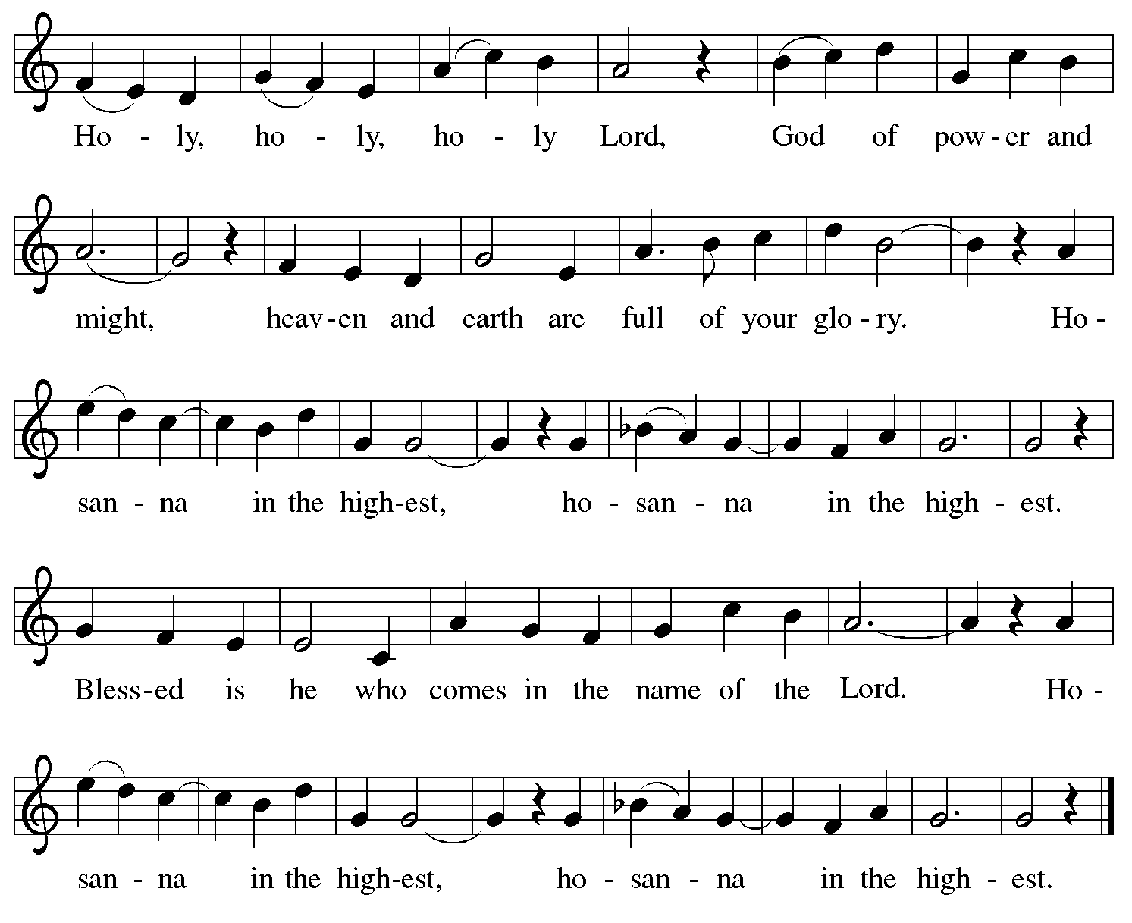

Eucharistic Prayer

P: Blessed are you, O God of the universe …
… Do this for the remembrance of me.

With this bread and cup
we remember our Lord’s passover from death to life
as we proclaim the mystery of faith:
C: Christ has died. Christ is risen. Christ will come again.

P: O God of resurrection and new life …
… Grace our table with your presence.
C: Come, Holy Spirit.

P: Reveal yourself to us in the breaking of the bread …
… Send us forth, burning with justice, peace, and love.
C: Come, Holy Spirit.

P: With your holy ones of all times and places …
… we praise you, O God, blessed and holy Trinity,
now and forever.
C: Amen.

Lord’s Prayer

P: Gathered as one by the Holy Spirit, let us pray as Jesus taught us.
C: Our Father in heaven,
hallowed be your name,
your kingdom come,
your will be done,
on earth as in heaven.
Give us today our daily bread.
Forgive us our sins
as we forgive those
who sin against us.
Save us from the time of trial
and deliver us from evil.
For the kingdom, the power,
and the glory are yours,
now and forever. Amen.

Fraction and Invitation

Agnus Dei / Lamb of God ELW p. 200

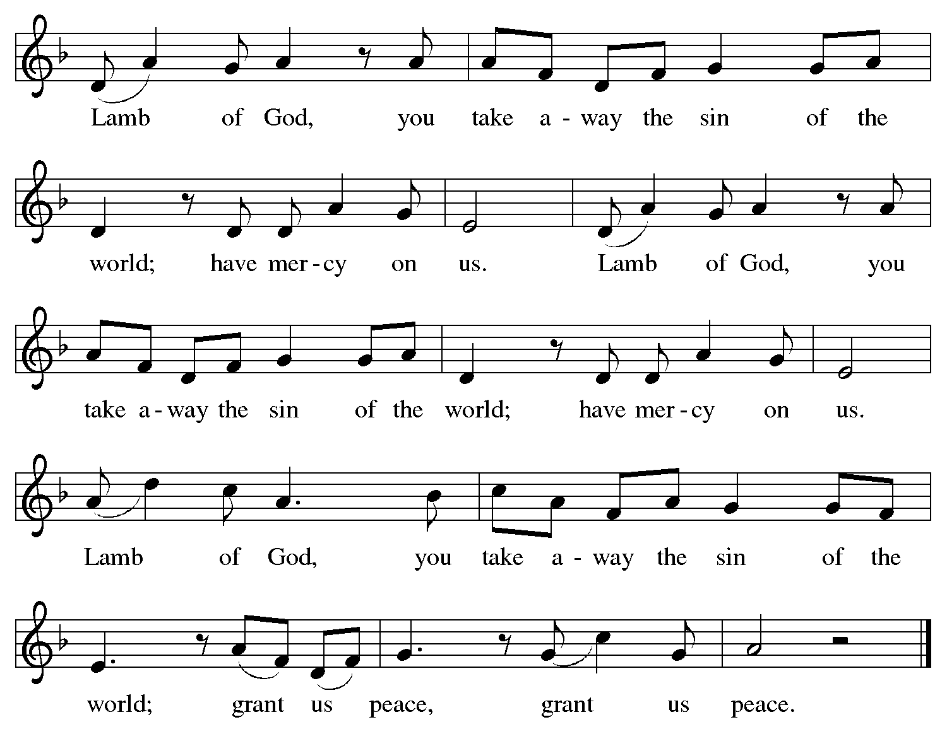

Please be seated.

Holy Communion

- All who seek God and desire a deeper and stronger life in Christ are welcome to receive Holy Communion.
- Worshipers from the pulpit side will proceed forward first, followed by the center section, and then the lectern side.
- Please inform an usher if you would like the ministers to bring Communion to you.
- Holy Communion will be served with bread and wine (amber) or grape juice (purple).
- The presiding minister will first distribute the bread (host) to each communicant. Please indicate if you require a gluten-free host.
- Once you have consumed the bread, please pick up an empty glass from the tray next to the presiding minister. The Communion Assistant will pour wine or grape juice into your glass.
- Please step to the side to consume the wine or grape juice.
- Feel free to kneel at the altar rail for prayer after receiving the sacrament.
- As you return to your pew, glasses may be returned to the empty tray on the side of the center section.
- A blessing will be provided for anyone who does not yet receive the sacrament.
- All are invited to join in singing the hymns during Holy Communion.

Hymns during Holy Communion
I Heard the Voice of Jesus Say ELW 611

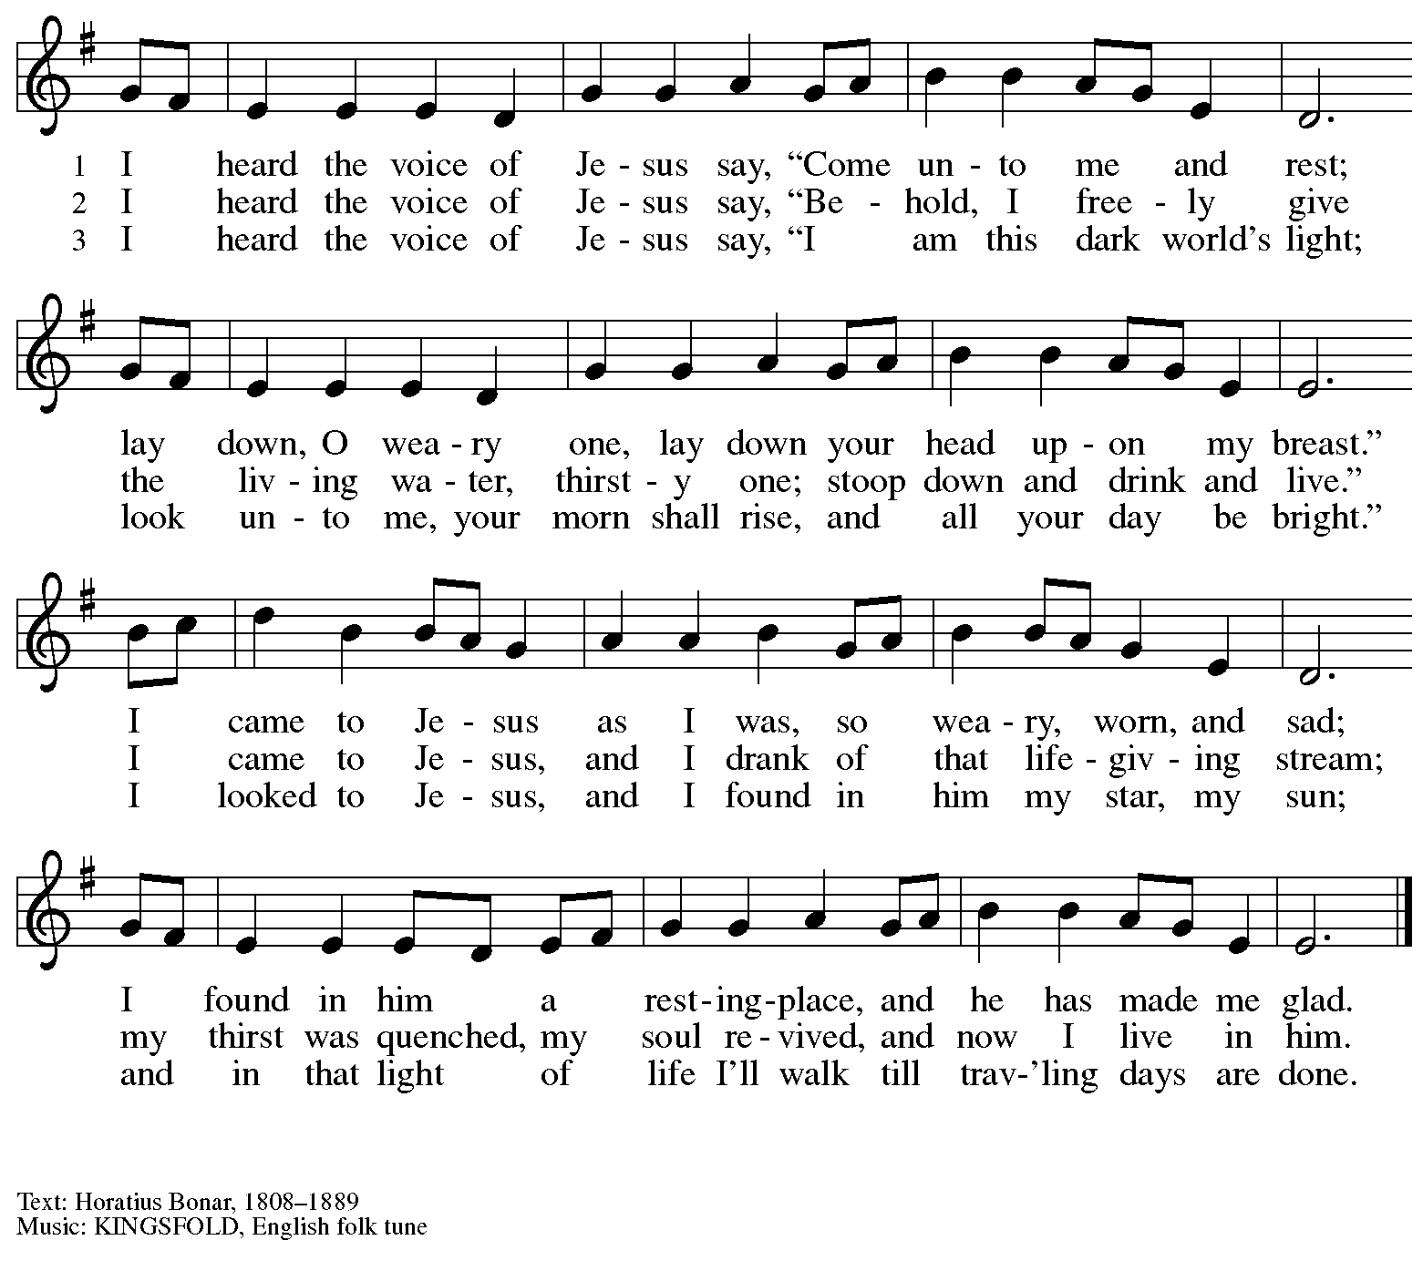

Hymns during Holy Communion
O Jesus, Joy of Loving Hearts ELW 658

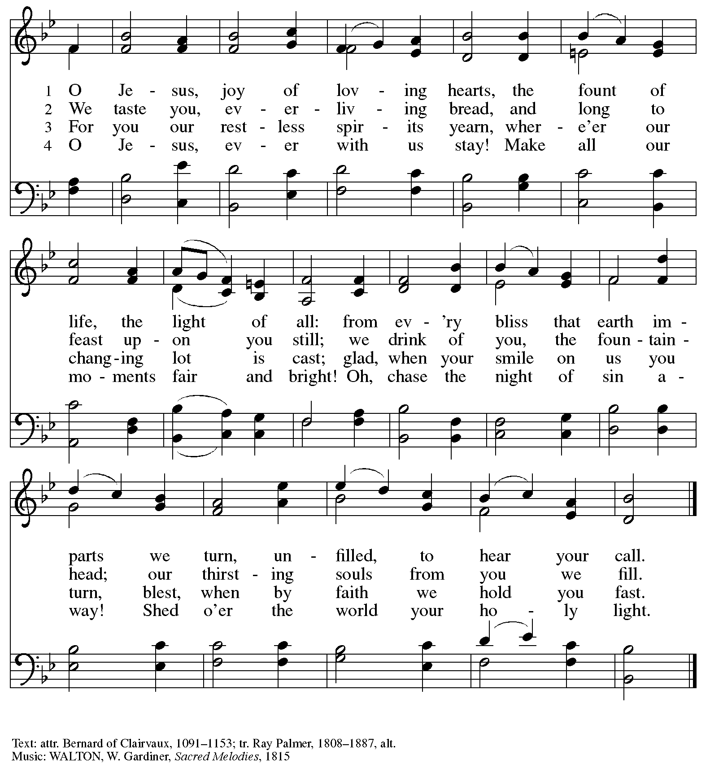

Hymns during Holy Communion
O Bread of Life from Heaven ELW 480

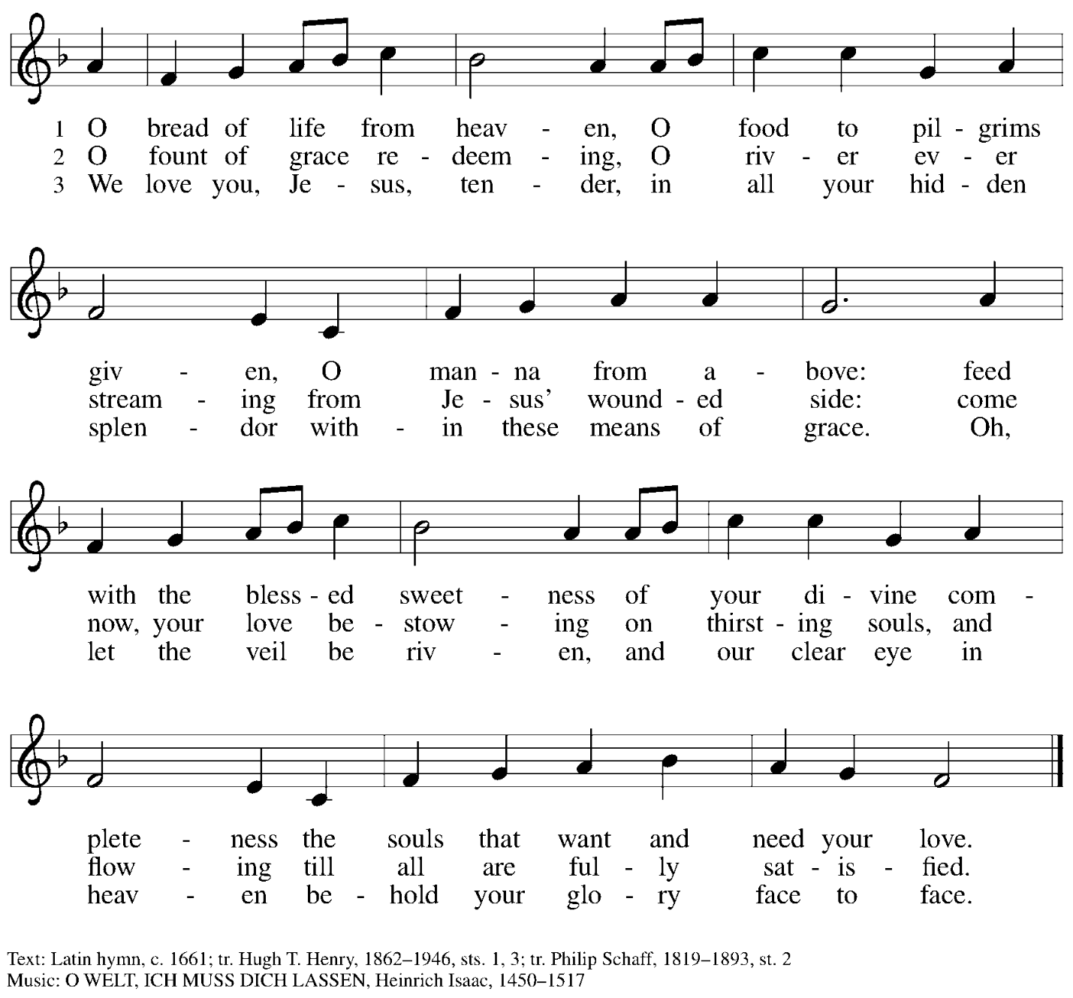

Hymns during Holy Communion
Rock of Ages, Cleft for Me ELW 623

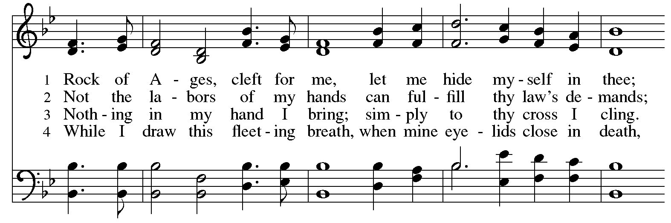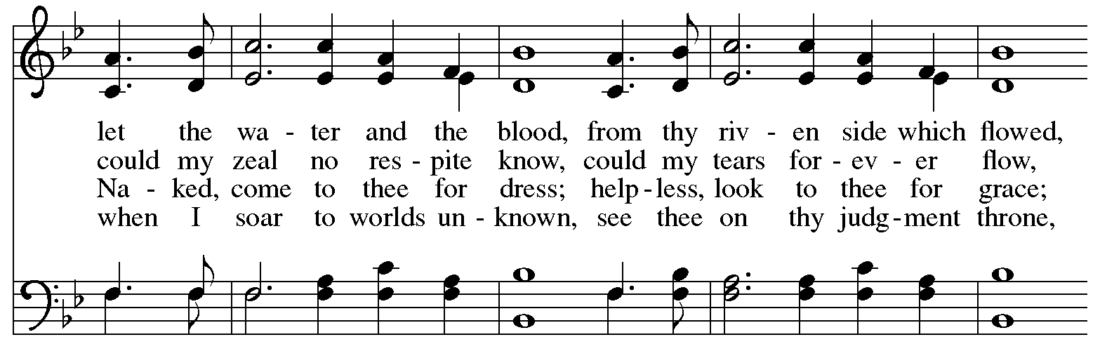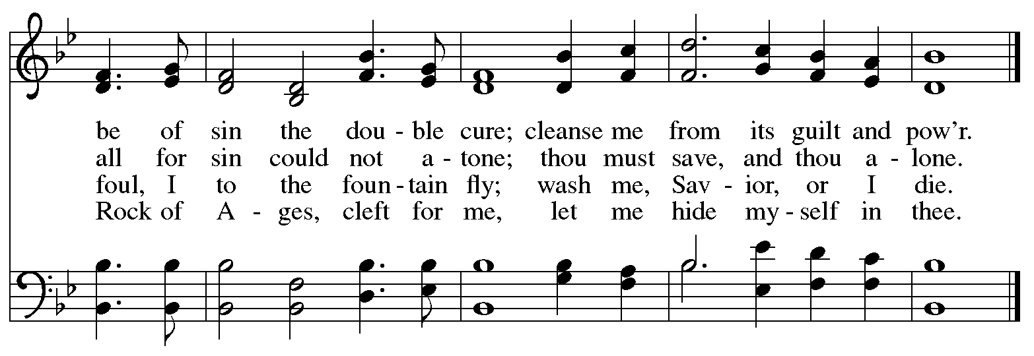


When all have returned to their places, please rise as you are able.

Blessing

P: The body and blood of our Lord Jesus Christ strengthen you and keep you in his grace.
C: Amen.

Prayer

A: Let us pray.
Compassionate God, you have fed us with the bread of heaven.
Sustain us in our Lenten pilgrimage: may our fasting be hunger for justice;
our alms, a making of peace; and our prayer, the song of grateful hearts, through Jesus Christ, our Savior and Lord.
C: Amen.

Please be seated.

Sending
God blesses us and sends us in mission to the world

Announcements

Please rise as you are able.

Benediction

P: Receive the blessing of the holy Trinity:
God, who calls all things into existence,
Jesus Christ, who redeems us,
and the Holy Spirit, whose breath sustains creation,
☩ bless you and keep you, now and forever.
C: Amen.

Sending Hymn Following page

Dismissal

A: Go in peace. Serve those in need.
C: Thanks be to God

Postlude

Sending Hymn Jesus, Keep Me Near the Cross ELW 335

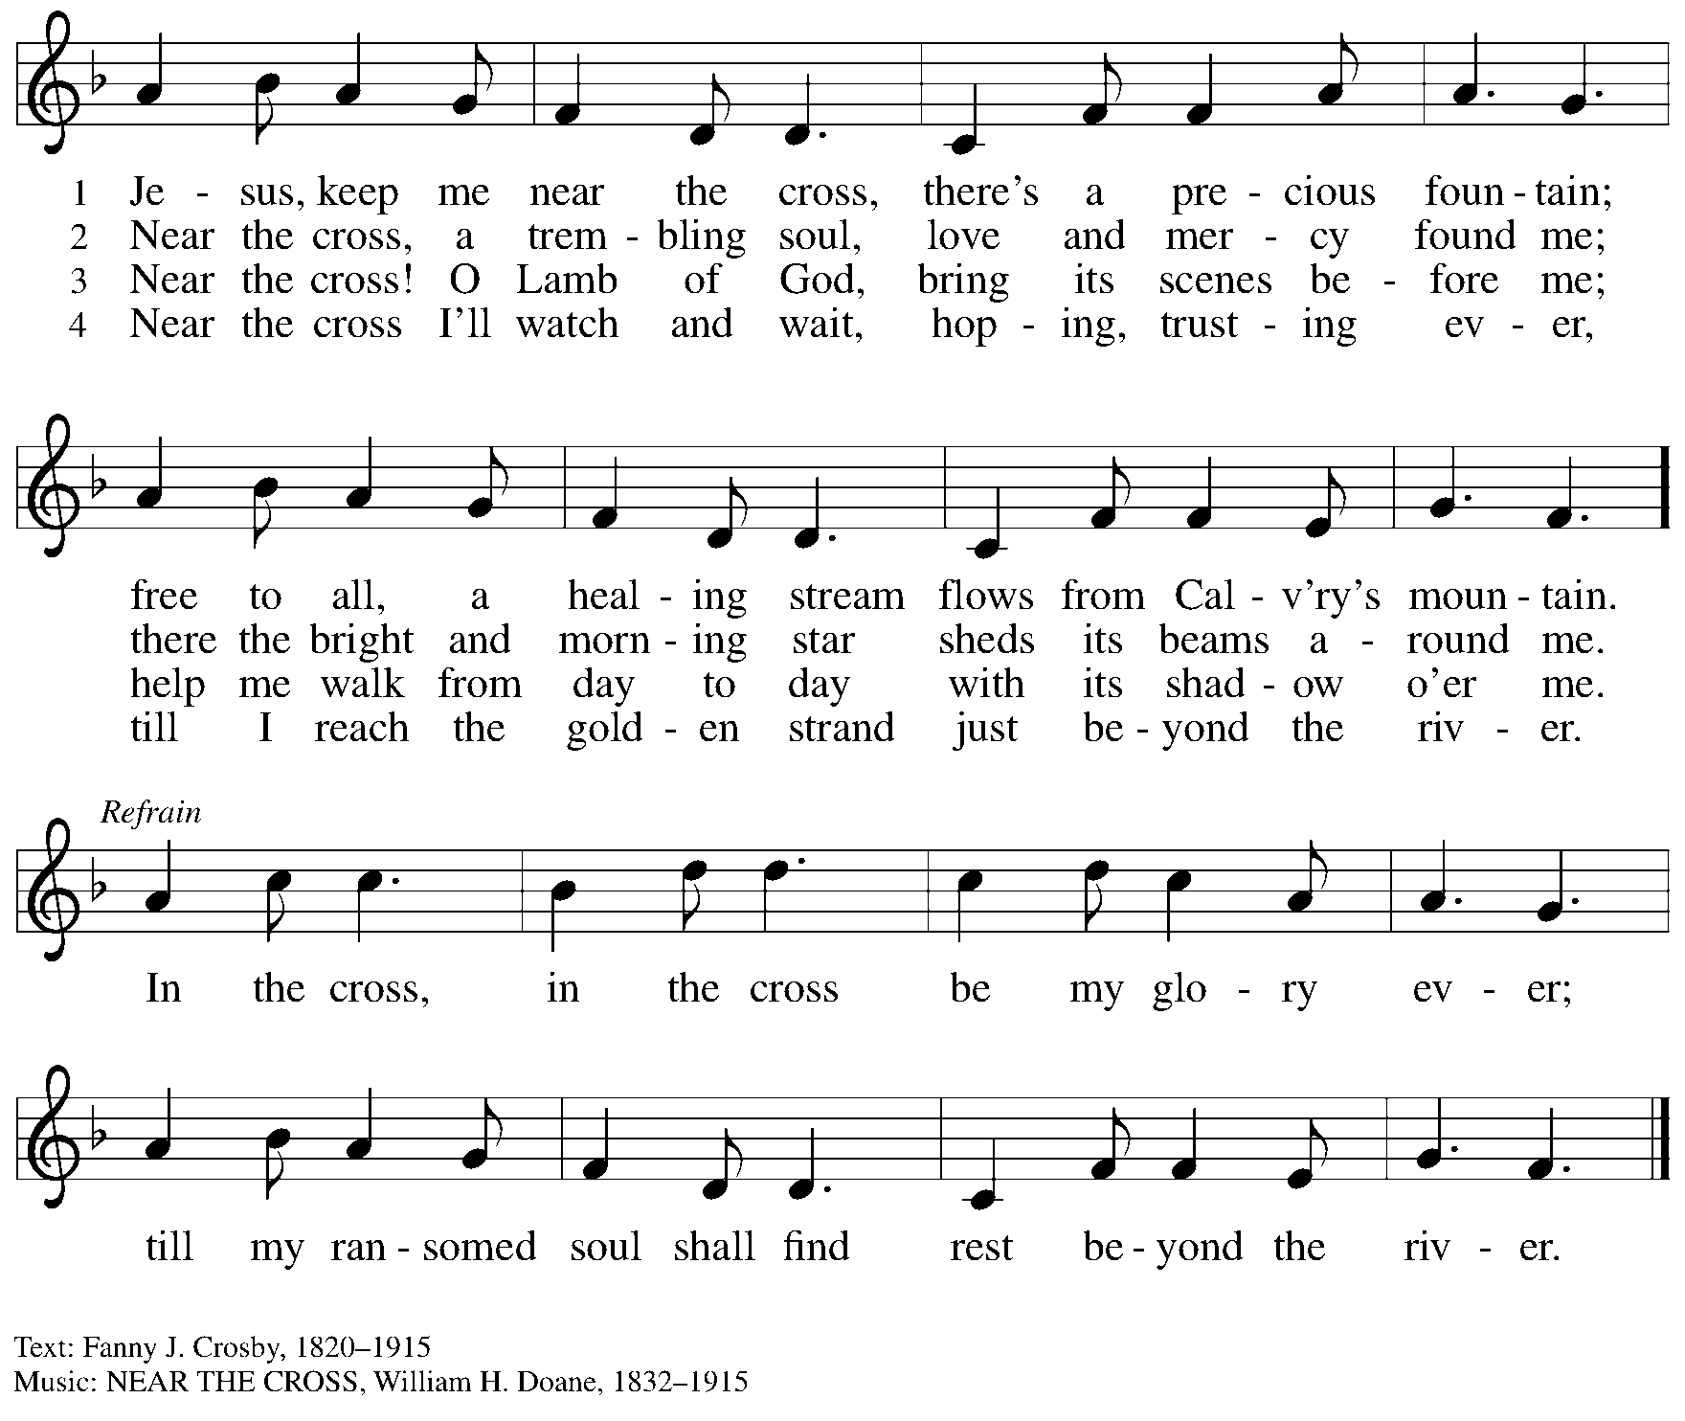

Serving in Worship Today

Altar Care Jodie Minor
Assisting Minister Jeff Denlinger
AV Ministers Sarita
Tyler Rietze
Cantor Mandy Best
Clarinet Maria Mangano
Lector Lindsay Baxter
Minister of Music Laura Reynolds
Presiding Minister The Rev. Ross Carmichael

Liturgy and Hymnody Acknowledgements

From SundaysandSeasons.com. Copyright © 2026 Augsburg Fortress. All rights reserved. Reprinted under OneLicense.net # A-722139.
Used by permission of Augsburg Fortress.

The Scripture readings contained herein are from New Revised Standard Version Updated Edition of the Bible © 2021 National Council of Churches of Christ in the United States of America. Used by permission. All rights reserved worldwide.

Please use the QR code below to link to St. Andrew’s Announcements online!



St. Andrew Lutheran Church Announcements
March 8th, 2026

- Welcome to Worship at St. Andrew on the Third Sunday in Lent – We are thankful you are here, and we offer a special welcome to all visitors and guests who are here for the first time! A nursery is available through the door to the left of the worship space and across the social hall (look for a purple room). There are also worship “toolkits” to help children engage with worship and “busy bags” for younger children available in the bookcase at the back of the sanctuary. Please feel free to take one to use with/for your children. All are invited to stay for coffee and other drinks, food, and conversation in the social hall (through the side door at the left of the worship space) after the service.
- Noisy Offering Next Week, Sunday, March 15th, during Worship – On the third Sunday of each month, St. Andrew’s children lead the congregation in a Noisy Offering, in which people are invited to throw their change into buckets that the children carry around the church and bring forward as an additional offering. Each month’s Noisy Offering supports a local, national, or international church-related or otherwise charitable organization. This month’s offering will benefit the Lutheran Campus Ministry in Greater Pittsburgh, our church's local ministry to the students of the University of Pittsburgh, Carnegie Mellon, Chatham, and Carlow Universities. You can more about their programming and service here: https://lucpgh.com/.
- Growing in Faith Together will Resume Today after Worship – This gathering is intended for people who are relatively new to St. Andrew, whether you are preparing to join the congregation by transfer or Affirmation of Baptism, or would just like to meet more people and learn about the congregation. Jeff Denlinger and Kelly Spanninger will serve as facilitators and will be happy to answer any questions.
- Bible Book Club, Wednesday, March 11th at 7:00 p.m. – Bible Book Club will meet weekly on Wednesdays at 7:00 p.m. All are welcome to participate. The group will be reading the Gospel of Mark along with The Gospel of Mark: A Beginner’s Guide to the Good News by Dr. Amy-Jill Levine. Here are the details on the book from one site: (https://www.cokesbury.com/The-Gospel-of-Mark-6?select=862810). You can join the Zoom call by going to: https://us02web.zoom.us/j/83196175976?pwd=ejdPOUYrTk4xVFdsdlhHUVJ1L3k2Zz09.
- Produce Distribution Supplemental Food of the Month – St. Andrew is collecting supplemental food each month to accompany our produce distribution. For March, we ask for donations of rice. There are collection boxes at the back of the worship space and social hall.
- Produce Distribution, Third Tuesday Each Month, March 17th from 5:30-6:30 p.m. – St. Andrew partners with Greater Pittsburgh Community Food Bank to serve as a distribution site for fresh produce on the first and third Tuesday of every month. We invite people of the congregation to help with the distribution from 5:30 p.m. – 6:30 p.m. and/or to help with unloading and setup during the day between 10:00 a.m. and 1:00 p.m.
- Lenten Resources – As ReconcilingWorks continues to strive to support you and your faith community in deepening and expanding the welcome, inclusion, and celebration of people of all sexual orientations, gender identities, and gender expressions, and commit to racial equity/anti-racism, they have shared this brand-new free Lenten devotional "of Justice, Liberation, and Flourishing." Lent draws us into a holy tension between humility and public faithfulness; Lent sharpens our moral attention. You can access the devotional here: https://www.reconcilingworks.org/wp-content/uploads/2026/02/Lenten-Devotional-from-ReconcilingWorks.pdf.
- Pittsburgh PRIDE Choir’s Spring Cabaret Concert, April 17th and 18th at 8:00 p.m. – The Board of Directors of the Pittsburgh PRIDE Choir, Pittsburgh's esteemed LGBTQIA+ choir, acknowledges and thanks you for your unwavering support and advocacy on behalf of our local LGBTQIA+ community. Your contributions, whether through business ownership, direct support, or quality of life initiatives, are invaluable. The Spring Season approaches rapidly and they would be privileged if you joined them for the Spring Cabaret Concert on April 17th and 18th. The concert begins at 8:00 pm, at East Liberty Presbyterian Church (116 S. Highland Ave, Pgh), a fully affirming and inclusive venue. For tickets to this and future events, visit https://events.ticketleap.com/events/pittsburgh-pride-choir.
- “Christ in Our Home” Booklets Available – “Christ in Our Home” is a quarterly devotional resource that encourages readers to live out their faith daily. Each reflective reading is accompanied by a daily scripture reference and prayer for the day. The January-March booklets are available at the entrances. Please feel free to take one home!
- Coffee Hour Signups – St. Andrew provides hospitality during a coffee hour after worship each Sunday. If you would like to participate and would like information about the duties of setting up, please sign up using the following form: https://www.signupgenius.com/go/5080B4AAFAF2CABF85-47069030-coffee#/.

Flowers for Easter

St. Andrew will be ordering Lilies (6 inch, five bloom - $8.25 each)
Tulips (8 inch - $9.00 each))
Daffodils (6 inch - $5.50 each)
to decorate the worship space for Easter Sunday, April 5th,
and the Easter season.
If you would like to sponsor or dedicate flowers, please complete this form
and submit it at the desk in the main office or through the Sunday offering plates.
Please submit payment with order - Checks may be made payable to:
St. Andrew Lutheran Church
Order by Sunday, March 29th.

Name __________________________________________
In Honor of __________________________________________
In Memory of __________________________________________
In Appreciation/Love for __________________________________________

Number of Lilies ________
Number of Tulips ________
Number of Daffodils ________

