

+ Fourth Sunday in Lent
March 15, 2026



St. Andrew Lutheran Church
304 Morewood Ave.
Pittsburgh, PA 15213
St_andrewELCA@verizon.net
www.standrewpittsburgh.org

+ Fourth Sunday in Lent
Order for Worship

Baptism is sometimes referred to as enlightenment. The gospel for this Sunday is the story of a man who was born blind being healed by Jesus. “I was blind, now I see,” declares the man. In Baptism, God opens our eyes to see the truth of who we are: God’s beloved children.
As David was anointed king of Israel, in Baptism God anoints our head with oil,
and calls us to bear witness to the light of Christ in our daily lives.

Welcome to St. Andrew!
- St. Andrew welcomes all who are seeking a place of healing, wholeness, and acceptance in a nurturing and faith-forming spiritual home. We are striving toward racial equity worldwide
and we seek to honor the lived experience of all individuals regardless of background. Our community embraces people of all ages, ethnicities, cultures, abilities, sexual orientations,
gender identities and expressions, and family constellations. Come and See!
- Worship Services are live-streamed to multiple online platforms. By attending worship, you agree that your image and voice may be broadcast.
- Everyone is invited to make a name tag at the black bookcase in the back of the worship space if they would like. There are stickers indicating pronouns on the bookcase if you would like to include them on your name tag.
- A nursery is available through the doors at the left side of the sanctuary and across from the doorway to the Social Hall. Look for a purple-colored room.
- Children are invited to attend Little Church – Big Faith, a Bible lesson and activity, during worship (after the Prayer of the Day). The group returns to the worship space for the liturgy of Holy Communion.
- Worship “toolkits” to help children engage with the service, along with “busy bags” for younger children, are available in the bookcase at the back of the sanctuary. Please feel free to take one to use with/for your children.
- Holy Communion is served with bread (gluten-free available) and wine or grape juice. The presiding minister will distribute the bread (host). Please consume this and then pick up an empty glass from the tray. The Communion Assistant will pour wine or grape juice into your glass. Please step to the side to consume the wine or grape juice. Feel free to kneel at the altar for prayer and reflection. As you return to your pew, glasses may be returned to the empty trays on either side of the center section.
- A restroom is available on the main level of the church, through the doors to the Social Hall and to the right in the main office.

Abbreviations
P: Pastor/Presiding Minister ELW: Evangelical Lutheran Worship hymnal
A: Assisting Minister ACS: All Creation Sings hymnal
L: Lector
C: Congregation

Musical Offering

Each week, different people from the congregation make an offering of pre-service music, with singing or instrumentation, to help the assembly focus and pray in preparation for worship.

Welcome

Prelude O Creator, We Have Wandered arr. Shaw

Gathering
The Holy Spirit calls us together as the people of God

Please rise as you are able. All may make the sign of the cross,
the sign that is marked at Baptism, as the presiding minister begins.

Confession and Forgiveness

P: Blessed be the holy Trinity, ☩ one God,
who forgives all our sin, whose mercy endures forever.
C: Amen.

P: Let us confess our sin before God, who removes our guilt
and blots out all offenses.

Silence is kept for reflection.

P: Gracious God,
C: have mercy on us according to your steadfast love.

P: For seeking worldly delights that deceive us and dishonor you:
Gracious God,
C: have mercy on us according to your steadfast love.

P: For desiring self-reliance instead of hungering for your word:
Gracious God,
C: have mercy on us according to your steadfast love.

P: For failing to recognize your coming reign,
and for hindering the work of the Spirit: Gracious God,
C: have mercy on us according to your steadfast love.

P: For drawing from the well of self-serving ambition,
and for disdaining the living water Christ offers: Gracious God,
C: have mercy on us according to your steadfast love.

P: For disregarding voices from the margins,
and for distrusting signs of your healing and hope in the world:
Gracious God,
C: have mercy on us according to your steadfast love.

P: For dwelling in tombs of self-pity and discontent,
and for disregarding Christ’s call to come forth to life:
Gracious God,
C: have mercy on us according to your steadfast love.

P: God’s steadfast love, grace, and forgiveness abound.
Through faith, the free gift of God,
you have been clothed in the righteousness of Christ.
In the name of ☩ Jesus Christ, your sins are forgiven.
The Spirit of the One who raised Christ from the dead dwells in you,
pours love into your hearts, and gives you life and peace.
C: Amen.



Gathering Hymn Dearest Jesus, at Your Word ELW 520
v. 1-3

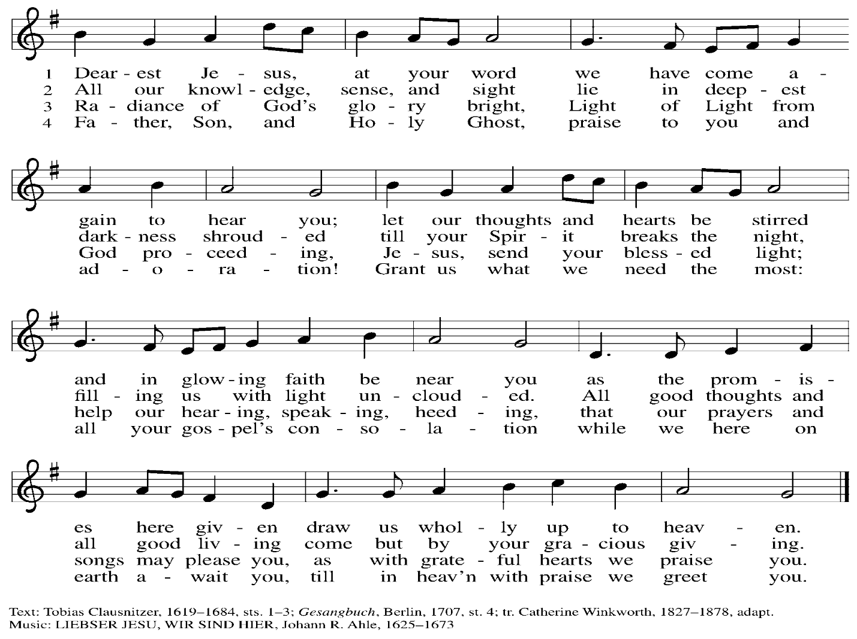

Greeting

P: The grace of our Lord Jesus Christ, the love of God,
and the communion of the Holy Spirit be with you all.
C: And also with you.

Kyrie ELW p. 193

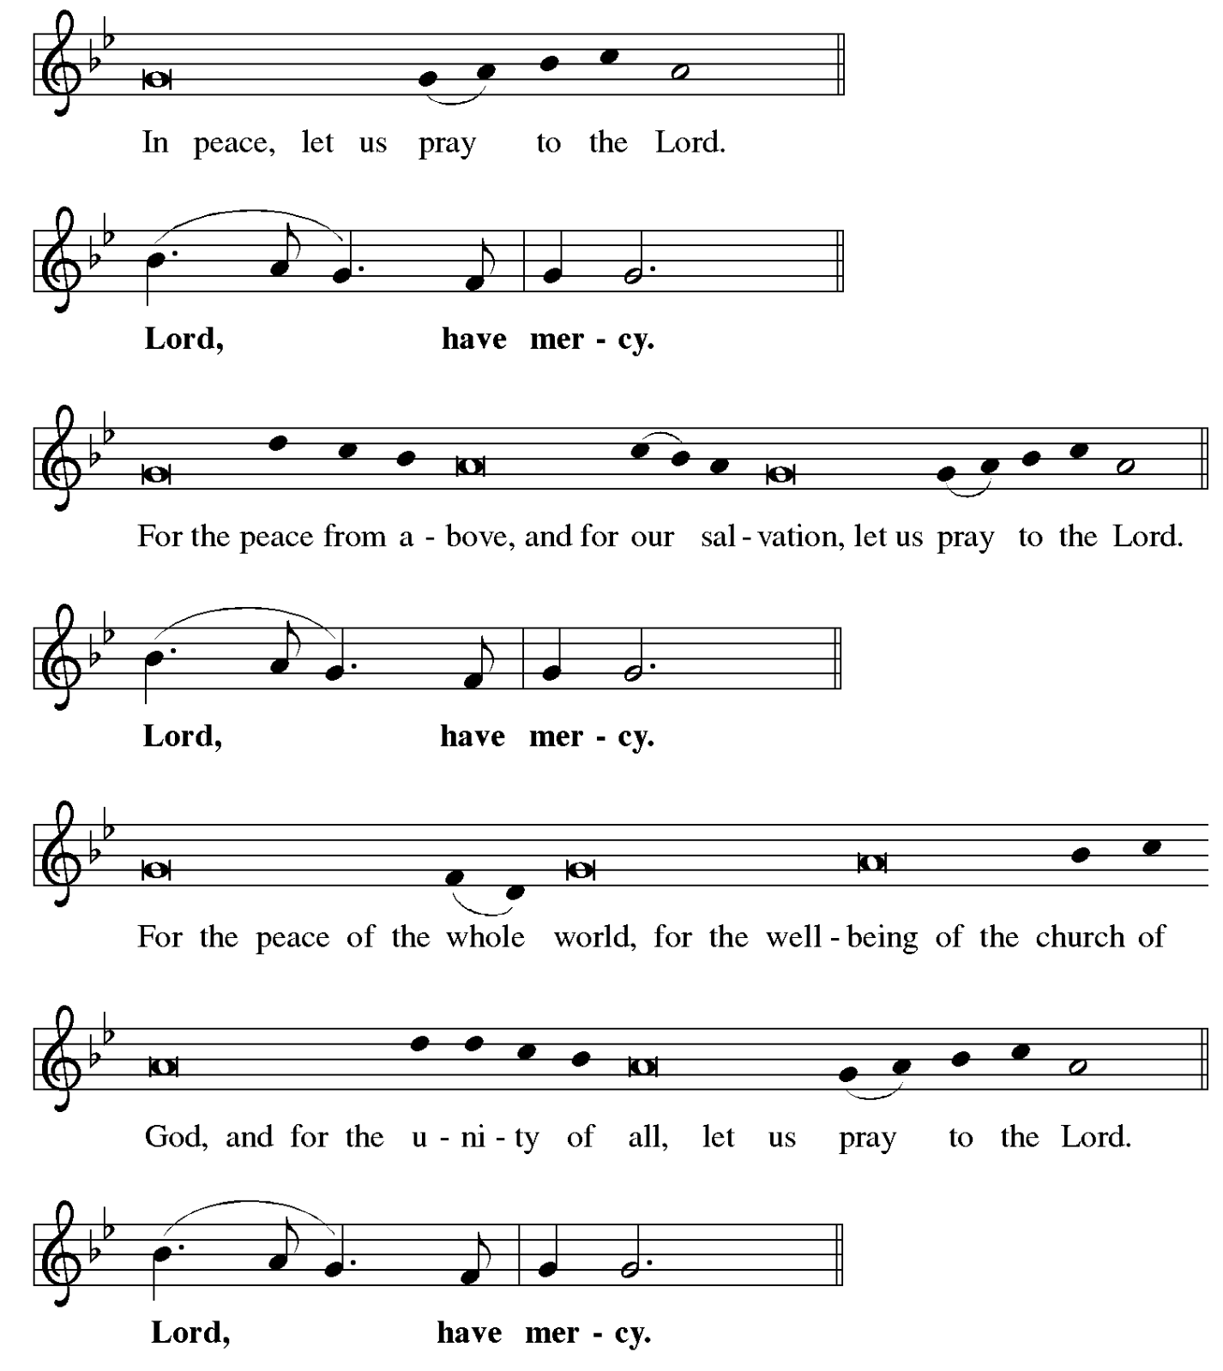
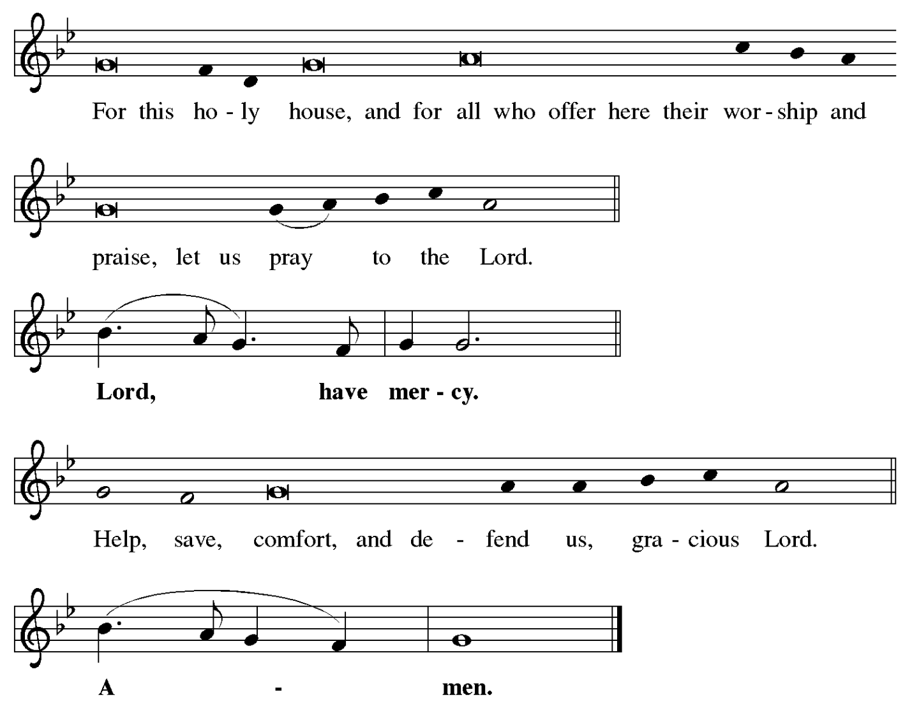

Prayer of the Day

P: The Lord be with you.
C: And also with you.

P: Bend your ear to our prayers, Lord Christ, and come among us.
By your gracious life and death for us, bring light into the darkness of our hearts,
and anoint us with your Spirit, for you live and reign with the Father and the Holy Spirit,
one God, now and forever.
C: Amen.

Please be seated.
Children are invited to join the adult leader(s) at the side door for Little Church – Big Faith.
We ask that an additional adult from the congregation attend with the children.

Word
God speaks to us in Scripture reading, preaching, and song

First Reading – 1 Samuel 16: 1-13

¹ The Lord said to Samuel, “How long will you grieve over Saul? I have rejected him from being king over Israel. Fill your horn with oil and set out; I will send you to Jesse the Bethlehemite, for I have provided for myself a king among his sons.” ² Samuel said, “How can I go? If Saul hears of it, he will kill me.” And the Lord said, “Take a heifer with you and say, ‘I have come to sacrifice to the Lord.’ ³ Invite Jesse to the sacrifice, and I will show you what you shall do, and you shall anoint for me the one whom I name to you.” ⁴ Samuel did what the Lord
commanded and came to Bethlehem. The elders of the city came to meet him trembling and said, “Do you come peaceably?” ⁵ He said, “Peaceably. I have come to sacrifice to the Lord; sanctify yourselves and come with me to the sacrifice.” And he sanctified Jesse and his sons and invited them to the sacrifice.
⁶ When they came, he looked on Eliab and thought, “Surely God’s anointed is now before the
Lord.” ⁷ But the Lord said to Samuel, “Do not look on his appearance or on the height of his stature, because I have rejected him, for the Lord does not see as mortals see; they look on the outward appearance, but the Lord looks on the heart.” ⁸ Then Jesse called Abinadab and made him pass before Samuel. He said, “Neither has the Lord chosen this one.” ⁹ Then Jesse made Shammah pass by. And he said, “Neither has the Lord chosen this one.” ¹⁰ Jesse made seven of his sons pass before Samuel, and Samuel said to Jesse, “The Lord has not chosen any of these.” ¹¹ Samuel said to Jesse, “Are all your sons here?” And he said, “There remains yet the youngest, but he is keeping the sheep.” And Samuel said to Jesse, “Send and bring him, for we will not sit down until he comes here.” ¹² He sent and brought him in. Now he was ruddy and had beautiful eyes and was handsome. The Lord said, “Rise and anoint him, for this is the one.”
¹³ Then Samuel took the horn of oil and anointed him in the presence of his brothers, and the spirit of the Lord came mightily upon David from that day forward. Samuel then set out and went to Ramah.

L: Word of God, word of life.
C: Thanks be to God.

Psalm 23 Shepherd Me, O God Following page

The appointed psalm for today is Psalm 23. The congregation is invited to join the choir in singing Shepherd Me, O God, ELW 780, which is based on the 23rd Psalm.

Psalm 23 Shepherd Me, O God ELW 780

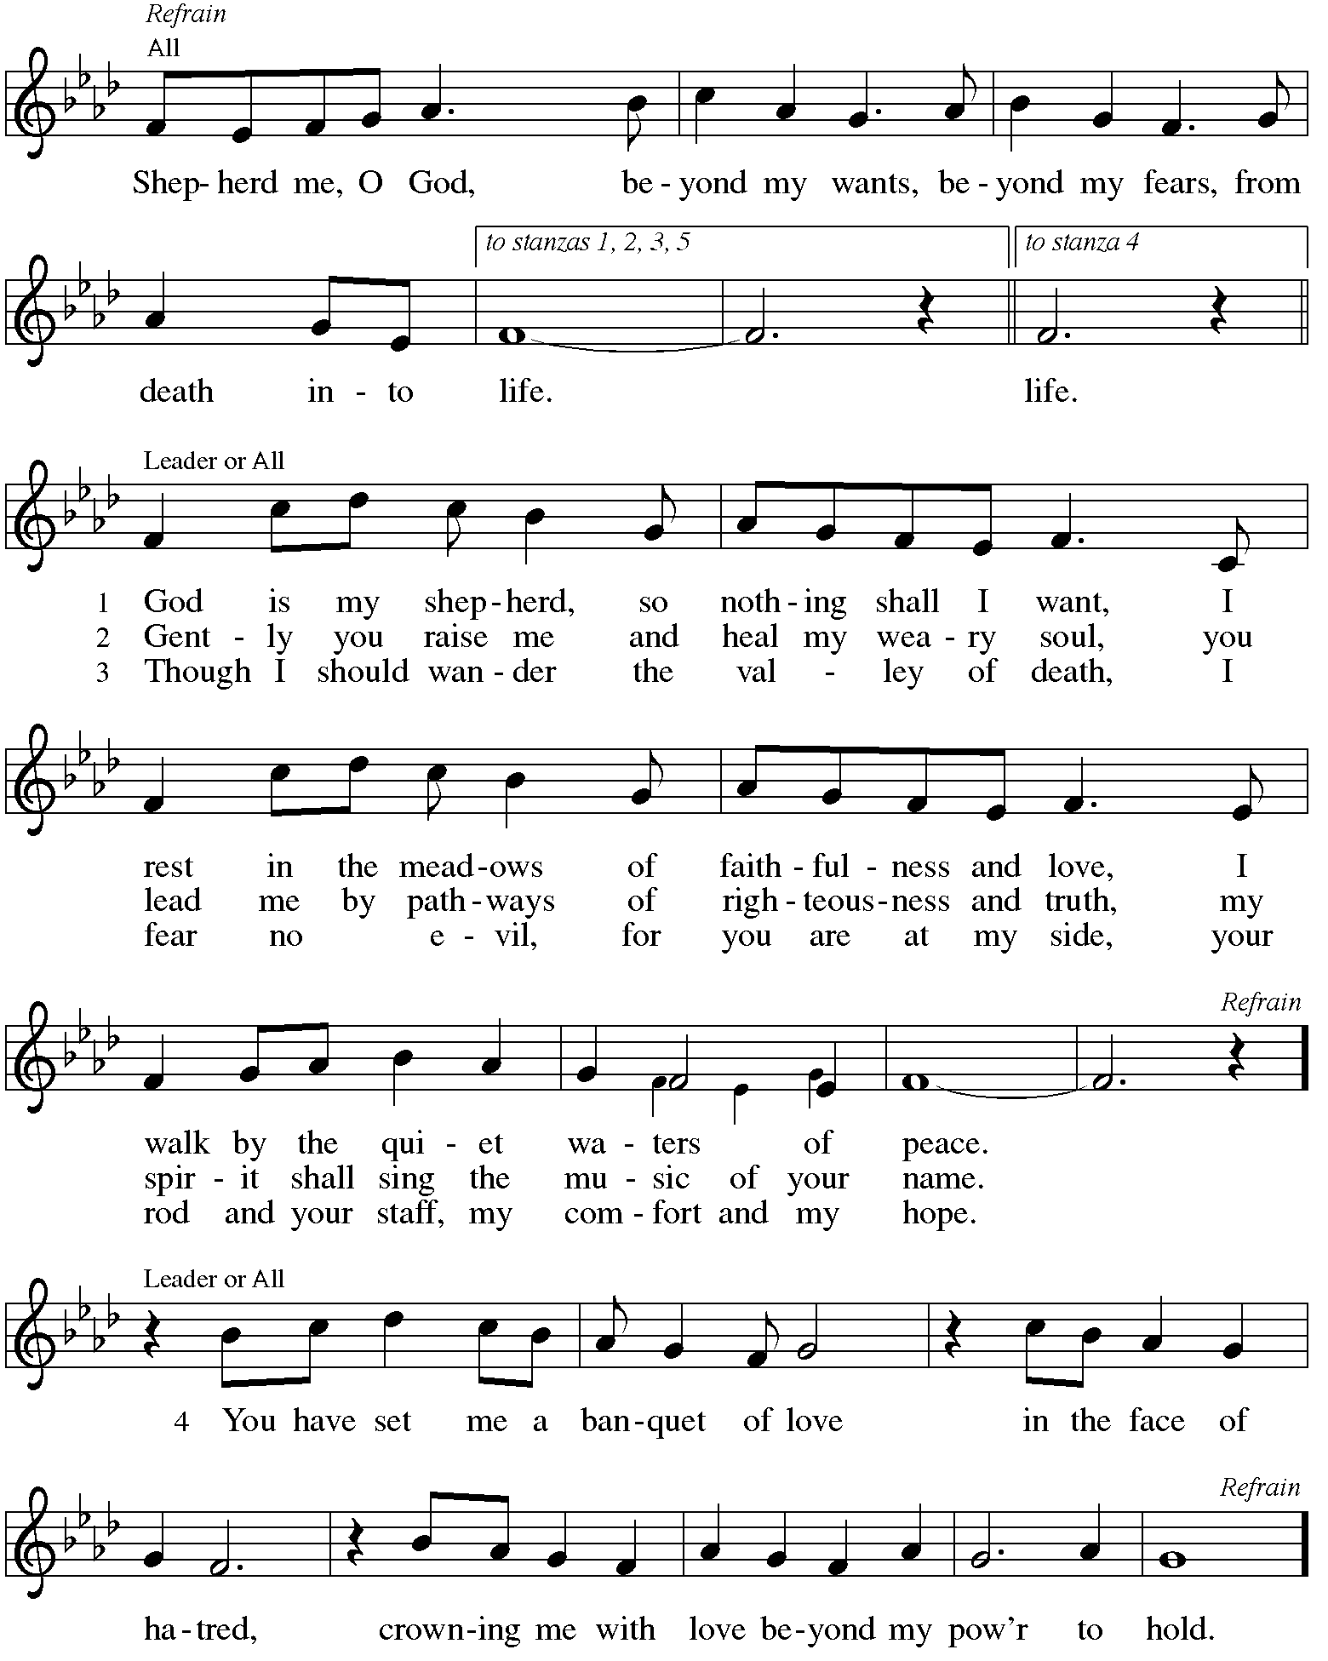

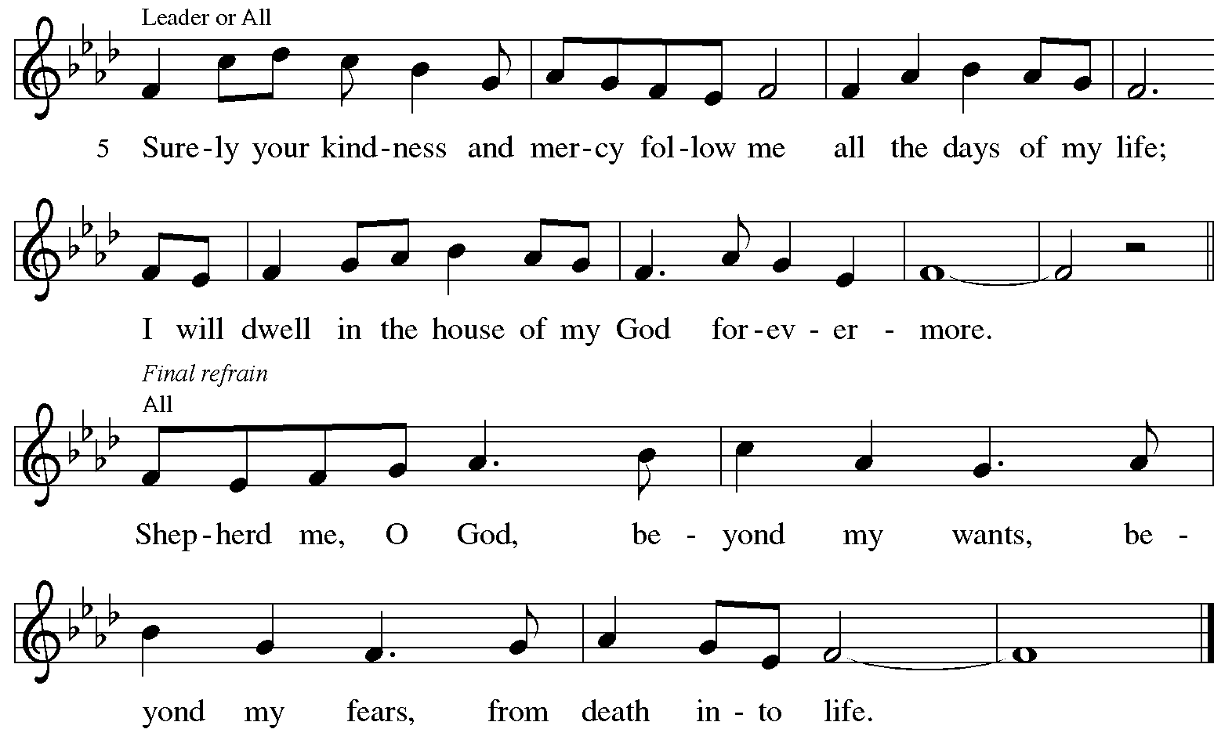

Reprinted under OneLicense.net # A-722139.

Second Reading – Ephesians 5: 8-14

⁸ Once you were darkness, but now in the Lord you are light. Walk as children of light, ⁹ for the fruit of the light is found in all that is good and right and true. ¹⁰ Try to find out what is pleasing to the Lord. ¹¹ Take no part in the unfruitful works of darkness; rather, expose them. ¹² For it is shameful even to mention what such people do secretly, ¹³ but everything exposed by the light becomes visible, ¹⁴ for everything that becomes visible is light. Therefore it says,
“Sleeper, awake!
Rise from the dead,
and Christ will shine on you.”

L: Word of God, word of life.
C: Thanks be to God.

Please rise as you are able.

Gospel Verse ELW p. 198

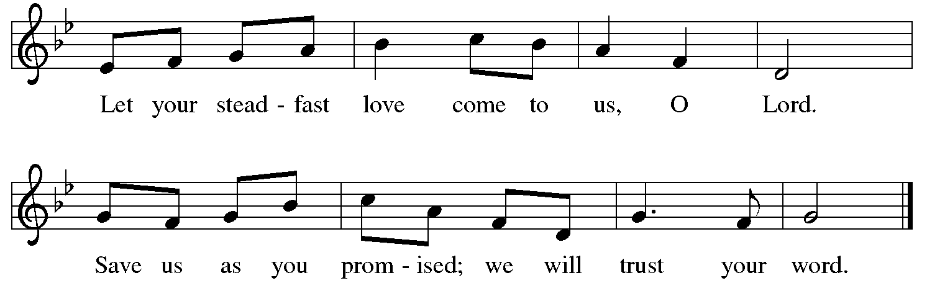

Gospel – John 9: 1-41

P: The holy Gospel according to St. John.
C: Glory to you, O Lord.

¹ As [Jesus] walked along, he saw a man blind from birth. ² His disciples asked him, “Rabbi, who sinned, this man or his parents, that he was born blind?” ³ Jesus answered, “Neither this man nor his parents sinned; he was born blind so that God’s works might be revealed in him. ⁴ We must work the works of the one who sent me while it is day; night is coming, when no one can work.
⁵ As long as I am in the world, I am the light of the world.” ⁶ When he had said this, he spat on the ground and made mud with the saliva and spread the mud on the man’s eyes, ⁷ saying to him, “Go, wash in the pool of Siloam” (which means Sent). Then he went and washed and came back able to see. ⁸ The neighbors and those who had seen him before as a beggar began to ask, “Is this not the man who used to sit and beg?” ⁹ Some were saying, “It is he.” Others were saying, “No, but it is someone like him.” He kept saying, “I am he.” ¹⁰ But they kept asking him, “Then how were your eyes opened?” ¹¹ He answered, “The man called Jesus made mud, spread it on my eyes, and said to me, ‘Go to Siloam and wash.’ Then I went and washed and received my sight.”
¹² They said to him, “Where is he?” He said, “I do not know.”
¹³ They brought to the Pharisees the man who had formerly been blind. ¹⁴ Now it was a Sabbath day when Jesus made the mud and opened his eyes. ¹⁵ Then the Pharisees also began to ask him how he had received his sight. He said to them, “He put mud on my eyes. Then I washed, and now I see.” ¹⁶ Some of the Pharisees said, “This man is not from God, for he does not observe the Sabbath.” Others said, “How can a man who is a sinner perform such signs?” And they were divided. ¹⁷ So they said again to the blind man, “What do you say about him? It was your eyes he opened.” He said, “He is a prophet.”
¹⁸ The Jews did not believe that he had been blind and had received his sight until they called the parents of the man who had received his sight ¹⁹ and asked them, “Is this your son, who you say was born blind? How then does he now see?” ²⁰ His parents answered, “We know that this is our son and that he was born blind, ²¹ but we do not know how it is that now he sees, nor do we know who opened his eyes. Ask him; he is of age. He will speak for himself.”
²² His parents said this because they were afraid of the Jews, for the Jews had already agreed that anyone who confessed Jesus to be the Messiah would be put out of the synagogue. ²³ Therefore his parents said, “He is of age; ask him.”
²⁴ So for the second time they called the man who had been blind, and they said to him, “Give glory to God! We know that this man is a sinner.” ²⁵ He answered, “I do not know whether he is a sinner. One thing I do know, that though I was blind, now I see.” ²⁶ They said to him, “What did he do to you? How did he open your eyes?” ²⁷ He answered them, “I have told you already, and you would not listen. Why do you want to hear it again? Do you also want to become his disciples?” ²⁸ Then they reviled him, saying, “You are his disciple, but we are disciples of Moses. ²⁹ We know that God has spoken to Moses, but as for this man, we do not know where he comes from.” ³⁰ The man answered, “Here is an astonishing thing! You do not know where he comes from, yet he opened my eyes. ³¹ We know that God does not listen to sinners, but God does listen to one who worships God and obeys God’s will. ³² Never since the world began has it been heard that anyone opened the eyes of a person born blind. ³³ If this man were not from God, he could do nothing.” ³⁴ They answered him, “You were born entirely in sins, and are you trying to teach us?” And they drove him out.
³⁵ Jesus heard that they had driven him out, and when he found him he said, “Do you believe in the Son of Humanity?” ³⁶ He answered, “And who is he, sir? Tell me, so that I may believe in him.” ³⁷ Jesus said to him, “You have seen him, and the one speaking with you is he.” ³⁸ He said, “Lord, I believe.” And he worshiped him. ³⁹ Jesus said, “I came into this world for judgment, so that those who do not see may see and those who do see may become blind.” ⁴⁰ Some of the Pharisees who were with him heard this and said to him, “Surely we are not blind, are we?”
⁴¹ Jesus said to them, “If you were blind, you would not have sin. But now that you say,
‘We see,’ your sin remains.”

P: The Gospel of the Lord.
C: Praise to you, O Christ.

Please be seated.

Sermon

A time of silence for prayer and reflection follows the sermon.
When the hymn of the day begins, please rise as you are able.

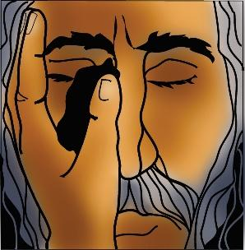

Hymn of the Day Let My Spirit Always Sing ACS 1020

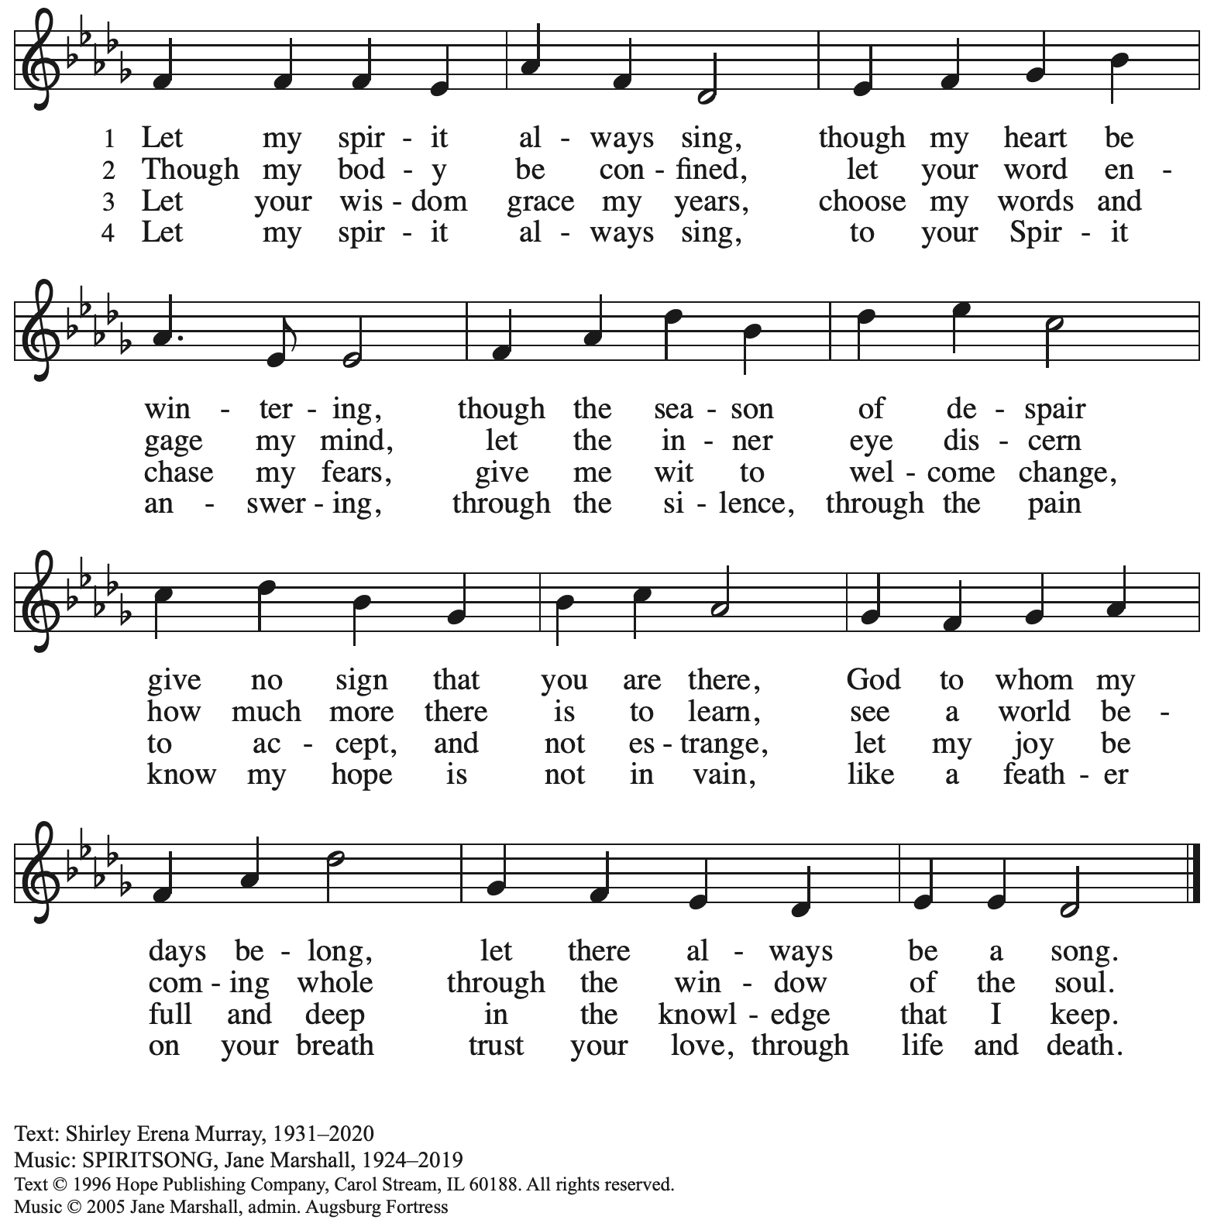
All rights reserved. Reprinted with permission under OneLicense.net # A-722139.

Apostles’ Creed

C: I believe in God, the Father almighty,
creator of heaven and earth.
C: I believe in Jesus Christ, God’s only Son, our Lord,
who was conceived by the Holy Spirit,
born of the virgin Mary,
suffered under Pontius Pilate,
was crucified, died, and was buried;
he descended to the dead.*
On the third day he rose again;
he ascended into heaven,
he is seated at the right hand of the Father,
and he will come to judge the living and the dead.

I believe in the Holy Spirit,
the holy catholic church,
the communion of saints,
the forgiveness of sins,
the resurrection of the body,
and the life everlasting. Amen.

*Or, “he descended into hell,” another translation of this text in widespread use.

Prayers of the People

A: Reconciled by God’s mercy and sustained by God’s presence,
let us pray for the world and its needs.

After each petition
A: Merciful God,
C: receive our prayer.

The presiding minister concludes the prayers
P: Receive our prayers, O God, through Jesus Christ, our strength and salvation.
C: Amen.

Peace

The presiding minister and the assembly greet one another in the peace of the risen Christ.
P: The peace of Christ be with you always.
C: And also with you.

The people may greet those around them with a sign of Christ’s peace and may say
Peace be with you or similar words. Please be mindful that not everyone will be comfortable with sharing the peace, so please seek consent before shaking hands or hugging.
Other possible ways to share the peace include a simple bow with the verbal greeting of peace, or simply a verbal expression of peace.

When the greetings of peace have concluded, please be seated.



Meal
God feeds us with the presence of Jesus Christ

Offering

We offer ourselves, our gifts, and our faithful service to God.
As the offering is gathered for the mission of the church, including the care of those in need,
the table is set for Holy Communion.

There are laminated giving cards in the pew racks that feature a QR code for anyone who would like to give online. Those who give using the QR code, as well as those who give regularly online or through their bank are encouraged to place the laminated card in the plate as an expression of your offering.

Noisy Offering

St. Andrew’s children lead the congregation in a special offering. As they carry buckets around the sanctuary, people of the congregation are invited to throw in their change as an offering.
This month’s Noisy Offering will benefit Lutheran Campus Ministry in Greater Pittsburgh, our church's local ministry to the students of the University of Pittsburgh, Carnegie Mellon, Chatham, and Carlow Universities. You can learn more about their programming and service here: https://lucpgh.com/.

Offertory Music The Old Rugged Cross arr. Edstrom

As the gifts are brought forward for presentation, please rise as you are able.

Offertory Song Create in Me a Clean Heart ELW 186

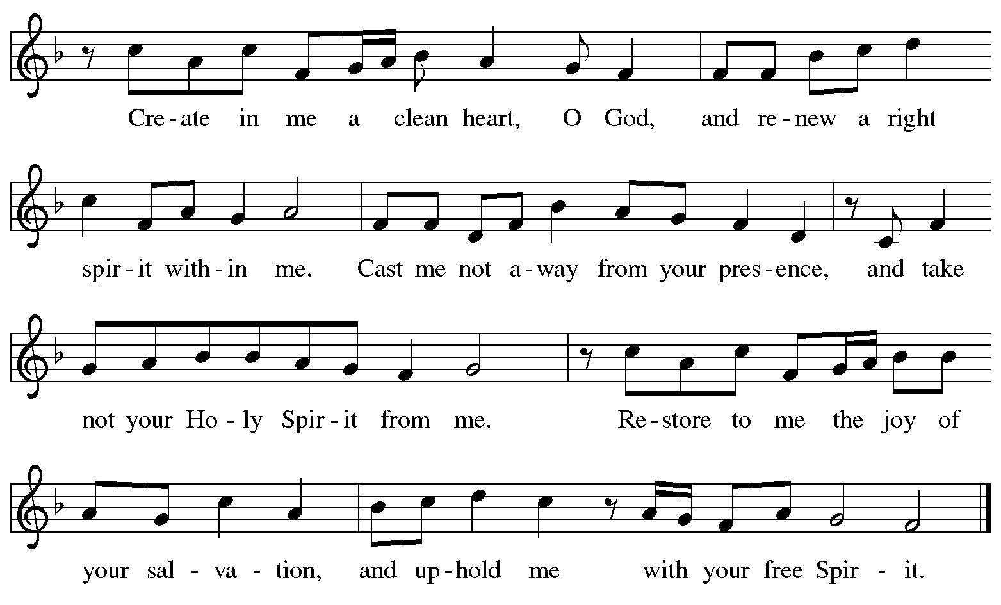
All rights reserved. Reprinted with permission under One License.net # A-722139.

Offertory Prayer

A: Let us pray.
God our provider,
C: have not fed us with bread alone, but with words of grace and life.
Bless us and these your gifts, which we receive from your bounty,
through Jesus Christ our Lord.
Amen.

Dialogue ELW p. 199

P: The Lord be with you.
C: And also with you.

P: Lift up your hearts.
C: We lift them to the Lord.

P: Let us give thanks to the Lord our God.
C: It is right to give our thanks and praise.
Preface (Spoken by the presiding minister)

P: It is indeed right, our duty and our joy,
that we should at all times and in all places
give thanks and praise to you, almighty and merciful God,
through our Savior Jesus Christ.
You call your people to cleanse their hearts
and prepare with joy for the paschal feast,
that, renewed in the gift of Baptism,
we may come to the fullness of your grace.
And so, with all the choirs of angels,
with the church on earth and the hosts of heaven,
we praise your name and join their unending hymn:

Sanctus ELW p. 200

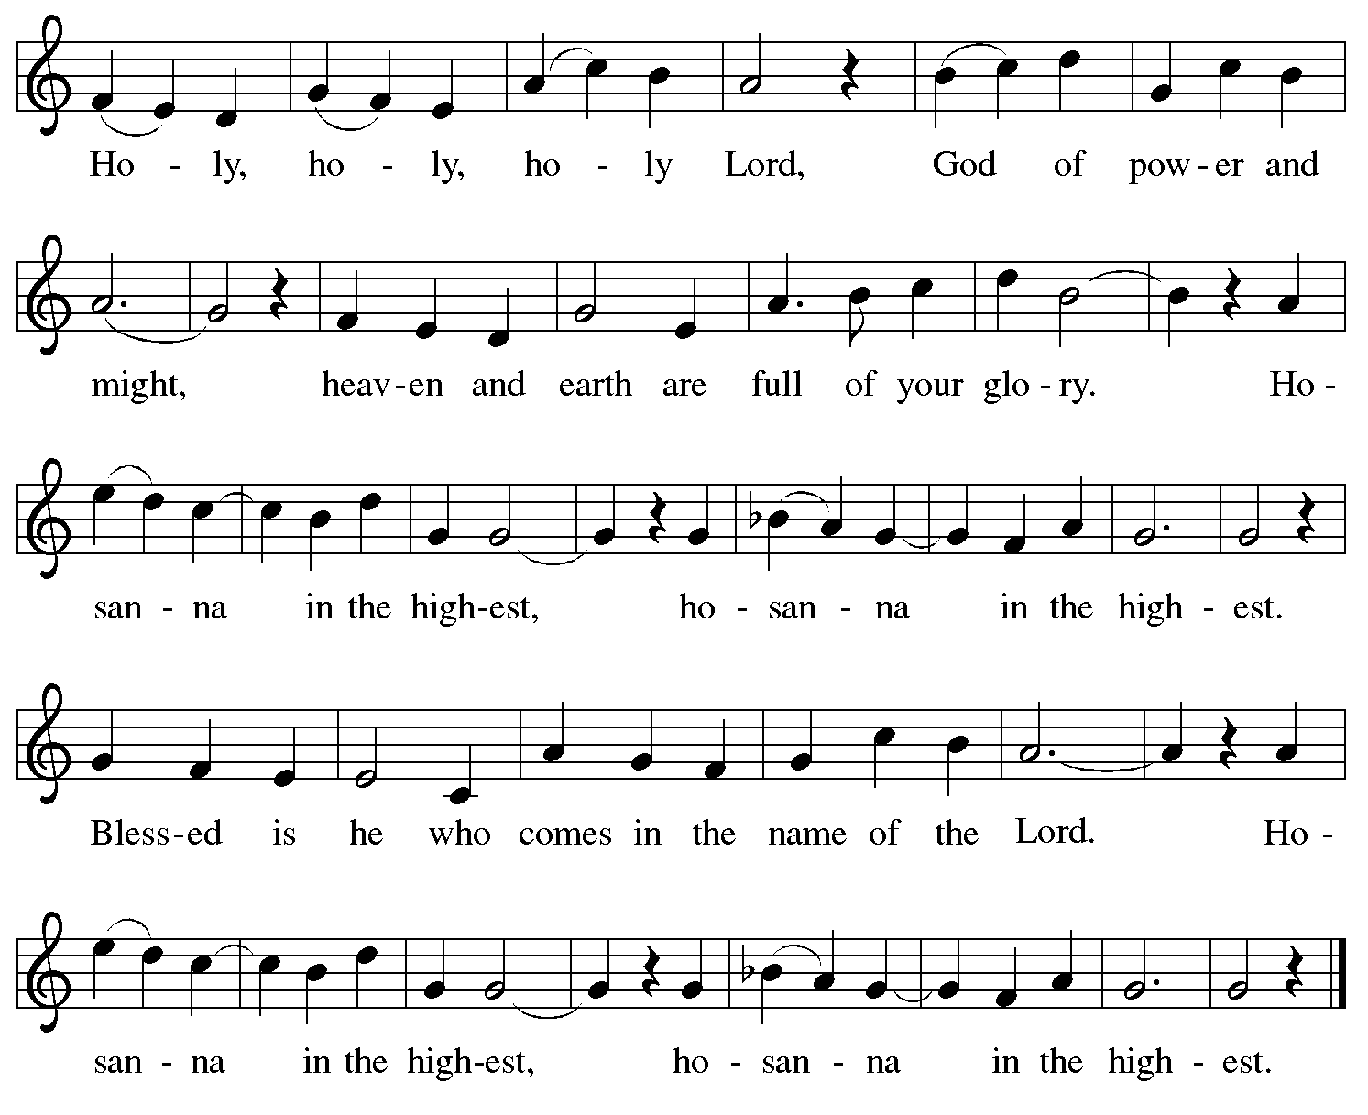

Eucharistic Prayer

P: Blessed are you, O God of the universe …
… Do this for the remembrance of me.

With this bread and cup
we remember our Lord’s passover from death to life
as we proclaim the mystery of faith:
C: Christ has died. Christ is risen. Christ will come again.

P: O God of resurrection and new life …
… Grace our table with your presence.
C: Come, Holy Spirit.

P: Reveal yourself to us in the breaking of the bread …
… Send us forth, burning with justice, peace, and love.
C: Come, Holy Spirit.

P: With your holy ones of all times and places …
… we praise you, O God, blessed and holy Trinity,
now and forever.
C: Amen.

Lord’s Prayer

P: Gathered as one by the Holy Spirit, let us pray as Jesus taught us.
C: Our Father in heaven,
hallowed be your name,
your kingdom come,
your will be done,
on earth as in heaven.
Give us today our daily bread.
Forgive us our sins
as we forgive those
who sin against us.
Save us from the time of trial
and deliver us from evil.
For the kingdom, the power,
and the glory are yours,
now and forever. Amen.

Fraction and Invitation

Agnus Dei / Lamb of God ELW p. 201

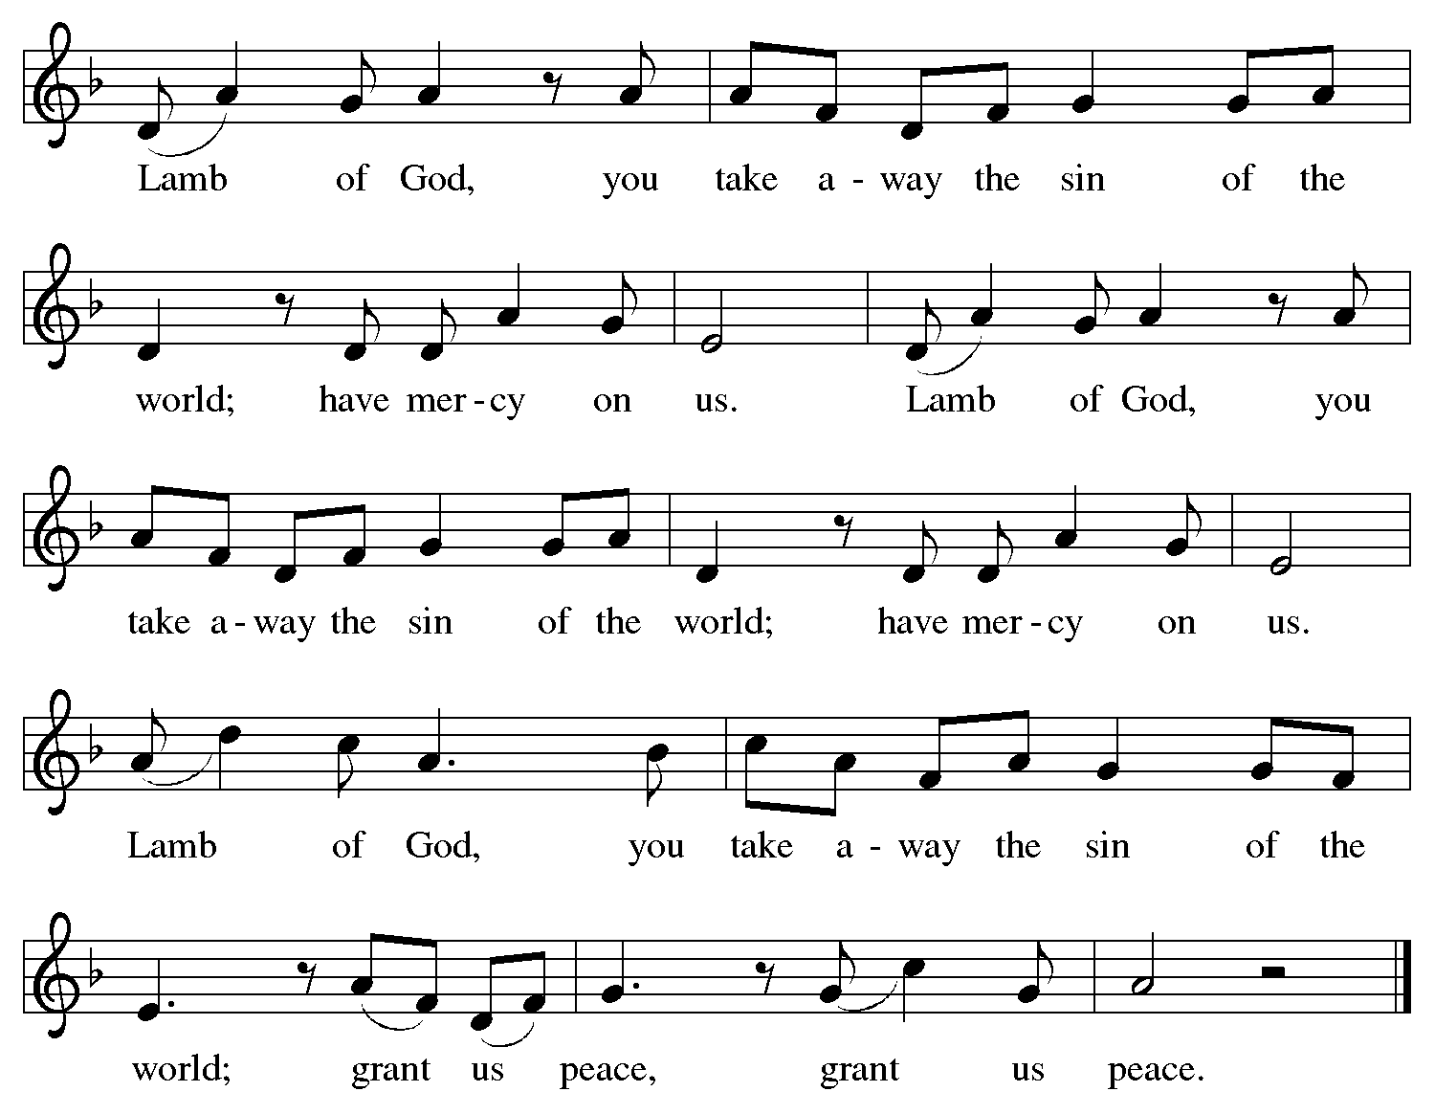

Please be seated.

Holy Communion

- All who seek God and desire a deeper and stronger life in Christ are welcome to receive Holy Communion.
- Worshipers from the pulpit side will proceed forward first, followed by the center section, and then the lectern side.
- Please inform an usher if you would like the ministers to bring Communion to you.
- Holy Communion will be served with bread and wine (amber) or grape juice (purple).
- The presiding minister will first distribute the bread (host) to each communicant. Please indicate if you require a gluten-free host.
- Once you have consumed the bread, please pick up an empty glass from the tray next to the presiding minister. The Communion Assistant will pour wine or grape juice into your glass.
- Please step to the side to consume the wine or grape juice.
- Feel free to kneel at the altar rail for prayer after receiving the sacrament.
- As you return to your pew, glasses may be returned to the empty tray on the side of the center section.
- A blessing will be provided for anyone who does not yet receive the sacrament.
- All are invited to join in singing the hymns during Holy Communion.

Hymns during Holy Communion
Awake, O Sleeper, Rise from Death ELW 452

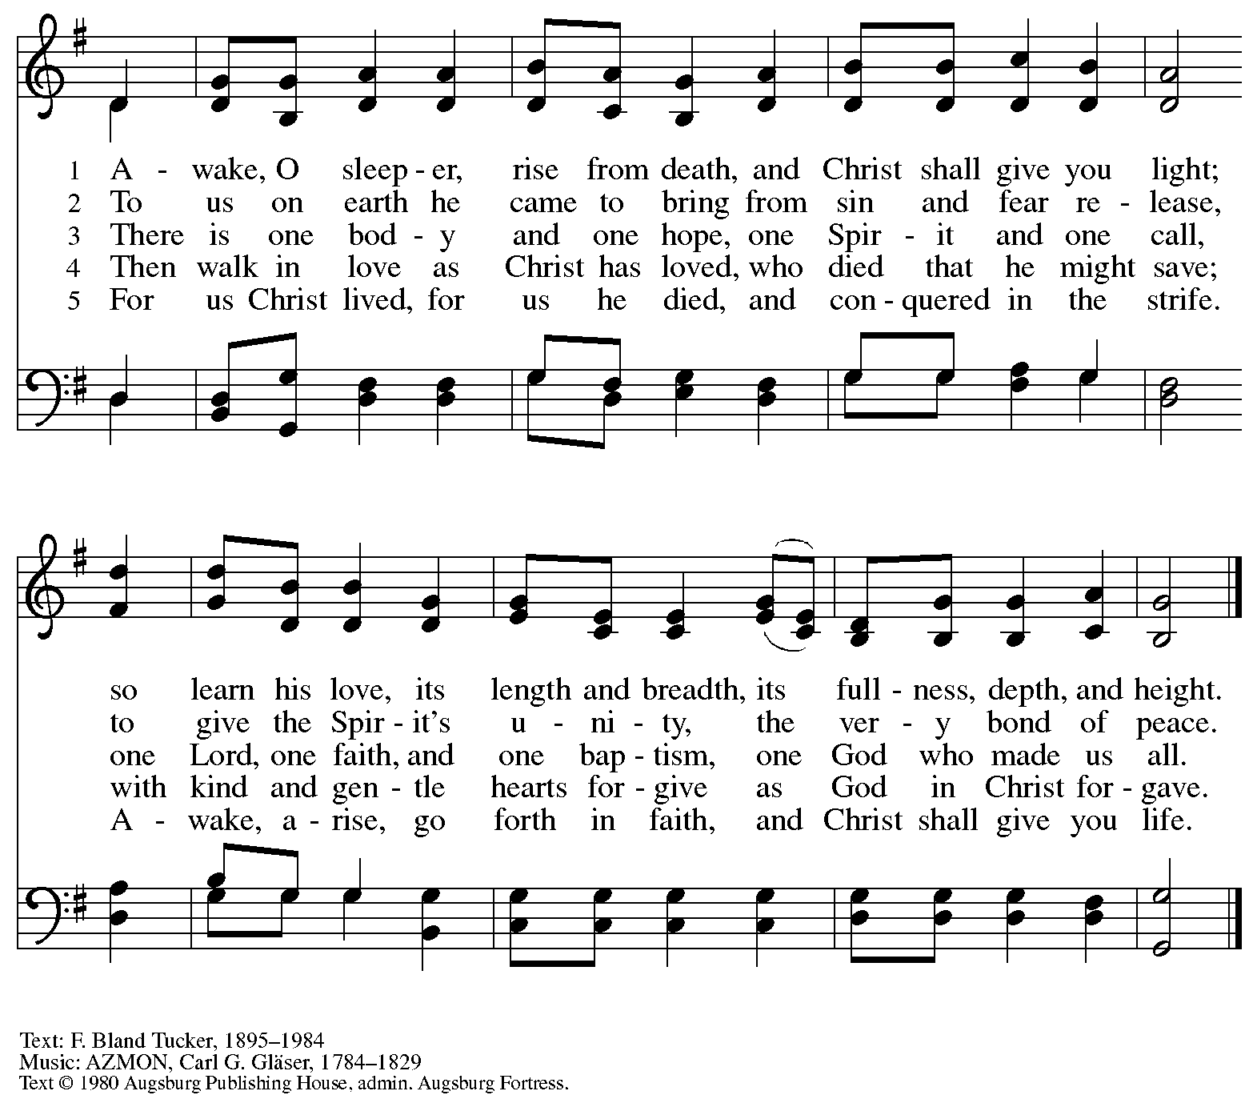
All rights reserved. Reprinted with permission under OneLicense.net # A-722319.

Hymns during Holy Communion
When We Must Bear Persistent Pain ACS 1014

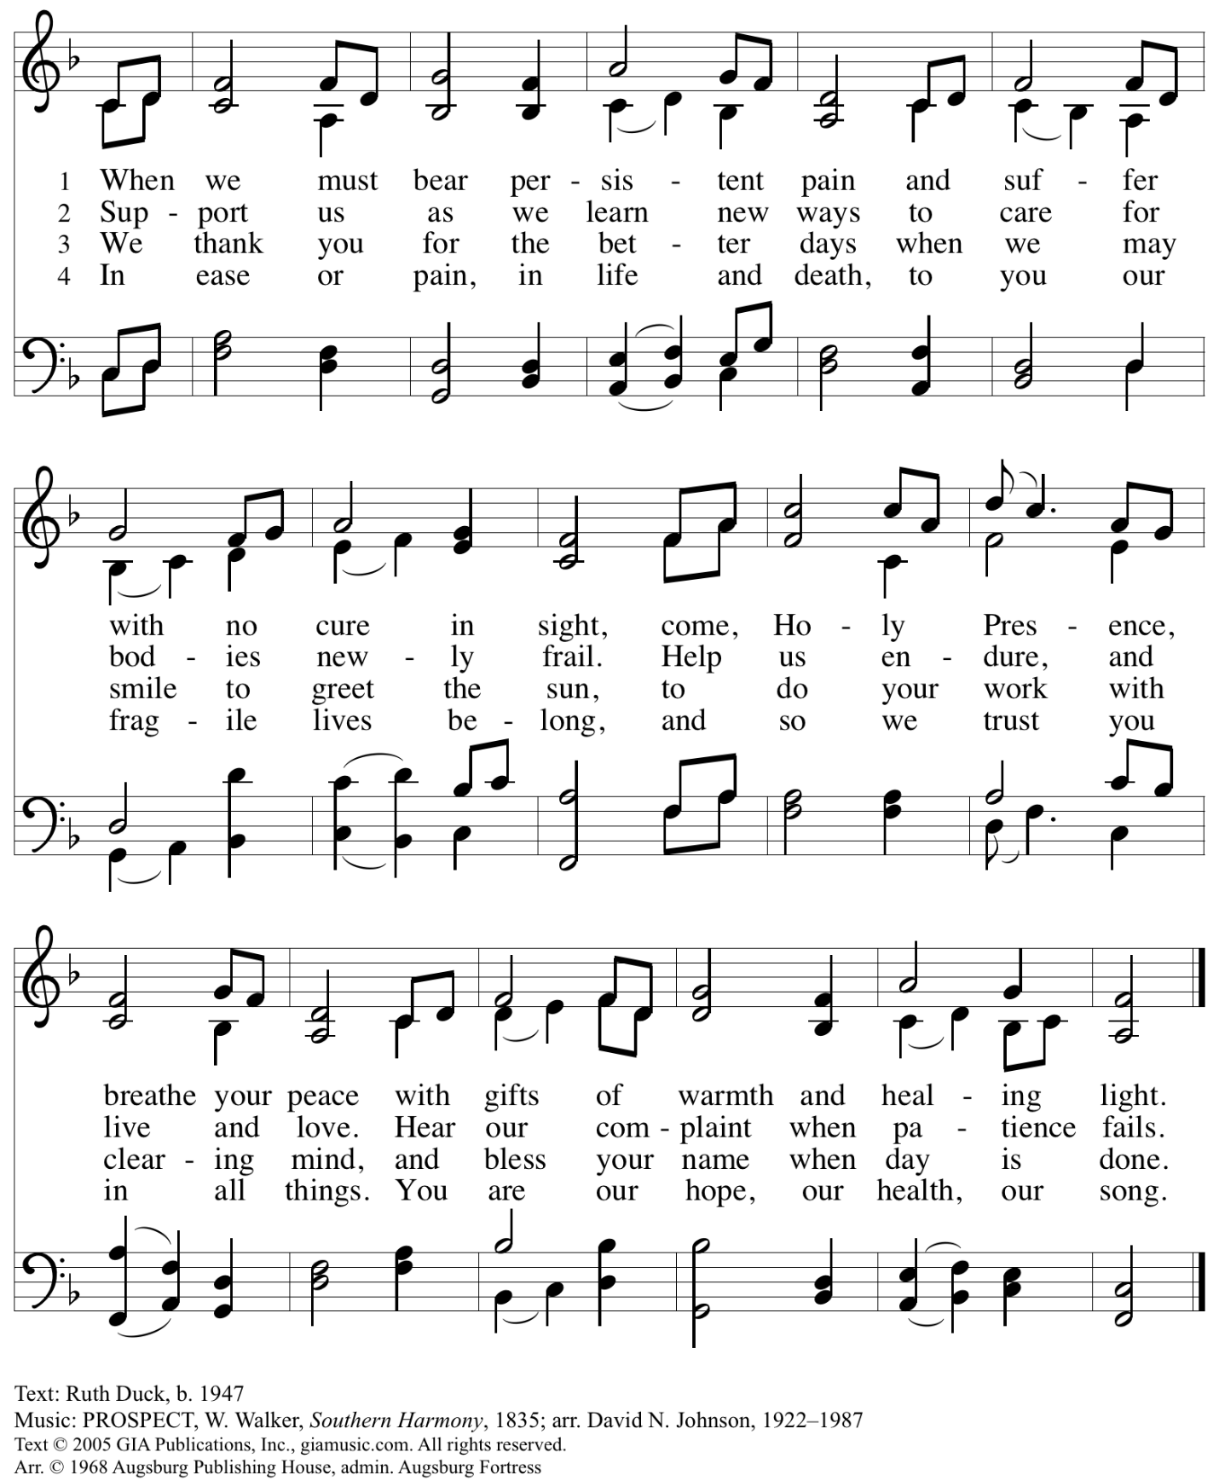
All rights reserved. Reprinted with permission under OneLicense.net # A-722139.

Hymns during Holy Communion
God, Whose Almighty Word ELW 673

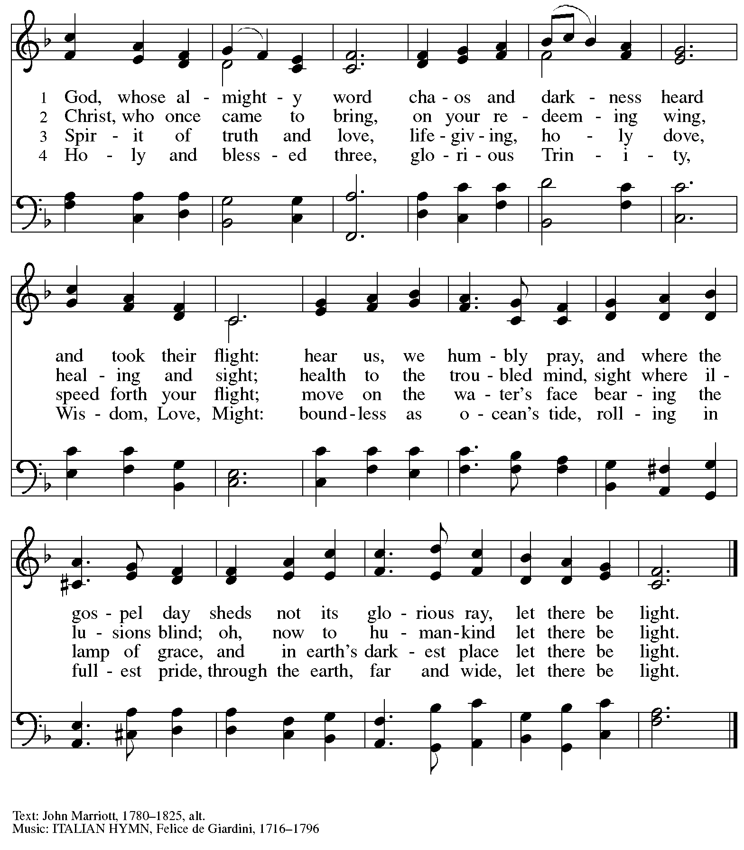

Hymns during Holy Communion
Be Thou My Vision ELW 793

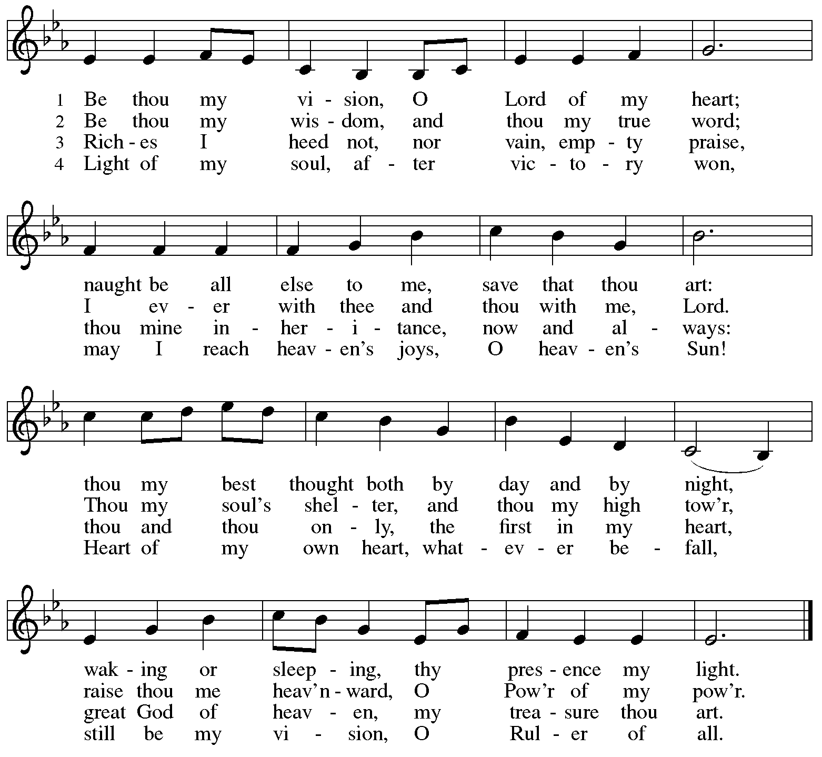

When all have returned to their places, please rise as you are able.

Blessing

P: The body and blood of our Lord Jesus Christ strengthen you and keep you in his grace.
C: Amen.
Prayer

A: Let us pray.
Compassionate God, you have fed us with the bread of heaven.
Sustain us in our Lenten pilgrimage: may our fasting be hunger for justice;
our alms, a making of peace; and our prayer, the song of grateful hearts, through Jesus Christ, our Savior and Lord.
C: Amen.

Please be seated.

Sending
God blesses us and sends us in mission to the world

Announcements

Please rise as you are able.

Benediction

P: Receive the blessing of the holy Trinity:
God, who calls all things into existence,
Jesus Christ, who redeems us,
and the Holy Spirit, whose breath sustains creation,
☩ bless you and keep you, now and forever.
C: Amen.

Sending Hymn Following page

Dismissal

A: Go in peace. Serve those in need.
C: Thanks be to God

Postlude

Sending Hymn Amazing Grace, How Sweet the Sound ELW 779

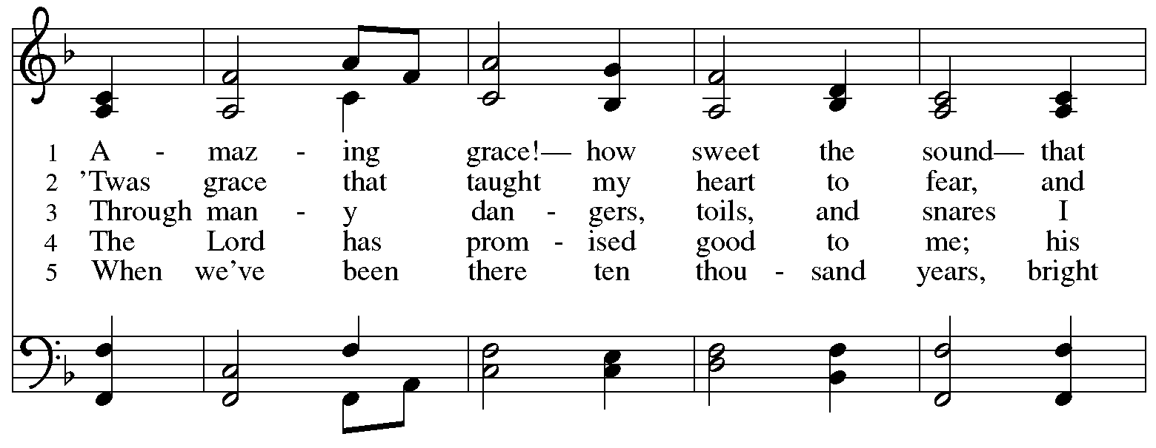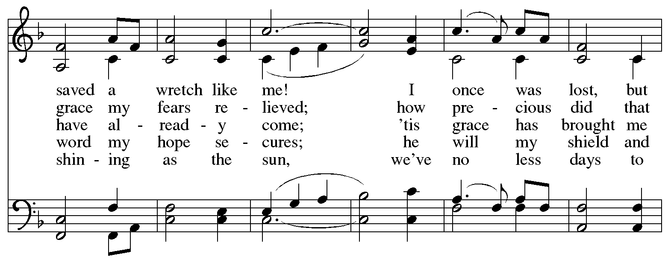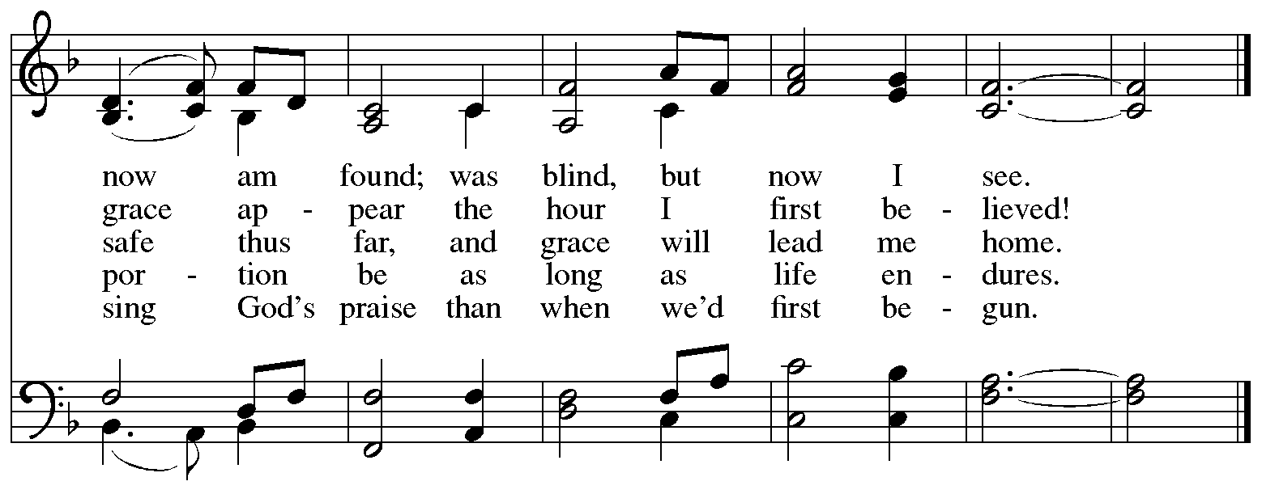

Serving in Worship Today

Altar Care Beverley Chapman
Assisting Minister Jeff Denlinger
AV Ministers Jered Stratton
Jason Galyardt
Cantor Pastor Erin Jones
Lector Lester Prince
Pre-Service Music Timothy Kocher-Hillmer
Tom Leech
Minister of Music Laura Reynolds
Presiding Minister The Rev. Ross Carmichael

Liturgy and Hymnody Acknowledgements

From SundaysandSeasons.com. Copyright © 2026 Augsburg Fortress. All rights reserved. Reprinted under OneLicense.net # A-722139.
Used by permission of Augsburg Fortress.

The Scripture readings contained herein are from New Revised Standard Version Updated Edition of the Bible © 2021 National Council of Churches of Christ in the United States of America. Used by permission. All rights reserved worldwide.

Please use the QR code below to link to St. Andrew’s Announcements online!



St. Andrew Lutheran Church Announcements
March 15th, 2026

- Welcome to Worship at St. Andrew on the Fourth Sunday in Lent – We are thankful you are here, and we offer a special welcome to all visitors and guests who are here for the first time! A nursery is available through the door to the left of the worship space and across the social hall (look for a purple room). Little Church – Big Faith, a Bible lesson and activity for children up to sixth grade, will take place after the prayer of the day. There are also worship “toolkits” to help children engage with worship and “busy bags” for younger children available in the bookcase at the back of the sanctuary. Please feel free to take one to use with/for your children. All are invited to stay for coffee and other drinks, food, and conversation in the social hall (through the side door at the left of the worship space) after the service.
- Noisy Offering Today during Worship – On the third Sunday of each month, St. Andrew’s children lead the congregation in a Noisy Offering, in which people are invited to throw their change into buckets that the children carry around the church and bring forward as an additional offering. Each month’s Noisy Offering supports a local, national, or international church-related or otherwise charitable organization. This month’s offering will benefit Lutheran Campus Ministry in Greater Pittsburgh, our church's local ministry to the students of the University of Pittsburgh, Carnegie Mellon, Chatham, and Carlow Universities. You can learn more about their programming and services here: https://lucpgh.com.
- Growing in Faith Together, Today after Worship – This gathering is intended for people who are relatively new to St. Andrew, whether you are preparing to join the congregation by transfer or Affirmation of Baptism, or would just like to meet more people and learn about the congregation. Jeff Denlinger and Kelly Spanninger will serve as facilitators and will be happy to answer any questions.
- Produce Distribution Supplemental Food of the Month – St. Andrew is collecting supplemental food each month to accompany our produce distribution. For March, we ask for donations of rice. There are collection boxes at the back of the worship space and social hall.
- Produce Distribution, Third Tuesday Each Month, March 17th from 5:30 to 6:30 p.m. – St. Andrew partners with Greater Pittsburgh Community Food Bank to serve as a distribution site for fresh produce on the first and third Tuesday of every month. We invite people of the congregation to help with the distribution from 5:30 p.m. to 6:30 p.m. and/or to help with unloading and setup during the day between 10:00 a.m. and 1:00 p.m.
- Bible Book Club, Wednesday, March 18th at 7:00 p.m. – Bible Book Club will meet weekly on Wednesdays at 7:00 p.m. All are welcome to participate. This will be the last session on the Gospel of Mark and The Gospel of Mark: A Beginner’s Guide to the Good News by Dr. Amy-Jill Levine. Here are the details on the book from one site: You can join the Zoom call here: https://us02web.zoom.us/j/83196175976?pwd=ejdPOUYrTk4xVFdsdlhHUVJ1L3k2Zz09. The next book we will read and discuss, starting next week, March 25th, will also be by Dr. Amy-Jill Levine, Entering the Passion of Jesus: A Beginner’s Guide to Holy Week, which can be found here: Entering the Passion of Jesus.
- Lenten Resources – As ReconcilingWorks continues to strive to support you and your faith community in deepening and expanding the welcome, inclusion, and celebration of people of all sexual orientations, gender identities, and gender expressions, and commit to racial equity/anti-racism, they have shared this brand-new free Lenten devotional "of Justice, Liberation, and Flourishing." Lent draws us into a holy tension between humility and public faithfulness; Lent sharpens our moral attention. You can access the devotional here: https://www.reconcilingworks.org/wp-content/uploads/2026/02/Lenten-Devotional-from-ReconcilingWorks.pdf.
- Hearts and Hands - Blanket Tying, Saturday, April 11th, 10 a.m. to 2 p.m. – Join us as we reboot Hearts and Hands to include Tied Blankets as well as knitted and crocheted items. Tying Blankets is something everyone can do! You can also bring your knitting needles, crochet hooks or even quilting items. If you want to learn to crochet, someone can also help you get started. Blankets will be provided to Proud Haven and Humane Animal Rescue. We also hope to rebuild our prayer shawl supplies with knitted items, crocheted items and blankets. Bring a Lunch (and something to share if you like) and join us!
- Alternatives to Violence Project Workshops, April 14th, May 16th, and May 23th – To learn more about the Alternatives to Violence Project, follow the link here: https://friendspeaceteams.org/cultures-justice-peace/. Below are the details for their upcoming workshops in Pittsburgh.”Choosing Integrity Over Influence” will be held on April 14th from 6:30 p.m. to 8 p.m. at Saint Maurice RC Church Campus, 2001 Ardmore Blvd. Pittsburgh, PA 15221. It will be open to all ages. Please register using this link: https://docs.google.com/forms/d/e/1FAIpQLSenWSjN487ufRn8K6W6CTi1Nsn7lU3JZSOt234oddOsyXMI4g/viewform.On May 16th and 23rd from 9 a.m. to 8 p.m., AVP will be hosting two basic workshops at St Andrews Lutheran Church, 304 Morewood Ave, Pittsburgh, PA 15213. These will be open to teens and adults. Please register using this link: https://docs.google.com/forms/d/e/1FAIpQLSfjPQKcnyQNx26wqTHzyby9YMi7BYHrUUfUha3PoxXpC50XNw/viewform.
- Pittsburgh PRIDE Choir’s Spring Cabaret Concert, April 17th and 18th at 8:00 p.m. – The Board of Directors of the Pittsburgh PRIDE Choir, Pittsburgh's esteemed LGBTQIA+ choir, acknowledges and thanks you for your unwavering support and advocacy on behalf of our local LGBTQIA+ community. Your contributions, whether through business ownership, direct support, or quality of life initiatives, are invaluable. The Spring Season approaches rapidly and they would be privileged if you joined them for the Spring Cabaret Concert on April 17th and 18th. The concert begins at 8:00 p.m., at East Liberty Presbyterian Church (116 S. Highland Ave, Pgh), a fully affirming and inclusive venue. For tickets to this and future events, visit https://events.ticketleap.com/events/pittsburgh-pride-choir.
- Lutherlyn Work Day, Saturday, April 25th 9:00 a.m. - 4:00 p.m. – It takes a lot of hands to prepare Lutherlyn for the many people who will visit throughout the spring and summer. Flower beds need to be weeded, firewood needs to be cut, fences need to be repaired, sticks and leaves need to be removed, as well as a variety of other jobs for volunteers of all ages and skill levels. Lutherlyn provides all of the tools (and lunch prepared by Chef Lisa) and our volunteers provide the willing hands! To RSVP, follow this link: https://www.lutherlyn.com/support/volunteer/workdays.html. If you have any questions feel free to contact the Development Office at development@lutherlyn.com or 724-865-2161.
- “Christ in Our Home” Booklets for April - June Now Available – “Christ in Our Home” is a quarterly devotional resource that encourages readers to live out their faith daily. Each reflective reading is accompanied by a daily scripture reference and prayer for the day. The April - June booklets are now available at the entrances, and there are still some left for March. Please feel free to take one home!
- Coffee Hour Signups – St. Andrew provides hospitality during a coffee hour after worship each Sunday. If you would like to participate and would like information about the duties of setting up, please sign up using the following form: https://www.signupgenius.com/go/5080B4AAFAF2CABF85-47069030-coffee#/.

Flowers for Easter

St. Andrew will be ordering Lilies (6 inch, five bloom - $8.25 each)
Tulips (8 inch - $9.00 each))
Daffodils (6 inch - $5.50 each)
to decorate the worship space for Easter Sunday, April 5th,
and the Easter season.
If you would like to sponsor or dedicate flowers, please complete this form
and submit it at the desk in the main office or through the Sunday offering plates.
Please submit payment with order - Checks may be made payable to:
St. Andrew Lutheran Church
Order by Sunday, March 29th.

Name __________________________________________
In Honor of __________________________________________
In Memory of __________________________________________
In Appreciation/Love for __________________________________________

Number of Lilies ________
Number of Tulips ________
Number of Daffodils ________

