

+ Fifth Sunday in Lent
March 22, 2026



St. Andrew Lutheran Church
304 Morewood Ave.
Pittsburgh, PA 15213
St_andrewELCA@verizon.net
www.standrewpittsburgh.org

+ Fifth Sunday in Lent
Order for Worship

In today’s gospel Jesus reveals his power over death by raising Lazarus from the dead.
The prophet Ezekiel prophesies God breathing new life into dry bones.
To those in exile or living in the shadows of death, these stories proclaim God’s promise of resurrection. In Baptism we die with Christ, so that we might also be raised with him to new life.
At the Easter Vigil we will welcome the newly baptized
as we remember God’s unfailing promise in our Baptism.

Welcome to St. Andrew!
- St. Andrew welcomes all who are seeking a place of healing, wholeness, and acceptance in a nurturing and faith-forming spiritual home. We are striving toward racial equity worldwide
and we seek to honor the lived experience of all individuals regardless of background. Our community embraces people of all ages, ethnicities, cultures, abilities, sexual orientations,
gender identities and expressions, and family constellations. Come and See!
- Worship Services are live-streamed to multiple online platforms. By attending worship, you agree that your image and voice may be broadcast.
- Everyone is invited to make a name tag at the black bookcase in the back of the worship space if they would like. There are stickers indicating pronouns on the bookcase if you would like to include them on your name tag.
- A nursery is available through the doors at the left side of the sanctuary and across from the doorway to the Social Hall. Look for a purple-colored room.
- Children are invited to attend Little Church – Big Faith, a Bible lesson and activity, during worship (after the Prayer of the Day). The group returns to the worship space for the liturgy of Holy Communion.
- Worship “toolkits” to help children engage with the service, along with “busy bags” for younger children, are available in the bookcase at the back of the sanctuary. Please feel free to take one to use with/for your children.
- Holy Communion is served with bread (gluten-free available) and wine or grape juice. The presiding minister will distribute the bread (host). Please consume this and then pick up an empty glass from the tray. The Communion Assistant will pour wine or grape juice into your glass. Please step to the side to consume the wine or grape juice. Feel free to kneel at the altar for prayer and reflection. As you return to your pew, glasses may be returned to the empty trays on either side of the center section.
- A restroom is available on the main level of the church, through the doors to the Social Hall and to the right in the main office.

Abbreviations
P: Pastor/Presiding Minister ELW: Evangelical Lutheran Worship hymnal
A: Assisting Minister ACS: All Creation Sings hymnal
L: Lector
C: Congregation

Musical Offering

Each week, different people from the congregation make an offering of pre-service music, with singing or instrumentation, to help the assembly focus and pray in preparation for worship.

Welcome

Prelude O Holy Spirit, Enter In arr. Shaw

Gathering
The Holy Spirit calls us together as the people of God

Please rise as you are able. All may make the sign of the cross,
the sign that is marked at Baptism, as the presiding minister begins.

Confession and Forgiveness

P: Blessed be the holy Trinity, ☩ one God,
who forgives all our sin, whose mercy endures forever.
C: Amen.

P: Let us confess our sin before God, who removes our guilt
and blots out all offenses.

Silence is kept for reflection.

P: Gracious God,
C: have mercy on us according to your steadfast love.

P: For seeking worldly delights that deceive us and dishonor you:
Gracious God,
C: have mercy on us according to your steadfast love.

P: For desiring self-reliance instead of hungering for your word:
Gracious God,
C: have mercy on us according to your steadfast love.

P: For failing to recognize your coming reign,
and for hindering the work of the Spirit: Gracious God,
C: have mercy on us according to your steadfast love.

P: For drawing from the well of self-serving ambition,
and for disdaining the living water Christ offers: Gracious God,
C: have mercy on us according to your steadfast love.

P: For disregarding voices from the margins,
and for distrusting signs of your healing and hope in the world:
Gracious God,
C: have mercy on us according to your steadfast love.

P: For dwelling in tombs of self-pity and discontent,
and for disregarding Christ’s call to come forth to life:
Gracious God,
C: have mercy on us according to your steadfast love.

P: God’s steadfast love, grace, and forgiveness abound.
Through faith, the free gift of God,
you have been clothed in the righteousness of Christ.
In the name of ☩ Jesus Christ, your sins are forgiven.
The Spirit of the One who raised Christ from the dead dwells in you,
pours love into your hearts, and gives you life and peace.
C: Amen.

Gathering Hymn This Is the Spirit’s Entry Now ELW 448

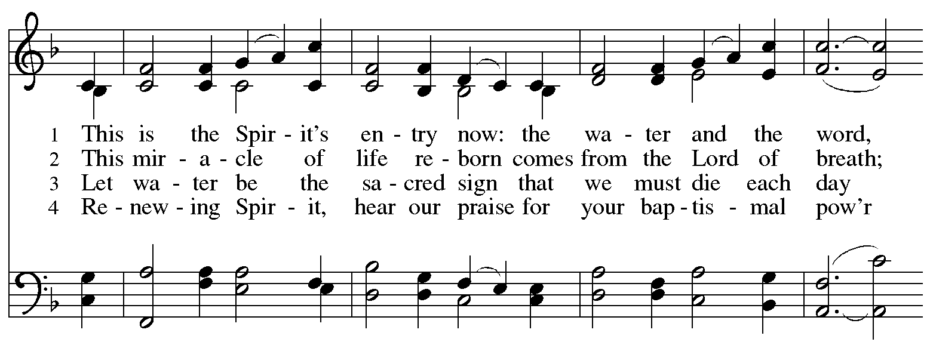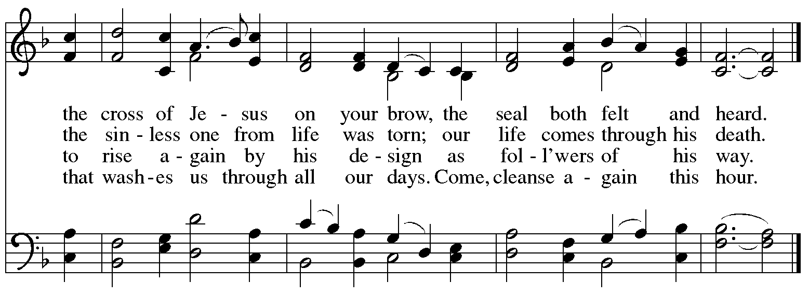
Greeting

P: The grace of our Lord Jesus Christ, the love of God,
and the communion of the Holy Spirit be with you all.
C: And also with you.

Kyrie ELW p. 193-194

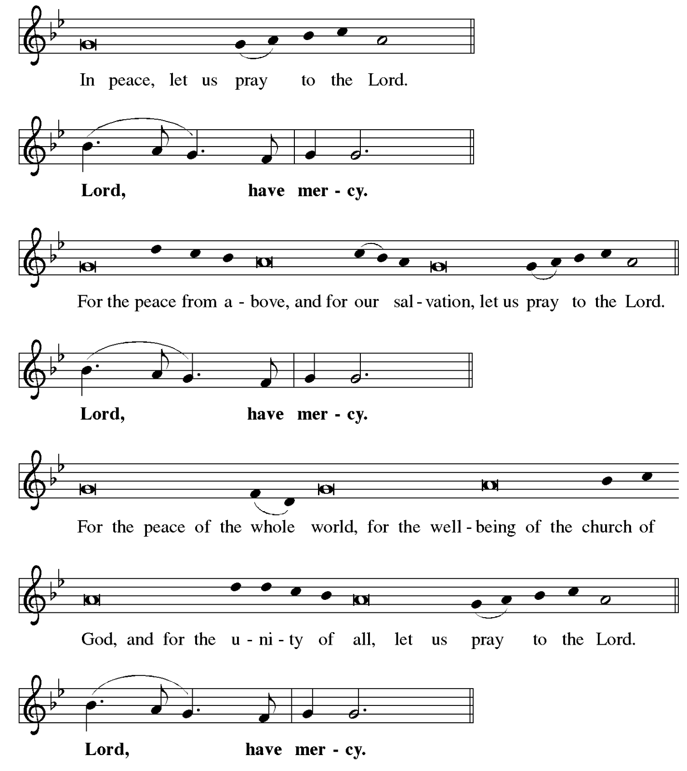
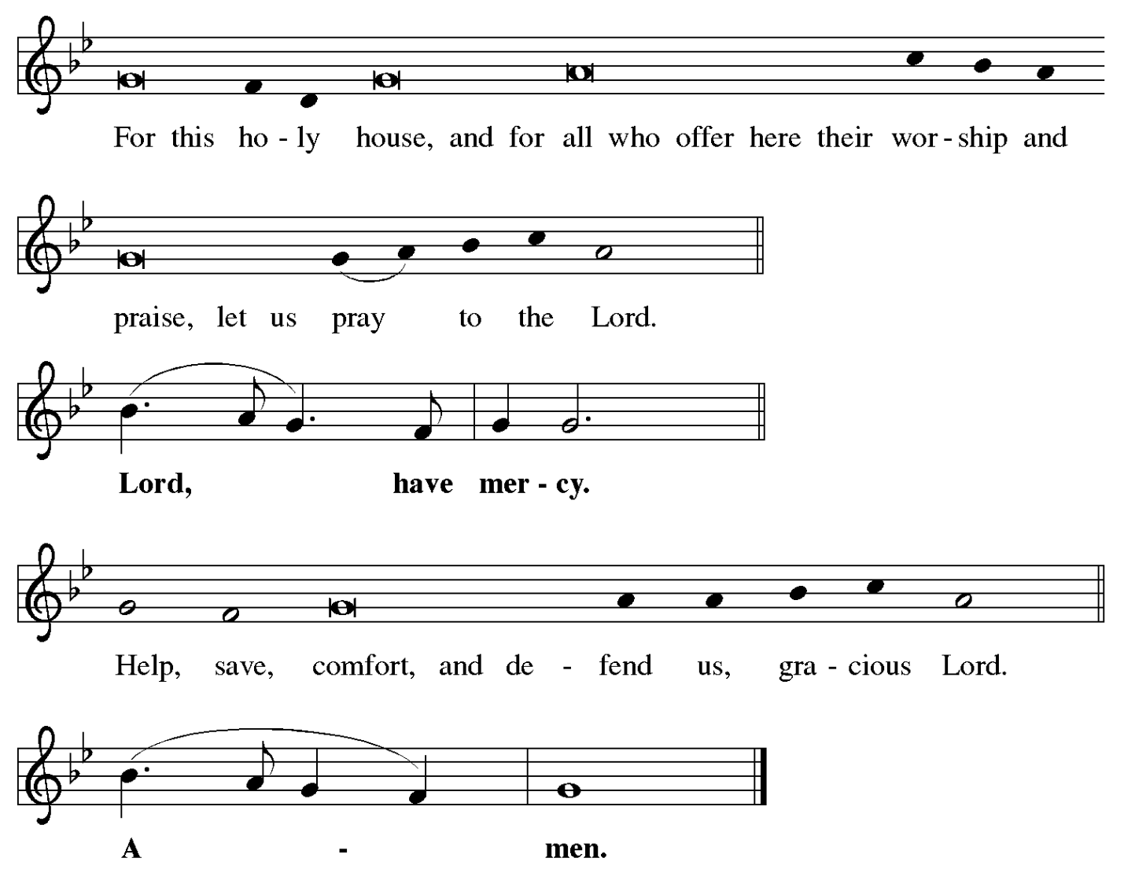

Prayer of the Day

P: The Lord be with you.
C: And also with you.

P: Almighty God, your Son came into the world to free us all from sin and death.
Breathe upon us the power of your Spirit, that we may be raised to new life in Christ
and serve you in righteousness all our days, through Jesus Christ, our Savior and Lord,
who lives and reigns with you and the Holy Spirit, one God, now and forever.
C: Amen.

Please be seated.
Children are invited to join the adult leader(s) at the side door for Little Church – Big Faith.
We ask that an additional adult from the congregation attend with the children.

Word
God speaks to us in Scripture reading, preaching, and song

First Reading – Ezekiel 37: 1-14

¹ The hand of the Lord came upon me, and the Lord brought me out by the spirit of the Lord
and set me down in the middle of a valley; it was full of bones. ² The Lord led me all around them; there were very many lying in the valley, and they were very dry. ³ The Lord said to me, “Mortal, can these bones live?” I answered, “O Lord God, you know.” ⁴ Then the Lord said to me, “Prophesy to these bones and say to them: O dry bones, hear the word of the Lord.
⁵ Thus says the Lord God to these bones: I will cause breath to enter you, and you shall live. ⁶ I will lay sinews on you and will cause flesh to come upon you and cover you with skin and put breath in you, and you shall live, and you shall know that I am the Lord.”
⁷ So I prophesied as I had been commanded, and as I prophesied, suddenly there was a noise, a rattling, and the bones came together, bone to its bone. ⁸ I looked, and there were sinews on them, and flesh had come upon them, and skin had covered them, but there was no breath in them. ⁹ Then the Lord said to me, “Prophesy to the breath, prophesy, mortal, and say to the breath: Thus says the Lord God: Come from the four winds, O breath, and breathe upon these slain, that they may live.” ¹⁰ I prophesied as the Lord commanded me, and the breath came into them, and they lived and stood on their feet, a vast multitude.
¹¹ Then the Lord said to me, “Mortal, these bones are the whole house of Israel. They say, ‘Our bones are dried up, and our hope is lost; we are cut off completely.’ ¹² Therefore prophesy and say to them: Thus says the Lord God: I am going to open your graves and bring you up from your graves, O my people, and I will bring you back to the land of Israel. ¹³ And you shall know that I am the Lord when I open your graves and bring you up from your graves, O my people. ¹⁴ I will put my spirit within you, and you shall live, and I will place you on your own soil; then you shall know that I, the Lord, have spoken and will act, says the Lord.”

L: Word of God, word of life.
C: Thanks be to God.

Psalm 130

The psalm will be sung responsively, led by the cantor, with the congregation singing the verses in bold type and joining in the refrain.

Psalm Tone

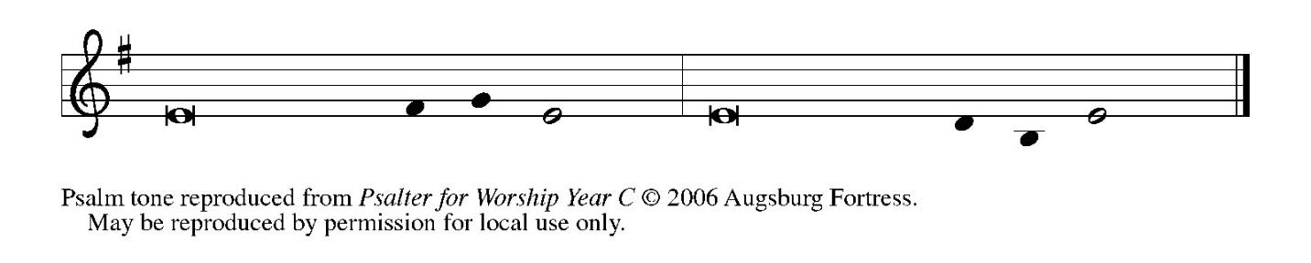
Psalm Refrain

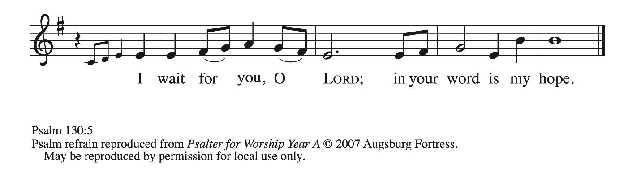

¹ Out | of the depths
I cry to | you, O Lord;
² O Lord, | hear my voice!
Let your ears be attentive to the voice of my | supplication.
³ If you were to keep watch | over sins,
O Lord, | who could stand?
⁴ Yet with you | is forgiveness,
in order that you | may be feared. R
⁵ I wait for you, O Lord; | my soul waits;
in your word | is my hope.
⁶ My soul waits for the Lord more than those who keep watch | for the morning,
more than those who keep watch | for the morning.
⁷ O Israel, wait for the Lord, for with the Lord there is | steadfast love;
with the Lord there is plen- | teous redemption.
⁸ For the Lord shall | redeem Israel
from | all their sins. R

Second Reading – Romans 6: 8-11

⁶ To set the mind on the flesh is death, but to set the mind on the Spirit is life and peace. ⁷ For this reason the mind that is set on the flesh is hostile to God; it does not submit to God’s law—indeed, it cannot, ⁸ and those who are in the flesh cannot please God.
⁹ But you are not in the flesh; you are in the Spirit, since the Spirit of God dwells in you. Anyone who does not have the Spirit of Christ does not belong to him. ¹⁰ But if Christ is in you, then the body is dead because of sin, but the Spirit is life because of righteousness. ¹¹ If the Spirit of the one who raised Jesus from the dead dwells in you, the one who raised Christ Jesus from the dead will give life to your mortal bodies also through God’s Spirit that dwells in you.

L: Word of God, word of life.
C: Thanks be to God.

Please rise as you are able.

Gospel Verse ELW p. 198

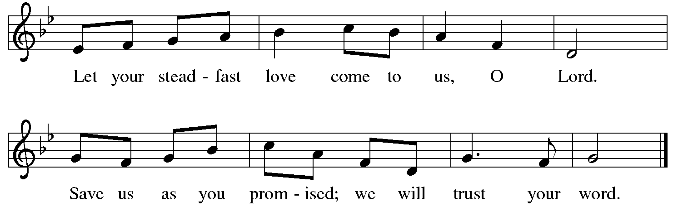

Gospel – John 11: 1-45

P: The holy Gospel according to St. John.
C: Glory to you, O Lord.

¹ Now a certain man was ill, Lazarus of Bethany, the village of Mary and her sister Martha.
² Mary was the one who anointed the Lord with perfume and wiped his feet with her hair;
her brother Lazarus was ill. ³ So the sisters sent a message to Jesus, “Lord, he whom you love is ill.” ⁴ But when Jesus heard it, he said, “This illness does not lead to death; rather, it is for God’s glory, so that the Son of God may be glorified through it.” ⁵ Accordingly, though Jesus loved Martha and her sister and Lazarus, ⁶ after having heard that Lazarus was ill, he stayed two days longer in the place where he was.
⁷ Then after this he said to the disciples, “Let us go to Judea again.” ⁸ The disciples said to him, “Rabbi, the Jews were just now trying to stone you, and are you going there again?” ⁹ Jesus answered, “Are there not twelve hours of daylight? Those who walk during the day do not stumble because they see the light of this world. ¹⁰ But those who walk at night stumble because the light is not in them.” ¹¹ After saying this, he told them, “Our friend Lazarus has fallen asleep, but I am going there to awaken him.” ¹² The disciples said to him, “Lord, if he has fallen asleep, he will be all right.” ¹³ Jesus, however, had been speaking about his death, but they thought that he was referring merely to sleep. ¹⁴ Then Jesus told them plainly, “Lazarus is dead. ¹⁵ For your sake I am glad I was not there, so that you may believe. But let us go to him.” ¹⁶ Thomas, who was called the Twin, said to his fellow disciples, “Let us also go, that we may die with him.”
¹⁷ When Jesus arrived, he found that Lazarus had already been in the tomb four days. ¹⁸ Now Bethany was near Jerusalem, some two miles away, ¹⁹ and many of the Jews had come to Martha and Mary to console them about their brother. ²⁰ When Martha heard that Jesus was coming, she went and met him, while Mary stayed at home. ²¹ Martha said to Jesus, “Lord, if you had been here, my brother would not have died. ²² But even now I know that God will give you whatever you ask.” ²³ Jesus said to her, “Your brother will rise again.” ²⁴ Martha said to him, “I know that he will rise again in the resurrection on the last day.” ²⁵ Jesus said to her, “I am the resurrection and the life. Those who believe in me, even though they die, will live, ²⁶ and everyone who lives and believes in me will never die. Do you believe this?”
²⁷ She said to him, “Yes, Lord, I believe that you are the Messiah, the Son of God, the one coming into the world.”
²⁸ When she had said this, she went back and called her sister Mary and told her privately, “The Teacher is here and is calling for you.” ²⁹ And when she heard it, she got up quickly and went to him. ³⁰ Now Jesus had not yet come to the village but was still at the place where Martha had met him. ³¹ The Jews who were with her in the house consoling her saw Mary get up quickly and go out. They followed her because they thought that she was going to the tomb to weep there. ³² When Mary came where Jesus was and saw him, she knelt at his feet and said to him, “Lord, if you had been here, my brother would not have died.” ³³ When Jesus saw her weeping and the Jews who came with her also weeping, he was greatly disturbed in spirit and deeply moved. ³⁴ He said, “Where have you laid him?” They said to him, “Lord, come and see.” ³⁵ Jesus began to weep. ³⁶ So the Jews said, “See how he loved him!” ³⁷ But some of them said, “Could not he who opened the eyes of the blind man have kept this man from dying?”
³⁸ Then Jesus, again greatly disturbed, came to the tomb. It was a cave, and a stone was lying against it. ³⁹ Jesus said, “Take away the stone.” Martha, the sister of the dead man, said to him, “Lord, already there is a stench because he has been dead four days.” ⁴⁰ Jesus said to her, “Did I not tell you that if you believed you would see the glory of God?” ⁴¹ So they took away the stone. And Jesus looked upward and said, “Father, I thank you for having heard me. ⁴² I knew that you always hear me, but I have said this for the sake of the crowd standing here, so that they may believe that you sent me.” ⁴³ When he had said this, he cried with a loud voice, “Lazarus, come out!” ⁴⁴ The dead man came out, his hands and feet bound with strips of cloth and his face wrapped in a cloth. Jesus said to them, “Unbind him, and let him go.”
⁴⁵ Many of the Jews, therefore, who had come with Mary and had seen what Jesus did believed in him.

P: The Gospel of the Lord.
C: Praise to you, O Christ.

Please be seated.

Sermon

A time of silence for prayer and reflection follows the sermon.
When the hymn of the day begins, please rise as you are able.

Hymn of the Day Christ Is the Life ACS 927

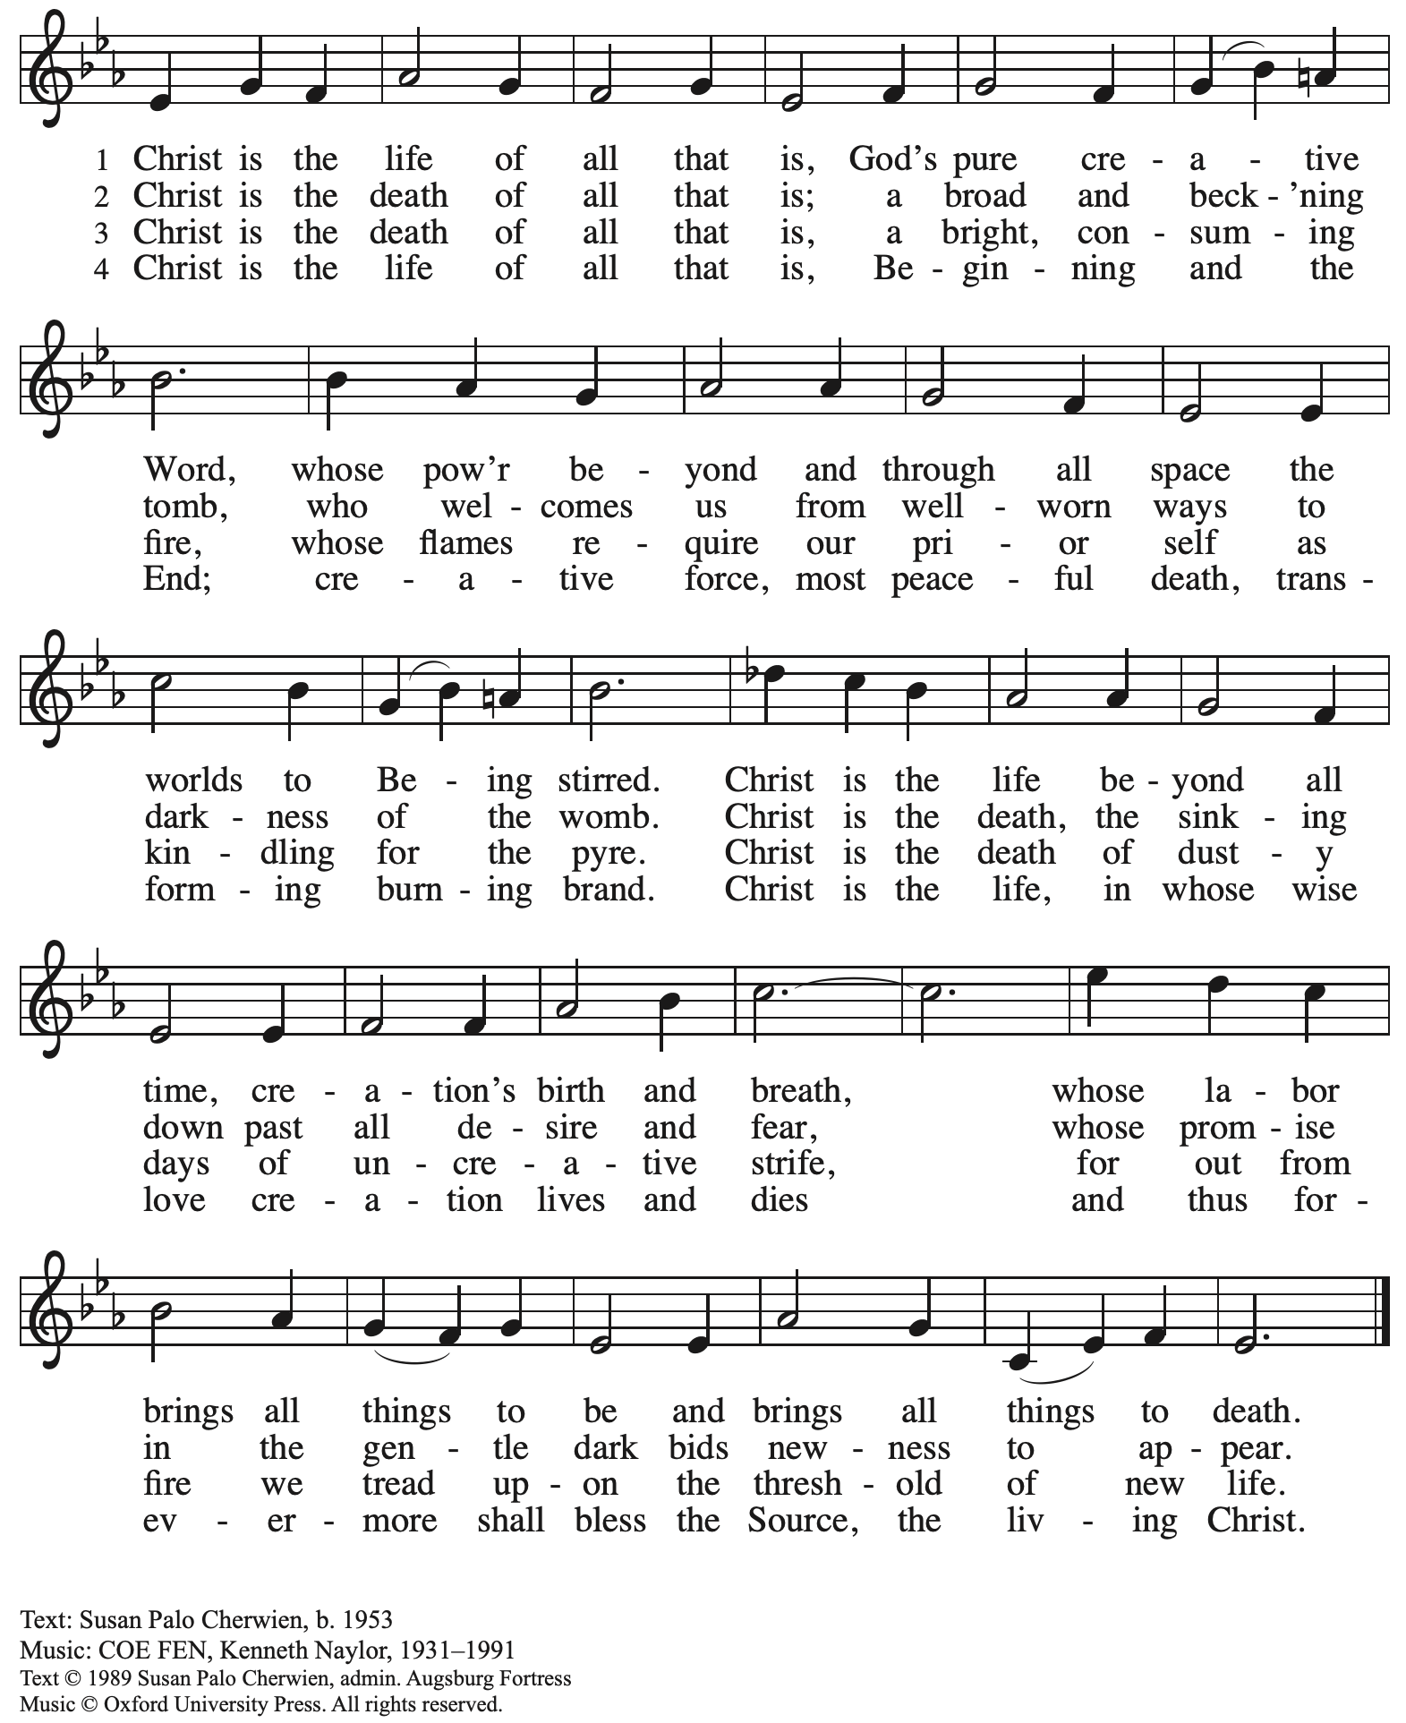
Reprinted with permission under OneLicense.net # A-722139.

Apostles’ Creed

C: I believe in God, the Father almighty,
creator of heaven and earth.

I believe in Jesus Christ, God’s only Son, our Lord,
who was conceived by the Holy Spirit,
born of the virgin Mary,
suffered under Pontius Pilate,
was crucified, died, and was buried;
he descended to the dead.*
On the third day he rose again;
he ascended into heaven,
he is seated at the right hand of the Father,
and he will come to judge the living and the dead.

I believe in the Holy Spirit,
the holy catholic church,
the communion of saints,
the forgiveness of sins,
the resurrection of the body,
and the life everlasting. Amen.

*Or, “he descended into hell,” another translation of this text in widespread use.

Prayers of the People

A: Reconciled by God’s mercy and sustained by God’s presence,
let us pray for the world and its needs.

After each petition
A: Merciful God,
C: receive our prayer.

The presiding minister concludes the prayers
P: Receive our prayers, O God, through Jesus Christ, our strength and salvation.
C: Amen.

Peace

The presiding minister and the assembly greet one another in the peace of the risen Christ.
P: The peace of Christ be with you always.
C: And also with you.

The people may greet those around them with a sign of Christ’s peace and may say
Peace be with you or similar words. Please be mindful that not everyone will be comfortable with sharing the peace, so please seek consent before shaking hands or hugging.
Other possible ways to share the peace include a simple bow with the verbal greeting of peace, or simply a verbal expression of peace.

When the greetings of peace have concluded, please be seated.



Meal
God feeds us with the presence of Jesus Christ

Offering

We offer ourselves, our gifts, and our faithful service to God.
As the offering is gathered for the mission of the church, including the care of those in need,
the table is set for Holy Communion.

There are laminated giving cards in the pew racks that feature a QR code for anyone who would like to give online. Those who give using the QR code, as well as those who give regularly online or through their bank are encouraged to place the laminated card in the plate as an expression of your offering.

Offertory Music Let Us Break Bread Together arr. Keveren

As the gifts are brought forward for presentation, please rise as you are able.

Offertory Song Create in Me a Clean Heart ELW 186

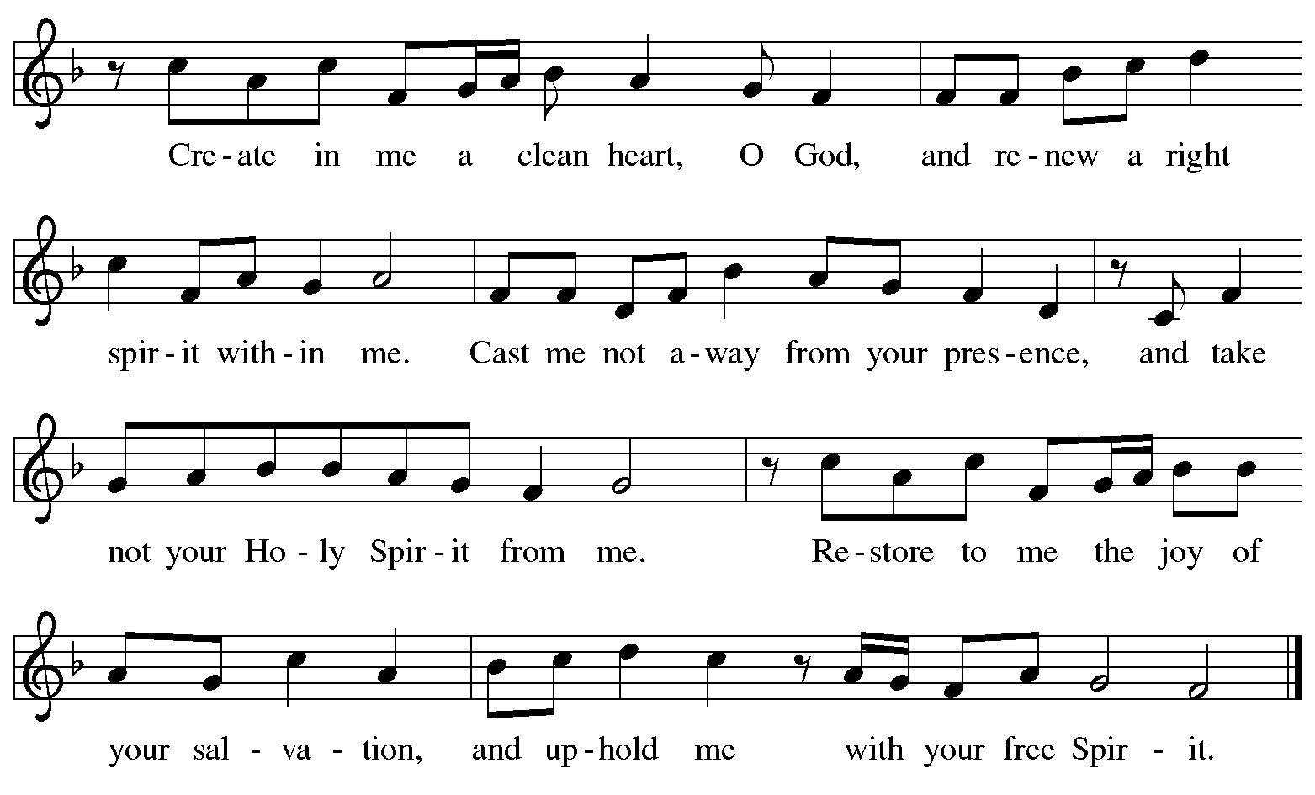
All rights reserved. Reprinted with permission under One License.net # A-722139.

Offertory Prayer

A: Let us pray.
God our provider,
C: You have not fed us with bread alone, but with words of grace and life.
Bless us and these your gifts, which we receive from your bounty,
through Jesus Christ our Lord.
Amen.

Dialogue ELW p. 199

P: The Lord be with you.
C: And also with you.

P: Lift up your hearts.
C: We lift them to the Lord.

P: Let us give thanks to the Lord our God.
C: It is right to give our thanks and praise.

Preface (Spoken by the presiding minister)

P: It is indeed right, our duty and our joy,
that we should at all times and in all places
give thanks and praise to you, almighty and merciful God,
through our Savior Jesus Christ.
You call your people to cleanse their hearts
and prepare with joy for the paschal feast,
that, renewed in the gift of Baptism,
we may come to the fullness of your grace.
And so, with all the choirs of angels,
with the church on earth and the hosts of heaven,
we praise your name and join their unending hymn:

Sanctus ELW p. 200

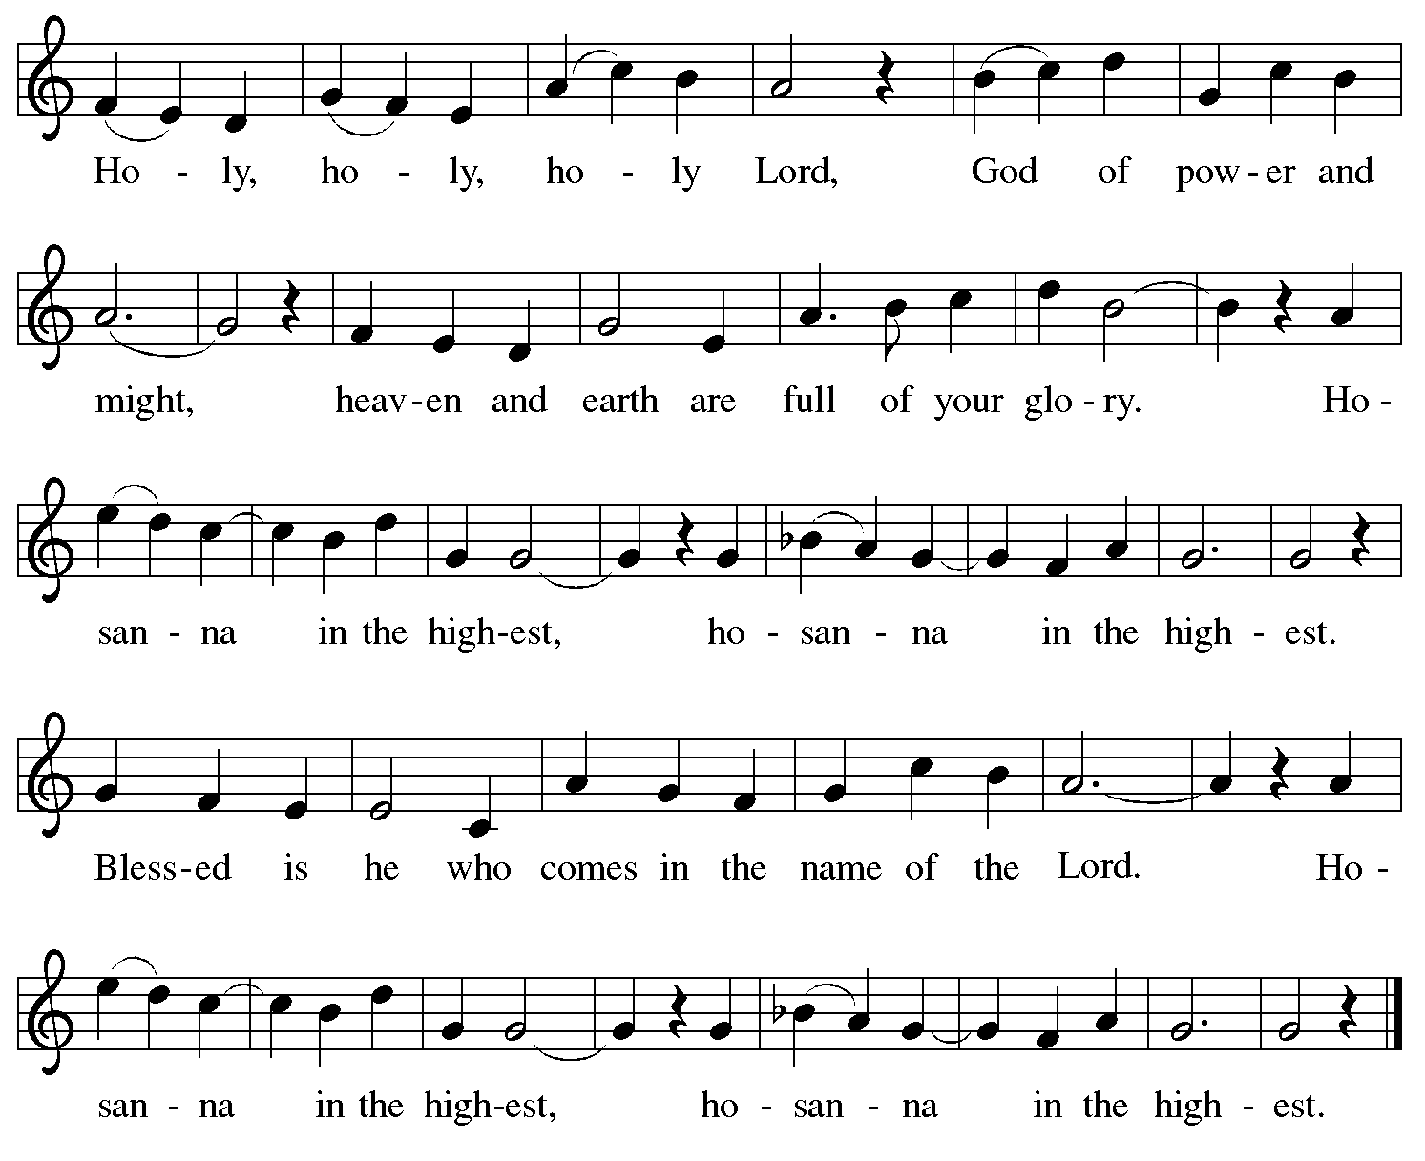
Eucharistic Prayer

P: Blessed are you, O God of the universe …
… Do this for the remembrance of me.

With this bread and cup
we remember our Lord’s passover from death to life
as we proclaim the mystery of faith:
C: Christ has died. Christ is risen. Christ will come again.

P: O God of resurrection and new life …
… Grace our table with your presence.
C: Come, Holy Spirit.

P: Reveal yourself to us in the breaking of the bread …
… Send us forth, burning with justice, peace, and love.
C: Come, Holy Spirit.

P: With your holy ones of all times and places …
… we praise you, O God, blessed and holy Trinity,
now and forever.
C: Amen.

Lord’s Prayer

P: Gathered as one by the Holy Spirit, let us pray as Jesus taught us.
C: Our Father in heaven,
hallowed be your name,
your kingdom come,
your will be done,
on earth as in heaven.
Give us today our daily bread.
Forgive us our sins
as we forgive those
who sin against us.
Save us from the time of trial
and deliver us from evil.
For the kingdom, the power,
and the glory are yours,
now and forever. Amen.

Fraction and Invitation

Agnus Dei / Lamb of God ELW p. 201

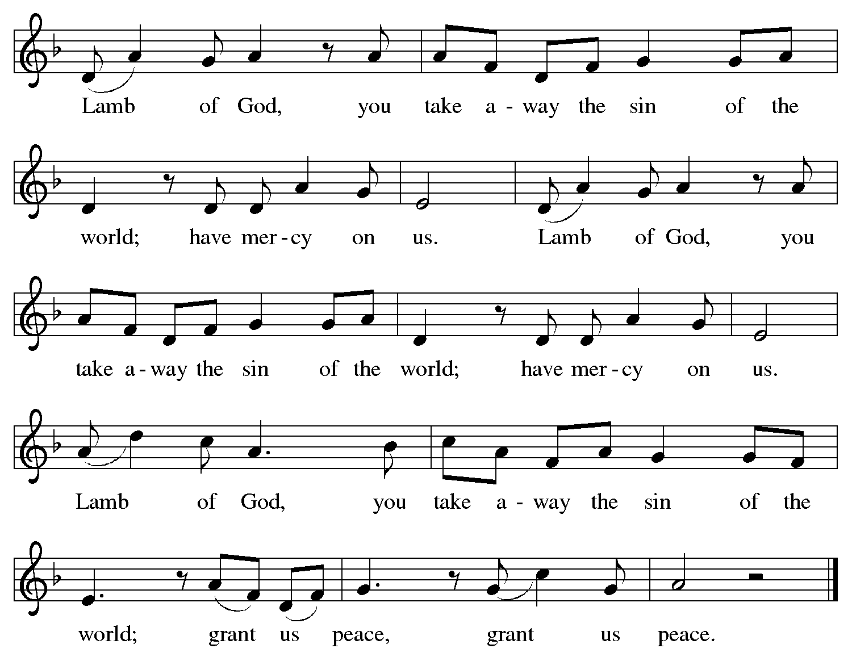

Please be seated.

Holy Communion

- All who seek God and desire a deeper and stronger life in Christ are welcome to receive Holy Communion.
- Worshipers from the pulpit side will proceed forward first, followed by the center section, and then the lectern side.
- Please inform an usher if you would like the ministers to bring Communion to you.
- Holy Communion will be served with bread and wine (amber) or grape juice (purple).
- The presiding minister will first distribute the bread (host) to each communicant. Please indicate if you require a gluten-free host.
- Once you have consumed the bread, please pick up an empty glass from the tray next to the presiding minister. The Communion Assistant will pour wine or grape juice into your glass.
- Please step to the side to consume the wine or grape juice.
- Feel free to kneel at the altar rail for prayer after receiving the sacrament.
- As you return to your pew, glasses may be returned to the empty tray on the side of the center section.
- A blessing will be provided for anyone who does not yet receive the sacrament.
- All are invited to join in singing the hymns during Holy Communion.

Hymns during Holy Communion
Christ, the Life of All the Living ELW 339

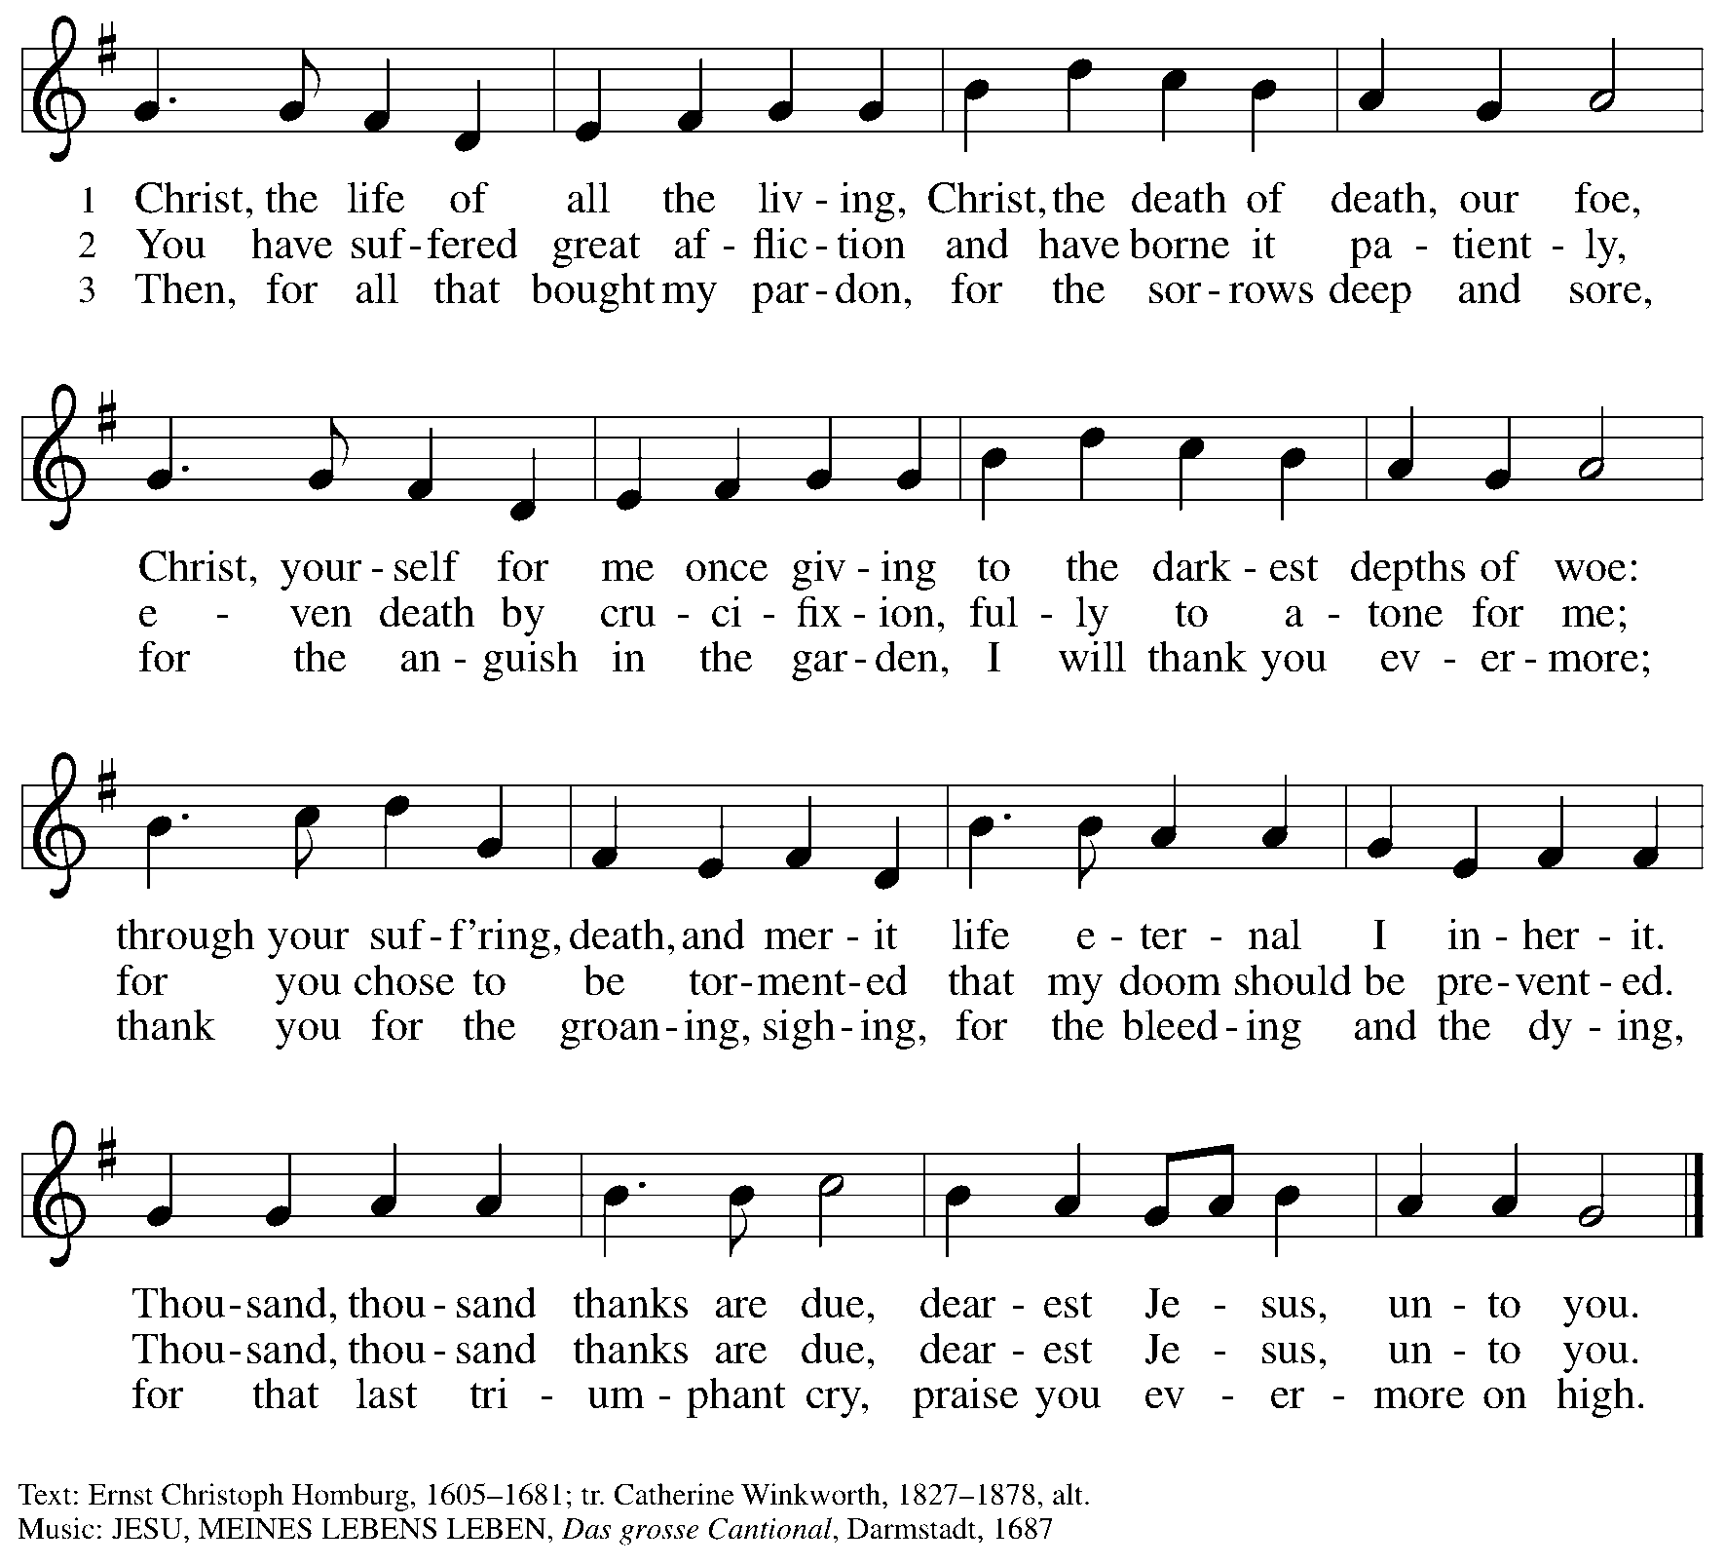

Hymns during Holy Communion
I Am the Bread of Life ELW 485
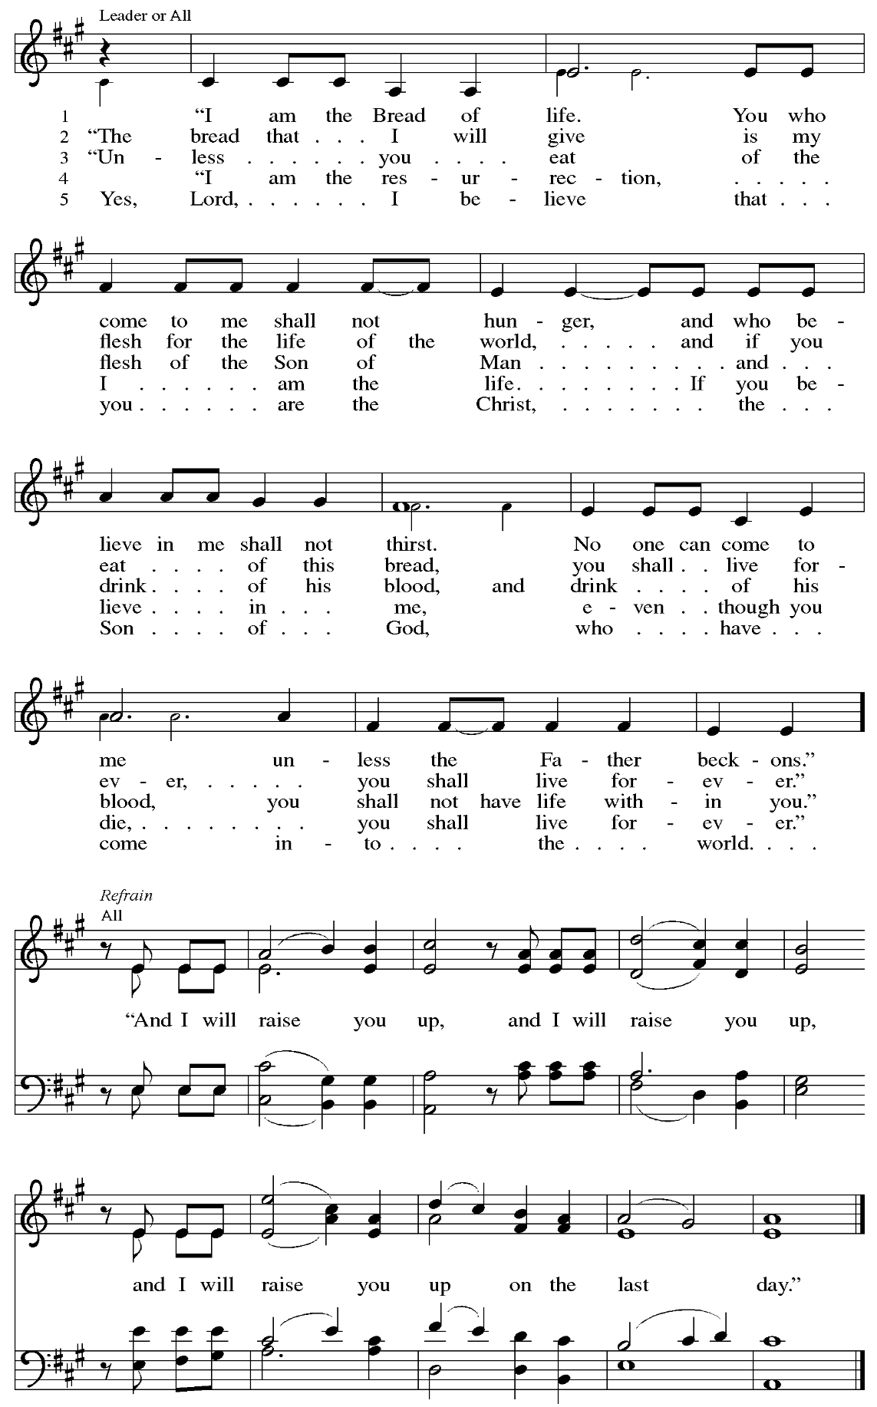
Hymns during Holy Communion
Tree of Life and Awesome Mystery ELW 334

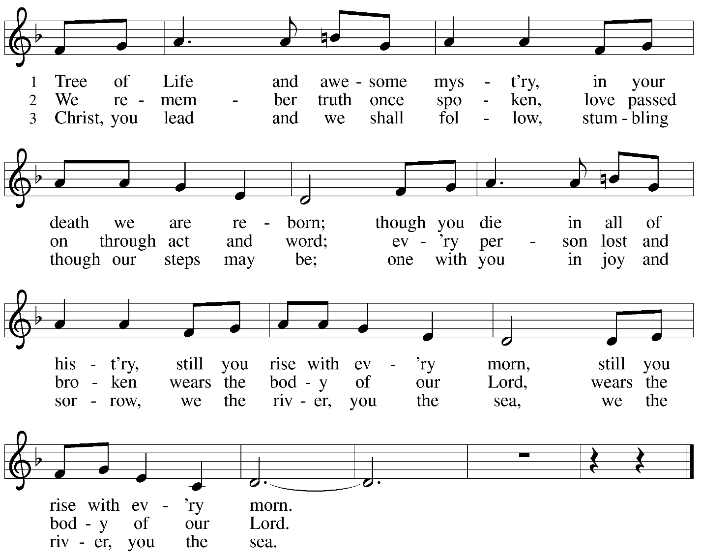




Reprinted with permission under OneLicense.net # A-722139.

Hymns during Holy Communion
Jesus Is a Rock in a Weary Land ELW 333

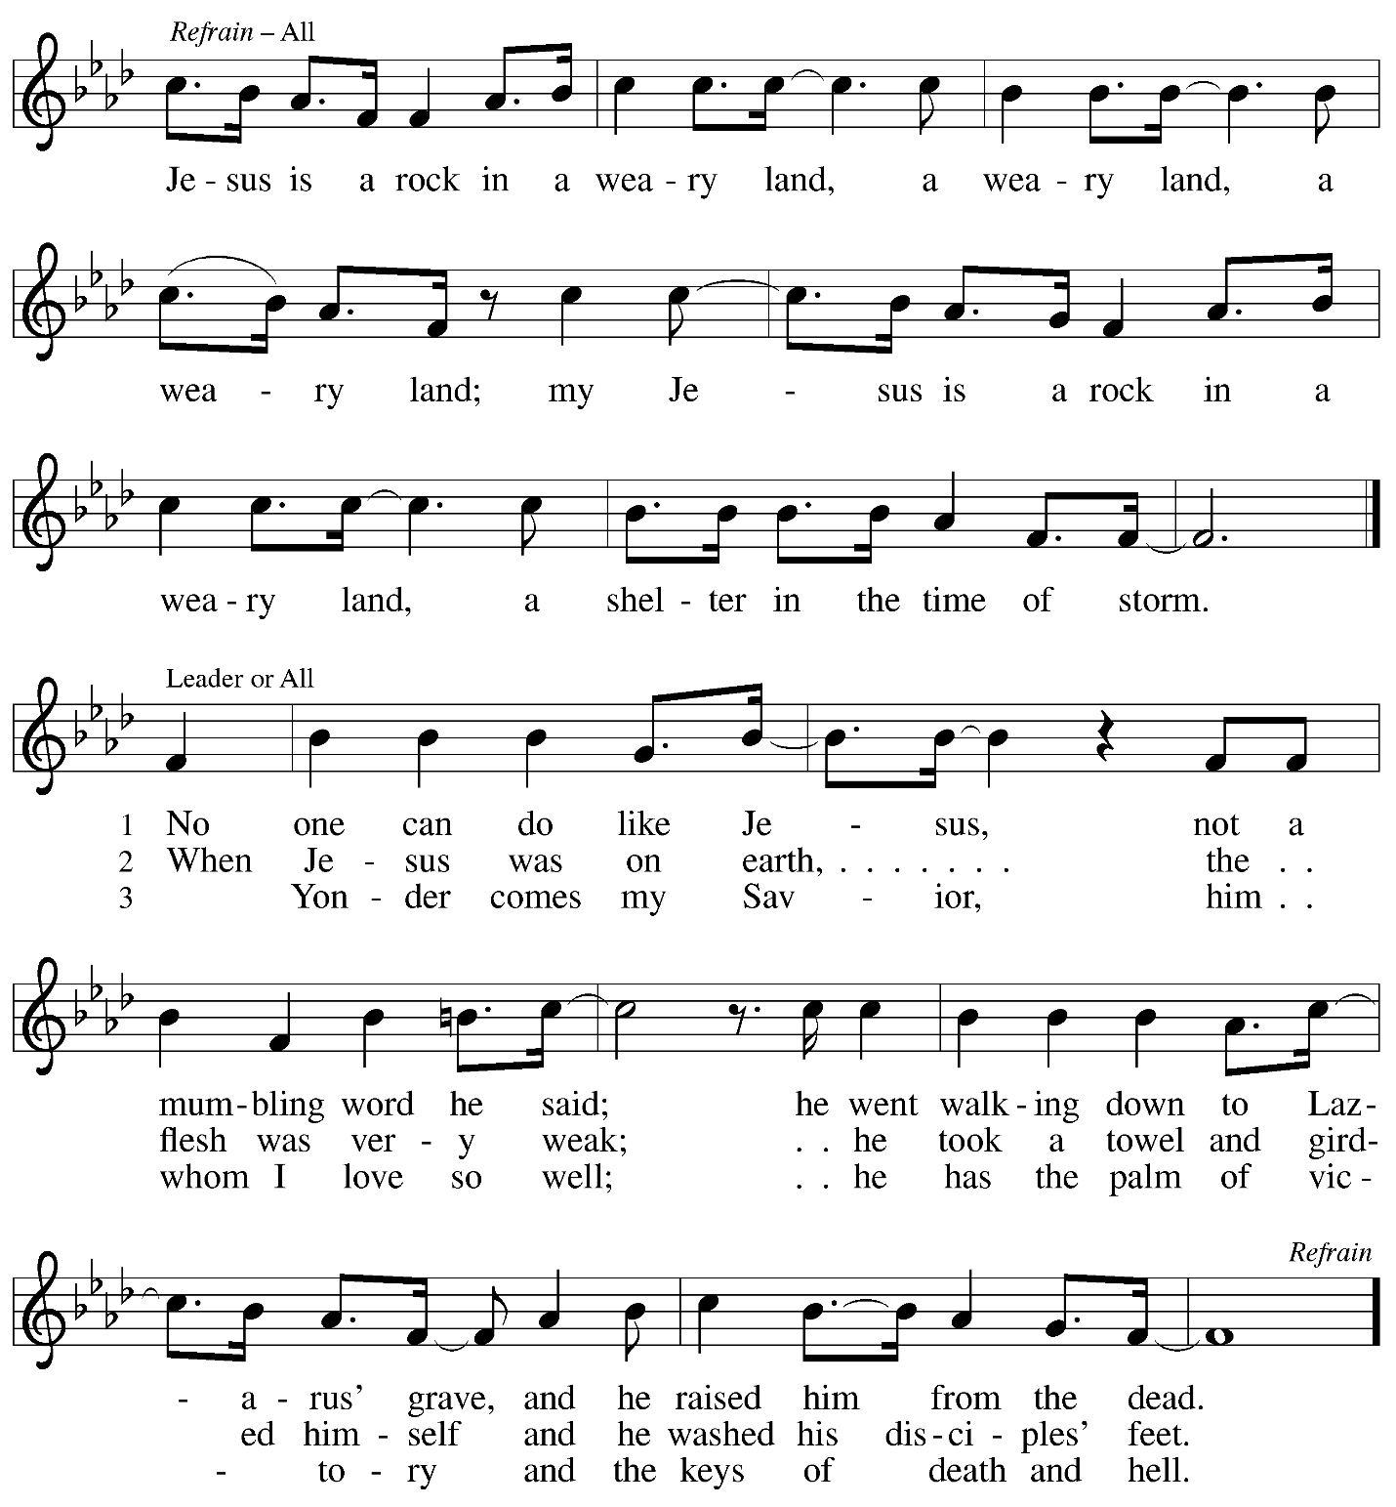

When all have returned to their places, please rise as you are able.

Blessing

P: The body and blood of our Lord Jesus Christ strengthen you and keep you in his grace.
C: Amen.

Prayer

A: Let us pray.
Compassionate God, you have fed us with the bread of heaven.
Sustain us in our Lenten pilgrimage: may our fasting be hunger for justice;
our alms, a making of peace; and our prayer, the song of grateful hearts, through Jesus Christ, our Savior and Lord.
C: Amen.

Please be seated.

Sending
God blesses us and sends us in mission to the world

Announcements

Please rise as you are able.

Benediction

P: Receive the blessing of the holy Trinity:
God, who calls all things into existence,
Jesus Christ, who redeems us,
and the Holy Spirit, whose breath sustains creation,
☩ bless you and keep you, now and forever.
C: Amen.

Sending Hymn Following page

Dismissal

A: Go in peace. Serve those in need.
C: Thanks be to God

Postlude

Sending Hymn O God, Who Gives Us Life ACS 1086

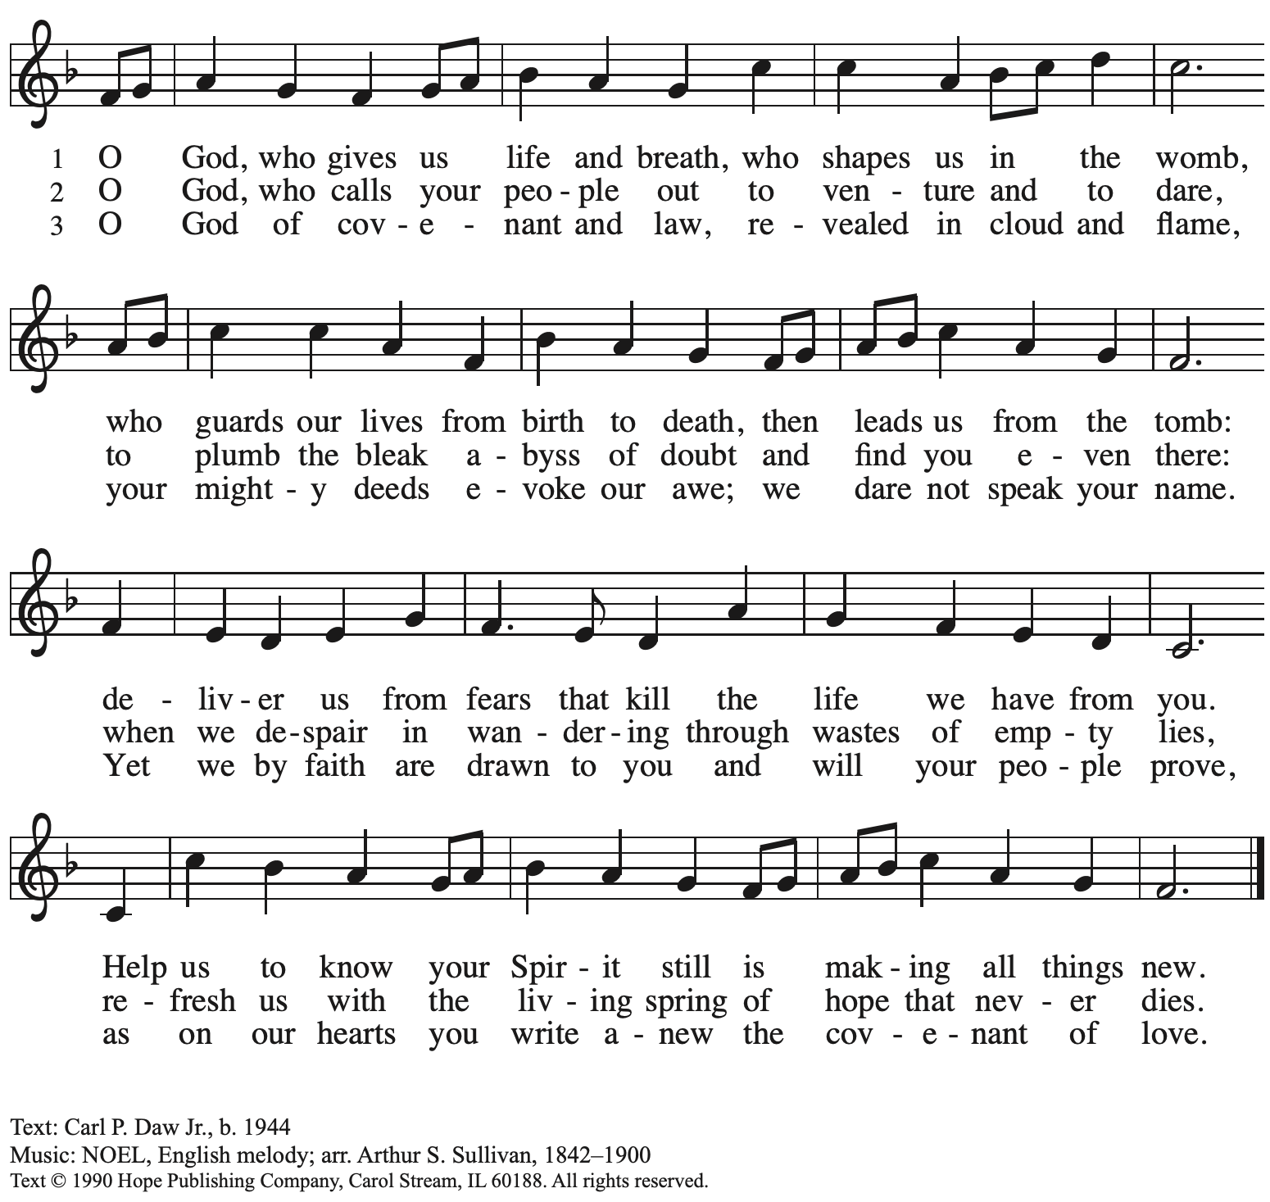
Reprinted with permission under OneLicense.net # A-722139.

Serving in Worship Today

Altar Care Christy Ruhe
Assisting Minister Lindsay Baxter
AV Ministers Kristen Asplin
Tyler Rietze
Cantor Joseph Paetz
Lector Alda Maria Gonzaga
Pre-Service Music Dave Rollinson, Joseph Paetz, Timothy Kocher-Hillmer
Minister of Music Laura Reynolds
Presiding Minister The Rev. Ross Carmichael

Liturgy and Hymnody Acknowledgements

From SundaysandSeasons.com. Copyright © 2026 Augsburg Fortress. All rights reserved. Reprinted under OneLicense.net # A-722139.
Used by permission of Augsburg Fortress.

The Scripture readings contained herein are from New Revised Standard Version Updated Edition of the Bible © 2021 National Council of Churches of Christ in the United States of America. Used by permission. All rights reserved worldwide.

This Is the Spirit’s Entry Now – Text: Thomas E. Herbranson, b. 1933. Music: LAND OF REST, North American traditional; arr. hymnal version. Text © Thomas E. Herbranson, admin. Augsburg Fortress. Arr. © 2006 Augsburg Fortress. All rights reserved. Reprinted with permission under OneLicense.net # A-722139.

I Am the Bread of Life – Text: Suzanne Toolan, RSM, b. 1927, based on John 6. Music: I AM THE BREAD, Suzanne Toolan, RSM. Text and music © 1966, 1970, 1986, 1993 GIA Publications, Inc., 7404 S. Mason Ave., Chicago, IL 60638. www.giamusic.com. 800.442.3358. All rights reserved. Reprinted with permission under OneLicense.net # A-722139.

Please use the QR code below to link to St. Andrew’s Announcements online!



St. Andrew Lutheran Church Announcements
March 22nd, 2026

- Welcome to Worship at St. Andrew on the Fifth Sunday in Lent – We are thankful you are here, and we offer a special welcome to all visitors and guests who are here for the first time! A nursery is available through the door to the left of the worship space and across the social hall (look for a purple room). Little Church – Big Faith, a Bible lesson and activity for children up to sixth grade, will take place after the prayer of the day. There are also worship “toolkits” to help children engage with worship and “busy bags” for younger children available in the bookcase at the back of the sanctuary. Please feel free to take one to use with/for your children.
All are invited to stay for coffee and other drinks, food, and conversation in the social hall (through the side door at the left of the worship space) after the service.
- Holy Week Worship Schedule – Holy Week invites us into the experience of and reflection on the story at the heart of our faith: the Passion, death, and resurrection of our Savior Jesus Christ. This year’s services are listed below.
- Palm – Passion Sunday March 29th 10:00 a.m.
- Triduum – Maundy Thursday April 2nd 7:00 p.m.
- Triduum – Good Friday April 3rd 7:00 p.m.
- Triduum – The Vigil of Easter April 4th 5:00 p.m.
- Easter Sunday April 5th 10:00 a.m.
Worship for Palm Sunday – Sunday of the Passion, Maundy Thursday, Good Friday, and Easter Sunday will be streamed via St. Andrew’s regular channels, Zoom, Facebook, and YouTube – we encourage everyone to come in person to the Easter Vigil service on Saturday!
- Growing in Faith Together, Today after Worship – This gathering is intended for people who are relatively new to St. Andrew, whether you are preparing to join the congregation by transfer or Affirmation of Baptism, or would just like to meet more people and learn about the congregation. Jeff Denlinger and Kelly Spanninger will serve as facilitators and will be happy to answer any questions.
- Produce Distribution Supplemental Food of the Month – St. Andrew is collecting supplemental food each month to accompany our produce distribution. For March, we ask for donations of rice. There are collection boxes at the back of the worship space and in the social hall.
- Produce Distribution, First and Third Tuesday Each Month, April 7th and 21st from 5:30 to 6:30 p.m. – St. Andrew partners with Greater Pittsburgh Community Food Bank to serve as a distribution site for fresh produce on the first and third Tuesday of every month. We invite people of the congregation to help with the distribution from 5:30 p.m. to 6:30 p.m. and/or to help with unloading and setup during the day between 10:00 a.m. and 1:00 p.m.
- Bible Book Club, Wednesday, March 25th at 7:00 p.m. – Bible Book Club meets weekly on Wednesdays at 7:00 p.m. All are welcome to participate. The group is reading Entering the Passion of Jesus: A Beginner’s Guide to Holy Week, by Dr. Amy-Jill Levine, which can be found here: Entering the Passion of Jesus.You can join the Zoom call here: https://us02web.zoom.us/j/83196175976?pwd=ejdPOUYrTk4xVFdsdlhHUVJ1L3k2Zz09
- Hearts and Hands - Blanket Tying, Saturday, April 11th, 10:00 a.m. to 2:00 p.m. – Join us as we reboot our Hearts and Hands ministry to include Tied Blankets as well as knitted and crocheted items. Tying Blankets is something everyone can do! You can also bring your knitting needles, crochet hooks or even quilting items. If you want to learn to crochet, someone can also help you get started. Blankets will be provided to Proud Haven and Humane Animal Rescue. We also hope to rebuild our prayer shawl supplies with knitted items, crocheted items and blankets. Bring a Lunch (and something to share if you like) and join us!
- Alternatives to Violence Project Workshops, April 14th, May 16th, and May 23th – To learn more about the Alternatives to Violence Project, follow the link here: https://friendspeaceteams.org/cultures-justice-peace/. Below are the details for their upcoming workshops in Pittsburgh.”Choosing Integrity Over Influence” will be held on April 14th from 6:30 p.m. to 8:00 p.m. at Saint Maurice RC Church Campus, 2001 Ardmore Blvd. Pittsburgh, PA 15221. It will be open to all ages.
Please register using this link: https://docs.google.com/forms/d/e/1FAIpQLSenWSjN487ufRn8K6W6CTi1Nsn7lU3JZSOt234oddOsyXMI4g/viewform.On May 16th and 23rd from 9:00 a.m. to 8:00 p.m., AVP will be hosting two basic workshops at St Andrews Lutheran Church, 304 Morewood Ave, Pittsburgh, PA 15213. These will be open to teens and adults. Please register using this link: https://docs.google.com/forms/d/e/1FAIpQLSfjPQKcnyQNx26wqTHzyby9YMi7BYHrUUfUha3PoxXpC50XNw/viewform.
- Pittsburgh PRIDE Choir’s Spring Cabaret Concert, April 17th and 18th at 8:00 p.m. – The Board of Directors of the Pittsburgh PRIDE Choir, Pittsburgh's esteemed LGBTQIA+ choir, acknowledges and thanks you for your unwavering support and advocacy on behalf of our local LGBTQIA+ community. Your contributions, whether through business ownership, direct support, or quality of life initiatives, are invaluable. The Spring Season approaches rapidly and they would be privileged if you joined them for the Spring Cabaret Concert on April 17th and 18th. The concert begins at 8:00 p.m., at East Liberty Presbyterian Church (116 S. Highland Ave, Pgh), a fully affirming and inclusive venue. For tickets to this and future events, visit https://events.ticketleap.com/events/pittsburgh-pride-choir.
- Dismantling Antisemitism 101, Sunday, April 26th, 12:00 p.m. to 1:30 p.m. – In the fall, St. Andrew hosted a Reckoning with Antisemitism as Christians event in collaboration with our Southwestern Pennsylvania Synod, The Holocaust Center of Pittsburgh, and Christian Associates of Southwest Pennsylvania. In an effort to continue the discussion from that event and to share possible next steps with the larger congregation, St. Andrew has invited Mr. Noah Schoen, Manager of Community Engagement for the Holocaust Center of Pittsburgh, to lead us in a Dismantling Antisemitism 101 workshop. After worship on April 26th, we will have an expanded coffee hour with light lunch foods, and then begin the workshop at 12:00 noon. Please put this on your calendars and plan to take part on April 26th.
- Lutherlyn Work Day, Saturday, April 25th, 9:00 a.m. - 4:00 p.m. – It takes a lot of hands to prepare Lutherlyn for the many people who will visit throughout the spring and summer. Flower beds need to be weeded, firewood needs to be cut, fences need to be repaired, sticks and leaves need to be removed, as well as a variety of other jobs for volunteers of all ages and skill levels. Lutherlyn provides all of the tools (and lunch prepared by Chef Lisa) and our volunteers provide the willing hands! To RSVP, follow this link: https://www.lutherlyn.com/support/volunteer/workdays.html. If you have any questions feel free to contact the Development Office at development@lutherlyn.com or 724-865-2161.
- “Christ in Our Home” Booklets for April - June Now Available – “Christ in Our Home” is a quarterly devotional resource that encourages readers to live out their faith daily. Each reflective reading is accompanied by a daily scripture reference and prayer for the day. The April - June booklets are now available at the entrances, and there are still some left for March. Please feel free to take one home!
- Coffee Hour Signups – St. Andrew provides hospitality during a coffee hour after worship each Sunday. If you would like to participate and would like information about the duties of setting up, please sign up using the following form: https://www.signupgenius.com/go/5080B4AAFAF2CABF85-47069030-coffee#/.

Flowers for Easter

St. Andrew will be ordering Lilies (6 inch, five bloom - $8.25 each)
Tulips (8 inch - $9.00 each))
Daffodils (6 inch - $5.50 each)
to decorate the worship space for Easter Sunday, April 5th,
and the Easter season.
If you would like to sponsor or dedicate flowers, please complete this form
and submit it at the desk in the main office or through the Sunday offering plates.
Please submit payment with order - Checks may be made payable to:
St. Andrew Lutheran Church
Order by Sunday, March 29th.

Name __________________________________________
In Honor of __________________________________________
In Memory of __________________________________________
In Appreciation/Love for __________________________________________

Number of Lilies ________
Number of Tulips ________
Number of Daffodils ________

