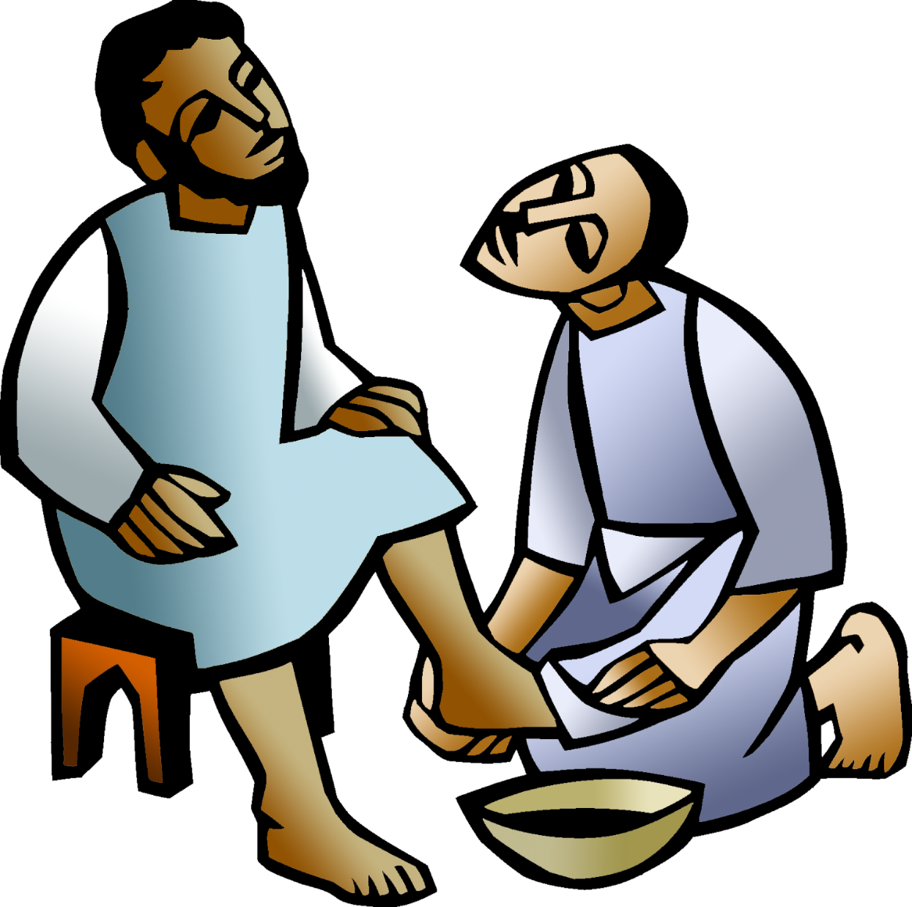

+ Triduum – Maundy Thursday
April 2, 2026


St. Andrew Lutheran Church
304 Morewood Ave.
Pittsburgh, PA 15213
St_andrewELCA@verizon.net
www.standrewpittsburgh.org

+ Triduum – Maundy Thursday
Order for Worship

This evening our Lenten observance comes to an end, and we gather with Christians around the world to celebrate the Triduum – the Three Days of Jesus’ death and resurrection. Tonight we remember Christ’s last meal with his disciples, but the central focus is his commandment that we live out the promise embodied in this meal. As Jesus washed his disciples’ feet, so we are called to give and receive love in humble service to one another. Formed into a new body in Christ through this holy meal, we are transformed by the mercy we have received and carry it into the world. Departing worship in solemn silence, we anticipate the coming days.

Welcome to St. Andrew!
- St. Andrew welcomes all who are seeking a place of healing, wholeness, and acceptance in a nurturing and faith-forming spiritual home. We are striving toward racial equity worldwide
and we seek to honor the lived experience of all individuals regardless of background. Our community embraces people of all ages, ethnicities, cultures, abilities, sexual orientations,
gender identities and expressions, and family constellations. Come and See!
- Worship Services are live-streamed to multiple online platforms. By attending worship, you agree that your image and voice may be broadcast.
- Everyone is invited to make a name tag at the black bookcase in the back of the worship space if they would like. There are stickers indicating pronouns on the bookcase if you would like to include them on your name tag.
- A nursery is available through the doors at the left side of the sanctuary and across from the doorway to the Social Hall. Look for a purple-colored room.
- Worship “toolkits” to help children engage with the service, along with “busy bags” for younger children, are available in the bookcase at the back of the sanctuary. Please feel free to take one to use with/for your children.
- Holy Communion is served with bread (gluten-free available) and wine or grape juice. The presiding minister will distribute the bread (host). Please consume this and then pick up an empty glass from the tray. The Communion Assistant will pour wine or grape juice into your glass. Please step to the side to consume the wine or grape juice. Feel free to kneel at the altar for prayer and reflection. As you return to your pew, glasses may be returned to the empty trays on either side of the center section.
- A restroom is available on the main level of the church, through the doors to the Social Hall and to the right in the main office.

Abbreviations
P: Pastor/Presiding Minister ELW: Evangelical Lutheran Worship hymnal
A: Assisting Minister ACS: All Creation Sings hymnal
L: Lector MSB1: Musician’s Source Book 1
C: Congregation WOV: With One Voice hymnal
W&P: Worship & Praise hymnal
LBW: Lutheran Book of Worship
Welcome

Prelude What Wondrous Love Is This arr. Carter

Gathering
The Holy Spirit calls us together as the people of God

Please rise as you are able.

Confession and Forgiveness

P: Friends in Christ, in this Lenten season
we have heard our Lord’s call to struggle against sin, death, and the devil—
all that keeps us from loving God and each other.
This is the struggle to which we were called at Baptism.

Within the community of the church,
God never wearies of forgiving sin and giving the peace of reconciliation.
On this night let us confess our sin against God and our neighbor,
and enter the celebration of the great Three Days
reconciled with God and with one another.

Silence is kept for reflection.

P: Most merciful God,
C: we confess that we are captive to sin and cannot free ourselves.
We have sinned against you in thought, word, and deed,
by what we have done and by what we have left undone.
We have not loved you with our whole heart;
we have not loved our neighbors as ourselves.
For the sake of your Son, Jesus Christ, have mercy on us.
Forgive us, renew us, and lead us,
so that we may delight in your will and follow in your ways,
to the glory of your holy name.
Amen.

P: God, who is rich in mercy,
loved us even when we were dead in sin,
and made us alive together with Christ.
By grace you have been saved.
In the name of ☩ Jesus Christ, your sins are forgiven.
Almighty God strengthen you with power through the Holy Spirit,
that Christ may live in your hearts through faith.
C: Amen.

Gathering Hymn Three Holy Days Enfold Us Now ACS 930

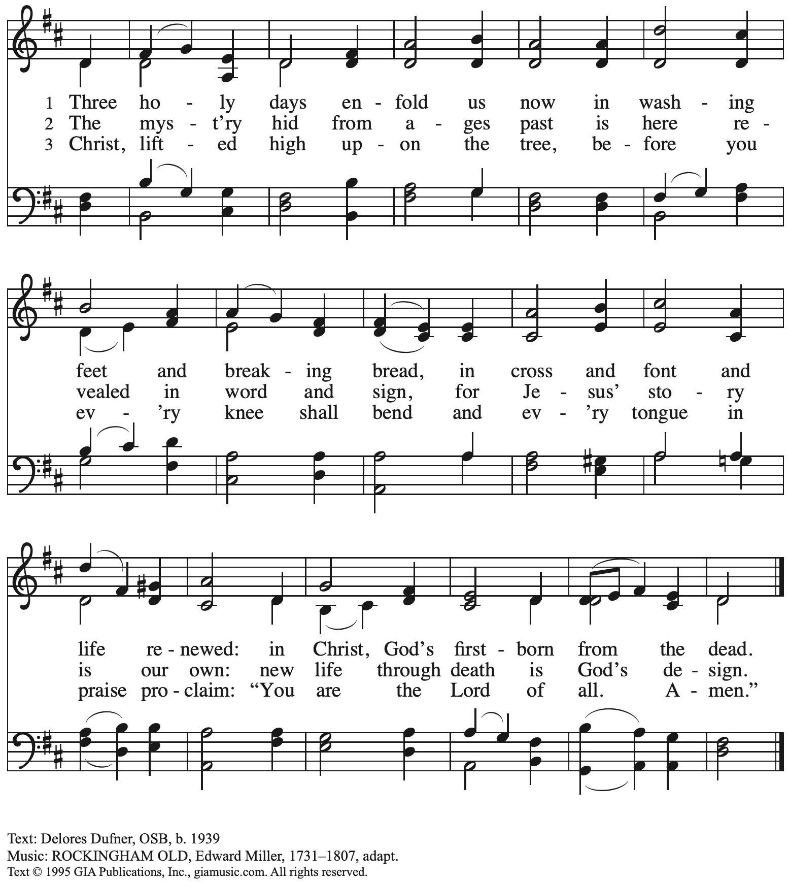
Reprinted with permission under OneLicense.net # A-722139.

Greeting

P: The grace of our Lord Jesus Christ, the love of God,
and the communion of the Holy Spirit be with you all.
C: And also with you.

Prayer of the Day

P: Let us pray.

A brief silence is kept.

Holy God, source of all love,
on the night of his betrayal, Jesus gave us a new commandment,
to love one another as he loves us.
Write this commandment in our hearts,
and give us the will to serve others as he was the servant of all,
your Son, Jesus Christ, our Savior and Lord,
who lives and reigns with you and the Holy Spirit,
one God, now and forever.
C: Amen.

Please be seated.

Word
God speaks to us in Scripture reading, preaching, and song

First Reading – Exodus 12: 1-4 [5-10] 11-14

¹The Lord said to Moses and Aaron in the land of Egypt: ²This month shall mark for you the beginning of months; it shall be the first month of the year for you. ³Tell the whole congregation of Israel that on the tenth of this month they are to take a lamb for each family, a lamb for each household. ⁴If a household is too small for a whole lamb, it shall join its closest neighbor in obtaining one; the lamb shall be divided in proportion to the number of people who eat of it.
[⁵Your lamb shall be without blemish, a year-old male; you may take it from the sheep or from the goats. ⁶You shall keep it until the fourteenth day of this month; then the whole assembled congregation of Israel shall slaughter it at twilight. ⁷They shall take some of the blood and put it on the two doorposts and the lintel of the houses in which they eat it. ⁸They shall eat the lamb that same night; they shall eat it roasted over the fire with unleavened bread and bitter herbs. ⁹Do not eat any of it raw or boiled in water but roasted over the fire, with its head, legs, and inner organs. ¹⁰You shall let none of it remain until the morning; anything that remains until the morning you shall burn with fire.] ¹¹This is how you shall eat it: your loins girded, your sandals on your feet, and your staff in your hand, and you shall eat it hurriedly. It is the Passover of the Lord.
¹²I will pass through the land of Egypt that night, and I will strike down every firstborn in the land of Egypt, from human to animal, and on all the gods of Egypt I will execute judgments: I am the Lord. ¹³The blood shall be a sign for you on the houses where you live: when I see the blood, I will pass over you, and no plague shall destroy you when I strike the land of Egypt.
¹⁴This day shall be a day of remembrance for you. You shall celebrate it as a festival to the Lord; throughout your generations you shall observe it as a perpetual ordinance.

L: Word of God, word of life.
C: Thanks be to God.

Psalm 116: 1-2, 12-19

The cantor will lead the singing of the psalm.
The congregation is invited to respond with the alternate verses in bold print,
and to join in singing the refrain.

Psalm tone

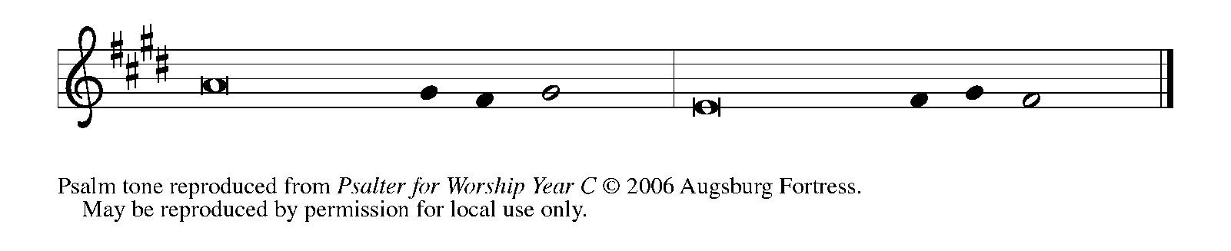

Psalm refrain

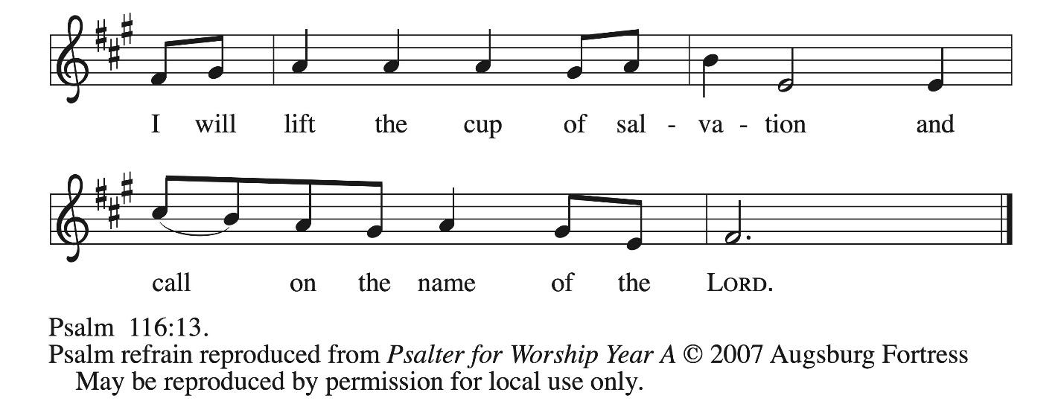

¹I love the Lord, who has | heard my voice,
and listened to my | supplication,
²for the Lord has given | ear to me
whenev- | er I called.
¹²How shall I re- | pay the Lord
for all the good things God has | done for me?
¹³I will lift the cup | of salvation
and call on the name | of the Lord. R
¹⁴I will fulfill my vows | to the Lord
in the presence of | all God’s people.
¹⁵Precious in your | sight, O Lord,
is the death | of your servants.
¹⁶O Lord, truly I | am your servant;
I am your servant, the child of your handmaid; you have freed me | from my bonds.
¹⁷I will offer you the sacrifice | of thanksgiving
and call upon the name | of the Lord.
¹⁸I will fulfill my vows | to the Lord
in the presence of | all God’s people,
¹⁹in the courts of | the Lord’s house,
in the midst of you, | O Jerusalem. R

Second Reading – 1 Corinthians 11: 23-26

²³For I received from the Lord what I also handed on to you, that the Lord Jesus on the night when he was betrayed took a loaf of bread, ²⁴and when he had given thanks, he broke it and said, “This is my body that is for you. Do this in remembrance of me.” ²⁵In the same way he took the cup also, after supper, saying, “This cup is the new covenant in my blood. Do this, as often as you drink it, in remembrance of me.” ²⁶For as often as you eat this bread and drink the cup, you proclaim the Lord’s death until he comes.

L: Word of God, word of life.
C: Thanks be to God.

Please rise as you are able.

Gospel Verse I Give You a New Commandment MSB1 S441

The Gospel Verse will be sung before and after the reading of the Gospel.

Cantor: I give you a | new commandment, that you love one another just as I | have loved you.

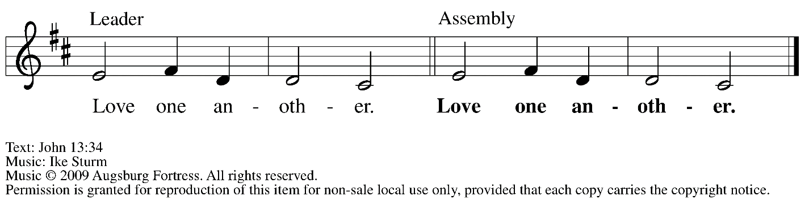

Gospel – John 13: 1-17, 31b-35

P: The holy Gospel according to St. John.
C: Glory to you, O Lord.

¹Now before the festival of the Passover, Jesus knew that his hour had come to depart from this world and go to the Father. Having loved his own who were in the world, he loved them to the end. ²The devil had already decided that Judas son of Simon Iscariot would betray Jesus. And during supper ³Jesus, knowing that the Father had given all things into his hands, and that he had come from God and was going to God, ⁴got up from supper, took off his outer robe, and tied a towel around himself. ⁵Then he poured water into a basin and began to wash the disciples’ feet and to wipe them with the towel that was tied around him. ⁶He came to Simon Peter, who said to him, “Lord, are you going to wash my feet?” ⁷Jesus answered, “You do not know now what I am doing, but later you will understand.” ⁸Peter said to him, “You will never wash my feet.” Jesus answered, “Unless I wash you, you have no share with me.” ⁹Simon Peter said to him, “Lord, not my feet only but also my hands and my head!” ¹⁰Jesus said to him, “One who has bathed does not need to wash, except for the feet, but is entirely clean. And you are clean, though not all of you.” ¹¹For he knew who was to betray him; for this reason he said, “Not all of you are clean.”
¹²After he had washed their feet, had put on his robe, and had reclined again, he said to them, “Do you know what I have done to you? ¹³You call me Teacher and Lord—and you are right, for that is what I am. ¹⁴So if I, your Lord and Teacher, have washed your feet, you also ought to wash one another’s feet. ¹⁵For I have set you an example, that you also should do as I have done to you. ¹⁶Very truly, I tell you, servants are not greater than their master, nor are messengers greater than the one who sent them. ¹⁷If you know these things, you are blessed if you do them.”

^{31b}Now the Son of Humanity has been glorified, and God has been glorified in him. ³²If God has been glorified in him, God will also glorify him in Godself and will glorify him at once. ³³Little children, I am with you only a little longer. You will look for me; and as I said to the Jews so now I say to you, ‘Where I am going, you cannot come.’ ³⁴I give you a new commandment, that you love one another. Just as I have loved you, you also should love one another. ³⁵By this everyone will know that you are my disciples, if you have love for one another.”

P: The Gospel of the Lord.
C: Praise to you, O Christ.

Please be seated.

Sermon

A period of silence for prayer and reflection follows the sermon.
When the Hymn of the Day begins, please rise as you are able.

Hymn of the Day Great God, Your Love Has Called Us ELW 358

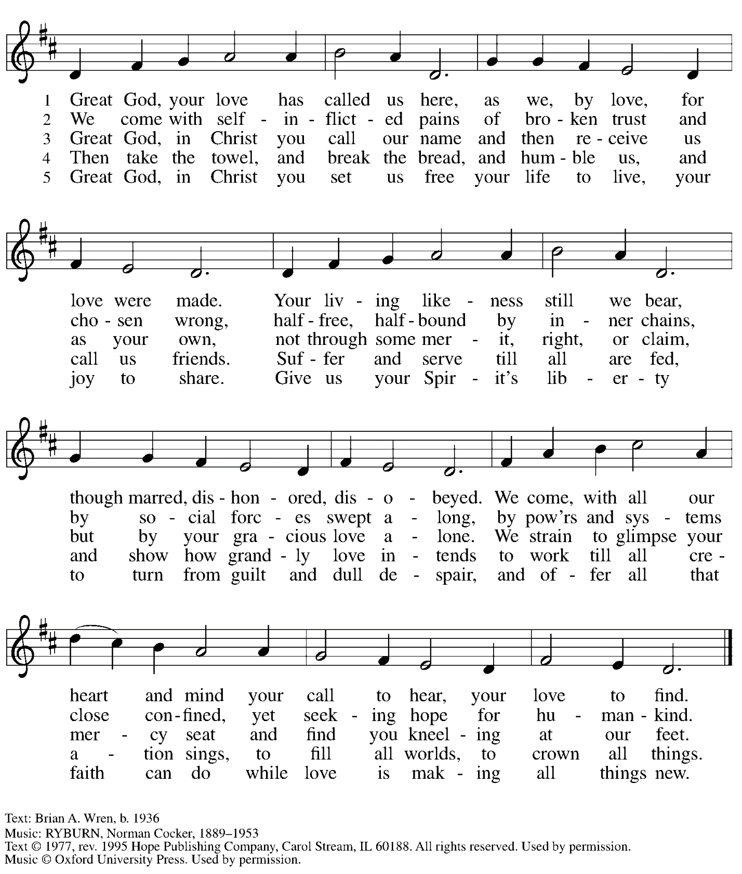
All rights reserved. Reprinted with permission under OneLicense.net # A-722139.

Footwashing

P: On this night, we have heard our Lord’s commandment to love one another as he has loved us. We who receive God’s love in Jesus Christ are called to love one another, to be servants to each other as Jesus became our servant. Our commitment to this loving service is signified in the washing of feet, following the example our Lord gave us on the night before his death.

People of the assembly are invited to come forward and remove shoes and socks
in preparation for the ministers to wash their feet.
Assembly song accompanies the footwashing.

Hymn during Footwashing
A New Commandment WOV 664

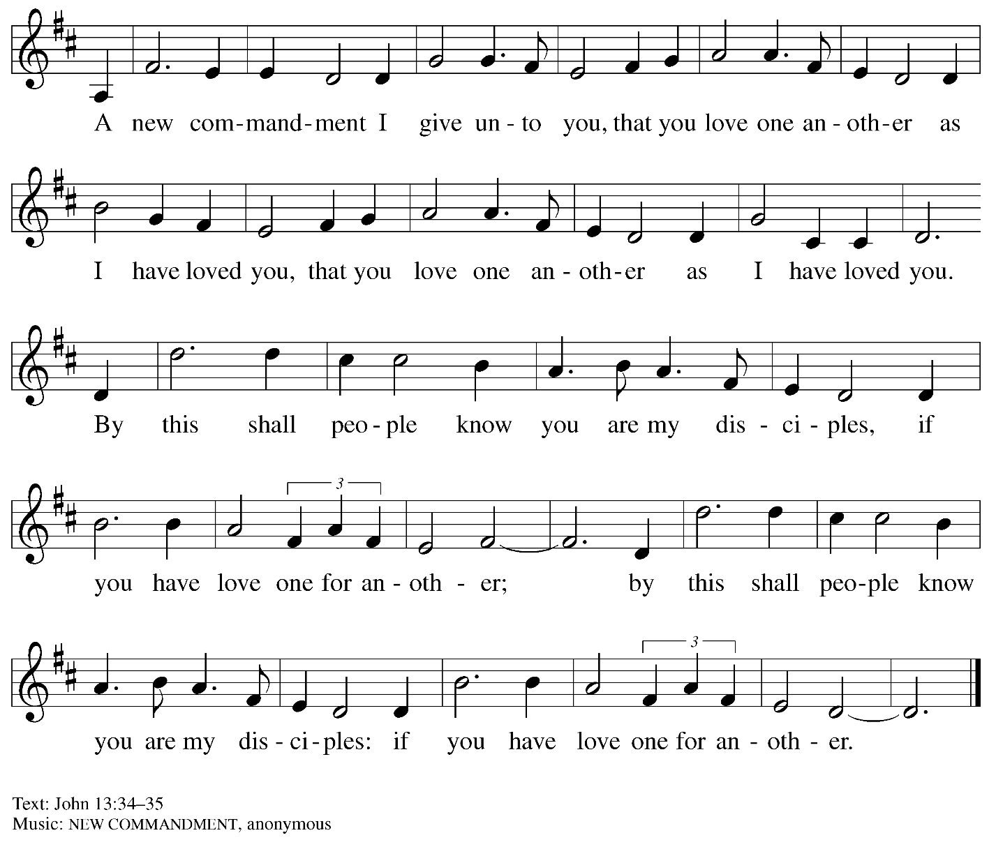

Hymn during Footwashing ACS 931
Where Charity and Love Are Shown – Donde hay caridad
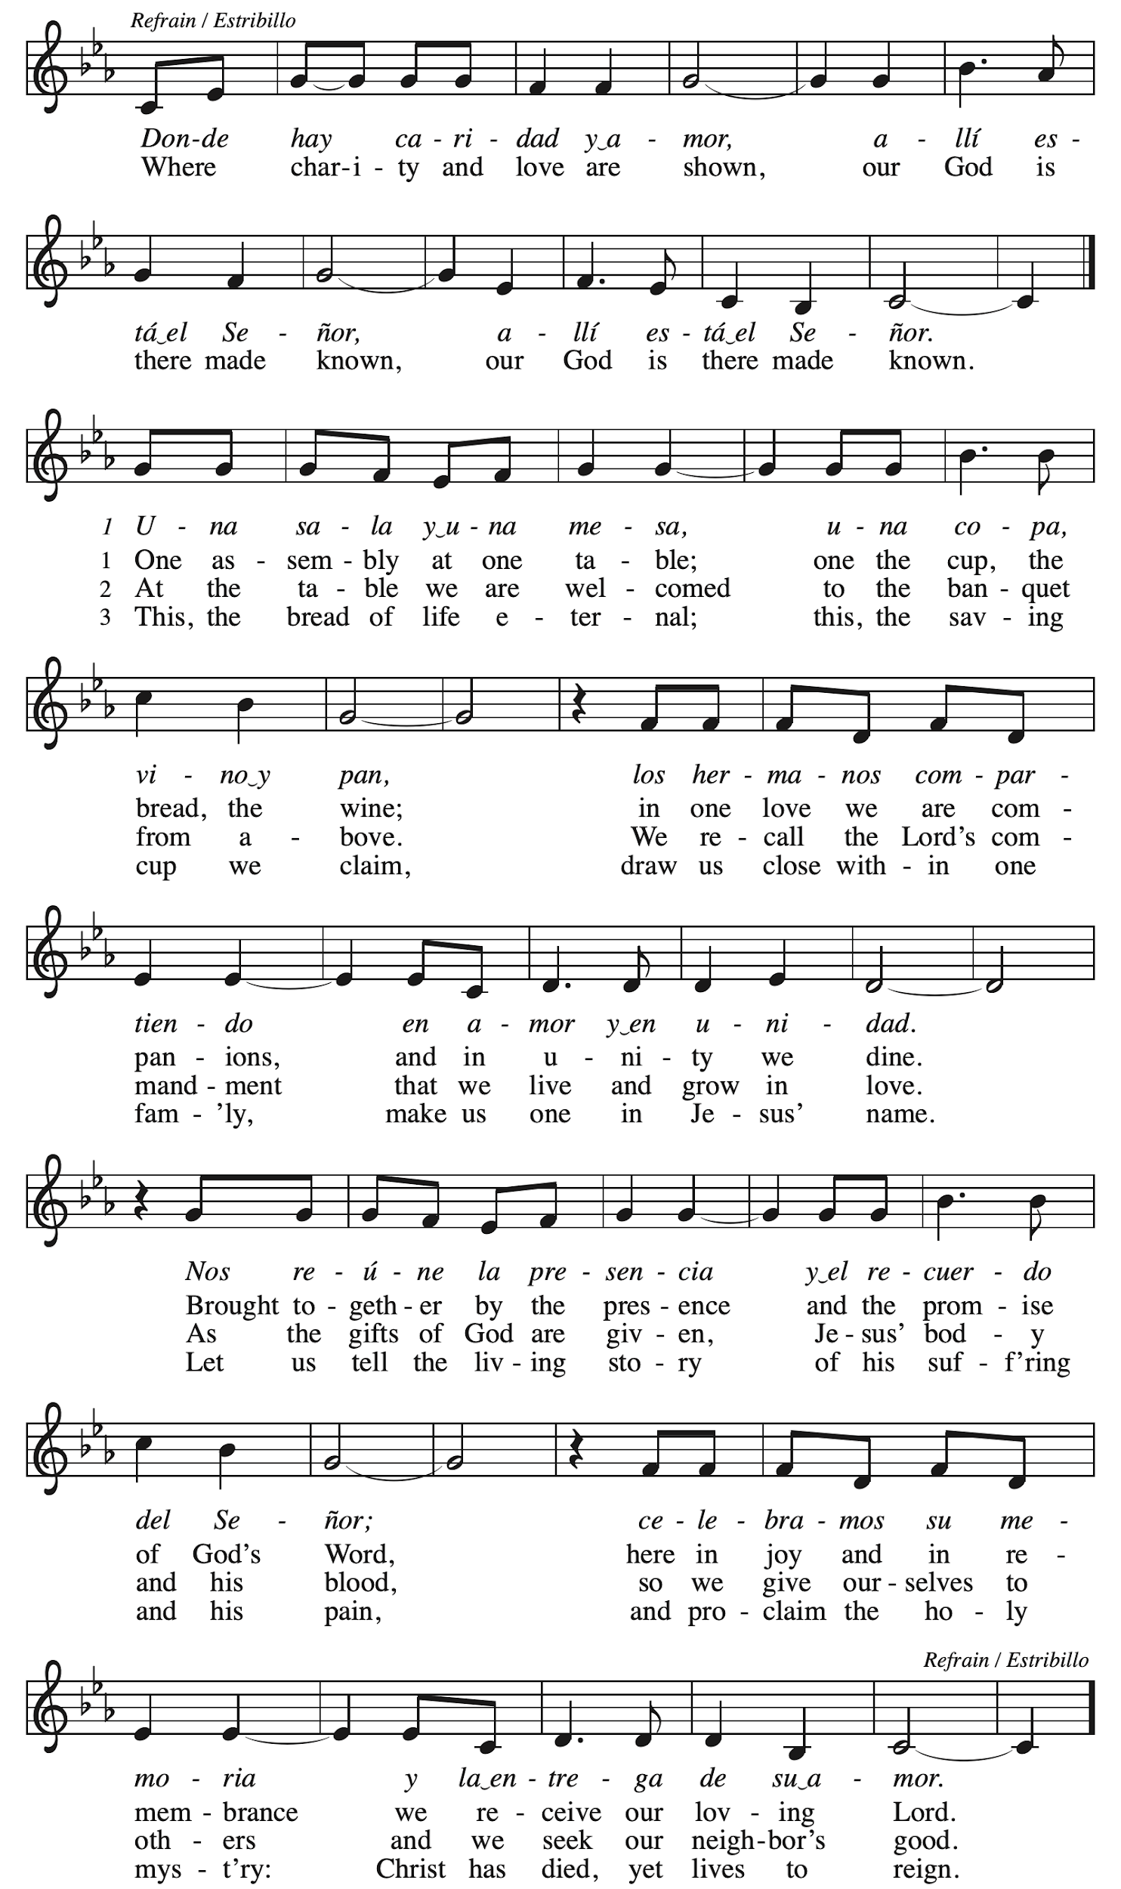
Hymns during Footwashing
Ubi caritas et amor ELW 642

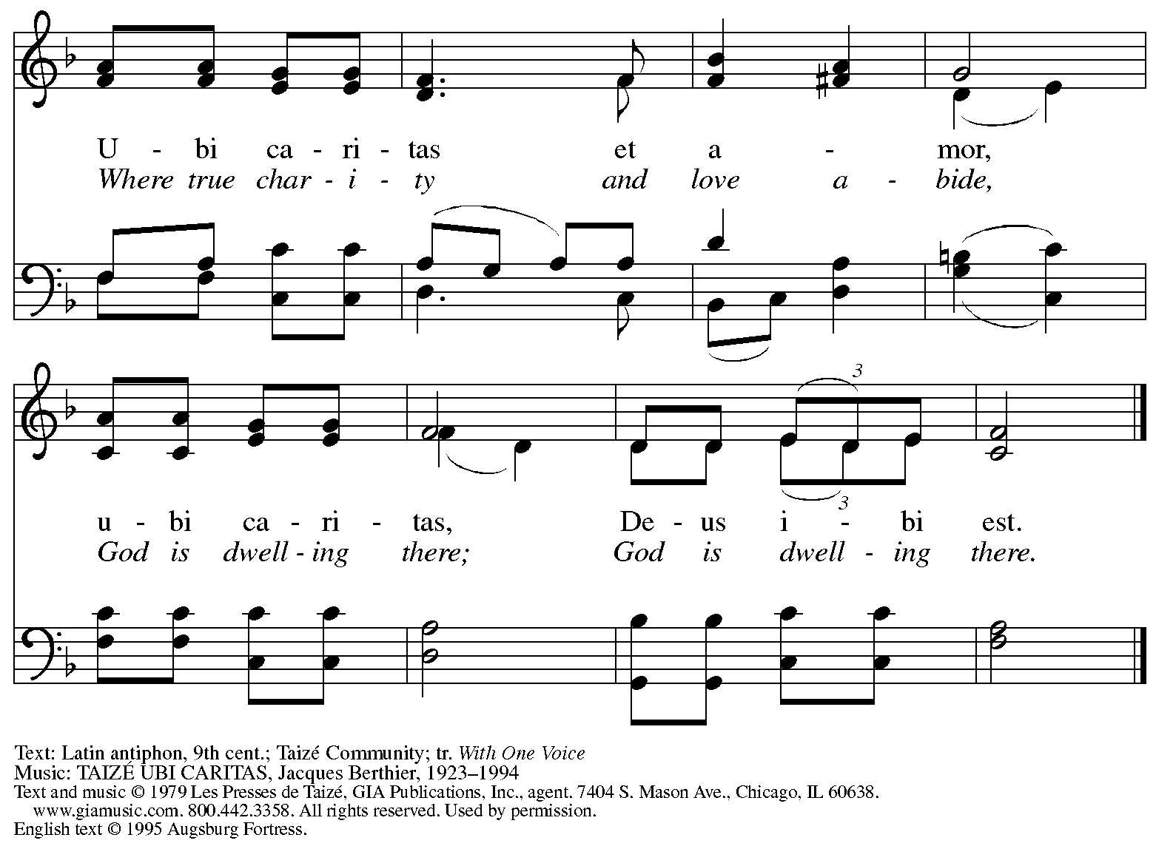
All rights reserved. Reprinted with permission under OneLicense.net # A-722139.

Hymns during Footwashing
What Wondrous Love Is This LBW 385

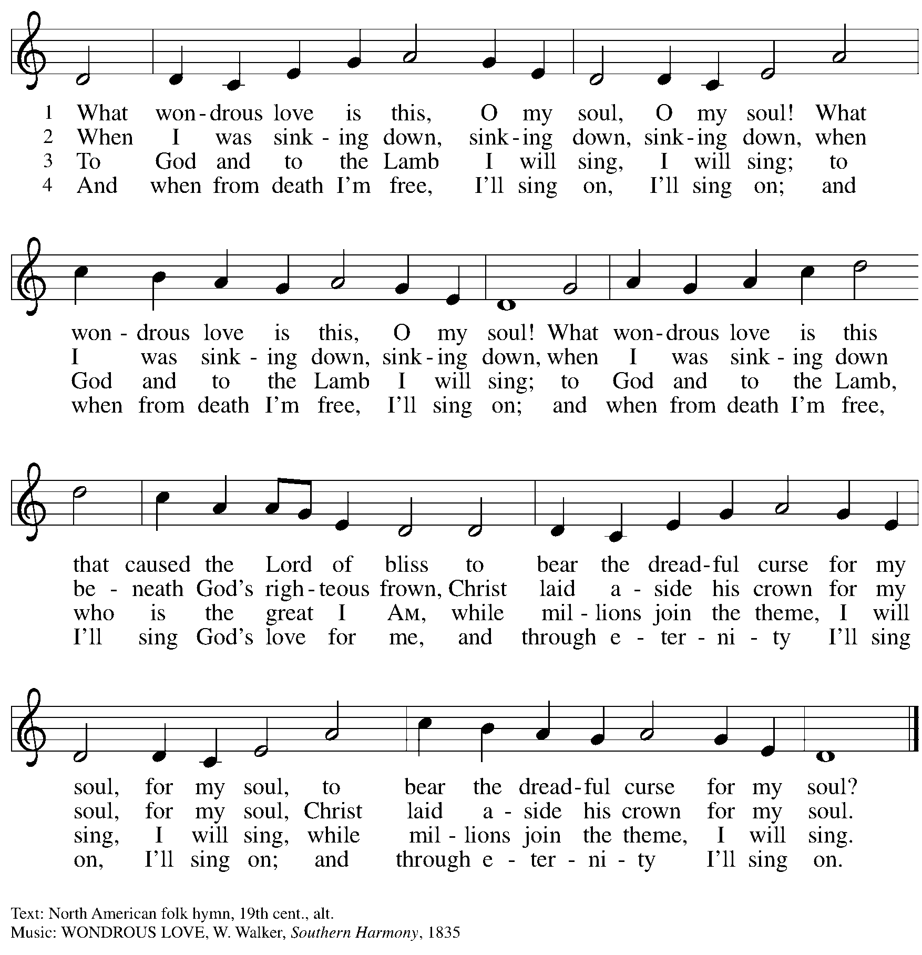

When the footwashing has concluded and all have returned to their places,
worship continues with the Prayers of the People.

Prayers of the People

A: Let us pray for new life in the church, new hope for the world,
and God’s love for all who are in need.

After each petition
A: Merciful God,
C: receive our prayer.

The presiding minister concludes the prayers
P: We pray to you, O God, in the name of the one who endured the cross, forgives our sin,
and feeds us at his table, Jesus Christ our Lord.
C: Amen.

Peace

The presiding minister and the assembly greet one another in the peace of the risen Christ.
P: The peace of Christ be with you always.
C: And also with you.

The people may greet those around them with a sign of Christ’s peace and may say
Peace be with you or similar words. Please be mindful that not everyone will be comfortable with sharing the peace, so please seek consent before shaking hands or hugging.
Other possible ways to share the peace include a simple bow with the verbal greeting of peace, or simply a verbal expression of peace.
When the greetings of peace have concluded, please be seated.


Meal
God feeds us with the presence of Jesus Christ

Offering

We offer ourselves, our gifts, and our faithful service to God.
As the offering is gathered for the mission of the church, including the care of those in need,
the table is set for Holy Communion.

There are laminated giving cards in the pew racks that feature a QR code for anyone who would like to give online. Those who give using the QR code, as well as those who give regularly online or through their bank are encouraged to place the laminated card in the plate as an expression of your offering.

Music during the Offering Just As I Am arr. Raney

As the gifts are brought forward for presentation, please rise as you are able.

Offertory Song Create in Me a Clean Heart ELW 186

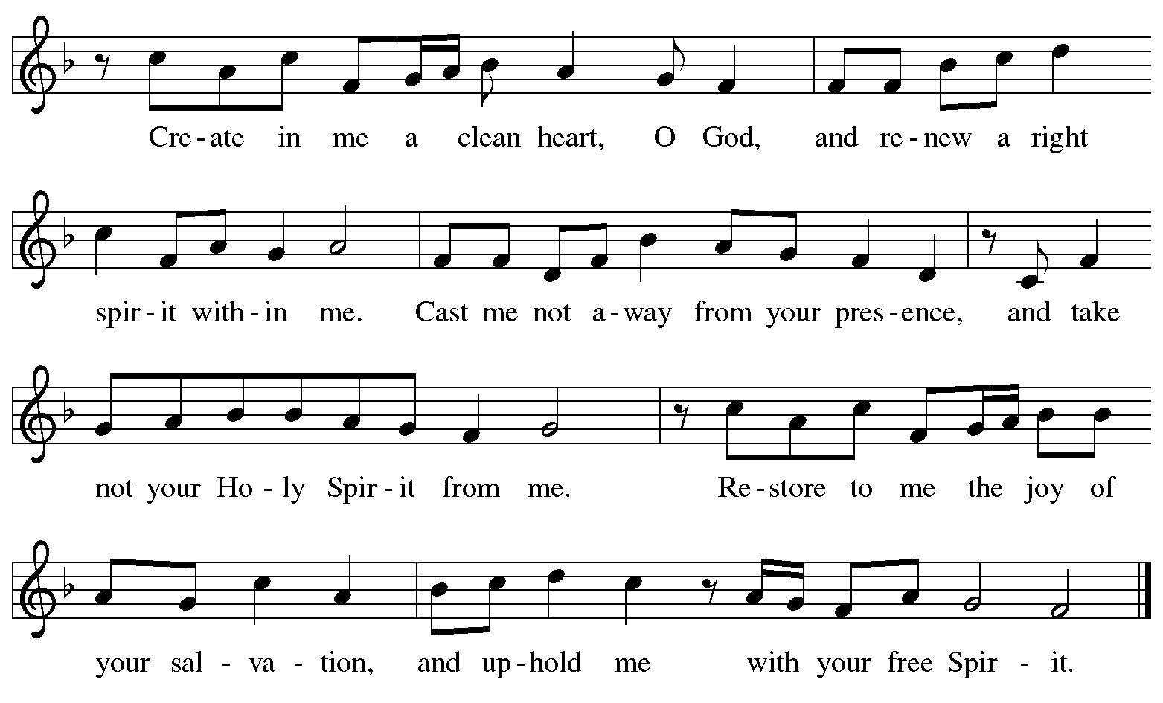

Offertory Prayer

A: Let us pray.
Jesus, our Savior,
C: you are the bread of life and host of this meal.
Bless us and these gifts that we have gathered
that all people may know your goodness and love.
We pray this in your holy name.
Amen.

Dialogue

P: The Lord be with you.
C: And also with you.

P: Lift up your hearts.
C: We lift them to the Lord.

P: Let us give thanks to the Lord our God.
C: It is right to give our thanks and praise.

Preface

P: It is indeed right, our duty and our joy,
that we should at all times and in all places
give thanks and praise to you, almighty and merciful God,
through our Savior Jesus Christ;
whose suffering and death gave salvation to all.
You gather your people around the tree of the cross,
transforming death into life.
And so, with all the choirs of angels,
with the church on earth and the hosts of heaven,
we praise your name and join their unending hymn:

Sanctus ELW p. 200

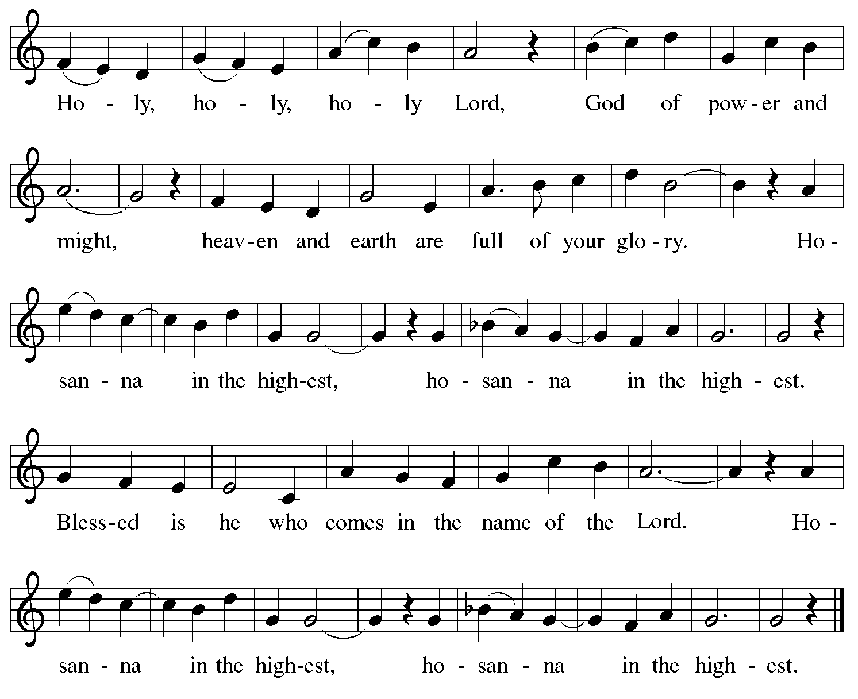

Eucharistic Prayer

P: Blessed are you, O living God, sovereign of time and space …
… Blessed be God forever!
C: Blessed be God forever!

P: Blessed are you, O living God, for your glory revealed in Jesus Christ …
… Blessed be God forever!
C: Blessed be God forever!

P: In the night in which he was betrayed …
… Do this for the remembrance of me.

Blessed be God forever!
C: Blessed be God forever!

P: Blessed are you, O Living God, for your Spirit of love …
Blessed be God forever!
C: Blessed be God forever!

P: Amen and Amen.
C: Amen and Amen.

Lord’s Prayer

P: Gathered as one by the Holy Spirit, let us pray as Jesus taught us.
C: Our Father in heaven,
hallowed be your name,
your kingdom come,
your will be done,
on earth as in heaven.
Give us today our daily bread.
Forgive us our sins
as we forgive those
who sin against us.
Save us from the time of trial
and deliver us from evil.
For the kingdom, the power,
and the glory are yours,
now and forever. Amen.

Fraction and Invitation

P: All who are hungry, come.
The feast of grace is ready.



Agnus Dei / Lamb of God ELW p. 201

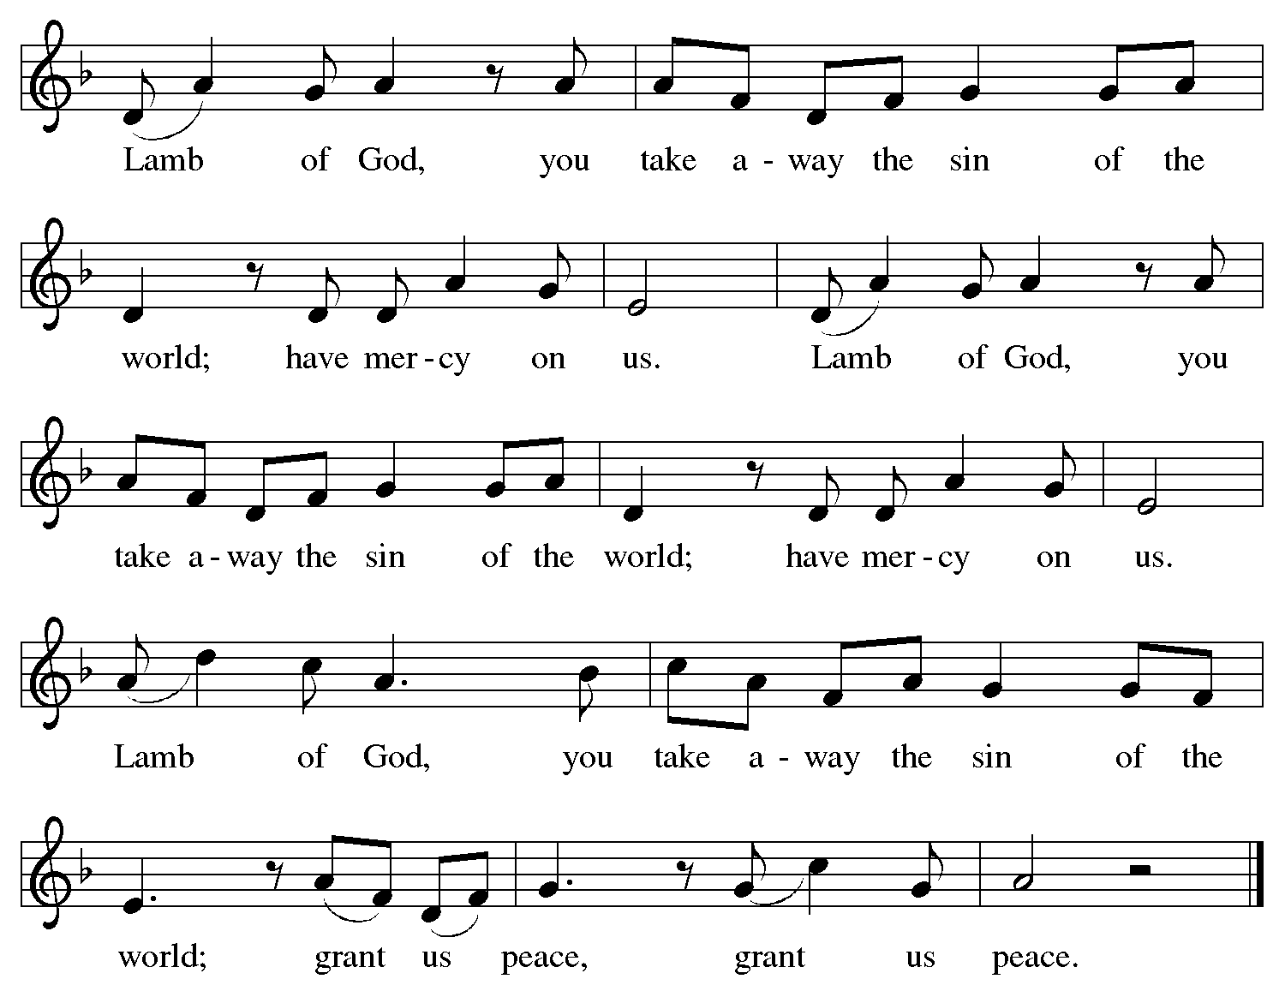

Please be seated.

Holy Communion
- All who seek God and desire a deeper and stronger life in Christ are welcome to receive Holy Communion.
- Worshipers from the pulpit side will proceed forward first, followed by the center section, and then the lectern side.
- Please inform an usher if you would like the ministers to bring Communion to you.
- On Maundy Thursday, we invite everyone to kneel at the altar rail (as able) to receive Holy Communion.
- Please pick up an empty glass from the tray near the baptismal font before taking your place at the altar rail.
- Holy Communion will be served with bread and wine (red) or grape juice (white).
- The presiding minister will first distribute the bread (host) to each communicant. Please indicate if you require a gluten-free host.
- Once you have consumed the bread, the Communion Assistant will pour wine or grape juice into your glass.
- As you return to your pew, glasses may be returned to the empty tray on the side of the center section.
- A blessing will be provided for anyone who does not yet receive the sacrament.
- All are invited to join in singing the hymns during Holy Communion.

Hymns during Holy Communion
Bread of Life, Our Host and Meal ELW 464

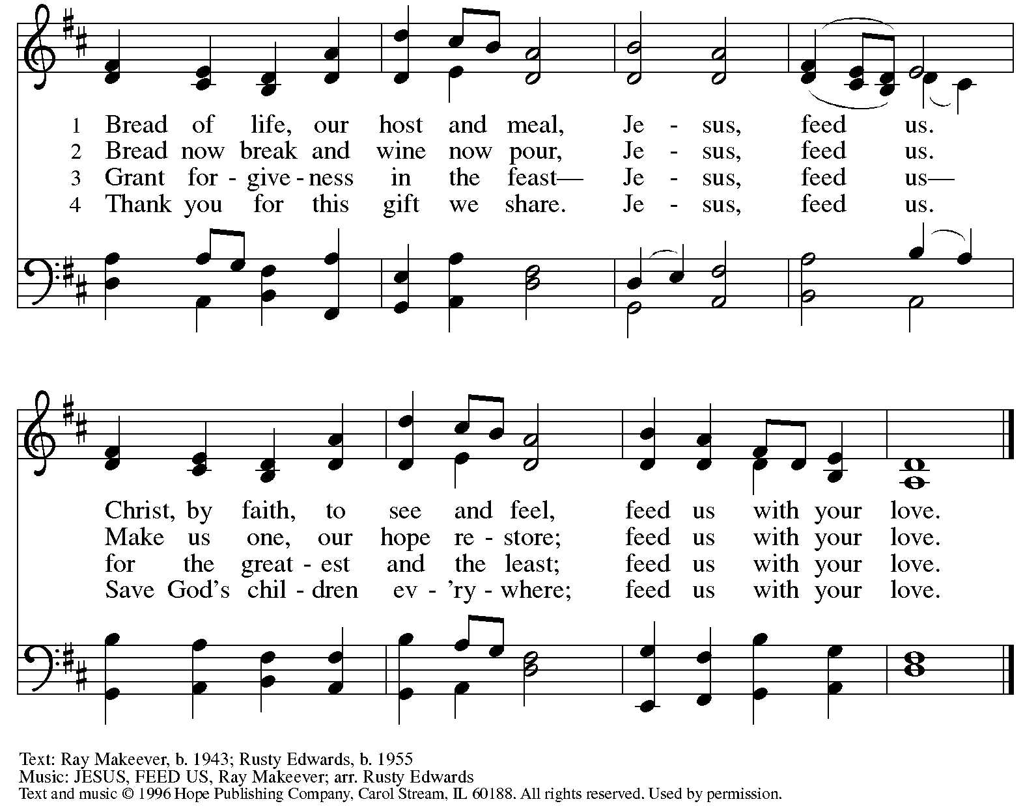
Reprinted under OneLicense.net # A-722139.

Hymns during Holy Communion
Lord, Who the Night You Were Betrayed ELW 463

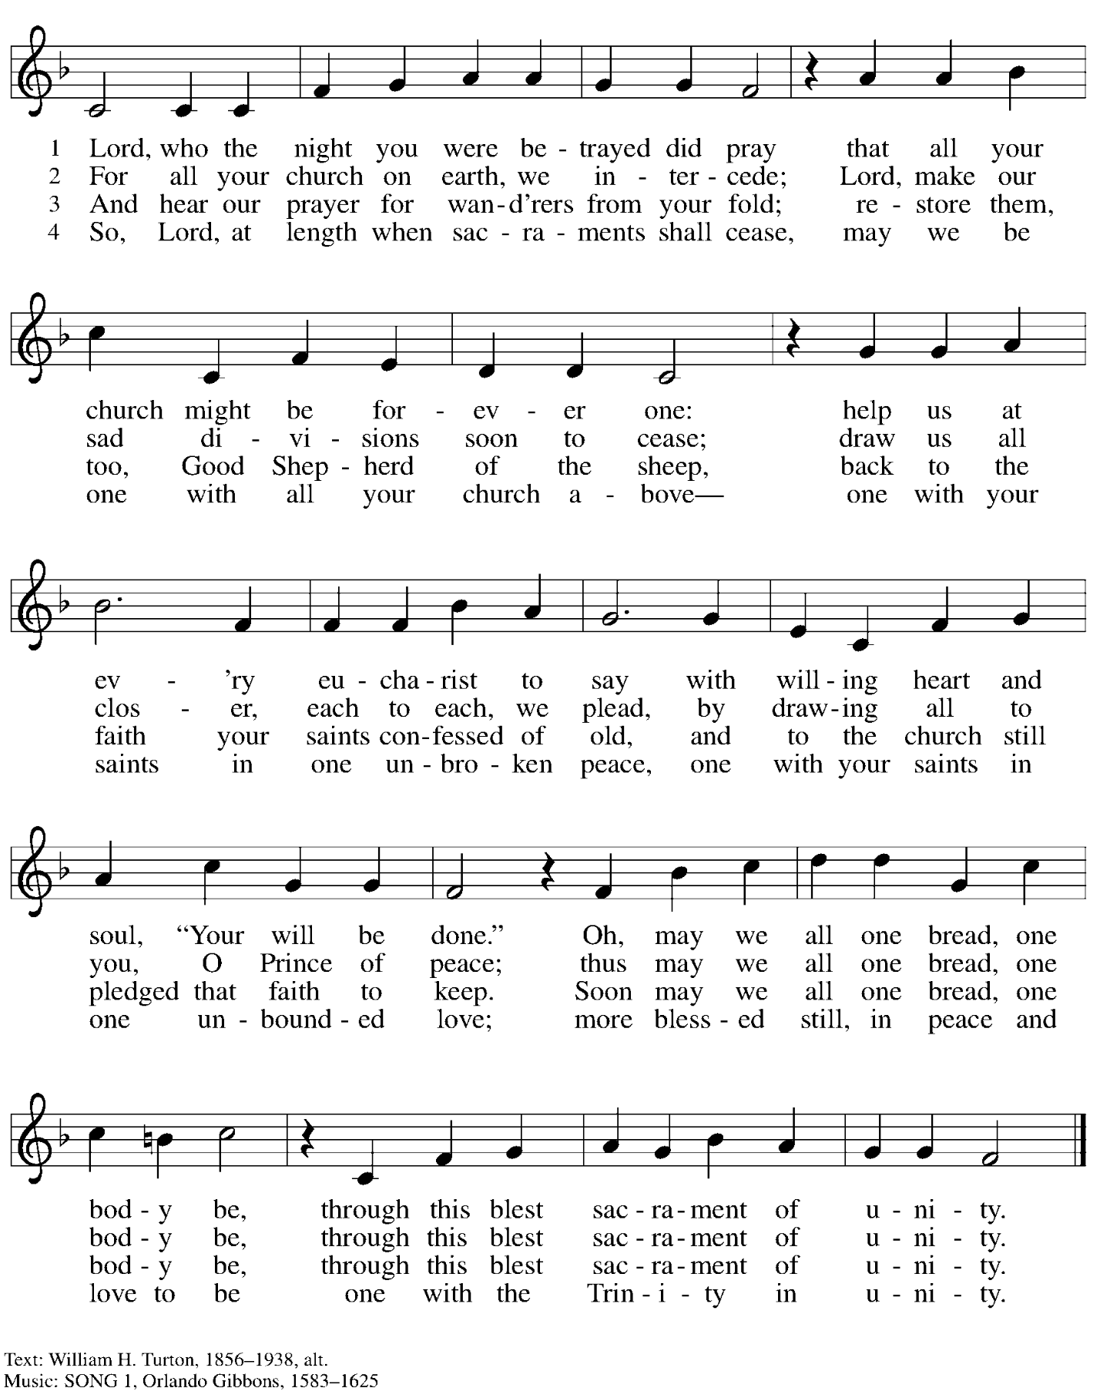

Hymns during Holy Communion
Broken in Love W&P 24

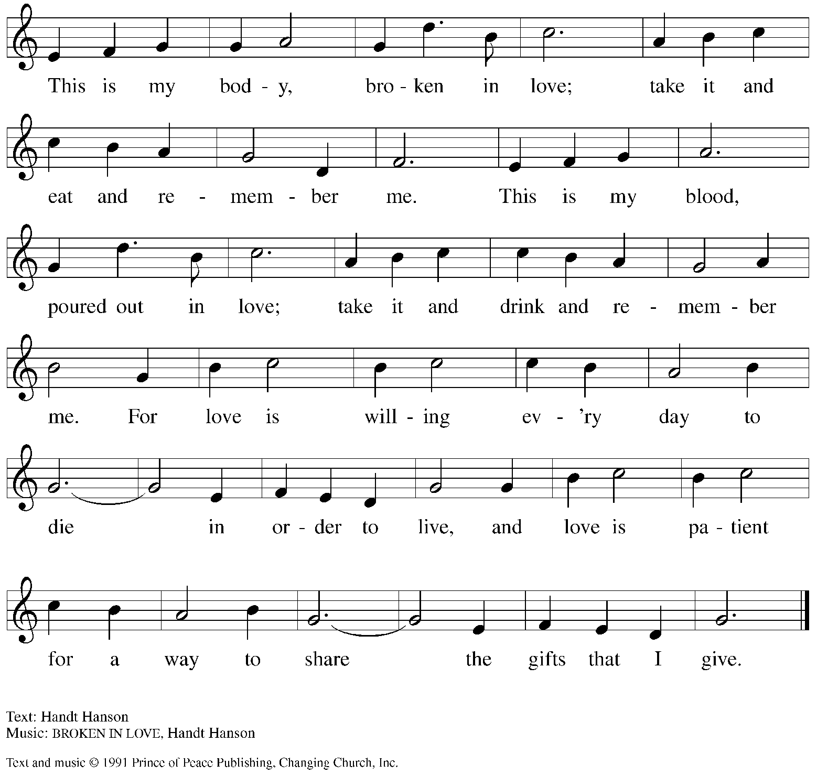
All rights reserved. Reprinted with permission under OneLicense.net # A-722139.

When all have returned to their places, please rise as you are able.

Blessing

P: The body and blood of our Lord Jesus Christ strengthen you and keep you in his grace.
C: Amen.

Prayer

A: Let us pray.
Lord Jesus, in a wonderful sacrament you strengthen us
with the saving power of your suffering, death, and resurrection.
May this sacrament of your body and blood so work in us
that the fruits of your redemption will show forth in the way we live,
for you live and reign with the Father and the Holy Spirit,
one God, now and forever.
C: Amen.

Stripping of the Altar

The service concludes with the stripping of the altar. The assembly is seated.

The sacramental elements and vessels, linens, paraments, banners, and books are removed from the worship space. Psalm 88 is sung. The congregation is invited to sing the ostinato refrain (printed below) continuously while the cantors sing the verses.
Lights are dimmed as the worship space is stripped.

Psalm 88 Refrain

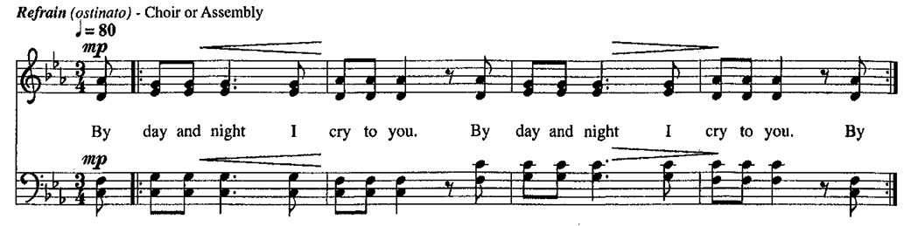

The benediction and dismissal are omitted.

All depart in silence.

The service of the Triduum continues tomorrow, Good Friday, with worship at 7:00 p.m.

Those serving in worship today

Altar Care Jodie Minor
C.E. Pino
Zie Weaver
Assisting Minister Jimmi Kocher-Hillmer
Audio-Visual Minister Kristen Asplin
Cantors Joy Givens
Joseph Paetz
Lector Alda Maria Gonzaga
Minister of Music Laura Reynolds
Presiding Minister Pastor Ross Carmichael

Liturgy and Hymnody Acknowledgements

From SundaysandSeasons.com. Copyright © 2026 Augsburg Fortress. All rights reserved. Reprinted under OneLicense.net # A-722139.
Used by permission of Augsburg Fortress.

The Scripture readings contained herein are from New Revised Standard Version Updated Edition of the Bible © 2021 National Council of Churches of Christ in the United States of America. Used by permission. All rights reserved worldwide.

Eucharistic Prayer – From Pray, Praise, and Give Thanks: A Collection of Litanies, Laments, and Thanksgivings at Font and Table by Gail Ramshaw, copyright © 2017 Augsburg Fortress. All rights reserved. Reprinted with permission.

Where Charity and Love Are Shown – Donde hay caridad – Text: Joaquín Madurga, 1938-2017; tr. Martin A. Seltz, b. 1951. Music: DONDE HAY CARIDAD, Joaquín Madurga. Text and music © 1981, 2009, Joaquín Madurga. Published by OCP, 5536 N. Hassalo, Portland, OR 97213. All rights reserved. Reprinted with permission under OneLicense.net # A-722139.

Please use the QR code below to link to St. Andrew’s announcements online!



St. Andrew Announcements
Thursday, April 2nd, 2026

- Welcome to Worship at St. Andrew on + Maundy Thursday – We are grateful for your presence, and we offer a special welcome to all visitors and guests who are gathered at the church or online. There are worship “toolkits” to help children engage with worship and “busy bags” for younger children available in the bookcase at the back of the sanctuary. Please feel free to take one to use with your children.
- Worship Schedule for Holy Week – Our reflection on the passion, death, and resurrection of Jesus Christ continues with the two remaining services of the Triduum, Good Friday and the Vigil of Easter, and worship on Easter Sunday.

The service schedule for the upcoming days is:
  - Triduum – Good Friday, April 3rd, 7:00 p.m. – Service of Shadows and Stones – In relative darkness, we hear Gospel accounts of the crucifixion, sing prayerful, meditative hymns, and leave stones at the foot of the cross as we honor our crucified Savior.
  - Triduum – The Vigil of Easter, Saturday, April 4th, 5:00 p.m. – The church tells God’s story of salvation through worship, word, sacrament, and song as we gather around a fire, hear stories of God’s faithfulness throughout the ages, give thanks for the gift of Baptism, and move into the celebration of the resurrection with Holy Communion.
  - The Resurrection of our Lord – Easter Sunday, April 5th, 10:00 a.m. – Worship with Holy Communion – We join the church throughout the world in proclaiming the good news of Christ’s resurrection!
- Reparations Offering on Easter Sunday – April 5th during Worship – In Luke’s Gospel, Jesus tells a story about a compassionate Samaritan, suggesting that God’s people are called to work for healing and restoration for our neighbors, regardless of who or what caused them harm. In light of this, St. Andrew has made a commitment to reparations in regard to African American spiritual songs used in our worship. The text and music of most hymns is attributed to specific authors, with copyrights in place, usage reported, and royalties paid to those whose works are featured in worship. With African American spirituals, this is not possible. In response to many years of such uncredited use, St. Andrew invites the congregation to give a reparations offering. Funds received in worship will be donated to our siblings at Bethel AME Church, whose land and building were taken from them in the 1950s, to fund their development in the Hill District.

