

+ Palm Sunday – Sunday of the Passion
March 29, 2026


St. Andrew Lutheran Church
304 Morewood Ave.
Pittsburgh, PA 15213
St_andrewELCA@verizon.net
www.standrewpittsburgh.org

+ Palm Sunday – Sunday of the Passion
Order for Worship

Today we follow Christ from triumphal entry to the cross, each waypoint of the journey marked by Jesus’ compassion for those who would betray, mock, accuse, or do violence to him.
Though persecuted and beaten, Jesus the Son of God is not disgraced; instead, he asks forgiveness for those who put him to death. We have followed the Lenten pathway these forty days, each of us invited through Baptism to “let the same mind be in you that was in Christ Jesus.” We enter this holy week accompanying Jesus to the cross with both grief
and thanksgiving in our hearts, trusting in God’s redeeming love.

Welcome to St. Andrew!

- St. Andrew welcomes all who are seeking a place of healing, wholeness, and acceptance in a nurturing and faith-forming spiritual home. We are striving toward racial equity worldwide
and we seek to honor the lived experience of all individuals regardless of background. Our community embraces people of all ages, ethnicities, cultures, abilities, sexual orientations,
gender identities and expressions, and family constellations. Come and See!
- Worship Services are live-streamed to multiple online platforms. By attending worship, you agree that your image and voice may be broadcast.
- Everyone is invited to make a name tag at the black bookcase in the back of the worship space if they would like. There are stickers indicating pronouns on the bookcase if you would like to include them on your name tag.
- Children are invited to attend Little Church – Big Faith, a Bible lesson and activity, during worship (after the Prayer of the Day). The group returns to the worship space for the liturgy of Holy Communion.
- A nursery is available through the doors at the left side of the sanctuary and across from the doorway to the Social Hall. Look for a purple-colored room.
- Worship “toolkits” to help children engage with the service, along with “busy bags” for younger children, are available in the bookcase at the back of the sanctuary. Please feel free to take one to use with/for your children.
- Holy Communion is served with bread (gluten-free available) and wine or grape juice. The presiding minister will distribute the bread (host). Please consume this and then pick up an empty glass from the tray. The Communion Assistant will pour wine or grape juice into your glass. Please step to the side to consume the wine or grape juice. Feel free to kneel at the altar for prayer and reflection. As you return to your pew, glasses may be returned to the empty trays on either side of the center section.
- A restroom is available on the main level of the church, through the doors to the Social Hall and to the right in the main office.
Abbreviations
P: Pastor/Presiding Minister ELW: Evangelical Lutheran Worship hymnal
A: Assisting Minister ACS: All Creation Sings hymnal
L: Lector MSB1: Musician’s Source Book 1
C: Congregation
Gathering
The Holy Spirit calls us together as the people of God

Acclamation

The presiding minister begins (3x)
P: Blessed is the one who comes in the name of the Lord!
C: Hosanna in the highest!

Processional Gospel – Matthew 21: 1-11

P: The holy Gospel according to St. Matthew.
C: Glory to you, O Lord.

¹ When they had come near Jerusalem and had reached Bethphage, at the Mount of Olives, Jesus sent two disciples, ² saying to them, “Go into the village ahead of you, and immediately you will find a donkey tied and a colt with her; untie them and bring them to me. ³ If anyone says anything to you, just say this, ‘The Lord needs them.’ And he will send them immediately.”
⁴ This took place to fulfill what had been spoken through the prophet:
⁵ “Tell the daughter of Zion,
Look, your king is coming to you,
humble and mounted on a donkey,
and on a colt, the foal of a donkey.”
⁶ The disciples went and did as Jesus had directed them; ⁷ they brought the donkey and the colt and put their cloaks on them, and he sat on them. ⁸ A very large crowd spread their cloaks on the road, and others cut branches from the trees and spread them on the road. ⁹ The crowds that went ahead of him and that followed were shouting,
“Hosanna to the Son of David!
Blessed is the one who comes in the name of the Lord!
Hosanna in the highest heaven!”
¹⁰ When he entered Jerusalem, the whole city was in turmoil, asking, “Who is this?”
¹¹ The crowds were saying, “This is the prophet Jesus from Nazareth in Galilee.”

P: The Gospel of the Lord.
C: Praise to you, O Christ.

Blessing of Palms

People of the assembly are invited to raise their palm branches, as able, for the blessing.

P: The Lord be with you.
C: And also with you.

P: Let us pray.
We praise you, O God, for redeeming the world through our Savior Jesus Christ.
Today he entered the holy city in triumph and was proclaimed messiah and king
by those who spread garments and branches along his way.
Bless these branches and those who carry them.
Grant us grace to follow our Lord in the way of the cross,
so that, joined to his death and resurrection, we enter into life with you;
through the same Jesus Christ, who lives and reigns with you and the Holy Spirit,
one God, now and forever.
C: Amen.

P: Let us go forth in peace.
C: In the name of Christ. Amen.

“Pave the Way with Branches” is sung as the assembly follows the ministers into the church.



Processional Hymn Pave the Way with Branches ACS 928

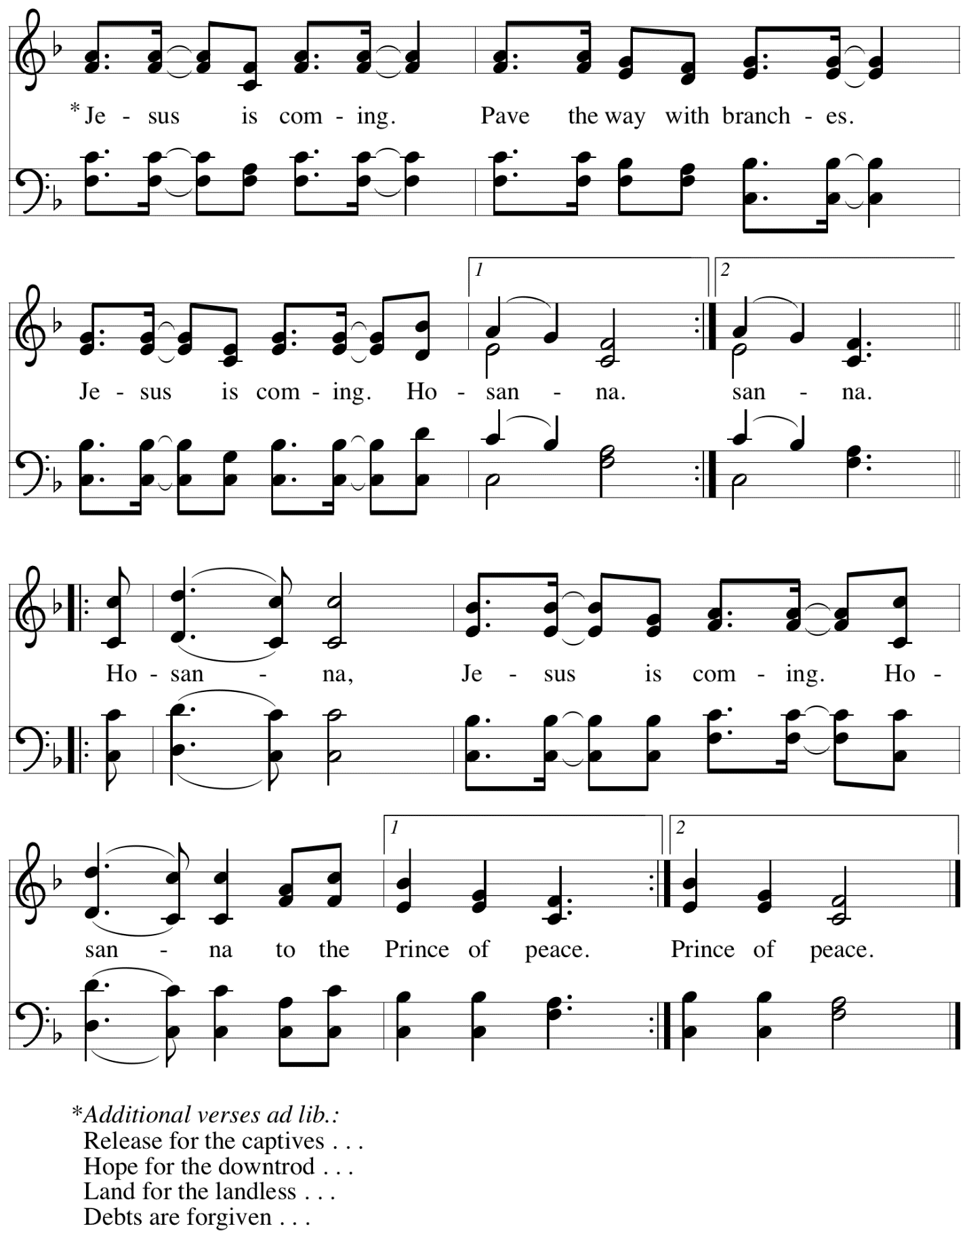
Acclamation

P: Blessed is the one who comes in the name of the Lord!
C: Hosanna in the highest!

Prayer of the Day

P: As we now enter into the contemplation of the Passion of our Lord Jesus Christ and meditate on the salvation of the world through his sufferings, death, burial, and resurrection, let us pray.

Silence is kept. Then the presiding minister prays the prayer of the day.

P: Everlasting God, in your endless love for the human race you sent our Lord Jesus Christ to take on our nature and to suffer death on the cross. In your mercy enable us to share in his obedience to your will and in the glorious victory of his resurrection, he who lives and reigns with you and the Holy Spirit, one God, now and forever.
C: Amen.

Please be seated.
Children are invited to join the adult leader(s) at the side door for Little Church – Big Faith.
We ask that an additional adult from the congregation attend with the children.

Word
God speaks to us in Scripture reading, preaching, and song

First Reading – Isaiah 50: 4-9a

⁴ The Lord God has given me
a trained tongue,
that I may know how to sustain
the weary with a word.
Morning by morning God wakens,
wakens my ear
to listen as those who are taught.
⁵ The Lord God has opened my ear,
and I was not rebellious;
I did not turn backward.
⁶ I gave my back to those who struck me
and my cheeks to those who pulled out the beard;
I did not hide my face
from insult and spitting.
⁷ The Lord God helps me;
therefore I have not been disgraced;
therefore I have set my face like flint,
and I know that I shall not be put to shame;
⁸ the one who vindicates me is near.
Who will contend with me?
Let us stand in court together.
Who are my adversaries?
Let them confront me.
^{9a} It is the Lord God who helps me;
who will declare me guilty?

L: Word of God, word of life.
C: Thanks be to God.

Psalm 31: 9-16

The cantor will lead the singing of the psalm.
The congregation is invited to respond with the alternate verses in bold print,
and to join in singing the refrain.

Psalm tone

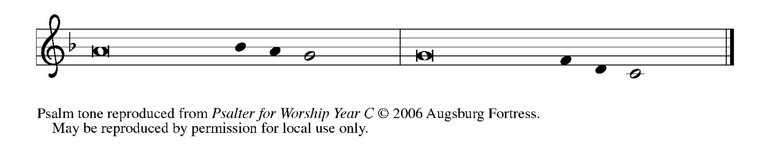

Psalm refrain

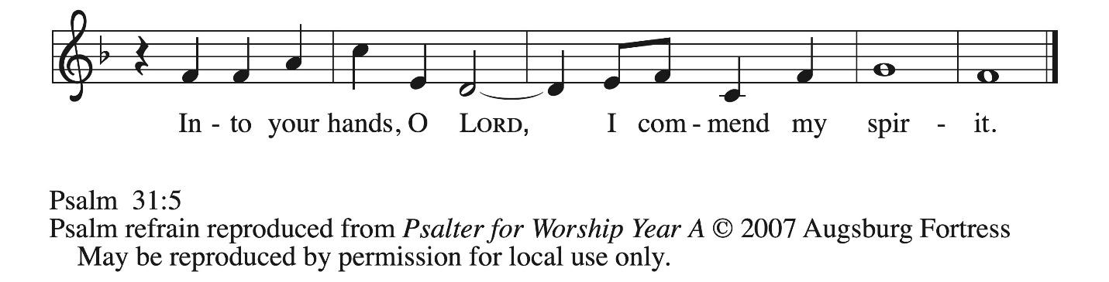

⁹ Have mercy on me, O Lord, for I | am in trouble;
my eye is consumed with sorrow, and also my throat | and my belly.
¹⁰ For my life is wasted with grief, and my | years with sighing;
my strength fails me because of affliction, and my bones | are consumed.
¹¹ I am the scorn of all my enemies, a disgrace to my neighbors, a dismay to | my acquaintances;
when they see me in the street | they avoid me.
¹² Like the dead I am forgotten, | out of mind;
I am as useless as a | broken pot. R
¹³ For I have heard the whispering of the crowd; fear is | all around;
they put their heads together against me; they plot to | take my life.
¹⁴ But as for me, I have trusted in | you, O Lord.
I have said, “You | are my God.
¹⁵ My times are | in your hand;
rescue me from the hand of my enemies, and from those who | persecute me.
¹⁶ Let your face shine up- | on your servant;
save me in your | steadfast love.” R

Second Reading – Philippians 2: 5-11

⁵Let the same mind be in you that was in Christ Jesus,
⁶who, though he existed in the form of God,
did not regard equality with God
as something to be grasped,
⁷but emptied himself,
taking the form of a slave,
assuming human likeness.
And being found in appearance as a human,
⁸he humbled himself
and became obedient to the point of death—
even death on a cross.

⁹Therefore God exalted him even more highly
and gave him the name
that is above every name,
¹⁰so that at the name given to Jesus
every knee should bend,
in heaven and on earth and under the earth,
¹¹and every tongue should confess
that Jesus Christ is Lord,
to the glory of God the Father.

L: Word of God, word of life.
C: Thanks be to God.

Please rise as you are able.

Gospel Acclamation All Glory, Laud, and Honor ELW 344
v. 1-4

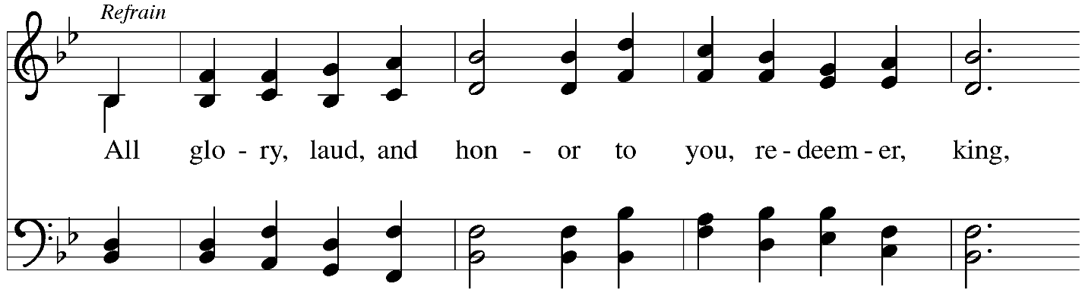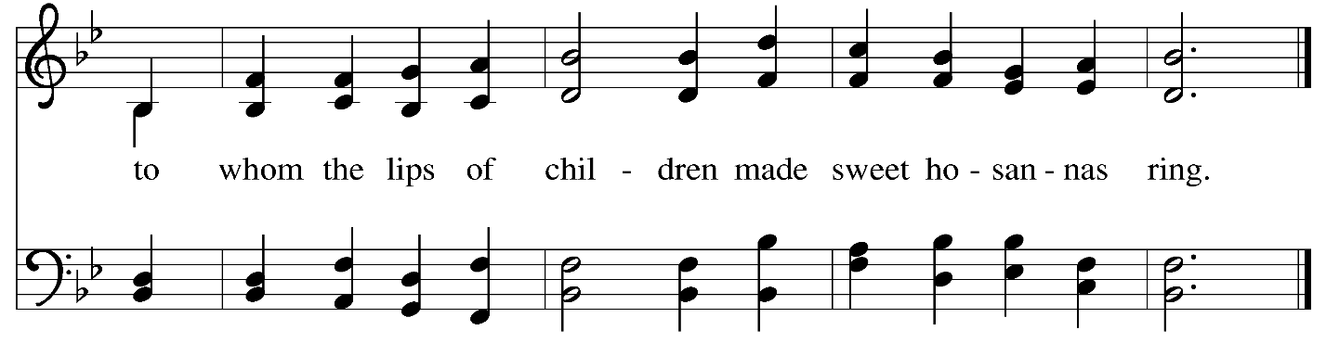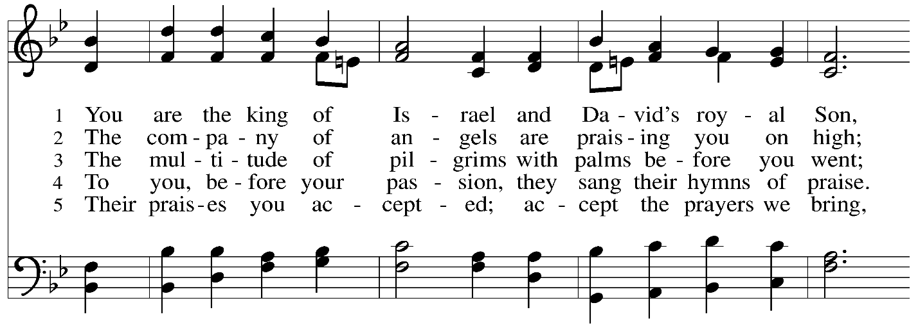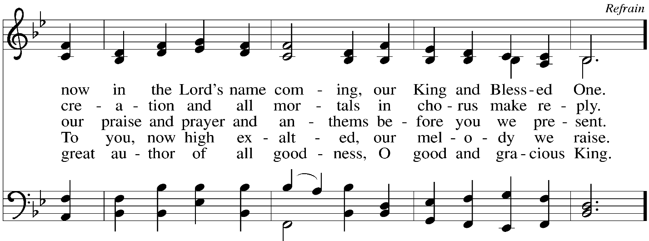
Gospel – Matthew 26: 14 – 27: 66

Narrator: The Passion of our Lord Jesus Christ according to St. Matthew.

Please be seated.
The narrative of Christ’s Passion from the Gospel of Matthew is read by several people of the congregation. At four interludes, a verse from the hymn Jesus, I Will Ponder Now – ELW 345, will be sung. Please follow the prompts below to join in the singing. People of the congregation are also invited to join in speaking the parts of the People, also indicated here.

Narrator: One of the twelve, …
… Jesus: You have said so.

Jesus, I Will Ponder Now v. 1 ELW 345

1 Jesus, I will ponder now
on your holy passion;
let your Spirit now endow
me for meditation.
Grant that I in love and faith
may the image cherish
of your suff'ring, pain, and death,
that I may not perish.

Narrator: While they were eating …
… Narrator: Then the disciples deserted him and fled.

Jesus, I Will Ponder Now v. 2 ELW 345

2 Make me see your great distress,
anguish, and affliction,
bonds and blows and wretchedness
and your crucifixion;
make me see how scourge and rod,
spear and nails, did wound you,
how you died for those, O God,
who with thorns had crowned you.

Narrator: Those who had arrested Jesus …
… Narrator: as the Lord commanded me.’

Jesus, I Will Ponder Now v. 3 ELW 345

3 Yet, O Lord, not thus alone
make me see your passion,
but its cause to me make known
and its termination.
For I also and my sin
wrought your deep affliction;
this the shameful cause has been
of your crucifixion.

Narrator: Now Jesus stood before the governor, …
… Narrator: Pilate said to them,

Pilate: Then what should I do with Jesus who is called the Messiah?

Congregation: Let him be crucified!

Narrator: Then he asked,

Pilate: Why, what evil has he done?

Narrator: But they shouted all the more,

Congregation: Let him be crucified!

Narrator: So when Pilate saw that he could do nothing,
but rather that a riot was beginning,
he took some water and washed his hands before the crowd, saying,

Pilate: I am innocent of this man’s blood; see to it yourselves.

Narrator: Then the people answered,

Congregation: His blood be on us and on our children!

Narrator: So he released Barabbas for them,
and after flogging Jesus he handed him over to be crucified.

Jesus, I Will Ponder Now v. 4 ELW 345

4 Let me view your pain and loss
with repentant grieving,
nor prepare again your cross
by unholy living.

May I give you love for love!
Hear me, O my Savior,
that I may in heav'n above
sing your praise forever.

Narrator: Then the soldiers of the guard …
… Narrator: So they went with the guard and made the tomb secure by sealing the stone.

When the Passion reading concludes, a period of silence is observed for prayer and reflection.
After the time of silence, a trio will sing a musical offering

Musical Offering Arise, My Soul, Arise Dan Forrest

Worship continues with the Prayers of the People.

Prayers of the People

A: Drawn close to the heart of God, we offer these prayers for the church,
the world, and all who are in need.

After each petition
A: Merciful God,
C: receive our prayer.

P: Accept the prayers we bring before you, O God, on behalf of a world in need,
through Jesus Christ, our Savior.
C: Amen.

Please be seated.

Meal
God feeds us with the presence of Jesus Christ

Offering

We offer ourselves, our gifts, and our faithful service to God.
As the offering is gathered for the mission of the church, including the care of those in need,
the table is set for Holy Communion.

There are laminated giving cards in the pew racks that feature a QR code for anyone who would like to give online. Those who give using the QR code, as well as those who give regularly online or through their bank are encouraged to place the laminated card in the plate as an expression of your offering.

Music during the Offering Near the Cross arr. Leech

As the gifts are brought forward for presentation, please rise as you are able.

Offertory Song Create in Me a Clean Heart ELW 186

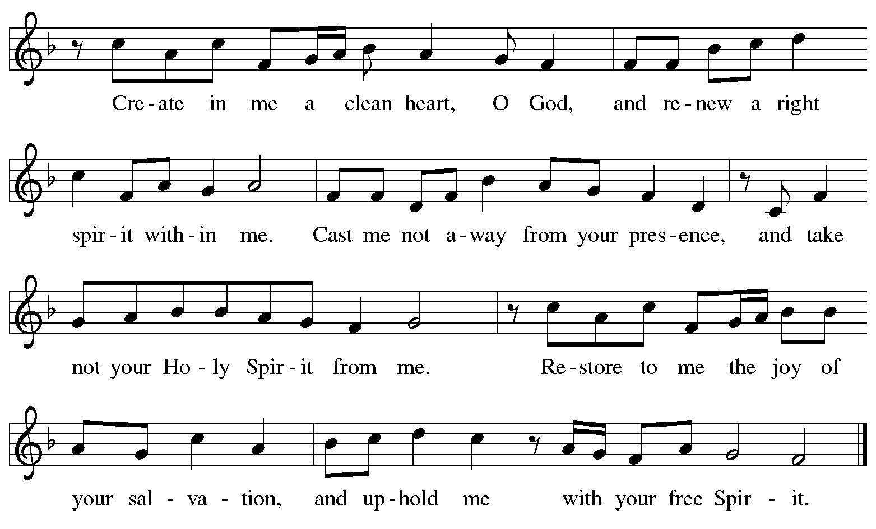
All rights reserved. Reprinted with permission under OneLicense.net # A-722139.

Offertory Prayer

A: Let us pray. God of all creation,
C: you have not fed us with bread alone, but with words of grace and life.
Bless us and these your gifts, which we receive from your bounty,
through Jesus Christ our Lord. Amen.

Dialogue

P: The Lord be with you.
C: And also with you.

P: Lift up your hearts.
C: We lift them to the Lord.

P: Let us give thanks to the Lord our God.
C: It is right to give our thanks and praise.

Preface

P: It is indeed right, our duty and our joy, …
… we praise your name and join their unending hymn.

Sanctus ELW p. 200

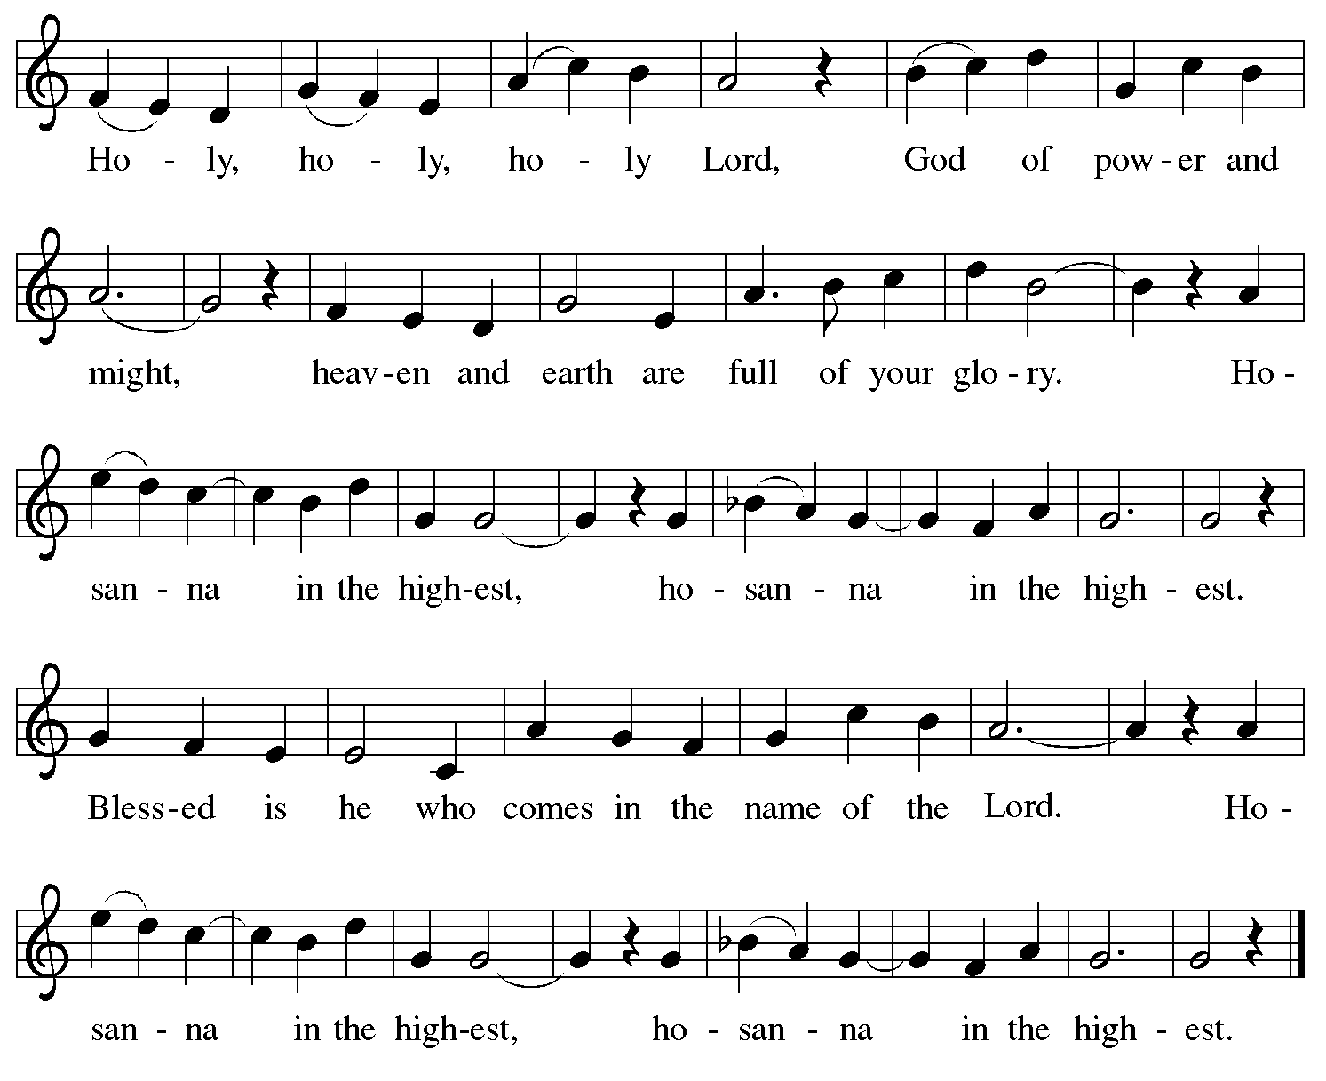

Eucharistic Prayer

P: Blessed are you, O God of the universe …
Do this for the remembrance of me.

With this bread and cup, we remember our Lord’s Passover from death to life
as we proclaim the mystery of faith.
C: Christ has died. Christ is risen. Christ will come again.

P: O God of resurrection and new life …
… grace our table with your presence.
C: Come, Holy Spirit.

P: Reveal yourself to us in the breaking of the bread …
… with justice, peace, and love.
C: Come, Holy Spirit.

P: With your holy ones of all times and places …
… blessed and Holy Trinity, now and forever.
C: Amen.

Lord’s Prayer

P: Gathered as one by the Holy Spirit, let us pray as Jesus taught us.
C: Our Father in heaven,
hallowed be your name,
your kingdom come,
your will be done,
on earth as in heaven.
Give us today our daily bread.
Forgive us our sins
as we forgive those
who sin against us.
Save us from the time of trial
and deliver us from evil.
For the kingdom, the power,
and the glory are yours,
now and forever. Amen.

Fraction and Invitation

P: All who are hungry, come.
The feast of grace is ready.

Agnus Dei / Lamb of God ELW p. 200

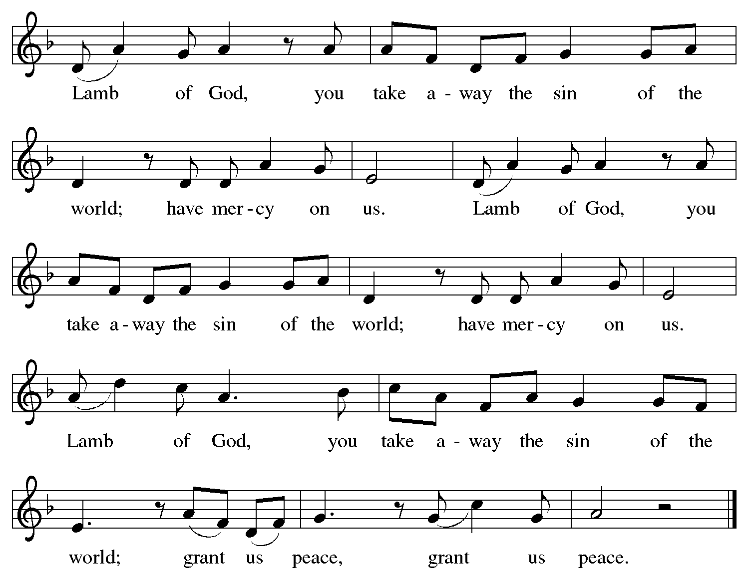

Please be seated.

Holy Communion
- All who seek God and desire a deeper and stronger life in Christ are welcome to receive Holy Communion.
- Worshipers from the pulpit side will proceed forward first, followed by the center section, and then the lectern side.
- Please inform an usher if you would like the ministers to bring Communion to you.
- Holy Communion will be served with bread and wine (red) or grape juice (white).
- The presiding minister will first distribute the bread (host) to each communicant. Please indicate if you require a gluten-free host.
- Once you have consumed the bread, please pick up an empty glass from the tray next to the presiding minister. The Communion Assistant will pour wine from the chalice or grape juice from the cruet into your glass.
- Please step to the side to consume the wine or grape juice.
- Feel free to kneel at the altar rail for prayer after receiving the sacrament.
- As you return to your pew, glasses may be returned to the empty tray on the side of the center section.
- A blessing will be provided for anyone who does not yet receive the sacrament.
- All are invited to join in singing the hymns during Holy Communion.

Hymns during Holy Communion
Let Us Break Bread Together ELW 471

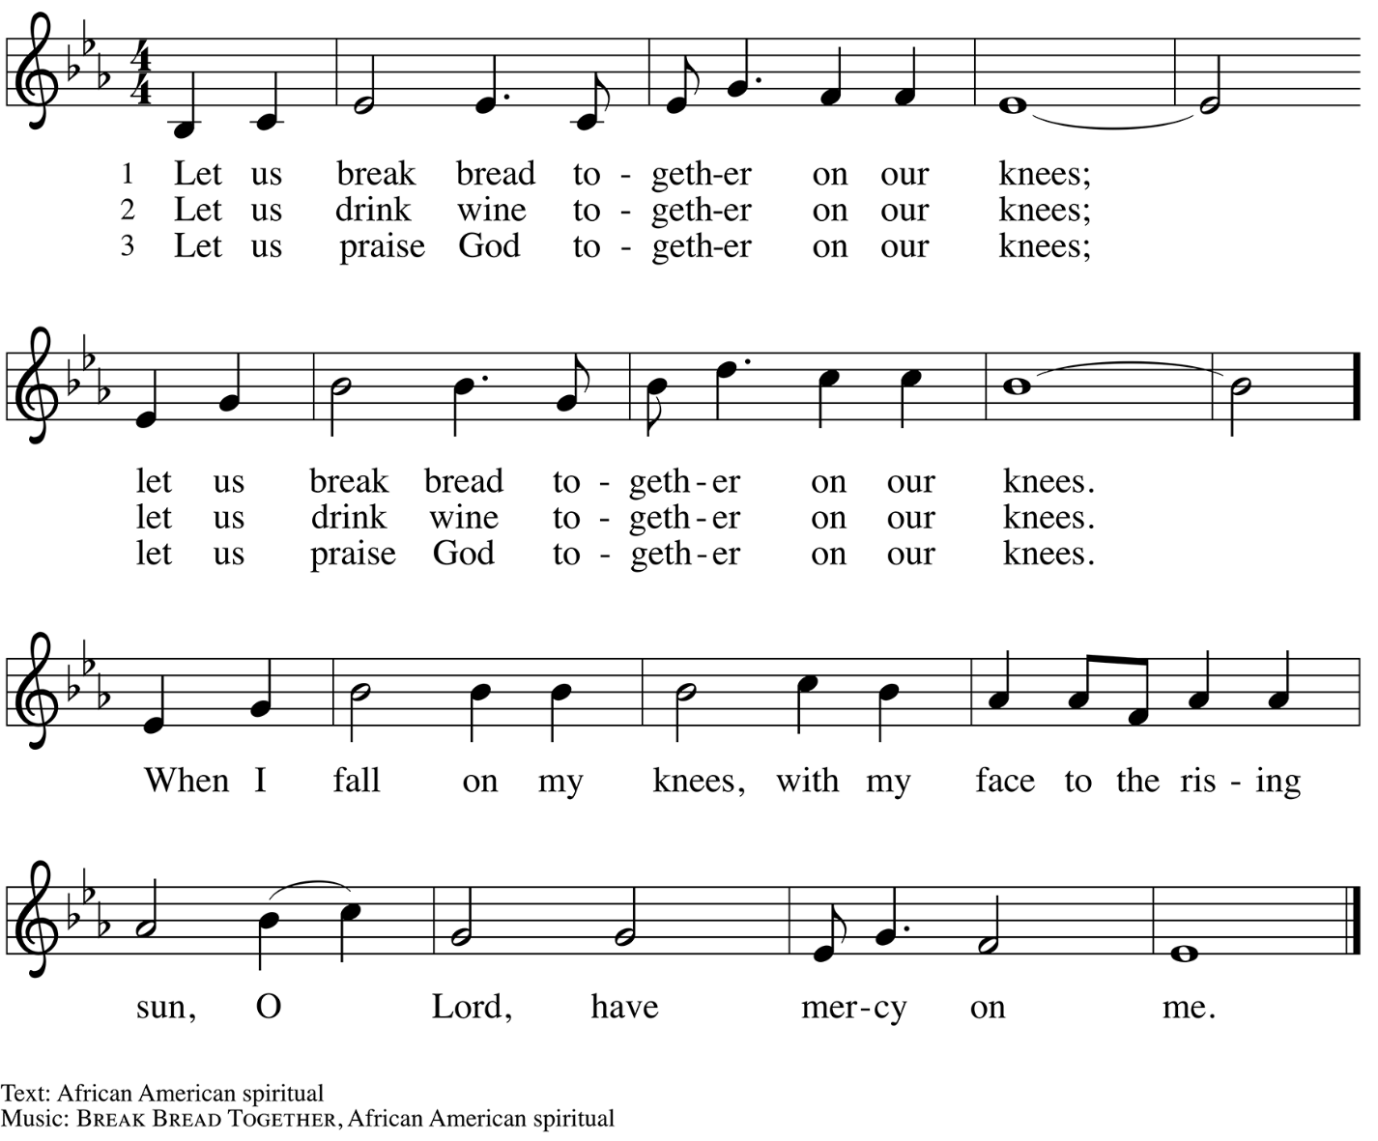

Hymns during Holy Communion
Alas! And Did My Savior Bleed ELW 337

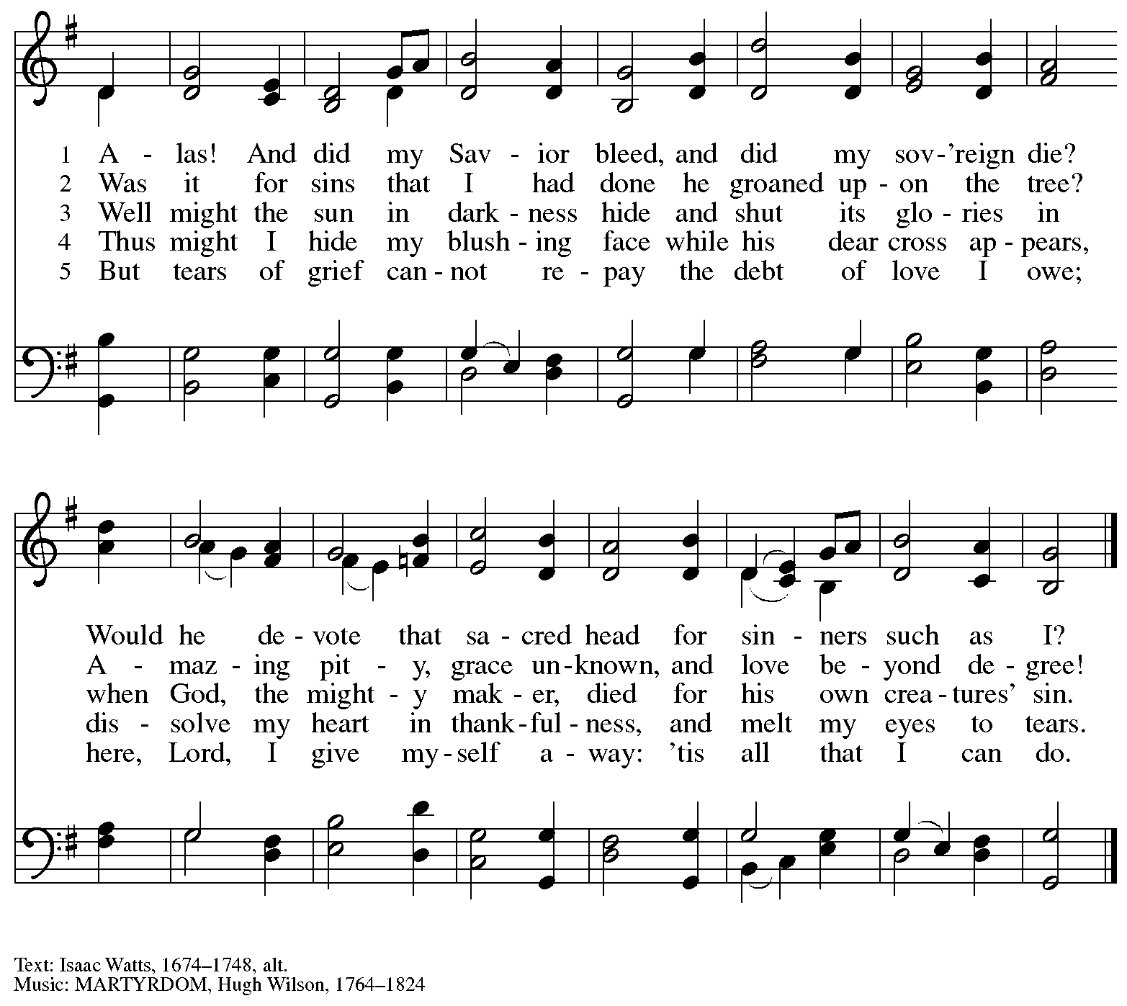

Hymns during Holy Communion
Lamb of God Most Holy – Santo Cordero ACS 932

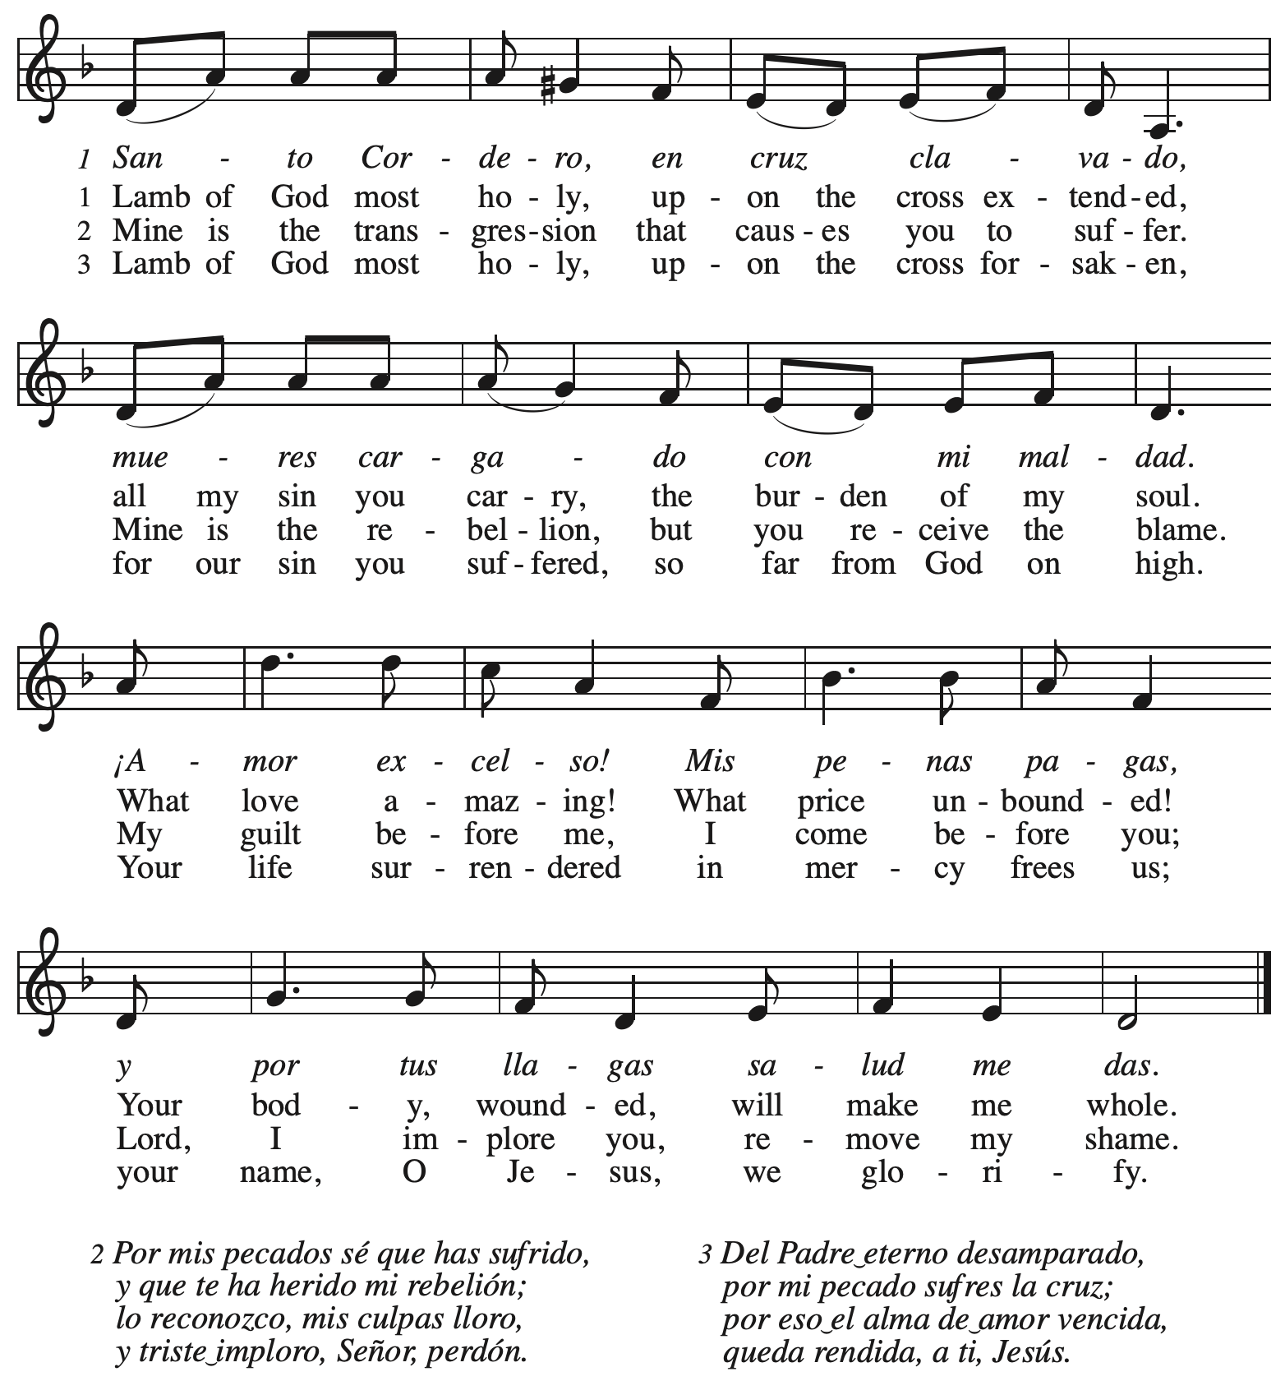
All rights reserved. Reprinted with permission under OneLicense.net # A-722139.

Hymns during Holy Communion
Christ Jesus Humbled Himself MSB1 S430

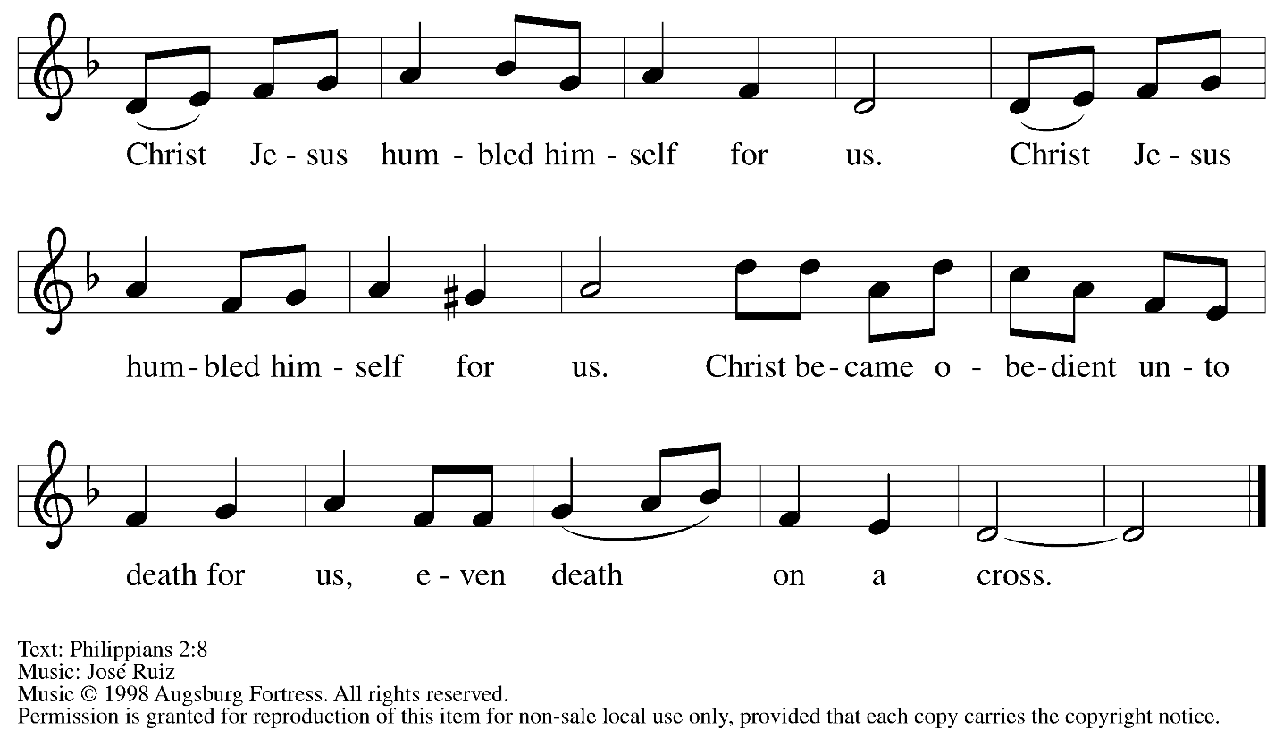

Reprinted with permission under OneLicense.net # A-722139.

Hymns during Holy Communion
Ah, Holy Jesus ELW 349

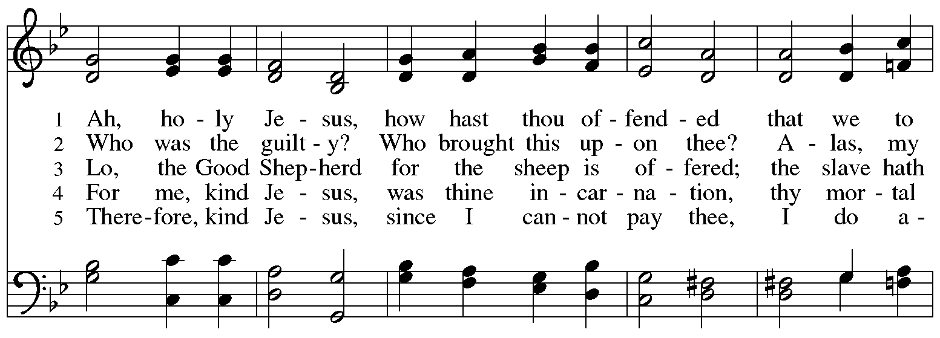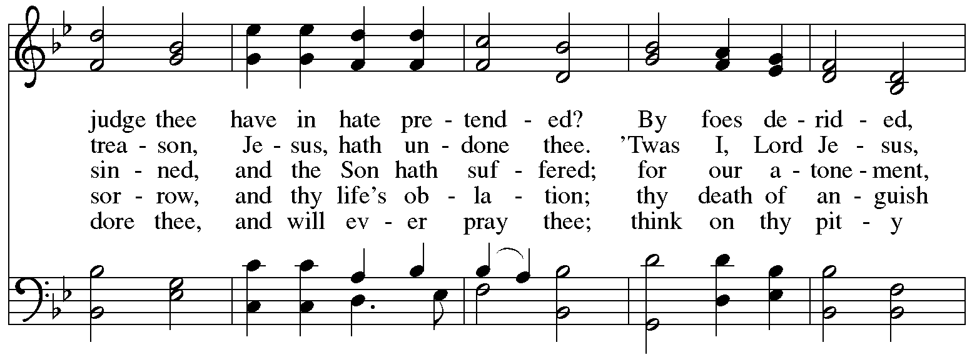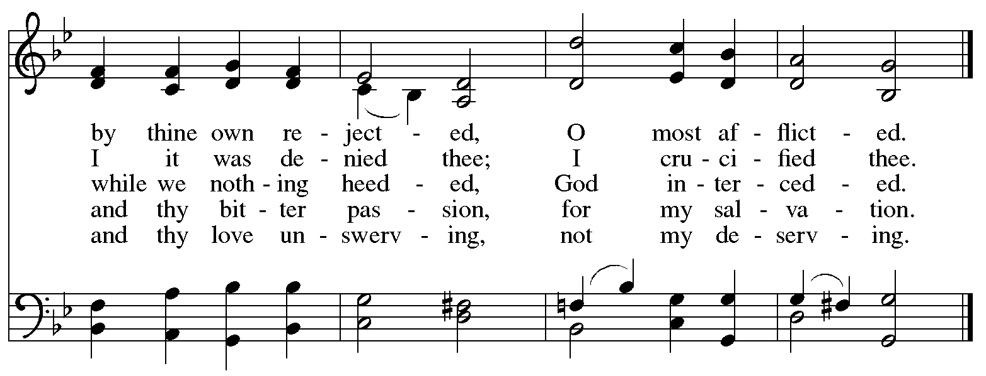

When all have returned to their places, please rise as you are able.

Blessing

P: The body and blood of our Lord Jesus Christ strengthen you and keep you in his grace.
C: Amen.

Prayer

A: Let us pray.
Compassionate God, you have fed us with the bread of heaven.
Sustain us in our Lenten pilgrimage:
may our fasting be hunger for justice;
our alms, a making of peace;
and our prayer, the song of grateful hearts,
through Jesus Christ, our Savior and Lord.
C: Amen.

Please be seated.

Sending
God blesses us and sends us in mission to the world

Announcements

Please rise as you are able.

Benediction

P: Receive the blessing of the holy Trinity:
God, who calls all things into existence,
Jesus Christ, who redeems us,
and the Holy Spirit, whose breath sustains creation,
☩ bless you and keep you, now and forever.
C: Amen.

Sending Hymn Following page

Dismissal

A: Go in peace. Christ is with you.
C: Thanks be to God.

Sending Hymn Beneath the Cross of Jesus ELW 338

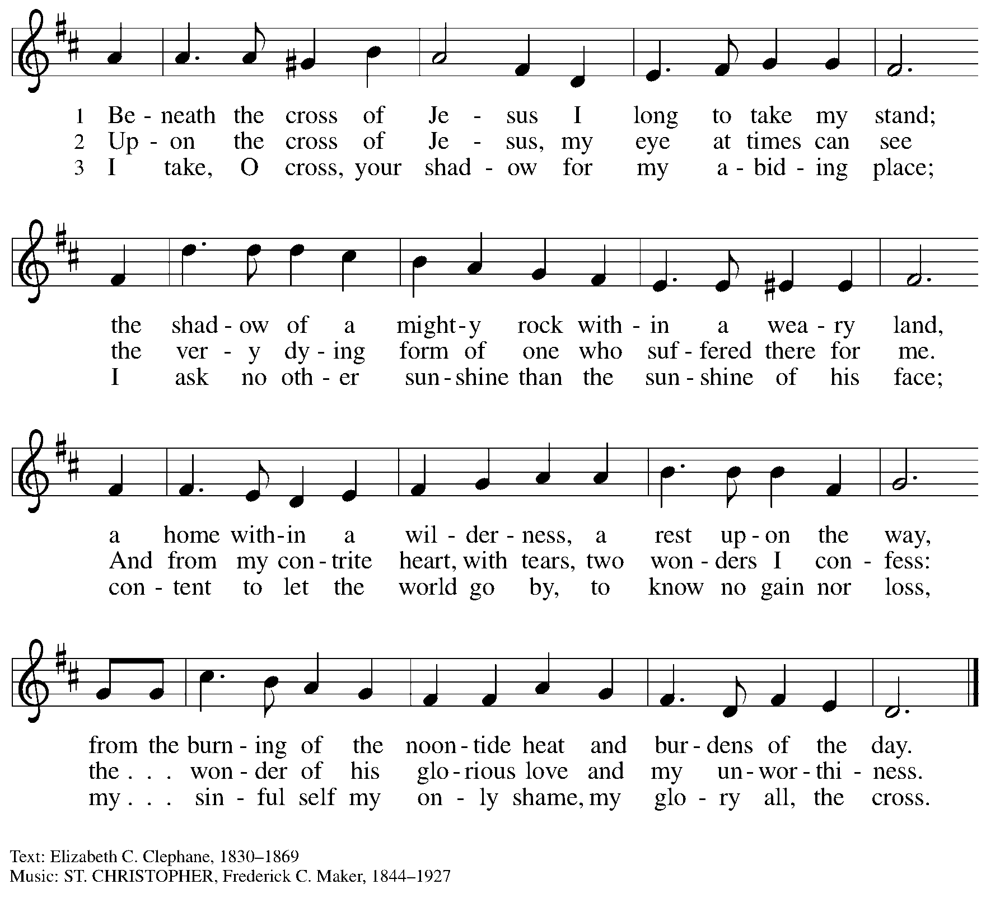

Those serving in worship

Altar Care Beverley Chapman
Assisting Minister Kathy Hays
Audio-Visual Ministers Tim Jones
Jered Stratton
Cantor Emily Duque
Crucifer Kai
Guitar Adam
Ty and Mandy Best
The Rev. Erin Jones
Lector Colleen Cooke
Offertory Vocalists Emily Duque, The Rev. Erin Jones
Percussion Jimmi and Timothy Kocher-Hillmer
Kathy Hays
Readers for the Passion Narrative Colleen Cooke
Erin McGann and Chloe Mobley
Gayle McLaughlin
Phil Pienkos
Kelly Spanninger
Vocal Trio Kristen Asplin, Emily Duque, The Rev. Erin Jones
Minister of Music Laura Reynolds
Presiding and Preaching Minister The Rev. Ross I. Carmichael

Liturgy and Hymnody Acknowledgements

From SundaysandSeasons.com. Copyright © 2026 Augsburg Fortress. All rights reserved. Reprinted under OneLicense.net # A-722139.
Used by permission of Augsburg Fortress.

The Scripture readings contained herein are from New Revised Standard Version Updated Edition of the Bible © 2021 National Council of Churches of Christ in the United States of America. Used by permission. All rights reserved worldwide.

All Glory, Laud, and Honor – Text: Theodulph of Orleans, c. 760-821; tr. John Mason Neale, 1818-1866, alt. MUSIC: VALET WILL ICH DIR GEBEN, Melchior Teschner, 1584-1635.

Jesus, I Will Ponder Now – Text: Sigismund von Birken, 1626-1681; tr. August Crull, 1846-1923, alt. Music: JESU KREUZ, LEIDEN UND PEIN, Melchior Vulpius, 1570-1615.

Please use the QR code below to link to St. Andrew’s Announcements online!



St. Andrew Lutheran Church Announcements
March 29th, 2026

- Welcome to Worship at St. Andrew on + Palm Sunday – Sunday of the Passion – We are so glad you are here, and we offer a special welcome to all visitors and guests who are here for the first time! Worship attendees are invited to make a name tag at the back of the worship space. Little Church – Big Faith, a Bible lesson and activity for children, will take place after the prayer of the day. There are worship “toolkits” to help children engage with worship and “busy bags” for younger children available in the bookcase at the back of the sanctuary. Please feel free to take one to use with/for your children. All are invited to gather for coffee, other drinks, food, and conversation in the social hall after worship.
- Worship Schedule for Holy Week – With today’s service, the church enters into the contemplation of the passion, death, and resurrection of our Savior Jesus Christ. Our primary means for this reflection is through the service of the Triduum – the Great Three Days of Holy Week – one service that unfolds in three parts: Maundy Thursday, Good Friday, and the Vigil of Easter. The service schedule for the upcoming week is:
  - Triduum – Maundy Thursday, April 2nd, 7:00 p.m. – The Church concludes the season of Lent with Confession and Forgiveness, receives Jesus’ command to love one another, remembers Christ’s example of such love in the washing of feet, and takes part in the sacrament of Holy Communion.
  - Holy Week Service for Children – Friday, April 3rd, 5:30 p.m. – This service, designed for children up to sixth grade, follows the story of Holy Week with the last supper, Jesus’ washing of his disciples feet, his prayer in the garden, and the cross.
  - Triduum – Good Friday, April 3rd, 7:00 p.m. – Service of Shadows and Stones. In relative darkness, we hear Gospel accounts of the crucifixion, sing prayerful, meditative hymns, and leave stones at the foot of the cross as we honor our crucified Savior.
  - Triduum – The Vigil of Easter, April 4th, 5:00 p.m. – The Vigil of Easter is a special service. Think of it as the people of God gathering around a campfire to tell their family’s stories of faith. The Church follows the history of God’s salvation through worship, word, sacrament, and song as we light the new fire and bless the Paschal candle, tell of God’s faithfulness throughout the ages, give thanks for the gift of Baptism, and move into the celebration of the resurrection with Holy Communion.
  - The Resurrection of our Lord – Easter Sunday, April 5th, 10:00 a.m. – Worship with Holy Communion – We join the church throughout the world in proclaiming the good news of Christ’s resurrection!
- Reparations Offering on Easter Sunday – April 5th during Worship – In Luke’s Gospel, Jesus tells a story about a compassionate Samaritan, suggesting that God’s people are called to work for healing and restoration for our neighbors, regardless of who or what caused them harm. In light of this, St. Andrew has made a commitment to reparations in regard to African American spiritual songs used in our worship. The text and music of most hymns is attributed to specific authors, with copyrights in place, usage reported, and royalties paid to those whose works are featured in worship. With African American spirituals, this is not possible. In response to many years of such uncredited use, St. Andrew invites the congregation to give a reparations offering. Funds received in worship will be donated to our siblings at Bethel AME Church, whose land and building were taken from them in the 1950s, to fund their development in the Hill District.
- Produce Distribution Supplemental Food of the Month – St. Andrew is collecting supplemental food each month to accompany our produce distribution. For March, we ask for donations of rice. There are collection boxes at the back of the worship space and in the social hall.
- Bible Book Club Will Not Meet during Holy Week – Bible Book Club will not meet on Wednesday, April 1st during Holy Week. The group will resume its discussion on Wednesday, April 8th, at 7:00 p.m. The group is currently reading Entering the Passion of Jesus: A Beginner’s Guide to Holy Week, by Dr. Amy-Jill Levine, which can be found here: Entering the Passion of Jesus.You can join the Zoom call here: https://us02web.zoom.us/j/83196175976?pwd=ejdPOUYrTk4xVFdsdlhHUVJ1L3k2Zz09
- Produce Distribution, First and Third Tuesday Each Month, April 7th and 21st from 5:30 to 6:30 p.m. – St. Andrew partners with Greater Pittsburgh Community Food Bank to serve as a distribution site for fresh produce on the first and third Tuesday of every month. We invite people of the congregation to help with the distribution from 5:30 p.m. to 6:30 p.m. and/or to help with unloading and setup during the day between 10:00 a.m. and 1:00 p.m.
- Hearts and Hands - Blanket Tying, Saturday, April 11th, 10:00 a.m. to 2:00 p.m. – Join us as we reboot our Hearts and Hands ministry to include Tied Blankets as well as knitted and crocheted items. Tying Blankets is something everyone can do! You can also bring your knitting needles, crochet hooks or even quilting items. If you want to learn to crochet, someone can also help you get started. Blankets will be provided to Proud Haven and Humane Animal Rescue. We also hope to rebuild our prayer shawl supplies with knitted items, crocheted items and blankets. Bring a Lunch (and something to share if you like) and join us!
- Alternatives to Violence Project Workshops, April 14th, May 16th, and May 23th – To learn more about the Alternatives to Violence Project, follow the link here: https://friendspeaceteams.org/cultures-justice-peace/. Below are the details for their upcoming workshops in Pittsburgh. “Choosing Integrity Over Influence” will be held on April 14th from 6:30 p.m. to 8:00 p.m. at Saint Maurice RC Church Campus (2001 Ardmore Blvd. Pittsburgh, PA 15221). It will be open to all ages. Please register using this link: https://docs.google.com/forms/d/e/1FAIpQLSenWSjN487ufRn8K6W6CTi1Nsn7lU3JZSOt234oddOsyXMI4g/viewform. On May 16th and 23rd from 9:00 a.m. to 8:00 p.m., AVP will be hosting two basic workshops at St Andrews Lutheran Church (304 Morewood Ave, Pittsburgh, PA 15213). These will be open to teens and adults. Please register using this link: https://docs.google.com/forms/d/e/1FAIpQLSfjPQKcnyQNx26wqTHzyby9YMi7BYHrUUfUha3PoxXpC50XNw/viewform.
- Pittsburgh PRIDE Choir’s Spring Cabaret Concert, April 17th and 18th at 8:00 p.m. – The Board of Directors of the Pittsburgh PRIDE Choir, Pittsburgh's esteemed LGBTQIA+ choir, acknowledges and thanks you for your unwavering support and advocacy on behalf of our local LGBTQIA+ community. Your contributions, whether through business ownership, direct support, or quality of life initiatives, are invaluable. The Spring Season approaches rapidly and they would be privileged if you joined them for the Spring Cabaret Concert on April 17th and 18th. The concert begins at 8:00 p.m., at East Liberty Presbyterian Church (116 S. Highland Ave, Pgh), a fully affirming and inclusive venue. For tickets to this and future events, visit https://events.ticketleap.com/events/pittsburgh-pride-choir.
- Dismantling Antisemitism 101, Sunday, April 26th, 12:00 p.m. to 1:30 p.m. – In the fall, St. Andrew hosted a Reckoning with Antisemitism as Christians event in collaboration with our Southwestern Pennsylvania Synod, The Holocaust Center of Pittsburgh, and Christian Associates of Southwest Pennsylvania. In an effort to continue the discussion from that event and to share possible next steps with the larger congregation, St. Andrew has invited Mr. Noah Schoen, Manager of Community Engagement for the Holocaust Center of Pittsburgh, to lead us in a Dismantling Antisemitism 101 workshop. After worship on April 26th, we will have an expanded coffee hour with light lunch foods, and then begin the workshop at 12:00 noon. Please put this on your calendars and plan to take part on April 26th. Please confirm your attendance here: https://www.signupgenius.com/go/5080B4AAFAF2CABF85-63105576-reckoning#/.
- Lutherlyn Work Day, Saturday, April 25th, 9:00 a.m. - 4:00 p.m. – It takes a lot of hands to prepare Lutherlyn for the many people who will visit throughout the spring and summer. Flower beds need to be weeded, firewood needs to be cut, fences need to be repaired, sticks and leaves need to be removed, as well as a variety of other jobs for volunteers of all ages and skill levels. Lutherlyn provides all of the tools (and lunch prepared by Chef Lisa) and our volunteers provide the willing hands! To RSVP, follow this link: https://www.lutherlyn.com/support/volunteer/workdays.html. If you have any questions feel free to contact the Development Office at development@lutherlyn.com or 724-865-2161.
- “Christ in Our Home” Booklets for April - June Now Available – “Christ in Our Home” is a quarterly devotional resource that encourages readers to live out their faith daily. Each reflective reading is accompanied by a daily scripture reference and prayer for the day. The April - June booklets are now available at the entrances, and there are still some left for March. Please feel free to take one home!
- Coffee Hour Signups – St. Andrew provides hospitality during a coffee hour after worship each Sunday. If you would like to participate and would like information about the duties of setting up, please sign up using the following form: https://www.signupgenius.com/go/5080B4AAFAF2CABF85-47069030-coffee#/.

