

+ Second Sunday of Easter
April 12, 2026


St. Andrew Lutheran Church
304 Morewood Ave.
Pittsburgh, PA 15213
St_andrewELCA@verizon.net
www.standrewpittsburgh.org

+ Second Sunday of Easter

In today’s gospel the risen Christ appears to the disciples and offers them the gift of peace.
Even amid doubts and questions, we experience the resurrection in our Sunday gathering
around word and meal, and in our everyday lives. Throughout the coming Sundays of Easter,
the first two readings will be from the Acts of the Apostles and the first letter of Peter.
Even as the early Christians proclaimed the resurrection, we rejoice in the new birth
and living hope we receive in Baptism.

Welcome to St. Andrew!
- St. Andrew welcomes all who are seeking a place of healing, wholeness, and acceptance in a nurturing and faith-forming spiritual home. We are striving toward racial equity worldwide
and we seek to honor the lived experience of all individuals regardless of background. Our community embraces people of all ages, ethnicities, cultures, abilities, sexual orientations,
gender identities and expressions, and family constellations. Come and See!
- Worship Services are live-streamed to multiple online platforms. By attending worship, you agree that your image and voice may be broadcast.
- Everyone is invited to make a name tag at the black bookcase in the back of the worship space if they would like. There are stickers indicating pronouns on the bookcase if you would like to include them on your name tag.
- Children are invited to attend Little Church – Big Faith, a Bible lesson and activity, during worship (after the Prayer of the Day). The group returns to the worship space for the liturgy of Holy Communion.
- A nursery is available through the doors at the left side of the sanctuary and across from the doorway to the Social Hall. Look for a purple-colored room.
- Worship “toolkits” to help children engage with the service, along with “busy bags” for younger children, are available in the bookcase at the back of the sanctuary. Please feel free to take one to use with/for your children.
- Holy Communion is served with bread (gluten-free available) and wine or grape juice. The presiding minister will distribute the bread (host). Please consume this and then pick up an empty glass from the tray. The Communion Assistant will pour wine or grape juice into your glass. Please step to the side to consume the wine or grape juice. Feel free to kneel at the altar for prayer and reflection. As you return to your pew, glasses may be returned to the empty trays on either side of the center section.
- A restroom is available on the main level of the church, through the doors to the Social Hall and to the right in the main office.

Abbreviations
P: Pastor/Presiding Minister ELW: Evangelical Lutheran Worship hymnal
A: Assisting Minister ACS: All Creation Sings hymnal
L: Lector
C: Congregation

Musical Offering

Each week, different people from the congregation make an offering of pre-service music, with singing or instrumentation, to help the assembly focus and pray in preparation for worship.

Welcome
Prelude Jesus Shall Reign arr. Shaw

Gathering
The Holy Spirit calls us together as the people of God

Please rise as you are able. All may make the sign of the cross,
the sign that is marked at Baptism, as the presiding minister begins.

Thanksgiving for Baptism

P: Alleluia! Christ is risen!
C: Christ is risen indeed! Alleluia! Alleluia!

P: Salvation belongs to our God who is seated on the throne and to the Lamb!
C: Amen.

P: Let us give thanks for the gift of Baptism.

Water may be poured into the font as the presiding minister continues.
P: Merciful God,
you are the one who was, who is, and who is to come.
You lead us beside still waters.
We thank you for the waters of creation:
morning dew, gentle rain, roaring waves.
We thank you for the waters that nourish us.
Blessed are you!
C: You guide us to springs of the water of life.

P: Jesus Christ, you are the faithful witness
who accompanies us on our journeys.
We give you thanks for your life-giving death and resurrection.
We praise you for joining us in joy and sorrow.
Blessed are you!
C: You guide us to springs of the water of life.

P: Holy Spirit, you anoint our head with oil and our cup overflows.
Break down barriers that divide us.

P: Fill us with the breath of peace.
Blessed are you!
C: You guide us to springs of the water of life.

P: Holy One, we thank you for the gifts and grace of Baptism,
and for making us a new creation.
We join with saints and angels, giving you honor and praise,
now and forever.
C: Amen.

Gathering Hymn ELW 369
Christ the Lord Is Risen Today; Alleluia!

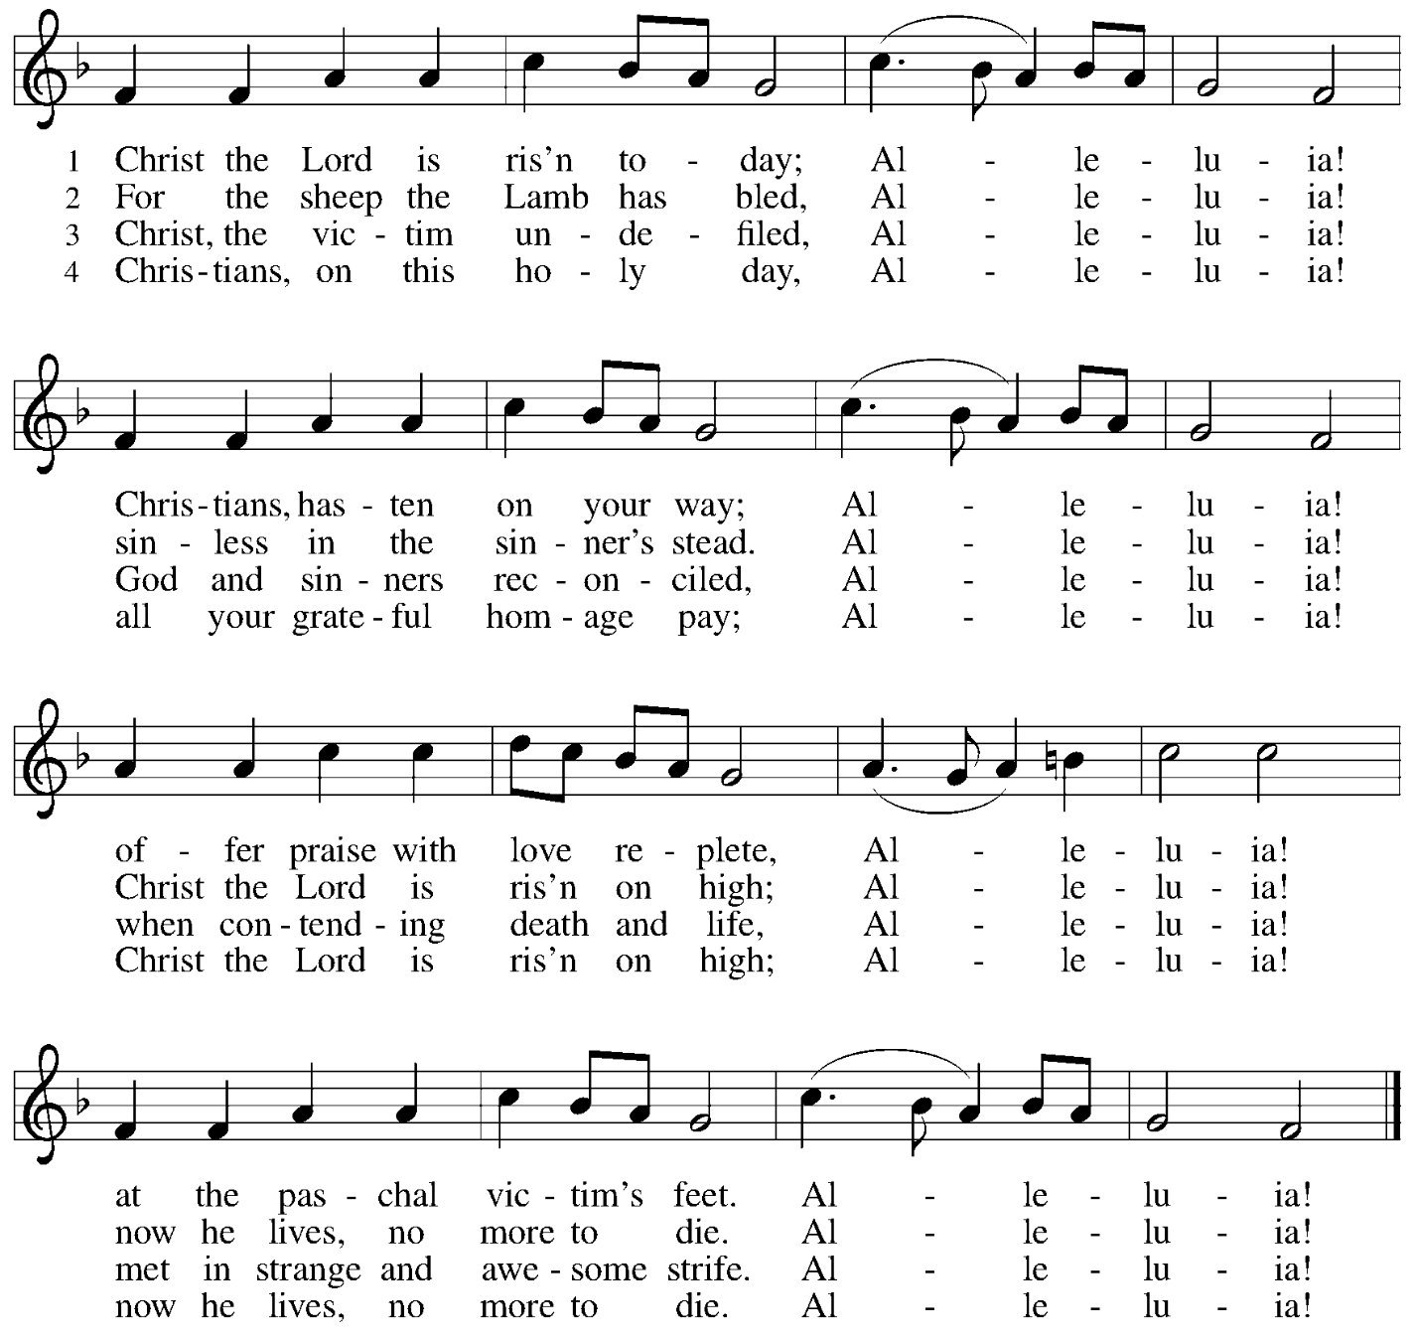

Greeting

P: The grace of our Lord Jesus Christ, the love of God,
and the communion of the Holy Spirit be with you all.
C: And also with you.

Hymn of Praise This Is the Feast ELW p. 149-150

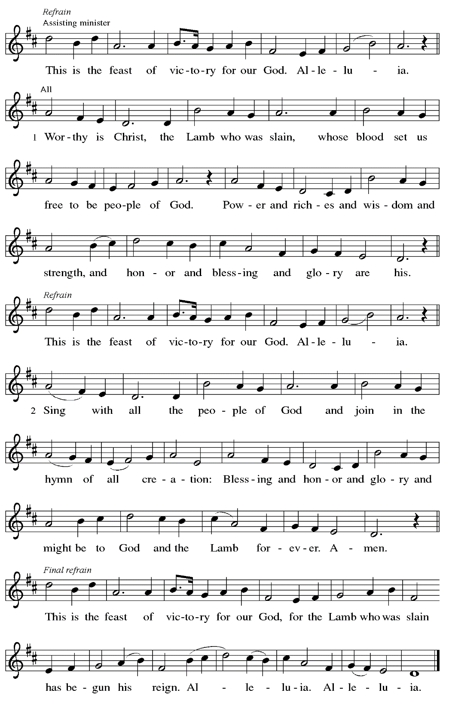
Prayer of the Day

P: The Lord be with you.
C: And also with you.

P: Let us pray.
Almighty and eternal God, the strength of those who believe and the hope of those who doubt, may we, who have not seen, have faith in you and receive the fullness of Christ’s blessing,
who lives and reigns with you and the Holy Spirit, one God, now and forever.
C: Amen.

Please be seated.
Children are invited to join the adult leader(s) at the side door for Little Church – Big Faith.
We ask that an additional adult from the congregation attend with the children.

Word
God speaks to us in Scripture reading, preaching, and song

First Reading – Acts 2: 14a, 22-32

^{14a} Peter, standing with the eleven, raised his voice and addressed [the crowd]: ²² “Fellow Israelites, listen to what I have to say: Jesus of Nazareth, a man attested to you by God with deeds of power, wonders, and signs that God did through him among you, as you yourselves know ²³ this man, handed over to you according to the definite plan and foreknowledge of God, you crucified and killed by the hands of those outside the law. ²⁴ But God raised him up, having released him from the agony of death, because it was impossible for him to be held in its power.
²⁵ For David says concerning him,
‘I saw the Lord always before me,
for the Lord is at my right hand so that I will not be shaken;
²⁶ therefore my heart was glad, and my tongue rejoiced;
moreover, my flesh will live in hope.
²⁷ For you will not abandon my soul to Hades
or let your Holy One experience corruption.
²⁸ You have made known to me the ways of life;
you will make me full of gladness with your presence.’
²⁹ “Fellow Israelites, I may say to you confidently of our ancestor David that he both died and was buried, and his tomb is with us to this day. ³⁰ Since he was a prophet, he knew that God had sworn with an oath to him that God would put one of his descendants on his throne. ³¹ Foreseeing this, David spoke of the resurrection of the Messiah, saying,
‘He was not abandoned to Hades,
nor did his flesh experience corruption.’
³² “This Jesus God raised up, and of that all of us are witnesses.”

L: Word of God, word of life.
C: Thanks be to God.
Psalm 16

The psalm will be sung responsively, led by the cantor,
with the congregation responding with the bold verses and refrain.

Psalm tone

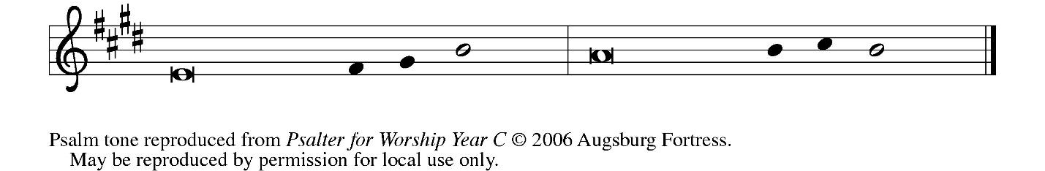

Psalm refrain

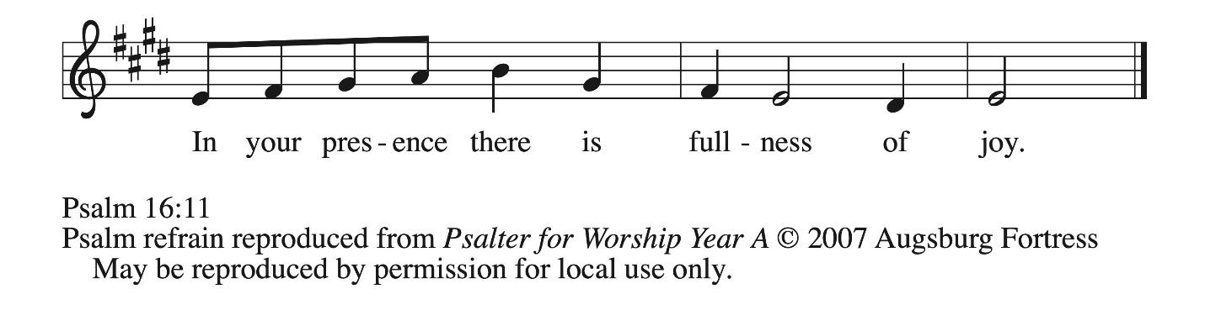

¹ Protect me, O God, for I take ref- | uge in you;
I have said to the Lord, “You are my Lord, my good a- | bove all other.”
² All my delight is in the godly that are | in the land,
upon those who are noble a- | mong the people.
³ But those who run after | other gods
shall have their troubles | multiplied.
⁴ I will not pour out drink offerings | to such gods,
never take their names up- | on my lips. R
⁵ O Lord, you are my portion | and my cup;
it is you who up- | hold my lot.
⁶ My boundaries enclose a | pleasant land;
indeed, I have a | rich inheritance.
⁷ I will bless the Lord who | gives me counsel;
my heart teaches me night | after night.
⁸ I have set the Lord al- | ways before me;
because God is at my right hand, I shall | not be shaken. R
⁹ My heart, therefore, is glad, and my spir- | it rejoices;
my body also shall | rest in hope.
¹⁰ For you will not abandon me | to the grave,
nor let your holy one | see the pit.
¹¹ You will show me the | path of life;
in your presence there is fullness of joy, and in your right hand are pleasures for- | evermore. R

Second Reading – 1 Peter 1: 3-9

³ Blessed be the God and Father of our Lord Jesus Christ! By God’s great mercy God has given us a new birth into a living hope through the resurrection of Jesus Christ from the dead ⁴ and into an inheritance that is imperishable, undefiled, and unfading, kept in heaven for you, ⁵ who are being protected by the power of God through faith for a salvation ready to be revealed in the last time. ⁶ In this you rejoice, even if now for a little while you have had to suffer various trials, ⁷ so that the genuineness of your faith—being more precious than gold that, though perishable, is tested by fire—may be found to result in praise and glory and honor when Jesus Christ is revealed. ⁸ Although you have not seen him, you love him, and even though you do not see him now, you believe in him and rejoice with an indescribable and glorious joy, ⁹ for you are receiving the outcome of your faith, the salvation of your souls.

L: Word of God, word of life.
C: Thanks be to God.

Please rise as you are able.

Gospel Acclamation ELW p. 151

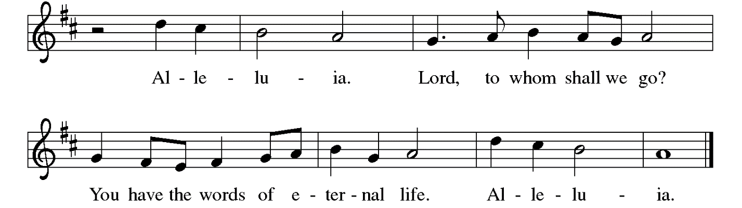

Gospel – John 20: 19-31

P: The holy Gospel according to St. John.
C: Glory to you, O Lord.

¹⁹ When it was evening on that day, the first day of the week, and the doors were locked where the disciples were, for fear of the Jews, Jesus came and stood among them and said, “Peace be with you.” ²⁰ After he said this, he showed them his hands and his side. Then the disciples rejoiced when they saw the Lord. ²¹ Jesus said to them again, “Peace be with you. As the Father has sent me, so I send you.” ²² When he had said this, he breathed on them and said to them,
“Receive the Holy Spirit. ²³ If you forgive the sins of any, they are forgiven them; if you retain the sins of any, they are retained.”
²⁴ But Thomas (who was called the Twin), one of the twelve, was not with them when Jesus came. ²⁵ So the other disciples told him, “We have seen the Lord.” But he said to them, “Unless I see the mark of the nails in his hands and put my finger in the mark of the nails and my hand in his side, I will not believe.”
²⁶ A week later his disciples were again in the house, and Thomas was with them. Although the doors were shut, Jesus came and stood among them and said, “Peace be with you.” ²⁷ Then he said to Thomas, “Put your finger here and see my hands. Reach out your hand and put it in my side. Do not doubt but believe.” ²⁸ Thomas answered him, “My Lord and my God!” ²⁹ Jesus said to him, “Have you believed because you have seen me? Blessed are those who have not seen and yet have come to believe.”
³⁰ Now Jesus did many other signs in the presence of his disciples that are not written in this book. ³¹ But these are written so that you may continue to believe that Jesus is the Messiah, the Son of God, and that through believing you may have life in his name.

P: The Gospel of the Lord.
C: Praise to you, O Christ.

Please be seated.

Sermon

A time of silence for prayer and reflection follows the sermon.
When the hymn of the day begins, please rise as you are able.



Hymn of the Day We Walk by Faith and Not by Sight WOV 675

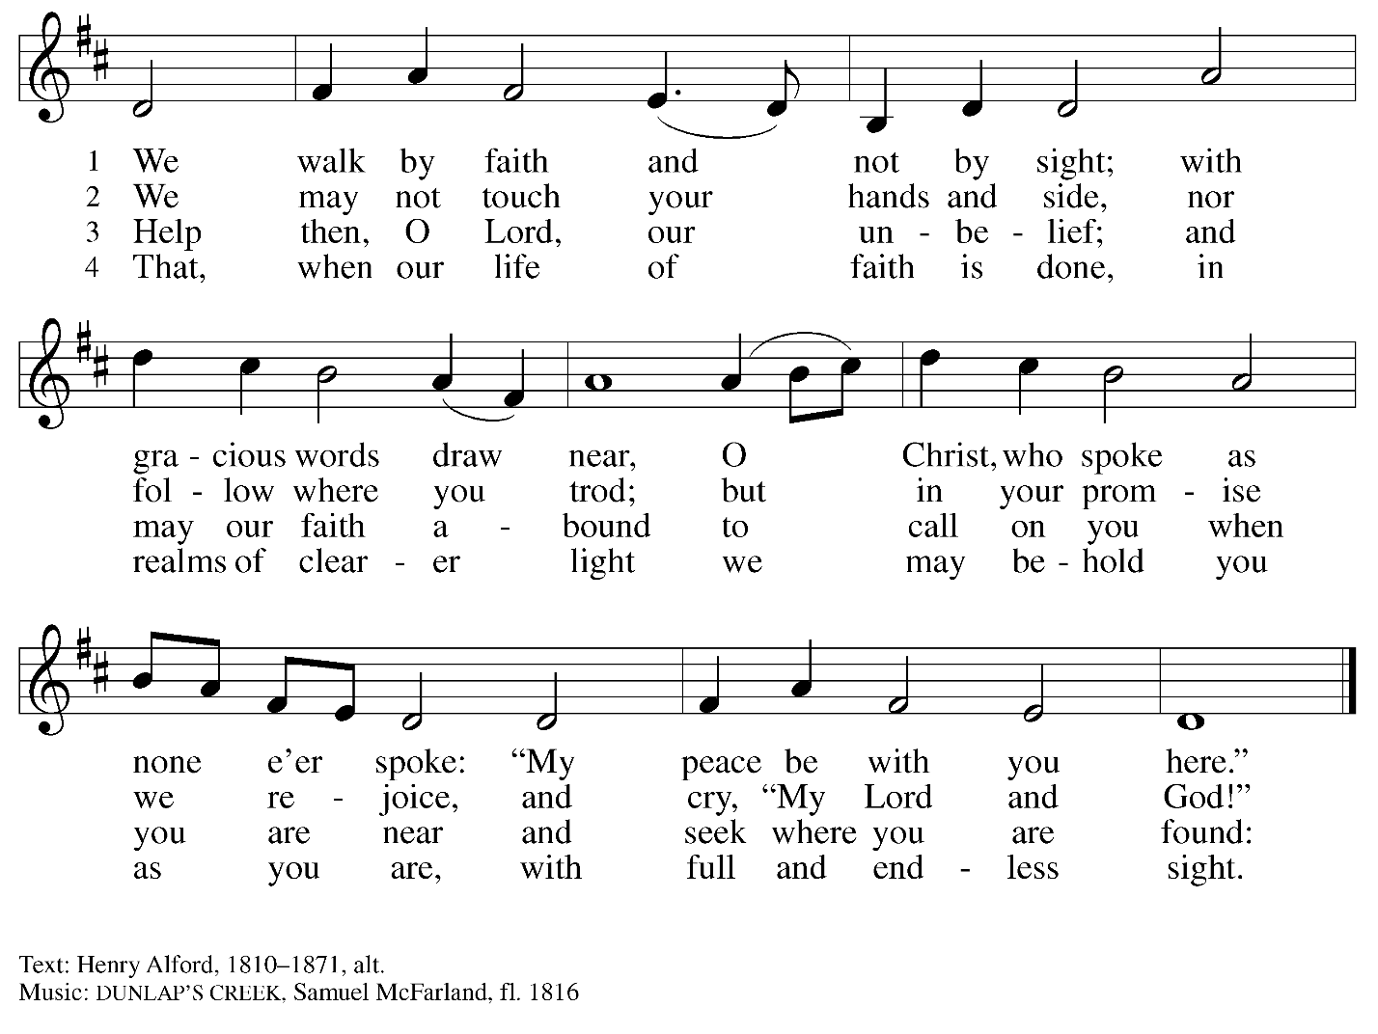

Nicene Creed

C: We believe in one God,
the Father, the Almighty,
maker of heaven and earth,
of all that is, seen and unseen.

We believe in one Lord, Jesus Christ,
the only Son of God,
eternally begotten of the Father,
God from God, Light from Light,
true God from true God,
begotten, not made,
of one Being with the Father;
through him all things were made.
For us and for our salvation
he came down from heaven,
was incarnate of the Holy Spirit and the virgin Mary
and became truly human.
For our sake he was crucified under Pontius Pilate;
he suffered death and was buried.
On the third day he rose again
in accordance with the scriptures;
he ascended into heaven
and is seated at the right hand of the Father.
He will come again in glory to judge the living and the dead,
and his kingdom will have no end.

We believe in the Holy Spirit, the Lord, the giver of life,
who proceeds from the Father and the Son,*
who with the Father and the Son is worshiped and glorified,
who has spoken through the prophets.
We believe in one holy catholic and apostolic church.
We acknowledge one baptism for the forgiveness of sins.
We look for the resurrection of the dead,
and the life of the world to come. Amen.

*Or, “who proceeds from the Father.” The phrase “and the Son” is a later addition to the creed.

Prayers of the People

A: United in the joy and hope of the resurrection, let us pray for the church, the world,
and all who are in need.

After each petition
A: Gracious God,
C: receive our prayer.

The presiding minister concludes the prayers
P: We lift these prayers to you O God, trusting in your abundant mercy,
through Jesus Christ our risen Savior.
C: Amen.

Peace

The presiding minister and the assembly greet one another in the peace of the risen Christ.
P: The peace of Christ be with you always.
C: And also with you.

The people may greet those around them with a sign of Christ’s peace and may say
Peace be with you or similar words. Please be mindful that not everyone will be comfortable with sharing the peace, so please seek consent before shaking hands or hugging.
Other possible ways to share the peace include a simple bow with the verbal greeting of peace, or simply a verbal expression of peace. When the greetings of peace have concluded, please be seated.



Meal
God feeds us with the presence of Jesus Christ

Offering

We offer ourselves, our gifts, and our faithful service to God.
As the offering is gathered for the mission of the church, including the care of those in need,
the table is set for Holy Communion.

There are laminated giving cards in the pew racks that feature a QR code for anyone who would like to give online. Those who give using the QR code, as well as those who give regularly online or through their bank are encouraged to place the laminated card in the plate as an expression of your offering.

Music during the Offering
The Strife Is O’er, the Battle Done arr. Shaw

As the gifts are brought forward for presentation, please rise as you are able.

Offertory Song Let the Vineyards Be Fruitful ELW 184

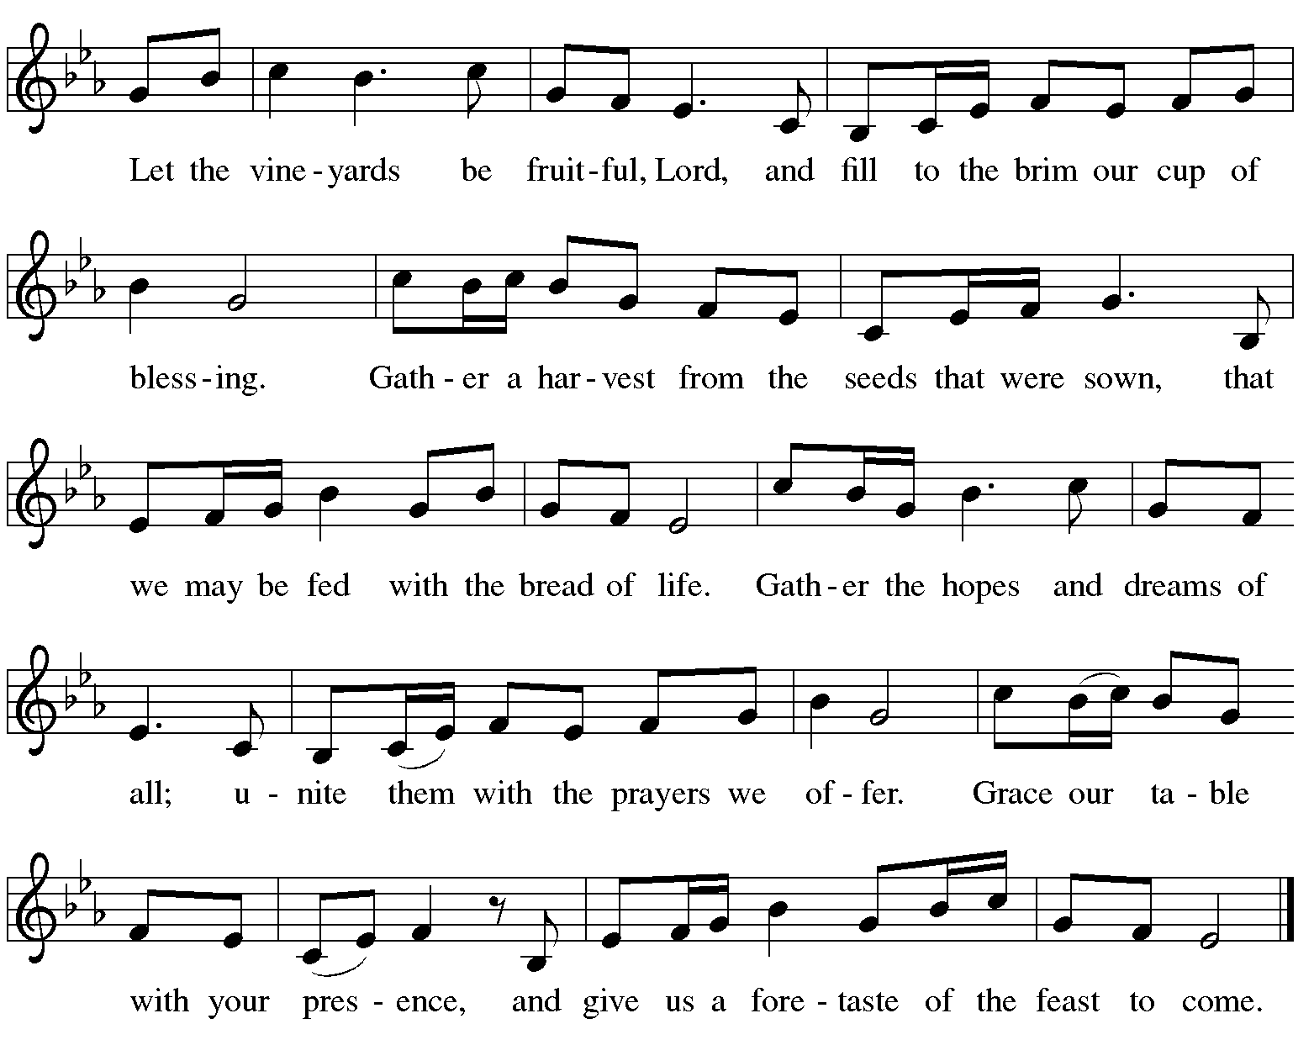

Offertory Prayer

A: Let us pray.
Blessed are you, O God,
C: ruler of heaven and earth.
Day by day you shower us with blessings.
As you have raised us to new life in Christ,
give us glad and generous hearts,
ready to praise you and to respond to those in need,
through Jesus Christ, our Savior and Lord.
Amen.

Dialogue ELW p. 152

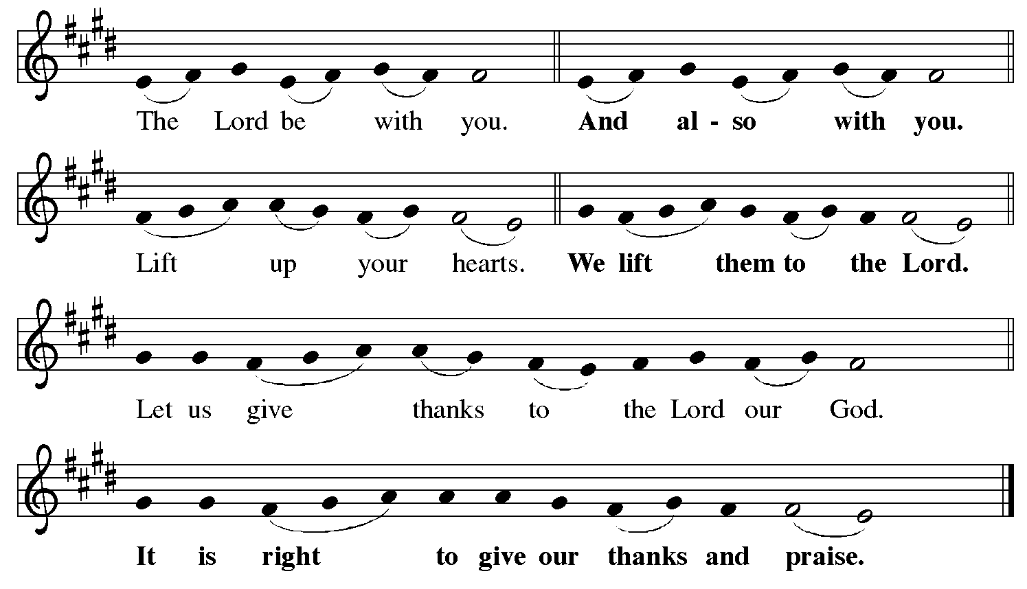

Preface (Sung by the presiding minister)

P: It is indeed right, our duty and our joy,
that we should at all times and in all places
give thanks and praise to you, almighty and merciful God,
for the glorious resurrection of our Savior Jesus Christ,
the true Paschal Lamb who gave himself to take away our sin;
who in dying has destroyed death,
and in rising has brought us to eternal life.
And so, with Mary Magdalene and Peter
and all the witnesses of the resurrection,
with earth and sea and all their creatures,
and with angels and archangels, cherubim and seraphim,
we praise your name and join their unending hymn:

Sanctus ELW p. 153

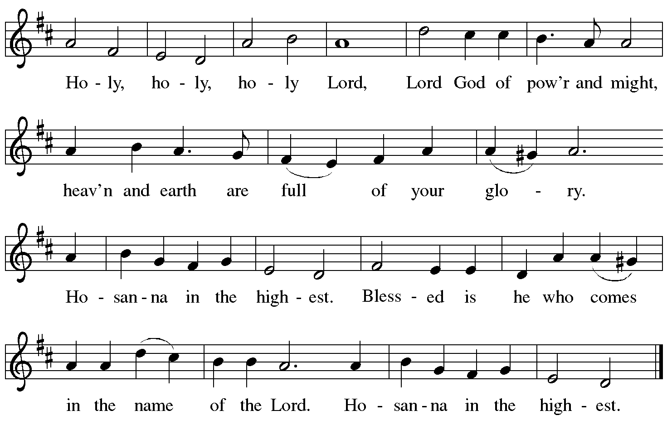

Eucharistic Prayer

P: Blessed are you, O God of the universe …
For Christ is risen:
C: Christ is risen indeed!

P: This is the day on which you gave light to the earth …
and that light is Christ:
C: Thanks be to God.

P: This is the day on which you broke the chains of death …
For Christ is risen:
C: Christ is risen indeed!

P: In the night in which he was betrayed …
… Do this for the remembrance of me.

Let us proclaim the mystery of faith.
C: Christ has died. Christ is risen. Christ will come again.

P: On this day send us the power of your Holy Spirit …
For that light is Christ:
C: Thanks be to God.

P: All holy and mighty and glorious God …
… for Christ is risen:
C: Christ is risen indeed!

P: Amen and Amen!
C: Amen and Amen!

Lord’s Prayer

P: Gathered as one by the Holy Spirit, let us pray as Jesus taught us.
C: Our Father, who art in heaven,
hallowed be thy name,
thy kingdom come,
thy will be done,
on earth as it is in heaven.
Give us this day our daily bread;
and forgive us our trespasses,
as we forgive those
who trespass against us;
and lead us not into temptation,
but deliver us from evil.
For thine is the kingdom,
and the power, and the glory,
forever and ever. Amen.

Fraction and Invitation

P: Alleluia! Christ is risen!
C: Christ is risen indeed! Alleluia! Alleluia!

P: This is the feast of victory for our God. Alleluia! Alleluia!
Come, share the feast.


Agnus Dei / Lamb of God ELW p. 154

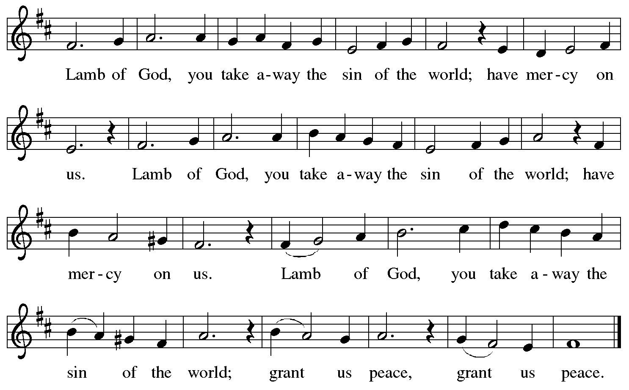

Please be seated.

Holy Communion

- All who seek God and desire a deeper and stronger life in Christ are welcome to receive Holy Communion.
- Worshipers from the pulpit side will proceed forward first, followed by the center section, and then the lectern side.
- Please inform an usher if you would like the ministers to bring Communion to you.
- Holy Communion will be served with bread and wine (red) or grape juice (white).
- The presiding minister will first distribute the bread (host) to each communicant. Please indicate if you require a gluten-free host.
- Once you have consumed the bread, please pick up an empty glass from the tray next to the presiding minister. The Communion Assistant will pour wine or grape juice into your glass.
- Please step to the side to consume the wine or grape juice.
- Feel free to kneel at the altar rail for prayer after receiving the sacrament.
- As you return to your pew, glasses may be returned to the empty tray on the side of the center section.
- A blessing will be provided for anyone who does not yet receive the sacrament.
- All are invited to join in singing the hymns during Holy Communion.
Hymns during Holy Communion
Soul, Adorn Yourself with Gladness ELW 488
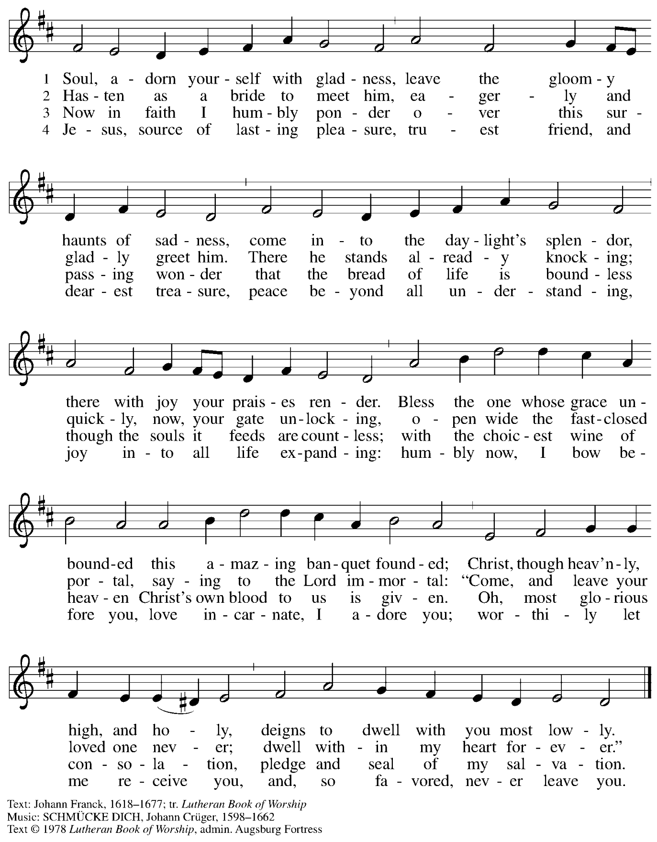
All rights reserved. Reprinted with permission under OneLicense.net # A-722319.

Hymns during Holy Communion
Touch That Soothes and Heals ACS 939

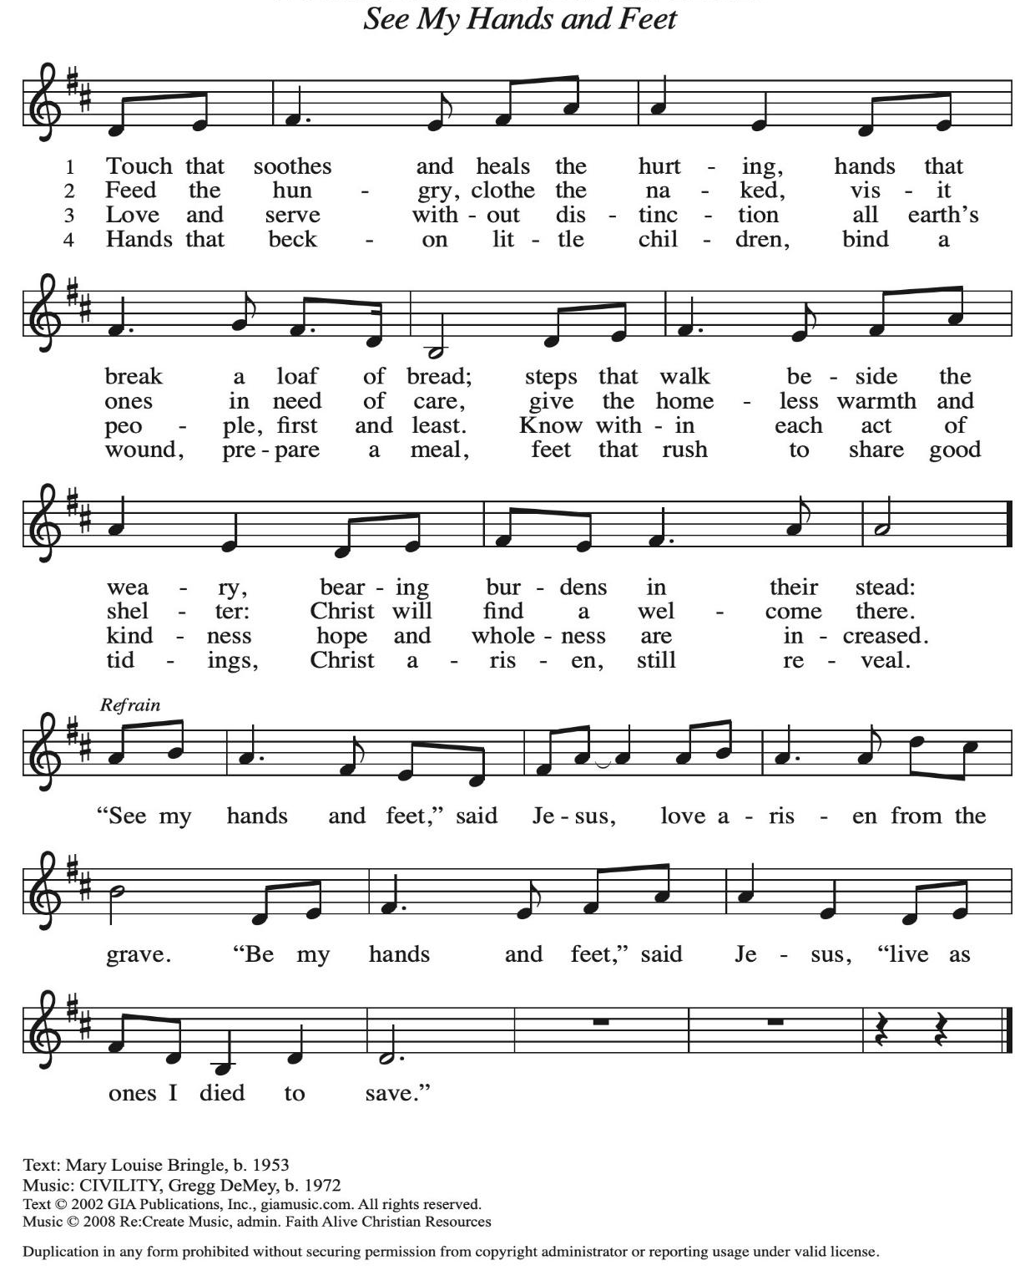
All rights reserved. Reprinted with permission under OneLicense.net # A-722319.
Hymns during Holy Communion
La Paz del Señor – The Peace of the Lord ELW 646
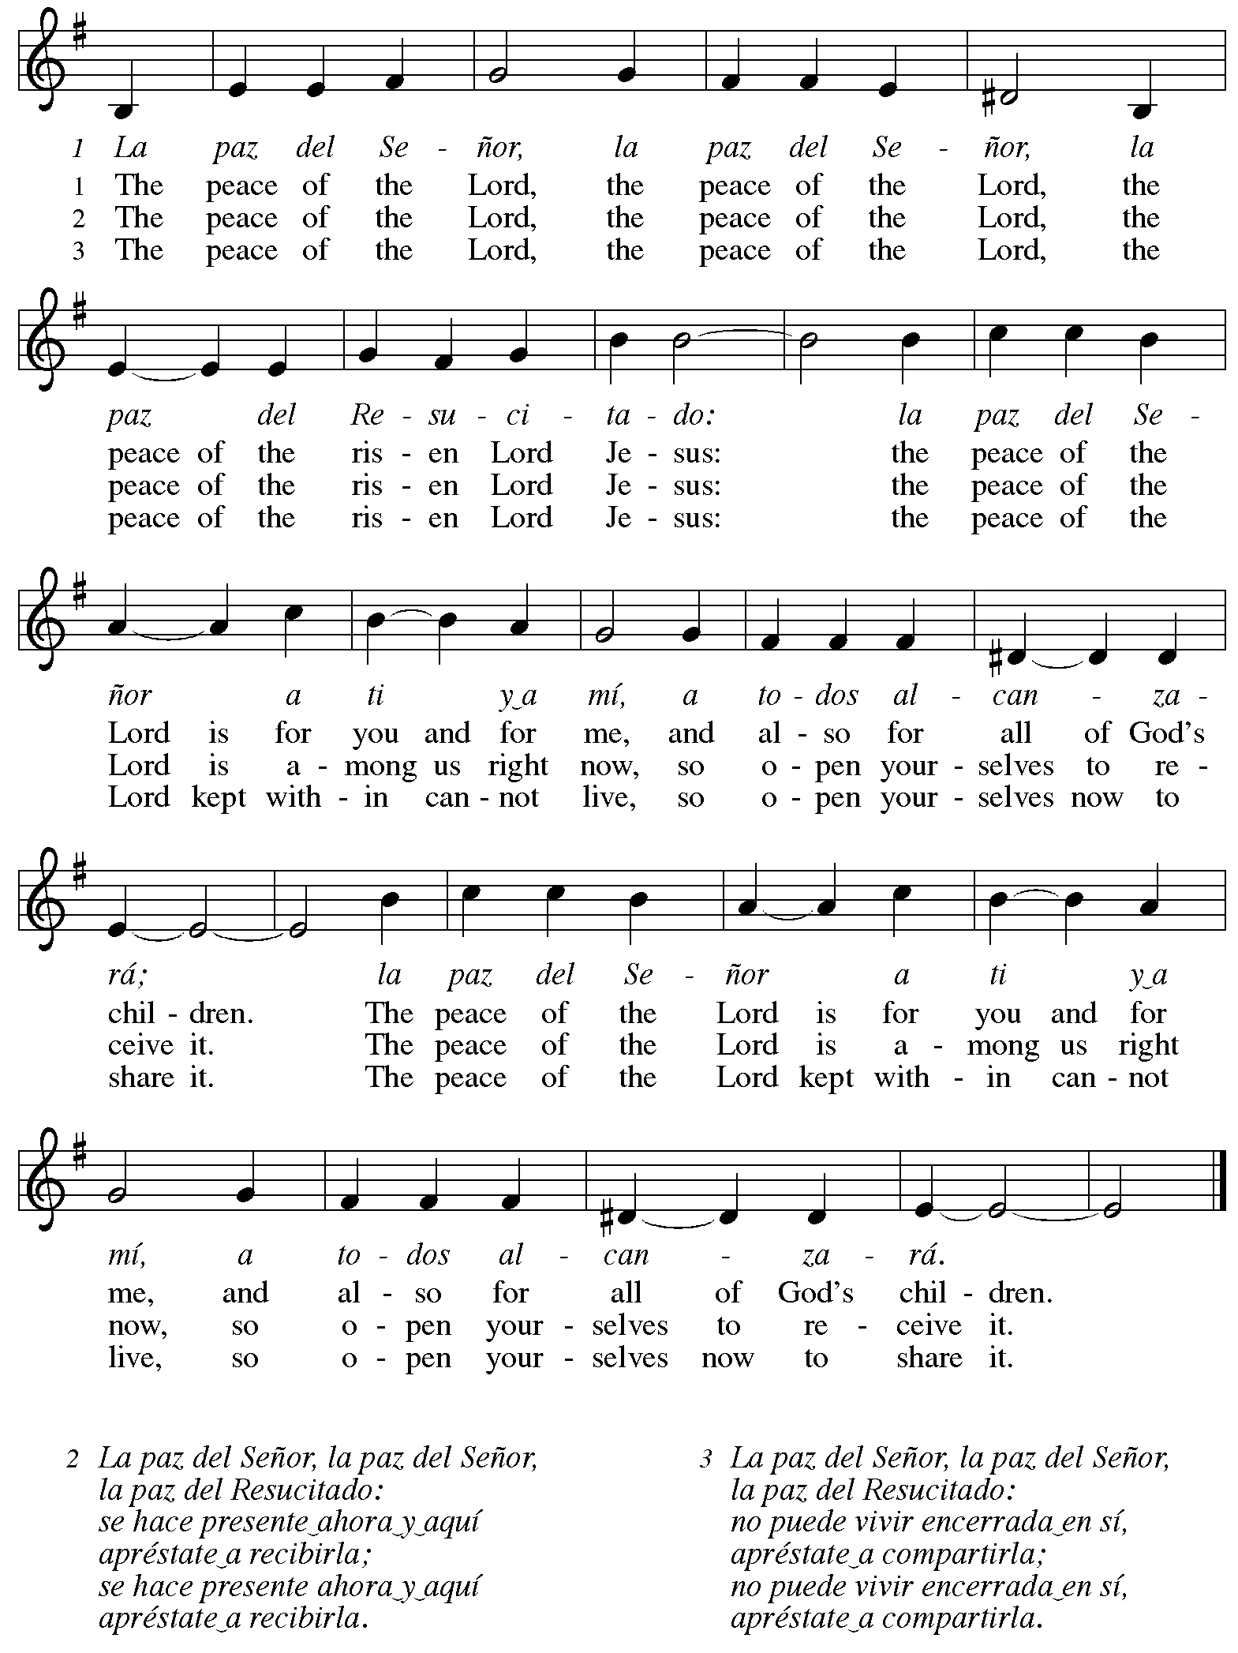
Hymns during Holy Communion
In Thee Is Gladness ELW 867

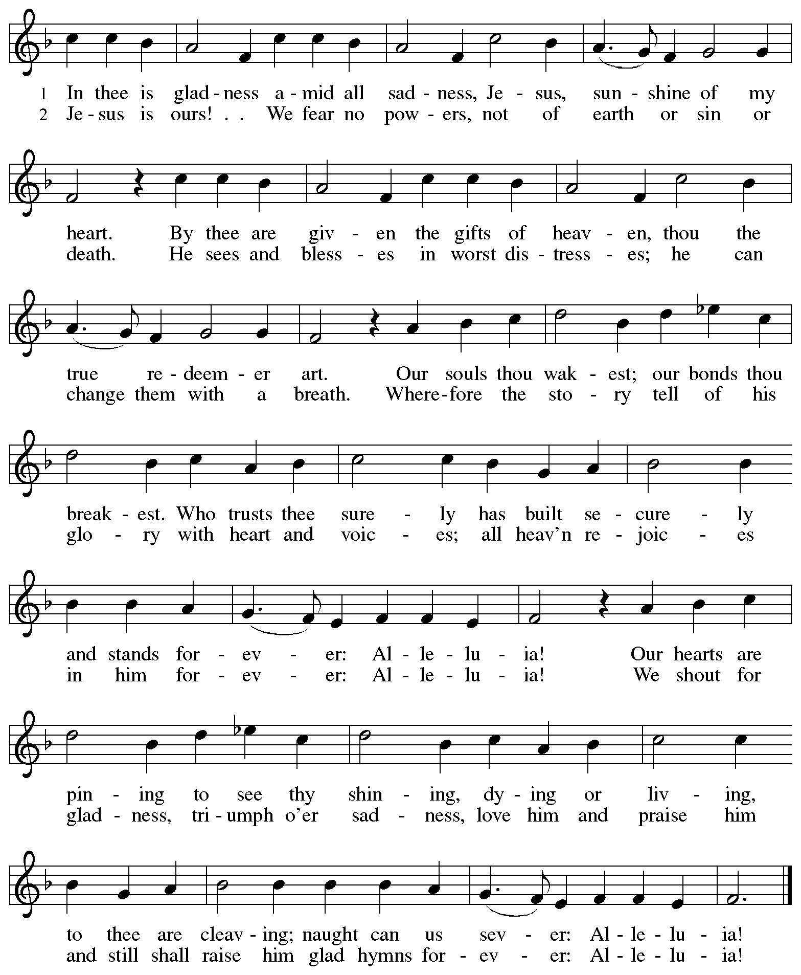
When all have returned to their places, please rise as you are able.

Blessing

P: The body and blood of our Lord Jesus Christ strengthen you and keep you in his grace.
C: Amen.

Prayer

A: Let us pray.
Life-giving God,
in the mystery of Christ’s resurrection, you send light to conquer darkness,
water to give new life, and the bread of life to nourish your people.
Send us forth as witnesses to your Son’s resurrection,
that we may show your glory to all the world,
through Jesus Christ, our risen Lord.
C: Amen.

Please be seated.

Sending
God blesses us and sends us in mission to the world

Announcements

Please rise as you are able.

Benediction

P: May our glorious God grant you a spirit of wisdom
to know and love the risen Christ.

Almighty God, holy One, ☩ holy Three,
bless you now and forever.
C: Amen.

Sending Hymn Following page

Sending Hymn Hallelujah! Jesus Lives! ELW 380
v. 1, 3-5

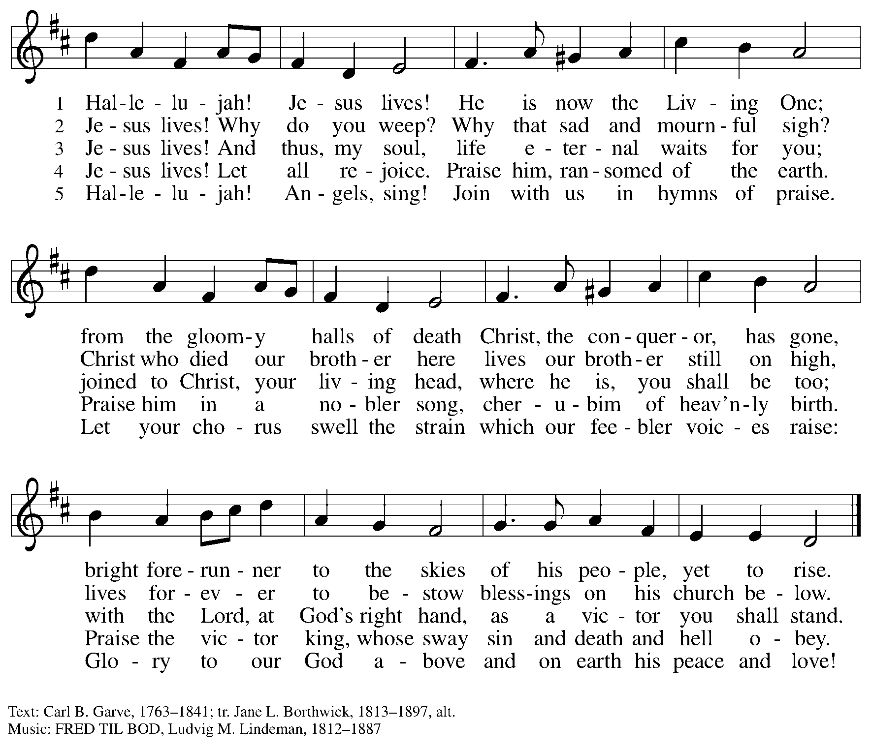

Dismissal

A: Alleluia! Christ is risen!
C: Christ is risen indeed! Alleluia! Alleluia!

A: Go in peace. Share the good news!
C: Thanks be to God!

Postlude

Serving in Worship Today

Altar Care Beverley Chapman
Assisting Minister Timothy Kocher-Hillmer
Audio-Visual Ministers Tim Jones
Dave Rollinson
Cantor Maria Mangano
Lector Brennan Coleman
Minister of Music Laura Reynolds
Presiding Minister The Rev. Ross I. Carmichael

Liturgy and Hymnody Acknowledgements

From SundaysandSeasons.com. Copyright © 2026 Augsburg Fortress. All rights reserved. Reprinted under OneLicense.net # A-722139.
Used by permission of Augsburg Fortress.

The Scripture readings contained herein are from New Revised Standard Version Updated Edition of the Bible © 2021 National Council of Churches of Christ in the United States of America. Used by permission. All rights reserved worldwide.

Christ the Lord Is Risen Today; Alleluia! Text: attr. Wipo of Burgundy, d.c 1050; tr. Jane E. Leeson, 1807-1882, alt. Music: LLANFAIR, Robert Williams, 1781-1821.

Let the Vineyards – Text: John W. Arthur, 1922-1980. Music: Ronald A. Nelson, b. 1927. Text and Music © 1978 Lutheran Book of Worship, admin. Augsburg Fortress. All rights reserved. Reprinted with permission under OneLicense.net # A-722139.

La Paz del Señor – The Peace of the Lord – Text: Anders Ruuth; tr. Gerhard M. Cartford, b. 1923. Music: LA PAZ DEL SEÑOR, Anders Ruuth. Spanish text and tune © Anders Ruuth, admin. Augsburg Fortress. English Text © Lutheran World Federation. All rights reserved. Reprinted with permission under OneLicense.net # A-722319.

Please use the QR code below to link to St. Andrew’s Announcements online!



St. Andrew Lutheran Church Announcements
April 12th, 2026

- Happy Easter! Welcome to Worship at St. Andrew on April 12th as We Celebrate the Second Sunday of Easter! – We are so glad you are here to share in this festive season, and we offer a special welcome to all visitors and guests who are here for the first time! Little Church – Big Faith, a Bible lesson and activity for children up to sixth grade, will take place after the prayer of the day. There are worship “toolkits” to help children engage with worship and “busy bags” for younger children available in the bookcase at the back of the sanctuary. Please feel free to take one to use with/for your children. A nursery is available through the door to the left of the worship space and across the social hall (look for a purple room). We pray that everyone has a blessed Easter season!
- Congratulations and Blessings to Pastor Emerita The Rev. Janet B. Grill on the 40th Anniversary of Her Ordination! – Pastor Janet Grill served as pastor of St. Andrew for 25 years, retiring in 2013. Yesterday, April 11th, was the 40th anniversary of her ordination to the Ministry of Word and Sacrament, and we would like to acknowledge this great blessing today! Please stay after worship today for a special coffee hour celebrating and giving thanks for Pastor Janet’s faithful ministry!
- Noisy Offering Next Sunday during Worship – On the third Sunday of each month, St. Andrew’s children lead the congregation in a Noisy Offering, in which people are invited to throw their change into buckets that the children carry around the church and bring forward as an additional offering. Each month’s Noisy Offering supports a local, national, or international church-related or otherwise charitable organization. A student from PSALM, Pittsburgh Students Active in Lutheran Ministry, will be with us to share stories of the impact that giving has on the lives of students, and this month’s offering will once again benefit PSALM’s larger organization, Lutheran Campus Ministry in Greater Pittsburgh, which serves the students of the University of Pittsburgh, Carnegie Mellon, Chatham, and Carlow Universities. You can learn more about their programming and services here: https://lucpgh.com.
- Alternatives to Violence Project Workshops, April 14th – “Choosing Integrity Over Influence” will be held on April 14th from 6:30 p.m. to 8:00 p.m. at Saint Maurice RC Church Campus (2001 Ardmore Blvd. Pittsburgh, PA 15221). It will be open to all ages. Please register here: https://docs.google.com/forms/d/e/1FAIpQLSenWSjN487ufRn8K6W6CTi1Nsn7lU3JZSOt234oddOsyXMI4g/viewform.
- Bible Book Club – Bible Book Club will meet on Wednesday, April 15th, at 7:00 p.m. The group is currently reading Entering the Passion of Jesus: A Beginner’s Guide to Holy Week, by Dr. Amy-Jill Levine, found here: Entering the Passion of Jesus. You can join the Zoom call here: https://us02web.zoom.us/j/83196175976?pwd=ejdPOUYrTk4xVFdsdlhHUVJ1L3k2Zz09.
- Pittsburgh PRIDE Choir’s Spring Cabaret Concert, this Friday, April 17th, and Saturday, April 18th, at 8:00 p.m. – The Board of Directors of the Pittsburgh PRIDE Choir, Pittsburgh's esteemed LGBTQIA+ choir, acknowledges and thanks you for your unwavering support and advocacy on behalf of our local LGBTQIA+ community. The concert begins at 8:00 p.m., at East Liberty Presbyterian Church (116 S. Highland Ave, Pgh). For tickets to this and future events, visit https://events.ticketleap.com/events/pittsburgh-pride-choir.
- Produce Distribution Supplemental Food of the Month – St. Andrew collects supplemental food each month to accompany our produce distribution. For April, we ask for donations of lentils and beans. There are collection boxes at the back of the worship space and social hall.
- Produce Distribution, Third Tuesday Each Month, April 21st from 5:30 to 6:30 p.m. – St. Andrew partners with Greater Pittsburgh Community Food Bank to serve as a distribution site for fresh produce on the first and third Tuesday of every month. We invite people of the congregation to help with the distribution from 5:30 p.m. to 6:30 p.m. and/or to help with unloading and setup during the day between 10:00 a.m. and 1:00 p.m.
- Dismantling Antisemitism 101, Sunday, April 26th, 12:00 p.m. to 1:30 p.m. – In the fall, St. Andrew hosted a Reckoning with Antisemitism as Christians event in collaboration with our Southwestern Pennsylvania Synod, The Holocaust Center of Pittsburgh, and Christian Associates of Southwest Pennsylvania. St. Andrew has invited Mr. Noah Schoen, Manager of Community Engagement for the Holocaust Center of Pittsburgh, to lead us in a Dismantling Antisemitism 101 workshop. After worship on April 26th, we will have an expanded coffee hour with light lunch foods, and then begin the workshop at 12:00 noon. Please put this on your calendars and plan to take part on April 26th. Please confirm your attendance here: https://www.signupgenius.com/go/5080B4AAFAF2CABF85-63105576-reckoning#/.
- “Christ in Our Home” Booklets Available – “Christ in Our Home” is a quarterly devotional resource that encourages readers to live out their faith daily. Each reflective reading is accompanied by a daily scripture reference and prayer for the day. The January-March booklets are available at the entrances. Please feel free to take one home!
- Coffee Hour Signups – St. Andrew provides hospitality during a coffee hour after worship each Sunday. If you would like to participate and would like information about the duties of setting up, please sign up using the following form: https://www.signupgenius.com/go/5080B4AAFAF2CABF85-47069030-coffee#/.

