

+ Third Sunday of Easter
April 19, 2026


St. Andrew Lutheran Church
304 Morewood Ave.
Pittsburgh, PA 15213
St_andrewELCA@verizon.net
www.standrewpittsburgh.org

+ Third Sunday of Easter

Today’s Gospel begins with two disciples walking to Emmaus, overcome with sadness, loss, and disappointment. They had hoped Jesus, who was crucified, would be the one to redeem Israel! Yet the risen Christ walks with them and then opens their eyes in the breaking of the bread.
Each Sunday our hearts burn within us as the scriptures are proclaimed
and Christ appears to us as bread is broken and wine is poured.
The story of Emmaus becomes the pattern of our worship each Lord’s day.

Welcome to St. Andrew!
- St. Andrew welcomes all who are seeking a place of healing, wholeness, and acceptance in a nurturing and faith-forming spiritual home. We are striving toward racial equity worldwide
and we seek to honor the lived experience of all individuals regardless of background. Our community embraces people of all ages, ethnicities, cultures, abilities, sexual orientations,
gender identities and expressions, and family constellations. Come and See!
- Worship Services are live-streamed to multiple online platforms. By attending worship, you agree that your image and voice may be broadcast.
- Everyone is invited to make a name tag at the black bookcase in the back of the worship space if they would like. There are stickers indicating pronouns on the bookcase if you would like to include them on your name tag.
- Children are invited to attend Little Church – Big Faith, a Bible lesson and activity, during worship (after the Prayer of the Day). The group returns to the worship space for the liturgy of Holy Communion.
- A nursery is available through the doors at the left side of the sanctuary and across from the doorway to the Social Hall. Look for a purple-colored room.
- Worship “toolkits” to help children engage with the service, along with “busy bags” for younger children, are available in the bookcase at the back of the sanctuary. Please feel free to take one to use with/for your children.
- Holy Communion is served with bread (gluten-free available) and wine or grape juice. The presiding minister will distribute the bread (host). Please consume this and then pick up an empty glass from the tray. The Communion Assistant will pour wine or grape juice into your glass. Please step to the side to consume the wine or grape juice. Feel free to kneel at the altar for prayer and reflection. As you return to your pew, glasses may be returned to the empty trays on either side of the center section.
- A restroom is available on the main level of the church, through the doors to the Social Hall and to the right in the main office.

Abbreviations
P: Pastor/Presiding Minister ELW: Evangelical Lutheran Worship hymnal
A: Assisting Minister ACS: All Creation Sings hymnal
L: Lector
C: Congregation

Musical Offering

Each week, different people from the congregation make an offering of pre-service music, with singing or instrumentation, to help the assembly focus and pray in preparation for worship.

Welcome
Prelude Crown Him with Many Crowns arr. Edstrom

Gathering
The Holy Spirit calls us together as the people of God

Please rise as you are able. All may make the sign of the cross,
the sign that is marked at Baptism, as the presiding minister begins.

Thanksgiving for Baptism

P: Alleluia! Christ is risen!
C: Christ is risen indeed! Alleluia! Alleluia!

P: Salvation belongs to our God who is seated on the throne and to the Lamb!
C: Amen.

P: Let us give thanks for the gift of Baptism.

Water may be poured into the font as the presiding minister continues.
P: Merciful God,
you are the one who was, who is, and who is to come.
You lead us beside still waters.
We thank you for the waters of creation:
morning dew, gentle rain, roaring waves.
We thank you for the waters that nourish us.
Blessed are you!
C: You guide us to springs of the water of life.

P: Jesus Christ, you are the faithful witness
who accompanies us on our journeys.
We give you thanks for your life-giving death and resurrection.
We praise you for joining us in joy and sorrow.
Blessed are you!
C: You guide us to springs of the water of life.

P: Holy Spirit, you anoint our head with oil and our cup overflows.
Break down barriers that divide us.

P: Fill us with the breath of peace.
Blessed are you!
C: You guide us to springs of the water of life.

P: Holy One, we thank you for the gifts and grace of Baptism,
and for making us a new creation.
We join with saints and angels, giving you honor and praise,
now and forever.
C: Amen.

Gathering Hymn The Day of Resurrection! ELW 361

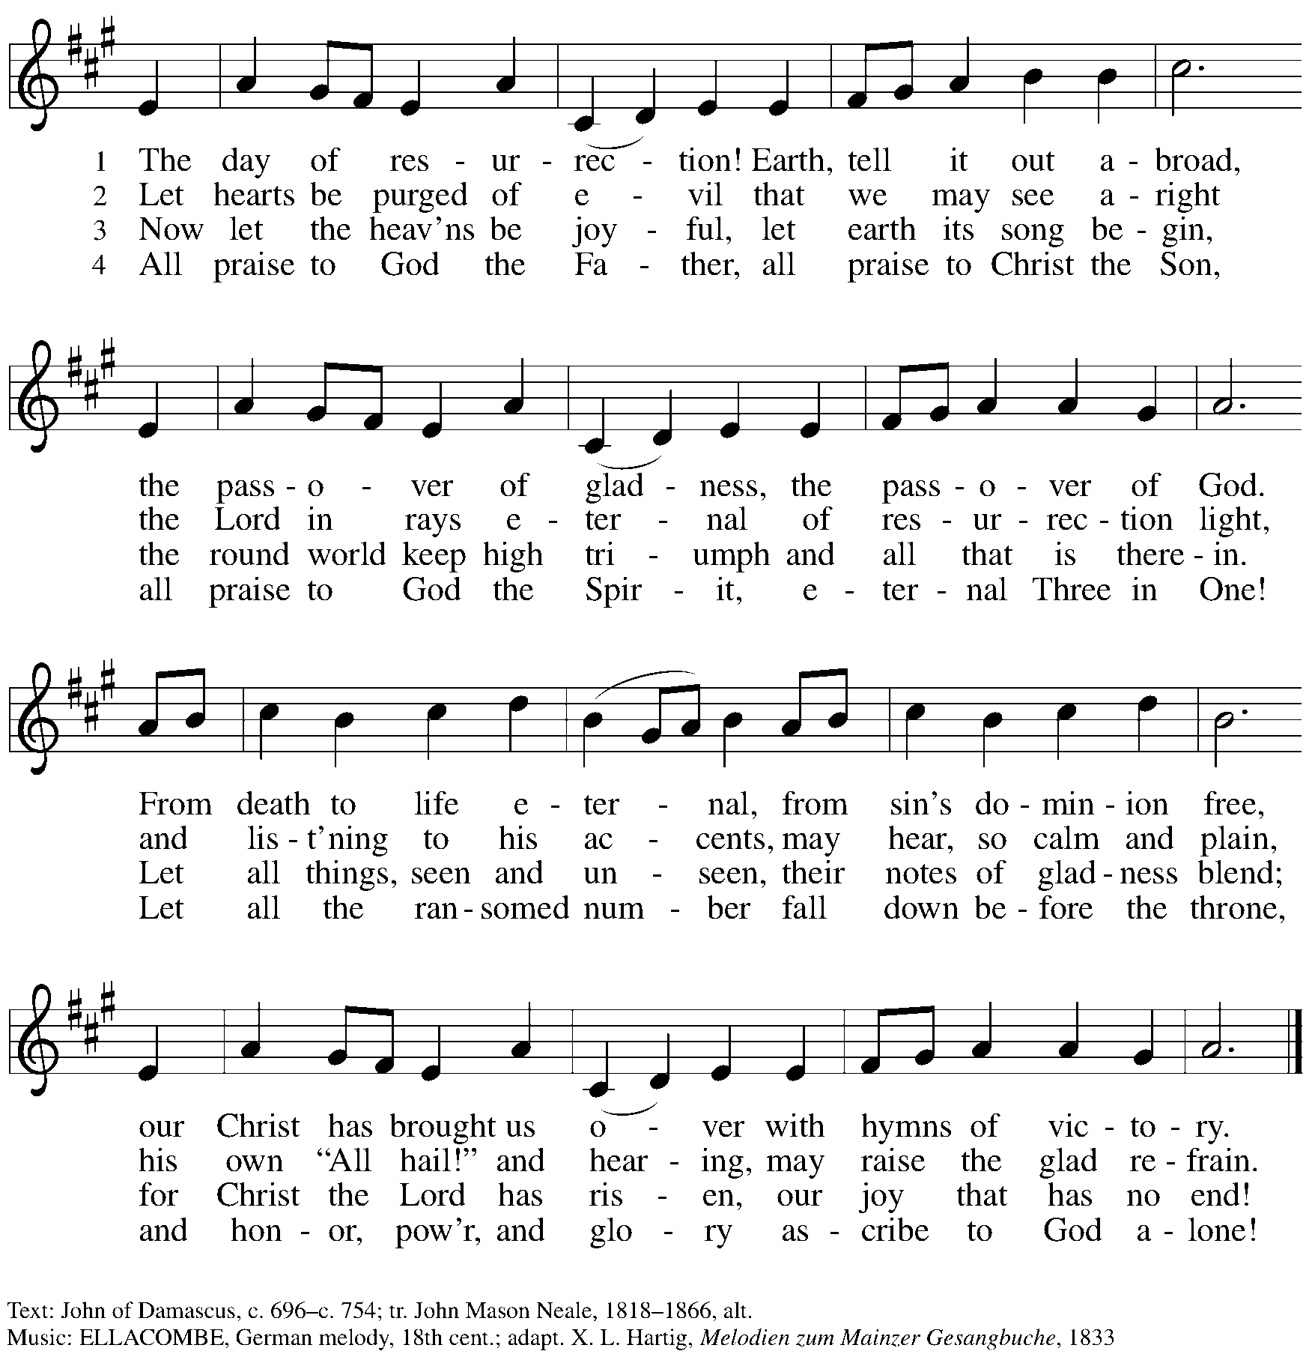

Greeting

P: The grace of our Lord Jesus Christ, the love of God,
and the communion of the Holy Spirit be with you all.
C: And also with you.

Hymn of Praise This Is the Feast ELW p. 149-150
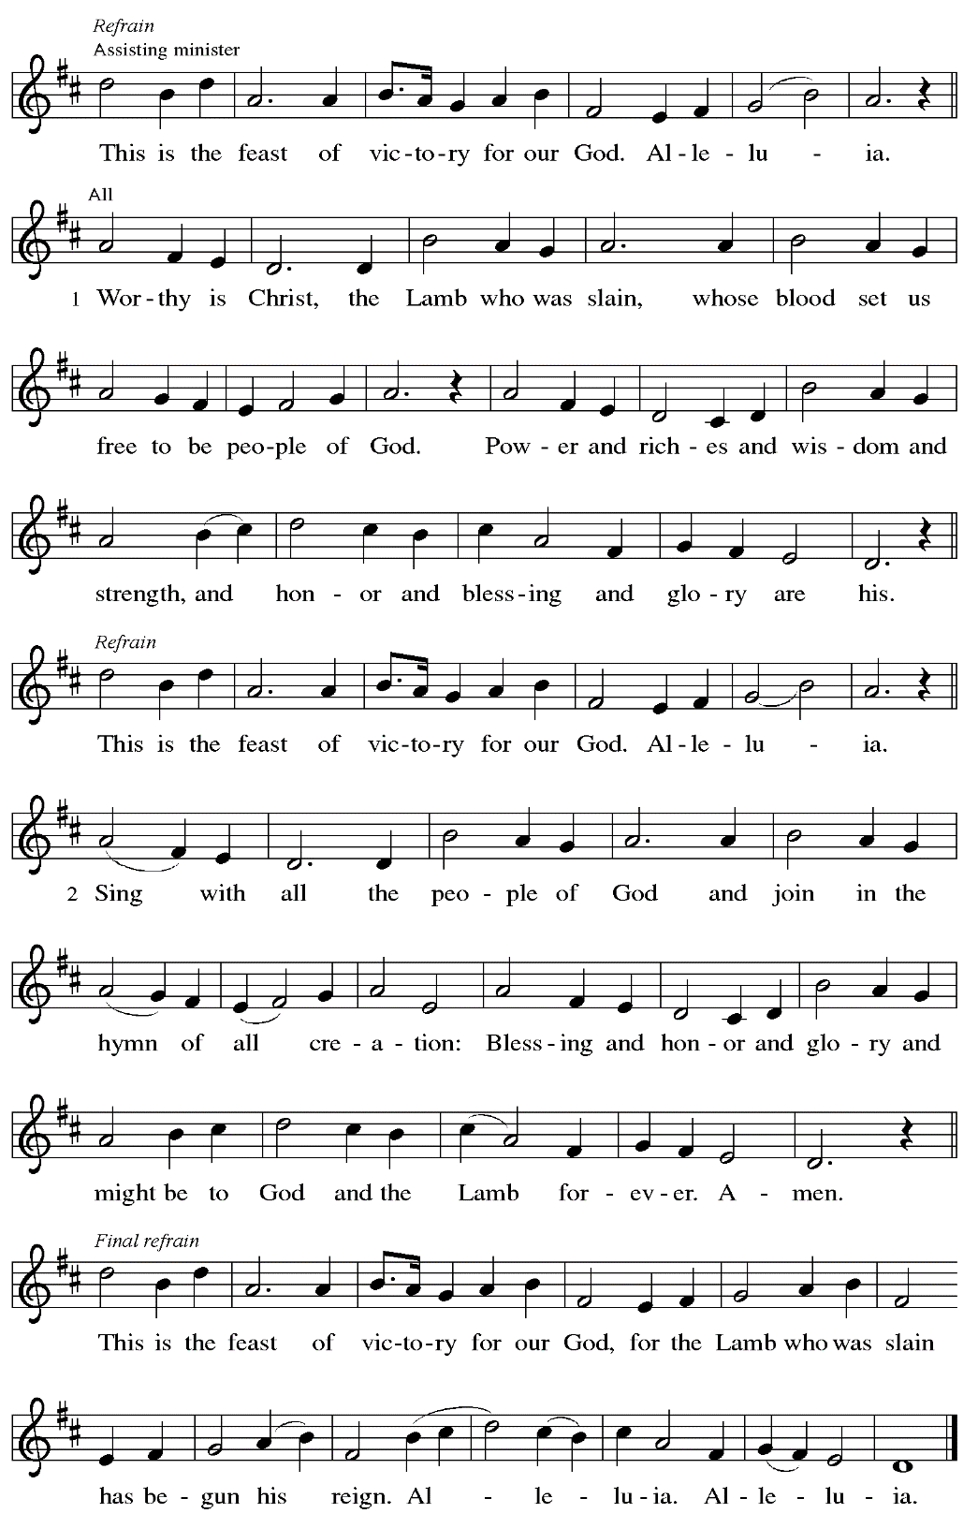
Prayer of the Day

P: The Lord be with you.
C: And also with you.

P: Let us pray.
O God, your Son makes himself known to all his disciples in the breaking of bread.
Open the eyes of our faith, that we may see him in his redeeming work,
who lives and reigns with you and the Holy Spirit, one God, now and forever.
C: Amen.

Please be seated.
Children are invited to join the adult leader(s) at the side door for Little Church – Big Faith.
We ask that an additional adult from the congregation attend with the children.

Word
God speaks to us in Scripture reading, preaching, and song

First Reading – Acts 2: 14a, 36-41

^{14a} Peter, standing with the eleven, raised his voice and addressed [the crowd]: ³⁶ “Therefore let the entire house of Israel know with certainty that God has made him both Lord and Messiah, this Jesus whom you crucified.”

³⁷ Now when they heard this, they were cut to the heart and said to Peter and to the other apostles, “Brothers, what should we do?” ³⁸ Peter said to them, “Repent and be baptized every one of you in the name of Jesus Christ so that your sins may be forgiven, and you will receive the gift of the Holy Spirit. ³⁹ For the promise is for you, for your children, and for all who are far away, everyone whom the Lord our God calls to God.” ⁴⁰ And he testified with many other arguments and exhorted them, saying, “Save yourselves from this corrupt generation.” ⁴¹ So those who welcomed his message were baptized, and that day about three thousand persons were
added.

L: Word of God, word of life.
C: Thanks be to God.

Psalm 116: 1-4, 12-19

The psalm will be sung responsively, led by the cantor,
with the congregation responding with the bold verses and refrain.

Psalm tone

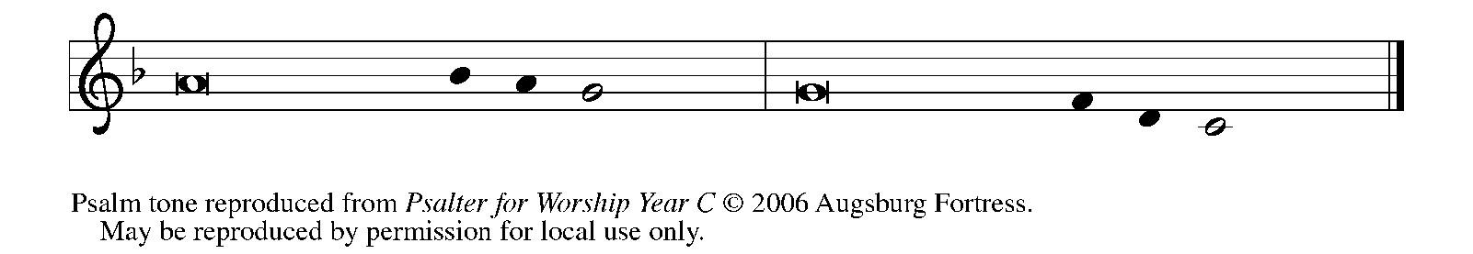

Psalm refrain

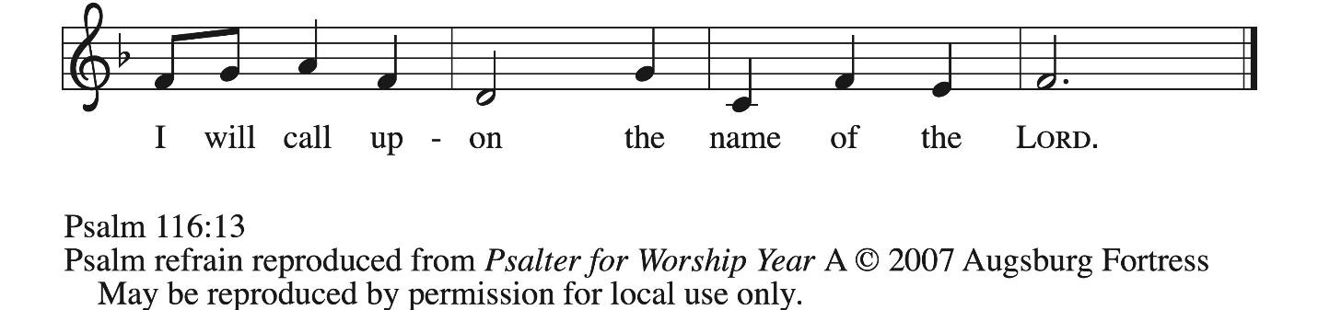

¹ I love the Lord, who has | heard my voice,
and listened to my | supplication,
² for the Lord has given | ear to me
whenev- | er I called.
³ The cords of death entangled me; the anguish of the grave | came upon me;
I came to | grief and sorrow.
⁴ Then I called upon the name | of the Lord:
“O Lord, I pray you, | save my life.” R
¹² How shall I re- | pay the Lord
for all the good things God has | done for me?
¹³ I will lift the cup | of salvation
and call on the name | of the Lord.
¹⁴ I will fulfill my vows | to the Lord
in the presence of | all God’s people.
¹⁵ Precious in your | sight, O Lord,
is the death | of your servants.
¹⁶ O Lord, truly I | am your servant;
I am your servant, the child of your handmaid; you have freed me | from my bonds.
¹⁷ I will offer you the sacrifice | of thanksgiving
and call upon the name | of the Lord. R
¹⁸ I will fulfill my vows | to the Lord
in the presence of | all God’s people,
¹⁹ in the courts of | the Lord’s house,
in the midst of you, O Jerusalem. | Hallelujah! R

Second Reading – 1 Peter 1: 17-23

¹⁷ If you invoke as Father the one who judges impartially according to each person’s work, live in fear during the time of your exile. ¹⁸ You know that you were ransomed from the futile conduct inherited from your ancestors, not with perishable things like silver or gold ¹⁹ but with the precious blood of Christ, like that of a lamb without defect or blemish. ²⁰ He was destined before the foundation of the world but was revealed at the end of the ages for your sake.
²¹ Through him you have come to trust in God, who raised him from the dead and gave him glory, so that your trust and hope are in God.
²² Now that you have purified your souls by your obedience to the truth so that you have genuine mutual affection, love one another deeply from the heart. ²³ You have been born anew, not of perishable but of imperishable seed, through the living and enduring word of God.
L: Word of God, word of life.
C: Thanks be to God.

Please rise as you are able.

Gospel Acclamation ELW p. 151

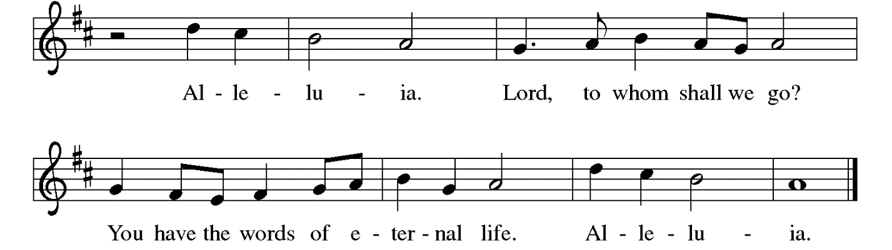

Gospel – Luke 24: 13-35

P: The holy Gospel according to St. Luke.
C: Glory to you, O Lord.

¹³ Now on that same day two [disciples] were going to a village called Emmaus, about seven miles from Jerusalem, ¹⁴ and talking with each other about all these things that had happened.
¹⁵ While they were talking and discussing, Jesus himself came near and went with them, ¹⁶ but their eyes were kept from recognizing him. ¹⁷ And he said to them, “What are you discussing with each other while you walk along?” They stood still, looking sad. ¹⁸ Then one of them, whose name was Cleopas, answered him, “Are you the only stranger in Jerusalem who does not know the things that have taken place there in these days?” ¹⁹ He asked them, “What things?”
They replied, “The things about Jesus of Nazareth, who was a prophet mighty in deed and word before God and all the people, ²⁰ and how our chief priests and leaders handed him over to be condemned to death and crucified him. ²¹ But we had hoped that he was the one to redeem Israel. Yes, and besides all this, it is now the third day since these things took place.
²² Moreover, some women of our group astounded us. They were at the tomb early this morning, ²³ and when they did not find his body there they came back and told us that they had indeed seen a vision of angels who said that he was alive. ²⁴ Some of those who were with us went to the tomb and found it just as the women had said, but they did not see him.” ²⁵ Then he said to them, “Oh, how foolish you are and how slow of heart to believe all that the prophets have declared! ²⁶ Was it not necessary that the Messiah should suffer these things and then enter into his glory?” ²⁷ Then beginning with Moses and all the prophets, he interpreted to them the things about himself in all the scriptures.
²⁸ As they came near the village to which they were going, he walked ahead as if he were going on. ²⁹ But they urged him strongly, saying, “Stay with us, because it is almost evening and the day is now nearly over.” So he went in to stay with them. ³⁰ When he was at the table with them, he took bread, blessed and broke it, and gave it to them. ³¹ Then their eyes were opened, and they recognized him, and he vanished from their sight. ³² They said to each other, “Were not our hearts burning within us while he was talking to us on the road, while he was opening the scriptures to us?” ³³ That same hour they got up and returned to Jerusalem, and they found the eleven and their companions gathered together. ³⁴ They were saying, “The Lord has risen indeed, and he has appeared to Simon!” ³⁵ Then they told what had happened on the road and how he had been made known to them in the breaking of the bread.

P: The Gospel of the Lord.
C: Praise to you, O Christ.

Please be seated.

Sermon

A time of silence for prayer and reflection follows the sermon.
When the hymn of the day begins, please rise as you are able.



Hymn of the Day Day of Arising ELW 374

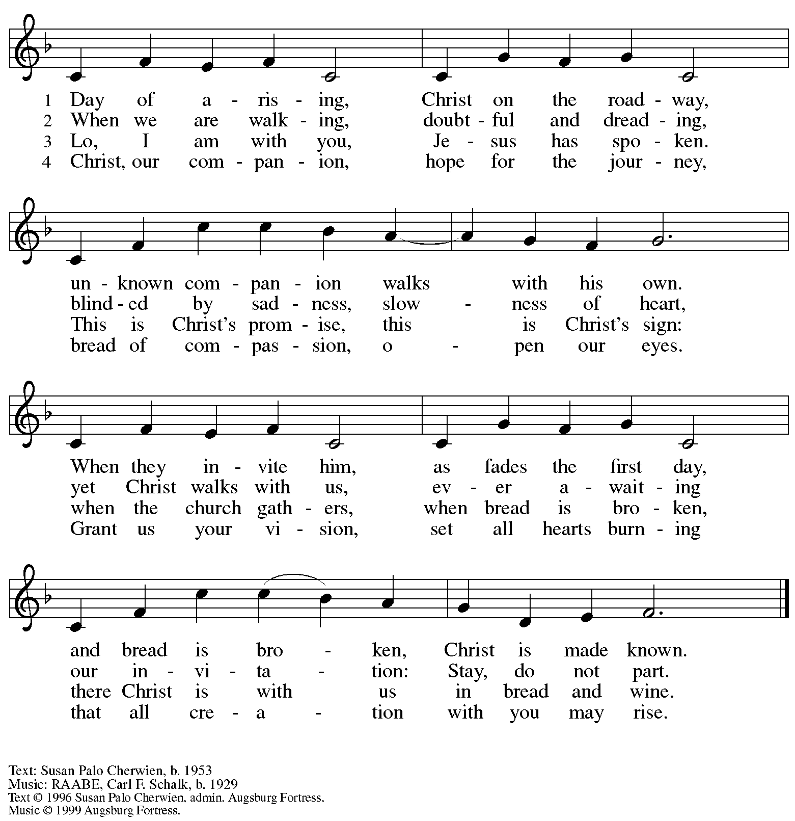
All rights reserved. Reprinted with permission under OneLicense.net # A-722139.

Nicene Creed

C: We believe in one God,
the Father, the Almighty,
maker of heaven and earth,
of all that is, seen and unseen.
C: We believe in one Lord, Jesus Christ,
the only Son of God,
eternally begotten of the Father,
God from God, Light from Light,
true God from true God,
begotten, not made,
of one Being with the Father;
through him all things were made.
For us and for our salvation
he came down from heaven,
was incarnate of the Holy Spirit and the virgin Mary
and became truly human.
For our sake he was crucified under Pontius Pilate;
he suffered death and was buried.
On the third day he rose again
in accordance with the scriptures;
he ascended into heaven
and is seated at the right hand of the Father.
He will come again in glory to judge the living and the dead,
and his kingdom will have no end.

We believe in the Holy Spirit, the Lord, the giver of life,
who proceeds from the Father and the Son,*
who with the Father and the Son is worshiped and glorified,
who has spoken through the prophets.
We believe in one holy catholic and apostolic church.
We acknowledge one baptism for the forgiveness of sins.
We look for the resurrection of the dead,
and the life of the world to come. Amen.
*Or, “who proceeds from the Father.” The phrase “and the Son” is a later addition to the creed.

Prayers of the People

A: United in the joy and hope of the resurrection, let us pray for the church, the world,
and all who are in need.

After each petition
A: Gracious God,
C: receive our prayer.

The presiding minister concludes the prayers
P: We lift these prayers to you O God, trusting in your abundant mercy,
through Jesus Christ our risen Savior.
C: Amen.
Peace

The presiding minister and the assembly greet one another in the peace of the risen Christ.
P: The peace of Christ be with you always.
C: And also with you.

The people may greet those around them with a sign of Christ’s peace and may say
Peace be with you or similar words. Please be mindful that not everyone will be comfortable with sharing the peace, so please seek consent before shaking hands or hugging. Other possible ways to share the peace include a simple bow with the verbal greeting of peace, or simply a verbal expression of peace. When the greetings of peace have concluded, please be seated.



Meal
God feeds us with the presence of Jesus Christ

Offering

We offer ourselves, our gifts, and our faithful service to God.
As the offering is gathered for the mission of the church, including the care of those in need,
the table is set for Holy Communion.

There are laminated giving cards in the pew racks that feature a QR code for anyone who would like to give online. Those who give using the QR code, as well as those who give regularly online or through their bank are encouraged to place the laminated card in the plate as an expression of your offering.

Music during the Offering
All Hail the Power of Jesus’ Name arr. Edstrom

As the gifts are brought forward for presentation, please rise as you are able.

Offertory Song Let the Vineyards Be Fruitful ELW 184

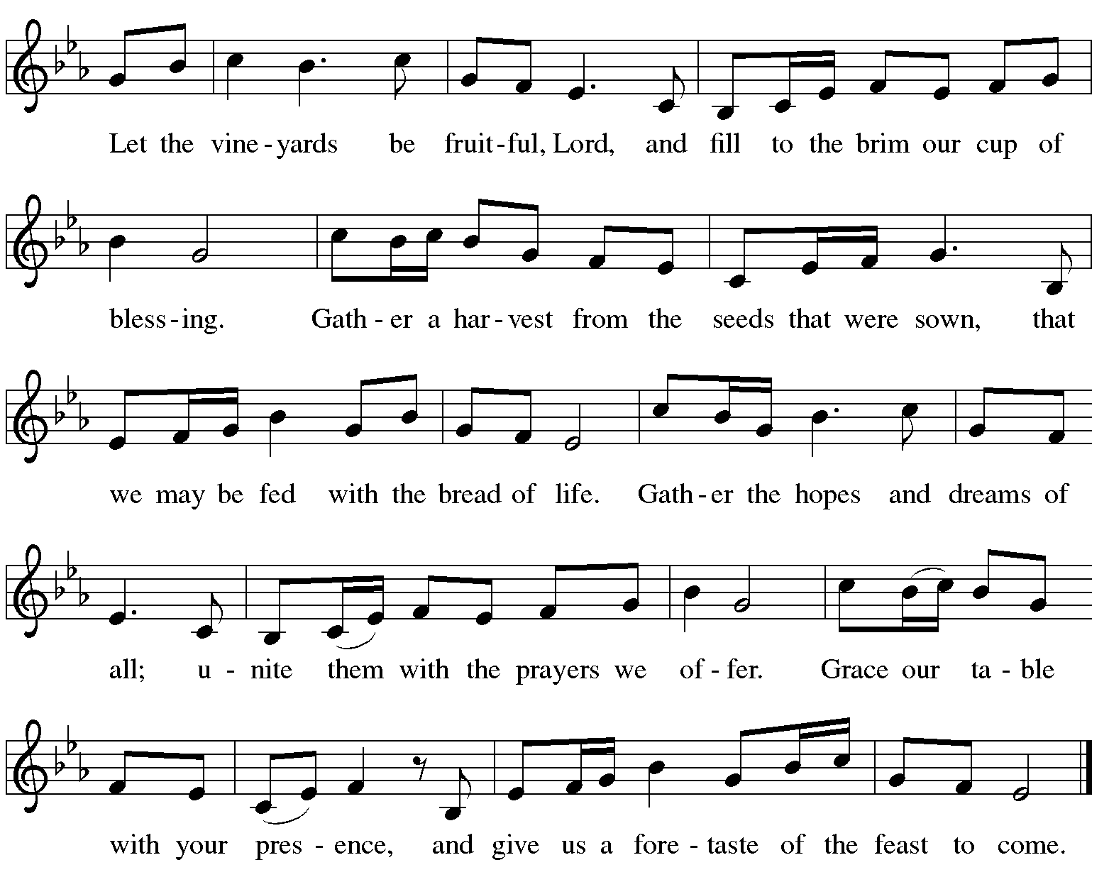

Offertory Prayer

A: Let us pray.
Blessed are you, O God,

C: ruler of heaven and earth.
Day by day you shower us with blessings.
As you have raised us to new life in Christ,
give us glad and generous hearts,
ready to praise you and to respond to those in need,
through Jesus Christ, our Savior and Lord.
Amen.

Dialogue ELW p. 152

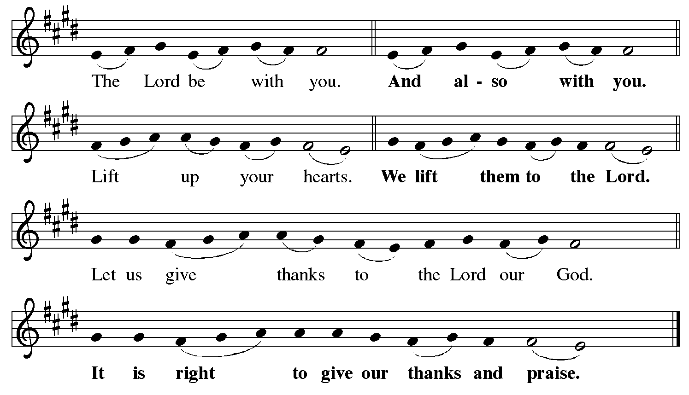

Preface (Sung by the presiding minister)

P: It is indeed right, our duty and our joy,
that we should at all times and in all places
give thanks and praise to you, almighty and merciful God,
for the glorious resurrection of our Savior Jesus Christ,
the true Paschal Lamb who gave himself to take away our sin;
who in dying has destroyed death,
and in rising has brought us to eternal life.
And so, with Mary Magdalene and Peter
and all the witnesses of the resurrection,
with earth and sea and all their creatures,
and with angels and archangels, cherubim and seraphim,
we praise your name and join their unending hymn:

Sanctus ELW p. 153

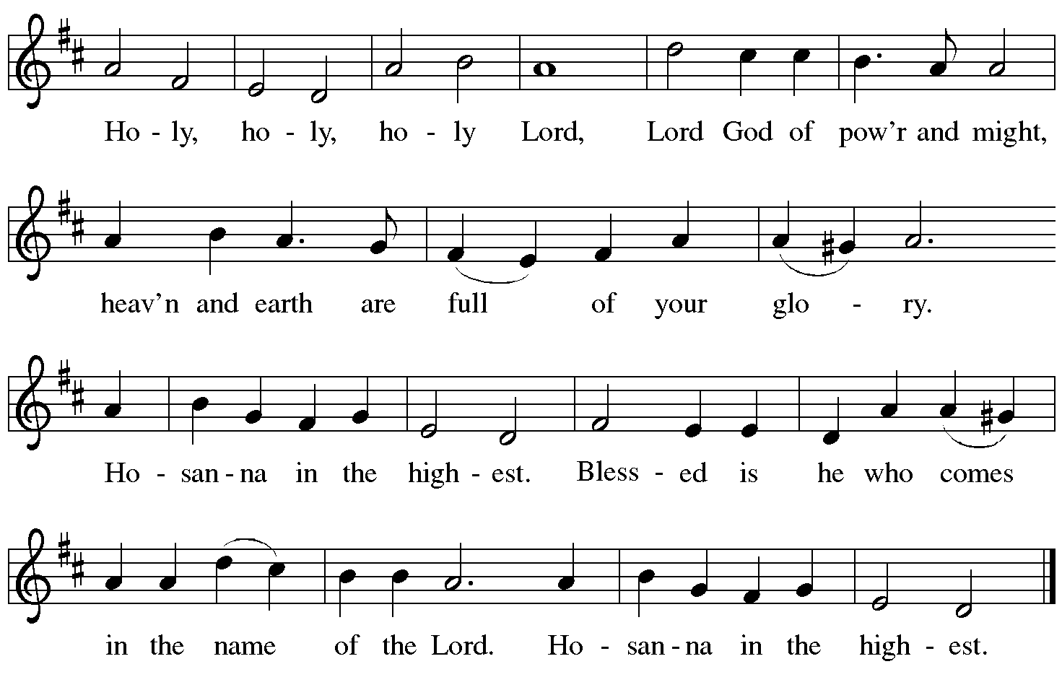

Eucharistic Prayer

P: Blessed are you, O God of the universe …
… Do this for the remembrance of me.

With this bread and cup we remember our Lord’s passover from death to life
as we proclaim the mystery of faith.
C: Christ has died. Christ is risen. Christ will come again.

P: O God of resurrection and new life …
… Grace our table with your presence.
C: Come, Holy Spirit.

P: Reveal yourself to us in the breaking of the bread …
… send us forth, burning with justice, peace, and love.
C: Come, Holy Spirit.

P: With your holy ones of all times and places …
… blessed and Holy Trinity, now and forever.
C: Amen.
Lord’s Prayer

P: Gathered as one by the Holy Spirit, let us pray as Jesus taught us.
C: Our Father, who art in heaven,
hallowed be thy name,
thy kingdom come,
thy will be done,
on earth as it is in heaven.
Give us this day our daily bread;
and forgive us our trespasses,
as we forgive those
who trespass against us;
and lead us not into temptation,
but deliver us from evil.
For thine is the kingdom,
and the power, and the glory,
forever and ever. Amen.

Fraction and Invitation

P: Alleluia! Christ is risen!
C: Christ is risen indeed! Alleluia! Alleluia!

P: This is the feast of victory for our God. Alleluia! Alleluia!
Come, share the feast.



Agnus Dei / Lamb of God ELW p. 154

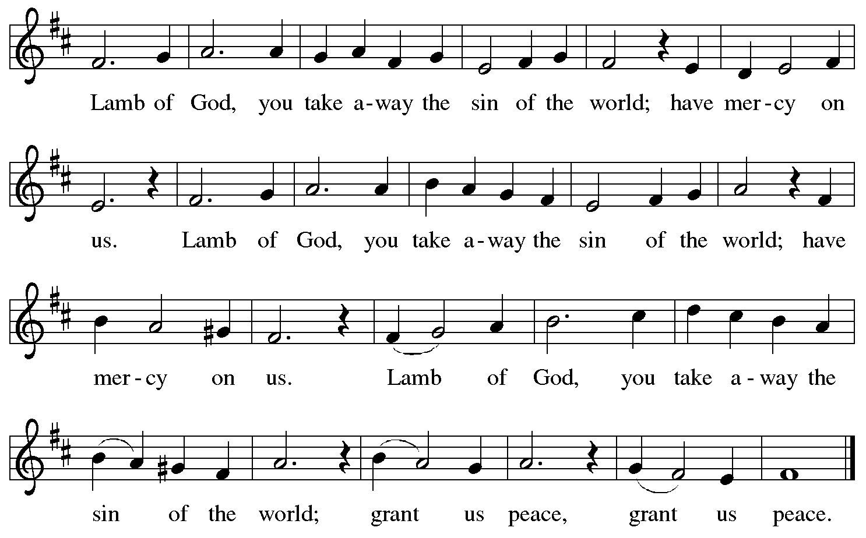

Please be seated.

Holy Communion

- All who seek God and desire a deeper and stronger life in Christ are welcome to receive Holy Communion.
- Worshipers from the pulpit side will proceed forward first, followed by the center section, and then the lectern side.
- Please inform an usher if you would like the ministers to bring Communion to you.
- Holy Communion will be served with bread and wine (red) or grape juice (white).
- The presiding minister will first distribute the bread (host) to each communicant. Please indicate if you require a gluten-free host.
- Once you have consumed the bread, please pick up an empty glass from the tray next to the presiding minister. The Communion Assistant will pour wine or grape juice into your glass.
- Please step to the side to consume the wine or grape juice.
- Feel free to kneel at the altar rail for prayer after receiving the sacrament.
- As you return to your pew, glasses may be returned to the empty tray on the side of the center section.
- A blessing will be provided for anyone who does not yet receive the sacrament.
- All are invited to join in singing the hymns during Holy Communion.
Hymns during Holy Communion
By Your Hand You Feed Your People ELW 469

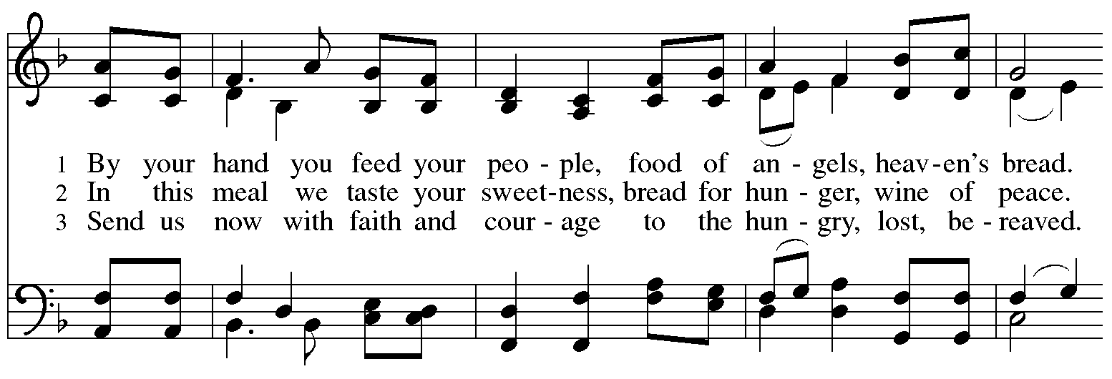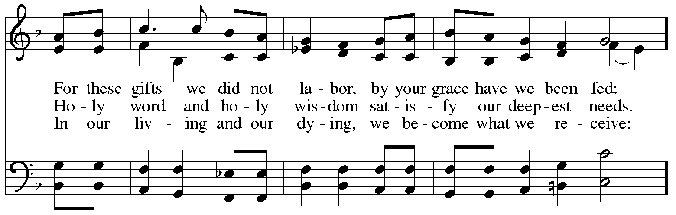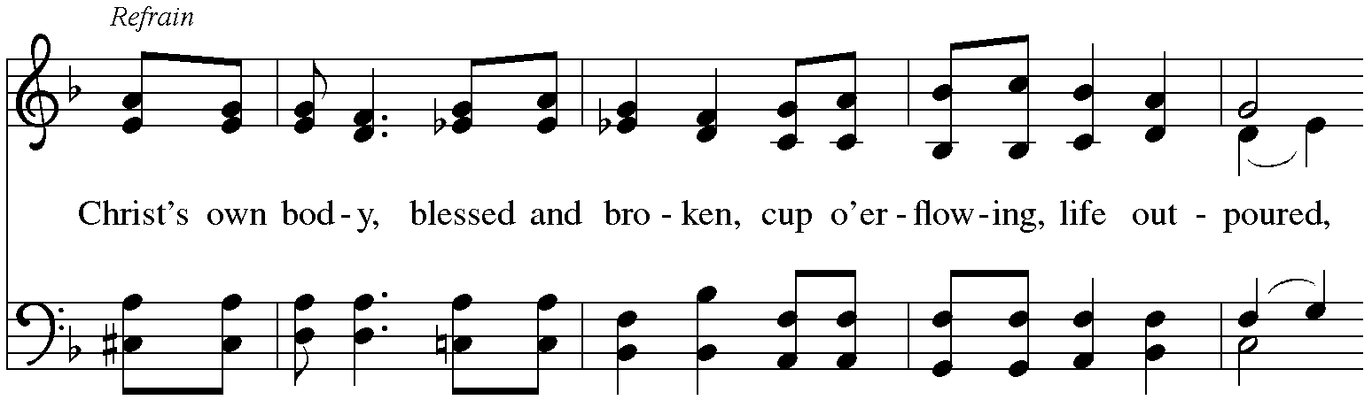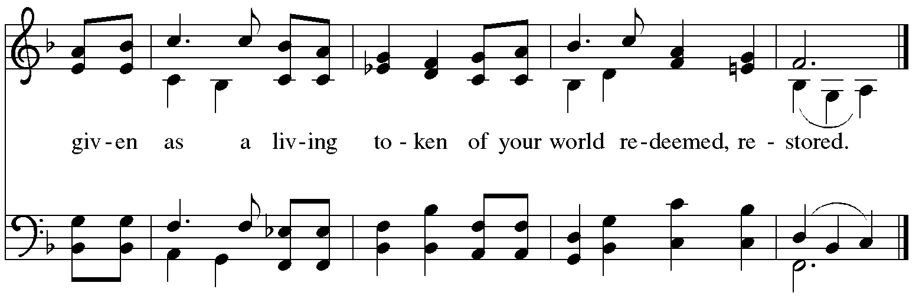

Hymns during Holy Communion
O Bread of Life from Heaven ELW 480

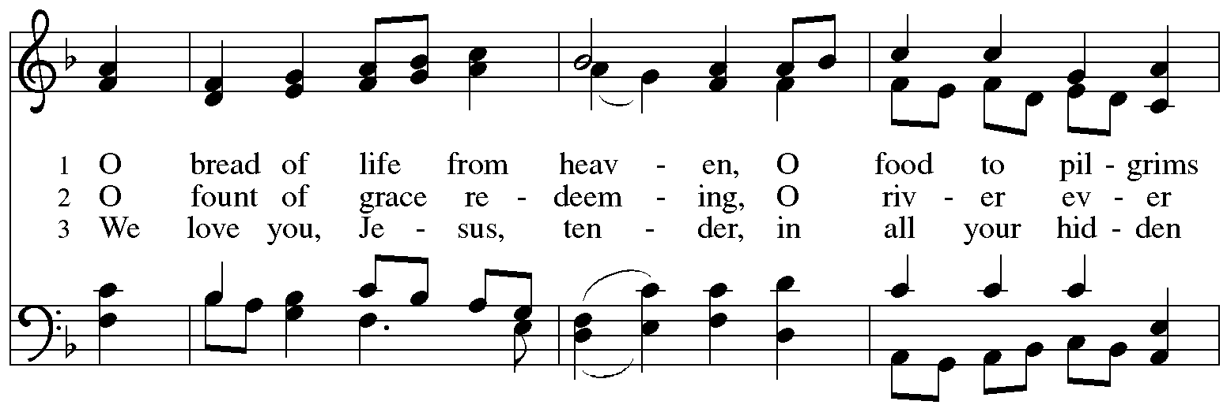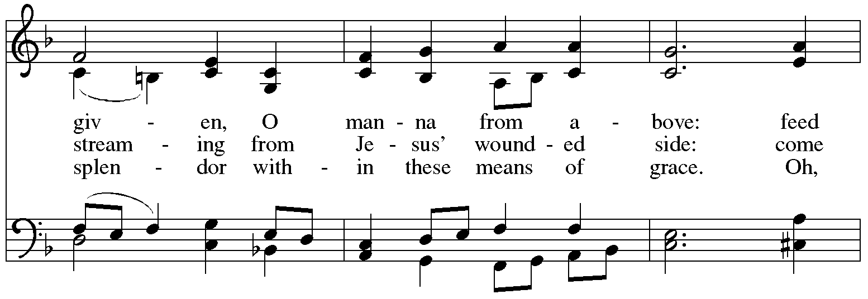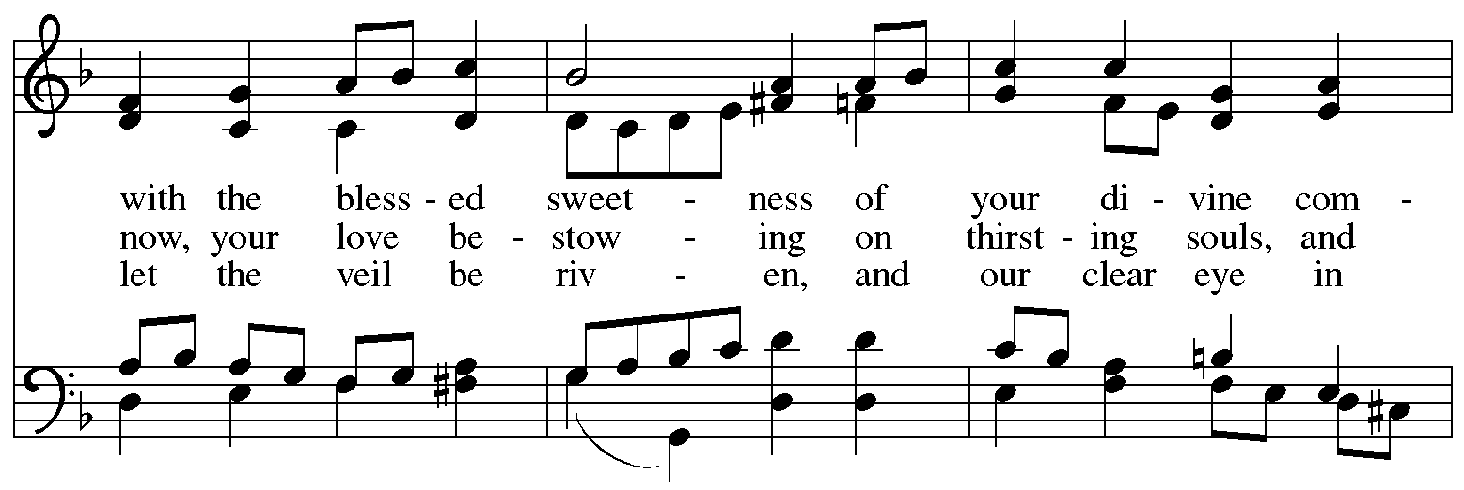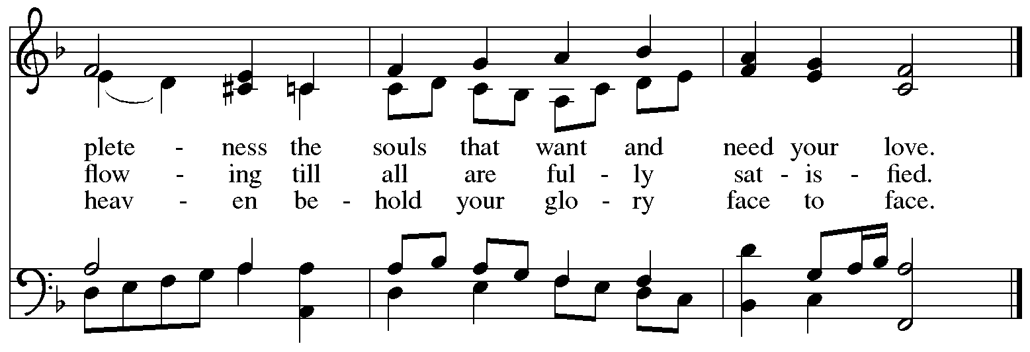
Hymns during Holy Communion
Draw Us in the Spirit’s Tether ELW 470

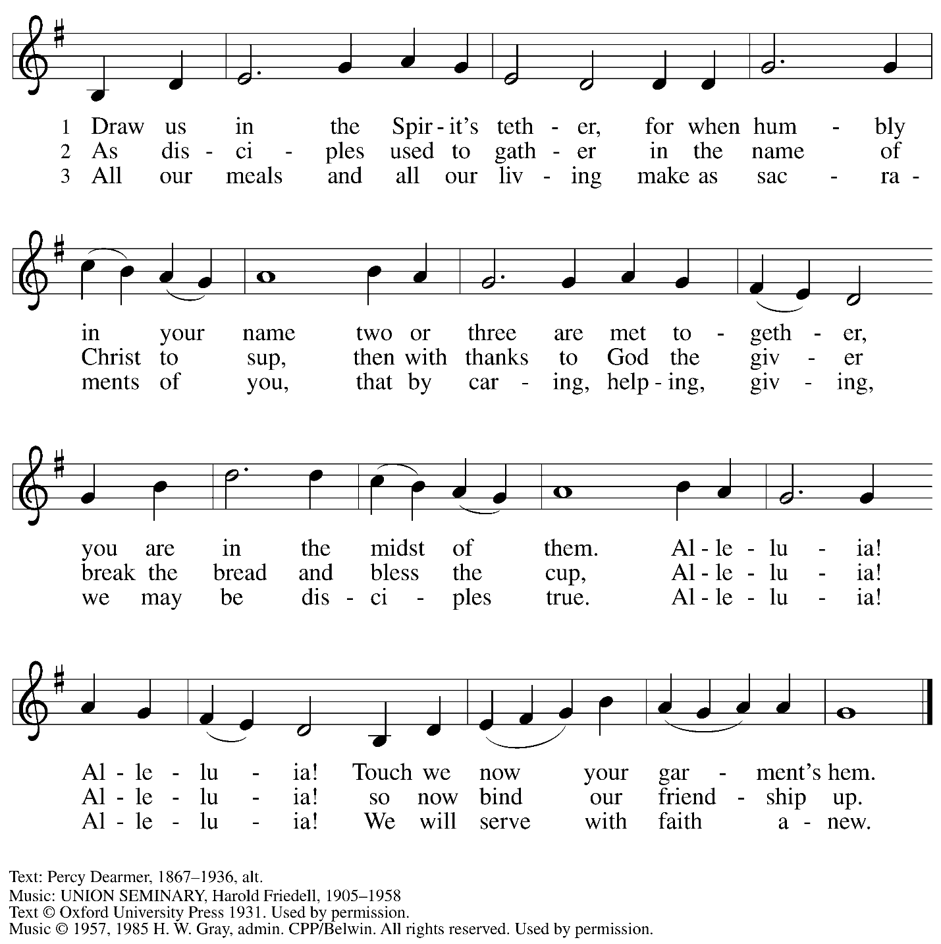
All rights reserved. Reprinted under OneLicense.net # A-722139.

Hymns during Holy Communion
Joyful, Joyful, We Adore Thee ELW 836
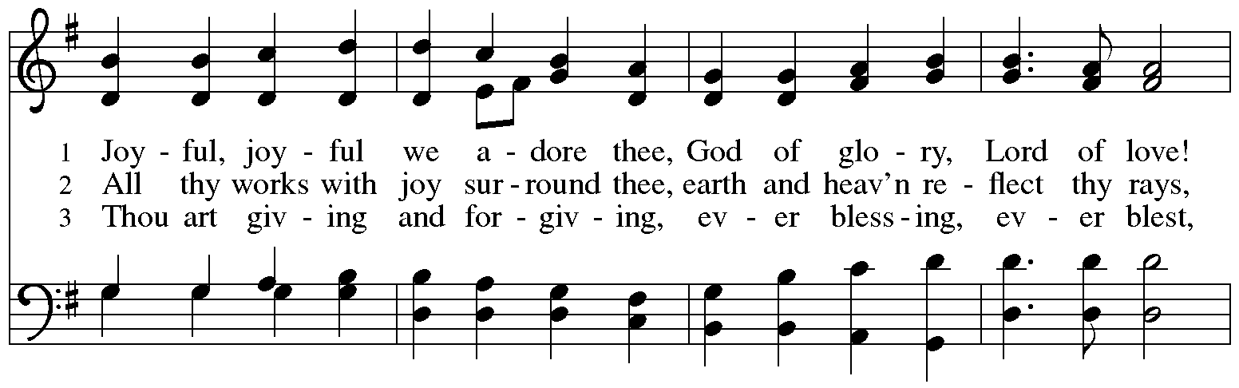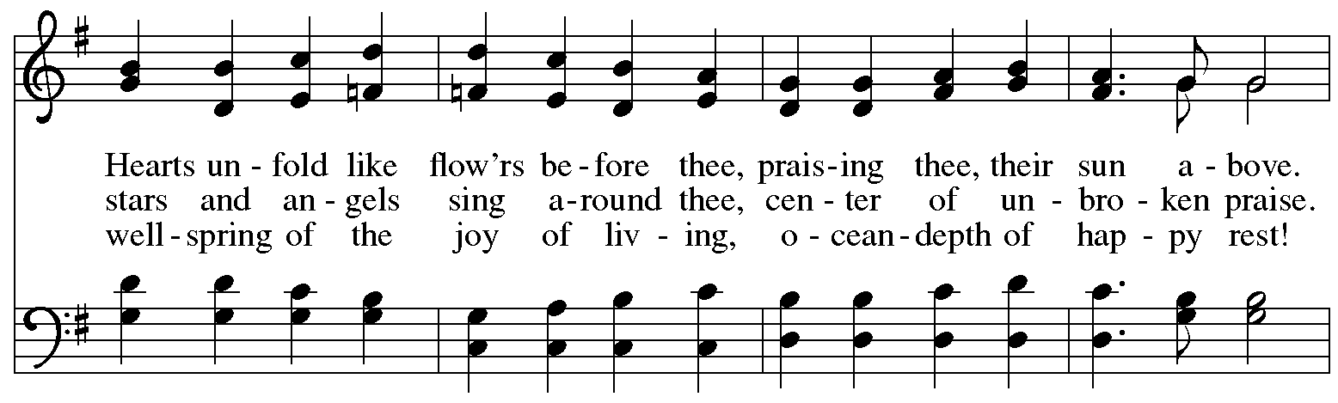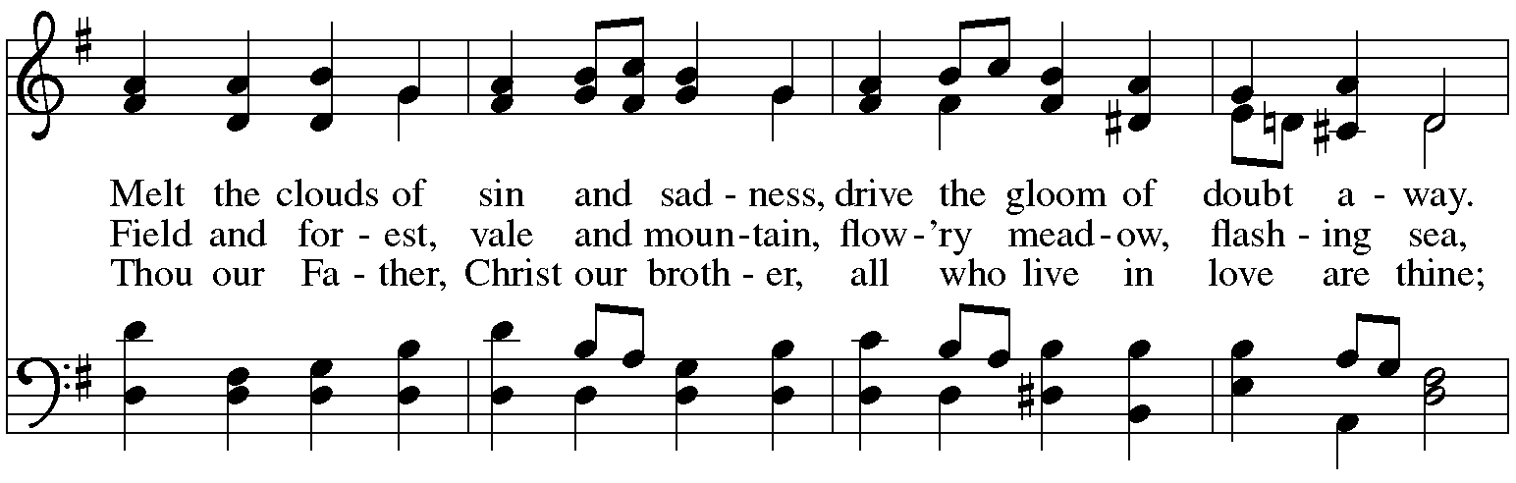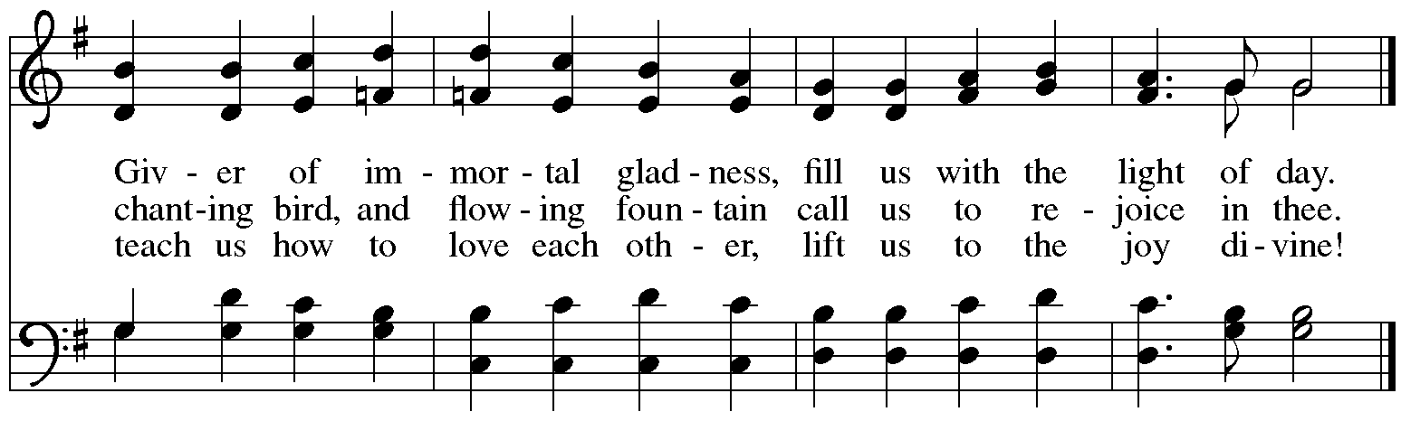
When all have returned to their places, please rise as you are able.

Blessing

P: The body and blood of our Lord Jesus Christ strengthen you and keep you in his grace.
C: Amen.

Prayer

A: Let us pray.
Life-giving God,
in the mystery of Christ’s resurrection, you send light to conquer darkness,
water to give new life, and the bread of life to nourish your people.
Send us forth as witnesses to your Son’s resurrection,
that we may show your glory to all the world,
through Jesus Christ, our risen Lord.
C: Amen.

Please be seated.

Sending
God blesses us and sends us in mission to the world

Announcements

Please rise as you are able.

Benediction

P: May our glorious God grant you a spirit of wisdom
to know and love the risen Christ.

Almighty God, holy One, ☩ holy Three,
bless you now and forever.
C: Amen.

Sending Hymn Following page

Sending Hymn On Our Way Rejoicing ELW 537

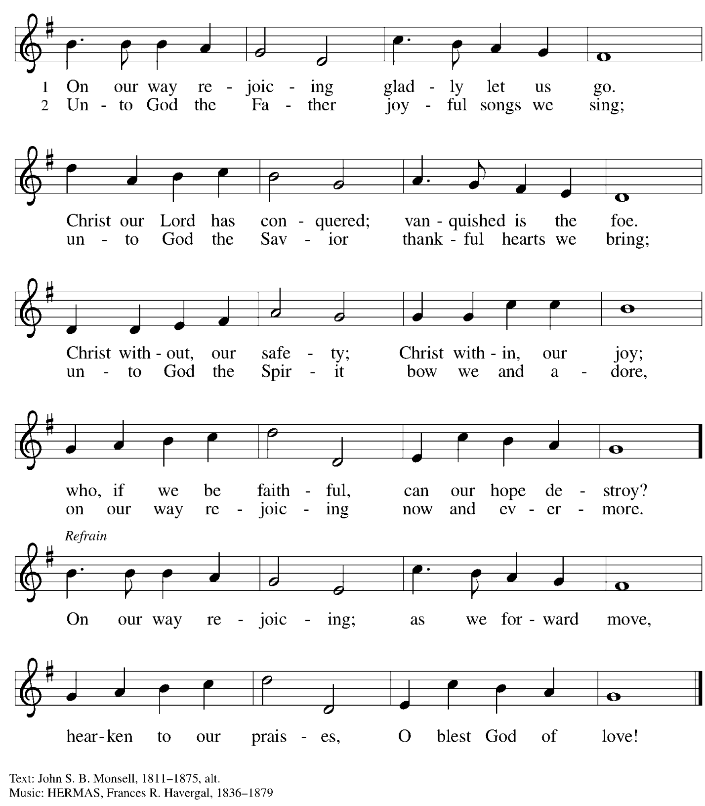

Dismissal

A: Alleluia! Christ is risen!
C: Christ is risen indeed! Alleluia! Alleluia!

A: Go in peace. Share the good news!
C: Thanks be to God!

Postlude
Those serving in worship today

Altar Care Christy Ruhe
Assisting Minister Lindsay Baxter
Audio-Visual Ministers Sarita Joseph Paetz
Cantor Ian Brown
Lector Michael Chapman
Organ Jimmi Kocher-Hillmer
Minister of Music Laura Reynolds
Presiding Minister The Rev. Ross I. Carmichael

Liturgy and Hymnody Acknowledgements

From SundaysandSeasons.com. Copyright © 2026 Augsburg Fortress. All rights reserved. Reprinted under OneLicense.net # A-722139.
Used by permission of Augsburg Fortress.

The Scripture readings contained herein are from New Revised Standard Version Updated Edition of the Bible © 2021 National Council of Churches of Christ in the United States of America. Used by permission. All rights reserved worldwide.

Let the Vineyards – Text: John W. Arthur, 1922-1980. Music: Ronald A. Nelson, b. 1927. Text and Music © 1978 Lutheran Book of Worship, admin. Augsburg Fortress.

By Your Hand You Feed Your People – Text: Susan R. Briehl, b. 1952. Music: CAMROSE, Marty Haugen, b. 1950. Text and music © 2002 GIA Publications, Inc. All rights reserved. Reprinted with permission under OneLicense.net # A-722319.

O Bread of Life from Heaven – Text: Latin hymn, c. 1661; tr. Hugh T. Henry, 1862-1946, sts. 1, 3; tr. Philip Schaff, 1819-1893, st. 2.
Music: O WELT, ICH MUSS DICH LASSEN, Heinrich Isaac, 1450-1517; arr. Johann Sebastian Bach, 1685-1750.

Please use the QR code below to link to St. Andrew’s Announcements online!


St. Andrew Lutheran Church Announcements
April 19th, 2026

- Happy Easter! Welcome to Worship at St. Andrew on April 19th as We Celebrate the Third Sunday of Easter! – We are so glad you are here to share in this festive season, and we offer a special welcome to all visitors and guests who are here for the first time! Little Church – Big Faith, a Bible lesson and activity for children up to sixth grade, will take place after the prayer of the day. There are worship “toolkits” to help children engage with worship and “busy bags” for younger children available in the bookcase at the back of the sanctuary. Please feel free to take one to use with/for your children. A nursery is available through the door to the left of the worship space and across the social hall (look for a purple room). All are invited to gather for coffee, other drinks, food, and conversation in the social hall after worship. We pray that everyone has a blessed Easter season!
- Welcome, Mr. Brendan White, Student with PSALM - Pittsburgh Students Active in Lutheran Ministry and Lutheran Campus Ministry in Greater Pittsburgh! – Mr. White is a junior math major at the University of Pittsburgh who participates in campus ministry activities and also serves on the board of Lutheran Campus Ministry in Greater Pittsburgh. He is visiting St. Andrew for worship today, where he will share stories about how congregational giving supports campus ministry and impacts the lives of current students. Today’s Noisy Offering, led by the children of St. Andrew, will once again benefit PSALM’s larger organization, Lutheran Campus Ministry in Greater Pittsburgh, which serves the students of the University of Pittsburgh, Carnegie Mellon, Chatham, and Carlow Universities. You can learn more about their programming and services here: https://lucpgh.com.
- Produce Distribution Supplemental Food of the Month – St. Andrew collects supplemental food each month to accompany our produce distribution. For April, we ask for donations of lentils and beans. There are collection boxes at the back of the worship space and social hall.
- Produce Distribution, Third Tuesday Each Month, April 21st from 5:30 to 6:30 p.m. – St. Andrew partners with Greater Pittsburgh Community Food Bank to serve as a distribution site for fresh produce on the first and third Tuesday of every month. We invite people of the congregation to help with the distribution from 5:30 p.m. to 6:30 p.m. and/or to help with unloading and setup during the day between 10:00 a.m. and 1:00 p.m.
- Dismantling Antisemitism 101, Sunday, April 26th, 12:00 p.m. to 1:30 p.m. – In the fall, St. Andrew hosted a Reckoning with Antisemitism as Christians event in collaboration with our Southwestern Pennsylvania Synod, The Holocaust Center of Pittsburgh, and Christian Associates of Southwest Pennsylvania. St. Andrew has invited Mr. Noah Schoen, Manager of Community Engagement for the Holocaust Center of Pittsburgh, to lead us in a Dismantling Antisemitism 101 workshop. After worship on April 26th, we will have an expanded coffee hour with light lunch foods, and then begin the workshop at 12:00 noon. Please put this on your calendars and plan to take part on April 26th. Please confirm your attendance here: https://www.signupgenius.com/go/5080B4AAFAF2CABF85-63105576-reckoning#/.
- Alternatives to Violence Project Workshops, Saturday, May 16th and 23rd, 9:00 a.m. to 8:00 p.m. – To learn more about the Alternatives to Violence Project, follow the link here: https://friendspeaceteams.org/cultures-justice-peace/. The AVP workshop will be held at St. Andrew Lutheran Church (304 Morewood Ave, Pittsburgh, PA 15213) and will be open to both teens and adults. You can register using this link: https://docs.google.com/forms/d/e/1FAIpQLSfjPQKcnyQNx26wqTHzyby9YMi7BYHrUUfUha3PoxXpC50XNw/viewform.
- Bible Book Club – Bible Book Club will meet each Wednesday at 7:00 p.m. The group is currently reading Entering the Passion of Jesus: A Beginner’s Guide to Holy Week, by Dr. Amy-Jill Levine, found here: Entering the Passion of Jesus. You can join the Zoom call here: https://us02web.zoom.us/j/83196175976?pwd=ejdPOUYrTk4xVFdsdlhHUVJ1L3k2Zz09.
- Christ in Our Home Booklets Available – Christ in Our Home is a quarterly devotional resource that encourages readers to live out their faith daily. Each reflective reading is accompanied by a daily scripture reference and prayer for the day. Booklets are available at the entrances. Please feel free to take one home!
- Coffee Hour Signups – St. Andrew provides hospitality during a coffee hour after worship each Sunday. If you would like to participate, please sign up using the following form: https://www.signupgenius.com/go/5080B4AAFAF2CABF85-47069030-coffee#/.

