

+ Fourth Sunday of Easter
April 26, 2026


St. Andrew Lutheran Church
304 Morewood Ave.
Pittsburgh, PA 15213
St_andrewELCA@verizon.net
www.standrewpittsburgh.org

+ Fourth Sunday of Easter

This Sunday is sometimes called “Good Shepherd Sunday.”
Jesus is called the “gate” of the sheep in today’s gospel.
The risen Christ opens the way to abundant life.
He anoints our heads with oil and guides us beside the still waters of our Baptism.
Each Sunday he spreads a feast before us amid the world’s violence and war.
We go forth to be signs of the resurrection and extend God’s tender care to all creation.

Welcome to St. Andrew!
- St. Andrew welcomes all who are seeking a place of healing, wholeness, and acceptance in a nurturing and faith-forming spiritual home. We are striving toward racial equity worldwide
and we seek to honor the lived experience of all individuals regardless of background. Our community embraces people of all ages, ethnicities, cultures, abilities, sexual orientations,
gender identities and expressions, and family constellations. Come and See!
- Worship Services are live-streamed to multiple online platforms. By attending worship, you agree that your image and voice may be broadcast.
- Everyone is invited to make a name tag at the black bookcase in the back of the worship space if they would like. There are stickers indicating pronouns on the bookcase if you would like to include them on your name tag.
- Children are invited to attend Little Church – Big Faith, a Bible lesson and activity, during worship (after the Prayer of the Day). The group returns to the worship space for the liturgy of Holy Communion.
- A nursery is available through the doors at the left side of the sanctuary and across from the doorway to the Social Hall. Look for a purple-colored room.
- Worship “toolkits” to help children engage with the service, along with “busy bags” for younger children, are available in the bookcase at the back of the sanctuary. Please feel free to take one to use with/for your children.
- Holy Communion is served with bread (gluten-free available) and wine or grape juice. The presiding minister will distribute the bread (host). Please consume this and then pick up an empty glass from the tray. The Communion Assistant will pour wine or grape juice into your glass. Please step to the side to consume the wine or grape juice. Feel free to kneel at the altar for prayer and reflection. As you return to your pew, glasses may be returned to the empty trays on either side of the center section.
- A restroom is available on the main level of the church, through the doors to the Social Hall and to the right in the main office.

Abbreviations
P: Pastor/Presiding Minister ELW: Evangelical Lutheran Worship hymnal
A: Assisting Minister ACS: All Creation Sings hymnal
L: Lector HS: Hymnal Supplement (GIA Publications)
C: Congregation PBS: Peace, Be Still
LIW: Living in Wonder

Musical Offering Timothy Kocher-Hillmer and Tom Leech

Each week, different people from the congregation make an offering of pre-service music, with singing or instrumentation, to help the assembly focus and pray in preparation for worship.

Welcome
Prelude Just As I Am, I Come McDonald
Vocal Duet: Timothy Kocher-Hillmer and Colten Rohleder

Gathering
The Holy Spirit calls us together as the people of God

Please rise as you are able. All may make the sign of the cross,
the sign that is marked at Baptism, as the presiding minister begins.

Thanksgiving for Baptism

P: Alleluia! Christ is risen!
C: Christ is risen indeed! Alleluia! Alleluia!

P: Salvation belongs to our God who is seated on the throne and to the Lamb!
C: Amen.

P: Let us give thanks for the gift of Baptism.

Water may be poured into the font as the presiding minister continues.
P: Merciful God,
you are the one who was, who is, and who is to come.
You lead us beside still waters.
We thank you for the waters of creation:
morning dew, gentle rain, roaring waves.
We thank you for the waters that nourish us.
Blessed are you!
C: You guide us to springs of the water of life.

P: Jesus Christ, you are the faithful witness
who accompanies us on our journeys.
We give you thanks for your life-giving death and resurrection.
We praise you for joining us in joy and sorrow.
Blessed are you!
C: You guide us to springs of the water of life.

P: Holy Spirit, you anoint our head with oil and our cup overflows.
Break down barriers that divide us.

P: Fill us with the breath of peace.
Blessed are you!
C: You guide us to springs of the water of life.

P: Holy One, we thank you for the gifts and grace of Baptism,
and for making us a new creation. We join with saints and angels,
giving you honor and praise, now and forever.
C: Amen.

Gathering Hymn That Easter Day with Joy Was Bright ELW 384

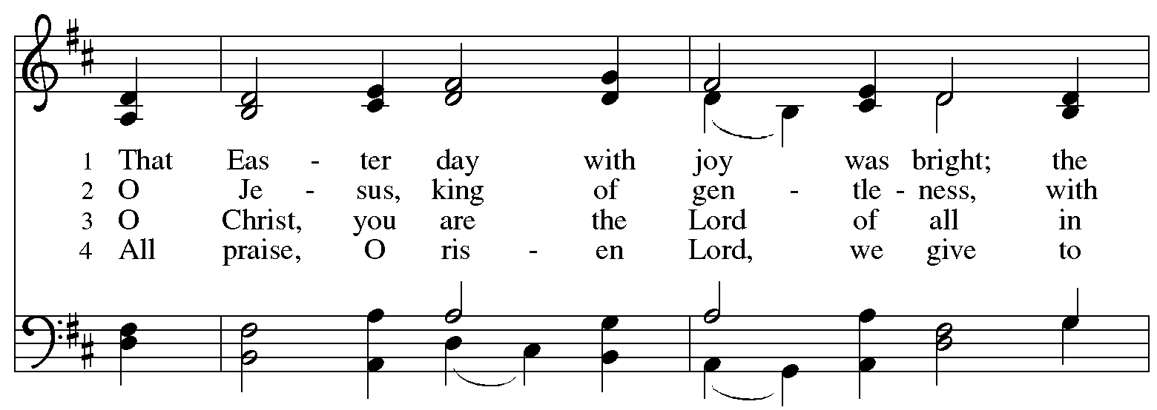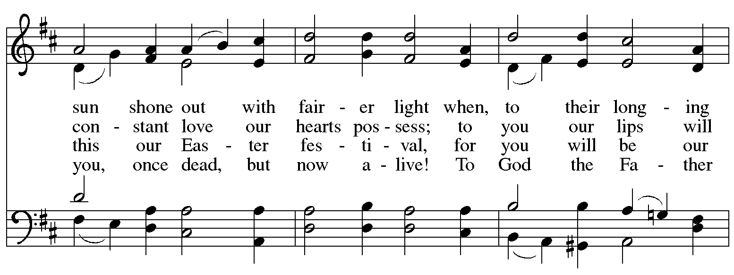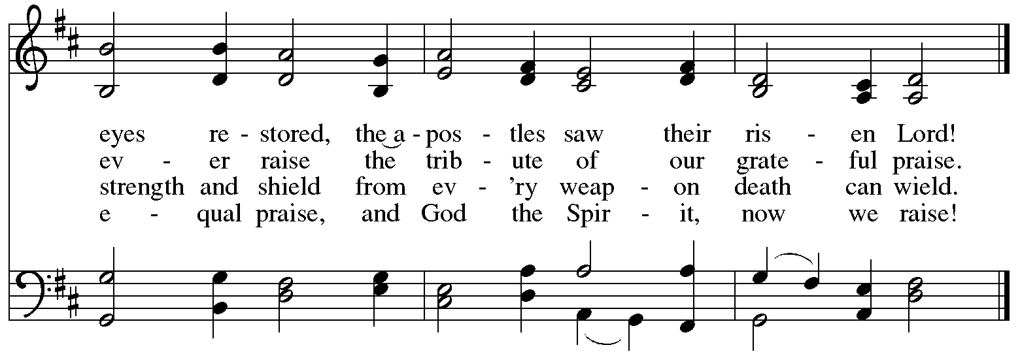
Greeting

P: The grace of our Lord Jesus Christ, the love of God,
and the communion of the Holy Spirit be with you all.
C: And also with you.

Hymn of Praise This Is the Feast ELW p. 149-150

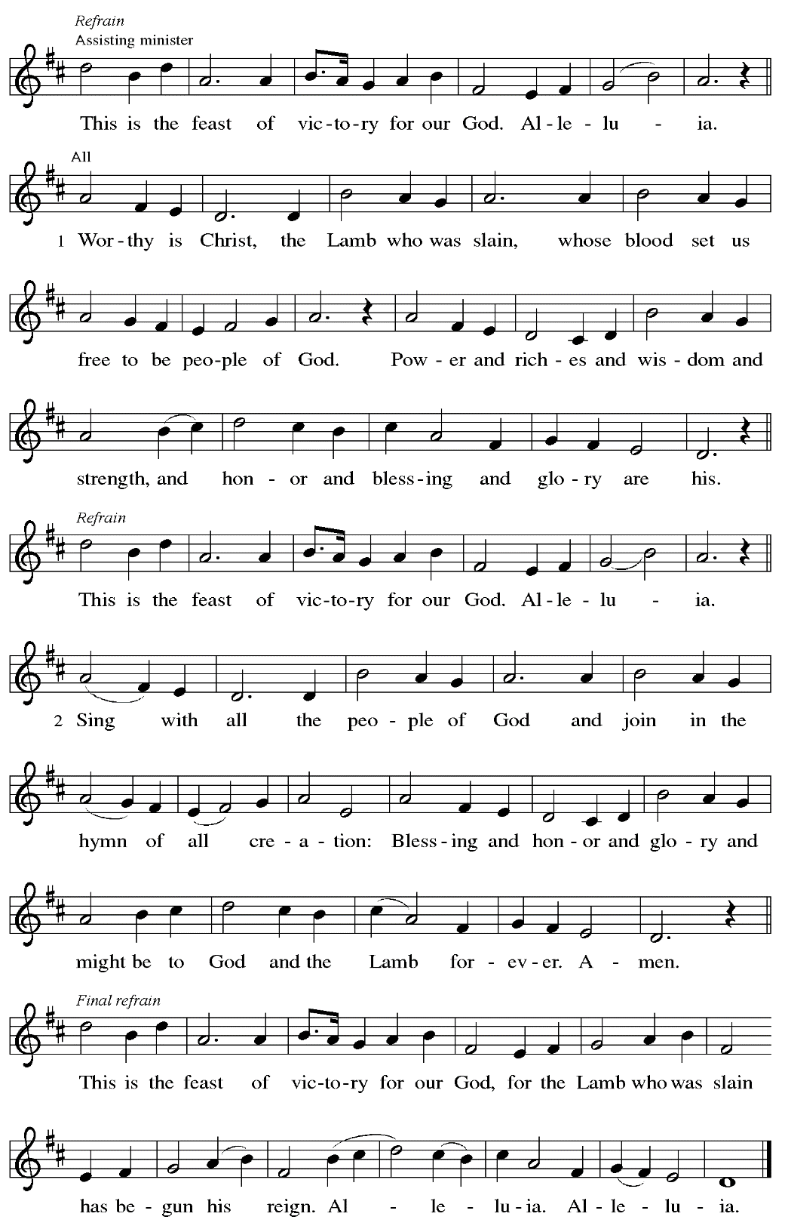
Prayer of the Day

P: The Lord be with you.
C: And also with you.

P: Let us pray.
O God our shepherd,
you know your sheep by name and lead us to safety through the valleys of death.
Guide us by your voice, that we may walk in certainty and security
to the joyous feast prepared in your house, through Jesus Christ, our Savior and Lord,
who lives and reigns with you and the Holy Spirit, one God, now and forever.
C: Amen.

Please be seated.
Children are invited to join the adult leader(s) at the side door for Little Church – Big Faith.
We ask that an additional adult from the congregation attend with the children.

Word
God speaks to us in Scripture reading, preaching, and song

First Reading – Acts 2: 42-47

⁴² [The baptized] devoted themselves to the apostles’ teaching and fellowship, to the breaking of bread and the prayers.
⁴³ Awe came upon everyone because many wonders and signs were being done through the apostles. ⁴⁴ All who believed were together and had all things in common; ⁴⁵ they would sell their possessions and goods and distribute the proceeds to all, as any had need. ⁴⁶ Day by day, as they spent much time together in the temple, they broke bread at home and ate their food with glad and generous hearts, ⁴⁷ praising God and having the goodwill of all the people. And day by day the Lord added to their number those who were being saved.

L: Word of God, word of life.
C: Thanks be to God.

Psalm 23 The Lord’s My Shepherd ELW 778

The appointed psalm for this day, Psalm 23, is proclaimed through a sung paraphrase,
“The Lord’s My Shepherd,” ELW 778, found on the following page.

Psalm 23 The Lord’s My Shepherd ELW 778

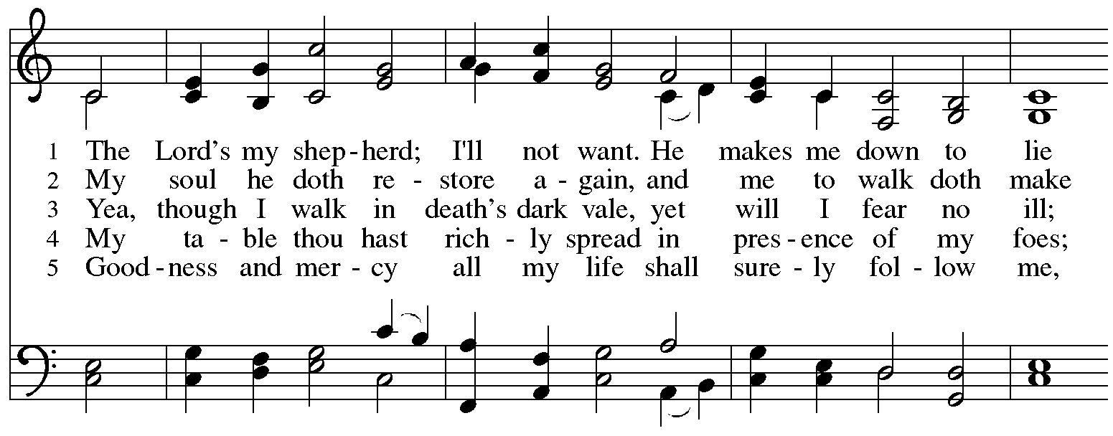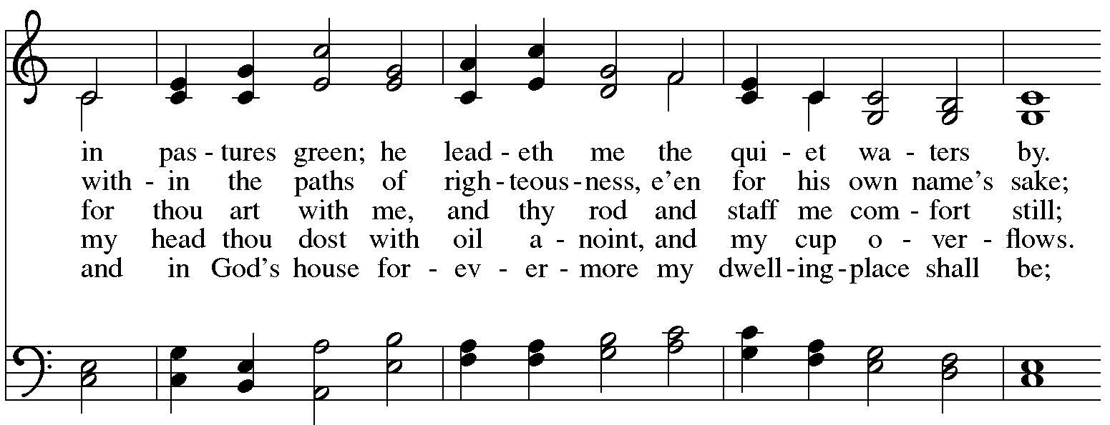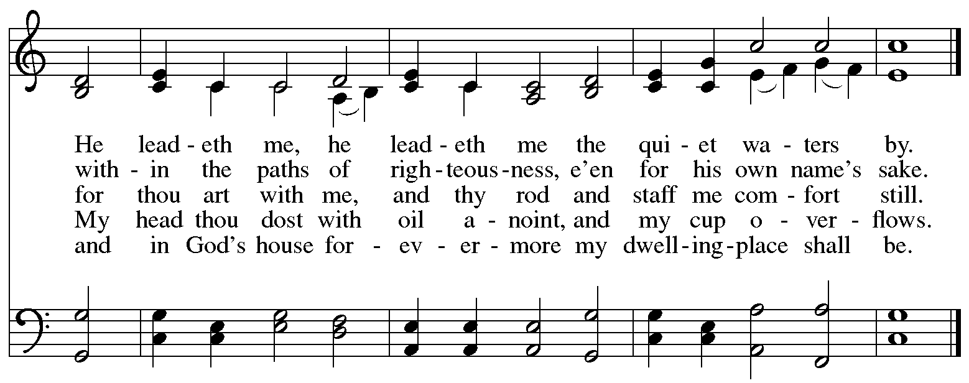
All rights reserved. Reprinted with permission under OneLicense.net # A-722139.
Second Reading – 1 Peter 2: 19-25

¹⁹ It is a commendable thing if, being aware of God, a person endures pain while suffering unjustly. ²⁰ If you endure when you are beaten for doing wrong, what credit is that? But if you endure when you do good and suffer for it, this is a commendable thing before God. ²¹ For to this you have been called, because Christ also suffered for you, leaving you an example, so that you should follow in his steps.
²² “He committed no sin,
and no deceit was found in his mouth.”
²³ When he was abused, he did not return abuse; when he suffered, he did not threaten, but he entrusted himself to the one who judges justly. ²⁴ He himself bore our sins in his body on the cross, so that, having died to sins, we might live for righteousness; by his wounds you have been healed. ²⁵ For you were going astray like sheep, but now you have returned to the shepherd and guardian of your souls.

L: Word of God, word of life.
C: Thanks be to God.

Please rise as you are able.
Gospel Acclamation ELW p. 151

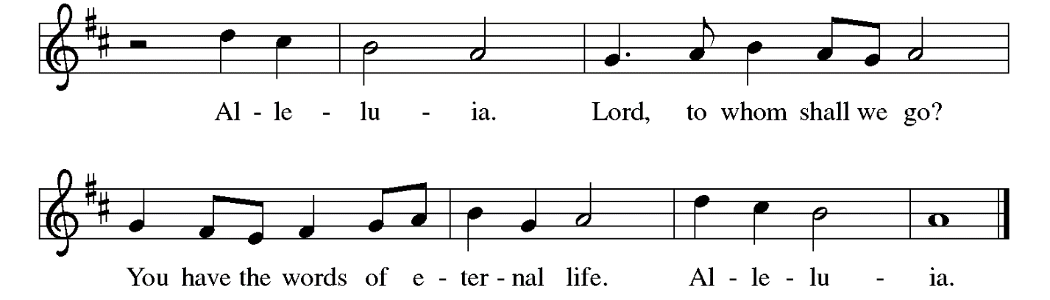

Gospel – John 10: 1-10

P: The holy Gospel according to St. John.
C: Glory to you, O Lord.

[Jesus said:] ¹ “Very truly, I tell you, anyone who does not enter the sheepfold by the gate but climbs in by another way is a thief and a bandit. ² The one who enters by the gate is the shepherd of the sheep. ³ The gatekeeper opens the gate for him, and the sheep hear his voice. He calls his own sheep by name and leads them out. ⁴ When he has brought out all his own, he goes ahead of them, and the sheep follow him because they know his voice. ⁵ They will not follow a stranger, but they will run from him because they do not know the voice of strangers.” ⁶ Jesus used this figure of speech with them, but they did not understand what he was saying to them.
⁷ So again Jesus said to them, “Very truly, I tell you, I am the gate for the sheep. ⁸ All who came before me are thieves and bandits, but the sheep did not listen to them. ⁹ I am the gate. Whoever enters by me will be saved and will come in and go out and find pasture. ¹⁰ The thief comes only to steal and kill and destroy. I came that they may have life and have it abundantly.”

P: The Gospel of the Lord.
C: Praise to you, O Christ.

Please be seated.

Sermon

A time of silence for prayer and reflection follows the sermon.
When the hymn of the day begins, please rise as you are able.

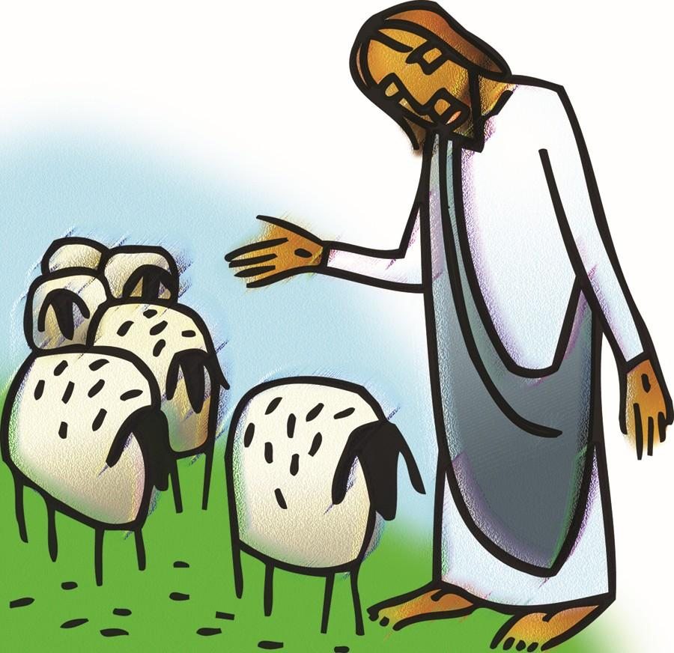

Hymn of the Day Savior, Like a Shepherd Lead Us ELW 789

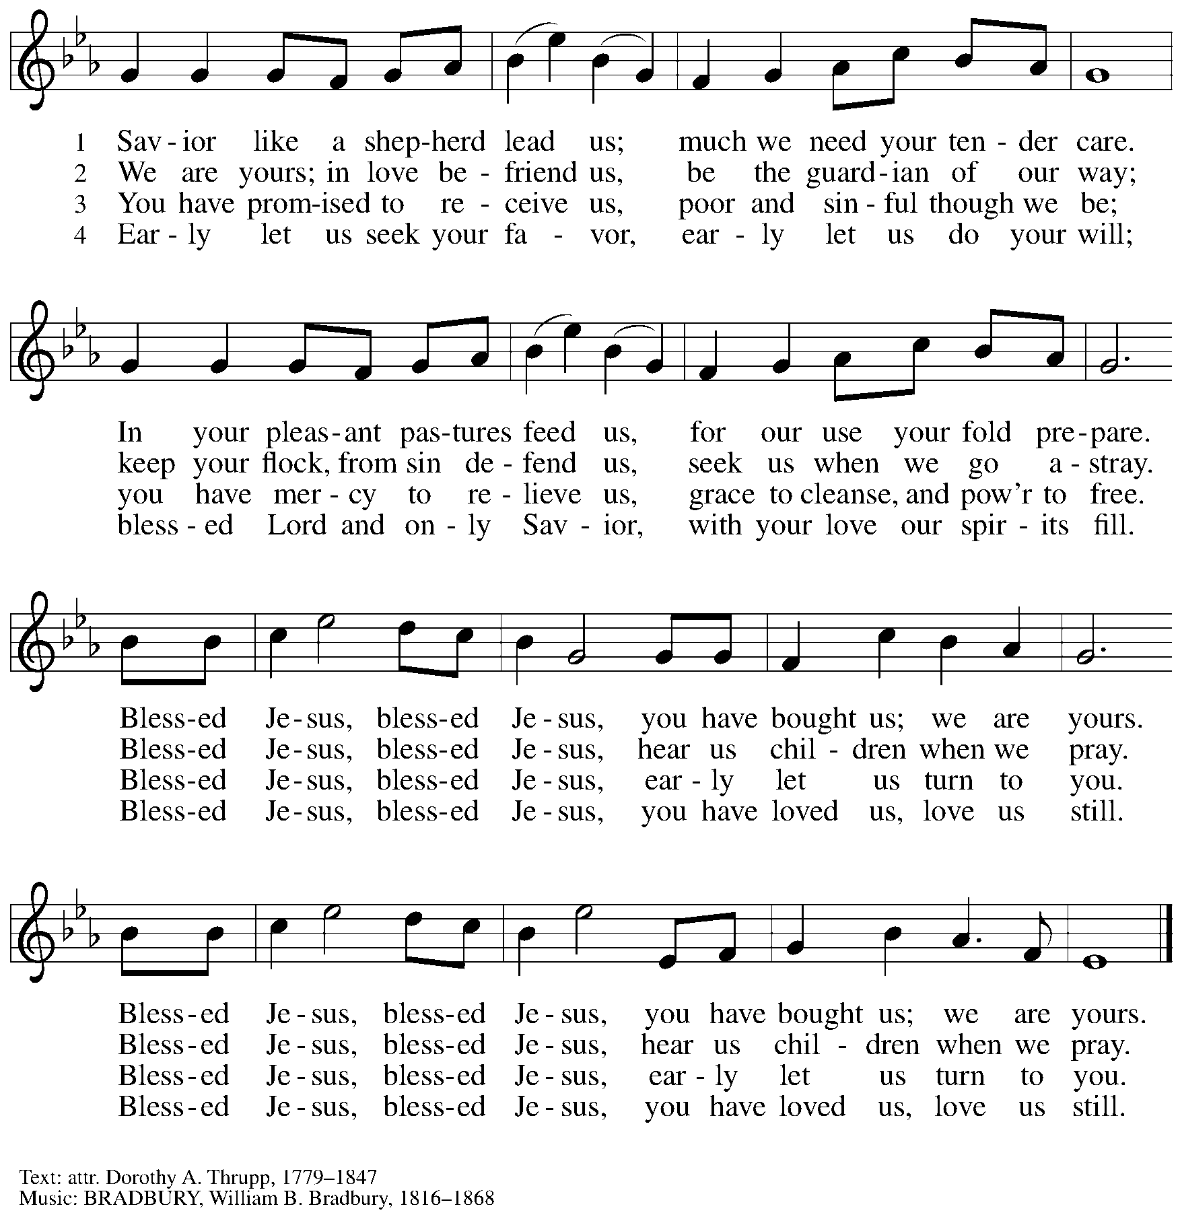

The Sacrament of Holy Baptism

Candidates for Baptism, sponsors, and parents gather with the ministers at the font.
The assembly is seated.

Presentation

The presiding minister may address the assembly in these or similar words:
P: God, who is rich in mercy and love, gives us a new birth into a living hope through the sacrament of Holy Baptism. By water and the Word God delivers us from sin and death and raises us to new life in Jesus Christ. We are united with all the baptized in the one body of Christ, anointed with the gift of the Holy Spirit, and joined in God's mission for the life of the world.

Sponsors for each candidate, in turn, present the candidates:
S: I present name for Baptism.

The presiding minister addresses parents or others who bring for Baptism
children who are not able to answer for themselves:
P: Called by the Holy Spirit, trusting in the grace and love of God,
do you desire to have your child baptized into Christ?
Response: I do.

P: As you bring your child to receive the gift of Baptism, you are entrusted with responsibilities:
to live with them among God's faithful people,
bring them to the word of God and the holy supper,
teach them the Lord's Prayer, the Creed, and the Ten Commandments,
place in their hands the holy scriptures,
and nurture them in faith and prayer,
so that your child may learn to trust God,
proclaim Christ through word and deed,
care for others and the world God made,
and work for justice and peace.
Do you promise to help your child grow in the Christian faith and life?
Response: I do.

The presiding minister addresses sponsors:
P: Sponsors, do you promise to nurture this person in the Christian faith as you are empowered by God's Spirit, and to help them live in the covenant of Baptism and in communion with the church?
Response: I do.

The presiding minister addresses the assembly:
P: People of God, do you promise to support name/s and pray for them in their new life in Christ?
C: We do.

People of the assembly please rise as you are able.

Profession of Faith

The presiding minister addresses candidates for Baptism as well as the parents and sponsors of young children. The assembly may join in the responses.
P: I ask you to profess your faith in Christ Jesus, reject sin, and confess the faith of the church.

Do you renounce the devil and all the forces that defy God?
Response: I renounce them.

P: Do you renounce the powers of this world that rebel against God?
Response: I renounce them.

P: Do you renounce the ways of sin that draw you from God?
Response: I renounce them.

The presiding minister addresses the candidates and the assembly.
P: Do you believe in God the Father?
C: I believe in God, the Father almighty,
creator of heaven and earth.

P: Do you believe in Jesus Christ, the Son of God?
C: I believe in Jesus Christ, God’s only Son, our Lord,
who was conceived by the Holy Spirit,
born of the virgin Mary,
suffered under Pontius Pilate,
was crucified, died, and was buried;
he descended to the dead.*
On the third day he rose again;
he ascended into heaven,
he is seated at the right hand of the Father,
and he will come to judge the living and the dead.

P: Do you believe in God the Holy Spirit?
C: I believe in the Holy Spirit,
the holy catholic church,
the communion of saints,
the forgiveness of sins,
the resurrection of the body,
and the life everlasting.

*Or, “he descended into hell,” another translation of this text in widespread use.

Thanksgiving at the Font

Water may be poured into the font before or during the thanksgiving.
At the font, the presiding minister begins the thanksgiving:
P: The Lord be with you.
C: And also with you.

P: Let us give thanks to the Lord our God.
C: It is right to give our thanks and praise.

P: We give you thanks, O God, for in the beginning your Spirit moved over the waters and by your Word you created the world, calling forth life in which you took delight.
Through the waters of the flood you delivered Noah and his family, and through the sea you led your people Israel from slavery into freedom. At the river your Son was baptized by John and anointed with the Holy Spirit. By the baptism of Jesus' death and resurrection you set us free from the power of sin and death and raise us up to live in you.

Pour out your Holy Spirit, the power of your living Word, that those who are washed in the waters of baptism may be given new life. To you be given honor and praise through Jesus Christ our Lord, in the unity of the Holy Spirit, now and forever.
C: Amen.

The assembly may be seated.

Baptism

The presiding minister baptizes the candidate. The candidate is immersed into the water, or water is poured on the candidate's head, as the presiding minister says:
P: Name , I baptize you in the name of the Father,*
The candidate is immersed or water is poured on the candidate's head a second time:
and of the Son,
The candidate is immersed or water is poured on the candidate's head a third time:
and of the Holy Spirit.
C: Amen.

The presiding minister continues
P: Let us pray.
We give you thanks, O God, that through water and the Holy Spirit
you give your children new birth, cleanse them from sin, and raise them to eternal life.

Laying both hands on the head of the newly baptized, the minister prays:
P: Sustain name with the gift of your Holy Spirit: the spirit of wisdom and understanding, the spirit of counsel and might, the spirit of knowledge and the fear of the Lord, the spirit of joy in your presence, both now and forever.
C: Amen.

The presiding minister marks the sign of the cross on the forehead of the baptized.
Oil prepared for this purpose may be used. As the sign of the cross is made, the minister says:
P: Name, child of God, you have been sealed by the Holy Spirit and marked with the cross of Christ forever.
C: Amen.

*Or, " Name is baptized in the name of the Father, . . ."

Welcome

A lighted candle may be given to each of the newly baptized (to a sponsor of a young child)
as a representative of the congregation says:
A: Jesus said, I am the light of the world.
Whoever follows me
will have the light of life.

The ministers and the baptismal group face the assembly.
A representative of the congregation leads the assembly in the welcome.
A: Let us welcome the newly baptized.
C: We welcome you into the body of Christ and into the mission we share:
join us in giving thanks and praise to God
and bearing God's creative and redeeming word to all the world.

After the welcome, the assembly sings the congregational refrain, featured on special occasions in the life of the congregation.

Congregational Refrain HS 808

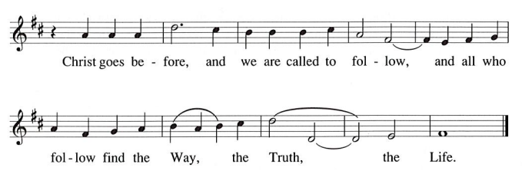

During the baptismal hymn, those who have gathered at the font move through the congregation
to introduce and celebrate our new sibling in Christ.

Baptismal Hymn Baptized in Water ELW 456

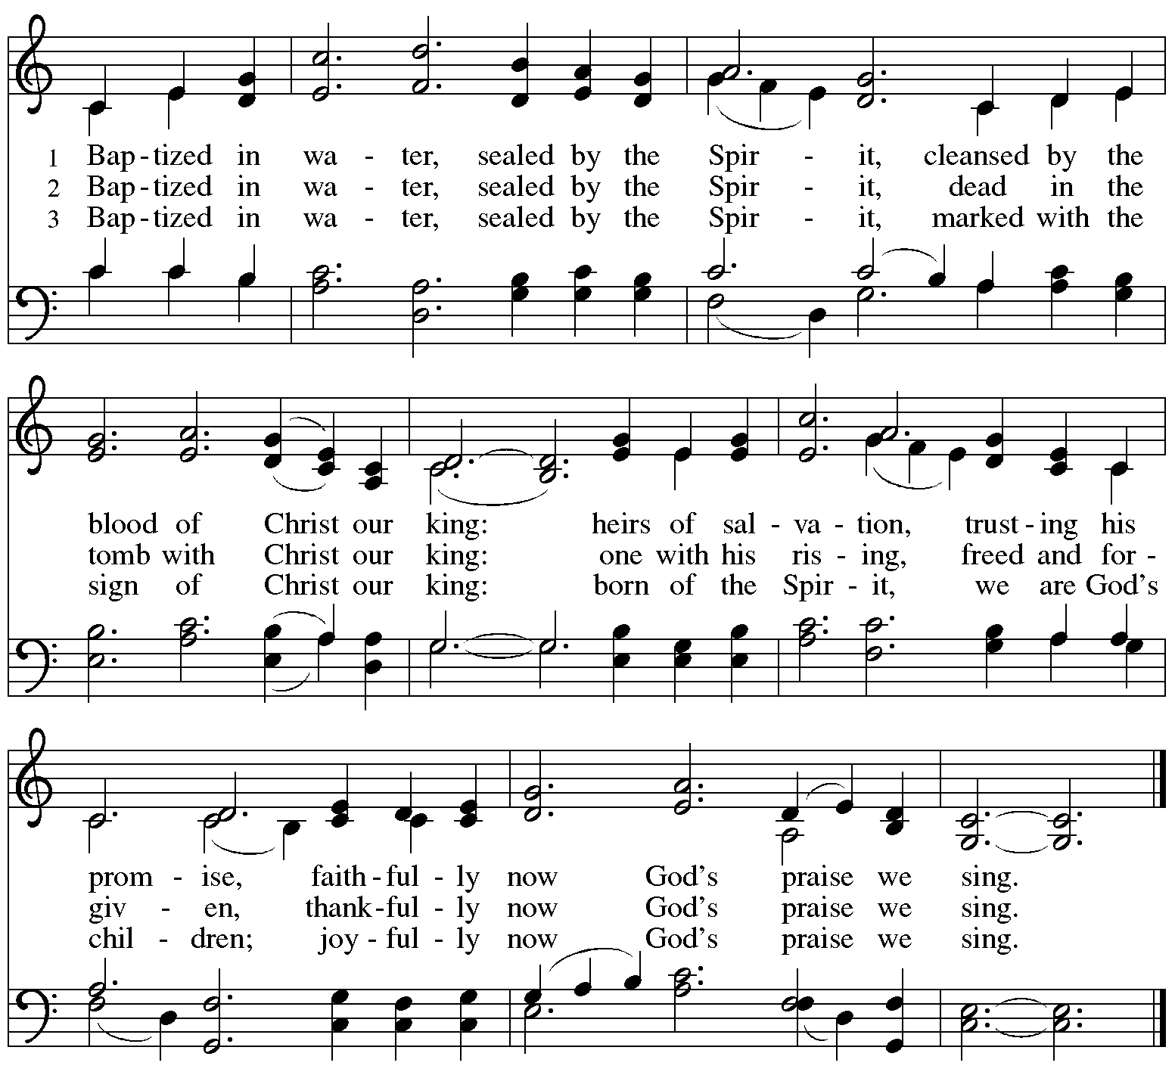
All rights reserved. Reprinted with permission under OneLicense.net # A-72219.

When all have returned to their places, worship continues with the prayers of the people.

Prayers of the People

A: United in the joy and hope of the resurrection, let us pray for the church, the world,
and all who are in need.

After each petition
A: Gracious God,
C: receive our prayer.

The presiding minister concludes the prayers
P: We lift these prayers to you O God, trusting in your abundant mercy,
through Jesus Christ our risen Savior.
C: Amen.

Peace

The presiding minister and the assembly greet one another in the peace of the risen Christ.
P: The peace of Christ be with you always.
C: And also with you.

The people may greet those around them with a sign of Christ’s peace and may say
Peace be with you or similar words. Please be mindful that not everyone will be comfortable with sharing the peace, so please seek consent before shaking hands or hugging. Other possible ways to share the peace include a simple bow with the verbal greeting of peace, or simply a verbal expression of peace.

When the greetings of peace have concluded, please be seated.

Meal
God feeds us with the presence of Jesus Christ

Offering

We offer ourselves, our gifts, and our faithful service to God.
As the offering is gathered for the mission of the church, including the care of those in need,
the table is set for Holy Communion.

There are laminated giving cards in the pew racks that feature a QR code for anyone who would like to give online. Those who give using the QR code, as well as those who give regularly online or through their bank are encouraged to place the laminated card in the plate as an expression of your offering.

Music during the Offering
I Love to Tell the Story arr. Keveren

As the gifts are brought forward for presentation, please rise as you are able.

Offertory Song Let the Vineyards Be Fruitful ELW 184

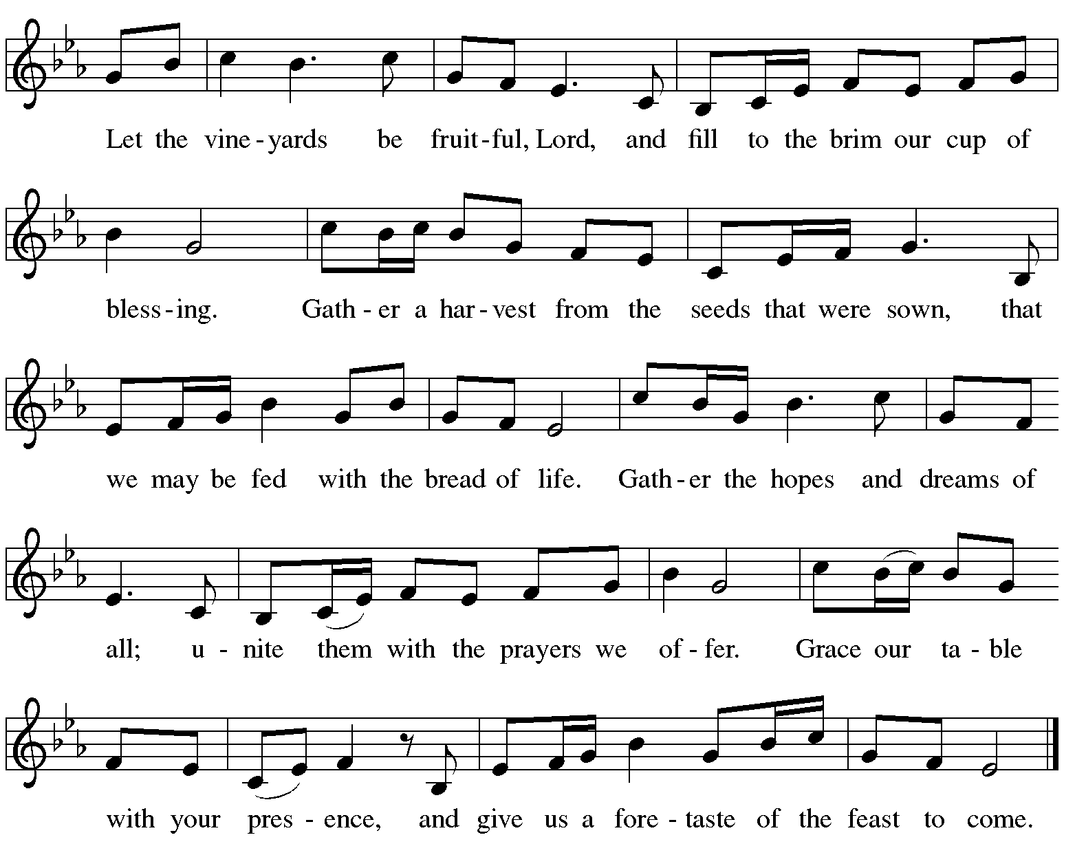

Offertory Prayer

A: Let us pray.
Blessed are you, O God,
C: ruler of heaven and earth.
Day by day you shower us with blessings.
As you have raised us to new life in Christ,
give us glad and generous hearts,
ready to praise you and to respond to those in need,
through Jesus Christ, our Savior and Lord.
Amen.

Dialogue ELW p. 152

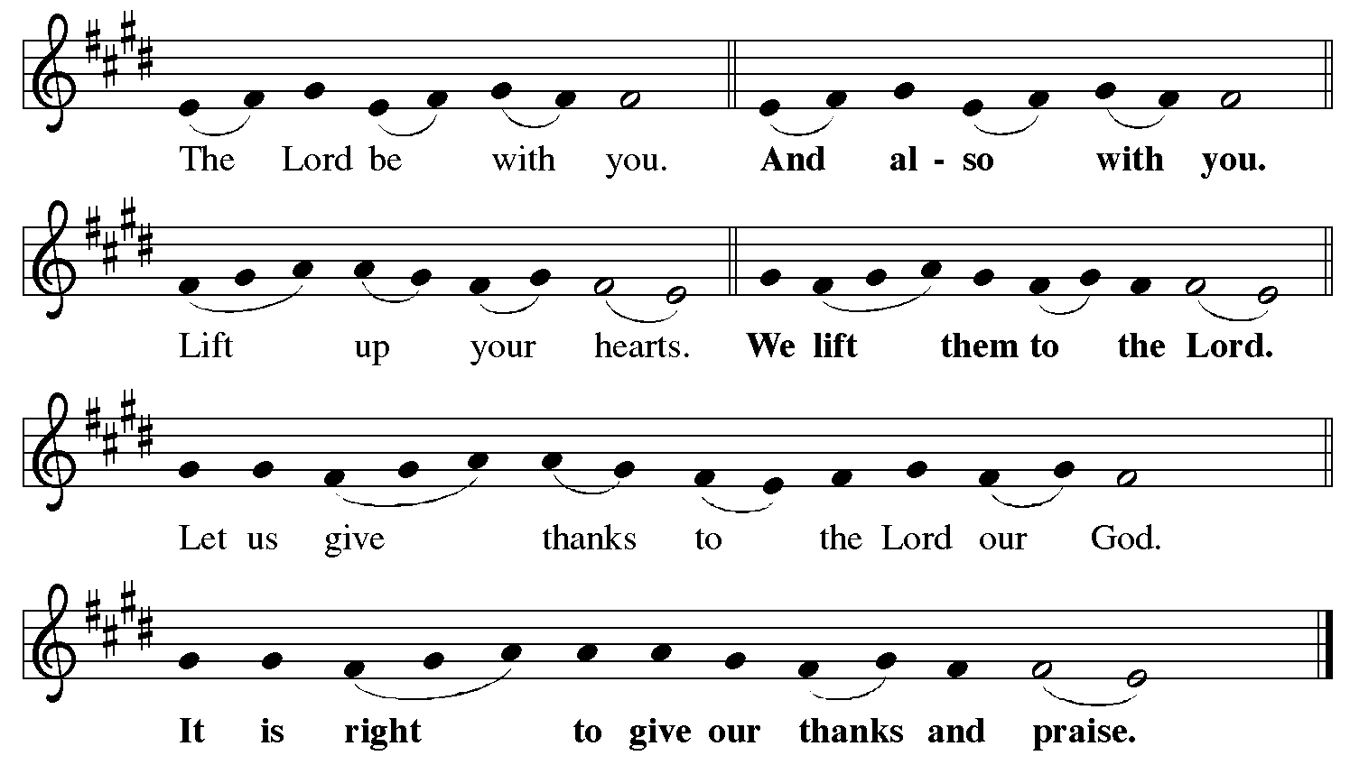

Preface (Sung by the presiding minister)

P: It is indeed right, our duty and our joy,
that we should at all times and in all places
give thanks and praise to you, almighty and merciful God,
for the glorious resurrection of our Savior Jesus Christ,
the true Paschal Lamb who gave himself to take away our sin;
who in dying has destroyed death,
and in rising has brought us to eternal life.
And so, with Mary Magdalene and Peter
and all the witnesses of the resurrection,
with earth and sea and all their creatures,
and with angels and archangels, cherubim and seraphim,
we praise your name and join their unending hymn:

Sanctus ELW p. 153

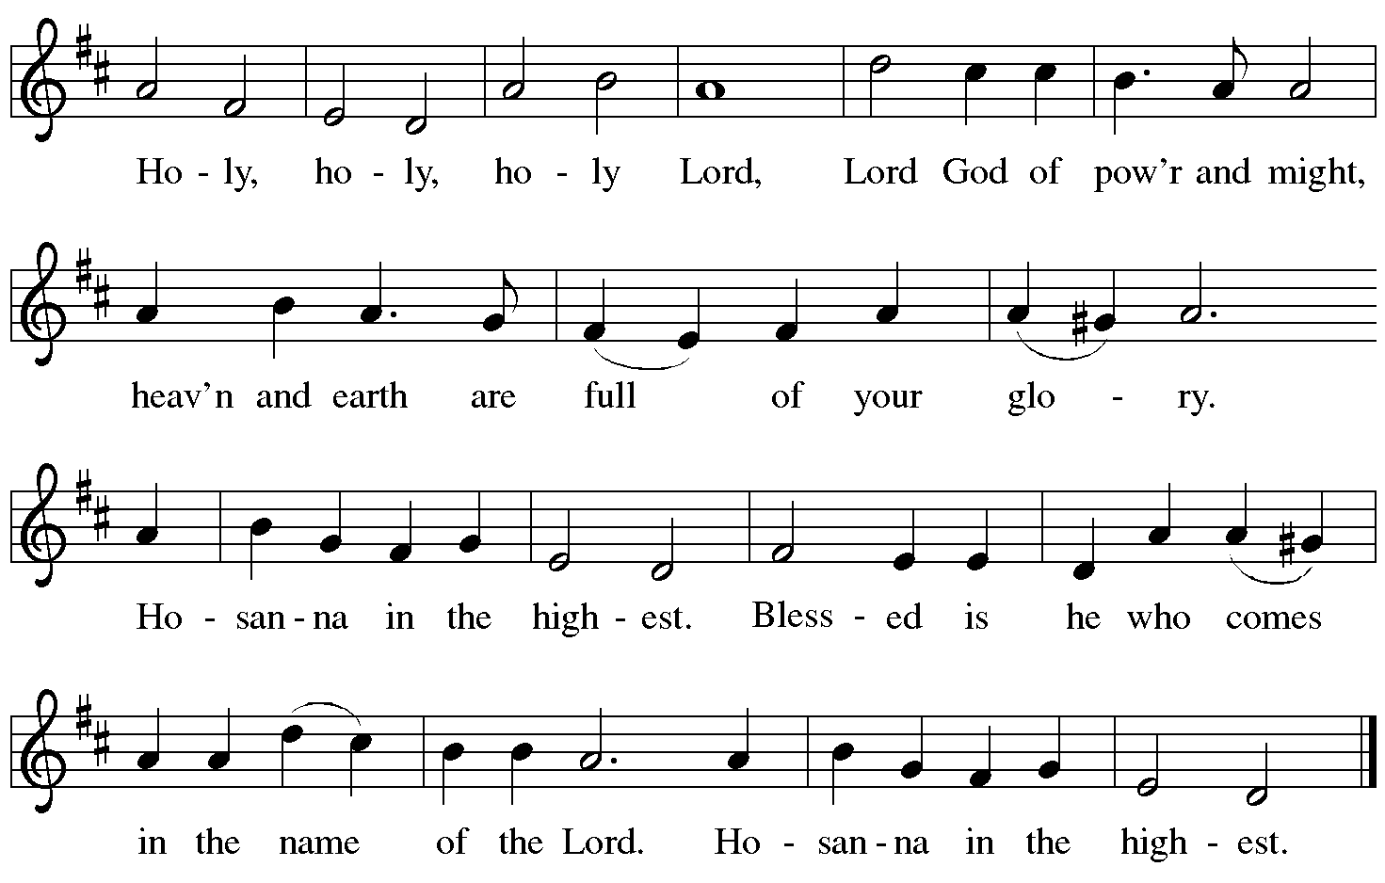

Eucharistic Prayer

P: Blessed are you, O God of the universe …
… Do this for the remembrance of me.

With this bread and cup we remember our Lord’s passover from death to life
as we proclaim the mystery of faith.
C: Christ has died. Christ is risen. Christ will come again.

P: O God of resurrection and new life …
… Grace our table with your presence.
C: Come, Holy Spirit.

P: Reveals yourself to us in the breaking of the bread …
… send us forth, burning with justice, peace, and love.
C: Come, Holy Spirit.

P: With your holy ones of all times and places …
… blessed and Holy Trinity, now and forever.
C: Amen.
Lord’s Prayer

P: Gathered as one by the Holy Spirit, let us pray as Jesus taught us.
C: Our Father, who art in heaven,
hallowed be thy name,
thy kingdom come,
thy will be done,
on earth as it is in heaven.
Give us this day our daily bread;
and forgive us our trespasses,
as we forgive those
who trespass against us;
and lead us not into temptation,
but deliver us from evil.
For thine is the kingdom,
and the power, and the glory,
forever and ever. Amen.

Fraction and Invitation

P: Alleluia! Christ is risen!
C: Christ is risen indeed! Alleluia! Alleluia!

P: This is the feast of victory for our God. Alleluia! Alleluia!
Come, share the feast.



Agnus Dei / Lamb of God ELW p. 154

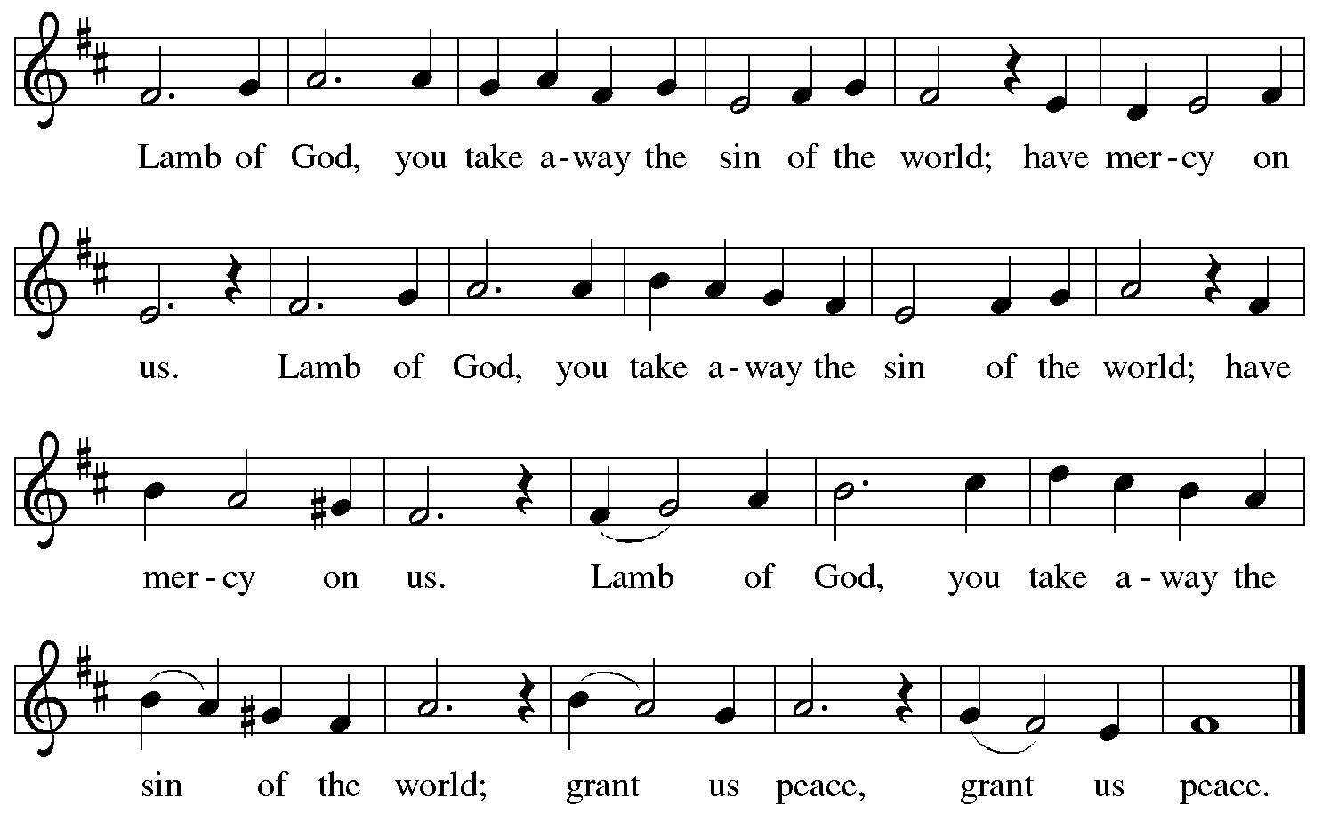

Please be seated.

Holy Communion

- All who seek God and desire a deeper and stronger life in Christ are welcome to receive Holy Communion.
- Worshipers from the pulpit side will proceed forward first, followed by the center section, and then the lectern side.
- Please inform an usher if you would like the ministers to bring Communion to you.
- Holy Communion will be served with bread and wine (red) or grape juice (white).
- The presiding minister will first distribute the bread (host) to each communicant. Please indicate if you require a gluten-free host.
- Once you have consumed the bread, please pick up an empty glass from the tray next to the presiding minister. The Communion Assistant will pour wine or grape juice into your glass.
- Please step to the side to consume the wine or grape juice.
- Feel free to kneel at the altar rail for prayer after receiving the sacrament.
- As you return to your pew, glasses may be returned to the empty tray on the side of the center section.
- A blessing will be provided for anyone who does not yet receive the sacrament.
- All are invited to join in singing the hymns during Holy Communion.
Hymns during Holy Communion
You Satisfy the Hungry Heart ELW 484

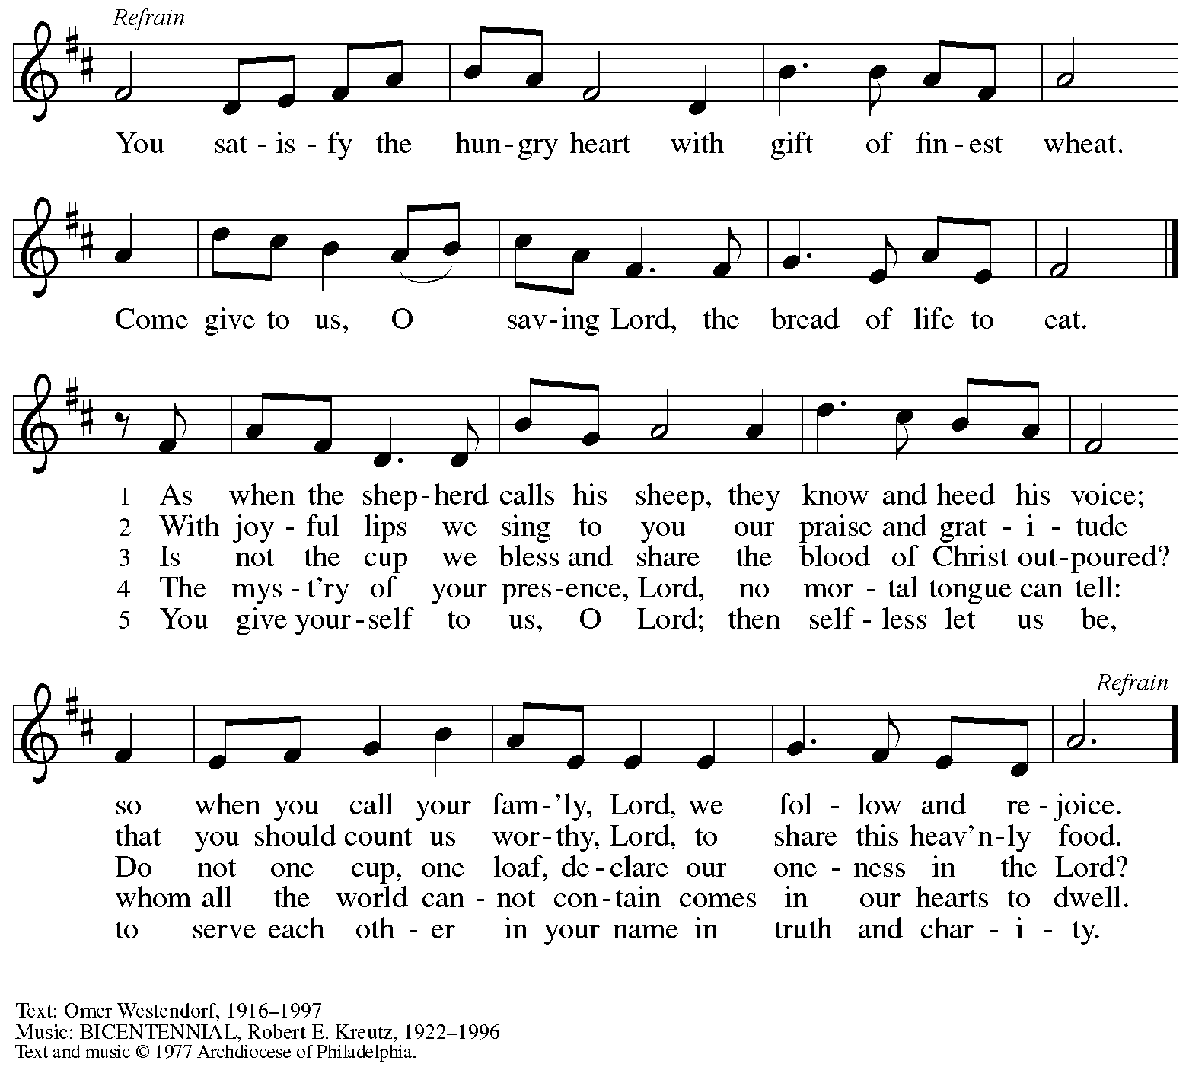
All rights reserved. Reprinted with permission under OneLicense.net # A-722139.

Hymns during Holy Communion
How Beautiful, O God, How Good PBS 78

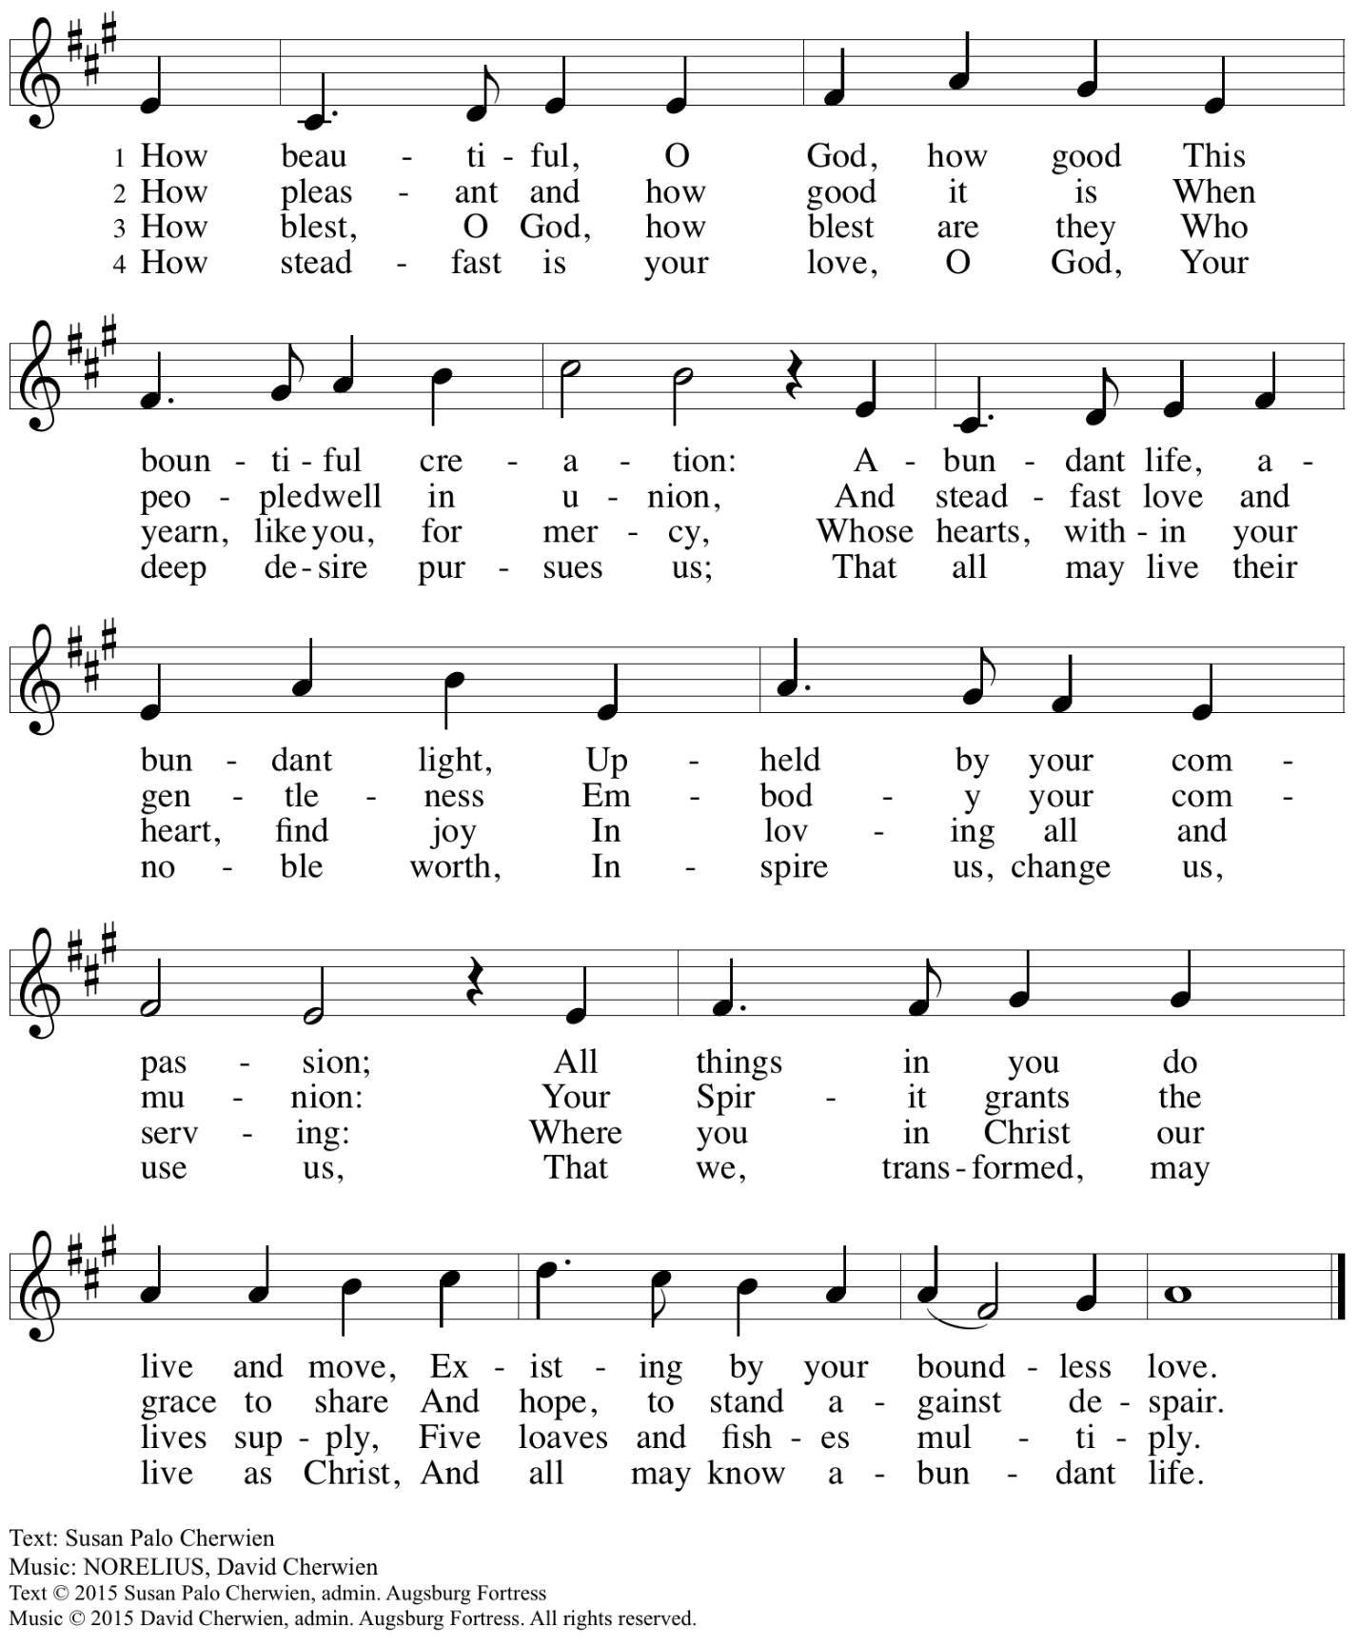
All rights reserved. Reprinted with permission under OneLicense.net # A-722139.

Hymns during Holy Communion
Draw Us, O God, into Your Holy Future LIW 54

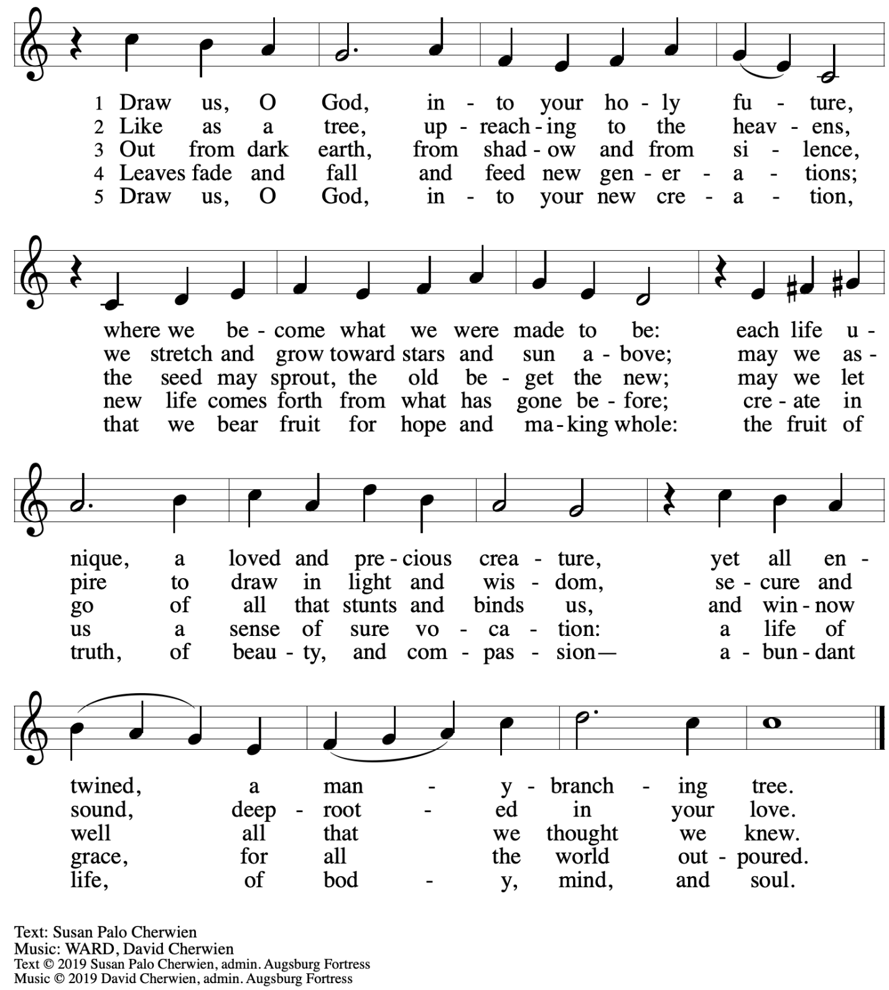
All rights reserved. Reprinted under OneLicense.net # A-722139.

Hymns during Holy Communion
Strengthen for Service, Lord ELW 497

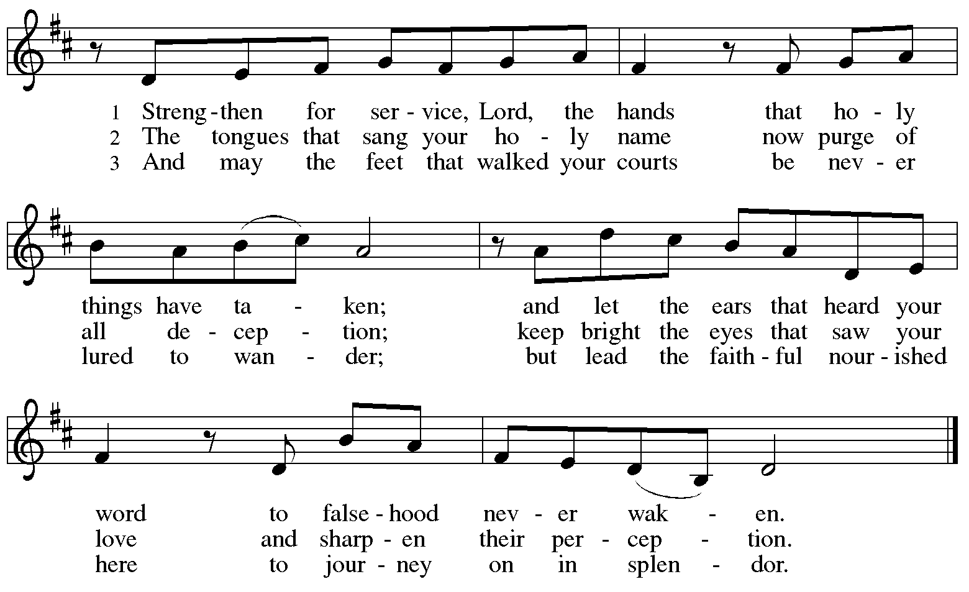
All rights reserved. Reprinted with permission under OneLicense.net # A-722139.

When all have returned to their places, please rise as you are able.

Blessing

P: The body and blood of our Lord Jesus Christ strengthen you and keep you in his grace.
C: Amen.

Prayer

A: Let us pray.
Life-giving God,
in the mystery of Christ’s resurrection, you send light to conquer darkness,
water to give new life, and the bread of life to nourish your people.
Send us forth as witnesses to your Son’s resurrection,
that we may show your glory to all the world,
through Jesus Christ, our risen Lord.
C: Amen.
Please be seated.

Sending
God blesses us and sends us in mission to the world

Announcements

Please rise as you are able.

Benediction

P: May our glorious God grant you a spirit of wisdom
to know and love the risen Christ.

Almighty God, holy One, ☩ holy Three,
bless you now and forever.
C: Amen.

Sending Hymn God Be with You Till We Meet Again ELW 536

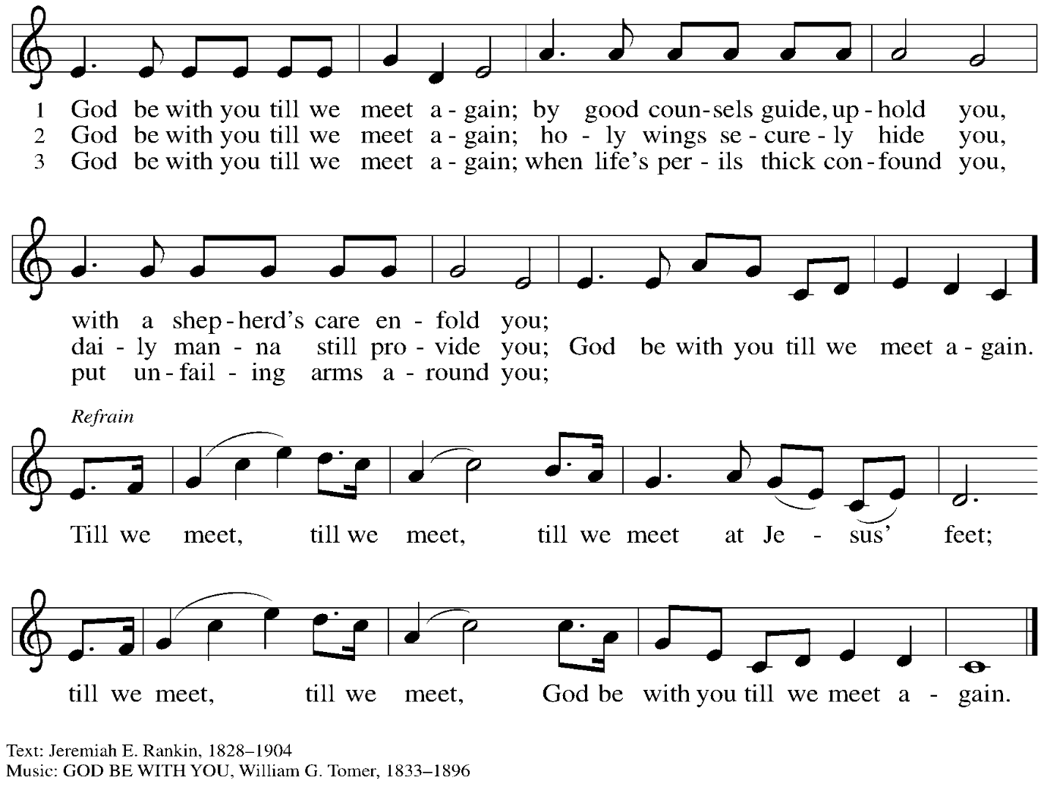
Dismissal

A: Alleluia! Christ is risen!
C: Christ is risen indeed! Alleluia! Alleluia!

A: Go in peace. Share the good news!
C: Thanks be to God!

Postlude

Those serving in worship today

Altar Care Jodie Minor
Assisting Minister Kathy Hays
Audio-Visual Ministers Dave Rollinson
Cantor Jered Stratton
Lector Pat Taylor
Organ Jimmi Kocher-Hillmer
Pre-Service Music Timothy Kocher-Hillmer
Tom Leech
Vocal Duet Timothy Kocher-Hillmer
Colten Rohleder
Minister of Music Laura Reynolds
Presiding Minister The Rev. Ross I. Carmichael

Liturgy and Hymnody Acknowledgements

From SundaysandSeasons.com. Copyright © 2026 Augsburg Fortress. All rights reserved. Reprinted under OneLicense.net # A-722139.
Used by permission of Augsburg Fortress.

The Scripture readings contained herein are from New Revised Standard Version Updated Edition of the Bible © 2021 National Council of Churches of Christ in the United States of America. Used by permission. All rights reserved worldwide.

That Easter Day with Joy Was Bright – Text: Latin hymn, 5th cent.; tr. John Mason Neale, 1818-1866, alt. Music: PUER NOBIS, European tune, adapt. Michael Praetorius, 1571-1621.

Let the Vineyards – Text: John W. Arthur, 1922-1980. Music: Ronald A. Nelson, b. 1927. Text and Music © 1978 Lutheran Book of Worship, admin. Augsburg Fortress.

Please use the QR code below to link to St. Andrew’s Announcements online!


St. Andrew Lutheran Church Announcements
April 26th, 2026

- Happy Easter! Welcome to Worship at St. Andrew as We Celebrate the Fourth Sunday of Easter! – We are so glad you are here to share in this festive season, and we offer a special welcome to all visitors and guests who are here for the first time! Little Church – Big Faith, a Bible lesson and activity for children up to sixth grade, will take place after the prayer of the day. There are worship “toolkits” to help children engage with worship and “busy bags” for younger children available in the bookcase at the back of the sanctuary. Please feel free to take one to use with/for your children. A nursery is available through the door to the left of the worship space and across the social hall (look for a purple room). We pray that everyone has a blessed Easter season!
- Blessings to Tristan Elias, Receiving the Sacrament of Holy Baptism! – Today is a day of celebration at St. Andrew not only because the Easter season continues but also because, in worship, we will welcome our new sibling in Christ, Tristan Elias, through the Sacrament of Holy Baptism! We invite your prayers for Tristan, parents Noël and Colten, godparents, and the whole family as together we give thanks for the gifts of God’s love and grace! Please stay for Coffee hour to continue the celebration with cake!
- Produce Distribution Supplemental Food of the Month – St. Andrew collects supplemental food each month to accompany our produce distribution. For April, we ask for donations of lentils and beans. There are collection boxes at the back of the worship space and social hall.
- Dismantling Antisemitism 101, Today, April 26th, 12:00 p.m. to 1:30 p.m. – St. Andrew has invited Mr. Noah Schoen, Manager of Community Engagement for the Holocaust Center of Pittsburgh, to lead us in a Dismantling Antisemitism 101 workshop. After worship today, we will have an expanded coffee hour with light lunch foods, and then begin the workshop at 12:00 noon.
- Next Sunday, May 3rd, is the Day of the Pittsburgh Marathon – Please look ahead at the map in your Friday email to plan your route to worship!
- Reparations Offering, Next Sunday, May 3rd during Worship – In Luke’s Gospel, Jesus tells a story about a compassionate Samaritan, suggesting that God’s people are called to work for healing and restoration for our neighbors, regardless of who or what caused them harm. In light of this, St. Andrew has made a commitment to reparations in regard to African American spiritual songs used in our worship. The text and music of most hymns is attributed to specific authors, with copyrights in place, usage reported, and royalties paid to those whose works are featured in worship. With African American spirituals, this is not possible. In response to many years of such uncredited use, St. Andrew invites the congregation to give a reparations offering. Funds received in worship will be donated to our siblings at Bethel AME Church, whose land and building were taken from them in the 1950s, to fund their development in the Hill District.
- Spring Cleaning Work Day, Saturday, May 9th, 9:00 a.m. – It is truly a blessing to see the signs of Spring returning to our landscape, which always means that some Spring Cleanup is surely due. This past winter and the new roof project have left our outdoor spaces desperately in need of some tender loving care. We will be having a work day here at St. Andrew on Saturday, May 9, 2026 which happens to be Mother's Day weekend. We are planning outdoor leaf clean-up, tree trimming and planting of flowers around the front entrances. There will be coffee and donuts ready for the early birds and water to keep you hydrated all day long. You do not need to come early in the morning and you do not need to stay for the entire day.
We ask that if anyone has boxes to recycle please drop them off at the church before cleanup day. Please join us on May 9th to share this love and fellowship…many hands make light work. To sign up, please click this link: https://www.signupgenius.com/go/5080B4AAFAF2CABF85-63009079-spring.
- Alternatives to Violence Project Workshops, Saturday, May 16th and 23rd, 9:00 a.m. to 8:00 p.m. – The AVP workshops will be held at St. Andrew Lutheran Church (304 Morewood Ave, Pittsburgh, PA 15213) and will be open to both teens and adults. AVP is not a lecture or a debate. It is a hands-on, participatory experience that equips people with practical tools for: affirmation and respect, clear communication, cooperation in the midst of tension, transforming conflict rather than avoiding or inflaming it. To learn more, follow the link here: https://friendspeaceteams.org/cultures-justice-peace/. You can register to these workshops here: https://docs.google.com/forms/d/e/1FAIpQLSfjPQKcnyQNx26wqTHzyby9YMi7BYHrUUfUha3PoxXpC50XNw/viewform.
- Bible Book Club – Bible Book Club will meet each Wednesday at 7:00 p.m. This week, the group is finishing its discussion of Entering the Passion of Jesus: A Beginner’s Guide to Holy Week, by Dr. Amy-Jill Levine,. You can join the Zoom call here: https://us02web.zoom.us/j/83196175976?pwd=ejdPOUYrTk4xVFdsdlhHUVJ1L3k2Zz09.
- Christ in Our Home Booklets Available – Christ in Our Home is a quarterly devotional resource that encourages readers to live out their faith daily. Each reflective reading is accompanied by a daily scripture reference and prayer for the day. Booklets are available at the entrances. Please feel free to take one home!
- Coffee Hour Signups – St. Andrew provides hospitality during a coffee hour after worship each Sunday. If you would like to participate, please sign up using the following form: https://www.signupgenius.com/go/5080B4AAFAF2CABF85-47069030-coffee#/.

