

+ Fifth Sunday of Easter
May 3, 2026


St. Andrew Lutheran Church
304 Morewood Ave.
Pittsburgh, PA 15213
St_andrewELCA@verizon.net
www.standrewpittsburgh.org

+ Fifth Sunday of Easter

As we continue to celebrate the fifty days of Easter, today’s Gospel includes Jesus’ promise
that he goes to prepare a place for his followers in his Father’s house.
Our Baptism commissions us to share Jesus’ mission in the world. As 1 Peter reminds us,
we are a holy people, called to proclaim the one who called us out of darkness into light.
In words and deeds we bear witness to the risen Christ—our way, our truth, our life.

Welcome to St. Andrew!
- St. Andrew welcomes all who are seeking a place of healing, wholeness, and acceptance in a nurturing and faith-forming spiritual home. We are striving toward racial equity worldwide
and we seek to honor the lived experience of all individuals regardless of background. Our community embraces people of all ages, ethnicities, cultures, abilities, sexual orientations,
gender identities and expressions, and family constellations. Come and See!
- Worship Services are live-streamed to multiple online platforms. By attending worship, you agree that your image and voice may be broadcast.
- Everyone is invited to make a name tag at the black bookcase in the back of the worship space if they would like. There are stickers indicating pronouns on the bookcase if you would like to include them on your name tag.
- Children are invited to attend Little Church – Big Faith, a Bible lesson and activity, during worship (after the Prayer of the Day). The group returns to the worship space for the liturgy of Holy Communion.
- A nursery is available through the doors at the left side of the sanctuary and across from the doorway to the Social Hall. Look for a purple-colored room.
- Worship “toolkits” to help children engage with the service, along with “busy bags” for younger children, are available in the bookcase at the back of the sanctuary. Please feel free to take one to use with/for your children.
- Holy Communion is served with bread (gluten-free available) and wine or grape juice. The presiding minister will distribute the bread (host). Please consume this and then pick up an empty glass from the tray. The Communion Assistant will pour wine or grape juice into your glass. Please step to the side to consume the wine or grape juice. Feel free to kneel at the altar for prayer and reflection. As you return to your pew, glasses may be returned to the empty trays on either side of the center section.
- A restroom is available on the main level of the church, through the doors to the Social Hall and to the right in the main office.

Abbreviations
P: Pastor/Presiding Minister ELW: Evangelical Lutheran Worship hymnal
A: Assisting Minister ACS: All Creation Sings hymnal
L: Lector
C: Congregation

Musical Offering

Each week, different people from the congregation make an offering of pre-service music, with singing or instrumentation, to help the assembly focus and pray in preparation for worship.

Welcome
Prelude That Easter Day with Joy Was Bright arr. Carter

Gathering
The Holy Spirit calls us together as the people of God

Please rise as you are able. All may make the sign of the cross,
the sign that is marked at Baptism, as the presiding minister begins.

Thanksgiving for Baptism

P: Alleluia! Christ is risen!
C: Christ is risen indeed! Alleluia! Alleluia!

P: Salvation belongs to our God who is seated on the throne and to the Lamb!
C: Amen.

P: Let us give thanks for the gift of Baptism.

Water may be poured into the font as the presiding minister continues.
P: Merciful God,
you are the one who was, who is, and who is to come.
You lead us beside still waters.
We thank you for the waters of creation:
morning dew, gentle rain, roaring waves.
We thank you for the waters that nourish us.
Blessed are you!
C: You guide us to springs of the water of life.

P: Jesus Christ, you are the faithful witness
who accompanies us on our journeys.
We give you thanks for your life-giving death and resurrection.
We praise you for joining us in joy and sorrow.
Blessed are you!
C: You guide us to springs of the water of life.

P: Holy Spirit, you anoint our head with oil and our cup overflows.
Break down barriers that divide us.

P: Fill us with the breath of peace.
Blessed are you!
C: You guide us to springs of the water of life.

P: Holy One, we thank you for the gifts and grace of Baptism,
and for making us a new creation. We join with saints and angels,
giving you honor and praise, now and forever.
C: Amen.

Gathering Hymn With High Delight Let Us Unite ELW 368

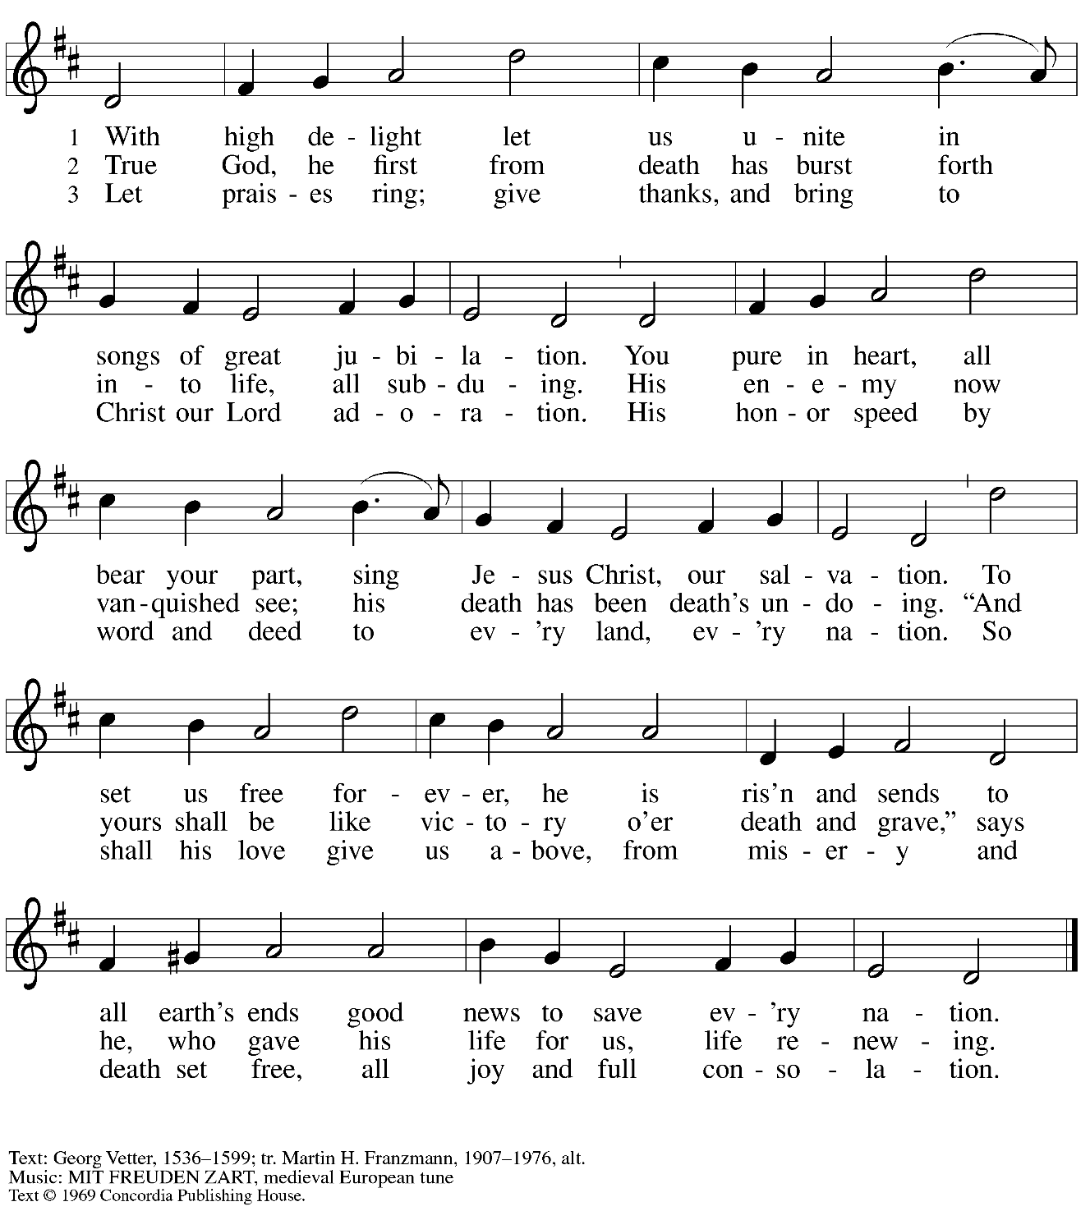
All rights reserved. Reprinted with permission under OneLicense.net # A-722139.
Greeting

P: The grace of our Lord Jesus Christ, the love of God,
and the communion of the Holy Spirit be with you all.
C: And also with you.

Hymn of Praise This Is the Feast ELW p. 149-150

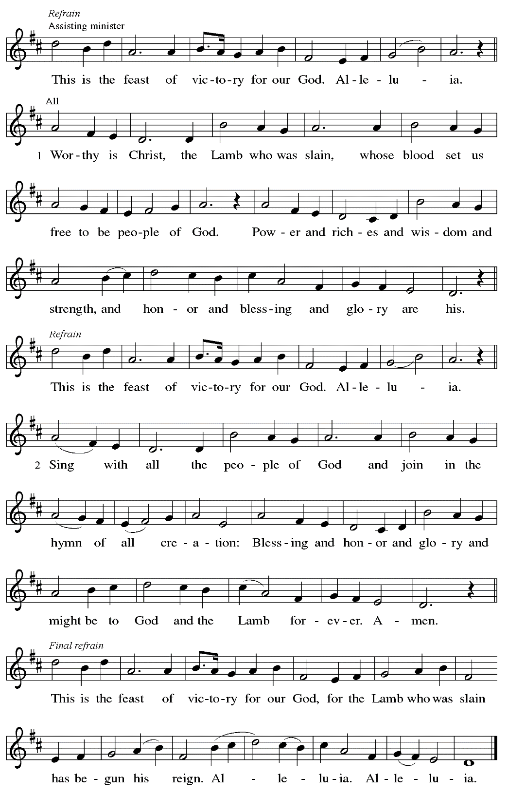

Prayer of the Day

P: The Lord be with you.
C: And also with you.

P: Let us pray.
Almighty God, your Son Jesus Christ is the way, the truth, and the life.
Give us grace to love one another,
to follow in the way of his commandments,
and to share his risen life with all the world,
for he lives and reigns with you and the Holy Spirit,
one God, now and forever.
C: Amen.

Please be seated.
Children are invited to join the adult leader(s) at the side door for Little Church – Big Faith.
We ask that an additional adult from the congregation attend with the children.

Word
God speaks to us in Scripture reading, preaching, and song

First Reading – Acts 7: 55-60

⁵⁵ Filled with the Holy Spirit, [Stephen] gazed into heaven and saw the glory of God and Jesus standing at the right hand of God. ⁵⁶ “Look,” he said, “I see the heavens opened and the Son of Humanity standing at the right hand of God!” ⁵⁷ But they covered their ears, and with a loud shout all rushed together against him. ⁵⁸ Then they dragged him out of the city and began to stone him, and the witnesses laid their coats at the feet of a young man named Saul. ⁵⁹ While they were stoning Stephen, he prayed, “Lord Jesus, receive my spirit.” ⁶⁰ Then he knelt down and cried out in a loud voice, “Lord, do not hold this sin against them.” When he had said this, he died.

L: Word of God, word of life.
C: Thanks be to God.

Psalm 31: 1-5, 15-16

The psalm will be sung responsively, led by the cantor,
with the congregation responding with the bold verses and refrain.

Psalm Tone

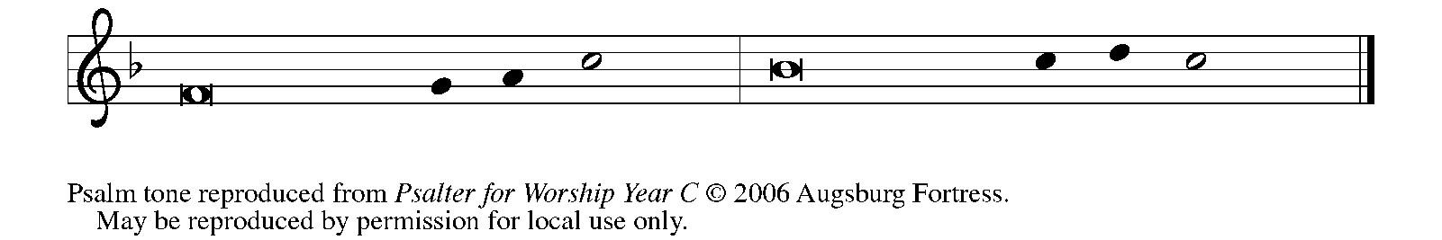

Psalm Refrain

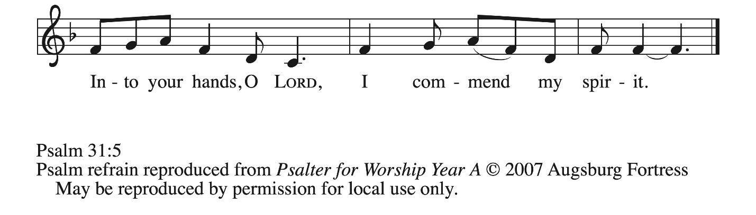

¹ In you, O Lord, have I taken refuge; let me never be | put to shame;
deliver me | in your righteousness.
² Incline your | ear to me;
make haste to de- | liver me.
³ Be my strong rock, a castle to keep me safe, for you are my crag | and my stronghold;
for the sake of your name, lead | me and guide me.
⁴ Take me out of the net that they have secretly | set for me,
for you are my tow- | er of strength. R
⁵ Into your hands I com- | mend my spirit,
for you have redeemed me, O Lord, | God of truth.
¹⁵ My times are | in your hand;
rescue me from the hand of my enemies, and from those who | persecute me.
¹⁶ Let your face shine up- | on your servant;
save me in your | steadfast love.”

Second Reading – 1 Peter 2: 2-10

² Like newborn infants, long for the pure, spiritual milk, so that by it you may grow into salvation ³ if indeed you have tasted that the Lord is good.
⁴ Come to him, a living stone, though rejected by mortals yet chosen and precious in God’s sight, and ⁵ like living stones let yourselves be built into a spiritual house, to be a holy priesthood, to offer spiritual sacrifices acceptable to God through Jesus Christ. ⁶ For it stands in scripture:
“See, I am laying in Zion a stone,
a cornerstone chosen and precious,
and whoever believes in him will not be put to shame.”
⁷ This honor, then, is for you who believe, but for those who do not believe,
“The stone that the builders rejected
has become the very head of the corner,”
⁸ and
“A stone that makes them stumble
and a rock that makes them fall.”
They stumble because they disobey the word, as they were destined to do.
⁹ But you are a chosen people, a royal priesthood, a holy nation, God’s own people, in order that you may proclaim the excellence of him who called you out of darkness into his marvelous light.
¹⁰ Once you were not a people,
but now you are God’s people;
once you had not received mercy,
but now you have received mercy.

L: Word of God, word of life.
C: Thanks be to God.

Please rise as you are able.

Gospel Acclamation ELW p. 151

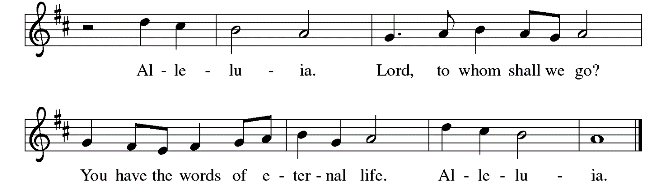

Gospel – John 14: 4-14

P: The holy Gospel according to St. John.
C: Glory to you, O Lord.

[Jesus said to the disciples:] ¹ “Do not let your hearts be troubled. Believe in God; believe also in me. ² In my Father’s house there are many dwelling places. If it were not so, would I have told you that I go to prepare a place for you? ³ And if I go and prepare a place for you, I will come again and will take you to myself, so that where I am, there you may be also. ⁴ And you know the way to the place where I am going.” ⁵ Thomas said to him, “Lord, we do not know where you are going. How can we know the way?” ⁶ Jesus said to him, “I am the way and the truth and the life. No one comes to the Father except through me. ⁷ If you know me, you will know my Father also. From now on you do know him and have seen him.”
⁸ Philip said to him, “Lord, show us the Father, and we will be satisfied.” ⁹ Jesus said to him, “Have I been with you all this time, Philip, and you still do not know me?
Whoever has seen me has seen the Father. How can you say, ‘Show us the Father’? ¹⁰ Do you not believe that I am in the Father and the Father is in me? The words that I say to you I do not speak on my own, but the Father who dwells in me does his works. ¹¹ Believe me that I am in the Father and the Father is in me, but if you do not, then believe because of the works themselves. ¹² Very truly, I tell you, the one who believes in me will also do the works that I do and, in fact, will do greater works than these, because I am going to the Father. ¹³ I will do whatever you ask in my name, so that the Father may be glorified in the Son. ¹⁴ If in my name you ask me for anything, I will do it.”

P: The Gospel of the Lord.
C: Praise to you, O Christ.

Please be seated.

Sermon

A time of silence for prayer and reflection follows the sermon.
When the hymn of the day begins, please rise as you are able.



Hymn of the Day Come, My Way, My Truth, My Life ELW 816

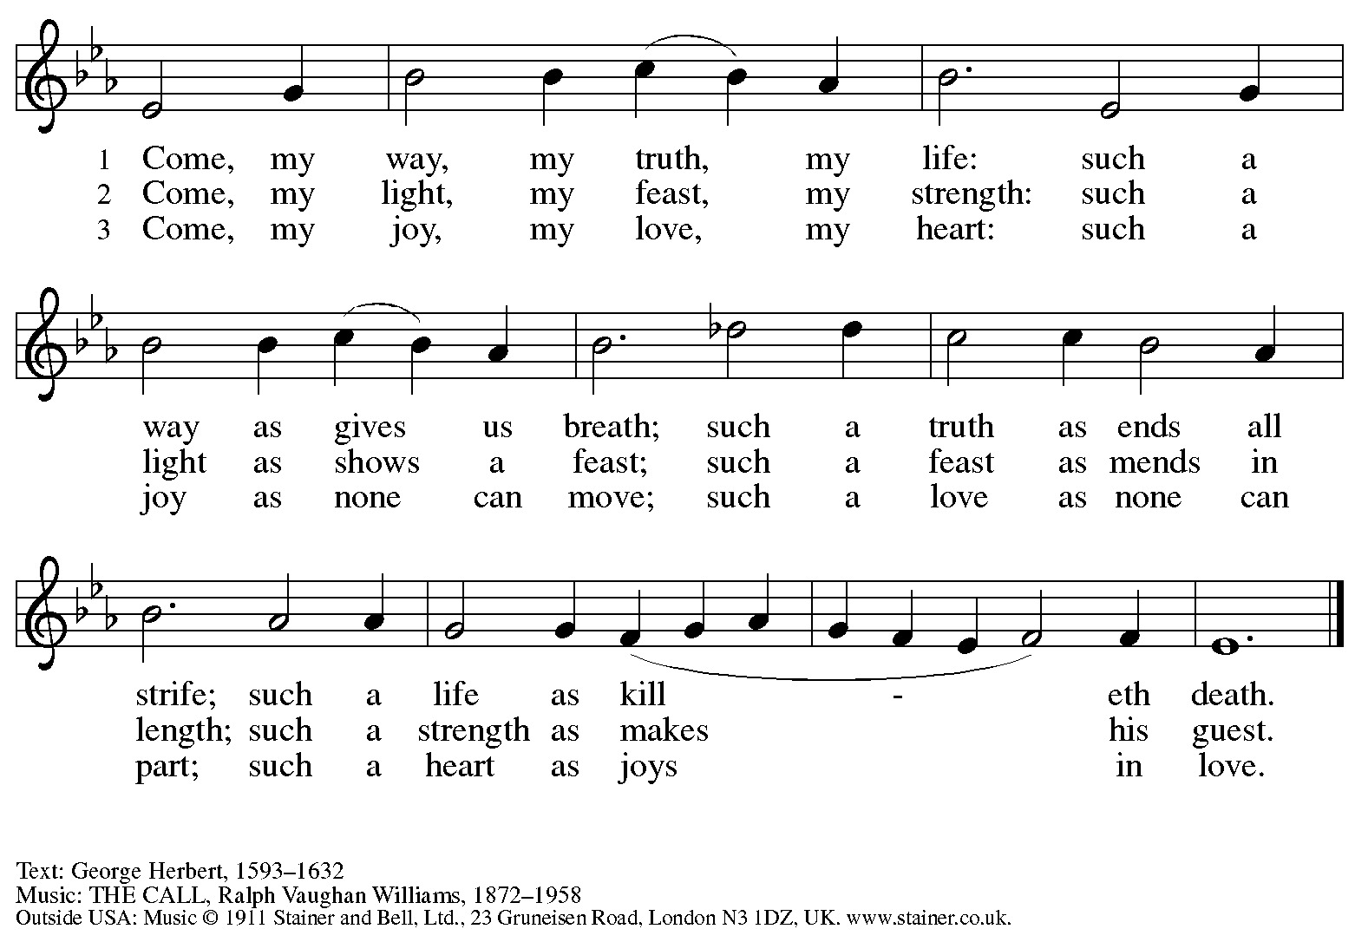
All rights reserved. Reprinted with permission under CCLI # 11561207.

Nicene Creed

C: We believe in one God,
the Father, the Almighty,
maker of heaven and earth,
of all that is, seen and unseen.

We believe in one Lord, Jesus Christ,
the only Son of God,
eternally begotten of the Father,
God from God, Light from Light,
true God from true God,
begotten, not made,
of one Being with the Father;
through him all things were made.
For us and for our salvation
he came down from heaven,
was incarnate of the Holy Spirit and the virgin Mary
and became truly human.
For our sake he was crucified under Pontius Pilate;
he suffered death and was buried.
On the third day he rose again
in accordance with the scriptures;
he ascended into heaven
and is seated at the right hand of the Father.
He will come again in glory to judge the living and the dead,
and his kingdom will have no end.

We believe in the Holy Spirit, the Lord, the giver of life,
who proceeds from the Father and the Son,*
who with the Father and the Son is worshiped and glorified,
who has spoken through the prophets.
We believe in one holy catholic and apostolic church.
We acknowledge one baptism for the forgiveness of sins.
We look for the resurrection of the dead,
and the life of the world to come. Amen.

*Or, “who proceeds from the Father.” The phrase “and the Son” is a later addition to the creed.

Prayers of the People

A: United in the joy and hope of the resurrection, let us pray for the church, the world,
and all who are in need.

After each petition
A: Gracious God,
C: receive our prayer.

The presiding minister concludes the prayers
P: We lift these prayers to you O God, trusting in your abundant mercy,
through Jesus Christ our risen Savior.
C: Amen.

Peace

The presiding minister and the assembly greet one another in the peace of the risen Christ.
P: The peace of Christ be with you always.
C: And also with you.

The people may greet those around them with a sign of Christ’s peace and may say
Peace be with you or similar words. Please be mindful that not everyone will be comfortable with sharing the peace, so please seek consent before shaking hands or hugging.
Other possible ways to share the peace include a simple bow with the verbal greeting of peace, or simply a verbal expression of peace. When the greetings of peace have concluded, please be seated.



Meal
God feeds us with the presence of Jesus Christ

Offering

We offer ourselves, our gifts, and our faithful service to God.
As the offering is gathered for the mission of the church, including the care of those in need,
the table is set for Holy Communion.

There are laminated giving cards in the pew racks that feature a QR code for anyone who would like to give online. Those who give using the QR code, as well as those who give regularly online or through their bank are encouraged to place the laminated card in the plate as an expression of your offering.

Reparations Offering

On the first Sunday of each month, St. Andrew invites people of the congregation to give a second offering for a reparations fund in acknowledgment of St. Andrew’s use of African American spiritual songs in our worship services. Please see the note in the announcements for more information.

Music during the Offering Amazing Grace arr. Schrader
April Galyardt and Kai

As the gifts are brought forward for presentation, please rise as you are able.

Offertory Song Let the Vineyards Be Fruitful ELW 184

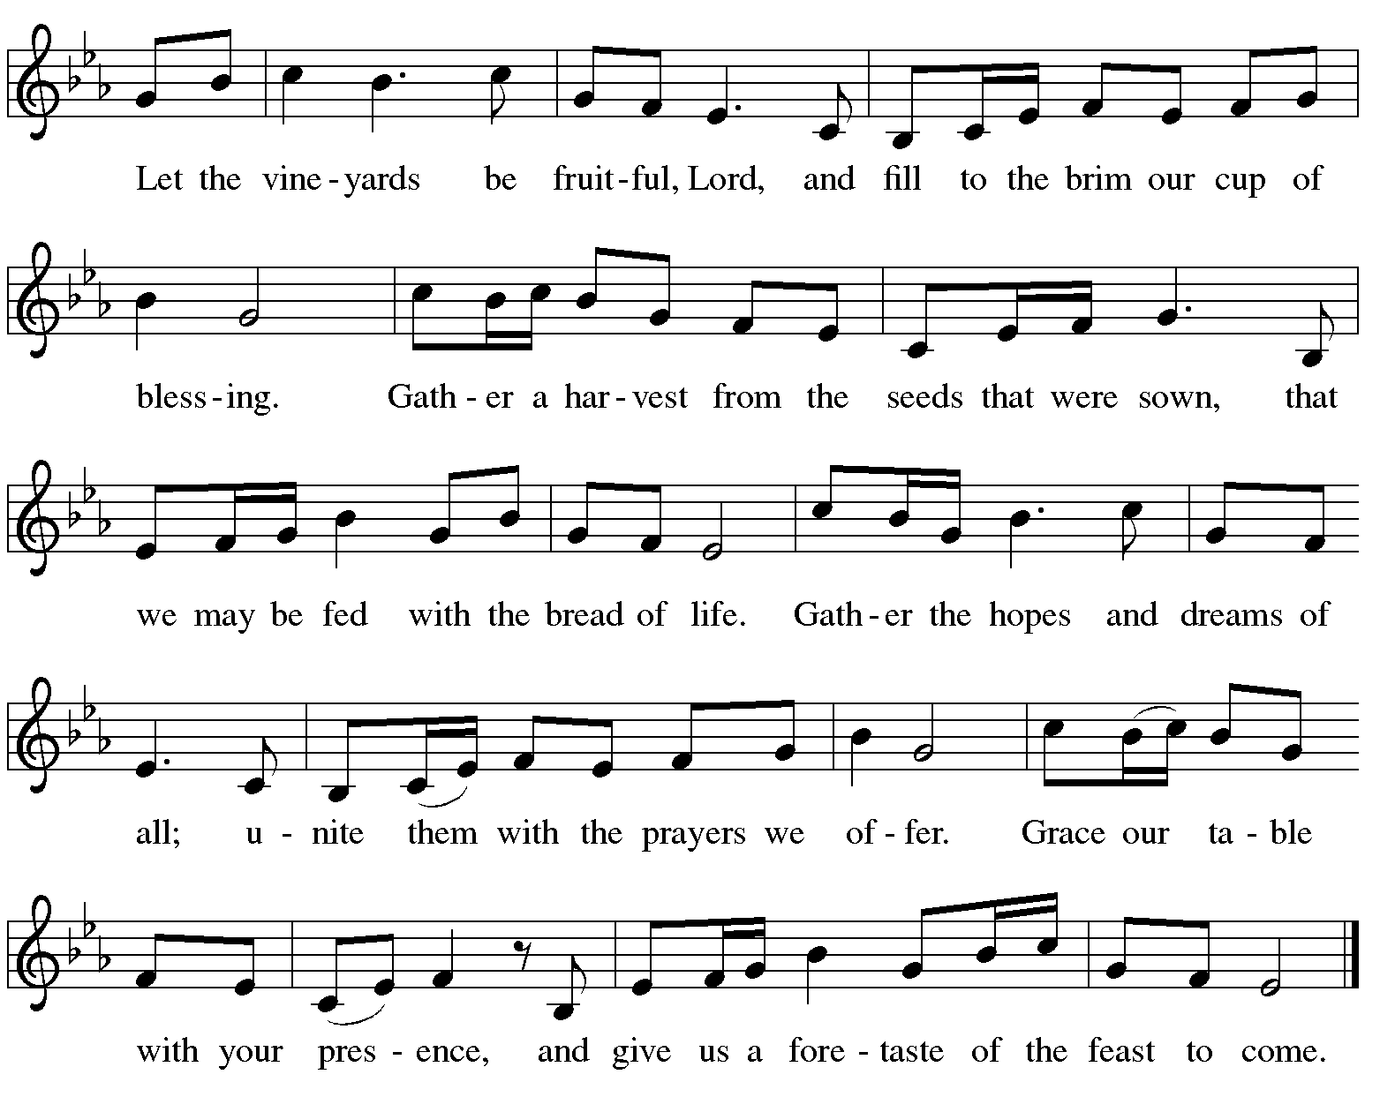

Offertory Prayer

A: Let us pray.
Blessed are you, O God,
C: ruler of heaven and earth.
Day by day you shower us with blessings.
As you have raised us to new life in Christ,
give us glad and generous hearts,
ready to praise you and to respond to those in need,
through Jesus Christ, our Savior and Lord.
Amen.

Dialogue ELW p. 152

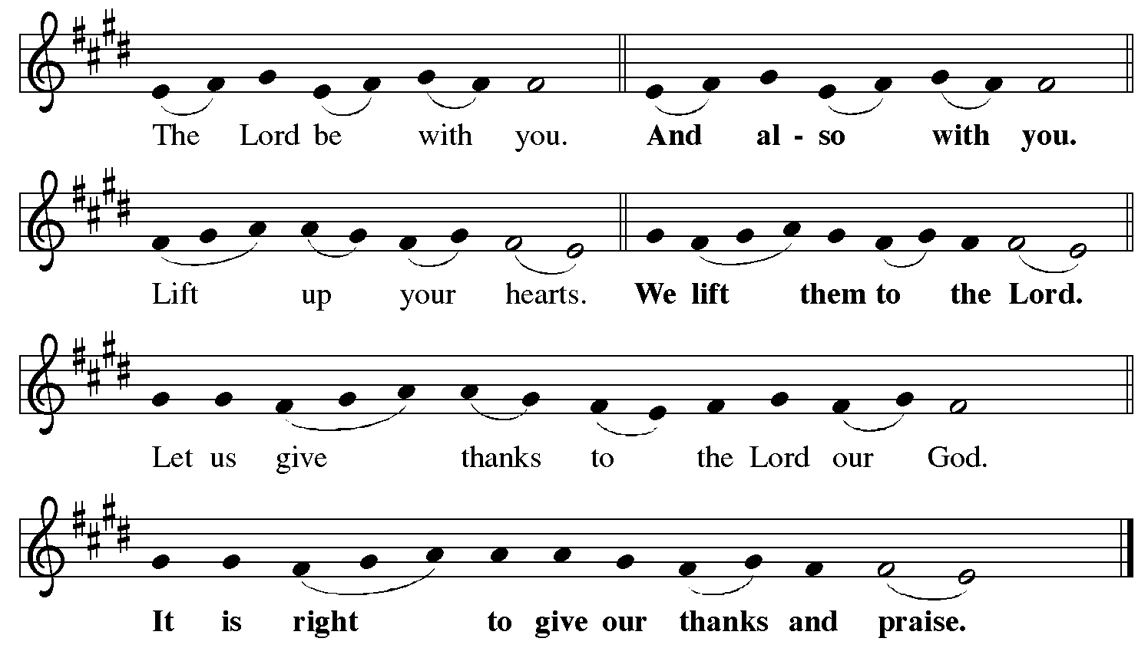

Preface (Sung by the presiding minister)

P: It is indeed right, our duty and our joy,
that we should at all times and in all places
give thanks and praise to you, almighty and merciful God,
for the glorious resurrection of our Savior Jesus Christ,
the true Paschal Lamb who gave himself to take away our sin;
who in dying has destroyed death,
and in rising has brought us to eternal life.
And so, with Mary Magdalene and Peter
and all the witnesses of the resurrection,
with earth and sea and all their creatures,
and with angels and archangels, cherubim and seraphim,
we praise your name and join their unending hymn:

Sanctus ELW p. 153

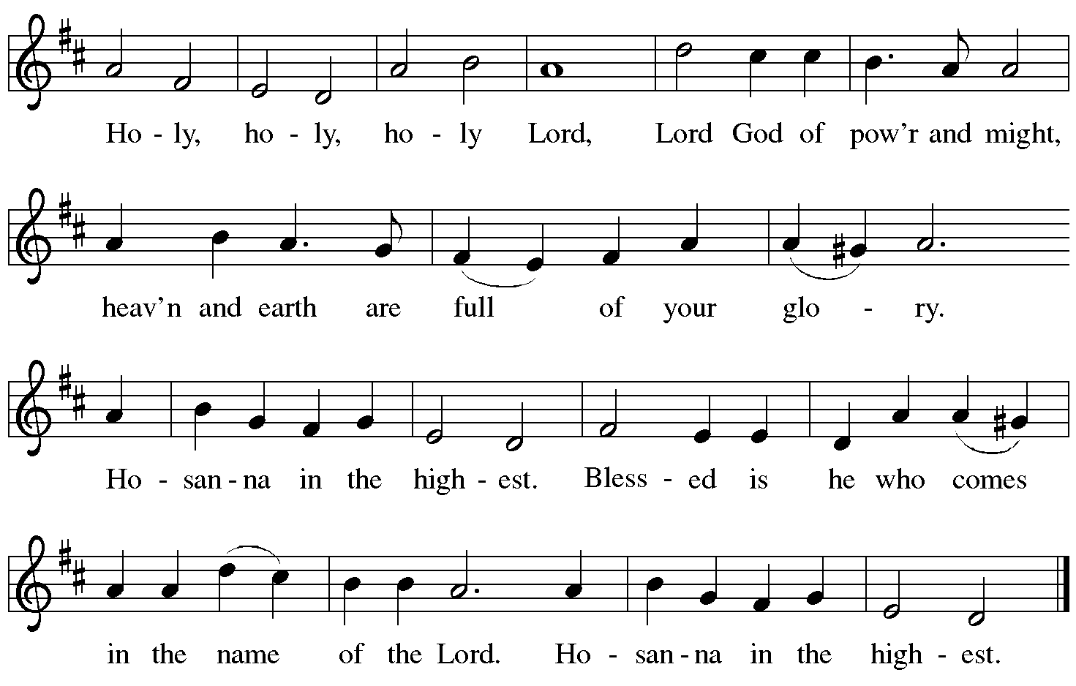

Eucharistic Prayer

P: Blessed are you, O God of the universe …
… Do this for the remembrance of me.

With this bread and cup we remember our Lord’s passover from death to life
as we proclaim the mystery of faith.
C: Christ has died. Christ is risen. Christ will come again.

P: O God of resurrection and new life …
… Grace our table with your presence.
C: Come, Holy Spirit.

P: Reveal yourself to us in the breaking of the bread …
… send us forth, burning with justice, peace, and love.
C: Come, Holy Spirit.

P: With your holy ones of all times and places …
… blessed and Holy Trinity, now and forever.
C: Amen.

Lord’s Prayer

P: Gathered as one by the Holy Spirit, let us pray as Jesus taught us.
C: Our Father, who art in heaven,
hallowed be thy name,
thy kingdom come,
thy will be done,
on earth as it is in heaven.
Give us this day our daily bread;
and forgive us our trespasses,
as we forgive those
who trespass against us;
and lead us not into temptation,
but deliver us from evil.
For thine is the kingdom,
and the power, and the glory,
forever and ever. Amen.

Fraction and Invitation

P: Alleluia! Christ is risen!
C: Christ is risen indeed! Alleluia! Alleluia!

P: This is the feast of victory for our God. Alleluia! Alleluia!
Come, share the feast.



Agnus Dei / Lamb of God ELW p. 154

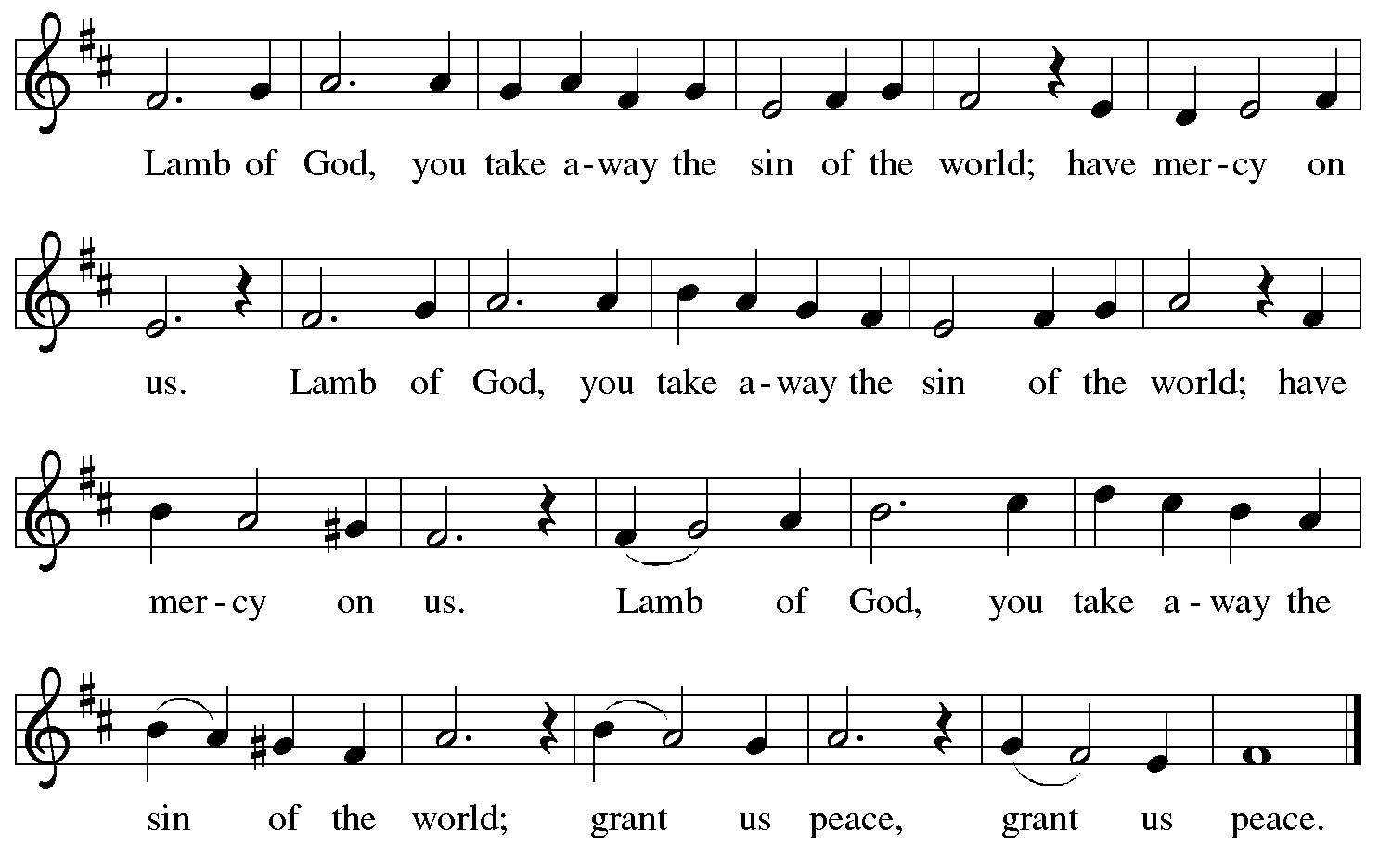

Please be seated.

Holy Communion

- All who seek God and desire a deeper and stronger life in Christ are welcome to receive Holy Communion.
- Worshipers from the pulpit side will proceed forward first, followed by the center section, and then the lectern side.
- Please inform an usher if you would like the ministers to bring Communion to you.
- Holy Communion will be served with bread and wine (red) or grape juice (white).
- The presiding minister will first distribute the bread (host) to each communicant. Please indicate if you require a gluten-free host.
- Once you have consumed the bread, please pick up an empty glass from the tray next to the presiding minister. The Communion Assistant will pour wine or grape juice into your glass.
- Please step to the side to consume the wine or grape juice.
- Feel free to kneel at the altar rail for prayer after receiving the sacrament.
- As you return to your pew, glasses may be returned to the empty tray on the side of the center section.
- A blessing will be provided for anyone who does not yet receive the sacrament.
- All are invited to join in singing the hymns during Holy Communion.

Hymns during Holy Communion
I Received the Living God ELW 477

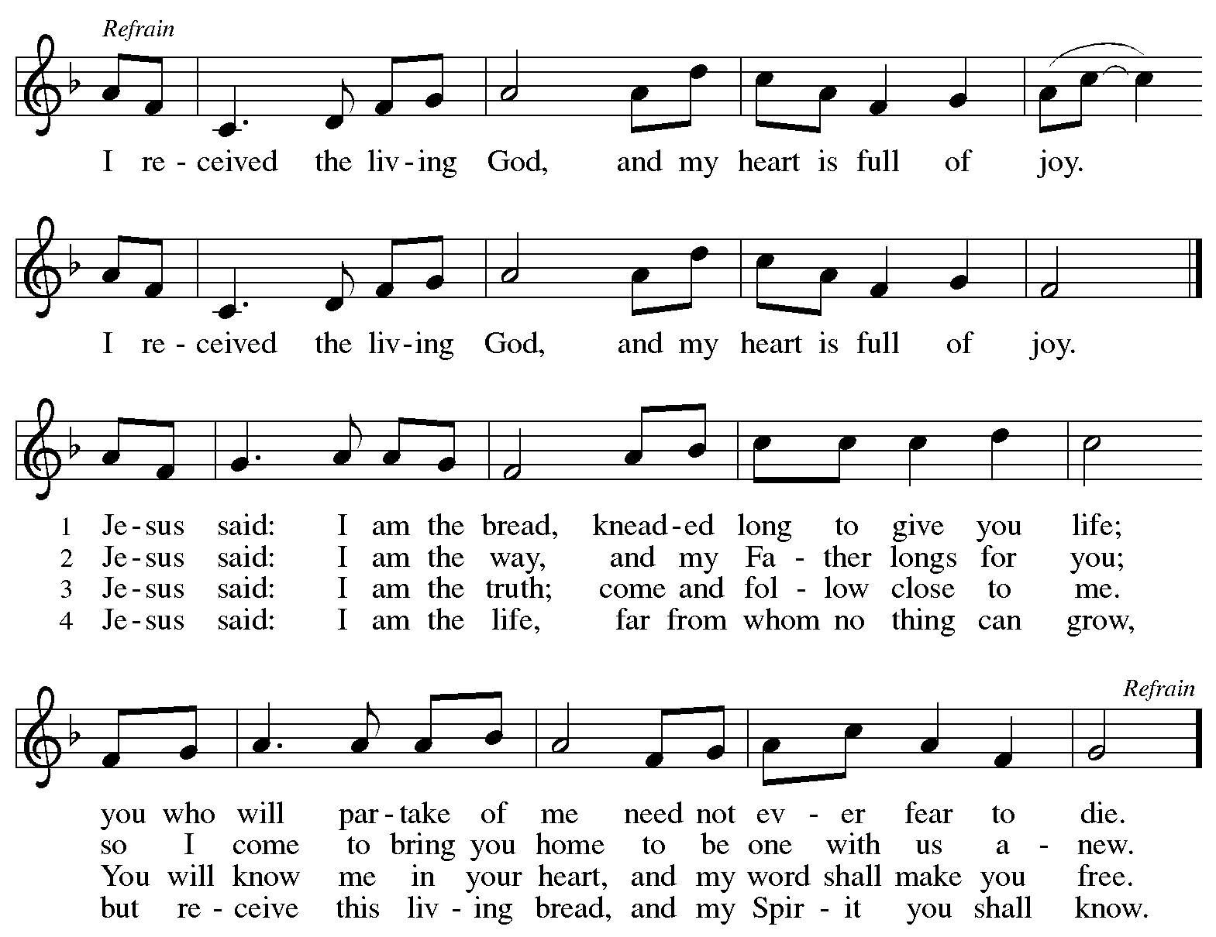

Hymns during Holy Communion
Christ Is Made the Sure Foundation ELW 648

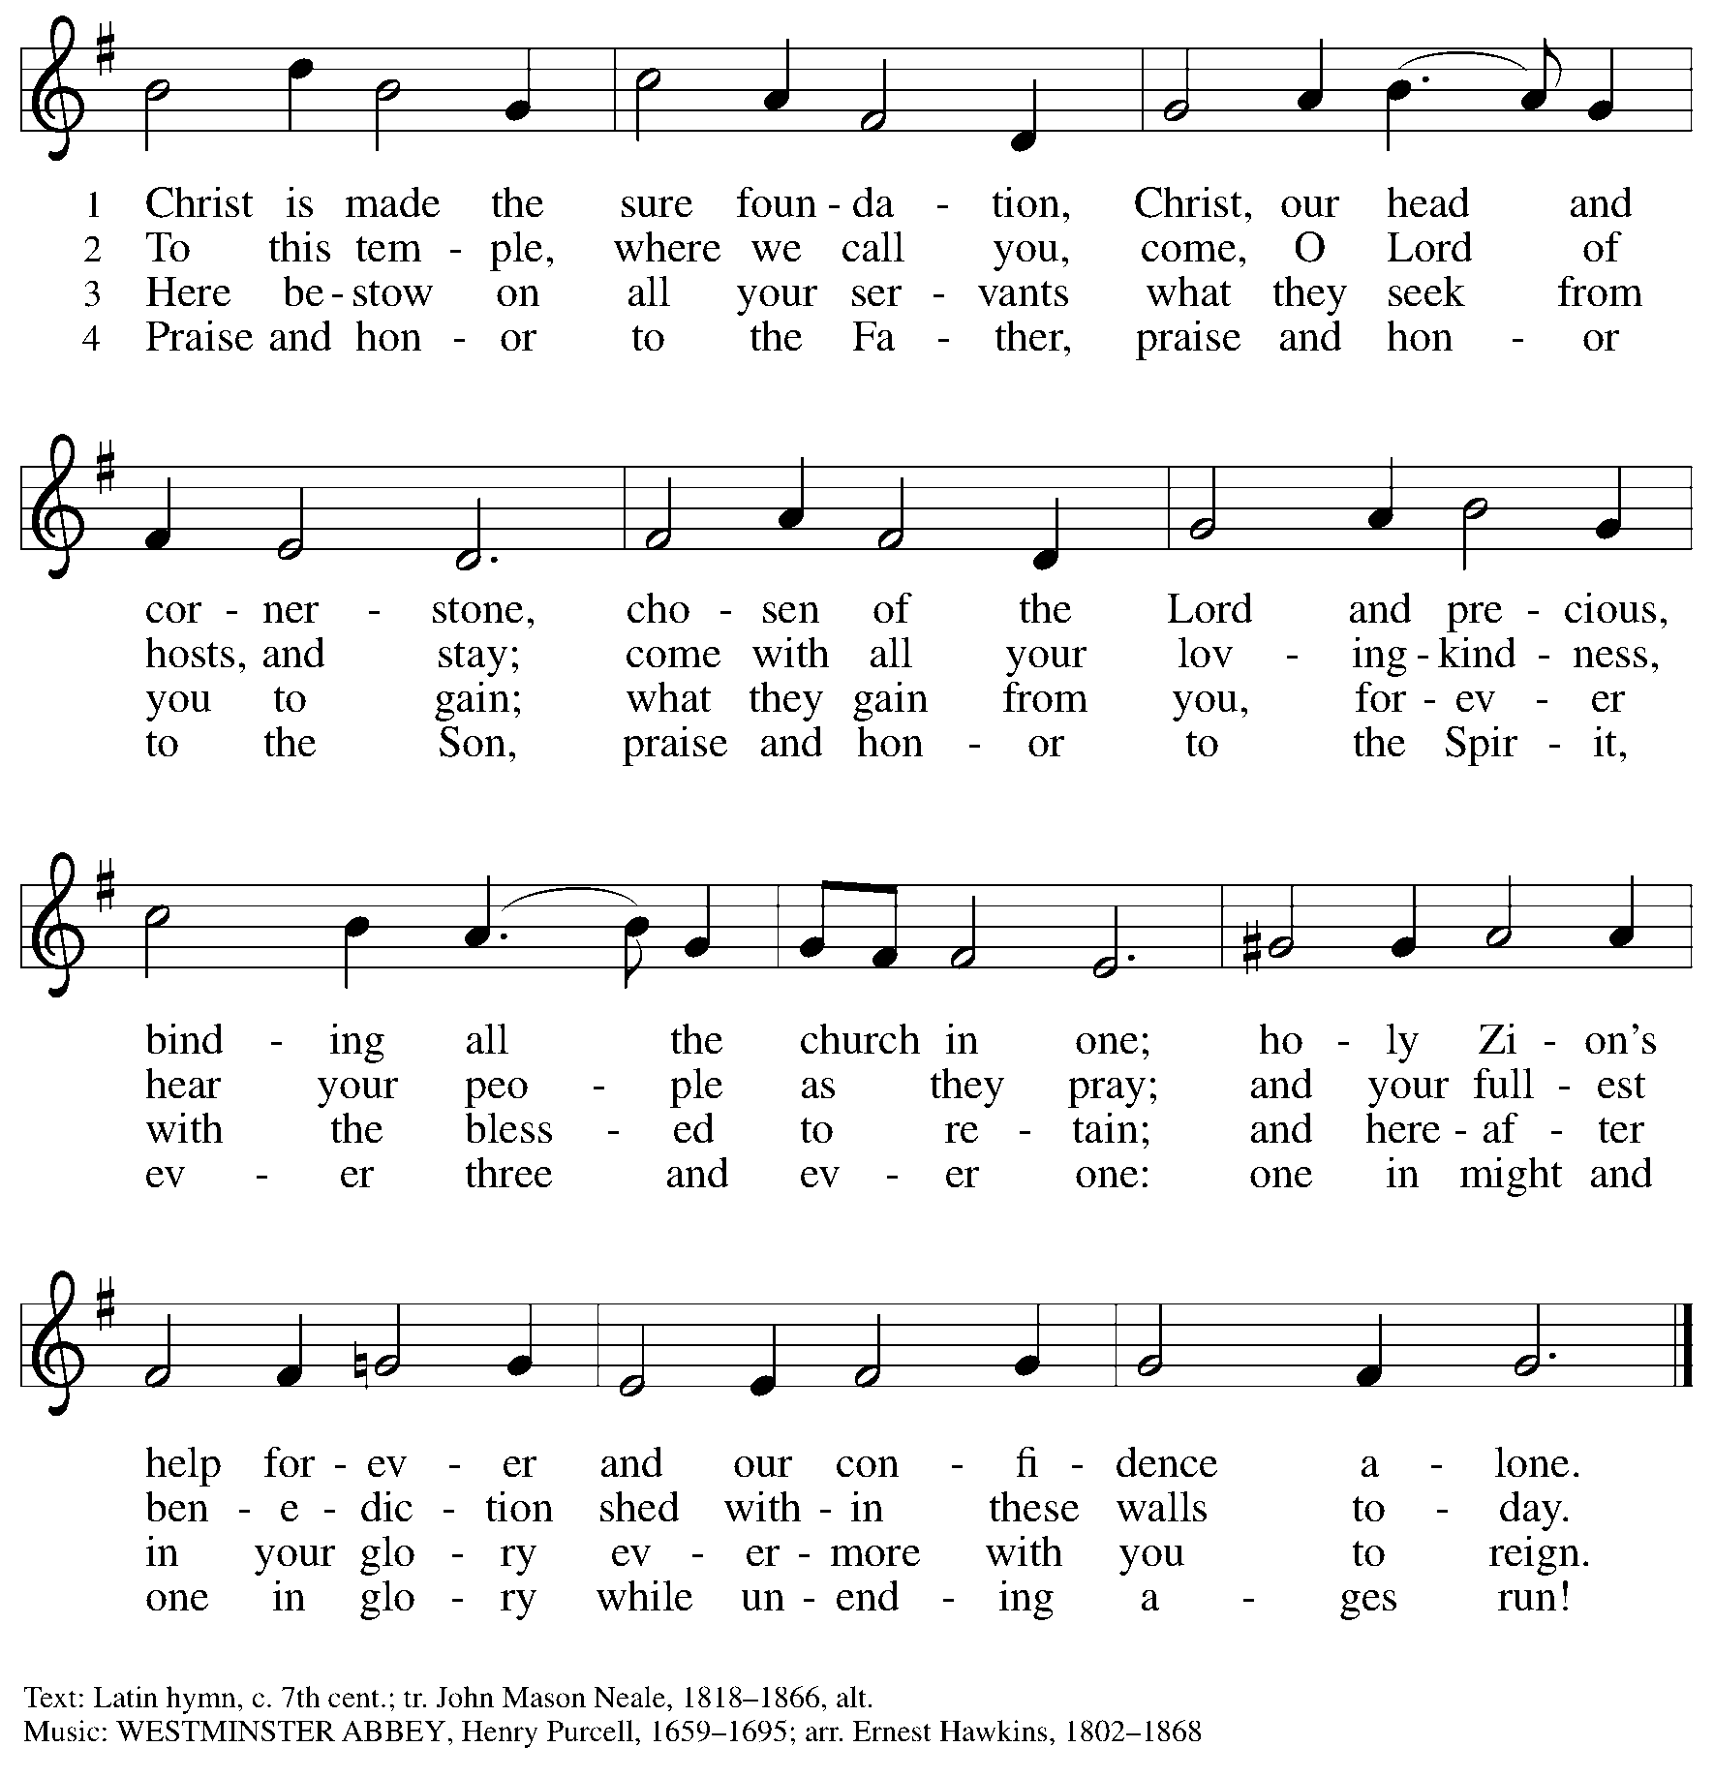

Hymns during Holy Communion
O God of Mercy, God of Light ELW 714

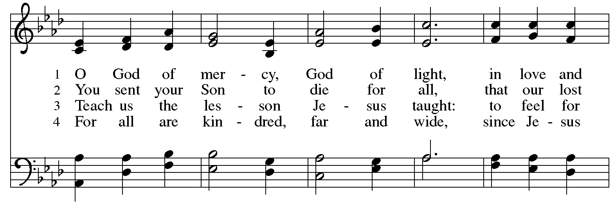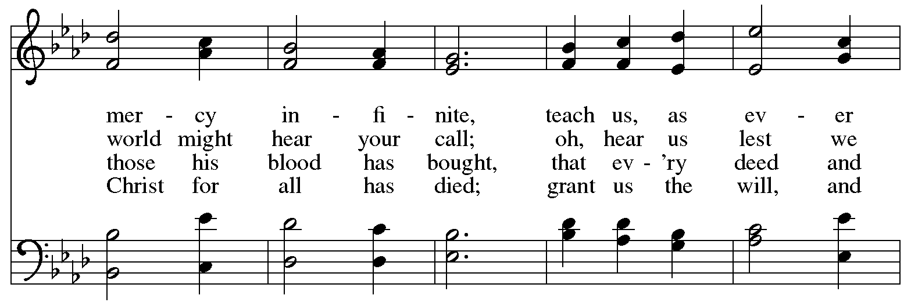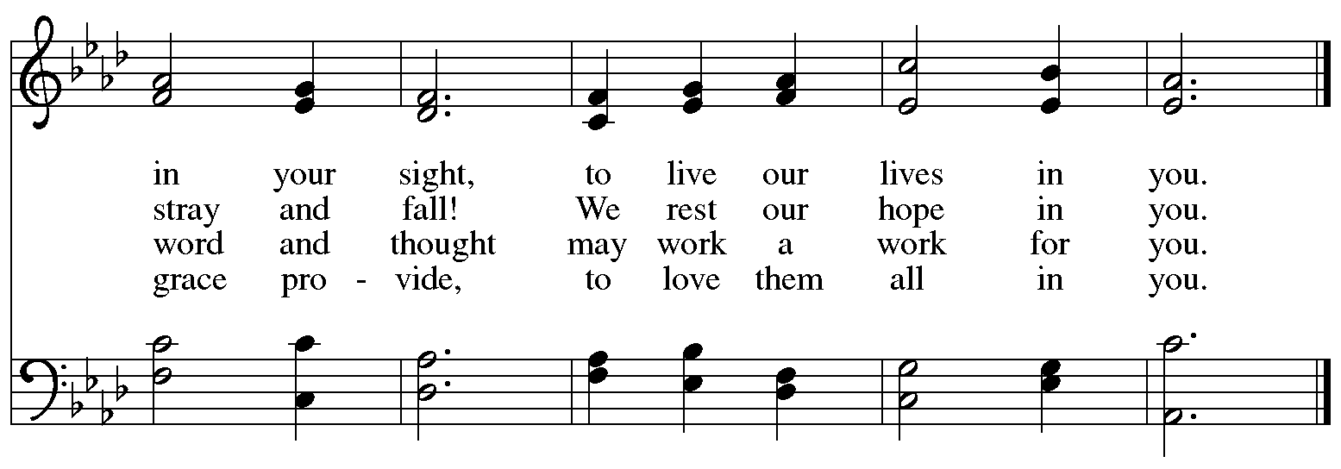
All rights reserved. Reprinted with permission under OneLicense.net # A-722139.
Hymns during Holy Communion
Come to the Table of Mercy ELW 481

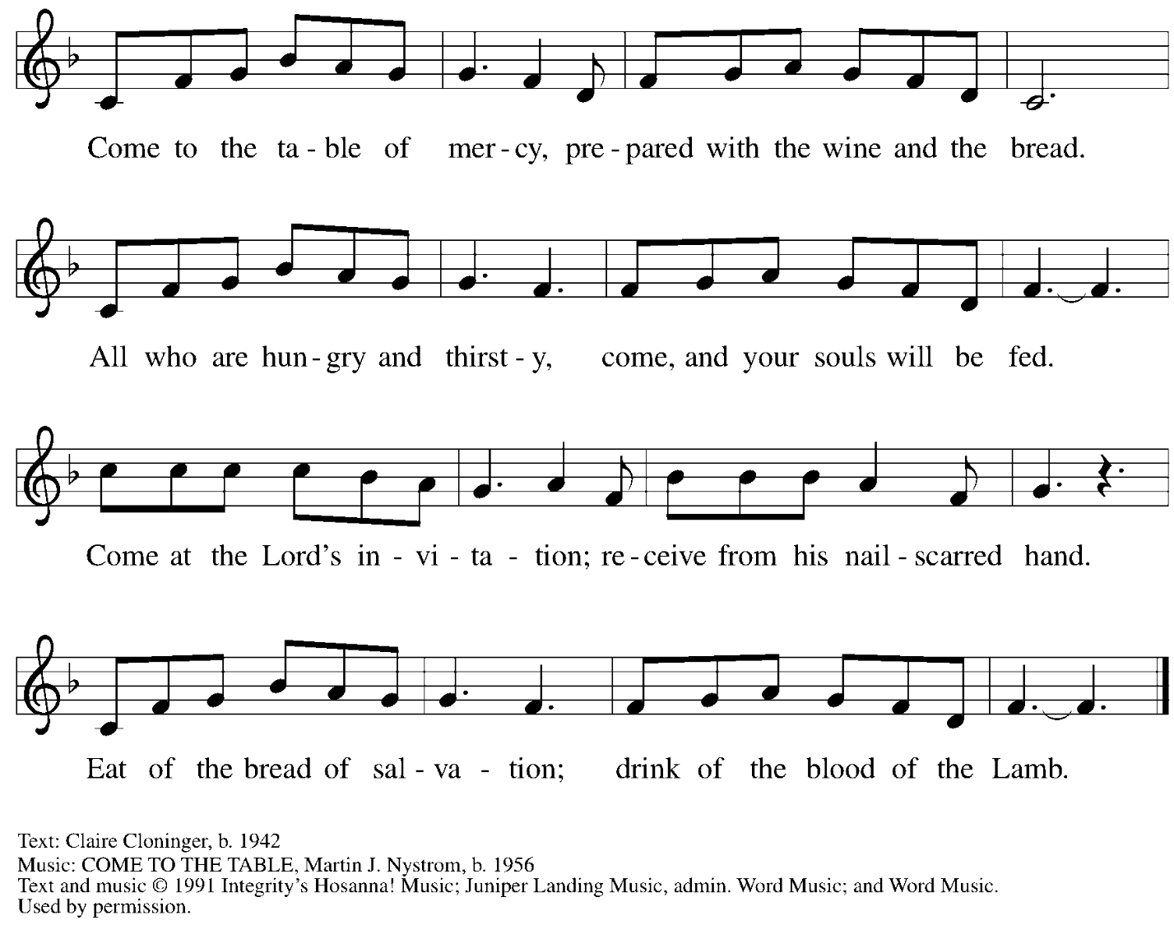
All rights reserved. Reprinted under OneLicense.net # A-722139.

When all have returned to their places, please rise as you are able.

Blessing

P: The body and blood of our Lord Jesus Christ strengthen you and keep you in his grace.
C: Amen.

Prayer

A: Let us pray.
Life-giving God,
in the mystery of Christ’s resurrection, you send light to conquer darkness,
water to give new life, and the bread of life to nourish your people.

Send us forth as witnesses to your Son’s resurrection,
that we may show your glory to all the world,
through Jesus Christ, our risen Lord.
C: Amen.

Please be seated.

Sending
God blesses us and sends us in mission to the world

Announcements

Please rise as you are able.

Benediction

P: May our glorious God grant you a spirit of wisdom
to know and love the risen Christ.

Almighty God, holy One, ☩ holy Three,
bless you now and forever.
C: Amen.

Sending Hymn Sent Forth by God’s Blessing Following Page

Dismissal

A: Alleluia! Christ is risen!
C: Christ is risen indeed! Alleluia! Alleluia!

A: Go in peace. Share the good news!
C: Thanks be to God!

Postlude

Sending Hymn Sent Forth by God’s Blessing ELW 547

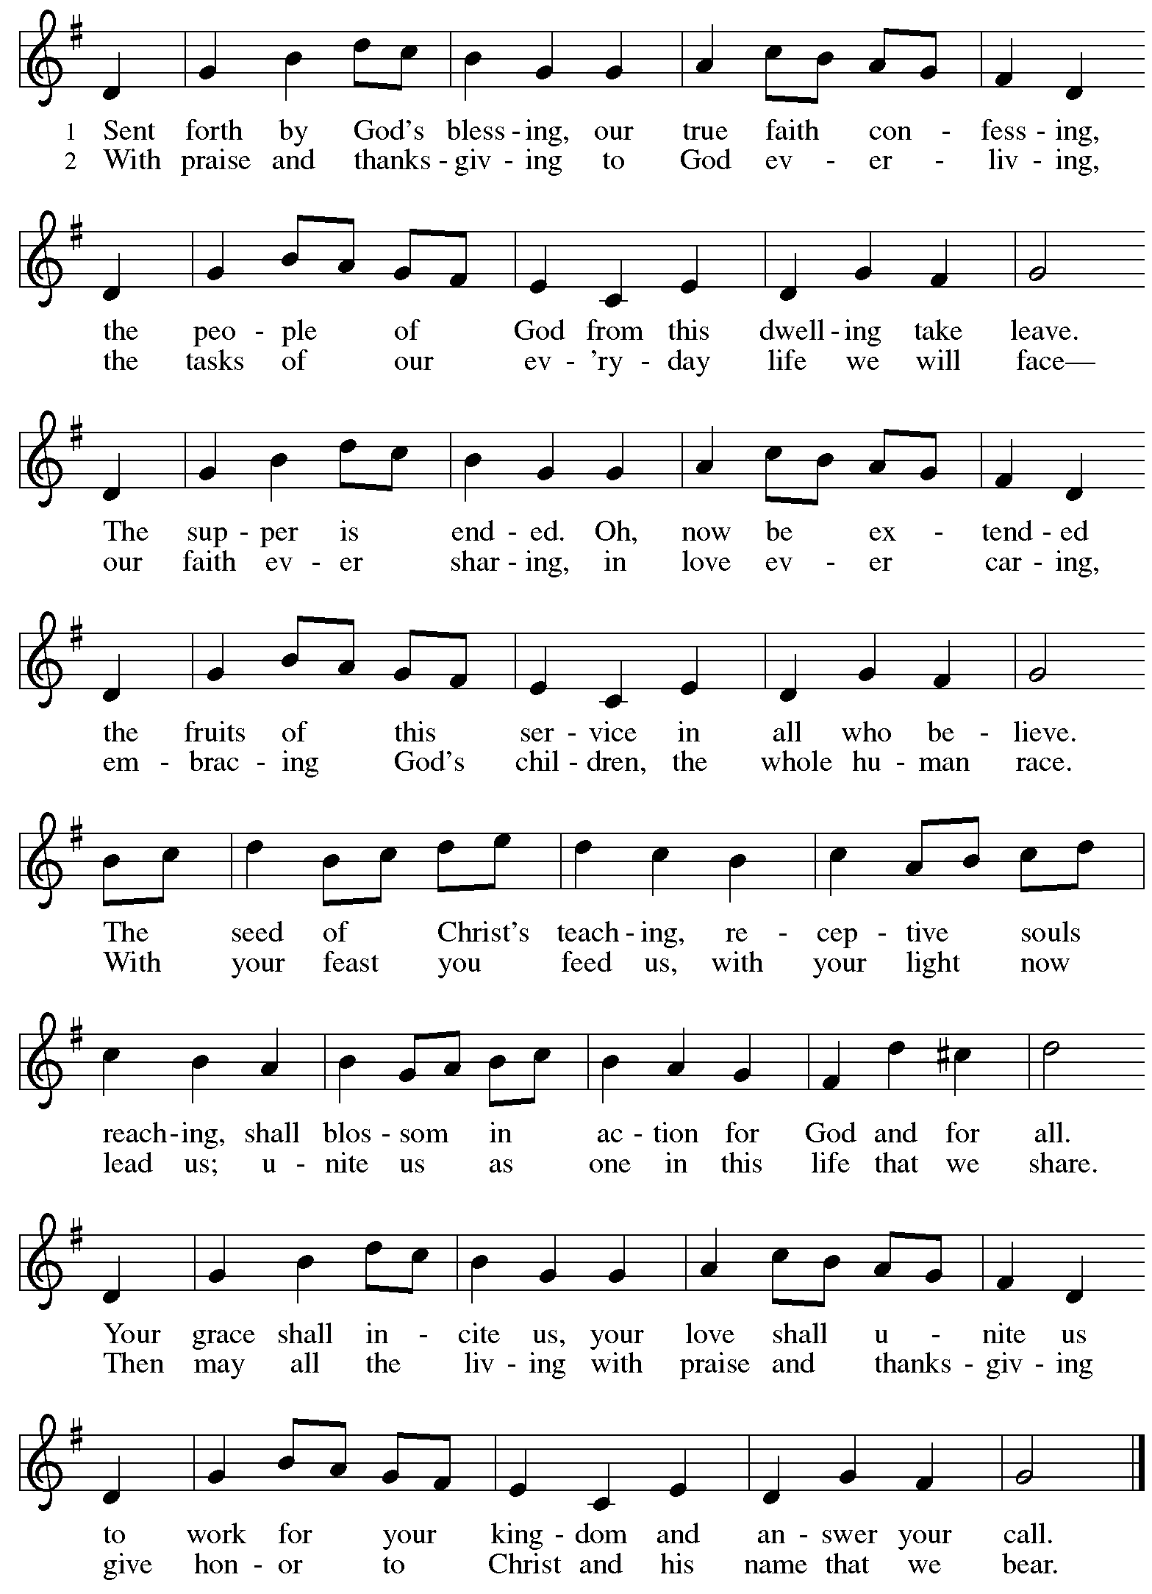
Those serving in worship today

Altar Care Jodie Minor
Assisting Minister Colleen Cooke
Audio-Visual Ministers Kristen Asplin
Tyler Rietze
Cantor Maria Mangano
Lector Kelly Spanninger
Offertory April Galyardt
Kai
Minister of Music Laura Reynolds
Presiding Minister The Rev. Ross I. Carmichael

Liturgy and Hymnody Acknowledgements

From SundaysandSeasons.com. Copyright © 2026 Augsburg Fortress. All rights reserved. Reprinted under OneLicense.net # A-722139.
Used by permission of Augsburg Fortress.

The Scripture readings contained herein are from New Revised Standard Version Updated Edition of the Bible © 2021 National Council of Churches of Christ in the United States of America. Used by permission. All rights reserved worldwide.

Let the Vineyards – Text: John W. Arthur, 1922-1980. Music: Ronald A. Nelson, b. 1927. Text and Music © 1978 Lutheran Book of Worship, admin. Augsburg Fortress.

Sent Forth by God’s Blessing – Text: Omer Westerdorf, 1916-1997, alt. Music: THE ASH GROVE, Welsh folk tune. Text © 1964 World Library Publications, 3708 River Rd., Franklin Park, IL 60131-2158. All rights reserved. Reprinted with permission under OneLicense.net # A-722139.

Please use the QR code below to link to St. Andrew’s Announcements online!



St. Andrew Lutheran Church Announcements
May 3rd, 2026

- Happy Easter! Welcome to Worship at St. Andrew as We Celebrate the Fifth Sunday of Easter! – We are so glad you are here to share in this festive season, and we offer a special welcome to all visitors and guests who are here for the first time! Little Church – Big Faith, a Bible lesson and activity for children up to sixth grade, will take place after the prayer of the day. There are worship “toolkits” to help children engage with worship and “busy bags” for younger children available in the bookcase at the back of the sanctuary. Please feel free to take one to use with/for your children. A nursery is available through the door to the left of the worship space and across the social hall (look for a purple room). All are invited to gather for coffee, other drinks, food, and conversation in the social hall after worship. We pray that everyone has a blessed Easter season!
- Reparations Offering, Today, May 3rd during Worship – In Luke’s Gospel, Jesus tells a story about a compassionate Samaritan, suggesting that God’s people are called to work for healing and restoration for our neighbors, regardless of who or what caused them harm. In light of this, St. Andrew has made a commitment to reparations in regard to African American spiritual songs used in our worship. The text and music of most hymns is attributed to specific authors, with copyrights in place, usage reported, and royalties paid to those whose works are featured in worship. With African American spirituals, this is not possible. In response to many years of such uncredited use, St. Andrew invites the congregation to give a reparations offering. Funds received in worship will be donated to our siblings at Bethel AME Church, whose land and building were taken from them in the 1950s, to fund their development in the Hill District.
- Produce Distribution Supplemental Food of the Month – St. Andrew is collecting supplemental food each month to accompany our produce distribution. For May, we ask for donations of shelf-stable sandwich toppings (e.g. peanut butter, jam, giardiniera, hummus, tapenade, etc). There are collection boxes at the back of the worship space and social hall.
- Spring Cleaning Work Day, Next Saturday, May 9th, 9:00 a.m. – It is truly a blessing to see the signs of Spring returning to our landscape, which always means that some Spring Cleanup is surely due. This past winter and the new roof project have left our outdoor spaces desperately in need of some tender loving care. There is a work day here at St. Andrew on Saturday, May 9th, on Mother's Day weekend. We are planning outdoor leaf clean-up, tree trimming and planting of flowers around the front entrances. There will be coffee and donuts ready for the early birds and water to keep you hydrated all day long. You do not need to come early in the morning and you do not need to stay for the entire day. We ask that if anyone has boxes to recycle please drop them off at the church before cleanup day. Please join us on May 9th to share this love and fellowship…many hands make light work. To sign up, please click this link: https://www.signupgenius.com/go/5080B4AAFAF2CABF85-63009079-spring.
- Alternatives to Violence Project Workshops, Saturday, May 16th and 23rd, 9:00 a.m. to 8:00 p.m. – The AVP workshops will be held at St. Andrew Lutheran Church (304 Morewood Ave, Pittsburgh, PA 15213) and will be open to both teens and adults. AVP is not a lecture or a debate. It is a hands-on, participatory experience that equips people with practical tools for: affirmation and respect, clear communication, cooperation in the midst of tension, transforming conflict rather than avoiding or inflaming it. To learn more, follow the link here: https://friendspeaceteams.org/cultures-justice-peace/. You can register to these workshops here: https://docs.google.com/forms/d/e/1FAIpQLSfjPQKcnyQNx26wqTHzyby9YMi7BYHrUUfUha3PoxXpC50XNw/viewform.
- Bible Book Club – Wednesdays, 7:00 p.m. on Zoom – Bible Book Club meets each Wednesday at 7:00 p.m. Bible Book Club reads not only the Bible but also books about the Bible and other theological topics. The discussions are informal with no pre-determined topics. Each week is a stand-alone discussion and not dependent on previous discussions. The next book we are planning on reading is Contemplative Prayer: Praying When the Well Runs Dry by Joann Nesser. You can join the Zoom call here: https://us02web.zoom.us/j/83196175976?pwd=ejdPOUYrTk4xVFdsdlhHUVJ1L3k2Zz09.
- Pride Month Celebrations, Saturday, June 6th, 10:00 a.m. to 6:00 p.m. – Every June is celebrated as Pride month to commemorate years of struggle for civil rights and the ongoing pursuit of justice for the LGBTQ+ community in the face of police brutality and systemic disenfranchisement. St Andrew will be sponsoring a booth at both Pittsburgh Pride on June 6th, between 10:00 a.m. and 6:00 p.m. and Millvale Pride on June 20th starting at 12:00 p.m.
You can sign up to volunteer here: https://www.signupgenius.com/go/5080B4AAFAF2CABF85-63577363-pittsburgh.
- Coffee Hour Signups – St. Andrew provides hospitality during a coffee hour after worship each Sunday. If you would like to participate, please sign up using the following form: https://www.signupgenius.com/go/5080B4AAFAF2CABF85-47069030-coffee#/.
- Christ in Our Home Devotional Booklets for April – June Available at Entrances – This resource offers a daily Bible reading with a short reflection and prayer, along with additional readings and prayer topics for those who would like to expand their devotional practices. We encourage people of the congregation to take one for yourself, your family/household, or others!

