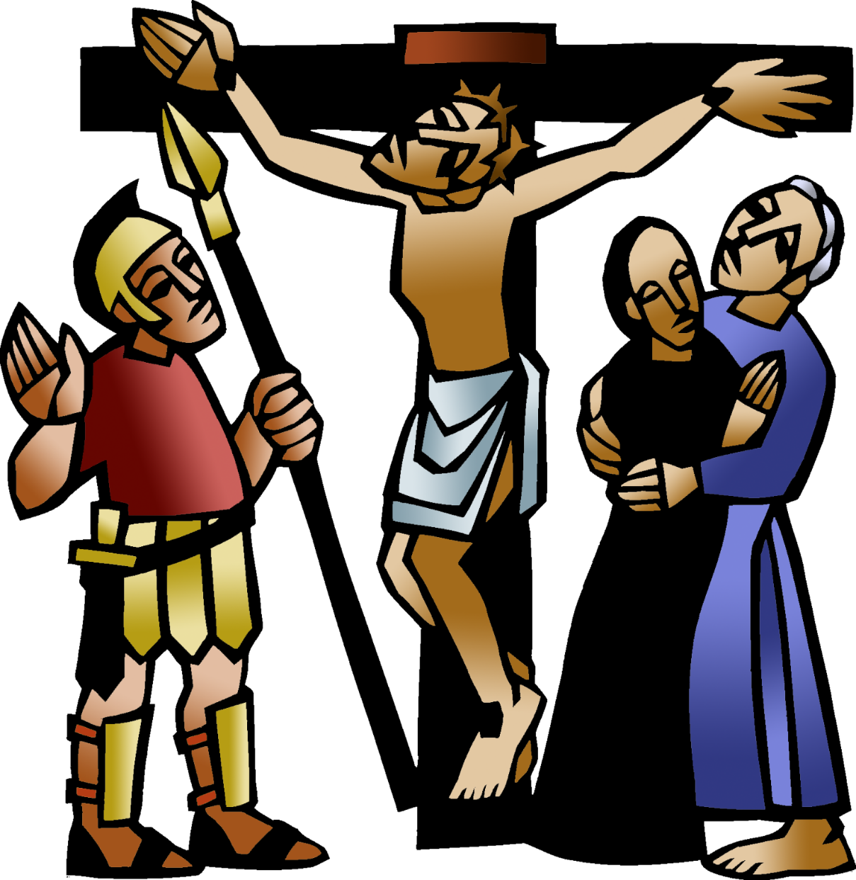

+ Triduum – Good Friday
Service of Shadows and Stones
April 3, 2026 – 7:00 p.m.


St. Andrew Lutheran Church
304 Morewood Ave.
Pittsburgh, PA 15213
St_andrewELCA@verizon.net
www.standrewpittsburgh.org
+ Triduum – Good Friday
+ Triduum – Good Friday
Service of Shadows and Stones
Order for Worship

Life and death are side by side as we enter into Good Friday.
Jesus reveals the power and glory of God, even as he is put on trial and sentenced to death.
We invite everyone to carry stones this evening as we worship. They may symbolize our hurtful words and actions toward others, who are the image of Christ among us. They may stand for the burdens that we carry and the troubles of our darkest days. They may represent all that separates us from God and neighbor, all that we want to leave behind as we gather at the foot of the cross. We will place the stones there, praying for the whole world and trusting that while we gather in solemn devotion, the tree around which we assemble is indeed a tree of life for all. The stones will make up the empty tomb at Easter, when God extends forgiveness and new life through the risen Christ. Worship for this evening concludes with adoration of the cross and the crucified Jesus, who brings the promise of salvation to the world. We depart in silence, and we anticipate the culmination of the Three Days in the Easter Vigil.

Welcome to St. Andrew
- St. Andrew welcomes all who are seeking a place of healing, wholeness, and acceptance in a nurturing and faith-forming spiritual home. We are striving toward racial equity worldwide
and we seek to honor the lived experience of all individuals regardless of background. Our community embraces people of all ages, ethnicities, cultures, abilities, sexual orientations,
gender identities and expressions, and family constellations. Come and See!
- Worship Services are live-streamed to multiple online platforms. By attending worship, you agree that your image and voice may be broadcast.
- Everyone is invited to make a name tag at the black bookcase in the back of the worship space if they would like. There are stickers indicating pronouns on the bookcase if you would like to include them on your name tag.
- A nursery is available through the doors at the left side of the sanctuary and across from the doorway to the Social Hall. Look for a purple-colored room.
- Worship “toolkits” to help children engage with the service, along with “busy bags” for younger children, are available in the bookcase at the back of the sanctuary. Please feel free to take one to use with/for your children.
- A restroom is available on the main level of the church, through the doors to the Social Hall and to the right in the main office.

Abbreviations
P: Pastor/Presiding Minister ELW: Evangelical Lutheran Worship hymnal
C: Congregation MSB1: Music Source Book

Worship begins in silence.

Please rise as you are able.

Invocation

P: In the name of the Father,
and of the ☩ Son,
and of the Holy Spirit.
C: Amen.

Dialogue (based on Lamentations 1: 12)

P: All you who pass this way,
C: look and see, the shadow of sin.

P: All you who pass this way,
C: look and see, the weight of the world.

P: All you who pass this way,
C: look and see, the suffering of our Savior.

P: All you who pass this way,
C: look and see, the sorrow of God’s people and of Jesus Christ.

P: Behold, the Lamb of God,
C: who takes away the sin of the world.

Prayer of the Day

P: Let us pray.

A brief silence is kept.

P: Almighty God,
look with loving mercy on your human family,
for whom our Lord Jesus Christ was willing to be betrayed,
to be given over to the hands of sinners, and to suffer death on the cross;
the one who now lives and reigns with you and the Holy Spirit,
one God, now and forever.
C: Amen.

Hymn My Song Is Love Unknown ELW 343

1 My song is love unknown,
my Savior's love to me,
love to the loveless shown
that they might lovely be.
Oh, who am I that for my sake
my Lord should take frail flesh and die?

2 He came from his blest throne
salvation to bestow;
the world that was his own
would not its Savior know.
But, oh, my friend, my friend indeed,
who at my need his life did spend!

3 Sometimes we strew his way
and his sweet praises sing;
resounding all the day
hosannas to our king.
Then "Crucify!" is all our breath,
and for his death we thirst and cry.

4 We cry out; we will have
our dear Lord made away,
a murderer to save,
the prince of life to slay.
Yet cheerful he to suff'ring goes
that he his foes from thence might free.

Text: Samuel Crossman, 1624-1683, alt.
Music: John Ireland, 1879-1962.
Music © 1924 John Ireland, admin. The John Ireland Trust.
All rights reserved. Reprinted with permission under OneLicense.net # A-722139.

Please be seated.

Shadow of Condemnation

Reading Matthew 27: 32-42

³²As they went out, they came upon a man from Cyrene named Simon; they compelled this man to carry [Jesus’] cross. ³³And when they came to a place called Golgotha (which means Place of a Skull), ³⁴they offered him wine to drink, mixed with gall, but when he tasted it, he would not drink it. ³⁵And when they had crucified him, they divided his clothes among themselves by
casting lots; ³⁶then they sat down there and kept watch over him. ³⁷Over his head they put the charge against him, which read, “This is Jesus, the King of the Jews.”
³⁸Then two rebels were crucified with him, one on his right and one on his left. ³⁹Those who passed by derided him, shaking their heads ⁴⁰and saying, “You who would destroy the temple and build it in three days, save yourself! If you are the Son of God, come down from the cross.” ⁴¹In the same way the chief priests also, along with the scribes and elders, were mocking him, saying, ⁴²“He saved others; he cannot save himself. He is the King of Israel; let him come down from the cross now, and we will believe in him.”

Response Ah, Holy Jesus ELW 349
v. 1-2, 4

1 Ah, holy Jesus, how hast thou offended
that we to judge thee have in hate pretended?
By foes derided, by thine own rejected,
O most afflicted.

2 Who was the guilty? Who brought this upon thee?
Alas, my treason, Jesus, hath undone thee.
'Twas I, Lord Jesus, I it was denied thee;
I crucified thee.

4 For me, kind Jesus, was thine incarnation,
thy mortal sorrow, and thy life's oblation;
thy death of anguish and thy bitter passion,
for my salvation.

Text: Johann Heermann, 1585-1647; tr. Robert Bridges, 1844-1930, alt. Music: HERZLIEBSTER JESU, Johann Crüger, 1598-1662.

Prayer

P: Let us pray.
Forgiving Christ,
when the world condemns us, when wrong is done to us,
when we carry the weight of things that feel too heavy to forgive,
come alongside us in the darkness,
and give us grace to be forgiven and forgiving.
C: Amen.

Shadow of Separation

Reading Luke 23: 39-43

³⁹One of the criminals who were hanged there kept deriding him and saying, “Are you not the Messiah? Save yourself and us!” ⁴⁰But the other rebuked him, saying, “Do you not fear God, since you are under the same sentence of condemnation? ⁴¹And we indeed have been condemned justly, for we are getting what we deserve for our deeds, but this man has done nothing wrong.”
⁴²Then he said, “Jesus, remember me when you come in your kingdom.” ⁴³He replied, “Truly I tell you, today you will be with me in paradise.”

Response Jesus, Remember Me ELW 616

Jesus, Remember Me is a hymn in the Taizé style,
sung multiple times to aid in focused meditation.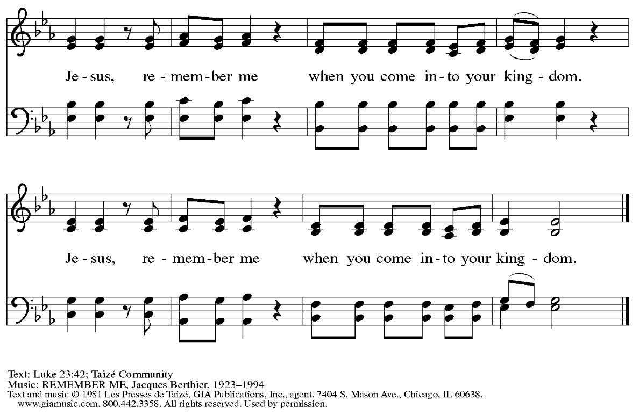
Reprinted with permission under OneLicense.net # A-722139.

Prayer

P: Let us pray.
Reconciling Christ,
we are weighed down by sin and separation, in a world that is not at peace,
amid people who like us are seeking healing and wholeness.
You reached out to the one crucified beside you and welcomed him to God’s side.
Come alongside us in the darkness,
and bring grace and peace to everything in need of redemption.
C: Amen.

Shadow of Sorrow

Reading John 19: 25b-27
Meanwhile, standing near the cross of Jesus were his mother, and his mother's sister, Mary the wife of Clopas, and Mary Magdalene. ²⁶When Jesus saw his mother and the disciple whom he loved standing beside her, he said to his mother, “Woman, here is your son.” ²⁷Then he said to the disciple, “Here is your mother.” And from that hour the disciple took her into his own home.

Response Tree of Life and Awesome Mystery ELW 334
v. 1-2, Lent 5

1 Tree of Life and awesome myst'ry,
in your death we are reborn;
though you die in all of hist'ry,
still you rise with ev'ry morn,
still you rise with ev'ry morn.

2 We remember truth once spoken,
love passed on through act and word;
ev'ry person lost and broken
wears the body of our Lord,
wears the body of our Lord.

Lent 5
God of all our fear and sorrow,
God who lives beyond our death,
hold us close through each tomorrow,
love as near as ev'ry breath.

Text: Marty Haugen, b. 1950. Music: THOMAS, Marty Haugen. Text and Music © 1984 GIA Publications, Inc., 7404 S. Mason Ave., Chicago, IL 60638. www.giamusic.com. 800.442.3358. All rights reserved. Reprinted with permission under OneLicense.net # A-722139.

Prayer

P: Let us pray.
Loving Christ, we carry the pain, sorrow, and suffering of the people we love.
Our care for them is deep, and sometimes there is little we can do.
Come alongside us in the darkness,
and embrace the ones we love in your strong and caring hands.
C: Amen.

Shadow of Despair

Reading Matthew 27: 45-49

⁴⁵From noon on, darkness came over the whole land until three in the afternoon. ⁴⁶And about three o'clock Jesus cried with a loud voice, “Eli, Eli, lema sabachthani?” that is, “My God, my God, why have you forsaken me?” ⁴⁷When some of the bystanders heard it, they said, “This man is calling for Elijah.” ⁴⁸At once one of them ran and got a sponge, filled it with sour wine, put it on a stick, and gave it to him to drink. ⁴⁹But the others said, “Wait, let us see whether Elijah will come to save him.”

Response – Psalm 22: 1-22 MSB1 S448

Psalm 22 is sung by two cantors. The congregation is invited to join in signing the refrain.

Psalm refrain

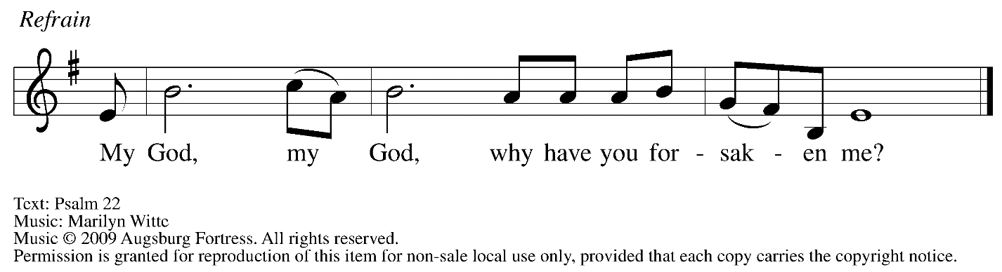

¹My God, my God, why have you for- | saken me?
Why so far from saving me, so far from the words | of my groaning?
²My God, I cry out by day, but you | do not answer;
by night, but I | find no rest.
³Yet you are the | Holy One,
enthroned on the prais- | es of Israel.
⁴Our ancestors put their | trust in you,
they trusted, and you | rescued them. R
⁵They cried out to you and | were delivered;
they trusted in you and were not | put to shame.
⁶But as for me, I am a worm | and not human,
scorned by all and despised | by the people.
⁷All who see me laugh | me to scorn;
they curl their lips; they | shake their heads.
⁸“Trust in the Lord; let the | Lord deliver;
let God rescue him if God so de- | lights in him.” R
⁹Yet you are the one who drew me forth | from the womb,
and kept me safe on my | mother’s breast.
¹⁰I have been entrusted to you ever since | I was born;
you were my God when I was still in my | mother’s womb.
¹¹Be not far from me, for trou- | ble is near,
and there is no | one to help.
¹²Many young bulls en- | circle me;
strong bulls of Ba- | shan surround me. R
¹³They open wide their | jaws at me,
like a slashing and | roaring lion.
¹⁴I am poured out like water; all my bones are | out of joint;
my heart within my breast is | melting wax.
¹⁵My strength is dried up like a potsherd; my tongue sticks to the roof | of my mouth;
and you have laid me in the | dust of death.
¹⁶Packs of dogs close me in, a band of evildoers | circles round me;
they pierce my hands | and my feet. R
¹⁷I can count | all my bones
while they stare at | me and gloat.
¹⁸They divide my gar- | ments among them;
for my clothing, | they cast lots.
¹⁹But you, O Lord, be not | far away;
O my help, hasten | to my aid.
²⁰Deliver me | from the sword,
my life from the power | of the dog.
²¹Save me from the | lion’s mouth!
From the horns of wild bulls you have | rescued me.
²²I will declare your name | to my people;
in the midst of the assembly | I will praise you. R
Prayer

P: Let us pray.
Lord Jesus Christ, you know what it is like to feel that God is far away.
You know what it is like to call out for God’s presence.
Come alongside us in the darkness,
and enable us to call on God in all our need.
C: Amen.

Shadow of Suffering

Reading John 19: 28-29

²⁸After this, when Jesus knew that all was now finished, he said (in order to fulfill the scripture), “I am thirsty.” ²⁹A jar full of sour wine was standing there. So they put a sponge full of the wine on a branch of hyssop and held it to his mouth.

Response O Sacred Head, Now Wounded ELW 351
v. 1-3

1 O sacred head, now wounded,
with grief and shame weighed down,
now scornfully surrounded
with thorns, thine only crown;
O sacred head, what glory,
what bliss till now was thine!
Yet, though despised and gory,
I joy to call thee mine.

2 How pale thou art with anguish,
with sore abuse and scorn;
how does thy face now languish,
which once was bright as morn!
Thy grief and bitter passion
were all for sinners' gain;
mine, mine was the transgression,
but thine the deadly pain.

3 What language shall I borrow
to thank thee, dearest friend,
for this thy dying sorrow,
thy pity without end?
Oh, make me thine forever,
and should I fainting be,
Lord, let me never, never
outlive my love to thee.

Prayer

P: Let us pray.
Suffering Christ, in all our thirst, in all our sickness,
in all our longing, in all our pain, you are there.
Come alongside us in the darkness,
and accompany us through all of our suffering.
C: Amen.

Shadow of Death

Reading Luke 23: 44-49

⁴⁴It was now about noon, and darkness came over the whole land until three in the afternoon,
⁴⁵while the sun's light failed, and the curtain of the temple was torn in two. ⁴⁶Then Jesus, crying out with a loud voice, said, “Father, into your hands I commend my spirit.” Having said this, he breathed his last. ⁴⁷When the centurion saw what had taken place, he praised God and said, “Certainly this man was innocent.” ⁴⁸And when all the crowds who had gathered there for this spectacle saw what had taken place, they returned home, beating their breasts. ⁴⁹But all his acquaintances, including the women who had followed him from Galilee, stood at a distance watching these things.

Response Were You There ELW 353

1 Were you there when they crucified my Lord?
Were you there when they crucified my Lord?
Oh, sometimes it causes me to tremble, tremble, tremble.
Were you there when they crucified my Lord?

2 Were you there when they nailed him to the tree?
Were you there when they nailed him to the tree?
Oh, sometimes it causes me to tremble, tremble, tremble.
Were you there when they nailed him to the tree?

3 Were you there when they pierced him in the side?
Were you there when they pierced him in the side?
Oh, sometimes it causes me to tremble, tremble, tremble.
Were you there when they pierced him in the side?

4 Were you there when the sun refused to shine?
Were you there when the sun refused to shine?
Oh, sometimes it causes me to tremble, tremble, tremble.
Were you there when the sun refused to shine?

5 Were you there when they laid him in the tomb?
Were you there when they laid him in the tomb?
Oh, sometimes it causes me to tremble, tremble, tremble.
Were you there when they laid him in the tomb?

Text: African American spiritual.
Music: WERE YOU THERE, African American spiritual.

Prayer

P: Let us pray.
Faithful Christ, even in death, you are there.
When we are afraid, when we mourn,
when we come to our own end, you are there, too.
Come alongside us in the darkness,
and carry us through death to life.
C: Amen.

Procession of the Cross

A large cross is carried in procession through the church and placed before the assembly.
The assembly faces the cross as it is brought forward.

The following dialogue is sung as procession begins, at its midpoint, and at the end,
with the assembly responding to the leader:

P: Behold, the life-giving cross, on which was hung the salvation of | the whole world.
C: Oh, come, let us | worship Christ.

When the cross has been placed in front of the altar, please be seated.

Adoration of the Cross

At this time, worshipers may come to the large cross to make a sign of reverence.
Reverencing the cross may include such actions as pausing before the cross, touching the cross, bowing, praying and/or kneeling before it.

All are invited to join in singing the hymns during Adoration of the Cross,
found on the following pages.



Hymns during Adoration of the Cross
Adoramus te Christe MSB1 S469

The verses will be sung by a cantor and the refrain will be sung in unison by the congregation.

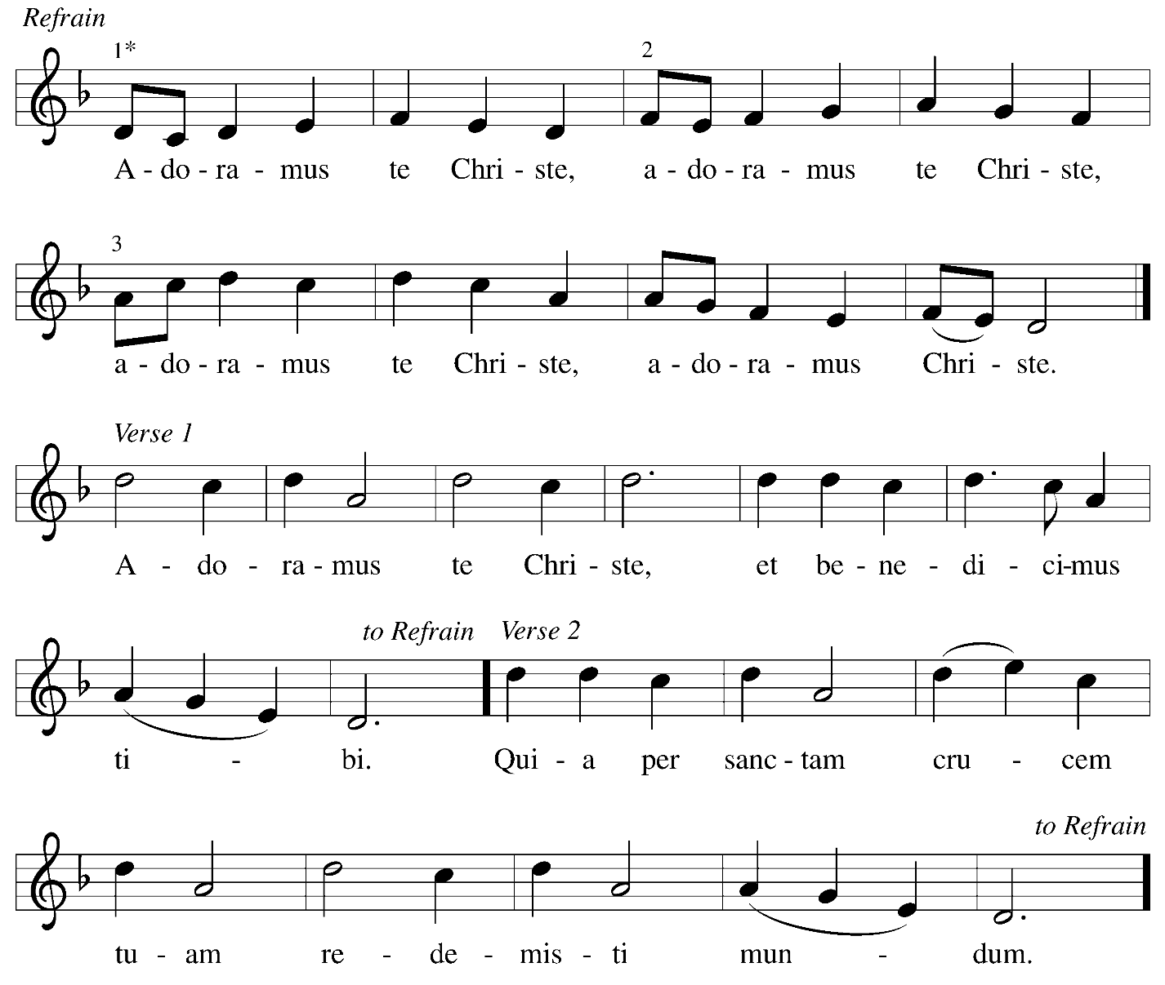

Translation of Refrain: We adore you, Christ.
Verses: 1 We adore you, Christ, and we bless you.
2 By your holy cross you have redeemed the world.

Hymns during Adoration of the Cross
In the Cross of Christ I Glory ELW 324

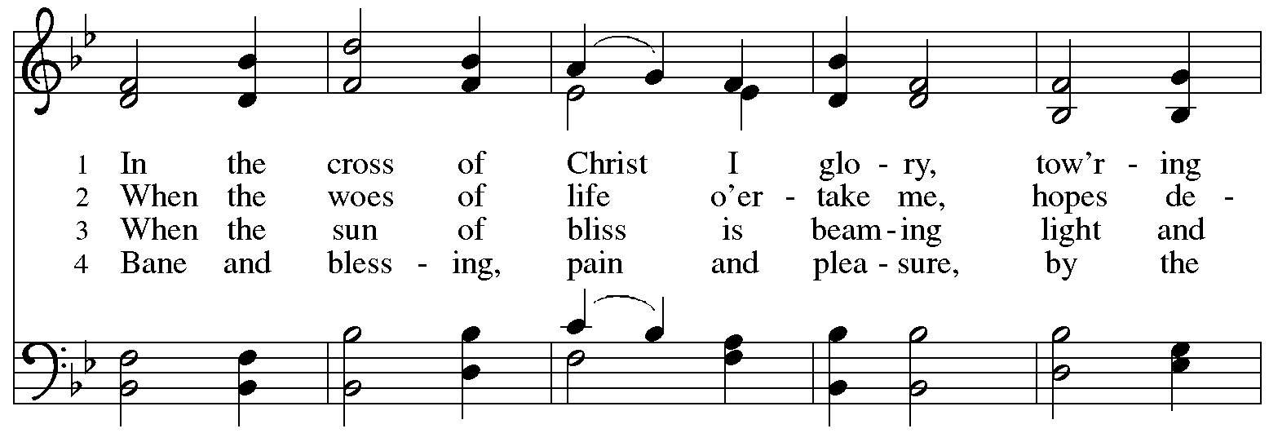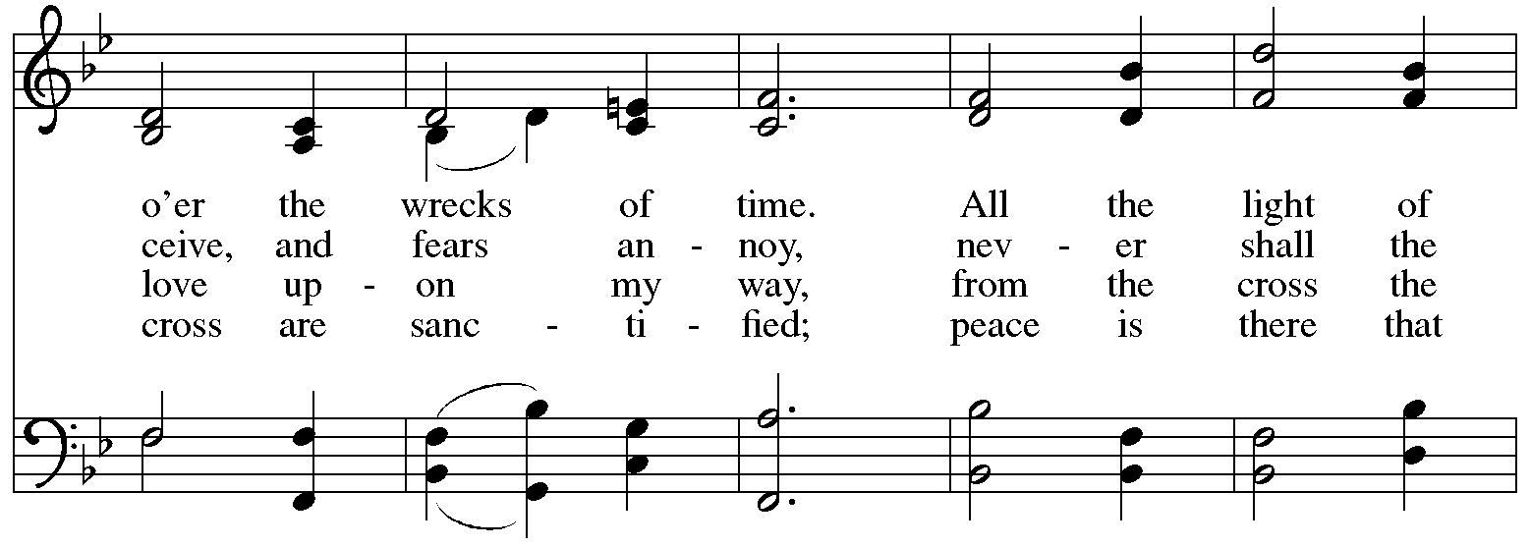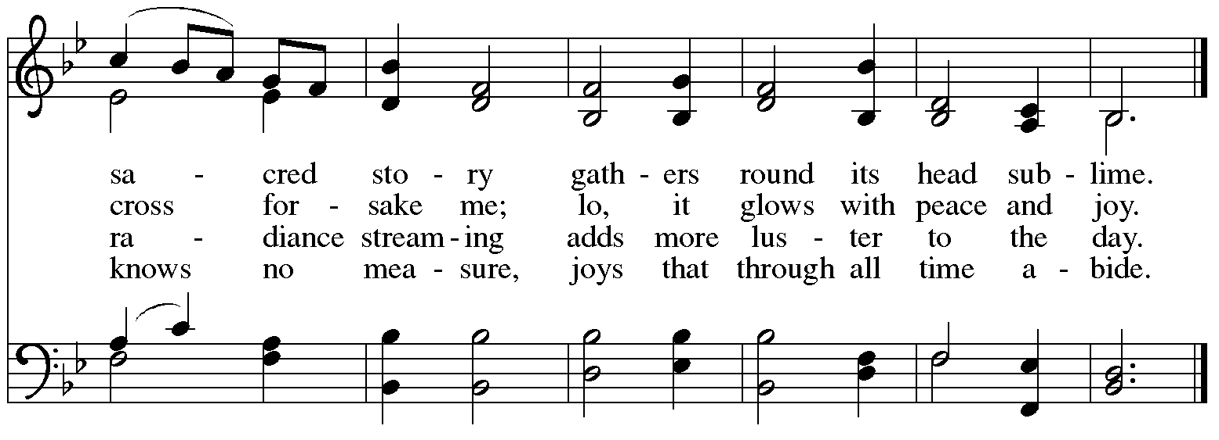

When all have returned to their places, after a brief silence, the concluding dialogue is sung:

P: We adore you, O Christ, | and we bless you,
C: for by your cross you have re- | deemed the world.

Silence is kept for prayer and meditation.

All depart in silence.

If they have not done so earlier, worshipers may reverence the cross before they depart. The service of the Triduum continues tomorrow with the Vigil of Easter at 5:00 p.m.

Those serving in worship today

Cantors Timothy Kocher-Hillmer
C. E. Pino
Minister of Music Laura Reynolds
Presiding Minister Pastor Ross Carmichael

Liturgy and Hymnody Acknowledgements

From SundaysandSeasons.com. Copyright © 2026 Augsburg Fortress. All rights reserved. Reprinted under OneLicense.net # A-722139.
Used by permission of Augsburg Fortress.

The Scripture readings contained herein are from New Revised Standard Version Updated Edition of the Bible © 2021 National Council of Churches of Christ in the United States of America. Used by permission. All rights reserved worldwide

O Sacred Head, Now Wounded – Text: Paul Gerhardt, 1607-1676, based on Arnulf of Louvain, d. 1250; tr. composite. Music: HERZLICH TUT MICH VERLANGEN, German melody, c. 1500; adapt. Hans Leo Hassler, 1564-1612; arr. Johann Sebastian Bach, 1685-1750.

Adoramus te Christe – Music: Marty Haugen, b. 1950. Music © 1984 GIA Publications, Inc., Chicago, giamusic.com. All rights reserved. Reprinted with permission under OneLicense.net # A-722139.

St. Andrew Announcements
Friday, April 3rd, 2026

- Welcome to Worship at St. Andrew on + Good Friday, April 3rd – We are grateful for your presence, and we offer a special welcome to all visitors and guests who are gathered at the church or online. There are worship “toolkits” to help children engage with worship and “busy bags” for younger children available in the bookcase at the back of the sanctuary. Please feel free to take one to use with your children.
- Worship Schedule for Holy Week – The service of the Triduum, the Great Three Days of Holy Week, concludes tomorrow with the Vigil of Easter. The service schedule for the rest of the weekend is:
  - Triduum – The Vigil of Easter, April 4th, 5:00 p.m. – The church tells God’s story of salvation through worship, word, sacrament, and song as we gather around a fire, hear stories of God’s faithfulness throughout the ages, give thanks for the gift of Baptism, and move into the celebration of the resurrection with Holy Communion.
  - The Resurrection of our Lord – Easter Sunday, April 5th, 10:00 a.m. – Worship with Holy Communion – We join the church throughout the world in proclaiming the good news of Christ’s resurrection!

