

+ The Resurrection of our Lord
Easter Sunday
April 5, 2026


St. Andrew Lutheran Church
304 Morewood Ave.
Pittsburgh, PA 15213
St_andrewELCA@verizon.net
www.standrewpittsburgh.org

+ The Resurrection of our Lord
Easter Sunday

“The last enemy to be destroyed is death,” Paul writes. Today Christ is risen, and we gather together with astonishment and joy. Christ is risen, and we have been set free from the bonds of death. Christ is risen, and we are forgiven. Christ is risen, and with the women at the tomb and Peter, we are amazed. Let us rejoice: Christ is risen indeed! Alleluia!

Welcome to St. Andrew!
- St. Andrew welcomes all who are seeking a place of healing, wholeness, and acceptance in a nurturing and faith-forming spiritual home. We are striving toward racial equity worldwide
and we seek to honor the lived experience of all individuals regardless of background. Our community embraces people of all ages, ethnicities, cultures, abilities, sexual orientations,
gender identities and expressions, and family constellations. Come and See!
- Worship Services are live-streamed to multiple online platforms. By attending worship, you agree that your image and voice may be broadcast.
- Everyone is invited to make a name tag at the black bookcase in the back of the worship space if they would like. There are stickers indicating pronouns on the bookcase if you would like to include them on your name tag.
- Little Church – Big Faith, our weekly Bible lesson and activity for children, will not meet during worship this week so the children can fully participate in the celebration of Easter!
- A nursery is available through the doors at the left side of the sanctuary and across from the doorway to the Social Hall. Look for a purple-colored room.
- Worship “toolkits” to help children engage with the service, along with “busy bags” for younger children, are available in the bookcase at the back of the sanctuary. Please feel free to take one to use with/for your children.
- Holy Communion is served with bread (gluten-free available) and wine or grape juice. The presiding minister will distribute the bread (host). Please consume this and then pick up an empty glass from the tray. The Communion Assistant will pour wine or grape juice into your glass. Please step to the side to consume the wine or grape juice. Feel free to kneel at the altar for prayer and reflection. As you return to your pew, glasses may be returned to the empty trays on either side of the center section.
- A restroom is available on the main level of the church, through the doors to the Social Hall and to the right in the main office.

Abbreviations
P: Pastor/Presiding Minister ELW: Evangelical Lutheran Worship hymnal
A: Assisting Minister ACS: All Creation Sings hymnal
L: Lector W&P: Worship & Praise hymnal
C: Congregation

Pre-Service Music

Welcome

Gathering
The Holy Spirit calls us together as the people of God

Children are invited to gather at the front of the worship space for the beginning of the service,
as we welcome back the “Alleluia,” the Church’s song of Easter joy!

Raising the Alleluia

Once the Alleluias have been brought out, the presiding minister and congregation proclaim:
P: Alleluia! Christ is risen!
C: Christ is risen indeed! Alleluia! Alleluia!

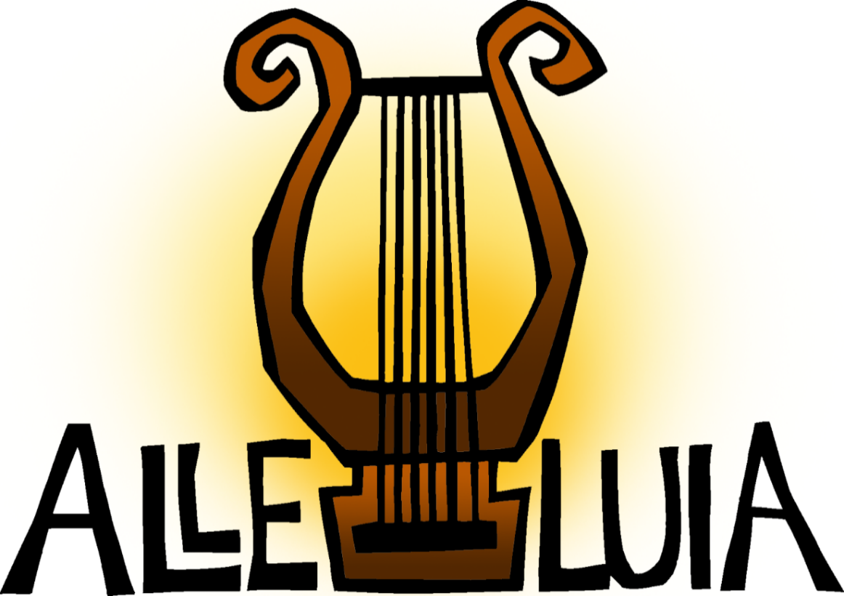

Please rise as you are able and face the cross as the Processional Hymn begins.

Processional Hymn Jesus Christ Is Risen Today ELW 365

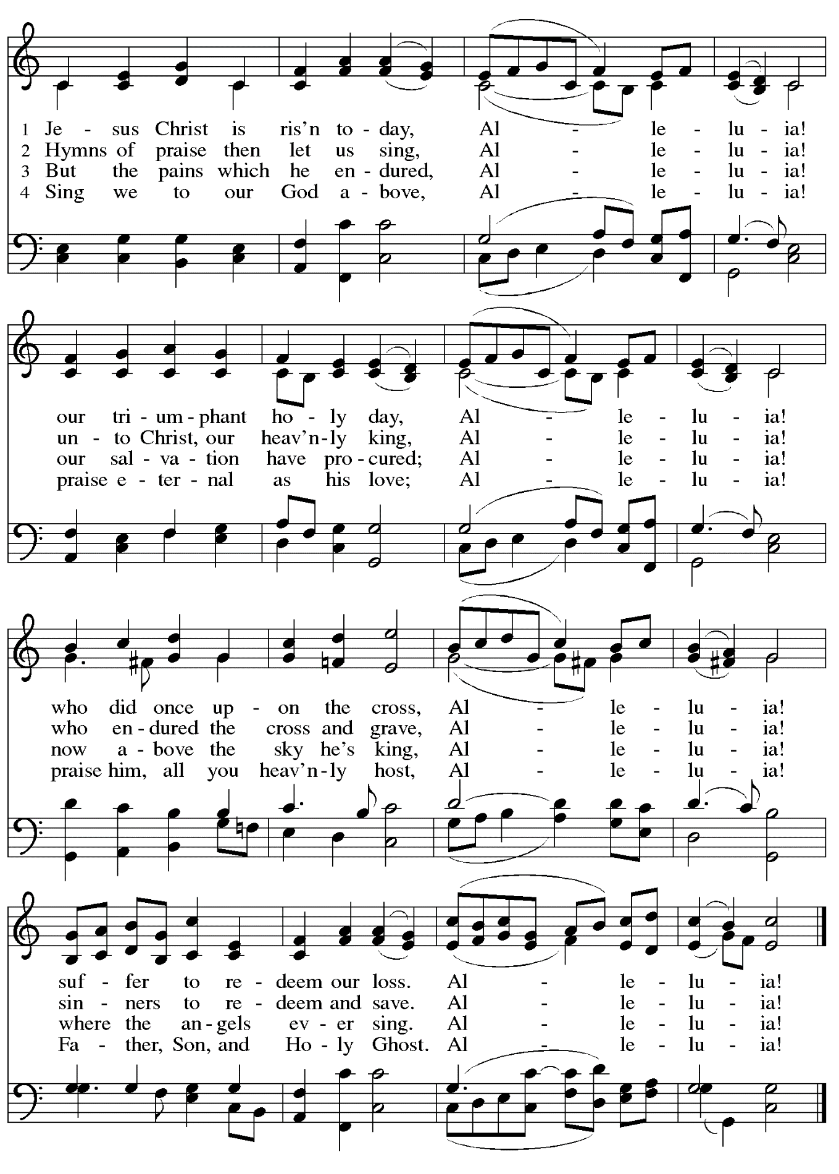

Greeting

P: The grace of our Lord Jesus Christ, the love of God,
and the communion of the Holy Spirit be with you all.
C: And also with you.

Hymn of Praise This Is the Feast ELW p. 149-150

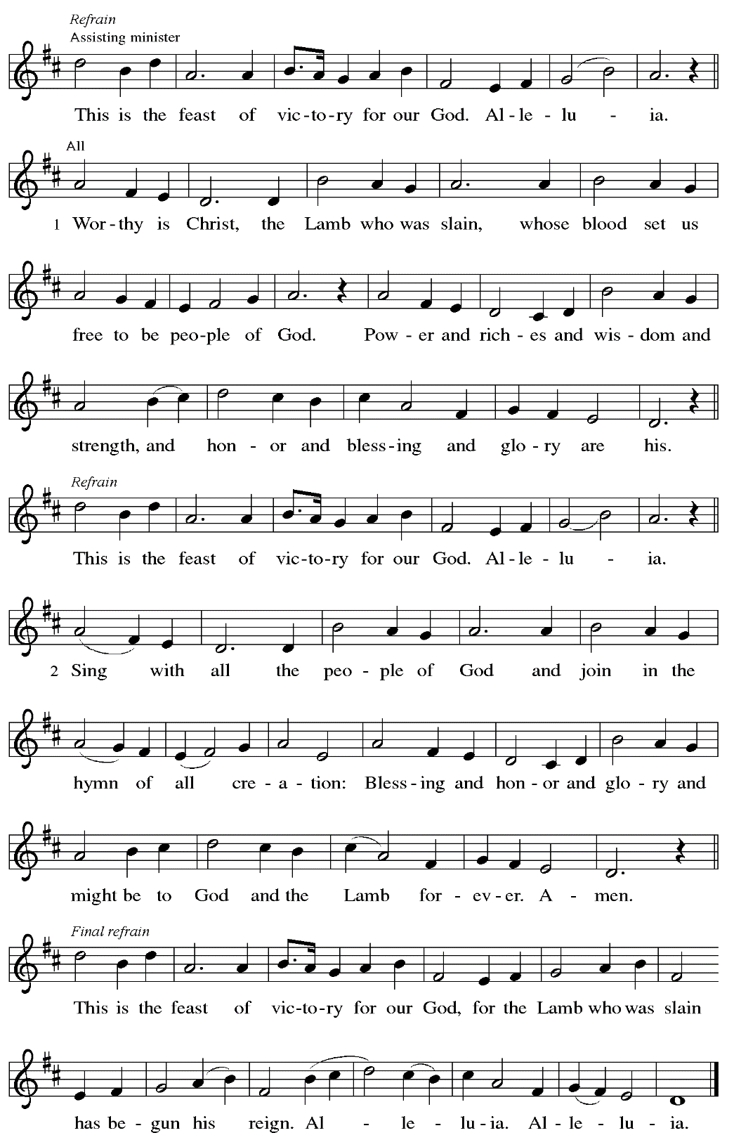

Prayer of the Day

P: The Lord be with you.
C: And also with you.

P: Let us pray.
O God, you gave your only Son to suffer death on the cross for our redemption,
and by his glorious resurrection you delivered us from the power of death.
Make us die every day to sin, that we may live with him forever in the joy of the resurrection, through your Son, Jesus Christ our Lord, who lives and reigns with you and the Holy Spirit,
one God, now and forever.
C: Amen.

Please be seated.

Word
God speaks to us in Scripture reading, preaching, and song

First Reading – Acts 10: 34-43

³⁴ Then Peter began to speak to [Cornelius and his household]: “I truly understand that God shows no partiality, ³⁵ but in every people anyone who fears God and practices righteousness is acceptable to God. ³⁶ You know the message God sent to the people of Israel, preaching peace by Jesus Christ—he is Lord of all. ³⁷ That message spread throughout Judea, beginning in Galilee after the baptism that John announced: ³⁸ how God anointed Jesus of Nazareth with the Holy Spirit and with power; how he went about doing good and healing all who were oppressed by the devil, for God was with him.
³⁹ We are witnesses to all that he did both in Judea and in Jerusalem. They put him to death by hanging him on a tree, ⁴⁰ but God raised him on the third day and allowed him to appear, ⁴¹ not to all the people but to us who were chosen by God as witnesses and who ate and drank with him after he rose from the dead. ⁴² He commanded us to preach to the people and to testify that he is the one ordained by God as judge of the living and the dead. ⁴³ All the prophets testify about him that everyone who believes in him receives forgiveness of sins through his name.”

L: Word of God, word of life.
C: Thanks be to God.

Psalm 118: 1-12, 14-24

The psalm will be sung responsively, led by the cantor,
with the congregation responding with the bold verses and refrain.

Psalm tone

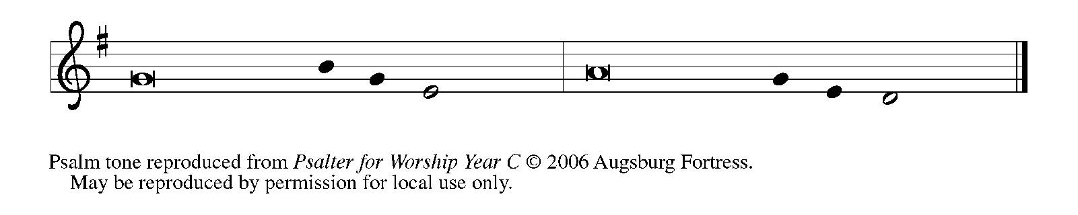

Psalm refrain

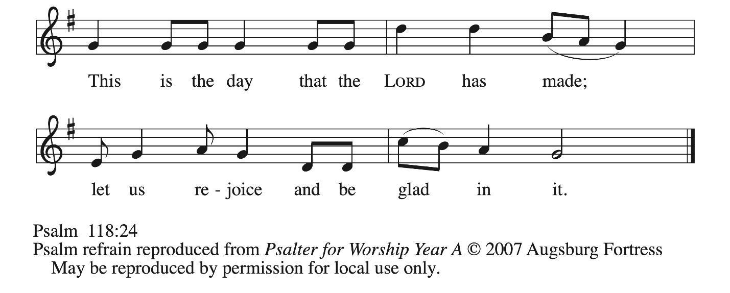
¹Give thanks to the Lord, for the | Lord is good;
God’s mercy en- | dures forever.
²Let Israel | now declare,
“God’s mercy en- | dures forever.”
¹⁴The Lord is my strength | and my song,
and has become | my salvation.
¹⁵Shouts of rejoicing and salvation echo in the tents | of the righteous:
“The right hand of the | Lord acts valiantly!
¹⁶The right hand of the Lord| is exalted!
The right hand of the | Lord acts valiantly!”
¹⁷I shall not | die, but live,
and declare the works | of the Lord. R
¹⁸The Lord indeed pun- | ished me sorely,
but did not hand me o- | ver to death.
¹⁹Open for me the | gates of righteousness;
I will enter them and give thanks | to the Lord.
²⁰“This is the gate | of the Lord;
here the righ- | teous may enter.”
²¹I give thanks to you, for you have | answered me
and you have become | my salvation. R
²²The stone that the build- | ers rejected
has become the chief | cornerstone.
²³By the Lord has | this been done;
it is marvelous | in our eyes.
²⁴This is the day that the | Lord has made;
let us rejoice and be | glad in it. R

Second Reading – Colossians 3: 1-4

¹ If you have been raised with Christ, seek the things that are above, where Christ is, seated at the right hand of God. ² Set your minds on the things that are above, not on the things that are on earth, ³ for you have died, and your life is hidden with Christ in God. ⁴ When Christ who is your life is revealed, then you also will be revealed with him in glory.

L: Word of God, word of life.
C: Thanks be to God.

Please rise as you are able.

Gospel Acclamation ELW p. 151

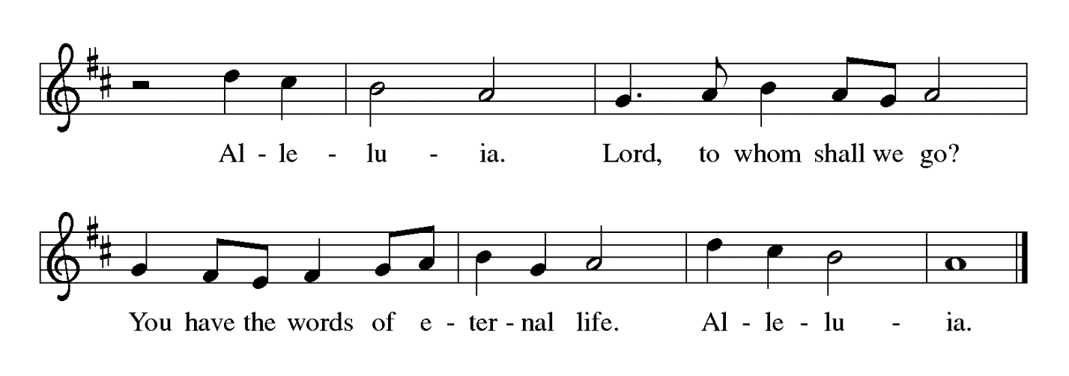

Gospel – Matthew 28: 1-10

P: The holy Gospel according to St. Matthew.
C: Glory to you, O Lord.

¹ After the Sabbath, as the first day of the week was dawning, Mary Magdalene and the other Mary went to see the tomb. ² And suddenly there was a great earthquake, for an angel of the Lord, descending from heaven, came and rolled back the stone and sat on it. ³ His appearance was like lightning and his clothing white as snow. ⁴ For fear of him the guards shook and became like dead men. ⁵ But the angel said to the women, “Do not be afraid, for I know that you are looking for Jesus who was crucified. ⁶ He is not here, for he has been raised, as he said. Come, see the place where he lay. ⁷ Then go quickly and tell his disciples, ‘He has been raised from the dead, and indeed he is going ahead of you to Galilee; there you will see him.’ This is my message for you.” ⁸ So they left the tomb quickly with fear and great joy and ran to tell his disciples. ⁹ Suddenly Jesus met them and said, “Greetings!” And they came to him, took hold of his feet, and worshiped him. ¹⁰ Then Jesus said to them, “Do not be afraid; go and tell my siblings to go to Galilee; there they will see me.”

P: The Gospel of the Lord.
C: Praise to you, O Christ.

Please be seated.

Sermon

A time of silence for prayer and reflection follows the sermon.
When the hymn of the day begins, please rise as you are able.



Hymn of the Day Christ Is Risen! Christ Is Alive! Larsen and Wren

The Hymn of the Day will be sung by the choir, with the congregation invited to sing incorporated verses (1, 5) from Christ Is Alive! Let Christians Sing – ELW 389, printed below.

1 Christ is alive! Let Christians sing.
The cross stands empty to the sky.
Let streets and homes with praises ring.
Love, drowned in death, shall never die.

5 Christ is alive, and comes to bring
good news to this and every age,
till earth and sky and ocean ring
with joy, with justice, love, and praise.

Text: Brian A. Wren, b. 1936.
Music: TRURO, T. Williams, Psalmodia Evangelica, 1789.
Text © 1975, rev. 1995 Hope Publishing Company, Carol Stream, IL 60188.
All rights reserved. Reprinted under OneLicense.net # A-722139.

Nicene Creed

C: We believe in one God,
the Father, the Almighty,
maker of heaven and earth,
of all that is, seen and unseen.

We believe in one Lord, Jesus Christ,
the only Son of God,
eternally begotten of the Father,
God from God, Light from Light,
true God from true God,
begotten, not made,
of one Being with the Father;
through him all things were made.
For us and for our salvation
he came down from heaven,
was incarnate of the Holy Spirit and the virgin Mary
and became truly human.
For our sake he was crucified under Pontius Pilate;
he suffered death and was buried.
On the third day he rose again
in accordance with the scriptures;

he ascended into heaven
and is seated at the right hand of the Father.
He will come again in glory to judge the living and the dead,
and his kingdom will have no end.

We believe in the Holy Spirit, the Lord, the giver of life,
who proceeds from the Father and the Son,*
who with the Father and the Son is worshiped and glorified,
who has spoken through the prophets.
We believe in one holy catholic and apostolic church.
We acknowledge one baptism for the forgiveness of sins.
We look for the resurrection of the dead,
and the life of the world to come. Amen.

*Or, “who proceeds from the Father.” The phrase “and the Son” is a later addition to the creed.

Prayers of the People

A: United in the joy and hope of the resurrection, let us pray for the church, the world,
and all who are in need.

After each petition
A: Gracious God,
C: receive our prayer.

The presiding minister concludes the prayers
P: We lift these prayers to you O God, trusting in your abundant mercy,
through Jesus Christ our risen Savior.
C: Amen.

Peace

The presiding minister and the assembly greet one another in the peace of the risen Christ.
P: The peace of Christ be with you always.
C: And also with you.

The people may greet those around them with a sign of Christ’s peace and may say
Peace be with you or similar words. Please be mindful that not everyone will be comfortable with sharing the peace, so please seek consent before shaking hands or hugging. Other possible ways to share the peace include a simple bow with the verbal greeting of peace, or simply a verbal expression of peace. When the greetings of peace have concluded, please be seated.



Meal
God feeds us with the presence of Jesus Christ

Offering

We offer ourselves, our gifts, and our faithful service to God.
As the offering is gathered for the mission of the church, including the care of those in need,
the table is set for Holy Communion.

There are laminated giving cards in the pew racks that feature a QR code for anyone who would like to give online. Those who give using the QR code, as well as those who give regularly online or through their bank are encouraged to place the laminated card in the plate as an expression of your offering.

Reparations Offering

On the first Sunday of each month, St. Andrew invites people of the congregation to give a second offering for a reparations fund in acknowledgment of St. Andrew’s use of African American spiritual songs in our worship services. Please see the note in the announcements for more information.

Music during the Offering Easter Medley arr. Oines

As the gifts are brought forward for presentation, please rise as you are able.

Offertory Song Let the Vineyards Be Fruitful ELW 184

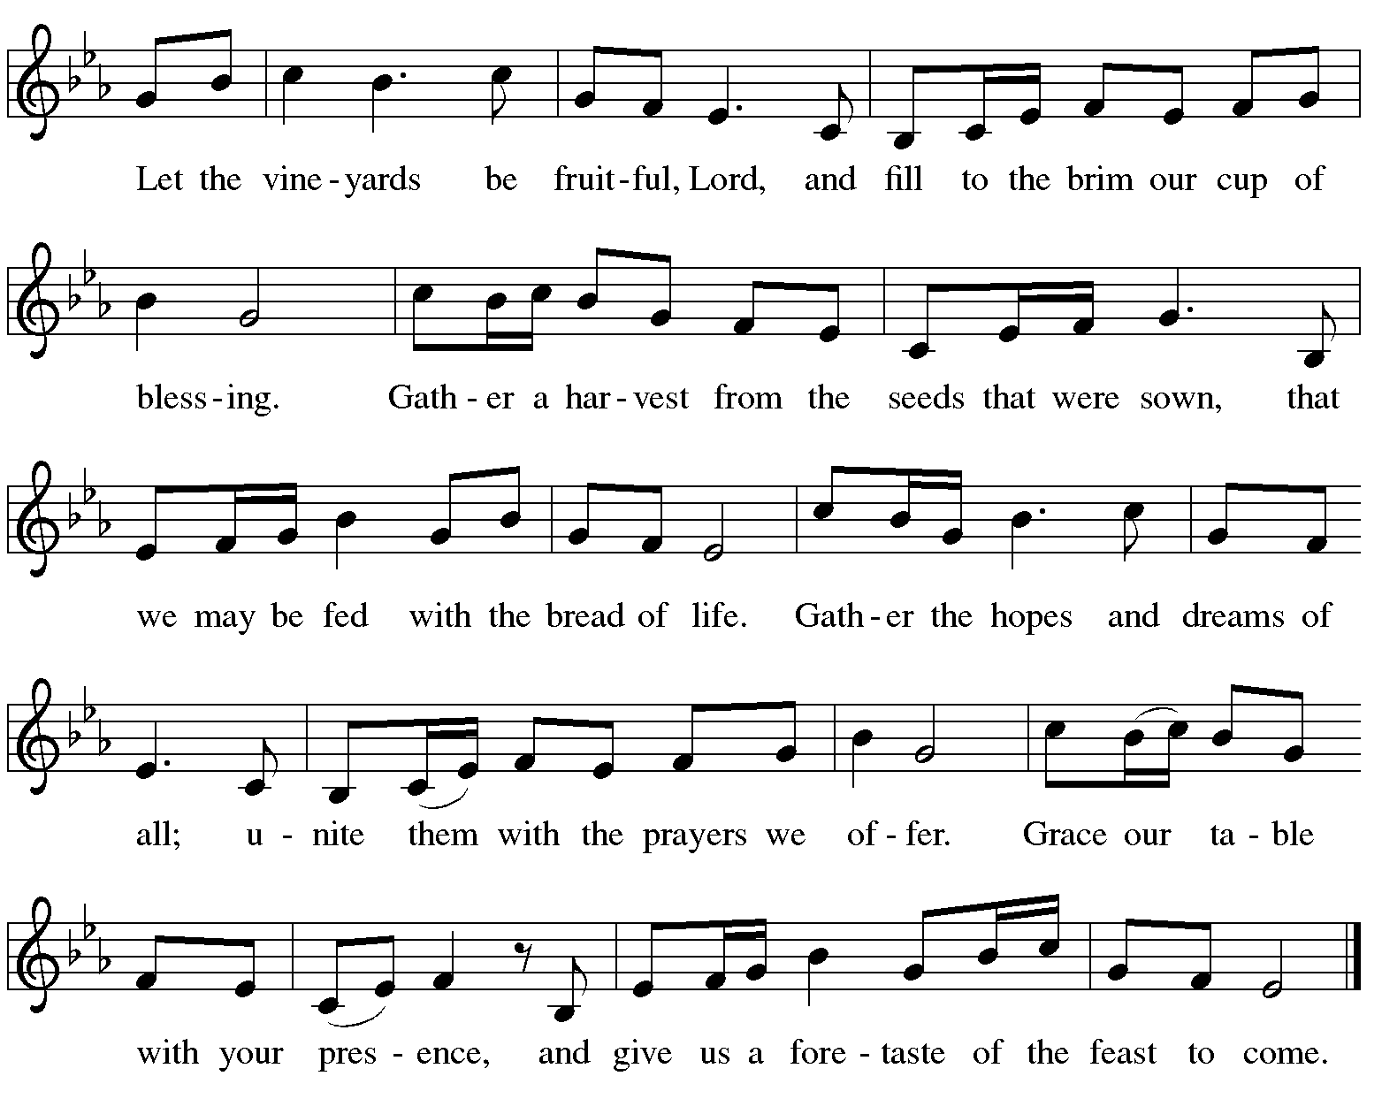

Offertory Prayer

A: Let us pray.
Blessed are you, O God,
C: ruler of heaven and earth.
Day by day you shower us with blessings.
As you have raised us to new life in Christ,
give us glad and generous hearts,
ready to praise you and to respond to those in need,
through Jesus Christ, our Savior and Lord.
Amen.

Dialogue ELW p. 152

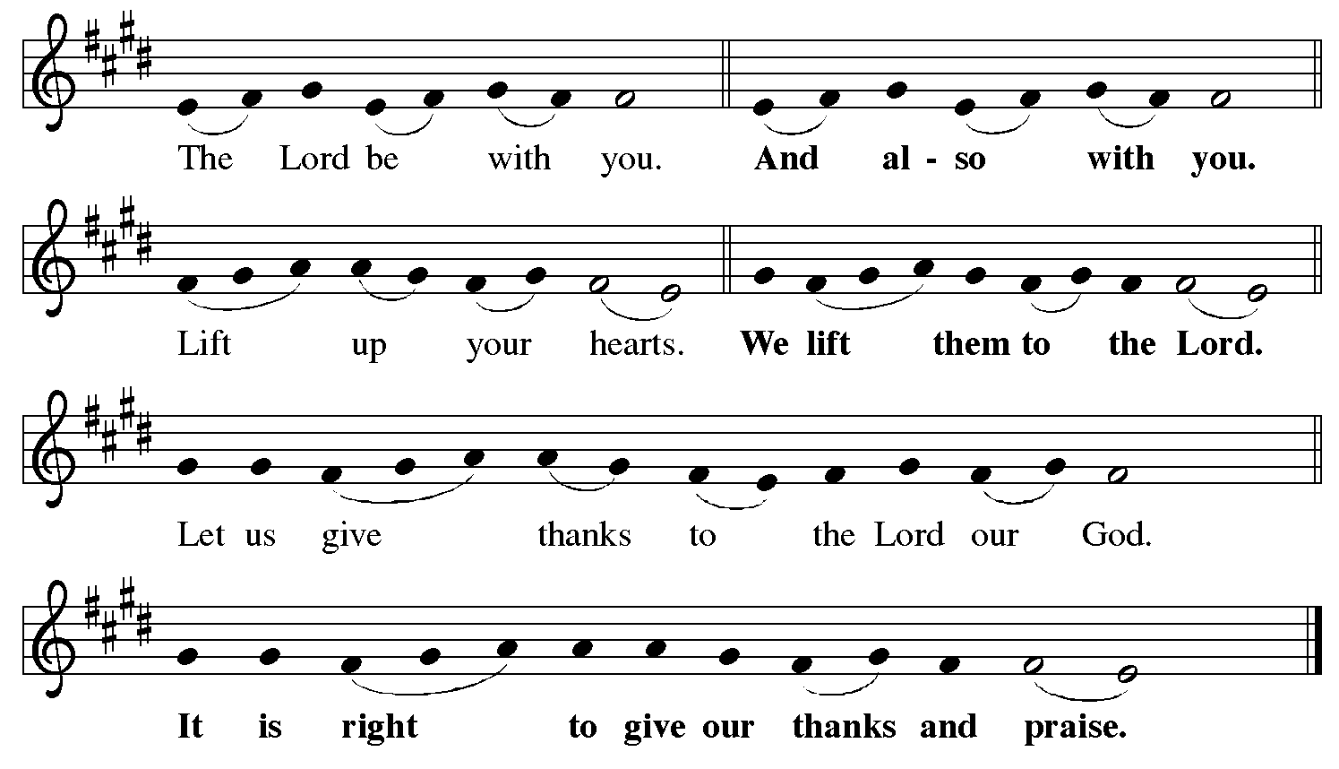

Preface (Sung by the presiding minister)

P: It is indeed right, our duty and our joy,
that we should at all times and in all places
give thanks and praise to you, almighty and merciful God,
for the glorious resurrection of our Savior Jesus Christ,
the true Paschal Lamb who gave himself to take away our sin;
who in dying has destroyed death,
and in rising has brought us to eternal life.
And so, with Mary Magdalene and Peter
and all the witnesses of the resurrection,
with earth and sea and all their creatures,
and with angels and archangels, cherubim and seraphim,
we praise your name and join their unending hymn:

Sanctus ELW p. 153

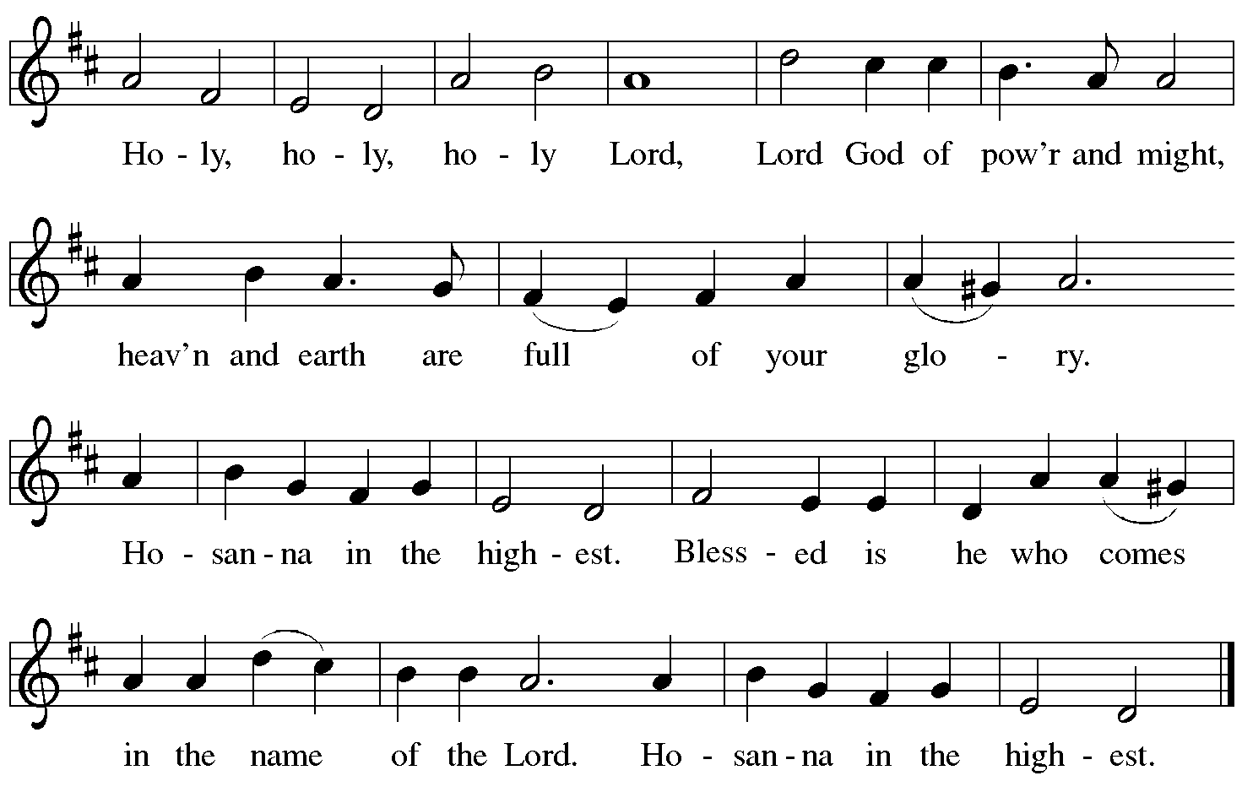

Eucharistic Prayer

P: Blessed are you, O God of the universe …
For Christ is risen:
C: Christ is risen indeed!

P: This is the day on which you gave light to the earth …
and that light is Christ:
C: Thanks be to God.

P: This is the day on which you broke the chains of death …
For Christ is risen:
C: Christ is risen indeed!

P: In the night in which he was betrayed …
… Do this for the remembrance of me.

Let us proclaim the mystery of faith.
C: Christ has died. Christ is risen. Christ will come again.

P: On this day send us the power of your Holy Spirit …
For that light is Christ:
C: Thanks be to God.

P: All holy and mighty and glorious God …
… for Christ is risen:
C: Christ is risen indeed!

P: Amen and Amen!
C: Amen and Amen!

Lord’s Prayer

P: Gathered as one by the Holy Spirit, let us pray as Jesus taught us.
C: Our Father, who art in heaven,
hallowed be thy name,
thy kingdom come,
thy will be done,
on earth as it is in heaven.
Give us this day our daily bread;
and forgive us our trespasses,
as we forgive those
who trespass against us;
and lead us not into temptation,
but deliver us from evil.
For thine is the kingdom,
and the power, and the glory,
forever and ever. Amen.

Fraction and Invitation

P: Alleluia! Christ is risen!
C: Christ is risen indeed! Alleluia! Alleluia!

P: This is the feast of victory for our God. Alleluia! Alleluia!
Come, share the feast.



Agnus Dei / Lamb of God ELW p. 154

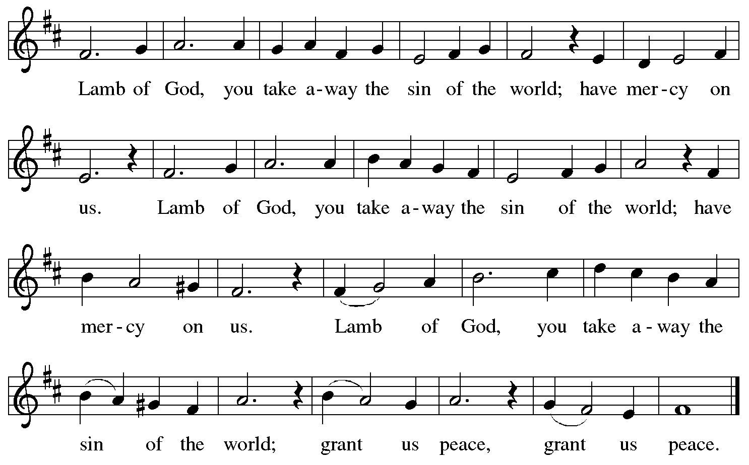

Please be seated.

Holy Communion

- All who seek God and desire a deeper and stronger life in Christ are welcome to receive Holy Communion.
- Worshipers from the pulpit side will proceed forward first, followed by the center section, and then the lectern side.
- Please inform an usher if you would like the ministers to bring Communion to you.
- Holy Communion will be served with bread and wine (red) or grape juice (white).
- The presiding minister will first distribute the bread (host) to each communicant. Please indicate if you require a gluten-free host.
- Once you have consumed the bread, please pick up an empty glass from the tray next to the presiding minister. The Communion Assistant will pour wine or grape juice into your glass.
- Please step to the side to consume the wine or grape juice.
- Feel free to kneel at the altar rail for prayer after receiving the sacrament.
- As you return to your pew, glasses may be returned to the empty tray on the side of the center section.
- A blessing will be provided for anyone who does not yet receive the sacrament.
- All are invited to join in singing the hymns during Holy Communion.

Hymns during Holy Communion
At the Lamb’s High Feast We Sing ELW 362

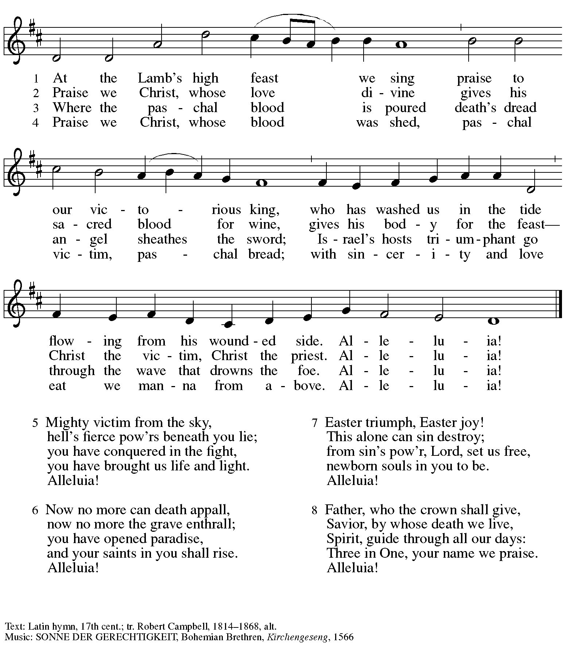

Hymns during Holy Communion
Alleluia! Jesus Is Risen! ELW 377

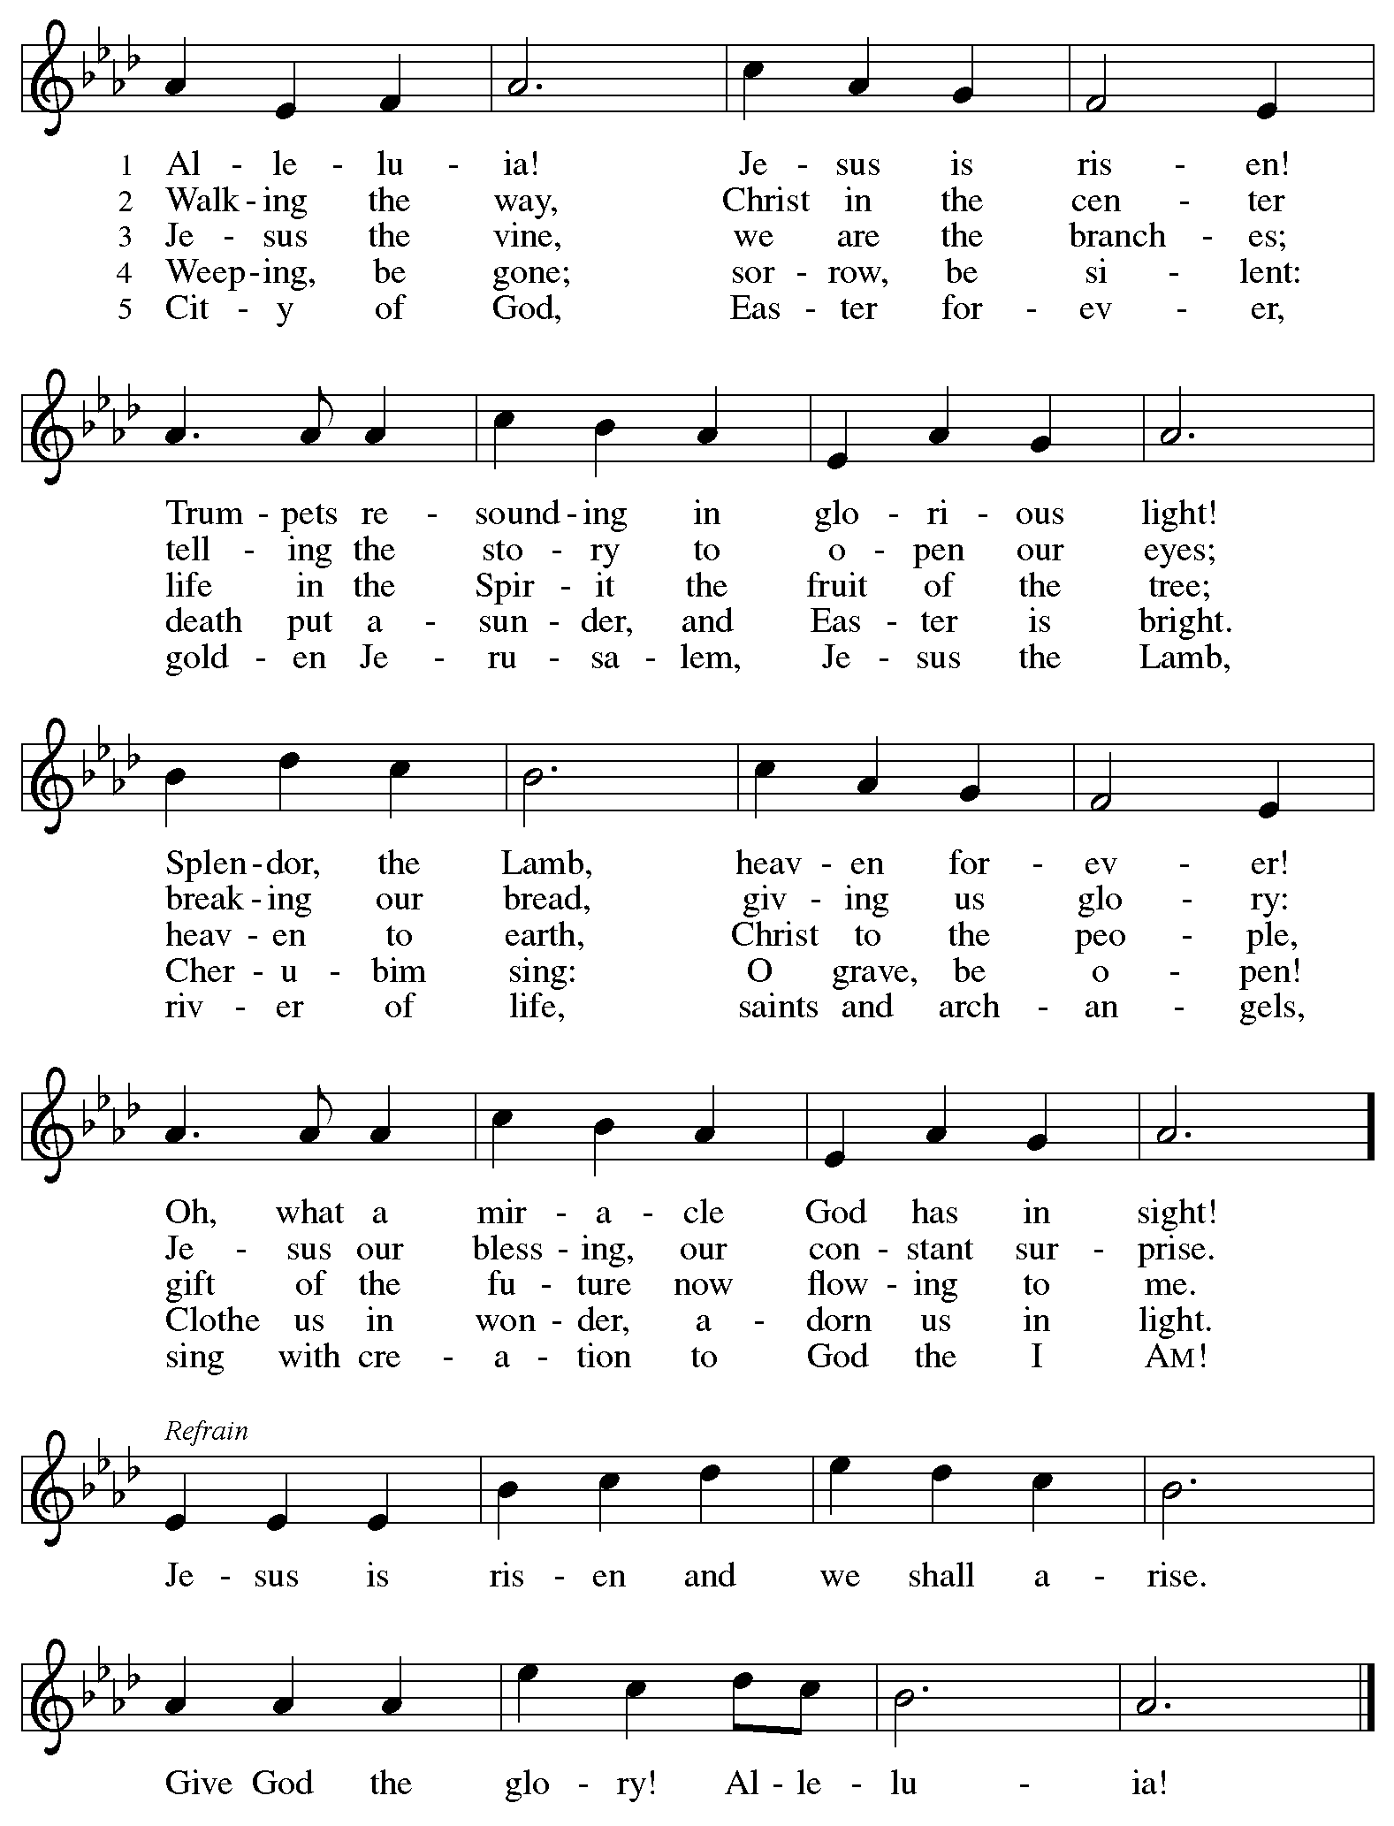
Hymns during Holy Communion
Now the Green Blade Rises ELW 379

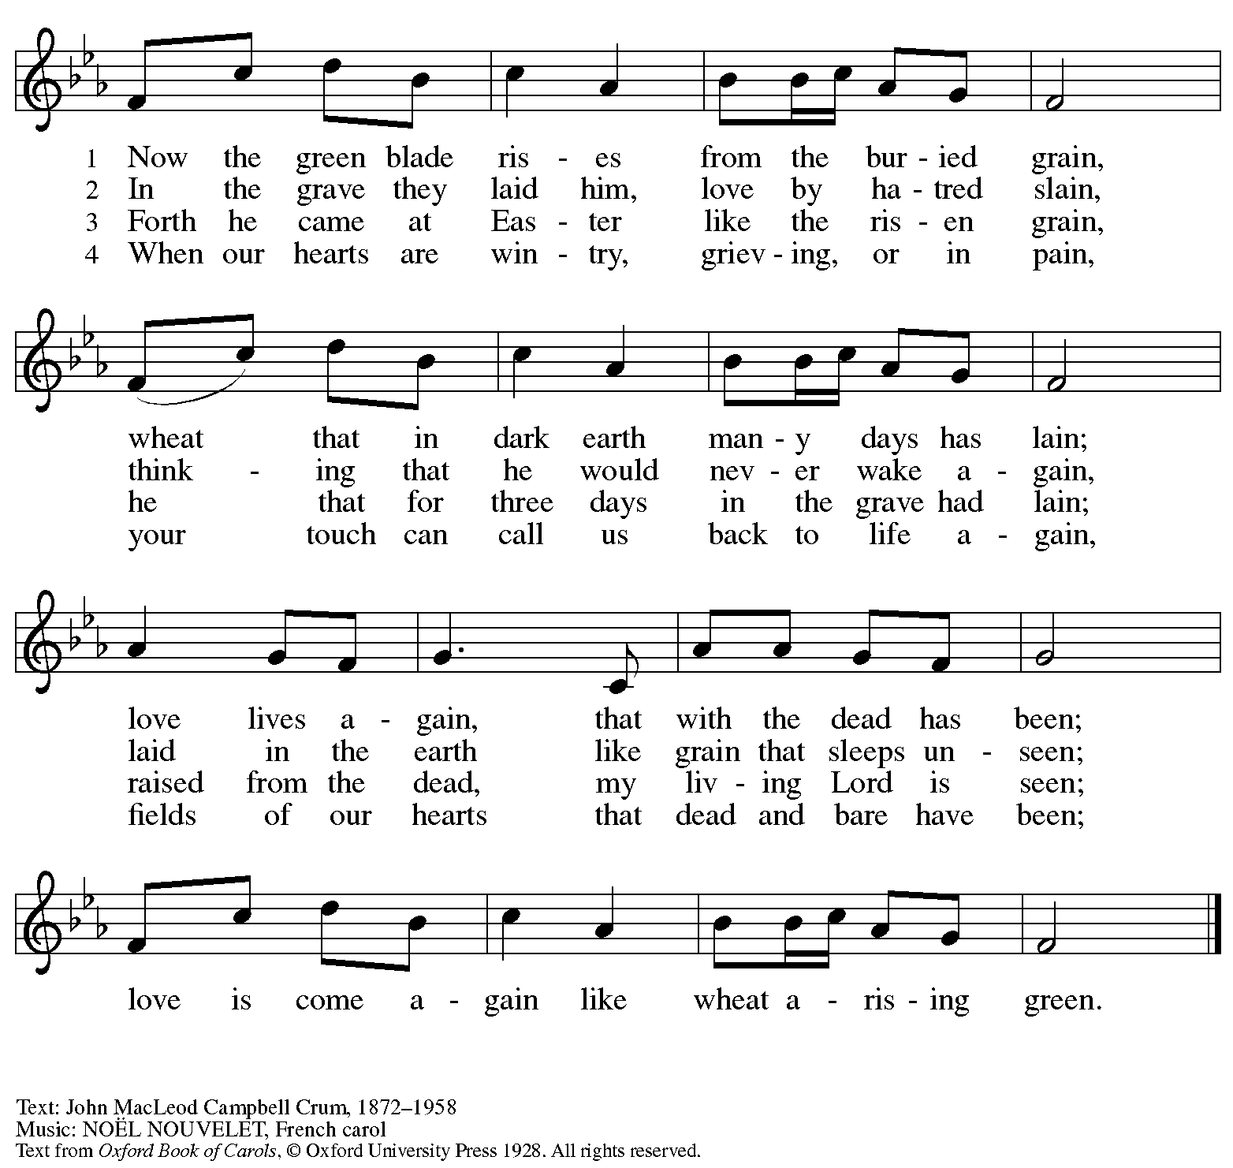
Reprinted with permission under OneLicense.net # A-722139.

Hymns during Holy Communion
Christ Is Risen! Alleluia! ELW 382

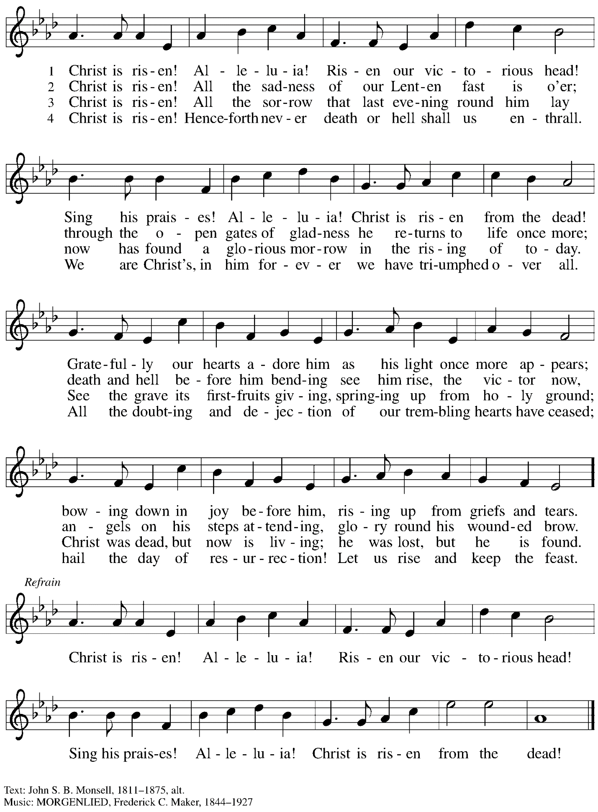

Hymns during Holy Communion
This Joyful Eastertide ELW 391

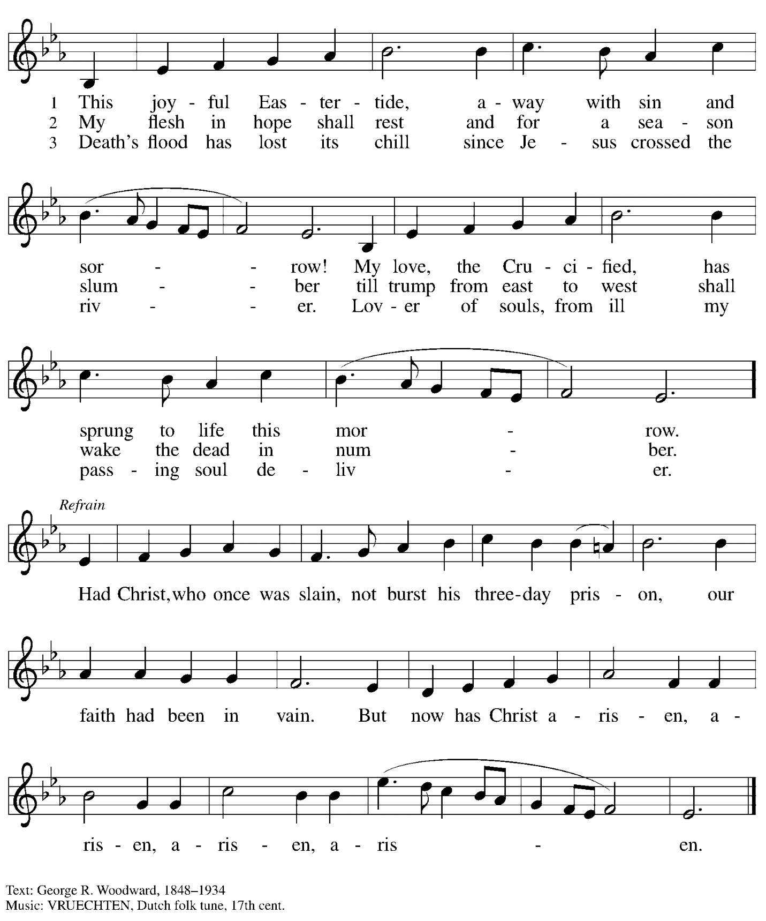

Hymns during Holy Communion
Thine Is the Glory ELW 376

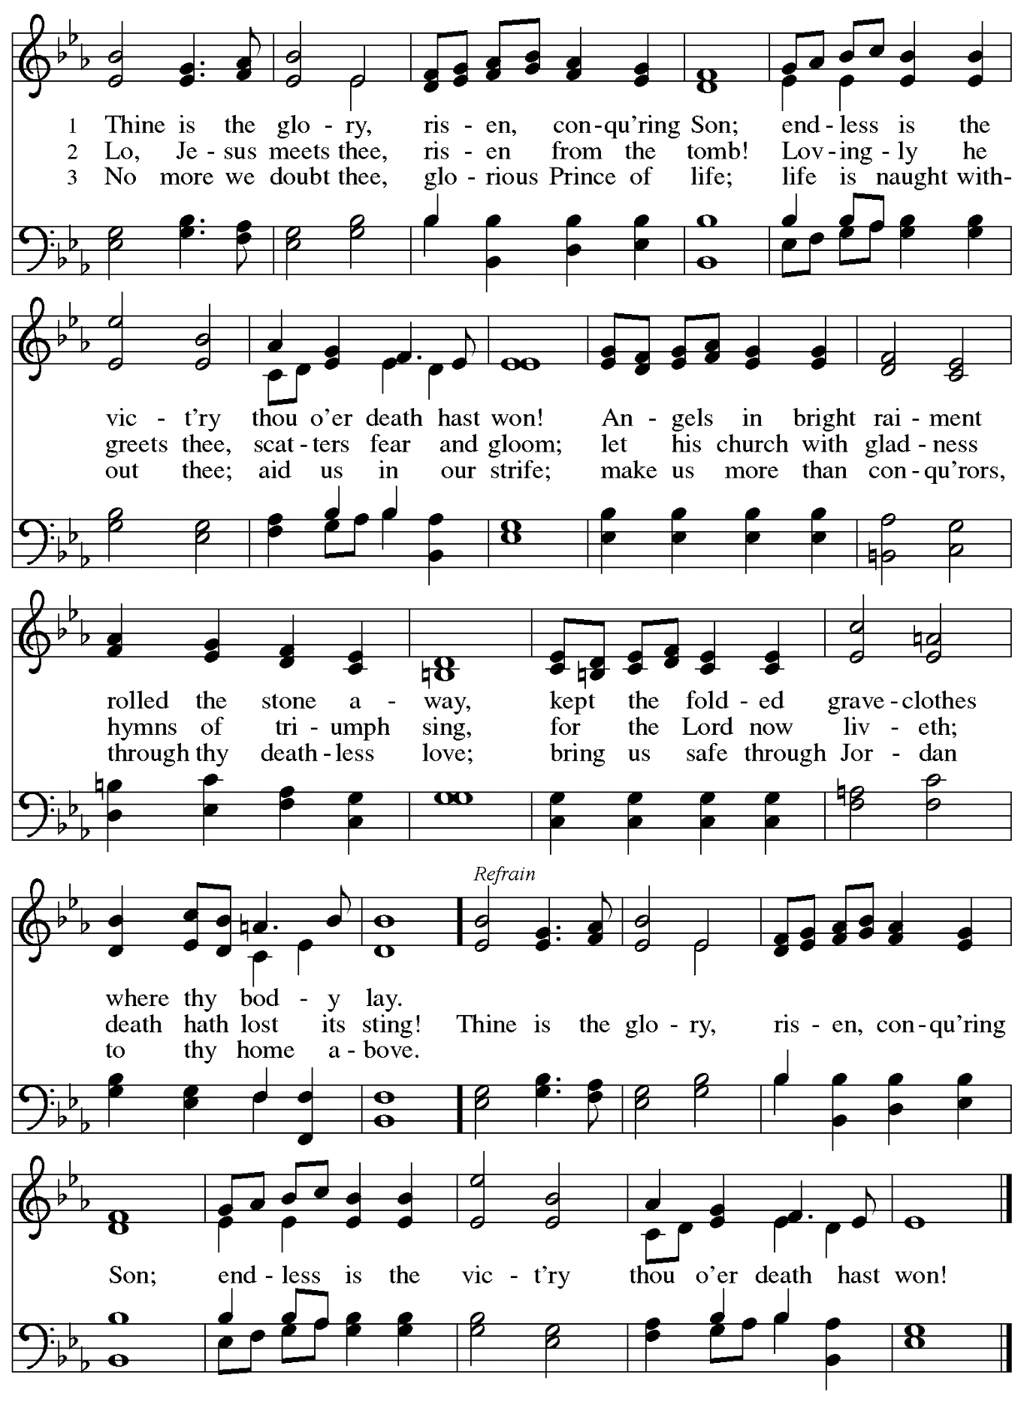
When all have returned to their places, please rise as you are able.

Blessing

P: The body and blood of our Lord Jesus Christ strengthen you and keep you in his grace.
C: Amen.

Prayer

A: Let us pray.
Life-giving God,
in the mystery of Christ’s resurrection, you send light to conquer darkness,
water to give new life, and the bread of life to nourish your people.
Send us forth as witnesses to your Son’s resurrection,
that we may show your glory to all the world,
through Jesus Christ, our risen Lord.
C: Amen.

Sending
God blesses us and sends us in mission to the world

Benediction

P: May our glorious God grant you a spirit of wisdom
to know and love the risen Christ.

Almighty God, holy One, ☩ holy Three,
bless you now and forever.
C: Amen.

Recessional Hymn Following page

Dismissal

A: Alleluia! Christ is risen!
C: Christ is risen indeed! Alleluia! Alleluia!

A: Go in peace. Share the good news!
C: Thanks be to God!

Postlude

Recessional Hymn ELW 367
Now All the Vault of Heaven Resounds

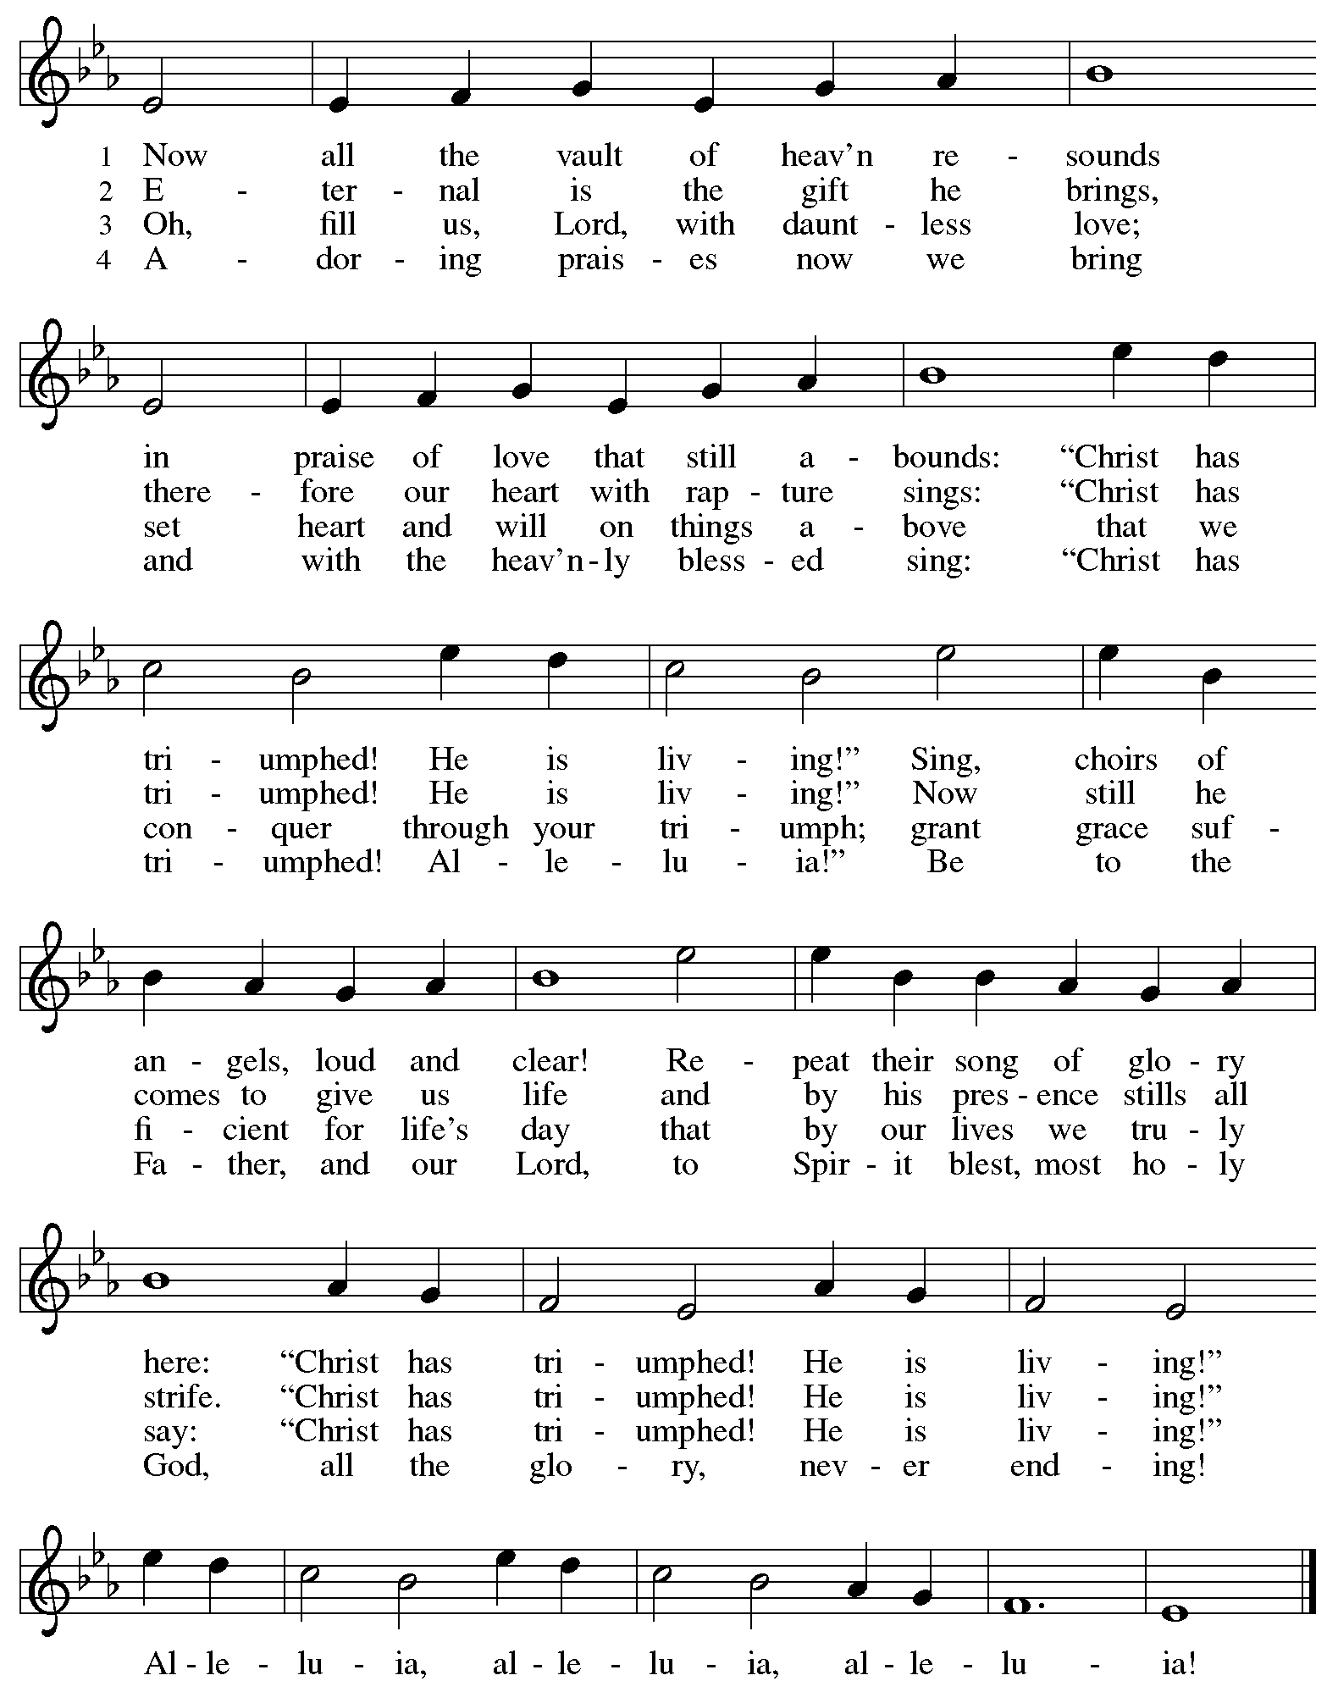
Those serving in worship today
Altar Care Christy Ruhe
Assisting Minister Jeff Denlinger
Audio-Visual Ministers Kristen Asplin
Tyler Rietze
Cantor C.E. Pino
Communion Assistant Lindsay Baxter
Crucifer Adam
Lector Pat Taylor
Clarinet Maria Mangano
Euphonium David Rollinson
French Horn Emily Duque
Organ Jimmi Kocher-Hillmer
Minister of Music Laura Reynolds
Presiding Minister The Rev. Ross I. Carmichael

Liturgy and Hymnody Acknowledgements

From SundaysandSeasons.com. Copyright © 2026 Augsburg Fortress. All rights reserved. Reprinted under OneLicense.net # A-722139.
Used by permission of Augsburg Fortress.

The Scripture readings contained herein are from New Revised Standard Version Updated Edition of the Bible © 2021 National Council of Churches of Christ in the United States of America. Used by permission. All rights reserved worldwide.

Jesus Christ Is Risen Today –Text: Latin carol, 14th cent., sts. 1-3; tr. J. Walsh, Lyra Davidica, 1708, alt.; Charles Wesley, 1707-1788, st. 4. Music: EASTER HYMN, J. Walsh, Lyra Davidica, 1708.

Let the Vineyards – Text: John W. Arthur, 1922-1980. Music: Ronald A. Nelson, b. 1927. Text and Music © 1978 Lutheran Book of Worship, admin. Augsburg Fortress.

Eucharistic Prayer, For the Resurrection of our Lord: Easter Day – Adapted from Pray, Praise, and Give Thanks: A Collection of Litanies, Laments, and Thanksgivings at Font and Table by Gail Ramshaw, copyright © 2017 Augsburg Fortress. All rights reserved. Reprinted with permission.

Alleluia! Jesus Is Risen! – Text: Herbert Brokering, b. 1926. Music: EARTH AND ALL STARS, David N. Johnson, 1922-1987. Text © 1995 Augsburg Fortress. Music © 1969 Contemporary Worship 1, admin. Augsburg Fortress. All rights reserved. Reprinted with permission under OneLicense.net # A-722139.

Thine Is the Glory – Text: Edmund Budry, 1854-1932; tr. R Birch Hoyle, 1875-1939. Music: JUDAS MACCABEUS, George Frideric Handel, 1685-1759.

Now All the Vault of Heaven Resounds – Text: Paul Z. Strodach, 1876-1947, alt. Music: LASST UNS ERFREUEN, Geistliche Kirchengesänge, Köln, 1623. Text © 1958 Service Book and Hymnal, admin. Augsburg Fortress. All rights reserved. Reprinted with permission under OneLicense.net # A-722139.

Please use the QR code below to link to St. Andrew’s Announcements online!


St. Andrew Lutheran Church Announcements
April 5th, 2026

- Happy Easter! Welcome to Worship at St. Andrew as We Celebrate + The Resurrection of our Lord! – We are so glad you are here to share in this festive day, and we offer a special welcome to all visitors and guests who are here for the first time! Little Church – Big Faith will not meet during worship this week so the children can fully participate in the celebration of Easter. There are worship “toolkits” to help children engage with worship and “busy bags” for younger children available in the bookcase at the back of the sanctuary. Please feel free to take one to use with/for your children. A nursery is available through the door to the left of the worship space and across the social hall (look for a purple room). We pray that everyone has a blessed Easter season!
- Reparations Offering during Worship Today! – In Luke’s Gospel, Jesus tells a story about a compassionate Samaritan, suggesting that God’s people are called to work for healing and restoration for our neighbors, regardless of who is responsible for their harm. In light of this, St. Andrew has made a commitment to reparations in regard to African American spiritual songs used in our worship. The text and music of most hymns is attributed to specific authors, with copyrights in place, usage reported, and royalties paid to those whose works are featured in worship. With African American spirituals, this is not possible. In response to many years of such uncredited use, St. Andrew invites the congregation to give a reparations offering. Funds received in worship will be donated to our siblings at Bethel AME Church, whose land and building were taken from them in the 1950s, to fund their development in the Hill District.
- Produce Distribution Supplemental Food of the Month – St. Andrew collects supplemental food each month to accompany our produce distribution. For April, we ask for donations of lentils and beans. There are collection boxes at the back of the worship space and social hall.
- Produce Distribution, First and Third Tuesday Each Month, April 7th and 21st from 5:30 to 6:30 p.m. – St. Andrew partners with Greater Pittsburgh Community Food Bank to serve as a distribution site for fresh produce on the first and third Tuesday of every month. We invite people of the congregation to help with the distribution from 5:30 p.m. to 6:30 p.m. and/or to help with unloading and setup during the day between 10:00 a.m. and 1:00 p.m.
- Bible Book Club – Bible Book Club will meet on Wednesday, April 8th, at 7:00 p.m. The group is currently reading Entering the Passion of Jesus: A Beginner’s Guide to Holy Week, by Dr. Amy-Jill Levine, found here: Entering the Passion of Jesus. You can join the Zoom call here: https://us02web.zoom.us/j/83196175976?pwd=ejdPOUYrTk4xVFdsdlhHUVJ1L3k2Zz09.
- Hearts and Hands - Blanket Tying, Next Saturday, April 11th, 10:00 a.m. to 2:00 p.m. – Join us as we reboot our Hearts and Hands ministry to include Tied Blankets as well as knitted and crocheted items. Tying Blankets is something everyone can do! You can also bring your knitting needles, crochet hooks or even quilting items. If you want to learn to crochet, someone can also help you get started. Blankets will be provided to Proud Haven and Humane Animal Rescue. We also hope to rebuild our prayer shawl supplies with knitted items, crocheted items and blankets. Bring a Lunch (and something to share if you like) and join us!
- Alternatives to Violence Project Workshops, April 14th, May 16th, and May 23th – To learn more about the Alternatives to Violence Project, follow the link here: https://friendspeaceteams.org/cultures-justice-peace/. Below are the details for their upcoming workshops in Pittsburgh. “Choosing Integrity Over Influence” will be held on April 14th from 6:30 p.m. to 8:00 p.m. at Saint Maurice RC Church Campus (2001 Ardmore Blvd. Pittsburgh, PA 15221). It will be open to all ages. Please register using this link: https://docs.google.com/forms/d/e/1FAIpQLSenWSjN487ufRn8K6W6CTi1Nsn7lU3JZSOt234oddOsyXMI4g/viewform. On May 16th and 23rd from 9:00 a.m. to 8:00 p.m., AVP will be hosting two basic workshops at St Andrews Lutheran Church (304 Morewood Ave, Pittsburgh, PA 15213). These will be open to teens and adults. Please register using this link: https://docs.google.com/forms/d/e/1FAIpQLSfjPQKcnyQNx26wqTHzyby9YMi7BYHrUUfUha3PoxXpC50XNw/viewform.
- Pittsburgh PRIDE Choir’s Spring Cabaret Concert, April 17th and 18th at 8:00 p.m. – The Board of Directors of the Pittsburgh PRIDE Choir, Pittsburgh's esteemed LGBTQIA+ choir, acknowledges and thanks you for your unwavering support and advocacy on behalf of our local LGBTQIA+ community. Your contributions, whether through business ownership, direct support, or quality of life initiatives, are invaluable. The Spring Season approaches rapidly and they would be privileged if you joined them for the Spring Cabaret Concert on April 17th and 18th. The concert begins at 8:00 p.m., at East Liberty Presbyterian Church (116 S. Highland Ave, Pgh), a fully affirming and inclusive venue. For tickets to this and future events, visit https://events.ticketleap.com/events/pittsburgh-pride-choir.
- Lutherlyn Work Day, Saturday, April 25th, 9:00 a.m. - 4:00 p.m. – It takes a lot of hands to prepare Lutherlyn for the many people who will visit throughout the spring and summer. Flower beds need to be weeded, firewood needs to be cut, fences need to be repaired, sticks and leaves need to be removed, as well as a variety of other jobs for volunteers of all ages and skill levels. Lutherlyn provides all of the tools (and lunch prepared by Chef Lisa) and our volunteers provide the willing hands! To RSVP, follow this link: https://www.lutherlyn.com/support/volunteer/workdays.html. If you have any questions feel free to contact the Development Office at development@lutherlyn.com or 724-865-2161.
- Dismantling Antisemitism 101, Sunday, April 26th, 12:00 p.m. to 1:30 p.m. – In the fall, St. Andrew hosted a Reckoning with Antisemitism as Christians event in collaboration with our Southwestern Pennsylvania Synod, The Holocaust Center of Pittsburgh, and Christian Associates of Southwest Pennsylvania. In an effort to continue the discussion from that event and to share possible next steps with the larger congregation, St. Andrew has invited Mr. Noah Schoen, Manager of Community Engagement for the Holocaust Center of Pittsburgh, to lead us in a Dismantling Antisemitism 101 workshop. After worship on April 26th, we will have an expanded coffee hour with light lunch foods, and then begin the workshop at 12:00 noon. Please put this on your calendars and plan to take part on April 26th. Please confirm your attendance here: https://www.signupgenius.com/go/5080B4AAFAF2CABF85-63105576-reckoning#/.
- Coffee Hour Signups – St. Andrew provides hospitality during a coffee hour after worship each Sunday. If you would like to participate and would like information about the duties of setting up, please sign up using the following form: https://www.signupgenius.com/go/5080B4AAFAF2CABF85-47069030-coffee#/.
- Flower Donors, Please Remember to Take Home Easter Flowers! – We are grateful for everyone who helped beautify the church by dedicating flowers this Easter! We encourage those who have done so to please take them with you today. If you choose not to take them, please let Pastor Ross know so that others may enjoy them!
- Christ in Our Home Devotional Booklets for April – June Available at Entrances – This resource offers a daily Bible reading with a short reflection and prayer, along with additional readings and prayer topics for those who would like to expand their devotional practices. We encourage people of the congregation to take one for yourself, your family/household, or others!
Easter Flowers Decorating the Chancel Have Been Given

In Gratitude / Appreciation / Love for
The AV Ministers by Ginny and Tom Leech
Janet and the Kids by Colleen Cooke
My New Church Home Anonymous
Our Children and Grandchildren by Tom and Gayle McLaughlin
Pastor Ross and Laura by Michael Smolleck and Arnie Rowlands
St. Andrew’s Music Ministry by Kathy Hays

In Honor of
All the Koch Kids by Sharon Koch
My Daughter, Megan Elk, and Their Wife, Rachel Schuldt
by Cynthia Holden
The Beautiful Givens Family by Megan Will
My Family by Kelly Spanninger
Susan and All Who Deal with Cancer by Colleen Cooke

In Loving Memory of
Barry’s and My Parents by Patricia Taylor
Joyce Compton by Kelly Spanninger
Shirley and Chick Cooke by Colleen Cooke
Dolly and Ray Ehrman by Victoria Al-Ebrahim
My Grandmother, Anne Peterson by Emily Duque
My Husband, The Rev. Paul Koch by Sharon Koch
My Mother and Sisters by Mary Lou Benedetti
My Parents, Regis and Edith Holden by Cynthia Holden
Berry Robben and Annemarie Bakkum by Emily Duque
Sally Rowlands and Rose Smolleck
by Arnie Rowlands and Michael Smolleck
Paul Spencer by Megan Will

In Memory of
Pops and All the Other Beings in Heaven by Lily Gaugler

In Thanksgiving for
The Birth of Samuel Henry by Maria Mangano

In Thanksgiving for
The Support and Care of the St. Andrew Community
by The Gauglers
With Thanksgiving for
Life by Audrey Gaugler

For My Father, Raymond Hoffman by Kristen Asplin

For My Husband, Peter Asplin by Kristen Asplin

