

+ Triduum – Vigil of Easter
April 4, 2026


St. Andrew Lutheran Church
304 Morewood Ave.
Pittsburgh, PA 15213
St_andrewELCA@verizon.net
www.standrewpittsburgh.org

+ Triduum – Vigil of Easter
Order for Worship

This is the night of salvation! At the Vigil of Easter, we gather around fire, word, water, bread, and wine, proclaiming through story and song that ours is a God who continuously brings life out of death. On this night we experience again the heart of God’s baptismal promise and the center of our faith: we are claimed and cleansed, renewed in the death and resurrection of Christ. We gather with all the saints of every time and place to celebrate the good news:
Christ is risen indeed! Alleluia!

Welcome to St. Andrew!
- St. Andrew welcomes all who are seeking a place of healing, wholeness, and acceptance in a nurturing and faith-forming spiritual home. We are striving toward racial equity worldwide
and we seek to honor the lived experience of all individuals regardless of background. Our community embraces people of all ages, ethnicities, cultures, abilities, sexual orientations,
gender identities and expressions, and family constellations. Come and See!
- Worship Services are live-streamed to multiple online platforms. By attending worship, you agree that your image and voice may be broadcast.
- Everyone is invited to make a name tag at the black bookcase in the back of the worship space if they would like. There are stickers indicating pronouns on the bookcase if you would like to include them on your name tag.
- A nursery is available through the doors at the left side of the sanctuary and across from the doorway to the Social Hall. Look for a purple-colored room.
- Worship “toolkits” to help children engage with the service, along with “busy bags” for younger children, are available in the bookcase at the back of the sanctuary. Please feel free to take one to use with/for your children.
- Holy Communion is served with bread (gluten-free available) and wine or grape juice. The presiding minister will distribute the bread (host). Please consume this and then pick up an empty glass from the tray. The Communion Assistant will pour wine or grape juice into your glass. Please step to the side to consume the wine or grape juice. Feel free to kneel at the altar for prayer and reflection. As you return to your pew, glasses may be returned to the empty trays on either side of the center section.
- A restroom is available on the main level of the church, through the doors to the Social Hall and to the right in the main office.

Abbreviations
P: Pastor/Presiding Minister ELW: Evangelical Lutheran Worship hymnal
A: Assisting Minister ACS: All Creation Sings hymnal
L: Lector MSB1: Musician’s Source Book 1
C: Cantor HS: Hymnal Supplement (GIA Publications)
C: Congregation W&P: Worship & Praise
R: Response

All are encouraged to gather outside, around the site where the new fire will be lighted.

Service of Light
The new fire and lighting of the Paschal candle signify the dawning of the resurrection

Greeting

The presiding minister and the assembly greet each other.
P: The grace of our Lord Jesus Christ, the love of God,
and the communion of the Holy Spirit be with you all.
C: And also with you.

The presiding minister welcomes the assembly to the vigil.
P: Beloved in Christ, on this most holy night when our Savior Jesus Christ passed from death to life, we gather with the church throughout the world in vigil and prayer. This is the passover of Jesus Christ. Through light and the word, through water and oil, bread and wine, we proclaim Christ’s death and resurrection, share Christ’s triumph over sin and death, and await Christ’s coming again in glory.

The new fire is lighted.

The presiding minister waits until the fire is burning before praying.
P: Let us pray.
Eternal God, in Jesus Christ you have given the light of life to all the world.
Bless this new fire, and increase in us a desire to shine forth
with the brightness of Christ’s rising, until we feast at the banquet of eternal light;
through the Sun of righteousness, Jesus Christ our Lord.
C: Amen.

The presiding minister traces the inscription on the Paschal candle.
P: Christ, yesterday and today, ☩
the beginning and the ending. A Ω
To Christ belongs all time 2
and all the ages; 0
to Christ belongs glory and dominion 2
now and forever. 6
C: Amen.

The presiding minister lights the Paschal candle, using a stick or taper from the fire, and sings:
P: The light of Christ, rising in glory,
dispel the darkness of our | hearts and minds.

The assisting minister lifts the candle so that all may see it.

Procession

The procession begins, led by the assisting minister bearing the Paschal candle.

As the procession begins, a cantor sings:



The procession continues, stopping at midpoint.
The assisting minister lifts the Paschal candle and the cantor sings on a higher tone:



The procession continues and enters the building.

The assisting minister takes the Paschal candle to its stand and lifts it high,
and the cantor sings on a still higher tone:



Once the congregation has assembled, the Paschal candle is placed in its stand.

As people of the assembly enter the social hall, an assisting minister lights smaller candles from the Paschal candle. Each worshiper is invited to take a small, unlit candle, which can be tilted into the flame to be lit as everyone takes their places. Please keep your candle burning for the duration of the Easter Proclamation.

Easter Proclamation

Cantors sing the Easter proclamation. The congregation is invited to join the assembly parts printed below.

C: Rejoice, now, all heavenly powers! Sing, choirs of angels! …
… echoing the mighty song of all God’s people.

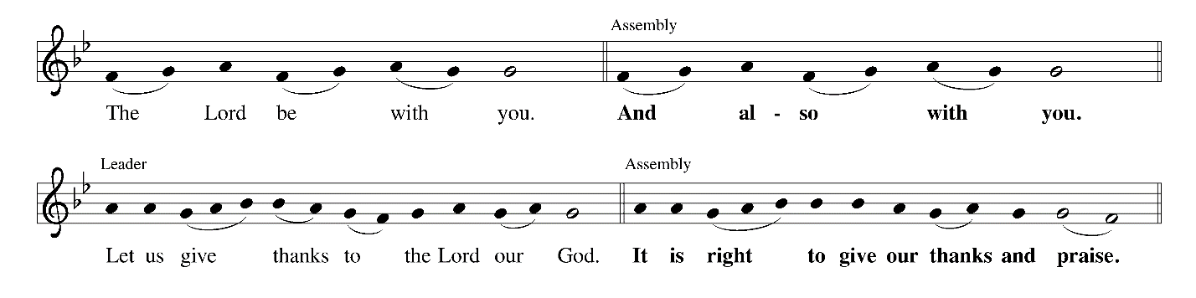

C: It is indeed right, our duty and our joy …
… the doorposts of the faithful are made holy.

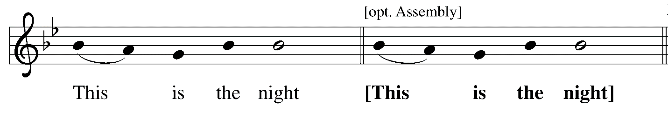

C: in which, in ancient times,
you delivered our forebears, the children of Israel,
and led them, dry-shod, through the sea.

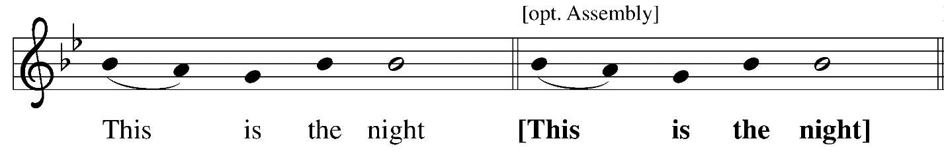

C: in which the darkness of sin has been purged away by the rising brightness.

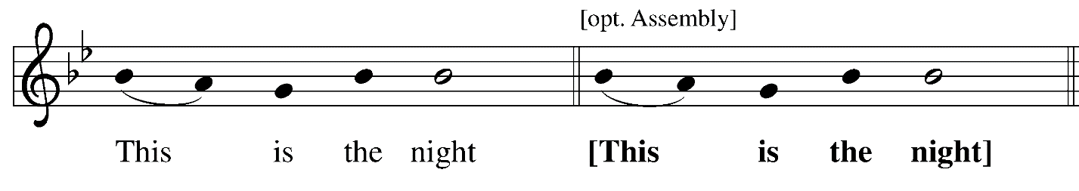

C: in which all who believe in Christ are rescued from evil and the gloom of sin,
are renewed in grace, and are restored to holiness.
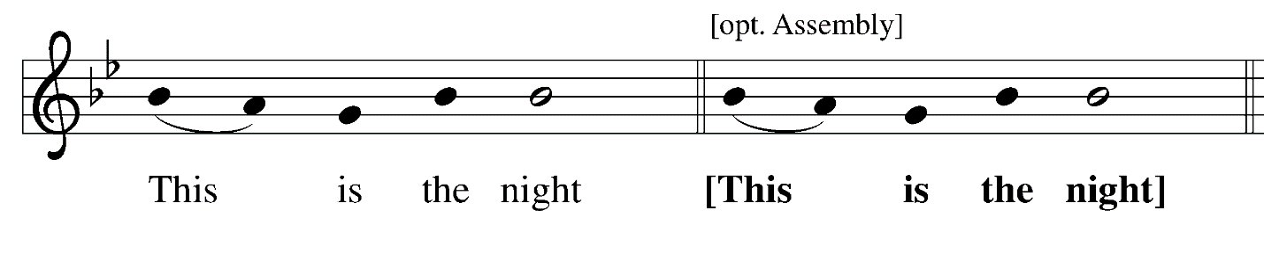
C: in which, breaking the chains of death, Christ arises from hell in triumph …
O night truly blessed which alone was worthy to know
the time and hour in which Christ rose again from hell!

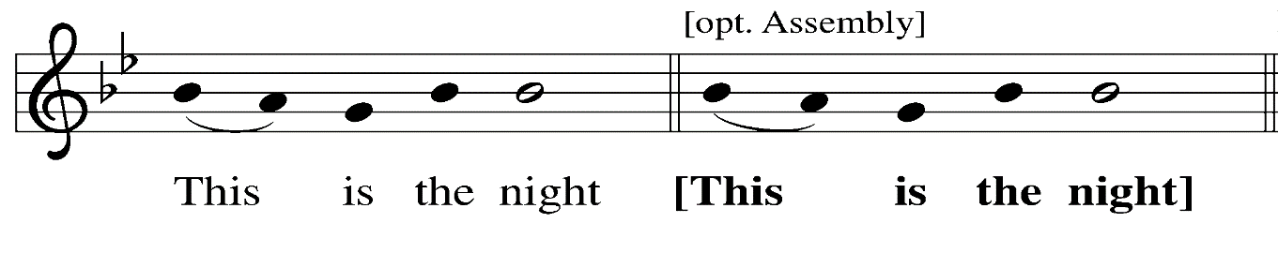
C: of which it is written: “The night is as clear as the day,” …
… have made for the substance of this candle.

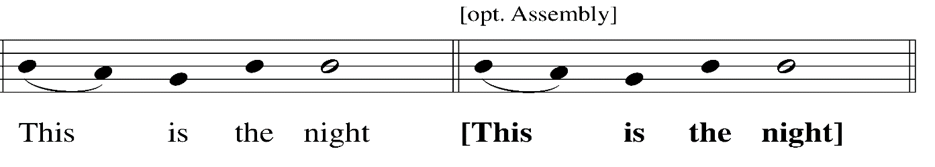

C: in which heaven and earth are joined – things human and things divine.
We therefore pray to you, O God …
… one God, now and forever.

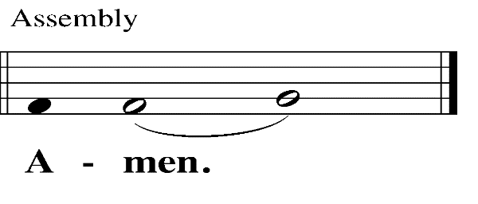
Prayer of the Day

P: Let us pray.

A brief silence is kept

P: Eternal giver of life and light, this holy night shines with the radiance of the risen Christ.
Renew your church with the Spirit given us in Baptism,
that we may worship you in sincerity and truth and may shine as a light in the world,
through your Son, Jesus Christ our Lord, who lives and reigns with you and the Holy Spirit,
one God, now and forever.
C: Amen.

Please be seated. Handheld candles may be extinguished.

Service of Readings
The history of God’s faithfulness and salvation is told through the Hebrew Scriptures

First Reading Genesis 1: 1 – 2: 4a

The first reading is the first account of creation in the book of Genesis.

First Response based on Psalm 136: 1-9, 23-26
Earth Is Full of Wit and Wisdom ACS 1064

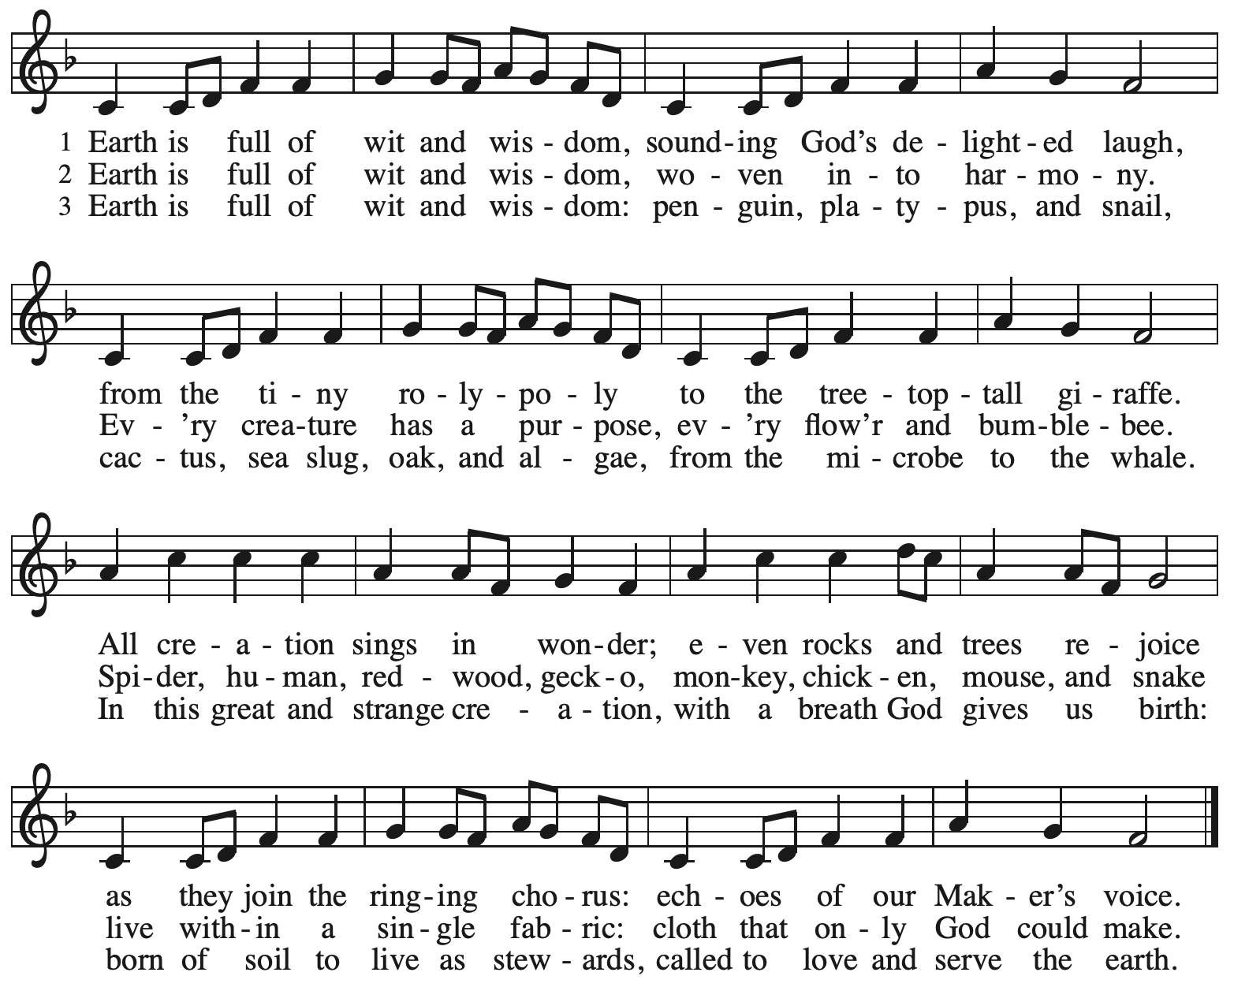
Silent reflection

First Prayer

P: Almighty God,
you wonderfully created the dignity of human nature and yet more wonderfully restored it.
In your mercy, let us share the divine life of the one who came to share our humanity,
Jesus Christ, your Son, our Lord.
C: Amen.

Second Reading Exodus 14: 10-31; 15: 20-21

The second reading presents the story of God’s deliverance through the Red Sea.



Second Response based on Exodus 15: 1b-13, 17-18
I Will Call upon the Lord W&P 70

The first section is sung in a call and response style, with the cantor singing a phrase
and the congregation repeating it. The remainder is sung in unison.

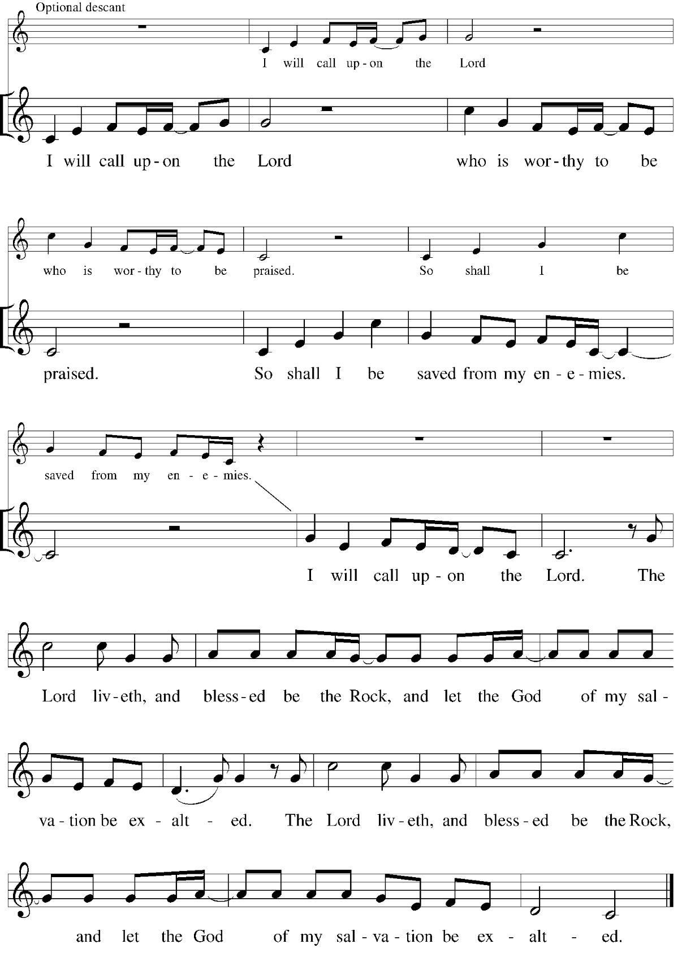

Silent reflection

Second Prayer

P: O God, whose wonderful deeds of old shine forth even to our own day: By the power of your mighty arm you once delivered your chosen people from slavery under Pharaoh, a sign for us
of the salvation offered to everyone by the water of Baptism. Grant that all the peoples of earth may partake in the salvation of the Israelites and together dance on the safe side of the sea, through Jesus Christ, our Savior and Lord.
C: Amen.

Third Reading Isaiah 55: 1-11

The third reading, an invitation to abundant life,
will be read from the New Revised Standard Version Updated Edition of the Bible.



Third Response based on Isaiah 12: 2-6
Surely God Is My Salvation MSB1 S482
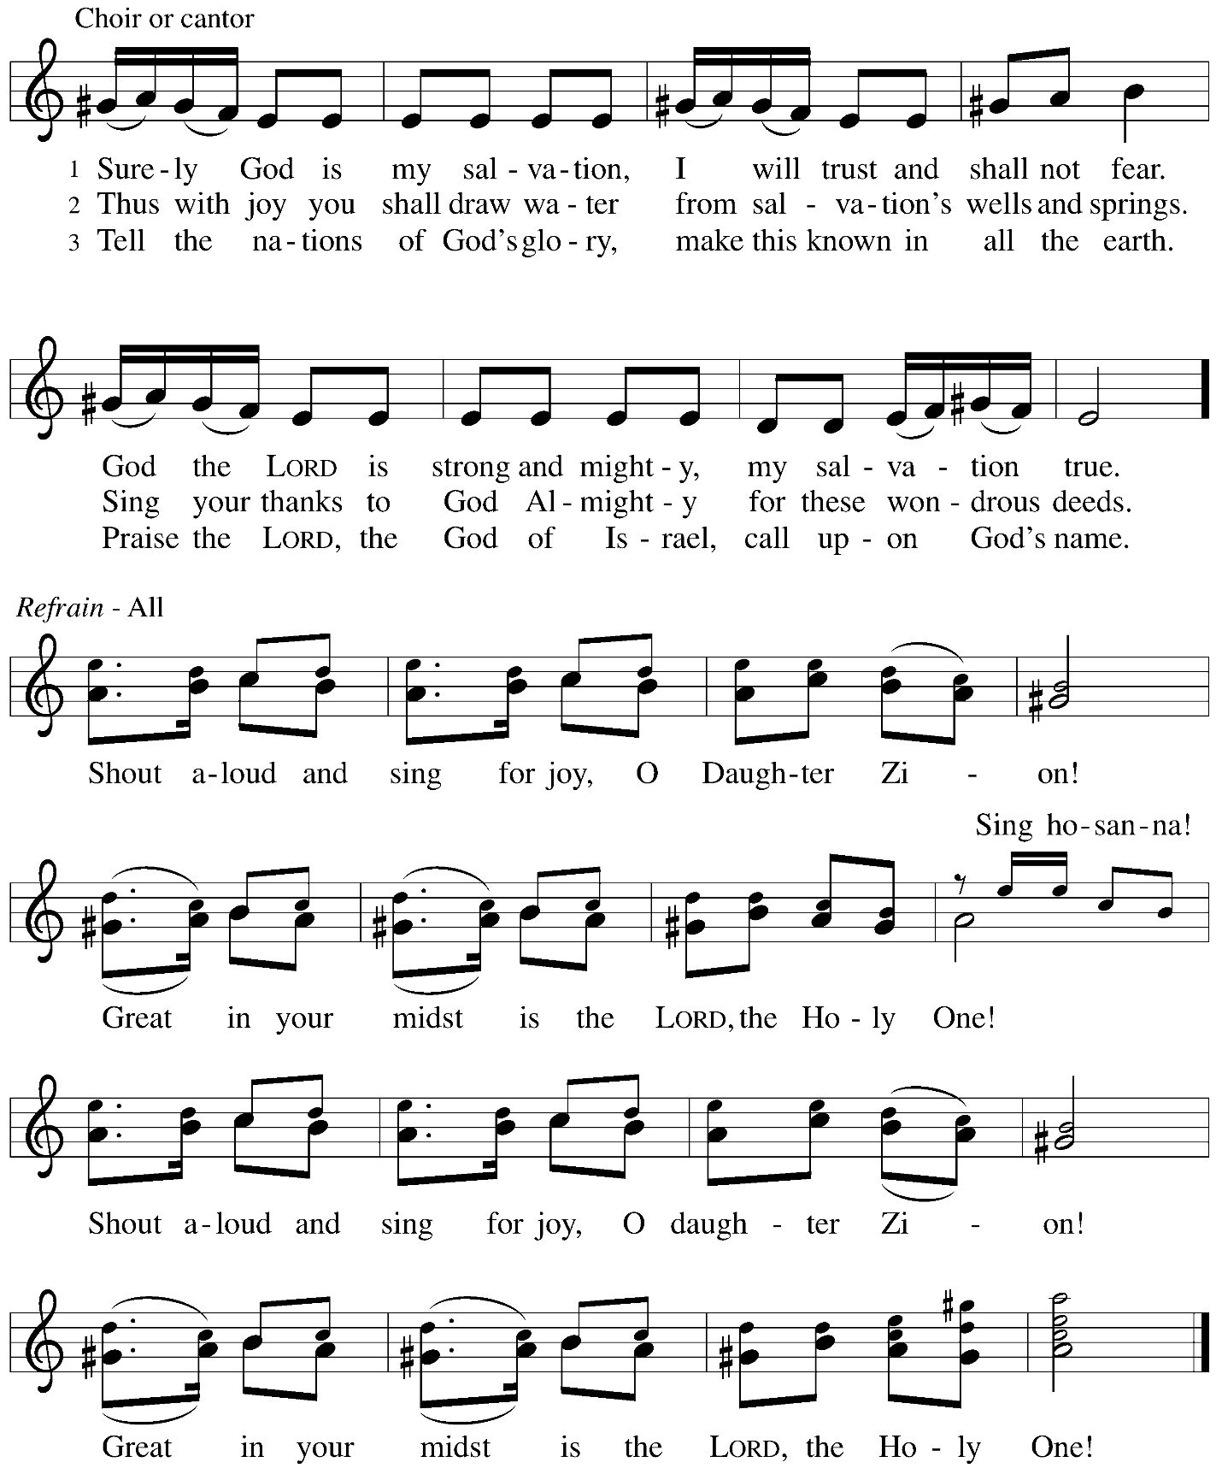

Silent reflection

Third Prayer

P: Holy God,
you created all things by the power of your Word, and you renew the whole earth by your Spirit. Give now the water of life to all who thirst for you, that, rejoicing in your covenant of mercy,
we may bring forth abundant fruit, through Jesus Christ, our Savior and Lord.
C: Amen.

Fourth Reading Jonah 1: 1 – 2: 1

The fourth reading tells of the deliverance of the prophet Jonah.

Fourth Response based on Jonah 2: 2-3 [4-6] 7-9
MSB1 S489

The response will be sung responsively as a call and response

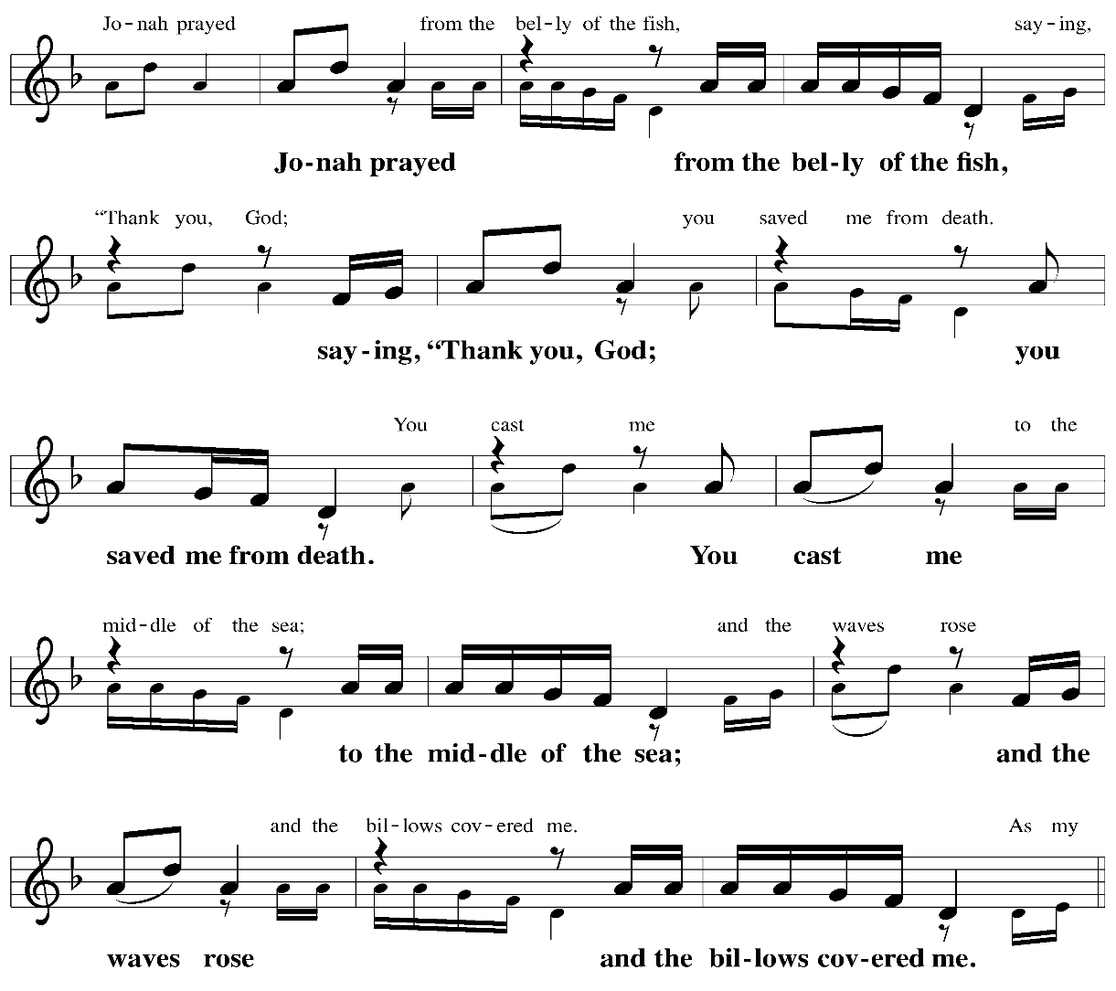
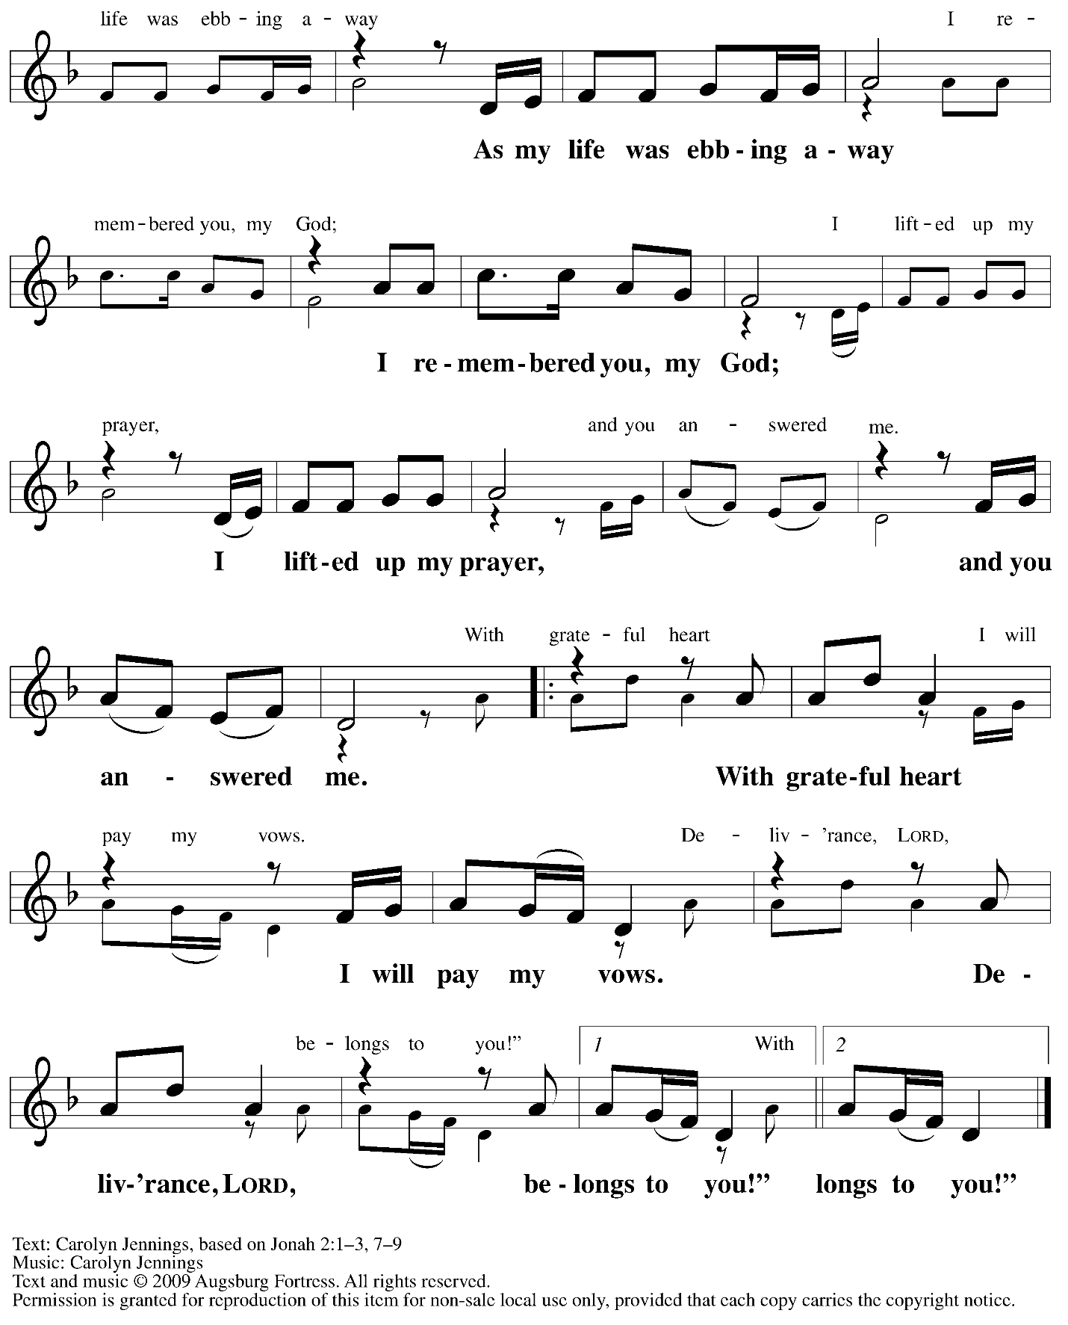
Reprinted under OneLicense.net # A-722139.

Silent reflection

Fourth Prayer

P: O God of deliverance, you saved Jonah through the waters of death, and after three days
you brought him to new life. Speak to us by this sign, and call us to repentance,
that we may heed the voice of your risen Son, Jesus Christ, our Savior and Lord.
C: Amen.

Fifth Reading Daniel 3: 1-29

As the story of the three faithful people of God and the fiery furnace unfolds, people of the congregation are invited to join in telling the story with voices, instruments, and props.

At various places in the reading, please join in a spoken listing of musical instruments:
C: Horn, pipe, lyre, trigon, harp, drum, and entire musical ensemble

and in saying the names of the three faithful Jewish leaders:
C: Shadrach, Meshach, and Abednego

Fifth Response based on Song of the Three 35-65
All You Works of God, Bless the Lord Following page

All are invited to join in singing the fifth response.
As the response is sung, the Paschal candle bearer will lift the Paschal candle from its stand
and lead the congregation in procession into the sanctuary.



Fifth Response based on Song of the Three 35-65
All You Works of God, Bless the Lord MSB1 S494

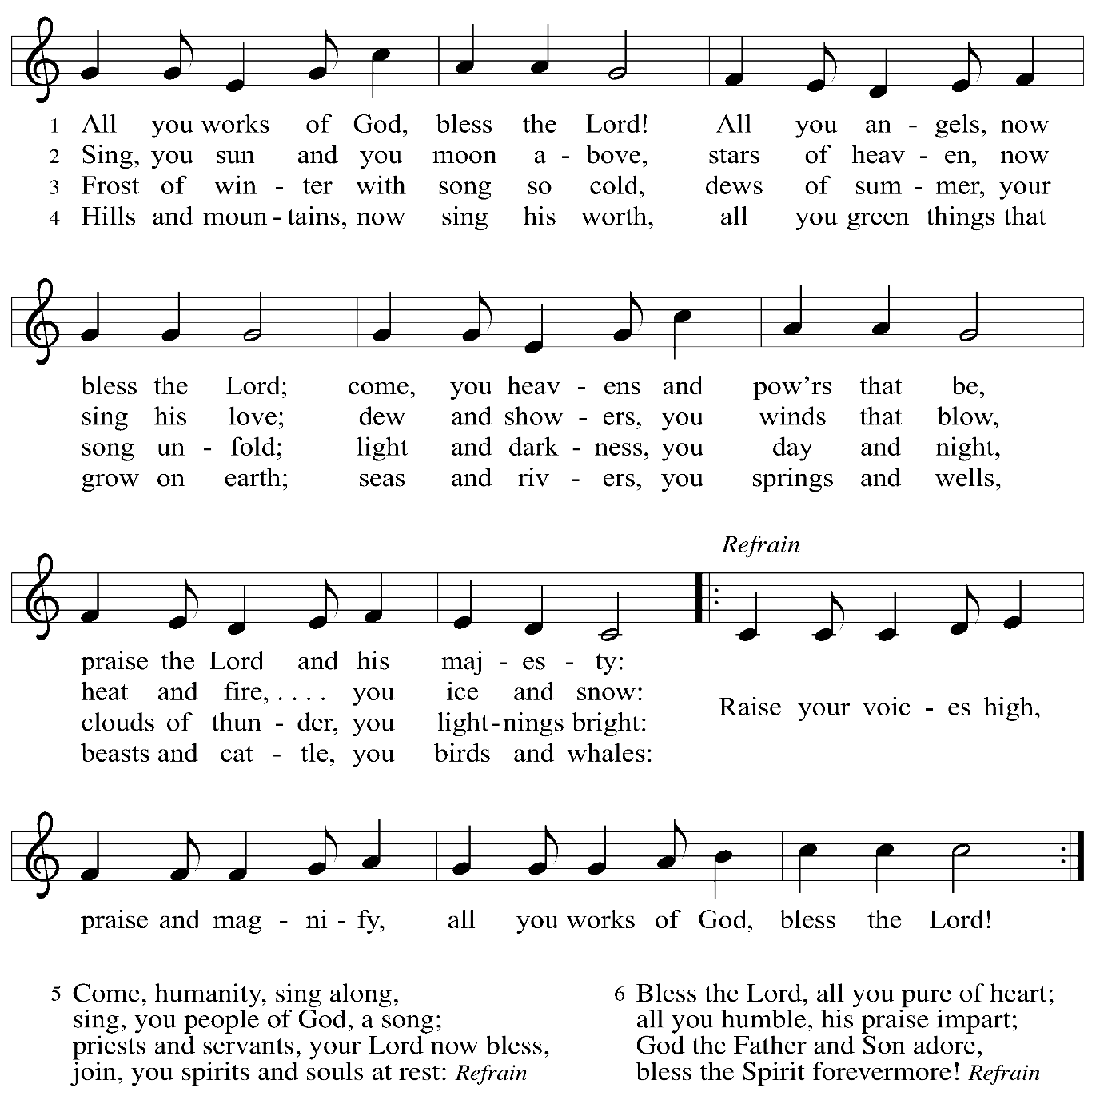

Once the congregation has processed into the sanctuary, the response has concluded,
and time of silent reflection has been kept, the presiding minister leads the fifth prayer.

Fifth Prayer

P: Almighty and eternal God, the only hope of the world, by the proclamation of your prophets you declare to us the word of salvation. By the grace of your Spirit, increase the devotion of all the baptized, that, strengthened by your presence, we may withstand hardship and sorrow,
and be united with your Son, Jesus Christ, our Savior and Lord.
C: Amen.

Please be seated.
Worship continues with the Service of the Word.

Service of the Word
God speaks to us in Scripture reading, preaching, and song

Reading Romans 6: 3-11

³Do you not know that all of us who have been baptized into Christ Jesus were baptized into his death? ⁴Therefore we have been buried with him by baptism into death, so that, just as Christ was raised from the dead by the glory of the Father, so we too might walk in newness of life.
⁵For if we have been united with him in a death like his, we will certainly be united with him in a resurrection like his. ⁶We know that our old self was crucified with him so that the body of sin might be destroyed, and we might no longer be enslaved to sin. ⁷For whoever has died is freed from sin. ⁸But if we have died with Christ, we believe that we will also live with him. ⁹We know that Christ, being raised from the dead, will never die again; death no longer has dominion over him. ¹⁰The death he died, he died to sin, once for all; but the life he lives, he lives to God. ¹¹So you also must consider yourselves dead to sin and alive to God in Christ Jesus.

L: Word of God, word of life.
C: Thanks be to God.

After the New Testament reading, a time of silence is observed.

A cantor will then introduce the first line of the Hymn of Praise, and the lights will come up.
Please rise as you are able.
The congregation is invited to join in singing as the music begins.
It is Easter! Christ is risen!

Gospel Acclamation Following page


Gospel Acclamation Glory to God ELW p. 148-149

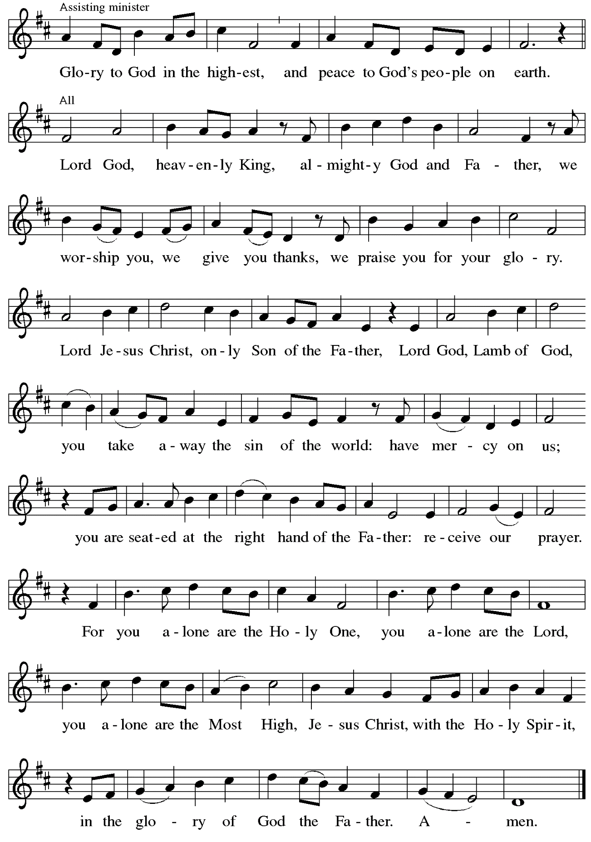
Gospel – John 20: 1-18

P: The holy Gospel according to St. John.
C: Glory to you, O Lord.

¹ Early on the first day of the week, while it was still dark, Mary Magdalene came to the tomb and saw that the stone had been removed from the tomb. ² So she ran and went to Simon Peter and the other disciple, the one whom Jesus loved, and said to them, “They have taken the Lord out of the tomb, and we do not know where they have laid him.” ³ Then Peter and the other disciple set out and went toward the tomb. ⁴ The two were running together, but the other disciple outran Peter and reached the tomb first. ⁵ He bent down to look in and saw the linen wrappings lying there, but he did not go in. ⁶ Then Simon Peter came, following him, and went into the tomb. He saw the linen wrappings lying there, ⁷ and the cloth that had been on Jesus’s head, not lying with the linen wrappings but rolled up in a place by itself. ⁸ Then the other disciple, who reached the tomb first, also went in, and he saw and believed, ⁹ for as yet they did not understand the scripture, that he must rise from the dead. ¹⁰ Then the disciples returned to their homes.
¹¹ But Mary stood weeping outside the tomb. As she wept, she bent over to look into the tomb, ¹² and she saw two angels in white sitting where the body of Jesus had been lying, one at the head and the other at the feet. ¹³ They said to her, “Woman, why are you weeping?” She said to them, “They have taken away my Lord, and I do not know where they have laid him.” ¹⁴ When she had said this, she turned around and saw Jesus standing there, but she did not know that it was Jesus. ¹⁵ Jesus said to her, “Woman, why are you weeping? Whom are you looking for?” Supposing him to be the gardener, she said to him, “Sir, if you have carried him away, tell me where you have laid him, and I will take him away.” ¹⁶ Jesus said to her, “Mary!” She turned and said to him in Hebrew, “Rabbouni!” (which means Teacher). ¹⁷ Jesus said to her, “Do not touch me, because I have not yet ascended to the Father. But go to my brothers and say to them, ‘I am ascending to my Father and your Father, to my God and your God.’ ” ¹⁸ Mary Magdalene went and announced to the disciples, “I have seen the Lord,” and she told them that he had said these things to her.

P: The Gospel of the Lord.
C: Praise to you, O Christ.

Please be seated.

Sermon

A time of silence for prayer and reflection follows the sermon.

When the Hymn of the Day begins, please rise as you are able.

Hymn of the Day Woman, Weeping in the Garden ACS 935

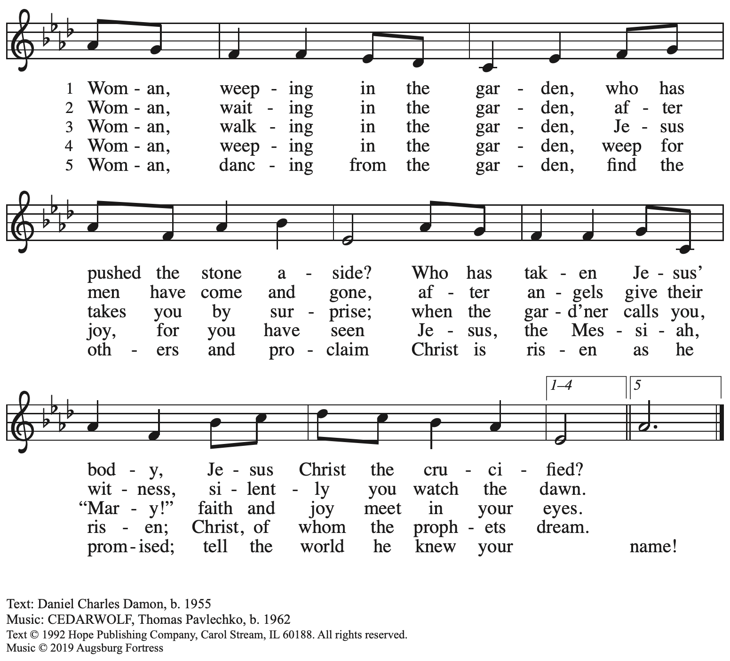
All rights reserved. Reprinted with permission under OneLicense.net # A-722139.

Service of Baptismal Affirmation
The congregation celebrates the gifts of the covenant of Holy Baptism

Thanksgiving for the Waters of Baptism

The ministers move to the baptismal font.
The Paschal candle, a sign of Christ’s presence among us,
is lowered into and raised from the water, as Christ was lowered into death and raised to life. The water becomes a symbol of both our death to sin and our rising to life in Christ.

The presiding minister prays over the baptismal waters.
P: Holy God, you give us grace through sacramental signs …
… May all who are buried with Christ in the death of Baptism rise also with Christ
to newness of life, through Christ our Lord.
C: Amen. Springs of water, bless the Lord!
Give God glory and praise forever!

P: Beloved in Christ, on this holiest of nights, the Church …
… and promised to serve God faithfully in the Church.

Affirmation of Baptism

Profession of Faith

The presiding minister addresses those making public affirmation of Baptism.
Please rise as you are able for the responses.

P: I ask you to profess your faith in Christ Jesus, reject sin, and confess the faith of the church.

P: Do you renounce the devil and all the forces that defy God?
R: / C: I renounce them.

P: Do you renounce the powers of this world that rebel against God?
R: / C: I renounce them.

P: Do you renounce the ways of sin that draw you from God?
R: / C: I renounce them.

The presiding minister addresses the assembly.
P: Do you believe in God the Father?
C: I believe in God, the Father almighty,
creator of heaven and earth.

P: Do you believe in Jesus Christ, the Son of God?
C: I believe in Jesus Christ, God’s only Son, our Lord,
who was conceived by the Holy Spirit,
born of the virgin Mary,
suffered under Pontius Pilate,
was crucified, died, and was buried;
he descended to the dead.*
On the third day he rose again;
he ascended into heaven,
he is seated at the right hand of the Father,
and he will come to judge the living and the dead.
P: Do you believe in God the Holy Spirit?
I believe in the Holy Spirit,
the holy catholic church,
the communion of saints,
the forgiveness of sins,
the resurrection of the body,
and the life everlasting.

*Or, “he descended into hell,” another translation of this text in widespread use.

Affirmation in the Presence of the Assembly

The presiding minister addresses those making public affirmation of Baptism.
P: You have made public profession of your faith.
Do you intend to continue in the covenant God made with you in Holy Baptism:
to live among God’s faithful people,
to hear the word of God and share in the Lord’s supper,
to proclaim the good news of God in Christ through word and deed,
to serve all people, following the example of Jesus,
and to strive for justice and peace in all the earth?
C: I do, and I ask God to help and guide me.

The minister addresses the assembly.
P: People of God, do you promise to support these siblings
and pray for them in their life in Christ?
C: We do, and we ask God to help and guide us.

The presiding minister prays for God’s blessing.
P: Let us pray.
We give you thanks, O God,
that through water and the Holy Spirit you give us new birth,
cleanse us from sin, and raise us to eternal life.

Stir up in Names the gift of your Holy Spirit:
the spirit of wisdom and understanding,
the spirit of counsel and might,
the spirit of knowledge and the fear of the Lord,
the spirit of joy in your presence,
both now and forever.
C: Amen.

Those making affirmation of Baptism turn and face the assembly.

A representative of the congregation addresses the assembly.
A: Let us rejoice with these siblings in Christ.
C: We rejoice with you in the life of Baptism.
Together we will give thanks and praise to God
and proclaim the good news to all the world.

The presiding minister welcomes those making Affirmation of Baptism to the congregation.
The assembly may welcome them with applause.

St. Andrew’s congregational refrain is sung in celebration of the gift of Baptism:

Congregational Refrain HS 808

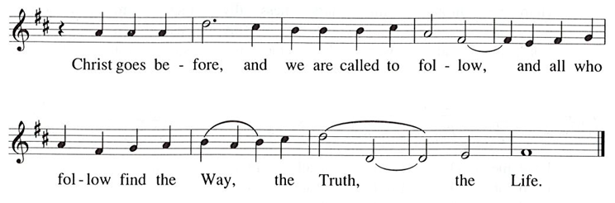

Text: Jaroslav J. Vajda, 1919-2008, © 1987. Music: RIVERSIDE, Irregular, Carl F. Schalk, 1919-2021, © 1987 GIA Publications, Inc. All rights reserved. Reprinted with permission under OneLicense.net # A-722139.

After all have returned to their places,
worship continues with the Prayers of the People.

Prayers of the People

A: On this holiest of nights, we pray for the church, those in need,
and the world God loves.

After each petition
A: Gracious God,
C: receive our prayer.

The presiding minister concludes the prayers
P: We offer these petitions and those we carry in our hearts, O God,
trusting in your abundant mercy, through Jesus Christ our Savior.
C: Amen.

Peace

The presiding minister and the assembly greet one another in the peace of the risen Christ.
P: The peace of Christ be with you always.
C: And also with you.

The people may greet those around them with a sign of Christ’s peace and may say
Peace be with you or similar words. Please be mindful that not everyone will be comfortable with sharing the peace, so please seek consent before shaking hands or hugging.
Other possible ways to share the peace include a simple bow with the verbal greeting of peace, or simply a verbal expression of peace. When the greetings of peace have concluded, please be seated.

Offering

We offer ourselves, our gifts, and our faithful service to God.
As the offering is gathered for the mission of the church, including the care of those in need,
the table is set for Holy Communion.

There are laminated giving cards in the pew racks that feature a QR code for anyone who would like to give online. Those who give using the QR code, as well as those who give regularly online or through their bank are encouraged to place the laminated card in the plate as an expression of your offering.

Music during the Offering
Crown Him with Many Crowns arr. Keveren



Service of Holy Communion
God feeds us with the presence of Jesus Christ

As the gifts are brought forward for presentation, please rise as you are able.

Offertory Song Let the Vineyards Be Fruitful ELW 184

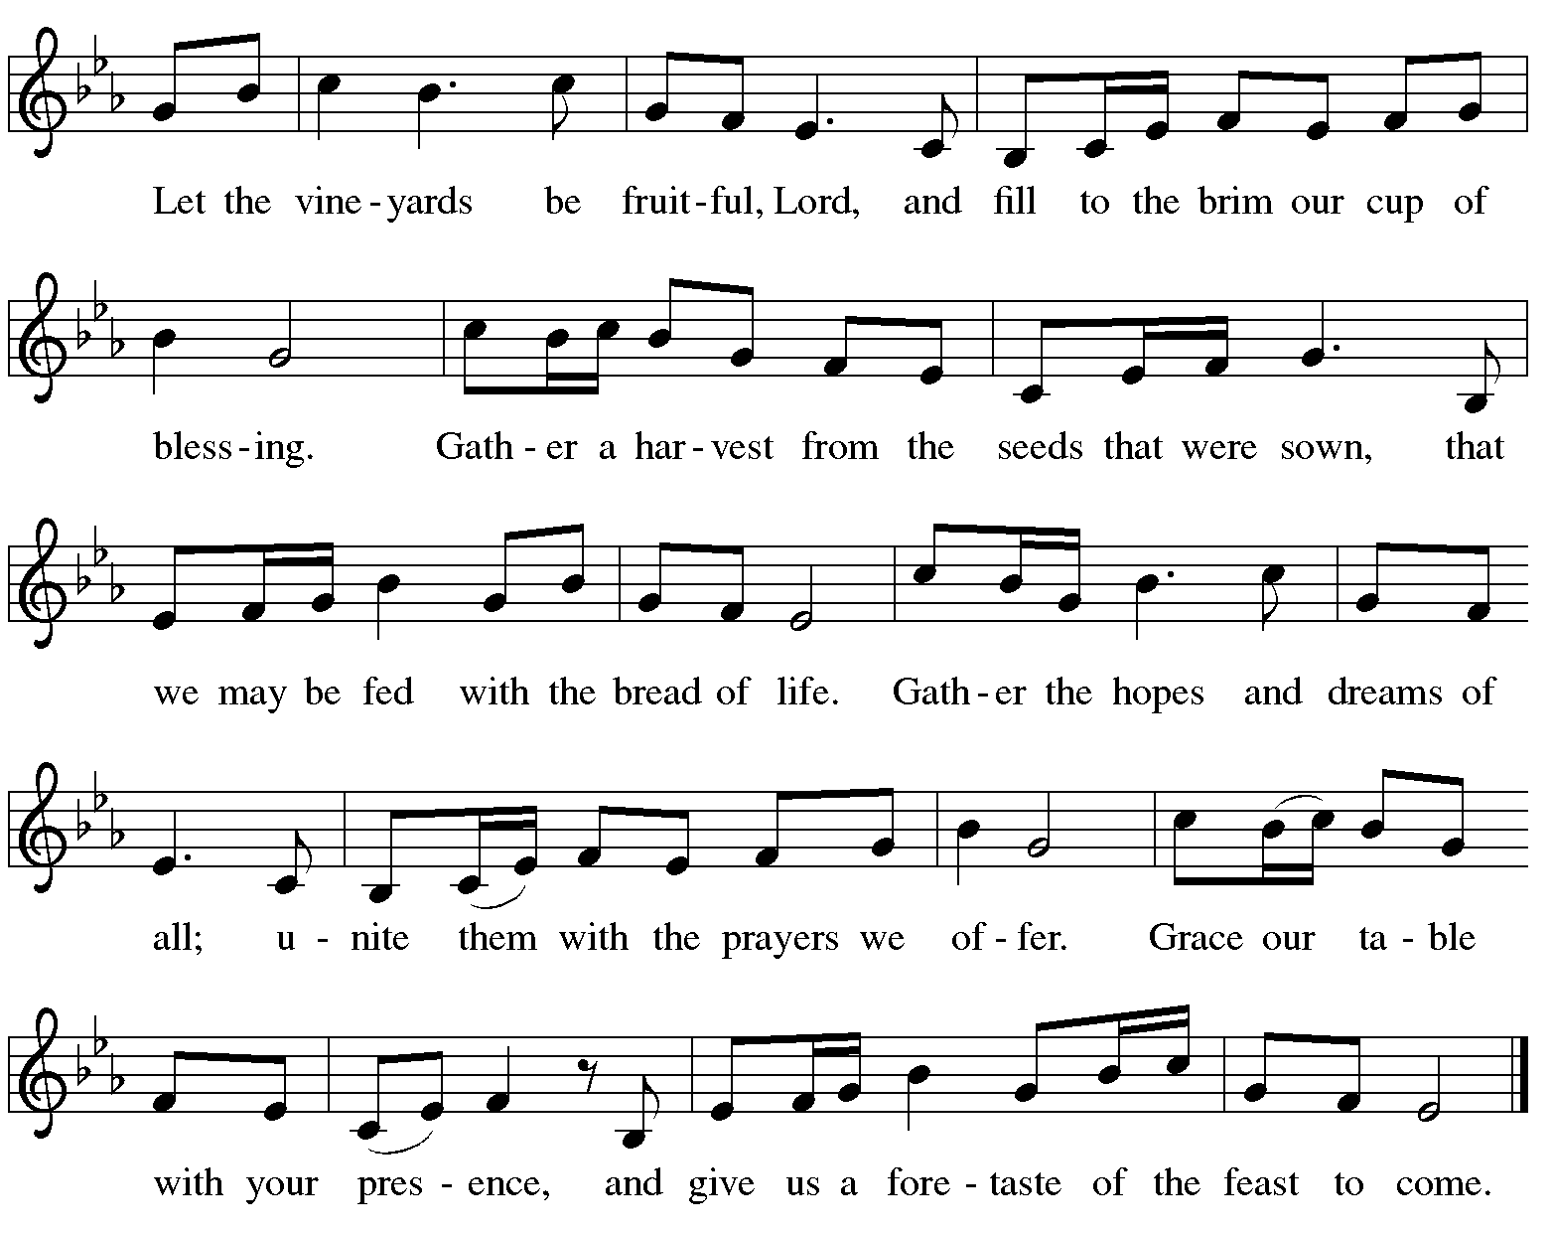

Offertory Prayer

A: Let us pray. Blessed are you,
C: O God, ruler of heaven and earth.
Day by day you shower us with blessings.
As you have raised us to new life in Christ,
give us glad and generous hearts,
ready to praise you and to respond to those in need,
through Jesus Christ, our Savior and Lord. Amen.

Dialogue ELW p. 152

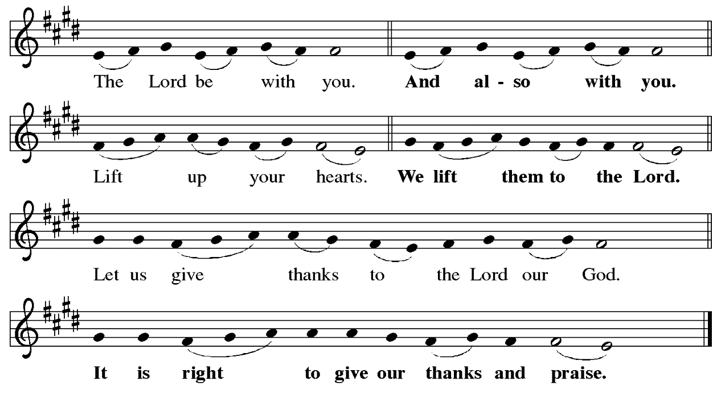

Preface (Sung by the presiding minister)

P: It is indeed right, our duty and our joy …
… we praise your name and join their unending hymn:

Sanctus ELW p. 153
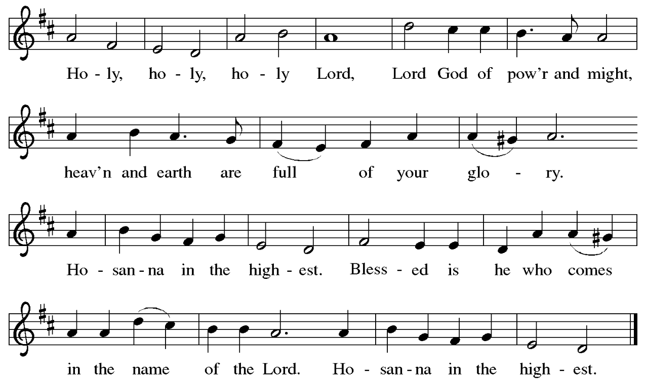
Eucharistic Prayer

P: Blessed are you, O God of the universe …
… for Christ is risen:
C: Christ is risen indeed!

P: This is the day on which you gave light to the earth …
and that light is Christ:
C: Thanks be to God.

P: This is the day on which you broke the chains of death …
… for Christ is risen:
C: Christ is risen indeed!

P: In the night in which he was betrayed …
… Do this for the remembrance of me.

Let us proclaim the mystery of faith.
C: Christ has died. Christ is risen. Christ will come again.

P: On this day send us the power of your Holy Spirit …
… for that light is Christ:
C: Thanks be to God.

P: All holy and mighty and glorious God …
… for Christ is risen:
C: Christ is risen indeed!

P: Amen and Amen!
C: Amen and Amen!

Lord’s Prayer

P: Gathered as one by the Holy Spirit, let us pray as Jesus taught us.
C: Our Father in heaven,
hallowed be your name,
your kingdom come,
your will be done,
on earth as in heaven.
Give us today our daily bread.
Forgive us our sins
as we forgive those
who sin against us.

C: Save us from the time of trial
and deliver us from evil.
For the kingdom, the power,
and the glory are yours,
now and forever. Amen.

Fraction and Invitation

P: These are the gifts of God for the people of God.
Come, be renewed by Christ’s gifts of life.

Agnus Dei / Lamb of God ELW p. 154

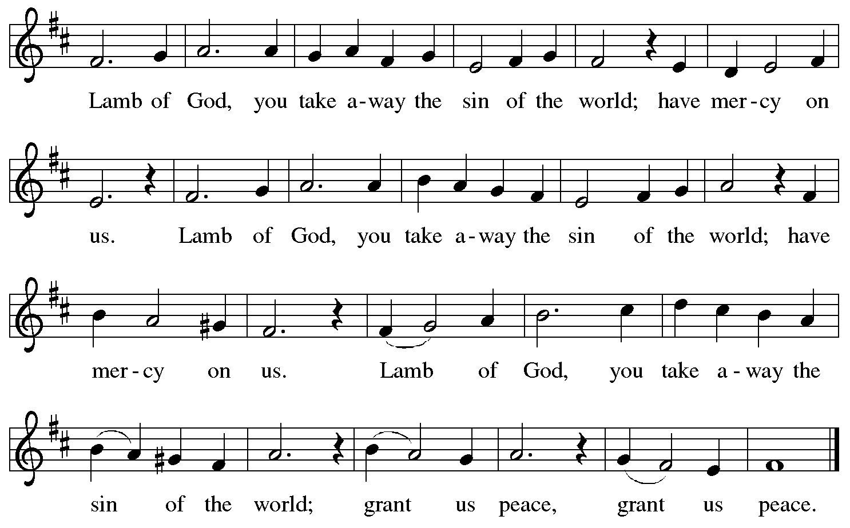

Please be seated.

Holy Communion
- All who seek God and desire a deeper and stronger life in Christ are welcome to receive Holy Communion.
- Worshipers from the pulpit side will proceed forward first, followed by the center section, and then the lectern side.
- Please inform an usher if you would like the ministers to bring Communion to you.
- Holy Communion will be served with bread and wine (red) or grape juice (white).
- The presiding minister will first distribute the bread (host) to each communicant. Please indicate if you require a gluten-free host.
- Once you have consumed the bread, please pick up an empty glass from the tray next to the presiding minister. The Communion Assistant will pour wine or grape juice into your glass.
- Please step to the side to consume the wine or grape juice.
- Feel free to kneel at the altar rail for prayer after receiving the sacrament.
- As you return to your pew, glasses may be returned to the empty tray on the side of the center section.
- A blessing will be provided for anyone who does not yet receive the sacrament.
- All are invited to join in singing the hymns during Holy Communion.

Hymns during Holy Communion
Now We Join in Celebration ELW 462

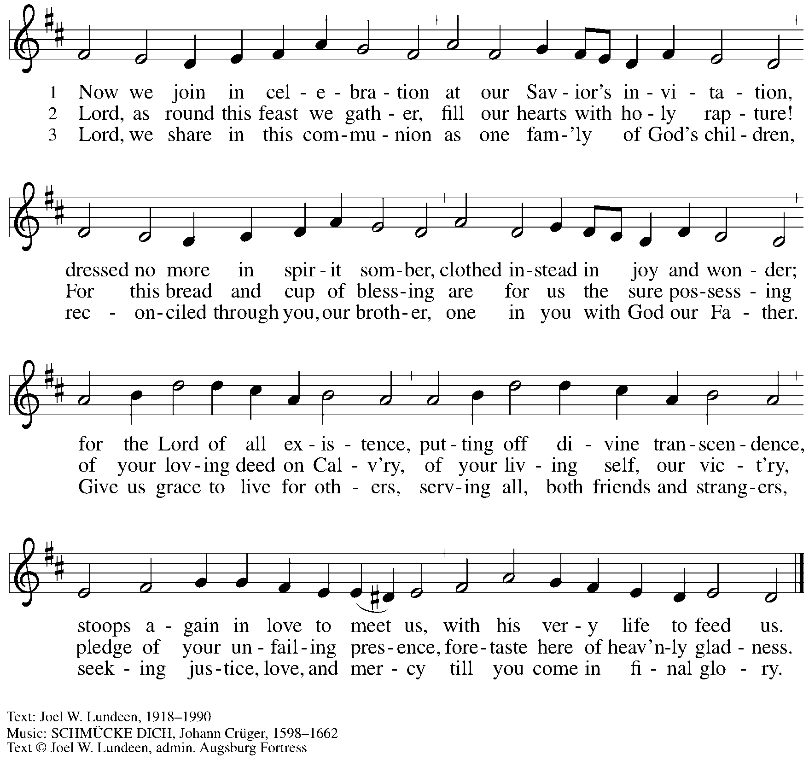
All rights reserved. Reprinted with permission under OneLicense.net # A-722139.
Hymns during Holy Communion ACS 938
Christ Has Risen While Earth Slumbers

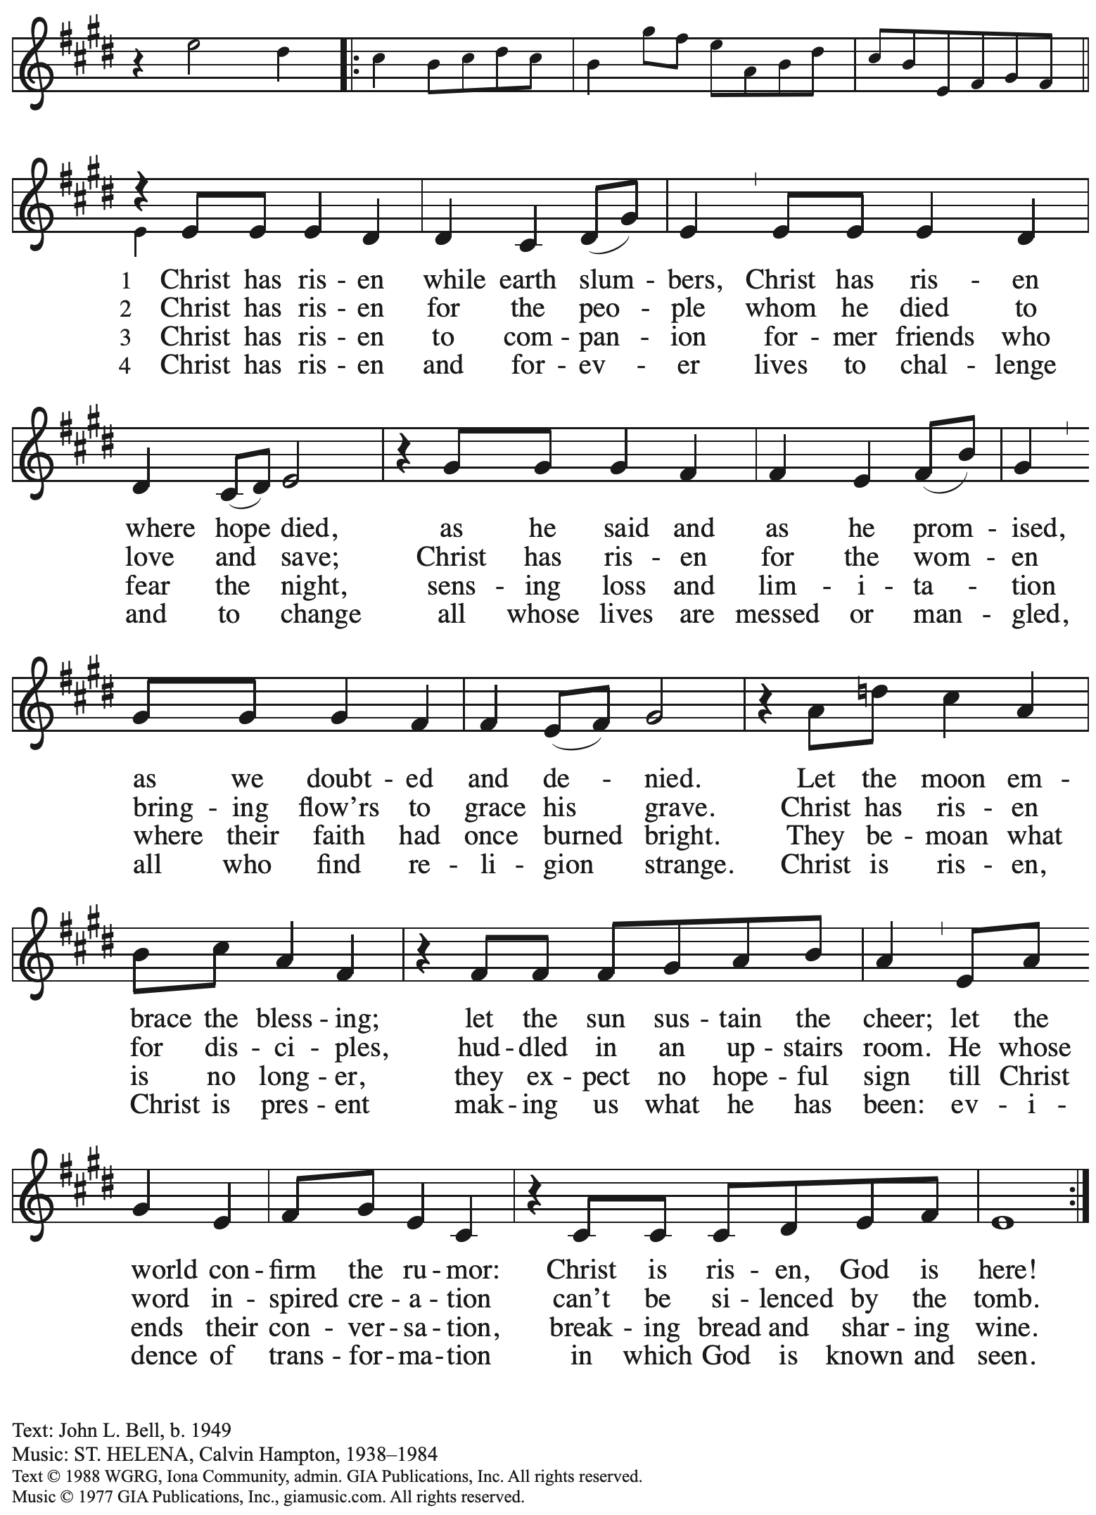
Reprinted with permission under OneLicense.net # A-722139
Hymns during Holy Communion
Hallelujah! Jesus Lives! ELW 380

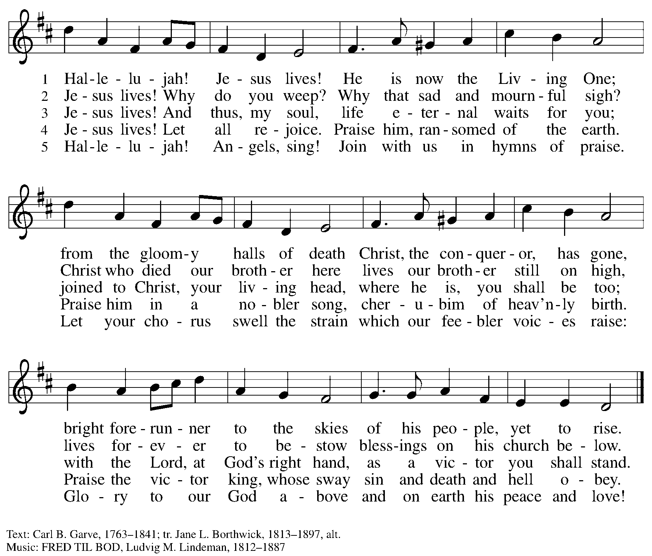

When all have returned to their places, please rise as you are able.

Blessing

P: The body and blood of our Lord Jesus Christ strengthen you and keep you in his grace.
C: Amen.

Prayer

A: Let us pray.
Life-giving God, in the mystery of Christ’s resurrection you send light to conquer darkness, water to give new life, and the bread of life to nourish your people.
Send us forth as witnesses to your son’s resurrection,
A: that we may show your glory to all the world,
through Jesus Christ, our risen Lord.
C: Amen.

Service of Sending
God blesses us and sends us in mission to the world

Benediction

P: May our glorious God grant you a spirit of wisdom
to know and love the risen Christ.

Almighty God, holy One, ☩ holy Three,
bless you now and forever.
C: Amen.

Sending Hymn Christ Is Risen! Shout Hosanna! ELW 383
v. 1
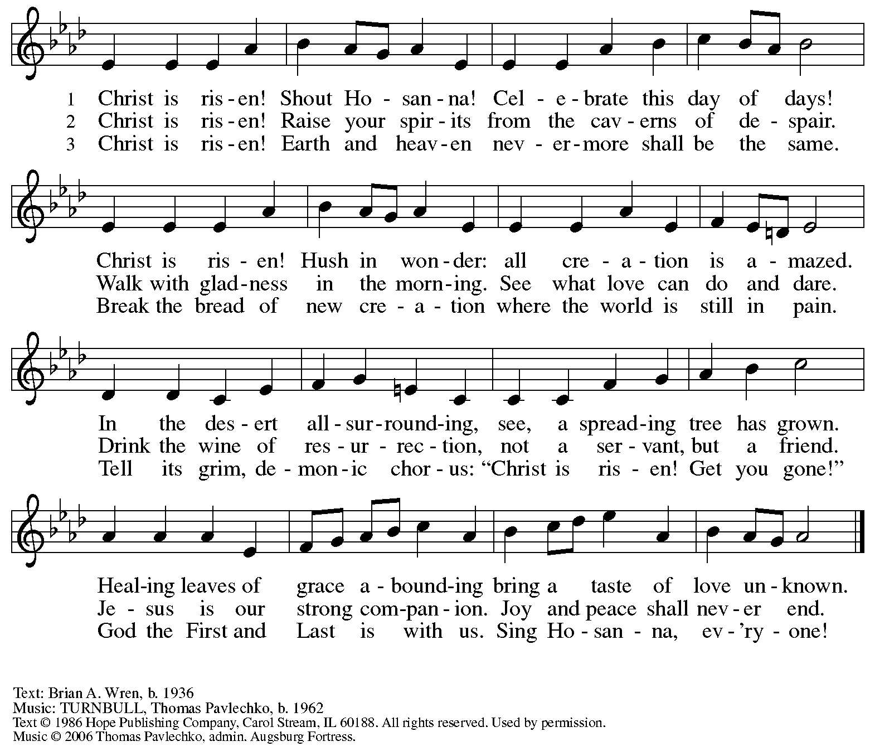
All rights reserved. Reprinted with permission under OneLicense.net # A-722139.
Dismissal

A: Go in peace. Share the good news!
C: Thanks be to God!

Postlude

The celebration of the Easter resurrection continues tomorrow morning
with worship at 10:00 a.m.

Please use the QR code below to link to St. Andrew’s announcements online!



Those serving in worship today

Altar Care Jodie Minor
Assisting Minister Mandy Best
Cantors Miriam Bohlmann Kunz
The Rev. Erin Jones
Maria Mangano
Fire Steward Alda Maria Gonzaga
Lectors / Storytellers Miriam Bohlmann Kunz
Alda Maria Gonzaga
Kathy Hays
Phil Koch
C. E. Pino
Paschal Candle Bearer Sarita Doshi
Minister of Music Laura Reynolds
Preaching and Presiding Minister The Rev. Ross I. Carmichael

Liturgy and Hymnody Acknowledgements

From SundaysandSeasons.com. Copyright © 2026 Augsburg Fortress. All rights reserved. Reprinted under OneLicense.net # A-722139.
Used by permission of Augsburg Fortress.

The Scripture readings contained herein are from New Revised Standard Version Updated Edition of the Bible © 2021 National Council of Churches of Christ in the United States of America. Used by permission. All rights reserved worldwide.

Easter Proclamation from Evangelical Lutheran Worship © 2007 Augsburg Fortress. All rights reserved. Reprinted under OneLicense.net # A-722139.

Earth Is Full of Wit and Wisdom – Text: Adam M.L. Tice, b. 1979. Music: HOLY MANNA, W. Moore, Columbian Harmony, 1825; arr. hymnal version. Text © 2009 GIA Publications, Inc. giamusic.com. All rights reserved. Arr. © 2003 Augsburg Fortress. All rights reserved. Reprinted with permission under OneLicense.net # A-722139.

I Will Call upon the Lord – Text: Michael O’Shields. Music: O’SHIELDS, Michael O’Shields. Text and Music © 1981 Sound III and All Nations Music; assigned to MCA Music Publishing and the Lorenz Corporation. All rights reserved. Reprinted with permission under OneLicense.net W A-722139.

Surely God Is My Salvation – Text: Zebulon M. Highben, based on Isaiah 12: 2-6. Music: YISRAEL V’ORAITA, Hasidic tune, arr. Zebulon M. Highben. Text and arr © 2009 Augsburg Fortress. All rights reserved. Reprinted with permission under OneLicense.net # A-722139.

All You Works of God, Bless the Lord – Text: Stephen P. Starke, paraphrase of Song of the Three 35-65. Music: LINSTEAD, Jamaican folk song, adapt. Doreen Potter. Text © 1995 Stephen P. Starke, admin. Concordia Publishing House. Music © 1975 Hope Publishing Co., Carol Stream, IL 60188. All rights reserved. Reprinted with permission under OneLicense.net # A-722139.

Eucharistic Prayer, For the Resurrection of our Lord: Easter Day – Adapted from Pray, Praise, and Give Thanks: A Collection of Litanies, Laments, and Thanksgivings at Font and Table by Gail Ramshaw, copyright © 2017 Augsburg Fortress. All rights reserved. Reprinted with permission.

St. Andrew Announcements
April 4th, 2026

- Welcome to Worship at St. Andrew on the Vigil of Easter, Saturday, April 4th – We are thankful for your presence, and we offer a special welcome to all visitors and guests!
- Welcome, New Members! – Tonight we celebrate and give thanks for Phil, Erin and Chloe, Gayle and Tom, and Tim and Griffin, who will be welcomed as new members of the congregation through Affirmation of Baptism. By God’s grace, their affirmation becomes an opportunity for all of us to be renewed in the promises and gifts of Baptism! Thanks be to God for these new siblings in Christ!
- Worship on The Resurrection of our Lord – Easter Sunday, April 5th, 10:00 a.m. – We join the church throughout the world in proclaiming the good news of Christ’s resurrection and celebrating Holy Communion!
- Reparations Offering on Easter Sunday – April 5th during Worship – In Luke’s Gospel, Jesus tells a story about a compassionate Samaritan, suggesting that God’s people are called to work for healing and restoration for our neighbors, regardless of who or what caused them harm. In light of this, St. Andrew has made a commitment to reparations in regard to African American spiritual songs used in our worship. The text and music of most hymns is attributed to specific authors, with copyrights in place, usage reported, and royalties paid to those whose works are featured in worship. With African American spirituals, this is not possible. In response to many years of such uncredited use, St. Andrew invites the congregation to give a reparations offering. Funds received in worship will be donated to our siblings at Bethel AME Church, whose land and building were taken from them in the 1950s, to fund their development in the Hill District.

