

+ Sixth Sunday of Easter
May 10, 2026


St. Andrew Lutheran Church
304 Morewood Ave.
Pittsburgh, PA 15213
St_andrewELCA@verizon.net
www.standrewpittsburgh.org

+ Sixth Sunday of Easter

Jesus does not abandon his followers.
Through the Holy Spirit, Jesus comes to abide with his disciples of every generation.
As Pentecost draws near, we are reminded that the risen Christ dwells in us as the Spirit of truth. We receive this Spirit in baptism and pray that in our gathering around the Lord’s table
the Spirit will transform us to be the body of the risen Christ in the world.

Welcome to St. Andrew!
- St. Andrew welcomes all who are seeking a place of healing, wholeness, and acceptance in a nurturing and faith-forming spiritual home. We are striving toward racial equity worldwide
and we seek to honor the lived experience of all individuals regardless of background. Our community embraces people of all ages, ethnicities, cultures, abilities, sexual orientations,
gender identities and expressions, and family constellations. Come and See!
- Worship Services are live-streamed to multiple online platforms. By attending worship, you agree that your image and voice may be broadcast.
- Everyone is invited to make a name tag at the black bookcase in the back of the worship space if they would like. There are stickers indicating pronouns on the bookcase if you would like to include them on your name tag.
- Children are invited to attend Little Church – Big Faith, a Bible lesson and activity, during worship (after the Prayer of the Day). The group returns to the worship space for the liturgy of Holy Communion.
- A nursery is available through the doors at the left side of the sanctuary and across from the doorway to the Social Hall. Look for a purple-colored room.
- Worship “toolkits” to help children engage with the service, along with “busy bags” for younger children, are available in the bookcase at the back of the sanctuary. Please feel free to take one to use with/for your children.
- Holy Communion is served with bread (gluten-free available) and wine or grape juice. The presiding minister will distribute the bread (host). Please consume this and then pick up an empty glass from the tray. The Communion Assistant will pour wine or grape juice into your glass. Please step to the side to consume the wine or grape juice. Feel free to kneel at the altar for prayer and reflection. As you return to your pew, glasses may be returned to the empty trays on either side of the center section.
- A restroom is available on the main level of the church, through the doors to the Social Hall and to the right in the main office.

Abbreviations
P: Pastor/Presiding Minister ELW: Evangelical Lutheran Worship hymnal
A: Assisting Minister ACS: All Creation Sings hymnal
L: Lector
C: Congregation

Musical Offering Jered Stratton

Each week, different people from the congregation make an offering of pre-service music, with singing or instrumentation, to help the assembly focus and pray in preparation for worship.

Welcome
Prelude God, Whose Giving Knows No Ending arr. Wahl

Gathering
The Holy Spirit calls us together as the people of God

Please rise as you are able. All may make the sign of the cross,
the sign that is marked at Baptism, as the presiding minister begins.

Thanksgiving for Baptism

P: Alleluia! Christ is risen!
C: Christ is risen indeed! Alleluia! Alleluia!

P: Salvation belongs to our God who is seated on the throne and to the Lamb!
C: Amen.

P: Let us give thanks for the gift of Baptism.

Water may be poured into the font as the presiding minister continues.
P: Merciful God,
you are the one who was, who is, and who is to come.
You lead us beside still waters.
We thank you for the waters of creation:
morning dew, gentle rain, roaring waves.
We thank you for the waters that nourish us.
Blessed are you!
C: You guide us to springs of the water of life.

P: Jesus Christ, you are the faithful witness
who accompanies us on our journeys.
We give you thanks for your life-giving death and resurrection.
We praise you for joining us in joy and sorrow.
Blessed are you!
C: You guide us to springs of the water of life.

P: Holy Spirit, you anoint our head with oil and our cup overflows.
Break down barriers that divide us.

P: Fill us with the breath of peace.
Blessed are you!
C: You guide us to springs of the water of life.

P: Holy One, we thank you for the gifts and grace of Baptism,
and for making us a new creation.
We join with saints and angels, giving you honor and praise,
now and forever.
C: Amen.

Gathering Hymn Christ Has Arisen, Alleluia ELW 364

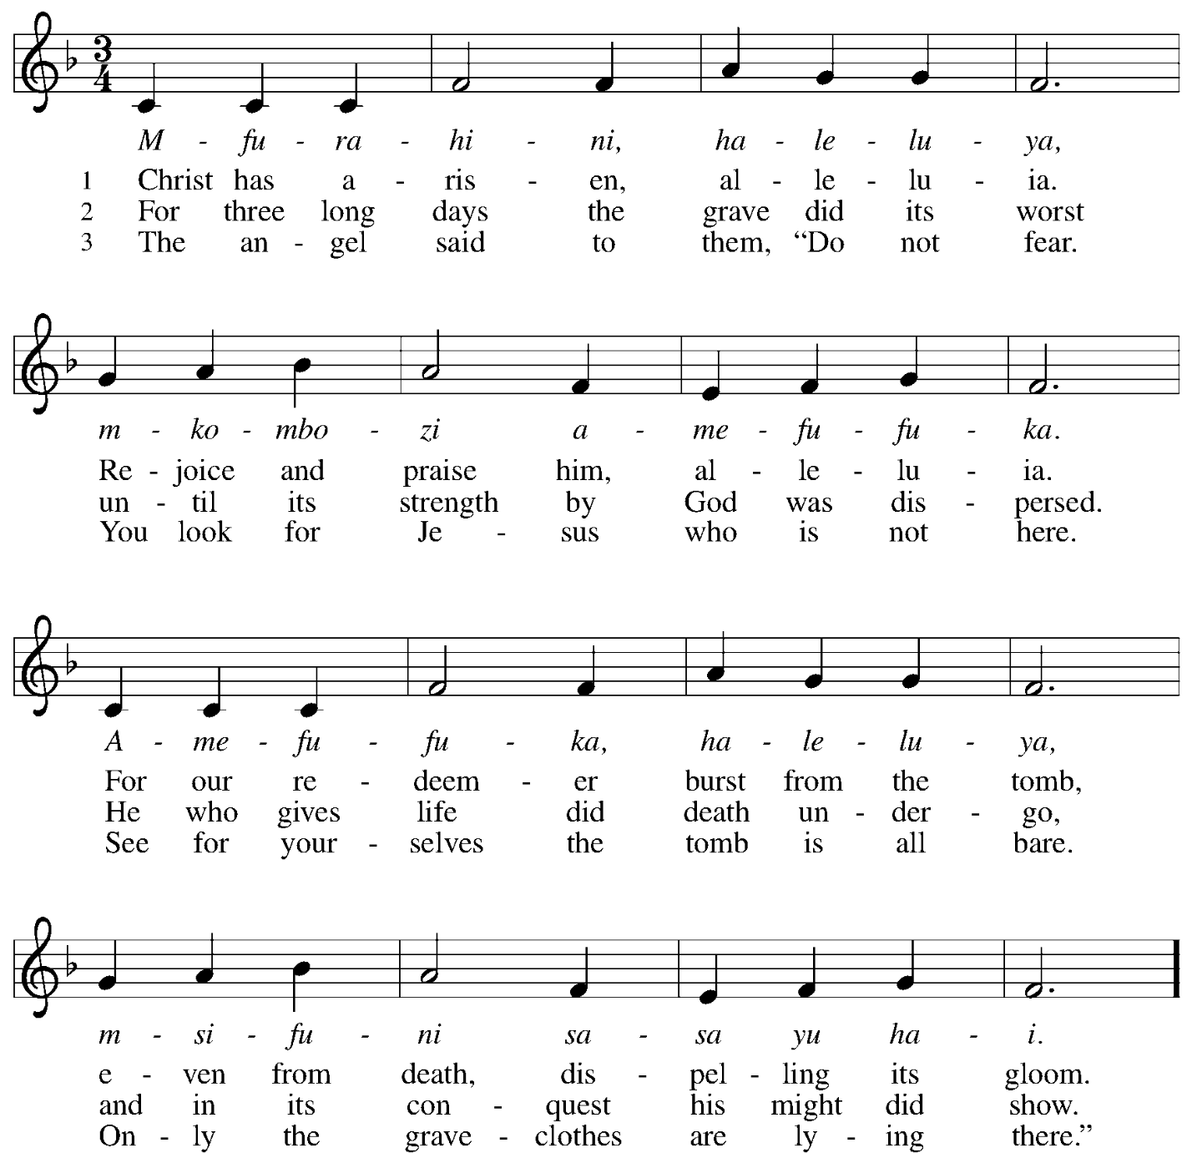
Continued
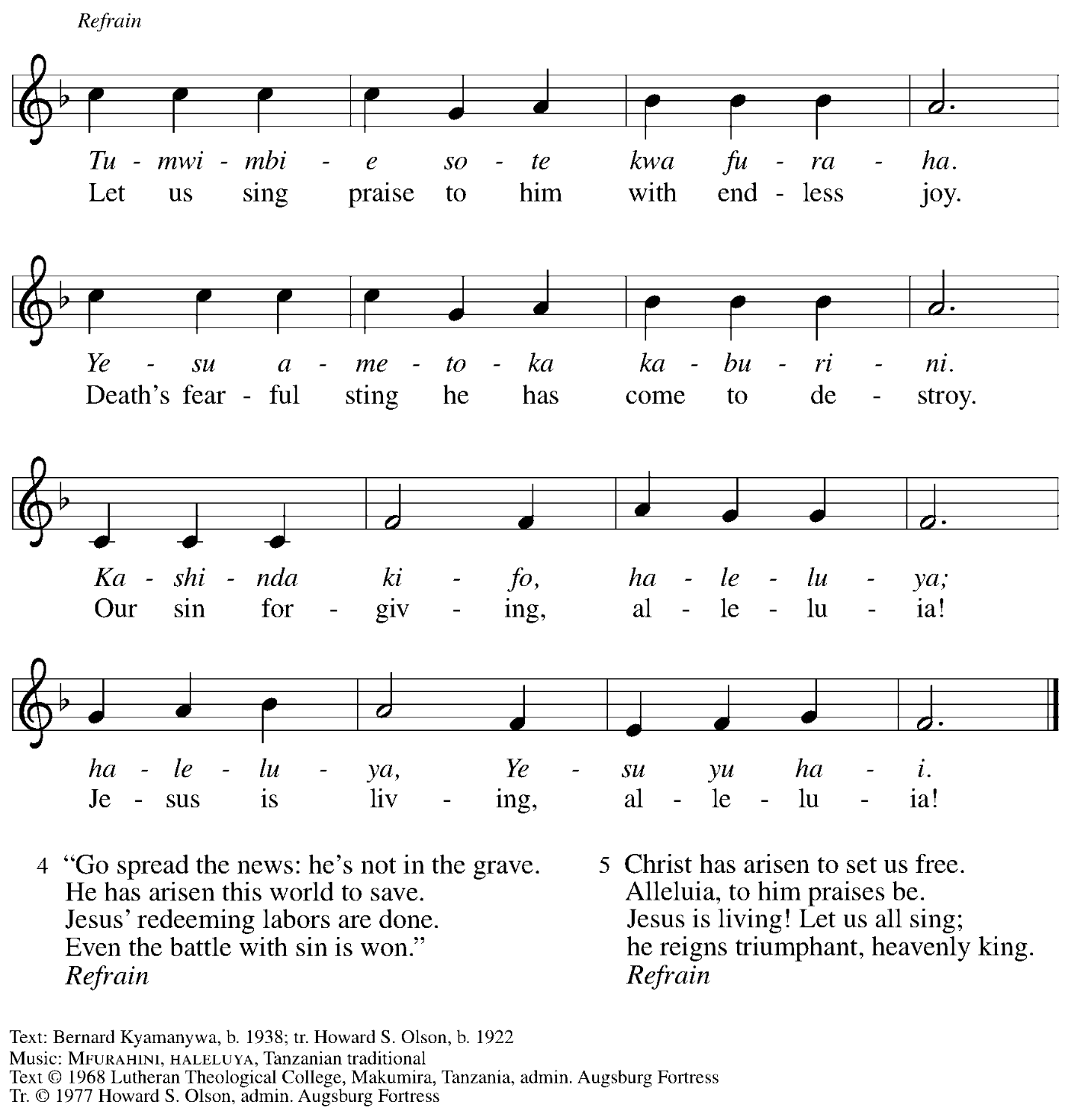
All rights reserved. Reprinted with permission under OneLicense.net # A-722139.

Greeting

P: The grace of our Lord Jesus Christ, the love of God,
and the communion of the Holy Spirit be with you all.
C: And also with you.

Hymn of Praise This Is the Feast ELW p. 149-150

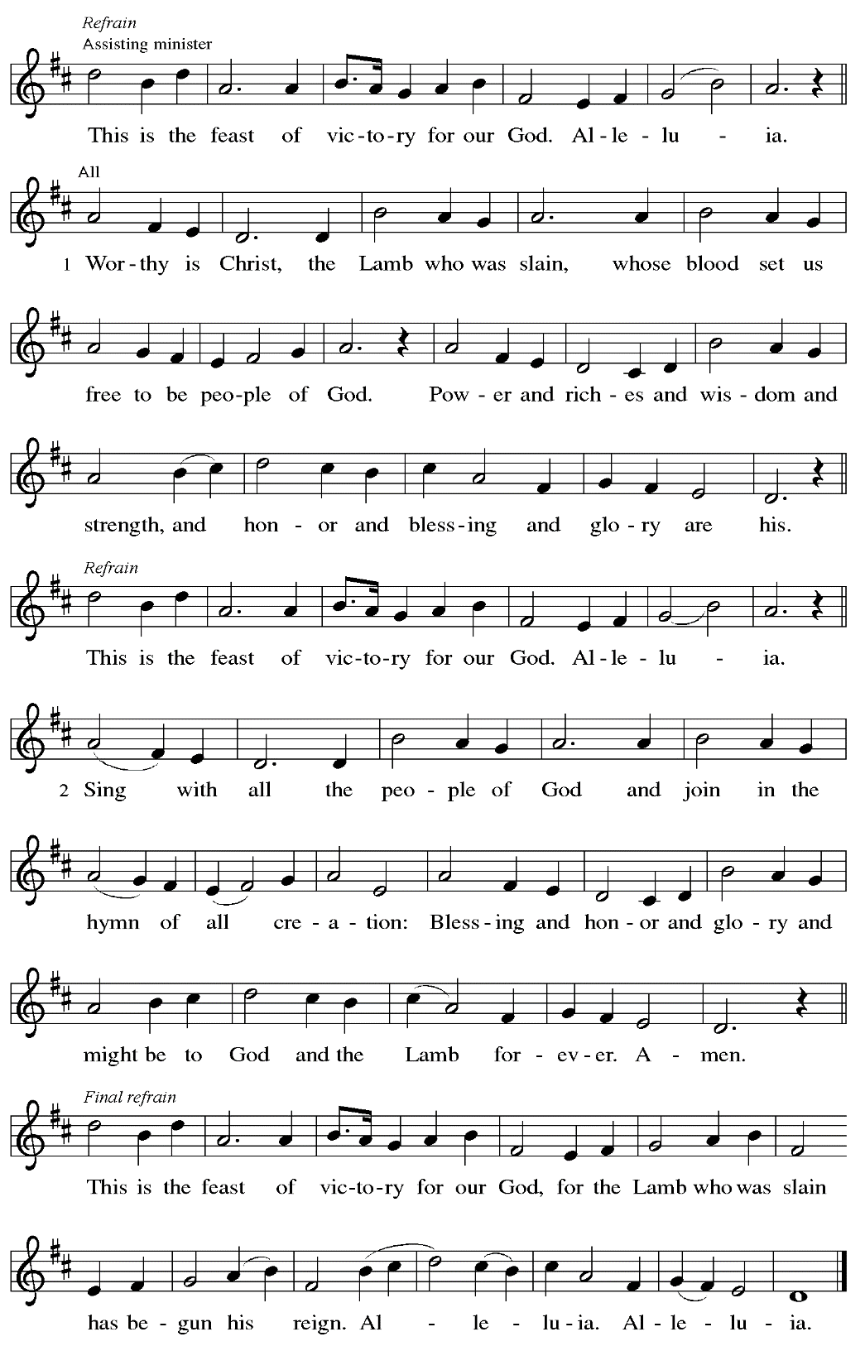
Prayer of the Day

P: The Lord be with you.
C: And also with you.

P: Let us pray.
Almighty and ever-living God, you hold together all things in heaven and on earth.
In your great mercy receive the prayers of all your children,
and give to all the world the Spirit of your truth and peace,
through Jesus Christ, our Savior and Lord,
who lives and reigns with you and the Holy Spirit,
one God, now and forever.
C: Amen.

Please be seated.
Children are invited to join the adult leader(s) at the side door for Little Church – Big Faith.
We ask that an additional adult from the congregation attend with the children.

Word
God speaks to us in Scripture reading, preaching, and song

First Reading – Acts 17: 22-31

²² Paul stood in front of the Areopagus and said, “Athenians, I see how extremely spiritual you are in every way. ²³ For as I went through the city and looked carefully at the objects of your worship, I found among them an altar with the inscription, ‘To an unknown god.’ What therefore you worship as unknown, this I proclaim to you. ²⁴ The God who made the world and everything in it, the one who is Lord of heaven and earth, does not live in shrines made by human hands,
²⁵ nor is God served by human hands, as though God needed anything, since God Godself gives to all mortals life and breath and all things. ²⁶ From one ancestor God made all peoples to inhabit the whole earth, and God allotted the times of their existence and the boundaries of the places where they would live, ²⁷ so that they would search for God and perhaps fumble about for God and find God—though indeed God is not far from each one of us. ²⁸ For ‘In God we live and move and have our being’; as even some of your own poets have said,
‘For we, too, are God’s offspring.’
²⁹ “Since we are God’s offspring, we ought not to think that the deity is like gold or silver or stone, an image formed by the art and imagination of mortals. ³⁰ While God has overlooked the times of human ignorance, now God commands all people everywhere to repent, ³¹ because God has fixed a day on which God will have the world judged in righteousness by one whom God has appointed, and of this God has given assurance to all by raising him from the dead.”

L: Word of God, word of life.
C: Thanks be to God.

Psalm 66: 8-20

The psalm will be sung responsively, led by the cantor,
with the congregation responding with the bold verses and refrain.

Psalm Tone

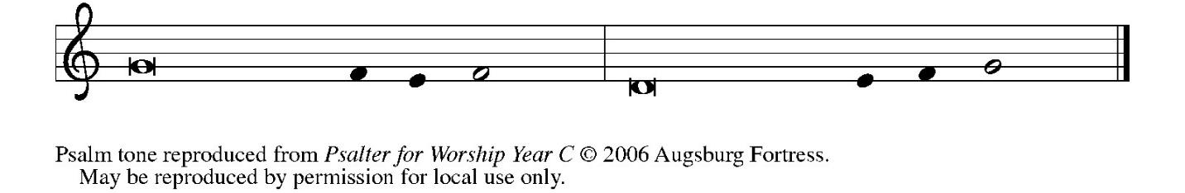

Psalm Refrain

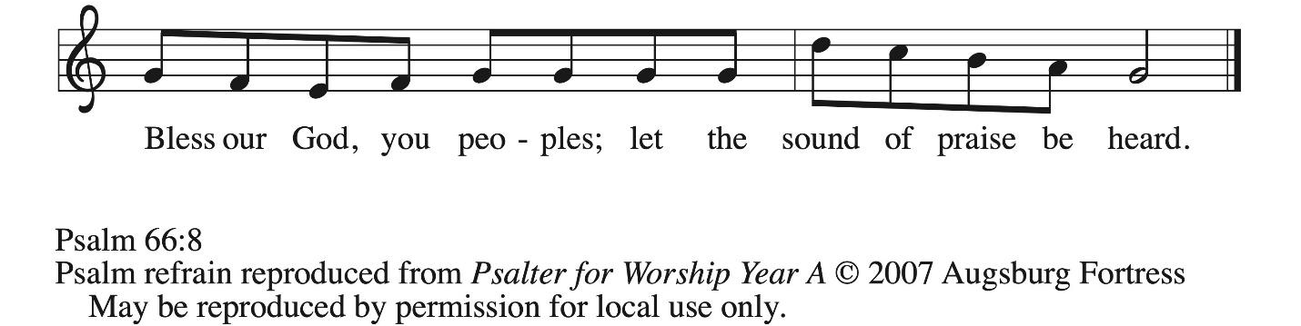

⁸ Bless our | God, you peoples;
let the sound of | praise be heard.
⁹ Our God has kept us a- | mong the living
and has not allowed our | feet to slip. R
¹⁰ For you, O God, have | tested us;
you have tried us just as sil- | ver is tried.
¹¹ You brought us in- | to the net;
you laid heavy burdens up- | on our backs.
¹² You let people ride over our heads; we went through | fire and water,
but you brought us out into a place | of refreshment.
¹³ I will enter your house | with burnt offerings
and will pay | you my vows—
¹⁴ those that I promised | with my lips
and spoke with my mouth when I | was in trouble.
¹⁵ I will offer you burnt offerings of fatlings with the | smoke of rams;
I will give you ox- | en and goats. R
¹⁶ Come and listen, all you | who believe,
and I will tell you what God has | done for me.
¹⁷ I called out to God | with my mouth,
and praised the Lord | with my tongue.
¹⁸ If I had cherished evil | in my heart,
the Lord would | not have heard me;
¹⁹ but in truth | God has heard me
and has attended to the sound | of my prayer.
²⁰ Blessed be God, who has not reject- | ed my prayer,
nor withheld unfailing | love from me. R

Second Reading – 1 Peter 3: 13-22

¹³ Now who will harm you if you are eager to do what is good? ¹⁴ But even if you do suffer for doing what is right, you are blessed. Do not fear what they fear, and do not be intimidated, ¹⁵ but in your hearts sanctify Christ as Lord. Always be ready to make your defense to anyone who demands from you an accounting for the hope that is in you, ¹⁶ yet do it with gentleness and respect. Maintain a good conscience so that, when you are maligned, those who abuse you for your good conduct in Christ may be put to shame. ¹⁷ For it is better to suffer for doing good, if suffering should be God’s will, than to suffer for doing evil. ¹⁸ For Christ also suffered for sins once for all, the righteous for the unrighteous, in order to bring you to God. He was put to death in the flesh but made alive in the spirit, ¹⁹ in which also he went and made a proclamation to the spirits in prison, ²⁰ who in former times did not obey, when God waited patiently in the days of Noah, during the building of the ark, in which a few, that is, eight lives, were saved through water. ²¹ And baptism, which this prefigured, now saves you—not as a removal of dirt from the body but as an appeal to God for a good conscience, through the resurrection of Jesus Christ,
²² who has gone into heaven and is at the right hand of God, with angels, authorities, and powers made subject to him.

L: Word of God, word of life.
C: Thanks be to God.

Please rise as you are able.

Gospel Acclamation ELW p. 151

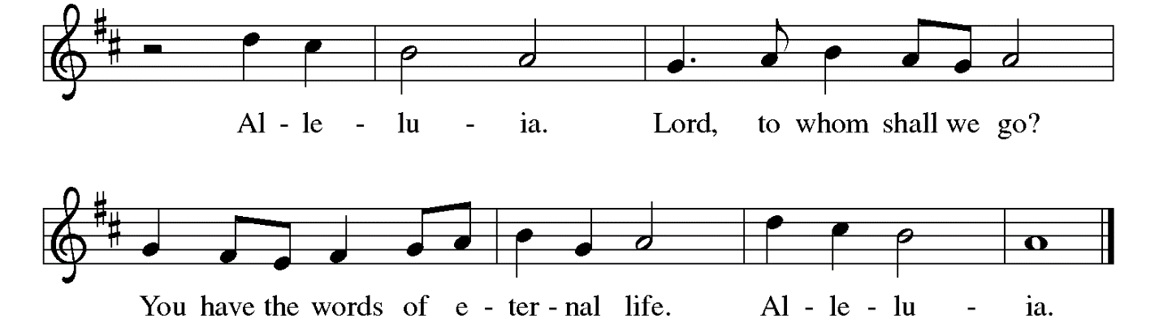

Gospel – John 14: 15-21

P: The holy Gospel according to St. John.
C: Glory to you, O Lord.

[Jesus said to the disciples:] ¹⁵ “If you love me, you will keep my commandments. ¹⁶ And I will ask the Father, and he will give you another Advocate, to be with you forever. ¹⁷ This is the Spirit of truth, whom the world cannot receive because it neither sees him nor knows him. You know him because he abides with you, and he will be in you.
¹⁸ “I will not leave you orphaned; I am coming to you. ¹⁹ In a little while the world will no longer see me, but you will see me; because I live, you also will live. ²⁰ On that day you will know that I am in my Father, and you in me, and I in you. ²¹ They who have my commandments and keep them are those who love me, and those who love me will be loved by my Father, and I will love them and reveal myself to them.”

P: The Gospel of the Lord.
C: Praise to you, O Christ.

Please be seated.

Sermon

A time of silence for prayer and reflection follows the sermon.
When the hymn of the day begins, please rise as you are able.

Hymn of the Day Holy Spirit, Truth Divine ELW 398

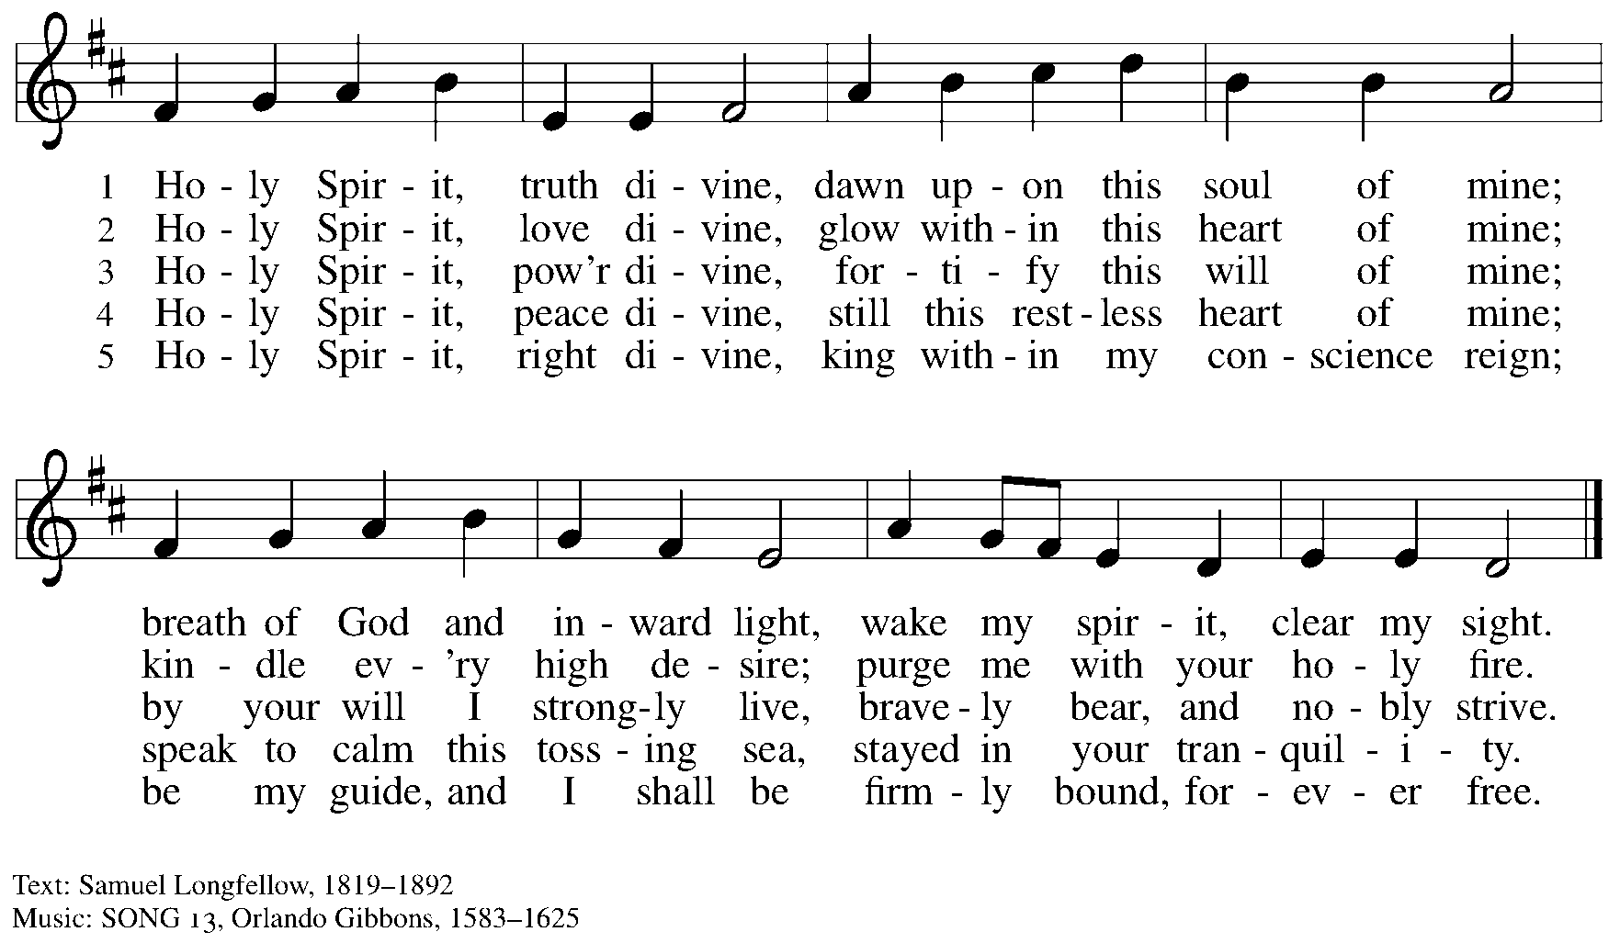

Nicene Creed

C: We believe in one God,
the Father, the Almighty,
maker of heaven and earth,
of all that is, seen and unseen.

We believe in one Lord, Jesus Christ,
the only Son of God,
eternally begotten of the Father,
God from God, Light from Light,
true God from true God,
begotten, not made,
of one Being with the Father;
through him all things were made.
For us and for our salvation
he came down from heaven,
was incarnate of the Holy Spirit and the virgin Mary
and became truly human.
For our sake he was crucified under Pontius Pilate;
he suffered death and was buried.
On the third day he rose again
in accordance with the scriptures;
he ascended into heaven
and is seated at the right hand of the Father.
He will come again in glory to judge the living and the dead,
and his kingdom will have no end.

We believe in the Holy Spirit, the Lord, the giver of life,
who proceeds from the Father and the Son,*
who with the Father and the Son is worshiped and glorified,
who has spoken through the prophets.
We believe in one holy catholic and apostolic church.
We acknowledge one baptism for the forgiveness of sins.
We look for the resurrection of the dead,
and the life of the world to come. Amen.

*Or, “who proceeds from the Father.” The phrase “and the Son” is a later addition to the creed.

Prayers of the People

A: United in the joy and hope of the resurrection, let us pray for the church, the world,
and all who are in need.

After each petition
A: Gracious God,
C: receive our prayer.

The presiding minister concludes the prayers
P: We lift these prayers to you O God, trusting in your abundant mercy,
through Jesus Christ our risen Savior.
C: Amen.

Peace

The presiding minister and the assembly greet one another in the peace of the risen Christ.
P: The peace of Christ be with you always.
C: And also with you.

The people may greet those around them with a sign of Christ’s peace and may say
Peace be with you or similar words. Please be mindful that not everyone will be comfortable with sharing the peace, so please seek consent before shaking hands or hugging. Other possible ways to share the peace include a simple bow with the verbal greeting of peace, or simply a verbal expression of peace. When the greetings of peace have concluded, please be seated.



Meal
God feeds us with the presence of Jesus Christ

Offering

We offer ourselves, our gifts, and our faithful service to God.
As the offering is gathered for the mission of the church, including the care of those in need,
the table is set for Holy Communion.

There are laminated giving cards in the pew racks that feature a QR code for anyone who would like to give online. Those who give using the QR code, as well as those who give regularly online or through their bank are encouraged to place the laminated card in the plate as an expression of your offering.

Music during the Offering
All Hail the Power of Jesus’ Name arr. Bober

As the gifts are brought forward for presentation, please rise as you are able.

Offertory Song Let the Vineyards Be Fruitful ELW 184

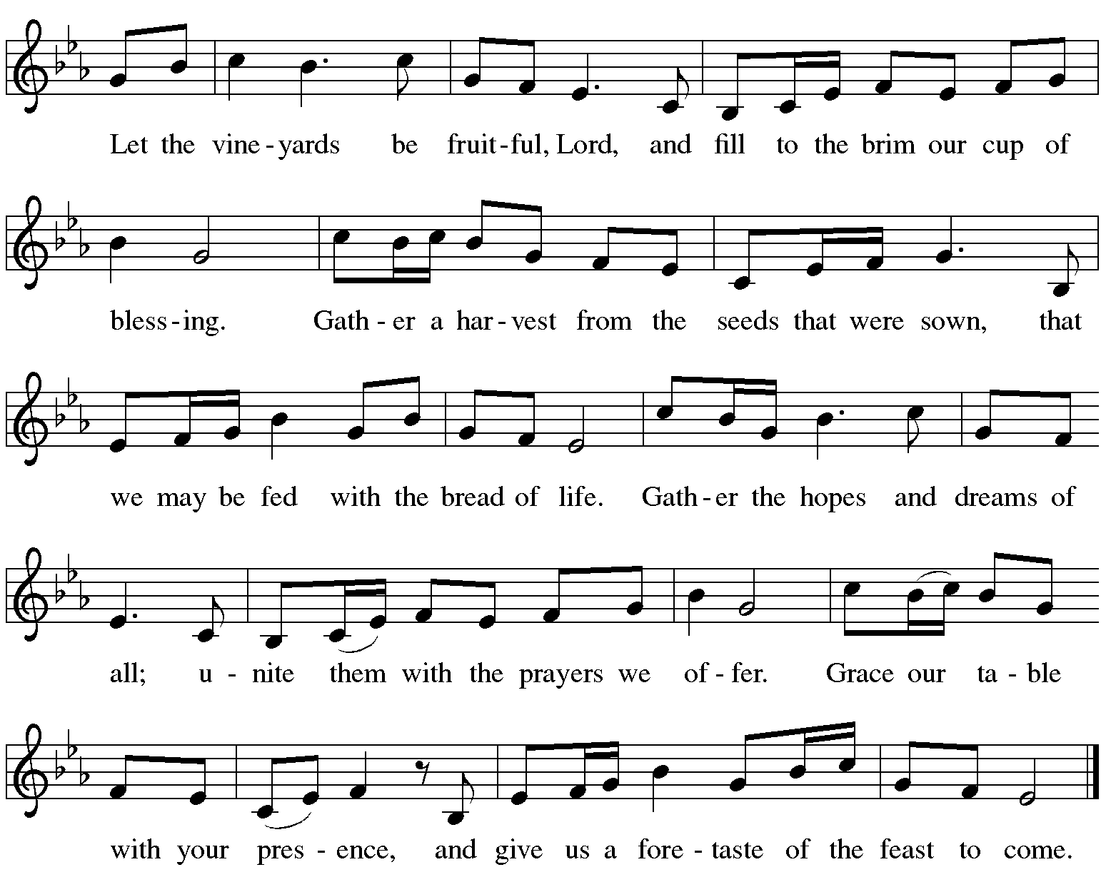

Offertory Prayer

A: Let us pray.
Blessed are you, O God,
C: ruler of heaven and earth.
Day by day you shower us with blessings.
As you have raised us to new life in Christ,
give us glad and generous hearts,
ready to praise you and to respond to those in need,
through Jesus Christ, our Savior and Lord.
Amen.

Dialogue ELW p. 152

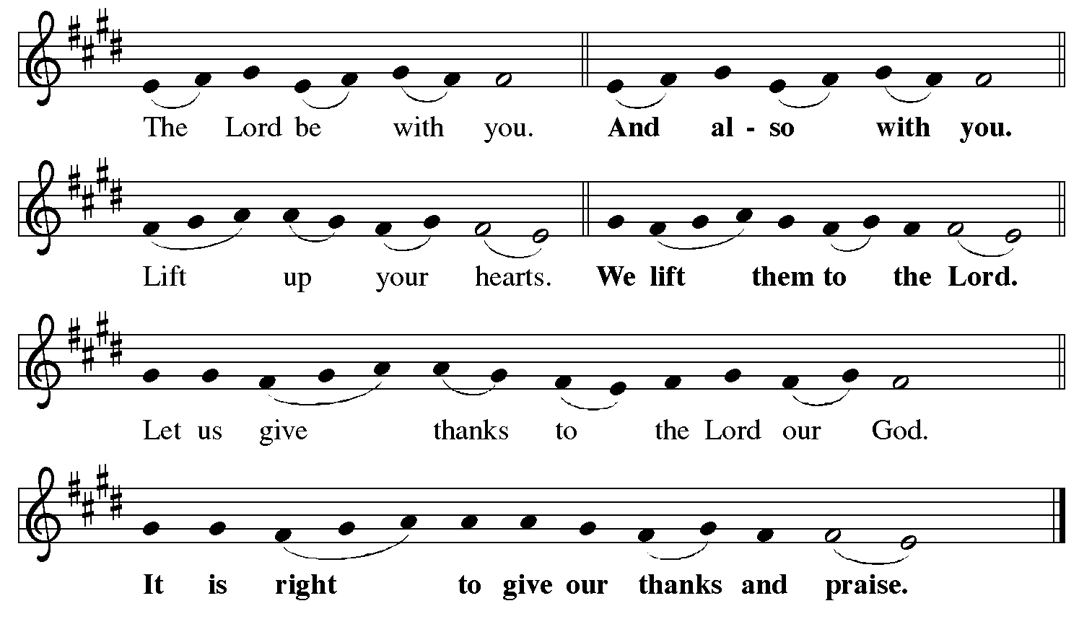

Preface (Sung by the presiding minister)

P: It is indeed right, our duty and our joy,
that we should at all times and in all places
give thanks and praise to you, almighty and merciful God,
for the glorious resurrection of our Savior Jesus Christ,
the true Paschal Lamb who gave himself to take away our sin;
who in dying has destroyed death,
and in rising has brought us to eternal life.
And so, with Mary Magdalene and Peter
and all the witnesses of the resurrection,
with earth and sea and all their creatures,
and with angels and archangels, cherubim and seraphim,
we praise your name and join their unending hymn:

Sanctus ELW p. 153

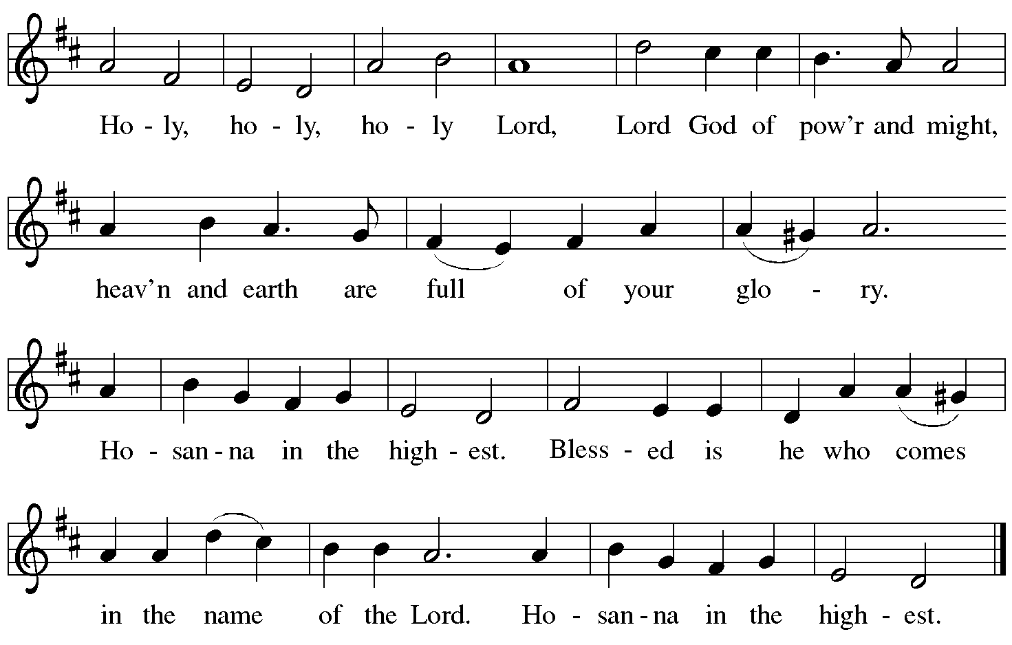

Eucharistic Prayer

P: Blessed are you, O God of the universe …
… Do this for the remembrance of me.

With this bread and cup we remember our Lord’s passover from death to life
as we proclaim the mystery of faith.
C: Christ has died. Christ is risen. Christ will come again.

P: O God of resurrection and new life …
… Grace our table with your presence.
C: Come, Holy Spirit.

P: Reveal yourself to us in the breaking of the bread …
… send us forth, burning with justice, peace, and love.
C: Come, Holy Spirit.

P: With your holy ones of all times and places …
… blessed and Holy Trinity, now and forever.
C: Amen.
Lord’s Prayer

P: Gathered as one by the Holy Spirit, let us pray as Jesus taught us.
C: Our Father, who art in heaven,
hallowed be thy name,
thy kingdom come,
thy will be done,
on earth as it is in heaven.
Give us this day our daily bread;
and forgive us our trespasses,
as we forgive those
who trespass against us;
and lead us not into temptation,
but deliver us from evil.
For thine is the kingdom,
and the power, and the glory,
forever and ever. Amen.

Fraction and Invitation

P: Alleluia! Christ is risen!
C: Christ is risen indeed! Alleluia! Alleluia!

P: This is the feast of victory for our God. Alleluia! Alleluia!
Come, share the feast.



Agnus Dei / Lamb of God ELW p. 154

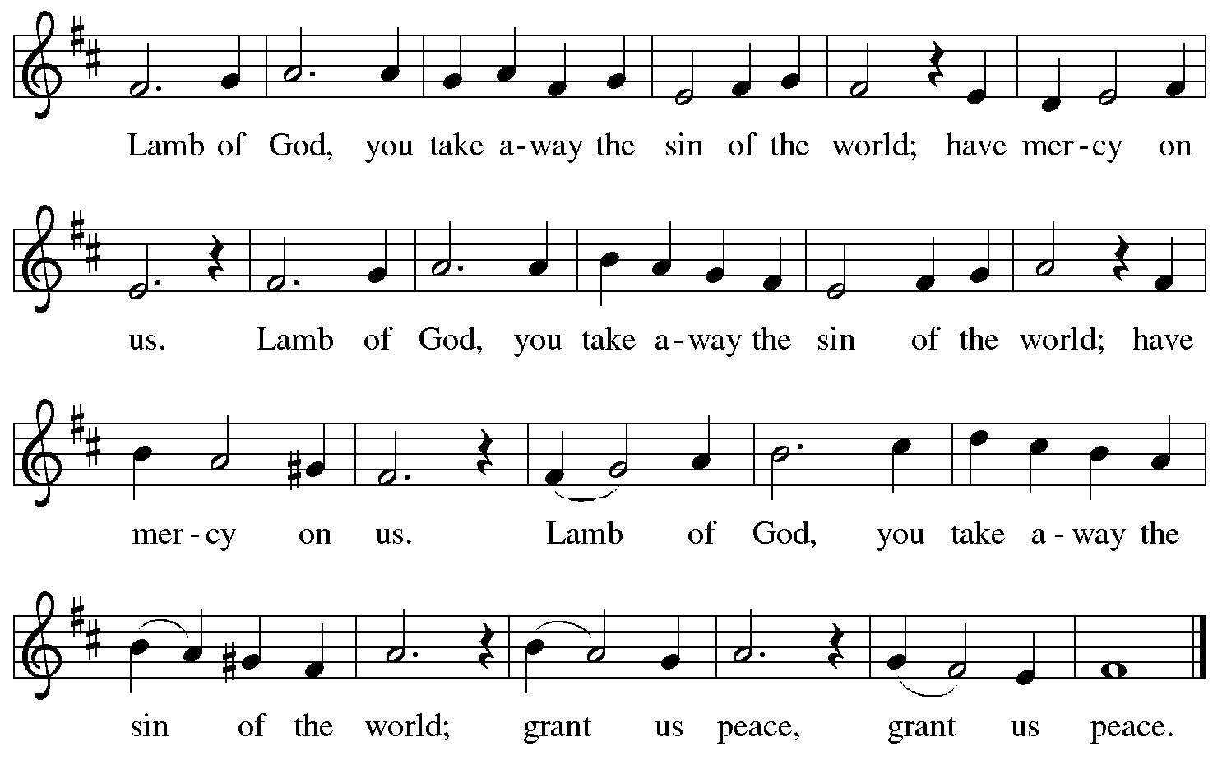

Please be seated.

Holy Communion

- All who seek God and desire a deeper and stronger life in Christ are welcome to receive Holy Communion.
- Worshipers from the pulpit side will proceed forward first, followed by the center section, and then the lectern side.
- Please inform an usher if you would like the ministers to bring Communion to you.
- Holy Communion will be served with bread and wine (red) or grape juice (white).
- The presiding minister will first distribute the bread (host) to each communicant. Please indicate if you require a gluten-free host.
- Once you have consumed the bread, please pick up an empty glass from the tray next to the presiding minister. The Communion Assistant will pour wine or grape juice into your glass.
- Please step to the side to consume the wine or grape juice.
- Feel free to kneel at the altar rail for prayer after receiving the sacrament.
- As you return to your pew, glasses may be returned to the empty tray on the side of the center section.
- A blessing will be provided for anyone who does not yet receive the sacrament.
- All are invited to join in singing the hymns during Holy Communion.

Hymns during Holy Communion
Loving Spirit ELW 397

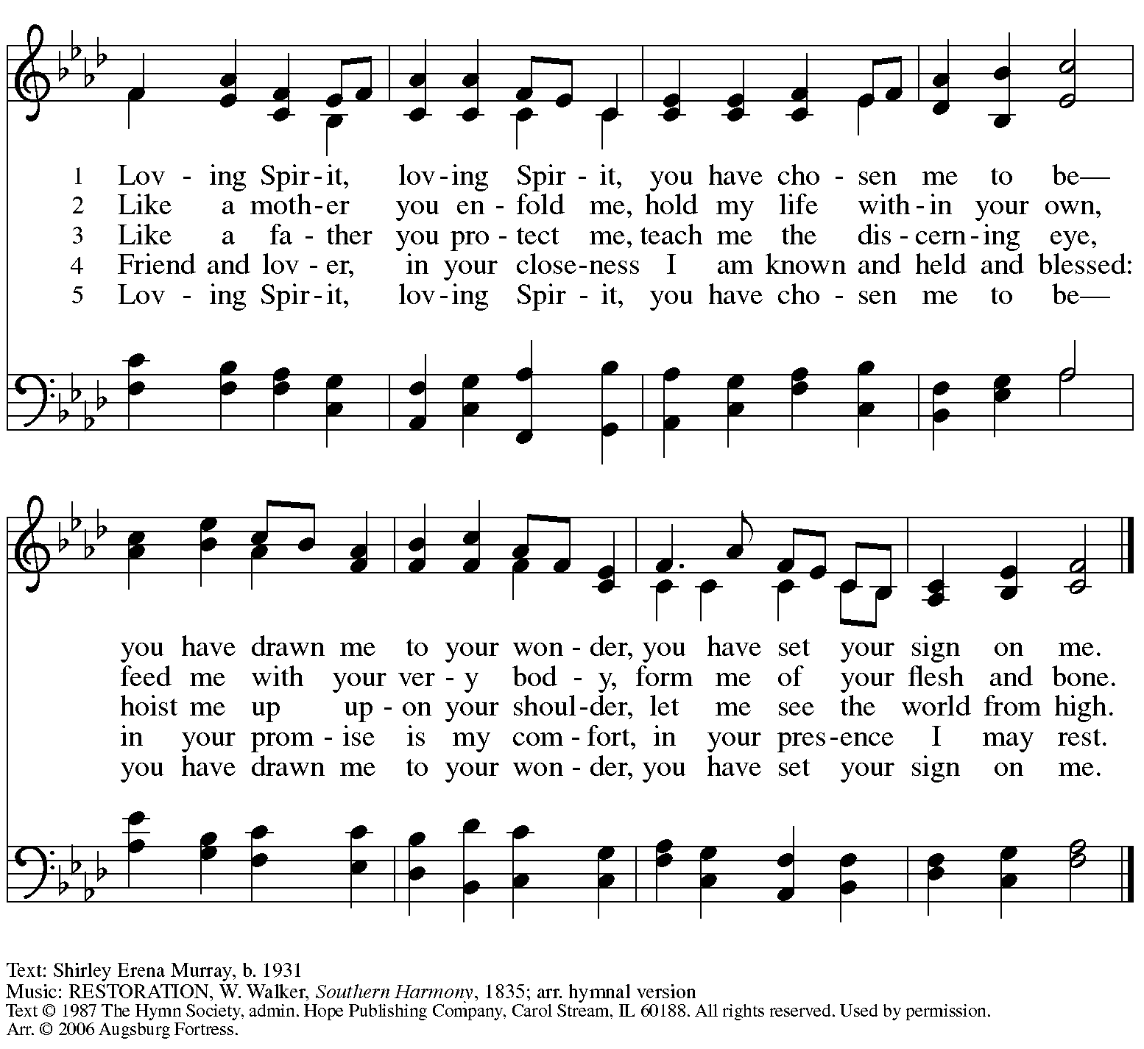
All rights reserved. Reprinted with permission under OneLicense.net # A-722139.

Hymns during Holy Communion
God Is Love ACS 1041

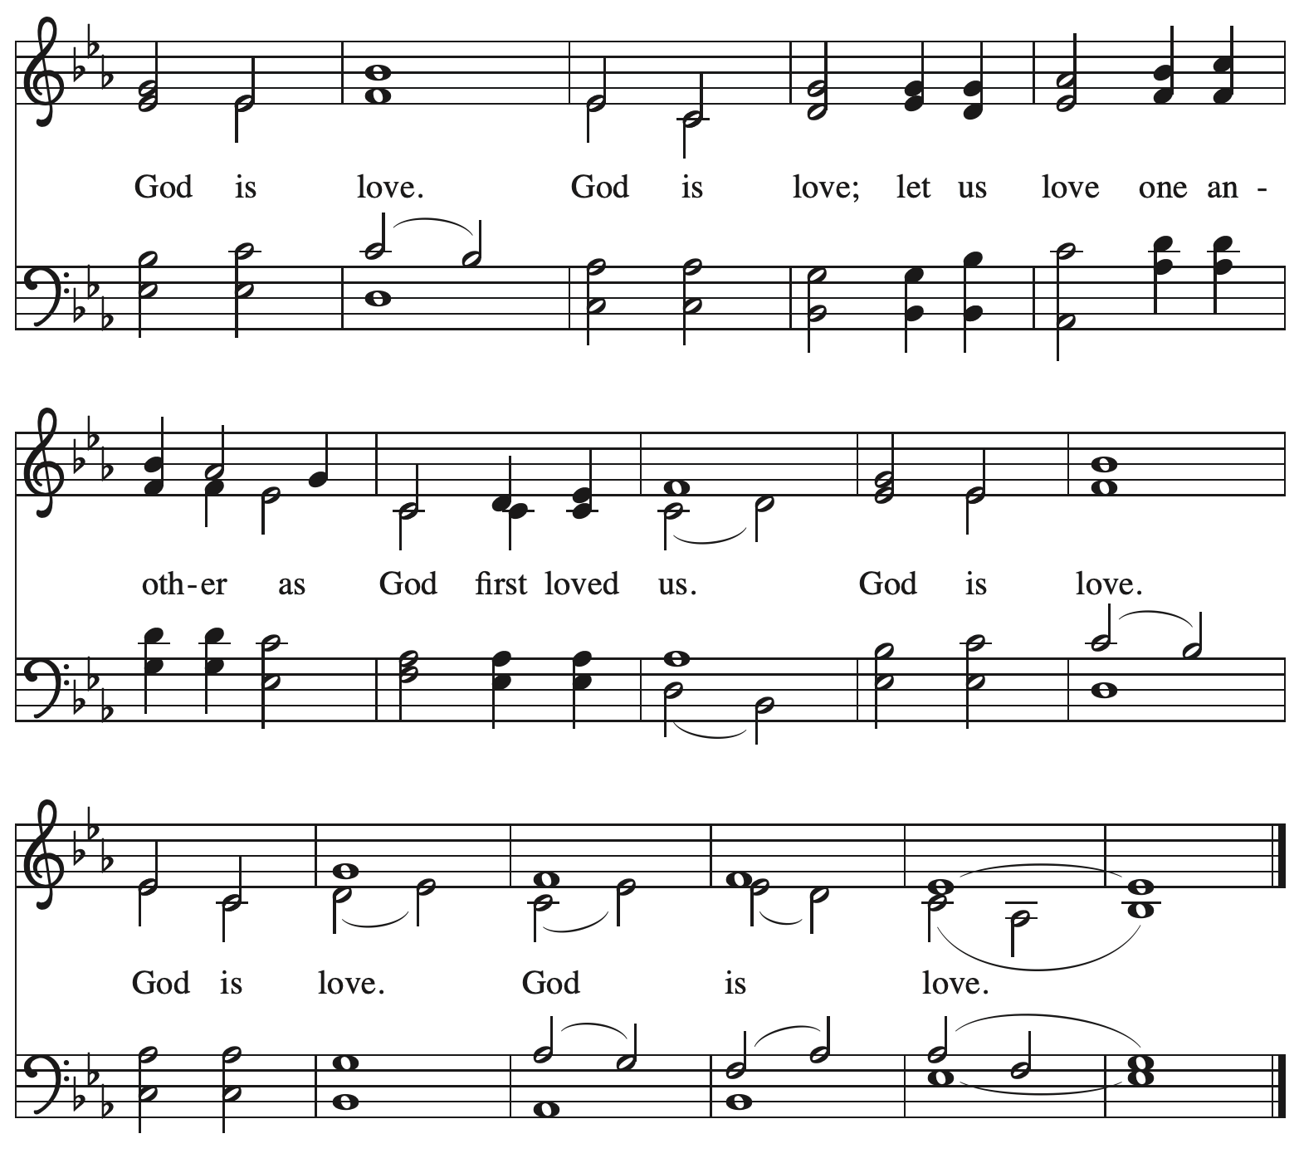

All rights reserved. Reprinted with permission under OneLicense.net # A-722139.

Hymns during Holy Communion
Spirit of God, Descend upon My Heart ELW 800

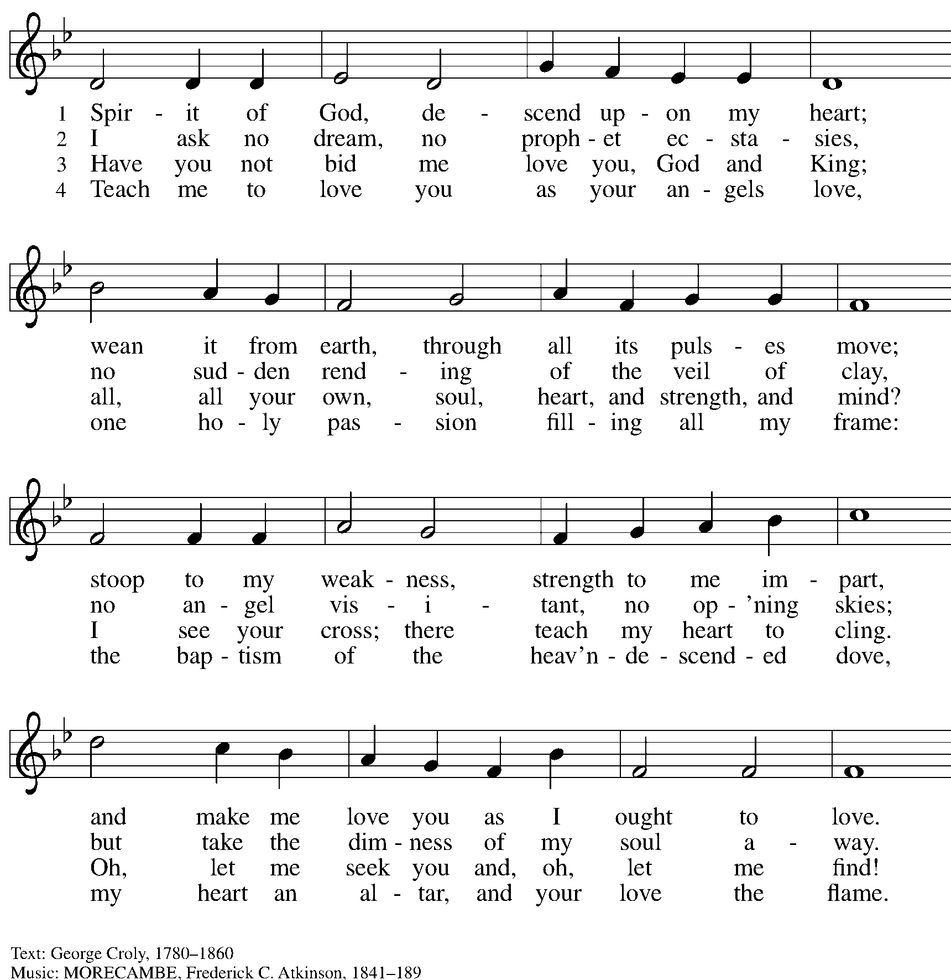

Hymns during Holy Communion
Spirit, Open My Heart ACS 1046

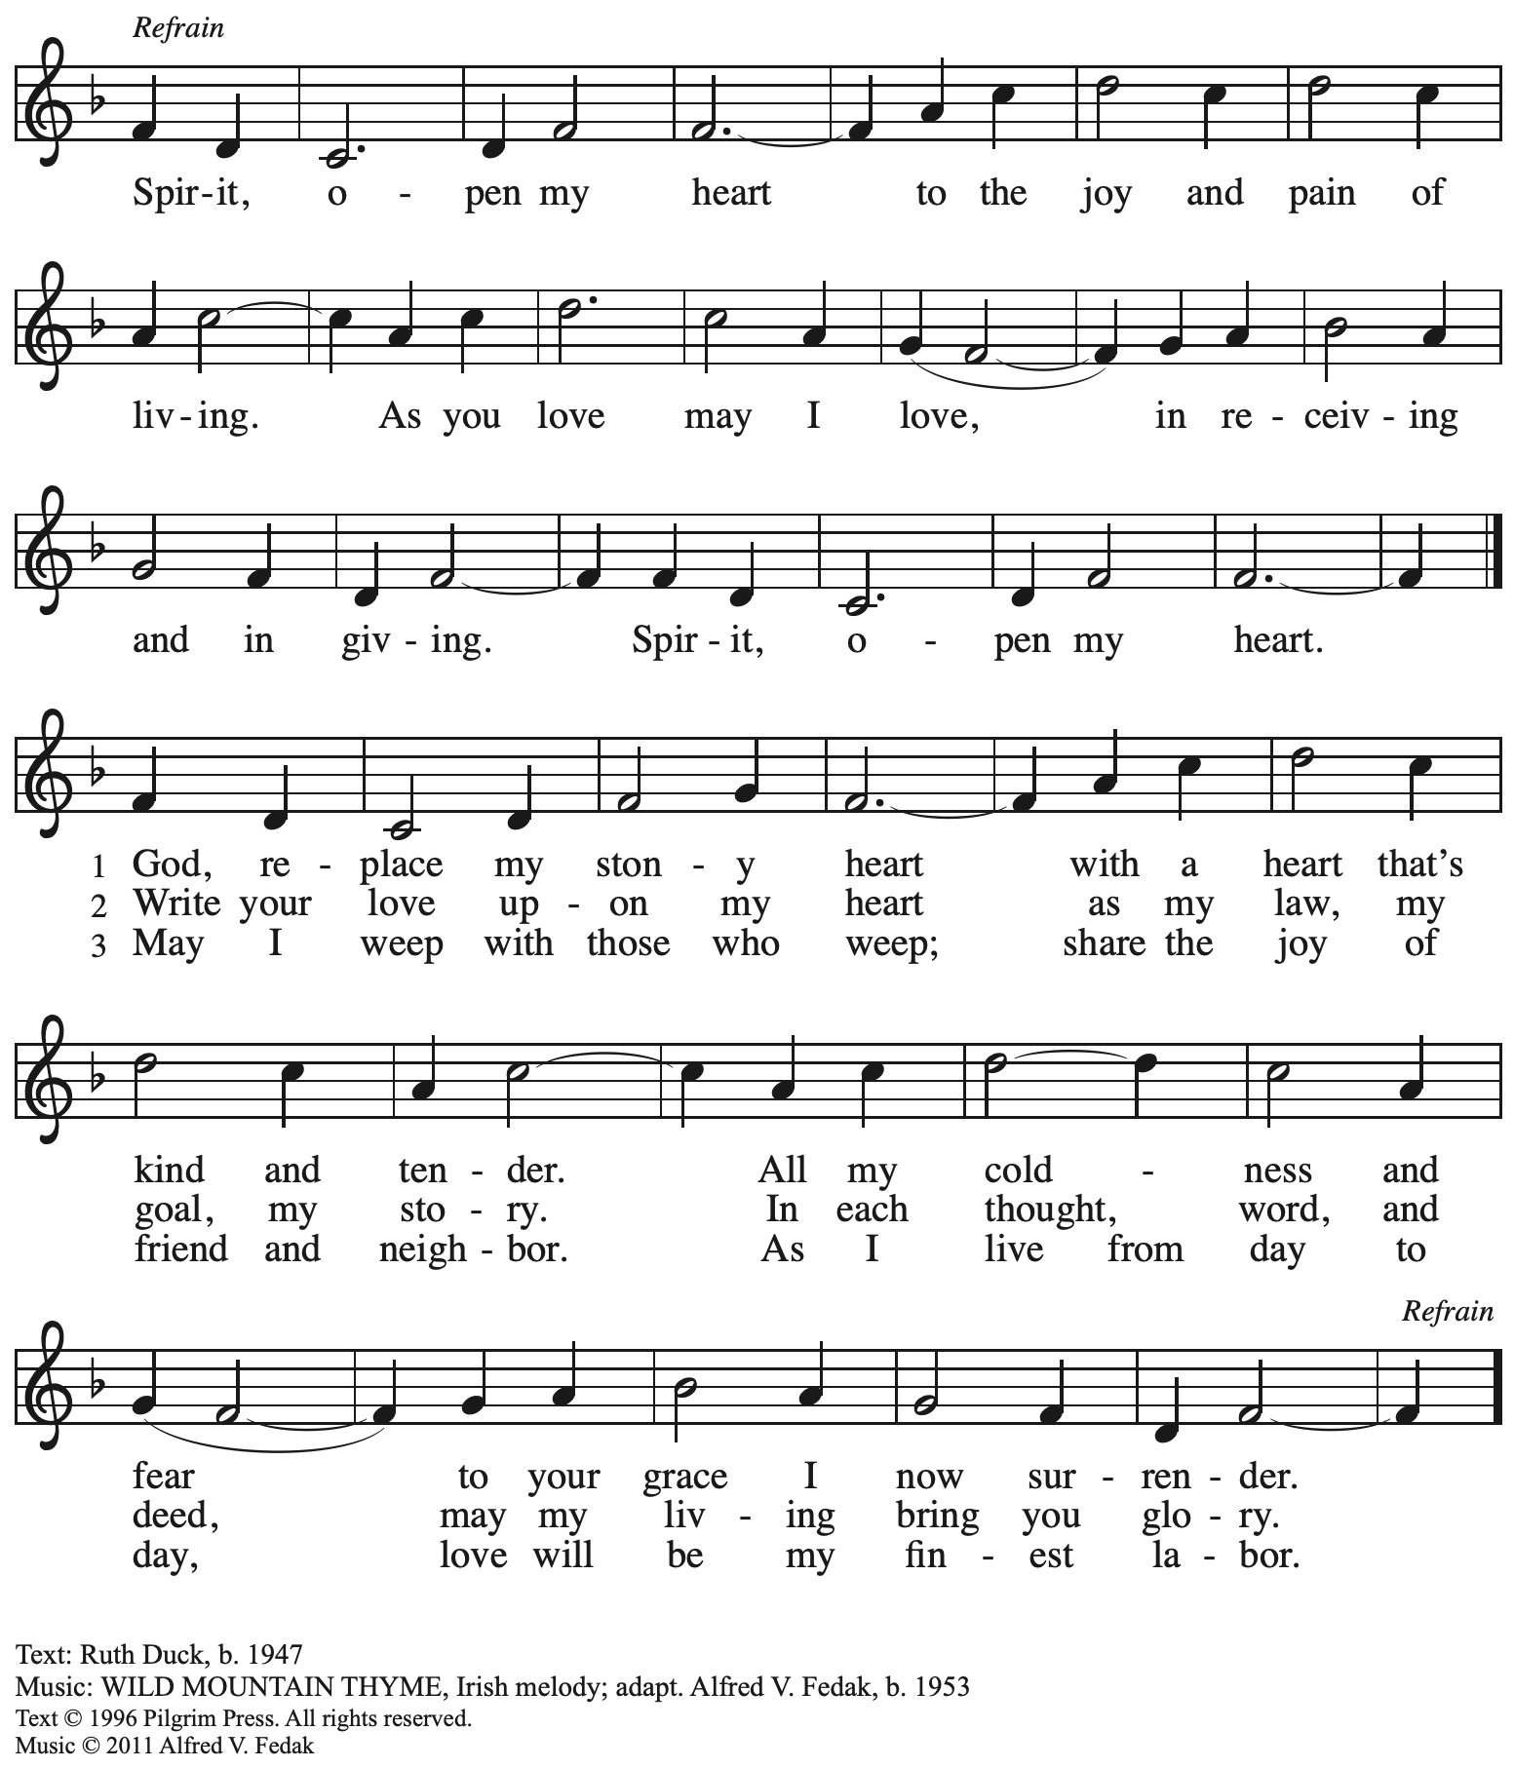
All rights reserved. Reprinted with permission under OneLicense.net # A-722139.

When all have returned to their places, please rise as you are able.

Blessing

P: The body and blood of our Lord Jesus Christ strengthen you and keep you in his grace.
C: Amen.

Prayer

A: Let us pray. Life-giving God, in the mystery of Christ’s resurrection,
you send light to conquer darkness, water to give new life, and the bread of life
to nourish your people. Send us forth as witnesses to your Son’s resurrection,
that we may show your glory to all the world, through Jesus Christ, our risen Lord.
C: Amen.

Please be seated.

Sending
God blesses us and sends us in mission to the world

Announcements

Please rise as you are able.

Benediction

P: May our glorious God grant you a spirit of wisdom
to know and love the risen Christ.

Almighty God, holy One, ☩ holy Three,
bless you now and forever.
C: Amen.

Sending Hymn Following Page

Dismissal

A: Alleluia! Christ is risen!
C: Christ is risen indeed! Alleluia! Alleluia!

A: Go in peace. Share the good news!
C: Thanks be to God!

Postlude

Sending Hymn The Spirit Sends Us Forth to Serve ELW 551

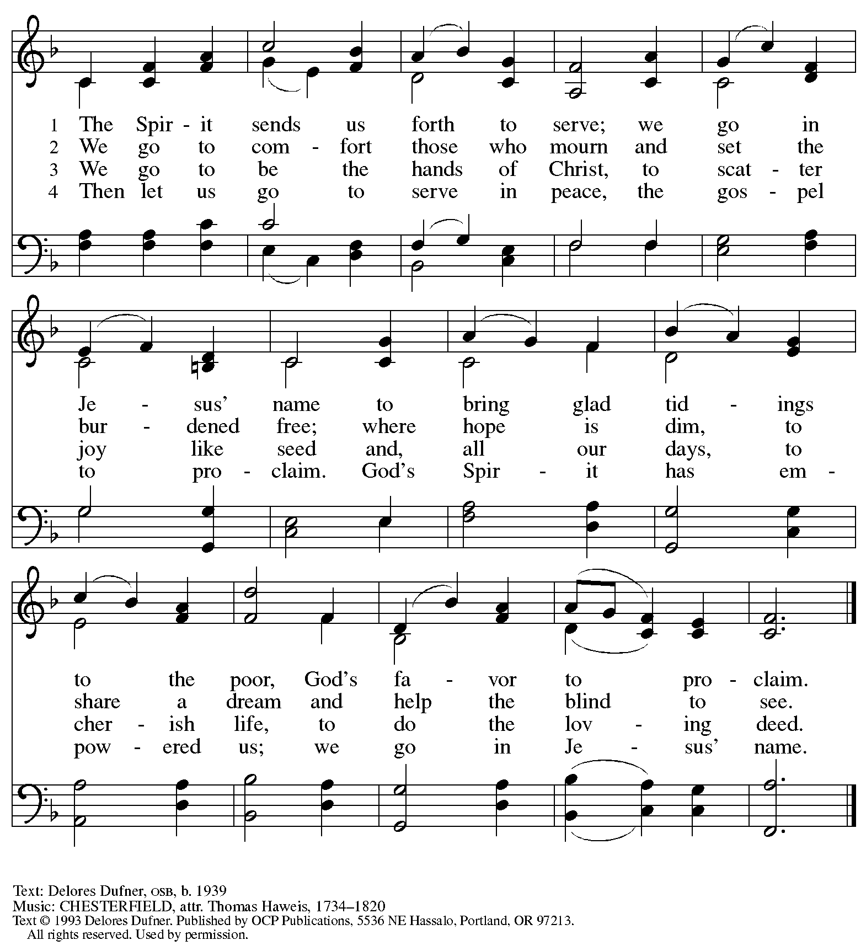
Reprinted with permission under OneLicense.net # A-722139.

Those serving in worship today

Altar Care Jodie Minor
Assisting Minister Lindsay Baxter
Audio-Visual Ministers Tim Jones
Joseph Paetz
Cantor Marit Bakken
Lector Lester Prince
Pre-Service Music Jered Stratton
Minister of Music Laura Reynolds
Presiding Minister The Rev. Ross I. Carmichael

Liturgy and Hymnody Acknowledgements

From SundaysandSeasons.com. Copyright © 2026 Augsburg Fortress. All rights reserved. Reprinted under OneLicense.net # A-722139.
Used by permission of Augsburg Fortress.

The Scripture readings contained herein are from New Revised Standard Version Updated Edition of the Bible © 2021 National Council of Churches of Christ in the United States of America. Used by permission. All rights reserved worldwide.

Let the Vineyards – Text: John W. Arthur, 1922-1980. Music: Ronald A. Nelson, b. 1927. Text and Music © 1978 Lutheran Book of Worship, admin. Augsburg Fortress.

Please use the QR code below to link to St. Andrew’s Announcements online!



St. Andrew Lutheran Church Announcements
May 10th, 2026

- Happy Easter! Welcome to Worship at St. Andrew as We Celebrate the Sixth Sunday of Easter! – We are so glad you are here to share in this festive season, and we offer a special welcome to all visitors and guests who are here for the first time! Little Church – Big Faith, a Bible lesson and activity for children up to sixth grade, will take place after the prayer of the day. There are worship “toolkits” to help children engage with worship and “busy bags” for younger children available in the bookcase at the back of the sanctuary. Please feel free to take one to use with/for your children. A nursery is available through the door to the left of the worship space and across the social hall (look for a purple room). All are invited to gather for coffee, other drinks, food, and conversation in the social hall after worship. We pray that everyone has a blessed Easter season!
- Alternatives to Violence Project Workshops, Saturday, May 16th and 23rd, 9:00 a.m. to 8:00 p.m. – The AVP workshops will be held at St. Andrew Lutheran Church (304 Morewood Ave, Pittsburgh, PA 15213) and will be open to both teens and adults. AVP is not a lecture or a debate. It is a hands-on, participatory experience that equips people with practical tools for: affirmation and respect, clear communication, cooperation in the midst of tension, transforming conflict rather than avoiding or inflaming it. To learn more, follow the link here: https://friendspeaceteams.org/cultures-justice-peace/. You can register to these workshops here: https://docs.google.com/forms/d/e/1FAIpQLSfjPQKcnyQNx26wqTHzyby9YMi7BYHrUUfUha3PoxXpC50XNw/viewform.
- Noisy Offering Next Sunday, Sunday, May 17th, during Worship – On the third Sunday of each month, St. Andrew’s children lead the congregation in a Noisy Offering, in which people are invited to throw their change into buckets that the children carry around the church and bring forward as an additional offering. Each month’s Noisy Offering supports a local, national, or international church-related or otherwise charitable organization. This month’s offering will benefit Lutheran World Relief, affirming God’s love for all people and seeking to end poverty, injustice and human suffering. You can learn more about their history and work here: https://lwr.org/about-lwr.
- Produce Distribution Supplemental Food of the Month – St. Andrew is collecting supplemental food each month to accompany our produce distribution. For May, we ask for donations of shelf-stable sandwich toppings (e.g. peanut butter, jam, giardiniera, hummus, tapenade, etc). There are collection boxes at the back of the worship space and social hall.
- Produce Distribution, Third Tuesday Each Month, May 19th from 5:30 to 6:30 p.m. – St. Andrew partners with Greater Pittsburgh Community Food Bank to serve as a distribution site for fresh produce on the first and third Tuesday of every month. We invite people of the congregation to help with the distribution from 5:30 p.m. to 6:30 p.m. and/or to help with unloading and setup during the day between 10:00 a.m. and 1:00 p.m.
- Bible Book Club – Wednesdays, 7:00 p.m. on Zoom – Bible Book Club meets each Wednesday at 7:00 p.m. Bible Book Club reads not only the Bible but also books about the Bible and other theological topics. The discussions are informal with no pre-determined topics. Each week is a stand-alone discussion and not dependent on previous discussions. The next book we are planning on reading is Contemplative Prayer: Praying When the Well Runs Dry by Joann Nesser. You can join the Zoom call here: https://us02web.zoom.us/j/83196175976?pwd=ejdPOUYrTk4xVFdsdlhHUVJ1L3k2Zz09.
- Pride Month Celebrations, Saturday, June 6th and 20th, 10:00 a.m. to 6:00 p.m. – Every June is celebrated as Pride month to commemorate years of struggle for civil rights and the ongoing pursuit of justice for the LGBTQ+ community in the face of police brutality and systemic disenfranchisement. St Andrew will be sponsoring a booth at both Pittsburgh Pride on June 6th, between 10:00 a.m. and 6:00 p.m. and Millvale Pride on June 20th starting at 12:00 p.m. You can sign up to volunteer here: https://www.signupgenius.com/go/5080B4AAFAF2CABF85-63577363-pittsburgh.
- Coffee Hour Signups – St. Andrew provides hospitality during a coffee hour after worship each Sunday. If you would like to participate, please sign up using the following form: https://www.signupgenius.com/go/5080B4AAFAF2CABF85-47069030-coffee#/.
- Christ in Our Home Devotional Booklets for April – June Available at Entrances – This resource offers a daily Bible reading with a short reflection and prayer, along with additional readings and prayer topics for those who would like to expand their devotional practices. We encourage people of the congregation to take one for yourself, your family/household, or others!

