

+ Seventh Sunday of Easter
May 17, 2026


St. Andrew Lutheran Church
304 Morewood Ave.
Pittsburgh, PA 15213
St_andrewELCA@verizon.net
www.standrewpittsburgh.org

+ Seventh Sunday of Easter

In these days between Ascension and Pentecost, we gather with the disciples in the upper room, waiting for the Spirit to transform the church around the world. In today’s Gospel Jesus prays for his followers and for their mission in his name. Amid religious, social, and economic divisions, we seek the unity that Jesus had with his Father. Made one in Baptism, we go forth
to live our faith in the world, eager for the unity that God intends for the whole human family.

Welcome to St. Andrew!
- St. Andrew welcomes all who are seeking a place of healing, wholeness, and acceptance in a nurturing and faith-forming spiritual home. We are striving toward racial equity worldwide
and we seek to honor the lived experience of all individuals regardless of background. Our community embraces people of all ages, ethnicities, cultures, abilities, sexual orientations,
gender identities and expressions, and family constellations. Come and See!
- Worship Services are live-streamed to multiple online platforms. By attending worship, you agree that your image and voice may be broadcast.
- Everyone is invited to make a name tag at the black bookcase in the back of the worship space if they would like. There are stickers indicating pronouns on the bookcase if you would like to include them on your name tag.
- Children are invited to attend Little Church – Big Faith, a Bible lesson and activity, during worship (after the Prayer of the Day). The group returns to the worship space for the liturgy of Holy Communion.
- A nursery is available through the doors at the left side of the sanctuary and across from the doorway to the Social Hall. Look for a purple-colored room.
- Worship “toolkits” to help children engage with the service, along with “busy bags” for younger children, are available in the bookcase at the back of the sanctuary. Please feel free to take one to use with/for your children.
- Holy Communion is served with bread (gluten-free available) and wine or grape juice. The presiding minister will distribute the bread (host). Please consume this and then pick up an empty glass from the tray. The Communion Assistant will pour wine or grape juice into your glass. Please step to the side to consume the wine or grape juice. Feel free to kneel at the altar for prayer and reflection. As you return to your pew, glasses may be returned to the empty trays on either side of the center section.
- A restroom is available on the main level of the church, through the doors to the Social Hall and to the right in the main office.

Abbreviations
P: Pastor/Presiding Minister ELW: Evangelical Lutheran Worship hymnal
A: Assisting Minister ACS: All Creation Sings hymnal
L: Lector
C: Congregation

Musical Offering Jeff Denlinger

Each week, different people from the congregation make an offering of pre-service music,
with singing or instrumentation, to help the assembly focus and pray in preparation for worship.

Welcome
Prelude Breathe on Me, O Breath of God arr. McKibben

Gathering
The Holy Spirit calls us together as the people of God

Please rise as you are able. All may make the sign of the cross,
the sign that is marked at Baptism, as the presiding minister begins.

Thanksgiving for Baptism

P: Alleluia! Christ is risen and ascended!
C: Christ is risen and ascended! Alleluia! Alleluia!

P: Salvation belongs to our God who is seated on the throne and to the Lamb!
C: Amen.

P: Let us give thanks for the gift of Baptism.

Water may be poured into the font as the presiding minister continues.
P: Merciful God,
you are the one who was, who is, and who is to come.
You lead us beside still waters.
We thank you for the waters of creation:
morning dew, gentle rain, roaring waves.
We thank you for the waters that nourish us.
Blessed are you!
C: You guide us to springs of the water of life.

P: Jesus Christ, you are the faithful witness
who accompanies us on our journeys.
We give you thanks for your life-giving death and resurrection.
We praise you for joining us in joy and sorrow.
Blessed are you!
C: You guide us to springs of the water of life.

P: Holy Spirit, you anoint our head with oil and our cup overflows.
Break down barriers that divide us.

P: Fill us with the breath of peace.
Blessed are you!
C: You guide us to springs of the water of life.

P: Holy One, we thank you for the gifts and grace of Baptism,
and for making us a new creation.
We join with saints and angels, giving you honor and praise,
now and forever.
C: Amen.

Gathering Hymn A Hymn of Glory Let Us Sing! ELW 393

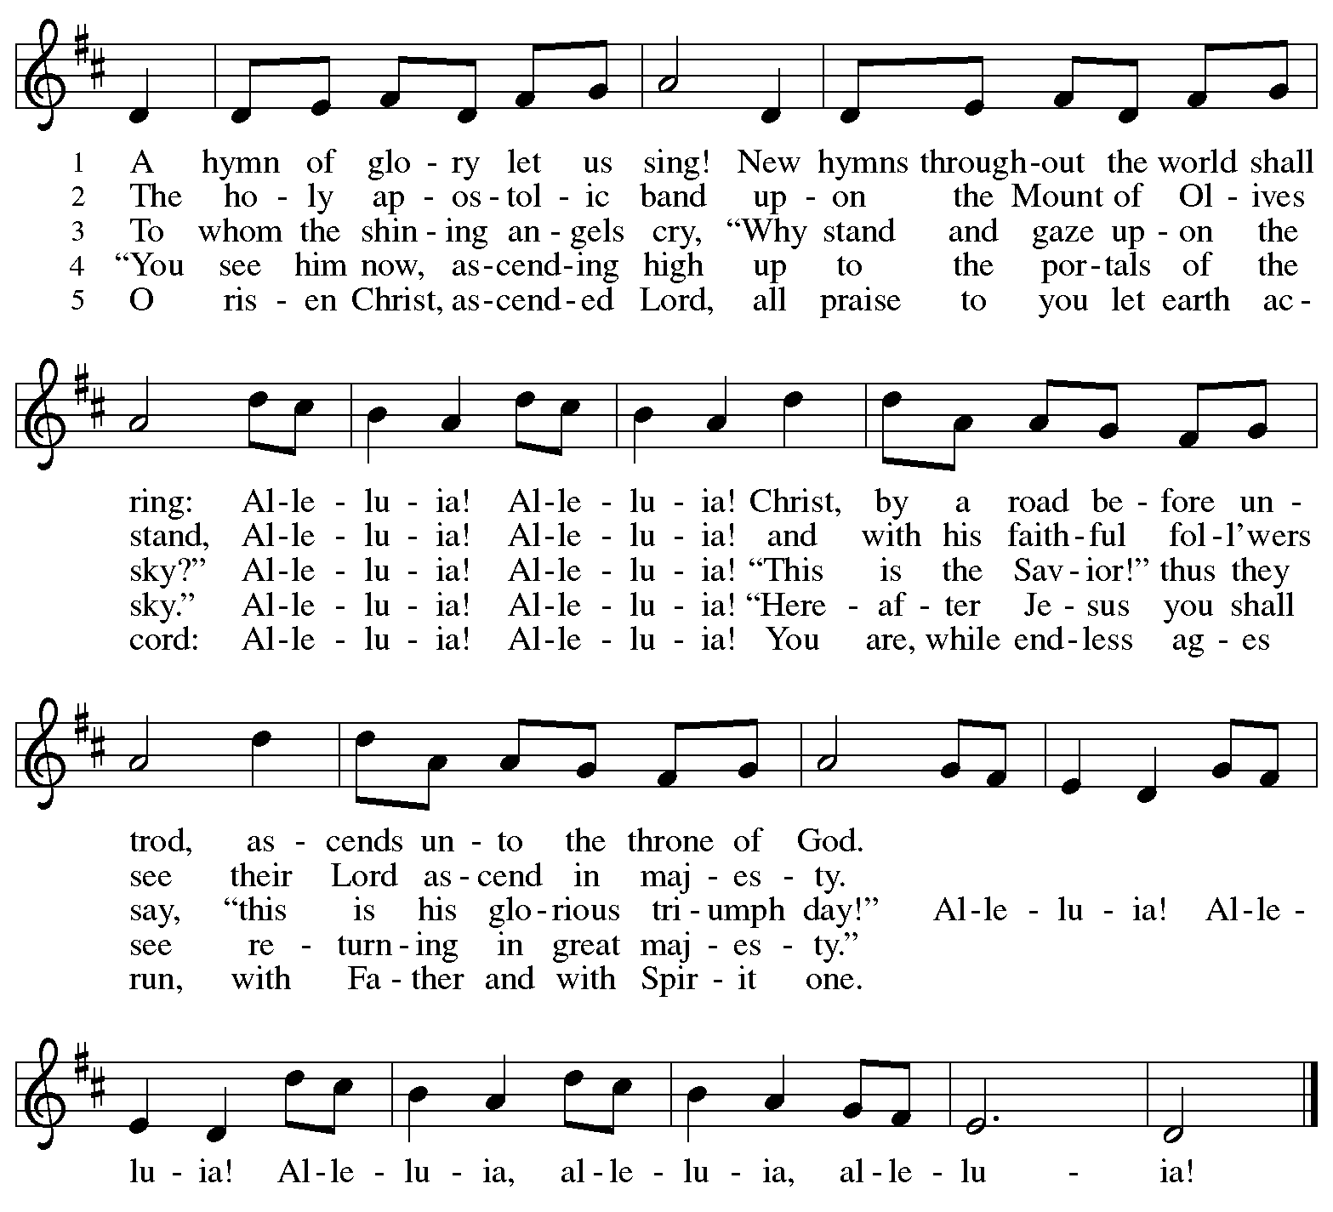
All rights reserved. Reprinted with permission under OneLicense.net # A-722139.
Greeting

P: The grace of our Lord Jesus Christ, the love of God,
and the communion of the Holy Spirit be with you all.
C: And also with you.

Hymn of Praise This Is the Feast ELW p. 149-150

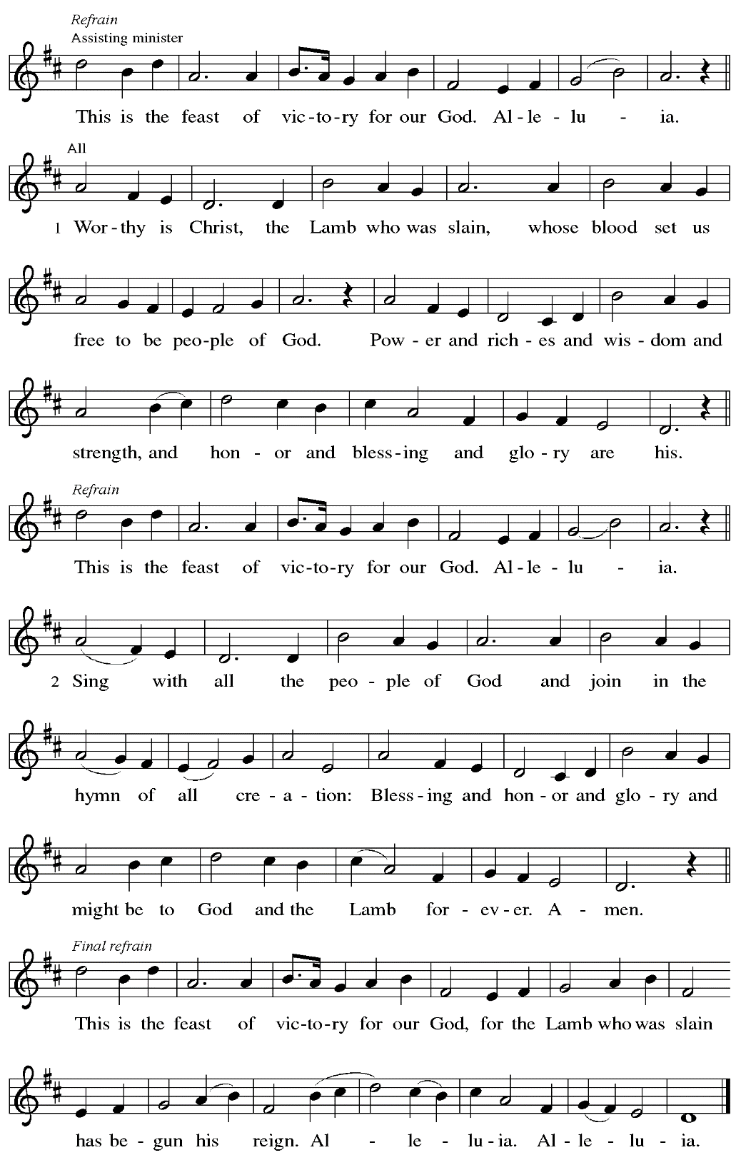
Prayer of the Day

P: The Lord be with you.
C: And also with you.

P: Let us pray.
O God of glory, your Son Jesus Christ suffered for us and ascended to your right hand.
Unite us with Christ and each other in suffering and in joy,
that all the world may be drawn into your bountiful presence,
through Jesus Christ, our Savior and Lord,
who lives and reigns with you and the Holy Spirit,
one God, now and forever.
C: Amen.

Please be seated.
Children are invited to join the adult leader(s) at the side door for Little Church – Big Faith.
We ask that an additional adult from the congregation attend with the children.

Word
God speaks to us in Scripture reading, preaching, and song

First Reading – Acts 1: 6-14

⁶ When [the apostles] had come together, they asked [Jesus], “Lord, is this the time when you will restore the kingdom to Israel?” ⁷ He replied, “It is not for you to know the times or periods that the Father has set by his own authority. ⁸ But you will receive power when the Holy Spirit has come upon you, and you will be my witnesses in Jerusalem, in all Judea and Samaria, and to the ends of the earth.” ⁹ When he had said this, as they were watching, he was lifted up, and a cloud took him out of their sight. ¹⁰ While he was going and they were gazing up toward heaven, suddenly two men in white robes stood by them. ¹¹ They said, “Men of Galilee, why do you stand looking up toward heaven? This Jesus, who has been taken up from you into heaven, will come in the same way as you saw him go into heaven.”
¹² Then they returned to Jerusalem from the mount called Olivet, which is near Jerusalem, a Sabbath day’s journey away. ¹³ When they had entered the city, they went to the room upstairs where they were staying: Peter, and John, and James, and Andrew, Philip and Thomas, Bartholomew and Matthew, James son of Alphaeus, and Simon the Zealot, and Judas son of James. ¹⁴ All these were constantly devoting themselves to prayer, together with certain women, including Mary the mother of Jesus, as well as his brothers.

L: Word of God, word of life.
C: Thanks be to God.

Psalm 68: 1-10, 32-35

The psalm will be sung responsively, led by the cantor,
with the congregation responding with the bold verses and refrain.

Psalm Tone

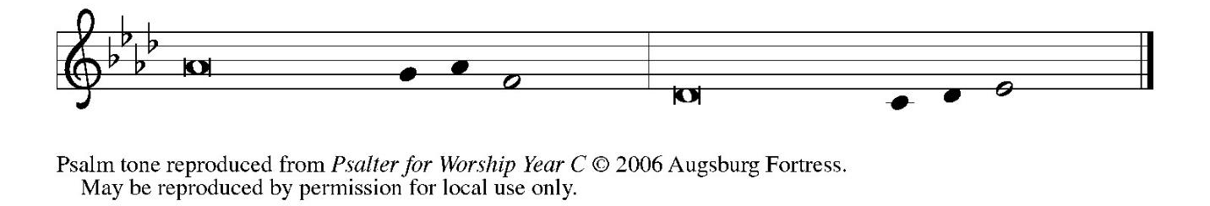

Psalm Refrain

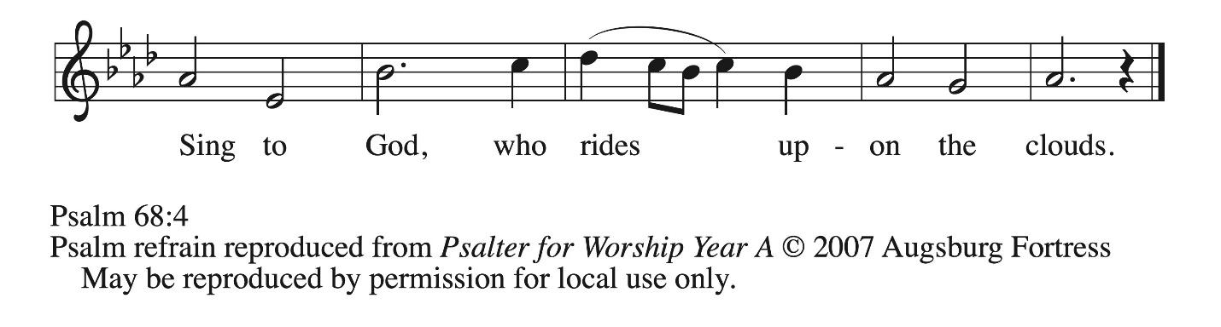

¹ Let God arise, and let God’s ene- | mies be scattered;
let those who | hate God flee.
² As smoke is driven away, so you should drive | them away;
as the wax melts before the fire, so let the wicked perish at the pres- | ence of God.
³ But let the righteous be glad and rejoice | before God;
let them also be mer- | ry and joyful.
⁴ Sing to God, sing praises to God’s name; exalt the one who | rides the clouds;
I Am is that name, rejoice | before God! R
⁵ In your holy habita- | tion, O God,
you are a father to orphans, defend- | er of widows;
⁶ you give the solitary a home and bring forth prisoners | into freedom;
but the rebels shall live in | desert places.
⁷ O God, when you went forth be- | fore your people,
when you marched | through the wilderness,
⁸ the earth quaked, and the skies poured down rain, at the presence of God, the | God of Sinai,
at the presence of God, the | God of Israel.
⁹ You sent a bountiful | rain, O God;
you restored your inheritance | when it languished.
¹⁰ Your people found their | home in it;
in your goodness, O God, you have made provision | for the poor. R
³² Sing to God, O kingdoms | of the earth;
sing praises | to the Lord.
³³ You ride in the heavens, O God, in the | ancient heavens;
you send forth your voice, your | mighty voice.
³⁴ Ascribe pow- | er to God,
whose majesty is over Israel; whose strength is | in the skies.
³⁵ How wonderful you are in your holy places, O | God of Israel,
giving strength and power to your people! | Blessed be God! R

Second Reading – 1 Peter 4: 12-14; 5: 6-11

¹² Beloved, do not be surprised at the fiery ordeal that is taking place among you to test you, as though something strange were happening to you. ¹³ But rejoice insofar as you are sharing Christ’s sufferings, so that you may also be glad and shout for joy when his glory is revealed.
¹⁴ If you are reviled for the name of Christ, you are blessed, because the spirit of glory, which is the Spirit of God, is resting on you.
^{5:6} Humble yourselves, therefore, under the mighty hand of God, so that God may exalt you in due time. ⁷ Cast all your anxiety on God, because God cares for you. ⁸ Discipline yourselves; keep alert. Like a roaring lion your adversary the devil prowls around, looking for someone to devour. ⁹ Resist him, steadfast in your faith, for you know that your siblings in all the world are undergoing the same kinds of suffering. ¹⁰ And after you have suffered for a little while, the God of all grace, who has called you to God’s eternal glory in Christ, will Godself restore, support, strengthen, and establish you. ¹¹ To God be the power forever and ever. Amen.

L: Word of God, word of life.
C: Thanks be to God.

Please rise as you are able.

Gospel Acclamation ELW p. 151

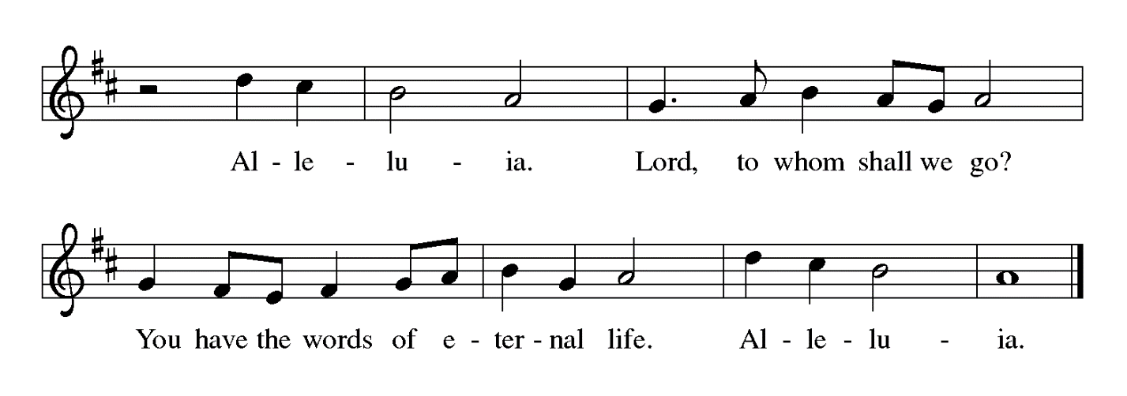
Gospel – John 17: 1-11

P: The holy Gospel according to St. John.
C: Glory to you, O Lord.

¹ After Jesus had spoken these words [to his disciples,] he looked up to heaven and said, “Father, the hour has come; glorify your Son so that the Son may glorify you, ² since you have given him authority over all people, to give eternal life to all whom you have given him. ³ And this is eternal life, that they may know you, the only true God, and Jesus Christ, whom you have sent. ⁴ I glorified you on earth by finishing the work that you gave me to do. ⁵ So now, Father, glorify me in your own presence with the glory that I had in your presence before the world existed.
⁶ “I have made your name known to those whom you gave me from the world. They were yours, and you gave them to me, and they have kept your word. ⁷ Now they know that everything you have given me is from you, ⁸ for the words that you gave to me I have given to them, and they have received them and know in truth that I came from you, and they have believed that you sent me. ⁹ I am asking on their behalf; I am not asking on behalf of the world but on behalf of those whom you gave me, because they are yours. ¹⁰ All mine are yours, and yours are mine, and I have been glorified in them. ¹¹ And now I am no longer in the world, but they are in the world, and I am coming to you. Holy Father, protect them in your name that you have given me, so that they may be one, as we are one.”

P: The Gospel of the Lord.
C: Praise to you, O Christ.

Please be seated.

Sermon

A time of silence for prayer and reflection follows the sermon.
When the hymn of the day begins, please rise as you are able.



Hymn of the Day Lord, Who the Night You Were Betrayed ELW 463

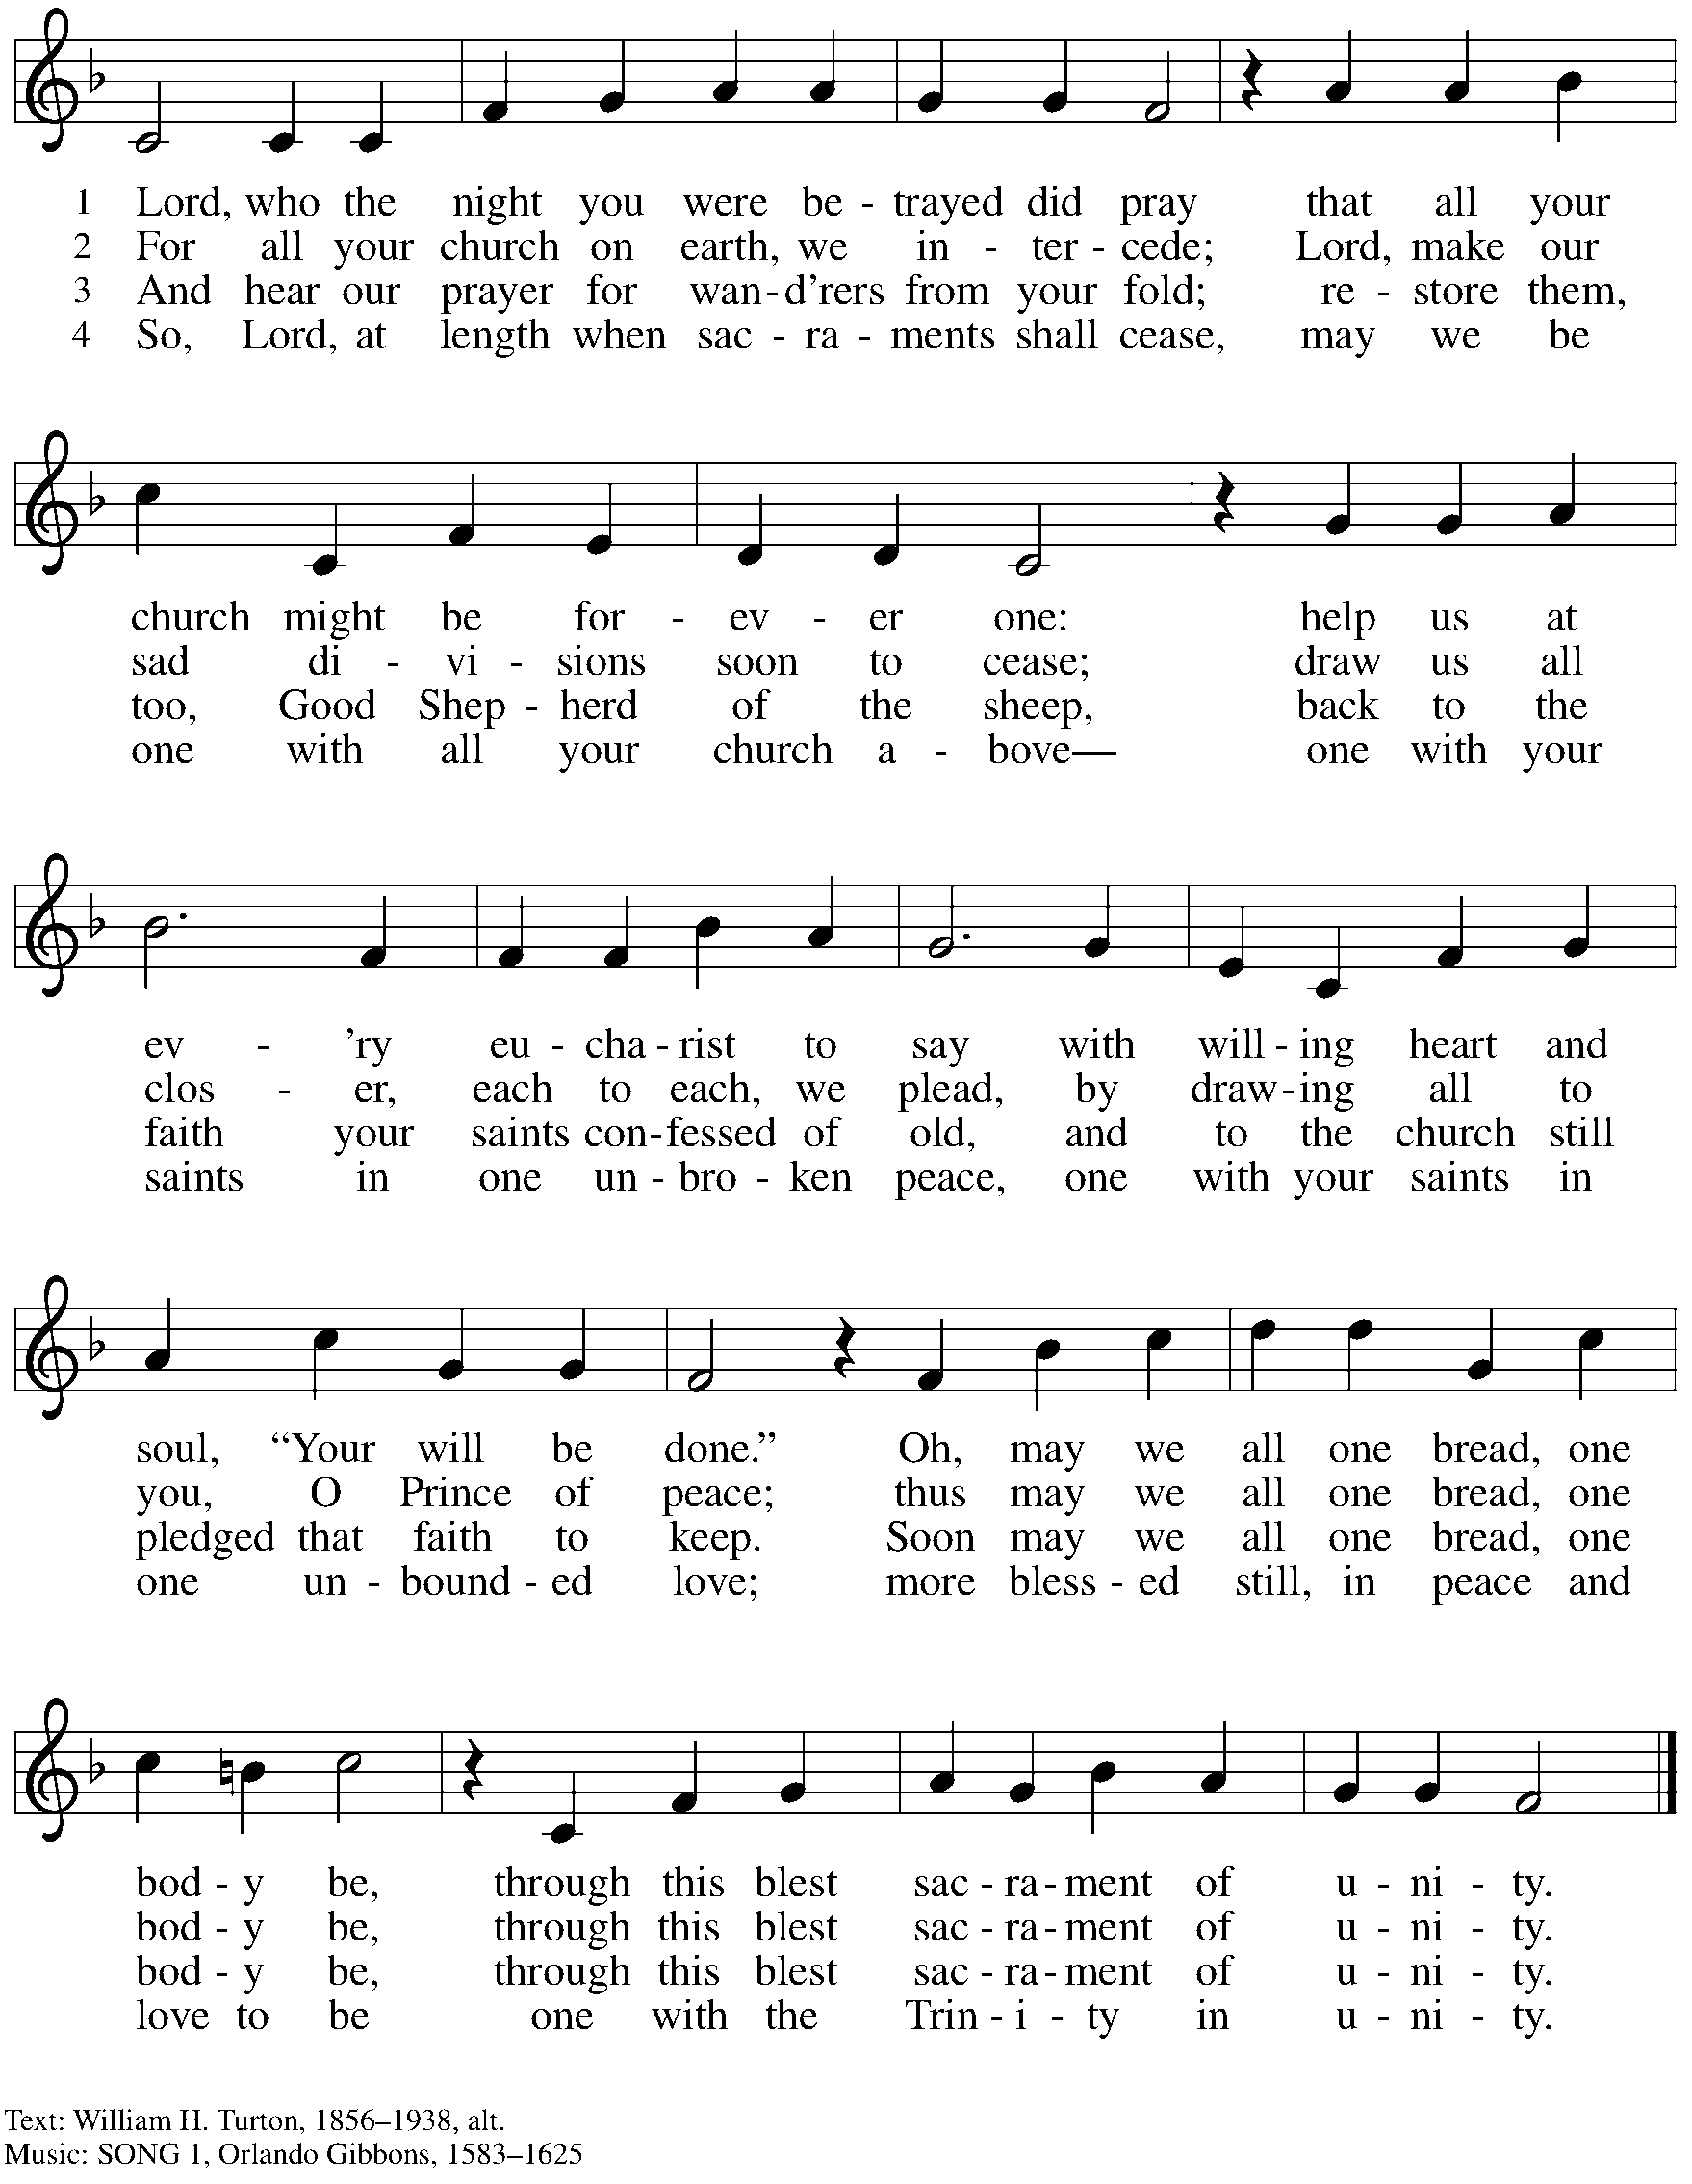

Nicene Creed

C: We believe in one God,
the Father, the Almighty,
maker of heaven and earth,
of all that is, seen and unseen.

We believe in one Lord, Jesus Christ,
the only Son of God,
eternally begotten of the Father,
God from God, Light from Light,
true God from true God,
begotten, not made,
of one Being with the Father;
through him all things were made.
For us and for our salvation
he came down from heaven,
was incarnate of the Holy Spirit and the virgin Mary
and became truly human.
For our sake he was crucified under Pontius Pilate;
he suffered death and was buried.
On the third day he rose again
in accordance with the scriptures;
he ascended into heaven
and is seated at the right hand of the Father.
He will come again in glory to judge the living and the dead,
and his kingdom will have no end.

We believe in the Holy Spirit, the Lord, the giver of life,
who proceeds from the Father and the Son,*
who with the Father and the Son is worshiped and glorified,
who has spoken through the prophets.
We believe in one holy catholic and apostolic church.
We acknowledge one baptism for the forgiveness of sins.
We look for the resurrection of the dead,
and the life of the world to come. Amen.

*Or, “who proceeds from the Father.” The phrase “and the Son” is a later addition to the creed.

Prayers of the People

A: United in the joy and hope of the resurrection, let us pray for the church, the world,
and all who are in need.

After each petition
A: Gracious God,
C: receive our prayer.

The presiding minister concludes the prayers
P: We lift these prayers to you O God, trusting in your abundant mercy,
through Jesus Christ our risen Savior.
C: Amen.

Peace

The presiding minister and the assembly greet one another in the peace of the risen Christ.
P: The peace of Christ be with you always.
C: And also with you.

The people may greet those around them with a sign of Christ’s peace and may say
Peace be with you or similar words. Please be mindful that not everyone will be comfortable with sharing the peace, so please seek consent before shaking hands or hugging. Other possible ways to share the peace include a simple bow with the verbal greeting of peace, or simply a verbal expression of peace. When the greetings of peace have concluded, please be seated.

Meal
God feeds us with the presence of Jesus Christ

Offering

We offer ourselves, our gifts, and our faithful service to God.
As the offering is gathered for the mission of the church, including the care of those in need,
the table is set for Holy Communion. There are laminated giving cards in the pew racks that feature a QR code for anyone who would like to give online. Those who give using the QR code, as well as those who give regularly online or through their bank are encouraged to place the laminated card in the plate as an expression of your offering.

Noisy Offering

St. Andrew’s children lead the congregation in a special offering. As they carry buckets around the sanctuary, people of the congregation are invited to throw in their change as an offering. This month’s Noisy Offering will support Lutheran World Relief, affirming God’s love for all people and seeking to end poverty, injustice, and human suffering. You can learn more about the work of Lutheran World Relief here: https://lwr.org/about-lwr.

Offertory Music How Firm a Foundation arr. Edstrom

After the children bring forward the Noisy Offering, the children’s choir sings an offering song.

Children’s Choir He’s Got the Whole World in His Hands London
As the gifts for Holy Communion are brought forward for presentation,
please rise as you are able.

Offertory Song Let the Vineyards Be Fruitful ELW 184

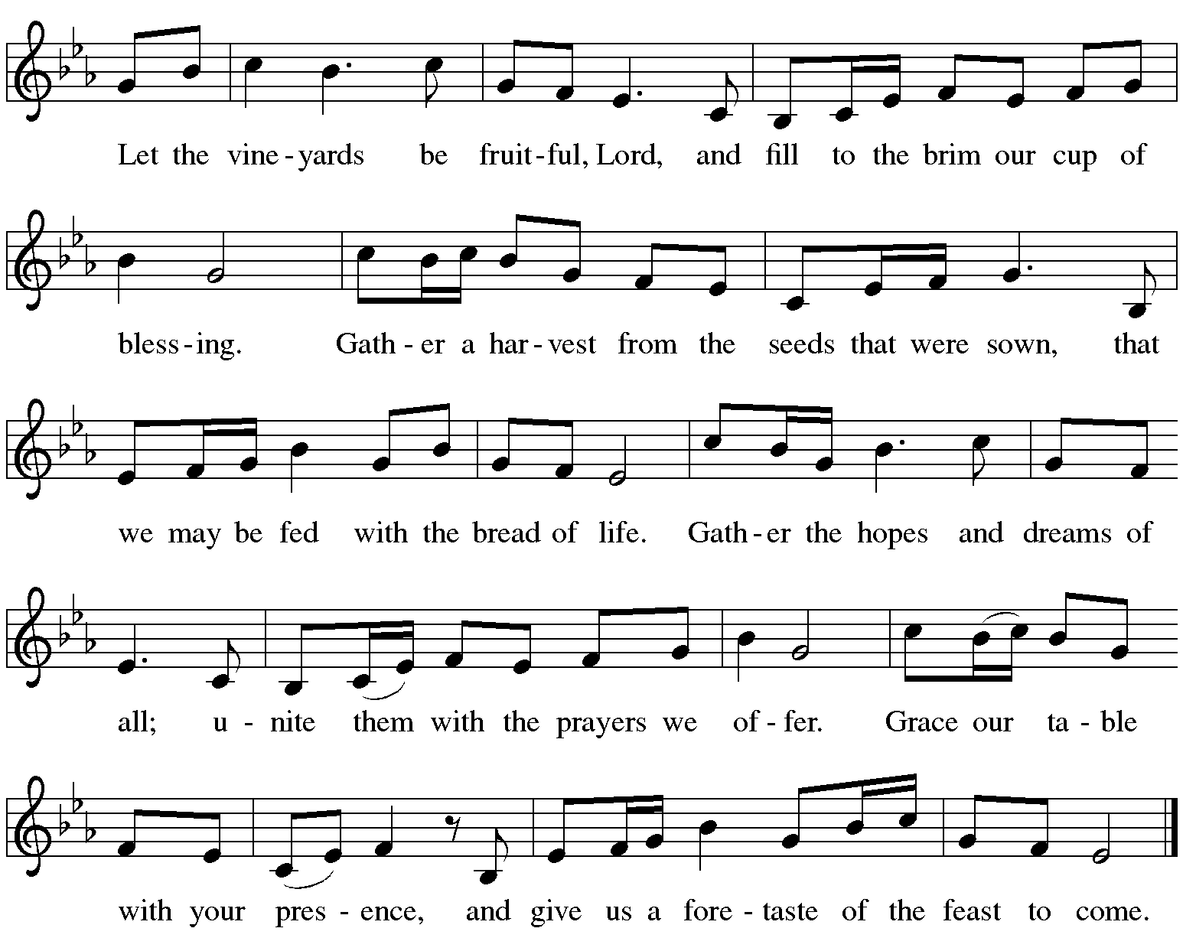

Offertory Prayer

A: Let us pray. Blessed are you, O God,
C: ruler of heaven and earth. Day by day you shower us with blessings.
As you have raised us to new life in Christ, give us glad and generous hearts,
ready to praise you and to respond to those in need,
through Jesus Christ, our Savior and Lord.
Amen.

Dialogue ELW p. 152

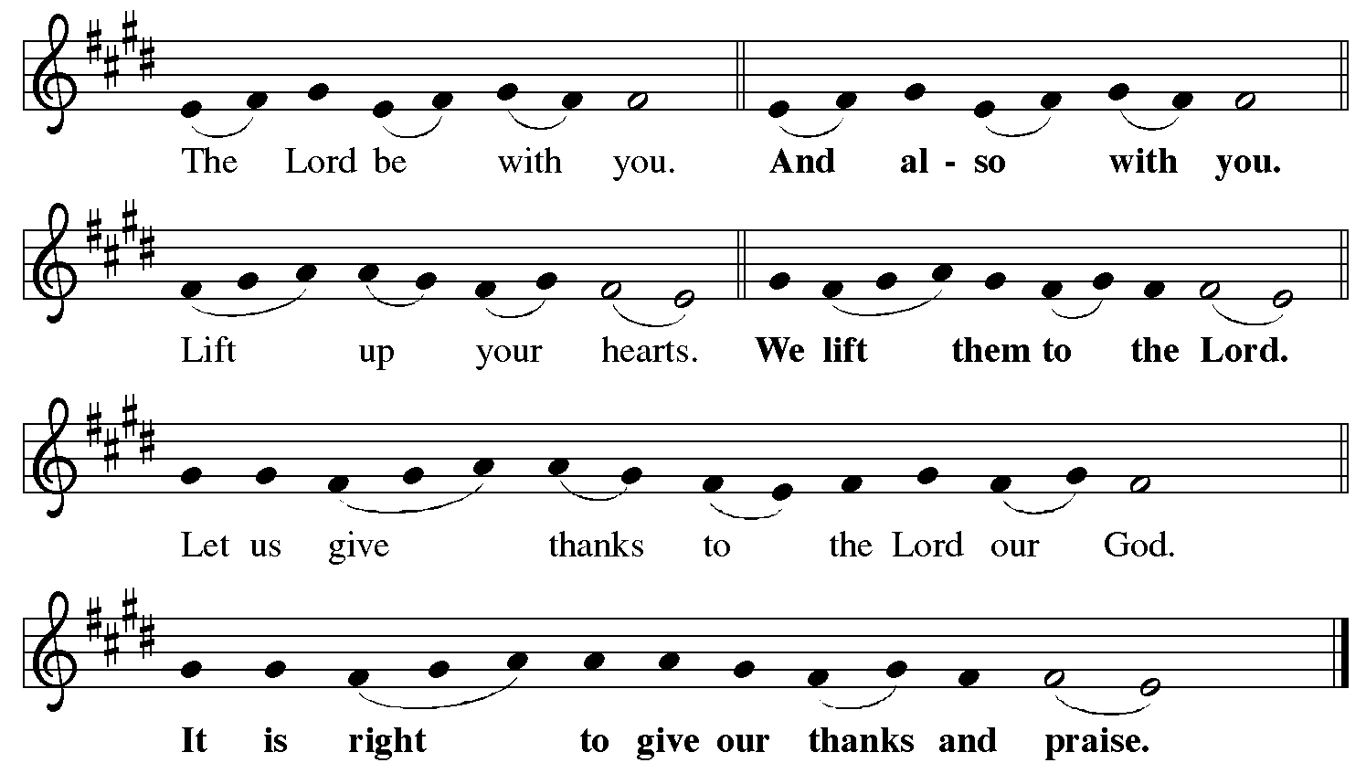

Preface (Sung by the presiding minister)

P: It is indeed right, our duty and our joy,
that we should at all times and in all places
give thanks and praise to you, almighty and merciful God,
for the glorious resurrection of our Savior Jesus Christ,
the true Paschal Lamb who gave himself to take away our sin;
who in dying has destroyed death,
and in rising has brought us to eternal life.
And so, with Mary Magdalene and Peter
and all the witnesses of the resurrection,
with earth and sea and all their creatures,
and with angels and archangels, cherubim and seraphim,
we praise your name and join their unending hymn:

Sanctus ELW p. 153

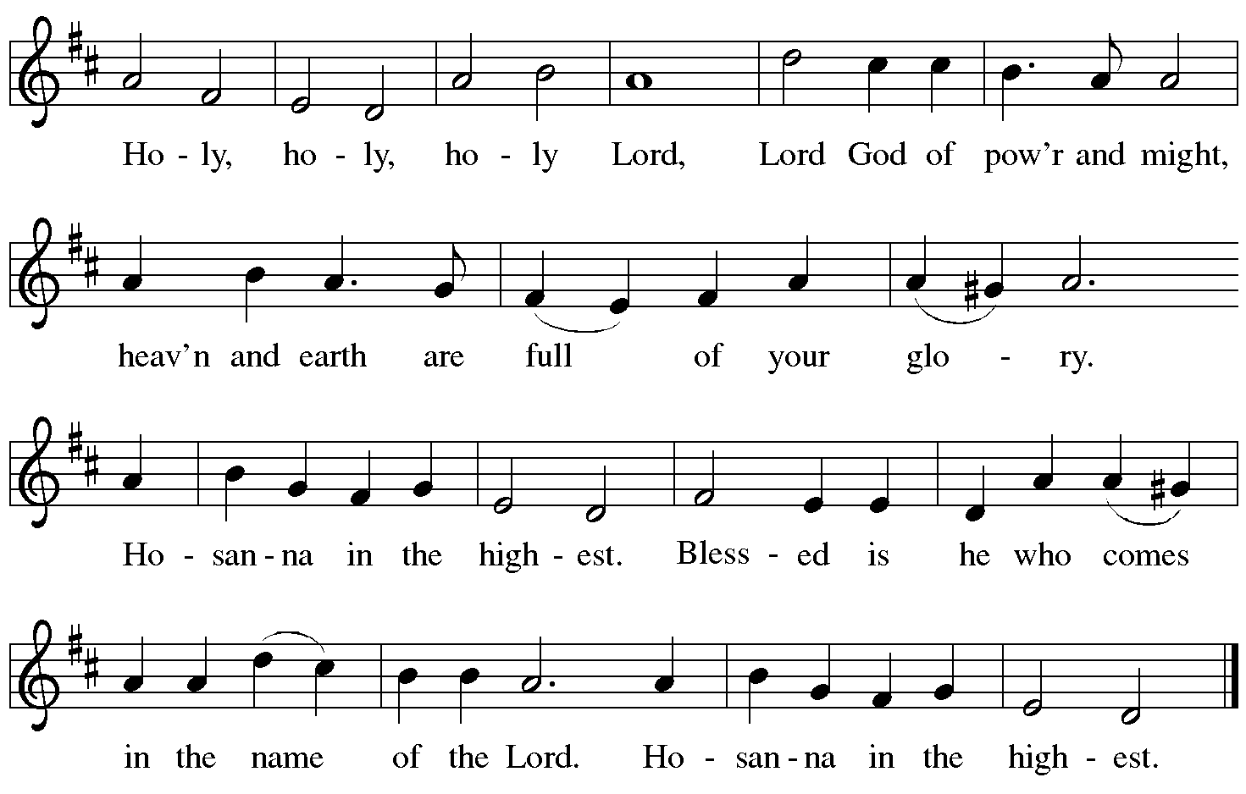

Eucharistic Prayer

P: Blessed are you, O God of the universe …
… Do this for the remembrance of me.

With this bread and cup we remember our Lord’s passover from death to life
as we proclaim the mystery of faith.
C: Christ has died. Christ is risen. Christ will come again.

P: O God of resurrection and new life …
… Grace our table with your presence.
C: Come, Holy Spirit.

P: Reveal yourself to us in the breaking of the bread …
… send us forth, burning with justice, peace, and love.
C: Come, Holy Spirit.

P: With your holy ones of all times and places …
… blessed and Holy Trinity, now and forever.
C: Amen.
Lord’s Prayer

P: Gathered as one by the Holy Spirit, let us pray as Jesus taught us.
C: Our Father, who art in heaven,
hallowed be thy name,
thy kingdom come,
thy will be done,
on earth as it is in heaven.
Give us this day our daily bread;
and forgive us our trespasses,
as we forgive those
who trespass against us;
and lead us not into temptation,
but deliver us from evil.
For thine is the kingdom,
and the power, and the glory,
forever and ever. Amen.

Fraction and Invitation

P: Alleluia! Christ is risen and ascended!
This is the feast of victory for our God.
Come, share the feast.



Agnus Dei / Lamb of God ELW p. 154

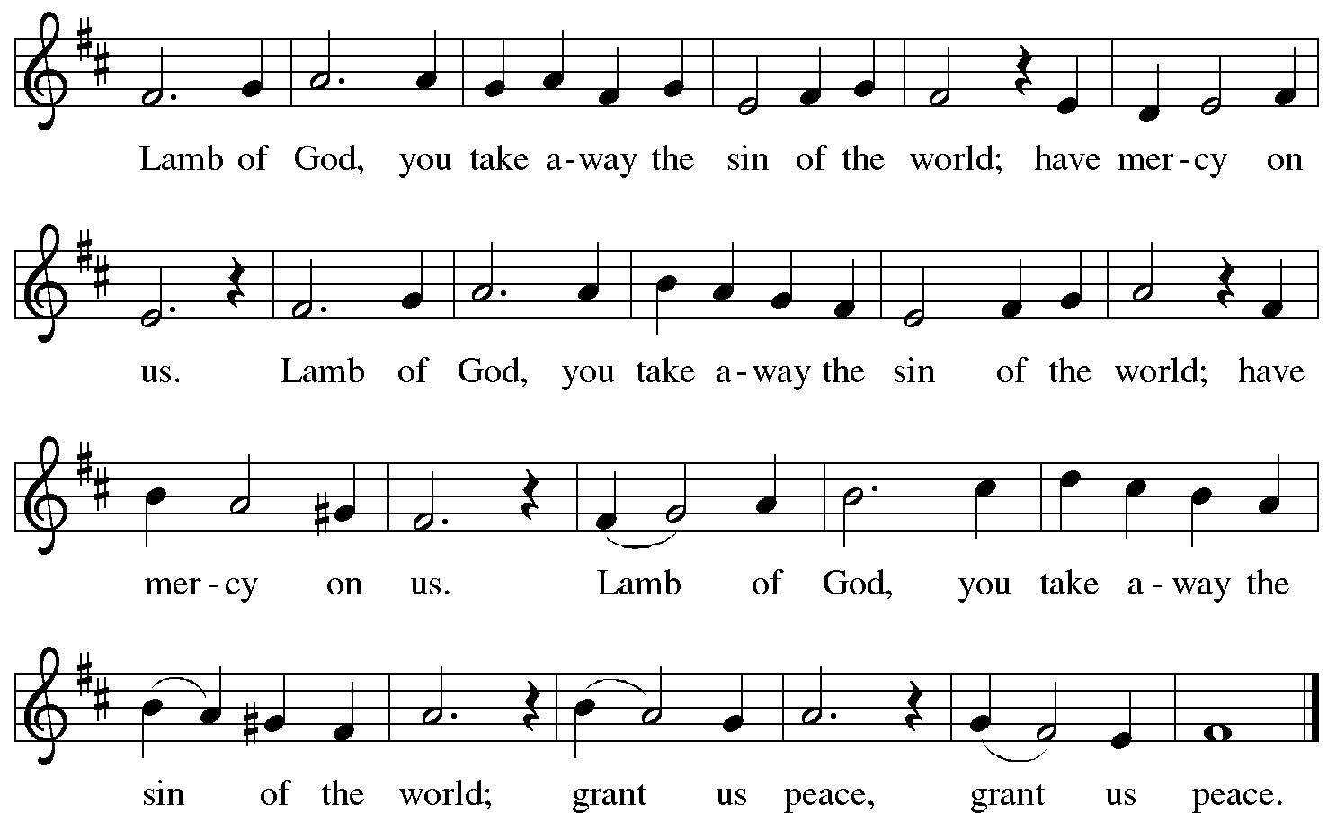

Please be seated.

Holy Communion

- All who seek God and desire a deeper and stronger life in Christ are welcome to receive Holy Communion.
- Worshipers from the pulpit side will proceed forward first, followed by the center section, and then the lectern side.
- Please inform an usher if you would like the ministers to bring Communion to you.
- Holy Communion will be served with bread and wine (red) or grape juice (white).
- The presiding minister will first distribute the bread (host) to each communicant. Please indicate if you require a gluten-free host.
- Once you have consumed the bread, please pick up an empty glass from the tray next to the presiding minister. The Communion Assistant will pour wine or grape juice into your glass.
- Please step to the side to consume the wine or grape juice.
- Feel free to kneel at the altar rail for prayer after receiving the sacrament.
- As you return to your pew, glasses may be returned to the empty tray on the side of the center section.
- A blessing will be provided for anyone who does not yet receive the sacrament.
- All are invited to join in singing the hymns during Holy Communion.
Hymns during Holy Communion
Beloved, God’s Chosen ELW 648

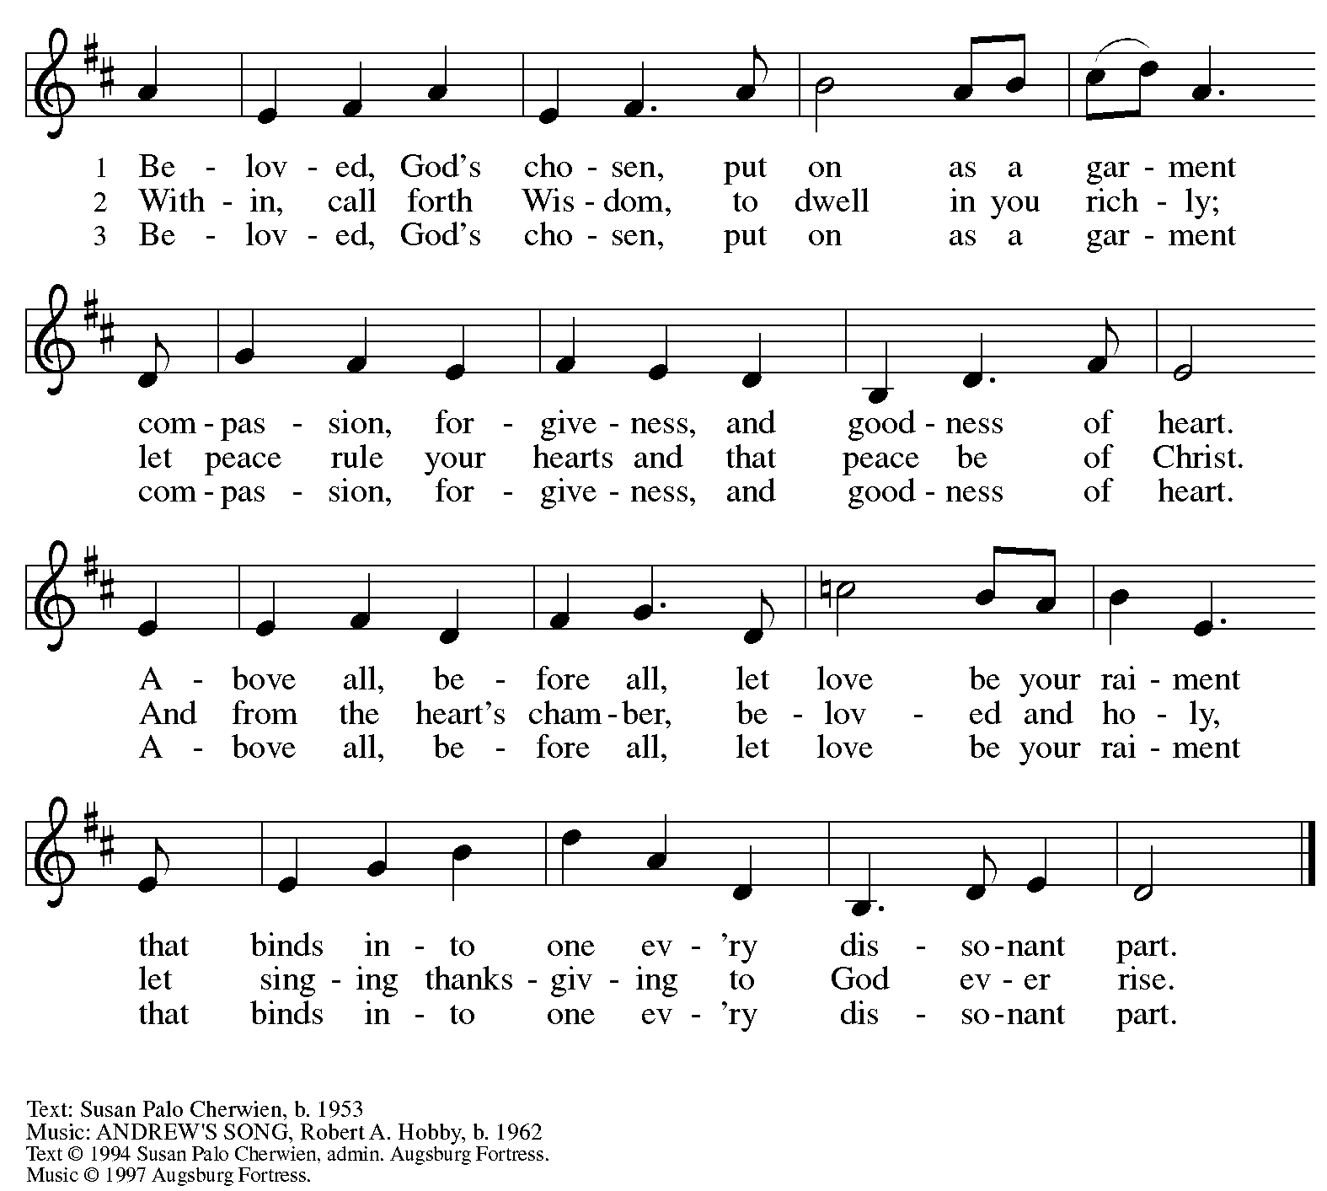
All rights reserved. Reprinted with permission under OneLicense.net # A-722139.

Hymns during Holy Communion
Mercy, We Abide in You ACS 1077

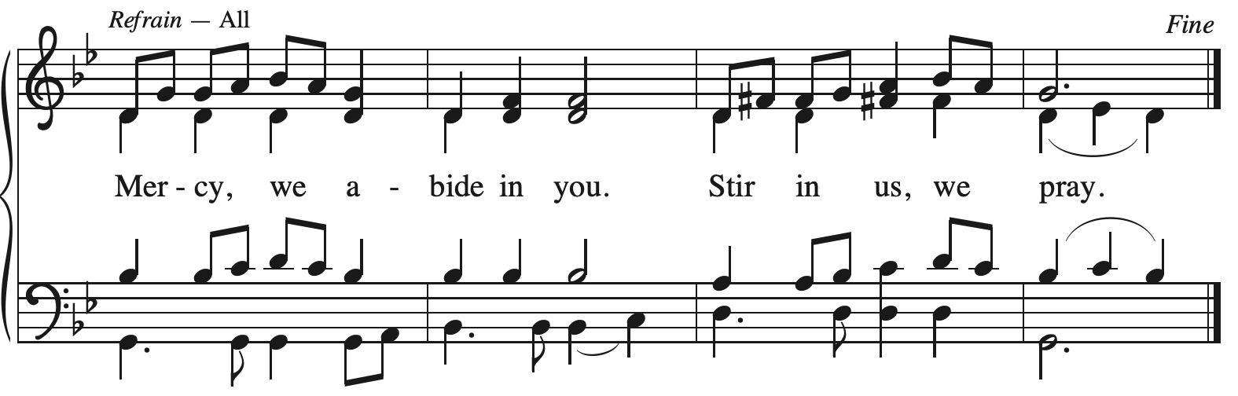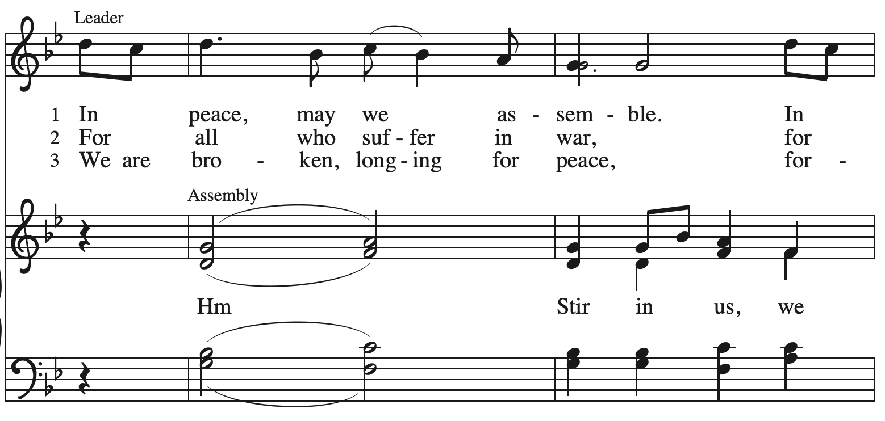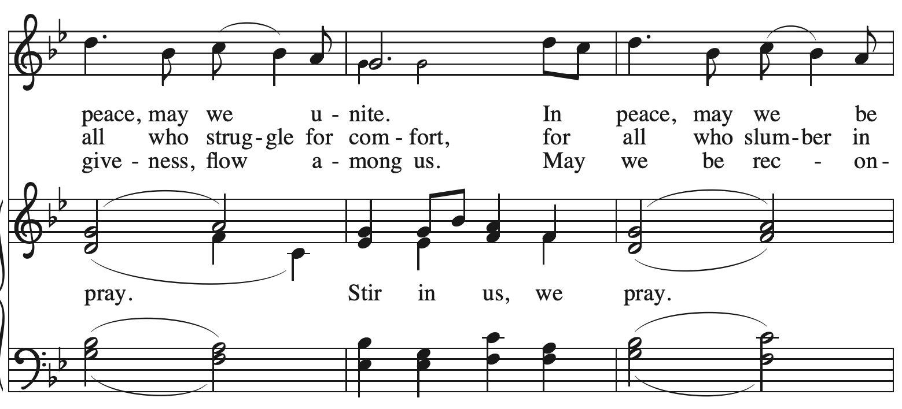
Continued

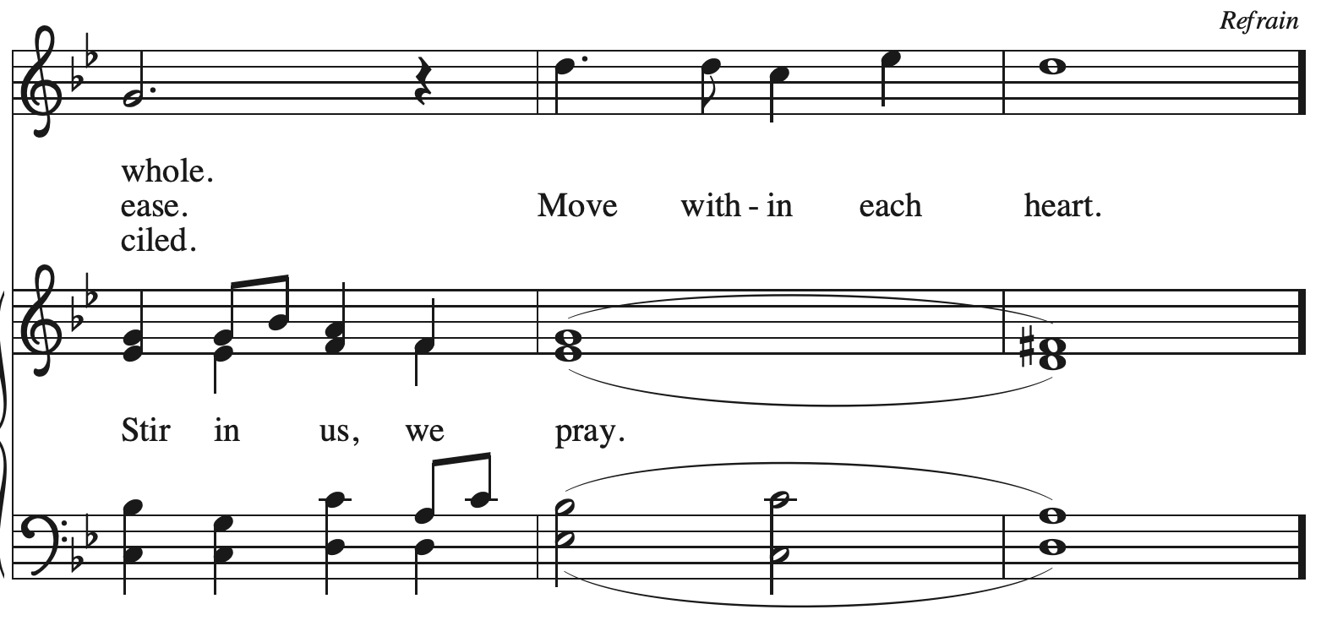
All rights reserved. Reprinted with permission under OneLicense.net # A-722139.

Hymns during Holy Communion
Somos uno en Cristo – We Are All One in Christ ELW 643

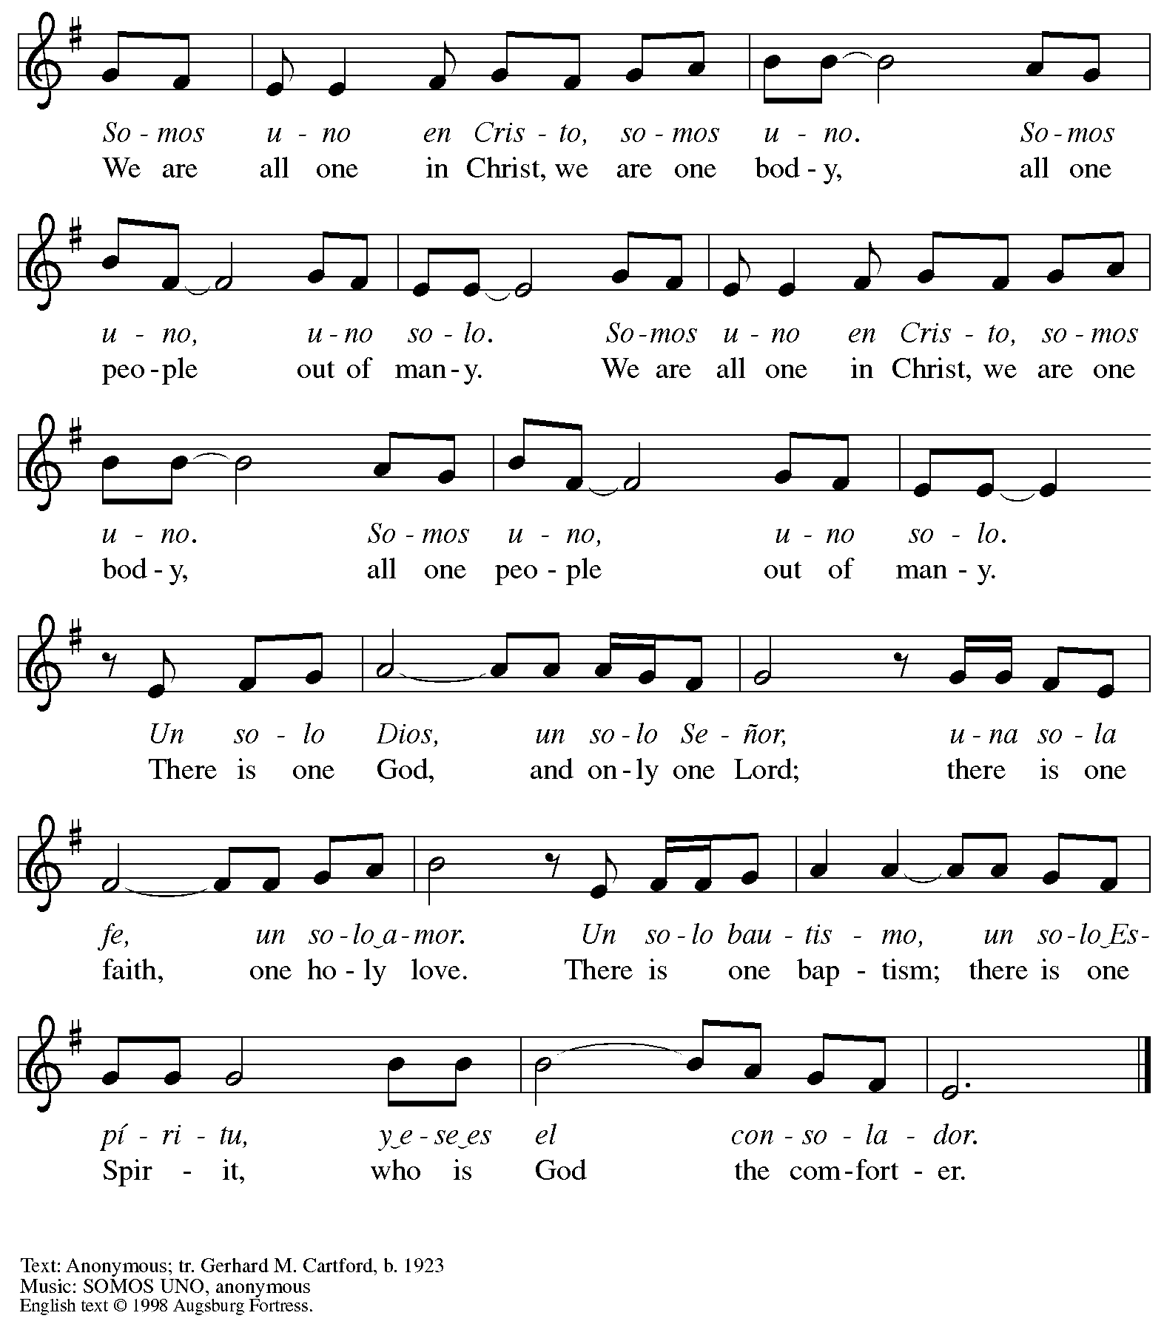
All rights reserved. Reprinted with permission under OneLicense.net # A-722139.

Hymns during Holy Communion
What a Friend We Have in Jesus ELW 742

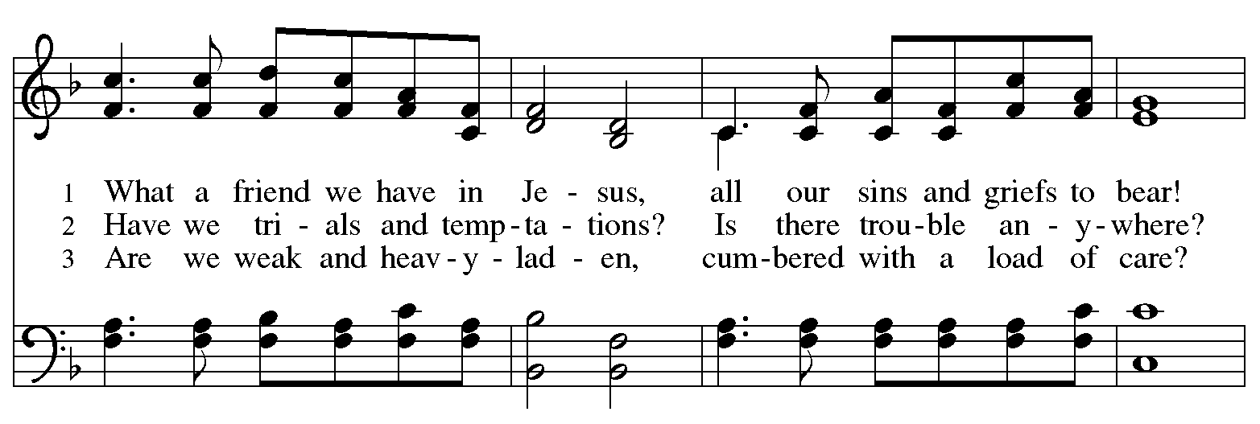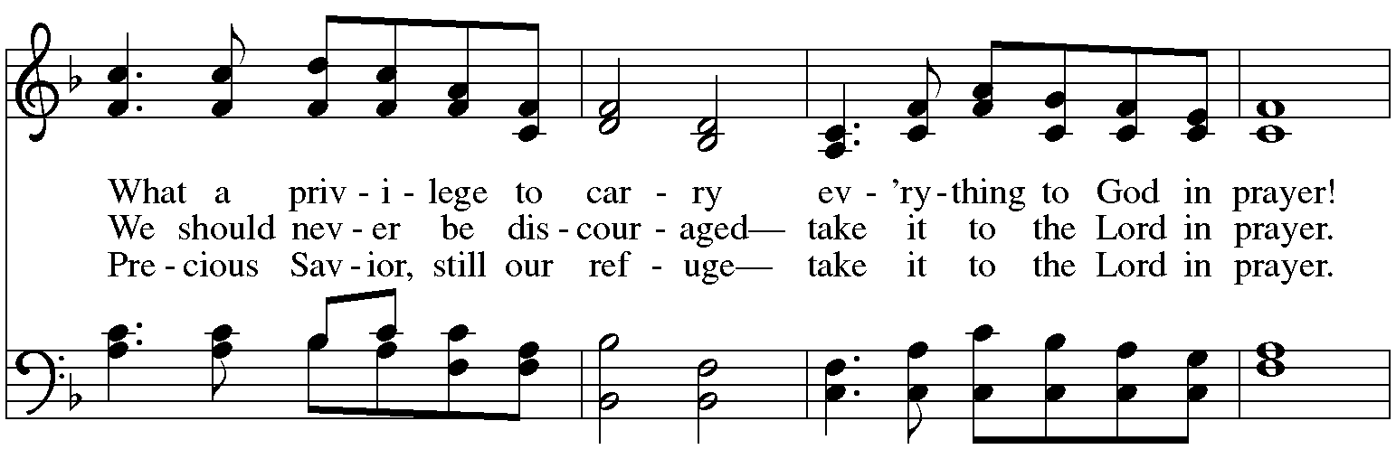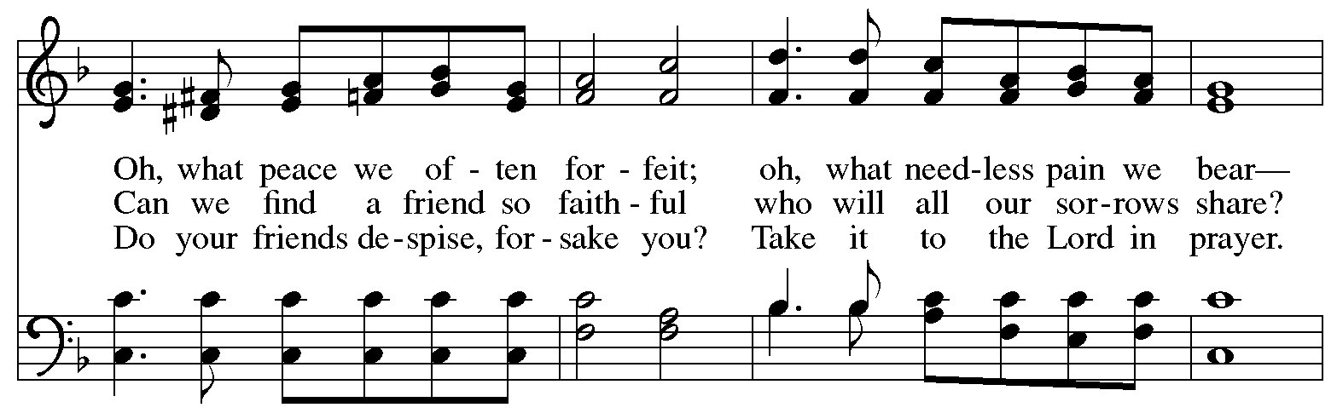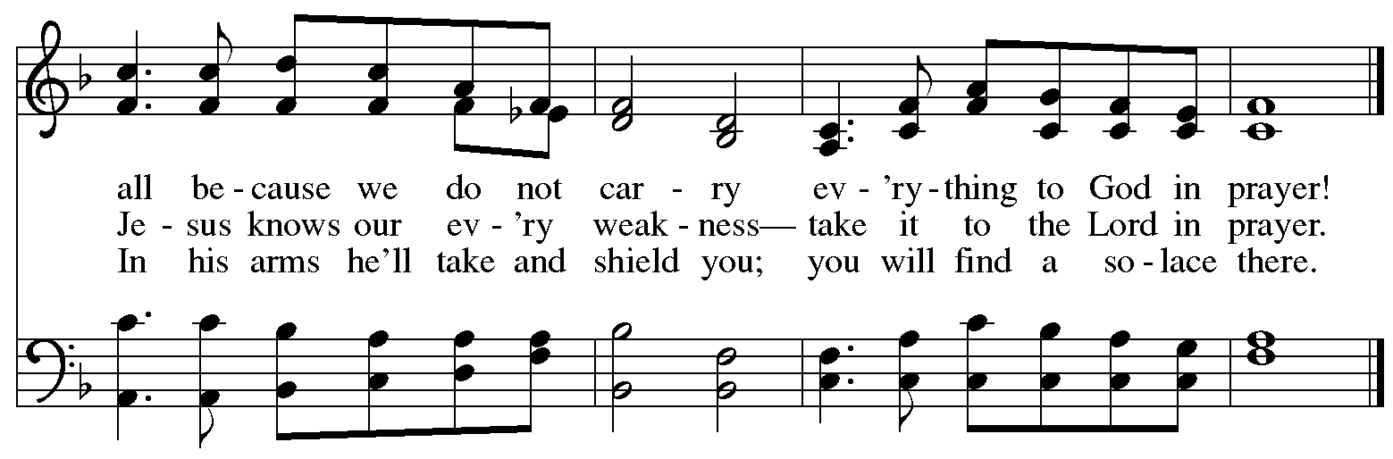
When all have returned to their places, please rise as you are able.
Blessing

P: The body and blood of our Lord Jesus Christ strengthen you and keep you in his grace.
C: Amen.

Prayer

A: Let us pray.
Life-giving God,
in the mystery of Christ’s resurrection, you send light to conquer darkness,
water to give new life, and the bread of life to nourish your people.
Send us forth as witnesses to your Son’s resurrection,
that we may show your glory to all the world,
through Jesus Christ, our risen Lord.
C: Amen.

Please be seated.

Sending
God blesses us and sends us in mission to the world

Announcements

Please rise as you are able.

Benediction

P: May our glorious God grant you a spirit of wisdom
to know and love the risen and ascended Christ.

Almighty God, holy One, ☩ holy Three,
bless you now and forever.
C: Amen.

Sending Hymn Rise, O Sun of Righteousness ELW 657

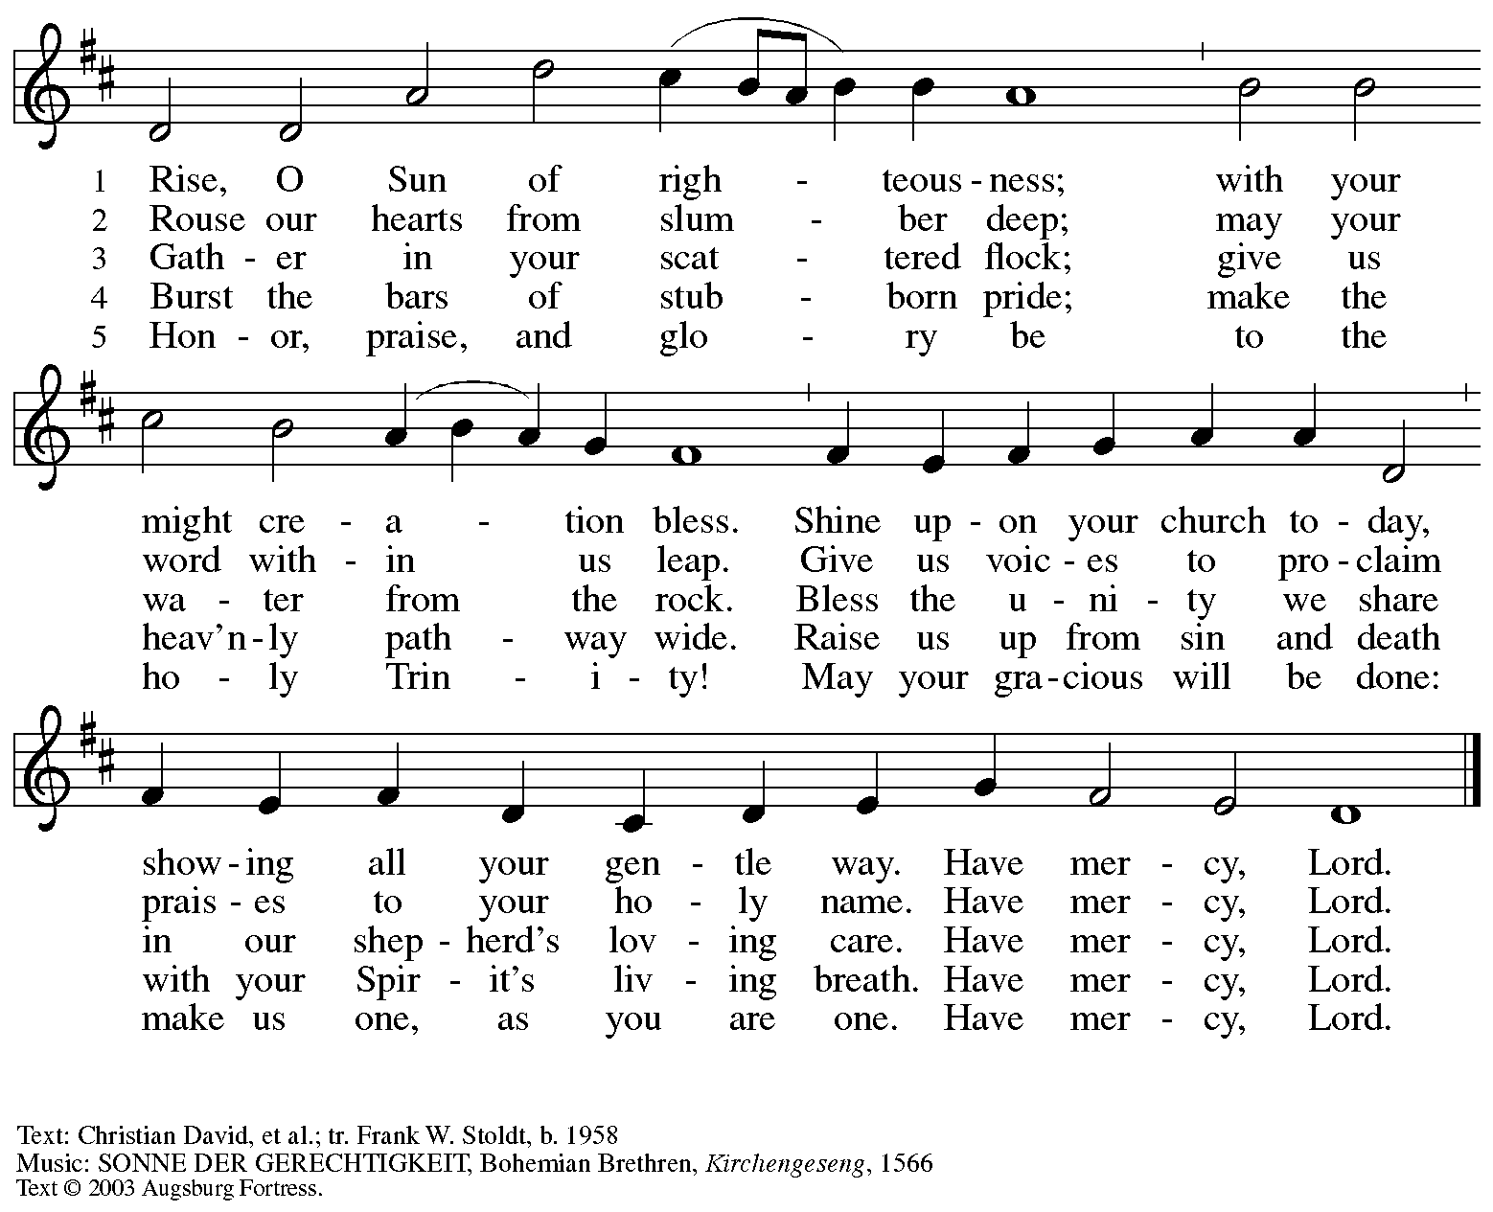
All rights reserved. Reprinted with permission under OneLicense.net # A-722139.

Dismissal

A: Alleluia! Christ is risen and ascended!
C: Christ is risen and ascended! Alleluia! Alleluia!

A: Go in peace. Share the good news!
C: Thanks be to God!

Postlude

Those serving in worship today

Altar Care Christy Ruhe
Assisting Minister Jimmi Kocher-Hillmer
Audio-Visual Ministers Sarita Jason Galyardt
Cantor Dave Rollinson
Children’s Choir Children of St. Andrew
Lector Pat Taylor
Musical Offering Jeff Denlinger
Minister of Music Laura Reynolds
Presiding Minister The Rev. Ross I. Carmichael

Liturgy and Hymnody Acknowledgements

From SundaysandSeasons.com. Copyright © 2026 Augsburg Fortress. All rights reserved. Reprinted under OneLicense.net # A-722139.
Used by permission of Augsburg Fortress.

The Scripture readings contained herein are from New Revised Standard Version Updated Edition of the Bible © 2021 National Council of Churches of Christ in the United States of America. Used by permission. All rights reserved worldwide.

Let the Vineyards – Text: John W. Arthur, 1922-1980. Music: Ronald A. Nelson, b. 1927. Text and Music © 1978 Lutheran Book of Worship, admin. Augsburg Fortress.

What a Friend We Have in Jesus – Text: Joseph Scriven, 1820-1886. Music: CONVERSE, Charles C. Converse, 1832-1918.

Please use the QR code below to link to St. Andrew’s Announcements online!



St. Andrew Lutheran Church Announcements
May 17th, 2026

- Happy Easter! Welcome to Worship at St. Andrew as We Celebrate the Seventh Sunday of Easter! – We are so glad you are here to share in this festive season, and we offer a special welcome to all visitors and guests who are here for the first time! Little Church – Big Faith, a Bible lesson and activity for children up to sixth grade, will take place after the prayer of the day. There are worship “toolkits” to help children engage with worship and “busy bags” for younger children available in the bookcase at the back of the sanctuary. Please feel free to take one to use with/for your children. A nursery is available through the door to the left of the worship space and across the social hall (look for a purple room). All are invited to gather for coffee, other drinks, food, and conversation in the social hall after worship. We pray that everyone has a blessed conclusion to the Easter season!
- Noisy Offering Today, May 17th, during Worship – On the third Sunday of each month, St. Andrew’s children lead the congregation in a Noisy Offering, in which people are invited to throw their change into buckets that the children carry around the church and bring forward as an additional offering. Each month’s Noisy Offering supports a local, national, or international church-related or otherwise charitable organization. This month’s offering will benefit Lutheran World Relief, affirming God’s love for all people and seeking to end poverty, injustice, and human suffering. You can learn more about their history and work here: https://lwr.org/about-lwr. The Children’s Choir will be signing "He's Got the Whole World" by Laurie London immediately following the noisy offering.
- Produce Distribution Supplemental Food of the Month – St. Andrew is collecting supplemental food each month to accompany our produce distribution. For May, we ask for donations of shelf-stable sandwich toppings (e.g. peanut butter, jam, giardiniera, hummus, tapenade, etc). There are collection boxes at the back of the worship space and social hall.
- Produce Distribution, Third Tuesday Each Month, May 19th from 5:30 to 6:30 p.m. – St. Andrew partners with Greater Pittsburgh Community Food Bank to serve as a distribution site for fresh produce on the first and third Tuesday of every month. We invite people of the congregation to help with the distribution from 5:30 p.m. to 6:30 p.m. and/or to help with unloading and setup during the day between 10:00 a.m. and 1:00 p.m.
- Bible Book Club Is on Pause for the Time Being
- Alternatives to Violence Project Workshop Continues Saturday, May 23rd, 9:00 a.m. to 8:00 p.m. – The AVP workshop will be held at St. Andrew Lutheran Church (304 Morewood Ave, Pittsburgh, PA 15213) and is open to both teens and adults. AVP is not a lecture or a debate. It is a hands-on, participatory experience that equips people with practical tools for: affirmation and respect, clear communication, cooperation in the midst of tension, transforming conflict rather than avoiding or inflaming it. To learn more, follow the link here: https://friendspeaceteams.org/cultures-justice-peace/. You can register to these workshops here: https://docs.google.com/forms/d/e/1FAIpQLSfjPQKcnyQNx26wqTHzyby9YMi7BYHrUUfUha3PoxXpC50XNw/viewform.
- St. Andrew's Capital Campaign Launch - Sunday, May 31st! – The congregation and campaign steering committee are excited to announce that the work on the roof of the church building is near completion, and it is time to begin the public phase of the capital campaign! We will launch the campaign during worship on + Holy Trinity Sunday, May 31st, beginning by offering thanks and praise for God's abiding love, ongoing faithfulness, and abundant provision in the life of the church and the St. Andrew congregation! We will have an extended coffee hour that day to share more specific updates on the building projects and more information about how you can support the campaign. Thank you to all who are serving on the campaign steering committee and to the whole congregation for your support in this big initiative!
- Pride Month Celebrations, Saturday, June 6th and 20th, 10:00 a.m. to 6:00 p.m. – Every June is celebrated as Pride month to commemorate years of struggle for civil rights and the ongoing pursuit of justice for the LGBTQ+ community in the face of police brutality and systemic disenfranchisement. St Andrew will be sponsoring a booth at both Pittsburgh Pride on June 6th, between 10:00 a.m. and 6:00 p.m. and Millvale Pride on June 20th starting at 12:00 p.m. You can sign up to volunteer here: https://www.signupgenius.com/go/5080B4AAFAF2CABF85-63577363-pittsburgh.
- Coffee Hour Signups – St. Andrew provides hospitality during a coffee hour after worship each Sunday. If you would like to participate, please sign up using the following form: https://www.signupgenius.com/go/5080B4AAFAF2CABF85-47069030-coffee#/.
- Christ in Our Home Devotional Booklets for April – June Available at Entrances – This resource offers a daily Bible reading with a short reflection and prayer, along with additional readings and prayer topics for those who would like to expand their devotional practices. We encourage people of the congregation to take one for yourself, your family/household, or others!

