

+ Holy Trinity
Building Community Together
May 31, 2026



St. Andrew Lutheran Church
304 Morewood Ave.
Pittsburgh, PA 15213
St_andrewELCA@verizon.net
www.standrewpittsburgh.org

+ Holy Trinity Sunday
Building Community Together

Today’s worship marks the beginning of St. Andrew’s capital campaign,
Building Community Together!
This initiative begins by giving thanks to our Triune God for the divine goodness, grace, and faithfulness that have sustained the St. Andrew congregation for over 135 years.
In this initiative, our goal is not only to ensure the long-term sustainability of the church building for future generations, but to continue expanding St. Andrew’s mission
of welcome for all in a place of hospitality and sanctuary for the community.

We begin on Trinity Sunday, as we celebrate our relational God who has been revealed
as the divine unity and community of Father, Son, and Holy Spirit.
Though the word “trinity” is not found in the scriptures, today’s second reading includes the apostolic greeting that begins the liturgy: The grace of our Lord Jesus Christ, the love of God, and the communion of the Holy Spirit be with you all. In the Gospel, Jesus sends his disciples forth to baptize in the name of the Father, and the Son, and the Holy Spirit. More than a doctrine, the Trinity expresses the heart of our faith: we have experienced the God of creation made known in Jesus Christ and with us always through the Holy Spirit. We celebrate the mystery of the Holy Trinity in Word and Sacrament, as we profess the creed, and as we are sent into the world to bear witness to our faith.

Welcome to St. Andrew!
- St. Andrew welcomes all who are seeking a place of healing, wholeness, and acceptance in a nurturing and faith-forming spiritual home. We are striving toward racial equity worldwide
and we seek to honor the lived experience of all individuals regardless of background. Our community embraces people of all ages, ethnicities, cultures, abilities, sexual orientations,
gender identities and expressions, and family constellations. Come and See!
- Worship Services are live-streamed to multiple online platforms. By attending worship, you agree that your image and voice may be broadcast.
- Everyone is invited to make a name tag at the black bookcase in the back of the worship space if they would like. There are stickers indicating pronouns on the bookcase if you would like to include them on your name tag.
- Children are invited to attend Little Church – Big Faith, a Bible lesson and activity, during worship (after the Prayer of the Day). The group returns to the worship space for the liturgy of Holy Communion.
- A nursery is available through the doors at the left side of the sanctuary and across from the doorway to the Social Hall. Look for a purple-colored room.
- Worship “toolkits” to help children engage with the service, along with “busy bags” for younger children, are available in the bookcase at the back of the sanctuary. Please feel free to take one to use with/for your children.
- Holy Communion is served with bread (gluten-free available) and wine or grape juice. The presiding minister will distribute the bread (host). Please consume this and then pick up an empty glass from the tray. The Communion Assistant will pour wine or grape juice into your glass. Please step to the side to consume the wine or grape juice. Feel free to kneel at the altar for prayer and reflection. As you return to your pew, glasses may be returned to the empty trays on either side of the center section.
- A restroom is available on the main level of the church, through the doors to the Social Hall and to the right in the main office.

Abbreviations
P: Pastor/Presiding Minister ELW: Evangelical Lutheran Worship hymnal
A: Assisting Minister ACS: All Creation Sings hymnal
L: Lector HS: Hymnal Supplement
C: Congregation

Musical Offering

Each week, different people from the congregation make an offering of pre-service music, with singing or instrumentation, to help the assembly focus and pray in preparation for worship.

Welcome
Prelude How Blessed Is This Place, O Lord arr. Bouman

Gathering
The Holy Spirit calls us together as the people of God

Please rise as you are able. All may make the sign of the cross,
the sign that is marked at Baptism, as the presiding minister begins.

Thanksgiving

P: Blessed be the ☩ one, holy, triune, ever-living God.
C: Amen.

P: Our God is a generous God,
C: providing manna in the wilderness.

P: Our God is a steadfast God,
C: with us even to the end of the age.

P: Our God is a God of newness and calling,
C: inviting us to follow the Spirit to honor new visions and embrace new dreams.

P: The Israelites were fed with manna from heaven. Christ invited those gathered at the feast of the five thousand to witness and receive a generosity beyond what they could imagine.
The ancient church, the people of the Way, shared all things in common, believing that the call to communal, spiritual growth is also a call to give back to God what God has first given us.

P: In keeping with this history and heritage,
trusting that God provides us with everything we need
to do what we are called to do and to be who we are called to be,
together we embark on a new season of planning and planting,
through the Building Community Together campaign.
C: Give us faith, O God, to witness your work among us! Amen.

P: The Lord be with you.
C: And also with you.

P: Let us pray. Blessed are you, O Lord our God, ruler of the universe.
You made the whole earth for your glory; all creation praises you.
We lift our voices to join the songs of heaven and earth, of things seen and unseen.
You stretched out the heavens like a tent; you divided the day from the night;
you appointed times and seasons for work and rest, for tearing down and building up.

You blessed your people through all generations and guided them in life and death:
Abraham and Sarah; Moses and Miriam; Isaiah and all the prophets;
Mary, the Mother of our Lord; St. Andrew and Peter, James and John, and all the apostles;
all the saints and witnesses in your church of ages past,
in whom your Spirit spoke and moved.
We give you thanks, O God, as we dedicate this campaign to your glory and praise.
Grant us faith to know your gracious purpose in all things, give us joy in them,
and lead us to the building up of your kin-dom; through your Son, Jesus Christ,
our Savior and Lord, who lives and reigns with you and the Holy Spirit,
one God, now and forever.
C: Amen.

Congregational Refrain HS 808

This refrain is sung by St. Andrew on significant occasions in the congregation’s life.

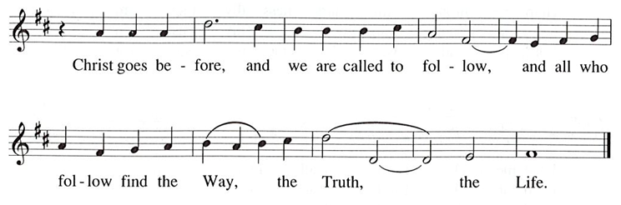

Text: Jaroslav J. Vajda, 1919-2008, © 1987. Music: RIVERSIDE, Irregular, Carl F. Schalk, 1919-2021, © 1987 GIA Publications, Inc. All rights reserved. Reprinted with permission under OneLicense.net # A-722139.
Gathering Hymn Holy, Holy, Holy, Lord God Almighty! ELW 413

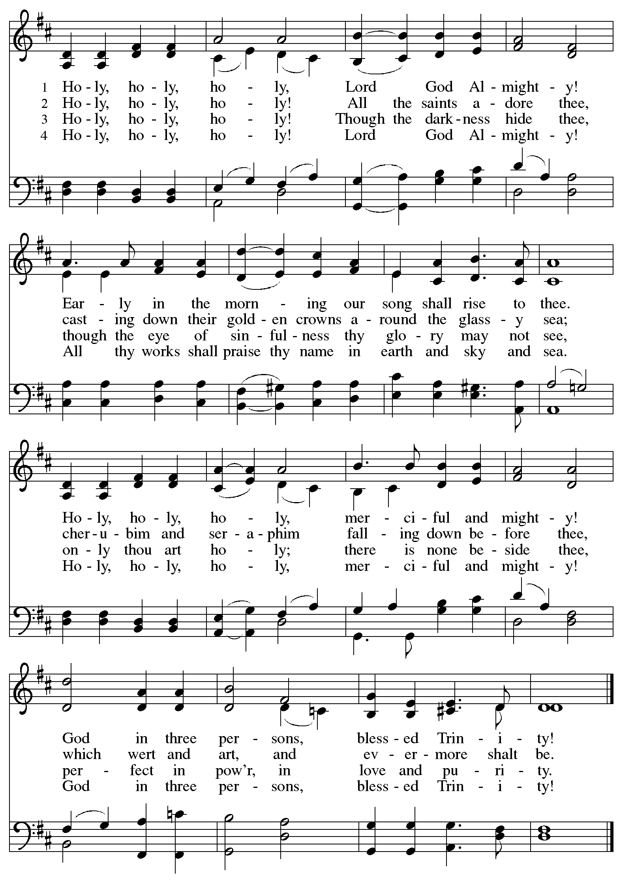
Greeting

P: The grace of our Lord Jesus Christ, the love of God,
and the communion of the Holy Spirit be with you all.
C: And also with you.

Hymn of Praise ACS p. 31

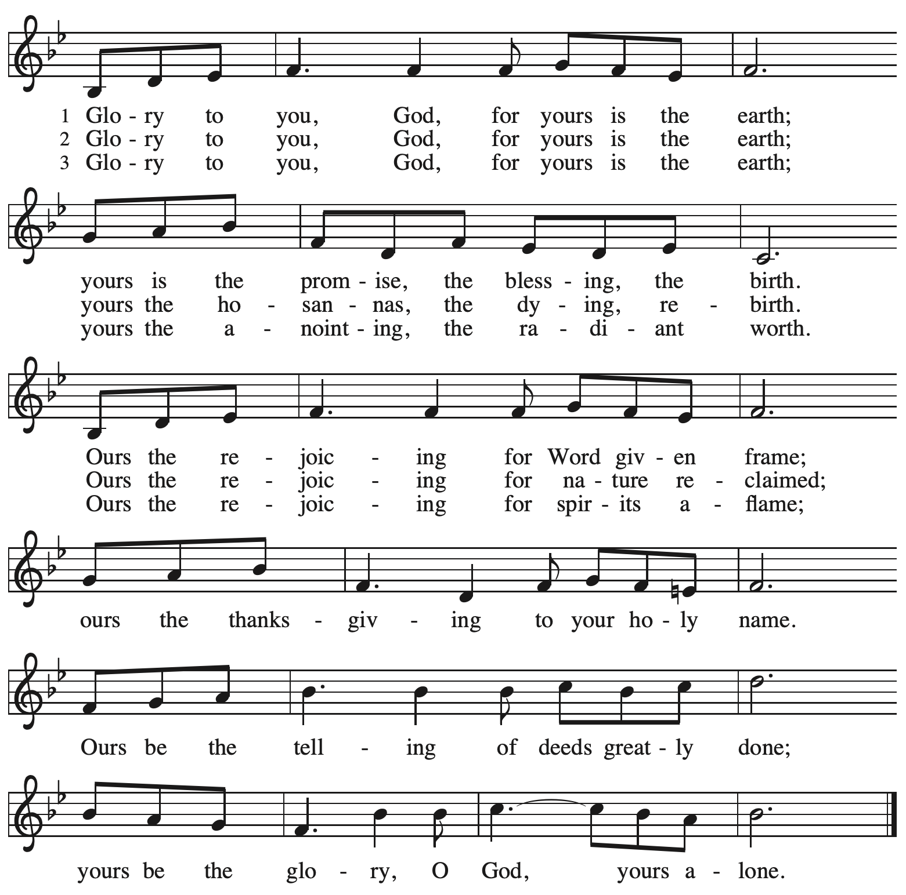

Prayer of the Day

P: The Lord be with you.
C: And also with you.

P: Let us pray.
Almighty Creator and ever-living God:
We worship your glory, eternal Three-in-One, and we praise your power, majestic One-in-Three. Keep us steadfast in this faith, defend us in all adversity, and bring us at last into your presence, where you live in endless joy and love, Father, Son, and Holy Spirit, one God, now and forever.
C: Amen.

Please be seated.

Word
God speaks to us in Scripture reading, preaching, and song

First Reading – Genesis 1: 1 – 2: 4a

¹ When God began to create the heavens and the earth, ² the earth was complete chaos, and darkness covered the face of the deep, while a wind from God swept over the face of the waters.
³ Then God said, “Let there be light,” and there was light. ⁴ And God saw that the light was good,
and God separated the light from the darkness. ⁵ God called the light Day, and the darkness God called Night. And there was evening and there was morning, the first day.
⁶ And God said, “Let there be a dome in the midst of the waters, and let it separate the waters from the waters.” ⁷ So God made the dome and separated the waters that were under the dome
from the waters that were above the dome. And it was so. ⁸ God called the dome Sky. And there was evening and there was morning, the second day.
⁹ And God said, “Let the waters under the sky be gathered together into one place, and let the dry land appear.” And it was so. ¹⁰ God called the dry land Earth, and the waters that were gathered together God called Seas. And God saw that it was good. ¹¹ Then God said, “Let the earth put forth vegetation: plants yielding seed and fruit trees of every kind on earth that bear fruit with the seed in it.” And it was so. ¹² The earth brought forth vegetation: plants yielding seed of every kind and trees of every kind bearing fruit with the seed in it. And God saw that it was good. ¹³ And there was evening and there was morning, the third day.
¹⁴ And God said, “Let there be lights in the dome of the sky to separate the day from the night,
and let them be for signs and for seasons and for days and years, ¹⁵ and let them be lights in the dome of the sky to give light upon the earth.” And it was so. ¹⁶ God made the two great lights—
the greater light to rule the day and the lesser light to rule the night—and the stars. ¹⁷ God set them in the dome of the sky to give light upon the earth, ¹⁸ to rule over the day and over the night, and to separate the light from the darkness. And God saw that it was good. ¹⁹ And there was evening and there was morning, the fourth day.
²⁰ And God said, “Let the waters bring forth swarms of living creatures, and let birds fly above the earth across the dome of the sky.” ²¹ So God created the great sea monsters and every living creature that moves, of every kind, with which the waters swarm and every winged bird of every kind. And God saw that it was good. ²² God blessed them, saying, “Be fruitful and multiply and fill the waters in the seas, and let birds multiply on the earth.” ²³ And there was evening and there was morning, the fifth day.
²⁴ And God said, “Let the earth bring forth living creatures of every kind: cattle and creeping things and wild animals of the earth of every kind.” And it was so. ²⁵ God made the wild animals of the earth of every kind and the cattle of every kind and everything that creeps upon the ground
of every kind. And God saw that it was good.
²⁶ Then God said, “Let us make humans in our image, according to our likeness, and let them have dominion over the fish of the sea and over the birds of the air and over the cattle and over all the wild animals of the earth and over every creeping thing that creeps upon the earth.”
²⁷ So God created humans in God’s image,
in the image of God, God created them;
male and female God created them.
²⁸ God blessed them, and God said to them, “Be fruitful and multiply and fill the earth and subdue it and have dominion over the fish of the sea and over the birds of the air and over every living thing that moves upon the earth.” ²⁹ God said, “See, I have given you every plant yielding seed that is upon the face of all the earth and every tree with seed in its fruit; you shall have them for food. ³⁰ And to every beast of the earth and to every bird of the air and to everything that creeps on the earth, everything that has the breath of life, I have given every green plant for food.” And it was so. ³¹ God saw everything that God had made, and indeed, it was very good.
And there was evening and there was morning, the sixth day.
^{2:1} Thus the heavens and the earth were finished and all their multitude. ² On the sixth day God finished the work that God had done, and God rested on the seventh day from all the work that God had done. ³ So God blessed the seventh day and hallowed it, because on it God rested from all the work that God had done in creation.
^{4a} These are the generations of the heavens and the earth when they were created.

L: Word of God, word of life.
C: Thanks be to God.

Psalm 8

The psalm will be sung responsively, led by the cantor,
with the congregation responding with the bold verses and refrain.

Psalm Tone
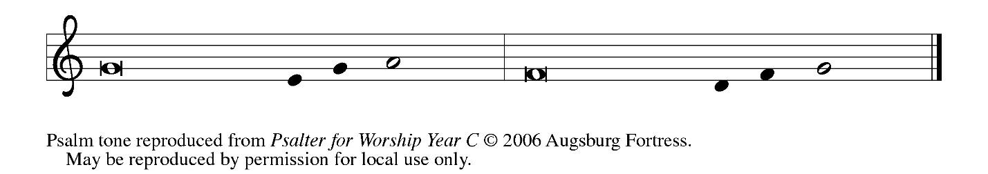

Psalm Refrain
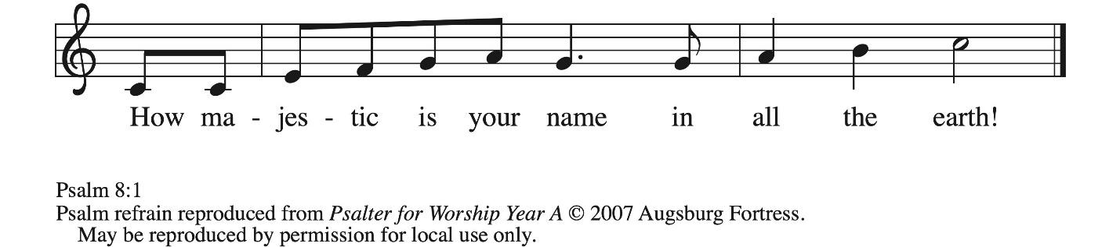

¹ O | Lord our Lord,
how majestic is your name in | all the earth!—
² you whose glory is chanted above the heavens out of the mouths of in- | fants and children;
you have set up a fortress against your enemies, to silence the foe | and avenger.
³ When I consider your heavens, the work | of your fingers,
the moon and the stars you have set | in their courses,
⁴ what are mere mortals that you should be mind- | ful of them,
human beings that you should | care for them? R
⁵ Yet you have made them little less | than divine;
with glory and hon- | or you crown them.
⁶ You have made them rule over the works | of your hands;
you have put all things un- | der their feet:
⁷ all | flocks and cattle,
even the wild beasts | of the field,
⁸ the birds of the air, the fish | of the sea,
and whatever passes along the paths | of the sea.
⁹ O | Lord our Lord,
how majestic is your name in | all the earth! R

Second Reading – 2 Corinthians 13: 11-13

[Paul writes:] ¹¹ Finally, kindred, farewell. Be restored; listen to my appeal; agree with one another; live in peace; and the God of love and peace will be with you. ¹² Greet one another with a holy kiss. All the saints greet you.
¹³ The grace of the Lord Jesus Christ, the love of God, and the communion of the Holy Spirit be with all of you.

L: Word of God, word of life.
C: Thanks be to God.

Please rise as you are able.

Gospel Acclamation ACS p. 33
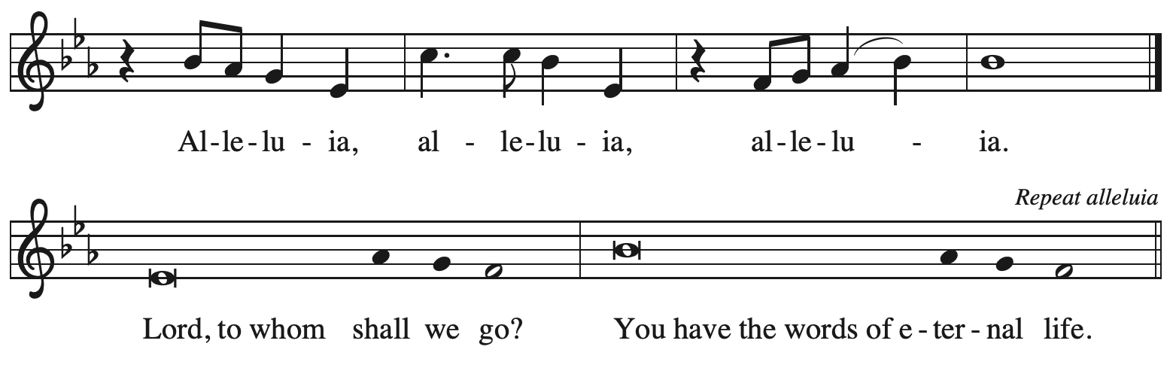
Gospel – Matthew 28: 16-20

P: The holy Gospel according to St. Matthew.
C: Glory to you, O Lord.

¹⁶ Now the eleven disciples went to Galilee, to the mountain to which Jesus had directed them.
¹⁷ When they saw him, they worshiped him, but they doubted. ¹⁸ And Jesus came and said to them, “All authority in heaven and on earth has been given to me. ¹⁹ Go therefore and make disciples of all nations, baptizing them in the name of the Father and of the Son and of the Holy Spirit ²⁰ and teaching them to obey everything that I have commanded you. And remember, I am with you always, to the end of the age.”

P: The Gospel of the Lord.
C: Praise to you, O Christ.

Please be seated.

Sermon

A time of silence for prayer and reflection follows the sermon.
When the hymn of the day begins, please rise as you are able.

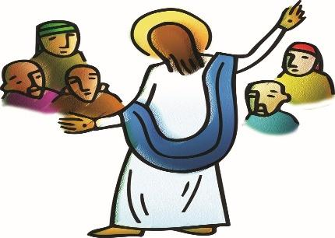

Hymn of the Day Great Is Thy Faithfulness ELW 733

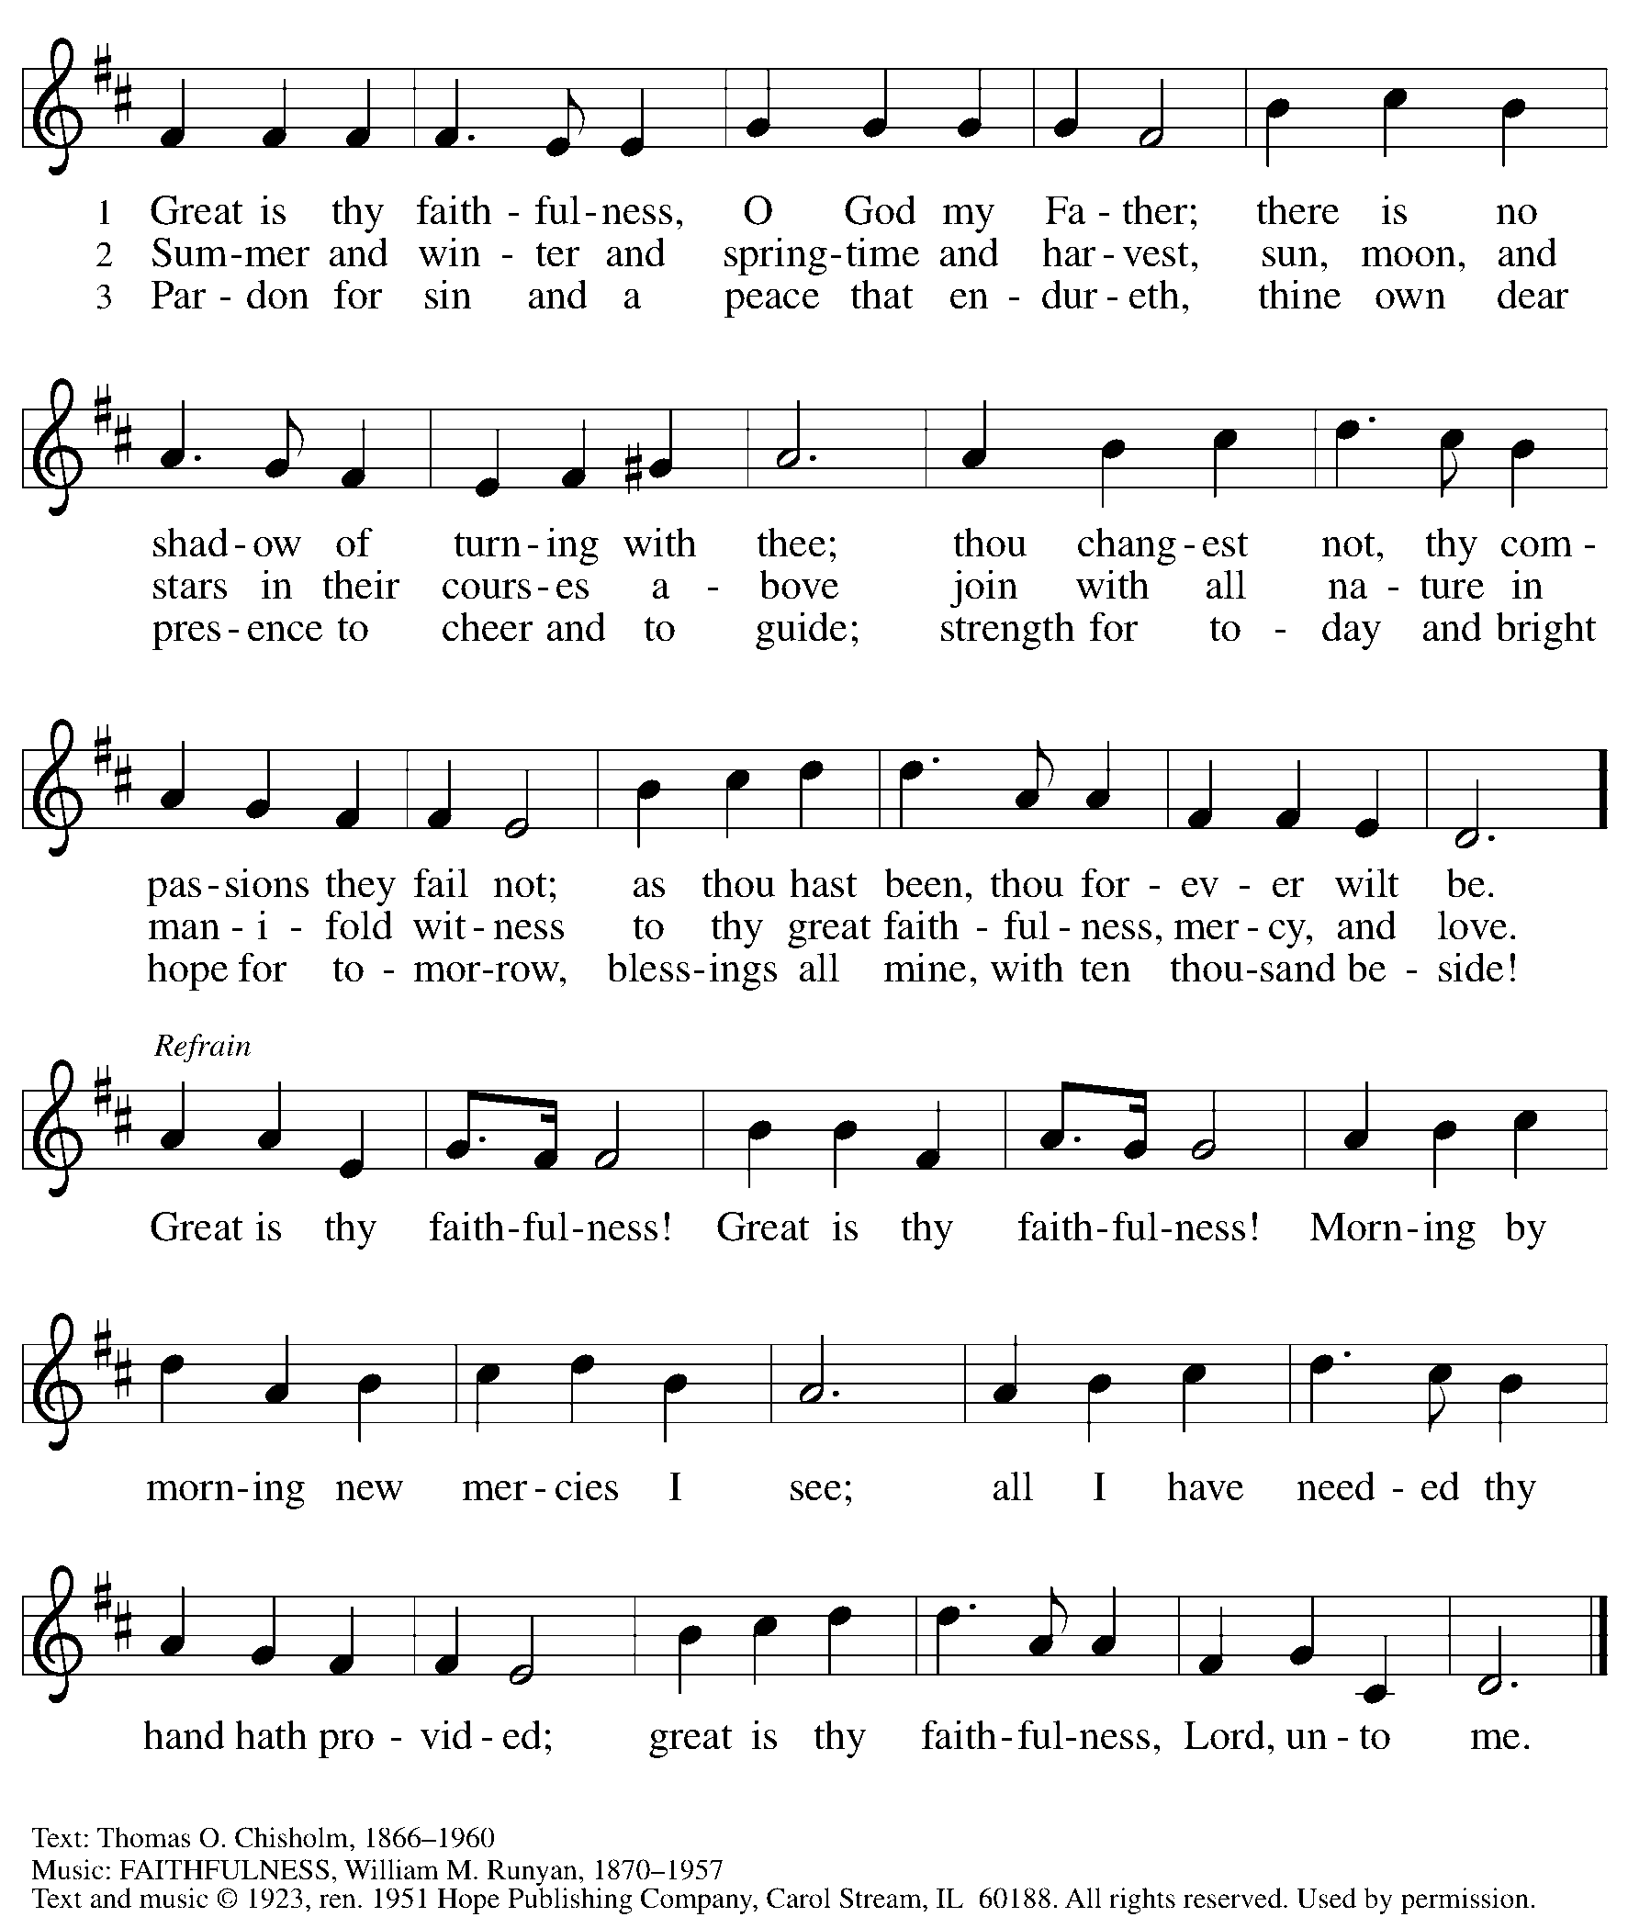
Reprinted under OneLicense.net # A-722139.

Nicene Creed

C: We believe in one God,
the Father, the Almighty,
maker of heaven and earth,
of all that is, seen and unseen.

We believe in one Lord, Jesus Christ,
the only Son of God,
eternally begotten of the Father,
God from God, Light from Light,
true God from true God,
begotten, not made,
of one Being with the Father;
through him all things were made.
For us and for our salvation
he came down from heaven,
was incarnate of the Holy Spirit and the virgin Mary
and became truly human.
For our sake he was crucified under Pontius Pilate;
he suffered death and was buried.
On the third day he rose again
in accordance with the scriptures;
he ascended into heaven
and is seated at the right hand of the Father.
He will come again in glory to judge the living and the dead,
and his kingdom will have no end.

We believe in the Holy Spirit, the Lord, the giver of life,
who proceeds from the Father and the Son,*
who with the Father and the Son is worshiped and glorified,
who has spoken through the prophets.
We believe in one holy catholic and apostolic church.
We acknowledge one baptism for the forgiveness of sins.
We look for the resurrection of the dead,
and the life of the world to come. Amen.

*Or, “who proceeds from the Father.” The phrase “and the Son” is a later addition to the creed.

Prayers of the People

A: Gathered by the Holy Spirit, let us pray for the church, the world,
and all people according to their need.
After each petition
A: God of grace,
C: receive our prayer.

The presiding minister concludes the prayers
P: Trusting that you receive all our prayers,
we commend our spoken and unspoken petitions to you, O God,
through Jesus Christ our Savior.
C: Amen.

Peace

The presiding minister and the assembly greet one another in the peace of the risen Christ.
P: The peace of Christ be with you always.
C: And also with you.

The people may greet those around them with a sign of Christ’s peace and may say
Peace be with you or similar words. Please be mindful that not everyone will be comfortable with sharing the peace, so please seek consent before shaking hands or hugging. Other possible ways to share the peace include a simple bow with the verbal greeting of peace, or simply a verbal expression of peace. When the greetings of peace have concluded, please be seated.



Meal
God feeds us with the presence of Jesus Christ

Offering

We offer ourselves, our gifts, and our faithful service to God.
As the offering is gathered for the mission of the church, including the care of those in need,
the table is set for Holy Communion.

There are laminated giving cards in the pew racks that feature a QR code for anyone who would like to give online. Those who give using the QR code, as well as those who give regularly online or through their bank are encouraged to place the laminated card in the plate as an expression of your offering.

Music during the Offering

As the gifts are brought forward for presentation, please rise as you are able.

Offertory Song Timothy Kocher-Hillmer

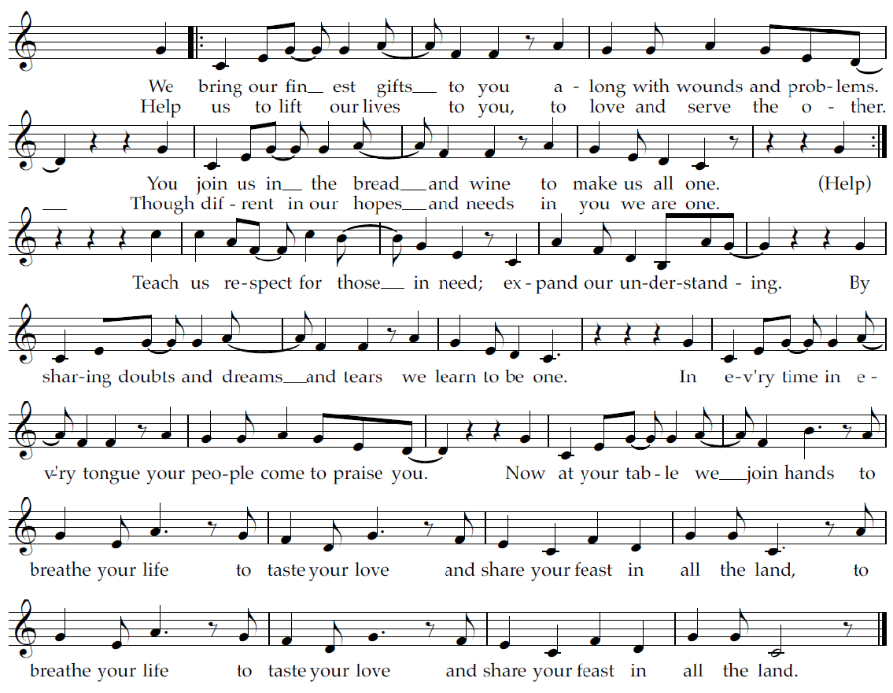

Offertory Prayer

A: Let us pray.
God of goodness and growth,
C: all creation is yours, and your faithfulness is sure.
Word and water, wine and bread: these are signs of your abundant grace.
Receive the gifts we bring,
and nourish us to proclaim your abiding love in our communities and in the world,
through Jesus Christ, our strength and our song.
Amen.

Dialogue ACS p. 36

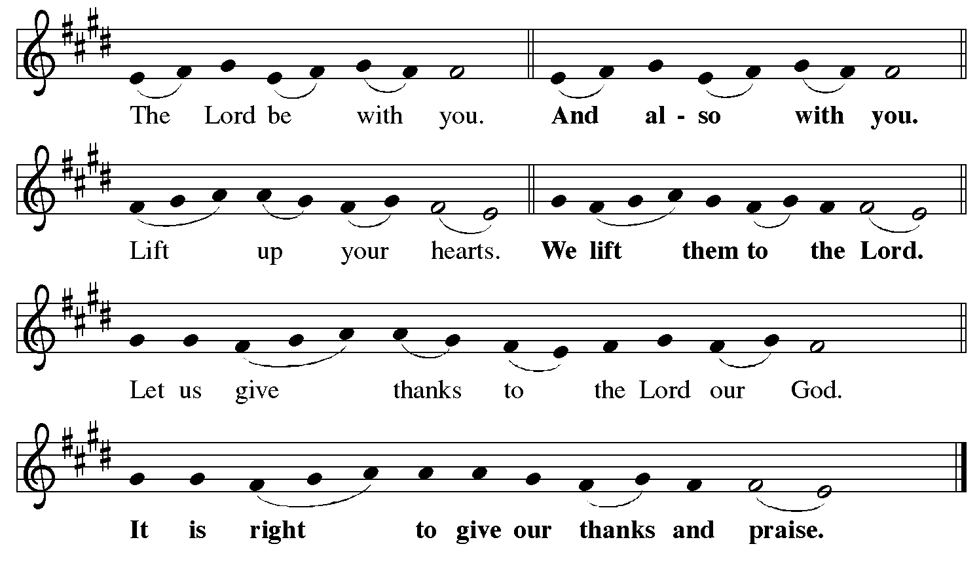

Preface (Sung by the presiding minister)

P: It is indeed right, our duty and our joy,
that we should at all times and in all places
give thanks and praise to you, almighty and merciful God,
through our Savior Jesus Christ.
You reveal your glory
as the glory of the Father, the Son, and the Holy Spirit:
equal in majesty, undivided in splendor,
one Lord, one God,
ever to be adored in your eternal glory.
And so, with all the choirs of angels,
with the church on earth and the hosts of heaven,
we praise your name and join their unending hymn:

Sanctus ACS p. 36

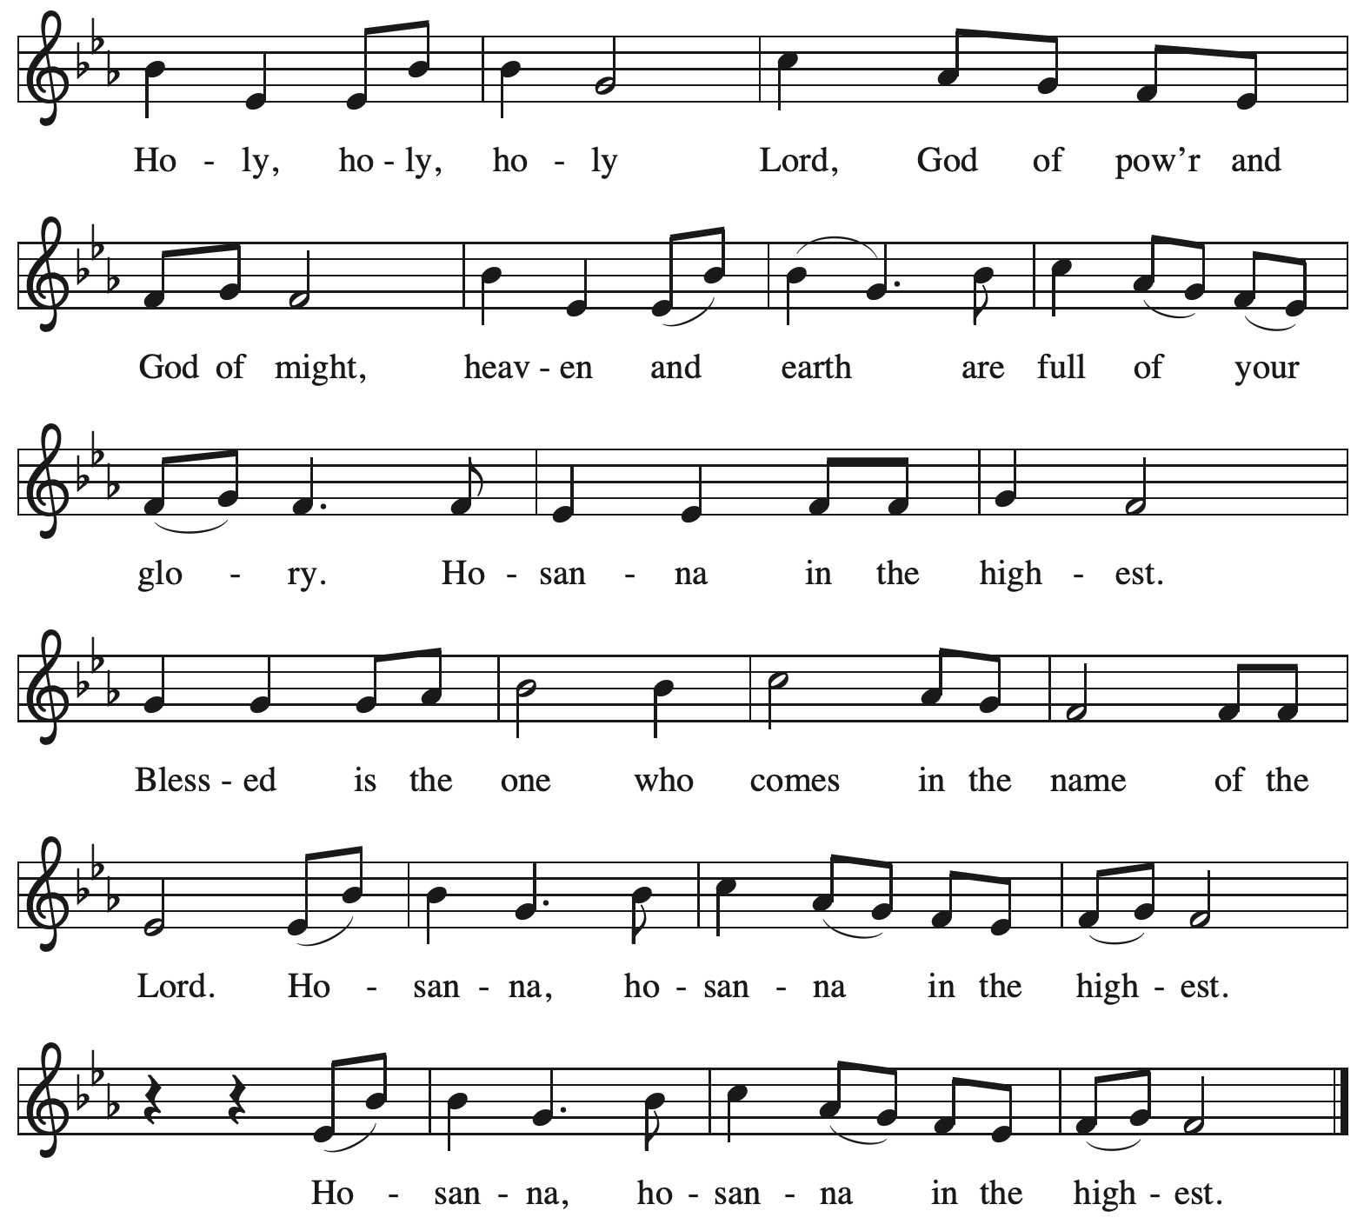

Eucharistic Prayer

P: O God triune, how majestic is your name in all the earth …
… The earth is full of your glory.
C: The earth is full of your glory.

P: O God triune, you made a home among us in Jesus our healer …
… The earth is full of your glory.
C: The earth is full of your glory.

P: We praise you for the heart of Jesus, so filled with your love for the world …
… Do this for the remembrance of me.

Gathered around your table, we your children unite in this song:
The earth is full of your glory.
C: The earth is full of your glory.

P: O God triune, your create the worlds, you uphold the living, you embrace the dead …
… The earth is full of your glory.
C: The earth is full of your glory.

P: Amen and Amen.
C: Amen and Amen.

Lord’s Prayer

P: Gathered as one by the Holy Spirit, let us pray as Jesus taught us.
C: Our Father in heaven,
hallowed be your name,
your kingdom come,
your will be done,
on earth as in heaven.
Give us today our daily bread.
Forgive us our sins
as we forgive those
who sin against us.
Save us from the time of trial
and deliver us from evil.
For the kingdom, the power,
and the glory are yours,
now and forever. Amen.

Fraction and Invitation



Agnus Dei / Lamb of God ACS p. 40

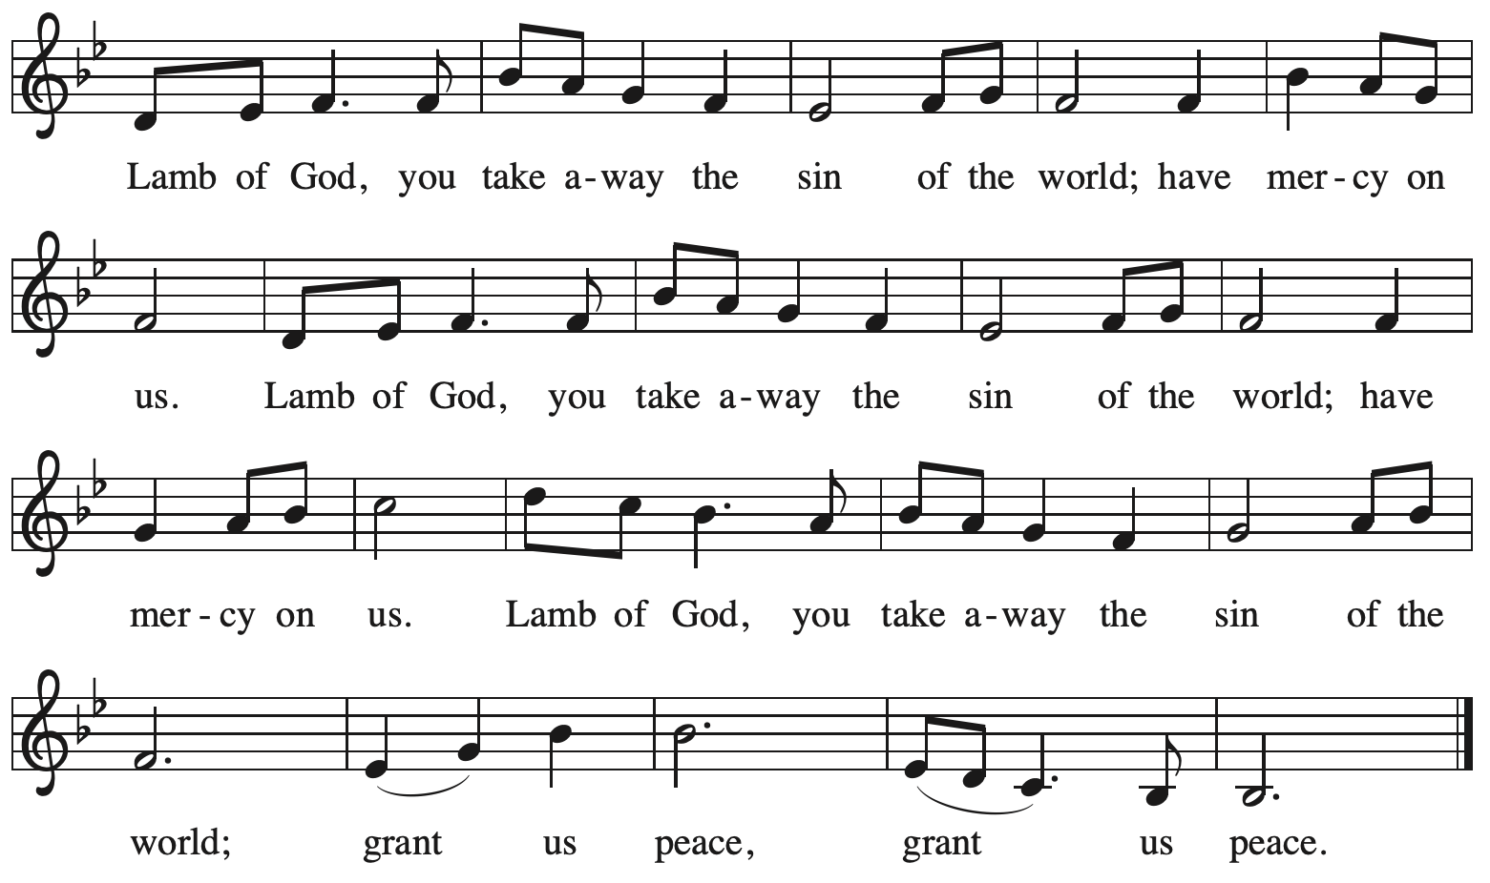

Please be seated.

Holy Communion

- All who seek God and desire a deeper and stronger life in Christ are welcome to receive Holy Communion.
- Worshipers from the pulpit side will proceed forward first, followed by the center section, and then the lectern side.
- Please inform an usher if you would like the ministers to bring Communion to you.
- Holy Communion will be served with bread and wine (red) or grape juice (white).
- The presiding minister will first distribute the bread (host) to each communicant. Please indicate if you require a gluten-free host.
- Once you have consumed the bread, please pick up an empty glass from the tray next to the presiding minister. The Communion Assistant will pour wine or grape juice into your glass.
- Please step to the side to consume the wine or grape juice.
- Feel free to kneel at the altar rail for prayer after receiving the sacrament.
- As you return to your pew, glasses may be returned to the empty tray on the side of the center section.
- A blessing will be provided for anyone who does not yet receive the sacrament.
- All are invited to join in singing the hymns during Holy Communion.

Hymns during Holy Communion
Come, Share the Spirit ACS 1045

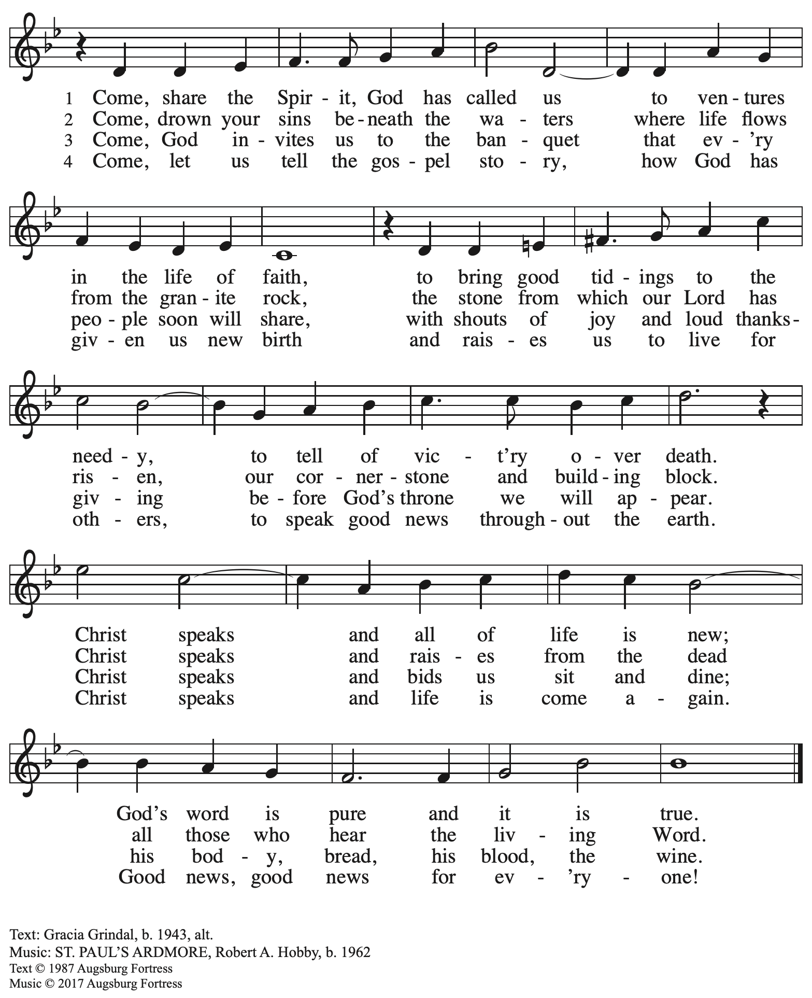
All rights reserved. Reprinted with permission under OneLicense.net # A-722139.
Hymns during Holy Communion
God, Whose Giving Knows No Ending ELW 678

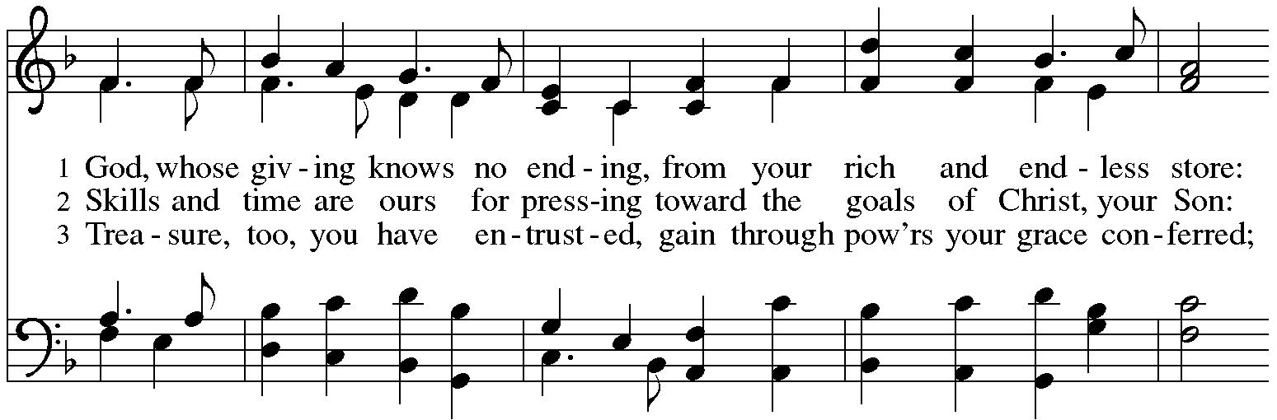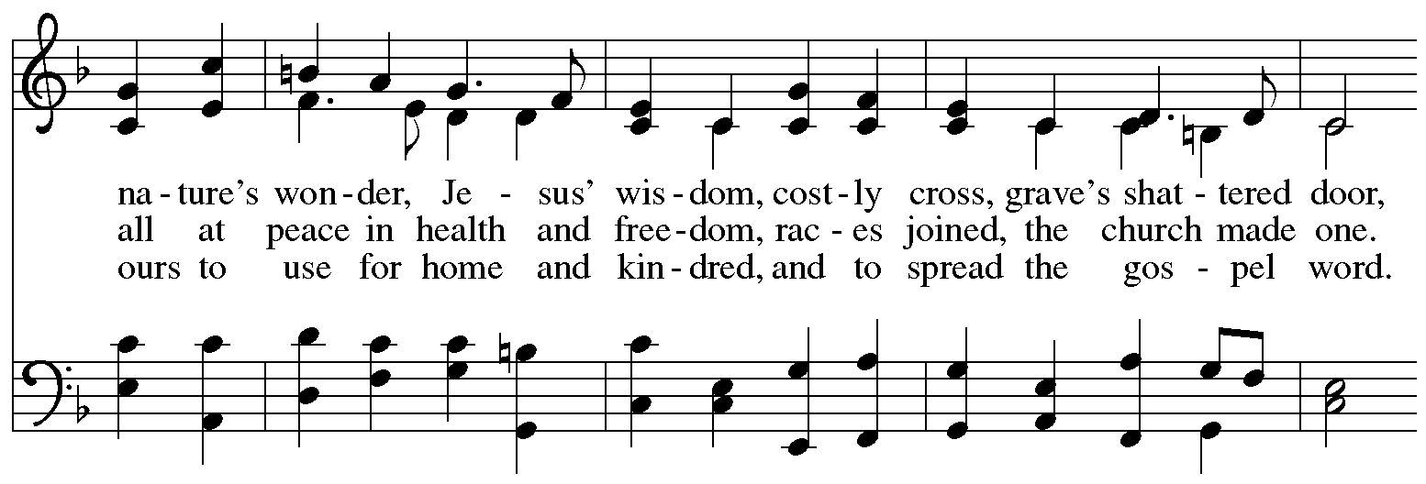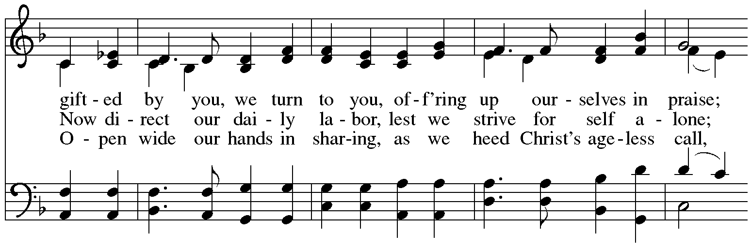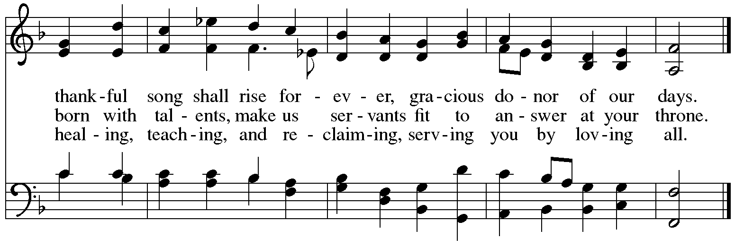
Hymns during Holy Communion
How Firm a Foundation ELW 796

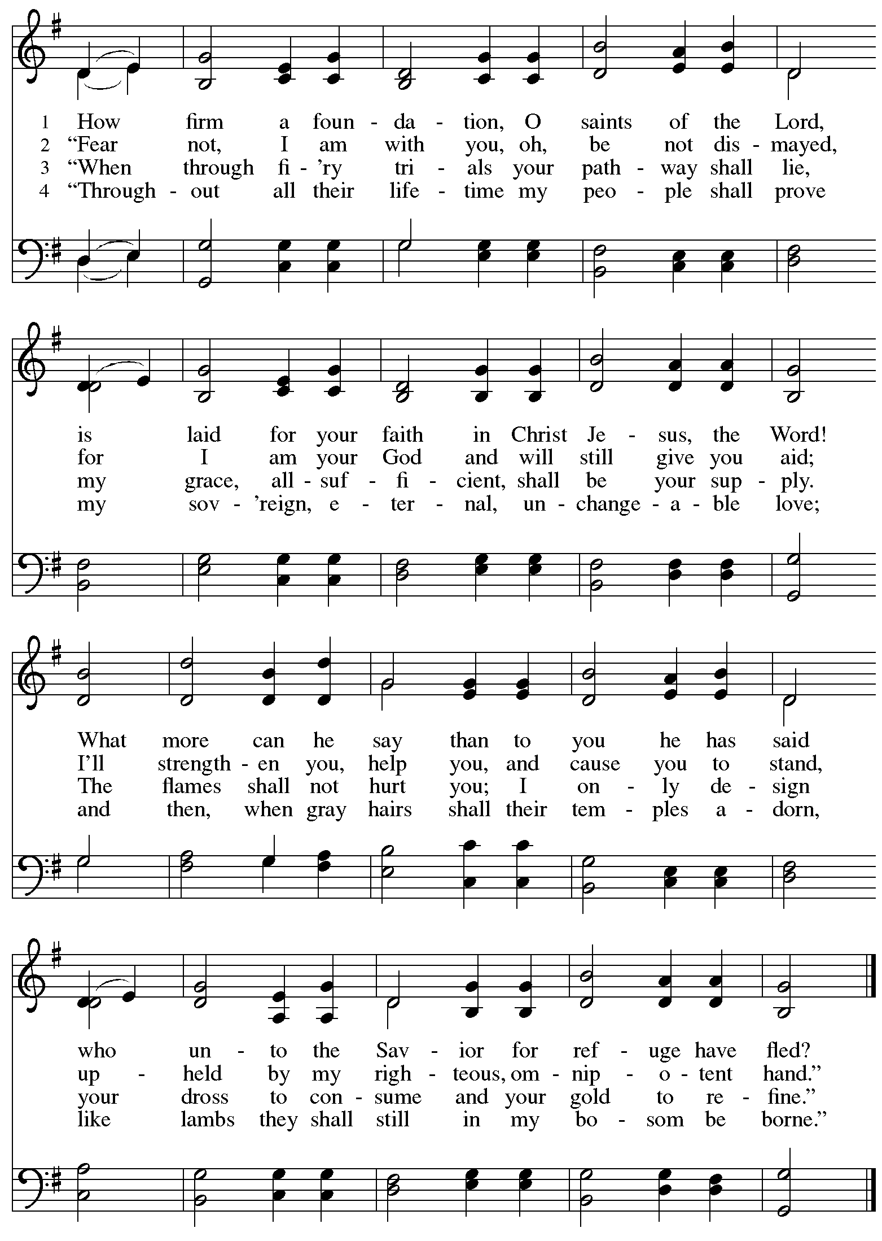
Hymns during Holy Communion
Build Us Up, Lord ELW 670
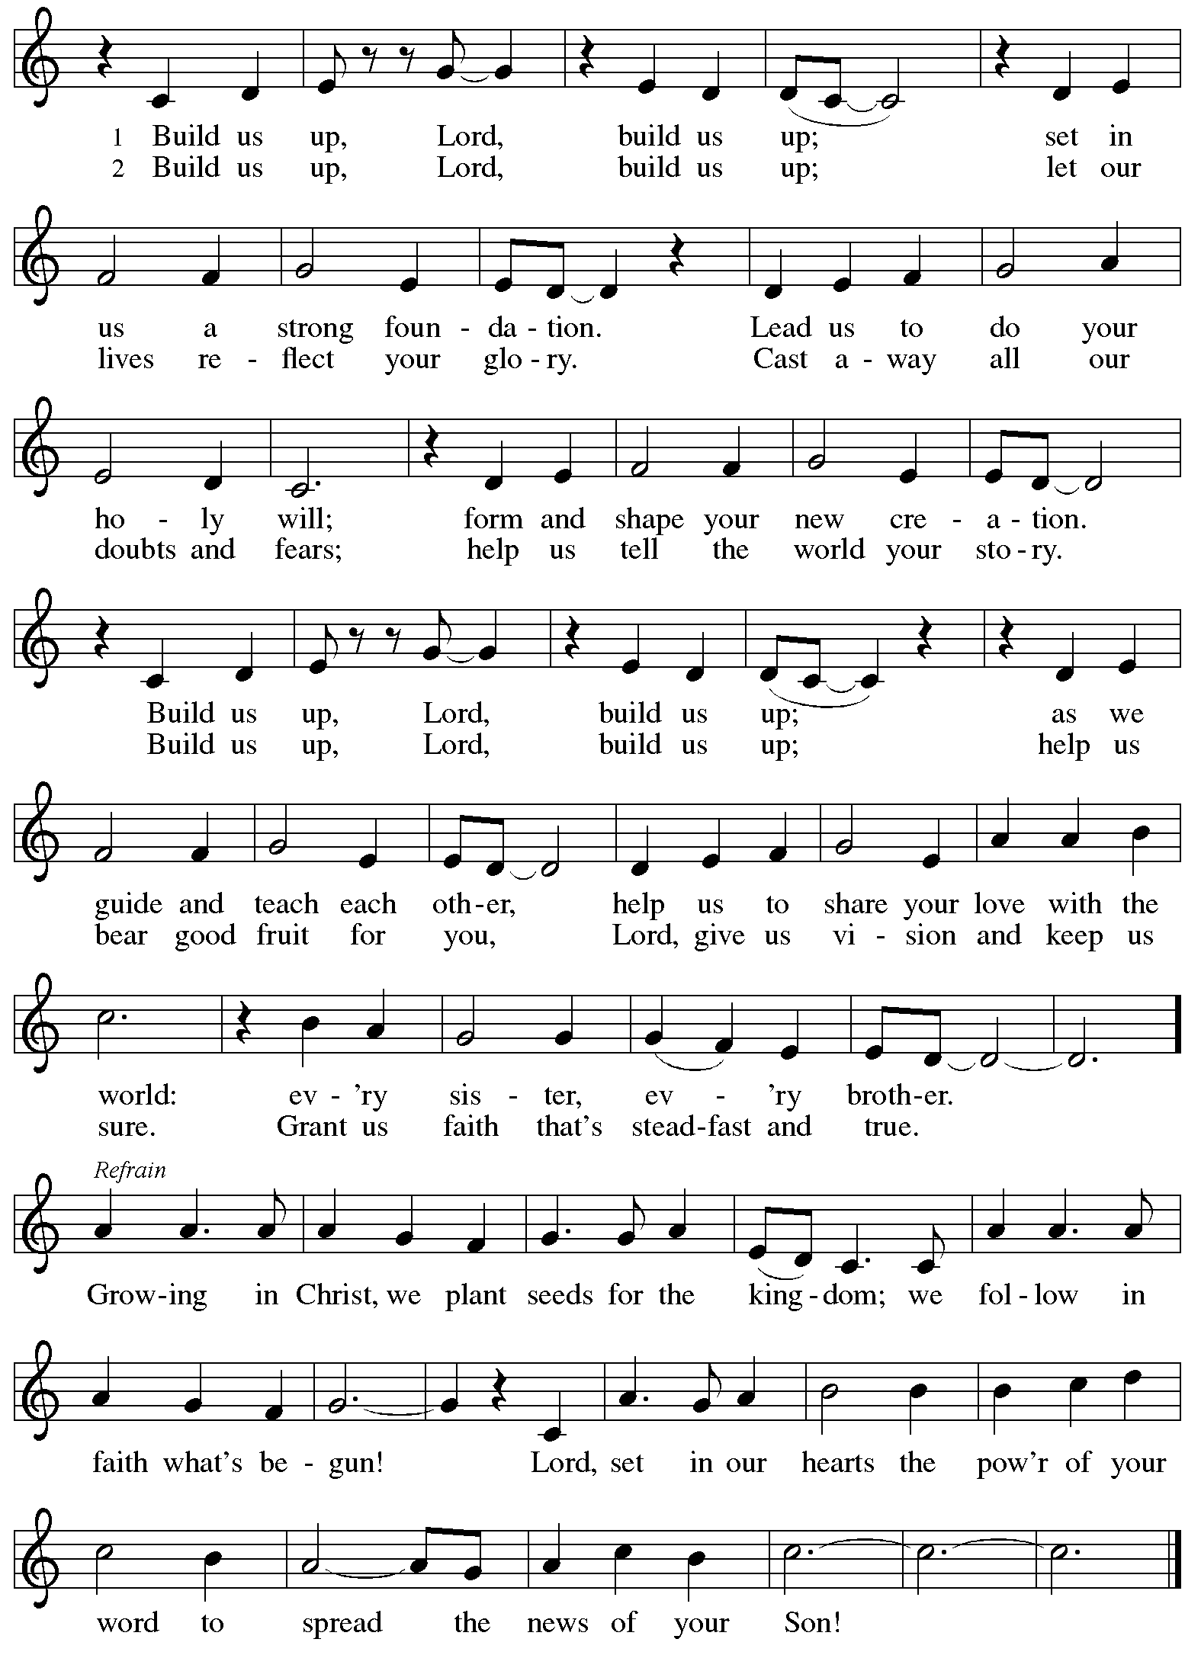
When all have returned to their places, please rise as you are able.

Blessing

P: The body and blood of our Lord Jesus Christ strengthen you and keep you in his grace.
C: Amen.

Prayer

A: Let us pray. Life-giving God,
through this meal you have made your home among us
and are making all things new.
Send us now to speak peace to anxious hearts,
to love our neighbors, and to bring your healing to the nations.
through Jesus Christ, our Savior.
C: Amen.

Please be seated.

Sending
God blesses us and sends us in mission to the world

Announcements

Capital Campaign Invitation

Please rise as you are able.

Prayer of Dedication

P: Let us give thanks for the Body of Christ, for God’s house of living stones.

We give you thanks, O God, for you transcend the boundaries of space and time,
yet you are willing to make your home in human hearts.
We are the temple of your presence, and this building is the house of your church.

Gather us in this place to share with others the promise of Baptism,
to hear your Word, to be nourished by the body and blood of your Son,
and to praise your name with all the company of heaven.
Send us from this place to be the body of Christ in the world,
to proclaim your love in word and deed,
to invite others into the promise of Baptism,
and to glorify your name in our daily living.

Pour out the abundance of your blessing on us and on this place,
which has been, is, and will be dedicated to your glory and honor
and to the service of all people,
in the name of the Father, and of the Son, and of the Holy Spirit.
C: Amen.

Doxology Praise God, from Whom All Blessings Flow ELW 885

For many years, the Doxology, Praise God from Whom All Blessings Flow,
was sung at the close of St. Andrew’s worship every Sunday.

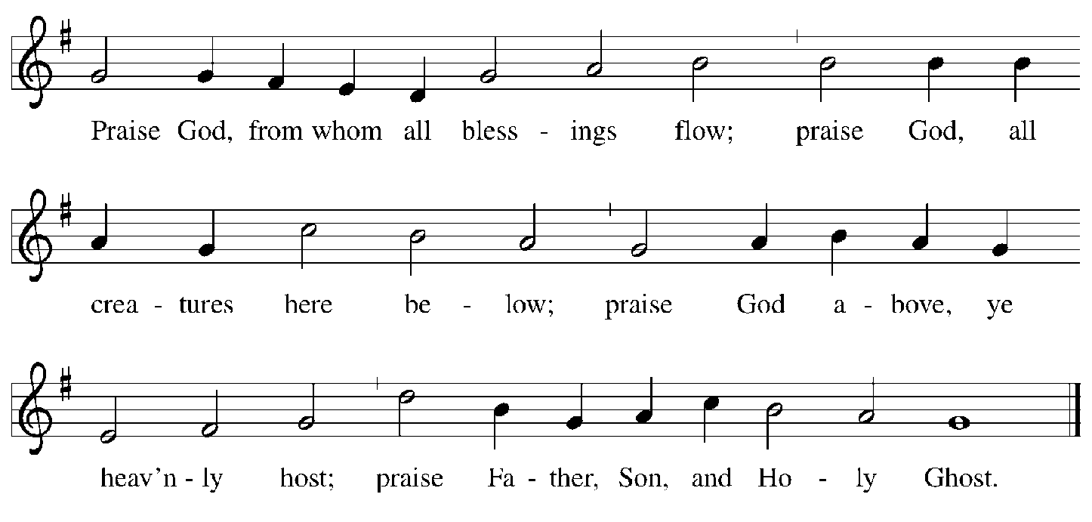

Benediction

P: God Almighty, who is the beginning and the end,
Jesus Christ, the firstborn of the dead,
and the Spirit, our advocate and peace,
☩ bless you now and forever.
C: Amen.

Sending Hymn Following Page

Dismissal

A: Go in peace. Build community together!
C: Thanks be to God!

Postlude
Sending Hymn Earth and All Stars! ELW 731
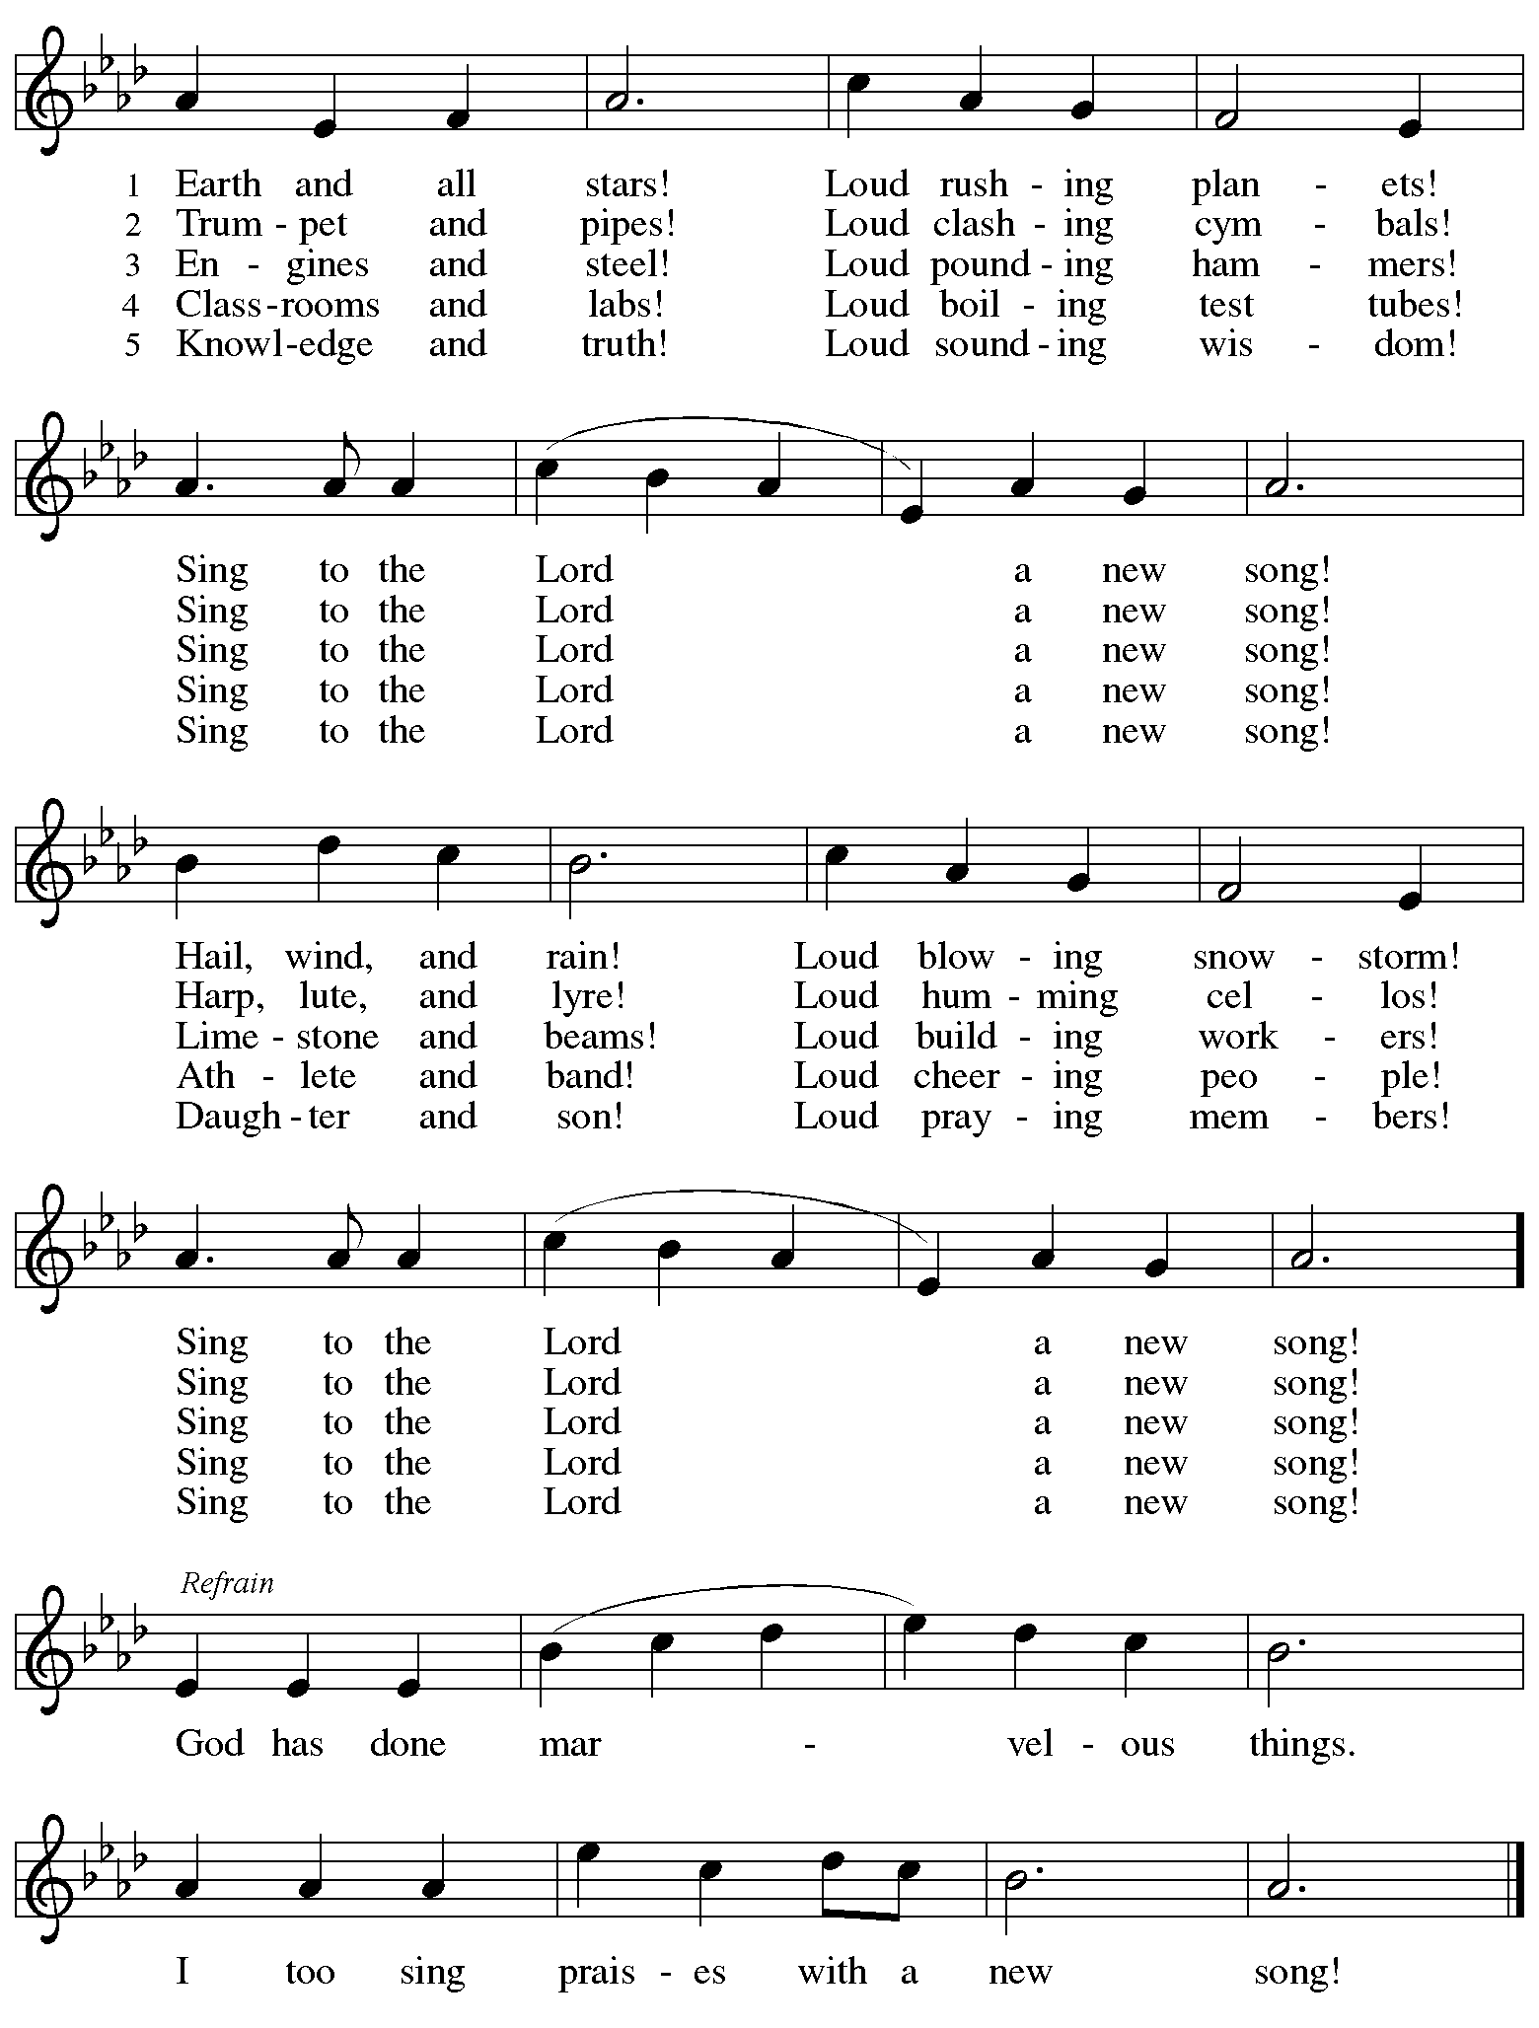

Those serving in worship today

Altar Care Jodie Minor
Assisting Minister Kathy Hays
Audio-Visual Ministers Kristen Asplin
Tyler Rietze
Cantor Richard Krug
Lector Pat Taylor
Organ Jimmi Kocher-Hillmer
Percussion Jimmi Kocher-Hillmer
Preservice Vocalist The Rev. Erin Jones
Recorder Timothy Kocher-Hillmer
Vocal Quartet on Prelude Gayle McLaughlin
Timothy Kocher-Hillmer
Marit Bakken and Jered Stratton
Minister of Music Laura Reynolds
Presiding Minister The Rev. Ross I. Carmichael

Liturgy and Hymnody Acknowledgements

From SundaysandSeasons.com. Copyright © 2026 Augsburg Fortress. All rights reserved. Reprinted under OneLicense.net # A-722139.
Used by permission of Augsburg Fortress.

The Scripture readings contained herein are from New Revised Standard Version Updated Edition of the Bible © 2021 National Council of Churches of Christ in the United States of America. Used by permission. All rights reserved worldwide.

Holy, Holy, Holy, Lord God Almighty! – Text: Reginald Heber, 1783-1826, alt. Music: NICAEA, John B. Dykes, 1823-1876.

God, Whose Giving Knows No Ending – Text: Robert L. Edwards, 1915-2006. Music: RUSTINGTON, C. Hubert H. Parry, 1848-1918. Text © 1961, ren. 1989 The Hymn Society, admin. Hope Publishing Company. All rights reserved. Reprinted with permission under OneLicense.net # A-722139.

How Firm a Foundation – Text: J. Rippon, A Selection of Hymns, 1787, alt. Music: FOUNDATION, early American.

Build Us Up, Lord – Text: Mark Glaeser, b. 1956, and Donna Hanna, b. 1952. Music: BUILD US UP, Mark Glaeser and Donna Hanna. Text and music © 2003 Augsburg Fortress. All rights reserved. Reprinted with permission under OneLicense.net # A-722139.

Elements of the Thanksgiving and Prayer of Dedication from Evangelical Lutheran Worship Occasional Services for the Assembly, © 2009 Evangelical Lutheran Church in America, published by Augsburg Fortress, Publishers.

Earth and All Stars! – Herbert F. Brokering, b. 1926. Music: EARTH AND ALL STARS, David N. Johnson, 1922-1987. Text and music © 1968 Augsburg Publishing House, admin. Augsburg Fortress.

Please use the QR code below to link to St. Andrew’s Announcements online!



St. Andrew Lutheran Church Announcements
May 31st, 2026

- Welcome to Worship at St. Andrew on Holy Trinity Sunday! – We are so glad you are here, and we offer a special welcome to all visitors and guests who are here for the first time! Little Church – Big Faith, a Bible lesson and activity for children up to sixth grade, will take place after the prayer of the day. There are worship “toolkits” to help children engage with worship and “busy bags” for younger children available in the bookcase at the back of the sanctuary. Please feel free to take one to use with/for your children. A nursery is available through the door to the left of the worship space and across the social hall (look for a purple room). All are invited to gather after worship for a special coffee hour in the social hall.
- St. Andrew’s Capital Campaign, Building Community Together, Begins Today! – The work on St. Andrew’s roof and towers is nearly complete, and as we prepare for the next phase of our ministry, today we introduce the capital campaign, Building Community Together! The name suggests improvements to the physical building, St. Andrew’s mission to be a place of welcome for the community, and the call to work together with one another and with our neighbors. We will begin by giving thanks to our Triune God for all our blessings, celebrating God’s goodness and faithfulness to St. Andrew and the world throughout the generations. Leaders will share updates briefly in worship, and at coffee hour we will introduce materials to read and share with others as we encourage support for the mission of St. Andrew and our capital campaign.
- Today Will be the Last Meeting of Little Church - Big Faith before a Summer Break – Check announcement in August for the ministry’s return in September!
- Produce Distribution Supplemental Food of the Month – St. Andrew collects supplemental food each month to accompany our produce distribution. For June, we ask for donations of rice.
- Produce Distribution, First and Third Tuesday Each Month, June 2nd and 16th from 5:30 to 6:30 p.m. – St. Andrew partners with Greater Pittsburgh Community Food Bank to serve as a distribution site for fresh produce on the first and third Tuesday of every month. We invite people of the congregation to help with the distribution from 5:30 p.m. to 6:30 p.m. and/or to help with unloading and setup during the day between 10:00 a.m. and 1:00 p.m.
- Pride Month Celebrations, Saturday, June 6th and 20th, 10:00 a.m. to 6:00 p.m. – Every June is celebrated as Pride month to commemorate years of struggle for civil rights and the ongoing pursuit of justice for the LGBTQ+ community in the face of police brutality and systemic disenfranchisement. St Andrew will be sponsoring a booth at both Pittsburgh Pride on June 6th, between 10:00 a.m. and 6:00 p.m. and Millvale Pride on June 20th starting at 12:00 p.m. You can sign up to volunteer here: https://www.signupgenius.com/go/5080B4AAFAF2CABF85-63577363-pittsburgh.
- Monthly Reparations Offering, Next Sunday, June 7th, during Worship – In Luke’s Gospel, Jesus tells a story about a compassionate Samaritan, suggesting that God’s people are called to work for healing and restoration for our neighbors, regardless of who or what caused them harm. In light of this, St. Andrew has made a commitment to reparations in regard to African American spiritual songs used in our worship. The text and music of most hymns is attributed to specific authors, with copyrights in place, usage reported, and royalties paid to those whose works are featured in worship. With African American spirituals, this is not possible. In response to many years of such uncredited use, St. Andrew invites the congregation to give a reparations offering. Funds received in worship will be donated to our siblings at Bethel AME Church, whose land and building were taken from them in the 1950s, to fund their development in the Hill District.
- “Freedom. Faith. Harvest.” - A Holy Day of Worship, Fellowship, and the Blessing of the Garden, Sunday, June 14th, 11:00 a.m – Bethel AME Church presents their Juneteenth celebration to include an 11:00 a.m. morning worship, which includes a celebration of liberation, song, and the preached Word from Bishop Melissa Stoller. After worship, there will be a Community Dinner in the Fellowship Hall. After dinner, there will be a blessing of the community garden, a consecrating of the seeds, equipment, and the hands that tend it from Dr. Kate Walker of the First Unitarian Church of Pittsburgh, and a “Libation Ceremony” led by the Ujamaa Collective. Bethel AME church is located at 2720 Webster Ave, Pittsburgh, PA 15219.
- Coffee Hour Signups – St. Andrew provides hospitality during a coffee hour after worship each Sunday. If you would like to participate, please sign up using the following form: https://www.signupgenius.com/go/5080B4AAFAF2CABF85-47069030-coffee#/.
- Christ in Our Home Devotional Booklets for April – June Available at Entrances – This resource offers a daily Bible reading with a short reflection and prayer, along with additional readings and prayer topics for those who would like to expand their devotional practices. We encourage people of the congregation to take one for yourself, your family/household, or others!

