

+ Day of Pentecost
May 24, 2026


St. Andrew Lutheran Church
304 Morewood Ave.
Pittsburgh, PA 15213
St_andrewELCA@verizon.net
www.standrewpittsburgh.org

+ Day of Pentecost

Pentecost derives its name from the Jewish festival celebrating the harvest and the giving of the Law on Mount Sinai fifty days after Passover. Fifty days after Easter, we celebrate the Holy Spirit as God’s presence within and among us. In Acts, the Spirit arrives in rushing wind and flame, bringing God’s presence to all people. Paul reminds us that though we each have different capacities, we are unified in the Spirit that equips us with these gifts. Jesus breathes the Holy Spirit on his disciples, empowering them to forgive sin. We celebrate that we too are given the breath of the Holy Spirit and sent out to proclaim God’s redeeming love to all the world.

Welcome to St. Andrew!
- St. Andrew welcomes all who are seeking a place of healing, wholeness, and acceptance in a nurturing and faith-forming spiritual home. We are striving toward racial equity worldwide
and we seek to honor the lived experience of all individuals regardless of background. Our community embraces people of all ages, ethnicities, cultures, abilities, sexual orientations,
gender identities and expressions, and family constellations. Come and See!
- Worship Services are live-streamed to multiple online platforms. By attending worship, you agree that your image and voice may be broadcast.
- Everyone is invited to make a name tag at the black bookcase in the back of the worship space if they would like. There are stickers indicating pronouns on the bookcase if you would like to include them on your name tag.
- Children are invited to attend Little Church – Big Faith, a Bible lesson and activity, during worship (after the Prayer of the Day). The group returns to the worship space for the liturgy of Holy Communion.
- A nursery is available through the doors at the left side of the sanctuary and across from the doorway to the Social Hall. Look for a purple-colored room.
- Worship “toolkits” to help children engage with the service, along with “busy bags” for younger children, are available in the bookcase at the back of the sanctuary. Please feel free to take one to use with/for your children.
- Holy Communion is served with bread (gluten-free available) and wine or grape juice. The presiding minister will distribute the bread (host). Please consume this and then pick up an empty glass from the tray. The Communion Assistant will pour wine or grape juice into your glass. Please step to the side to consume the wine or grape juice. Feel free to kneel at the altar for prayer and reflection. As you return to your pew, glasses may be returned to the empty trays on either side of the center section.
- A restroom is available on the main level of the church, through the doors to the Social Hall and to the right in the main office.

Abbreviations
P: Pastor/Presiding Minister ELW: Evangelical Lutheran Worship hymnal
A: Assisting Minister ACS: All Creation Sings hymnal
L: Lector HS: Hymnal Supplement
C: Congregation
Musical Offering

Each week, different people from the congregation make an offering of pre-service music, with singing or instrumentation, to help the assembly focus and pray in preparation for worship.

Welcome
Prelude

Gathering
The Holy Spirit calls us together as the people of God

Please rise as you are able. All may make the sign of the cross,
the sign that is marked at Baptism, as the presiding minister begins.

Thanksgiving for Baptism

P: Alleluia! Christ is risen!
C: Christ is risen indeed! Alleluia! Alleluia!

P: Salvation belongs to our God who is seated on the throne and to the Lamb!
C: Amen.

P: Let us give thanks for the gift of Baptism.

Water may be poured into the font as the presiding minister continues.
P: Merciful God,
you are the one who was, who is, and who is to come.
You lead us beside still waters.
We thank you for the waters of creation:
morning dew, gentle rain, roaring waves.
We thank you for the waters that nourish us.
Blessed are you!
C: You guide us to springs of the water of life.

P: Jesus Christ, you are the faithful witness
who accompanies us on our journeys.
We give you thanks for your life-giving death and resurrection.
We praise you for joining us in joy and sorrow.
Blessed are you!
C: You guide us to springs of the water of life.

P: Holy Spirit, you anoint our head with oil and our cup overflows.
Break down barriers that divide us.

P: Fill us with the breath of peace.
Blessed are you!
C: You guide us to springs of the water of life.

P: Holy One, we thank you for the gifts and grace of Baptism,
and for making us a new creation.
We join with saints and angels, giving you honor and praise,
now and forever.
C: Amen.

Gathering Hymn ELW 401
Njoo kwetu, Roho mwema – Gracious Spirit, Heed Our Pleading

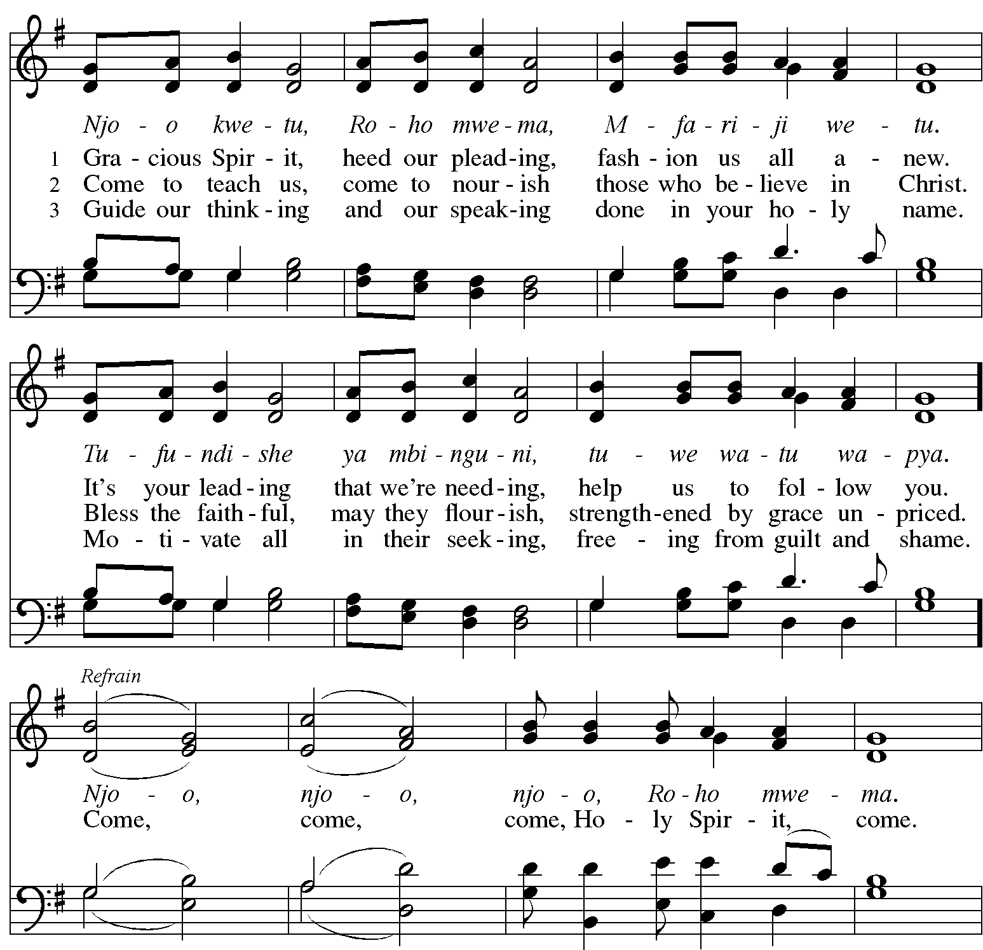

Continued
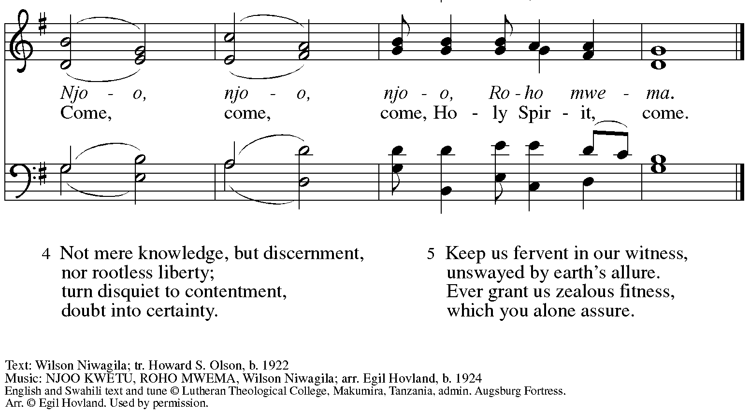
All rights reserved. Reprinted with permission under OneLicense.net # A-722139.



Greeting

P: The grace of our Lord Jesus Christ, the love of God,
and the communion of the Holy Spirit be with you all.
C: And also with you.

Hymn of Praise This Is the Feast ELW p. 149-150
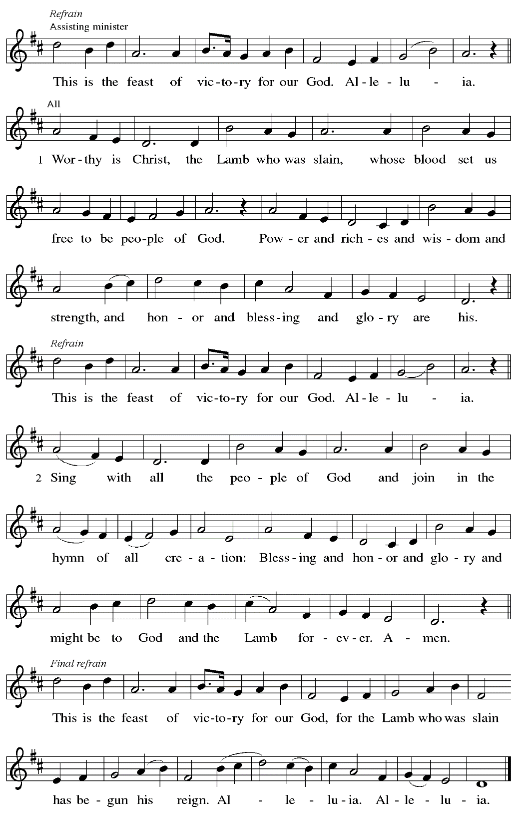
Prayer of the Day

P: The Lord be with you.
C: And also with you.

P: Let us pray.
O God,
on this day you open the hearts of your faithful people by sending into us your Holy Spirit. Direct us by the light of that Spirit, that we may have a right judgment in all things
and rejoice at all times in your peace, through Jesus Christ, your Son and our Lord,
who lives and reigns with you and the Holy Spirit, one God, now and forever.
C: Amen.

Please be seated.
Children are invited to join the adult leader(s) at the side door for Little Church – Big Faith.
We ask that an additional adult from the congregation attend with the children.

Word
God speaks to us in Scripture reading, preaching, and song

First Reading – Acts 2: 1-21

¹ When the day of Pentecost had come, [the apostles] were all together in one place. ² And suddenly from heaven there came a sound like the rush of a violent wind, and it filled the entire house where they were sitting. ³ Divided tongues, as of fire, appeared among them, and a tongue rested on each of them. ⁴ All of them were filled with the Holy Spirit and began to speak in other languages, as the Spirit gave them ability.
⁵ Now there were devout Jews from every people under heaven living in Jerusalem. ⁶ And at this sound the crowd gathered and was bewildered, because each one heard them speaking in the native language of each. ⁷ Amazed and astonished, they asked, “Are not all these who are speaking Galileans? ⁸ And how is it that we hear, each of us, in our own native language?
⁹ Parthians, Medes, Elamites, and residents of Mesopotamia, Judea and Cappadocia, Pontus and Asia, ¹⁰ Phrygia and Pamphylia, Egypt and the parts of Libya belonging to Cyrene, and visitors from Rome, both Jews and proselytes, ¹¹ Cretans and Arabs—in our own languages we hear them speaking about God’s deeds of power.” ¹² All were amazed and perplexed, saying to one another, “What does this mean?” ¹³ But others sneered and said, “They are filled with new wine.”
¹⁴ But Peter, standing with the eleven, raised his voice and addressed them, “Fellow Jews and all who live in Jerusalem, let this be known to you, and listen to what I say. ¹⁵ Indeed, these are not drunk, as you suppose, for it is only nine o’clock in the morning. ¹⁶ No, this is what was spoken through the prophet Joel:
¹⁷ ‘In the last days it will be, God declares,
that I will pour out my Spirit upon all flesh,
and your sons and your daughters shall prophesy,
and your young men shall see visions,
and your old men shall dream dreams.
¹⁸ Even upon my slaves, both men and women,
in those days I will pour out my Spirit,
and they shall prophesy.
¹⁹ And I will show portents in the heaven above
and signs on the earth below,
blood, and fire, and smoky mist.
²⁰ The sun shall be turned to darkness
and the moon to blood,
before the coming of the Lord’s great and glorious day.
²¹ Then everyone who calls on the name of the Lord shall be saved.’ ”

L: Word of God, word of life.
C: Thanks be to God.

Psalm 104: 24-34, 35b

The psalm will be sung responsively, led by the cantor,
with the congregation responding with the bold verses and refrain.

Psalm Tone

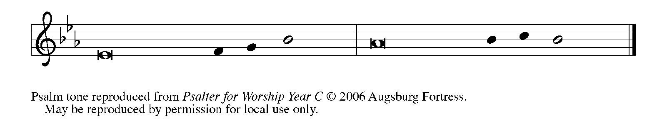

Psalm Refrain

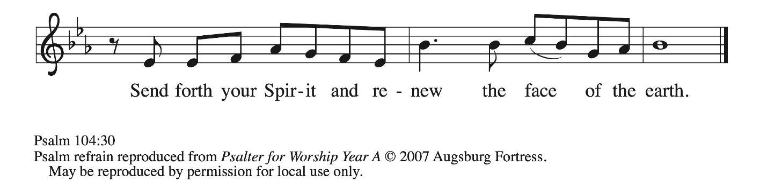

²⁴ How manifold are your | works, O Lord!
In wisdom you have made them all; the earth is full | of your creatures.
²⁵ Yonder is the sea, great and wide, with its swarms too man- | y to number,
living things both | small and great.
²⁶ There go the ships | to and fro,
and Leviathan, which you made for the | sport of it.
²⁷ All of them | look to you
to give them their food | in due season. R
²⁸ You give it to them; they | gather it;
you open your hand, and they are filled | with good things.
²⁹ When you hide your face, | they are terrified;
when you take away their breath, they die and return | to their dust.
³⁰ You send forth your Spirit, and they | are created;
and so you renew the face | of the earth.
³¹ May the glory of the Lord en- | dure forever;
O Lord, rejoice in | all your works. R
³² You look at the earth | and it trembles;
you touch the mountains | and they smoke.
³³ I will sing to the Lord as long | as I live;
I will praise my God while I | have my being.
³⁴ May these words of | mine please God.
I will rejoice | in the Lord.
^{35b} Bless the Lord, | O my soul.
Hal- | lelujah! R

Second Reading – 1 Corinthians 12: 3b-13

^{3b} No one can say “Jesus is Lord” except by the Holy Spirit.
⁴ Now there are varieties of gifts but the same Spirit, ⁵ and there are varieties of services but the same Lord, ⁶ and there are varieties of activities, but it is the same God who activates all of them in everyone. ⁷ To each is given the manifestation of the Spirit for the common good. ⁸ To one is given through the Spirit the utterance of wisdom and to another the utterance of knowledge according to the same Spirit, ⁹ to another faith by the same Spirit, to another gifts of healing by the one Spirit, ¹⁰ to another the working of powerful deeds, to another prophecy, to another the discernment of spirits, to another various kinds of tongues, to another the interpretation of tongues. ¹¹ All these are activated by one and the same Spirit, who allots to each one individually just as the Spirit chooses.
¹² For just as the body is one and has many members, and all the members of the body, though many, are one body, so it is with Christ. ¹³ For in the one Spirit we were all baptized into one body—Jews or Greeks, slaves or free—and we were all made to drink of one Spirit.

L: Word of God, word of life.
C: Thanks be to God.

Please rise as you are able.

Gospel Acclamation ELW p. 151

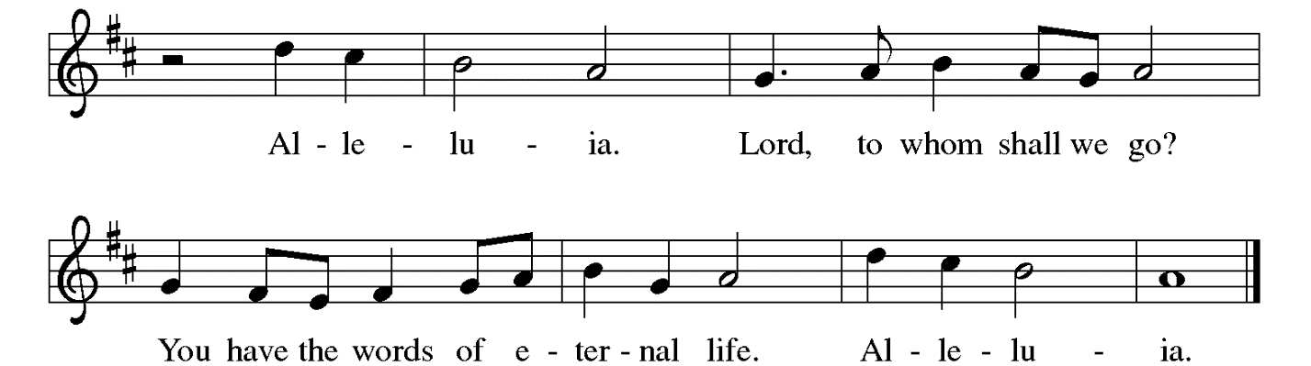

Gospel – John 20: 19-23

P: The holy Gospel according to St. John.
C: Glory to you, O Lord.

¹⁹ When it was evening on that day, the first day of the week, and the doors were locked where the disciples were, for fear of the Jews, Jesus came and stood among them and said, “Peace be with you.” ²⁰ After he said this, he showed them his hands and his side. Then the disciples rejoiced when they saw the Lord. ²¹ Jesus said to them again, “Peace be with you. As the Father has sent me, so I send you.” ²² When he had said this, he breathed on them and said to them, “Receive the Holy Spirit. ²³ If you forgive the sins of any, they are forgiven them; if you retain the sins of any, they are retained.”

P: The Gospel of the Lord.
C: Praise to you, O Christ.

Please be seated.

Sermon

A time of silence for prayer and reflection follows the sermon.
When the hymn of the day begins, please rise as you are able.

Hymn of the Day O Spirit All-Embracing ACS 944

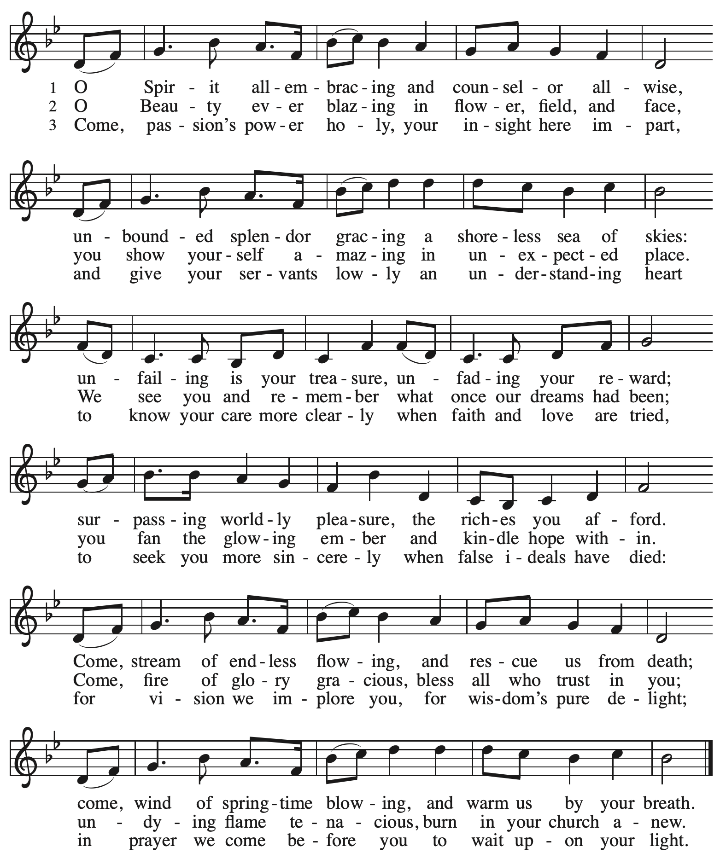

Reprinted with permission under OneLicense.net # A-722139.

Affirmation of Baptism by the Assembly

P: Dear friends, we give thanks for the gift of Baptism as we come before God
to make public affirmation of Baptism into Christ.

The presiding minister may note briefly the occasion

P: Let us pray.
Merciful God, we thank you that you have made us your own by water and the Word in Baptism. You have called us to yourself, enlightened us with the gifts of your Spirit, and nourished us in the community of faith. Uphold us and all your servants in the gifts and promises of Baptism, and unite the hearts of all whom you have brought to new birth. We ask this in the name of Christ.
C: Amen.

Profession of Faith

The presiding minister addresses those making affirmation of Baptism.
The assembly may stand and join in the responses.
P: I ask you to profess your faith in Christ Jesus, reject sin, and confess the faith of the church.

Do you renounce the devil and all the forces that defy God?
Response: I renounce them.

P: Do you renounce the powers of this world that rebel against God?
Response: I renounce them.

P: Do you renounce the ways of sin that draw you from God?
Response: I renounce them.

The presiding minister addresses the assembly.
P: Do you believe in God the Father?
C: I believe in God, the Father almighty,
creator of heaven and earth.

P: Do you believe in Jesus Christ, the Son of God?
C: I believe in Jesus Christ, God’s only Son, our Lord,
who was conceived by the Holy Spirit,
born of the virgin Mary,
suffered under Pontius Pilate,
was crucified, died, and was buried;
he descended to the dead.*
On the third day he rose again;
he ascended into heaven,
he is seated at the right hand of the Father,
and he will come to judge the living and the dead.

P: Do you believe in God the Holy Spirit?
C: I believe in the Holy Spirit,
the holy catholic church,
the communion of saints,
the forgiveness of sins,
the resurrection of the body,
and the life everlasting.

*Or, “he descended into hell,” another translation of this text in widespread use.

P: You have made public profession of your faith. Do you intend to continue in the covenant God made with you in holy baptism:
to live among God’s faithful people,
to hear the word of God and share in the Lord’s supper,
to proclaim the good news of God in Christ through word and deed,
to serve all people, following the example of Jesus,
and to strive for justice and peace in all the earth?

The assembly makes affirmation:
C: I do, and I ask God to help and guide me.

The minister addresses the assembly.
P: People of God, do you promise to support and pray for one another in your life in Christ?
C: We do, and we ask God to help and guide us.

The presiding minister prays for God’s blessing.
P: Let us pray.
We give you thanks, O God, that through water and the Holy Spirit you give us new birth, cleanse us from sin, and raise us to eternal life. Stir up in your people the gift of your Holy Spirit: the spirit of wisdom and understanding, the spirit of counsel and might, the spirit of knowledge and the fear of the Lord, the spirit of joy in your presence both now and forever.
C: Amen.

The assembly sings the congregational refrain, featured on special occasions
in the life of the congregation.

Congregational Refrain HS 808

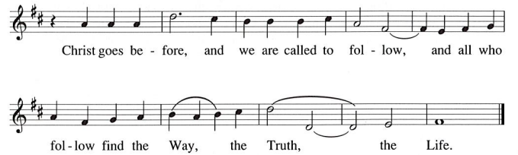

Worship continues with the prayers of the people.

Prayers of the People

A: United in the joy and hope of the resurrection, let us pray for the church, the world,
and all who are in need.

After each petition
A: Gracious God,
C: receive our prayer.

The presiding minister concludes the prayers
P: We lift these prayers to you O God, trusting in your abundant mercy,
through Jesus Christ our risen Savior.
C: Amen.

Peace

The presiding minister and the assembly greet one another in the peace of the risen Christ.
P: The peace of Christ be with you always.
C: And also with you.

The people may greet those around them with a sign of Christ’s peace and may say
Peace be with you or similar words. Please be mindful that not everyone will be comfortable with sharing the peace, so please seek consent before shaking hands or hugging. Other possible ways to share the peace include a simple bow with the verbal greeting of peace, or simply a verbal expression of peace.

When the greetings of peace have concluded, please be seated.

Meal
God feeds us with the presence of Jesus Christ
Offering

We offer ourselves, our gifts, and our faithful service to God.
As the offering is gathered for the mission of the church, including the care of those in need,
the table is set for Holy Communion.

There are laminated giving cards in the pew racks that feature a QR code for anyone who would like to give online. Those who give using the QR code, as well as those who give regularly online or through their bank are encouraged to place the laminated card in the plate as an expression of your offering.

Music during the Offering

As the gifts are brought forward for presentation, please rise as you are able.

Offertory Song Let the Vineyards Be Fruitful ELW 184

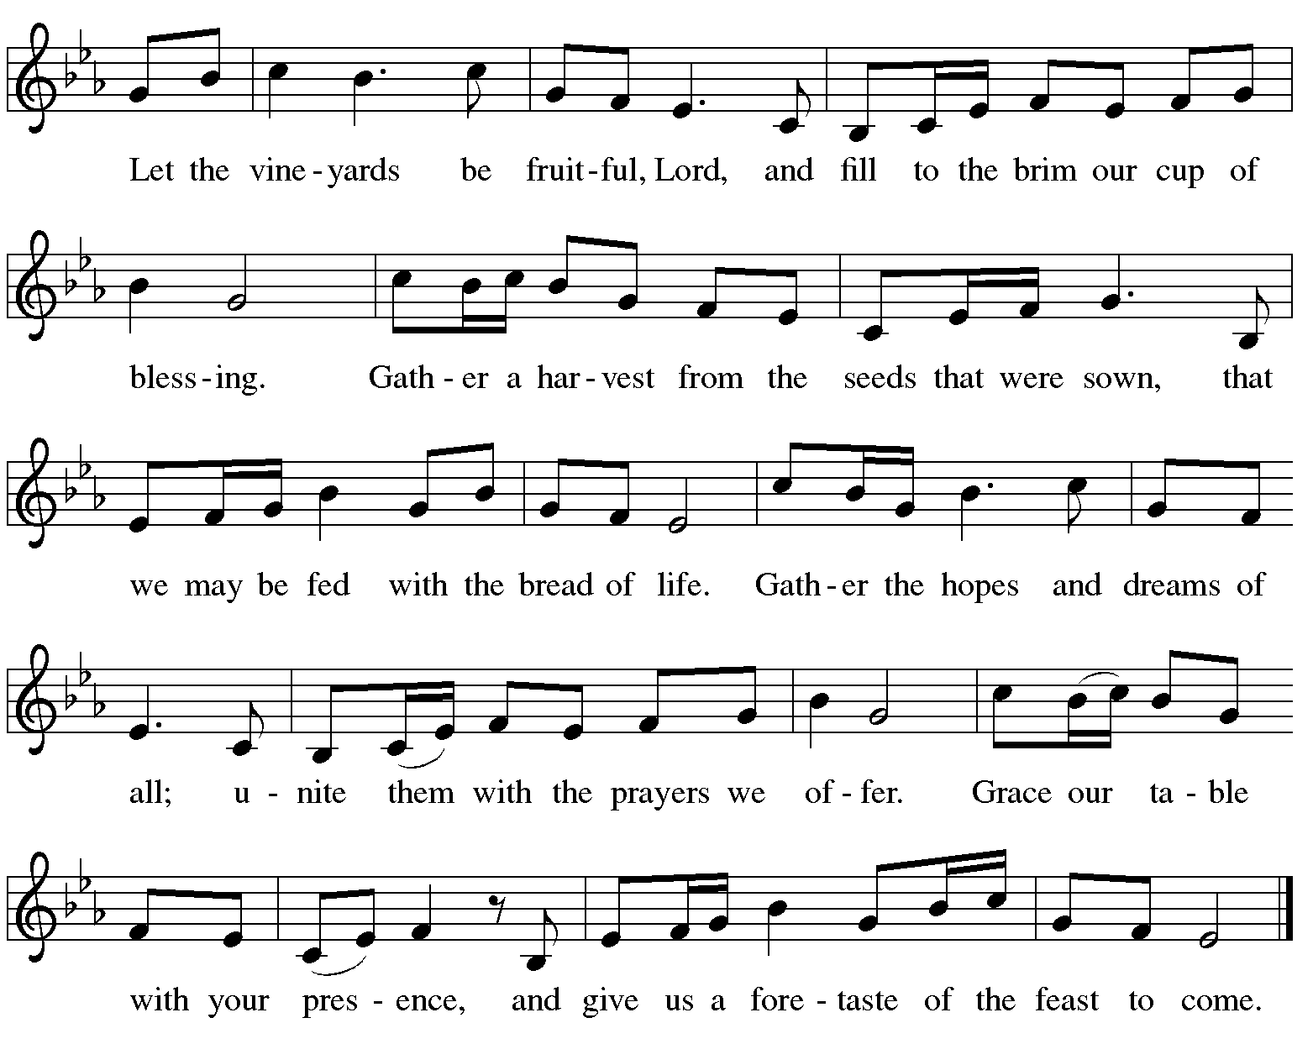

Offertory Prayer

A: Let us pray.
Blessed are you, O God,
C: ruler of heaven and earth.
Day by day you shower us with blessings.
As you have raised us to new life in Christ,
give us glad and generous hearts,
ready to praise you and to respond to those in need,
through Jesus Christ, our Savior and Lord.
Amen.

Dialogue ELW p. 152

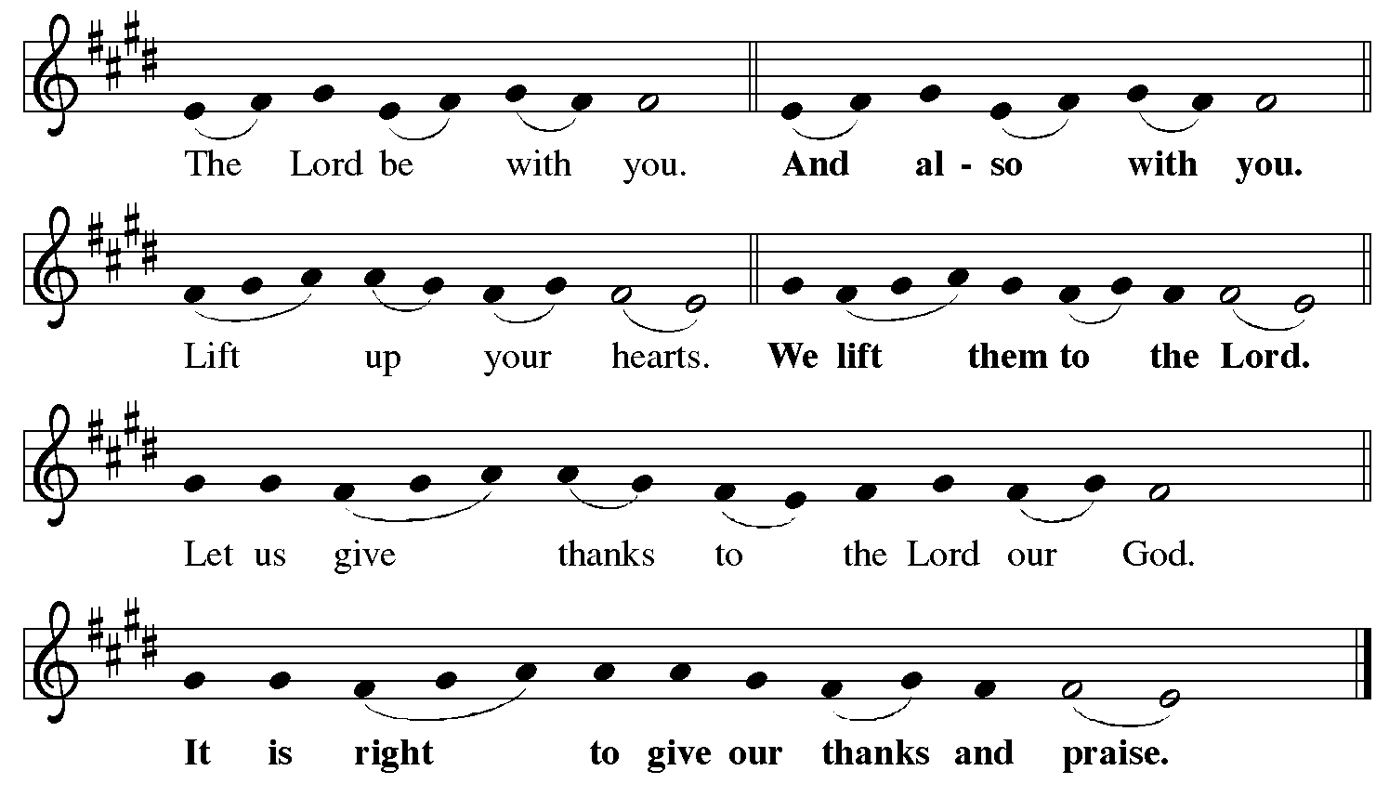

Preface (Sung by the presiding minister)

P: It is indeed right, our duty and our joy,
that we should at all times and in all places
give thanks and praise to you, almighty and merciful God,
through our Savior Jesus Christ.
Fulfilling the promise of the resurrection,
you pour out the fire of your Spirit,
P: uniting in one body people of every nation and tongue.
And so, with Mary Magdalene and Peter and all the witnesses of the resurrection,
with earth and sea and all their creatures,
and with angels and archangels, cherubim and seraphim,
we praise your name and join their unending hymn:

Sanctus ELW p. 153

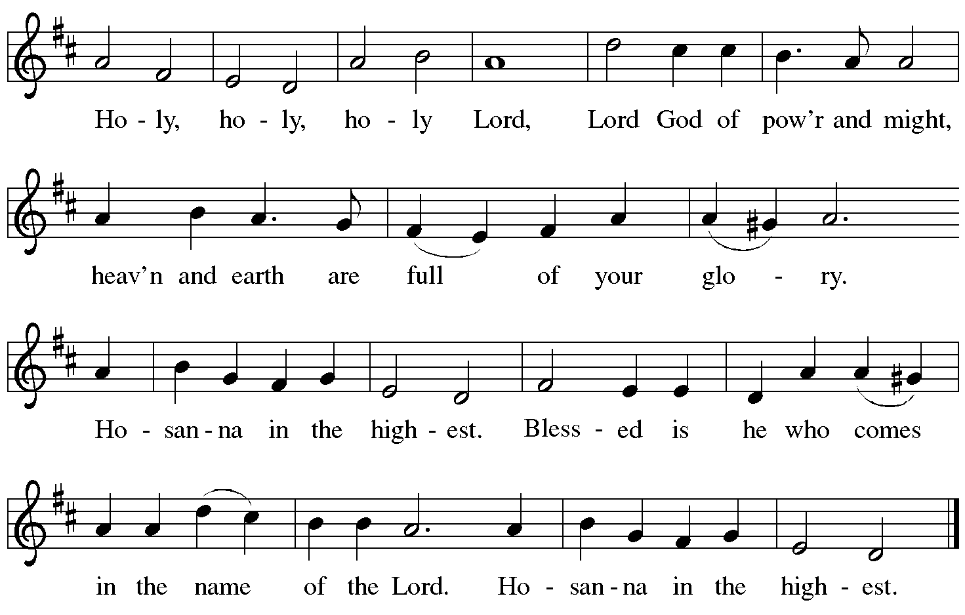

Eucharistic Prayer

P: Blessed are you, O God of the universe …
… Do this for the remembrance of me.

With this bread and cup we remember our Lord’s passover from death to life
as we proclaim the mystery of faith.
C: Christ has died. Christ is risen. Christ will come again.

P: O God of resurrection and new life …
… Grace our table with your presence.
C: Come, Holy Spirit.

P: Reveal yourself to us in the breaking of the bread …
… send us forth, burning with justice, peace, and love.
C: Come, Holy Spirit.

P: With your holy ones of all times and places …
… blessed and Holy Trinity, now and forever.
C: Amen.

Lord’s Prayer

P: Gathered as one by the Holy Spirit, let us pray as Jesus taught us.
C: Our Father, who art in heaven,
hallowed be thy name,
thy kingdom come,
thy will be done,
on earth as it is in heaven.
Give us this day our daily bread;
and forgive us our trespasses,
as we forgive those
who trespass against us;
and lead us not into temptation,
but deliver us from evil.
For thine is the kingdom,
and the power, and the glory,
forever and ever. Amen.

Fraction and Invitation



Agnus Dei / Lamb of God ELW p. 154

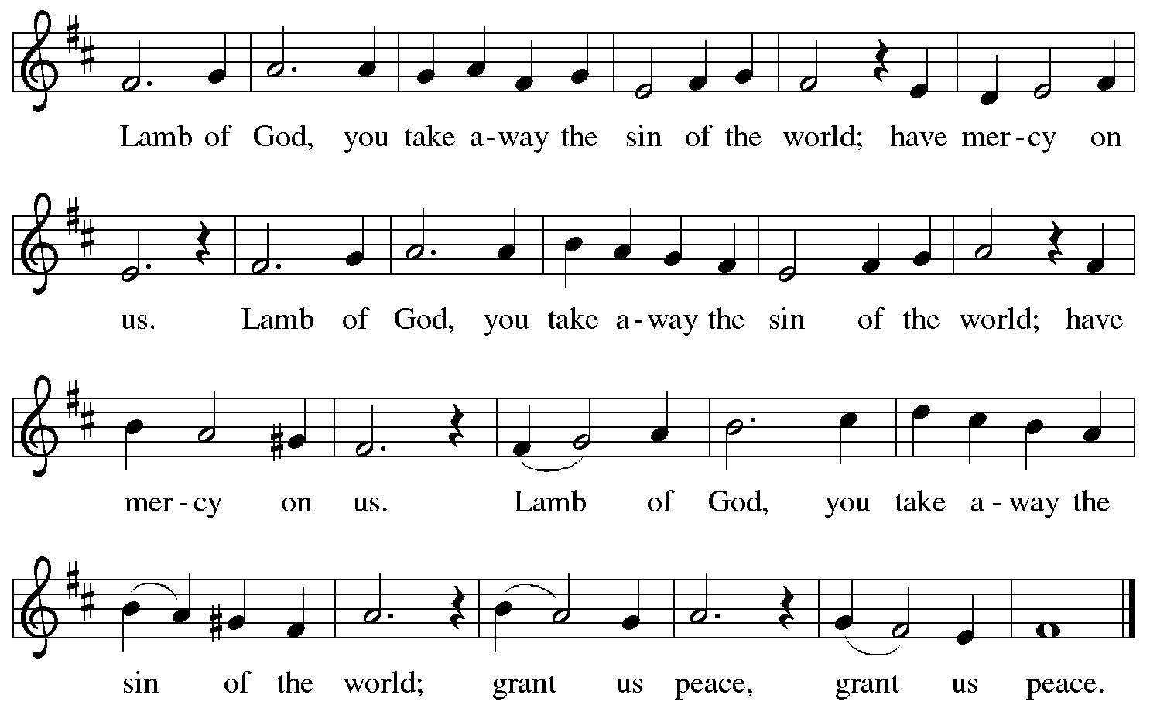

Please be seated.

Holy Communion

- All who seek God and desire a deeper and stronger life in Christ are welcome to receive Holy Communion.
- Worshipers from the pulpit side will proceed forward first, followed by the center section, and then the lectern side.
- Please inform an usher if you would like the ministers to bring Communion to you.
- Holy Communion will be served with bread and wine (red) or grape juice (white).
- The presiding minister will first distribute the bread (host) to each communicant. Please indicate if you require a gluten-free host.
- Once you have consumed the bread, please pick up an empty glass from the tray next to the presiding minister. The Communion Assistant will pour wine or grape juice into your glass.
- Please step to the side to consume the wine or grape juice.
- Feel free to kneel at the altar rail for prayer after receiving the sacrament.
- As you return to your pew, glasses may be returned to the empty tray on the side of the center section.
- A blessing will be provided for anyone who does not yet receive the sacrament.
- All are invited to join in singing the hymns during Holy Communion.
Hymns during Holy Communion
Draw Us in the Spirit’s Tether ELW 470

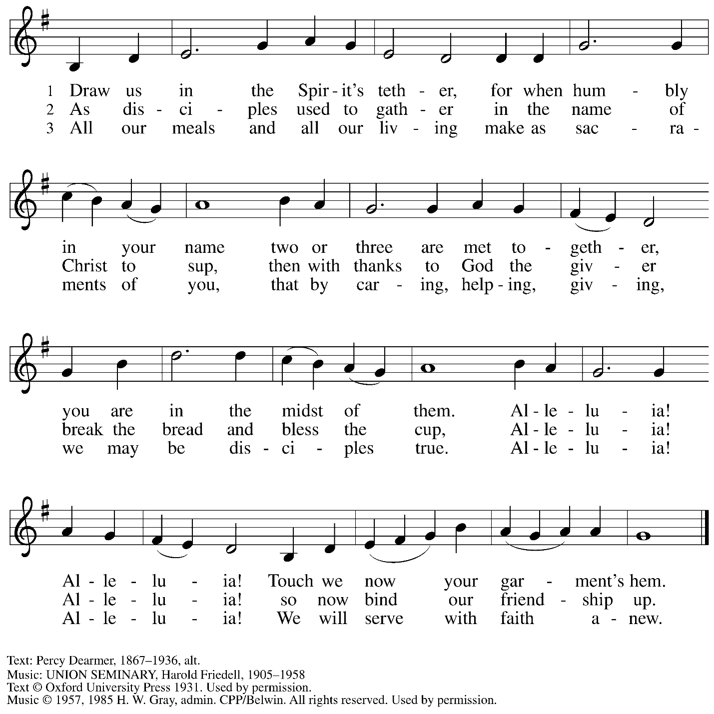
Reprinted under OneLicense.net # A-722139.

Hymns during Holy Communion
As the Wind Song ACS 943

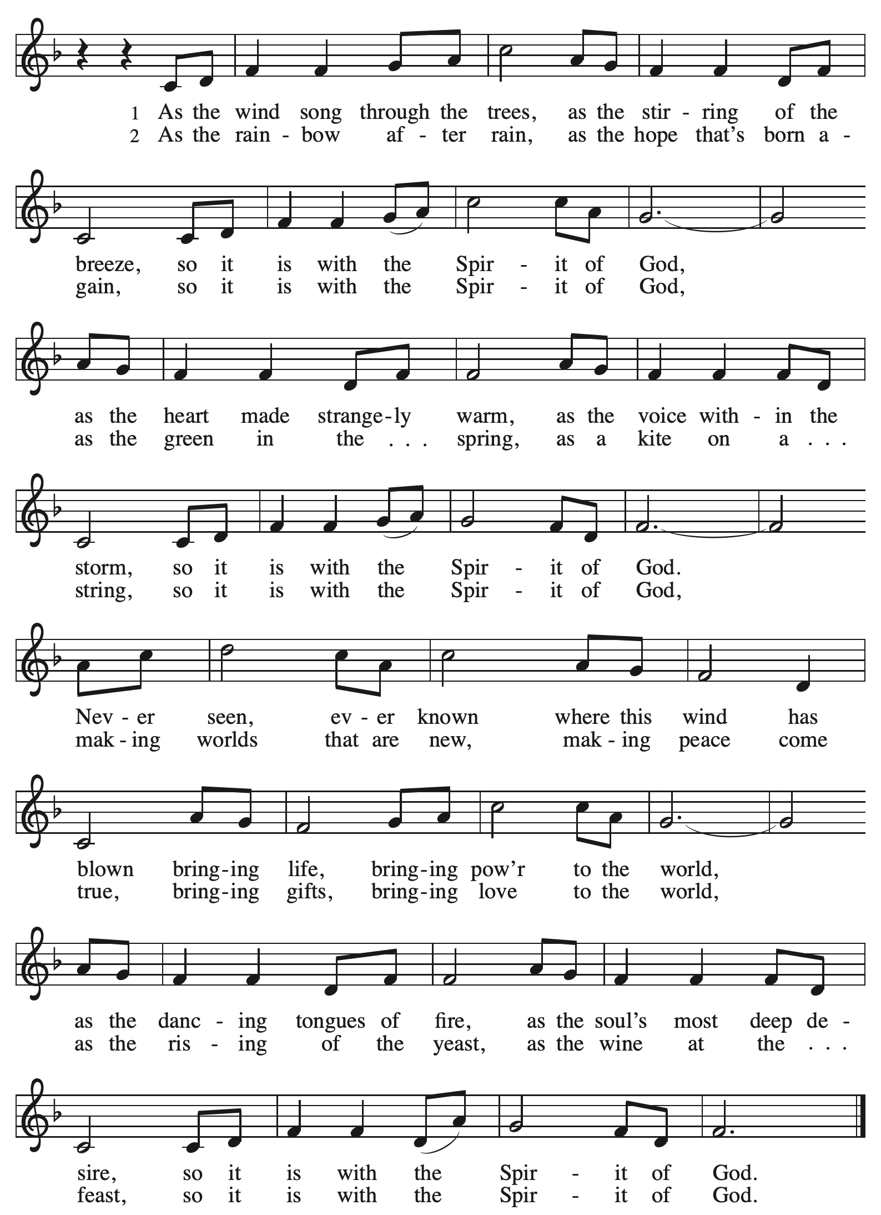
Hymns during Holy Communion
Like the Murmur of the Dove’s Song ELW 403

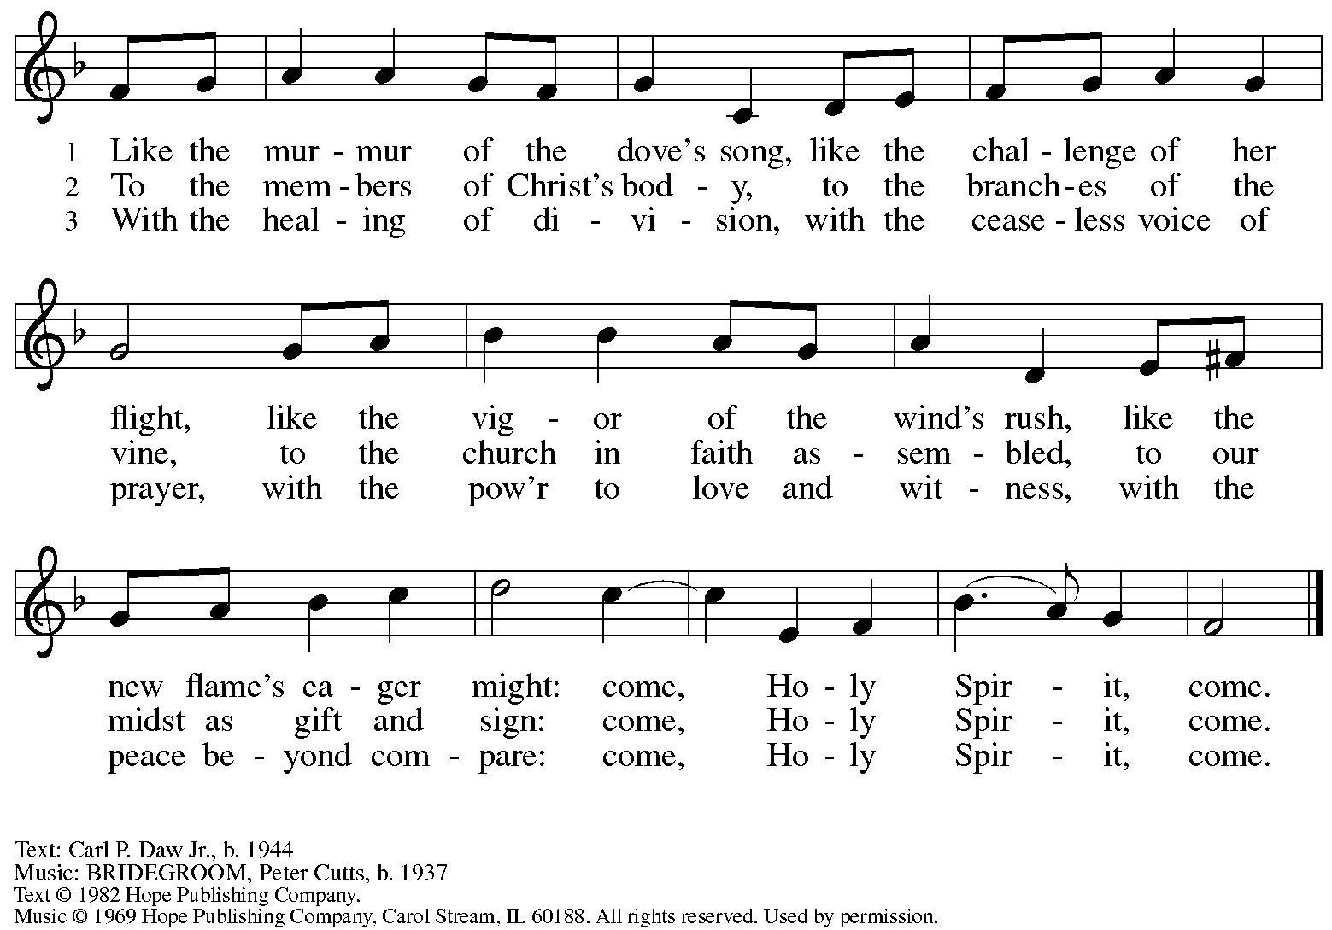
All rights reserved. Reprinted under OneLicense.net # A-722139.

Hymns during Holy Communion
Veni Sancte Spiritus ELW 406

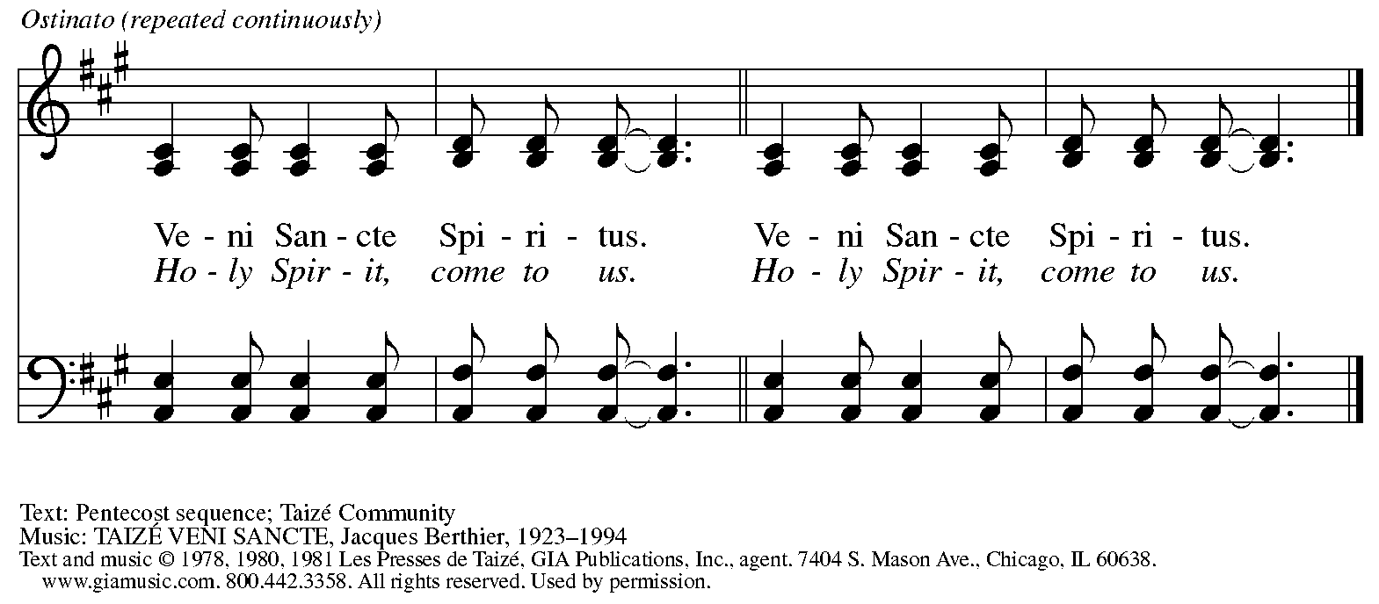
Reprinted with permission under OneLicense.net # A-722139.
When all have returned to their places, please rise as you are able.

Blessing

P: The body and blood of our Lord Jesus Christ strengthen you and keep you in his grace.
C: Amen.

Prayer

A: Let us pray. Life-giving God,
in the mystery of Christ’s resurrection, you send light to conquer darkness,
water to give new life, and the bread of life to nourish your people.
Send us forth as witnesses to your Son’s resurrection,
that we may show your glory to all the world,
through Jesus Christ, our risen Lord.
C: Amen.

Please be seated.

Sending
God blesses us and sends us in mission to the world

Announcements

Please rise as you are able.

Benediction

P: May our glorious God grant you a spirit of wisdom to know and love the risen Christ.

Almighty God, holy One, ☩ holy Three, bless you now and forever.
C: Amen.

Sending Hymn Following Page

Dismissal

A: Go in peace. Share the good news!
C: Thanks be to God!

Postlude

Sending Hymn God of Tempest, God of Whirlwind ELW 400

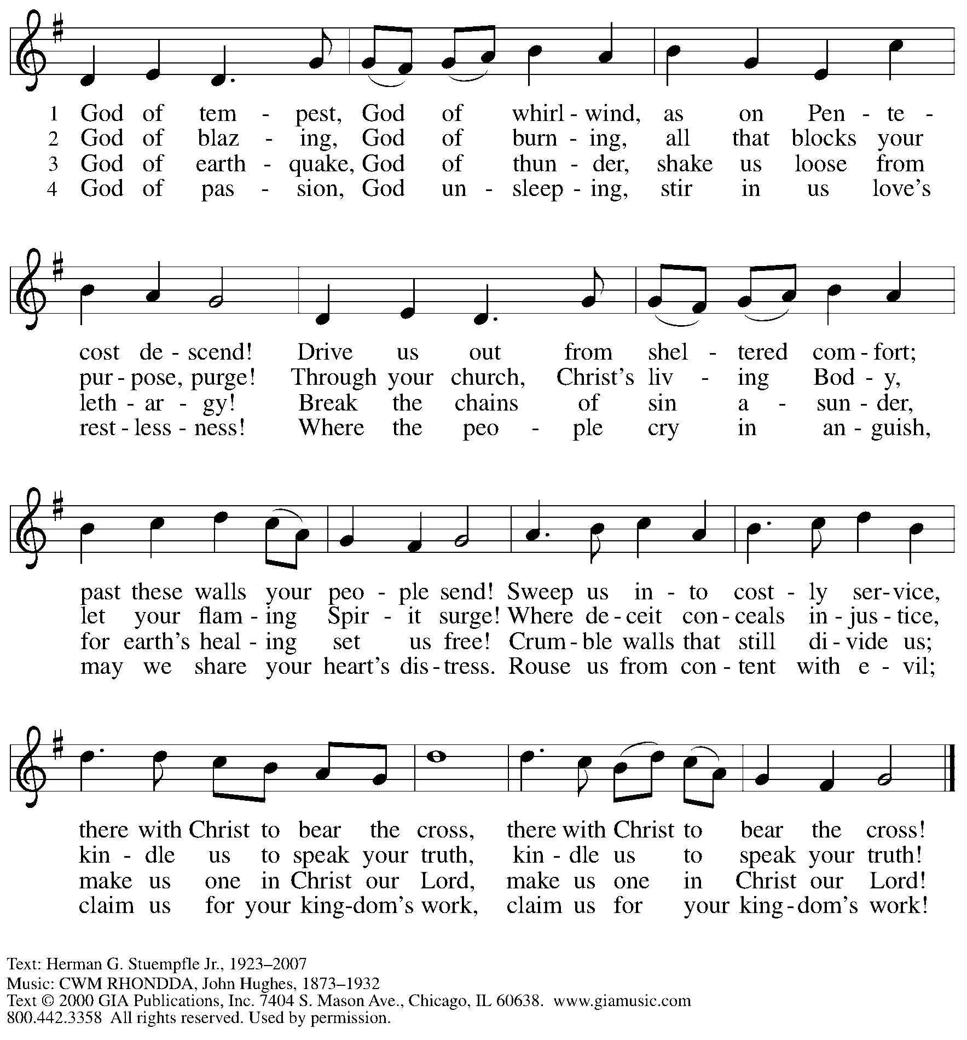
Reprinted under OneLicense.net # A-722139.

Those serving in worship today

Altar Care
Assisting Minister Timothy Kocher-Hillmer
Audio-Visual Ministers Jered Stratton
Jason Galyardt
Cantor Joy Givens
Lector Brennan Coleman
Minister of Music Laura Reynolds
Presiding Minister The Rev. Ross I. Carmichael

Liturgy and Hymnody Acknowledgements

From SundaysandSeasons.com. Copyright © 2026 Augsburg Fortress. All rights reserved. Reprinted under OneLicense.net # A-722139.
Used by permission of Augsburg Fortress.

The Scripture readings contained herein are from New Revised Standard Version Updated Edition of the Bible © 2021 National Council of Churches of Christ in the United States of America. Used by permission. All rights reserved worldwide.

Let the Vineyards – Text: John W. Arthur, 1922-1980. Music: Ronald A. Nelson, b. 1927. Text and Music © 1978 Lutheran Book of Worship, admin. Augsburg Fortress.

As the Wind Song – Text: Shirley Erena Murray, 1931-2020. Music: WAIRUA TAPU, Lim Swee Hong, b. 1963. Text and music © 2005 Hope Publishing Company, Carol Stream, IL 60188. All rights reserved. Reprinted with permission under OneLicense.net # A-722139.

Please use the QR code below to link to St. Andrew’s Announcements online!



St. Andrew Lutheran Church Announcements
May 24th, 2026

- Happy Easter! Welcome to Worship at St. Andrew as We Celebrate the Day of Pentecost! – We are so glad you are here to share in this festive season, and we offer a special welcome to all visitors and guests who are here for the first time! Little Church – Big Faith, a Bible lesson and activity for children up to sixth grade, will take place after the prayer of the day. There are worship “toolkits” to help children engage with worship and “busy bags” for younger children available in the bookcase at the back of the sanctuary. Please feel free to take one to use with/for your children. A nursery is available through the door to the left of the worship space and across the social hall (look for a purple room). All are invited to gather for coffee, other drinks, food, and conversation in the social hall after worship.
- Bible Book Club Is Paused for the Time Being
- St. Andrew's Capital Campaign Launch - Sunday, May 31st! – The congregation and campaign steering committee are excited to announce that the work on the roof of the church building is near completion, and it is time to begin the public phase of the capital campaign! We will launch the campaign during worship on + Holy Trinity Sunday, May 31st, beginning by offering thanks and praise for God's abiding love, ongoing faithfulness, and abundant provision in the life of the church and the St. Andrew congregation! We will have an extended coffee hour that day to share more specific updates on the building projects and more information about how you can support the campaign. Thank you to all who are serving on the campaign steering committee and to the whole congregation for your support in this big initiative!
- Produce Distribution Supplemental Food of the Month – St. Andrew is collecting supplemental food each month to accompany our produce distribution. For May, we ask for donations of shelf-stable sandwich toppings (e.g. peanut butter, jam, giardiniera, hummus, tapenade, etc). There are collection boxes at the back of the worship space and social hall.
- Produce Distribution, First and Third Tuesday Each Month, June 2nd and 16th from 5:30 to 6:30 p.m. – St. Andrew partners with Greater Pittsburgh Community Food Bank to serve as a distribution site for fresh produce on the first and third Tuesday of every month. We invite people of the congregation to help with the distribution from 5:30 p.m. to 6:30 p.m. and/or to help with unloading and setup during the day between 10:00 a.m. and 1:00 p.m.
- Pride Month Celebrations, Saturday, June 6th and 20th, 10:00 a.m. to 6:00 p.m. – Every June is celebrated as Pride month to commemorate years of struggle for civil rights and the ongoing pursuit of justice for the LGBTQ+ community in the face of police brutality and systemic disenfranchisement. St Andrew will be sponsoring a booth at both Pittsburgh Pride on June 6th, between 10:00 a.m. and 6:00 p.m. and Millvale Pride on June 20th starting at 12:00 p.m. You can sign up to volunteer here: https://www.signupgenius.com/go/5080B4AAFAF2CABF85-63577363-pittsburgh.
- Monthly Reparations Offering, Sunday, June 7th, during Worship – In Luke’s Gospel, Jesus tells a story about a compassionate Samaritan, suggesting that God’s people are called to work for healing and restoration for our neighbors, regardless of who or what caused them harm. In light of this, St. Andrew has made a commitment to reparations in regard to African American spiritual songs used in our worship. The text and music of most hymns is attributed to specific authors, with copyrights in place, usage reported, and royalties paid to those whose works are featured in worship. With African American spirituals, this is not possible. In response to many years of such uncredited use, St. Andrew invites the congregation to give a reparations offering. Funds received in worship will be donated to our siblings at Bethel AME Church, whose land and building were taken from them in the 1950s, to fund their development in the Hill District.
- Coffee Hour Signups – St. Andrew provides hospitality during a coffee hour after worship each Sunday. If you would like to participate, please sign up using the following form: https://www.signupgenius.com/go/5080B4AAFAF2CABF85-47069030-coffee#/.
- Christ in Our Home Devotional Booklets for April – June Available at Entrances – This resource offers a daily Bible reading with a short reflection and prayer, along with additional readings and prayer topics for those who would like to expand their devotional practices. We encourage people of the congregation to take one for yourself, your family/household, or others!

