

+ Second Sunday after Pentecost
June 7, 2026


St. Andrew Lutheran Church
304 Morewood Ave.
Pittsburgh, PA 15213
St_andrewELCA@verizon.net
www.standrewpittsburgh.org

+ Second Sunday after Pentecost

Jesus was a devout Jew who practiced his faith, he was criticized for eating with tax collectors and sinners—the religiously nonobservant. Jesus criticizes the self-righteous and reminds us that mercy is to be at the heart of our religious practices. God continues to be made known in those on the margins of society, like Matthew the tax collector and the hemorrhaging woman.
As we gather each Lord’s day we receive the healing that makes us well and sends us forth
to be signs of God’s mercy for the world.

Welcome to St. Andrew!
- St. Andrew welcomes all who are seeking a place of healing, wholeness, and acceptance in a nurturing and faith-forming spiritual home. We are striving toward racial equity worldwide
and we seek to honor the lived experience of all individuals regardless of background. Our community embraces people of all ages, ethnicities, cultures, abilities, sexual orientations,
gender identities and expressions, and family constellations. Come and See!
- Worship Services are live-streamed to multiple online platforms. By attending worship, you agree that your image and voice may be broadcast.
- Everyone is invited to make a name tag at the black bookcase in the back of the worship space if they would like. There are stickers indicating pronouns on the bookcase if you would like to include them on your name tag.
- Little Church – Big Faith is on break for the Summer.
- A nursery is available through the doors at the left side of the sanctuary and across from the doorway to the Social Hall. Look for a purple-colored room.
- Worship “toolkits” to help children engage with the service, along with “busy bags” for younger children, are available in the bookcase at the back of the sanctuary. Please feel free to take one to use with/for your children.
- Holy Communion is served with bread (gluten-free available) and wine or grape juice. The presiding minister will distribute the bread (host). Please consume this and then pick up an empty glass from the tray. The Communion Assistant will pour wine or grape juice into your glass. Please step to the side to consume the wine or grape juice. Feel free to kneel at the altar for prayer and reflection. As you return to your pew, glasses may be returned to the empty trays on either side of the center section.
- A restroom is available on the main level of the church, through the doors to the Social Hall and to the right in the main office.

Abbreviations
P: Pastor/Presiding Minister ELW: Evangelical Lutheran Worship hymnal
A: Assisting Minister ACS: All Creation Sings hymnal
L: Lector
C: Congregation

Musical Offering

Each week, different people from the congregation make an offering of pre-service music, with singing or instrumentation, to help the assembly focus and pray in preparation for worship.

Welcome
Prelude Allegretto in E Minor Johann Wilhelm Hässler
Andrew

Gathering
The Holy Spirit calls us together as the people of God

Please rise as you are able. All may make the sign of the cross,
the sign that is marked at Baptism, as the presiding minister begins.

Confession and Forgiveness ACS p. 29

P: Blessed be the holy Trinity, ☩ one God,
who looks upon us in compassion,
forgives our sin, and heals our lives.
C: Amen.

P: Let us confess our sin in the presence of God and of one another.

P: Have mercy, O God,
C: for we have sinned against you
and our neighbor.
In your compassion,
cleanse us from our sin
and take away our guilt.
Create in us a new heart
and give us a steadfast spirit.
Do not cast us away,
but fill us with your Holy Spirit
and restore your joy within us.
Amen.

P: As tender as parent to child,
so deep is God’s compassion for you.
As high as heaven is above earth,
so vast is God’s love for you.
As far as east is from west,
so far God removes your sin from you,
renewing your life through Jesus Christ.
Blessed be God who crowns us with mercy and love.
C: Blessed be God forever. Amen.

Gathering Hymn All Are Welcome ELW 641
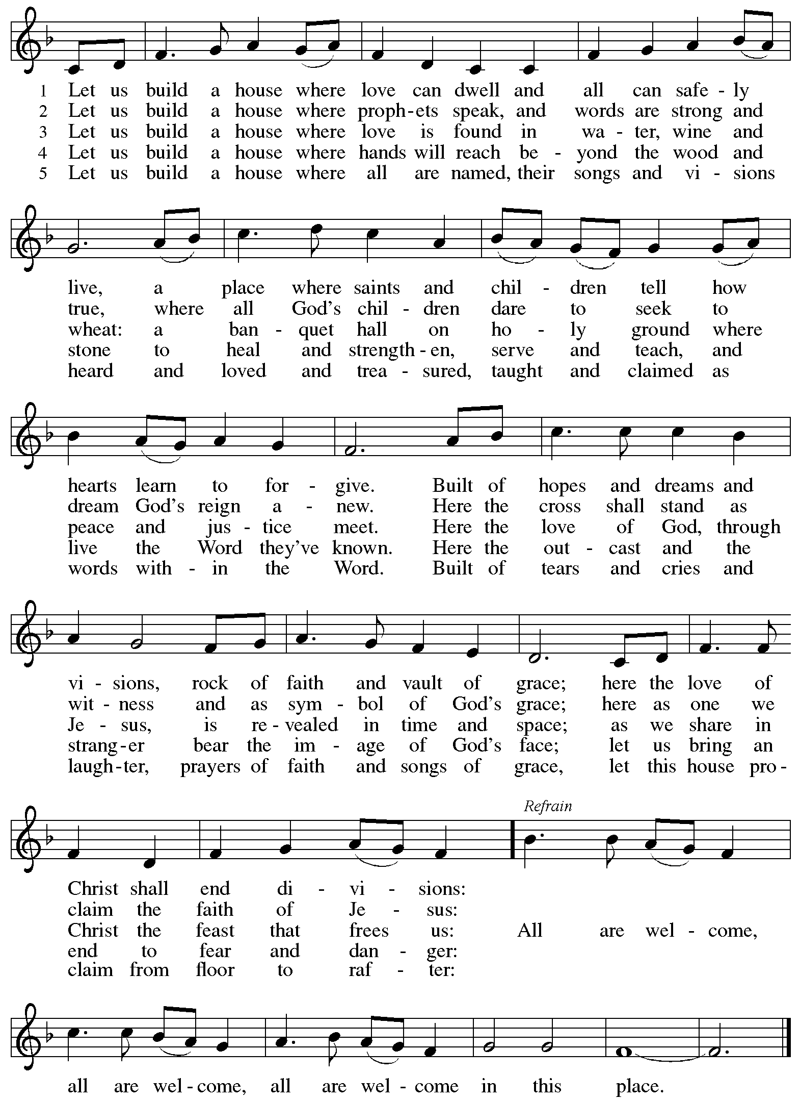

Greeting

P: The grace of our Lord Jesus Christ, the love of God,
and the communion of the Holy Spirit be with you all.
C: And also with you.

Hymn of Praise ACS p. 31

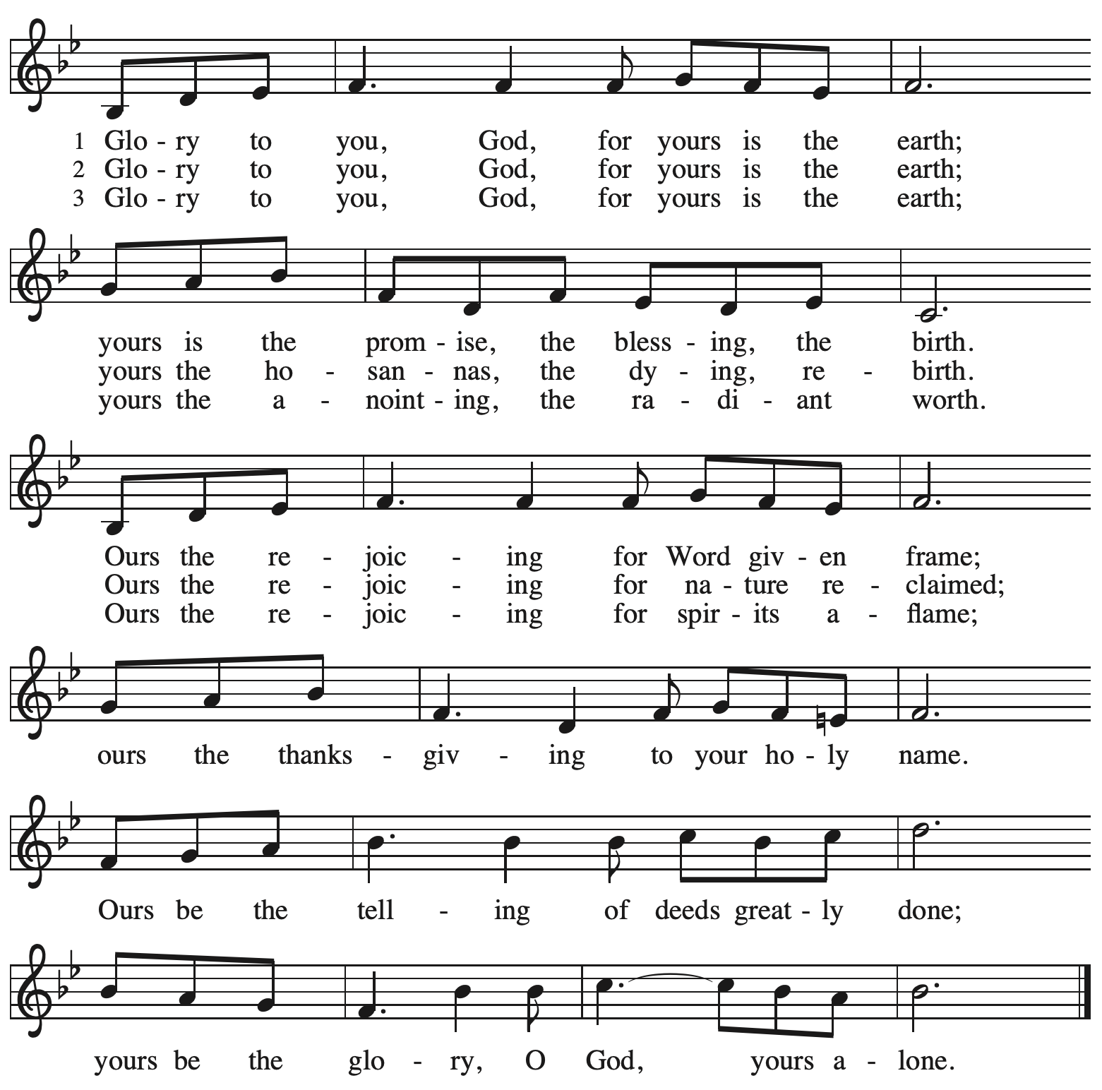

Prayer of the Day

P: The Lord be with you.
C: And also with you.
P: Let us pray.
O God, you are the source of life and the ground of our being.
By the power of your Spirit, bring healing to this wounded world,
and raise us to the new life of your Son, Jesus Christ, our Savior and Lord.
C: Amen.

Please be seated.

Word
God speaks to us in Scripture reading, preaching, and song

First Reading – Hosea 5: 15 – 6: 6

¹⁵ I will return again to my place
until they acknowledge their guilt and seek my face.
In their distress they will beg my favor:
^{6:1} “Come, let us return to the Lord,
for it is the Lord who has torn, and the Lord will heal us;
the Lord has struck down, and the Lord will bind us up.
² After two days the Lord will revive us;
on the third day the Lord will raise us up,
that we may live before the Lord.
³ Let us know, let us press on to know the Lord;
the Lord’s appearing is as sure as the dawn;
the Lord will come to us like the showers,
like the spring rains that water the earth.”
⁴ What shall I do with you, O Ephraim?
What shall I do with you, O Judah?
Your love is like a morning cloud,
like the dew that goes away early.
⁵ Therefore I have hewn them by the prophets;
I have killed them by the words of my mouth,
and my judgment goes forth as the light.
⁶ For I desire steadfast love and not sacrifice,
the knowledge of God rather than burnt offerings.

L: Word of God, word of life.
C: Thanks be to God.

Psalm 50: 7-15

The psalm will be sung responsively, led by the cantor,
with the congregation responding with the bold verses and refrain.

Psalm Tone

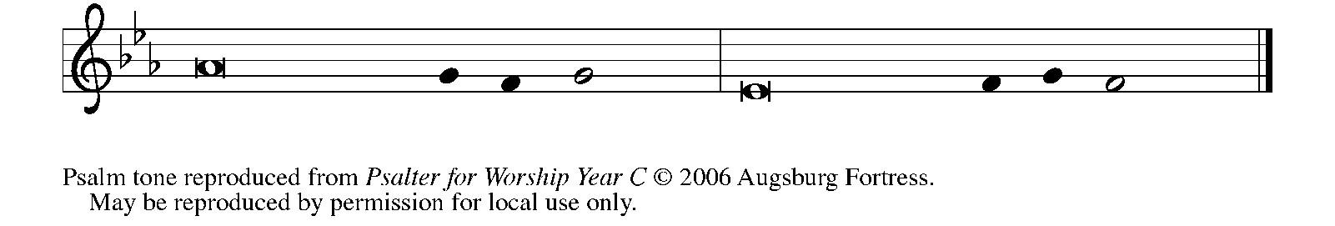

Psalm Refrain

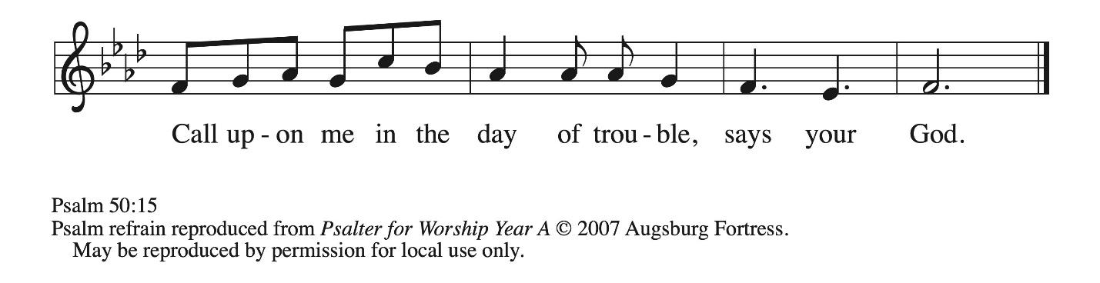

⁷ “Listen, my people, and I will speak: Israel, I will bear wit- | ness against you;
for I am | God, your God.
⁸ I do not accuse you because | of your sacrifices;
your burnt offerings are al- | ways before me.
⁹ I will not accept a calf | from your stalls,
nor goats | from your pens;
¹⁰ for all the wild animals of the for- | est are mine,
the cattle on a | thousand hills. R
¹¹ I know every bird | of the mountains,
and the creatures of the | fields are mine.
¹² If I were hungry, I | would not tell you,
for the whole world is mine and all | that is in it.
¹³ Do you think I eat the | flesh of bulls,
or drink the | blood of goats?
¹⁴ Offer to God a sacrifice | of thanksgiving
and make good your vows to | the Most High.
¹⁵ Call upon me in the | day of trouble;
I will deliver you, and you shall | honor me. R

Second Reading – Romans 4: 13-25

¹³ The promise that he would inherit the world did not come to Abraham or to his descendants through the law but through the righteousness of faith. ¹⁴ For if it is the adherents of the law who are to be the heirs, faith is null and the promise is void. ¹⁵ For the law brings wrath, but where there is no law, neither is there transgression.
¹⁶ For this reason the promise depends on faith, in order that it may rest on grace, so that it may be guaranteed to all his descendants, not only to the adherents of the law but also to those who share the faith of Abraham (who is the father of all of us, ¹⁷ as it is written, “I have made you the father of many nations”), in the presence of the God in whom he believed, who gives life to the dead and calls into existence the things that do not exist. ¹⁸ Hoping against hope, he believed that he would become “the father of many nations,” according to what was said, “So shall your descendants be.” ¹⁹ He did not weaken in faith when he considered his own body, which was already as good as dead (for he was about a hundred years old), and the barrenness of Sarah’s womb. ²⁰ No distrust made him waver concerning the promise of God, but he grew strong in his faith as he gave glory to God, ²¹ being fully convinced that God was able to do what God had promised. ²² Therefore “it was reckoned to him as righteousness.” ²³ Now the words, “it was reckoned to him,” were written not for his sake alone ²⁴ but for ours also. It will be reckoned to us who believe in the one who raised Jesus our Lord from the dead, ²⁵ who was handed over for our trespasses and was raised for our justification.

L: Word of God, word of life.
C: Thanks be to God.

Please rise as you are able.

Gospel Acclamation ACS p. 33

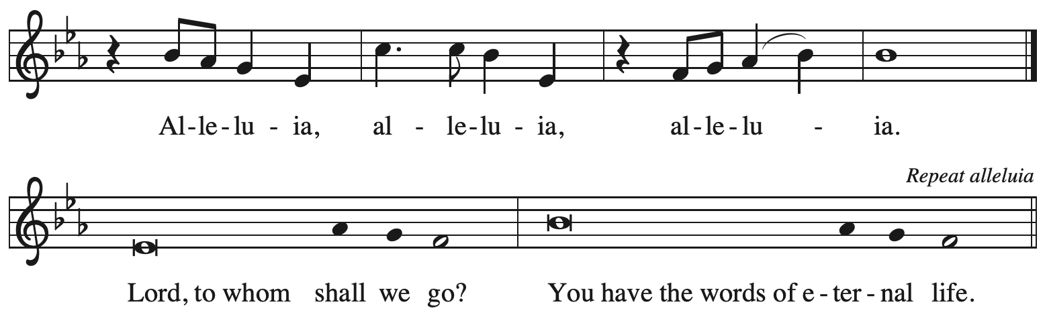

Gospel – Matthew 9: 9-13, 18-26

P: The holy Gospel according to St. Matthew.
C: Glory to you, O Lord.

⁹ As Jesus was walking along, he saw a man called Matthew sitting at the tax-collection station, and he said to him, “Follow me.” And he got up and followed him.
¹⁰ And as he sat at dinner in the house, many tax collectors and sinners came and were sitting with Jesus and his disciples. ¹¹ When the Pharisees saw this, they said to his disciples, “Why does your teacher eat with tax collectors and sinners?” ¹² But when he heard this, he said, “Those who are well have no need of a physician, but those who are sick. ¹³ Go and learn what this means, ‘I desire mercy, not sacrifice.’ For I have not come to call the righteous but sinners.”
¹⁸ While he was saying these things to them, suddenly a leader came in and knelt before him, saying, “My daughter has just died, but come and lay your hand on her, and she will live.” ¹⁹ And Jesus got up and followed him, with his disciples. ²⁰ Then suddenly a woman who had been suffering from a flow of blood for twelve years came up behind him and touched the fringe of his cloak, ²¹ for she was saying to herself, “If I only touch his cloak, I will be made well.” ²² Jesus turned, and seeing her he said, “Take heart, daughter; your faith has made you well.” And the woman was made well from that moment. ²³ When Jesus came to the leader’s house and saw the flute players and the crowd making a commotion, ²⁴ he said, “Go away, for the girl is not dead but sleeping.” And they laughed at him. ²⁵ But when the crowd had been put outside, he went in and took her by the hand, and the girl got up. ²⁶ And the report of this spread through all of that district.

P: The Gospel of the Lord.
C: Praise to you, O Christ.

Please be seated.

Sermon

A time of silence for prayer and reflection follows the sermon.
When the hymn of the day begins, please rise as you are able.



Hymn of the Day O Christ, Your Heart, Compassionate ELW 722

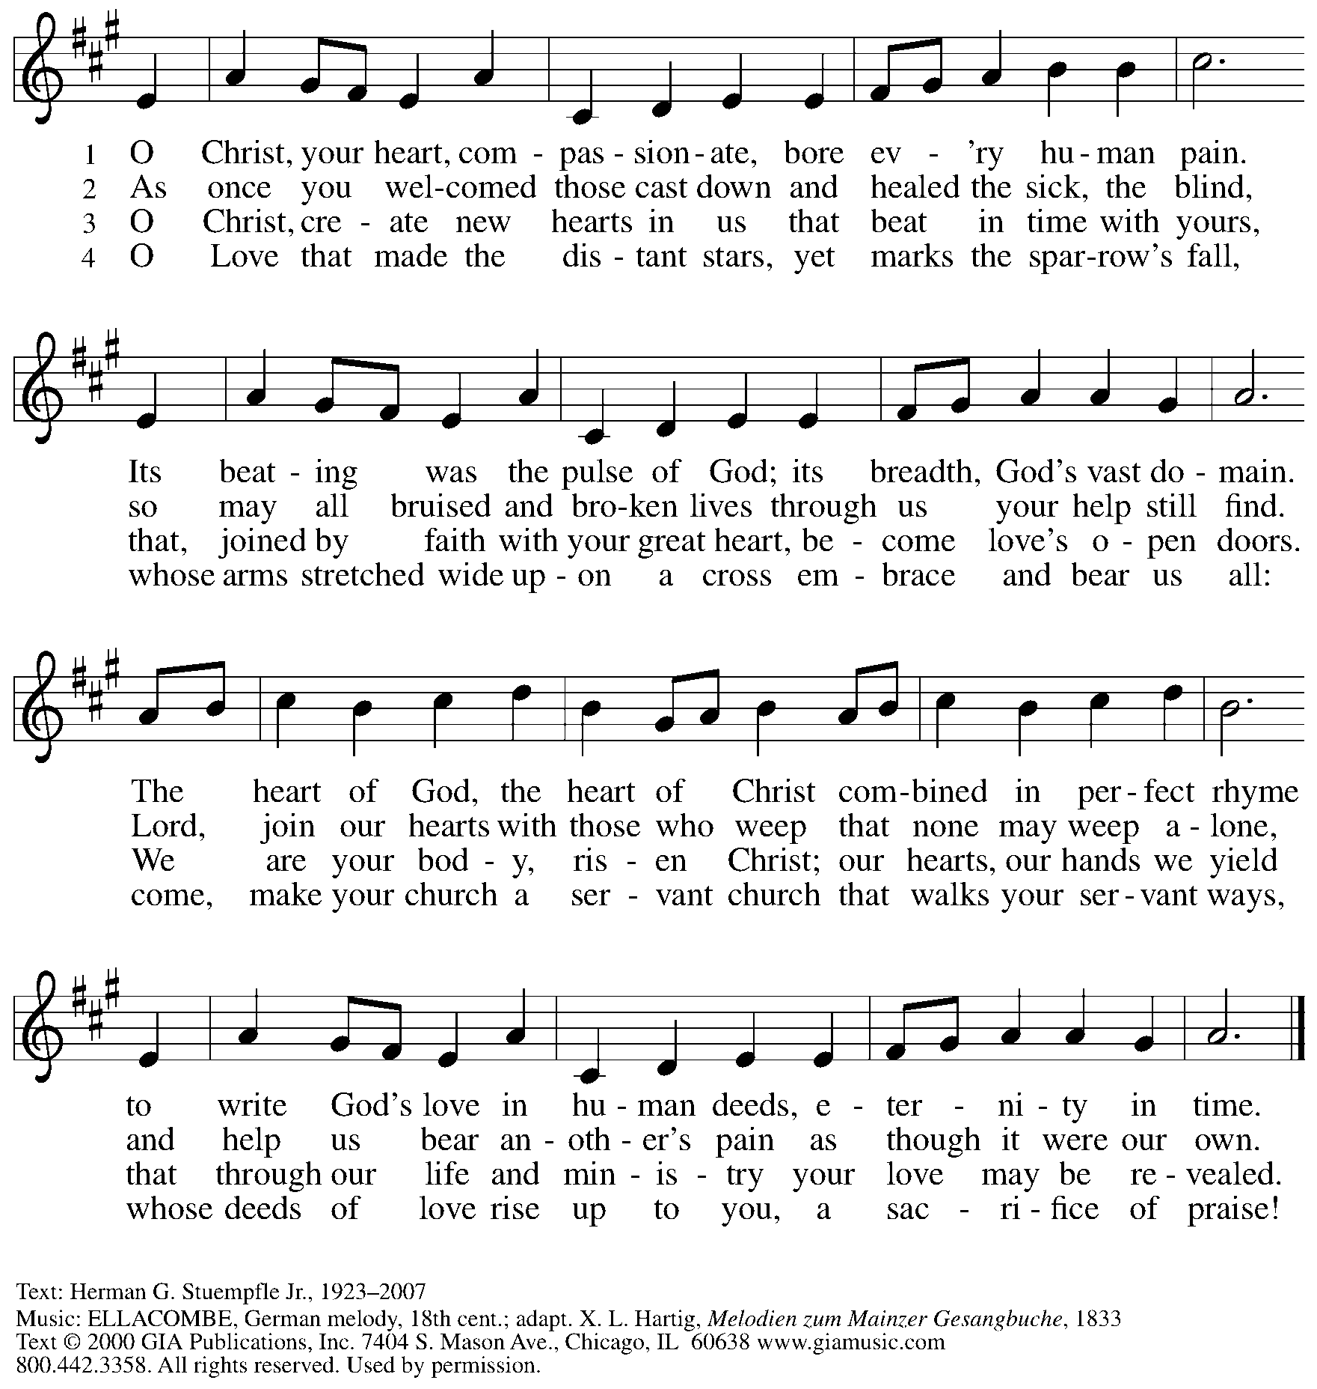
Reprinted under OneLicense.net # A-722139.

Apostles’ Creed

C: I believe in God, the Father almighty,
creator of heaven and earth.

I believe in Jesus Christ, God’s only Son, our Lord,
who was conceived by the Holy Spirit,
born of the virgin Mary,
suffered under Pontius Pilate,
was crucified, died, and was buried;
he descended to the dead.*
On the third day he rose again;
he ascended into heaven,
he is seated at the right hand of the Father,
and he will come to judge the living and the dead.

I believe in the Holy Spirit,
the holy catholic church,
the communion of saints,
the forgiveness of sins,
the resurrection of the body,
and the life everlasting. Amen.

*Or, “he descended into hell,” another translation of this text in widespread use.

Prayers of the People

A: Gathered by the Holy Spirit, let us pray for the church, the world,
and all people according to their need.

After each petition
A: God of grace,
C: receive our prayer.

The presiding minister concludes the prayers
P: Trusting that you receive all our prayers,
we commend our spoken and unspoken petitions to you, O God,
through Jesus Christ our Savior.
C: Amen.

Peace

The presiding minister and the assembly greet one another in the peace of the risen Christ.
P: The peace of Christ be with you always.
C: And also with you.

The people may greet those around them with a sign of Christ’s peace and may say
Peace be with you or similar words. Please be mindful that not everyone will be comfortable with sharing the peace, so please seek consent before shaking hands or hugging.
Other possible ways to share the peace include a simple bow with the verbal greeting of peace, or simply a verbal expression of peace. When the greetings of peace have concluded, please be seated.



Meal
God feeds us with the presence of Jesus Christ

Offering

We offer ourselves, our gifts, and our faithful service to God.
As the offering is gathered for the mission of the church, including the care of those in need,
the table is set for Holy Communion.

There are laminated giving cards in the pew racks that feature a QR code for anyone who would like to give online. Those who give using the QR code, as well as those who give regularly online or through their bank are encouraged to place the laminated card in the plate as an expression of your offering.

Reparations Offering

On the first Sunday of each month, St. Andrew invites people of the congregation to give a second offering for a reparations fund in acknowledgment of St. Andrew’s use of African American spiritual songs in our worship services. Please see the note in the announcements for more information.

Music during the Offering
How Firm a Foundation arr. Wendy Stevens
Elyse

As the gifts are brought forward for presentation, please rise as you are able.

Offertory Song Timothy Kocher-Hillmer

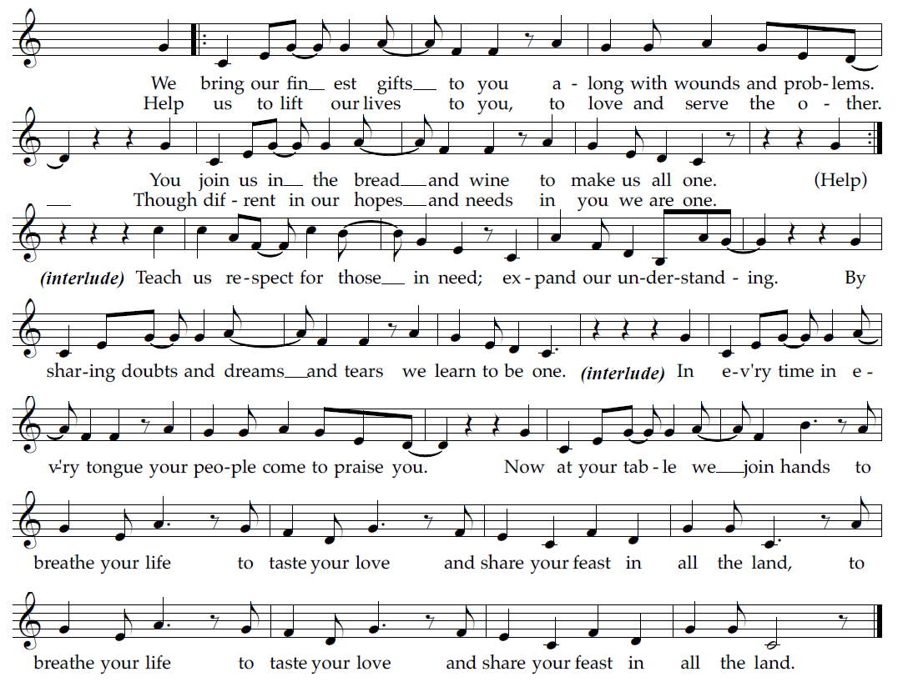

Offertory Prayer

A: Let us pray.
God of goodness and growth,
C: all creation is yours, and your faithfulness is sure.
Word and water, wine and bread: these are signs of your abundant grace.
Receive the gifts we bring,
and nourish us to proclaim your abiding love in our communities and in the world,
through Jesus Christ, our strength and our song.
Amen.

Dialogue ACS p. 36

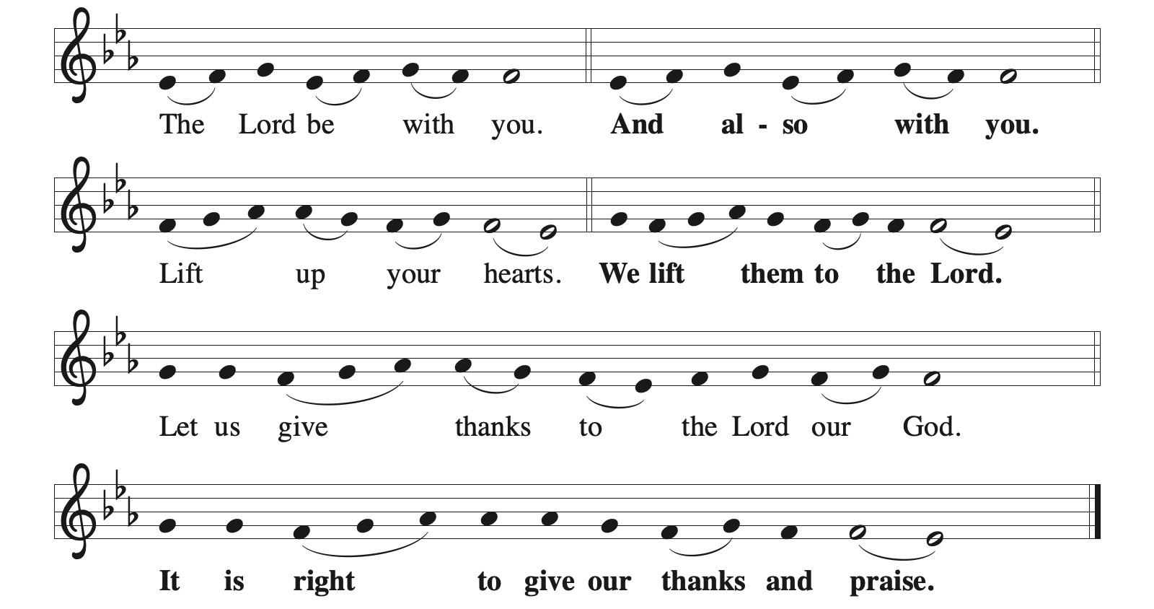

Preface (Sung by the presiding minister)

P: It is indeed right, our duty and our joy,
that we should at all times and in all places
give thanks and praise to you, almighty and merciful God,
through our Savior Jesus Christ;
who on this day overcame death and the grave,
and by his glorious resurrection opened to us the way of everlasting life.
And so, with all the choirs of angels,
with the church on earth and the hosts of heaven,
we praise your name and join their unending hymn:

Sanctus ACS p. 36

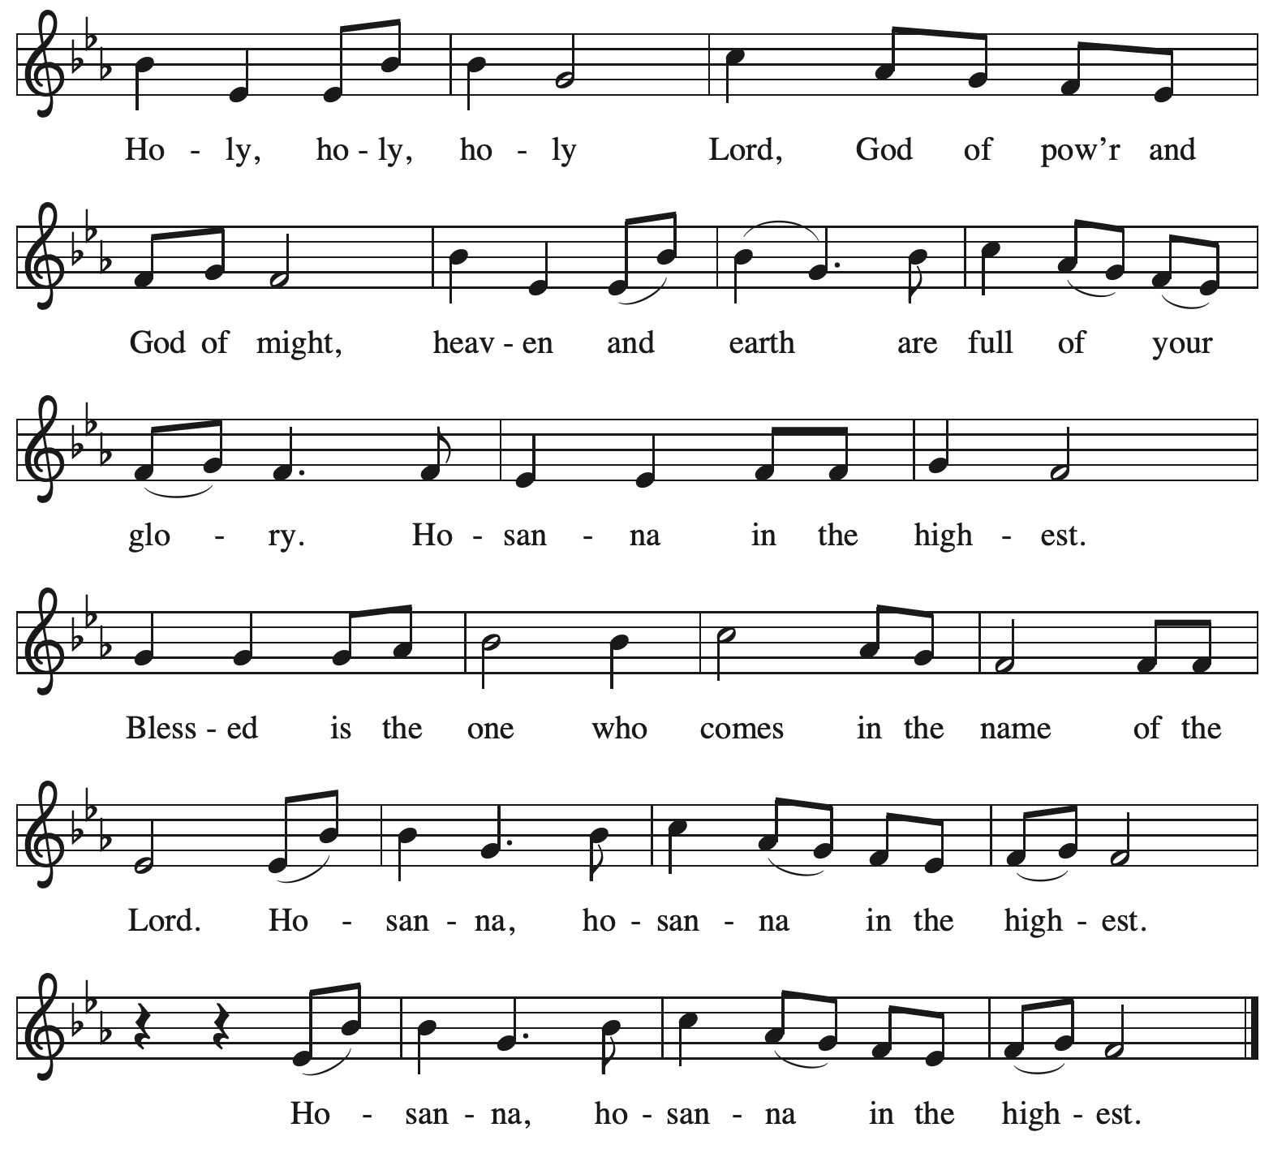

Eucharistic Prayer

P: O God triune, how majestic is your name in all the earth …
… The earth is full of your glory.
C: The earth is full of your glory.

P: O God triune, you made a home among us in Jesus our healer …
… The earth is full of your glory.
C: The earth is full of your glory.

P: We praise you for the heart of Jesus, so filled with your love for the world …
… Do this for the remembrance of me.

Gathered around your table, we your children unite in this song:
The earth is full of your glory.
C: The earth is full of your glory.

P: O God triune, you create the worlds, you uphold the living, you embrace the dead …
… The earth is full of your glory.
C: The earth is full of your glory.

P: Amen and Amen.
C: Amen and Amen.

Lord’s Prayer

P: Gathered as one by the Holy Spirit, let us pray as Jesus taught us.
C: Our Father in heaven,
hallowed be your name,
your kingdom come,
your will be done,
on earth as in heaven.
Give us today our daily bread.
Forgive us our sins
as we forgive those
who sin against us.
Save us from the time of trial
and deliver us from evil.
For the kingdom, the power,
and the glory are yours,
now and forever. Amen.

Fraction and Invitation



Agnus Dei / Lamb of God ACS p. 40

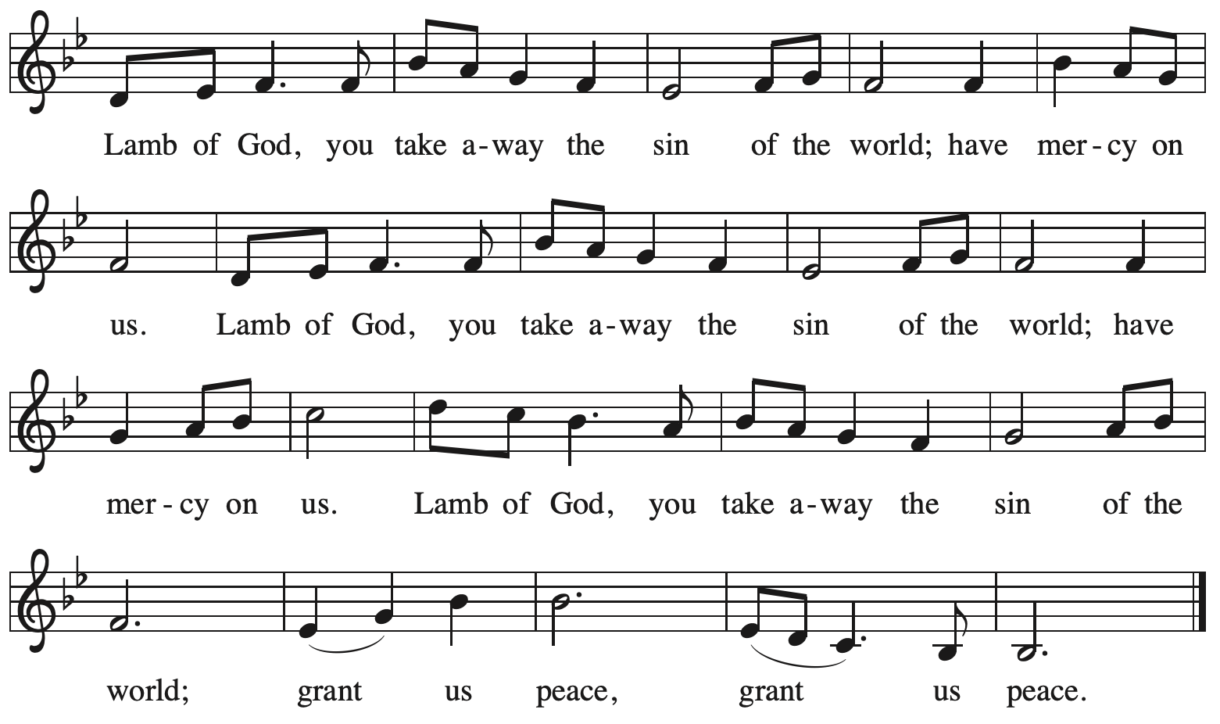

Please be seated.

Holy Communion

- All who seek God and desire a deeper and stronger life in Christ are welcome to receive Holy Communion.
- Worshipers from the pulpit side will proceed forward first, followed by the center section, and then the lectern side.
- Please inform an usher if you would like the ministers to bring Communion to you.
- Holy Communion will be served with bread and wine (red) or grape juice (white).
- The presiding minister will first distribute the bread (host) to each communicant. Please indicate if you require a gluten-free host.
- Once you have consumed the bread, please pick up an empty glass from the tray next to the presiding minister. The Communion Assistant will pour wine or grape juice into your glass.
- Please step to the side to consume the wine or grape juice.
- Feel free to kneel at the altar rail for prayer after receiving the sacrament.
- As you return to your pew, glasses may be returned to the empty tray on the side of the center section.
- A blessing will be provided for anyone who does not yet receive the sacrament.
- All are invited to join in singing the hymns during Holy Communion.

Hymns during Holy Communion
Draw Us in the Spirit’s Tether ELW 470

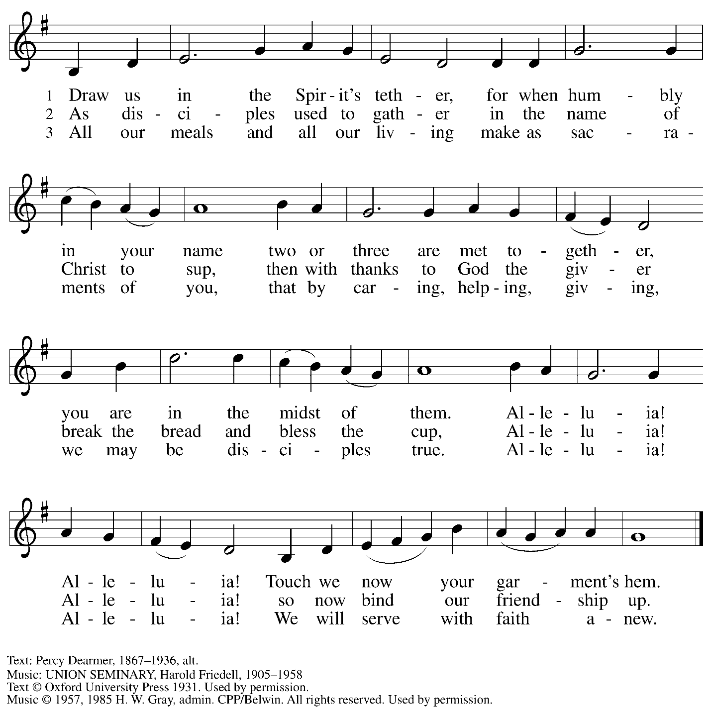
Reprinted under OneLicense.net # A-722139.

Hymns during Holy Communion
There’s a Wideness in God’s Mercy ELW 587

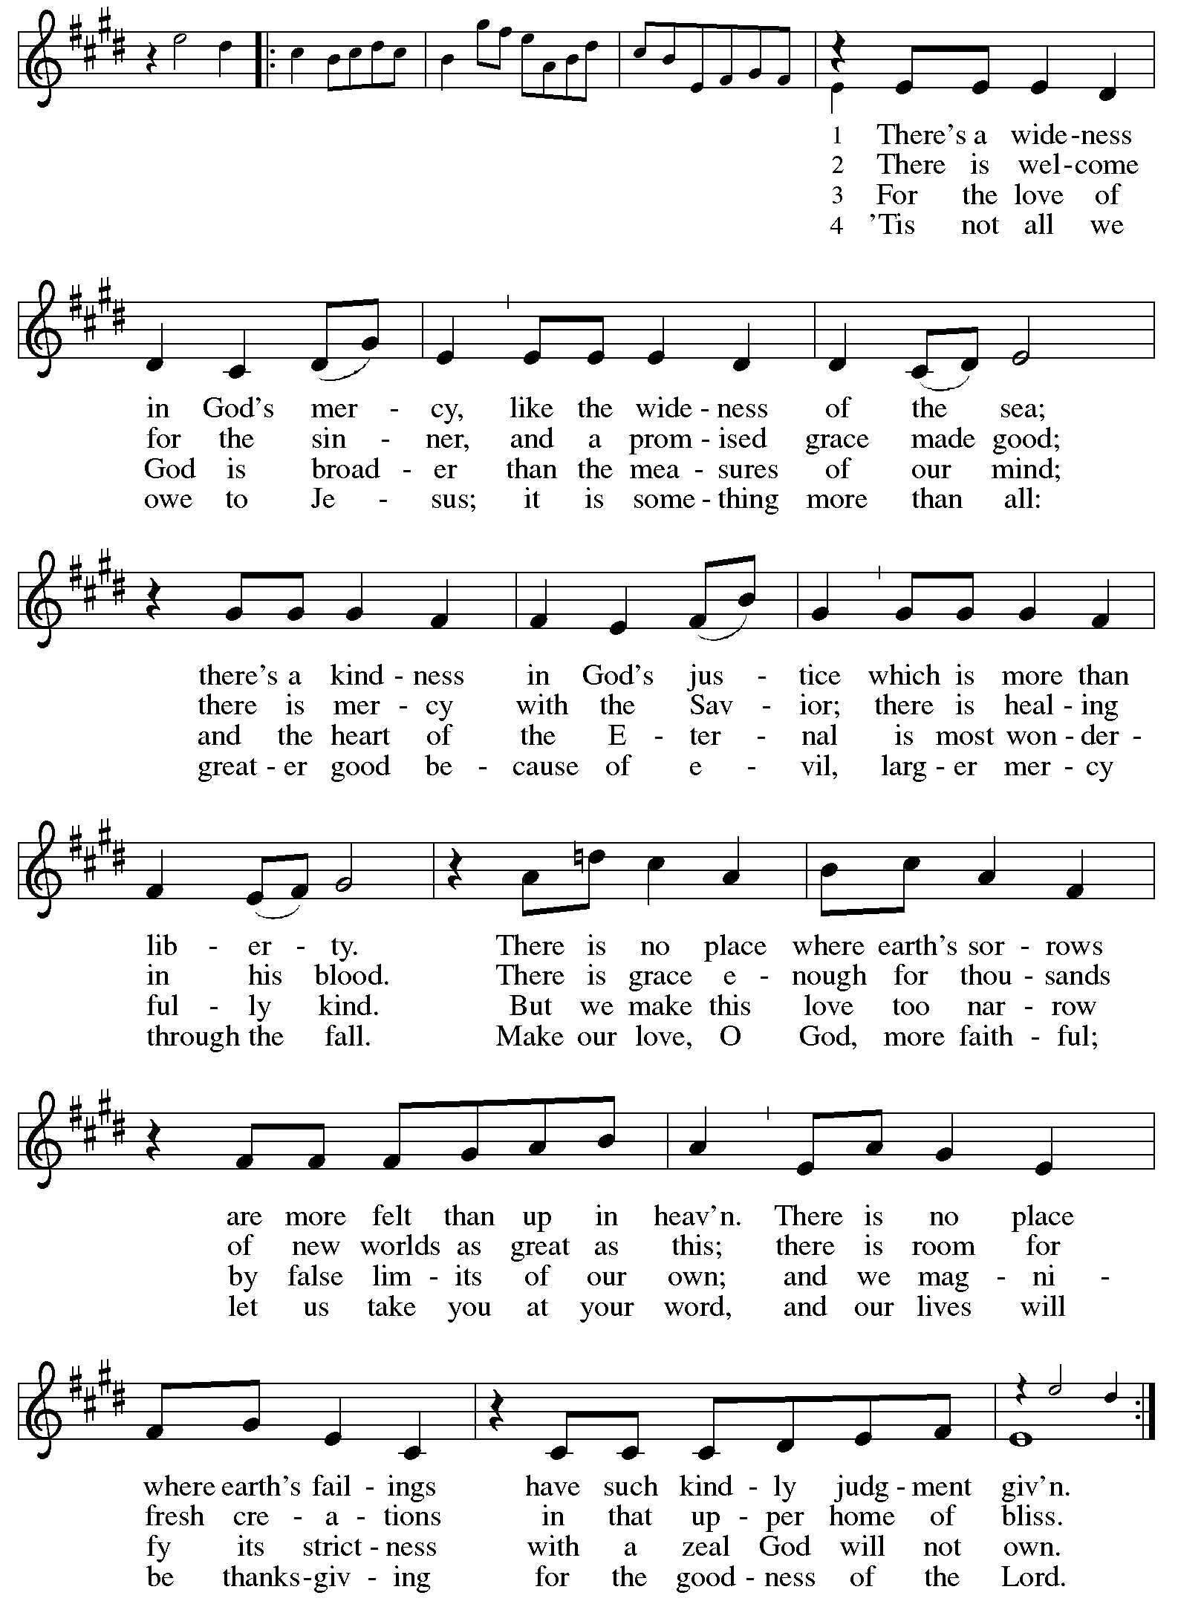
Hymns during Holy Communion
Let My Spirit Always Sing ACS 1020

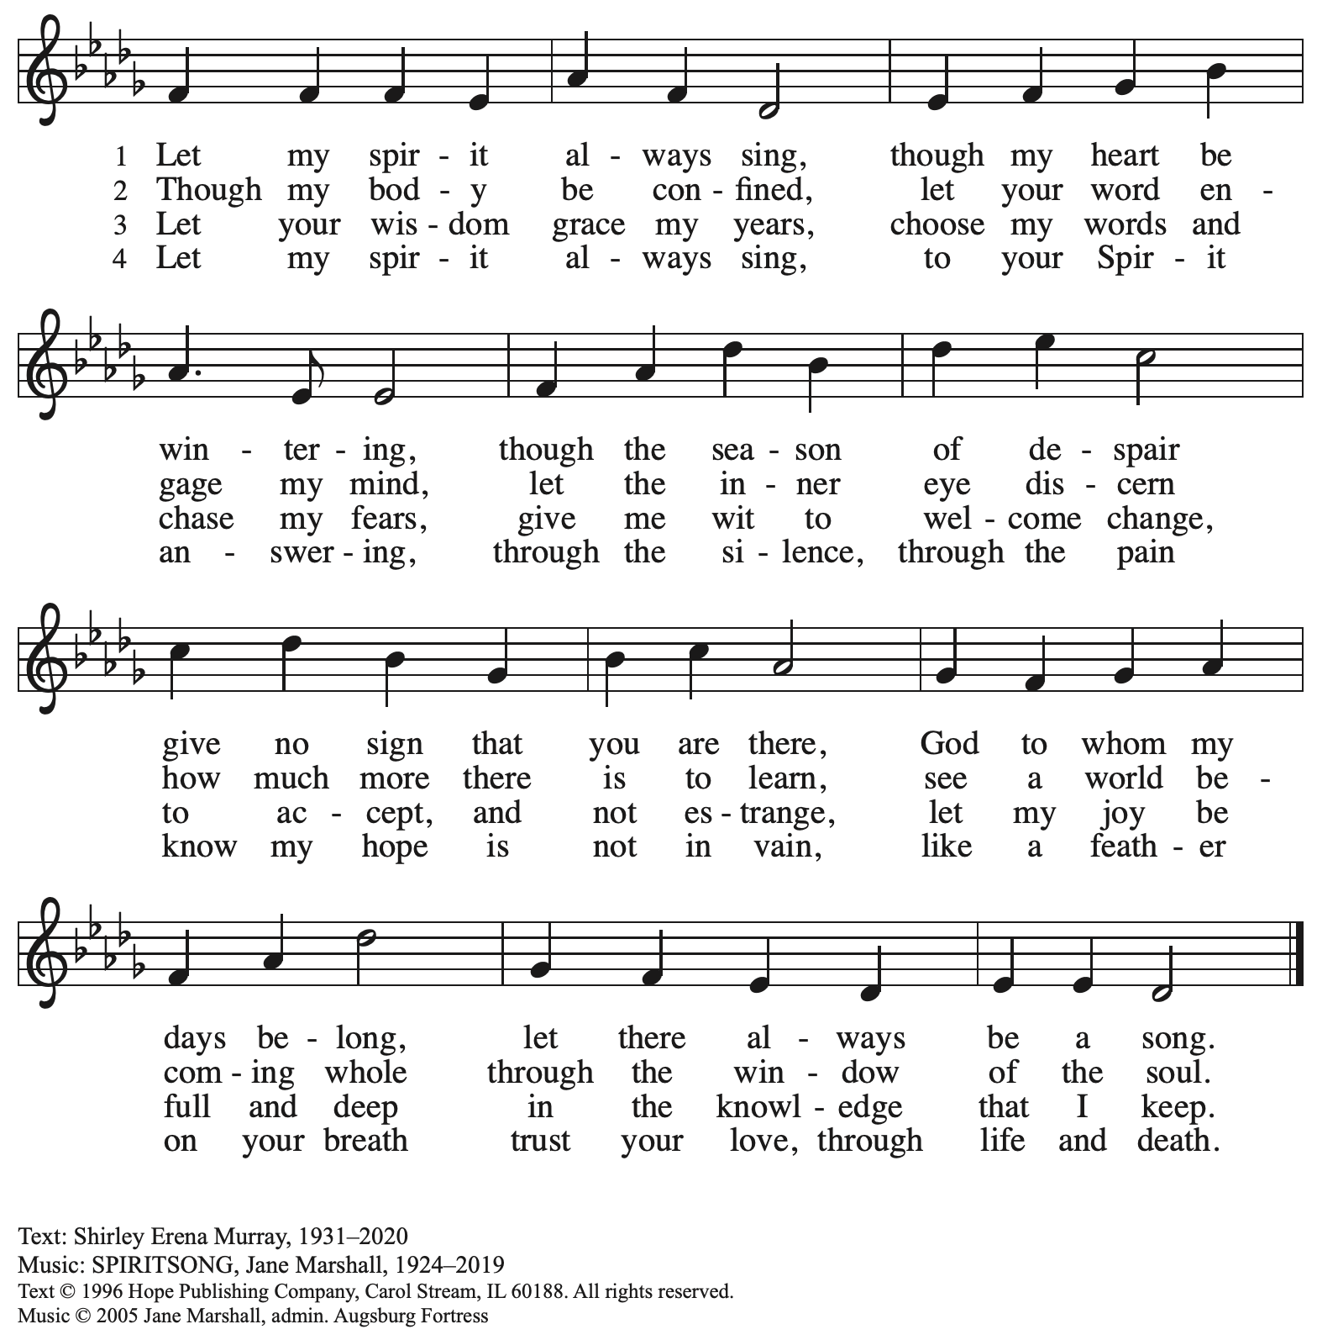
All rights reserved. Reprinted with permission under OneLicense.net # A-722139.

When all have returned to their places, please rise as you are able.

Blessing

P: The body and blood of our Lord Jesus Christ strengthen you and keep you in his grace.
C: Amen.
Prayer

A: Let us pray. Life-giving God,
through this meal you have made your home among us
and are making all things new.
Send us now to speak peace to anxious hearts,
to love our neighbors, and to bring your healing to the nations.
through Jesus Christ, our Savior.
C: Amen.

Please be seated.

Sending
God blesses us and sends us in mission to the world

Announcements

Please rise as you are able.

Benediction

P: God Almighty, who is the beginning and the end,
Jesus Christ, the firstborn of the dead,
and the Spirit, our advocate and peace,
☩ bless you now and forever.
C: Amen.

Sending Hymn Following Page

Dismissal

A: Go in peace. Build Community Together!
C: Thanks be to God!

Postlude

Sending Hymn Vamos todos al banquete ELW 523
Let Us Go Now to the Banquet

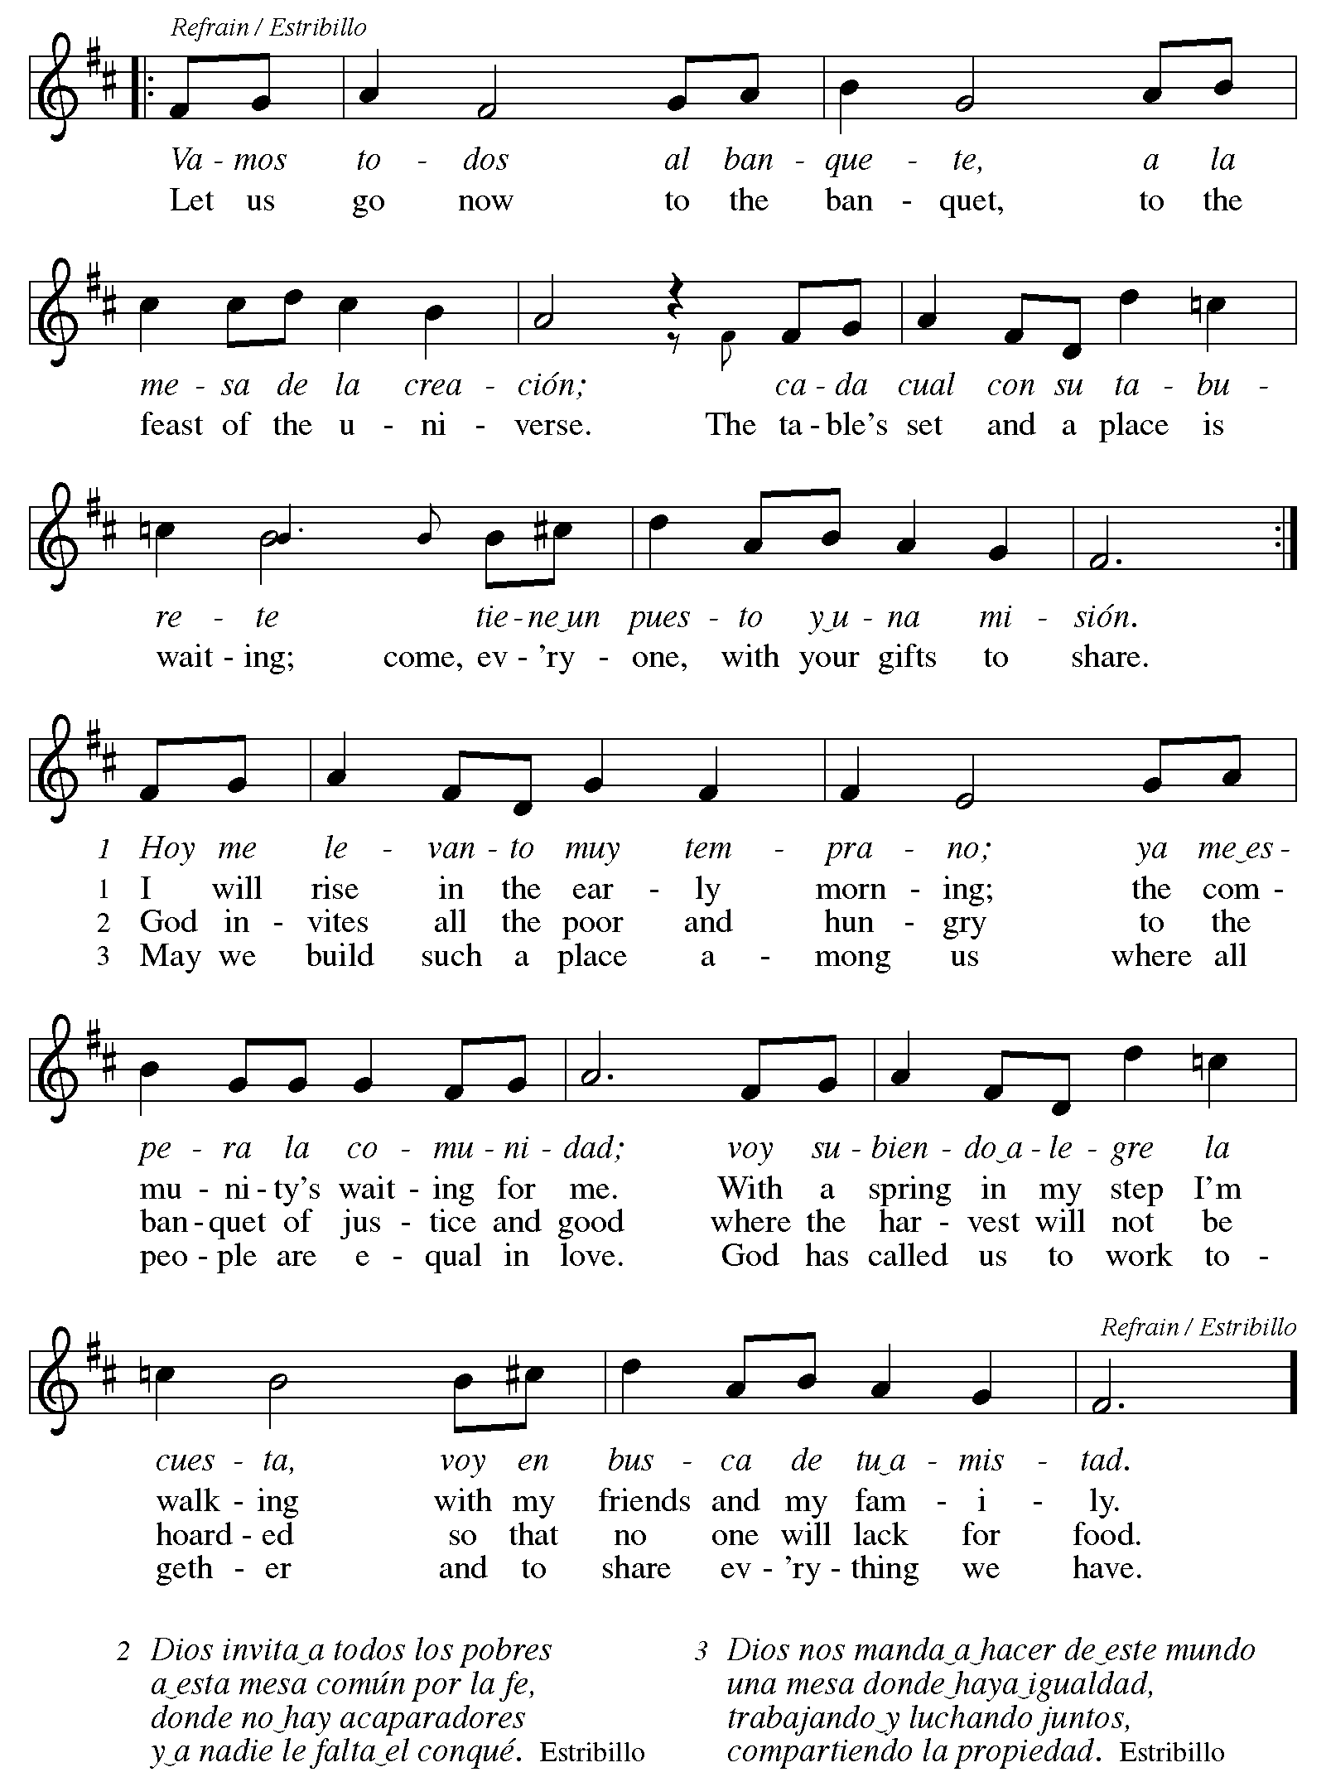
Those serving in worship today

Altar Care Christy Ruhe
Assisting Minister Timothy Kocher-Hillmer
Audio-Visual Ministers Tim Jones
Joseph Paetz
Cantor Jered Stratton
Lector Brennan Coleman
Piano on Prelude Andrew
Piano during the Offertoring Elyse
Minister of Music Laura Reynolds
Presiding Minister The Rev. Ross I. Carmichael

Liturgy and Hymnody Acknowledgements

From SundaysandSeasons.com. Copyright © 2026 Augsburg Fortress. All rights reserved. Reprinted under OneLicense.net # A-722139.
Used by permission of Augsburg Fortress.

The Scripture readings contained herein are from New Revised Standard Version Updated Edition of the Bible © 2021 National Council of Churches of Christ in the United States of America. Used by permission. All rights reserved worldwide.

All Are Welcome – Text: Marty Haugen, b. 1950. Music: TWO OAKS, Marty Haugen. Text and music © 1994 GIA Publications, Inc., 7404 S. Mason Ave., Chicago, IL 60638. www.giamusic.com. 800.442.3358. All rights reserved. Reprinted with permission under OneLicense.net # A-722139.

There’s a Wideness in God’s Mercy – Text: Frederick W. Faber, 1814-1863, alt. Music: ST. HELENA, Calvin Hampton, 1938-1984. Music © 1977 GIA Publications, Inc., 7404 S. Mason Ave., Chicago, IL 60638. www.giamusic.com. 800.442.3358. All rights reserved. Reprinted with permission under OneLicense.net # A-722139.

Vamos todos al banquete – Let Us Go Now to the Banquet – Text: Guillermo Cuéllar, b. 1955, Misa popular salvadoreña; tr. Bret Hesla, b. 1957 and William Dexheimer Pharris, b. 1956. Music: VAMOS TODOS AL BANQUETE, Guillermo Cuéllar, b. 1955. Text and music © 1994, 1996, GIA Publications, Inc., 7404 S. Mason Ave., Chicago, IL 60638. www.giamusic.com. 800.442.3358. All rights reserved. Reprinted with permission under OneLicense.net # A-722139.

Please use the QR code below to link to St. Andrew’s Announcements online!



St. Andrew Lutheran Church Announcements
June 7th, 2026

- Welcome to Worship at St. Andrew on the Second Sunday after Pentecost – We are so glad you are here, and we offer a special welcome to all visitors and guests who are here for the first time! There are worship “toolkits” to help children engage with worship and “busy bags” for younger children available in the bookcase at the back of the sanctuary. Please feel free to take one to use with/for your children. A nursery is available through the door to the left of the worship space and across the social hall (look for a purple room). All are invited to gather for coffee, other drinks, food, and conversation in the social hall after worship.
- Monthly Reparations Offering, Today, June 7th, during Worship – In Luke’s Gospel, Jesus tells a story about a compassionate Samaritan, suggesting that God’s people are called to work for healing and restoration for our neighbors, regardless of who or what caused them harm. In light of this, St. Andrew has made a commitment to reparations in regard to African American spiritual songs used in our worship. The text and music of most hymns is attributed to specific authors, with copyrights in place, usage reported, and royalties paid to those whose works are featured in worship. With African American spirituals, this is not possible. In response to many years of such uncredited use, St. Andrew invites the congregation to give a reparations offering. Funds received in worship will be donated to our siblings at Bethel AME Church, whose land and building were taken from them in the 1950s, to fund their development in the Hill District
- Produce Distribution Supplemental Food of the Month – St. Andrew collects supplemental food each month to accompany our produce distribution. For June, we ask for donations of rice.
- Produce Distribution, Third Tuesday Each Month, June 16th from 5:30 to 6:30 p.m. – St. Andrew partners with Greater Pittsburgh Community Food Bank to serve as a distribution site for fresh produce on the first and third Tuesday of every month. We invite people of the congregation to help with the distribution from 5:30 p.m. to 6:30 p.m. and/or to help with unloading and setup during the day between 10:00 a.m. and 1:00 p.m.
- Pride Month Celebrations, Saturday, June 20th, 10:00 a.m. to 6:00 p.m. – Every June is celebrated as Pride month to commemorate years of struggle for civil rights and the ongoing pursuit of justice for the LGBTQIA+ community in the face of police brutality and systemic disenfranchisement. St Andrew is sponsoring a booth at Millvale Pride on June 20th starting at 12:00 p.m. You can sign up to volunteer here: https://www.signupgenius.com/go/5080B4AAFAF2CABF85-63577363-pittsburgh.
- “Freedom. Faith. Harvest.” - A Holy Day of Worship, Fellowship, and the Blessing of the Garden at Bethel AME Church, Sunday, June 14th, 11:00 a.m – Bethel AME Church presents their Juneteenth celebration to include an 11:00 a.m. morning worship, which includes a celebration of liberation, song, and the preached Word from Bishop Melissa Stoller. After worship, there will be a Community Dinner in the Fellowship Hall. After dinner, there will be a blessing of the community garden, a consecrating of the seeds, equipment, and the hands that tend it from Dr. Kate Walker of the First Unitarian Church of Pittsburgh, and a “Libation Ceremony” led by the Ujamaa Collective. Bethel AME church is located at 2720 Webster Ave, Pittsburgh, PA 15219.
- Reckoning with Antisemitism: Reflections at One Year, Wednesday, June 24th at 7:00 p.m. – Gather on June 24th at Beit Kulanu (Formerly Rodef Shalom - 4905 Fifth Avenue, Pittsburgh, PA 15213) for an evening of celebration and reflection on the past year of the Reckoning with Antisemitism as Christians project. Over the past 12 months, Christian clergy and lay leaders across southwestern PA have been engaging with this new project co-founded by Christian Associates of Southwest PA and the Holocaust Center of Pittsburgh. We will hear from Christians who have been reckoning with antisemitism and from Jews who have taken part in their efforts. We will also share (for the first time!) a published book of sermons written by local Christian clergy who have engaged their congregations and communities in conversations about antisemitism, from the pulpit and beyond. You can register to attend using this link: https://www.eventbrite.com/e/reckoning-with-antisemitism-as-christians-reflections-at-one-year-tickets-1988560210119.

