

+ Third Sunday after Pentecost
June 14, 2026


St. Andrew Lutheran Church
304 Morewood Ave.
Pittsburgh, PA 15213
St_andrewELCA@verizon.net
www.standrewpittsburgh.org

+ Third Sunday after Pentecost

Moses tells the Israelites that they are called to be a priestly kingdom and a holy people.
Jesus sends out the disciples as laborers into the harvest.
In Baptism we too are anointed for ministry, sharing God’s compassion with our needy world. From the Lord’s table we go forth to proclaim the good news, to heal the sick,
and to share our bread with the hungry.

Welcome to St. Andrew!

- St. Andrew welcomes all who are seeking a place of healing, wholeness, and acceptance in a nurturing and faith-forming spiritual home. We are striving toward racial equity worldwide
and we seek to honor the lived experience of all individuals regardless of background. Our community embraces people of all ages, ethnicities, cultures, abilities, sexual orientations,
gender identities and expressions, and family constellations. Come and See!
- Worship Services are live-streamed to multiple online platforms. By attending worship, you agree that your image and voice may be broadcast.
- Everyone is invited to make a name tag at the black bookcase in the back of the worship space if they would like. There are stickers indicating pronouns on the bookcase if you would like to include them on your name tag.
- A nursery is available through the doors at the left side of the sanctuary and across from the doorway to the Social Hall. Look for a purple-colored room.
- Worship “toolkits” to help children engage with the service, along with “busy bags” for younger children, are available in the bookcase at the back of the sanctuary. Please feel free to take one to use with/for your children.
- Holy Communion is served with bread (gluten-free available) and wine or grape juice. The presiding minister will distribute the bread (host). Please consume this and then pick up an empty glass from the tray. The Communion Assistant will pour wine or grape juice into your glass. Please step to the side to consume the wine or grape juice. Feel free to kneel at the altar for prayer and reflection. As you return to your pew, glasses may be returned to the empty trays on either side of the center section.
- A restroom is available on the main level of the church, through the doors to the Social Hall and to the right in the main office.

Abbreviations
P: Pastor/Presiding Minister ELW: Evangelical Lutheran Worship hymnal
A: Assisting Minister ACS: All Creation Sings hymnal
L: Lector
C: Congregation

June 17th – Emanuel Nine, Martyrs, 2015
On June 17th, 2015, Clementa C. Pinckney, Cynthia Marie Graham Hurd, Susie Jackson, Ethel Lee Lance, DePayne Middleton-Doctor, Tywanza Sanders, Daniel Lee Simmons, Sharonda Coleman-Singleton, and Myra Thompson were murdered by a self-professed white supremacist while they were gathered for Bible study and prayer at the Emanuel African Methodist Episcopal Church (often referred to as Mother Emanuel) in Charleston, South Carolina. Pastors Pinckney and Simmons were both graduates of the Lutheran Theological Southern Seminary. A resolution to commemorate June 17th as a day of repentance for the martyrdom of the Emanuel Nine was adopted by the Churchwide Assembly of the Evangelical Lutheran Church in America on August 8th, 2019. Congregations of the ELCA are encouraged to reaffirm their commitment to repenting of the sins of racism and white supremacy which continue to plague this church, to venerate the martyrdom of the Emanuel Nine, and to mark a day of penitence with study and prayer.

June 19th – Juneteenth, 1865
Juneteenth is a holiday that commemorates the end of slavery in the United States. It recalls how the states of Louisiana and Texas heard the news that President Abraham Lincoln had signed the Emancipation Proclamation on January 1st, 1863. Slavery continued in those two states for more than two years after the proclamation was signed because the word had yet to travel there. Texas and Louisiana finally got the good news on June 19th, 1865. Formerly enslaved people broke out in spontaneous celebration. These were dangerous times. Even in the face of resistance and threat, the formerly enslaved Africans found ways to give voice to the wide range of thoughts and emotions at the announcement of the end of legalized slavery in the United States of America

Musical Offering

Each week, different people from the congregation make an offering of pre-service music, with singing or instrumentation, to help the assembly focus and pray in preparation for worship.

Welcome
Prelude Eagle’s Wings arr. Raabe

Gathering
The Holy Spirit calls us together as the people of God

Please rise as you are able. All may make the sign of the cross,
the sign that is marked at Baptism, as the presiding minister begins.

Invocation

P: Blessed be the holy Trinity, ☩ one God,
whose mercy endures forever.
C: Amen.

Commemoration of the Emanuel Nine

Today we join with Mother Emanuel Methodist Episcopal Church in Charleston, South Carolina and our siblings in Christ across the AME Church in remembering the Emanuel Nine.

The Emanuel Nine, of blessed and eternal memory, were gifted, loving, and faithful people who spent their lives striving for excellence, connection, and the presence of God, and their last moments in the study of God’s word. They leave a legacy of grace, resistance, family, and faith.

We remember:
The Rev. Clementa C. Pinckney
Cynthia Marie Graham Hurd
The Rev. Daniel Lee Simmons
The Rev. DePayne Middleton-Doctor
Ethel Lee Lance
The Rev. Myra Singleton Quarles Thompson
The Rev. Sharonda Coleman-Singleton
Susie Jackson
Tywanza Kibwe Diop Sanders

P: In faithfulness and dedication, your beloved lived by your promises, sharing their gifts with their families and communities. Ensure, gracious God, that in remembering their lives and witness, the world comes to know of your love and your Spirit at work in and through them.

We ask this in the name of Jesus.
C: Amen.

Confessing Racism: A Lament for the Church

P: The sin of racism hurts communities of color, fractures human relationships, and denies God’s good creation. To lament is a way for us to recognize the harm caused by racism.

P: Nothing can separate us from the love of God in Christ Jesus (Romans 8:35-39). God’s grace in Christ frees us for the difficult work of recognizing and lamenting racism.

We are all part of one body in Christ, called to act with equity, fairness, and justice. God’s saving love creates grace-filled spaces within us and within our relationships. God’s saving love calls and leads us toward rooting out the racism that continues to harm the body. Remembering the lives and witness of the Emanuel Nine, let us join the whole church in confession and lament.

P: Within the human family, people of color have experienced both interpersonal aggression and structural oppression instead of abundant life. We recognize and lament the harm racism has caused to African Descent communities; American Indian and Alaska Native communities; Indigenous Peoples within Canada; Arab and Middle Eastern communities; Asian and Pacific Islander communities; and Latine communities. We cry out to you,
C: Lord, have mercy,

P: We have assigned the notion of race to human beings created in God’s own divine image. We have judged God’s beautiful diversity by our flawed and artificial standards. We cry out to you, C: Lord, have mercy.

P: We have used language and images in ways that equate black and dark with stain and sin, and that fail to welcome the treasures of darkness in God’s good creation. We cry out to you,
C: Lord, have mercy.

P: We have accepted practices in our churches and in our society that privilege whiteness over diversity and equity. We have been complicit in how racism continues to exclude and harm people of color. We cry out to you,
C: Lord, have mercy.

P: When one part of the body of Christ suffers, the whole body suffers.
As we listen to people who are harmed by racism, we call to you,
C: open our hearts, O God.

P: As we reflect on our daily interactions with people and communities of color, we call to you, C: open our hearts, O God.

P: As we reconsider what we have been taught about race and racism, we call to you,
C: open our hearts, O God.

P: As we contemplate what we have done and what we have left undone, we call to you,
C: open our hearts, O God.

P: As we work to cultivate loving and safe communities for our siblings of color and all people, we call to you,
C: open our hearts, O God.

P: Holy, merciful and living God, we commit ourselves anew to the work of loving one another as you have loved us. Unite us as members of your body, connected to one another
and empowered for the work you call us to do, in the name of Jesus and by the power of your renewing Spirit.
C: Amen.

Gathering Hymn Search Me, O God ACS 1076

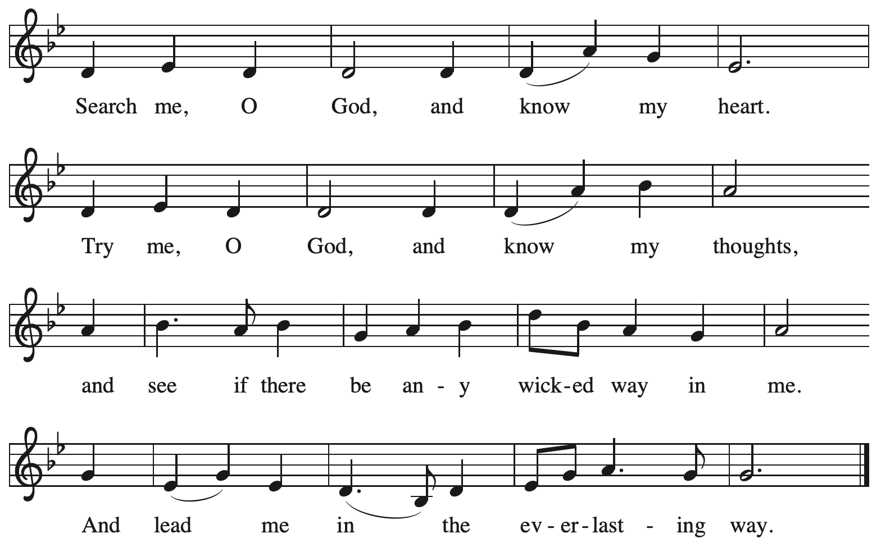

All rights reserved. Reprinted with permission under OneLicense.net # A-722139.
Greeting

P: The grace of our Lord Jesus Christ, the love of God,
and the communion of the Holy Spirit be with you all.
C: And also with you.

Hymn of Praise ACS p. 31

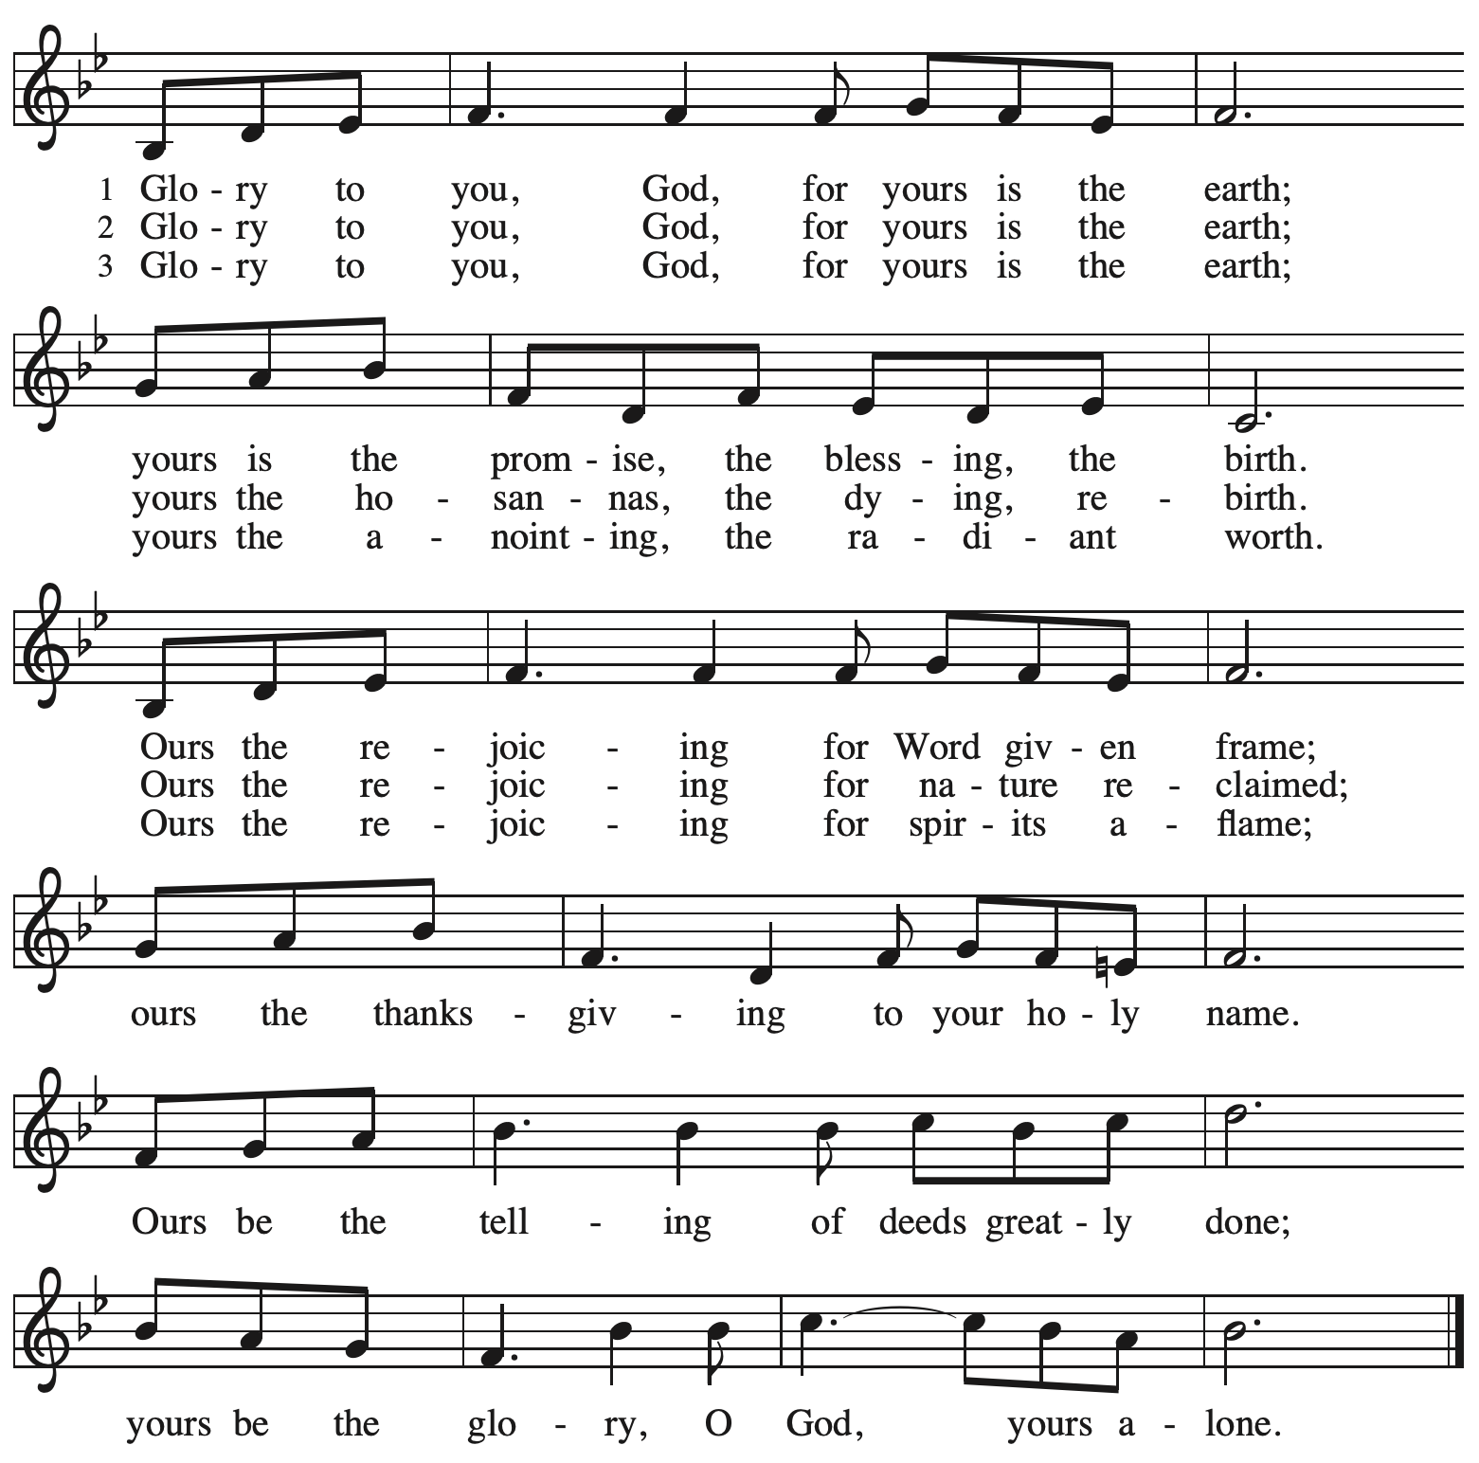

Prayer of the Day

P: The Lord be with you.
C: And also with you.

P: Let us pray.
God of compassion,
you have opened the way for us and brought us to yourself.
Pour your love into our hearts, that, overflowing with joy, we may freely share the blessings of your realm and faithfully proclaim the good news of your Son, Jesus Christ, our Savior and Lord.
C: Amen.

Please be seated.

Word
God speaks to us in Scripture reading, preaching, and song

First Reading – Exodus 19: 2-8a

² [The Israelites] journeyed from Rephidim, entered the wilderness of Sinai, and camped in the wilderness; Israel camped there in front of the mountain.³ Then Moses went up to God; the
Lord called to him from the mountain, “Thus you shall say to the house of Jacob and tell the Israelites: ⁴ ‘You have seen what I did to the Egyptians and how I bore you on eagles’ wings and brought you to myself. ⁵ Now, therefore, if you obey my voice and keep my covenant, you shall be my treasured possession out of all the peoples. Indeed, the whole earth is mine, ⁶ but you shall be for me a priestly kingdom and a holy nation.’ These are the words that you shall speak to the Israelites.”
⁷ So Moses went, summoned the elders of the people, and set before them all these words that the Lord had commanded him. ^{8a} The people all answered as one, “Everything that the Lord has spoken we will do.”

L: Word of God, word of life.
C: Thanks be to God.

Psalm 100

The psalm will be sung responsively, led by the cantor,
with the congregation responding with the bold verses and refrain.

Psalm Tone

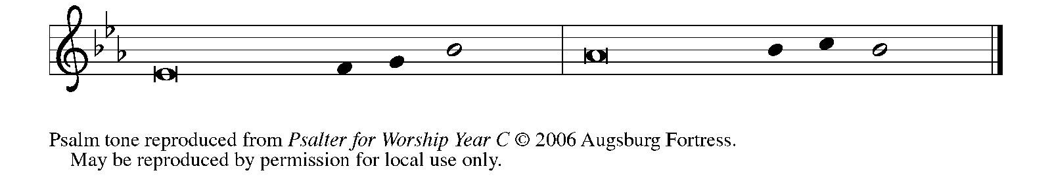

Psalm Refrain
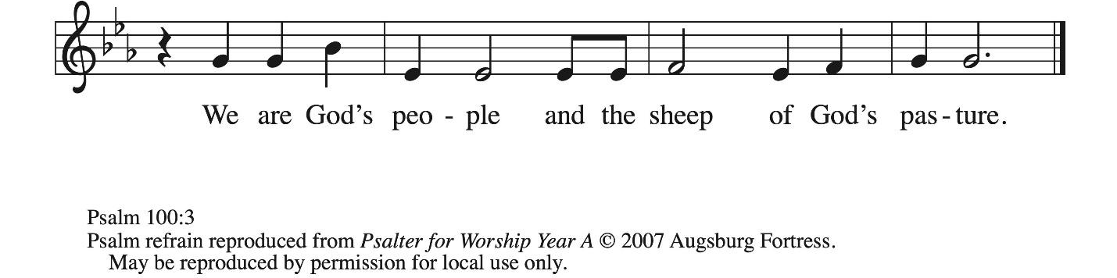

¹ Make a joyful noise to the Lord, | all you lands!
² Serve the Lord with gladness; come into God’s presence | with a song.
³ Know that the Lord is God, our maker to whom | we belong;
we are God’s people and the sheep | of God’s pasture. R
⁴ Enter the gates of the Lord with thanksgiving and the | courts with praise;
give thanks and bless God’s | holy name.
⁵ Good indeed is the Lord, whose steadfast love is | everlasting,
whose faithfulness endures from | age to age. R

Second Reading – Romans 5: 1-8

¹ Since we are justified by faith, we have peace with God through our Lord Jesus Christ,
² through whom we have obtained access to this grace in which we stand, and we boast in our hope of sharing the glory of God. ³ And not only that, but we also boast in our afflictions, knowing that affliction produces endurance, ⁴ and endurance produces character, and character produces hope, ⁵ and hope does not put us to shame, because God’s love has been poured into our hearts through the Holy Spirit that has been given to us.
⁶ For while we were still weak, at the right time Christ died for the ungodly. ⁷ Indeed, rarely will anyone die for a righteous person—though perhaps for a good person someone might actually dare to die. ⁸ But God proves God’s love for us in that while we still were sinners Christ died for us.

L: Word of God, word of life.
C: Thanks be to God.

Please rise as you are able.

Gospel Acclamation ACS p. 33\

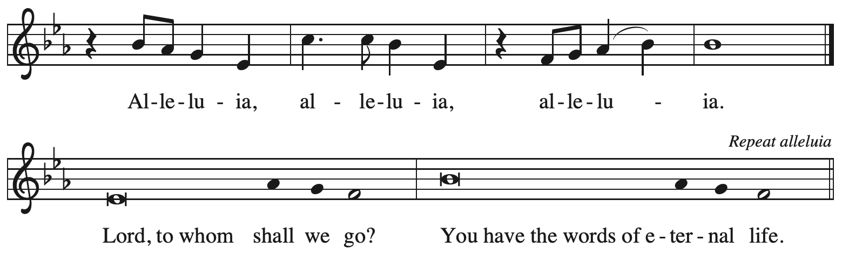

Gospel – Matthew 9: 35: 10: 8 [9-23]

P: The holy Gospel according to St. Matthew.
C: Glory to you, O Lord.

³⁵ Jesus went about all the cities and villages, teaching in their synagogues and proclaiming the good news of the kingdom and curing every disease and every sickness. ³⁶ When he saw the crowds, he had compassion for them because they were harassed and helpless, like sheep without a shepherd. ³⁷ Then he said to his disciples, “The harvest is plentiful, but the laborers are few; ³⁸ therefore ask the Lord of the harvest to send out laborers into his harvest.”
^{10:1} Then Jesus summoned his twelve disciples and gave them authority over unclean spirits, to cast them out, and to cure every disease and every sickness. ² These are the names of the twelve apostles: first, Simon, also known as Peter, and his brother Andrew; James son of Zebedee and his brother John; ³ Philip and Bartholomew; Thomas and Matthew the tax collector; James son of Alphaeus and Thaddaeus; ⁴ Simon the Cananaean and Judas Iscariot, the one who betrayed him.
⁵ These twelve Jesus sent out with the following instructions: “Do not take a road leading to gentiles, and do not enter a Samaritan town, ⁶ but go rather to the lost sheep of the house of Israel. ⁷ As you go, proclaim the good news, ‘The kingdom of heaven has come near.’ ⁸ Cure the sick; raise the dead; cleanse those with a skin disease; cast out demons. You received without payment; give without payment. [⁹ Take no gold, or silver, or copper in your belts, ¹⁰ no bag for your journey, or two tunics, or sandals, or a staff, for laborers deserve their food. ¹¹ Whatever town or village you enter, find out who in it is worthy, and stay there until you leave. ¹² As you enter the house, greet it. ¹³ If the house is worthy, let your peace come upon it, but if it is not worthy, let your peace return to you. ¹⁴ If anyone will not welcome you or listen to your words, shake off the dust from your feet as you leave that house or town. ¹⁵ Truly I tell you, it will be more tolerable for the land of Sodom and Gomorrah on the day of judgment than for that town.
¹⁶ “I am sending you out like sheep into the midst of wolves, so be wise as serpents and innocent as doves. ¹⁷ Beware of them, for they will hand you over to councils and flog you in their synagogues, ¹⁸ and you will be dragged before governors and kings because of me, as a testimony to them and the gentiles. ¹⁹ When they hand you over, do not worry about how you are to speak or what you are to say, for what you are to say will be given to you at that time, ²⁰ for it is not you who speak, but the Spirit of your Father speaking through you. ²¹ Sibling will betray sibling to death and a father his child, and children will rise against parents and have them put to death, ²² and you will be hated by all because of my name. But the one who endures to the end will be saved. ²³ When they persecute you in this town, flee to the next, for truly I tell you, you will not have finished going through all the towns of Israel before the Son of Humanity comes.”]

P: The Gospel of the Lord.
C: Praise to you, O Christ.

Please be seated.

Sermon

A time of silence for prayer and reflection follows the sermon.
When the hymn of the day begins, please rise as you are able.



Hymn of the Day Lord, You Give the Great Commission ELW 579

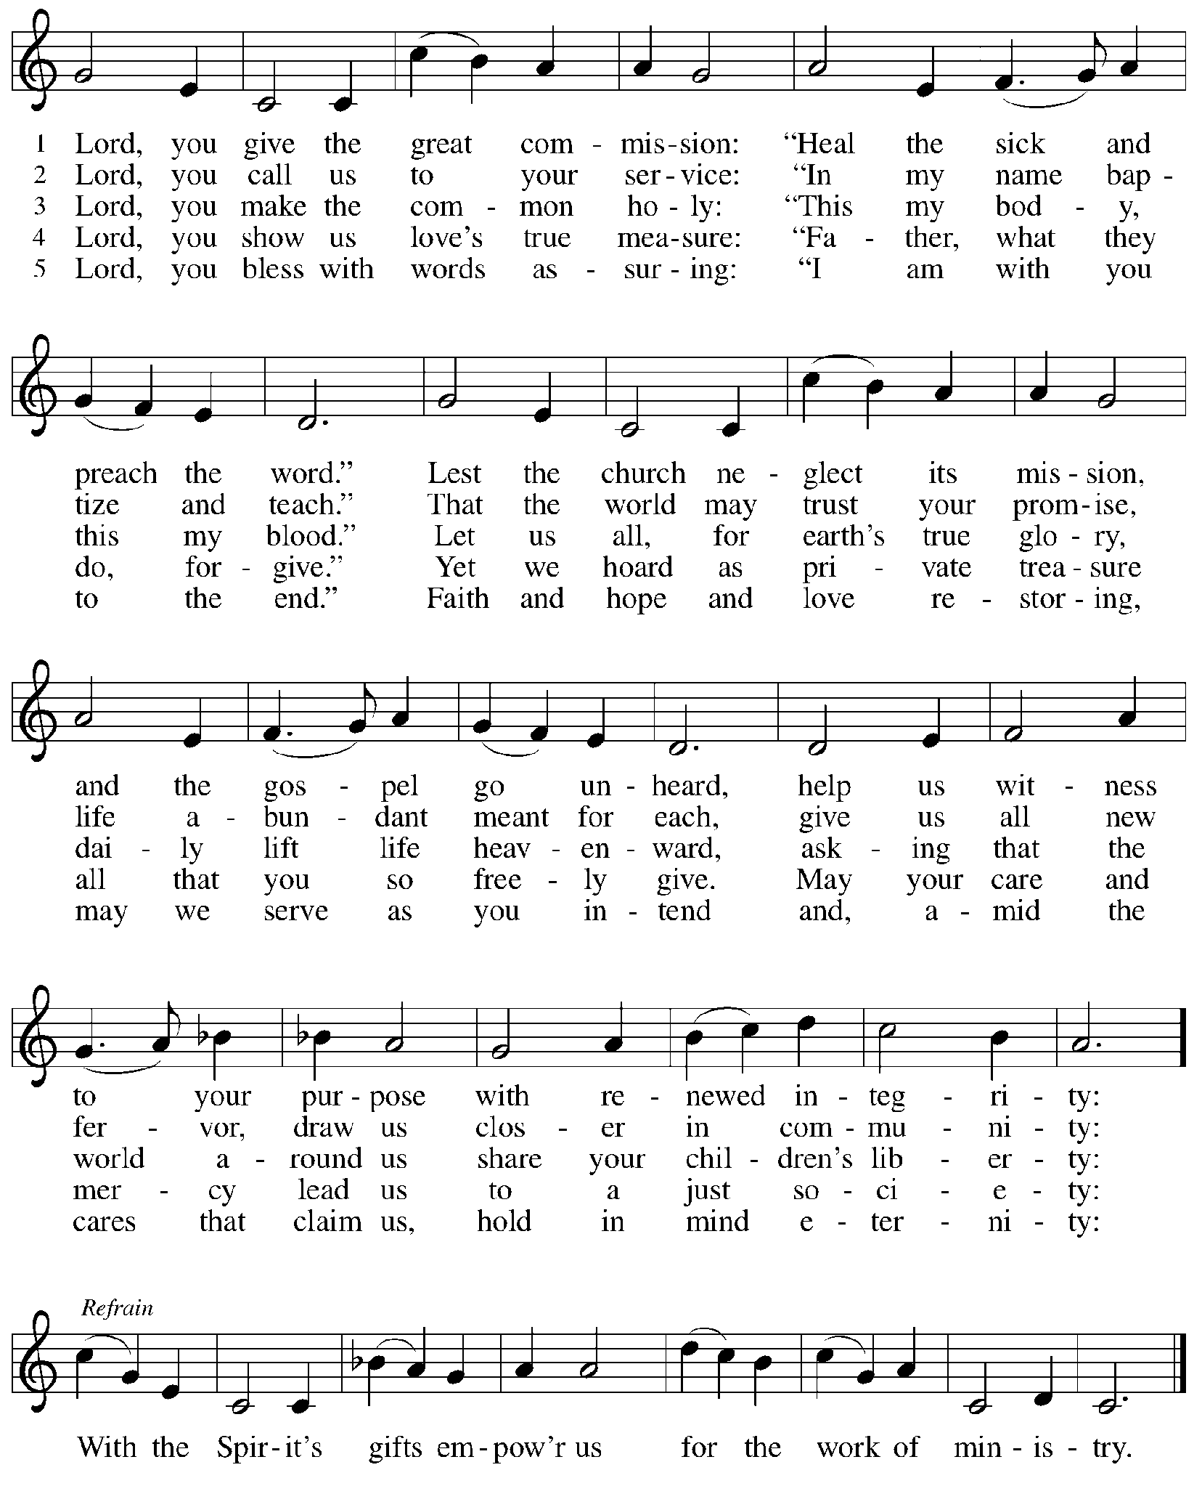

Apostles’ Creed

C: I believe in God, the Father almighty,
creator of heaven and earth.

I believe in Jesus Christ, God’s only Son, our Lord,
who was conceived by the Holy Spirit,
born of the virgin Mary,
suffered under Pontius Pilate,
was crucified, died, and was buried;
he descended to the dead.*
On the third day he rose again;
he ascended into heaven,
he is seated at the right hand of the Father,
and he will come to judge the living and the dead.

I believe in the Holy Spirit,
the holy catholic church,
the communion of saints,
the forgiveness of sins,
the resurrection of the body,
and the life everlasting. Amen.

*Or, “he descended into hell,” another translation of this text in widespread use.

Prayers of the People

A: Gathered by the Holy Spirit, let us pray for the church, the world,
and all people according to their need.

After each petition
A: God of grace,
C: receive our prayer.

The presiding minister concludes the prayers
P: Trusting that you receive all our prayers,
we commend our spoken and unspoken petitions to you, O God,
through Jesus Christ our Savior.
C: Amen.

Peace

The presiding minister and the assembly greet one another in the peace of the risen Christ.
P: The peace of Christ be with you always.
C: And also with you.

The people may greet those around them with a sign of Christ’s peace and may say
Peace be with you or similar words. Please be mindful that not everyone will be comfortable with sharing the peace, so please seek consent before shaking hands or hugging. Other possible ways to share the peace include a simple bow with the verbal greeting of peace, or simply a verbal expression of peace. When the greetings of peace have concluded, please be seated.



Meal
God feeds us with the presence of Jesus Christ

Offering

We offer ourselves, our gifts, and our faithful service to God.
As the offering is gathered for the mission of the church, including the care of those in need,
the table is set for Holy Communion.

There are laminated giving cards in the pew racks that feature a QR code for anyone who would like to give online. Those who give using the QR code, as well as those who give regularly online or through their bank are encouraged to place the laminated card in the plate as an expression of your offering.

Music during the Offering
Jesus Calls Us arr. Smith

As the gifts are brought forward for presentation, please rise as you are able.

Offertory Song Timothy Kocher-Hillmer

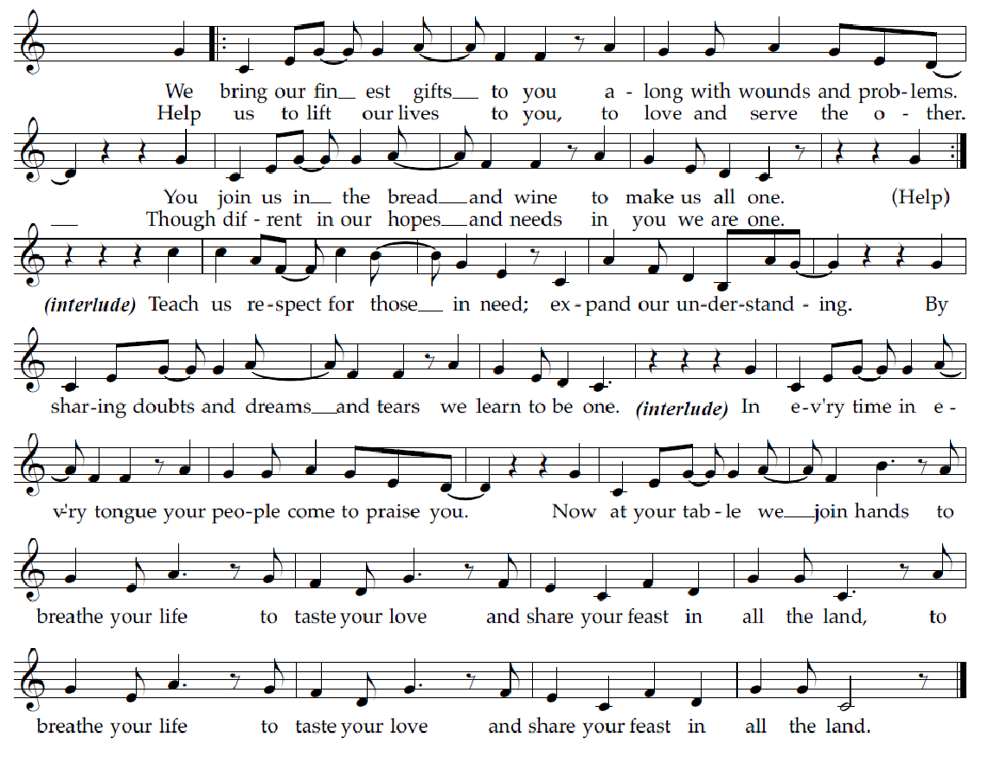

Offertory Prayer

A: Let us pray.
God of goodness and growth,
C: all creation is yours, and your faithfulness is sure.
Word and water, wine and bread: these are signs of your abundant grace.
Receive the gifts we bring,
and nourish us to proclaim your abiding love in our communities and in the world,
through Jesus Christ, our strength and our song.
Amen.

Dialogue ACS p. 36

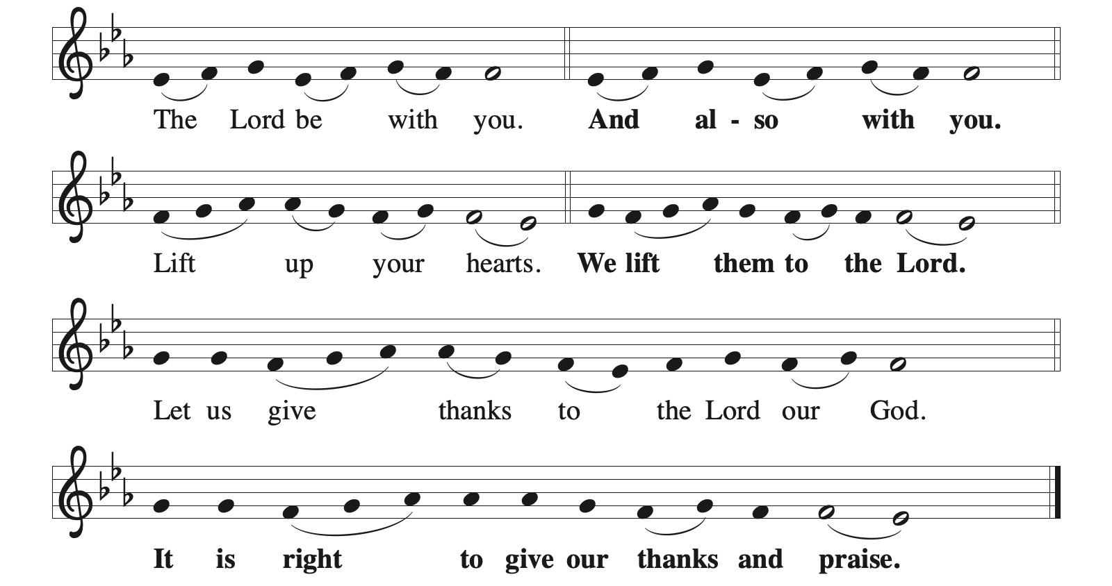

Preface (Sung by the presiding minister)

P: It is indeed right, our duty and our joy,
that we should at all times and in all places
give thanks and praise to you, almighty and merciful God,
through our Savior Jesus Christ;
who on this day overcame death and the grave,
and by his glorious resurrection opened to us the way of everlasting life.
And so, with all the choirs of angels,
with the church on earth and the hosts of heaven,
we praise your name and join their unending hymn:

Sanctus ACS p. 36

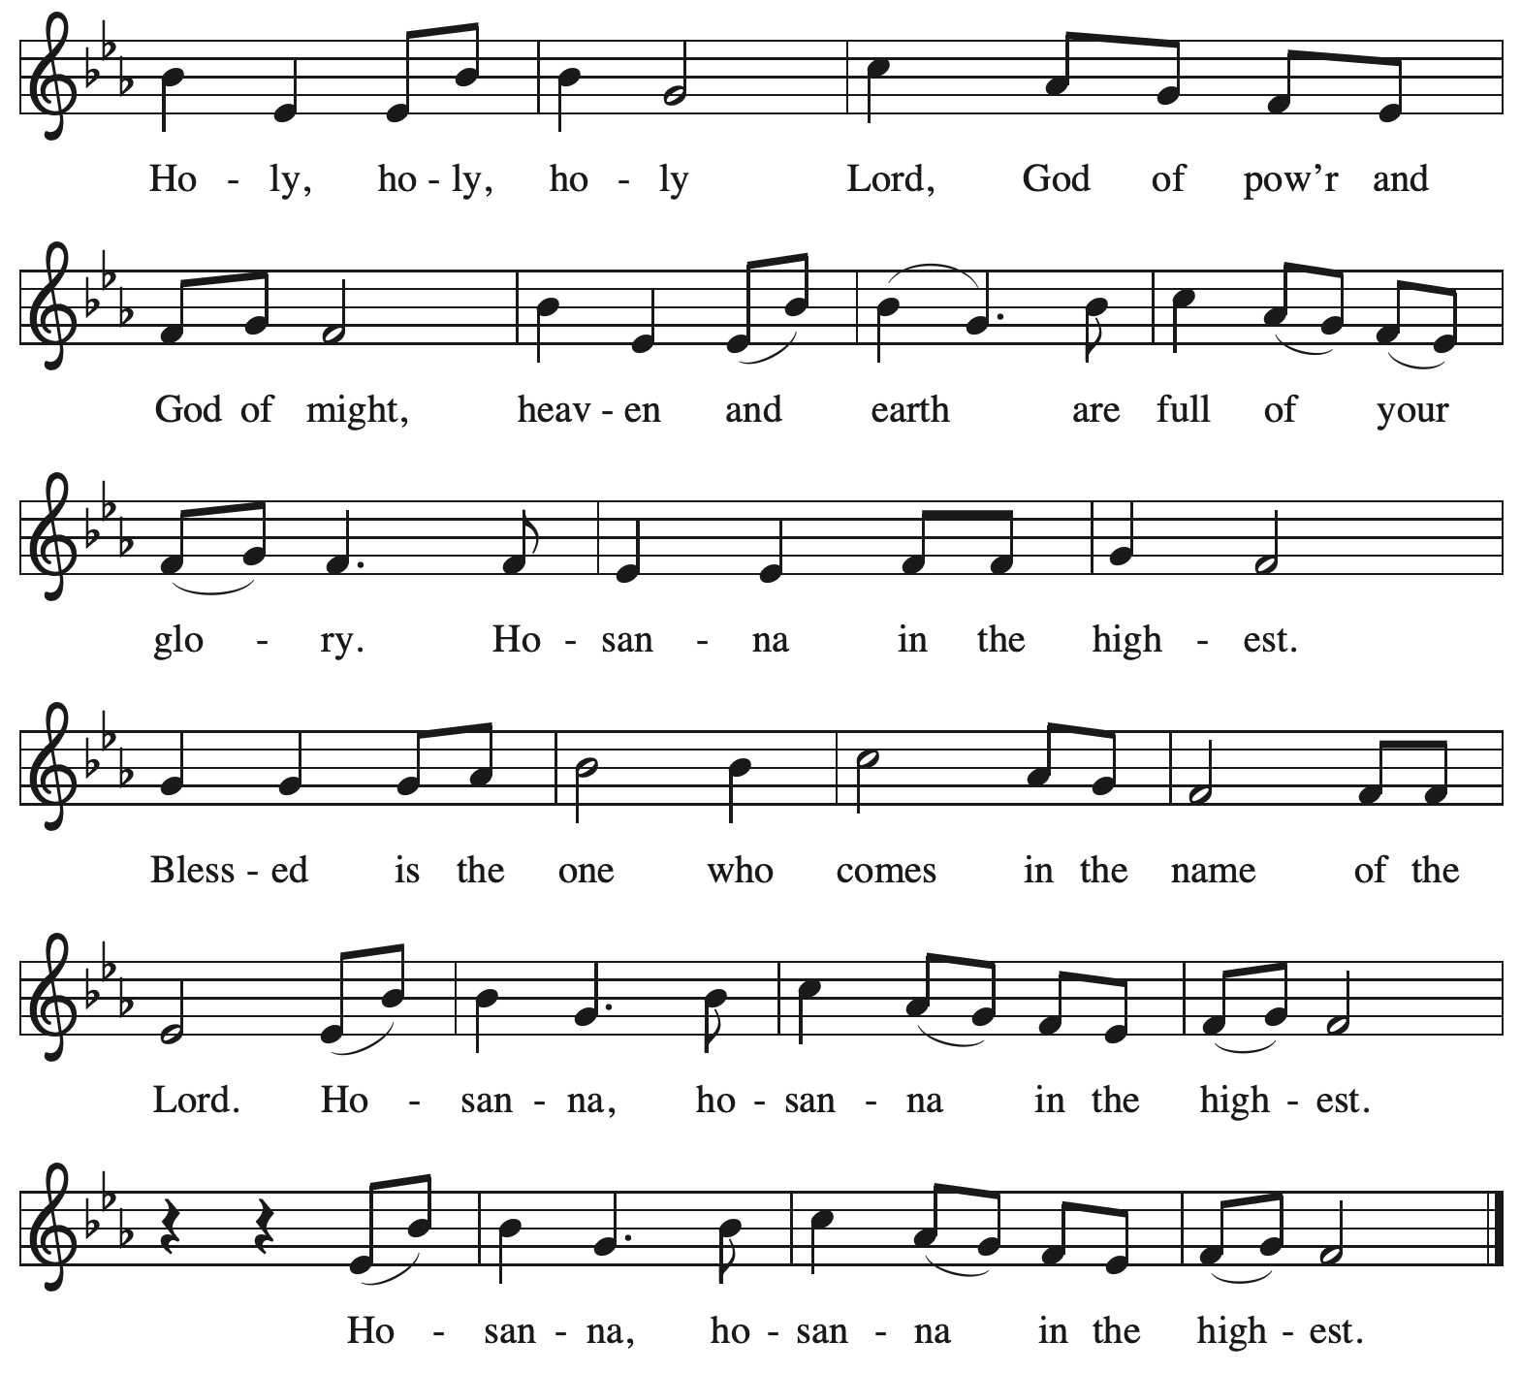

Eucharistic Prayer

P: O God triune, how majestic is your name in all the earth …
… The earth is full of your glory.
C: The earth is full of your glory.

P: O God triune, you made a home among us in Jesus our healer …
… The earth is full of your glory.
C: The earth is full of your glory.

P: We praise you for the heart of Jesus, so filled with your love for the world …
… Do this for the remembrance of me.
Gathered around your table, we your children unite in this song:
The earth is full of your glory.
C: The earth is full of your glory.

P: O God triune, you create the worlds, you uphold the living, you embrace the dead …
… The earth is full of your glory.
C: The earth is full of your glory.

P: Amen and Amen.
C: Amen and Amen.

Lord’s Prayer

P: Gathered as one by the Holy Spirit, let us pray as Jesus taught us.
C: Our Father in heaven,
hallowed be your name,
your kingdom come,
your will be done,
on earth as in heaven.
Give us today our daily bread.
Forgive us our sins
as we forgive those
who sin against us.
Save us from the time of trial
and deliver us from evil.
For the kingdom, the power,
and the glory are yours,
now and forever. Amen.

Fraction and Invitation



Agnus Dei / Lamb of God ACS p. 40

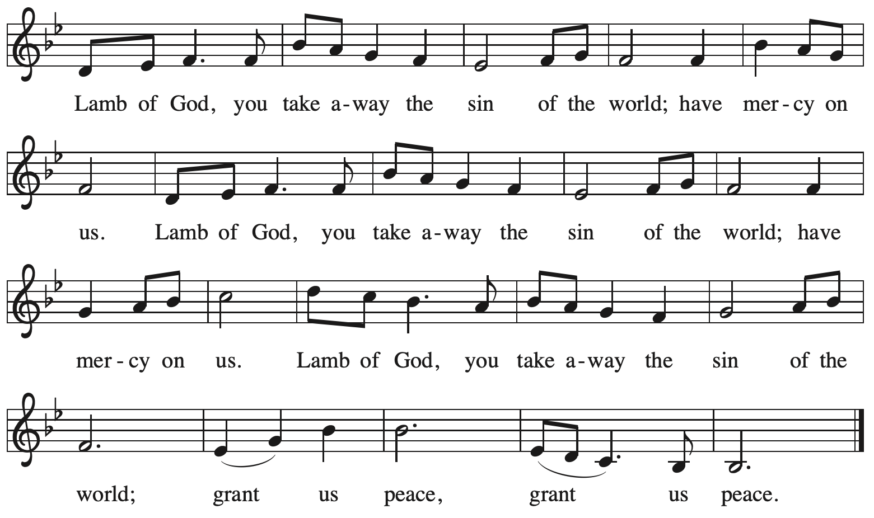

Please be seated.

Holy Communion

- All who seek God and desire a deeper and stronger life in Christ are welcome to receive Holy Communion.
- Worshipers from the pulpit side will proceed forward first, followed by the center section, and then the lectern side.
- Please inform an usher if you would like the ministers to bring Communion to you.
- Holy Communion will be served with bread and wine (red) or grape juice (white).
- The presiding minister will first distribute the bread (host) to each communicant. Please indicate if you require a gluten-free host.
- Once you have consumed the bread, please pick up an empty glass from the tray next to the presiding minister. The Communion Assistant will pour wine or grape juice into your glass.
- Please step to the side to consume the wine or grape juice.
- Feel free to kneel at the altar rail for prayer after receiving the sacrament.
- As you return to your pew, glasses may be returned to the empty tray on the side of the center section.
- A blessing will be provided for anyone who does not yet receive the sacrament.
- All are invited to join in singing the hymns during Holy Communion.

Hymns during Holy Communion
Faith Begins by Letting Go ACS 1104

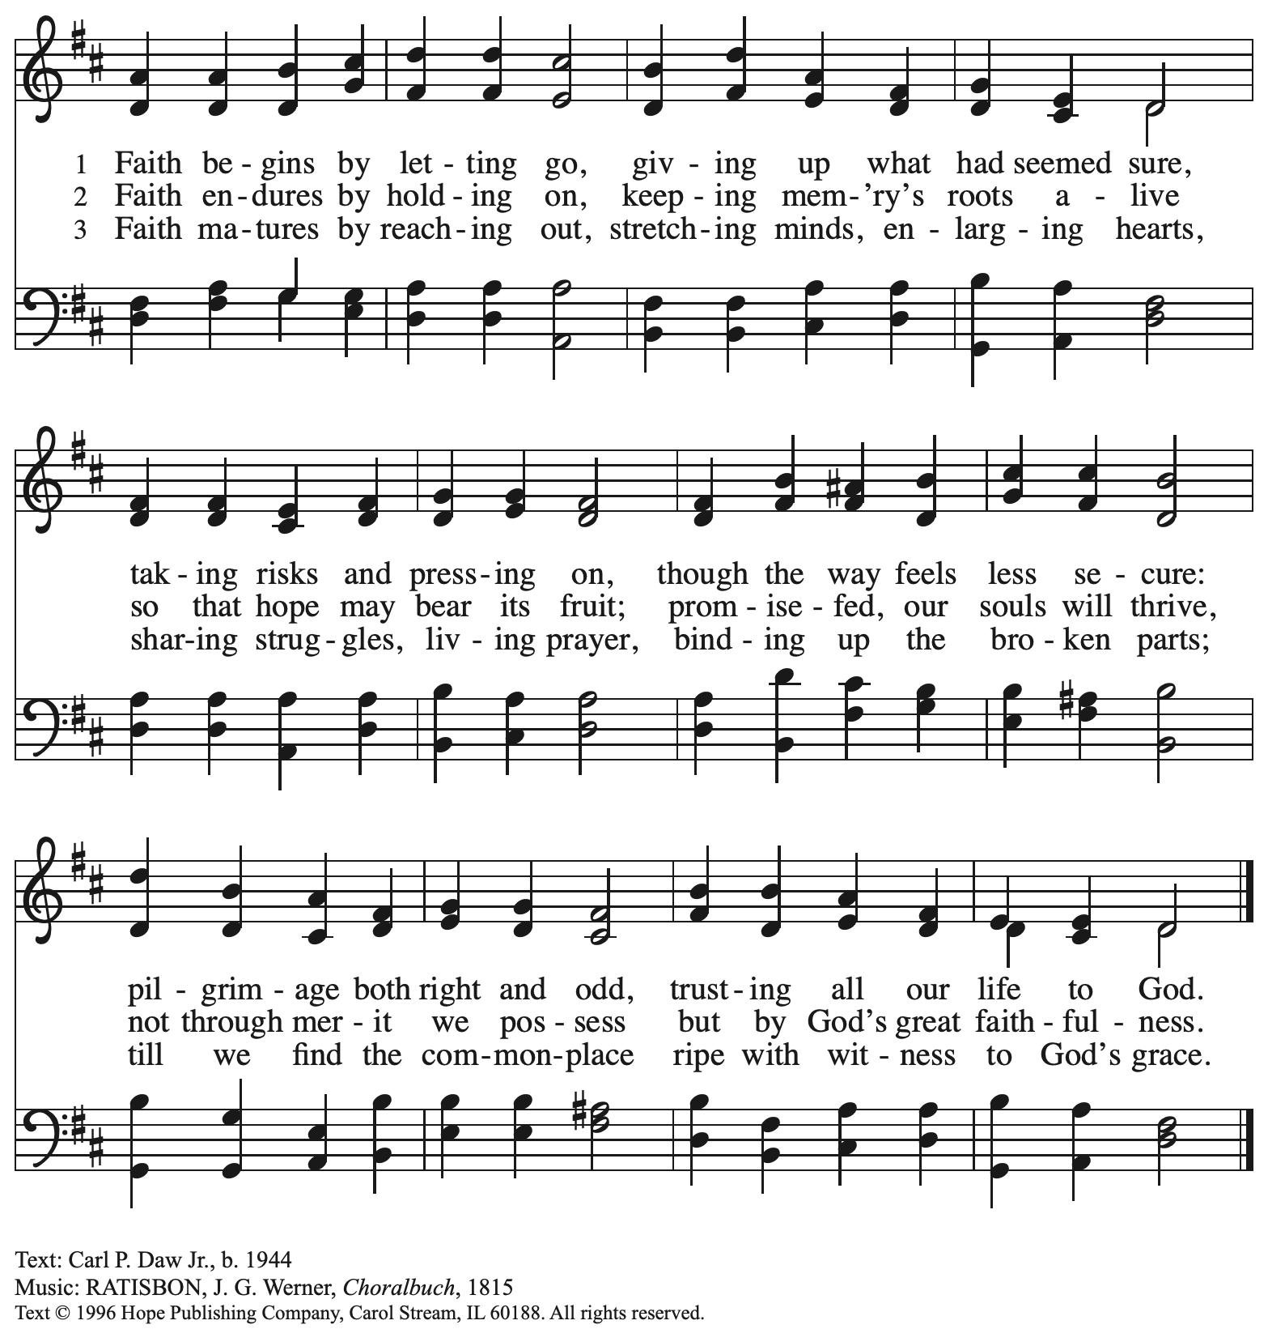
Reprinted with permission under OneLicense.net # A-722139.

Hymns during Holy Communion
On Eagle’s Wings ELW 787

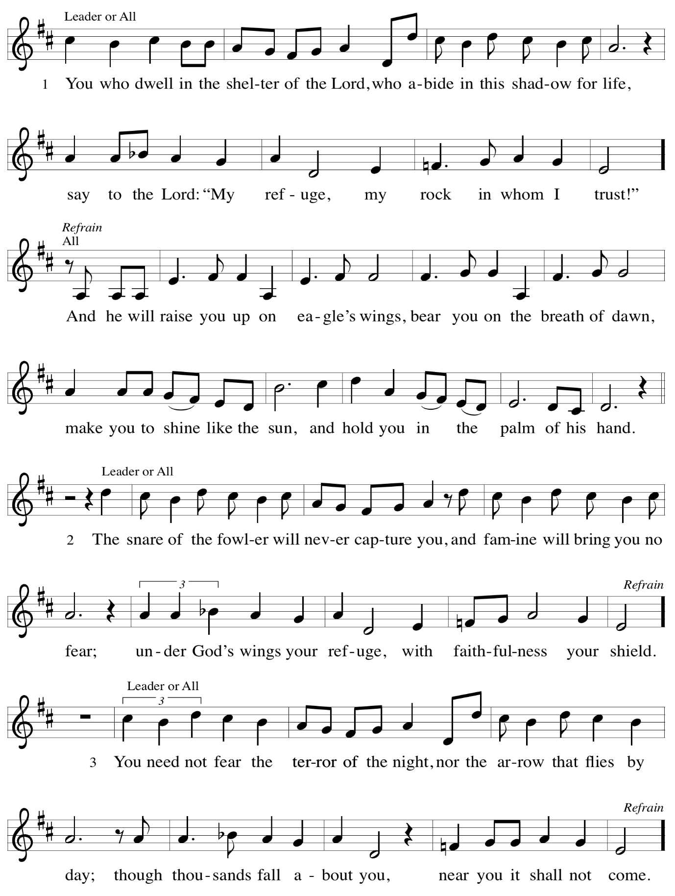
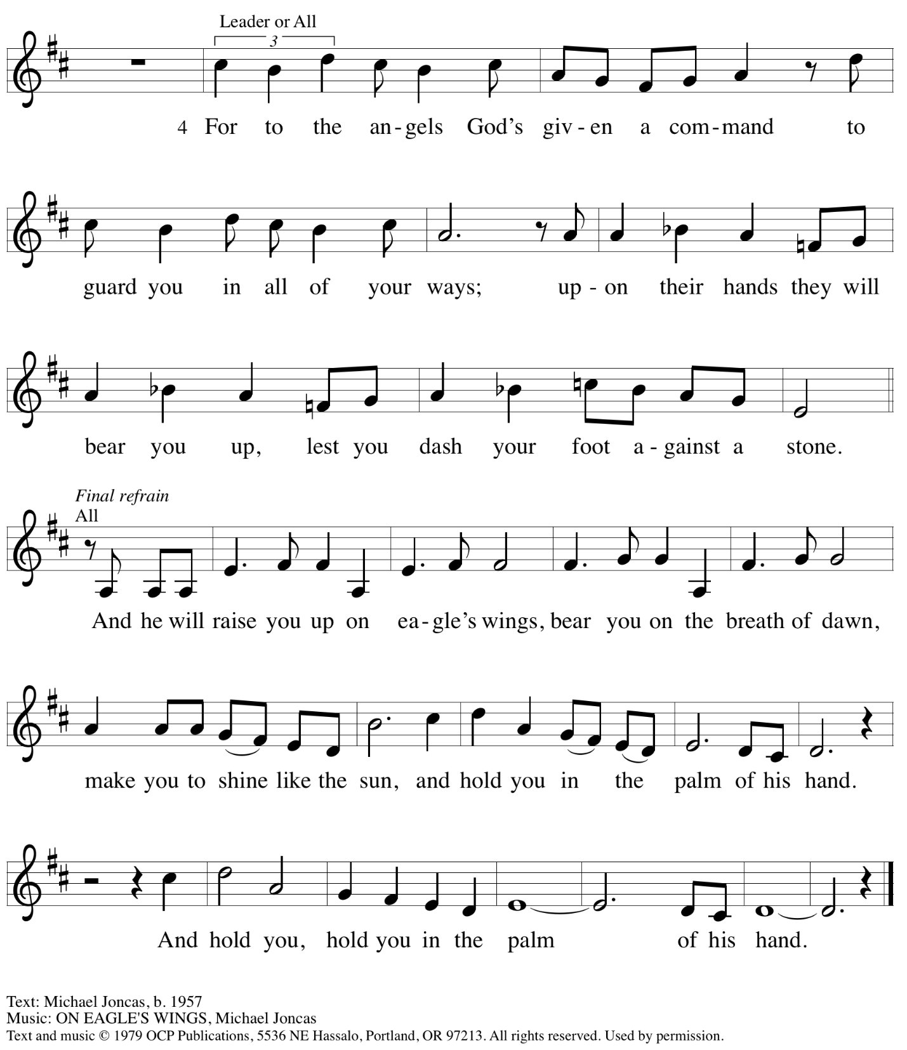
Reprinted under OneLicense.net # A-722139.

Hymns during Holy Communion
Now the Meal Is Over ACS 983

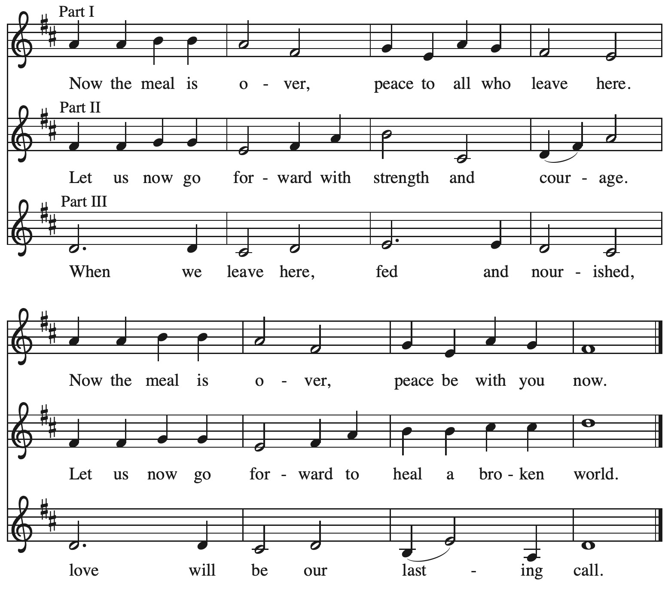
All rights reserved. Reprinted with permission under OneLicense.net # A-722139.

When all have returned to their places, please rise as you are able.

Blessing

P: The body and blood of our Lord Jesus Christ strengthen you and keep you in his grace.
C: Amen.
Prayer

A: Let us pray.
Life-giving God,
through this meal you have made your home among us
and are making all things new.
Send us now to speak peace to anxious hearts,
to love our neighbors, and to bring your healing to the nations,
through Jesus Christ, our Savior.
C: Amen.

Please be seated.

Sending
God blesses us and sends us in mission to the world

Announcements

Please rise as you are able.

Benediction

P: God Almighty, who is the beginning and the end,
Jesus Christ, the firstborn of the dead,
and the Spirit, our advocate and peace,
☩ bless you now and forever.
C: Amen.

Sending Hymn Following Page

Dismissal

A: Go in peace. Build Community Together!
C: Thanks be to God!

Postlude

Sending Hymn Hallelujah! We Sing Your Praises ELW 535

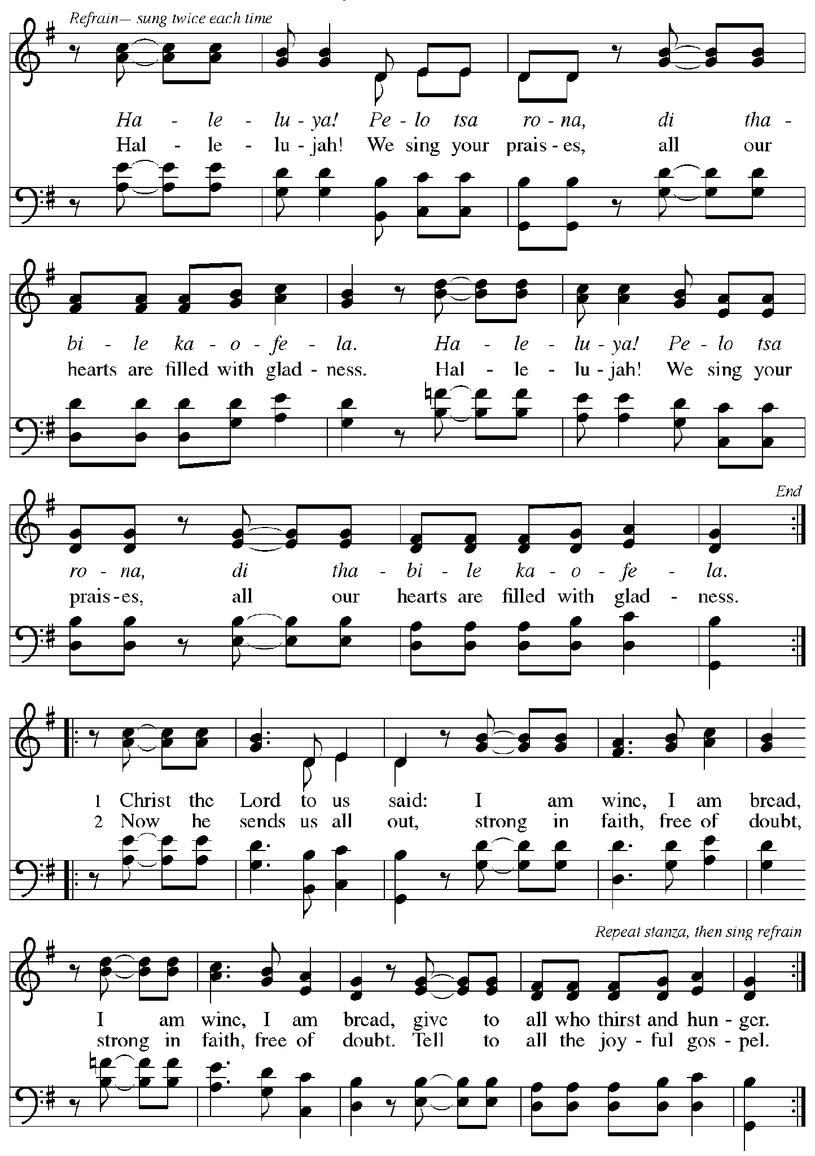

Those serving in worship today

Altar Care Jodie Minor
Assisting Minister Colleen Cooke
Audio-Visual Ministers Sarita
Dave Rollinson
Cantor Joseph Paetz
Lector Lindsay Baxter
Minister of Music Laura Reynolds
Presiding Minister The Rev. Ross I. Carmichael

Liturgy and Hymnody Acknowledgements

From SundaysandSeasons.com. Copyright © 2026 Augsburg Fortress. All rights reserved. Reprinted under OneLicense.net # A-722139.
Used by permission of Augsburg Fortress.

The Scripture readings contained herein are from New Revised Standard Version Updated Edition of the Bible © 2021 National Council of Churches of Christ in the United States of America. Used by permission. All rights reserved worldwide.

Lord, You Give the Great Commission – Text: Jeffery Rowthorn, b. 1934. Music: ABBOT’S LEIGH, Cyril V. Taylor, 1907-1991. Text © 1978 and music © 1942, ren. Hope Publishing Company, Carol Stream, IL 60188. All rights reserved. Reprinted with permission under OneLicense.net # A-722139.

Hallelujah! We Sing Your Praises – Text: South African; tr. Freedom Is Coming, 1984. Music: HALELUYA! PELO TSA RONA, South African; arr. Freedom Is Coming. English text and arr. © 1984 Utryck, admin. Walton Music Corp. All rights reserved. Reprinted with permission under OneLicense.net # A-722139.

Please use the QR code below to link to St. Andrew’s Announcements online!



St. Andrew Lutheran Church Announcements
June 14th, 2026

- Welcome to Worship at St. Andrew on the Third Sunday after Pentecost – We are so glad you are here, and we offer a special welcome to all visitors and guests who are here for the first time! There are worship “toolkits” to help children engage with worship and “busy bags” for younger children available in the bookcase at the back of the sanctuary. Please feel free to take one to use with/for your children. A nursery is available through the door to the left of the worship space and across the social hall (look for a purple room). All are invited to gather for coffee, other drinks, food, and conversation in the social hall after worship.
- Commemoration of the Emanuel Nine, Martyrs, June 17th, 2015 – Worship this week begins on a solemn note as we remember the Emanuel Nine, the saints of God whose lives were taken by a gunman during their Bible study at Mother Emanuel African Methodist Episcopal (AME) Church in Charleston, SC on June 17th, 2015. We confess and lament the sins of racism and white supremacy that continue to harm God's people, the church, and our society, and we dedicate ourselves anew to the work of repentance, reconciliation, restoration, and repair, especially with our siblings in Christ in the AME Church.
- “Freedom. Faith. Harvest.” - A Holy Day of Worship, Fellowship, and the Blessing of the Garden at Bethel AME Church, Sunday, June 14th, 11:00 a.m – Bethel AME Church presents their Juneteenth celebration to include an 11:00 a.m. morning worship, which includes a celebration of liberation, song, and the preached Word from Bishop Melissa Stoller. After worship, there will be a Community Dinner in the Fellowship Hall. After dinner, there will be a blessing of the community garden, a consecration of the seeds, equipment, and the hands that tend it from Dr. Kate Walker of the First Unitarian Church of Pittsburgh, and a “Libation Ceremony” led by the Ujamaa Collective. Bethel AME church is located at 2720 Webster Ave., Pittsburgh, PA 15219.
- Produce Distribution Supplemental Food of the Month – St. Andrew collects supplemental food each month to accompany our produce distribution. For June, we ask for donations of rice.
- Produce Distribution, Third Tuesday Each Month, June 16th from 5:30 to 6:30 p.m. – St. Andrew partners with Greater Pittsburgh Community Food Bank to serve as a distribution site for fresh produce on the first and third Tuesday of every month. We invite people of the congregation to help with the distribution from 5:30 p.m. to 6:30 p.m. and/or to help with unloading and setup during the day between 10:00 a.m. and 1:00 p.m.
- Pride Month Celebrations - Millvale Pride, Saturday, June 20th, 10:00 a.m. to 6:00 p.m. – Every June is celebrated as Pride month to commemorate years of struggle for civil rights and the ongoing pursuit of justice for the LGBTQIA+ community in the face of police brutality and systemic disenfranchisement. St Andrew is sponsoring a booth at Millvale Pride on June 20th starting at 12:00 p.m. You can sign up to volunteer here: https://www.signupgenius.com/go/5080B4AAFAF2CABF85-63577363-pittsburgh.
- Noisy Offering, Next Sunday, June 21st, during Worship – On the third Sunday of each month, St. Andrew’s children lead the congregation in a Noisy Offering, in which people are invited to throw their change into buckets that the children carry around the church and bring forward as an additional offering. Each month’s Noisy Offering supports a local, national, or international church-related or otherwise charitable organization. This month’s offering will go to support Proud Haven, whose mission is to provide a safe shelter for LGBTQIA+ youth (ages 18-25) experiencing homelessness in Pittsburgh. For more about their work, please visit https://proudhaven.org/.
- Reckoning with Antisemitism: Reflections at One Year, Wednesday, June 24th at 7:00 p.m. – Gather on June 24th at Beit Kulanu (Formerly Rodef Shalom - 4905 Fifth Avenue, Pittsburgh, PA 15213) for an evening of celebration and reflection on the past year of the Reckoning with Antisemitism as Christians project. Over the past 12 months, Christian clergy and lay leaders across Southwestern PA have been engaging with this new project co-founded by Christian Associates of Southwest PA and the Holocaust Center of Pittsburgh. We will hear from Christians who have been reckoning with antisemitism and from Jews who have taken part in their efforts. We will also share (for the first time!) a published book of sermons written by local Christian clergy who have engaged their congregations and communities in conversations about antisemitism, from the pulpit and beyond. You can register to attend using this link: https://www.eventbrite.com/e/reckoning-with-antisemitism-as-christians-reflections-at-one-year-tickets-1988560210119.

