

+ Fourth Sunday after Pentecost
June 21, 2026


St. Andrew Lutheran Church
304 Morewood Ave.
Pittsburgh, PA 15213
St_andrewELCA@verizon.net
www.standrewpittsburgh.org
+ Fourth Sunday after Pentecost

God does not promise that the path of the disciple will be easy. Jeremiah feels the pain of rejection from those who do not want to hear what he has to say. Jesus declares that his words may bring stark division. Even so, we need not be afraid, for God accounts for each hair on our heads. Though we may experience rejection, frustration, division, and death, God’s grace and love make us a new creation each day. Marked with the cross and filled with holy food, we are sent from worship to witness to Christ in the world.

Welcome to St. Andrew!

- St. Andrew welcomes all who are seeking a place of healing, wholeness, and acceptance in a nurturing and faith-forming spiritual home. We are striving toward racial equity worldwide
and we seek to honor the lived experience of all individuals regardless of background. Our community embraces people of all ages, ethnicities, cultures, abilities, sexual orientations,
gender identities and expressions, and family constellations. Come and See!
- Worship Services are live-streamed to multiple online platforms. By attending worship, you agree that your image and voice may be broadcast.
- Everyone is invited to make a name tag at the black bookcase in the back of the worship space if they would like. There are stickers indicating pronouns on the bookcase if you would like to include them on your name tag.
- Little Church – Big Faith is on break for the summer.
- A nursery is available through the doors at the left side of the sanctuary and across from the doorway to the Social Hall. Look for a purple-colored room.
- Worship “toolkits” to help children engage with the service, along with “busy bags” for younger children, are available in the bookcase at the back of the sanctuary. Please feel free to take one to use with/for your children.
- Holy Communion is served with bread (gluten-free available) and wine or grape juice. The presiding minister will distribute the bread (host). Please consume this and then pick up an empty glass from the tray. The Communion Assistant will pour wine or grape juice into your glass. Please step to the side to consume the wine or grape juice. Feel free to kneel at the altar for prayer and reflection. As you return to your pew, glasses may be returned to the empty trays on either side of the center section.
- A restroom is available on the main level of the church, through the doors to the Social Hall and to the right in the main office.

Abbreviations
P: Pastor/Presiding Minister ELW: Evangelical Lutheran Worship hymnal
A: Assisting Minister ACS: All Creation Sings hymnal
L: Lector TFF: This Far by Faith hymnal
C: Congregation

Musical Offering

Each week, different people from the congregation make an offering of pre-service music, with singing or instrumentation, to help the assembly focus and pray in preparation for worship.

Welcome
Prelude
They'll Know We Are Christians By Our Love arr. Hayes

Gathering
The Holy Spirit calls us together as the people of God

Please rise as you are able. All may make the sign of the cross,
the sign that is marked at Baptism, as the presiding minister begins.

Confession and Forgiveness ACS p. 29

P: Blessed be the holy Trinity, ☩ one God,
who looks upon us in compassion,
forgives our sin, and heals our lives.
C: Amen.

P: Let us confess our sin in the presence of God and of one another.

P: Have mercy, O God,
C: for we have sinned against you
and our neighbor.
In your compassion,
cleanse us from our sin
and take away our guilt.
Create in us a new heart
and give us a steadfast spirit.
Do not cast us away,
but fill us with your Holy Spirit
and restore your joy within us.
Amen.

P: As tender as parent to child,
so deep is God’s compassion for you.
As high as heaven is above earth, so vast is God’s love for you.
As far as east is from west, so far God removes your sin from you,
renewing your life through Jesus Christ.
Blessed be God who crowns us with mercy and love.
C: Blessed be God forever. Amen.

Gathering Hymn God of Grace and God of Glory ELW 705

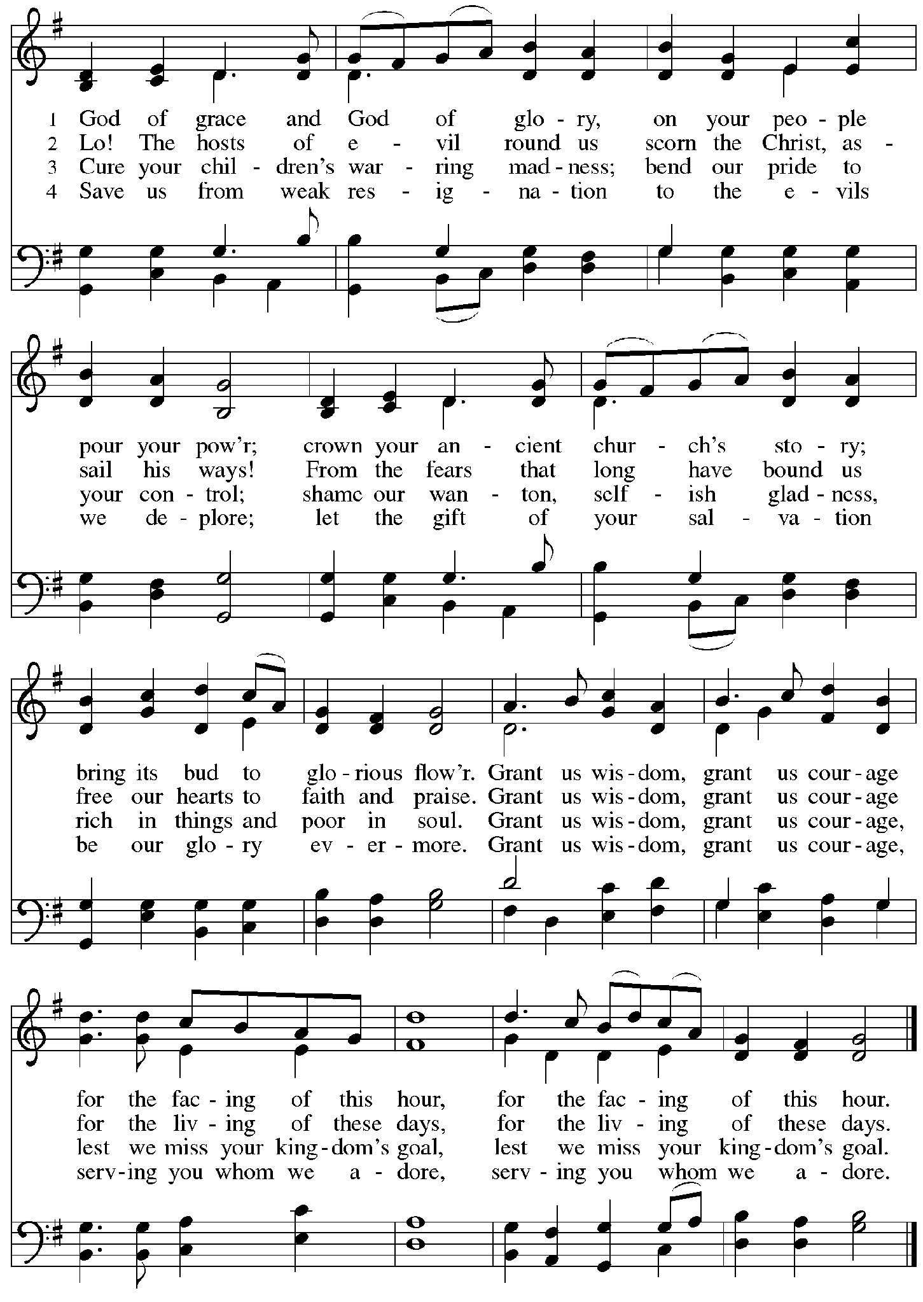

Greeting

P: The grace of our Lord Jesus Christ, the love of God,
and the communion of the Holy Spirit be with you all.
C: And also with you.

Hymn of Praise Glory to You, God ACS p. 31

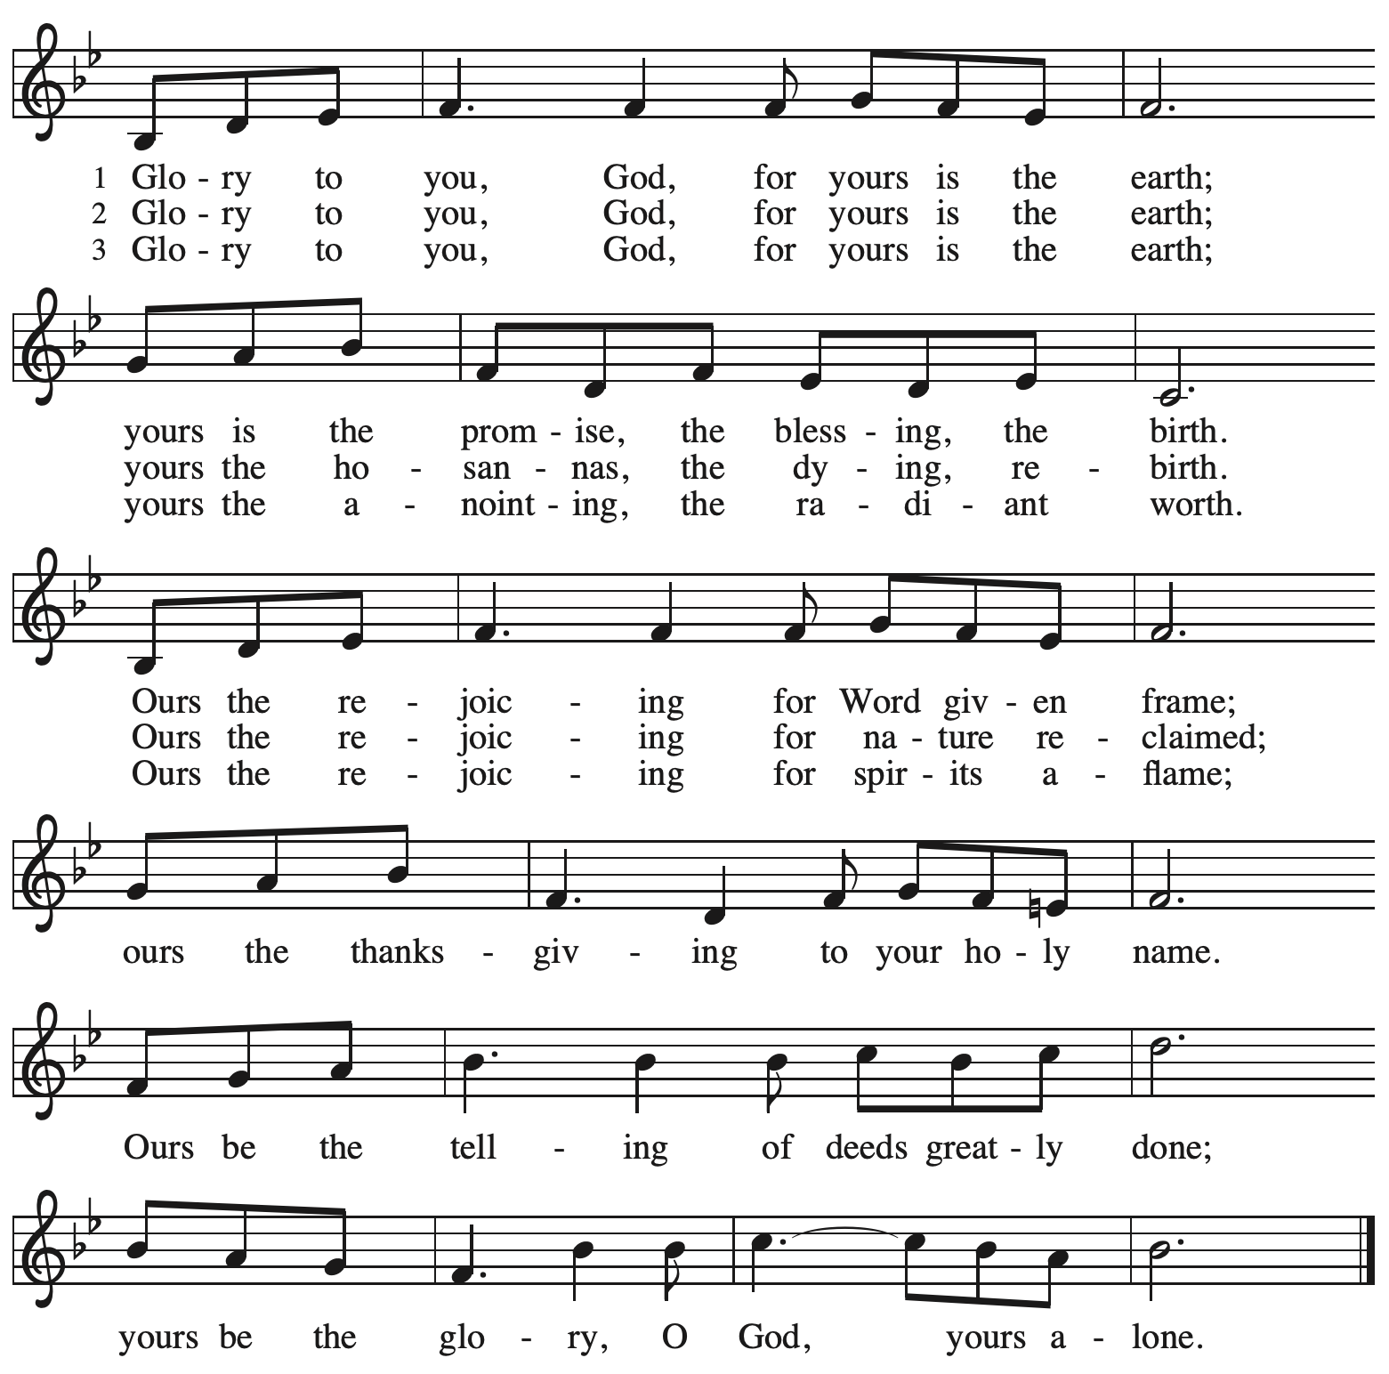

Prayer of the Day

P: The Lord be with you.
C: And also with you.
P: Let us pray.
Teach us, good Lord God, to serve you as you deserve, to give and not to count the cost,
to struggle and not to heed the wounds, to toil and not to seek for rest,
to labor and not to ask for reward, except that of knowing that we do your will,
through Jesus Christ, our Savior and Lord.
C: Amen.

Please be seated.

Word
God speaks to us in Scripture reading, preaching, and song

First Reading – Jeremiah 20: 7-13

⁷ O Lord, you have enticed me,
and I was enticed;
you have overpowered me,
and you have prevailed.
I have become a laughingstock all day long;
everyone mocks me.
⁸ For whenever I speak, I must cry out;
I must shout, “Violence and destruction!”
For the word of the Lord has become for me
a reproach and derision all day long.
⁹ If I say, “I will not mention the Lord
or speak any more in God’s name,”
then within me there is something like a burning fire
shut up in my bones;
I am weary with holding it in,
and I cannot.
¹⁰ For I hear many whispering:
“Terror is all around!
Denounce him! Let us denounce him!”
All my close friends
are watching for me to stumble.
“Perhaps he can be enticed,
and we can prevail against him
and take our revenge on him.”

¹¹ But the Lord is with me like a terrifying warrior;
therefore my persecutors will stumble,
and they will not prevail.
They will be greatly shamed,
for they will not succeed.
Their eternal dishonor
will never be forgotten.
¹² O Lord of hosts, you test the righteous;
you see the heart and the mind;
let me see your retribution upon them,
for to you I have committed my cause.
¹³ Sing to the Lord;
praise the Lord!
For the Lord has delivered the life of the needy
from the hands of evildoers.

L: Word of God, word of life.
C: Thanks be to God.

Psalm 69: 7-10 [11-15] 16-18

The psalm will be sung responsively, led by the cantor,
with the congregation responding with the bold verses and refrain.

Psalm Tone

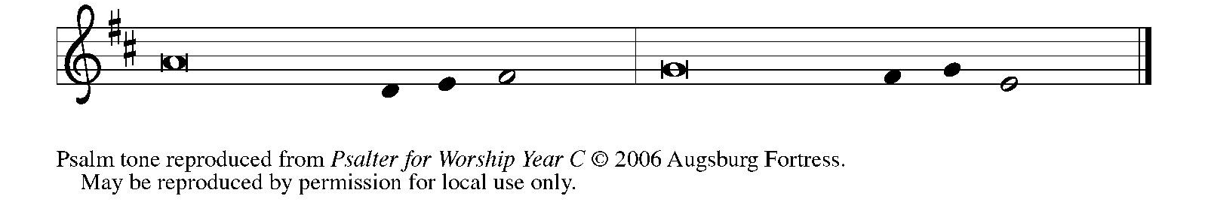

Psalm Refrain

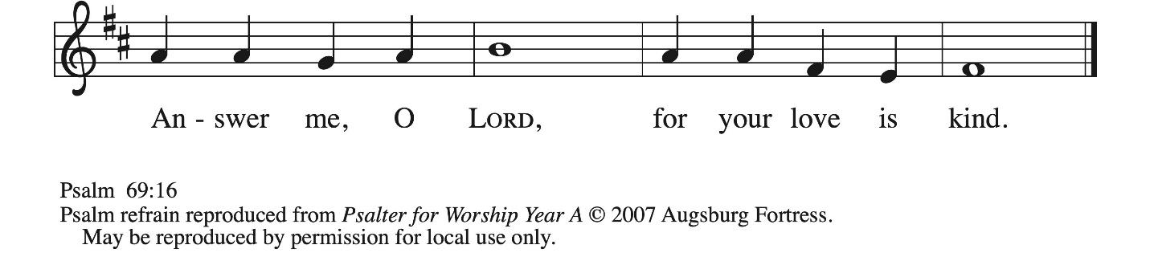

⁷ Surely, for your sake I have suf- | fered reproach,
and shame has cov- | ered my face.
⁸ I have become a stranger to | my own kindred,
an alien to my | mother’s children.
⁹ Zeal for your house has eat- | en me up;
the scorn of those who scorn you has fall- | en upon me.
¹⁰ I humbled my- | self with fasting,
but that was turned to | my reproach. R
[ ¹¹ I put on | sackcloth also,
and became a by- | word among them.
¹² Those who sit at the gate mur- | mur against me,
and the drunkards make | songs about me.
¹³ But as for me, this is my prayer to you, at the time you have | set, O Lord:
“In your great mercy, O God, answer me with your un- | failing help.
¹⁴ Save me from the mire; do not | let me sink;
let me be rescued from those who hate me and out of | the deep waters. R
¹⁵ Let not the torrent of waters wash over me, neither let the deep swal- | low me up;
do not let the pit shut its | mouth upon me.
] ¹⁶ Answer me, O Lord, for your | love is kind;
in your great compassion, | turn to me.
¹⁷ Hide not your face | from your servant;
be swift and answer me, for I am | in distress.
¹⁸ Draw near to me | and redeem me;
because of my enemies de- | liver me. R

Second Reading – Romans 6: 1b-11

^{1b} Should we continue in sin in order that grace may increase? ² By no means! How can we who died to sin go on living in it? ³ Do you not know that all of us who were baptized into Christ Jesus were baptized into his death? ⁴ Therefore we were buried with him by baptism into death, so that, just as Christ was raised from the dead by the glory of the Father, so we also might walk in newness of life.
⁵ For if we have been united with him in a death like his, we will certainly be united with him in a resurrection like his. ⁶ We know that our old self was crucified with him so that the body of sin might be destroyed, so we might no longer be enslaved to sin. ⁷ For whoever has died is freed from sin. ⁸ But if we died with Christ, we believe that we will also live with him. ⁹ We know that Christ, being raised from the dead, will never die again; death no longer has dominion over him. ¹⁰ The death he died, he died to sin once for all, but the life he lives, he lives to God. ¹¹ So you also must consider yourselves dead to sin and alive to God in Christ Jesus.

L: Word of God, word of life.
C: Thanks be to God.

Please rise as you are able.

Gospel Acclamation ACS p. 33
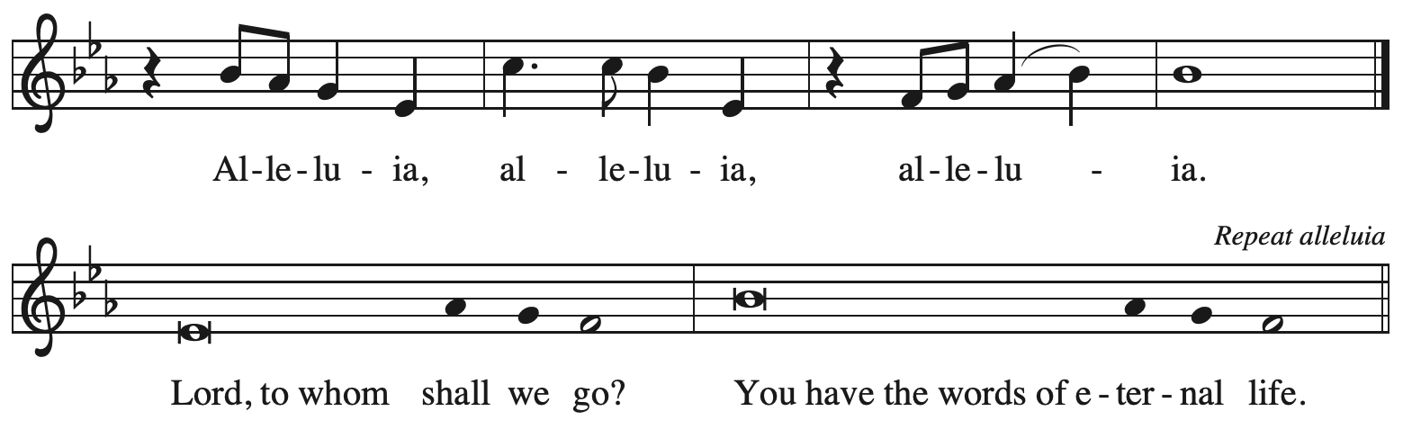
Gospel – Matthew 10: 24-39

P: The holy Gospel according to St. Matthew.
C: Glory to you, O Lord.

[Jesus said to the twelve:] ²⁴ “A disciple is not above the teacher nor a slave above the master;
²⁵ it is enough for the disciple to be like the teacher and the slave like the master. If they have called the master of the house Beelzebul, how much more will they malign those of his household!
²⁶ “So have no fear of them, for nothing is covered up that will not be uncovered and nothing secret that will not become known. ²⁷ What I say to you in the dark, tell in the light, and what you hear whispered, proclaim from the housetops. ²⁸ Do not fear those who kill the body but cannot kill the soul; rather, fear the one who can destroy both soul and body in hell. ²⁹ Are not two sparrows sold for a penny? Yet not one of them will fall to the ground apart from your Father.
³⁰ And even the hairs of your head are all counted. ³¹ So do not be afraid; you are of more value than many sparrows.
³² “Everyone, therefore, who acknowledges me before others, I also will acknowledge before my Father in heaven, ³³ but whoever denies me before others, I also will deny before my Father in heaven.
³⁴ “Do not think that I have come to bring peace to the earth; I have not come to bring peace but a sword.
³⁵ For I have come to set a man against his father,
and a daughter against her mother,
and a daughter-in-law against her mother-in-law,
³⁶ and one’s foes will be members of one’s own household.
³⁷ “Whoever loves father or mother more than me is not worthy of me, and whoever loves son or daughter more than me is not worthy of me, ³⁸ and whoever does not take up the cross and follow me is not worthy of me. ³⁹ Those who find their life will lose it, and those who lose their life for my sake will find it.”

P: The Gospel of the Lord.
C: Praise to you, O Christ.

Please be seated.

Sermon

A time of silence for prayer and reflection follows the sermon.
When the hymn of the day begins, please rise as you are able.

Hymn of the Day Take Up Your Cross, the Savior Said ELW 667

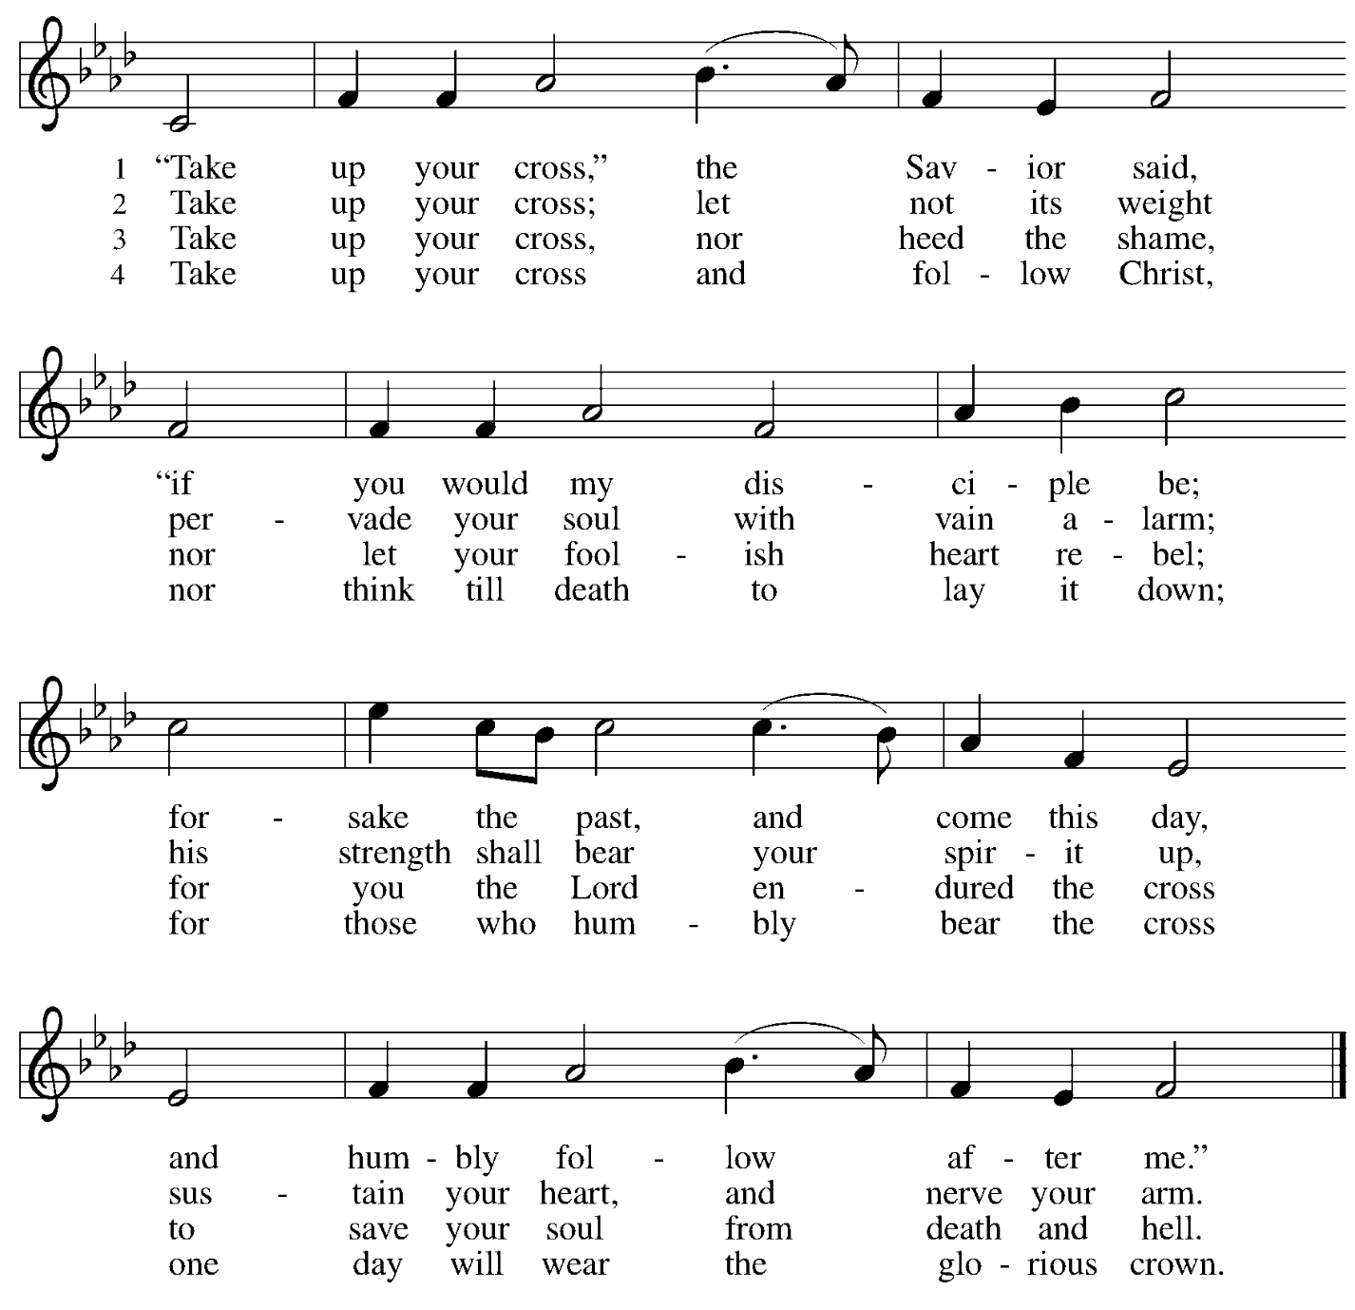

Apostles’ Creed

C: I believe in God, the Father almighty,
creator of heaven and earth.

I believe in Jesus Christ, God’s only Son, our Lord,
who was conceived by the Holy Spirit,
born of the virgin Mary,
suffered under Pontius Pilate,
was crucified, died, and was buried;
he descended to the dead.*
On the third day he rose again;
he ascended into heaven,
he is seated at the right hand of the Father,
and he will come to judge the living and the dead.

I believe in the Holy Spirit,
the holy catholic church,
the communion of saints,
the forgiveness of sins,
the resurrection of the body,
and the life everlasting. Amen.

*Or, “he descended into hell,” another translation of this text in widespread use.

Prayers of the People

A: Gathered by the Holy Spirit, let us pray for the church, the world,
and all people according to their need.

After each petition
A: God of grace,
C: receive our prayer.

The presiding minister concludes the prayers
P: Trusting that you receive all our prayers,
we commend our spoken and unspoken petitions to you, O God,
through Jesus Christ our Savior.
C: Amen.

Peace

The presiding minister and the assembly greet one another in the peace of the risen Christ.
P: The peace of Christ be with you always.
C: And also with you.

The people may greet those around them with a sign of Christ’s peace and may say
Peace be with you or similar words. Please be mindful that not everyone will be comfortable with sharing the peace, so please seek consent before shaking hands or hugging. Other possible ways to share the peace include a simple bow with the verbal greeting of peace, or simply a verbal expression of peace.

When the greetings of peace have concluded, please be seated.

Meal
God feeds us with the presence of Jesus Christ



Offering

We offer ourselves, our gifts, and our faithful service to God.
As the offering is gathered for the mission of the church, including the care of those in need,
the table is set for Holy Communion.

There are laminated giving cards in the pew racks that feature a QR code for anyone who would like to give online. Those who give using the QR code, as well as those who give regularly online or through their bank are encouraged to place the laminated card in the plate as an expression of your offering.

Music during the Offering
What a Friend We Have in Jesus arr. Edstrom

As the gifts are brought forward for presentation, please rise as you are able.

Noisy Offering

St. Andrew’s children lead the congregation in a special offering. As they carry buckets around the sanctuary, people of the congregation are invited to throw in their change as an offering. This month’s Noisy Offering will support Proud Haven, which provides safe shelter for LGBTQIA+ youth (ages 18-25) experiencing homelessness in Pittsburgh. For more on Proud Haven’s work, please see https://proudhaven.org/.

Offertory Song Timothy Kocher-Hillmer

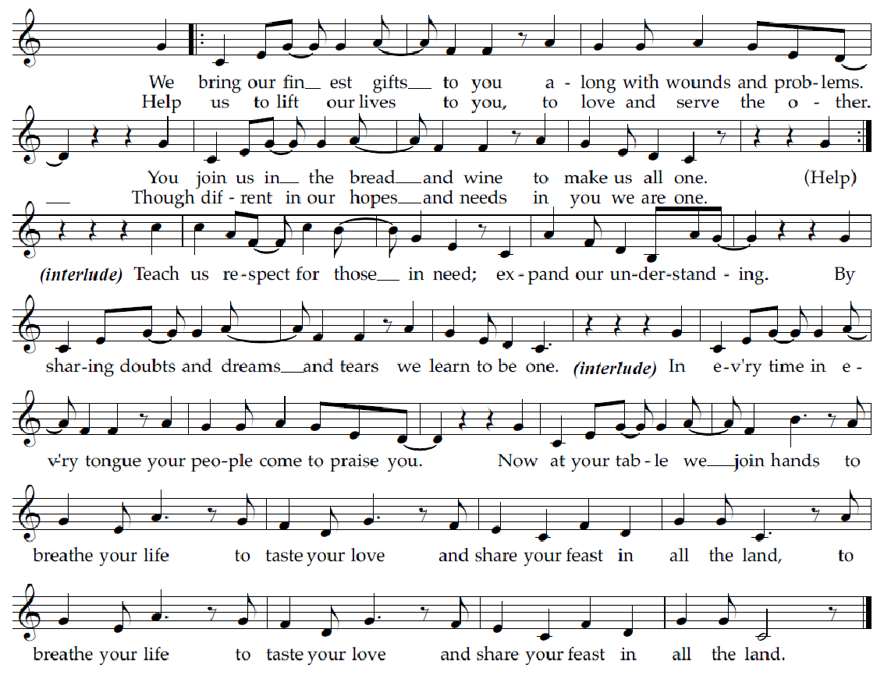

Offertory Prayer

A: Let us pray.
God of goodness and growth,
C: all creation is yours, and your faithfulness is sure.
Word and water, wine and bread: these are signs of your abundant grace.
Receive the gifts we bring,
and nourish us to proclaim your abiding love in our communities and in the world,
through Jesus Christ, our strength and our song.
Amen.

Dialogue ACS p. 36

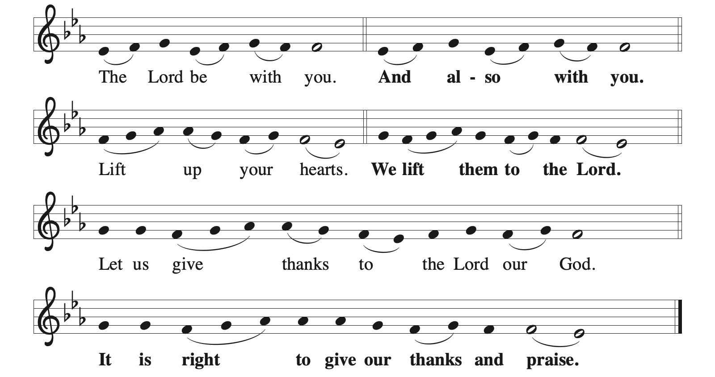

Preface (Sung by the presiding minister)

P: It is indeed right, our duty and our joy,
that we should at all times and in all places
give thanks and praise to you, almighty and merciful God,
through our Savior Jesus Christ;
who on this day overcame death and the grave,
and by his glorious resurrection opened to us the way of everlasting life.
And so, with all the choirs of angels,
with the church on earth and the hosts of heaven,
we praise your name and join their unending hymn:

Sanctus ACS p. 36

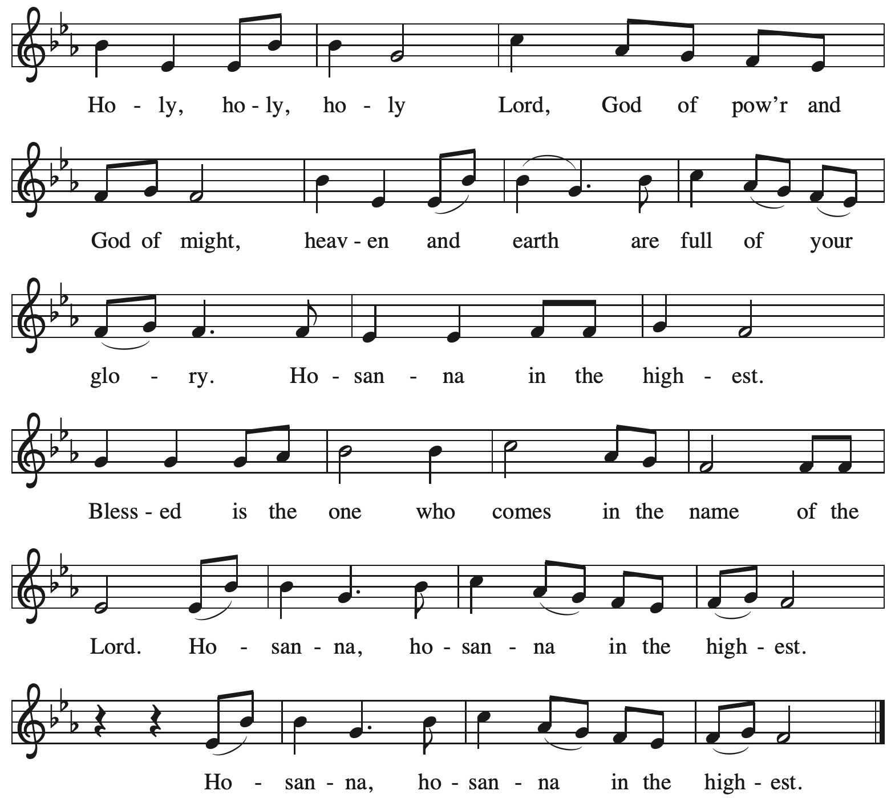

Eucharistic Prayer

P: O God triune, how majestic is your name in all the earth …
… The earth is full of your glory.
C: The earth is full of your glory.

P: O God triune, you made a home among us in Jesus our healer …
… The earth is full of your glory.
C: The earth is full of your glory.

P: We praise you for the heart of Jesus, so filled with your love for the world …
… Do this for the remembrance of me.

Gathered around your table, we your children unite in this song:
The earth is full of your glory.
C: The earth is full of your glory.

P: O God triune, you create the worlds, you uphold the living, you embrace the dead …
… The earth is full of your glory.
C: The earth is full of your glory.

P: Amen and Amen.
C: Amen and Amen.

Lord’s Prayer

P: Gathered as one by the Holy Spirit, let us pray as Jesus taught us.
C: Our Father in heaven,
hallowed be your name,
your kingdom come,
your will be done,
on earth as in heaven.
Give us today our daily bread.
Forgive us our sins
as we forgive those
who sin against us.
Save us from the time of trial
and deliver us from evil.
For the kingdom, the power,
and the glory are yours,
now and forever. Amen.

Fraction and Invitation



Agnus Dei / Lamb of God ACS p. 40

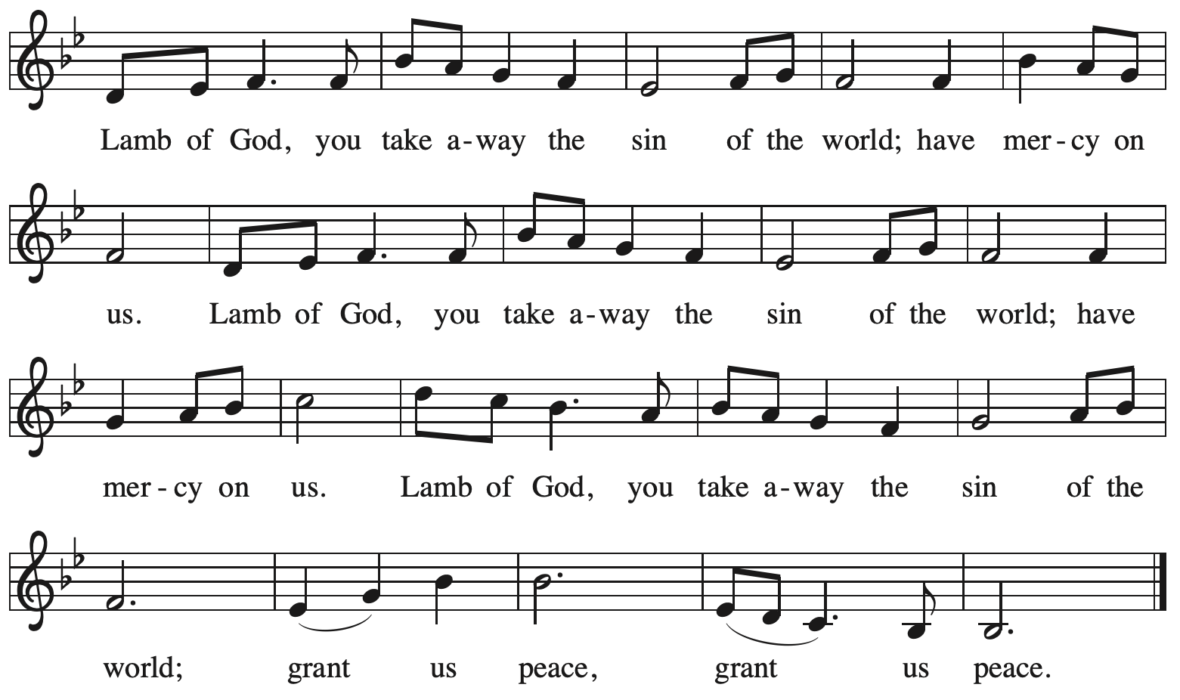

Please be seated.

Holy Communion

- All who seek God and desire a deeper and stronger life in Christ are welcome to receive Holy Communion.
- Worshipers from the pulpit side will proceed forward first, followed by the center section, and then the lectern side.
- Please inform an usher if you would like the ministers to bring Communion to you.
- Holy Communion will be served with bread and wine (red) or grape juice (white).
- The presiding minister will first distribute the bread (host) to each communicant. Please indicate if you require a gluten-free host.
- Once you have consumed the bread, please pick up an empty glass from the tray next to the presiding minister. The Communion Assistant will pour wine or grape juice into your glass.
- Please step to the side to consume the wine or grape juice.
- Feel free to kneel at the altar rail for prayer after receiving the sacrament.
- As you return to your pew, glasses may be returned to the empty tray on the side of the center section.
- A blessing will be provided for anyone who does not yet receive the sacrament.
- All are invited to join in singing the hymns during Holy Communion.

Hymns during Holy Communion
All Who Love and Serve Your City ELW 724

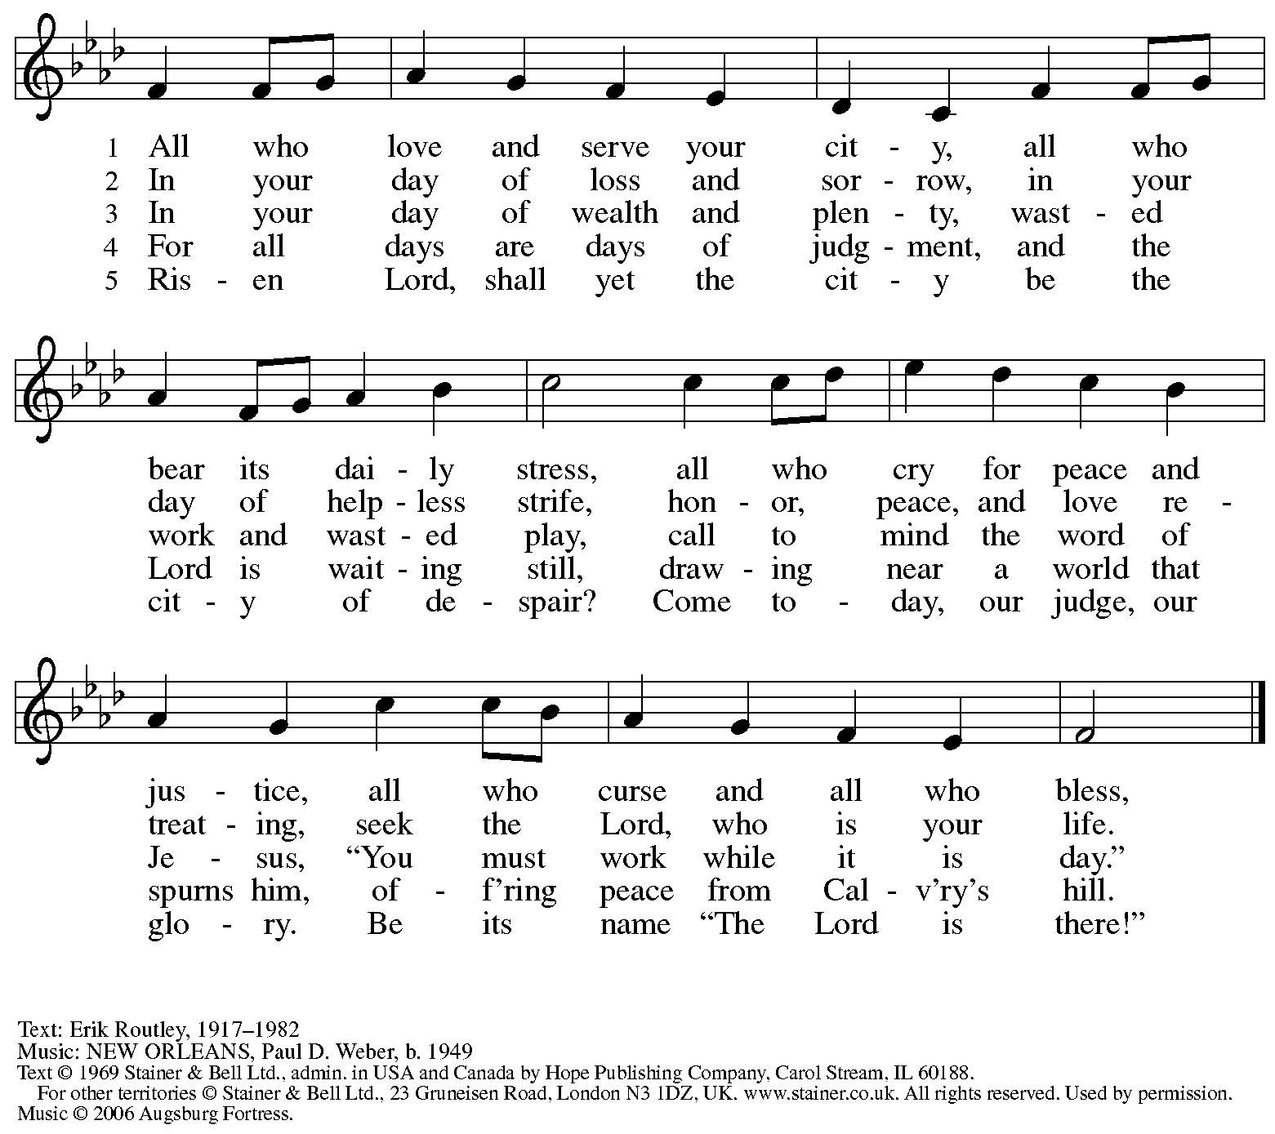
All rights reserved. Reprinted with permission under OneLicense.net # A-722139.

Hymns during Holy Communion
O Living Bread from Heaven ELW 542

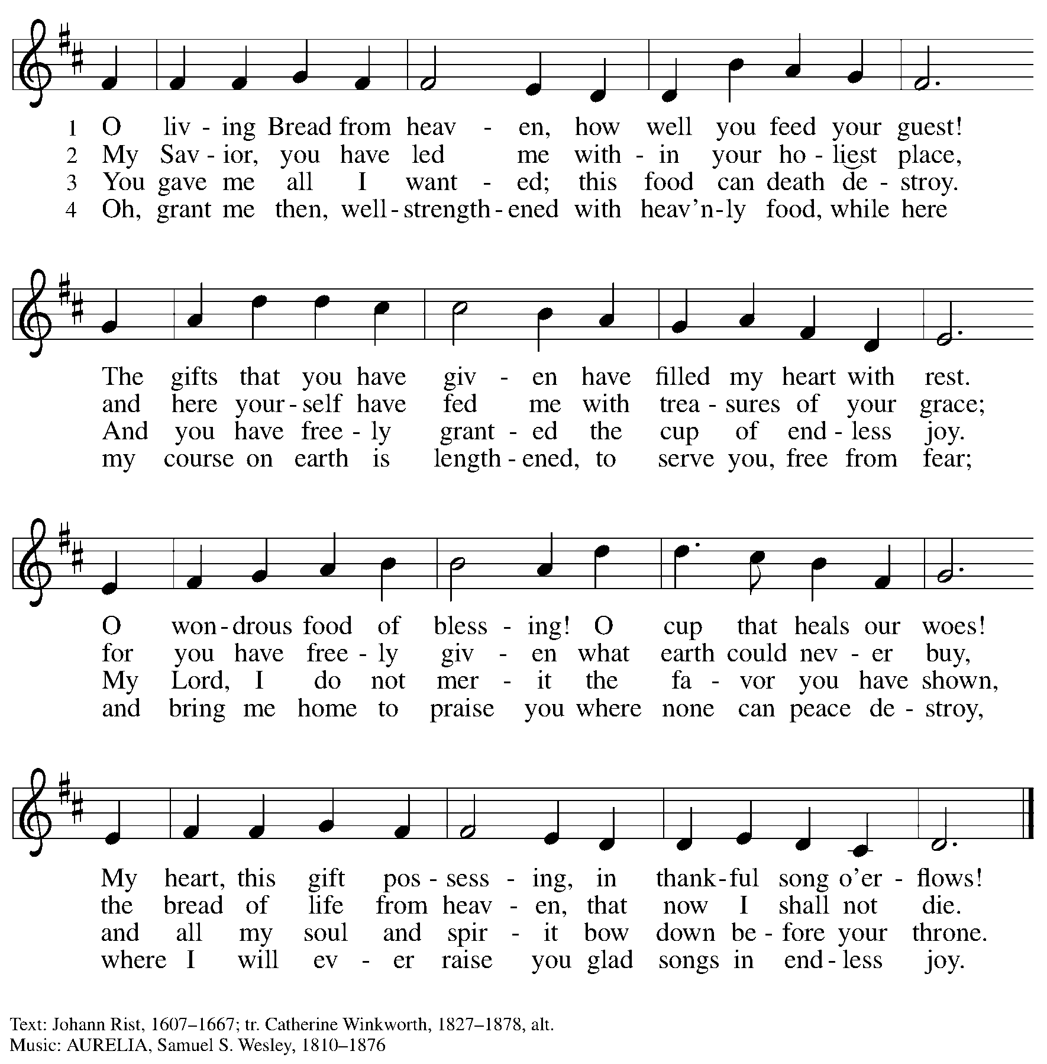

Hymns during Holy Communion
I Can Hear My Savior Calling TFF 146

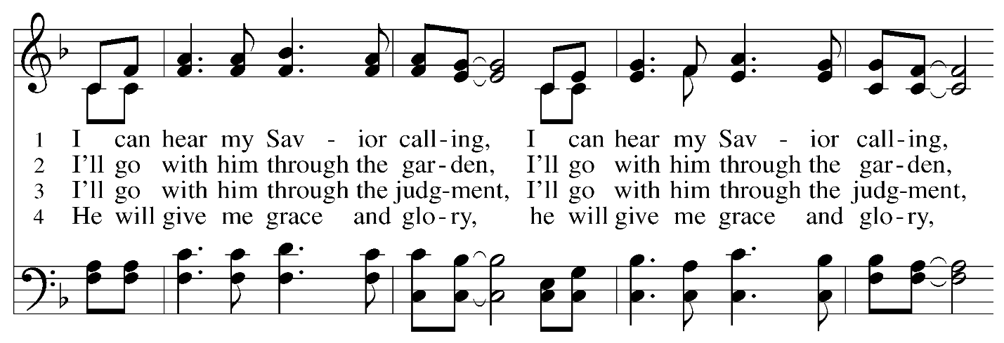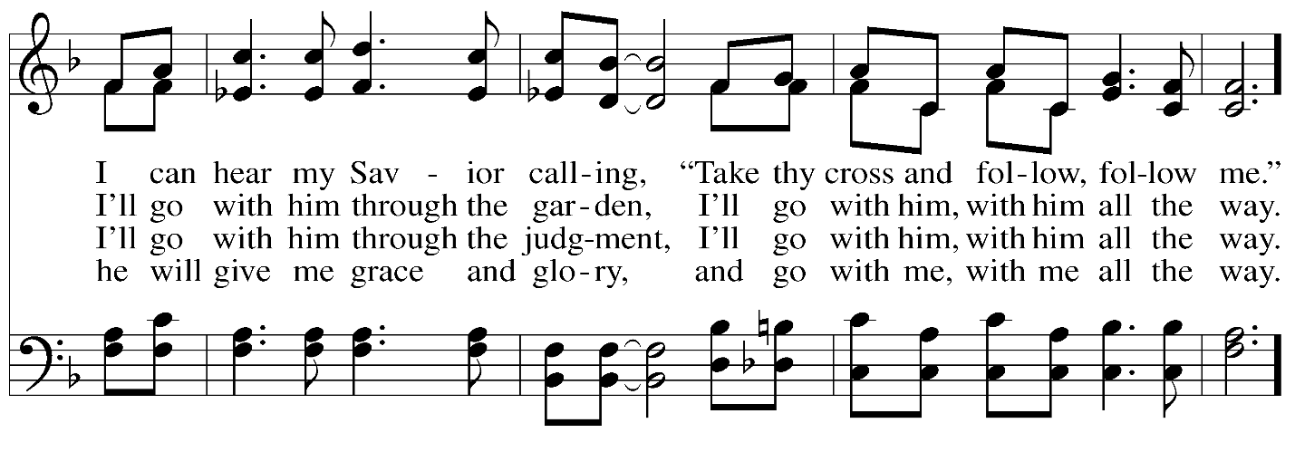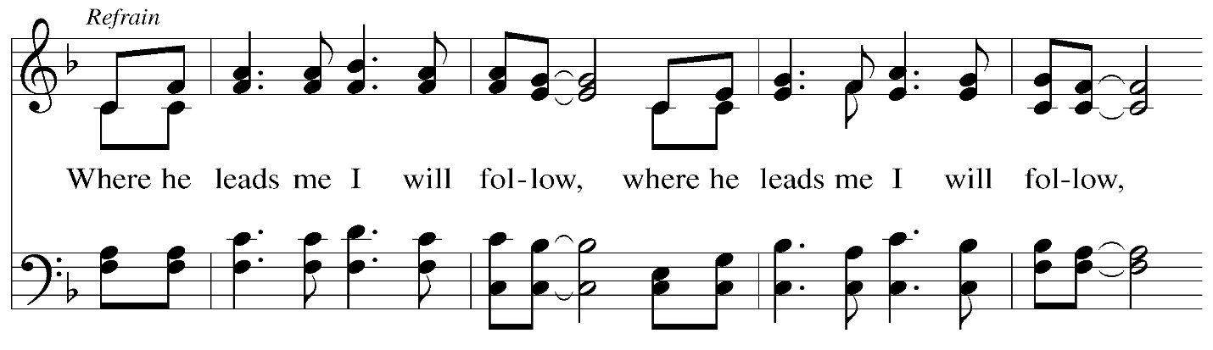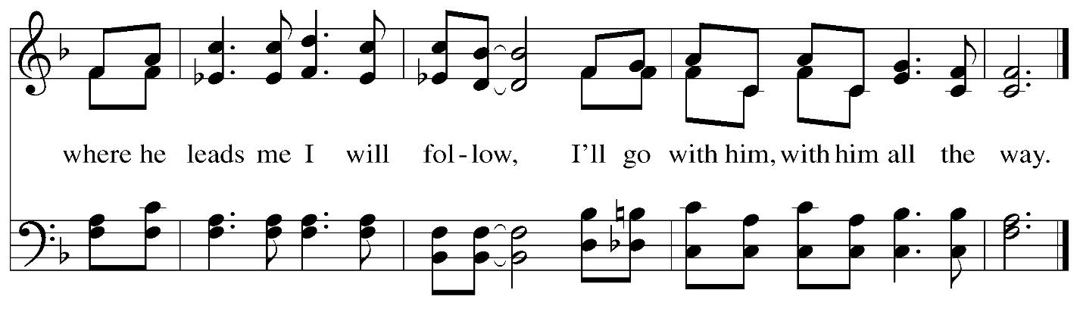
When all have returned to their places, please rise as you are able.
Blessing

P: The body and blood of our Lord Jesus Christ strengthen you and keep you in his grace.
C: Amen.

Prayer

A: Let us pray. Life-giving God,
through this meal you have made your home among us
and are making all things new.
Send us now to speak peace to anxious hearts,
to love our neighbors, and to bring your healing to the nations,
through Jesus Christ, our Savior.
C: Amen.

Please be seated.

Sending
God blesses us and sends us in mission to the world

Announcements

Please rise as you are able.
Benediction

P: God Almighty, who is the beginning and the end,
Jesus Christ, the firstborn of the dead,
and the Spirit, our advocate and peace,
☩ bless you now and forever.
C: Amen.

Sending Hymn Guide My Feet ACS 987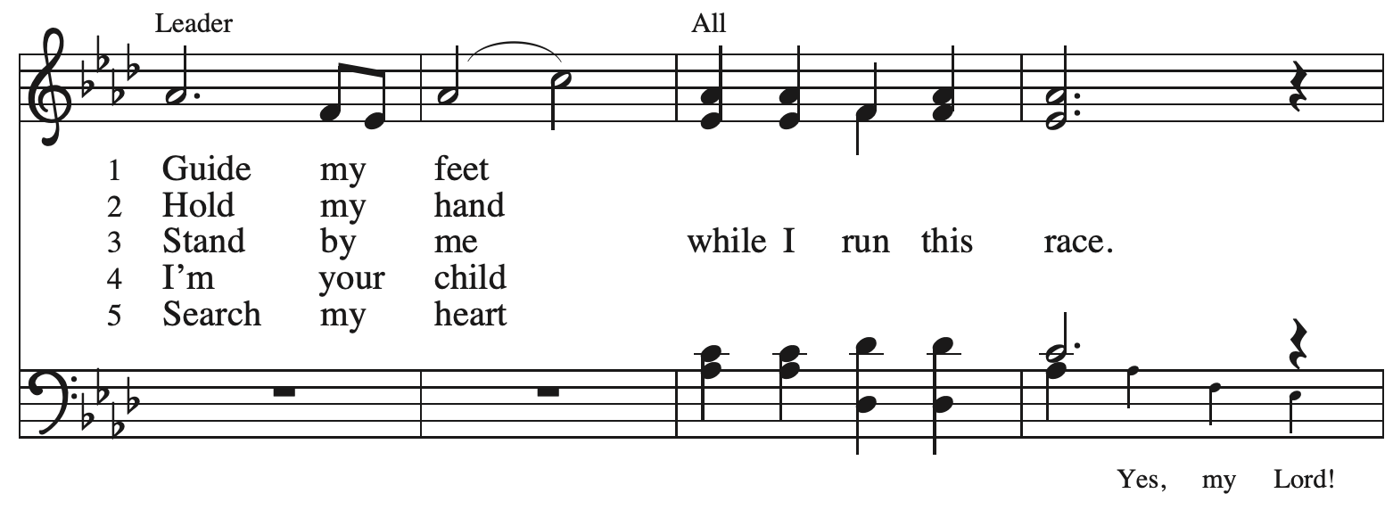
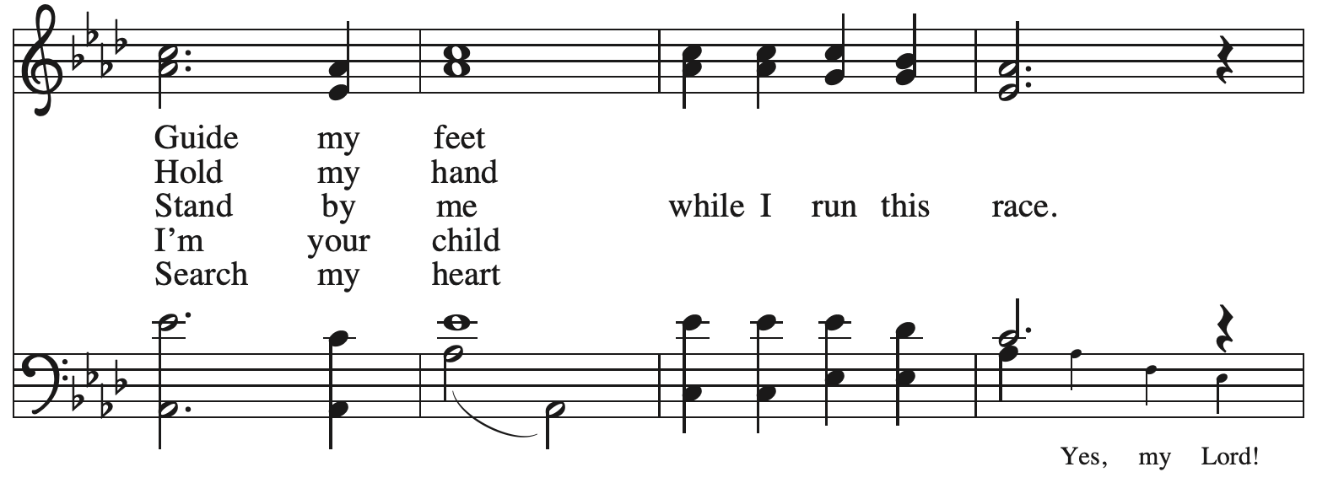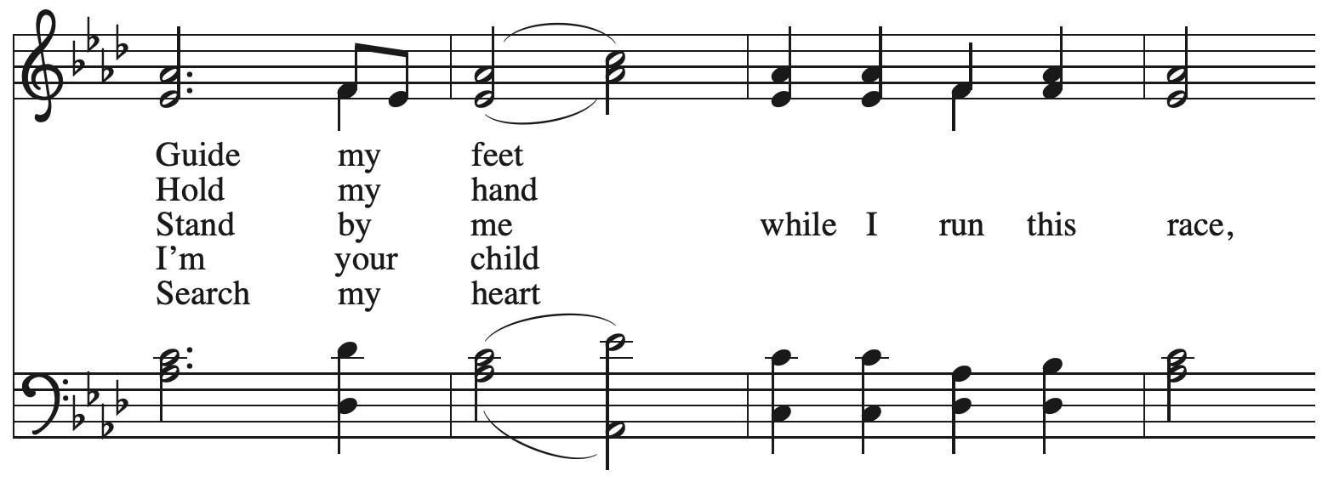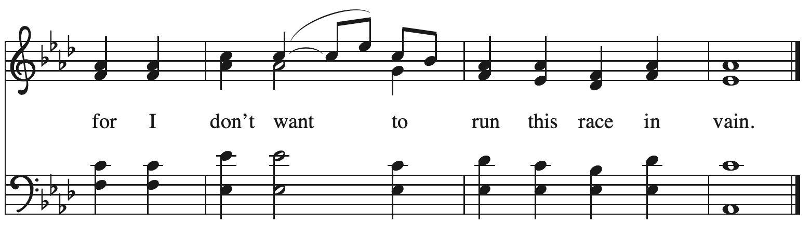

Dismissal

A: Go in peace. Build Community Together!
C: Thanks be to God!

Postlude

Those serving in worship today

Altar Care Beverley Chapman
Assisting Minister Jimmi Kocher-Hillmer
Audio-Visual Ministers Jered Stratton
Jason Galyardt
Cantor Mandy Best
Lector Michael Chapman
Minister of Music Laura Reynolds
Presiding Minister The Rev. Ross I. Carmichael

Liturgy and Hymnody Acknowledgements

From SundaysandSeasons.com. Copyright © 2026 Augsburg Fortress. All rights reserved. Reprinted under OneLicense.net # A-722139.
Used by permission of Augsburg Fortress.

The Scripture readings contained herein are from New Revised Standard Version Updated Edition of the Bible © 2021 National Council of Churches of Christ in the United States of America. Used by permission. All rights reserved worldwide.

God of Grace and God of Glory – Text: Harry E. Fosdick, 1878-1969. Music: CWM RHONDDA, John Hughes, 1873-1932.

Take Up Your Cross, the Savior Said – Text: Charles W. Everest, 1814-1877, alt. Music: BOURBON, W. Hauser, Hesperian Harp, 1848.

I Can Hear My Savior Calling – E.W. Blandy. Music: NORRIS, John S. Norris, 1844-1907.

Guide My Feet – Text: African American Spiritual. Music: GUIDE MY FEET, African American Spiritual; arr. This Far by Faith. Arr. © 1999 Augsburg Fortress. All rights reserved. Reprinted with permission under OneLicense.net # A-722139.

Please use the QR code below to link to St. Andrew’s Announcements online!



St. Andrew Lutheran Church Announcements
June 21st, 2026

- Welcome to Worship at St. Andrew on the Fourth Sunday after Pentecost – We are so glad you are here, and we offer a special welcome to all visitors and guests who are here for the first time! There are worship “toolkits” to help children engage with worship and “busy bags” for younger children available in the bookcase at the back of the sanctuary. Please feel free to take one to use with/for your children. A nursery is available through the door to the left of the worship space and across the social hall (look for a purple room). All are invited to gather for coffee, other drinks, food, and conversation in the social hall after worship.
- Noisy Offering, Next Sunday, June 21st, during Worship – On the third Sunday of each month, St. Andrew’s children lead the congregation in a Noisy Offering, in which people are invited to throw their change into buckets that the children carry around the church and bring forward as an additional offering. Each month’s Noisy Offering supports a local, national, or international church-related or otherwise charitable organization. This month’s offering will go to support Proud Haven, whose mission is to provide a safe shelter for LGBTQIA+ youth (ages 18-25) experiencing homelessness in Pittsburgh. For more about their work, please visit https://proudhaven.org/.
- Torah Walk and Celebration, Sunday, June 21st from 3:00 p.m. to 5:00 p.m. – This Sunday, the Temple Sinai and Rodef Shalom Congregations will be merging and their Torahs brought together via a ceremony and celebration. The group will walk from Temple Sinai and from Rodef Shalom Congregation to the Tepper Quad Building at Carnegie Mellon University. If you are unable to walk, you may drive. We are also looking for anyone with convertibles to carry a Torah and passengers. Contact Edie Raphael at ERaphael@BeitKulanu.org or (412) 621-6566, ext. 114, if you want to volunteer to drive your convertible. Rabbi Daniel Fellman, Rabbi David Young, and Cantor David Reinwald will lead a short service in the Main Sanctuary about 5:00 p.m. The congregation will also affix a new mezuzah. Everyone is welcome. The celebration will continue with a catered BBQ dinner and a chance to meet with longtime friends and new. Please use this link to register for this complimentary catered dinner: https://www.templesinaipgh.org/event/torah-walk--celebration.html
- Reckoning with Antisemitism: Reflections at One Year, Wednesday, June 24th at 7:00 p.m. – Gather on June 24th at Beit Kulanu (Formerly Rodef Shalom - 4905 Fifth Avenue, Pittsburgh, PA 15213) for an evening of celebration and reflection on the past year of the Reckoning with Antisemitism as Christians project. Over the past 12 months, Christian clergy and lay leaders across Southwestern PA have been engaging with this new project co-founded by Christian Associates of Southwest PA and the Holocaust Center of Pittsburgh. We will hear from Christians who have been reckoning with antisemitism and from Jews who have taken part in their efforts. We will also share (for the first time!) a published book of sermons written by local Christian clergy who have engaged their congregations and communities in conversations about antisemitism, from the pulpit and beyond. You can register to attend using this link: https://www.eventbrite.com/e/reckoning-with-antisemitism-as-christians-reflections-at-one-year-tickets-1988560210119.
- Produce Distribution Supplemental Food of the Month – St. Andrew collects supplemental food each month to accompany our produce distribution. For June, we ask for donations of rice.
- Produce Distribution, Third Tuesday Each Month, July 7th and 21st from 5:30 to 6:30 p.m. – St. Andrew partners with Greater Pittsburgh Community Food Bank to serve as a distribution site for fresh produce on the first and third Tuesday of every month. We invite people of the congregation to help with the distribution from 5:30 p.m. to 6:30 p.m. and/or to help with unloading and setup during the day between 10:00 a.m. and 1:00 p.m.
- Friendly Wiffle Ball game with St. Andrew's Episcopal, Sunday, July 26th, 4:00 p.m. – In the past, our congregation shared community with St. Andrew's Episcopal Church in events like an annual pet blessing, and the compilation of backpacks and school supplies for students of The Neighborhood Academy. St. Andrew's Episcopal Church has invited people of St. Andrew, of all ages and abilities, to join in a friendly game of Wiffle ball on Sunday, July 26th, at 4:00 p.m. St. Andrew's Episcopal is located at 5801 Hampton Street 15206 in Highland Park will host the game and the outdoor area is accessible. Please plan to come for fun, food, and conversation with our neighbors!
- Coffee Hour Will Break for July and August

