

+ Fifth Sunday after Pentecost
June 28, 2026


St. Andrew Lutheran Church
304 Morewood Ave.
Pittsburgh, PA 15213
St_andrewELCA@verizon.net
www.standrewpittsburgh.org

+ Fifth Sunday after Pentecost

The welcome of Baptism is for all God’s children.
This baptismal gift sets us free from the power of sin and death.
In today’s Gospel, Christ promises that the disciple who gives a cup of cold water to the little ones serves Christ himself. From worship we are sent on our baptismal mission:
to serve the little ones of this world and to be a sign of God’s merciful welcome.

Welcome to St. Andrew!

- St. Andrew welcomes all who are seeking a place of healing, wholeness, and acceptance in a nurturing and faith-forming spiritual home. We are striving toward racial equity worldwide
and we seek to honor the lived experience of all individuals regardless of background. Our community embraces people of all ages, ethnicities, cultures, abilities, sexual orientations,
gender identities and expressions, and family constellations. Come and See!
- Worship Services are live-streamed to multiple online platforms. By attending worship, you agree that your image and voice may be broadcast.
- Everyone is invited to make a name tag at the black bookcase in the back of the worship space if they would like. There are stickers indicating pronouns on the bookcase if you would like to include them on your name tag.
- Children are invited to attend Little Church – Big Faith, a Bible lesson and activity, during worship (after the Prayer of the Day). The group returns to the worship space for the liturgy of Holy Communion.
- A nursery is available through the doors at the left side of the sanctuary and across from the doorway to the Social Hall. Look for a purple-colored room.
- Worship “toolkits” to help children engage with the service, along with “busy bags” for younger children, are available in the bookcase at the back of the sanctuary. Please feel free to take one to use with/for your children.
- Holy Communion is served with bread (gluten-free available) and wine or grape juice. The presiding minister will distribute the bread (host). Please consume this and then pick up an empty glass from the tray. The Communion Assistant will pour wine or grape juice into your glass. Please step to the side to consume the wine or grape juice. Feel free to kneel at the altar for prayer and reflection. As you return to your pew, glasses may be returned to the empty trays on either side of the center section.
- A restroom is available on the main level of the church, through the doors to the Social Hall and to the right in the main office.

Abbreviations
P: Pastor/Presiding Minister ELW: Evangelical Lutheran Worship hymnal
A: Assisting Minister ACS: All Creation Sings hymnal
L: Lector
C: Congregation

Musical Offering

Each week, different people from the congregation make an offering of pre-service music, with singing or instrumentation, to help the assembly focus and pray in preparation for worship.

Welcome
Prelude Just As I Am arr. Keveren

Gathering
The Holy Spirit calls us together as the people of God

Please rise as you are able. All may make the sign of the cross,
the sign that is marked at Baptism, as the presiding minister begins.

Confession and Forgiveness ACS p. 29

P: Blessed be the holy Trinity, ☩ one God,
who looks upon us in compassion,
forgives our sin, and heals our lives.
C: Amen.

P: Let us confess our sin in the presence of God and of one another.

P: Have mercy, O God,
C: for we have sinned against you
and our neighbor.
In your compassion,
cleanse us from our sin
and take away our guilt.
Create in us a new heart
and give us a steadfast spirit.
Do not cast us away,
but fill us with your Holy Spirit
and restore your joy within us.
Amen.

P: As tender as parent to child,
so deep is God’s compassion for you.
As high as heaven is above earth, so vast is God’s love for you.
As far as east is from west, so far God removes your sin from you,
renewing your life through Jesus Christ.
Blessed be God who crowns us with mercy and love.
C: Blessed be God forever. Amen.

Gathering Hymn God, We Gather as Your People ACS 1038

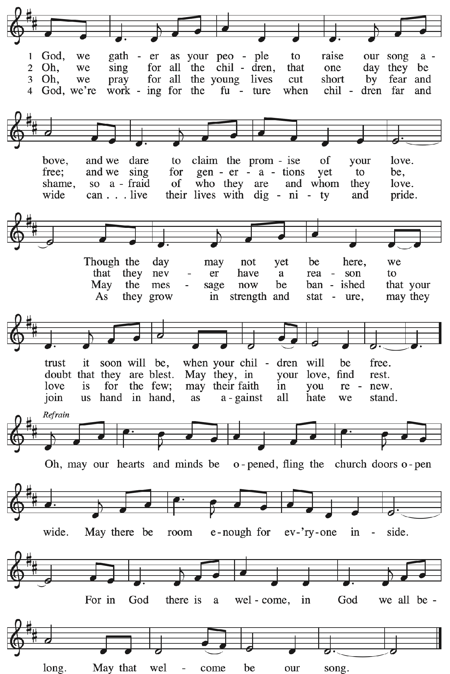

Greeting

P: The grace of our Lord Jesus Christ, the love of God,
and the communion of the Holy Spirit be with you all.
C: And also with you.

Hymn of Praise Glory to You, God ACS p. 31

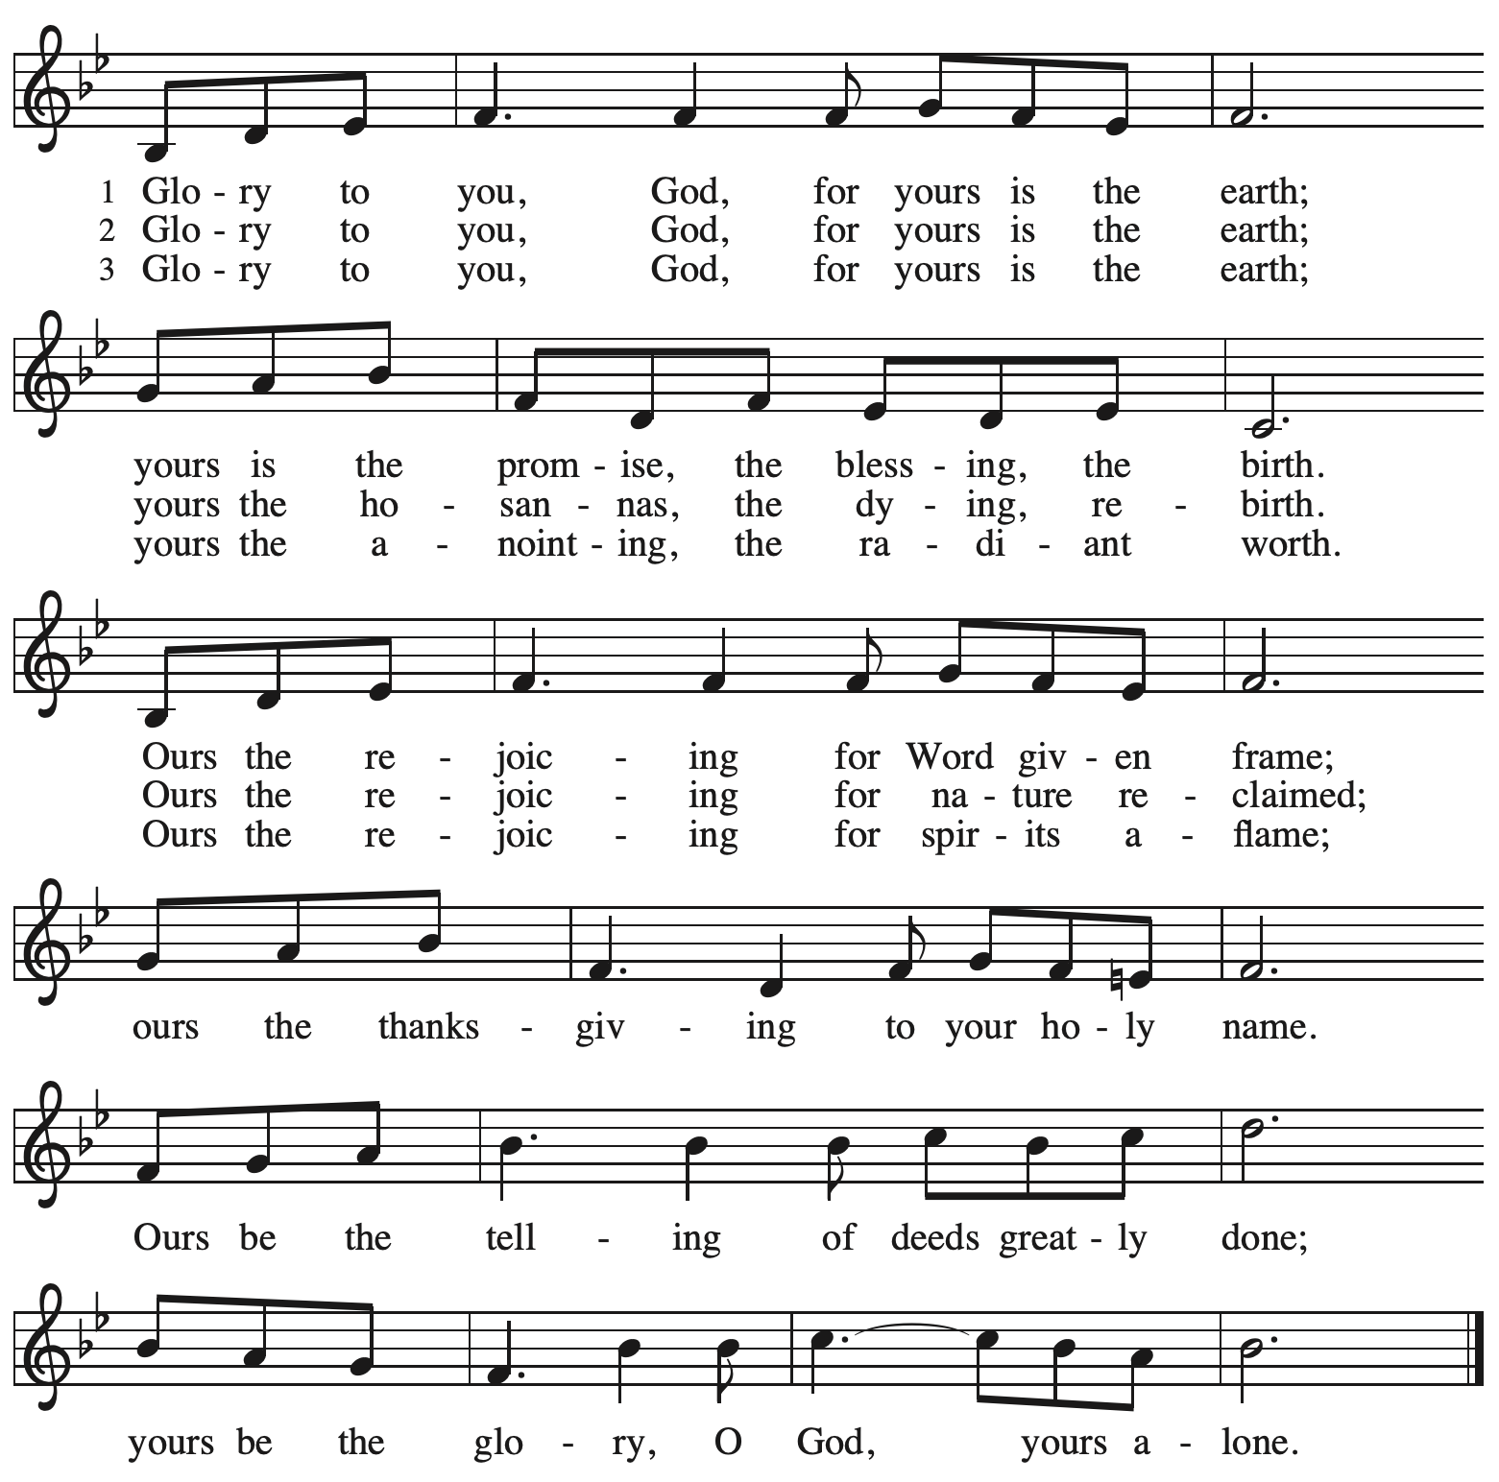

Prayer of the Day

P: The Lord be with you.
C: And also with you.

P: Let us pray.
O God, you direct our lives by your grace,
and your words of justice and mercy reshape the world.
Mold us into a people who welcome your word and serve one another,
through Jesus Christ, our Savior and Lord.
C: Amen.

Please be seated.

Word
God speaks to us in Scripture reading, preaching, and song

First Reading – Jeremiah 28: 5-9

⁵ The prophet Jeremiah spoke to the prophet Hananiah in the presence of the priests and all the people who were standing in the house of the Lord, ⁶ and the prophet Jeremiah said, “Amen! May the Lord do so; may the Lord fulfill the words that you have prophesied and bring back to this place from Babylon the vessels of the house of the Lord and all the exiles. ⁷ But listen now to this word that I speak in your hearing and in the hearing of all the people. ⁸ The prophets who preceded you and me from ancient times prophesied war, famine, and pestilence against many countries and great kingdoms. ⁹ As for the prophet who prophesies peace, when the word of that prophet comes true, then it will be known that the Lord has truly sent the prophet.”

L: Word of God, word of life.
C: Thanks be to God.

Psalm 89: 1-4, 15-18

The psalm will be sung responsively, led by the cantor,
with the congregation responding with the bold verses and refrain.

Psalm Tone

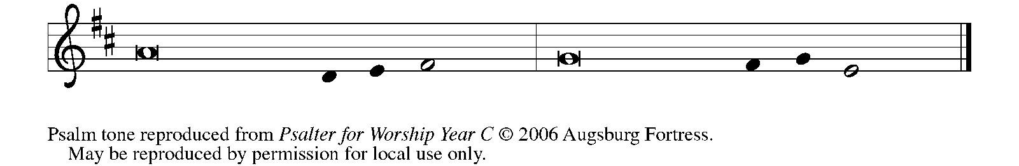

Psalm Refrain

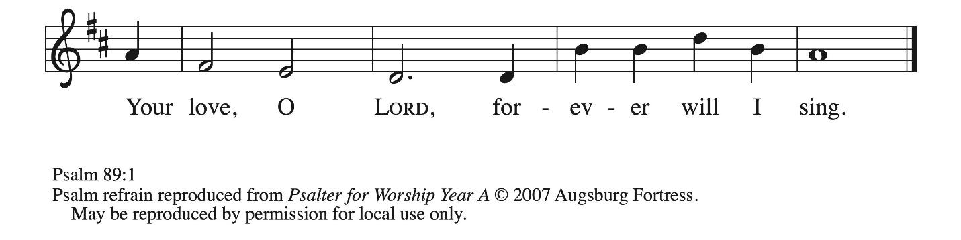

¹ Your love, O Lord, forever | will I sing;
from age to age my mouth will pro- | claim your faithfulness.
² For I am persuaded that your steadfast love is estab- | lished forever;
you have set your faithfulness firmly | in the heavens.
³ “I have made a covenant with my | chosen one;
I have sworn an oath to Da- | vid my servant:
⁴ ‘I will establish your | line forever,
and preserve your throne for all | generations.’ ” R
¹⁵ Happy are the people who know the | festal shout!
They walk, O Lord, in the light | of your presence.
¹⁶ They rejoice daily | in your name;
they are jubilant | in your righteousness.
¹⁷ For you are the glory | of their strength,
and by your favor our might | is exalted.
¹⁸ Truly, our shield belongs | to the Lord;
our king to the Holy | One of Israel. R

Second Reading – Romans 6: 12-23

¹² Do not let sin reign in your mortal bodies, so that you obey their desires. ¹³ No longer present your members to sin as instruments of unrighteousness, but present yourselves to God as those who have been brought from death to life, and present your members to God as instruments of righteousness. ¹⁴ For sin will have no dominion over you, since you are not under law but under grace.
¹⁵ What then? Should we sin because we are not under law but under grace? By no means!
¹⁶ Do you not know that, if you present yourselves to anyone as obedient slaves, you are slaves of the one whom you obey, either of sin, which leads to death, or of obedience, which leads to righteousness? ¹⁷ But thanks be to God that you who were slaves of sin have become obedient from the heart to the form of teaching to which you were entrusted ¹⁸ and that you, having been set free from sin, have become enslaved to righteousness. ¹⁹ I am speaking in human terms because of your limitations. For just as you once presented your members as slaves to impurity and lawlessness, leading to even more lawlessness, so now present your members as slaves to righteousness, leading to sanctification.
²⁰ When you were slaves of sin, you were free in regard to righteousness. ²¹ So what fruit did you then gain from the things of which you now are ashamed? The end of those things is death.
²² But now that you have been freed from sin and enslaved to God, the fruit you have leads to sanctification, and the end is eternal life. ²³ For the wages of sin is death, but the free gift of God is eternal life in Christ Jesus our Lord.

L: Word of God, word of life.
C: Thanks be to God.

Please rise as you are able.

Gospel Acclamation ACS p. 33

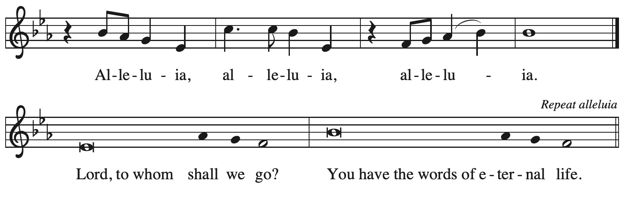

Gospel – Matthew 10: 40-42

P: The holy Gospel according to St. Matthew.
C: Glory to you, O Lord.

[Jesus said to the twelve:] ⁴⁰ “Whoever welcomes you welcomes me, and whoever welcomes me welcomes the one who sent me. ⁴¹ Whoever welcomes a prophet in the name of a prophet will receive a prophet’s reward, and whoever welcomes a righteous person in the name of a righteous person will receive the reward of the righteous, ⁴² and whoever gives even a cup of cold water to one of these little ones in the name of a disciple—truly I tell you, none of these will lose their reward.”

P: The Gospel of the Lord.
C: Praise to you, O Christ.

Please be seated.

Sermon

A time of silence for prayer and reflection follows the sermon.
When the hymn of the day begins, please rise as you are able.
Hymn of the Day The Church of Christ, in Every Age ELW 729

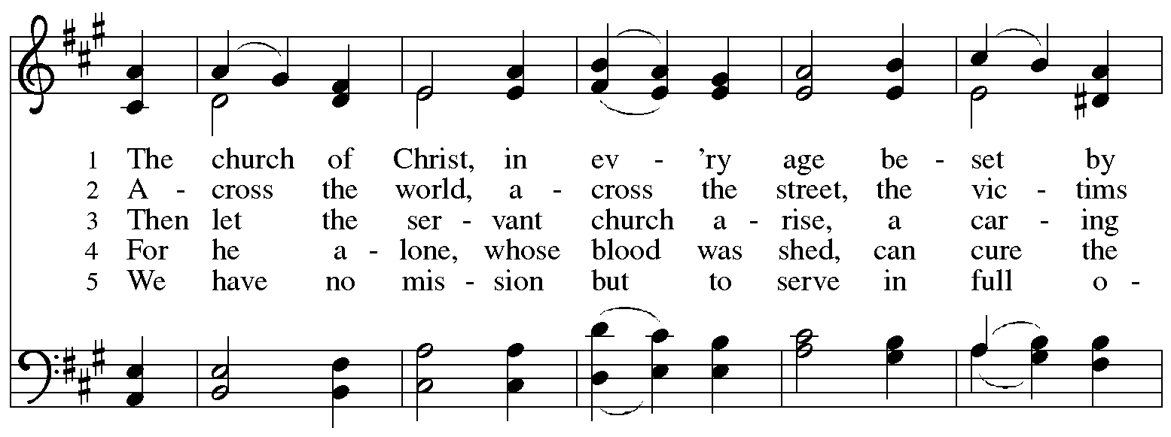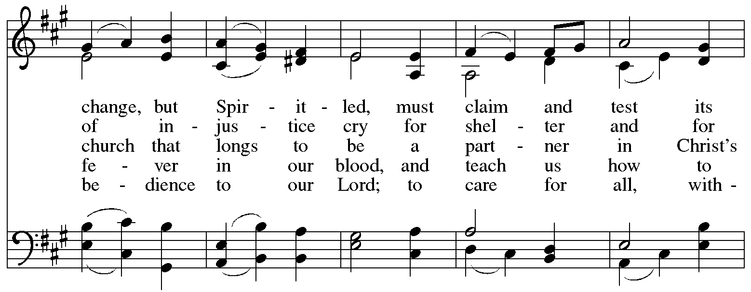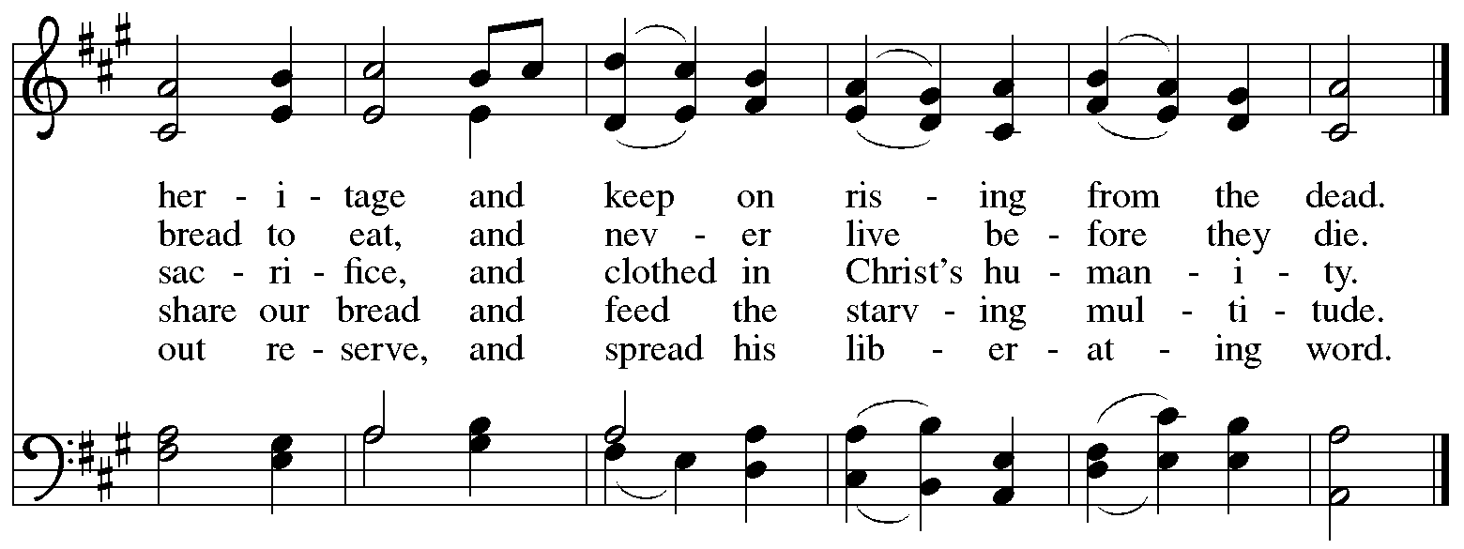
Reprinted under OneLicense.net # A-722139.

Apostles’ Creed

C: I believe in God, the Father almighty,
creator of heaven and earth.

I believe in Jesus Christ, God’s only Son, our Lord,
who was conceived by the Holy Spirit,
born of the virgin Mary,
suffered under Pontius Pilate,
was crucified, died, and was buried;
he descended to the dead.*
On the third day he rose again;
he ascended into heaven,
he is seated at the right hand of the Father,
and he will come to judge the living and the dead.

I believe in the Holy Spirit,
the holy catholic church,
the communion of saints,
the forgiveness of sins,
the resurrection of the body,
and the life everlasting. Amen.

*Or, “he descended into hell,” another translation of this text in widespread use.

Prayers of the People

A: Gathered by the Holy Spirit, let us pray for the church, the world,
and all people according to their need.

After each petition
A: God of grace,
C: receive our prayer.

The presiding minister concludes the prayers
P: Trusting that you receive all our prayers,
we commend our spoken and unspoken petitions to you, O God,
through Jesus Christ our Savior.
C: Amen.

Peace

The presiding minister and the assembly greet one another in the peace of the risen Christ.
P: The peace of Christ be with you always.
C: And also with you.
The people may greet those around them with a sign of Christ’s peace and may say
Peace be with you or similar words. Please be mindful that not everyone will be comfortable with sharing the peace, so please seek consent before shaking hands or hugging. Other possible ways to share the peace include a simple bow with the verbal greeting of peace, or simply a verbal expression of peace. When the greetings of peace have concluded, please be seated.



Meal
God feeds us with the presence of Jesus Christ

Offering

We offer ourselves, our gifts, and our faithful service to God.
As the offering is gathered for the mission of the church, including the care of those in need,
the table is set for Holy Communion.

There are laminated giving cards in the pew racks that feature a QR code for anyone who would like to give online. Those who give using the QR code, as well as those who give regularly online or through their bank are encouraged to place the laminated card in the plate as an expression of your offering.

Music during the Offering
All Are Welcome arr. Hayes

As the gifts are brought forward for presentation, please rise as you are able.

Offertory Song Timothy Kocher-Hillmer

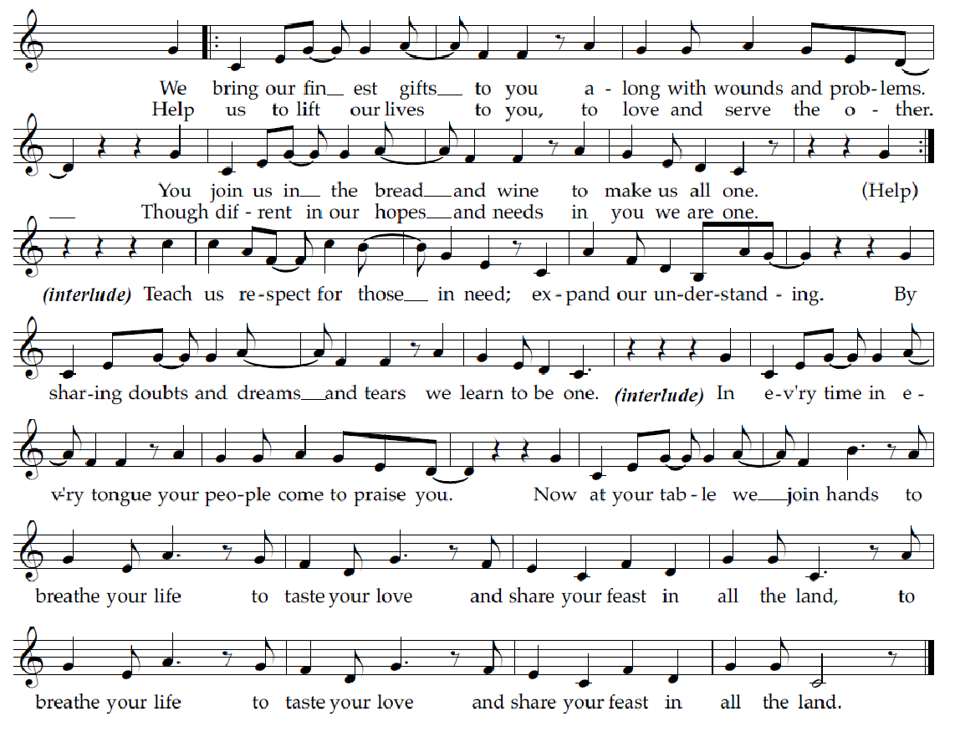

Offertory Prayer

A: Let us pray.
God of goodness and growth,
C: all creation is yours, and your faithfulness is sure.
Word and water, wine and bread: these are signs of your abundant grace.
Receive the gifts we bring,
and nourish us to proclaim your abiding love in our communities and in the world,
through Jesus Christ, our strength and our song.
Amen.

Dialogue ACS p. 36

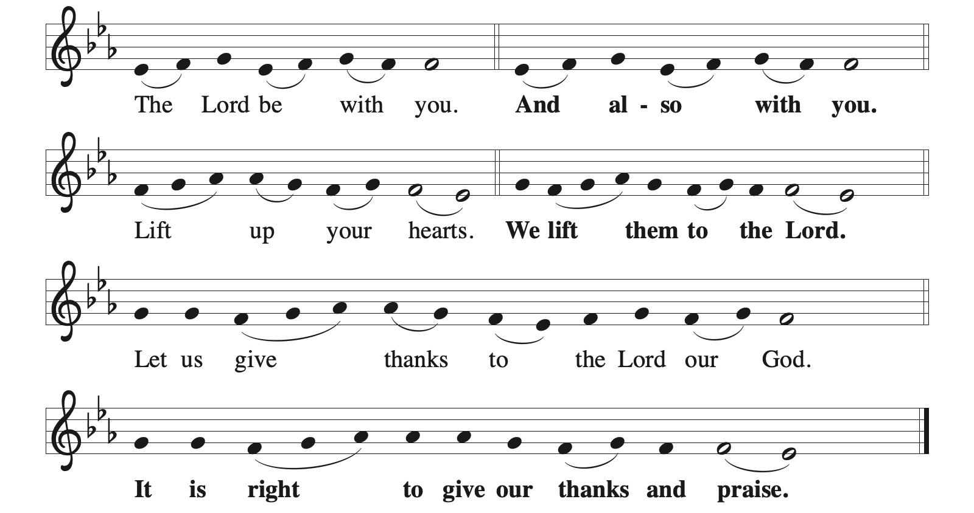

Preface (Sung by the presiding minister)

P: It is indeed right, our duty and our joy,
that we should at all times and in all places
give thanks and praise to you, almighty and merciful God,
through our Savior Jesus Christ;
who on this day overcame death and the grave,
and by his glorious resurrection opened to us the way of everlasting life.
And so, with all the choirs of angels,
with the church on earth and the hosts of heaven,
we praise your name and join their unending hymn:

Sanctus ACS p. 36

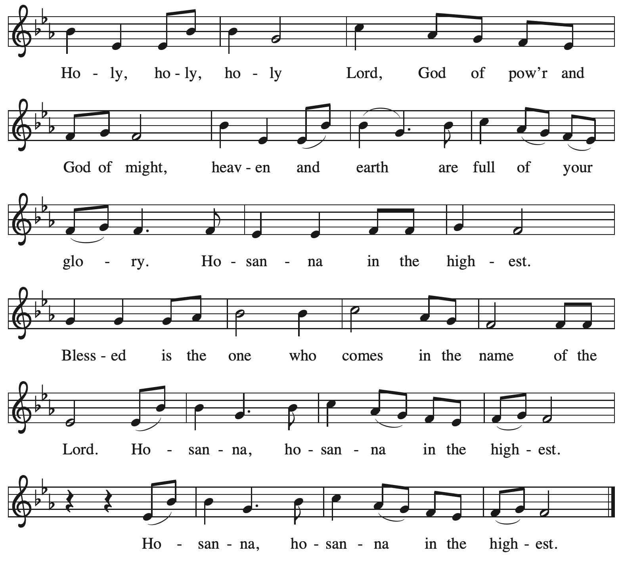

Eucharistic Prayer

P: O God triune, how majestic is your name in all the earth …
… The earth is full of your glory.
C: The earth is full of your glory.

P: O God triune, you made a home among us in Jesus our healer …
… The earth is full of your glory.
C: The earth is full of your glory.

P: We praise you for the heart of Jesus, so filled with your love for the world …
… Do this for the remembrance of me.

Gathered around your table, we your children unite in this song:
The earth is full of your glory.
C: The earth is full of your glory.

P: O God triune, you create the worlds, you uphold the living, you embrace the dead …
… The earth is full of your glory.
C: The earth is full of your glory.

P: Amen and Amen.
C: Amen and Amen.

Lord’s Prayer

P: Gathered as one by the Holy Spirit, let us pray as Jesus taught us.
C: Our Father, who art in heaven,
hallowed be thy name,
thy kingdom come,
thy will be done,
on earth as it is in heaven.
Give us this day our daily bread;
and forgive us our trespasses,
as we forgive those
who trespass against us;
and lead us not into temptation,
but deliver us from evil.
For thine is the kingdom,
and the power, and the glory,
forever and ever. Amen.

Fraction and Invitation


Agnus Dei / Lamb of God ACS p. 40

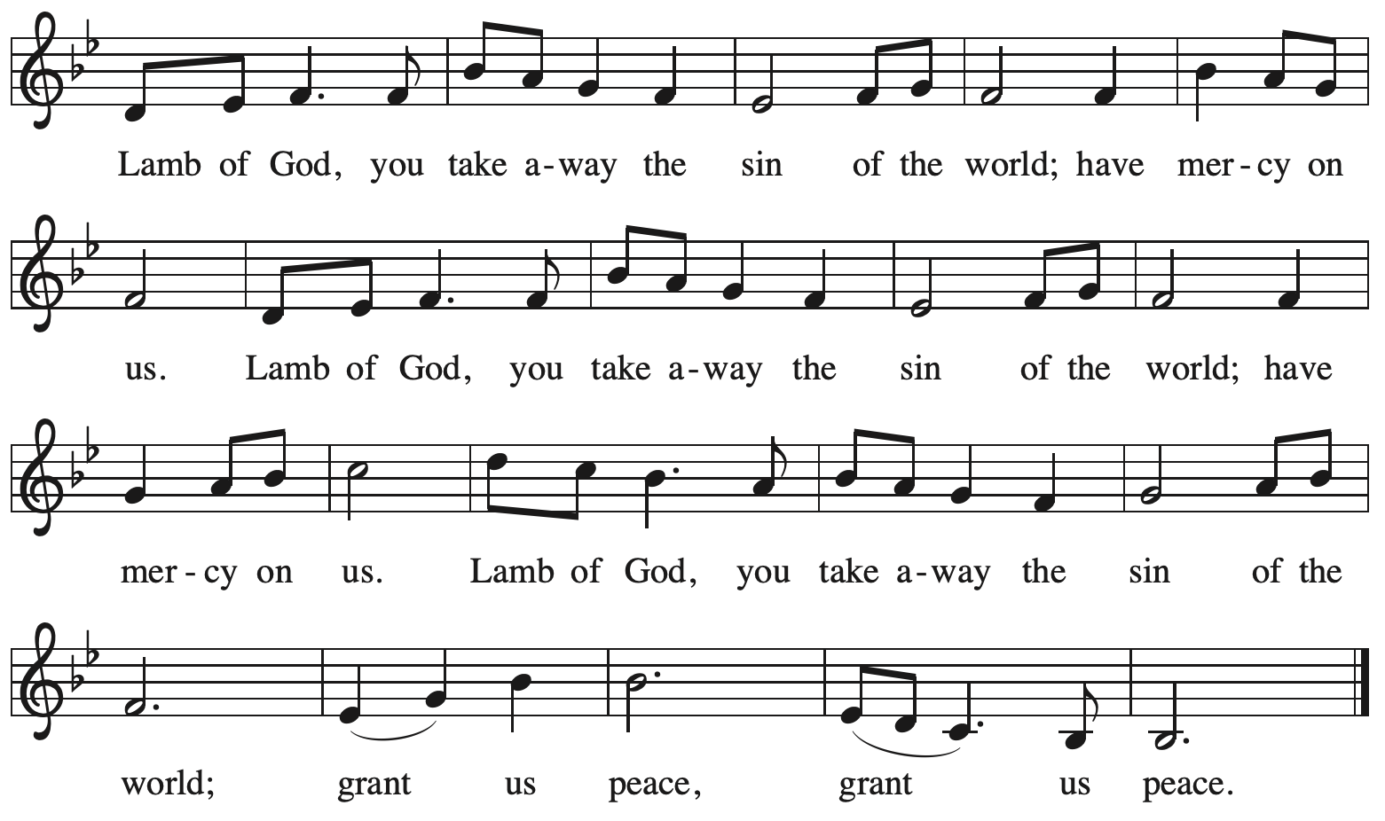

Please be seated.

Holy Communion

- All who seek God and desire a deeper and stronger life in Christ are welcome to receive Holy Communion.
- Worshipers from the pulpit side will proceed forward first, followed by the center section, and then the lectern side.
- Please inform an usher if you would like the ministers to bring Communion to you.
- Holy Communion will be served with bread and wine (red) or grape juice (white).
- The presiding minister will first distribute the bread (host) to each communicant. Please indicate if you require a gluten-free host.
- Once you have consumed the bread, please pick up an empty glass from the tray next to the presiding minister. The Communion Assistant will pour wine or grape juice into your glass.
- Please step to the side to consume the wine or grape juice.
- Feel free to kneel at the altar rail for prayer after receiving the sacrament.
- As you return to your pew, glasses may be returned to the empty tray on the side of the center section.
- A blessing will be provided for anyone who does not yet receive the sacrament.
- All are invited to join in singing the hymns during Holy Communion.

Hymns during Holy Communion
Lord, Whose Love in Humble Service ELW 712

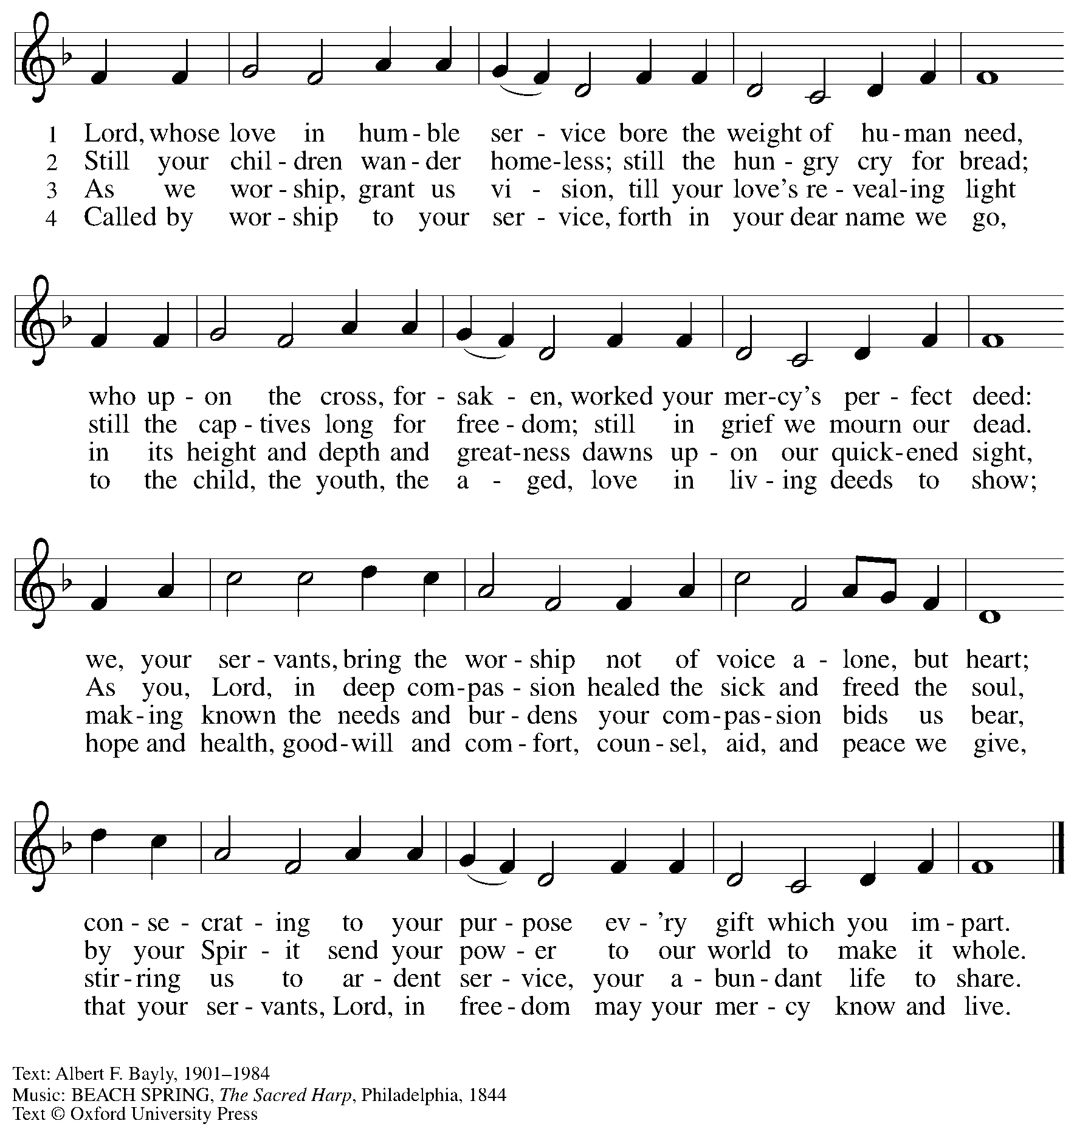
All rights reserved. Reprinted with permission under OneLicense.net # A-722139.

Hymns during Holy Communion
Lord, Speak to Us, That We May Speak ELW 676

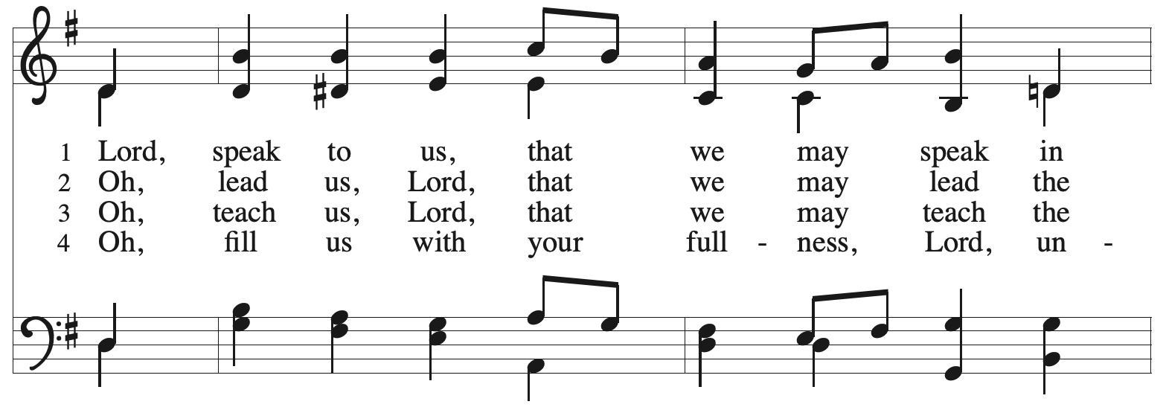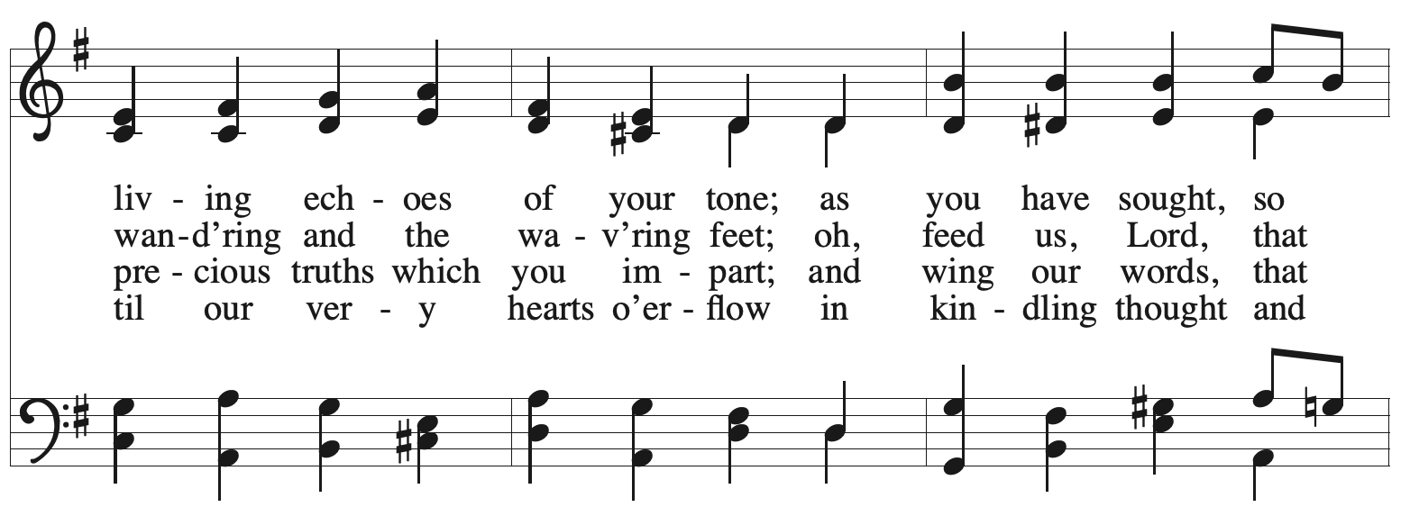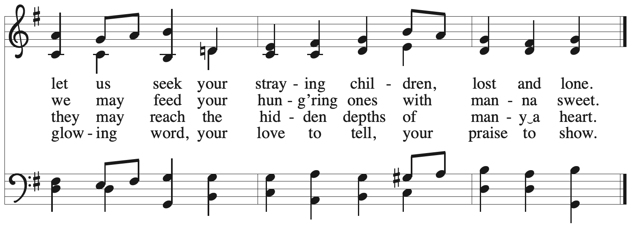

All rights reserved. Reprinted with permission under OneLicense.net # A-722139.

Hymns during Holy Communion
Just As I Am, without One Plea ELW 592

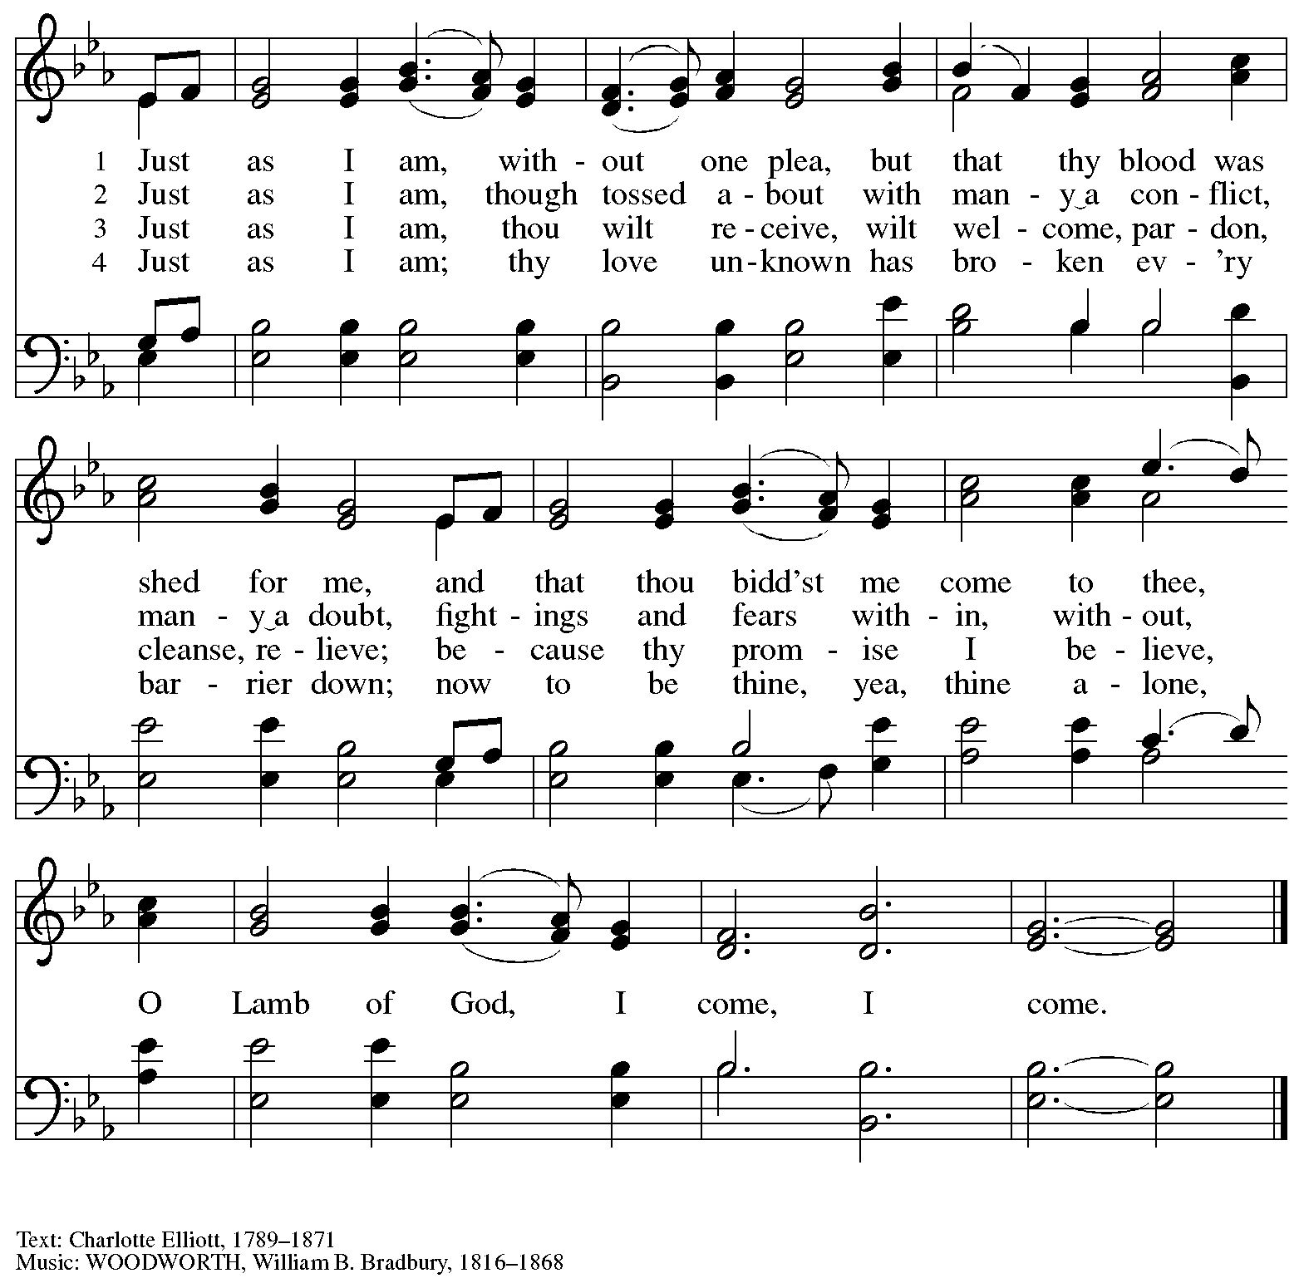

When all have returned to their places, please rise as you are able.

Blessing

P: The body and blood of our Lord Jesus Christ strengthen you and keep you in his grace.
C: Amen.

Prayer

A: Let us pray.
Life-giving God,
through this meal you have made your home among us
and are making all things new.
Send us now to speak peace to anxious hearts,
to love our neighbors, and to bring your healing to the nations,
through Jesus Christ, our Savior.
C: Amen.

Please be seated.

Sending
God blesses us and sends us in mission to the world

Announcements

Please rise as you are able.

Benediction

P: God Almighty, who is the beginning and the end,
Jesus Christ, the firstborn of the dead,
and the Spirit, our advocate and peace,
☩ bless you now and forever.
C: Amen.

Sending Hymn Following Page

Dismissal

A: Go in peace. Serve the Lord.
C: Thanks be to God!

Postlude

Sending Hymn Welcome Table ACS 969

1 I'm gonna eat at the welcome table,
I'm gonna eat at the welcome table,
some of these days.
I'm gonna eat at the welcome table,
I'm gonna eat at the welcome table,
some of these days.

2 I'm gonna feast on milk and honey,
I'm gonna feast on milk and honey,
some of these days.
I'm gonna feast on milk and honey,
I'm gonna feast on milk and honey,
some of these days.

3 I'm gonna wade 'cross Jordan's river,
I'm gonna wade 'cross Jordan's river,
some of these days.
I'm gonna wade 'cross Jordan's river,
I'm gonna wade 'cross Jordan's river,
some of these days.

Text: African American spiritual.
Music: WELCOME TABLE, African American spiritual.

Those serving in worship today

Altar Care Christy Ruhe
Assisting Minister Lindsay Baxter
Audio-Visual Ministers Kristen Asplin
Tyler Rietze
Cantor Emily Duque
Lector Brennan Coleman
Minister of Music Laura Reynolds
Presiding Minister The Rev. Ross I. Carmichael

Liturgy and Hymnody Acknowledgements

From SundaysandSeasons.com. Copyright © 2026 Augsburg Fortress. All rights reserved. Reprinted under OneLicense.net # A-722139.
Used by permission of Augsburg Fortress.

The Scripture readings contained herein are from New Revised Standard Version Updated Edition of the Bible © 2021 National Council of Churches of Christ in the United States of America. Used by permission. All rights reserved worldwide.

God, We Gather as Your People – Text: David Lohman, b. 1961. Music: WELCOME BE OUR SONG, David Lohman. Text and music © 2007 Welcome Song Music, admin. Augsburg Fortress. All rights reserved. Reprinted with permission under OneLicense.net # A-722139.

Please use the QR code below to link to St. Andrew’s Announcements online!



St. Andrew Lutheran Church Announcements
June 28th, 2026

- Welcome to Worship at St. Andrew on the Fifth Sunday after Pentecost – We are so glad you are here, and we offer a special welcome to all visitors and guests who are here for the first time! There are worship “toolkits” to help children engage with worship and “busy bags” for younger children available in the bookcase at the back of the sanctuary. Please feel free to take one to use with/for your children. A nursery is available through the door to the left of the worship space and across the social hall (look for a purple room). All are invited to gather for coffee, other drinks, food, and conversation in the social hall after worship.
- Monthly Reparations Offering, Next Sunday, July 5th, during Worship – In Luke’s Gospel, Jesus tells a story about a compassionate Samaritan, suggesting that God’s people are called to work for healing and restoration for our neighbors, regardless of who or what caused them harm. In light of this, St. Andrew has made a commitment to reparations in regard to African American spiritual songs used in our worship. The text and music of most hymns is attributed to specific authors, with copyrights in place, usage reported, and royalties paid to those whose works are featured in worship. With African American spirituals, this is not possible. In response to many years of such uncredited use, St. Andrew invites the congregation to give a reparations offering. Funds received in worship will be donated to our siblings at Bethel AME Church, whose land and building were taken from them in the 1950s, to fund their development in the Hill District.
- Produce Distribution Supplemental Food of the Month – St. Andrew is collecting supplemental food each month to accompany our produce distribution. For July, we ask for donations of canned, dehydrated, or freeze dried fruits. There are collection boxes at the back of the worship space and social hall.
- Produce Distribution, First and Third Tuesday Each Month, July 7th and 21st from 5:30 to 6:30 p.m. – St. Andrew partners with Greater Pittsburgh Community Food Bank to serve as a distribution site for fresh produce on the first and third Tuesday of every month. We invite people of the congregation to help with the distribution from 5:30 p.m. to 6:30 p.m. and/or to help with unloading and setup during the day between 10:00 a.m. and 1:00 p.m.
- Coffee Hour Will Be on Break for July and August.
- Bible Book is on break for the summer. In August, we will announce when it will return.

