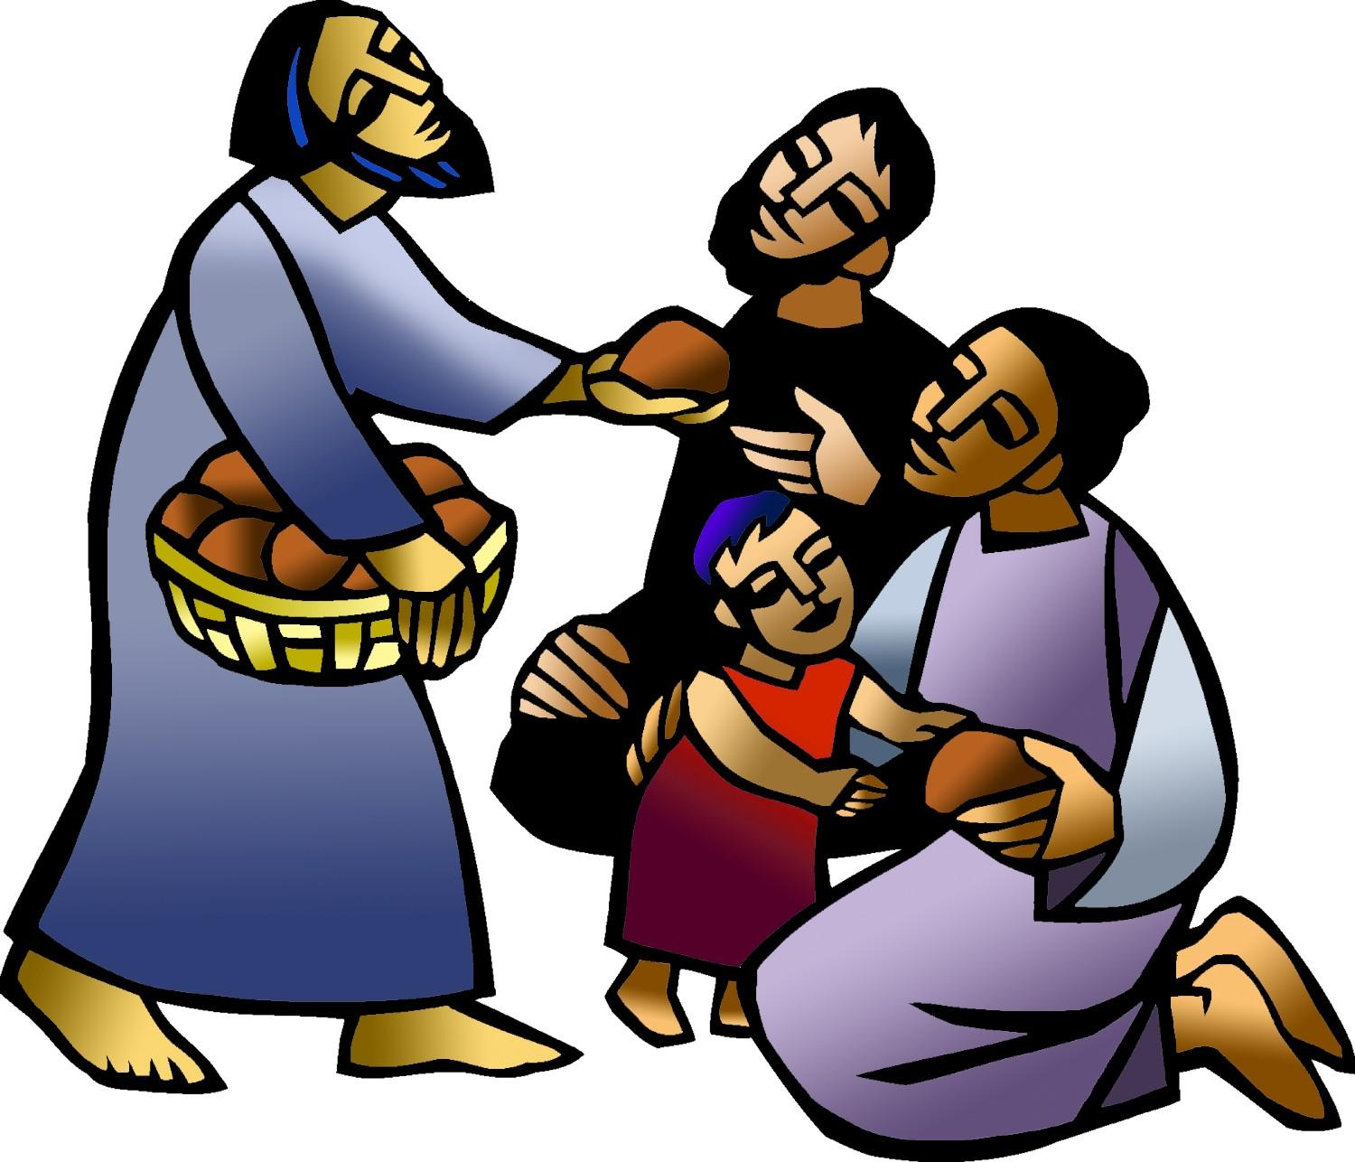

+ Eleventh Sunday after Pentecost
August 2, 2026


St. Andrew Lutheran Church
304 Morewood Ave.
Pittsburgh, PA 15213
St_andrewELCA@verizon.net
www.standrewpittsburgh.org

+ Tenth Sunday after Pentecost

In today’s first reading, God invites all who are hungry or thirsty to receive food and drink without cost. Jesus feeds the hungry multitude and reveals the abundance of God.
At the eucharistic table we remember all who are hungry or poor in our world today.
As we share the bread of life, we are sent forth to give ourselves away as bread for the hungry.

Welcome to St. Andrew!

- St. Andrew welcomes all who are seeking a place of healing, wholeness, and acceptance in a nurturing and faith-forming spiritual home. We are striving toward racial equity worldwide
and we seek to honor the lived experience of all individuals regardless of background. Our community embraces people of all ages, ethnicities, cultures, abilities, sexual orientations,
gender identities and expressions, and family constellations. Come and See!
- Worship Services are live-streamed to multiple online platforms. By attending worship, you agree that your image and voice may be broadcast.
- Everyone is invited to make a name tag at the black bookcase in the back of the worship space if they would like. There are stickers indicating pronouns on the bookcase if you would like to include them on your name tag.
- Little Church – Big Faith is on break for the summer.
- A nursery is available through the doors at the left side of the sanctuary and across from the doorway to the Social Hall. Look for a purple-colored room.
- Worship “toolkits” to help children engage with the service, along with “busy bags” for younger children, are available in the bookcase at the back of the sanctuary. Please feel free to take one to use with/for your children.
- Holy Communion is served with bread (gluten-free available) and wine or grape juice. The presiding minister will distribute the bread (host). Please consume this and then pick up an empty glass from the tray. The Communion Assistant will pour wine or grape juice into your glass. Please step to the side to consume the wine or grape juice. Feel free to kneel at the altar for prayer and reflection. As you return to your pew, glasses may be returned to the empty trays on either side of the center section.
- A restroom is available on the main level of the church, through the doors to the Social Hall and to the right in the main office.

Abbreviations
P: Pastor/Presiding Minister ELW: Evangelical Lutheran Worship hymnal
A: Assisting Minister ACS: All Creation Sings hymnal
L: Lector
C: Congregation

Musical Offering

Each week, different people from the congregation make an offering of pre-service music, with singing or instrumentation, to help the assembly focus and pray in preparation for worship.

Welcome
Prelude Let Us Break Bread Together arr. Carter

Gathering
The Holy Spirit calls us together as the people of God

Please rise as you are able. All may make the sign of the cross,
the sign that is marked at Baptism, as the presiding minister begins.

Confession and Forgiveness

P: Blessed be the ☩ holy Trinity,
one God, whose compassion endures forever.
C: Amen.

P: Let us confess our sin in the presence of God and of one another.

Silence is kept for reflection.

P: Compassionate God,
C: we confess to you all our sins.
Our burden is heavy, and we cannot free ourselves.
In your mercy, forgive us our sin, and call us back to you.
Your yoke is easy and your burden is light.
Restore us to dwell in your peace.
In Christ’s name we pray,
Amen.

P: Jesus says, “Come to me,
all you who are weary
and are carrying heavy burdens,
and I will give you rest.”
In the name of God,
Father, ☩ Son, and Holy Spirit,
your sins are forgiven.
Rest in God’s love.
C: Amen.

Gathering Hymn O Jesus, Joy of Loving Hearts ELW 658

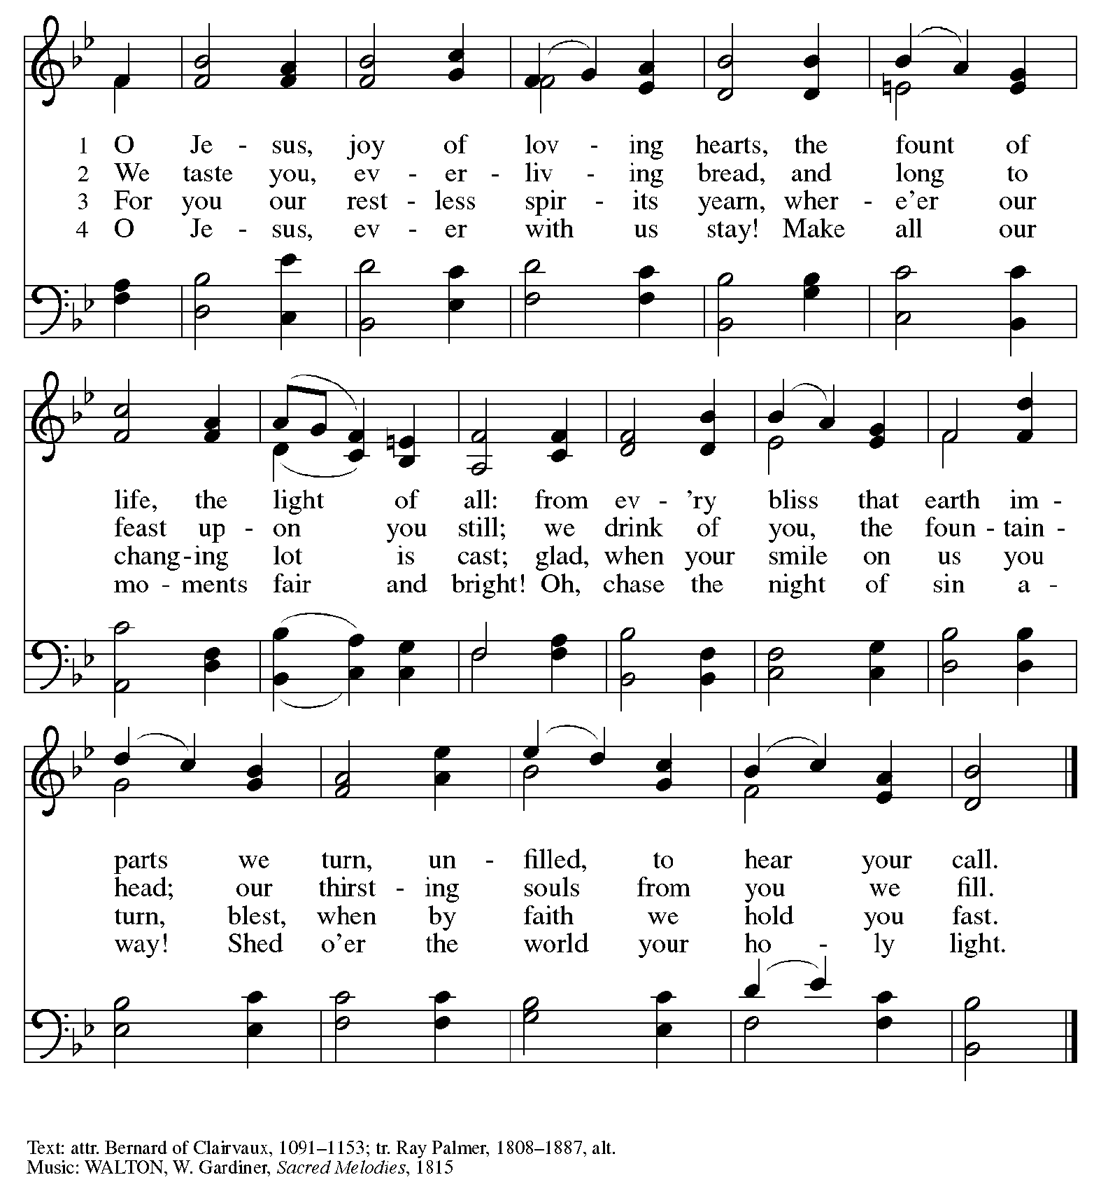

Greeting

P: The grace of our Lord Jesus Christ, the love of God,
and the communion of the Holy Spirit be with you all.
C: And also with you.

Prayer of the Day

P: Let us pray. Glorious God, your generosity waters the world with goodness,
and you cover creation with abundance.
Awaken in us a hunger for the food that satisfies both body and spirit,
and with this food fill all the starving world;
through your Son, Jesus Christ, our Savior and Lord.
C: Amen.

Please be seated.

Word
God speaks to us in Scripture reading, preaching, and song

First Reading – Isaiah 55: 1-5

¹ Hear, everyone who thirsts;
come to the waters;
and you who have no money,
come, buy and eat!
Come, buy wine and milk
without money and without price.
² Why do you spend your money for that which is not bread
and your earnings for that which does not satisfy?
Listen carefully to me, and eat what is good,
and delight yourselves in rich food.
³ Incline your ear, and come to me;
listen, so that you may live.
I will make with you an everlasting covenant,
my steadfast, sure love for David.
⁴ See, I made him a witness to the peoples,
a leader and commander for the peoples.
⁵ Now you shall call nations that you do not know,
and nations that do not know you shall run to you,
because of the Lord your God, the Holy One of Israel,
for the Lord has glorified you.

L: Word of God, word of life.
C: Thanks be to God.

Psalm 145: 8-9, 14-21

The psalm will be read responsively, led by the cantor,
with the congregation responding with the verses in bold.

⁸ The Lord is gracious and full of compassion,
slow to anger and abounding in steadfast love.
⁹ Lord, you are good to all,
and your compassion is over all your works.
¹⁴ The Lord upholds all those who fall
and lifts up those who are bowed down.
¹⁵ The eyes of all wait upon you, O Lord,
and you give them their food in due season.
¹⁶ You open wide your hand
and satisfy the desire of every living thing.
¹⁷ You are righteous in all your ways
and loving in all your works.
¹⁸ You are near to all who call upon you,
to all who call upon you faithfully.
¹⁹ You fulfill the desire of those who fear you;
you hear their cry and save them.
²⁰ You watch over all those who love you,
but all the wicked you shall destroy.
²¹ My mouth shall speak the praise of the Lord;
let all flesh bless God’s holy name forever and ever.

Second Reading – Romans 9: 1-5

¹ I am speaking the truth in Christ—I am not lying; my conscience confirms it by the Holy Spirit—² I have great sorrow and unceasing anguish in my heart. ³ For I could wish that I myself were accursed and cut off from Christ for the sake of my own siblings, my own flesh and blood. ⁴ They are Israelites, and to them belong the adoption, the glory, the covenants, the giving of the law, the worship, and the promises; ⁵ to them belong the patriarchs, and from them, according to the flesh, comes the Christ, who is over all, God blessed forever. Amen.
L: Word of God, word of life.
C: Thanks be to God.

Please rise as you are able.

Gospel Acclamation

C: Alleluia. One does not live by bread alone,
but by every word that comes from the mouth of God. Alleluia.

Gospel – Matthew 14: 13-21

P: The holy Gospel according to St. Matthew.
C: Glory to you, O Lord.
¹³ Now when Jesus heard [about the beheading of John the Baptist,] he withdrew from there in a boat to a deserted place by himself. But when the crowds heard it, they followed him on foot from the towns. ¹⁴ When he went ashore, he saw a great crowd, and he had compassion for them and cured their sick. ¹⁵ When it was evening, the disciples came to him and said, “This is a deserted place, and the hour is now late; send the crowds away so that they may go into the villages and buy food for themselves.” ¹⁶ Jesus said to them, “They need not go away; you give them something to eat.” ¹⁷ They replied, “We have nothing here but five loaves and two fish.” ¹⁸ And he said, “Bring them here to me.” ¹⁹ Then he ordered the crowds to sit down on the grass. Taking the five loaves and the two fish, he looked up to heaven and blessed and broke the loaves and gave them to the disciples, and the disciples gave them to the crowds. ²⁰ And all ate and were filled, and they took up what was left over of the broken pieces, twelve baskets full. ²¹ And those who ate were about five thousand men, besides women and children.

P: The Gospel of the Lord.
C: Praise to you, O Christ.

Please be seated.

Sermon

A time of silence for prayer and reflection follows the sermon.
When the hymn of the day begins, please rise as you are able.



Hymn of the Day ACS 966
Loaves Were Broken, Words Were Spoken

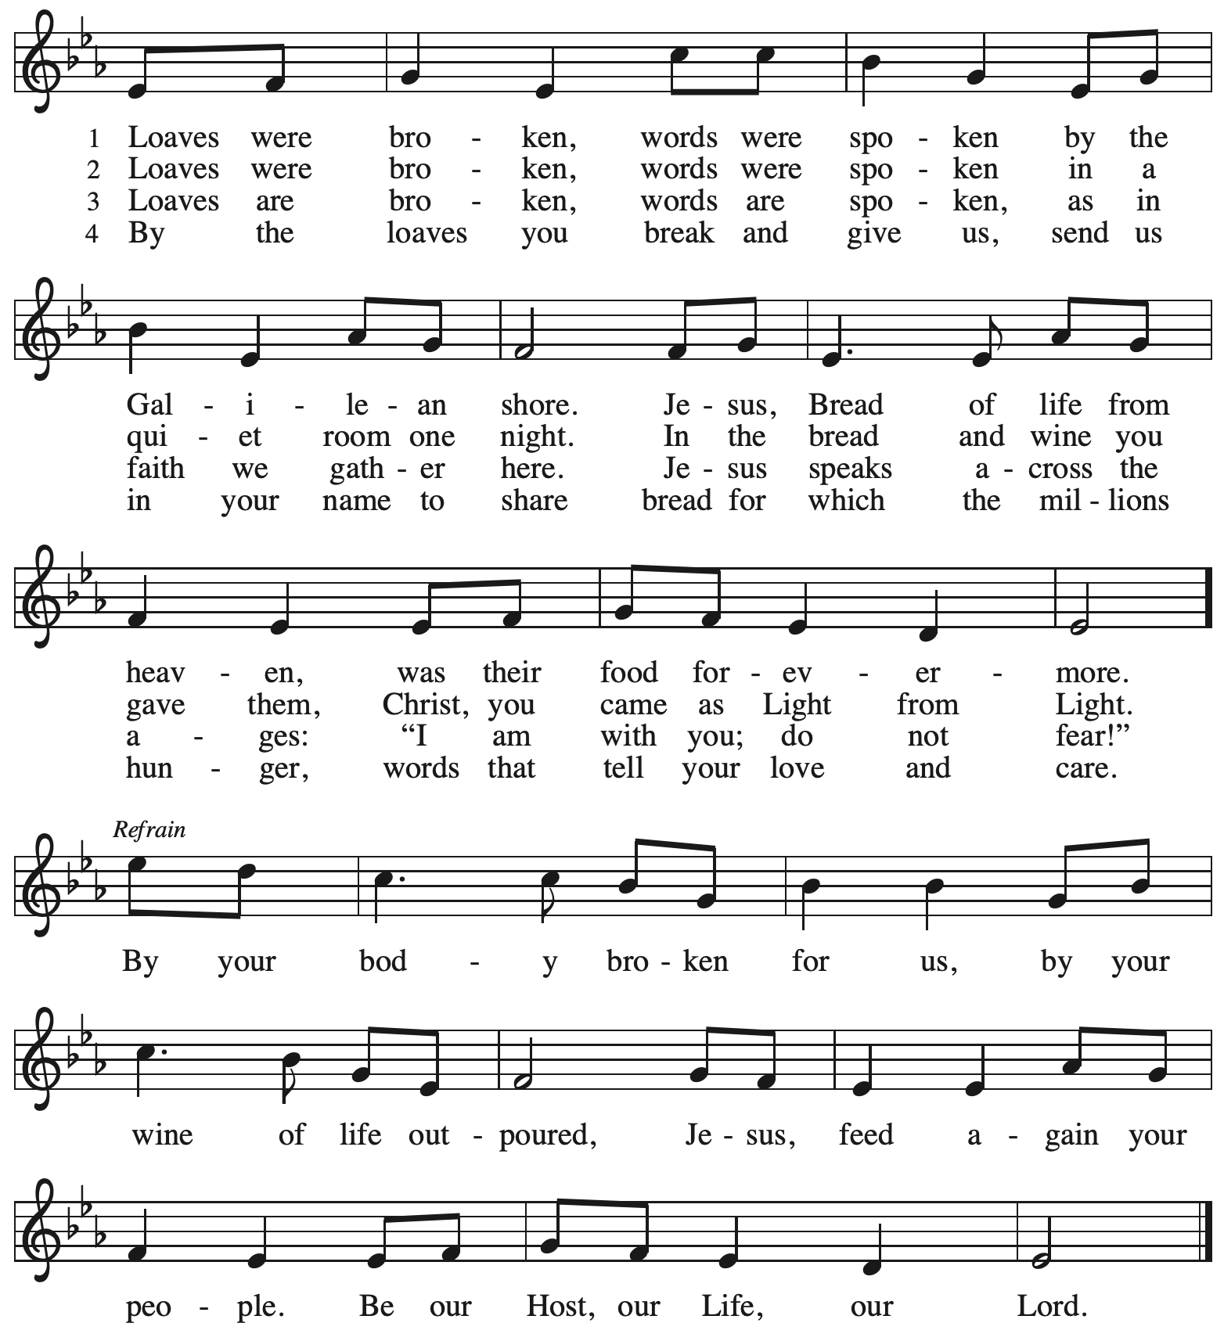
Reprinted with permission under OneLicense.net # A-722139.
Prayers of the People

A: Trusting in God’s steadfast love for all God has made,
let us pray for the church, the world, and those who are in need.

After each petition
A: Gracious God,
C: receive our prayer.

The presiding minister concludes the prayers
P: Grateful for your abundant provision and trusting in your goodness, O God,
we commend into your care all for whom we pray, through the priceless grace of Jesus Christ.
C: Amen.

Peace

The presiding minister and the assembly greet one another in the peace of the risen Christ.
P: The peace of Christ be with you always.
C: And also with you.

The people may greet those around them with a sign of Christ’s peace and may say
Peace be with you or similar words. Please be mindful that not everyone will be comfortable with sharing the peace, so please seek consent before shaking hands or hugging. Other possible ways to share the peace include a simple bow with the verbal greeting of peace, or simply a verbal expression of peace. When the greetings of peace have concluded, please be seated.

Meal
God feeds us with the presence of Jesus Christ

Offering

We offer ourselves, our gifts, and our faithful service to God. As the offering is gathered for the mission of the church, including the care of those in need, the table is set for Holy Communion.

There are laminated giving cards in the pew racks that feature a QR code for anyone who would like to give online. Those who give using the QR code, as well as those who give regularly online or through their bank are encouraged to place the laminated card in the plate as an expression of your offering.

Reparations Offering

On the first Sunday of each month, St. Andrew invites people of the congregation to give a second offering for a reparations fund in acknowledgment of St. Andrew’s use of African American spiritual songs in our worship. Please see the announcements for more information.

Music during the Offering
Jesu, Jesu, Fill Us with Your Love arr. Raabe

As the gifts are brought forward for presentation, please rise as you are able.

Offertory Song God, Whose Farm Is All Creation ELW 734
v. 1, 3

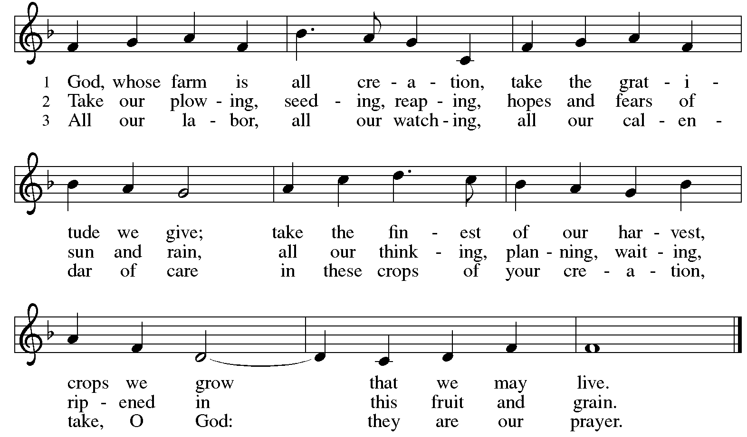
All rights reserved. Reprinted with permission under OneLicense.net # A-722139.

Offertory Prayer

A: Let us pray.
God of all creation,
C: all you have made is good, and your love endures forever.
You bring forth bread from the earth and fruit from the vine.
Nourish us with these gifts, that we might be for the world
signs of your gracious presence in Jesus Christ, our Savior and Lord.
Amen.

Dialogue

P: The Lord be with you.
C: And also with you.

P: Lift up your hearts.
C: We lift them to the Lord.

P: Let us give thanks to the Lord our God.
C: It is right to give our thanks and praise.

Preface (Spoken by the presiding minister)

P: It is indeed right, our duty and our joy …
… we praise your name and join their unending hymn:

Sanctus

C: Holy, holy, holy Lord,
God of power and might,
heaven and earth are full of your glory.
Hosanna in the highest.
Blessed is the one who comes in the name of the Lord.
Hosanna in the highest.

Eucharistic Prayer

P: Holy, mighty, and merciful Lord …
… be all honor and glory, now and forever.
C: Amen.

Lord’s Prayer

P: Gathered as one by the Holy Spirit, we pray as Jesus taught us.
C: Our Father in heaven,
hallowed be your name,
your kingdom come,
your will be done,
on earth as in heaven.
Give us today our daily bread.
Forgive us our sins,
as we forgive those
who sin against us;
Save us from the time of trial,
and deliver us from evil.
For the kingdom, the power,
and the glory are yours,
now and ever. Amen.

Fraction and Invitation

Agnus Dei / Lamb of God

C: Lamb of God, you take away the sin of the world; have mercy on us.
Lamb of God, you take away the sin of the world; have mercy on us.
Lamb of God, you take away the sin of the world; grant us peace.



Please be seated.

Holy Communion

- All who seek God and desire a deeper and stronger life in Christ are welcome to receive Holy Communion.
- Worshipers from the pulpit side will proceed forward first, followed by the center section, and then the lectern side.
- Please inform an usher if you would like the ministers to bring Communion to you.
- Holy Communion will be served with bread and wine (red) or grape juice (white).
- The presiding minister will first distribute the bread (host) to each communicant. Please indicate if you require a gluten-free host.
- Once you have consumed the bread, please pick up an empty glass from the tray next to the presiding minister. The Communion Assistant will pour wine or grape juice into your glass.
- Please step to the side to consume the wine or grape juice.
- Feel free to kneel at the altar rail for prayer after receiving the sacrament.
- As you return to your pew, glasses may be returned to the empty tray on the side of the center section.
- A blessing will be provided for anyone who does not yet receive the sacrament.
- All are invited to join in singing the hymns during Holy Communion.
Hymns during Holy Communion
We Eat the Bread of Teaching ELW 518

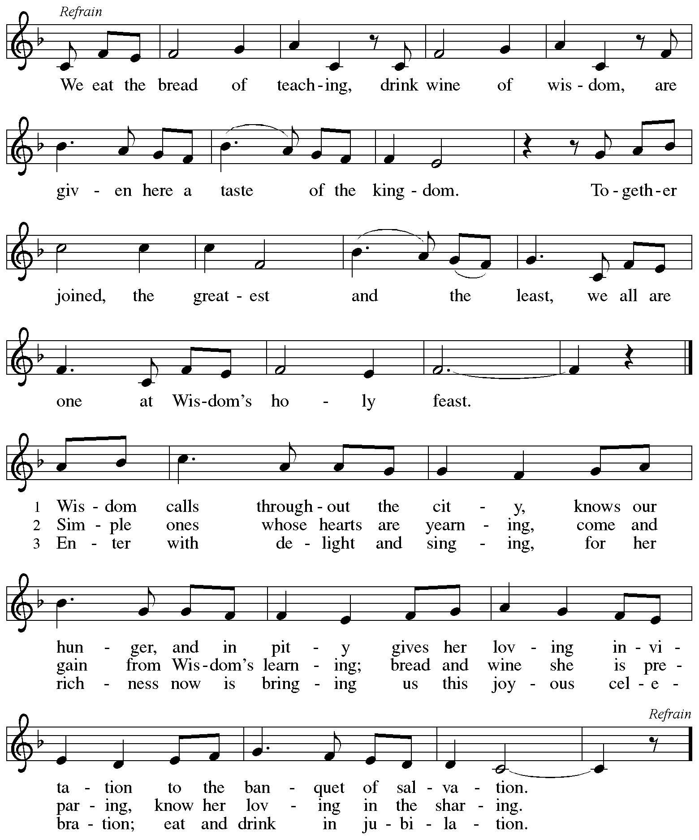
All rights reserved. Reprinted with permission under OneLicense.net # A-722139.
Hymns during Holy Communion
All Who Hunger, Gather Gladly ELW 461

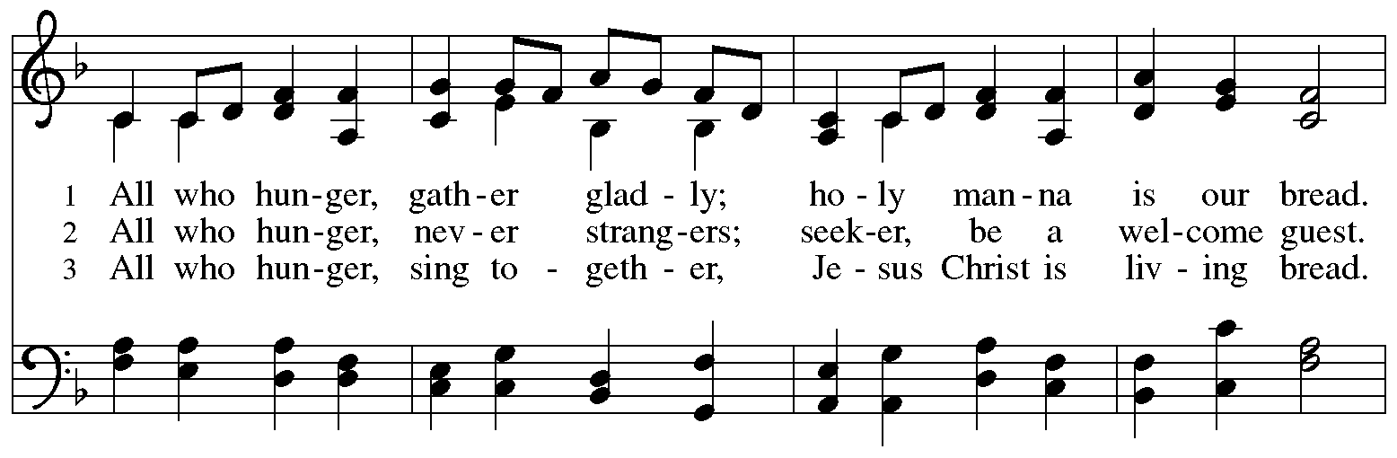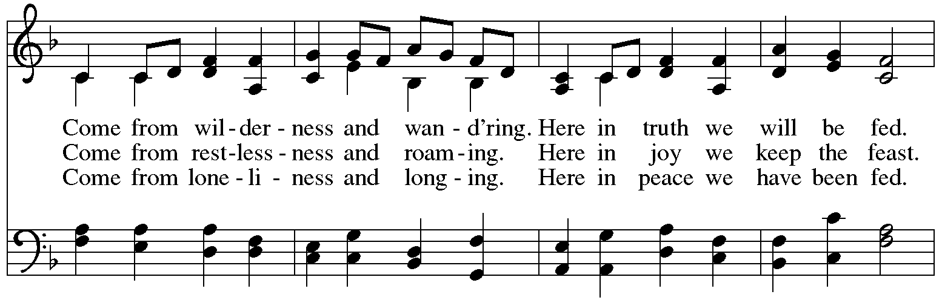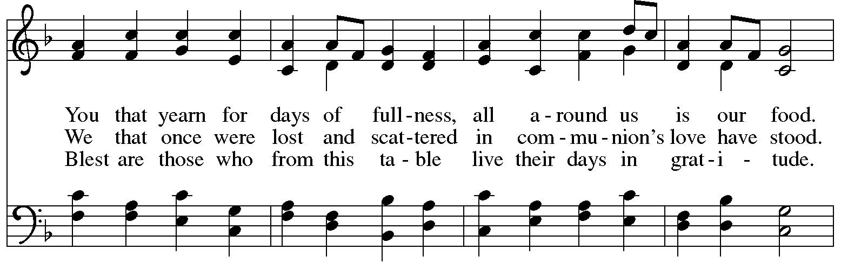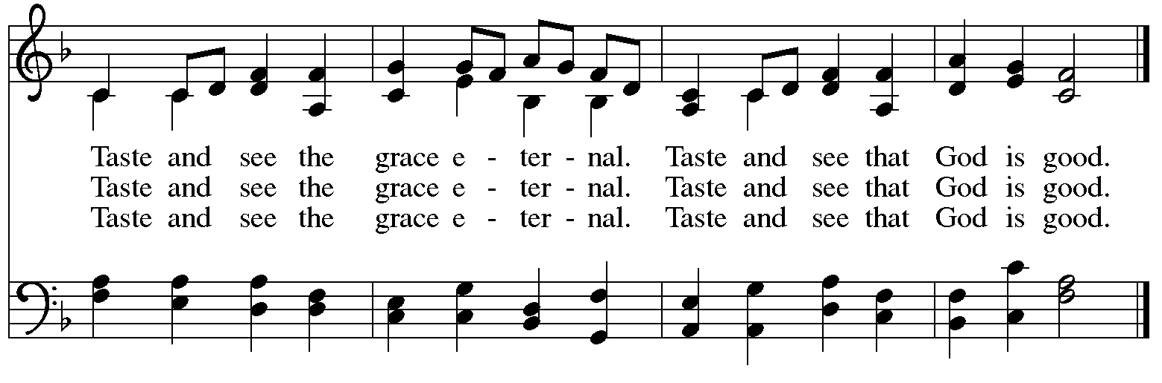
Hymns during Holy Communion
Come, Thou Fount of Every Blessing ELW 807

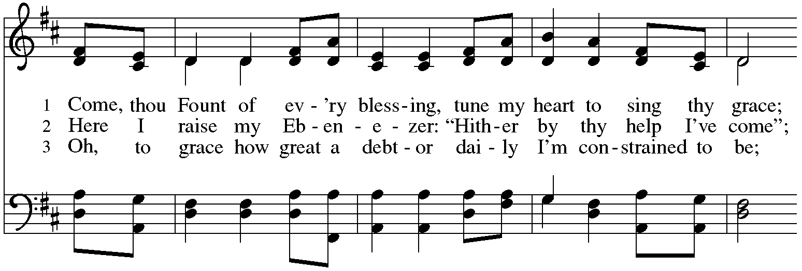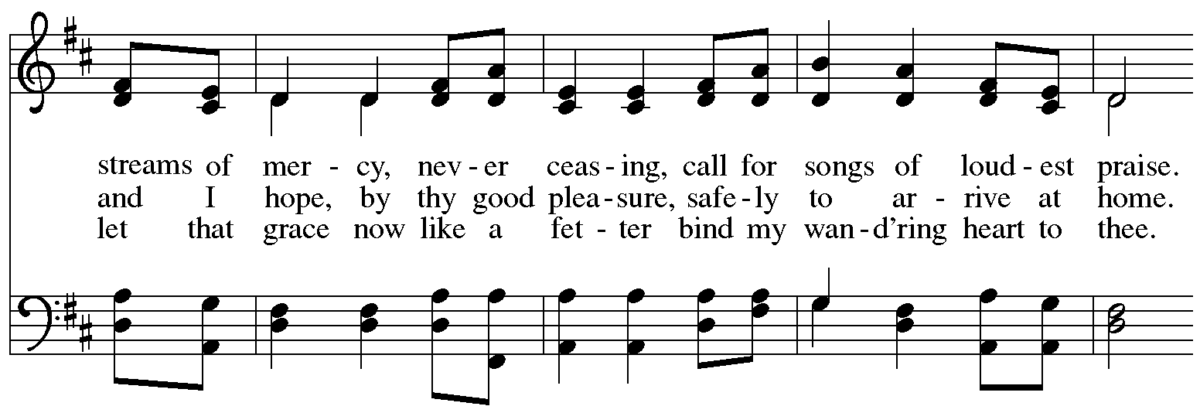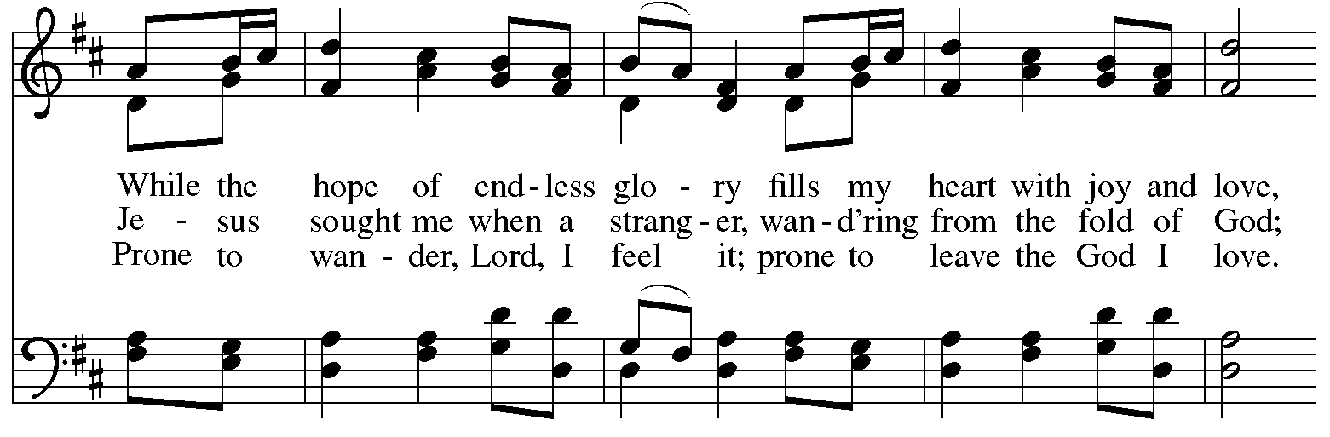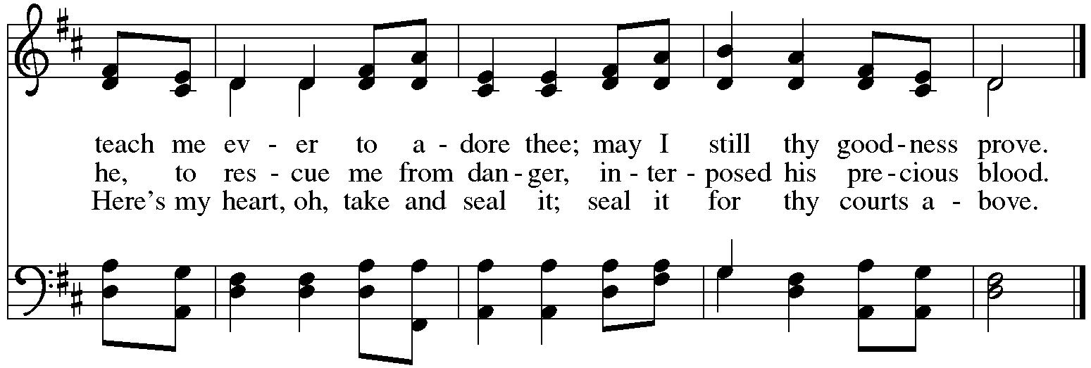
When all have returned to their places, please rise as you are able.

Blessing

P: The body and blood of our Lord Jesus Christ strengthen you and keep you in his grace.
C: Amen.

Prayer

A: Let us pray.
We give you thanks, almighty God, that you have refreshed us
through the healing power of this gift of life.
In your mercy, strengthen us through this gift,
in faith toward you and in fervent love toward one another;
for the sake of Jesus Christ our Lord.
C: Amen.

Please be seated.

Sending
God blesses us and sends us in mission to the world

Announcements

Please rise as you are able.

Benediction

P: The Lord bless you and keep you.
The Lord’s face shine on you with grace and mercy.
The Lord look upon you with favor and ☩ give you peace.
C: Amen.

Sending Hymn Following Page

Dismissal

A: Go in peace. Serve the Lord.
C: Thanks be to God!

Postlude

Sending Hymn United at the Table – Unidos en la fiesta ELW 498

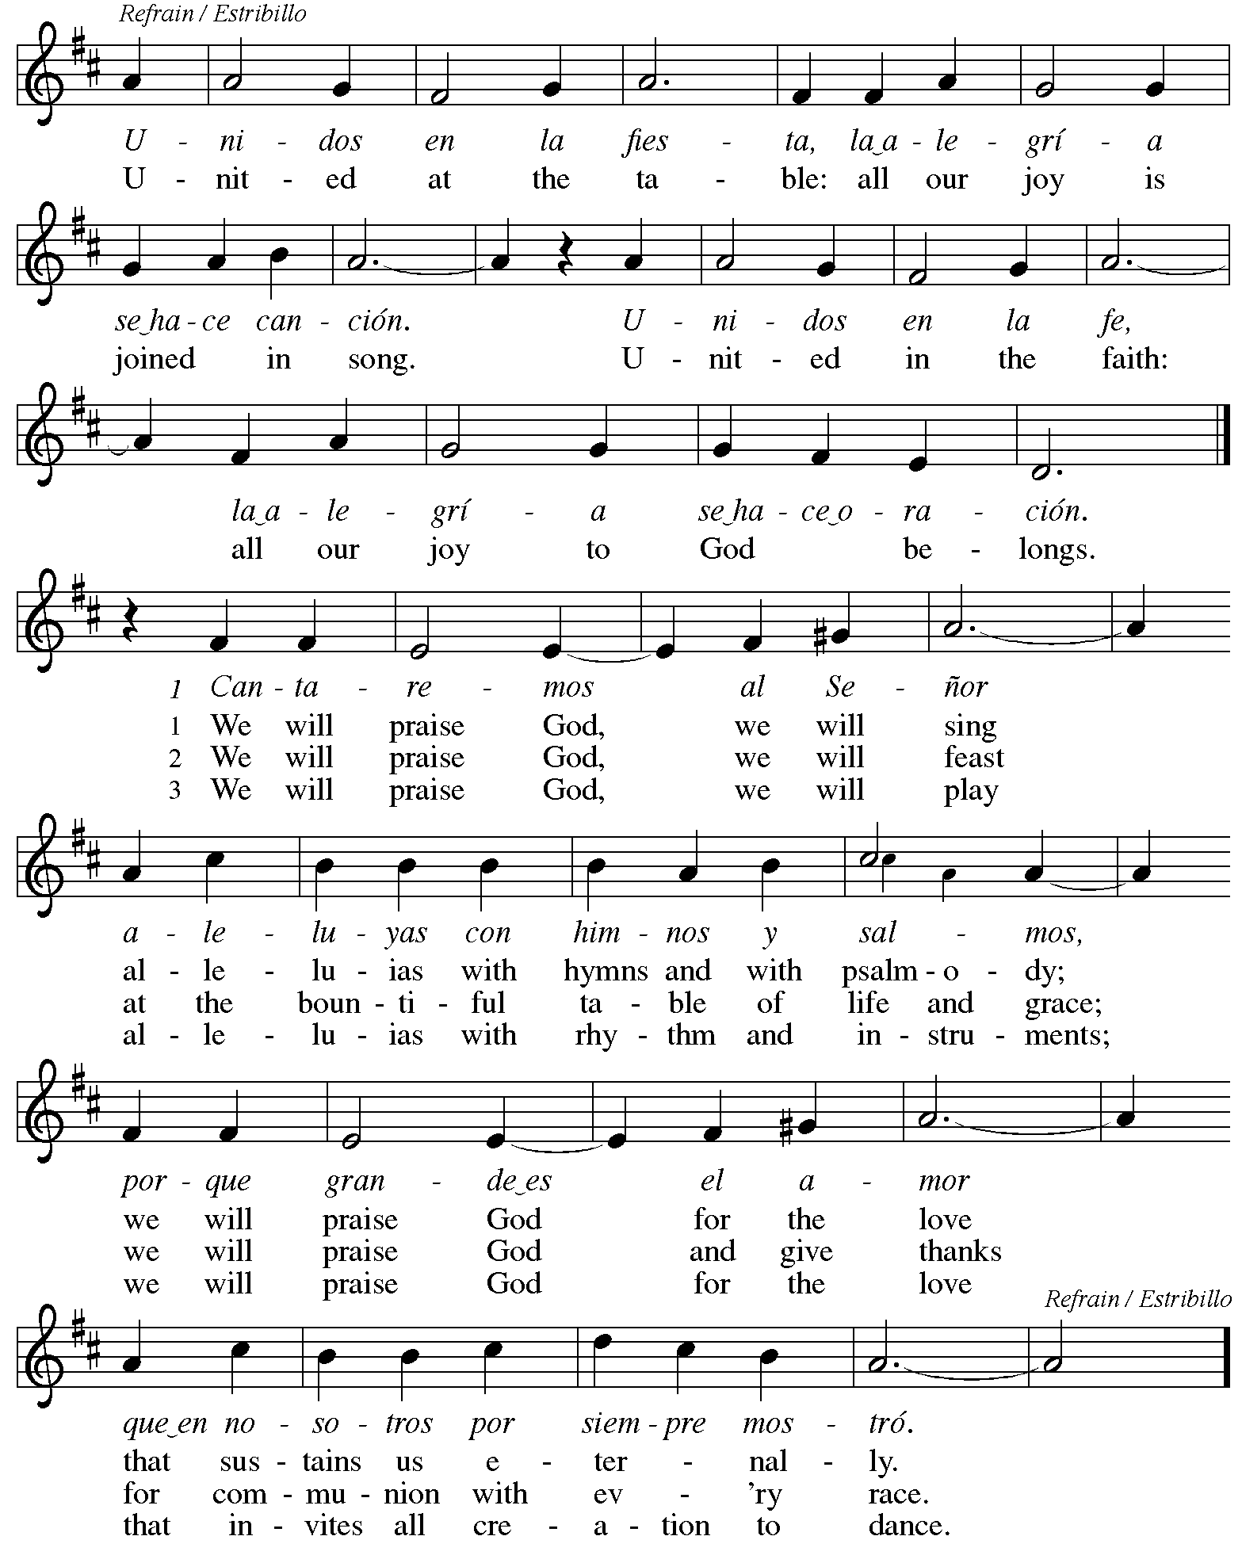
Serving in Worship Today

Altar Care Jodie Minor
Assisting Minister Lindsay Baxter
Audio-Visual Ministers Tim Jones
Joseph Paetz
Cantor Maria Mangano
Lector Michael Chapman
Minister of Music Laura Reynolds
Presiding Minister The Rev. Ross I. Carmichael

Liturgy and Hymnody Acknowledgements

From SundaysandSeasons.com. Copyright © 2026 Augsburg Fortress. All rights reserved. Reprinted under OneLicense.net # A-722139.
Used by permission of Augsburg Fortress.

Liturgical material reprinted with permission under Augsburg Fortress Liturgies Annual License SB124976.

The Scripture readings contained herein are from New Revised Standard Version Updated Edition of the Bible © 2021 National Council of Churches of Christ in the United States of America. Used by permission. All rights reserved worldwide.

All Who Hunger, Gather Gladly – Text: Sylvia G. Dunstan, 1955-1993. Music: HOLY MANNA, W. Moore, Columbian Harmony, 1825; arr. hymnal version. Text © 1991 GIA Publications, Inc., 7404 S. Mason Ave., Chicago, IL 60638. www.giamusic.com. 800.442.3358. All rights reserved. Used by permission. Arr. © 2003 Augsburg Fortress. All rights reserved. Reprinted with permission under OneLicense.net # A-722139.

Come, Thou Fount of Every Blessing – Text: Robert Robinson, 1735-1790, alt. Music: NETTLETON, J. Wyeth, Repository of Sacred Music, Part II, 1813.

United at the Table – Unidos en la fiesta – Text: Joaquín Madurga; tr. Angel Mattos, b. 1947 and Gerhard M. Cartford, b. 1923. Music: UNIDOS EN LA FIESTA, Joaquín Madurga. Text and music © 1979, 1998 J. Madurga and San Pablo Internacional – SSP, admin. OCP Publications, sole U.S. agent. All rights reserved. Reprinted with permission under OneLicense.net # A-722139.

Please use the QR code below to link to St. Andrew’s Announcements online!



St. Andrew Lutheran Church Announcements
August 2nd, 2026

- Welcome to Worship at St. Andrew on the Tenth Sunday after Pentecost – We are so glad you are here, and we offer a special welcome to all visitors and guests who are here for the first time! There are worship “toolkits” to help children engage with worship and “busy bags” for younger children available in the bookcase at the back of the sanctuary. Please feel free to take one to use with/for your children. A nursery is available through the door to the left of the worship space and across the social hall (look for a purple room).
- Monthly Reparations Offering Today during Worship – In Luke’s Gospel, Jesus tells a story about a compassionate Samaritan, suggesting that God’s people are called to work for healing and restoration for our neighbors, regardless of who or what caused them harm. In light of this, St. Andrew has made a commitment to reparations in regard to African American spiritual songs used in our worship. The text and music of most hymns is attributed to specific authors, with copyrights in place, usage reported, and royalties paid to those whose works are featured in worship. With African American spirituals, this is not possible. In response to many years of such uncredited use, St. Andrew invites the congregation to give a reparations offering. Funds received in worship will be donated to our siblings at Bethel AME Church, whose land and building were taken from them in the 1950s, to fund their development in the Hill District.
- Want to Learn More about Supporting Little Church - Big Faith? Meet with the Christian Education Team after Worship Today, August 2nd – Little Church - Big Faith is St. Andrew's ministry of Christian education for children 6th grade and under on Sundays during worship. We are seeking additional support for our children and their teachers and leaders, and invite you to gather for conversation about the ministry after worship this Sunday, August 2nd. If you are unable to attend today, please speak with Ty Best or email him at christian.education@standrewpittsburgh.org and to work out an alternative time to meet.
- Produce Distribution Supplemental Food of the Month – St. Andrew is collecting supplemental food each month to accompany our produce distribution. For August, we ask for donations of dried beans. There are collection boxes at the back of the worship space and social hall.
- Produce Distribution, First and Third Tuesday Each Month, August 4th and 18th from 5:30 to 6:30 p.m. – St. Andrew partners with Greater Pittsburgh Community Food Bank to serve as a distribution site for fresh produce on the first and third Tuesday of every month. We invite people of the congregation to help with the distribution from 5:30 p.m. to 6:30 p.m. and/or to help with unloading and setup during the day between 10:00 a.m. and 1:00 p.m.
- Congregation Council Retreat - Saturday, August 15th, 9:00 a.m. - 2:00 p.m. – The Congregation Council is a group of leaders (usually around 12) who plan and guide the ministry of the congregation, and twice a year, the group meets for a longer session. This year’s August retreat will be held on Saturday, August 15th, starting at 9:00 a.m.

