

+ Sixth Sunday after Pentecost

July 5, 2026

St. Andrew Lutheran Church
304 Morewood Ave.
Pittsburgh, PA 15213
St_andrewELCA@verizon.net
www.standrewpittsburgh.org

+ Sixth Sunday after Pentecost

In Matthew’s Gospel, Jesus says that the mystery of God’s ways is sometimes hidden from the wise and intelligent. Jesus associates with those often excluded from the religious community.
Like Paul, we struggle with our own selfish desires and seek God’s mercy and forgiveness.
We gather to be refreshed by Christ’s invitation: “Come to me, all you that are weary.”
Gathered around word, water, and meal, we find rest for our souls.

Welcome to St. Andrew!

- St. Andrew welcomes all who are seeking a place of healing, wholeness, and acceptance in a nurturing and faith-forming spiritual home. We are striving toward racial equity worldwide
and we seek to honor the lived experience of all individuals regardless of background. Our community embraces people of all ages, ethnicities, cultures, abilities, sexual orientations,
gender identities and expressions, and family constellations. Come and See!
- Worship Services are live-streamed to multiple online platforms. By attending worship, you agree that your image and voice may be broadcast.
- Everyone is invited to make a name tag at the black bookcase in the back of the worship space if they would like. There are stickers indicating pronouns on the bookcase if you would like to include them on your name tag.
- Little Church - Big Faith – Is on hold for the Summer and will return in the Fall.
- A nursery is available through the doors at the left side of the sanctuary and across from the doorway to the Social Hall. Look for a purple-colored room.
- Worship “toolkits” to help children engage with the service, along with “busy bags” for younger children, are available in the bookcase at the back of the sanctuary. Please feel free to take one to use with/for your children.
- Holy Communion is served with bread (gluten-free available) and wine or grape juice. The presiding minister will distribute the bread (host). Please consume this and then pick up an empty glass from the tray. The Communion Assistant will pour wine or grape juice into your glass. Please step to the side to consume the wine or grape juice. Feel free to kneel at the altar for prayer and reflection. As you return to your pew, glasses may be returned to the empty trays on either side of the center section.
- A restroom is available on the main level of the church, through the doors to the Social Hall and to the right in the main office.

Abbreviations
P: Pastor/Presiding Minister ELW: Evangelical Lutheran Worship hymnal
A: Assisting Minister ACS: All Creation Sings hymnal
L: Lector
C: Congregation

Musical Offering

Each week, different people from the congregation make an offering of pre-service music, with singing or instrumentation, to help the assembly focus and pray in preparation for worship.

Welcome
Prelude O Day of Rest and Gladness arr. Carter

Gathering
The Holy Spirit calls us together as the people of God

Please rise as you are able. All may make the sign of the cross,
the sign that is marked at Baptism, as the presiding minister begins.

Confession and Forgiveness

P: Blessed be the holy Trinity, ☩ one God,
source of hope in every nation, rest for the weary,
whose glory and peace extend to the ends of the earth.
C: Amen.

P: Let us bring every burden to God.

Silence is kept for reflection.

P: God of all mercy,
we have sinned against you,
our neighbors, and your creation.
Within ourselves and our communities,
our desire to do what is good
struggles against the sin that dwells in us.
We lament the evil that holds us captive.
We repent of the evil we have done, and the evil done on our behalf.
Rescue us, forgive us, and restore us for lives of compassion and courage
through our Savior Jesus Christ.
Amen.

P: All-merciful, Almighty God
forgive you all your sins
through the grace of ☩ Jesus Christ,
and by the Spirit’s power strengthen you
in doing that which is good and pleasing in God’s sight.
C: Amen.

Gathering Hymn This Is My Song ELW 887

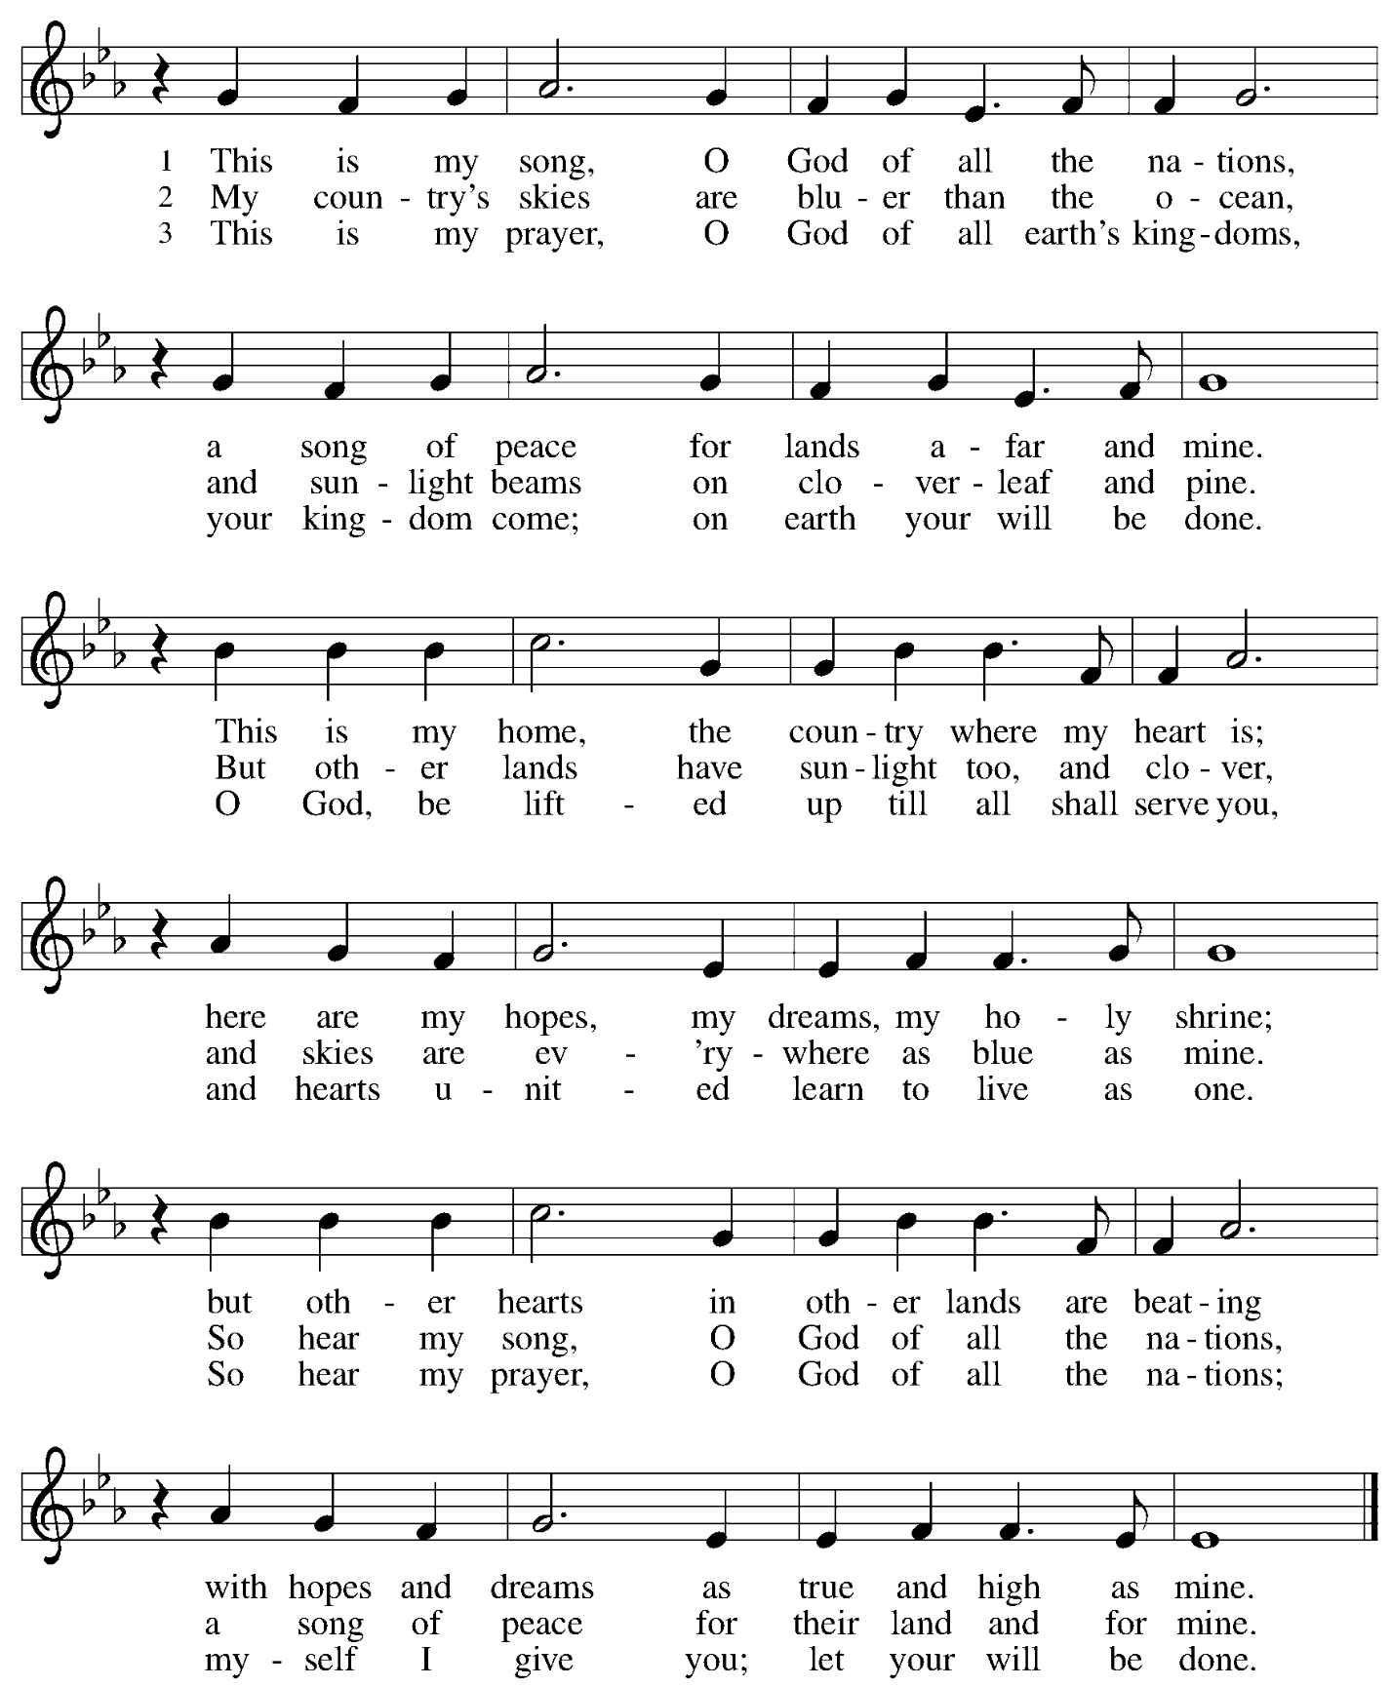

Greeting

P: The grace of our Lord Jesus Christ, the love of God,
and the communion of the Holy Spirit be with you all.
C: And also with you.

Hymn of Praise Glory to You, God ACS p. 31

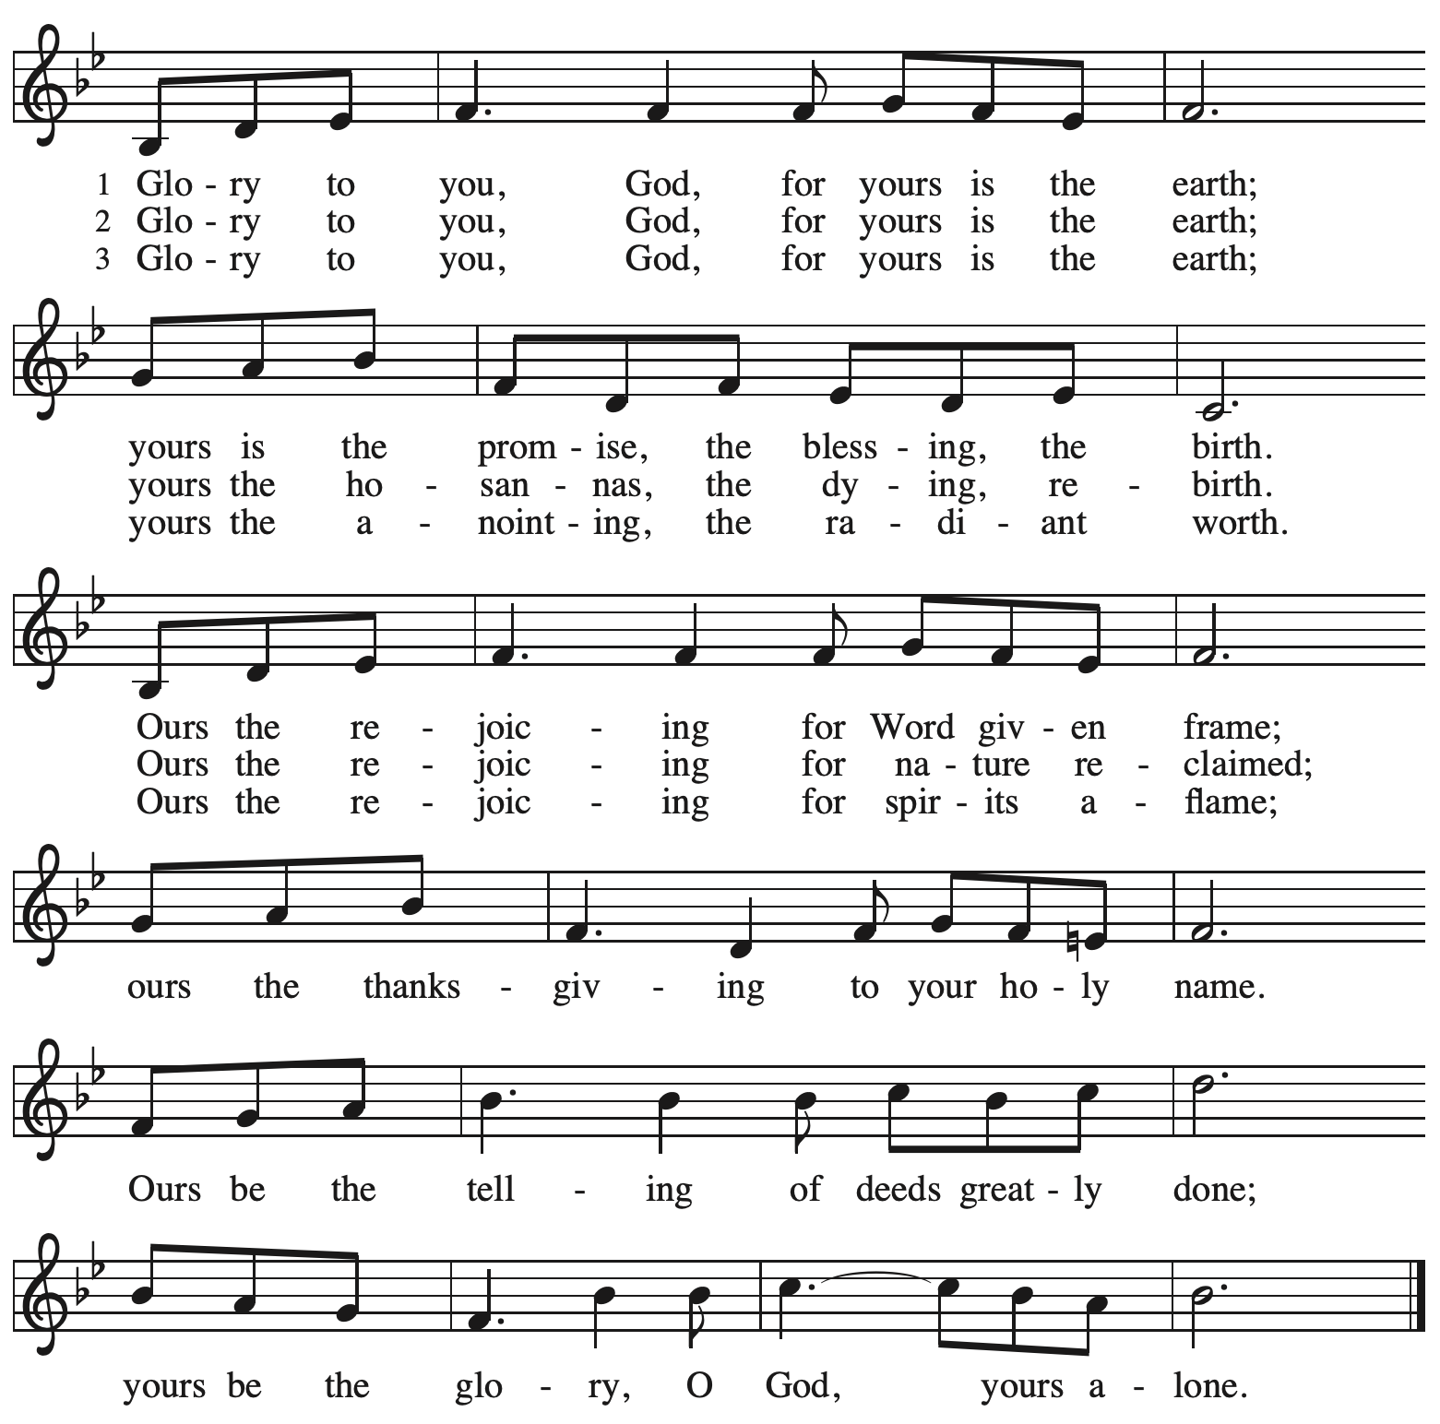

Prayer of the Day

P: The Lord be with you.
C: And also with you.

P: Let us pray.
You are great, O God, and greatly to be praised.
You have made us for yourself, and our hearts are restless until they rest in you.
Grant that we may believe in you, call upon you, know you, and serve you,
through your Son, Jesus Christ, our Savior and Lord.
C: Amen.

Please be seated.

Word
God speaks to us in Scripture reading, preaching, and song

First Reading – Zechariah 9: 9-12

⁹ Rejoice greatly, O daughter Zion!
Shout aloud, O daughter Jerusalem!
See, your king comes to you;
triumphant and victorious is he,
humble and riding on a donkey,
on a colt, the foal of a donkey.
¹⁰ He will cut off the chariot from Ephraim
and the war horse from Jerusalem;
and the battle bow shall be cut off,
and he shall command peace to the nations;
his dominion shall be from sea to sea
and from the River to the ends of the earth.
¹¹ As for you also, because of the blood of my covenant with you,
I will set your prisoners free from the waterless pit.
¹² Return to your stronghold, O prisoners of hope;
today I declare that I will restore to you double.

L: Word of God, word of life.
C: Thanks be to God.

Psalm 145: 8-14

The psalm will be sung responsively, led by the cantor,
with the congregation responding with the bold verses and refrain.

Psalm Tone

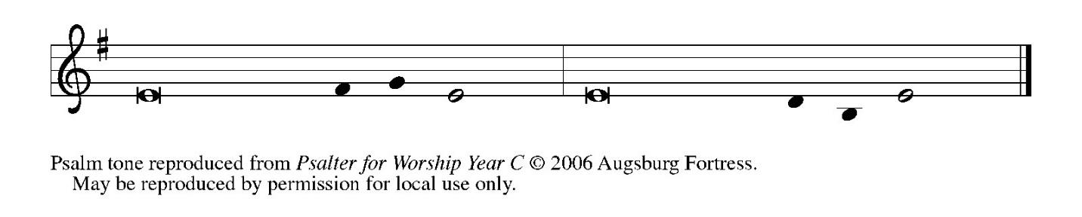

Psalm Refrain

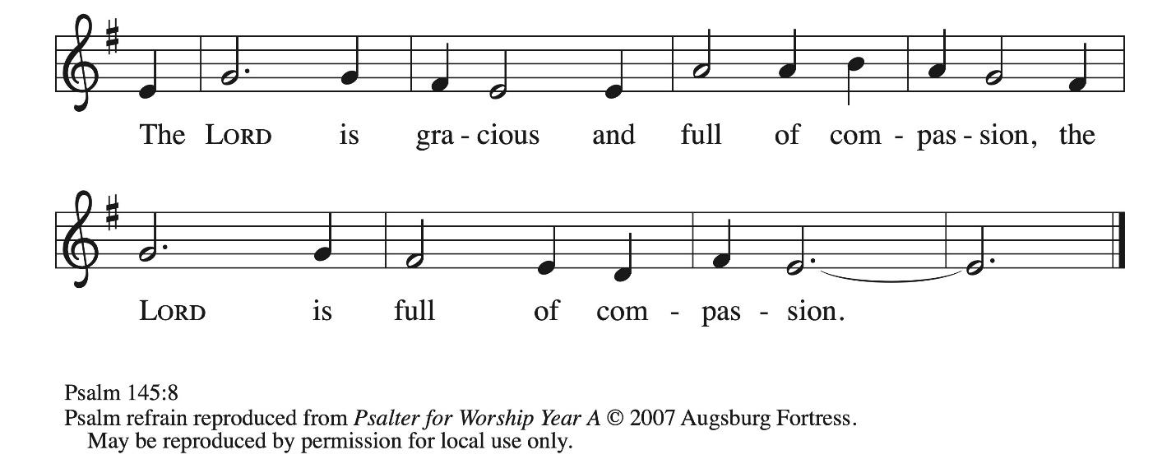

⁸ The Lord is gracious and full | of compassion,
slow to anger and abounding in | steadfast love.
⁹ Lord, you are | good to all,
and your compassion is over | all your works. R
¹⁰ All your works shall praise | you, O Lord,
and your faithful | ones shall bless you.
¹¹ They shall tell of the glory | of your kingdom
and speak | of your power,
¹² that all people may know | of your power
and the glorious splendor | of your kingdom.
¹³ Your kingdom is an everlasting kingdom; your dominion endures through- | out all ages.
You, Lord, are faithful in all your words, and loving in | all your works.
¹⁴ The Lord upholds all | those who fall
and lifts up those who | are bowed down. R

Second Reading – Romans 7: 15-25a

¹⁵ I do not understand my own actions. For I do not do what I want, but I do the very thing I hate. ¹⁶ Now if I do what I do not want, I agree that the law is good. ¹⁷ But in fact it is no longer I who do it but sin that dwells within me. ¹⁸ For I know that the good does not dwell within me, that is, in my flesh. For the desire to do the good lies close at hand, but not the ability. ¹⁹ For I do not do the good I want, but the evil I do not want is what I do. ²⁰ Now if I do what I do not want, it is no longer I who do it but sin that dwells within me.
²¹ So I find it to be a law that, when I want to do what is good, evil lies close at hand. ²² For I delight in the law of God in my inmost self, ²³ but I see in my members another law at war with the law of my mind, making me captive to the law of sin that dwells in my members. ²⁴ Wretched person that I am! Who will rescue me from this body of death? ^{25a} Thanks be to God through Jesus Christ our Lord!
L: Word of God, word of life.
C: Thanks be to God.

Please rise as you are able.

Gospel Acclamation ACS p. 33

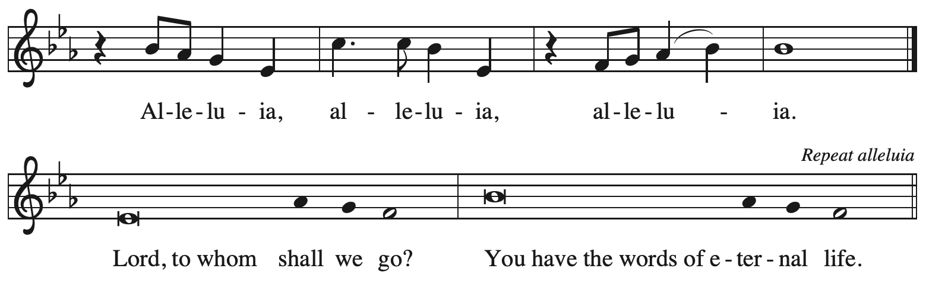

Gospel – Matthew 11: 16-19, 25-30

P: The holy Gospel according to St. Matthew.
C: Glory to you, O Lord.

[Jesus spoke to the crowd saying:] ¹⁶ “To what will I compare this generation? It is like children sitting in the marketplaces and calling to one another,
¹⁷ ‘We played the flute for you, and you did not dance;
we wailed, and you did not mourn.’
¹⁸ “For John came neither eating nor drinking, and they say, ‘He has a demon’; ¹⁹ the Son of Humanity came eating and drinking, and they say, ‘Look, a glutton and a drunkard, a friend of tax collectors and sinners!’ Yet wisdom is vindicated by her deeds.”
²⁰ Then he began to reproach the cities in which most of his deeds of power had been done because they did not repent. ²¹ “Woe to you, Chorazin! Woe to you, Bethsaida! For if the deeds of power done in you had been done in Tyre and Sidon, they would have repented long ago in
sackcloth and ashes. ²² But I tell you, on the day of judgment it will be more tolerable for Tyre and Sidon than for you. ²³ And you, Capernaum,
will you be exalted to heaven?
No, you will be brought down to Hades.
“For if the deeds of power done in you had been done in Sodom, it would have remained until this day. ²⁴ But I tell you that on the day of judgment it will be more tolerable for the land of Sodom than for you.”
²⁵ At that time Jesus said, “I thank you, Father, Lord of heaven and earth, because you have hidden these things from the wise and the intelligent and have revealed them to infants; ²⁶ yes, Father, for such was your gracious will. ²⁷ All things have been handed over to me by my Father, and no one knows the Son except the Father, and no one knows the Father except the Son and anyone to whom the Son chooses to reveal him.
²⁸ “Come to me, all you who are weary and are carrying heavy burdens, and I will give you rest. ²⁹ Take my yoke upon you, and learn from me, for I am gentle and humble in heart, and you will find rest for your souls. ³⁰ For my yoke is easy, and my burden is light.”

P: The Gospel of the Lord.
C: Praise to you, O Christ.

Please be seated.

Sermon

A time of silence for prayer and reflection follows the sermon.
When the hymn of the day begins, please rise as you are able.


Hymn of the Day I Heard the Voice of Jesus Say ELW 611

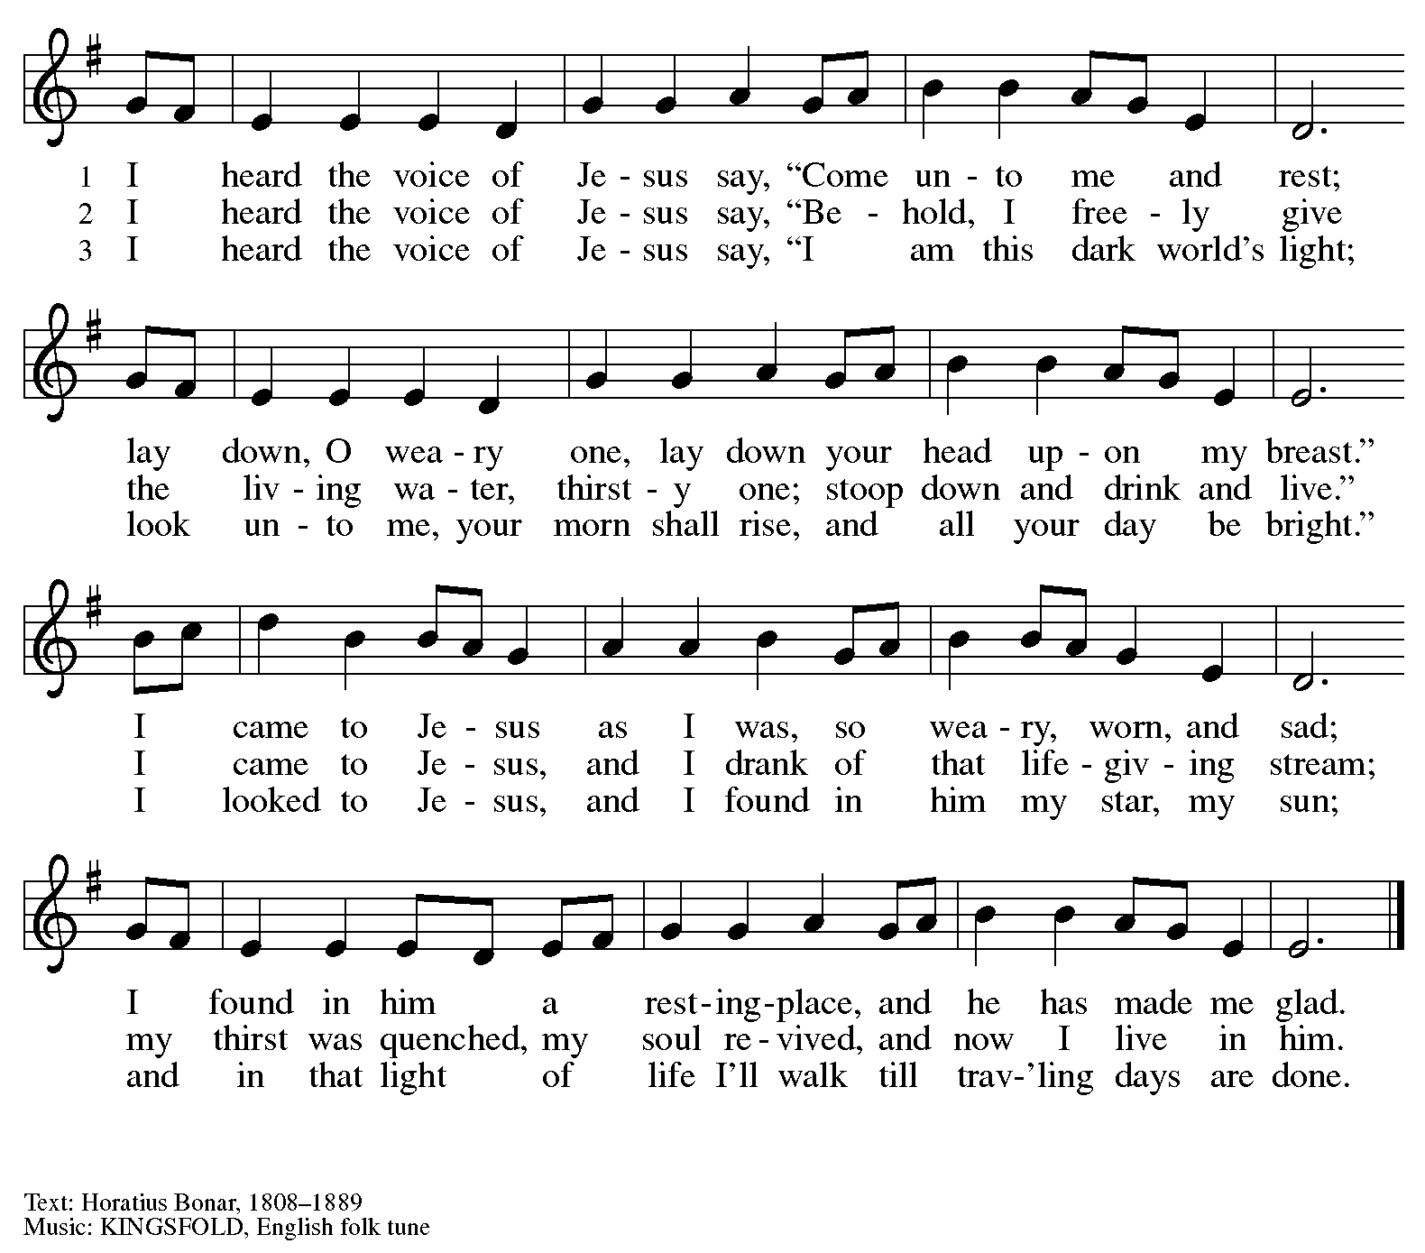

Apostles’ Creed

C: I believe in God, the Father almighty,
creator of heaven and earth.

I believe in Jesus Christ, God’s only Son, our Lord,
who was conceived by the Holy Spirit,
born of the virgin Mary,
suffered under Pontius Pilate,
was crucified, died, and was buried;
he descended to the dead.*

C: On the third day he rose again;
he ascended into heaven,
he is seated at the right hand of the Father,
and he will come to judge the living and the dead.

I believe in the Holy Spirit,
the holy catholic church,
the communion of saints,
the forgiveness of sins,
the resurrection of the body,
and the life everlasting. Amen.

*Or, “he descended into hell,” another translation of this text in widespread use.

Prayers of the People

A: Gathered by the Holy Spirit, let us pray for the church, the world,
and all people according to their need.

After each petition
A: God of grace,
C: receive our prayer.

The presiding minister concludes the prayers
P: Trusting that you receive all our prayers,
we commend our spoken and unspoken petitions to you, O God,
through Jesus Christ our Savior.
C: Amen.

Peace

The presiding minister and the assembly greet one another in the peace of the risen Christ.
P: The peace of Christ be with you always.
C: And also with you.

The people may greet those around them with a sign of Christ’s peace and may say
Peace be with you or similar words. Please be mindful that not everyone will be comfortable with sharing the peace, so please seek consent before shaking hands or hugging. Other possible ways to share the peace include a simple bow with the verbal greeting of peace, or simply a verbal expression of peace.

When the greetings of peace have concluded, please be seated.

Meal
God feeds us with the presence of Jesus Christ



Offering

We offer ourselves, our gifts, and our faithful service to God.
As the offering is gathered for the mission of the church, including the care of those in need,
the table is set for Holy Communion.

There are laminated giving cards in the pew racks that feature a QR code for anyone who would like to give online. Those who give using the QR code, as well as those who give regularly online or through their bank are encouraged to place the laminated card in the plate as an expression of your offering.

Reparations Offering

On the first Sunday of each month, St. Andrew invites people of the congregation to give a second offering for a reparations fund in acknowledgment of St. Andrew’s use of African American spiritual songs in our worship services. Please see the note in the announcements for more information.

Music during the Offering
Immortal, Invisible, God Only Wise arr. Shackley
As the gifts are brought forward for presentation, please rise as you are able.

Offertory Song Timothy Kocher-Hillmer

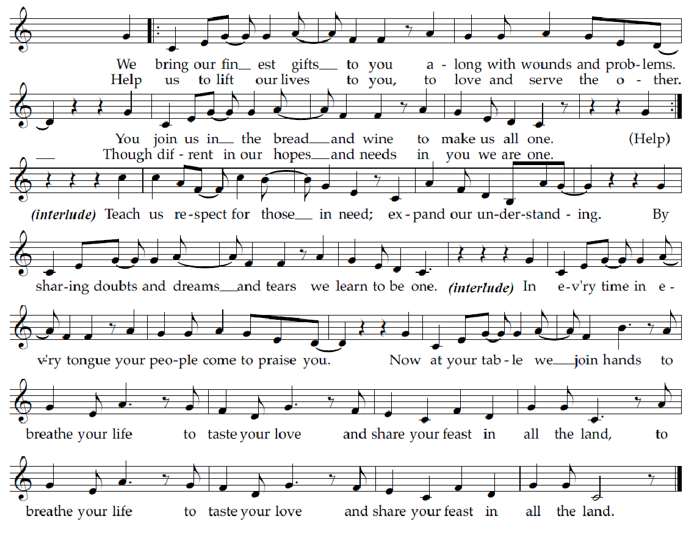

Offertory Prayer

A: Let us pray.
God of goodness and growth,
C: all creation is yours, and your faithfulness is sure.
Word and water, wine and bread: these are signs of your abundant grace.
Receive the gifts we bring,
and nourish us to proclaim your abiding love in our communities and in the world,
through Jesus Christ, our strength and our song.
Amen.

Dialogue ACS p. 36

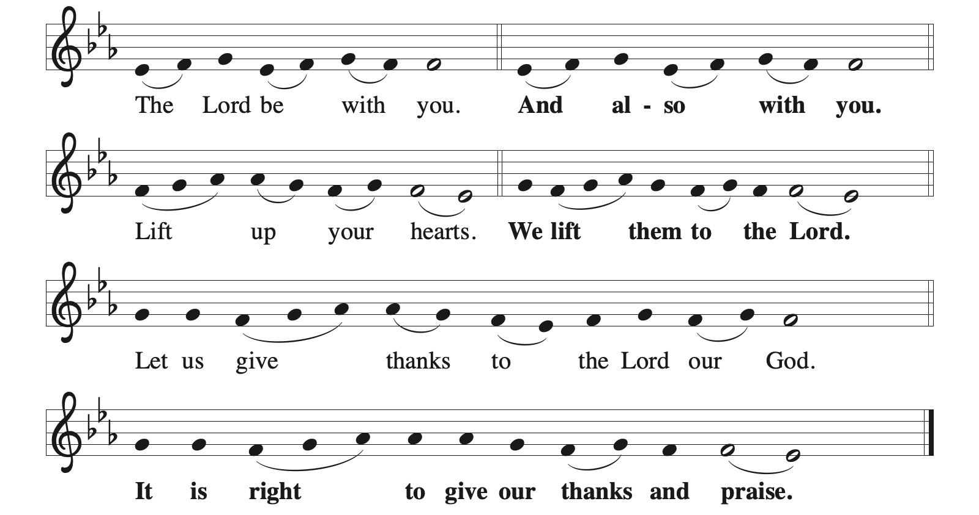

Preface (Sung by the presiding minister)

P: It is indeed right, our duty and our joy,
that we should at all times and in all places
give thanks and praise to you, almighty and merciful God,
through our Savior Jesus Christ;
who on this day overcame death and the grave,
and by his glorious resurrection opened to us the way of everlasting life.
And so, with all the choirs of angels,
with the church on earth and the hosts of heaven,
we praise your name and join their unending hymn:

Sanctus ACS p. 36

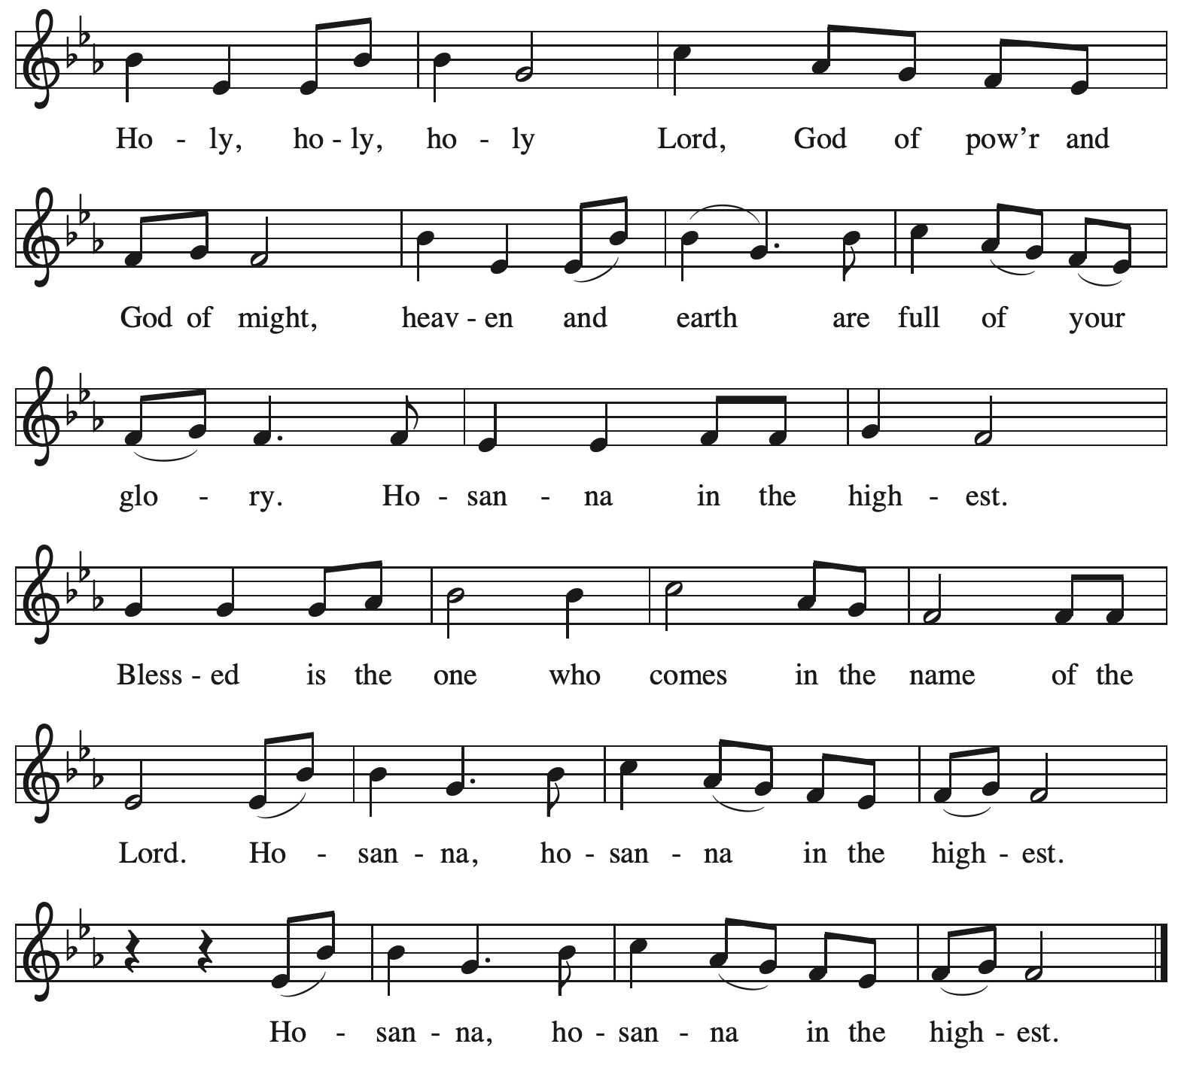

Eucharistic Prayer

P: O God triune, how majestic is your name in all the earth …
… The earth is full of your glory.
C: The earth is full of your glory.

P: O God triune, you made a home among us in Jesus our healer …
… The earth is full of your glory.
C: The earth is full of your glory.

P: We praise you for the heart of Jesus, so filled with your love for the world …
… Do this for the remembrance of me.

Gathered around your table, we your children unite in this song:
The earth is full of your glory.
C: The earth is full of your glory.

P: O God triune, you create the worlds, you uphold the living, you embrace the dead …
… The earth is full of your glory.
C: The earth is full of your glory.

P: Amen and Amen.
C: Amen and Amen.

Lord’s Prayer

P: Gathered as one by the Holy Spirit, let us pray as Jesus taught us.
C: Our Father in heaven,
hallowed be your name,
your kingdom come,
your will be done,
on earth as in heaven.
Give us today our daily bread.
Forgive us our sins
as we forgive those
who sin against us.
Save us from the time of trial
and deliver us from evil.
For the kingdom, the power,
and the glory are yours,
now and forever. Amen.

Fraction and Invitation



Agnus Dei / Lamb of God ACS p. 40

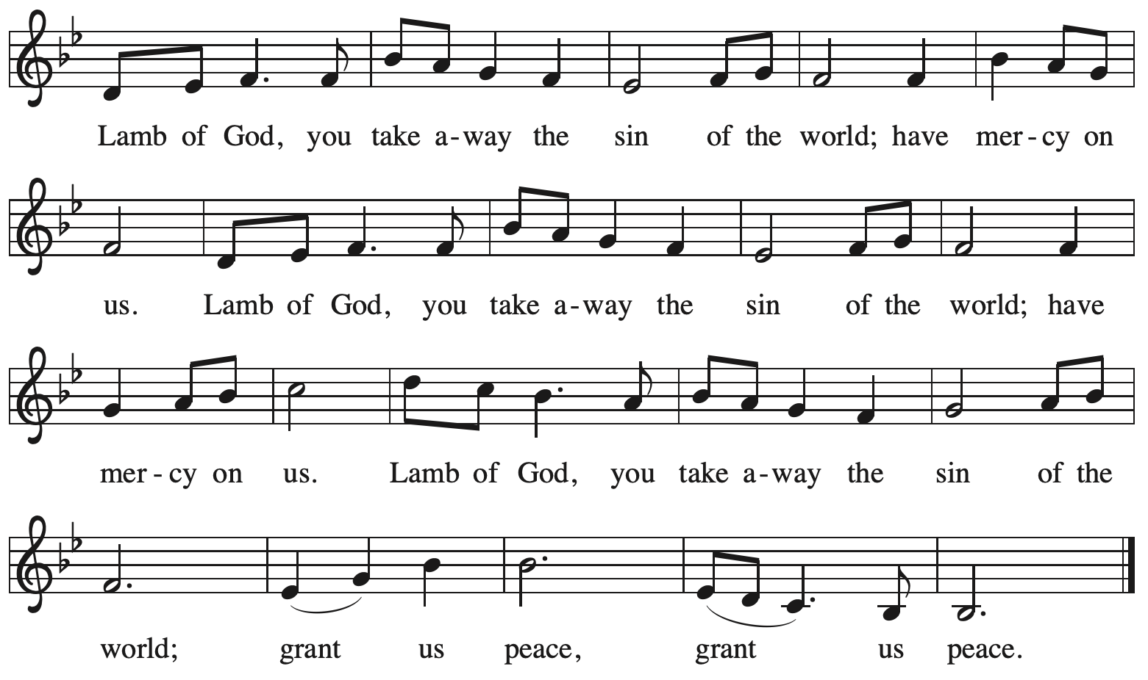

Please be seated.

Holy Communion

- All who seek God and desire a deeper and stronger life in Christ are welcome to receive Holy Communion.
- Worshipers from the pulpit side will proceed forward first, followed by the center section, and then the lectern side.
- Please inform an usher if you would like the ministers to bring Communion to you.
- Holy Communion will be served with bread and wine (red) or grape juice (white).
- The presiding minister will first distribute the bread (host) to each communicant. Please indicate if you require a gluten-free host.
- Once you have consumed the bread, please pick up an empty glass from the tray next to the presiding minister. The Communion Assistant will pour wine or grape juice into your glass.
- Please step to the side to consume the wine or grape juice.
- Feel free to kneel at the altar rail for prayer after receiving the sacrament.
- As you return to your pew, glasses may be returned to the empty tray on the side of the center section.
- A blessing will be provided for anyone who does not yet receive the sacrament.
- All are invited to join in singing the hymns during Holy Communion.

Hymns during Holy Communion
How Sweet the Name of Jesus Sounds ELW 620

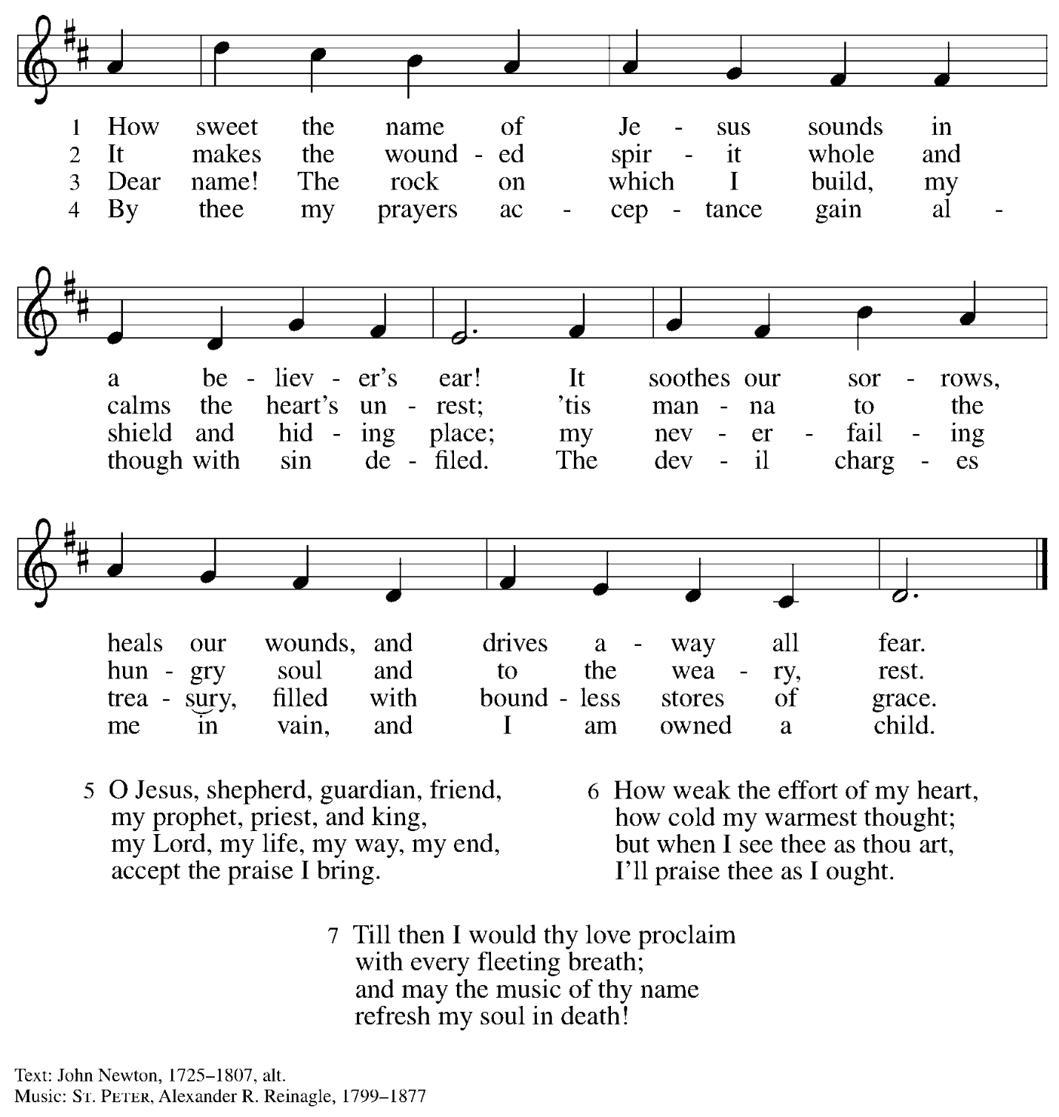

Hymns during Holy Communion
Come and Seek the Ways of Wisdom ACS 971

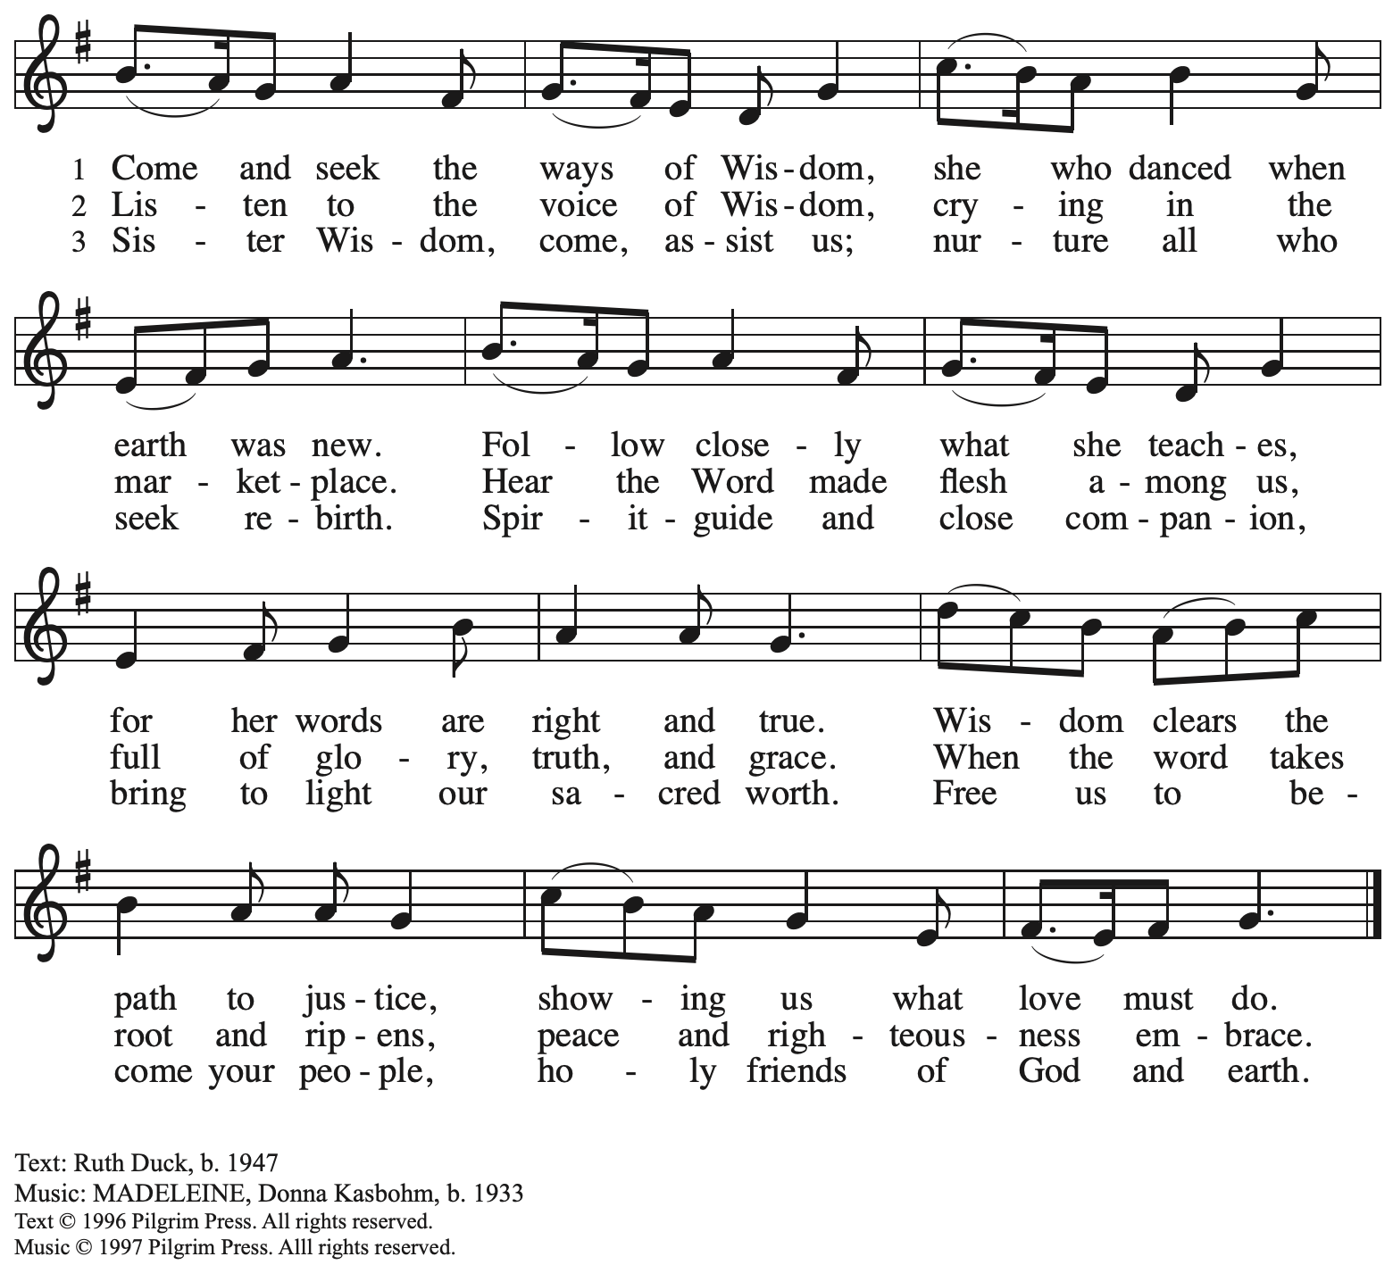
Reprinted with permission under OneLicense.net # A-722139.

Hymns during Holy Communion
What a Friend We Have in Jesus ELW 742

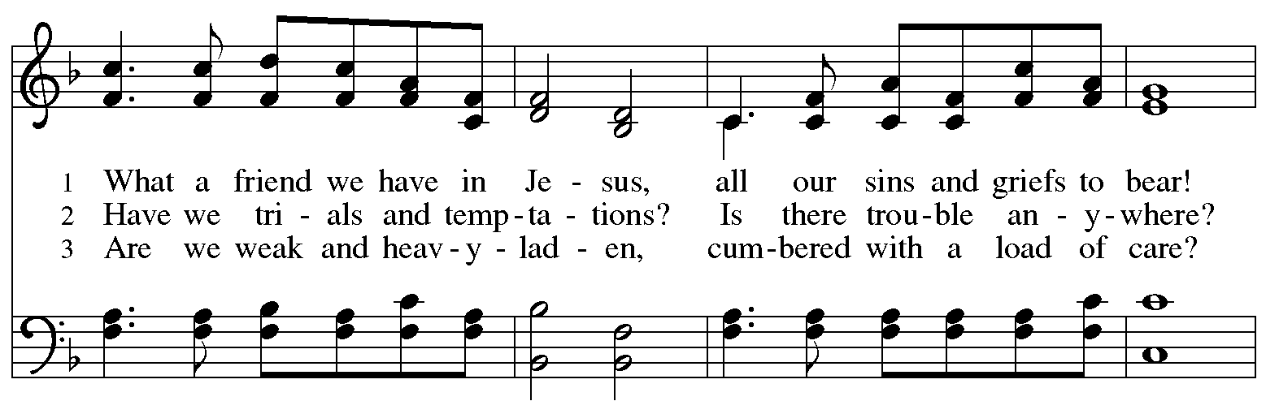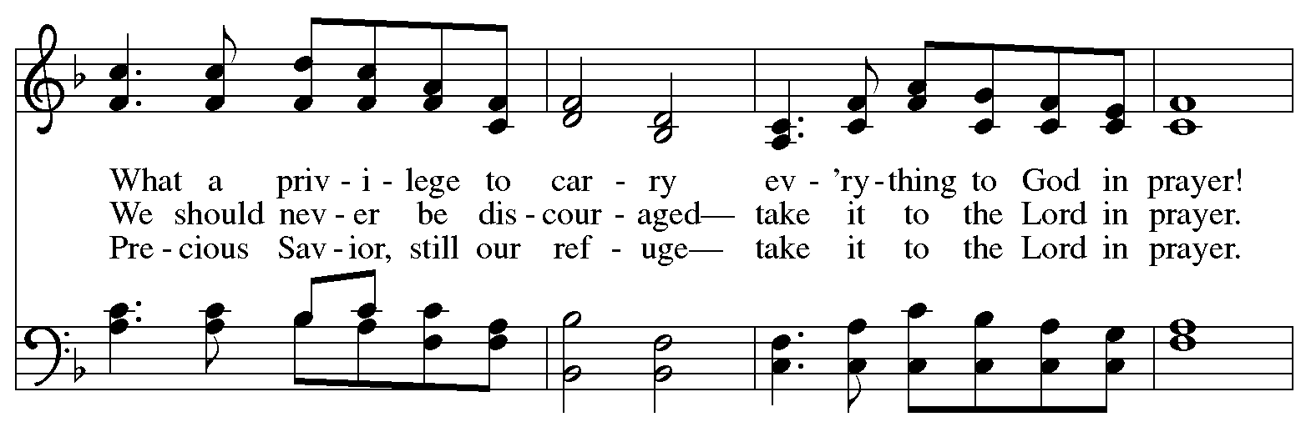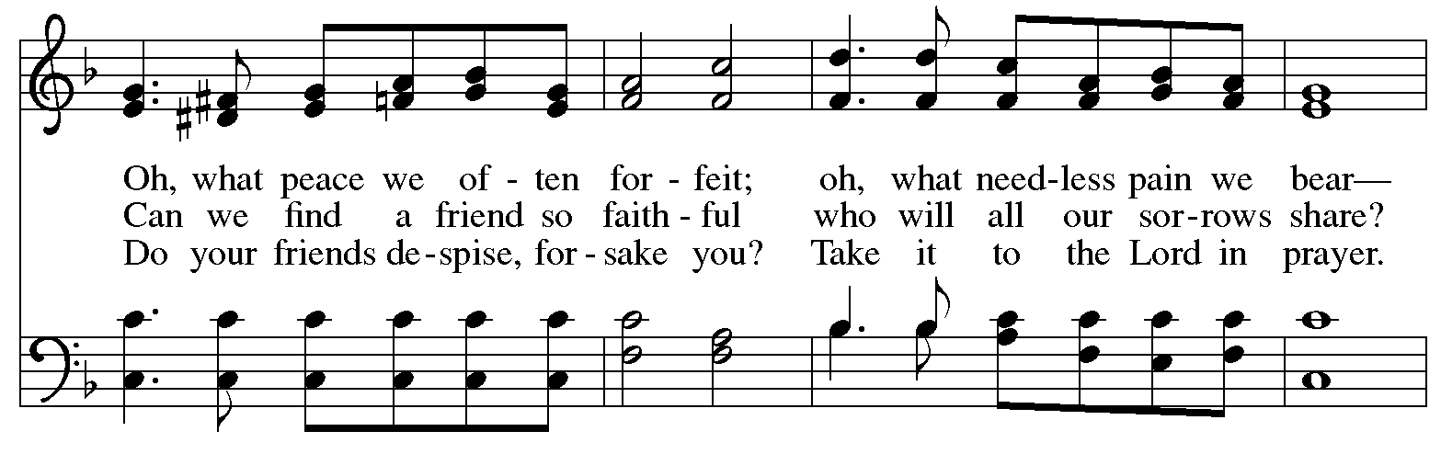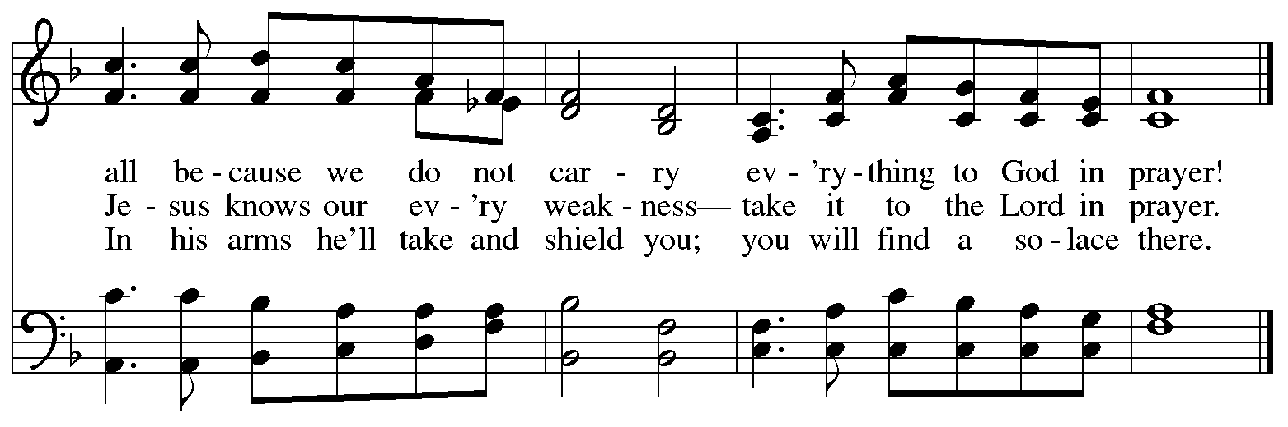

When all have returned to their places, please rise as you are able.

Blessing

P: The body and blood of our Lord Jesus Christ strengthen you and keep you in his grace.
C: Amen.

Prayer

A: Let us pray. Life-giving God,
through this meal you have made your home among us
and are making all things new.
Send us now to speak peace to anxious hearts,
to love our neighbors, and to bring your healing to the nations,
through Jesus Christ, our Savior.
C: Amen.

Please be seated.

Sending
God blesses us and sends us in mission to the world

Announcements

Please rise as you are able.

Benediction

P: God Almighty, who is the beginning and the end,
Jesus Christ, the firstborn of the dead,
and the Spirit, our advocate and peace,
☩ bless you now and forever.
C: Amen.

Sending Hymn Following Page

Dismissal

A: Go in peace. Seek liberty and justice for all.
C: Thanks be to God!

Postlude
Sending Hymn We’ve Come This Far by Faith ELW 633

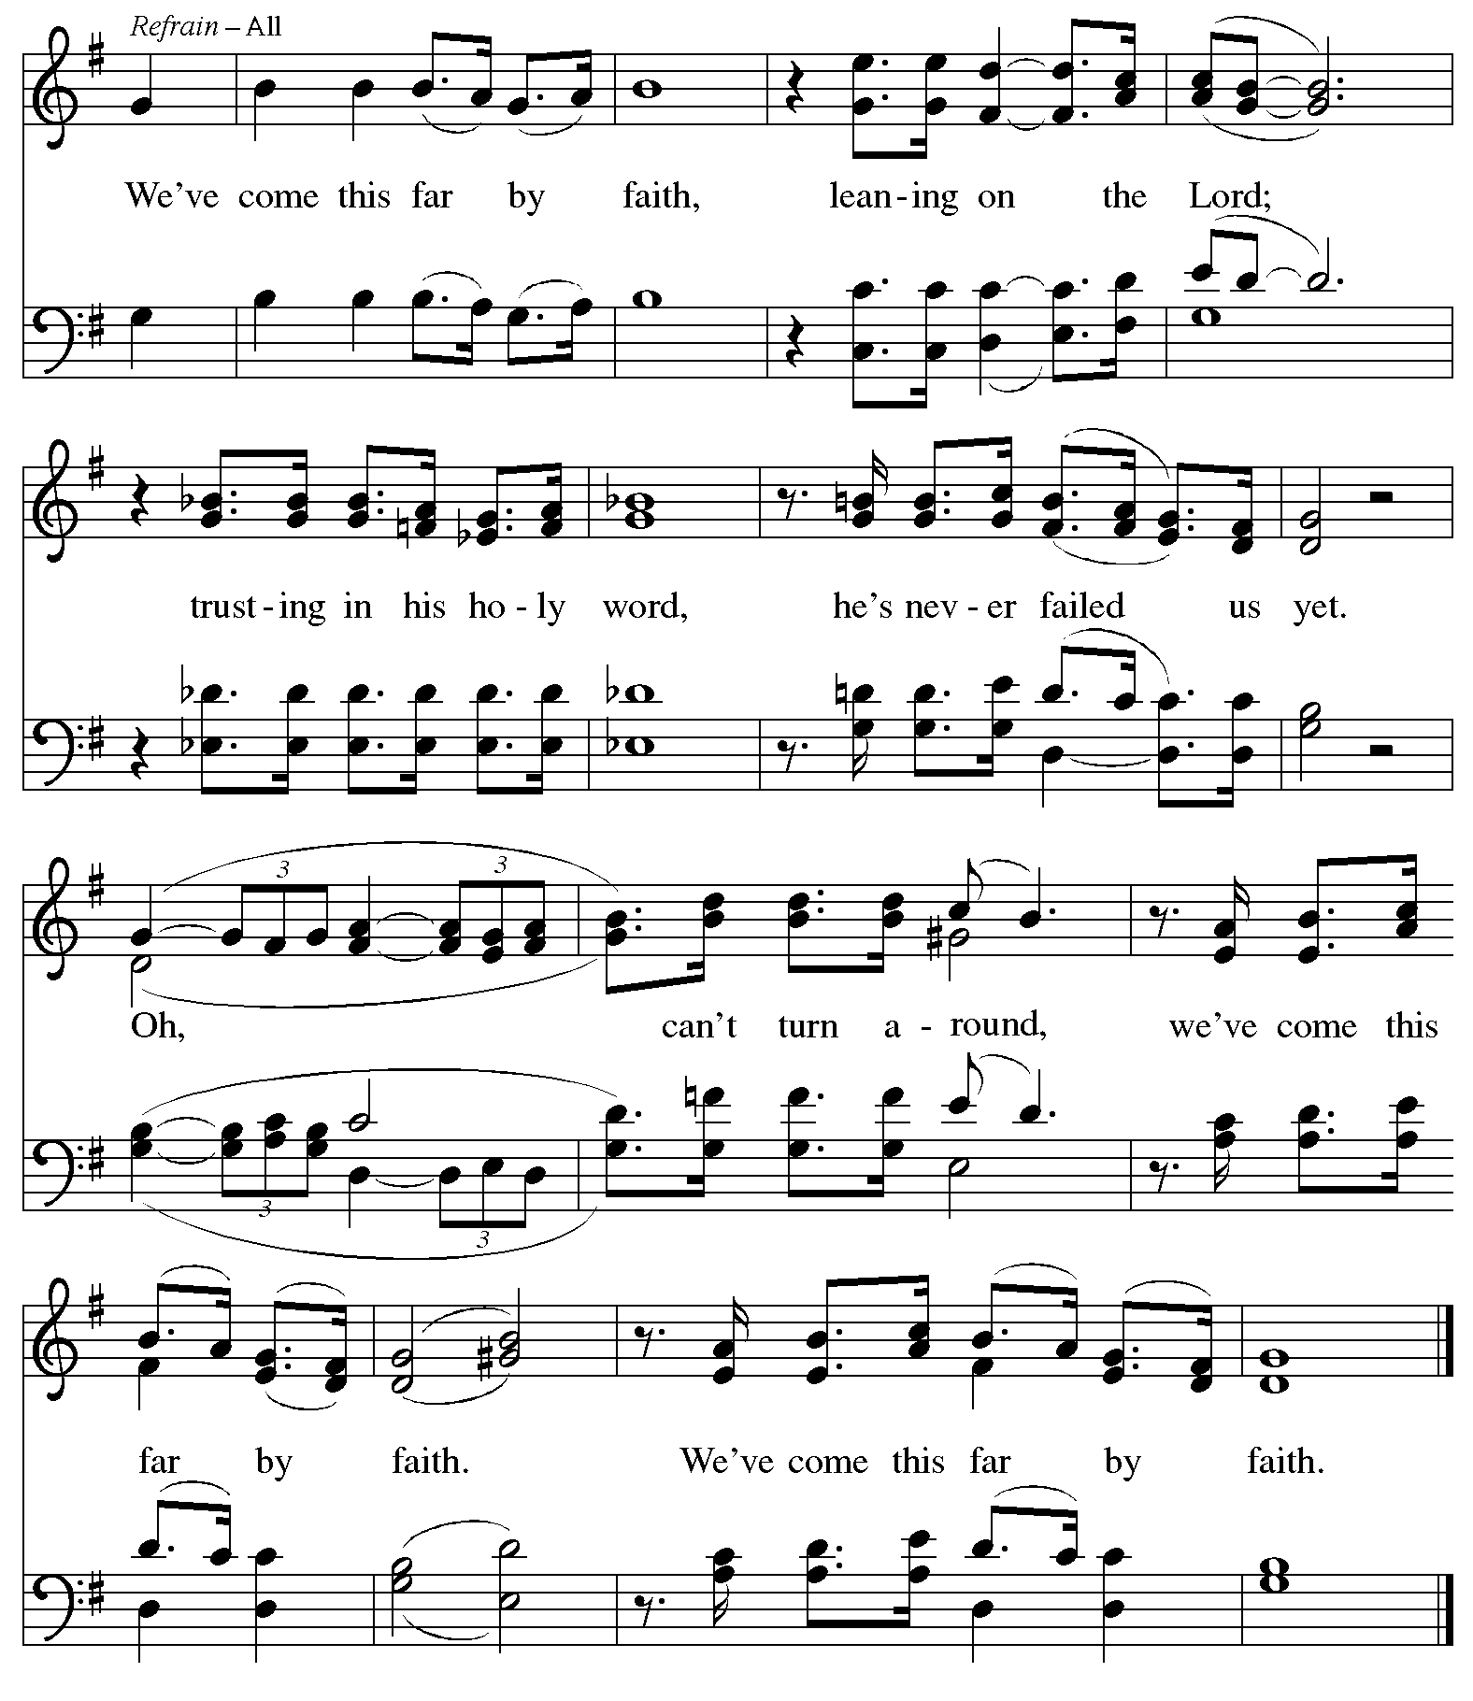
Reprinted under OneLicense.net # A-722139.
Those serving in worship today

Altar Care Jodie Minor
Assisting Minister Jeff Denlinger
Audio-Visual Ministers Tim Jones
Joseph Paetz
Cantor Miriam Bohlmann Kunz
Lector Kelly Spanninger
Minister of Music Laura Reynolds
Presiding Minister The Rev. Ross I. Carmichael

Liturgy and Hymnody Acknowledgements

From SundaysandSeasons.com. Copyright © 2026 Augsburg Fortress. All rights reserved. Reprinted under OneLicense.net # A-722139.
Used by permission of Augsburg Fortress.

Liturgical material reprinted with permission under Augsburg Fortress Liturgies Annual License SB124976.

The Scripture readings contained herein are from New Revised Standard Version Updated Edition of the Bible © 2021 National Council of Churches of Christ in the United States of America. Used by permission. All rights reserved worldwide.

This Is My Song – Text: Lloyd Stone, 1912-1993, sts. 1-2; Georgia Harkness, 1891-1974, st. 3. Music: FINLANDIA, Jean Sibelius, 1865-1957. Text sts. 1-2 © 1934, 1962 Lorenz Publishing Company, st. 3 © 1964 Lorenz Publishing Company. All rights reserved. Reprinted with permission under OneLicense.net # A-722139.

What a Friend We Have in Jesus – Text: Joseph Scriven, 1820-1886. Music: CONVERSE, Charles C. Converse, 1832-1918.

Please use the QR code below to link to St. Andrew’s Announcements online!



St. Andrew Lutheran Church Announcements
June 21st, 2026

- Welcome to Worship at St. Andrew on the Sixth Sunday after Pentecost – We are so glad you are here, and we offer a special welcome to all visitors and guests who are here for the first time! There are worship “toolkits” to help children engage with worship and “busy bags” for younger children available in the bookcase at the back of the sanctuary. Please feel free to take one to use with/for your children. A nursery is available through the door to the left of the worship space and across the social hall (look for a purple room).
- Monthly Reparations Offering, This Sunday, July 5th, during Worship – In Luke’s Gospel, Jesus tells a story about a compassionate Samaritan, suggesting that God’s people are called to work for healing and restoration for our neighbors, regardless of who or what caused them harm. In light of this, St. Andrew has made a commitment to reparations in regard to African American spiritual songs used in our worship. The text and music of most hymns is attributed to specific authors, with copyrights in place, usage reported, and royalties paid to those whose works are featured in worship. With African American spirituals, this is not possible. In response to many years of such uncredited use, St. Andrew invites the congregation to give a reparations offering. Funds received in worship will be donated to our siblings at Bethel AME Church, whose land and building were taken from them in the 1950s, to fund their development in the Hill District.
- Produce Distribution Supplemental Food of the Month – St. Andrew is collecting supplemental food each month to accompany our produce distribution. For July, we ask for donations of canned, dehydrated, or freeze dried fruits. There are collection boxes at the back of the worship space and social hall.
- Produce Distribution, First and Third Tuesday Each Month, July 7th and 21st from 5:30 to 6:30 p.m. – St. Andrew partners with Greater Pittsburgh Community Food Bank to serve as a distribution site for fresh produce on the first and third Tuesday of every month. We invite people of the congregation to help with the distribution from 5:30 p.m. to 6:30 p.m. and/or to help with unloading and setup during the day between 10:00 a.m. and 1:00 p.m.
- Wiffle Ball with St. Andrew’s Episcopal Church - Sunday, July 26th, 4:00 p.m. – St. Andrew’s Episcopal Church (5801 Hampton St. in Highland Park, 15206) has invited this St. Andrew to gather for an afternoon of wiffle ball and community-building on Sunday, July 26th at 4:00 p.m. People of all ages are welcome to play or just come to meet new neighbors and siblings in Christ! We ask people of the congregation to bring cold drinks and/or light snacks to share!
- Lutheran Disaster Response in Venezuela – Last week, two powerful and devastating earthquakes struck Venezuela. Entire communities have been shaken to the ground. More than 1,700 lives have been confirmed lost so far, thousands more are injured, and countless families are now without shelter, safety or access to necessities. ELCA partners have deployed assessment teams to affected areas, working together to identify urgent needs, provide immediate relief (e.g. food, shelter, water) and coordinate a plan for long-term assistance. You can support this aid project using the following link: https://give.elca.org/page/99823/donate.
- Bible Book Club and Coffee Hour are on break for the Summer.

