

+ Seventh Sunday after Pentecost
July 12, 2026


St. Andrew Lutheran Church
304 Morewood Ave.
Pittsburgh, PA 15213
St_andrewELCA@verizon.net
www.standrewpittsburgh.org

+ Seventh Sunday after Pentecost

God’s Word is like the rain that waters the earth and brings forth vegetation. It is also like the sower who scatters seed indiscriminately. Our lives are like seeds sown in the earth. Even from what appears to be little, dormant, or dead, God promises a harvest. At the Lord’s table we are fed with the bread of life, that we may bear fruit in the world.

Welcome to St. Andrew!

- St. Andrew welcomes all who are seeking a place of healing, wholeness, and acceptance in a nurturing and faith-forming spiritual home. We are striving toward racial equity worldwide and we seek to honor the lived experience of all individuals regardless of background. Our community embraces people of all ages, ethnicities, cultures, abilities, sexual orientations, gender identities and expressions, and family constellations.
Come and See!
- Worship Services are live-streamed to multiple online platforms. By attending worship, you agree that your image and voice may be broadcast.
- Everyone is invited to make a name tag at the black bookcase in the back of the worship space if they would like. There are stickers indicating pronouns on the bookcase if you would like to include them on your name tag.
- Little Church – Big Faith is on break for the summer.
- A nursery is available through the doors at the left side of the sanctuary and across from the doorway to the Social Hall. Look for a purple-colored room.
- Worship “toolkits” to help children engage with the service, along with “busy bags” for younger children, are available in the bookcase at the back of the sanctuary. Please feel free to take one to use with/for your children.
- Holy Communion is served with bread (gluten-free available) and wine or grape juice. The presiding minister will distribute the bread (host). Please consume this and then pick up an empty glass from the tray. The Communion Assistant will pour wine or grape juice into your glass. Please step to the side to consume the wine or grape juice. Feel free to kneel at the altar for prayer and reflection. As you return to your pew, glasses may be returned to the empty trays on either side of the center section.
- A restroom is available on the main level of the church, through the doors to the Social Hall and to the right in the main office.

Abbreviations
P: Pastor/Presiding Minister ELW: Evangelical Lutheran Worship hymnal
A: Assisting Minister ACS: All Creation Sings hymnal
L: Lector
C: Congregation

Musical Offering

Each week, different people from the congregation make an offering of pre-service music, with singing or instrumentation, to help the assembly focus and pray in preparation for worship.

Welcome
Prelude To God Be the Glory arr. Bober

Gathering
The Holy Spirit calls us together as the people of God

Please rise as you are able. All may make the sign of the cross,
the sign that is marked at Baptism, as the presiding minister begins.

Confession and Forgiveness

P: Blessed be the ☩ holy Trinity,
one God, whose compassion endures forever.
C: Amen.

P: Let us confess our sin in the presence of God and of one another.

Silence is kept for reflection.

P: Compassionate God,
C: we confess to you all our sins.
Our burden is heavy, and we cannot free ourselves.
In your mercy, forgive us our sin, and call us back to you.
Your yoke is easy and your burden is light.
Restore us to dwell in your peace.
In Christ’s name we pray,
Amen.

P: Jesus says, “Come to me,
all you who are weary
and are carrying heavy burdens,
and I will give you rest.”
In the name of God,
Father, ☩ Son, and Holy Spirit,
your sins are forgiven.
Rest in God’s love.
C: Amen.

Gathering Hymn Day by Day ELW 790

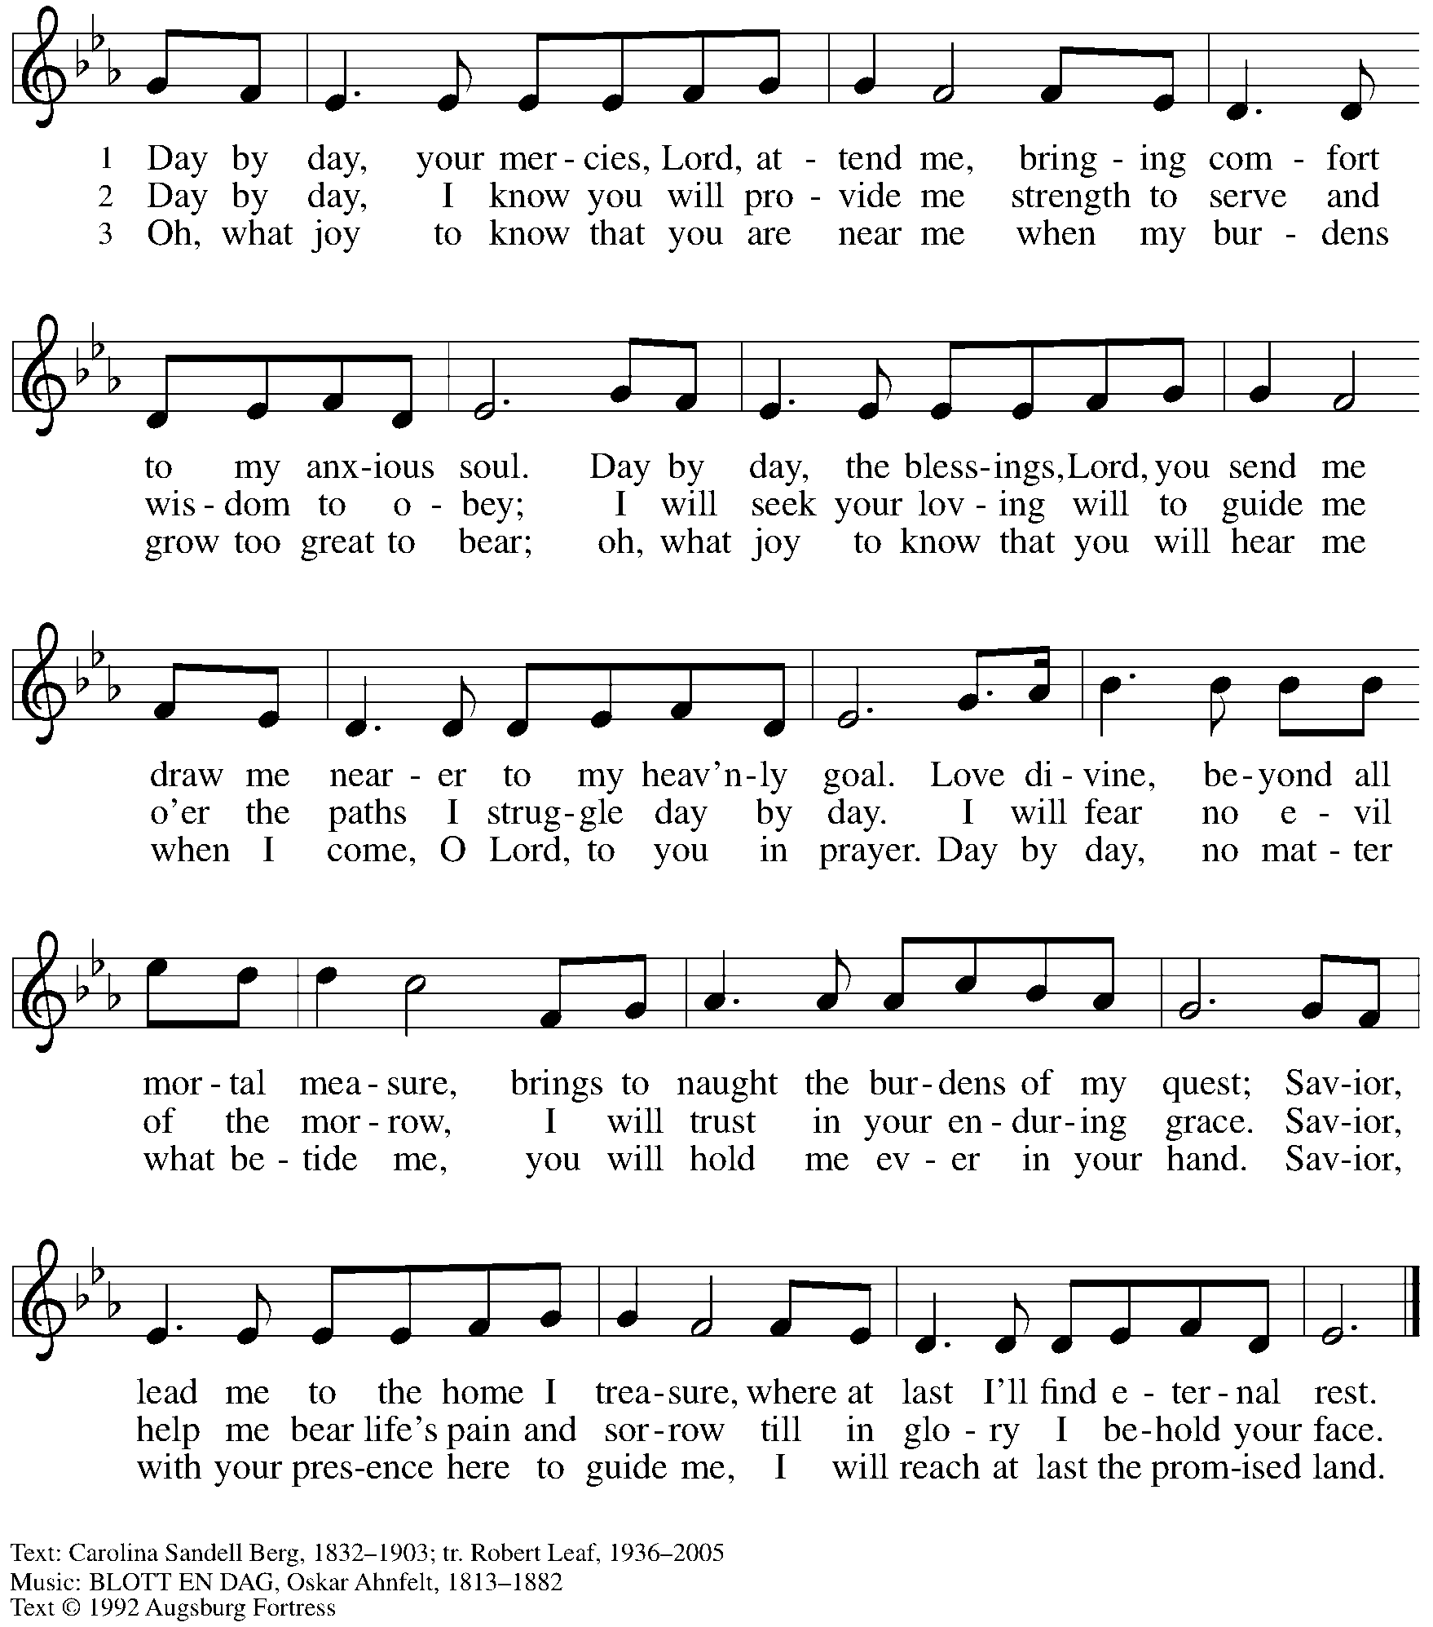
All rights reserved. Reprinted with permission under OneLicense.net # A-722139.

Greeting

P: The grace of our Lord Jesus Christ, the love of God,
and the communion of the Holy Spirit be with you all.
C: And also with you.
Prayer of the Day

P: Let us pray.
Almighty God, we thank you for planting in us the seed of your word.
By your Holy Spirit help us to receive it with joy, live according to it,
and grow in faith and hope and love, through Jesus Christ, our Savior and Lord.
C: Amen.

Please be seated.

Word
God speaks to us in Scripture reading, preaching, and song

First Reading – Isaiah 55: 10-13

¹⁰ For as the rain and the snow come down from heaven
and do not return there until they have watered the earth,
making it bring forth and sprout,
giving seed to the sower and bread to the eater,
¹¹ so shall my word be that goes out from my mouth;
it shall not return to me empty,
but it shall accomplish that which I purpose
and succeed in the thing for which I sent it.
¹² For you shall go out in joy
and be led back in peace;
the mountains and the hills before you
shall burst into song,
and all the trees of the field shall clap their hands.
¹³ Instead of the thorn shall come up the cypress;
instead of the brier shall come up the myrtle,
and it shall be to the Lord for a memorial,
for an everlasting sign that shall not be cut off.

L: Word of God, word of life.
C: Thanks be to God.

Psalm 65: 9-13

The psalm will be read responsively, led by the cantor,
with the congregation responding with the verses in bold.

⁹ You visit the earth and water it abundantly; you make it very plenteous; the river of God is | full of water.
You prepare the grain, for so you provide | for the earth.
¹⁰ You drench the furrows and smooth | out the ridges;
with heavy rain you soften the ground and | bless its increase.
¹¹ You crown the year | with your goodness,
and your paths over- | flow with plenty.
¹² May the fields of the wilderness be | rich for grazing,
and the hills be | clothed with joy.
¹³ May the meadows cover themselves with flocks, and the valleys cloak them- | selves with grain;
let them shout for | joy and sing. R

Second Reading – Romans 8: 1-11

¹ Therefore there is now no condemnation for those who are in Christ Jesus. ² For the law of the Spirit of life in Christ Jesus has set you free from the law of sin and of death. ³ For God has done what the law, weakened by the flesh, could not do: by sending God’s own Son in the likeness of sinful flesh and to deal with sin, God condemned sin in the flesh, ⁴ so that the just requirement of the law might be fulfilled in us, who walk not according to the flesh but according to the Spirit.
⁵ For those who live according to the flesh set their minds on the things of the flesh, but those who live according to the Spirit set their minds on the things of the Spirit. ⁶ To set the mind on the flesh is death, but to set the mind on the Spirit is life and peace. ⁷ For this reason the mind that is set on the flesh is hostile to God; it does not submit to God’s law—indeed, it cannot, ⁸ and those who are in the flesh cannot please God.
⁹ But you are not in the flesh; you are in the Spirit, since the Spirit of God dwells in you. Anyone who does not have the Spirit of Christ does not belong to him. ¹⁰ But if Christ is in you, then the body is dead because of sin, but the Spirit is life because of righteousness. ¹¹ If the Spirit of the one who raised Jesus from the dead dwells in you, the one who raised Christ Jesus from the dead will give life to your mortal bodies also through God’s Spirit that dwells in you.
L: Word of God, word of life.
C: Thanks be to God.

Please rise as you are able.

Gospel Acclamation

C: Alleluia. The word is very near to you;
it is in your mouth and in your heart. Alleluia.

Gospel – Matthew 13: 1-9, 18-23

P: The holy Gospel according to St. Matthew.
C: Glory to you, O Lord.

¹ That same day Jesus went out of the house and sat beside the sea. ² Such great crowds gathered around him that he got into a boat and sat there, while the whole crowd stood on the beach. ³ And he told them many things in parables, saying: “Listen! A sower went out to sow. ⁴ And as he sowed, some seeds fell on a path, and the birds came and ate them up. ⁵ Other seeds fell on rocky ground, where they did not have much soil, and they sprang up quickly, since they had no depth of soil. ⁶ But when the sun rose, they were scorched, and since they had no root, they withered away. ⁷ Other seeds fell among thorns, and the thorns grew up and choked them. ⁸ Other seeds fell on good soil and brought forth grain, some a hundredfold, some sixty, some thirty. ⁹ If you have ears, hear!”
¹⁸ “Hear, then, the parable of the sower. ¹⁹ When anyone hears the word of the kingdom and does not understand it, the evil one comes and snatches away what is sown in the heart; this is what was sown on the path. ²⁰ As for what was sown on rocky ground, this is the one who hears the word and immediately receives it with joy, ²¹ yet such a person has no root but endures only for a while, and when trouble or persecution arises on account of the word, that person immediately falls away. ²² As for what was sown among thorns, this is the one who hears the word, but the cares of this age and the lure of wealth choke the word, and it yields nothing. ²³ But as for what was sown on good soil, this is the one who hears the word and understands it, who indeed bears fruit and yields in one case a hundredfold, in another sixty, and in another thirty.”

P: The Gospel of the Lord.
C: Praise to you, O Christ.

Please be seated.

Sermon

A time of silence for prayer and reflection follows the sermon.
When the hymn of the day begins, please rise as you are able.



Hymn of the Day The Word of God Is Source and Seed ELW 506

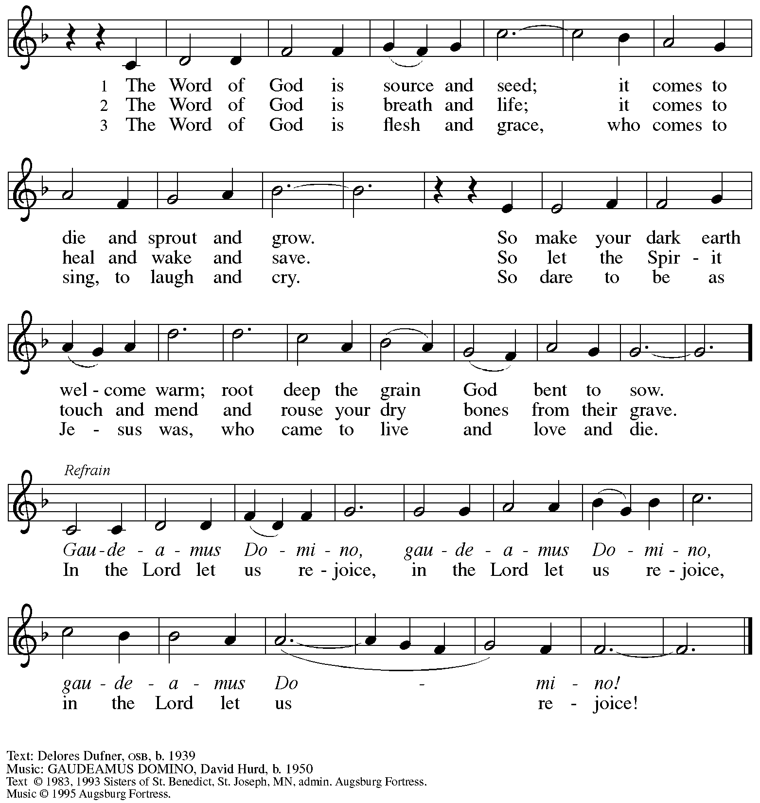
All rights reserved. Reprinted with permission under OneLicense.net # A-721139.

Prayers of the People

A: Trusting in God’s steadfast love for all creation,
let us pray for the church, the world, and those who are in need.

After each petition
A: Gracious God,
C: receive our prayer.

The presiding minister concludes the prayers
P: Grateful for your abundant provision and trusting in your goodness, O God,
we commend all for whom we pray, through the priceless grace of Jesus Christ.
C: Amen.

Peace

The presiding minister and the assembly greet one another in the peace of the risen Christ.
P: The peace of Christ be with you always.
C: And also with you.

The people may greet those around them with a sign of Christ’s peace and may say
Peace be with you or similar words. Please be mindful that not everyone will be comfortable with sharing the peace, so please seek consent before shaking hands or hugging. Other possible ways to share the peace include a simple bow with the verbal greeting of peace, or simply a verbal expression of peace.

When the greetings of peace have concluded, please be seated.

Meal
God feeds us with the presence of Jesus Christ

Offering

We offer ourselves, our gifts, and our faithful service to God.
As the offering is gathered for the mission of the church, including the care of those in need,
the table is set for Holy Communion.

There are laminated giving cards in the pew racks that feature a QR code for anyone who would like to give online. Those who give using the QR code, as well as those who give regularly online or through their bank are encouraged to place the laminated card in the plate as an expression of your offering.

Music during the Offering
I Love to Tell the Story arr. Bober

As the gifts are brought forward for presentation, please rise as you are able.

Offertory Song God, Whose Farm Is All Creation ELW 734
v. 1, 3

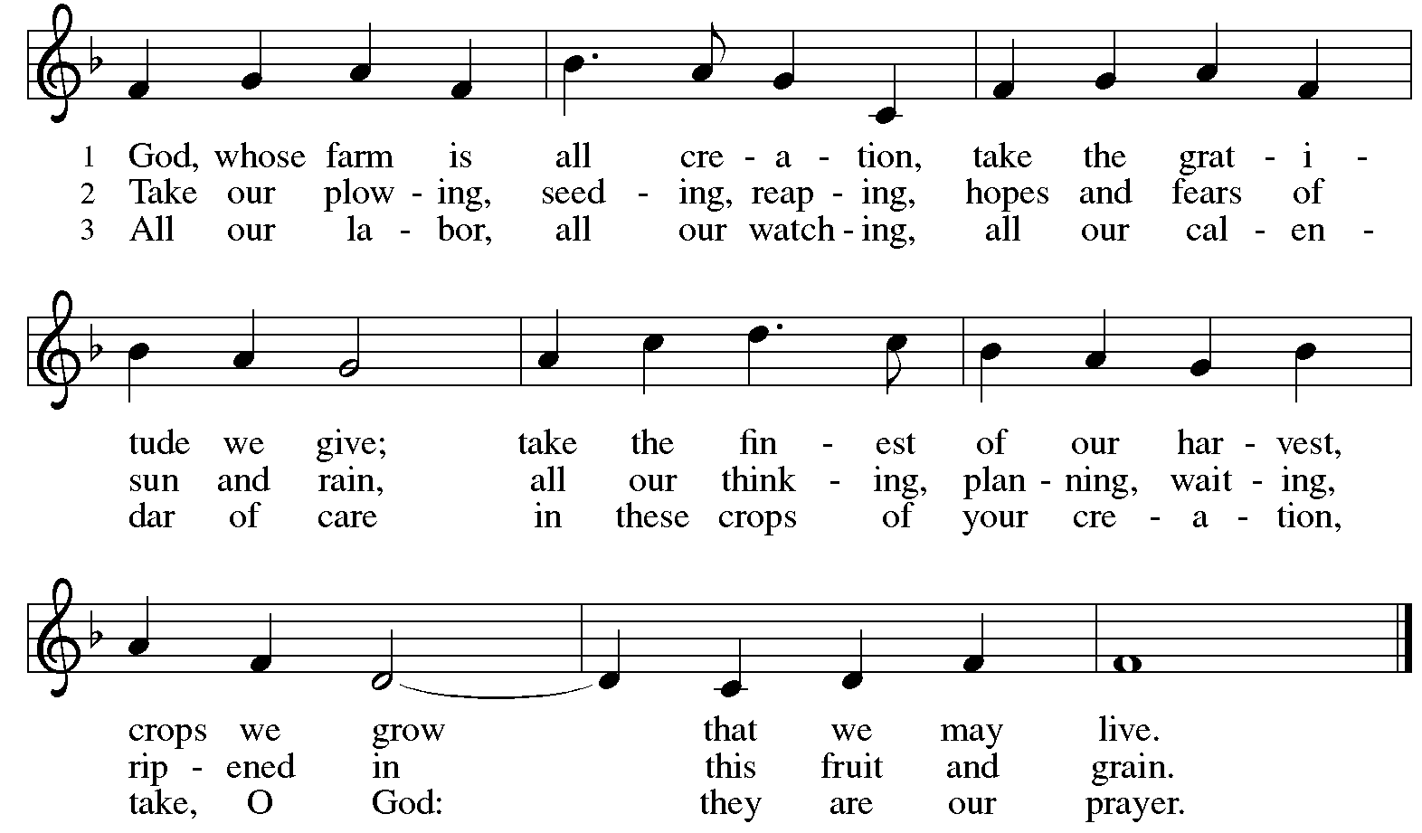
All rights reserved. Reprinted with permission under OneLicense.net # A-722139.

Offertory Prayer

A: Let us pray.
God of all creation,
C: all you have made is good, and your love endures forever.
You bring forth bread from the earth and fruit from the vine.
Nourish us with these gifts, that we might be for the world
signs of your gracious presence in Jesus Christ, our Savior and Lord.
Amen.

Dialogue

P: The Lord be with you.
C: And also with you.

P: Lift up your hearts.
C: We lift them to the Lord.

P: Let us give thanks to the Lord our God.
C: It is right to give our thanks and praise.

Preface (Spoken by the presiding minister)

P: It is indeed right, our duty and our joy …
… we praise your name and join their unending hymn:

Sanctus

C: Holy, holy, holy Lord,
God of power and might,
heaven and earth are full of your glory.
Hosanna in the highest.
Blessed is the one who comes in the name of the Lord.
Hosanna in the highest.

Eucharistic Prayer

P: Holy, mighty, and merciful Lord …
… be all honor and glory, now and forever.
C: Amen.

Lord’s Prayer

P: Gathered as one by the Holy Spirit, we pray as Jesus taught us.
C: Our Father in heaven,
hallowed be your name,
your kingdom come,
your will be done,
on earth as in heaven.
Give us today our daily bread.
Forgive us our sins,
as we forgive those
who sin against us;
Save us from the time of trial,
and deliver us from evil.
For the kingdom, the power,
and the glory are yours,
now and ever. Amen.

Fraction and Invitation

Agnus Dei / Lamb of God

C: Lamb of God, you take away the sin of the world; have mercy on us.
Lamb of God, you take away the sin of the world; have mercy on us.
Lamb of God, you take away the sin of the world; grant us peace.



Please be seated.

Holy Communion

- All who seek God and desire a deeper and stronger life in Christ are welcome to receive Holy Communion.
- Worshipers from the pulpit side will proceed forward first, followed by the center section, and then the lectern side.
- Please inform an usher if you would like the ministers to bring Communion to you.
- Holy Communion will be served with bread and wine (red) or grape juice (white).
- The presiding minister will first distribute the bread (host) to each communicant. Please indicate if you require a gluten-free host.
- Once you have consumed the bread, please pick up an empty glass from the tray next to the presiding minister. The Communion Assistant will pour wine or grape juice into your glass.
- Please step to the side to consume the wine or grape juice.
- Feel free to kneel at the altar rail for prayer after receiving the sacrament.
- As you return to your pew, glasses may be returned to the empty tray on the side of the center section.
- A blessing will be provided for anyone who does not yet receive the sacrament.
- All are invited to join in singing the hymns during Holy Communion.

Hymns during Holy Communion
Come, Let Us Eat ELW 491

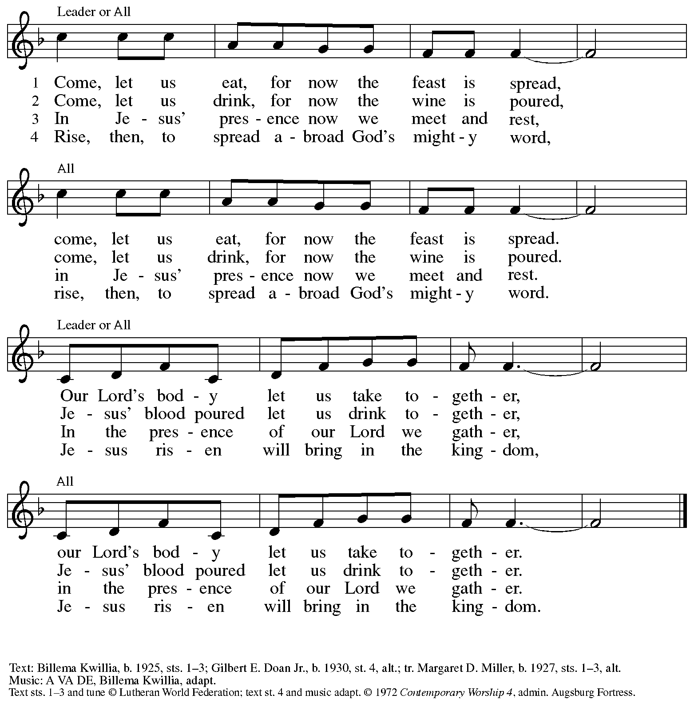
All rights reserved. Reprinted with permission under OneLicense.net # A-722139.

Hymns during Holy Communion
We Plow the Fields and Scatter ELW 680

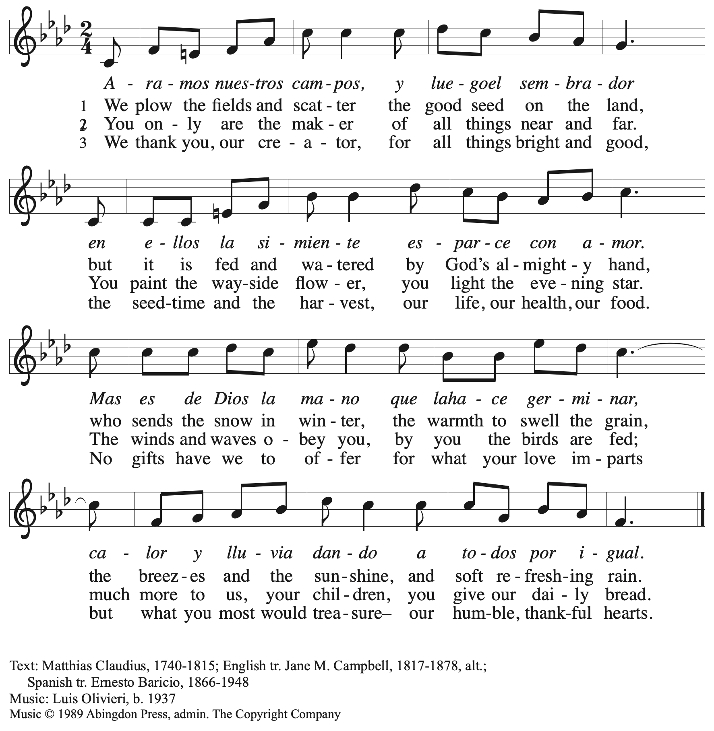
All rights reserved. Reprinted with permission under OneLicense.net # A-722139.

Hymns during Holy Communion
Light Dawns on a Weary World ELW 726

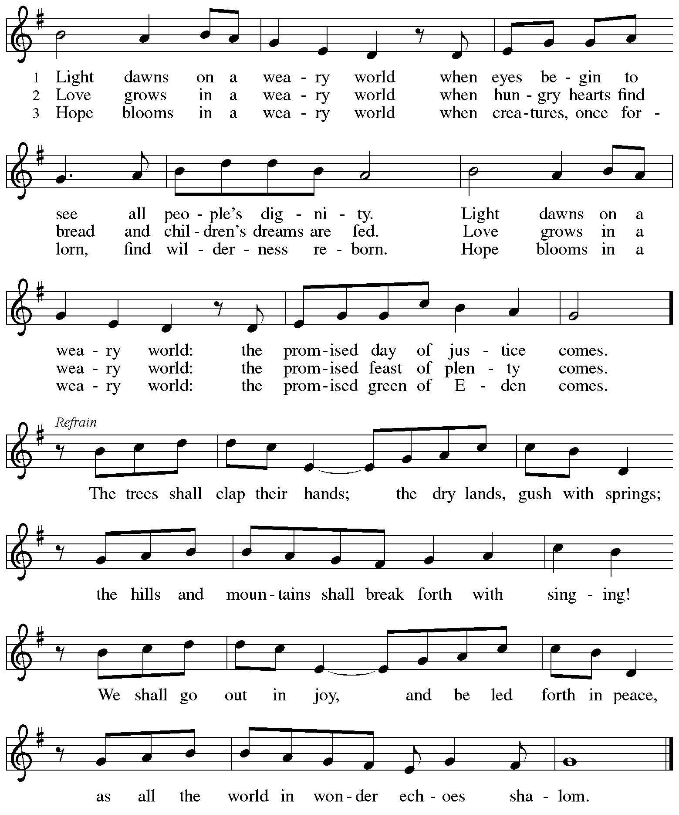

When all have returned to their places, please rise as you are able.
Blessing

P: The body and blood of our Lord Jesus Christ strengthen you and keep you in his grace.
C: Amen.

Prayer

A: Let us pray.
We give you thanks, almighty God, that you have refreshed us
through the healing power of this gift of life.
In your mercy, strengthen us through this gift,
in faith toward you and in fervent love toward one another;
for the sake of Jesus Christ our Lord.
C: Amen.

Please be seated.

Sending
God blesses us and sends us in mission to the world

Announcements

Please rise as you are able.

Benediction

P: The Lord bless you and keep you.
The Lord’s face shine on you with grace and mercy.
The Lord look upon you with favor and ☩ give you peace.
C: Amen.

Sending Hymn Following Page

Dismissal

A: Go in peace. Serve the Lord.
C: Thanks be to God!

Postlude

Sending Hymn Sent Forth by God’s Blessing ELW 547
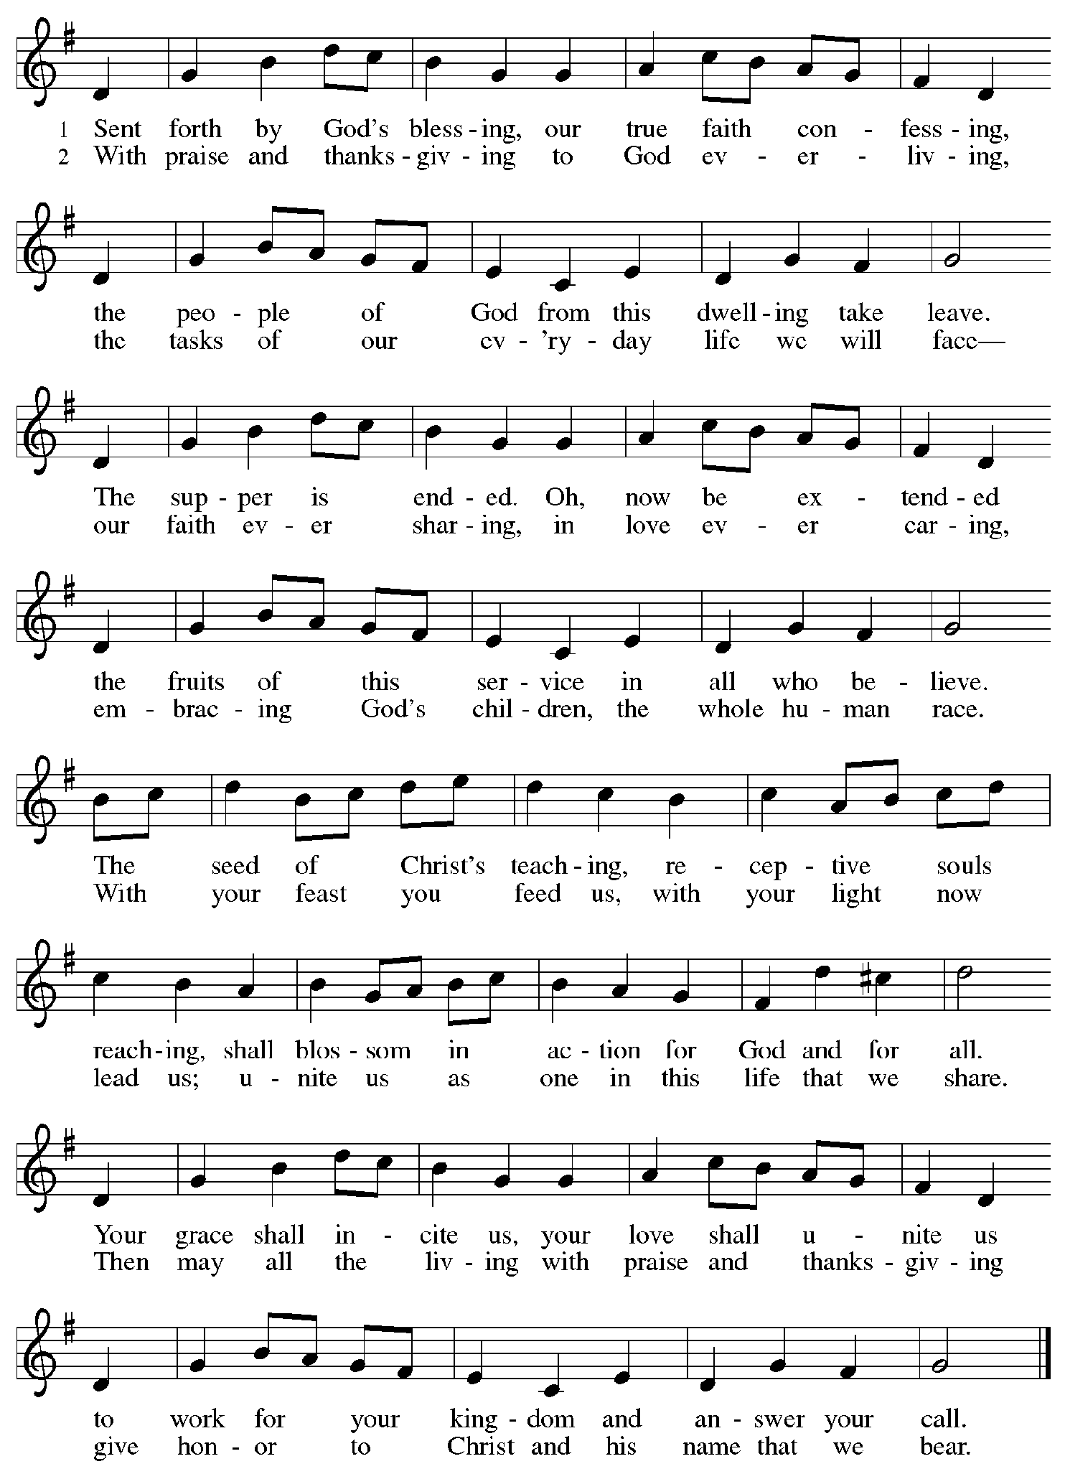

Those serving in worship today

Altar Care Jodie Minor
Assisting Minister Kathy Hays
Audio-Visual Ministers Dave Rollinson
Cantor Timothy Kocher-Hillmer
Lector Pat Taylor
Piano Sarita
Minister of Music Laura Reynolds
Presiding Minister The Rev. Ross I. Carmichael

Liturgy and Hymnody Acknowledgements

From SundaysandSeasons.com. Copyright © 2026 Augsburg Fortress. All rights reserved. Reprinted under OneLicense.net # A-722139.
Used by permission of Augsburg Fortress.

Liturgical material reprinted with permission under Augsburg Fortress Liturgies Annual License SB124976.

The Scripture readings contained herein are from New Revised Standard Version Updated Edition of the Bible © 2021 National Council of Churches of Christ in the United States of America. Used by permission. All rights reserved worldwide.

Light Dawns on a Weary World – Text: Mary Louise Bringle, b. 1953. Music: TEMPLE OF PEACE, William P. Rowan, b. 1951. Text © 2002 GIA Publications, Inc., 7404 S. Mason Ave., Chicago, IL 60638. www.giamusic.com. 800.442.3358. All rights reserved. Used by permission. Music © 2000 William P. Rowan, admin. GIA Publications, Inc., 7404 S. Mason Ave., Chicago, IL 60638. www.giamusic.com. 800.442.3358. All rights reserved. Used by permission. Reprinted under OneLicense.net # A-72219.

Sent Forth by God’s Blessing – Text: Omer Westendorf, 1916-1997, alt. Music: THE ASH GROVE, Welsh folk tune. Text © 1964 World Library Publications, 3708 River Rd., Franklin Park, IL 60131-2158. All rights reserved. Reprinted with permission under OneLicense.net # A-722139.

Please use the QR code below to link to St. Andrew’s Announcements online!



St. Andrew Lutheran Church Announcements
July 12th, 2026

- Welcome to Worship at St. Andrew on the Seventh Sunday after Pentecost – We are so glad you are here, and we offer a special welcome to all visitors and guests who are here for the first time! There are worship “toolkits” to help children engage with worship and “busy bags” for younger children available in the bookcase at the back of the sanctuary. Please feel free to take one to use with/for your children. A nursery is available through the door to the left of the worship space and across the social hall (look for a purple room).
- Noisy Offering, Next Sunday During Worship – On the third Sunday of each month, St. Andrew’s children lead the congregation in a Noisy Offering, in which people are invited to throw their change into buckets that the children carry around the church and bring forward as an additional offering. Each month’s Noisy Offering supports a local, national, or international church-related or otherwise charitable organization. This month’s Noisy Offering will benefit Lutherlyn, a Lutheran camp located near Butler, PA affiliated with the Southwestern Pennsylvania synod. Lutherlyn offers a variety of camp opportunities for people of all ages, especially summer camps for children and youth. For more information, please visit https://www.lutherlyn.com/programs/.
- Produce Distribution Supplemental Food of the Month – St. Andrew is collecting supplemental food each month to accompany our produce distribution. For July, we ask for donations of canned, dehydrated, or freeze-dried fruits. There are collection boxes at the back of the worship space and social hall.
- Produce Distribution, Third Tuesday Each Month, July 21st from 5:30 to 6:30 p.m. – St. Andrew partners with Greater Pittsburgh Community Food Bank to serve as a distribution site for fresh produce on the first and third Tuesday of every month. We invite people of the congregation to help with the distribution from 5:30 p.m. to 6:30 p.m. and/or to help with unloading and setup during the day between 10:00 a.m. and 1:00 p.m.
- Wiffle Ball with St. Andrew’s Episcopal Church - Sunday, July 26th, 4:00 p.m. – St. Andrew’s Episcopal Church (5801 Hampton St. in Highland Park, 15206) has invited this St. Andrew to gather for an afternoon of wiffle ball and community-building on Sunday, July 26th at 4:00 p.m. People of all ages are welcome to play or just come to meet new neighbors and siblings in Christ! We ask people of the congregation to bring cold drinks and/or light snacks to share!
- Lutheran Disaster Response in Venezuela – Last week, two powerful and devastating earthquakes struck Venezuela. Entire communities have been shaken to the ground. More than 1,700 lives have been confirmed lost so far, thousands more are injured, and countless families are now without shelter, safety or access to necessities. ELCA partners have deployed assessment teams to affected areas, working together to identify urgent needs, provide immediate relief (e.g. food, shelter, water) and coordinate a plan for long-term assistance. You can support this aid project using the following link: https://give.elca.org/page/99823/donate.
- Bible Book Club and Coffee Hour are on break for the Summer.

