

+ Ninth Sunday after Pentecost
July 26, 2026


St. Andrew Lutheran Church
304 Morewood Ave.
Pittsburgh, PA 15213
St_andrewELCA@verizon.net
www.standrewpittsburgh.org

+ Ninth Sunday after Pentecost

As Solomon prays for wisdom, we seek to more deeply know the treasures of faith.
In today’s Gospel Jesus offers everyday images that reveal to us the reign of God:
a tree that becomes a sheltering home, yeast that penetrates and expands, a treasured pearl,
a net that gains a great catch. Even as we seek the riches of God’s reign,
the great surprise is that God’s grace finds us first!

Welcome to St. Andrew!

- St. Andrew welcomes all who are seeking a place of healing, wholeness, and acceptance in a nurturing and faith-forming spiritual home. We are striving toward racial equity worldwide
and we seek to honor the lived experience of all individuals regardless of background. Our community embraces people of all ages, ethnicities, cultures, abilities, sexual orientations,
gender identities and expressions, and family constellations. Come and See!
- Worship Services are live-streamed to multiple online platforms. By attending worship, you agree that your image and voice may be broadcast.
- Everyone is invited to make a name tag at the black bookcase in the back of the worship space if they would like. There are stickers indicating pronouns on the bookcase if you would like to include them on your name tag.
- Little Church – Big Faith is on break for the summer.
- A nursery is available through the doors at the left side of the sanctuary and across from the doorway to the Social Hall. Look for a purple-colored room.
- Worship “toolkits” to help children engage with the service, along with “busy bags” for younger children, are available in the bookcase at the back of the sanctuary. Please feel free to take one to use with/for your children.
- Holy Communion is served with bread (gluten-free available) and wine or grape juice. The presiding minister will distribute the bread (host). Please consume this and then pick up an empty glass from the tray. The Communion Assistant will pour wine or grape juice into your glass. Please step to the side to consume the wine or grape juice. Feel free to kneel at the altar for prayer and reflection. As you return to your pew, glasses may be returned to the empty trays on either side of the center section.
- A restroom is available on the main level of the church, through the doors to the Social Hall and to the right in the main office.

Abbreviations
P: Pastor/Presiding Minister ELW: Evangelical Lutheran Worship hymnal
A: Assisting Minister ACS: All Creation Sings hymnal
L: Lector W&P: Worship and Praise
C: Congregation
Musical Offering

Each week, different people from the congregation make an offering of pre-service music, with singing or instrumentation, to help the assembly focus and pray in preparation for worship.

Welcome
Prelude

Gathering
The Holy Spirit calls us together as the people of God

Please rise as you are able. All may make the sign of the cross,
the sign that is marked at Baptism, as the presiding minister begins.

Confession and Forgiveness

P: Blessed be the ☩ holy Trinity,
one God, whose compassion endures forever.
C: Amen.

P: Let us confess our sin in the presence of God and of one another.

Silence is kept for reflection.

P: Compassionate God,
C: we confess to you all our sins.
Our burden is heavy, and we cannot free ourselves.
In your mercy, forgive us our sin, and call us back to you.
Your yoke is easy and your burden is light.
Restore us to dwell in your peace.
In Christ’s name we pray,
Amen.

P: Jesus says, “Come to me,
all you who are weary
and are carrying heavy burdens,
and I will give you rest.”
In the name of God,
Father, ☩ Son, and Holy Spirit,
your sins are forgiven.
Rest in God’s love.
C: Amen.

Gathering Hymn Gather Us In ELW 532

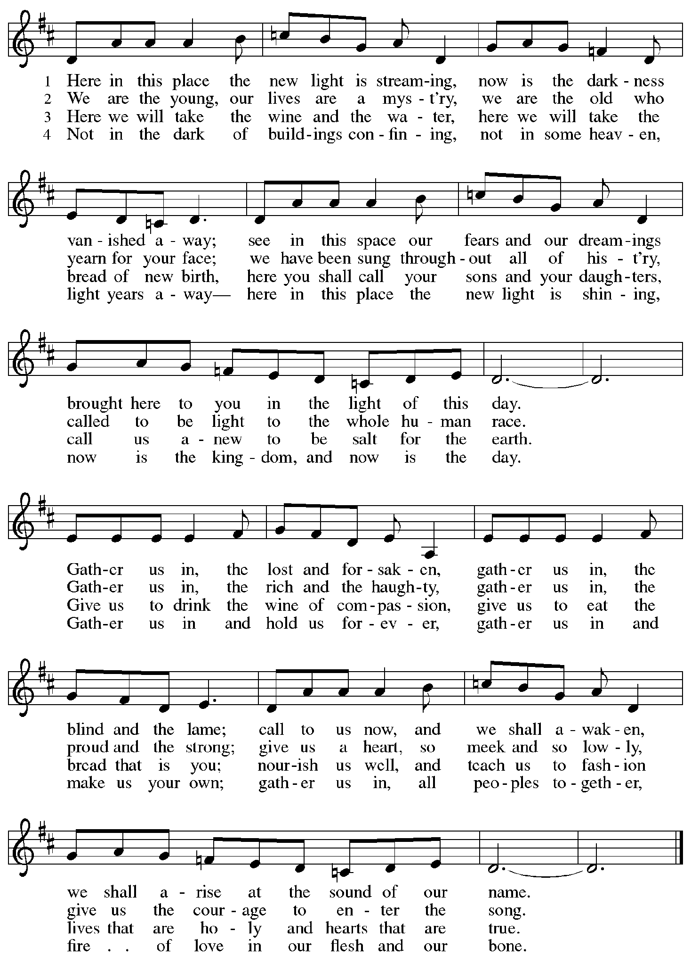

Greeting

P: The grace of our Lord Jesus Christ, the love of God,
and the communion of the Holy Spirit be with you all.
C: And also with you.

Prayer of the Day

P: Let us pray.
Beloved and sovereign God, through the death and resurrection of your Son
you bring us into your kingdom of justice and mercy. By your Spirit, give us your wisdom,
that we may treasure the life that comes from Jesus Christ, our Savior and Lord.
C: Amen.

Please be seated.

Word
God speaks to us in Scripture reading, preaching, and song

First Reading – 1 Kings 3: 5-12

⁵ At Gibeon the Lord appeared to Solomon in a dream by night, and God said, “Ask what I should give you.” ⁶ And Solomon said, “You have shown great and steadfast love to your servant my father David because he walked before you in faithfulness, in righteousness, and in uprightness of heart toward you, and you have kept for him this great and steadfast love and have given him a son to sit on his throne today. ⁷ And now, O Lord my God, you have made your servant king in place of my father David, although I am only a little child; I do not know how to go out or come in. ⁸ And your servant is in the midst of the people whom you have chosen, a great people so numerous they cannot be numbered or counted. ⁹ Give your servant, therefore, an understanding mind to govern your people, able to discern between good and evil, for who can govern this great people of yours?”
¹⁰ It pleased the Lord that Solomon had asked this. ¹¹ God said to him, “Because you have asked this and have not asked for yourself long life or riches or for the life of your enemies but have asked for yourself understanding to discern what is right, ¹² I now do according to your word. Indeed, I give you a wise and discerning mind; no one like you has been before you, and no one like you shall arise after you.”

L: Word of God, word of life.
C: Thanks be to God.

Psalm 119: 129-136

The psalm will be read responsively, led by the cantor,
with the congregation responding with the verses in bold.

¹²⁹ Your decrees are wonderful;
therefore I obey them with all my heart.
¹³⁰ When your word is opened it gives light;
it gives understanding to the simple.
¹³¹ I open my mouth and pant
because I long for your commandments.
¹³² Turn to me and be gracious to me,
as you always do to those who love your name.
¹³³ Order my footsteps in your word;
let no iniquity have dominion over me.
¹³⁴ Rescue me from those who oppress me,
and I will keep your commandments.
¹³⁵ Let your face shine upon your servant
and teach me your statutes.
¹³⁶ My eyes shed streams of tears,
because people do not keep your teaching.

Second Reading – Romans 8: 26-39

²⁶ The Spirit helps us in our weakness, for we do not know how to pray as we ought, but that very Spirit intercedes with groanings too deep for words. ²⁷ And God, who searches hearts, knows what is the mind of the Spirit, because the Spirit intercedes for the saints according to the will of God.
²⁸ We know that all things work together for good for those who love God, who are called according to God’s purpose. ²⁹ For those whom God foreknew God also predestined to be conformed to the image of God’s Son, in order that he might be the firstborn within a large family. ³⁰ And those whom God predestined, God also called, and those whom God called, God also justified, and those whom God justified, God also glorified.
³¹ What then are we to say about these things? If God is for us, who is against us? ³² The one who did not withhold God’s own Son but gave him up for all of us, how will God not with him also give us everything else? ³³ Who will bring any charge against God’s elect? It is God who justifies. ³⁴ Who is to condemn? It is Christ who died, or rather, who was raised, who is also at the right hand of God, who also intercedes for us. ³⁵ Who will separate us from the love of Christ? Will affliction or distress or persecution or famine or nakedness or peril or sword? ³⁶ As it is written,
“For your sake we are being killed all day long;
we are accounted as sheep to be slaughtered.”
³⁷ No, in all these things we are more than victorious through him who loved us. ³⁸ For I am convinced that neither death, nor life, nor angels, nor rulers, nor things present, nor things to come, nor powers, ³⁹ nor height, nor depth, nor anything else in all creation will be able to separate us from the love of God in Christ Jesus our Lord.
L: Word of God, word of life.
C: Thanks be to God.

Please rise as you are able.

Gospel Acclamation

C: Alleluia. Many will come from east and west
and will eat in the kingdom of heaven. Alleluia.

Gospel – Matthew 13: 31-33, 44-52

P: The holy Gospel according to St. Matthew.
C: Glory to you, O Lord.
³¹ [Jesus] put before [the crowds] another parable: “The kingdom of heaven is like a mustard seed that someone took and sowed in his field; ³² it is the smallest of all the seeds, but when it has grown it is the greatest of shrubs and becomes a tree, so that the birds of the air come and make nests in its branches.”
³³ He told them another parable: “The kingdom of heaven is like yeast that a woman took and mixed in with three measures of flour until all of it was leavened.”
⁴⁴ “The kingdom of heaven is like treasure hidden in a field, which a man found and reburied; then in his joy he goes and sells all that he has and buys that field.
⁴⁵ “Again, the kingdom of heaven is like a merchant in search of fine pearls; ⁴⁶ on finding one pearl of great value, he went and sold all that he had and bought it.
⁴⁷ “Again, the kingdom of heaven is like a net that was thrown into the sea and caught fish of every kind; ⁴⁸ when it was full, they drew it ashore, sat down, and put the good into baskets but threw out the bad. ⁴⁹ So it will be at the end of the age. The angels will come out and separate the evil from the righteous ⁵⁰ and throw them into the furnace of fire, where there will be weeping and gnashing of teeth.
⁵¹ “Have you understood all this?” They answered, “Yes.” ⁵² And he said to them, “Therefore every scribe who has become a disciple in the kingdom of heaven is like the master of a household who brings out of his treasure what is new and what is old.”

P: The Gospel of the Lord.
C: Praise to you, O Christ.

Please be seated.

Sermon

A time of silence for prayer and reflection follows the sermon.
When the hymn of the day begins, please rise as you are able.

Hymn of the Day Bring Forth the Kingdom W&P 22

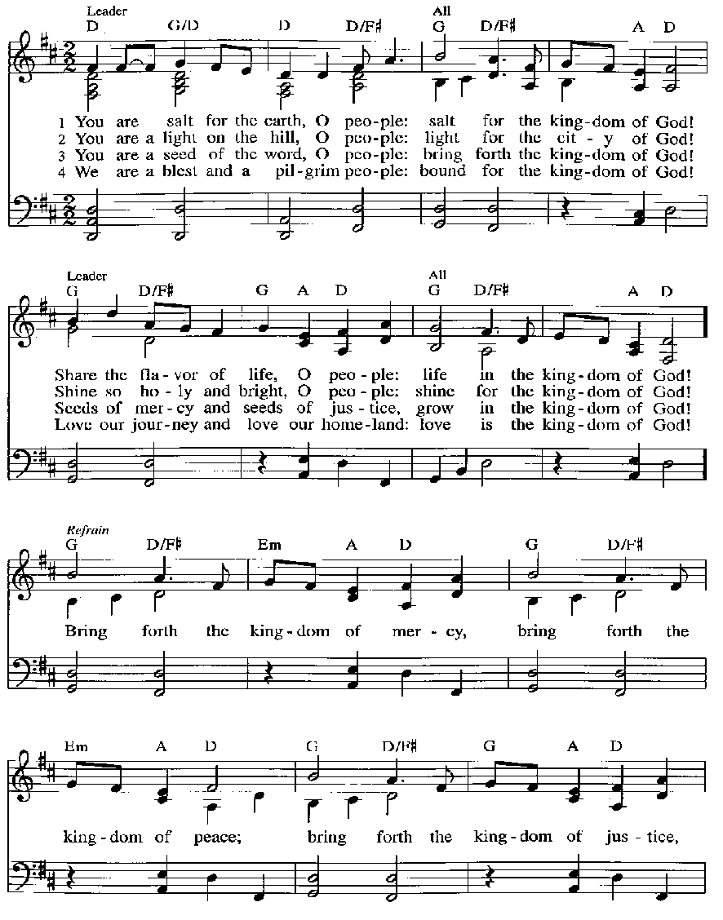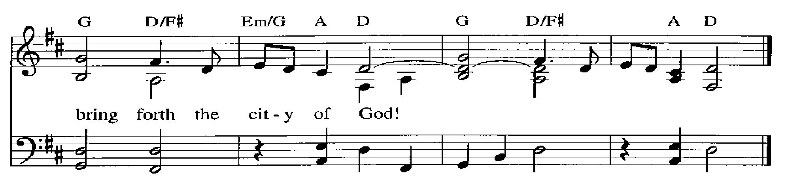

Prayers of the People

A: Trusting in God’s steadfast love for all creation,
let us pray for the church, the world, and those who are in need.

After each petition
A: Gracious God,
C: receive our prayer.

The presiding minister concludes the prayers
P: Grateful for your abundant provision and trusting in your goodness, O God,
we commend into your care all for whom we pray, through the priceless grace of Jesus Christ.
C: Amen.

Peace

The presiding minister and the assembly greet one another in the peace of the risen Christ.
P: The peace of Christ be with you always.
C: And also with you.

The people may greet those around them with a sign of Christ’s peace and may say
Peace be with you or similar words. Please be mindful that not everyone will be comfortable with sharing the peace, so please seek consent before shaking hands or hugging. Other possible ways to share the peace include a simple bow with the verbal greeting of peace, or simply a verbal expression of peace. When the greetings of peace have concluded, please be seated.

Meal
God feeds us with the presence of Jesus Christ

Offering

We offer ourselves, our gifts, and our faithful service to God.
As the offering is gathered for the mission of the church, including the care of those in need,
the table is set for Holy Communion.

There are laminated giving cards in the pew racks that feature a QR code for anyone who would like to give online. Those who give using the QR code, as well as those who give regularly online or through their bank are encouraged to place the laminated card in the plate as an expression of your offering.

Music during the Offering Beautiful Savior arr. Raabe

As the gifts are brought forward for presentation, please rise as you are able.

Offertory Song God, Whose Farm Is All Creation ELW 734
v. 1, 3

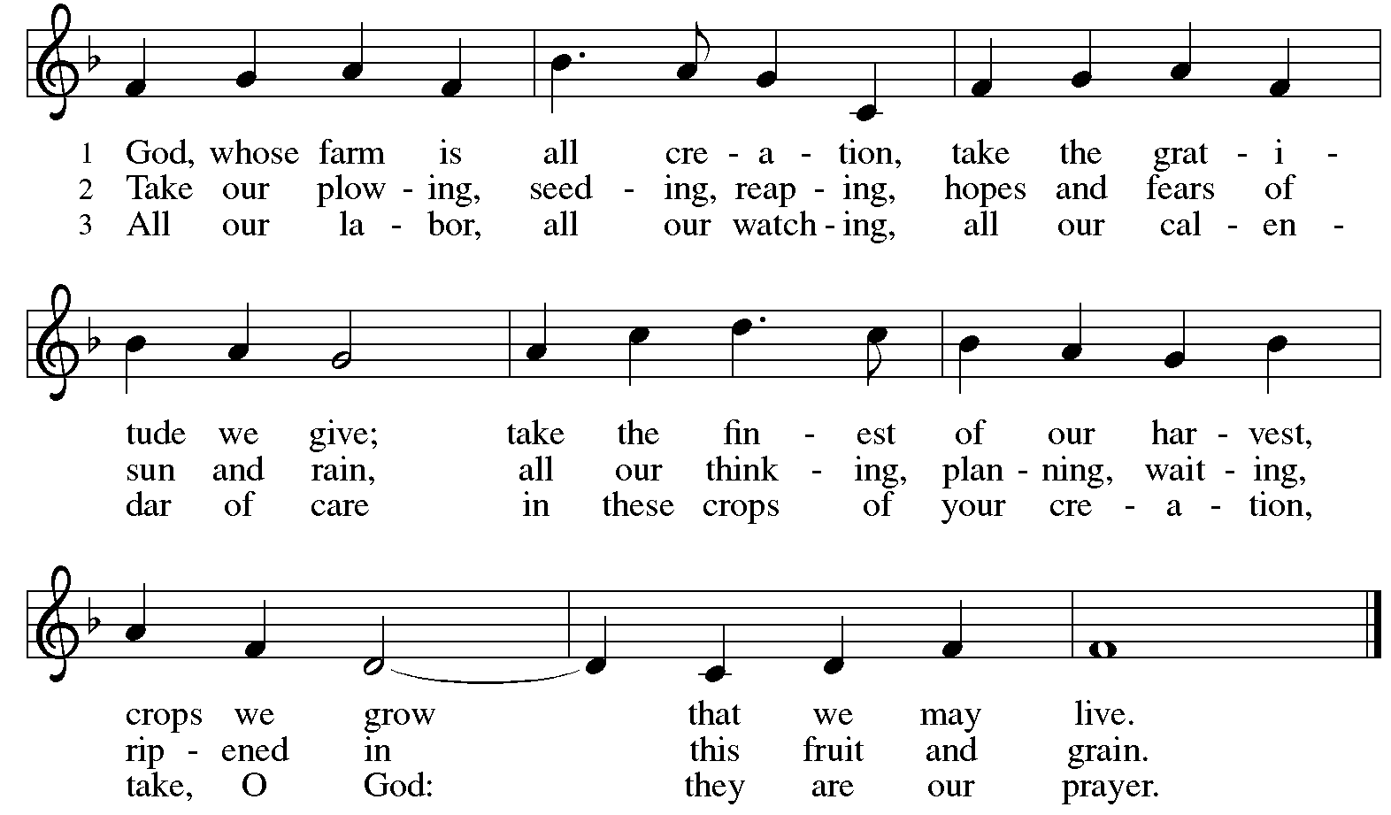
All rights reserved. Reprinted with permission under OneLicense.net # A-722139.

Offertory Prayer

A: Let us pray.
God of all creation,
C: all you have made is good, and your love endures forever.
You bring forth bread from the earth and fruit from the vine.
Nourish us with these gifts, that we might be for the world
signs of your gracious presence in Jesus Christ, our Savior and Lord.
Amen.

Dialogue

P: The Lord be with you.
C: And also with you.

P: Lift up your hearts.
C: We lift them to the Lord.

P: Let us give thanks to the Lord our God.
C: It is right to give our thanks and praise.

Preface (Spoken by the presiding minister)

P: It is indeed right, our duty and our joy …
… we praise your name and join their unending hymn:

Sanctus

C: Holy, holy, holy Lord,
God of power and might,
heaven and earth are full of your glory.
Hosanna in the highest.
Blessed is the one who comes in the name of the Lord.
Hosanna in the highest.

Eucharistic Prayer

P: Holy, mighty, and merciful Lord …
… be all honor and glory, now and forever.
C: Amen.

Lord’s Prayer

P: Gathered as one by the Holy Spirit, we pray as Jesus taught us.
C: Our Father in heaven,
hallowed be your name,
your kingdom come,
your will be done,
on earth as in heaven.
Give us today our daily bread.
Forgive us our sins,
as we forgive those
who sin against us;
Save us from the time of trial,
and deliver us from evil.
For the kingdom, the power,
and the glory are yours,
now and ever. Amen.

Fraction and Invitation

Agnus Dei / Lamb of God

C: Lamb of God, you take away the sin of the world; have mercy on us.
Lamb of God, you take away the sin of the world; have mercy on us.
Lamb of God, you take away the sin of the world; grant us peace.



Please be seated.

Holy Communion

- All who seek God and desire a deeper and stronger life in Christ are welcome to receive Holy Communion.
- Worshipers from the pulpit side will proceed forward first, followed by the center section, and then the lectern side.
- Please inform an usher if you would like the ministers to bring Communion to you.
- Holy Communion will be served with bread and wine (red) or grape juice (white).
- The presiding minister will first distribute the bread (host) to each communicant. Please indicate if you require a gluten-free host.
- Once you have consumed the bread, please pick up an empty glass from the tray next to the presiding minister. The Communion Assistant will pour wine or grape juice into your glass.
- Please step to the side to consume the wine or grape juice.
- Feel free to kneel at the altar rail for prayer after receiving the sacrament.
- As you return to your pew, glasses may be returned to the empty tray on the side of the center section.
- A blessing will be provided for anyone who does not yet receive the sacrament.
- All are invited to join in singing the hymns during Holy Communion.

Hymns during Holy Communion
Jesus, Priceless Treasure ELW 775

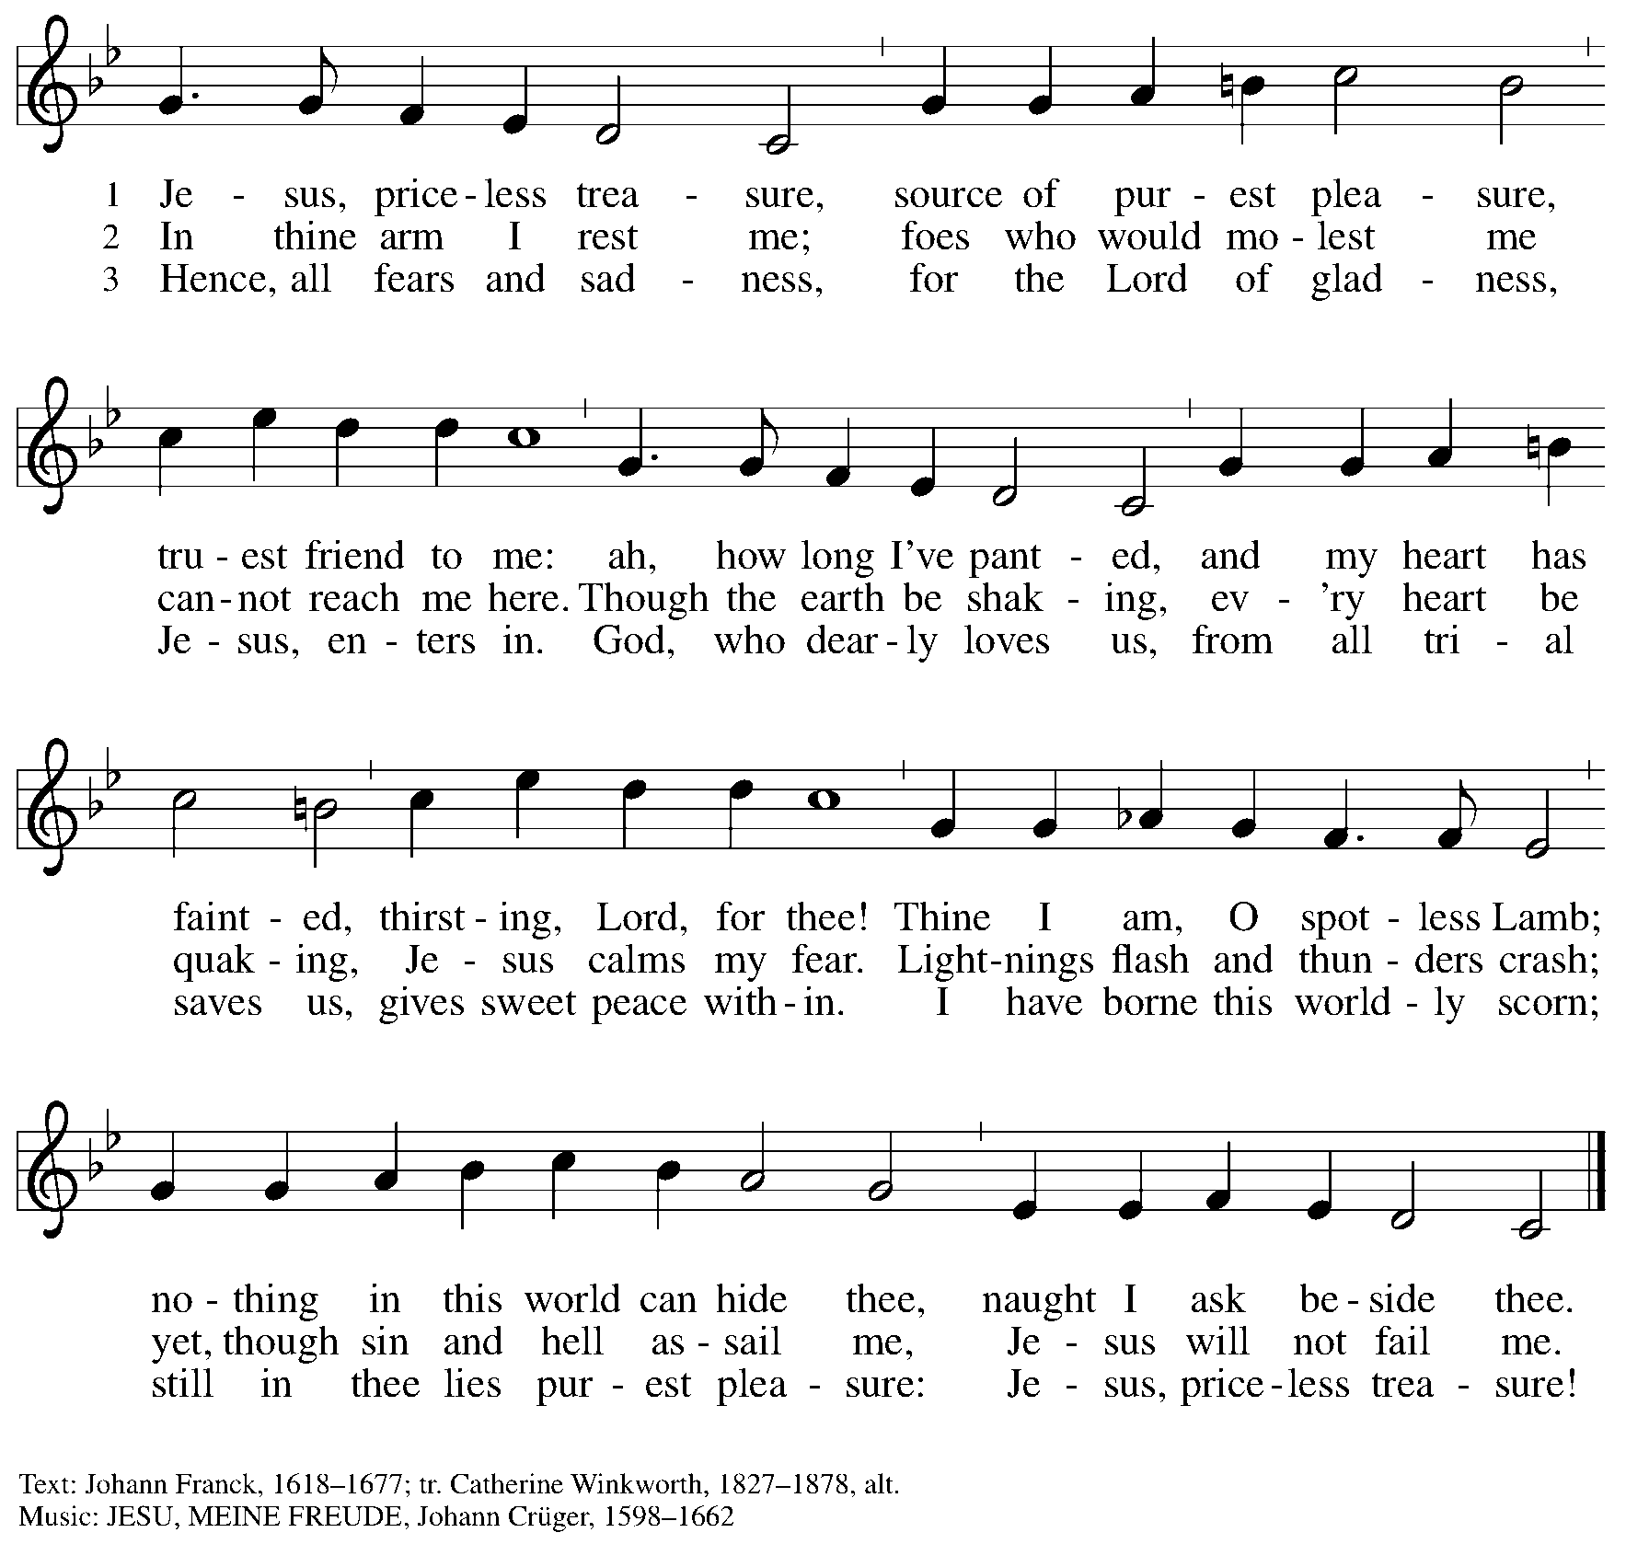

Hymns during Holy Communion
Many Will Come ACS 982

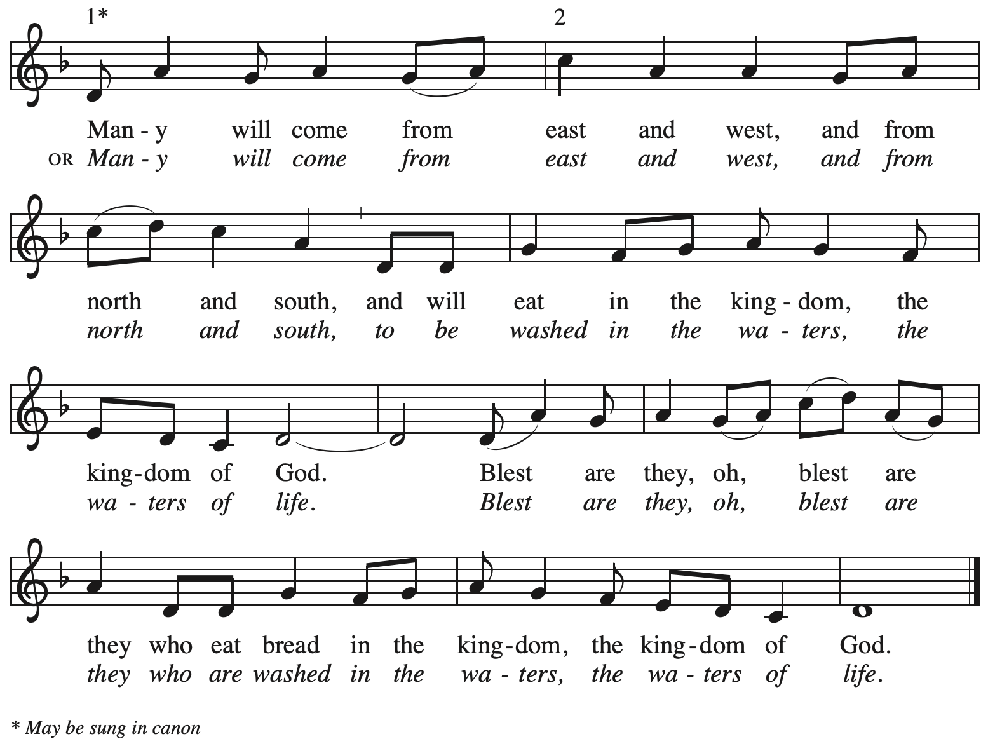
All rights reserved. Reprinted with permission under OneLicense.net # A-722139.

Hymns during Holy Communion
Soul, Adorn Yourself with Gladness ELW 488

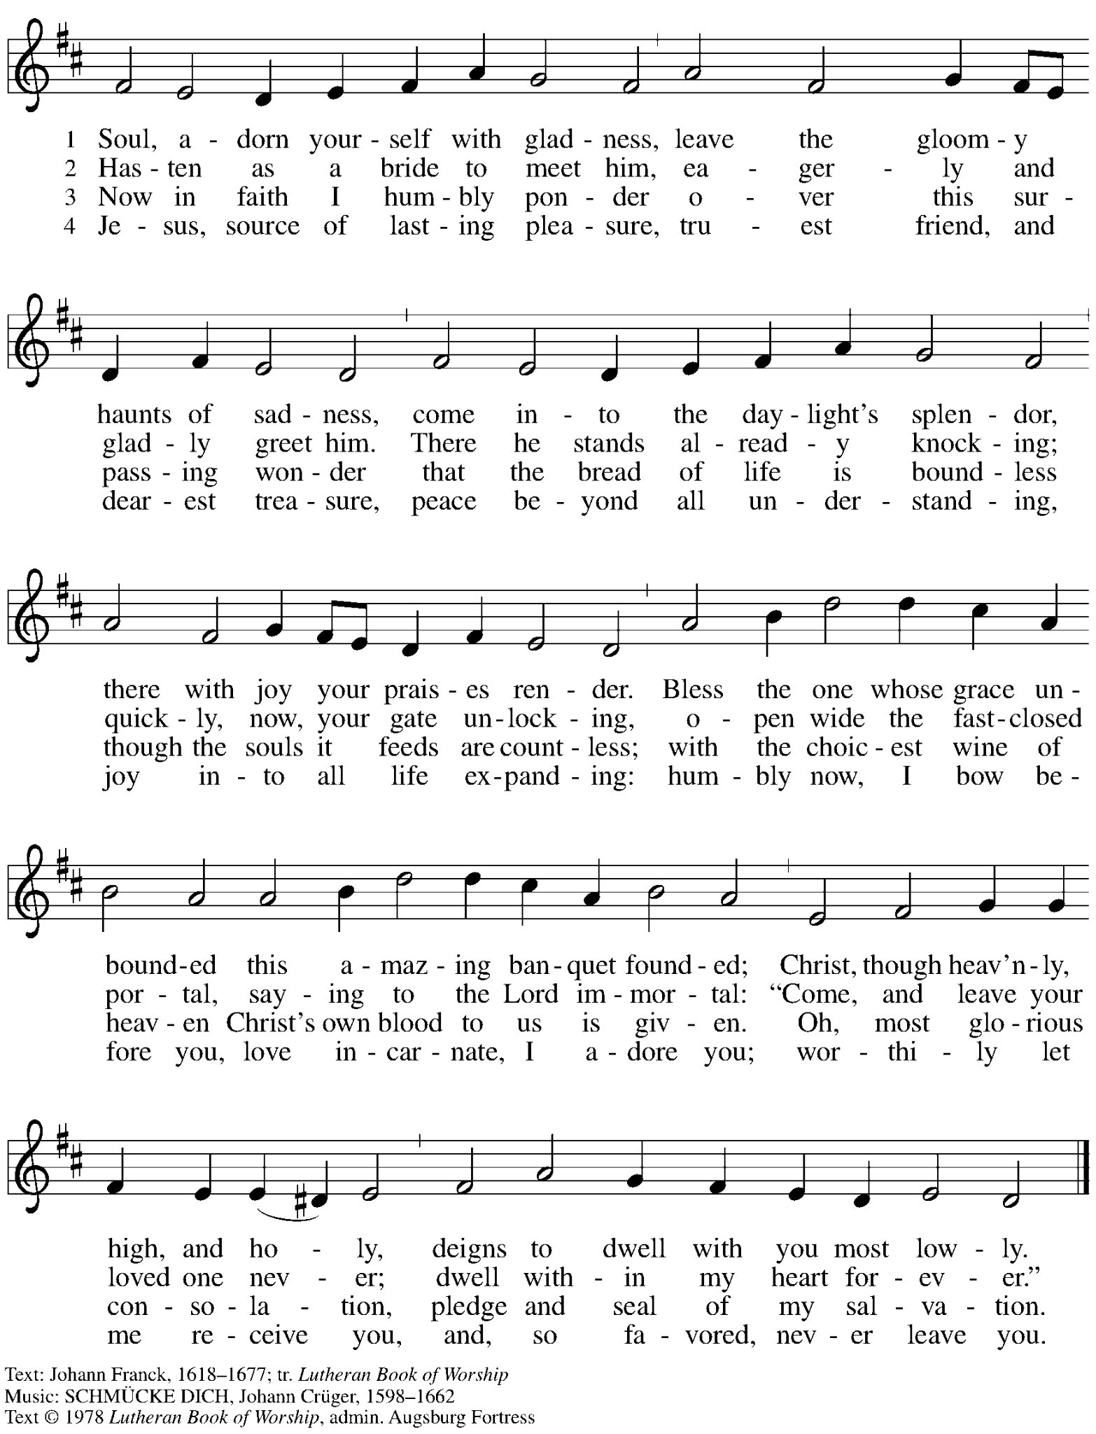
All rights reserved. Reprinted with permission under OneLicense.net # A-722139.

When all have returned to their places, please rise as you are able.

Blessing

P: The body and blood of our Lord Jesus Christ strengthen you and keep you in his grace.
C: Amen.

Prayer

A: Let us pray.
We give you thanks, almighty God, that you have refreshed us
through the healing power of this gift of life.
In your mercy, strengthen us through this gift,
in faith toward you and in fervent love toward one another;
for the sake of Jesus Christ our Lord
C: Amen.

Please be seated.

Sending
God blesses us and sends us in mission to the world

Announcements

Please rise as you are able.

Benediction

P: The Lord bless you and keep you.
The Lord’s face shine on you with grace and mercy.
The Lord look upon you with favor and ☩ give you peace.
C: Amen.

Sending Hymn Following Pages

Dismissal

A: Go in peace. Serve the Lord.
C: Thanks be to God!

Postlude

Sending Hymn Neither Death nor Life ELW 622

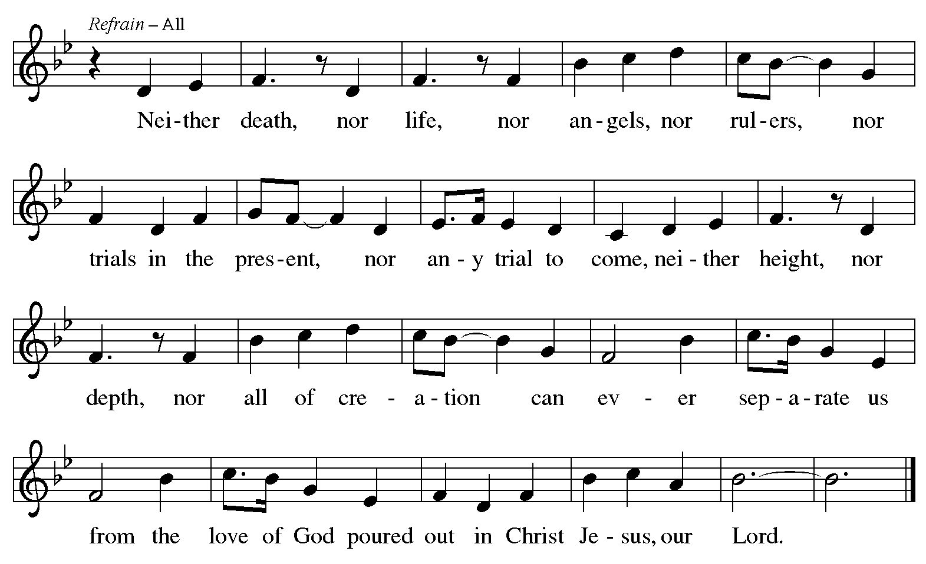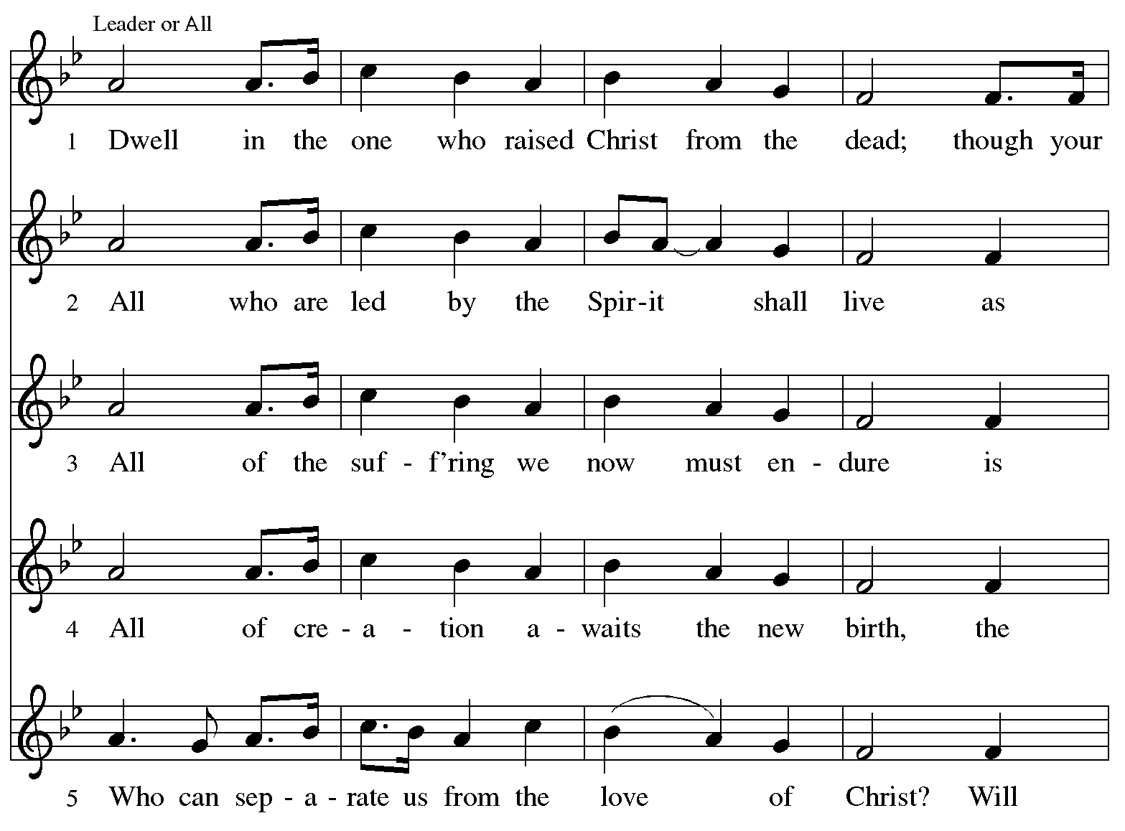
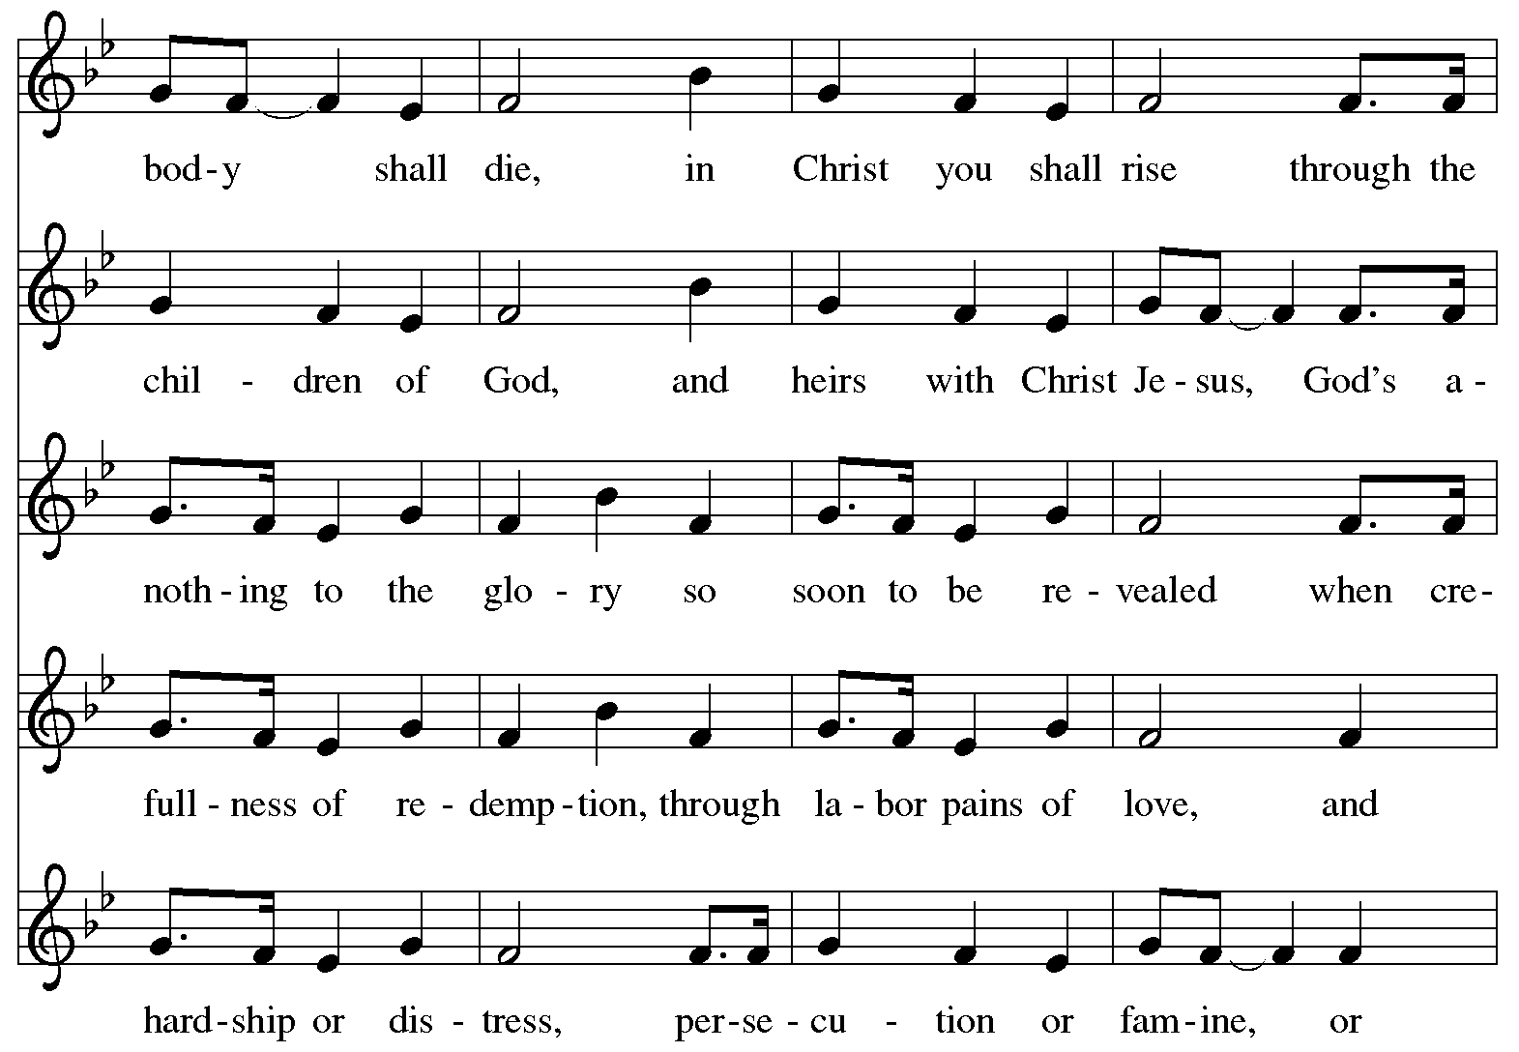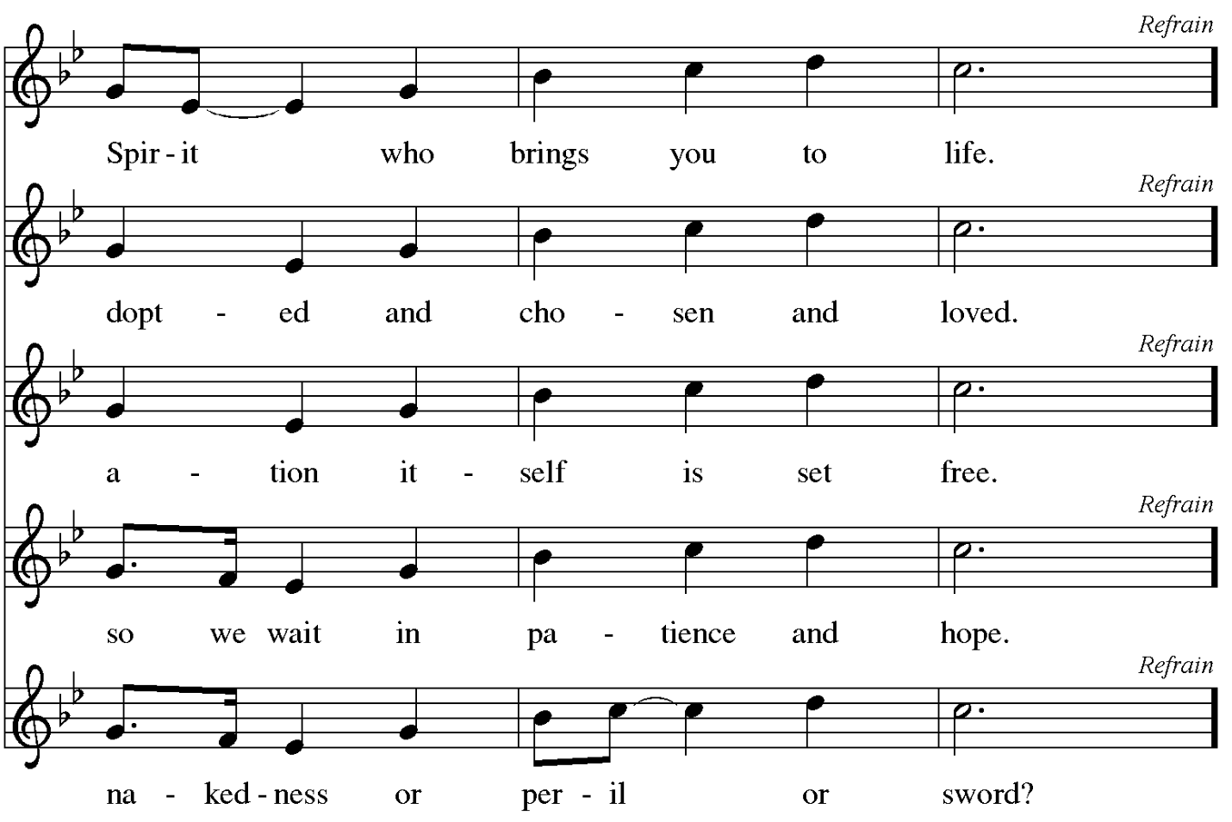

Those serving in worship today

Altar Care Beverley Chapman
Assisting Minister Colleen Cooke
Audio-Visual Ministers Kristen Asplin
Tyler Rietze
Cantor Ian Brown
Lector Brennan Coleman
Prelude Kristen, Linnea, and Johanna Asplin
Pre-Service Musical Offering C.E. Pino
Minister of Music Laura Reynolds
Presiding Minister The Rev. Peter D. Asplin

Liturgy and Hymnody Acknowledgements

From SundaysandSeasons.com. Copyright © 2026 Augsburg Fortress. All rights reserved. Reprinted under OneLicense.net # A-722139.
Used by permission of Augsburg Fortress.

Liturgical material reprinted with permission under Augsburg Fortress Liturgies Annual License SB124976.

The Scripture readings contained herein are from New Revised Standard Version Updated Edition of the Bible © 2021 National Council of Churches of Christ in the United States of America. Used by permission. All rights reserved worldwide.

Gather Us In – Text: Marty Haugen, b. 1950. Music: GATHER US IN, Marty Haugen. Text and music © 1982 GIA Publications, Inc., 7404 S. Mason Ave., Chicago, IL 60638. www.giamusic.com. 800.442.3358. All rights reserved. Reprinted with permission under One:icense.net # A-722139.

Neither Death nor Life – Text: Marty Haugen, b. 1950, based on Romans 8. Music: NEITHER DEATH NOR LIFE, Marty Haugen. Text and music © 2001 GIA Publications, Inc., 7404 S. Mason Ave., Chicago, IL 60638. www.giamusic.com. 800.442.3358. All rights reserved. Reprinted with permission under OneLicense.net # A-722139.

Please use the QR code below to link to St. Andrew’s Announcements online!



St. Andrew Lutheran Church Announcements
July 26th, 2026

- Welcome to Worship at St. Andrew on the Ninth Sunday after Pentecost – We are so glad you are here, and we offer a special welcome to all visitors and guests who are here for the first time! There are worship “toolkits” to help children engage with worship and “busy bags” for younger children available in the bookcase at the back of the sanctuary. Please feel free to take one to use with/for your children. A nursery is available through the door to the left of the worship space and across the social hall (look for a purple room).
- Welcome Back to The Rev. Peter D. Asplin, Today’s Preaching and Presiding Minister! – Pastor Peter Asplin, a member of St. Andrew and Assistant to the Bishop of the Southwestern Pennsylvania Synod, will be preaching and leading worship today. We thank Pastor Asplin for proclaiming God’s word and sharing his gifts with St. Andrew!
- Monthly Reparations Offering Next Week, Sunday, August 2nd, during Worship – In Luke’s Gospel, Jesus tells a story about a compassionate Samaritan, suggesting that God’s people are called to work for healing and restoration for our neighbors, regardless of who or what caused them harm. In light of this, St. Andrew has made a commitment to reparations in regard to African American spiritual songs used in our worship. The text and music of most hymns is attributed to specific authors, with copyrights in place, usage reported, and royalties paid to those whose works are featured in worship. With African American spirituals, this is not possible. In response to many years of such uncredited use, St. Andrew invites the congregation to give a reparations offering. Funds received in worship will be donated to our siblings at Bethel AME Church, whose land and building were taken from them in the 1950s, to fund their development in the Hill District.
- Produce Distribution Supplemental Food of the Month – St. Andrew is collecting supplemental food each month to accompany our produce distribution. For July, we ask for donations of canned, dehydrated, or freeze dried fruits. There are collection boxes at the back of the worship space and social hall.
- Friendly Wiffle Ball game with St. Andrew's Episcopal! Today, July 26th, 4:00 p.m. – In the past, our congregation shared community with St. Andrew's Episcopal Church in events like an annual pet blessing, and the compilation of backpacks and school supplies for students of The Neighborhood Academy. St. Andrew’s Episcopal Church (5801 Hampton St. in Highland Park, 15206) has invited this St. Andrew to gather for an afternoon of wiffle ball and community-building today, July 26th at 4:00 p.m. People of all ages are welcome to play or just come to meet new neighbors and siblings in Christ! We ask people of the congregation to bring cold drinks and/or light snacks to share!
- Bible Book Club and Coffee Hour are on break for the Summer.

