

+ Eleventh Sunday after Pentecost
August 9, 2026


St. Andrew Lutheran Church
304 Morewood Ave.
Pittsburgh, PA 15213
St_andrewELCA@verizon.net
www.standrewpittsburgh.org

+ Eleventh Sunday after Pentecost

Elijah finds the presence of God not in earthquake, wind, or fire,
but in the sound of sheer silence. When the disciples face a great storm on the sea,
they cry out with fear. Jesus says: “Take heart, it is I; do not be afraid.”
Amid the storms of life, we gather to seek the calm presence of Christ that soothes our fears.
In comforting words of scripture and in the refreshing bread and cup of the Eucharist,
God grants us peace and sends us forth to be a sign of God’s presence to others.

Welcome to St. Andrew!
- St. Andrew welcomes all who are seeking a place of healing, wholeness, and acceptance in a nurturing and faith-forming spiritual home. We are striving toward racial equity worldwide
and we seek to honor the lived experience of all individuals regardless of background. Our community embraces people of all ages, ethnicities, cultures, abilities, sexual orientations,
gender identities and expressions, and family constellations. Come and See!
- Worship Services are live-streamed to multiple online platforms. By attending worship, you agree that your image and voice may be broadcast.
- Everyone is invited to make a name tag at the black bookcase in the back of the worship space if they would like. There are stickers indicating pronouns on the bookcase if you would like to include them on your name tag.
- Little Church – Big Faith is on break for the summer.
- A nursery is available through the doors at the left side of the sanctuary and across from the doorway to the Social Hall. Look for a purple-colored room.
- Worship “toolkits” to help children engage with the service, along with “busy bags” for younger children, are available in the bookcase at the back of the sanctuary. Please feel free to take one to use with/for your children.
- Holy Communion is served with bread (gluten-free available) and wine or grape juice. The presiding minister will distribute the bread (host). Please consume this and then pick up an empty glass from the tray. The Communion Assistant will pour wine or grape juice into your glass. Please step to the side to consume the wine or grape juice. Feel free to kneel at the altar for prayer and reflection. As you return to your pew, glasses may be returned to the empty trays on either side of the center section.
- A restroom is available on the main level of the church, through the doors to the Social Hall and to the right in the main office.

Abbreviations
P: Pastor/Presiding Minister ELW: Evangelical Lutheran Worship hymnal
A: Assisting Minister ACS: All Creation Sings hymnal
L: Lector
C: Congregation

Musical Offering

Each week, different people from the congregation make an offering of pre-service music, with singing or instrumentation, to help the assembly focus and pray in preparation for worship.

Welcome
Prelude All Things Bright and Beautiful arr. Raabe

Gathering
The Holy Spirit calls us together as the people of God

Please rise as you are able. All may make the sign of the cross,
the sign that is marked at Baptism, as the presiding minister begins.

Confession and Forgiveness

P: Blessed be the ☩ holy Trinity,
one God, whose compassion endures forever.
C: Amen.

P: Let us confess our sin in the presence of God and of one another.

Silence is kept for reflection.

P: Compassionate God,
C: we confess to you all our sins.
Our burden is heavy, and we cannot free ourselves.
In your mercy, forgive us our sin, and call us back to you.
Your yoke is easy and your burden is light.
Restore us to dwell in your peace.
In Christ’s name we pray,
Amen.

P: Jesus says, “Come to me,
all you who are weary
and are carrying heavy burdens,
and I will give you rest.”
In the name of God,
Father, ☩ Son, and Holy Spirit,
your sins are forgiven.
Rest in God’s love.
C: Amen.

Gathering Hymn Cantad al Señor – Oh, Sing to the Lord ELW 822

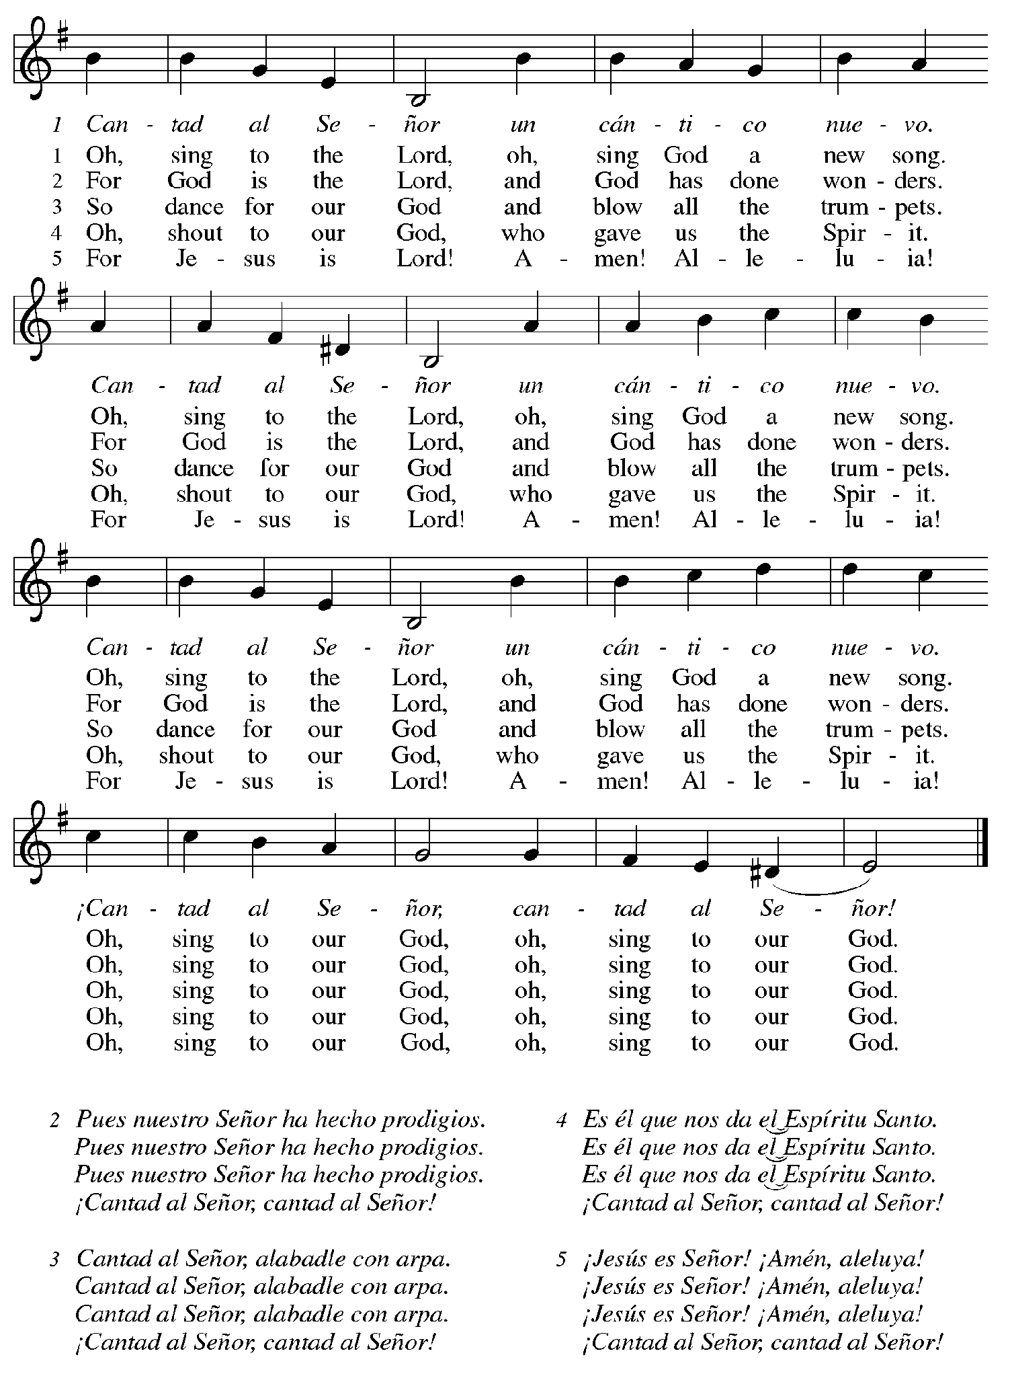

Greeting

P: The grace of our Lord Jesus Christ, the love of God,
and the communion of the Holy Spirit be with you all.
C: And also with you.

Prayer of the Day

P: Let us pray. O God our defender, storms rage around and within us and cause us to be afraid.
Rescue your people from despair, deliver your children from fear,
and preserve us in the faith of your Son, Jesus Christ, our Savior and Lord.
C: Amen.

Please be seated.

Word
God speaks to us in Scripture reading, preaching, and song

First Reading – 1 Kings 19: 9-18

⁹ At [Horeb, the mount of God,][Elijah] came to a cave and spent the night there.
Then the word of the Lord came to him, saying, “What are you doing here, Elijah?” ¹⁰ He answered, “I have been very zealous for the Lord, the God of hosts, for the Israelites have forsaken your covenant, thrown down your altars, and killed your prophets with the sword.
I alone am left, and they are seeking my life, to take it away.”
¹¹ God said, “Go out and stand on the mountain before the Lord, for the Lord is about to pass by.” Now there was a great wind, so strong that it was splitting mountains and breaking rocks in pieces before the Lord, but the Lord was not in the wind, and after the wind an earthquake, but the Lord was not in the earthquake, ¹² and after the earthquake a fire, but the Lord was not in the fire, and after the fire a sound of sheer silence. ¹³ When Elijah heard it, he wrapped his face in his mantle and went out and stood at the entrance of the cave. Then there came a voice to him that said, “What are you doing here, Elijah?” ¹⁴ He answered, “I have been very zealous for the Lord, the God of hosts, for the Israelites have forsaken your covenant, thrown down your altars, and killed your prophets with the sword. I alone am left, and they are seeking my life, to take it away.” ¹⁵ Then the Lord said to him, “Go, return on your way to the wilderness of Damascus; when you arrive, you shall anoint Hazael as king over Aram. ¹⁶ Also you shall anoint Jehu son of Nimshi as king over Israel, and you shall anoint Elisha son of Shaphat of Abel-meholah as prophet in your place. ¹⁷ Whoever escapes from the sword of Hazael, Jehu shall kill, and whoever escapes from the sword of Jehu, Elisha shall kill. ¹⁸ Yet I will leave seven thousand in Israel, all the knees that have not bowed to Baal, and every mouth that has not kissed him.”

L: Word of God, word of life.
C: Thanks be to God.

Psalm 85: 8-13

The psalm will be read responsively, led by the cantor,
with the congregation responding with the verses in bold.

⁸ I will listen to what the Lord God is saying;
for you speak peace to your faithful people and to those who turn their hearts to you.
⁹ Truly, your salvation is very near to those who fear you,
that your glory may dwell in our land.
¹⁰ Steadfast love and faithfulness have met together;
righteousness and peace have kissed each other.
¹¹ Faithfulness shall spring up from the earth,
and righteousness shall look down from heaven.
¹² The Lord will indeed grant prosperity,
and our land will yield its increase.
¹³ Righteousness shall go before the Lord
and shall prepare for God a pathway.

Second Reading – Romans 10: 5-15

⁵ Moses writes concerning the righteousness that comes from the law, that “the person who does these things will live by them.” ⁶ But the righteousness that comes from faith says, “Do not say in your heart, ‘Who will ascend into heaven?’ ” (that is, to bring Christ down) ⁷ “or ‘Who will descend into the abyss?’ ” (that is, to bring Christ up from the dead). ⁸ But what does it say?
“The word is near you,
in your mouth and in your heart”
(that is, the word of faith that we proclaim), ⁹ because if you confess with your mouth that Jesus is Lord and believe in your heart that God raised him from the dead, you will be saved. ¹⁰ For one believes with the heart, leading to righteousness, and one confesses with the mouth, leading to salvation. ¹¹ The scripture says, “No one who believes in him will be put to shame.” ¹² For there is no distinction between Jew and Greek; the same Lord is Lord of all and is generous to all who call on him. ¹³ For “everyone who calls on the name of the Lord shall be saved.”
¹⁴ But how are they to call on one in whom they have not believed? And how are they to believe in one of whom they have never heard? And how are they to hear without someone to proclaim him? ¹⁵ And how are they to proclaim him unless they are sent? As it is written, “How beautiful are the feet of those who bring good news!”
L: Word of God, word of life.
C: Thanks be to God.

Please rise as you are able.

Gospel Acclamation

C: Alleluia. I wait for you, O Lord;
in your word is my hope. Alleluia.
Gospel – Matthew 14: 22-33

P: The holy Gospel according to St. Matthew.
C: Glory to you, O Lord.
²² [Jesus] made the disciples get into a boat and go on ahead to the other side [of the Sea of Galilee,] while he dismissed the crowds.²³ And after he had dismissed the crowds, he went up the mountain by himself to pray. When evening came, he was there alone, ²⁴ but by this time the boat, battered by the waves, was far from the land, for the wind was against them. ²⁵ And early in the morning he came walking toward them on the sea. ²⁶ But when the disciples saw him walking on the sea, they were terrified, saying, “It is a ghost!” And they cried out in fear. ²⁷ But immediately Jesus spoke to them and said, “Take heart, it is I; do not be afraid.”
²⁸ Peter answered him, “Lord, if it is you, command me to come to you on the water.”
²⁹ He said, “Come.” So Peter got out of the boat, started walking on the water, and came toward Jesus. ³⁰ But when he noticed the strong wind, he became frightened, and, beginning to sink, he cried out, “Lord, save me!” ³¹ Jesus immediately reached out his hand and caught him, saying to him, “You of little faith, why did you doubt?” ³² When they got into the boat, the wind ceased.
³³ And those in the boat worshiped him, saying, “Truly you are the Son of God.”

P: The Gospel of the Lord.
C: Praise to you, O Christ.

Please be seated.

Sermon

A time of silence for prayer and reflection follows the sermon.
When the hymn of the day begins, please rise as you are able.



Hymn of the Day Jesus, Savior, Pilot Me ELW 755

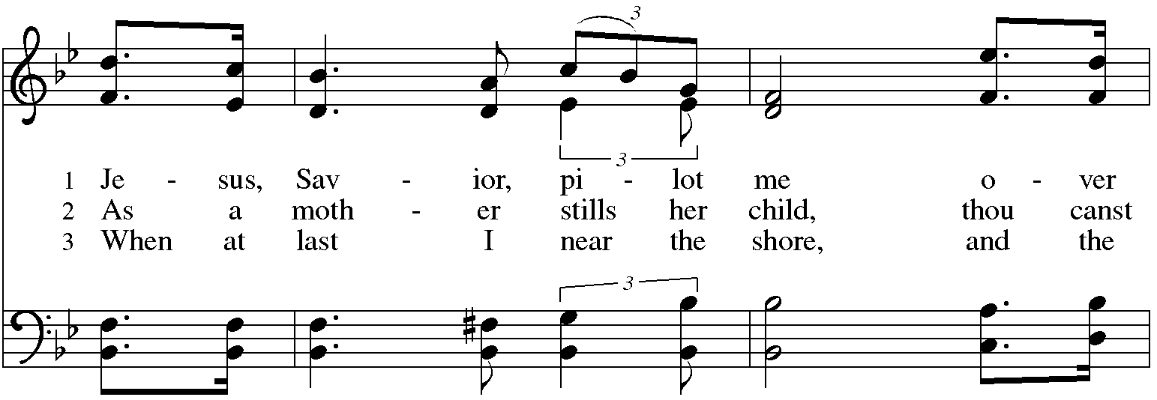
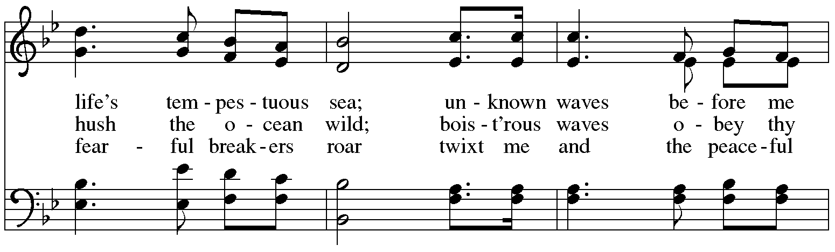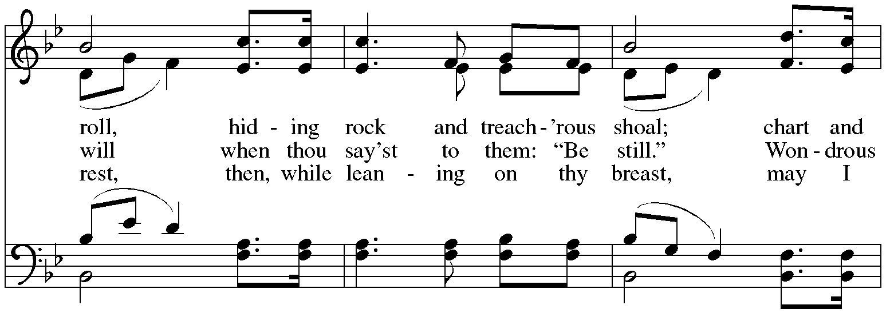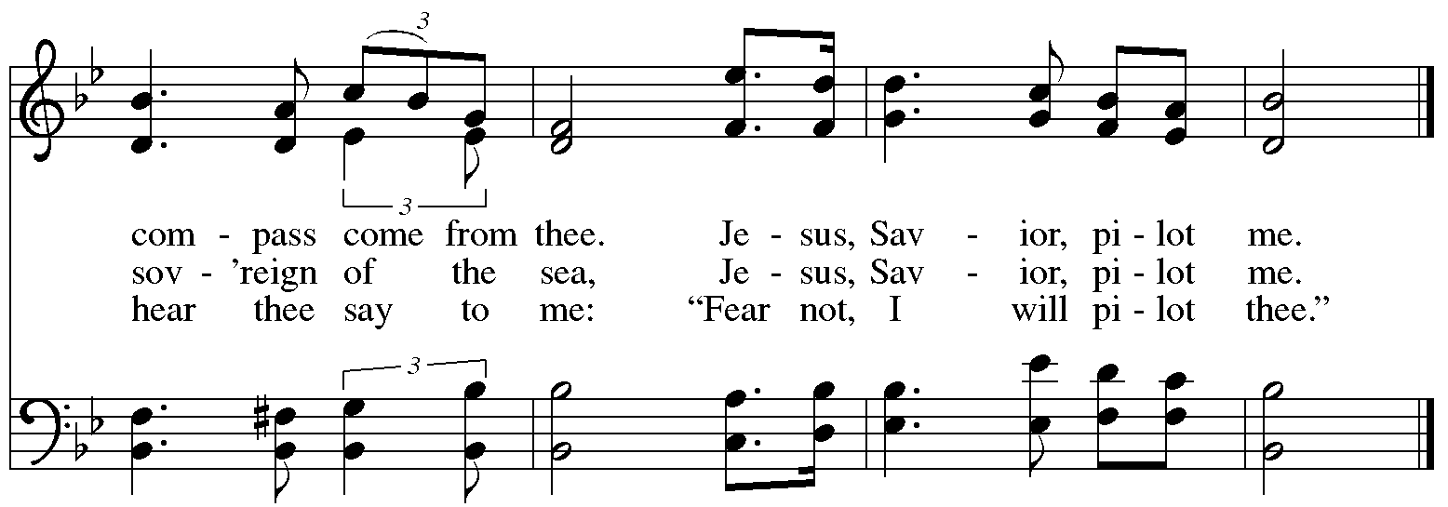
Prayers of the People

A: Trusting in God’s steadfast love for all God has made,
let us pray for the church, the world, and those who are in need.

After each petition
A: Gracious God,
C: receive our prayer.

The presiding minister concludes the prayers
P: Grateful for your abundant provision and trusting in your goodness, O God,
we commend into your care all for whom we pray, through the priceless grace of Jesus Christ.
C: Amen.

Peace

The presiding minister and the assembly greet one another in the peace of the risen Christ.
P: The peace of Christ be with you always.
C: And also with you.

The people may greet those around them with a sign of Christ’s peace and may say
Peace be with you or similar words. Please be mindful that not everyone will be comfortable with sharing the peace, so please seek consent before shaking hands or hugging. Other possible ways to share the peace include a simple bow with the verbal greeting of peace, or simply a verbal expression of peace. When the greetings of peace have concluded, please be seated.



Meal
God feeds us with the presence of Jesus Christ

Offering

We offer ourselves, our gifts, and our faithful service to God.
As the offering is gathered for the mission of the church, including the care of those in need,
the table is set for Holy Communion. There are laminated giving cards in the pew racks that feature a QR code for anyone who would like to give online. Those who give using the QR code, as well as those who give regularly online or through their bank are encouraged to place the laminated card in the plate as an expression of your offering.

Music during the Offering
I Need Thee Every Hour arr. Keveren

As the gifts are brought forward for presentation, please rise as you are able.

Offertory Song God, Whose Farm Is All Creation ELW 734
v. 1, 3

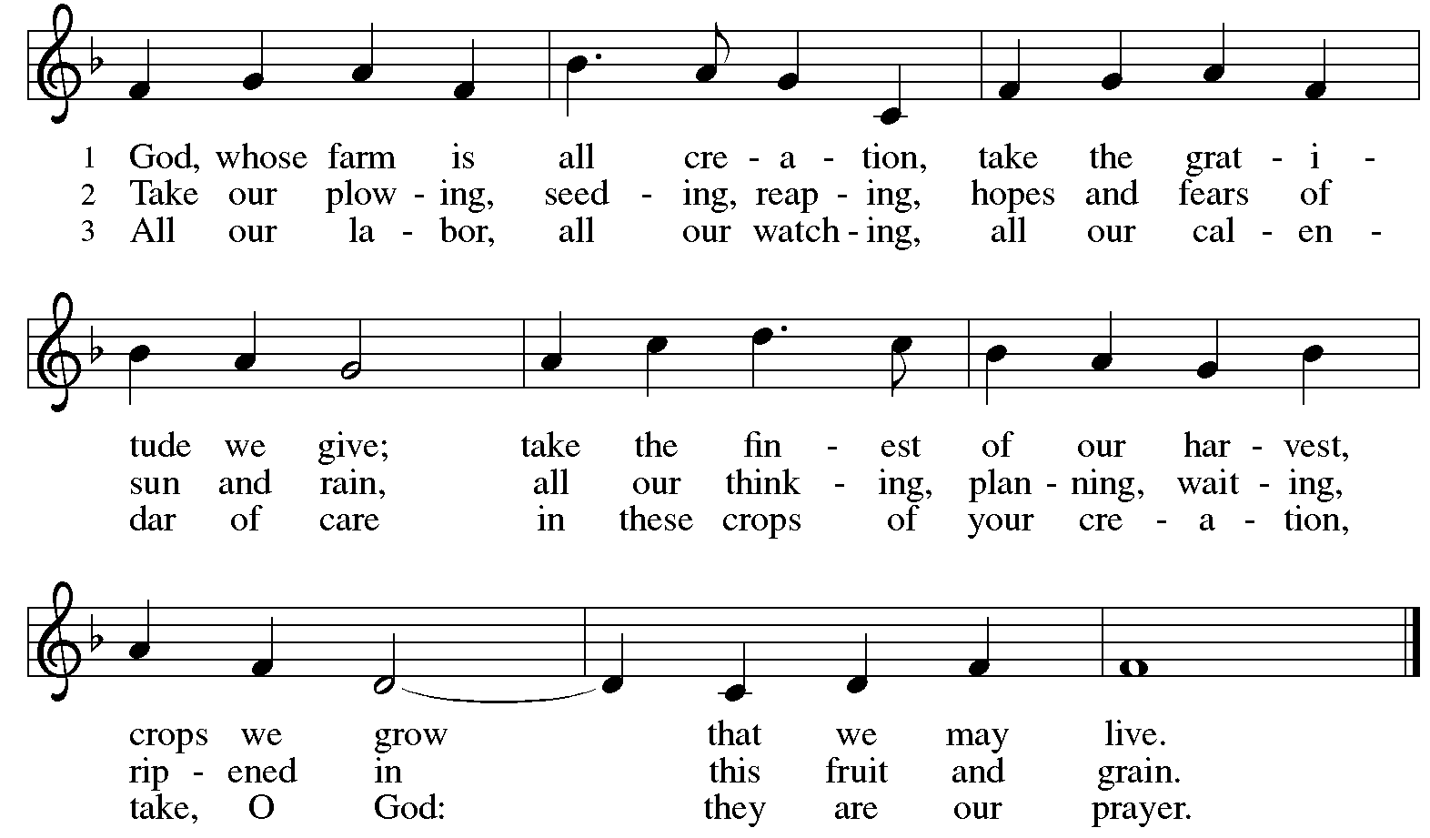
All rights reserved. Reprinted with permission under OneLicense.net # A-722139.

Offertory Prayer

A: Let us pray. God of all creation,
C: all you have made is good, and your love endures forever.
You bring forth bread from the earth and fruit from the vine.
Nourish us with these gifts, that we might be for the world
signs of your gracious presence in Jesus Christ, our Savior and Lord.
Amen.
Dialogue

P: The Lord be with you.
C: And also with you.

P: Lift up your hearts.
C: We lift them to the Lord.

P: Let us give thanks to the Lord our God.
C: It is right to give our thanks and praise.

Preface (Spoken by the presiding minister)

P: It is indeed right, our duty and our joy …
… we praise your name and join their unending hymn:

Sanctus

C: Holy, holy, holy Lord,
God of power and might,
heaven and earth are full of your glory.
Hosanna in the highest.
Blessed is the one who comes in the name of the Lord.
Hosanna in the highest.

Eucharistic Prayer

P: Holy, mighty, and merciful Lord …
… be all honor and glory, now and forever.
C: Amen.

Lord’s Prayer

P: Gathered as one by the Holy Spirit, we pray as Jesus taught us.
C: Our Father in heaven,
hallowed be your name,
your kingdom come,
your will be done,
on earth as in heaven.
Give us today our daily bread.
Forgive us our sins,
as we forgive those who sin against us;

Save us from the time of trial,
and deliver us from evil.
For the kingdom, the power,
and the glory are yours,
now and ever. Amen.

Fraction and Invitation

Agnus Dei / Lamb of God

C: Lamb of God, you take away the sin of the world; have mercy on us.
Lamb of God, you take away the sin of the world; have mercy on us.
Lamb of God, you take away the sin of the world; grant us peace.

Please be seated.

Holy Communion

- All who seek God and desire a deeper and stronger life in Christ are welcome to receive Holy Communion.
- Worshipers from the pulpit side will proceed forward first, followed by the center section, and then the lectern side.
- Please inform an usher if you would like the ministers to bring Communion to you.
- Holy Communion will be served with bread and wine (red) or grape juice (white).
- The presiding minister will first distribute the bread (host) to each communicant. Please indicate if you require a gluten-free host.
- Once you have consumed the bread, please pick up an empty glass from the tray next to the presiding minister. The Communion Assistant will pour wine or grape juice into your glass.
- Please step to the side to consume the wine or grape juice.
- Feel free to kneel at the altar rail for prayer after receiving the sacrament.
- As you return to your pew, glasses may be returned to the empty tray on the side of the center section.
- A blessing will be provided for anyone who does not yet receive the sacrament.
- All are invited to join in singing the hymns during Holy Communion.

Hymns during Holy Communion
Precious Lord, Take My Hand ELW 773

No downloads are available for this hymn. Please refer to the red Evangelical Lutheran Worship hymnal, hymn 773 near the back of the book.

Hymns during Holy Communion
O God, Our Help in Ages Past ELW 632

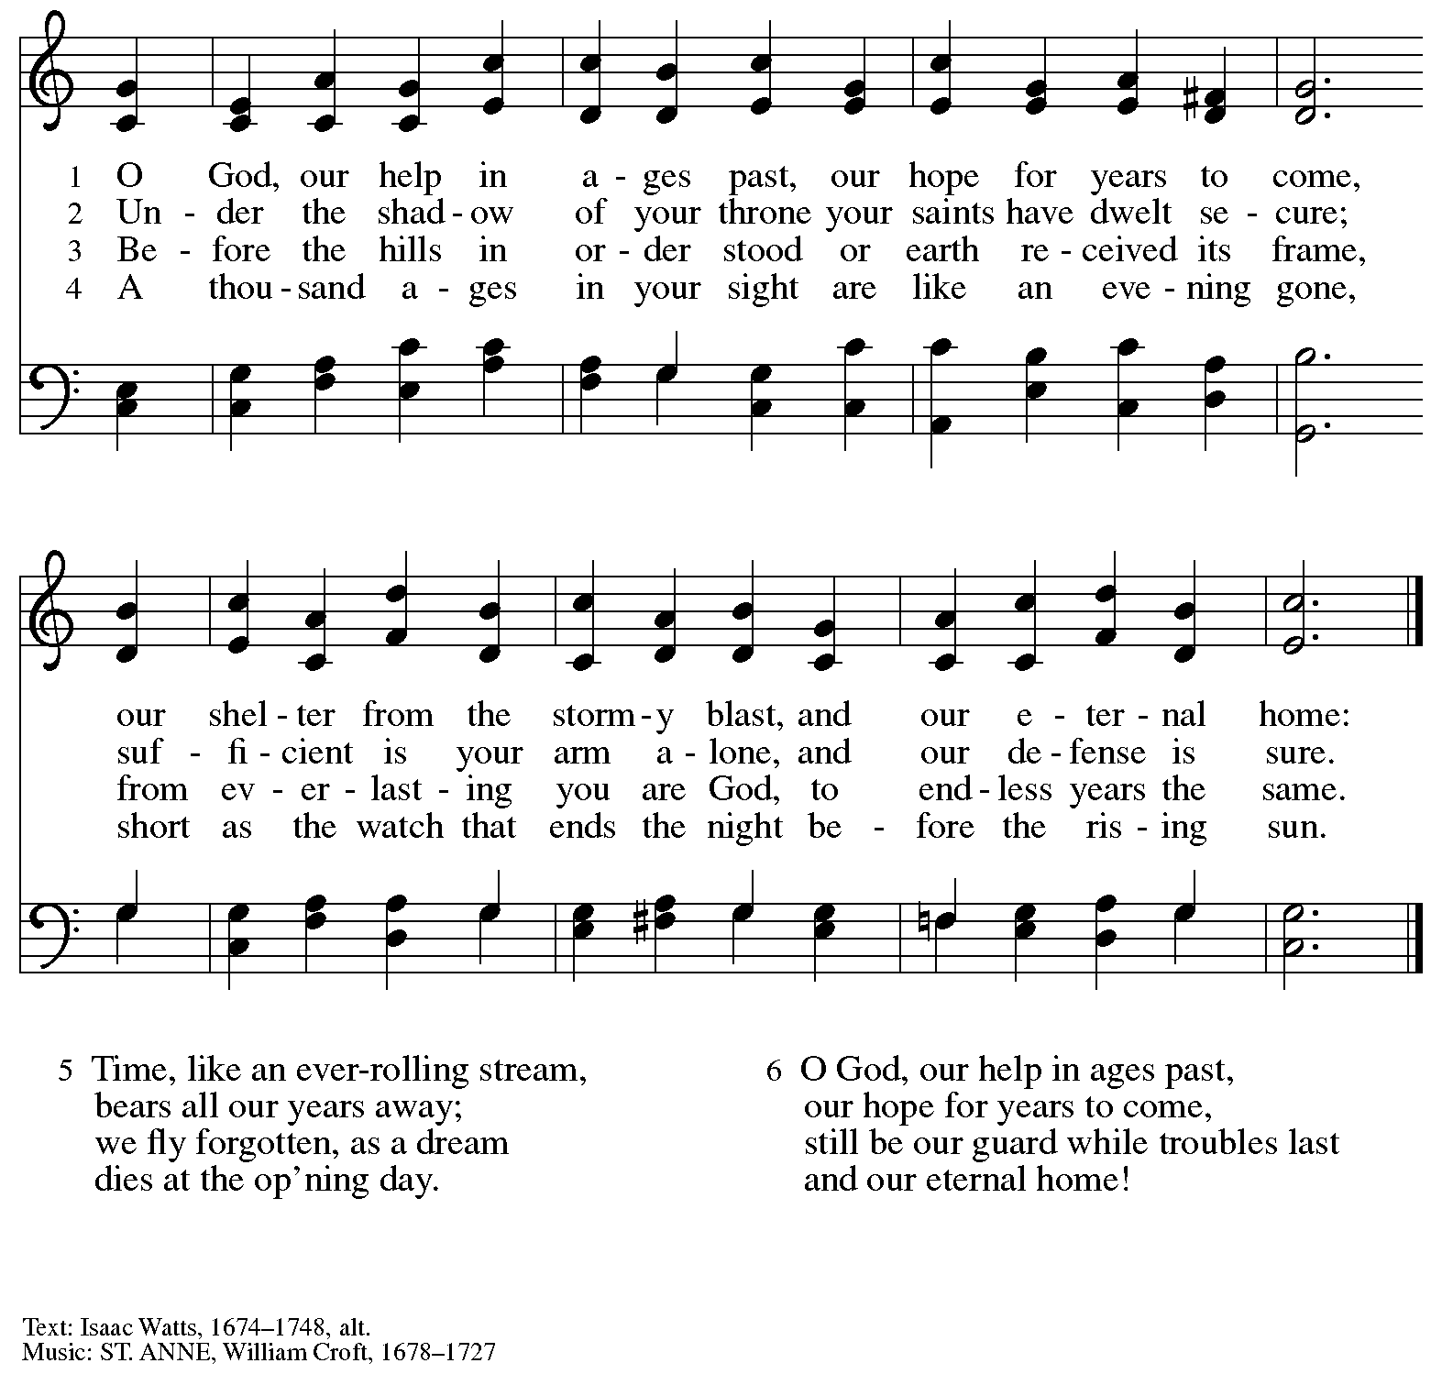

Hymns during Holy Communion
When Peace, like a River ELW 785

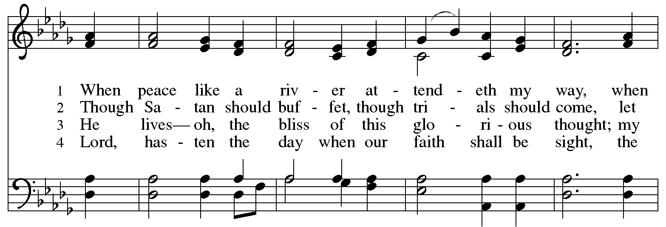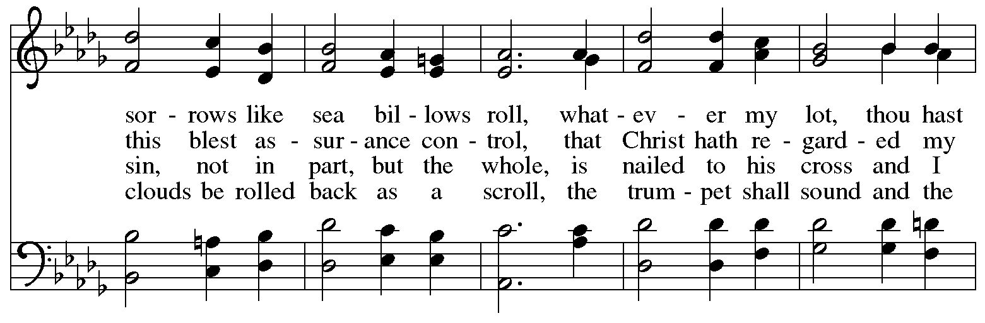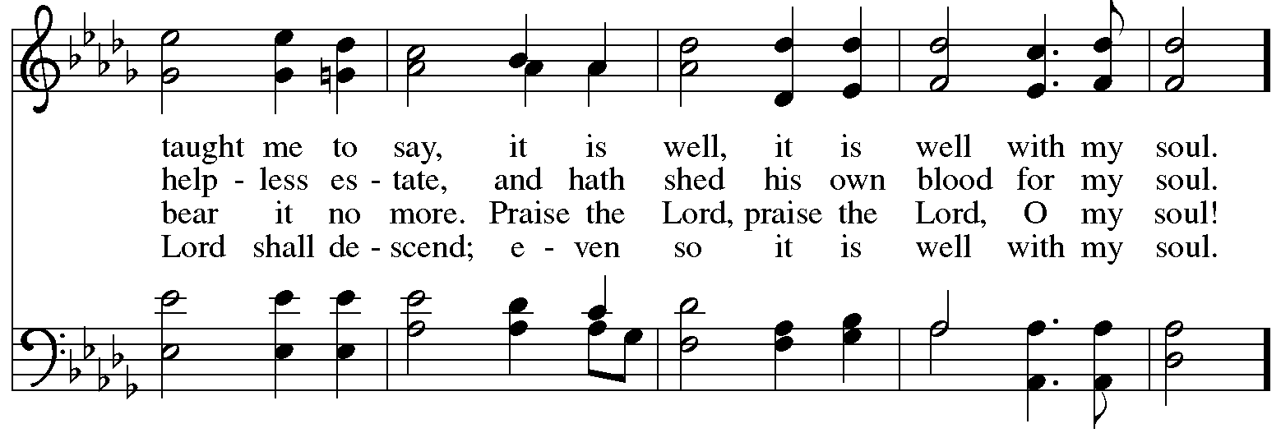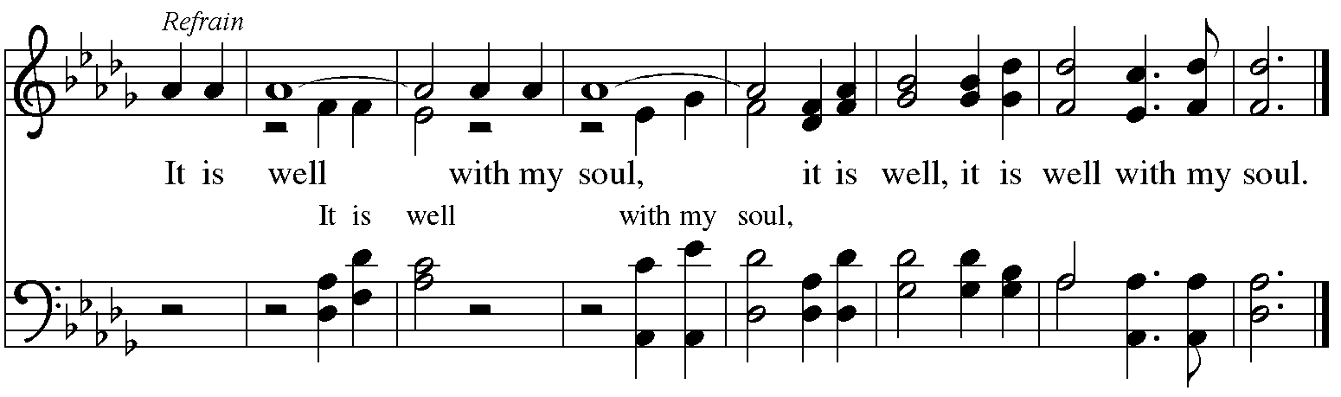
When all have returned to their places, please rise as you are able.

Blessing

P: The body and blood of our Lord Jesus Christ strengthen you and keep you in his grace.
C: Amen.

Prayer

A: Let us pray.
We give you thanks, almighty God, that you have refreshed us
through the healing power of this gift of life.
In your mercy, strengthen us through this gift,
in faith toward you and in fervent love toward one another;
for the sake of Jesus Christ our Lord
C: Amen.

Please be seated.

Sending
God blesses us and sends us in mission to the world

Announcements

Please rise as you are able.

Benediction

P: The Lord bless you and keep you.
The Lord’s face shine on you with grace and mercy.
The Lord look upon you with favor and ☩ give you peace.
C: Amen.

Sending Hymn Following Page

Dismissal

A: Go in peace. Serve the Lord.
C: Thanks be to God!

Postlude

Sending Hymn My Life Flows on in Endless Song ELW 763

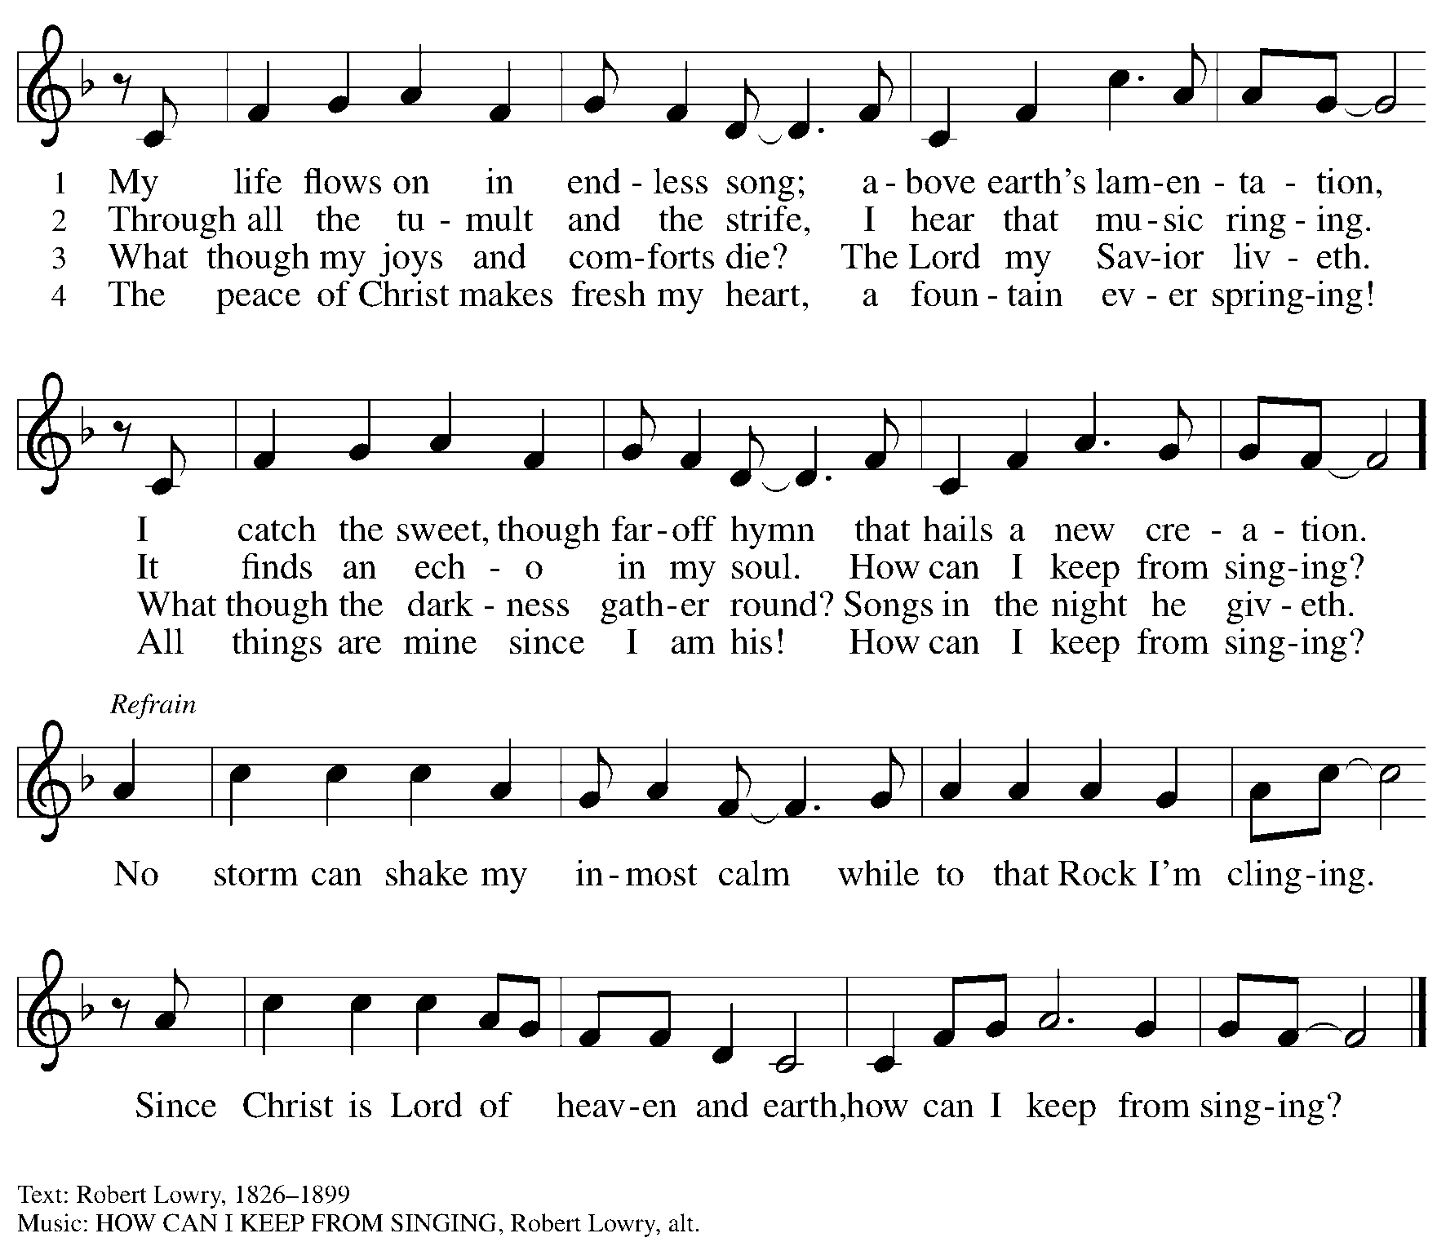

Those serving in worship today

Altar Care Christy Ruhe
Assisting Minister Jimmi Kocher-Hillmer
Audio-Visual Ministers Sarita
Dave Rollinson
Cantor Marit Bakken
Lector Colleen Cooke
Minister of Music Laura Reynolds
Presiding Minister The Rev. Ross I. Carmichael

Liturgy and Hymnody Acknowledgements

From SundaysandSeasons.com. Copyright © 2026 Augsburg Fortress. All rights reserved. Reprinted under OneLicense.net # A-722139.
Used by permission of Augsburg Fortress.

Liturgical material reprinted with permission under Augsburg Fortress Liturgies Annual License SB124976.

The Scripture readings contained herein are from New Revised Standard Version Updated Edition of the Bible © 2021 National Council of Churches of Christ in the United States of America. Used by permission. All rights reserved worldwide.

Cantad al Señor – Oh, Sing to the Lord – Text: Brazilian folk song; tr. Gerhard M. Cartford, b. 1923, Spanish and English. Music: CANTAD AL SEÑOR, Brazilian folk tune. Spanish and English text © Gerhard M. Cartford, admin. Augsburg Fortress. All rights reserved. Reprinted with permission under OneLicense.net # A-722139.

Jesus, Savior, Pilot Me – Text: Edward Hopper, 1818-1888. Music: PILOT, John Edgar Gould, 1822-1875.

When Peace, like a River – Text: Horatio G. Spafford, 1828-1888. Music: VILLE DU HAVRE, Philip P. Bliss, 1838-1876.

Please use the QR code below to link to St. Andrew’s Announcements online!



St. Andrew Lutheran Church Announcements
August 9th, 2026

- Welcome to Worship at St. Andrew on the Eleventh Sunday after Pentecost – We are so glad you are here, and we offer a special welcome to all visitors and guests who are here for the first time! There are worship “toolkits” to help children engage with worship and “busy bags” for younger children available in the bookcase at the back of the sanctuary. Please feel free to take one to use with/for your children. A nursery is available through the door to the left of the worship space and across the social hall (look for a purple room).
- Produce Distribution Supplemental Food of the Month – St. Andrew is collecting supplemental food each month to accompany our produce distribution. For August, we ask for donations of dried beans. There are collection boxes at the back of the worship space and in the social hall.
- Produce Distribution, First and Third Tuesday Each Month, August 18th from 5:30 to 6:30 p.m. – St. Andrew partners with Greater Pittsburgh Community Food Bank to serve as a distribution site for fresh produce on the first and third Tuesday of every month. We invite people of the congregation to help with the distribution from 5:30 p.m. to 6:30 p.m. and/or to help with unloading and setup during the day between 10:00 a.m. and 1:00 p.m.
- Noisy Offering Next Sunday During Worship – On the third Sunday of each month, St. Andrew’s children lead the congregation in a Noisy Offering, in which people are invited to throw their change into buckets that the children carry around the church and bring forward as an additional offering. Each month’s Noisy Offering supports a local, national, or international church-related or otherwise charitable organization. This month’s offering will benefit Lutheran Disaster Response. Their work includes providing care for affected people and leaders who respond, assisting communities holistically to meet varied needs, infrastructure and preparedness planning, and providing long-term recovery by addressing unmet needs months or years after a disaster strikes. You can learn more about them here: https://www.elca.org/how-we-serve/relief-and-development/lutheran-disaster-response.
- Blessing of Teachers and Blessing of Backpacks, Sunday, August 23rd, during Worship – As a new school year begins and we prepare for another year of Christian education for the children and youth of St. Andrew, we pray for God's blessings upon all participating in the vocations of education. Teachers and educators, along with Little Church - Big Faith leaders will be invited to come forward to receive a blessing. We also invite students, children, and youth to bring a backpack or other item representative of their studies as they receive a blessing, as well.
- ELCA Podcast on Reconsideration of Social Statement – The task force leading the ELCA in the reconsideration of one section of the social statement Human Sexuality: Gift and Trust is excited to share an important opportunity for you to engage with this summer. The task force is releasing a podcast called Learn and Discern as an educational tool as we journey together through the reconsideration process. The podcast’s episodes will explore the following topics: A history of the ELCA’s social teachings and ministry policy on human sexuality; The nuances of Lutheran theological ethics; A deeper look at the history of the Lutheran understanding of “the bound conscience”; The sources of agreement and disagreement on human sexuality in the church; and Lutheran approaches to faithful conversation. This five-episode podcast is a companion to the study “Conscience and Conversation.” Individual episodes will be released in audio and video over the summer at elca.org/reconsiderations.
- AVP Basic Workshop, September 12th and 19th, 9:00 a.m. - 8:00 p.m. – Please plan to arrive on time as each part of the workshop builds upon the previous one. Your presence from the start ensures a smooth group learning experience and helps you get the most out of the workshop. Open to teens and adults. This workshop is organized by AVP Pittsburgh and Friends Peace Teams. We are requesting donations of hot food for the workshop as well. Vegan soups are usually a good option. If you wish to donate hot food, please reach out to Pastor Ross at pastorrcarmichael@gmail.com. You can register for the workshop here: https://docs.google.com/forms/d/e/1FAIpQLSfW_fVUD_bkgcd4K1e9Q-t5fz-rW1mTF72C7pcAmTwfYiH50A/viewform. Be on the lookout for the upcoming AVP Advanced workshop, November 6th - 8th!
- Coffee Hour Signups – Coffee hour returns in September! St. Andrew provides hospitality during a coffee hour after worship each Sunday. If you would like to participate and would like information about the duties of setting up, please sign up using the following form: https://www.signupgenius.com/go/5080B4AAFAF2CABF85-47069030-coffee#/.

