

+ Twelfth Sunday after Pentecost
August 16, 2026


St. Andrew Lutheran Church
304 Morewood Ave.
Pittsburgh, PA 15213
St_andrewELCA@verizon.net
www.standrewpittsburgh.org
+ Twelfth Sunday after Pentecost

The prophet Isaiah proclaims that God’s house shall be a house of prayer for all people and that God will gather the outcasts of Israel. The Canaanite woman in today’s gospel is a Gentile,
an outsider, who is unflinching in her request that Jesus heal her daughter. As Jesus commends her bold faith, how might our church extend its mission to those on the margins of society?
In our gathering around word and meal we receive strength to be signs of comfort, healing,
and justice for those in need.

Welcome to St. Andrew!
- St. Andrew welcomes all who are seeking a place of healing, wholeness, and acceptance in a nurturing and faith-forming spiritual home. We are striving toward racial equity worldwide
and we seek to honor the lived experience of all individuals regardless of background. Our community embraces people of all ages, ethnicities, cultures, abilities, sexual orientations,
gender identities and expressions, and family constellations. Come and See!
- Worship Services are live-streamed to multiple online platforms. By attending worship, you agree that your image and voice may be broadcast.
- Everyone is invited to make a name tag at the black bookcase in the back of the worship space if they would like. There are stickers indicating pronouns on the bookcase if you would like to include them on your name tag.
- Little Church – Big Faith is on break for the summer.
- A nursery is available through the doors at the left side of the sanctuary and across from the doorway to the Social Hall. Look for a purple-colored room.
- Worship “toolkits” to help children engage with the service, along with “busy bags” for younger children, are available in the bookcase at the back of the sanctuary. Please feel free to take one to use with/for your children.
- Holy Communion is served with bread (gluten-free available) and wine or grape juice. The presiding minister will distribute the bread (host). Please consume this and then pick up an empty glass from the tray. The Communion Assistant will pour wine or grape juice into your glass. Please step to the side to consume the wine or grape juice. Feel free to kneel at the altar for prayer and reflection. As you return to your pew, glasses may be returned to the empty trays on either side of the center section.
- A restroom is available on the main level of the church, through the doors to the Social Hall and to the right in the main office.

Abbreviations
P: Pastor/Presiding Minister ELW: Evangelical Lutheran Worship hymnal
A: Assisting Minister ACS: All Creation Sings hymnal
L: Lector
C: Congregation
Musical Offering

Each week, different people from the congregation make an offering of pre-service music, with singing or instrumentation, to help the assembly focus and pray in preparation for worship.

Welcome
Prelude Children of the Heavenly Maker arr. Raabe

Gathering
The Holy Spirit calls us together as the people of God

Please rise as you are able. All may make the sign of the cross,
the sign that is marked at Baptism, as the presiding minister begins.

Confession and Forgiveness

P: Blessed be the ☩ holy Trinity,
one God, whose compassion endures forever.
C: Amen.

P: Let us confess our sin in the presence of God and of one another.

Silence is kept for reflection.

P: Compassionate God,
C: we confess to you all our sins.
Our burden is heavy, and we cannot free ourselves.
In your mercy, forgive us our sin, and call us back to you.
Your yoke is easy and your burden is light.
Restore us to dwell in your peace.
In Christ’s name we pray,
Amen.

P: Jesus says, “Come to me,
all you who are weary
and are carrying heavy burdens,
and I will give you rest.”
In the name of God,
Father, ☩ Son, and Holy Spirit,
your sins are forgiven.
Rest in God’s love.
C: Amen.

Gathering Hymn God, We Gather as Your People ACS 1038

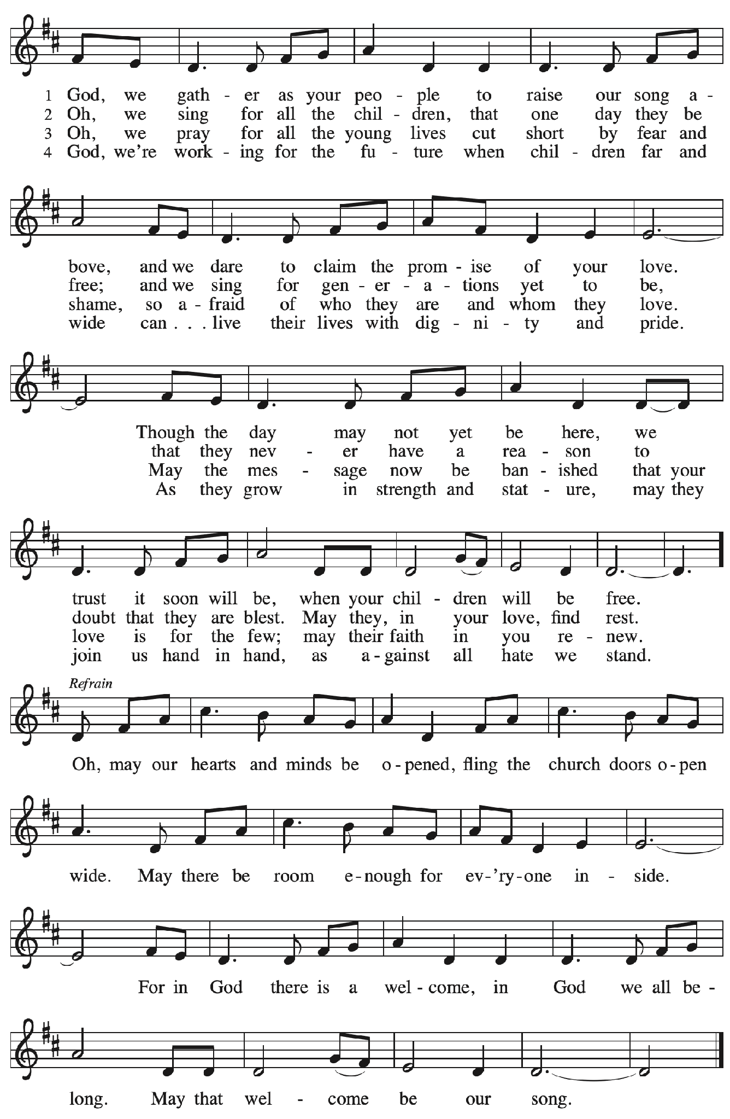
Greeting

P: The grace of our Lord Jesus Christ, the love of God,
and the communion of the Holy Spirit be with you all.
C: And also with you.

Prayer of the Day

P: Let us pray.
God of all peoples, your arms reach out to embrace all those who call upon you.
Teach us as disciples of your Son to love the world with compassion and constancy,
that your name may be known throughout the earth, through Jesus Christ, our Savior and Lord.
C: Amen.

Please be seated.

Word
God speaks to us in Scripture reading, preaching, and song

First Reading – Isaiah 56: 1, 6-8

¹ Thus says the Lord:
Maintain justice, and do what is right,
for soon my salvation will come
and my deliverance be revealed.
⁶ And the foreigners who join themselves to the Lord,
to minister to him, to love the name of the Lord,
and to be the Lord’s servants,
all who keep the Sabbath and do not profane it
and hold fast my covenant—
⁷ these I will bring to my holy mountain
and make them joyful in my house of prayer;
their burnt offerings and their sacrifices
will be accepted on my altar,
for my house shall be called a house of prayer
for all peoples.
⁸ Thus says the Lord God,
who gathers the outcasts of Israel:
I will gather others to them
besides those already gathered.

L: Word of God, word of life.
C: Thanks be to God.

Psalm 67

The psalm will be read responsively, led by the cantor,
with the congregation responding with the verses in bold.

¹ May God be merciful to us and bless us;
may the light of God’s face shine upon us.
² Let your way be known upon earth,
your saving health among all nations.
³ Let the peoples praise you, O God;
let all the peoples praise you.
⁴ Let the nations be glad and sing for joy,
for you judge the peoples with equity and guide all the nations on earth.
⁵ Let the peoples praise you, O God;
let all the peoples praise you.
⁶ The earth has brought forth its increase;
God, our own God, has blessed us.
⁷ May God give us blessing,
and may all the ends of the earth stand in awe.

Second Reading – Romans 11: 1-2a, 29-32

[Paul writes:] ¹ I ask, then, has God rejected God’s people? By no means! I myself am an Israelite, a descendant of Abraham, a member of the tribe of Benjamin. ^{2a} God has not rejected God’s people whom God foreknew.
²⁹ For the gifts and the calling of God are irrevocable. ³⁰ Just as you were once disobedient to God but have now received mercy because of their disobedience, ³¹ so also they have now been disobedient in order that, by the mercy shown to you, they also may now receive mercy. ³² For God has imprisoned all in disobedience so that God may be merciful to all.
L: Word of God, word of life.
C: Thanks be to God.

Please rise as you are able.

Gospel Acclamation

C: Alleluia. Jesus preached the good news of the kingdom
and cured every sickness and disease. Alleluia.

Gospel – Matthew 15: 21-28

P: The holy Gospel according to St. Matthew.
C: Glory to you, O Lord.
²¹ Jesus left that place and went away to the district of Tyre and Sidon. ²² Just then a Canaanite woman from that region came out and started shouting, “Have mercy on me, Lord, Son of David; my daughter is tormented by a demon.” ²³ But he did not answer her at all. And his disciples came and urged him, saying, “Send her away, for she keeps shouting after us.” ²⁴ He answered, “I was sent only to the lost sheep of the house of Israel.” ²⁵ But she came and knelt before him, saying, “Lord, help me.” ²⁶ He answered, “It is not fair to take the children’s food and throw it to the dogs.” ²⁷ She said, “Yes, Lord, yet even the dogs eat the crumbs that fall from their masters’ table.” ²⁸ Then Jesus answered her, “Woman, great is your faith! Let it be done for you as you wish.” And her daughter was healed from that moment.

P: The Gospel of the Lord.
C: Praise to you, O Christ.

Please be seated.

Sermon

A time of silence for prayer and reflection follows the sermon.
When the hymn of the day begins, please rise as you are able.



Hymn of the Day There’s a Wideness in God’s Mercy ELW 588

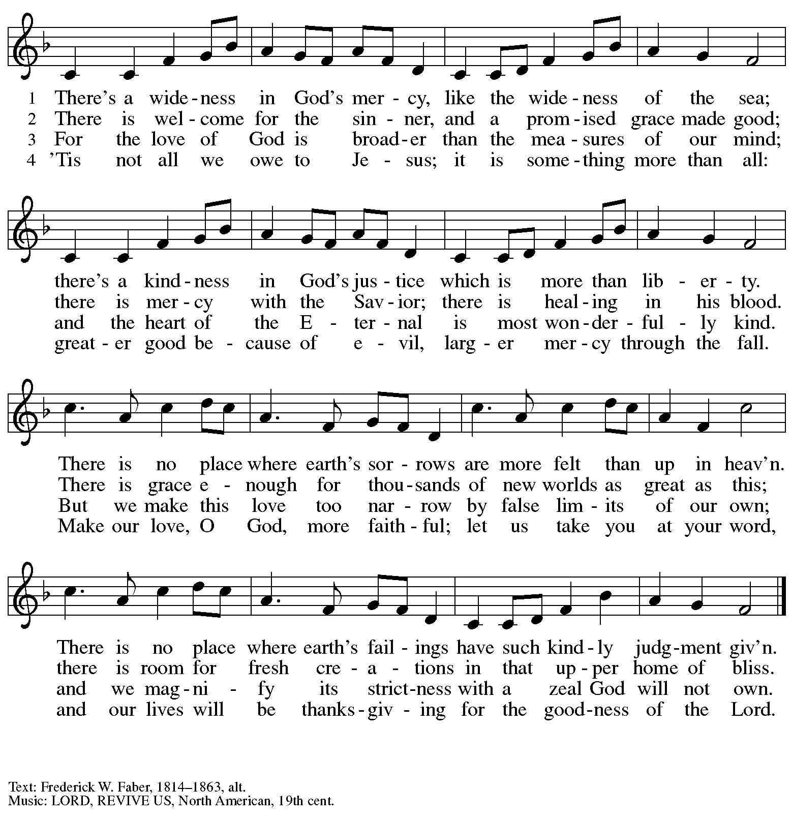

Prayers of the People

A: Trusting in God’s steadfast love for all God has made,
let us pray for the church, the world, and those who are in need.

After each petition
A: Gracious God,
C: receive our prayer.

The presiding minister concludes the prayers
P: Grateful for your abundant provision and trusting in your goodness, O God,
we commend into your care all for whom we pray, through the priceless grace of Jesus Christ.
C: Amen.

Peace

The presiding minister and the assembly greet one another in the peace of the risen Christ.
P: The peace of Christ be with you always.
C: And also with you.

The people may greet those around them with a sign of Christ’s peace and may say
Peace be with you or similar words. Please be mindful that not everyone will be comfortable with sharing the peace, so please seek consent before shaking hands or hugging. Other possible ways to share the peace include a simple bow with the verbal greeting of peace, or simply a verbal expression of peace. When the greetings of peace have concluded, please be seated.

Meal
God feeds us with the presence of Jesus Christ

Offering

We offer ourselves, our gifts, and our faithful service to God.
As the offering is gathered for the mission of the church, including the care of those in need,
the table is set for Holy Communion.

There are laminated giving cards in the pew racks that feature a QR code for anyone who would like to give online. Those who give using the QR code, as well as those who give regularly online or through their bank are encouraged to place the laminated card in the plate as an expression of your offering.

Noisy Offering

St. Andrew’s children lead the congregation in a special offering. As they carry buckets around the sanctuary, people of the congregation are invited to throw in their change as an offering.
This month’s offering will benefit Lutheran Disaster Response. They provide care for affected people and leaders who respond, assist communities holistically, aid in infrastructure and preparedness planning, and provide long-term recovery by addressing unmet needs months or years after a disaster strikes. You can learn more about them here: https://www.elca.org/how-we-serve/relief-and-development/lutheran-disaster-response.

Music during the Offering Do Lord arr. Edstrom

Offertory Song God, Whose Farm Is All Creation ELW 734
v. 1, 3

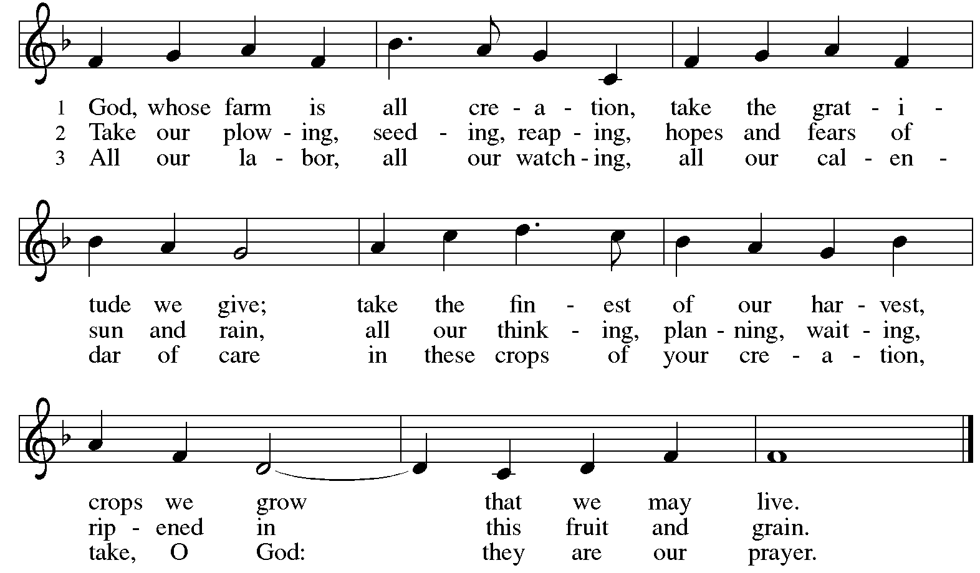
All rights reserved. Reprinted with permission under OneLicense.net # A-722139.

As the gifts are brought forward for presentation, please rise as you are able.

Offertory Prayer

A: Let us pray. God of all creation,
C: all you have made is good, and your love endures forever.
You bring forth bread from the earth and fruit from the vine.
Nourish us with these gifts, that we might be for the world
signs of your gracious presence in Jesus Christ, our Savior and Lord.
Amen.

Dialogue

P: The Lord be with you.
C: And also with you.

P: Lift up your hearts.
C: We lift them to the Lord.

P: Let us give thanks to the Lord our God.
C: It is right to give our thanks and praise.

Preface (Spoken by the presiding minister)

P: It is indeed right, our duty and our joy …
… we praise your name and join their unending hymn:

Sanctus

C: Holy, holy, holy Lord,
God of power and might,
heaven and earth are full of your glory.
Hosanna in the highest.
Blessed is the one who comes in the name of the Lord.
Hosanna in the highest.

Eucharistic Prayer

P: Holy, mighty, and merciful Lord …
… be all honor and glory, now and forever.
C: Amen.

Lord’s Prayer

P: Gathered as one by the Holy Spirit, we pray as Jesus taught us.
C: Our Father in heaven,
hallowed be your name,
your kingdom come,
your will be done,
on earth as in heaven.
Give us today our daily bread.
Forgive us our sins,
as we forgive those who sin against us;
Save us from the time of trial,
and deliver us from evil.
For the kingdom, the power,
and the glory are yours,
now and ever. Amen.

Fraction and Invitation

Agnus Dei / Lamb of God

C: Lamb of God, you take away the sin of the world; have mercy on us.
Lamb of God, you take away the sin of the world; have mercy on us.
Lamb of God, you take away the sin of the world; grant us peace.



Please be seated.

Holy Communion

- All who seek God and desire a deeper and stronger life in Christ are welcome to receive Holy Communion.
- Worshipers from the pulpit side will proceed forward first, followed by the center section, and then the lectern side.
- Please inform an usher if you would like the ministers to bring Communion to you.
- Holy Communion will be served with bread and wine (red) or grape juice (white).
- The presiding minister will first distribute the bread (host) to each communicant. Please indicate if you require a gluten-free host.
- Once you have consumed the bread, please pick up an empty glass from the tray next to the presiding minister. The Communion Assistant will pour wine or grape juice into your glass.
- Please step to the side to consume the wine or grape juice.
- Feel free to kneel at the altar rail for prayer after receiving the sacrament.
- As you return to your pew, glasses may be returned to the empty tray on the side of the center section.
- A blessing will be provided for anyone who does not yet receive the sacrament.
- All are invited to join in singing the hymns during Holy Communion.

Hymns during Holy Communion
In Christ There Is No East or West ELW 650

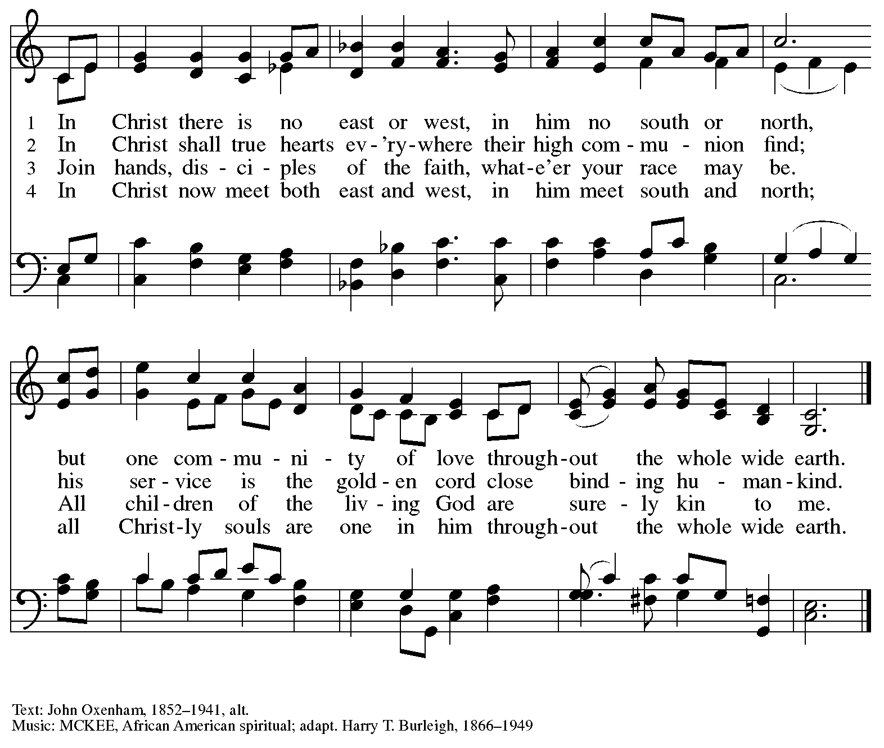

Hymns during Holy Communion
Oh, Praise the Gracious Power ELW 651

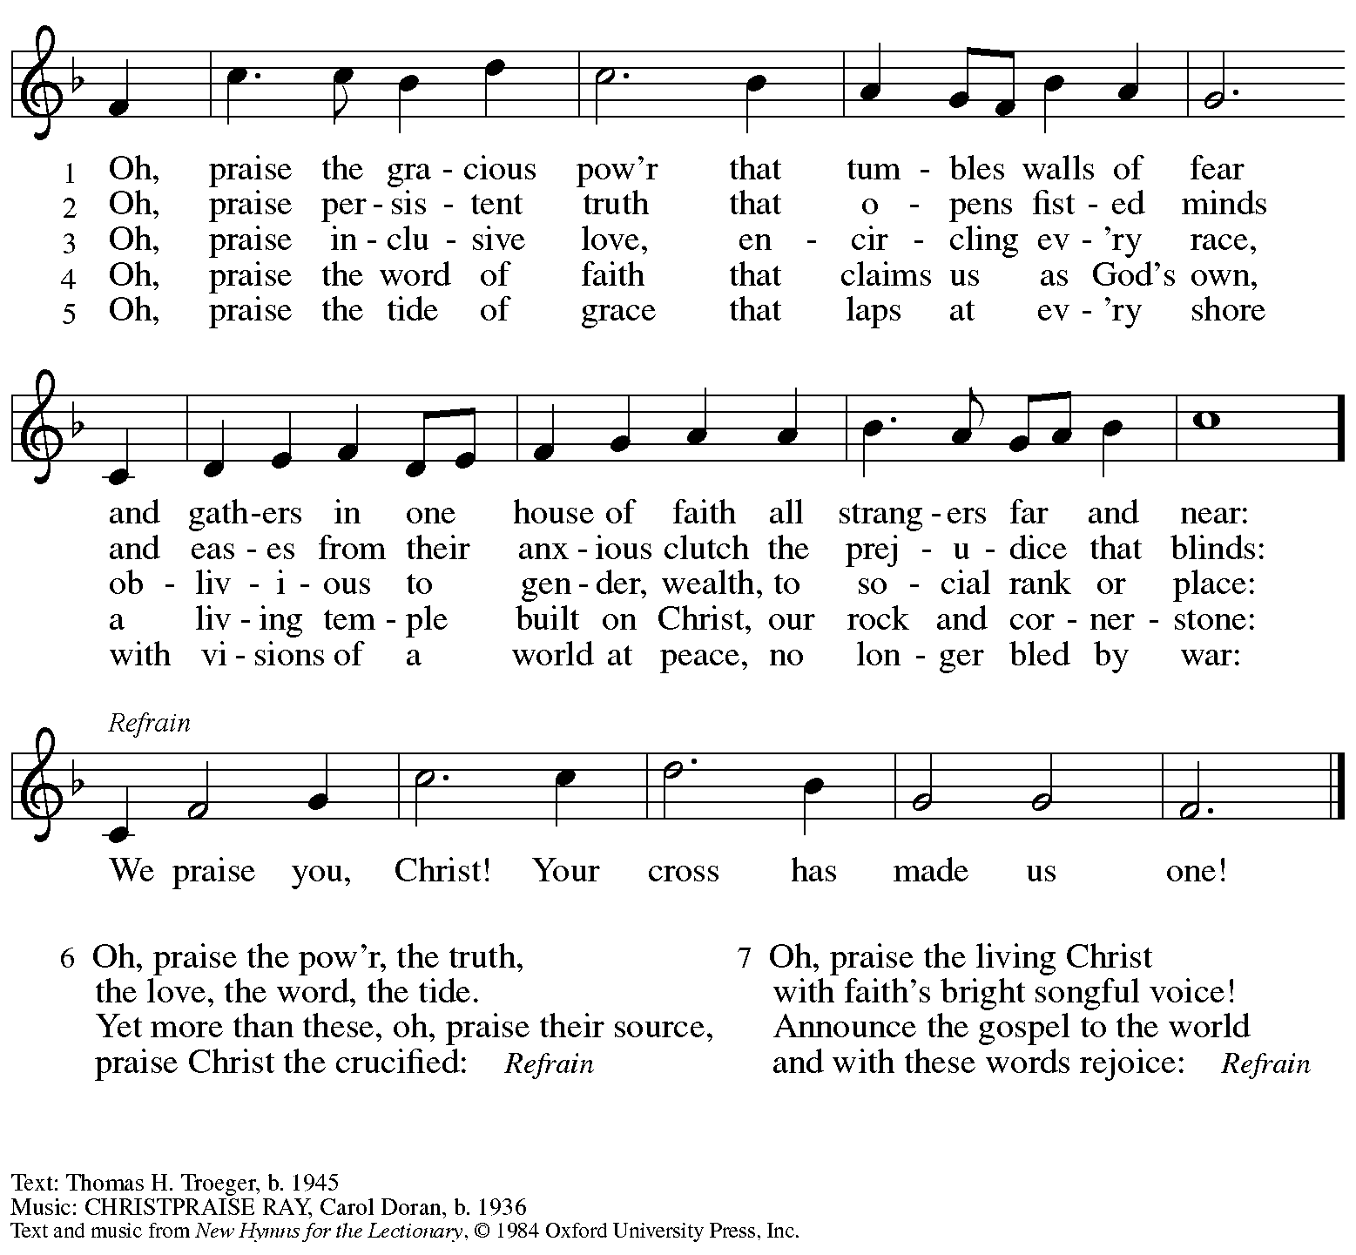
All rights reserved. Reprinted with permission under OneLicense.net # A-722139.

Hymns during Holy Communion
Build a Longer Table ACS 1062

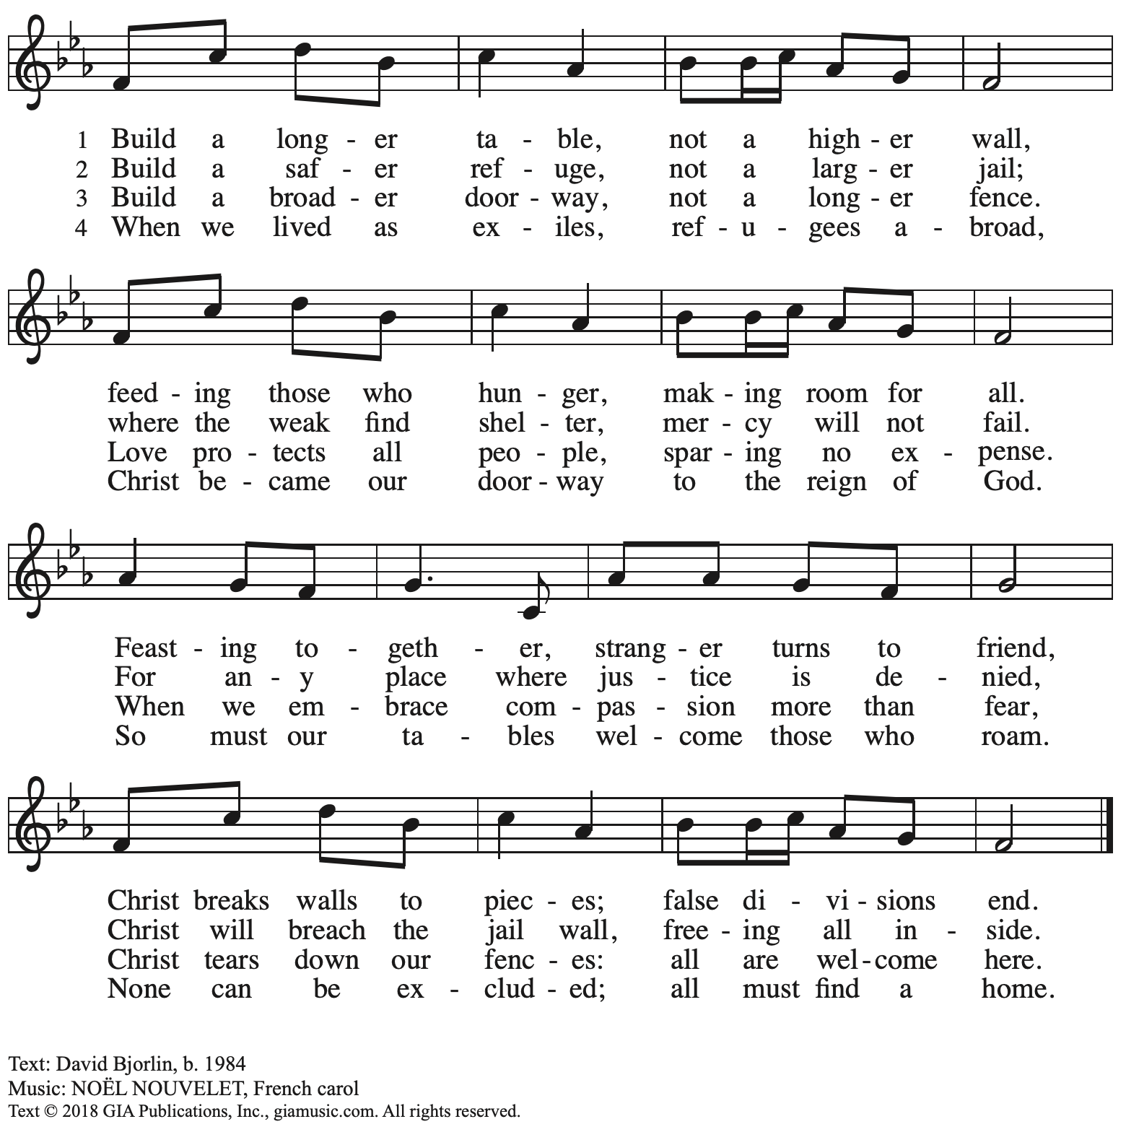
Reprinted with permission under OneLicense.net # A-722139.

When all have returned to their places, please rise as you are able.

Blessing

P: The body and blood of our Lord Jesus Christ strengthen you and keep you in his grace.
C: Amen.

Prayer

A: Let us pray.
We give you thanks, almighty God, that you have refreshed us
through the healing power of this gift of life.
In your mercy, strengthen us through this gift,
in faith toward you and in fervent love toward one another;
for the sake of Jesus Christ our Lord
C: Amen.

Please be seated.

Sending
God blesses us and sends us in mission to the world

Announcements

Please rise as you are able.

Benediction

P: The Lord bless you and keep you.
The Lord’s face shine on you with grace and mercy.
The Lord look upon you with favor and ☩ give you peace.
C: Amen.

Sending Hymn Following Page

Dismissal

A: Go in peace. Serve the Lord.
C: Thanks be to God!

Postlude

Sending Hymn Praise the One Who Breaks the Darkness ELW 843

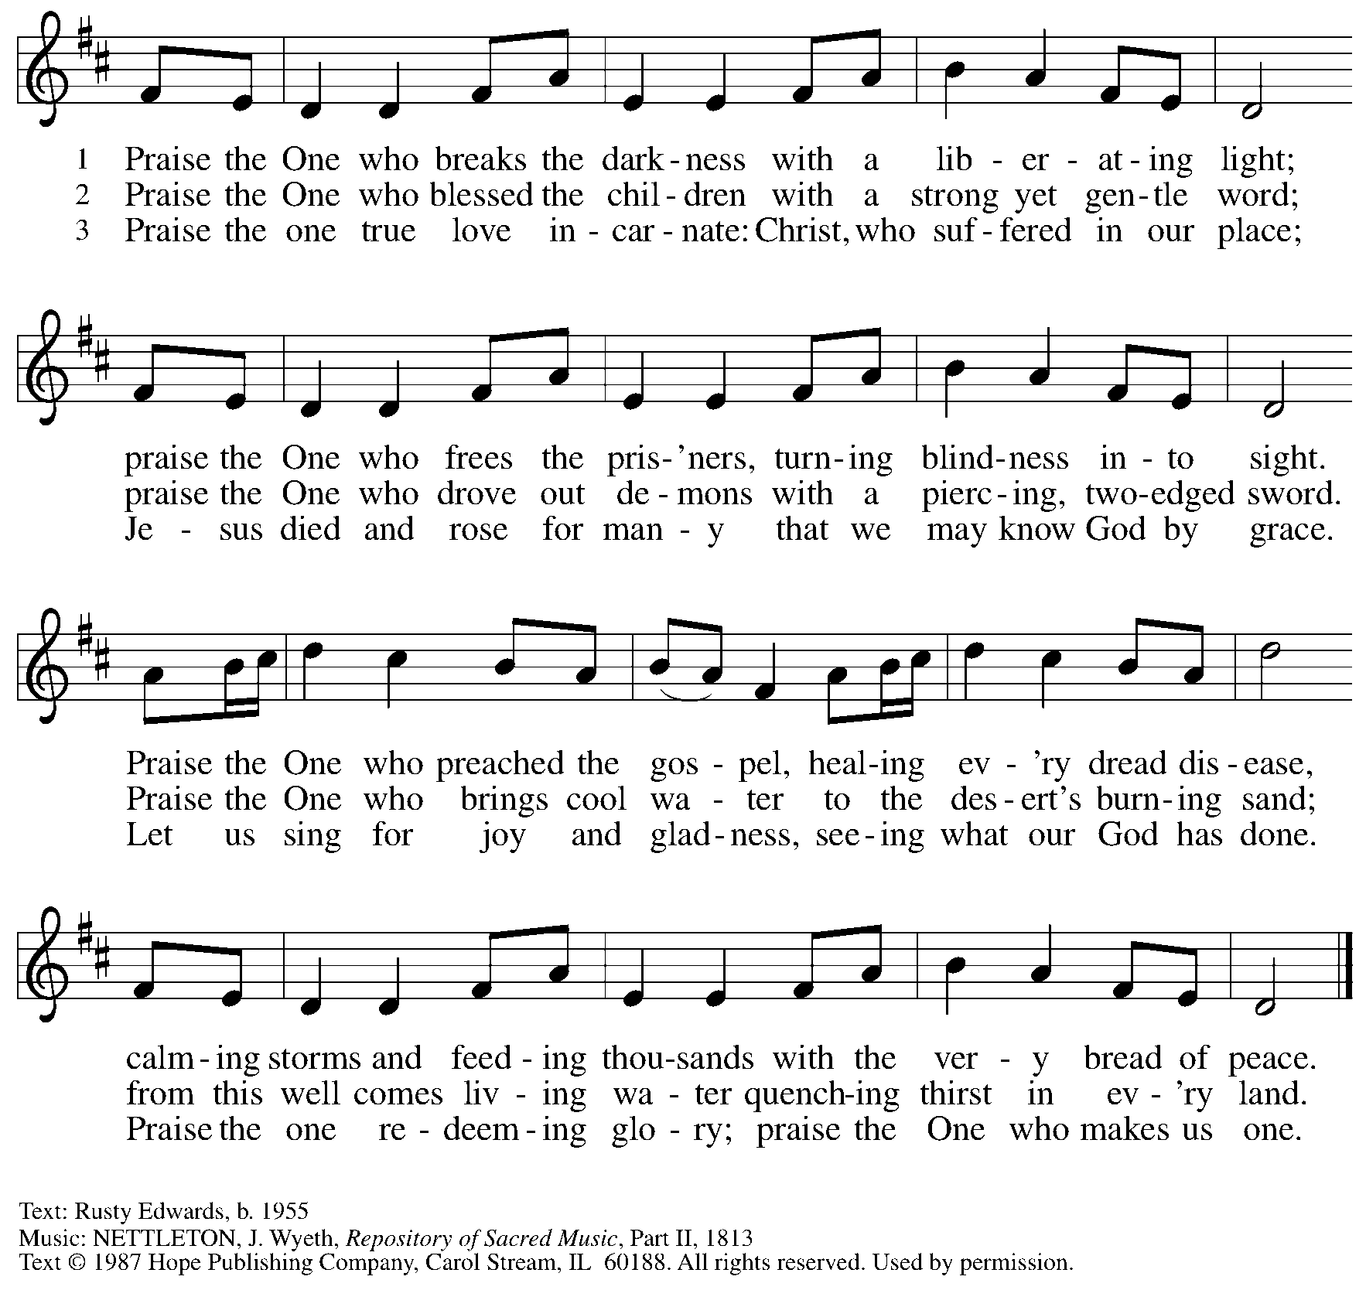
Reprinted under OneLicense.net # A-722139.

Those serving in worship today

Altar Care Beverley Chapman
Assisting Minister Jeff Denlinger
Audio-Visual Ministers Jered Stratton
Jason Galyardt
Cantor David Rollinson
Lector Brennan Coleman
Organ Jimmi Kocher-Hillmer
Minister of Music Laura Reynolds
Presiding Minister The Rev. Ross I. Carmichael

Liturgy and Hymnody Acknowledgements

From SundaysandSeasons.com. Copyright © 2026 Augsburg Fortress. All rights reserved. Reprinted under OneLicense.net # A-722139.
Used by permission of Augsburg Fortress.

Liturgical material reprinted with permission under Augsburg Fortress Liturgies Annual License SB124976.

The Scripture readings contained herein are from New Revised Standard Version Updated Edition of the Bible © 2021 National Council of Churches of Christ in the United States of America. Used by permission. All rights reserved worldwide.

God, We Gather as Your People – Text: David Lohman, b. 1961. Music: WELCOME BE OUR SONG, David Lohman. Text and music © 2007, Welcome Song Music, admin. Augsburg Fortress. All rights reserved. Reprinted with permission under OneLicense.net # A-722139.

Please use the QR code below to link to St. Andrew’s Announcements online!



St. Andrew Lutheran Church Announcements
August 16th, 2026

- Welcome to Worship at St. Andrew on the Twelfth Sunday after Pentecost – We are so glad you are here, and we offer a special welcome to all visitors and guests who are here for the first time! There are worship “toolkits” to help children engage with worship and “busy bags” for younger children available in the bookcase at the back of the sanctuary. Please feel free to take one to use with/for your children. A nursery is available through the door to the left of the worship space and across the social hall (look for a purple room).
- Noisy Offering Today During Worship – On the third Sunday of each month, St. Andrew’s children lead the congregation in a Noisy Offering, in which people are invited to throw their change into buckets that the children carry around the church and bring forward as an additional offering. Each month’s Noisy Offering supports a local, national, or international church-related or otherwise charitable organization. This month’s offering will benefit Lutheran Disaster Response. They provide care for affected people and leaders who respond, assist communities holistically, aid in infrastructure and preparedness planning, and provide long-term recovery by addressing unmet needs months or years after a disaster strikes. You can learn more about them here: https://www.elca.org/how-we-serve/relief-and-development/lutheran-disaster-response.
- Produce Distribution Supplemental Food of the Month – St. Andrew is collecting supplemental food each month to accompany our produce distribution. For August, we ask for donations of dried beans. There are collection boxes at the back of the worship space and in the social hall.
- Produce Distribution, First and Third Tuesday Each Month, August 18th from 5:30 to 6:30 p.m. – St. Andrew partners with Greater Pittsburgh Community Food Bank to serve as a distribution site for fresh produce on the first and third Tuesday of every month. We invite people of the congregation to help with the distribution from 5:30 p.m. to 6:30 p.m. and/or to help with unloading and setup during the day between 10:00 a.m. and 1:00 p.m.
- Blessing of Teachers and Blessing of Backpacks, Next Sunday, August 23rd, during Worship – As a new school year begins and we prepare for another year of Christian education for the children and youth of St. Andrew, we pray for God's blessings upon all participating in the vocations of education. Teachers and educators, along with Little Church - Big Faith leaders will be invited to come forward to receive a blessing. We also invite students, children, and youth to bring a backpack or other item representative of their studies as they receive a blessing, as well.
- Worship Committee Meeting, Sunday, August 23rd, after Worship – The worship committee meets regularly to organize and plan upcoming services for the congregation. We invite anyone interested in participating or learning more to speak with council liaison Miriam Bohlmann Kunz (worship@standrewpittsburgh.org) or Pastor Ross.
- Bread of Life Feeding Ministry at Bethel-Trinity, Thursday, August 27th from 5:00 p.m. to 7:00 p.m. – This food and clothing giveaway marks the start of a monthly donation effort for Bethel AME Church as their new community food pantry opens its doors free of charge. Help is needed in sorting donations on August 25th and 26th and carrying, greeting, and handing out items on the 27th. Please call 412-683-2160 with any questions or to volunteer.
- Help Move Furniture for Food Pantry and Little Church - Big Faith, Sunday, August 30th, after Worship – St. Andrew has received a grant to purchase a new industrial-sized refrigerator as we grow our ministry to address hunger in our local communities. Little Church - Big Faith and its supplies will be moving to an upstairs classroom, and we are asking for help from people who can carry large/heavy items upstairs after worship on Sunday, August 30th. Thank you for your support as we make adjustments to better facilitate our current ministries!
- AVP Basic Workshop, September 12th and 19th, 9:00 a.m. - 8:00 p.m. – Please plan to arrive on time as each part of the workshop builds upon the previous one. Your presence from the start ensures a smooth group learning experience and helps you get the most out of the workshop. Open to teens and adults. This workshop is organized by AVP Pittsburgh and Friends Peace Teams. We are requesting donations of hot food for the workshop as well. Vegan soups are usually a good option. If you wish to donate hot food, please reach out to Pastor Ross at pastorrcarmichael@gmail.com. You can register for the workshop here: https://docs.google.com/forms/d/e/1FAIpQLSfW_fVUD_bkgcd4K1e9Q-t5fz-rW1mTF72C7pcAmTwfYiH50A/viewform. Be on the lookout for the upcoming AVP Advanced workshop, November 6th - 8th!
- ELCA Podcast on Reconsideration of Social Statement – The task force leading the ELCA in the reconsideration of one section of the social statement Human Sexuality: Gift and Trust is excited to share an important opportunity for you to engage with this summer. The task force is releasing a podcast called Learn and Discern as an educational tool as we journey together through the reconsideration process. The podcast’s episodes will explore the following topics: A history of the ELCA’s social teachings and ministry policy on human sexuality; The nuances of Lutheran theological ethics; A deeper look at the history of the Lutheran understanding of “the bound conscience;” The sources of agreement and disagreement on human sexuality in the church; and Lutheran approaches to faithful conversation. This five-episode podcast is a companion to the study “Conscience and Conversation.” Individual episodes are available in audio and video at elca.org/reconsiderations.
- Coffee Hour Signups – Coffee hour returns in September! St. Andrew provides hospitality during a coffee hour after worship each Sunday. If you would like to participate and would like information about the duties of setting up, please sign up using the following form: https://www.signupgenius.com/go/5080B4AAFAF2CABF85-47069030-coffee#/.

