

+ Thirteenth Sunday after Pentecost
August 23, 2026


St. Andrew Lutheran Church
304 Morewood Ave.
Pittsburgh, PA 15213
St_andrewELCA@verizon.net
www.standrewpittsburgh.org

+ Thirteenth Sunday after Pentecost

In Isaiah the people are advised to look to their spiritual ancestors as the rock from which they were hewn. Jesus declares that the church will be built on the rock of Peter’s bold confession of faith. God’s word of reconciliation and God’s mercy are keys to the church’s mission. Paul urges us to not be conformed to this world but to offer our bodies as a living sacrifice, using our individual gifts to build up the body of Christ. From the table we go forth to offer our spiritual worship through word and deed.

Welcome to St. Andrew!
- St. Andrew welcomes all who are seeking a place of healing, wholeness, and acceptance in a nurturing and faith-forming spiritual home. We are striving toward racial equity worldwide
and we seek to honor the lived experience of all individuals regardless of background. Our community embraces people of all ages, ethnicities, cultures, abilities, sexual orientations,
gender identities and expressions, and family constellations. Come and See!
- Worship Services are live-streamed to multiple online platforms. By attending worship, you agree that your image and voice may be broadcast.
- Everyone is invited to make a name tag at the black bookcase in the back of the worship space if they would like. There are stickers indicating pronouns on the bookcase if you would like to include them on your name tag.
- Little Church – Big Faith is on break for the summer.
- A nursery is available through the doors at the left side of the sanctuary and across from the doorway to the Social Hall. Look for a purple-colored room.
- Worship “toolkits” to help children engage with the service, along with “busy bags” for younger children, are available in the bookcase at the back of the sanctuary. Please feel free to take one to use with/for your children.
- Holy Communion is served with bread (gluten-free available) and wine or grape juice. The presiding minister will distribute the bread (host). Please consume this and then pick up an empty glass from the tray. The Communion Assistant will pour wine or grape juice into your glass. Please step to the side to consume the wine or grape juice. Feel free to kneel at the altar for prayer and reflection. As you return to your pew, glasses may be returned to the empty trays on either side of the center section.
- A restroom is available on the main level of the church, through the doors to the Social Hall and to the right in the main office.

Abbreviations
P: Pastor/Presiding Minister ELW: Evangelical Lutheran Worship hymnal
A: Assisting Minister ACS: All Creation Sings hymnal
L: Lector HS: Hymnal Supplement
C: Congregation
Musical Offering

Each week, different people from the congregation make an offering of pre-service music, with singing or instrumentation, to help the assembly focus and pray in preparation for worship.

Welcome
Prelude

Gathering
The Holy Spirit calls us together as the people of God

Please rise as you are able. All may make the sign of the cross,
the sign that is marked at Baptism, as the presiding minister begins.

Confession and Forgiveness

P: Blessed be the ☩ holy Trinity,
one God, whose compassion endures forever.
C: Amen.

P: If we say we have no sin, we deceive ourselves and the truth is not us.
Let us confess our sin to God who is faithful and just,
and who has promised to forgive sin and cleanse us from all unrighteousness.

Silence is kept for reflection.

P: Most merciful God,
C: we confess to you that we have sinned against you in thought, word, and deed,
by what we have done and by what we have left undone.
We have not trusted you with our whole heart;
we have not loved one another in deed and in truth.
In your compassion, forgive our sin and so uphold us by your Spirit
that we may live and serve you in newness of life,
through Jesus Christ, our light and our truth.
Amen.

P: With joy I proclaim to you that Almighty God,
rich in mercy, abundant in love,
forgives you all your sin and grants you newness of life
☩ in Jesus Christ.
C: Amen. Thanks be to God!

Gathering Hymn Dearest Jesus, at Your Word ELW 520

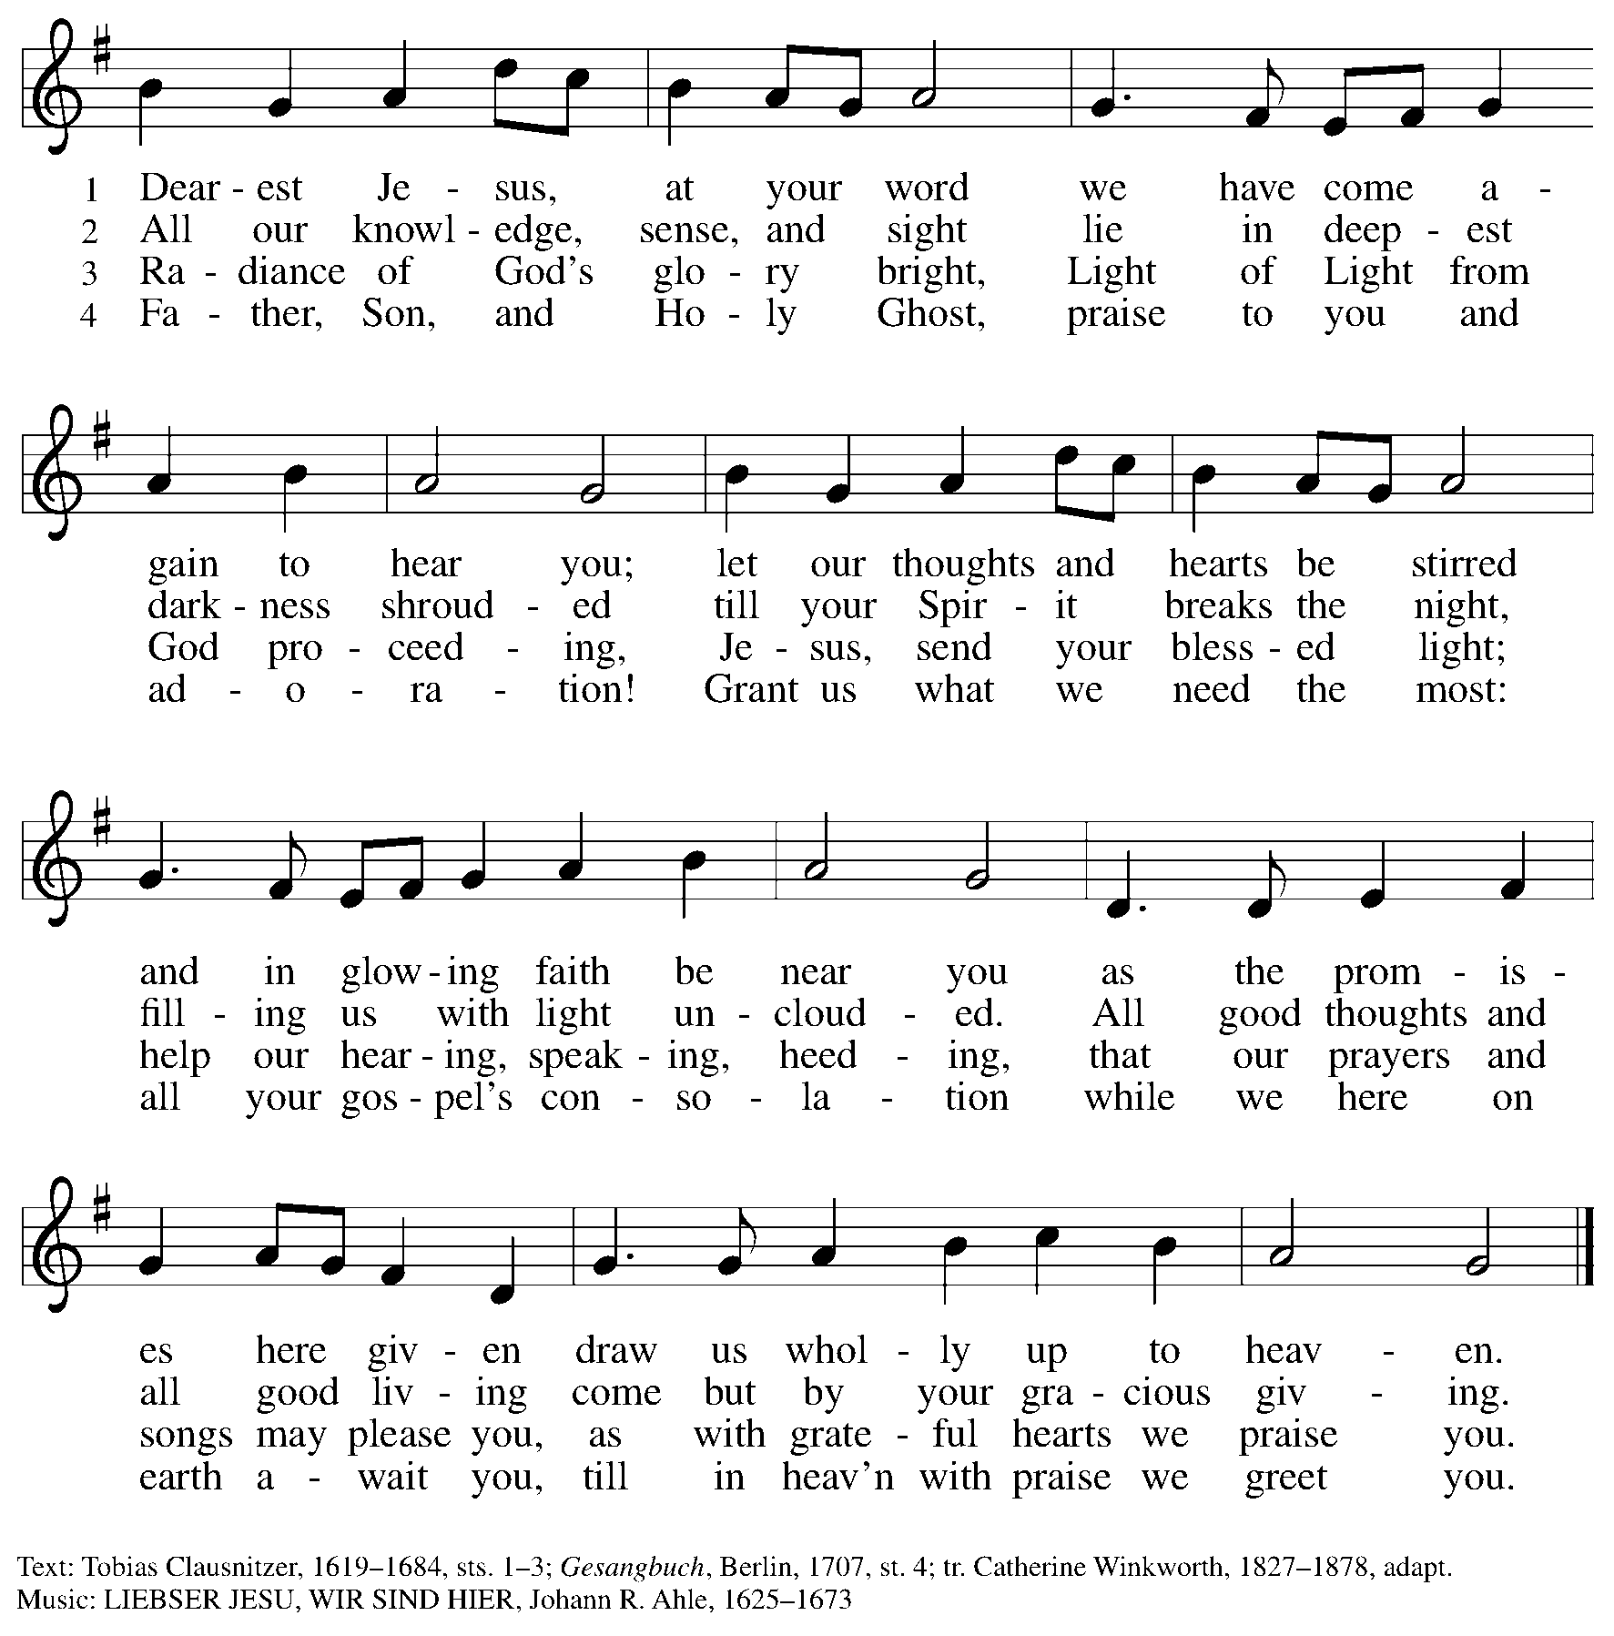

Greeting

P: The grace of our Lord Jesus Christ, the love of God,
and the communion of the Holy Spirit be with you all.
C: And also with you.

Hymn of Praise Glory to God HS p. 6-7

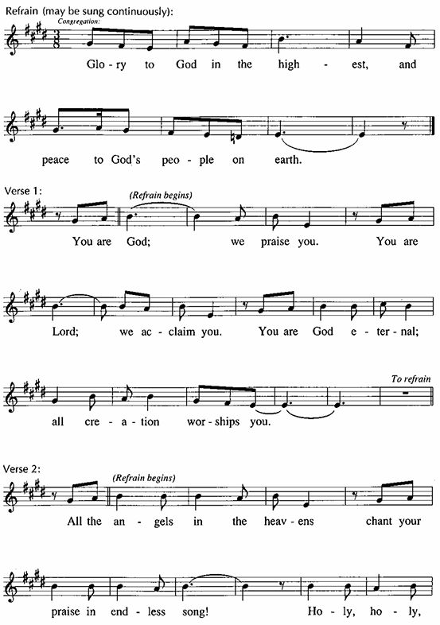

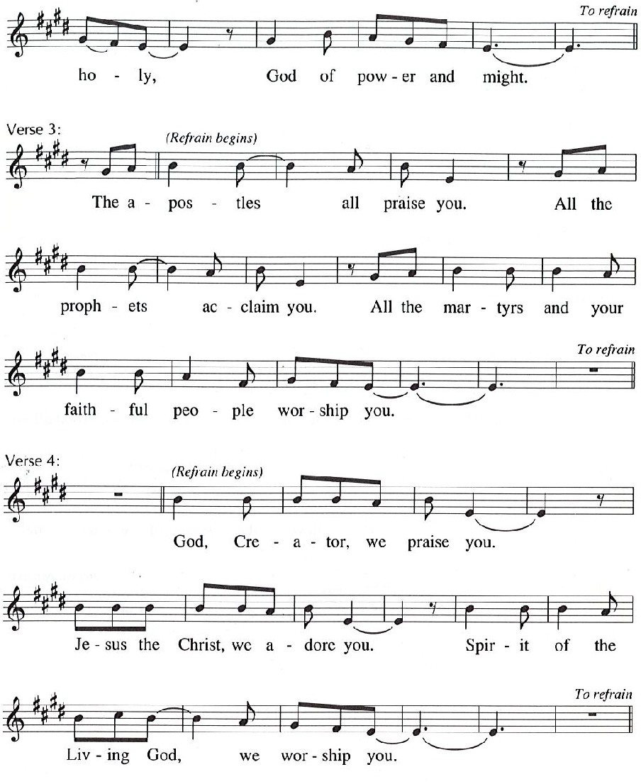

Prayer of the Day
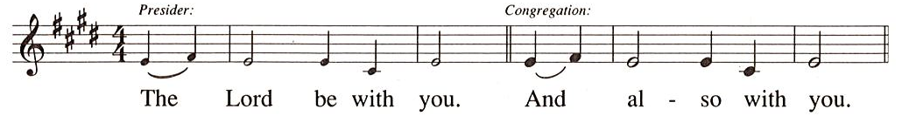
P: Let us pray.
O God, with all your faithful followers of every age, we praise you, the rock of our life.
Be our strong foundation and form us into the body of your Son,
that we may gladly minister to all the world, through Jesus Christ, our Savior and Lord.
C: Amen.

Please be seated.

Word
God speaks to us in Scripture reading, preaching, and song

First Reading – Isaiah 51: 1-6

¹ Listen to me, you who pursue righteousness,
you who seek the Lord.
Look to the rock from which you were hewn
and to the quarry from which you were dug.
² Look to Abraham your father
and to Sarah, who bore you,
for he was but one when I called him,
but I blessed him and made him many.
³ For the Lord will comfort Zion;
the Lord will comfort all her waste places
and will make her wilderness like Eden,
her desert like the garden of the Lord;
joy and gladness will be found in her,
thanksgiving and the voice of song.
⁴ Listen to me, my people,
and give heed to me, my nation,
for a teaching will go out from me
and my justice for a light to the peoples.
⁵ I will bring near my deliverance swiftly;
my salvation has gone out,
and my arms will rule the peoples;
the coastlands wait for me,
and for my arm they hope.
⁶ Lift up your eyes to the heavens
and look at the earth beneath,
for the heavens will vanish like smoke,
the earth will wear out like a garment,
and those who live on it will die like gnats,
but my salvation will be forever,
and my deliverance will never be ended.

L: Word of God, word of life.
C: Thanks be to God.

Psalm 138

The psalm will be read responsively, led by the cantor,
with the congregation responding with the verses in bold.

Psalm Tone

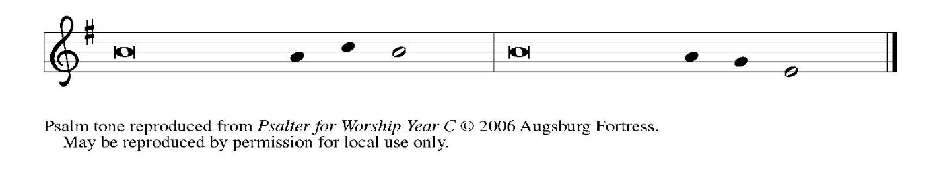

Psalm Refrain

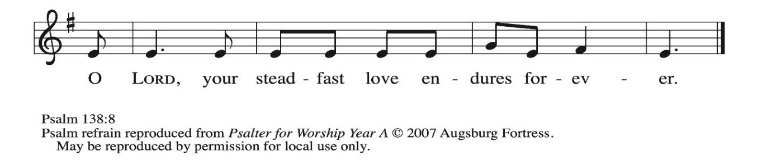

¹ I will give thanks to you, O Lord, with | my whole heart;
before the gods I will | sing your praise.
² I will bow down toward your holy temple and praise your name, because of your steadfast | love and faithfulness;
for you have glorified your name and your word a- | bove all things.
³ When I called, you | answered me;
you increased my | strength within me.
⁴ All the rulers of the earth will praise | you, O Lord,
when they have heard the words | of your mouth. R
⁵ They will sing of the ways | of the Lord,
that great is the glory | of the Lord.
⁶ The Lord is high, yet cares | for the lowly,
perceiving the haughty | from afar.
⁷ Though I walk in the midst of trouble, you | keep me safe;
you stretch forth your hand against the fury of my enemies; your right | hand shall save me.
⁸ You will make good your pur- | pose for me;
O Lord, your steadfast love endures forever; do not abandon the works | of your hands. R

Second Reading – Romans 12: 1-8

¹ I appeal to you, therefore, kindred, on the basis of God’s mercy, to present your bodies as a living sacrifice, holy and acceptable to God, which is your reasonable act of worship. ² Do not be conformed to this age, but be transformed by the renewing of the mind, so that you may discern what is the will of God—what is good and acceptable and perfect.
³ For by the grace given to me I say to everyone among you not to think of yourself more highly than you ought to think but to think with sober judgment, each according to the measure of faith that God has assigned. ⁴ For as in one body we have many members and not all the members have the same function, ⁵ so we, who are many, are one body in Christ, and individually we are members one of another. ⁶ We have gifts that differ according to the grace given to us: prophecy, in proportion to faith; ⁷ ministry, in ministering; the teacher, in teaching; ⁸ the encourager, in encouragement; the giver, in sincerity; the leader, in diligence; the compassionate, in cheerfulness.
L: Word of God, word of life.
C: Thanks be to God.

Please rise as you are able.

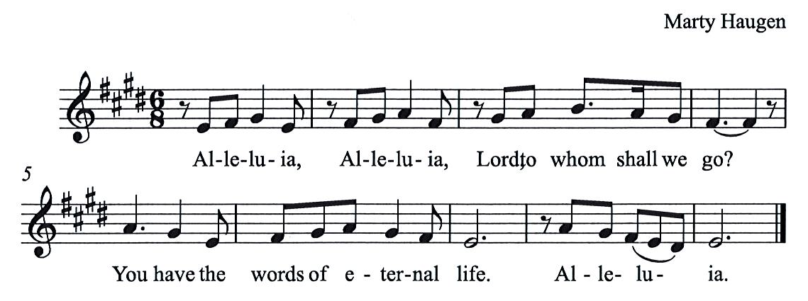
Gospel Acclamation HS p. 8

Gospel – Matthew 16: 13-20

P: The holy Gospel according to St. Matthew.
C: Glory to you, O Lord.

¹³ Now when Jesus came into the district of Caesarea Philippi, he asked his disciples, “Who do people say that the Son of Humanity is?” ¹⁴ And they said, “Some say John the Baptist but others Elijah and still others Jeremiah or one of the prophets.” ¹⁵ He said to them, “But who do you say that I am?” ¹⁶ Simon Peter answered, “You are the Messiah, the Son of the living God.” ¹⁷ And Jesus answered him, “Blessed are you, Simon son of Jonah! For flesh and blood has not revealed this to you but my Father in heaven. ¹⁸ And I tell you, you are Peter, and on this rock I will build my church, and the gates of Hades will not prevail against it. ¹⁹ I will give you the keys of the kingdom of heaven, and whatever you bind on earth will be bound in heaven, and whatever you loose on earth will be loosed in heaven.” ²⁰ Then he sternly ordered the disciples not to tell anyone that he was the Messiah.

P: The Gospel of the Lord.
C: Praise to you, O Christ.

Please be seated.

Sermon

A time of silence for prayer and reflection follows the sermon.
When the hymn of the day begins, please rise as you are able.



Hymn of the Day The Church’s One Foundation ELW 654

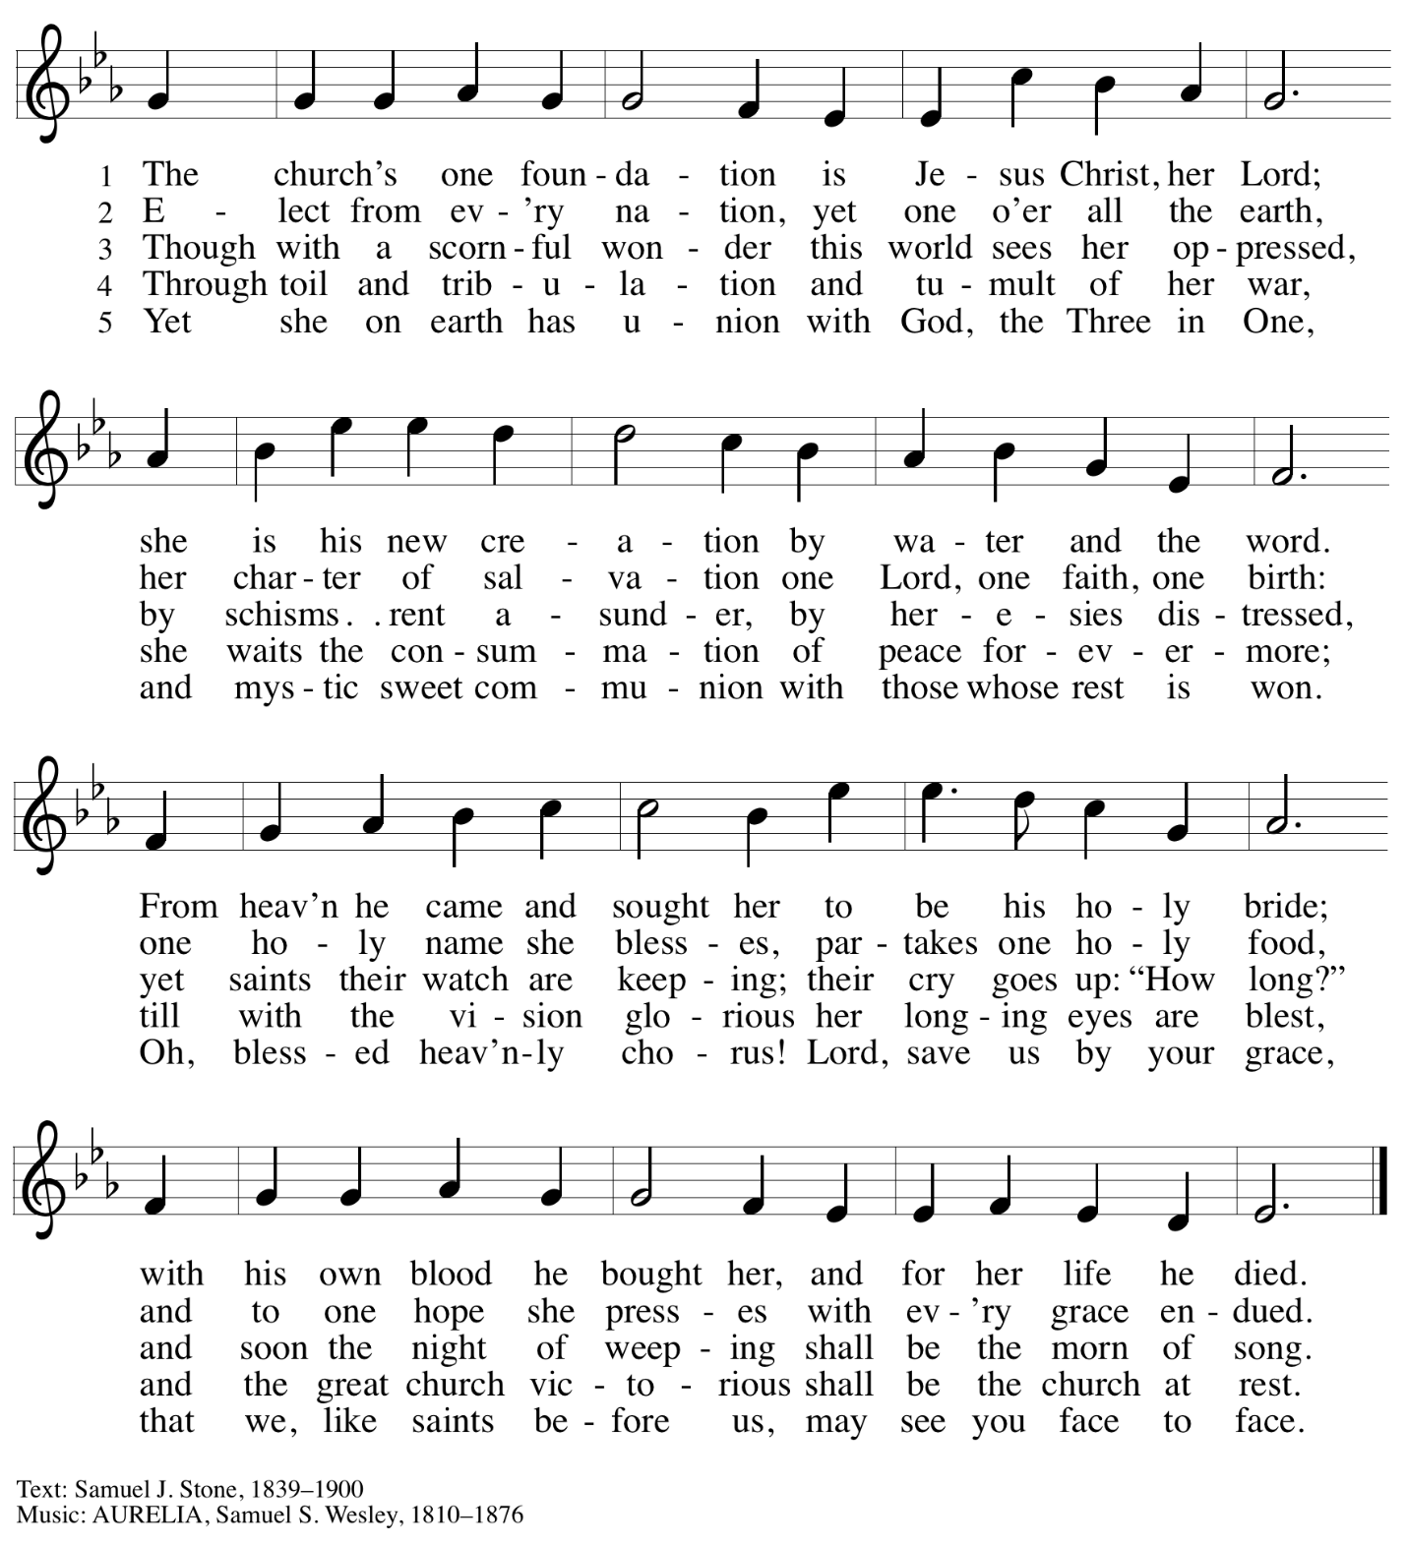

Sacrament of Holy Baptism

Presentation

Candidates for Baptism, sponsors, and parents gather with the ministers at the font.
The assembly is seated.

The presiding minister may address the assembly in these or similar words:
P: God, who is rich in mercy and love,
gives us a new birth into a living hope through the sacrament of Baptism. By water and the Word God delivers us from sin and death and raises us to new life in Jesus Christ. We are united with all the baptized in the one body of Christ, anointed with the gift of the Holy Spirit, and joined in God's mission for the life of the world.

Sponsors for each candidate, in turn, present the candidates:
I present name for Baptism.

The presiding minister addresses parents or others who bring for Baptism
children who are not able to answer for themselves:
P: Called by the Holy Spirit, trusting in the grace and love of God,
do you desire to have your child baptized into Christ?
Response: I do.

P: As you bring your child to receive the gift of Baptism,
you are entrusted with responsibilities:
to live with them among God's faithful people,
bring them to the word of God and the holy supper,
teach them the Lord's Prayer, the Creed, and the Ten Commandments,
place in their hands the holy scriptures,
and nurture them in faith and prayer,
so that your child may learn to trust God,
proclaim Christ through word and deed,
care for others and the world God made,
and work for justice and peace.
Do you promise to help your child grow in the Christian faith and life?
Response: I do.

The presiding minister addresses sponsors:
P: Sponsors, do you promise to nurture this person in the Christian faith
as you are empowered by God's Spirit,
and to help them live in the covenant of Baptism
and in communion with the church?
Response: I do.

The presiding minister addresses the assembly:
P: People of God, do you promise to support name/s and pray for them
in their new life in Christ?
C: We do.

Please rise as you are able.

Profession of Faith

The presiding minister addresses candidates for Baptism as well as the parents and sponsors
of young children. The assembly may join in the responses.

P: I ask you to profess your faith in Christ Jesus, reject sin,
and confess the faith of the church.

Do you renounce the devil and all the forces that defy God?
Response:
I renounce them.

P: Do you renounce the powers of this world that rebel against God?
Response:
I renounce them.

P: Do you renounce the ways of sin that draw you from God?
Response:
I renounce them.

P: Do you believe in God the Father?
C: I believe in God, the Father almighty,
creator of heaven and earth.

P: Do you believe in Jesus Christ, the Son of God?
C: I believe in Jesus Christ, God’s only Son, our Lord,
who was conceived by the Holy Spirit,
born of the virgin Mary,
suffered under Pontius Pilate,
was crucified, died, and was buried;
he descended to the dead.*
On the third day he rose again;
he ascended into heaven,
he is seated at the right hand of the Father,
and he will come to judge the living and the dead.

P: Do you believe in the Holy Spirit?
C: I believe in the Holy Spirit,
the holy catholic church,
the communion of saints,
the forgiveness of sins,
the resurrection of the body,
and the life everlasting. Amen.

*Or, “he descended into hell,” another translation of this text in widespread use.

Thanksgiving at the Font

Water may be poured into the font before or during the thanksgiving.
At the font, the presiding minister begins the thanksgiving:

P: The Lord be with you.
C: And also with you.

P: Let us give thanks to the Lord our God.
C: It is right to give our thanks and praise.

P: We give you thanks, O God,
for in the beginning your Spirit moved over the waters
and by your Word you created the world,
calling forth life in which you took delight.
Through the waters of the flood you delivered Noah and his family,
and through the sea you led your people Israel from slavery into freedom.
At the river your Son was baptized by John and anointed with the Holy Spirit.
By the baptism of Jesus' death and resurrection
you set us free from the power of sin and death and raise us up to live in you.
Pour out your Holy Spirit, the power of your living Word,
that those who are washed in the waters of Baptism may be given new life.
To you be given honor and praise through Jesus Christ our Lord,
in the unity of the Holy Spirit, now and forever.
C: Amen.

Baptism

The presiding minister baptizes each candidate. The candidate is immersed into the water,
or water is poured on the candidate's head, as the presiding minister says:

P: Name , I baptize you in the name of the Father,*

The candidate is immersed or water is poured on the candidate's head a second time:
and of the Son,

The candidate is immersed or water is poured on the candidate's head a third time:
and of the Holy Spirit.
C: Amen.

The baptismal party proceeds to the altar rail. The presiding minister continues:
P: Let us pray.
We give you thanks, O God, that through water and the Holy Spirit
you give your children new birth, cleanse them from sin,
and raise them to eternal life.

Laying both hands on the head of each of the newly baptized,
the minister prays for each:
P: Sustain name with the gift of your Holy Spirit:
the spirit of wisdom and understanding, the spirit of counsel and might,
the spirit of knowledge and the fear of the Lord, the spirit of joy in your presence,
both now and forever.
C: Amen.

The presiding minister marks the sign of the cross on the forehead of each of the baptized.
Oil prepared for this purpose may be used. As the sign of the cross is made, the minister says:
P: Name , child of God, you have been sealed by the Holy Spirit and marked with the cross of Christ forever.
C: Amen.

Welcome

A lighted candle may be given to each of the newly baptized
(to a sponsor of a young child) as a representative of the congregation says:
A: Let your light so shine before others
that they may see your good works
and glorify your Father in heaven.

The ministers and the baptismal group face the assembly.
A representative of the congregation leads the assembly in the welcome.
A: Let us welcome the newly baptized.
C: We welcome you into the body of Christ and into the mission we share:
join us in giving thanks and praise to God
and bearing God's creative and redeeming word to all the world.

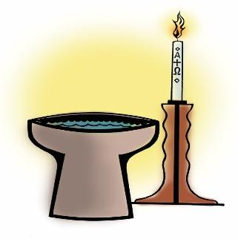
St. Andrew’s congregational refrain, sung on important occasions in the life of the congregation, is sung in celebration of the gift of Baptism.

Congregational Refrain

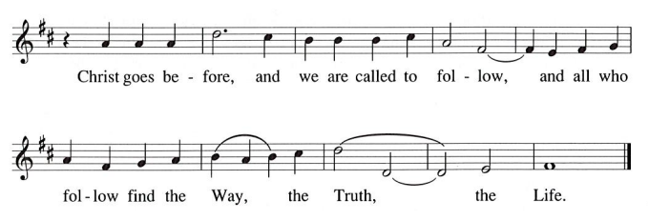

The congregation is invited to sing the baptismal hymn as our newly baptized sibling in Christ is introduced to and welcomed by the assembly.

Baptismal Hymn Baptized in Water ELW 456

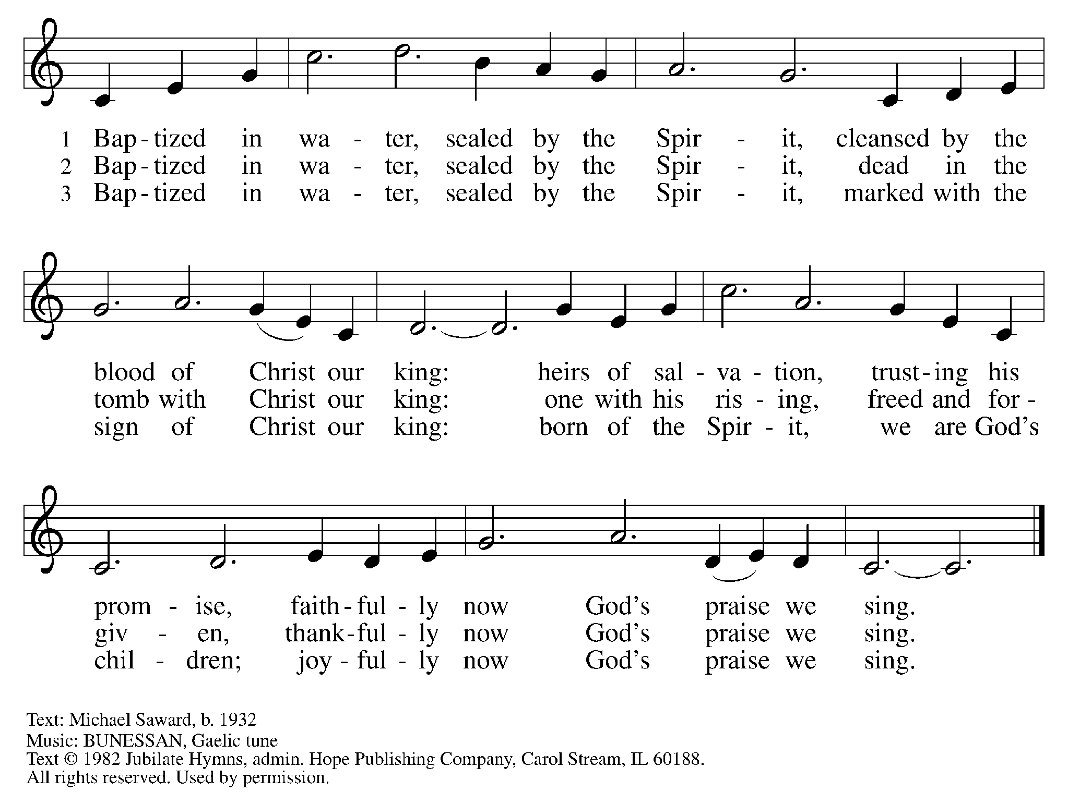
Reprinted under OneLicense.net # A-722139.

When all have returned to their places, worship continues with the prayers of the people.

Prayers of the People

A: Trusting in God’s steadfast love for all God has made,
let us pray for the church, the world, and those who are in need.

After each petition
A: Gracious God,
C: receive our prayer.

The presiding minister concludes the prayers
P: Grateful for your abundant provision and trusting in your goodness, O God,
we commend into your care all for whom we pray, through the priceless grace of Jesus Christ.
C: Amen.

Peace

The presiding minister and the assembly greet one another in the peace of the risen Christ.
P: The peace of Christ be with you always.
C: And also with you.

The people may greet those around them with a sign of Christ’s peace and may say
Peace be with you or similar words. Please be mindful that not everyone will be comfortable with sharing the peace, so please seek consent before shaking hands or hugging. Other possible ways to share the peace include a simple bow with the verbal greeting of peace, or simply a verbal expression of peace. When the greetings of peace have concluded, please be seated.

Meal
God feeds us with the presence of Jesus Christ

Offering

We offer ourselves, our gifts, and our faithful service to God.
As the offering is gathered for the mission of the church, including the care of those in need,
the table is set for Holy Communion.

There are laminated giving cards in the pew racks that feature a QR code for anyone who would like to give online. Those who give using the QR code, as well as those who give regularly online or through their bank are encouraged to place the laminated card in the plate as an expression of your offering.

Music during the Offering

As the gifts are brought forward for presentation, please rise as you are able.

Offertory Song As the Grains of Wheat ELW 465

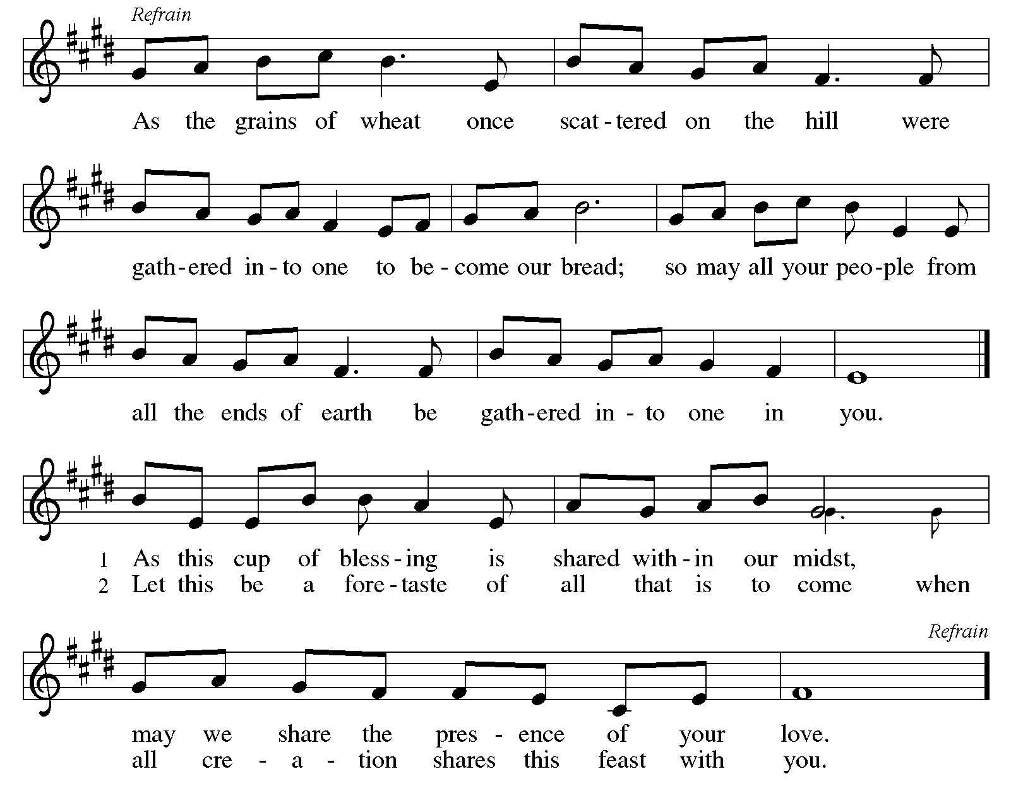

Offertory Prayer

A: Let us pray.
Merciful God,
C: everything in heaven and on earth belongs to you.
We joyfully release what you have entrusted to us.
May these gifts be signs of our whole lives returned to you,
dedicated to the healing and unity of all creation,
through Jesus Christ.
Amen.

Dialogue HS p. 14

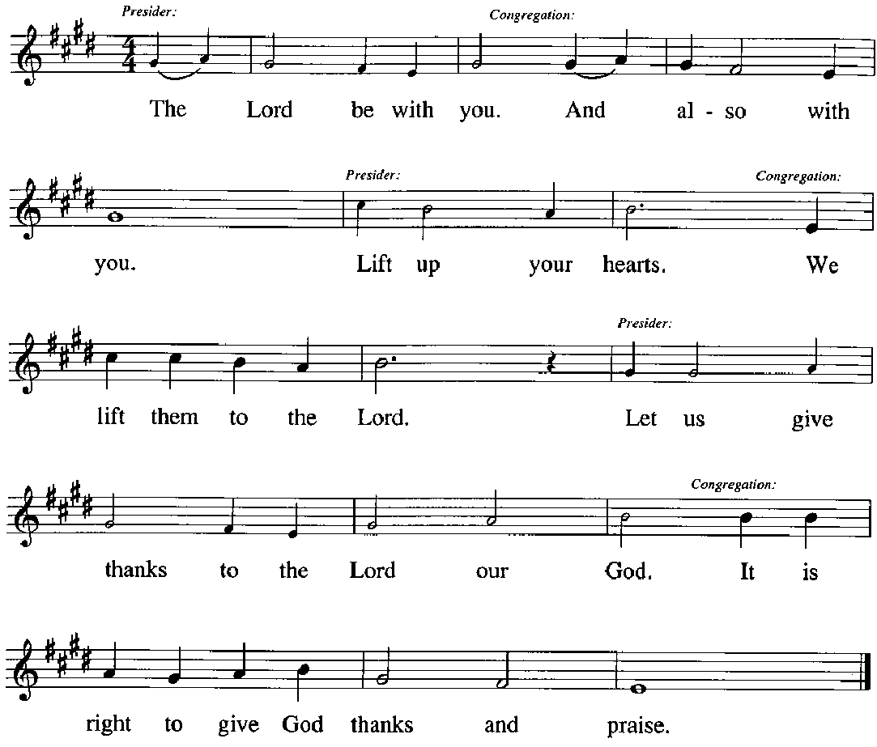

Preface (Sung by the presiding minister)

P: It is our duty and delight,
that we should everywhere and always
offer thanks and praise to you, O God,
through Jesus Christ,
who calls us to follow his way
of humble service and love,
and so with the church on earth,
all creation and the hosts of heaven,
we praise your name and join their unending hymn:

Sanctus HS p. 15

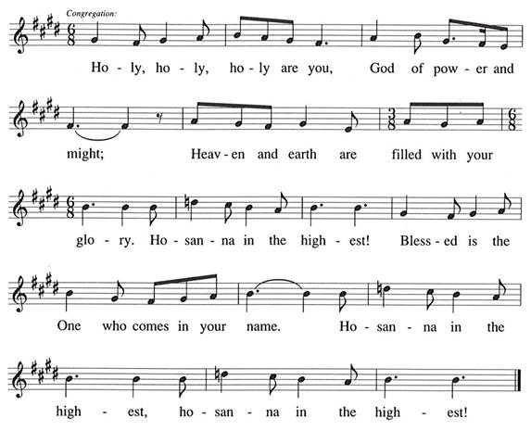

Eucharistic Prayer

P: You are indeed holy, gracious and merciful God …
… Do this for the remembrance of me.

Remembering his command to love one another,
his life and death, his resurrection and ascension,
we pray for his coming again, even as we cry:

(Sung by the presiding minister)
P: Amen. Come, Lord Jesus. Amen. Come, Lord Jesus.
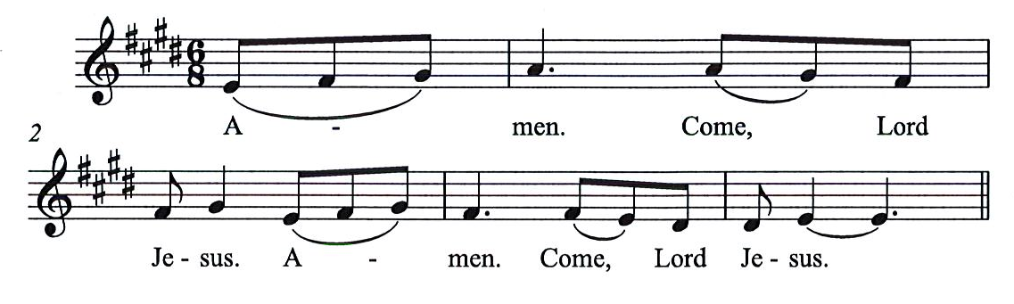
C:

P: Send now, we pray, your Holy Spirit,
that all of your promises
may come to us and your whole creation.

(Sung by the presiding minister)
P: Amen. Come Holy Spirit. Amen. Come, Holy Spirit.
C:
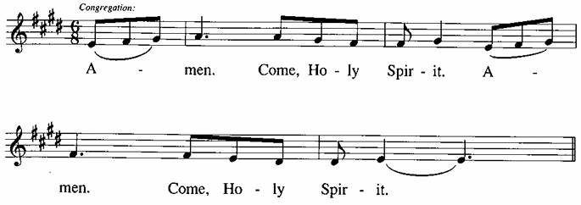

P: This we pray through Jesus Christ,
our Savor and our friend.
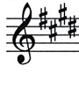
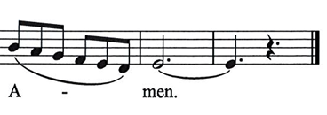
C:

Lord’s Prayer

P: Gathered as one by the Holy Spirit, we pray as Jesus taught us.
C: Our Father in heaven,
hallowed be your name,
your kingdom come,
your will be done,
on earth as in heaven.
Give us today our daily bread.
Forgive us our sins,
as we forgive those
who sin against us;
Save us from the time of trial,
and deliver us from evil.
For the kingdom, the power,
and the glory are yours,
now and ever. Amen.
Fraction and Invitation

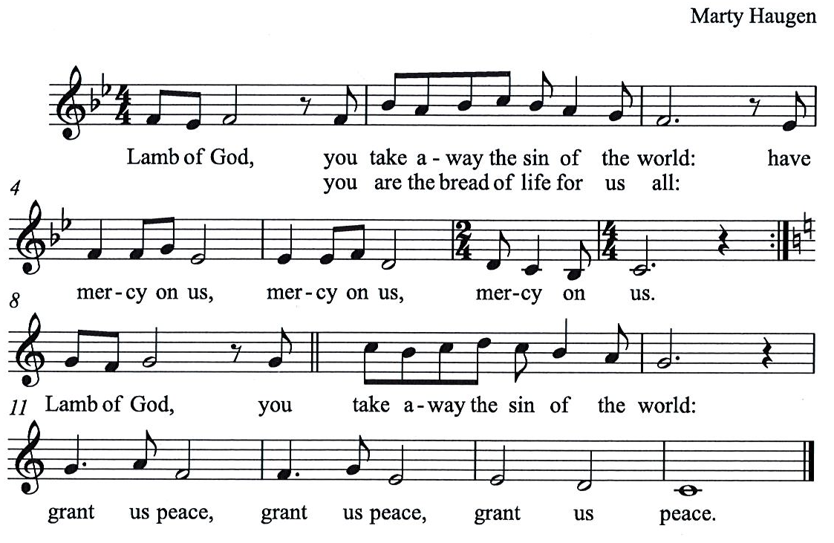
Agnus Dei / Lamb of God HS p. 18

Please be seated.

Holy Communion

- All who seek God and desire a deeper and stronger life in Christ are welcome to receive Holy Communion.
- Worshipers from the pulpit side will proceed forward first, followed by the center section, and then the lectern side.
- Please inform an usher if you would like the ministers to bring Communion to you.
- Holy Communion will be served with bread and wine (red) or grape juice (white).
- The presiding minister will first distribute the bread (host) to each communicant. Please indicate if you require a gluten-free host.
- Once you have consumed the bread, please pick up an empty glass from the tray next to the presiding minister. The Communion Assistant will pour wine or grape juice into your glass.
- Please step to the side to consume the wine or grape juice.
- Feel free to kneel at the altar rail for prayer after receiving the sacrament.
- As you return to your pew, glasses may be returned to the empty tray on the side of the center section.
- A blessing will be provided for anyone who does not yet receive the sacrament.
- All are invited to join in singing the hymns during Holy Communion.

Hymns during Holy Communion
I Received the Living God ELW 477

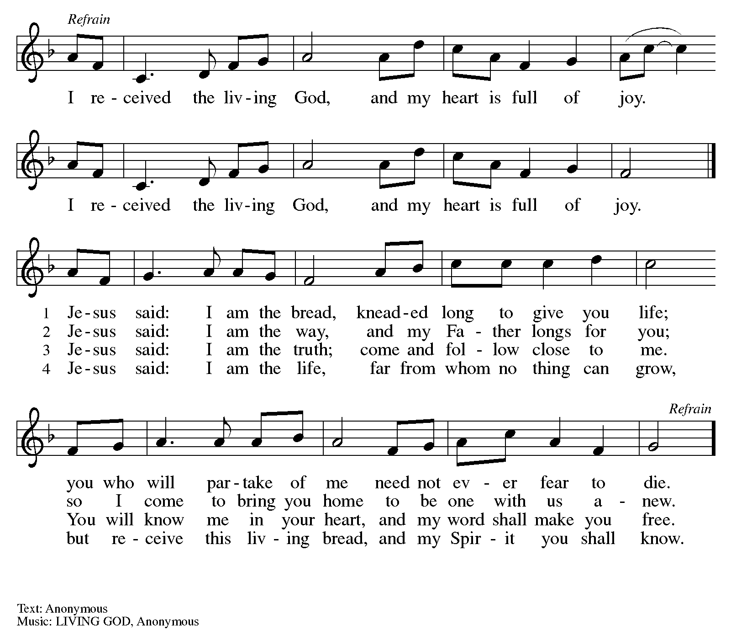

Hymns during Holy Communion
Rock of Ages, Cleft for Me ELW 623

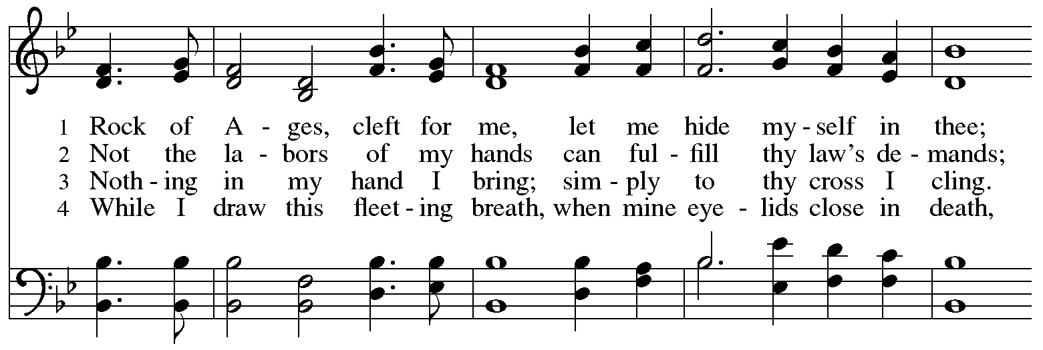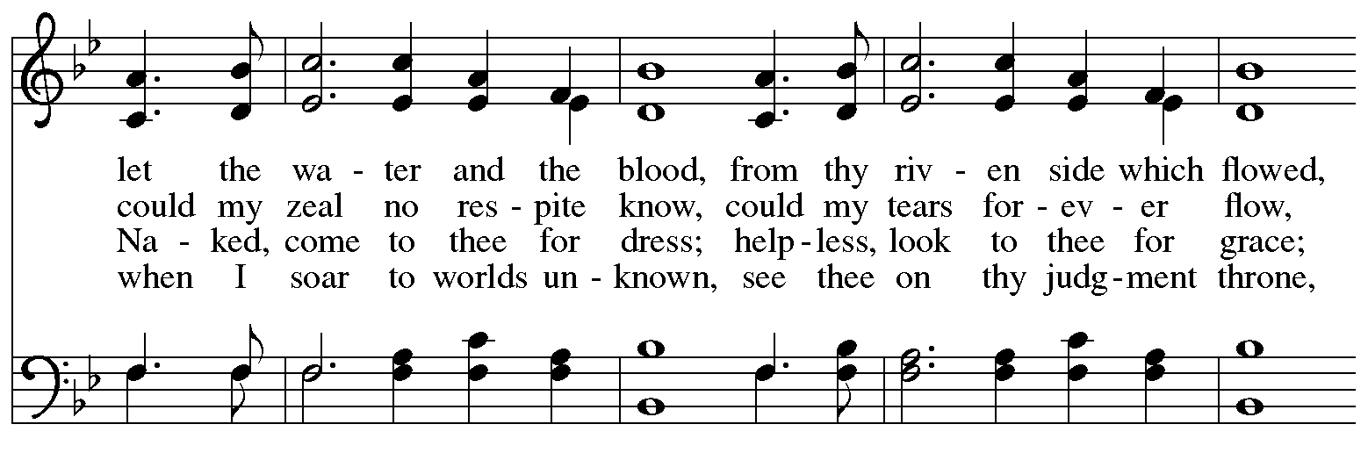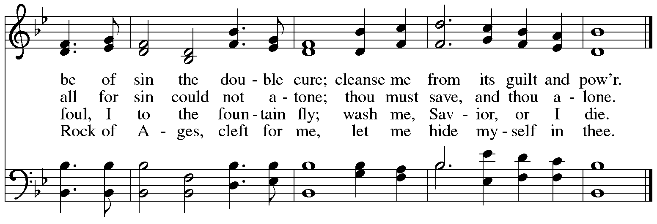

Hymns during Holy Communion
What Does the Lord Require of You? ACS 1057

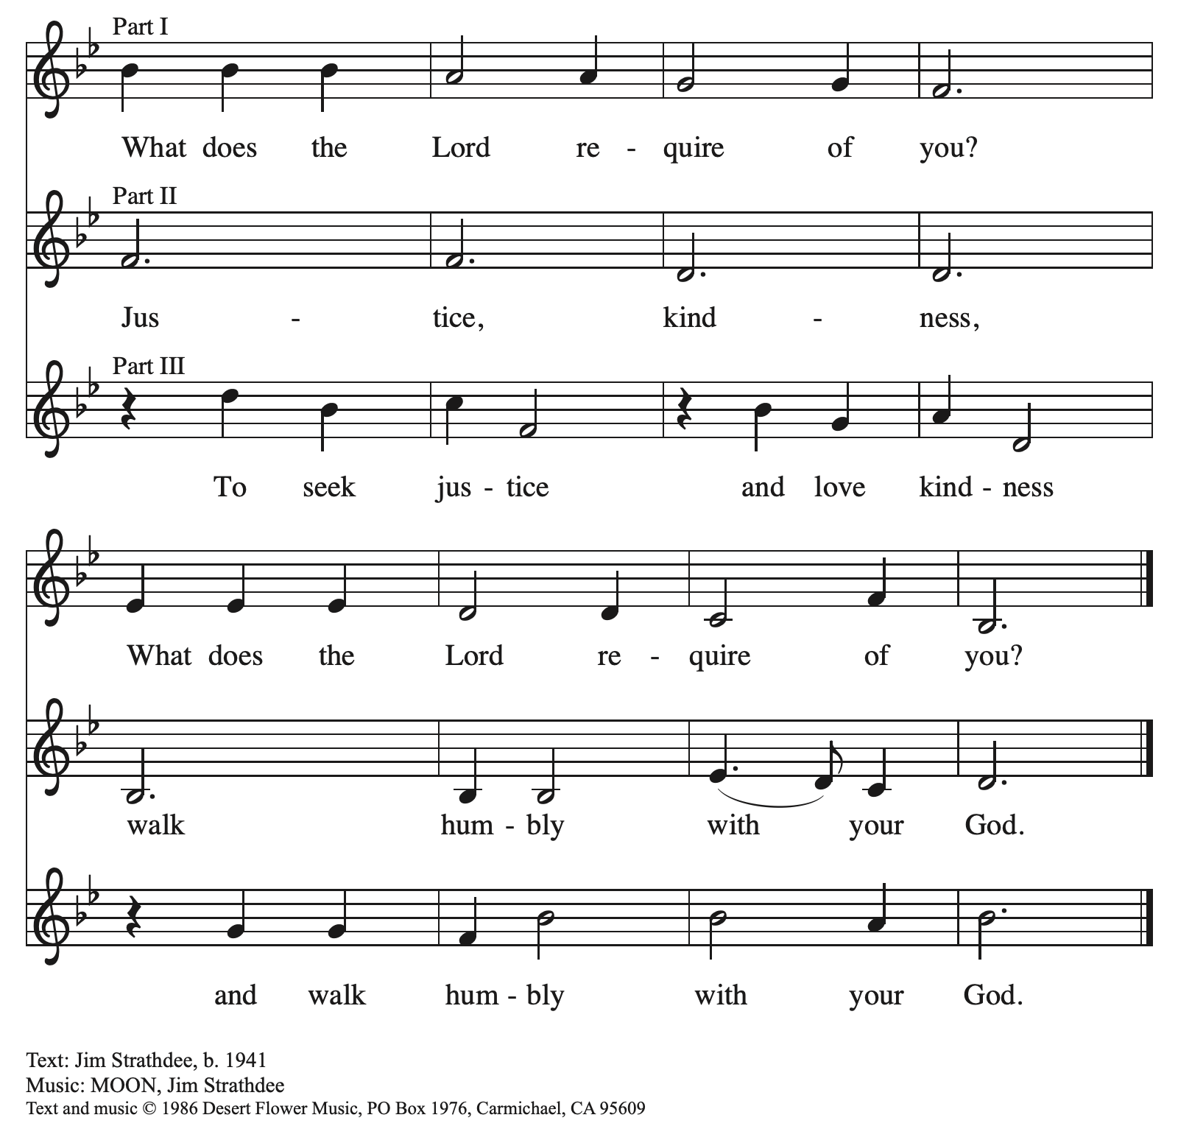
All rights reserved. Reprinted with permission under OneLicense.net # A-722139.

Hymns during Holy Communion
My Hope Is Built on Nothing Less ELW 596

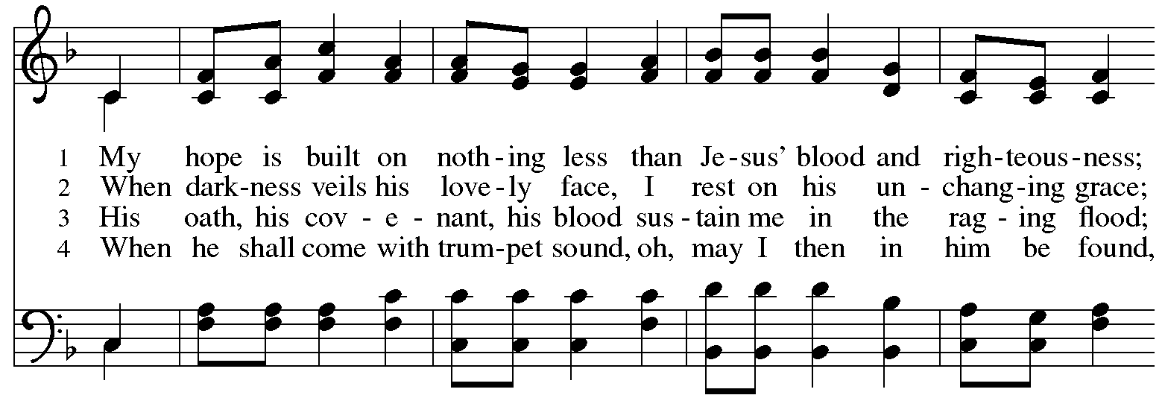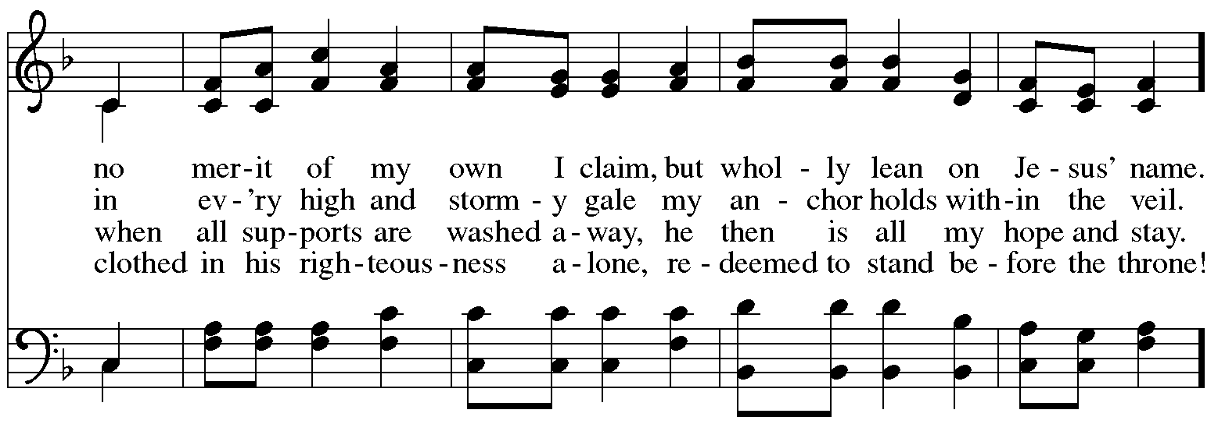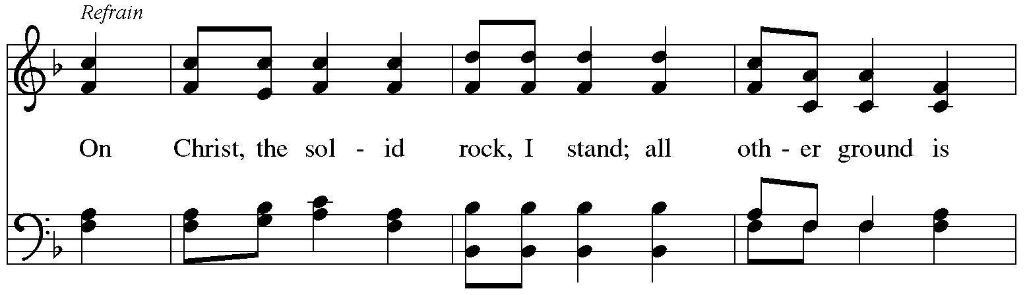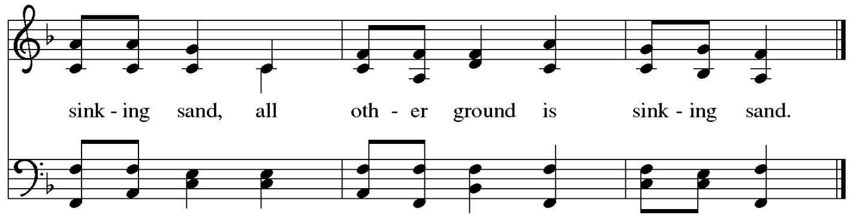
When all have returned to their places, please rise as you are able.

Blessing

P: The body and blood of our Lord Jesus Christ strengthen you and keep you in his grace.
C: Amen.

Prayer

A: Let us pray. Compassionate God,
through these gifts of bread and wine
our hearts are filled with the abundance of your love.
Strengthen us that we, through this holy meal,
may share your love freely, as you have shared with us.
We ask this in the name of Jesus, through the Spirit nourishing us now and forever.
C: Amen.

Please be seated.

Announcements

Sending
God blesses us and sends us in mission to the world

Teachers and leaders of St. Andrew’s Christian education ministries, along with all who serve in teaching vocations, are invited to come forward to gather at the baptismal font to receive a blessing. Students, especially children and youth, are also invited to come forward with their backpacks to receive a blessing as they begin a new school year.

Blessing of Teachers

Blessing of Backpacks

The assembly may offer acclamation with applause.

Congregational Refrain
Benediction

P: The love of God abound in you;
the grace of our Savior Jesus Christ fill your hearts;
and the life of the Spirit ☩ bless you and give you peace.
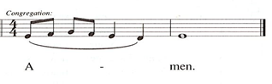
C:

Sending Hymn Following Page

Dismissal

A: Go in peace. Serve the Lord.
C: Thanks be to God!

Postlude

Sending Hymn Earth and All Stars! ELW 731

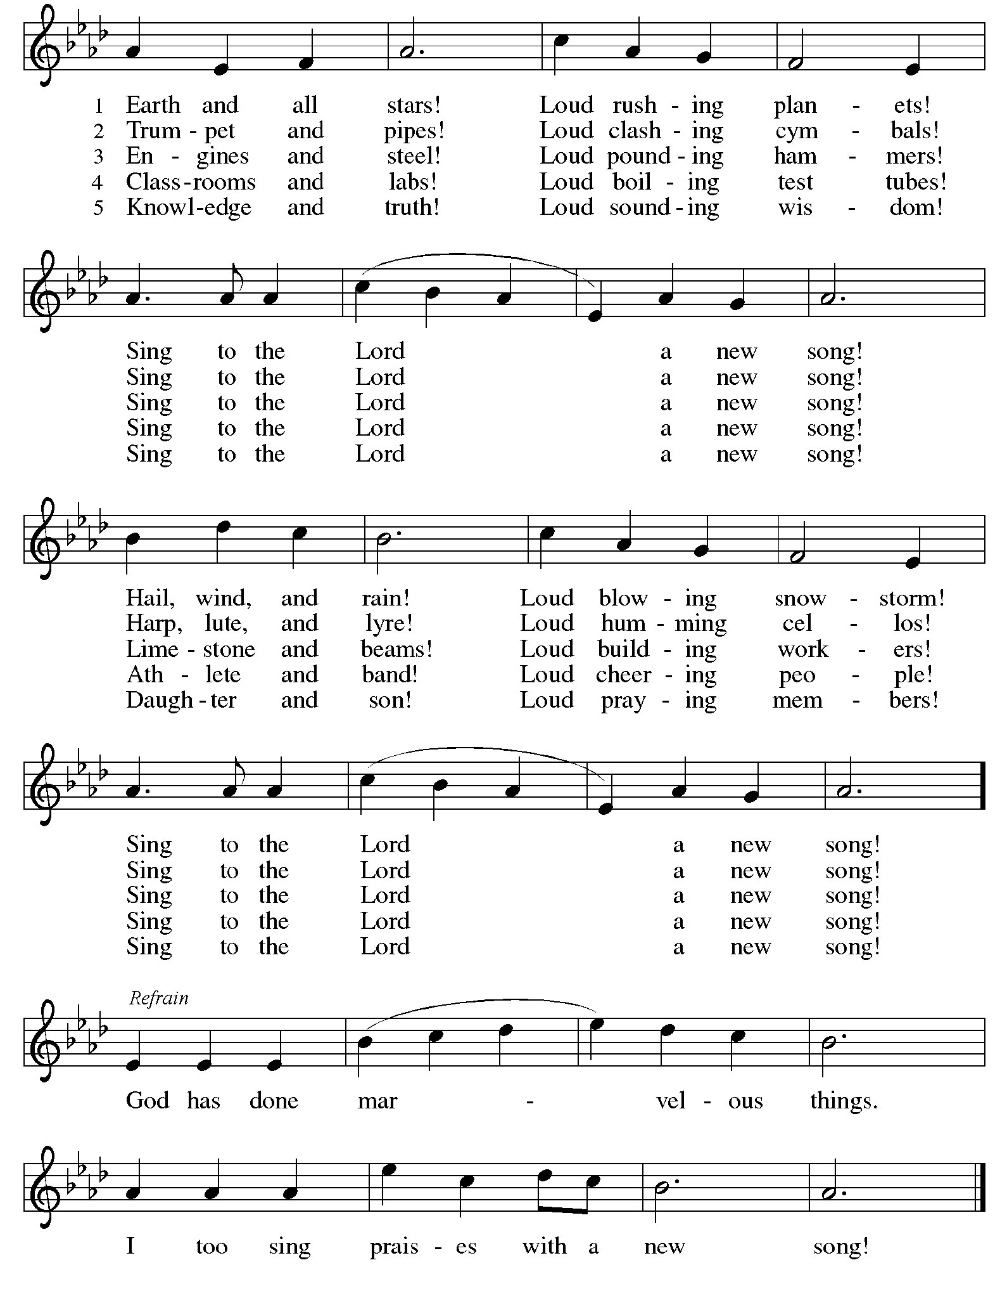
Those serving in worship today

Altar Care Jodie Minor
Assisting Minister Kathy Hays
Audio-Visual Ministers Kristen Asplin
Tyler Rietze
Cantor Joy Givens
Lector Lindsay Baxter
Organ Jimmi Kocher-Hillmer
Minister of Music Laura Reynolds
Presiding Minister at Holy Baptism The Rev. Janet B. Grill, Pastor Emerita
Presiding Minister The Rev. Ross I. Carmichael

Liturgy and Hymnody Acknowledgements

From SundaysandSeasons.com. Copyright © 2026 Augsburg Fortress. All rights reserved. Reprinted under OneLicense.net # A-722139.
Used by permission of Augsburg Fortress.

From Hymnal Supplement. Copyright © 1991 GIA Publications, Inc. All rights reserved. Reprinted under OneLicense.net # A-722139.
Used by permission of GIA Publications, Inc.

The Scripture readings contained herein are from New Revised Standard Version Updated Edition of the Bible © 2021 National Council of Churches of Christ in the United States of America. Used by permission. All rights reserved worldwide.

As the Grains of Wheat – Text: Didache, 2nd cent.; Marty Haugen, b. 1950. Music: AS THE GRAINS, Marty Haugen. Text and music © 1990 GIA Publications, Inc., 7404 S. Mason Ave., Chicago, IL 60638. www.giamusic.com. 800.442.3358. All rights reserved. Reprinted with permission under OneLicense.net # A722139.

Commissioning and Blessing of Teachers and Blessing of Backpacks adapted from sundaysandseasons.com. Copyright © 2026 Augsburg Fortress. All rights reserved. Reprinted with permission.

Earth and All Stars! Text: Herbet F. Brokering, b. 1926. Music: EARTH AND ALL STARS, David N. Johnson, 1922-1987. Text and music © 1978 Augsburg Publishing House, admin. Augsburg Fortress. All rights reserved. Reprinted with permission under OneLicense.net # A-722139

Please use the QR code below to link to St. Andrew’s Announcements online!



St. Andrew Lutheran Church Announcements
August 23rd, 2026

- Welcome to Worship at St. Andrew on the Thirteenth Sunday after Pentecost – We are so glad you are here, and we offer a special welcome to all visitors and guests who are here for the first time! There are worship “toolkits” to help children engage with worship and “busy bags” for younger children available in the bookcase at the back of the sanctuary. Please feel free to take one to use with/for your children. A nursery is available through the door to the left of the worship space and across the social hall (look for a purple room). All are welcome to gather in the Social Hall for coffee and conversation after worship!
- Welcome to the Grill Family as We Celebrate Holy Baptism! – Today St. Andrew is blessed to share in celebrating the Sacrament of Holy Baptism with the great-grandchild of Pastors Emeriti Janet and Keith Grill! Pastor Janet will preside at the Baptism!
- Blessing of Teachers and Blessing of Backpacks (and Students!) Today during Worship – As a new school year begins and we prepare for another year of Christian education for the children and youth of St. Andrew, we pray for God's blessings upon all participating in the vocations of education. Teachers and educators, along with Little Church - Big Faith leaders will be invited to come forward to receive a blessing. We also invite students, children, and youth to bring a backpack or other item representative of their studies as they receive a blessing, as well.
- Worship Committee Meeting, Sunday, August 23rd, after Worship – The worship committee meets regularly to organize and plan upcoming services for the congregation. We invite anyone interested in participating or learning more to speak with council liaison Miriam Bohlmann Kunz (worship@standrewpittsburgh.org) or Pastor Ross.
- Produce Distribution Supplemental Food of the Month – St. Andrew is collecting supplemental food each month to accompany our produce distribution. For August, we ask for donations of dried beans. There are collection boxes at the back of the worship space and in the social hall.
- Bread of Life Feeding Ministry at Bethel-Trinity, Thursday, August 27th from 5:00 p.m. to 7:00 p.m. – This food and clothing giveaway marks the start of a monthly donation effort for Bethel AME Church as their new community food pantry opens its doors free of charge. Help is needed in sorting donations on August 25th and 26th and carrying, greeting, and handing out items on the 27th. Please call 412-683-2160 with any questions or to volunteer.
- Help Move Furniture for Food Pantry and Little Church - Big Faith, Sunday, August 30th, after Worship – St. Andrew has received a grant to purchase a new industrial-sized refrigerator as we grow our ministry to address hunger in our local communities. Little Church - Big Faith and its supplies will be moving to an upstairs classroom, and we are asking for help from people who can carry large/heavy items upstairs after worship on Sunday, August 30th. Thank you for your support as we make adjustments to better facilitate our current ministries!
- Alternatives to Violence Project (AVP) Basic Workshop, September 12th and 19th, 9:00 a.m. - 8:00 p.m. – St. Andrew members are warmly invited to experience an Alternatives to Violence Project (AVP) Basic Workshop, hosted here at St. Andrew on Saturdays, September 12th and 19th, from 9:00 a.m. to 8:00 p.m., exploring practical ways to address conflict, strengthen relationships, communicate across differences, and discover the transforming power that can move us from aggression toward cooperation. AVP’s commitment to nonviolence, respect for every person, and building more just and peaceful communities resonates deeply with St. Andrew’s commitment to inclusion and justice. While the full two-day workshop offers the richest experience, you are also welcome to come for Day 1 — or even a portion of Day 1 — to experience AVP for yourself and see whether this work speaks to you. Experience with the basic workshop is a prerequisite for the advanced workshop, held November 6th-8th. Registration is required https://docs.google.com/forms/d/e/1FAIpQLSfW_fVUD_bkgcd4K1e9Q-t5fz-rW1mTF72C7pcAmTwfYiH50A/viewform. You can contact Martin Rafanan at 314-258-0452 or mjr9201@gmail.com with any questions.
- St. Andrew Talks about "Conscience and Conversation: A Study during Reconsideration of the Social Statement Human Sexuality: Gift and Trust", Tuesday, August 25th and Tuesday, September 8th, 7:00 p.m., on Zoom – The Evangelical Lutheran Church in America (ELCA) is seeking to update language from its 2009 social statement Human Sexuality: Gift and Trust, and is inviting congregations to engage in their own study and conversation in order to share feedback by September 30th. To guide these discussions, the ELCA has published Conscience and Conversation, which can be found here: https://resources.elca.org/faith-and-society/conscience-and-conversation-study/.
Pastor Ross will facilitate a conversation on the two sessions of this study on Zoom on Tuesday, August 25th and Tuesday, September 8th, at 7:00 p.m. The link will be shared internally with the congregation. This will allow parishioners time to formulate and submit feedback to the churchwide organization by the deadline of September 30th. The Zoom link can be found in the Friday email. If you cannot find it, please contact Pastor Ross. The ELCA has also released a five-episode podcast as a companion to the study. Individual episodes are available at elca.org/reconsiderations.
- Coffee Hour Signups – Coffee hour returns in September! St. Andrew provides hospitality during a coffee hour after worship each Sunday. If you would like to participate and would like information about the duties of setting up, please sign up using the following form: https://www.signupgenius.com/go/5080B4AAFAF2CABF85-47069030-coffee#/.

