

+ Fourteenth Sunday after Pentecost
August 30, 2026



St. Andrew Lutheran Church
304 Morewood Ave.
Pittsburgh, PA 15213
St_andrewELCA@verizon.net
www.standrewpittsburgh.org

+ Fourteenth Sunday after Pentecost

The prophet Jeremiah speaks of the incurable wound of his suffering yet finds in God’s words the delight of his heart. When Peter doesn’t grasp Jesus’ words about suffering, Jesus tells the disciples they will find their lives in losing them. Such sacrificial love is described by Paul when he urges us to associate with the lowly and not repay evil with evil. In worship we gather as a community that we might offer ourselves for the sake of our suffering world.

Welcome to St. Andrew!
- St. Andrew welcomes all who are seeking a place of healing, wholeness, and acceptance in a nurturing and faith-forming spiritual home. We are striving toward racial equity worldwide
and we seek to honor the lived experience of all individuals regardless of background. Our community embraces people of all ages, ethnicities, cultures, abilities, sexual orientations,
gender identities and expressions, and family constellations. Come and See!
- Worship Services are live-streamed to multiple online platforms. By attending worship, you agree that your image and voice may be broadcast.
- Everyone is invited to make a name tag at the black bookcase in the back of the worship space if they would like. There are stickers indicating pronouns on the bookcase if you would like to include them on your name tag.
- Little Church – Big Faith will resume on Sunday, September 13th.
- A nursery is available through the doors at the left side of the sanctuary and across from the doorway to the Social Hall. Look for a purple-colored room.
- Worship “toolkits” to help children engage with the service, along with “busy bags” for younger children, are available in the bookcase at the back of the sanctuary. Please feel free to take one to use with/for your children.
- Holy Communion is served with bread (gluten-free available) and wine or grape juice. The presiding minister will distribute the bread (host). Please consume this and then pick up an empty glass from the tray. The Communion Assistant will pour wine or grape juice into your glass. Please step to the side to consume the wine or grape juice. Feel free to kneel at the altar for prayer and reflection. As you return to your pew, glasses may be returned to the empty trays on either side of the center section.
- A restroom is available on the main level of the church, through the doors to the Social Hall and to the right in the main office.

Abbreviations
P: Pastor/Presiding Minister ELW: Evangelical Lutheran Worship hymnal
A: Assisting Minister ACS: All Creation Sings hymnal
L: Lector HS: Hymnal Supplement (GIA Publications)
C: Congregation

Musical Offering

Each week, different people from the congregation make an offering of pre-service music, with singing or instrumentation, to help the assembly focus and pray in preparation for worship.

Welcome
Prelude We Walk by Faith arr. Kim

Gathering
The Holy Spirit calls us together as the people of God

Please rise as you are able. All may make the sign of the cross,
the sign that is marked at Baptism, as the presiding minister begins.

Confession and Forgiveness

P: Blessed be the ☩ holy Trinity,
one God, whose compassion endures forever.
C: Amen.

P: If we say we have no sin, we deceive ourselves and the truth is not us.
Let us confess our sin to God who is faithful and just,
and who has promised to forgive sin and cleanse us from all unrighteousness.

Silence is kept for reflection.

P: Most merciful God,
C: we confess to you that we have sinned against you in thought, word, and deed,
by what we have done and by what we have left undone.
We have not trusted you with our whole heart;
we have not loved one another in deed and in truth.
In your compassion, forgive our sin and so uphold us by your Spirit
that we may live and serve you in newness of life,
through Jesus Christ, our light and our truth.
Amen.

P: With joy I proclaim to you that Almighty God,
rich in mercy, abundant in love,
forgives you all your sin and grants you newness of life
☩ in Jesus Christ.
C: Amen. Thanks be to God!

Gathering Hymn Making Their Way ACS 979

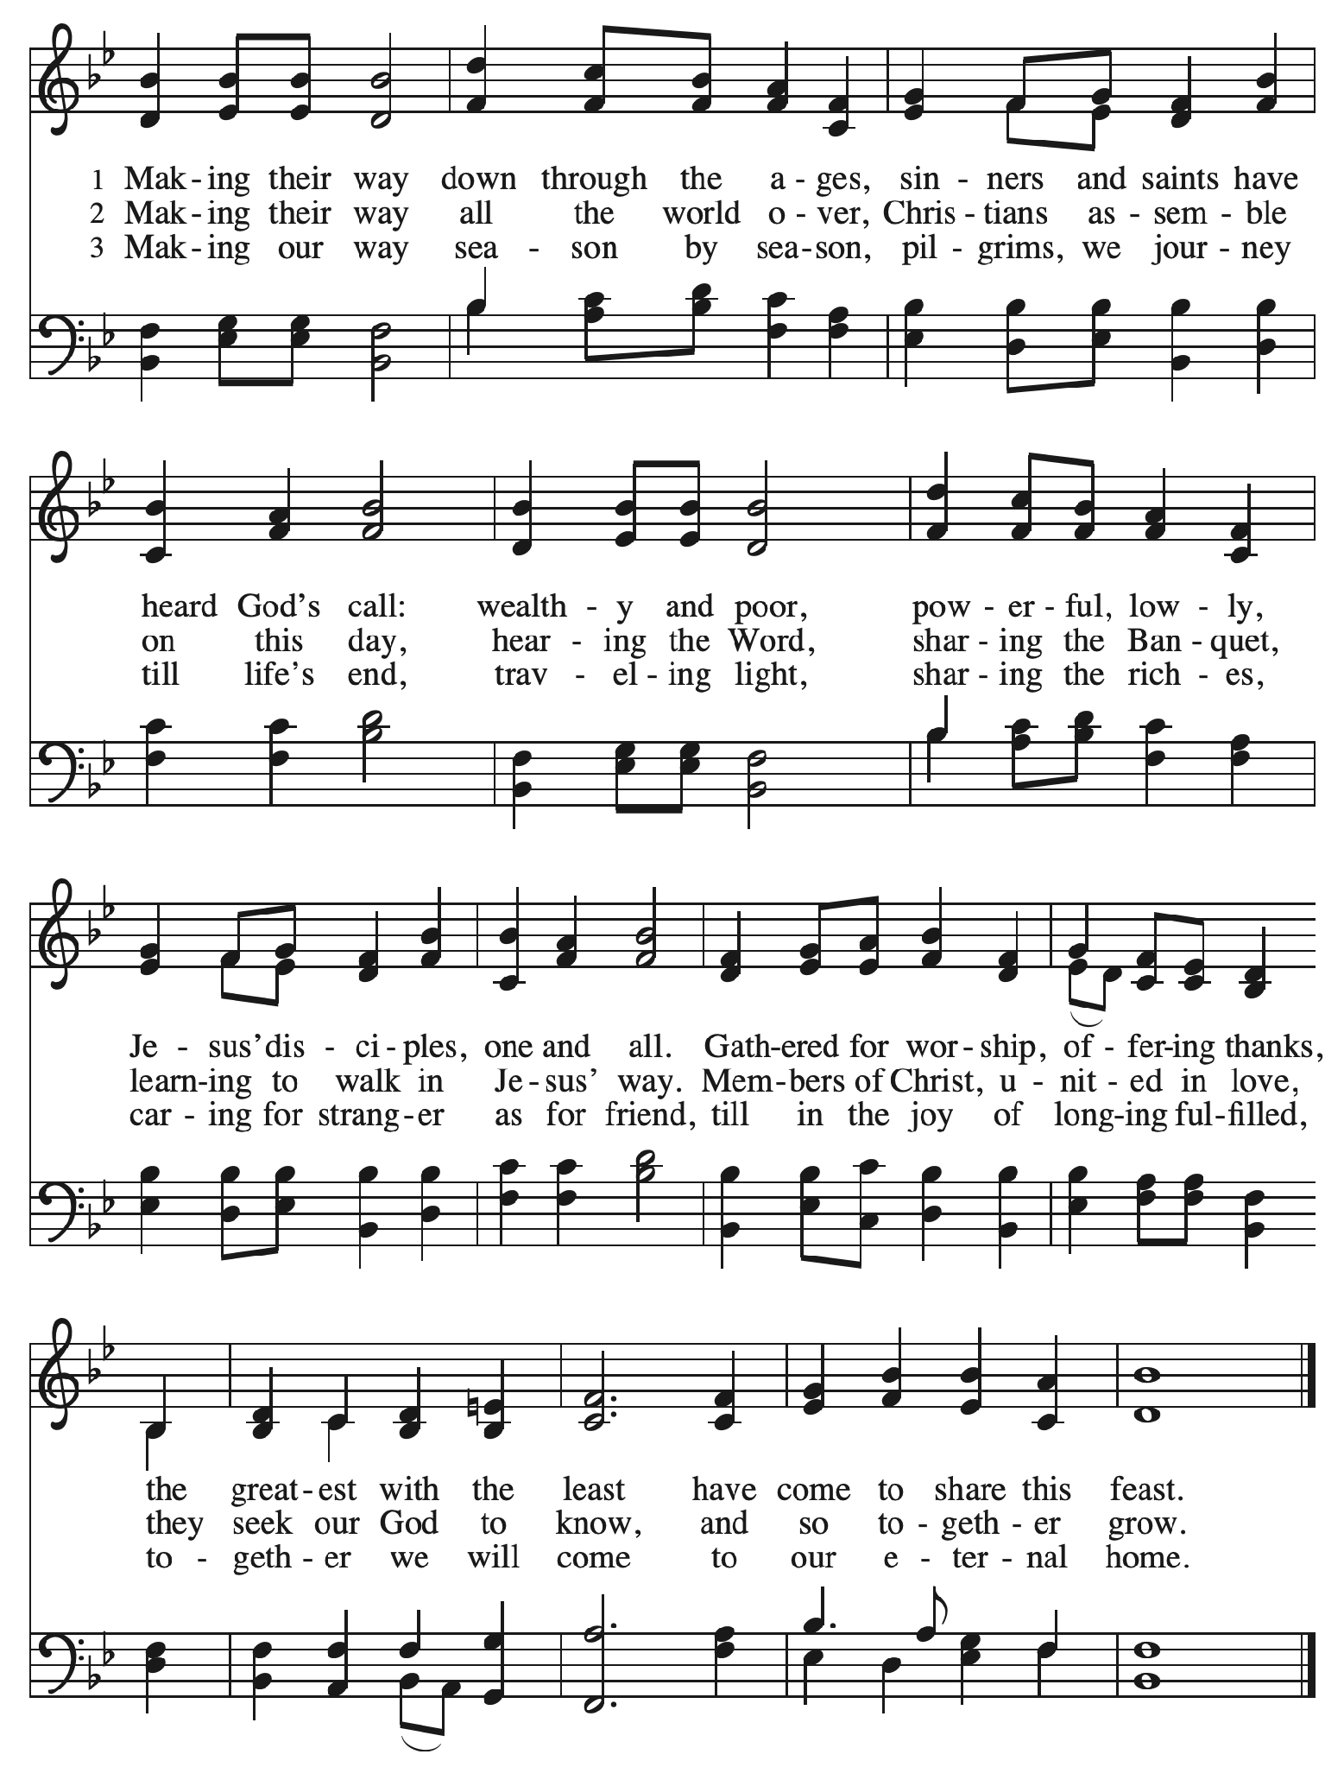

Greeting

P: The grace of our Lord Jesus Christ, the love of God,
and the communion of the Holy Spirit be with you all.
C: And also with you.

Hymn of Praise Glory to God HS p. 6-7

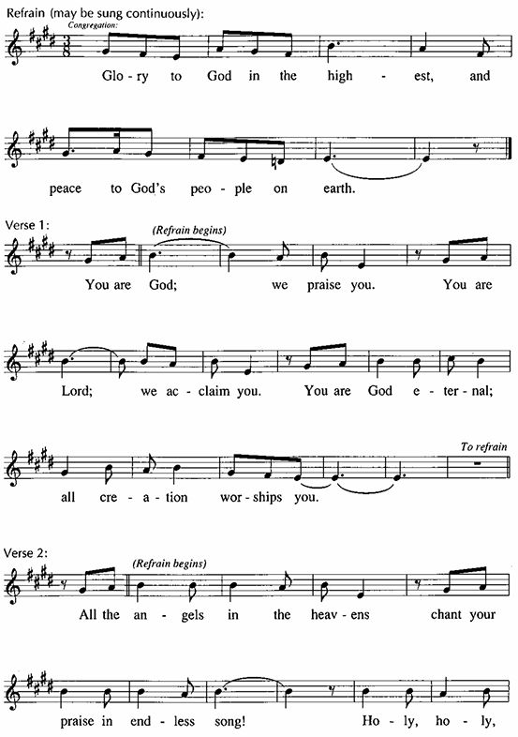

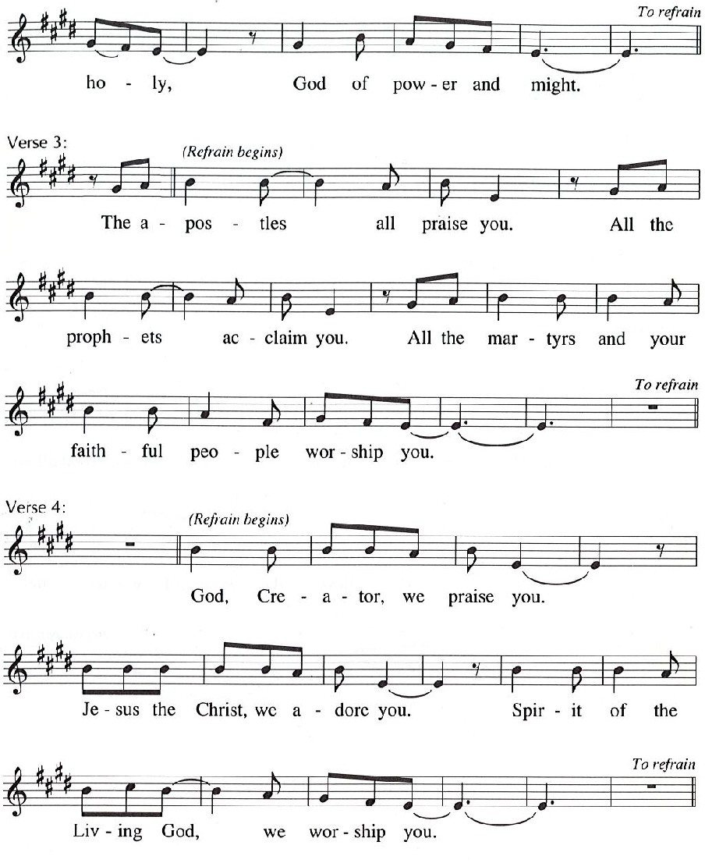

Prayer of the Day

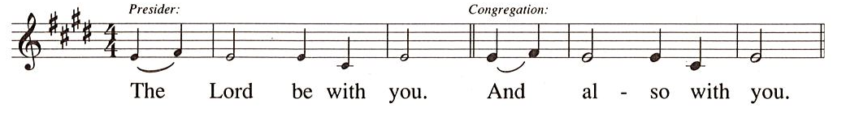
P: Let us pray.
O God, we thank you for your Son, who chose the path of suffering for the sake of the world. Humble us by his example, point us to the path of obedience,
and give us strength to follow your commands, through Jesus Christ, our Savior and Lord.
C: Amen.

Please be seated.

Word
God speaks to us in Scripture reading, preaching, and song

First Reading – Jeremiah 15: 15-21

¹⁵ O Lord, you know;
remember me and visit me,
and bring down retribution for me on my persecutors.
In your forbearance do not take me away;
know that on your account I suffer insult.
¹⁶ Your words were found, and I ate them,
and your words became to me a joy
and the delight of my heart,
for I am called by your name,
O Lord, God of hosts.
¹⁷ I did not sit in the company of merrymakers,
nor did I rejoice;
under the weight of your hand I sat alone,
for you had filled me with indignation.
¹⁸ Why is my pain unceasing,
my wound incurable,
refusing to be healed?
Truly, you are to me like a deceitful brook,
like waters that fail.
¹⁹ Therefore thus says the Lord:
If you turn back, I will take you back,
and you shall stand before me.
If you utter what is precious and not what is worthless,
you shall serve as my mouth.
It is they who will turn to you,
not you who will turn to them.
²⁰ And I will make you to this people
a fortified wall of bronze;
they will fight against you,
but they shall not prevail over you,
for I am with you
to save you and deliver you,
says the Lord.
²¹ I will deliver you out of the hand of the wicked
and redeem you from the grasp of the ruthless.

L: Word of God, word of life.
C: Thanks be to God.

Psalm 26: 1-8

The psalm will be read responsively, led by the cantor,
with the congregation responding with the verses in bold.

Psalm Tone

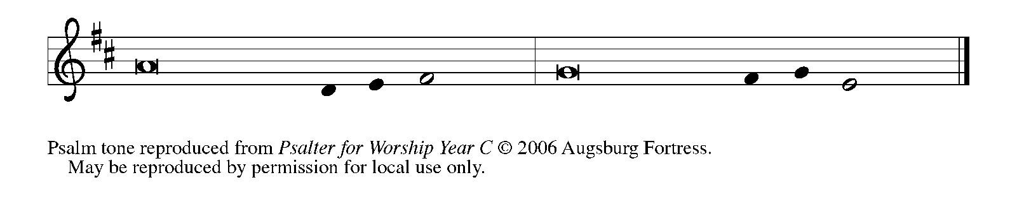

Psalm Refrain

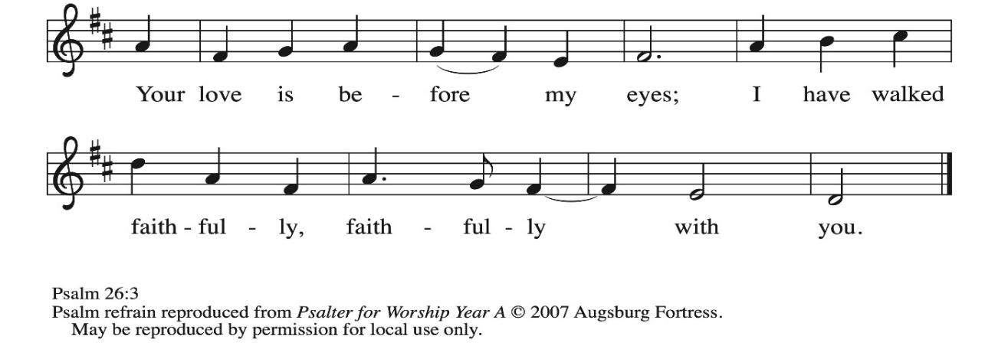

¹ Give judgment for me, O Lord, for I have lived | with integrity;
I have trusted in the Lord and | have not faltered.
² Test me, O | Lord, and try me;
examine my heart | and my mind.
³ For your steadfast love is be- | fore my eyes;
I have walked faithful- | ly with you.
⁴ I have not sat | with the worthless,
nor do I consort with | the deceitful. R
⁵ I have hated the company of | evildoers;
I will not sit down | with the wicked.
⁶ I will wash my hands in inno- | cence, O Lord,
that I may go in procession | round your altar,
⁷ singing aloud a song | of thanksgiving
and recounting all your won- | derful deeds.
⁸ Lord, I love the house in | which you dwell
and the place where your glo- | ry abides. R

Second Reading – Romans 12: 9-21

⁹ Let love be genuine; hate what is evil; hold fast to what is good; ¹⁰ love one another with mutual affection; outdo one another in showing honor. ¹¹ Do not lag in zeal; be ardent in spirit; serve the Lord. ¹² Rejoice in hope; be patient in affliction; persevere in prayer. ¹³ Contribute to the needs of the saints; pursue hospitality to strangers.
¹⁴ Bless those who persecute you; bless and do not curse them. ¹⁵ Rejoice with those who rejoice; weep with those who weep. ¹⁶ Live in harmony with one another; do not be arrogant, but associate with the lowly; do not claim to be wiser than you are. ¹⁷ Do not repay anyone evil for evil, but take thought for what is noble in the sight of all. ¹⁸ If it is possible, so far as it depends on you, live peaceably with all. ¹⁹ Beloved, never avenge yourselves, but leave room for the wrath of God, for it is written, “Vengeance is mine; I will repay, says the Lord.” ²⁰ Instead, “if your enemies are hungry, feed them; if they are thirsty, give them something to drink, for by doing this you will heap burning coals on their heads.” ²¹ Do not be overcome by evil, but overcome evil with good.
L: Word of God, word of life.
C: Thanks be to God.

Please rise as you are able.

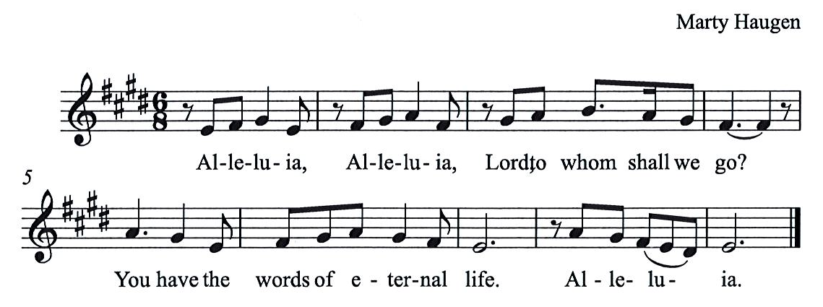
Gospel Acclamation HS p. 8

Gospel – Matthew 16: 21-28

P: The holy Gospel according to St. Matthew.
C: Glory to you, O Lord.
²¹ From that time on, [after Peter confessed that Jesus was the Messiah,] Jesus began to show his disciples that he must go to Jerusalem and undergo great suffering at the hands of the elders and chief priests and scribes and be killed and on the third day be raised. ²² And Peter took him aside and began to rebuke him, saying, “God forbid it, Lord! This must never happen to you.” ²³ But he turned and said to Peter, “Get behind me, Satan! You are a hindrance to me, for you are setting your mind not on divine things but on human things.”
²⁴ Then Jesus told his disciples, “If any wish to come after me, let them deny themselves and take up their cross and follow me. ²⁵ For those who want to save their life will lose it, and those who lose their life for my sake will find it. ²⁶ For what will it profit them if they gain the whole world but forfeit their life? Or what will they give in return for their life?
²⁷ “For the Son of Humanity is to come with his angels in the glory of his Father, and then he will repay everyone for what has been done. ²⁸ Truly I tell you, there are some standing here who will not taste death before they see the Son of Humanity coming in his kingdom.”

P: The Gospel of the Lord.
C: Praise to you, O Christ.

Please be seated.

Sermon

A time of silence for prayer and reflection follows the sermon.
When the hymn of the day begins, please rise as you are able.

Hymn of the Day Take Up Your Cross, the Savior Said ELW 667

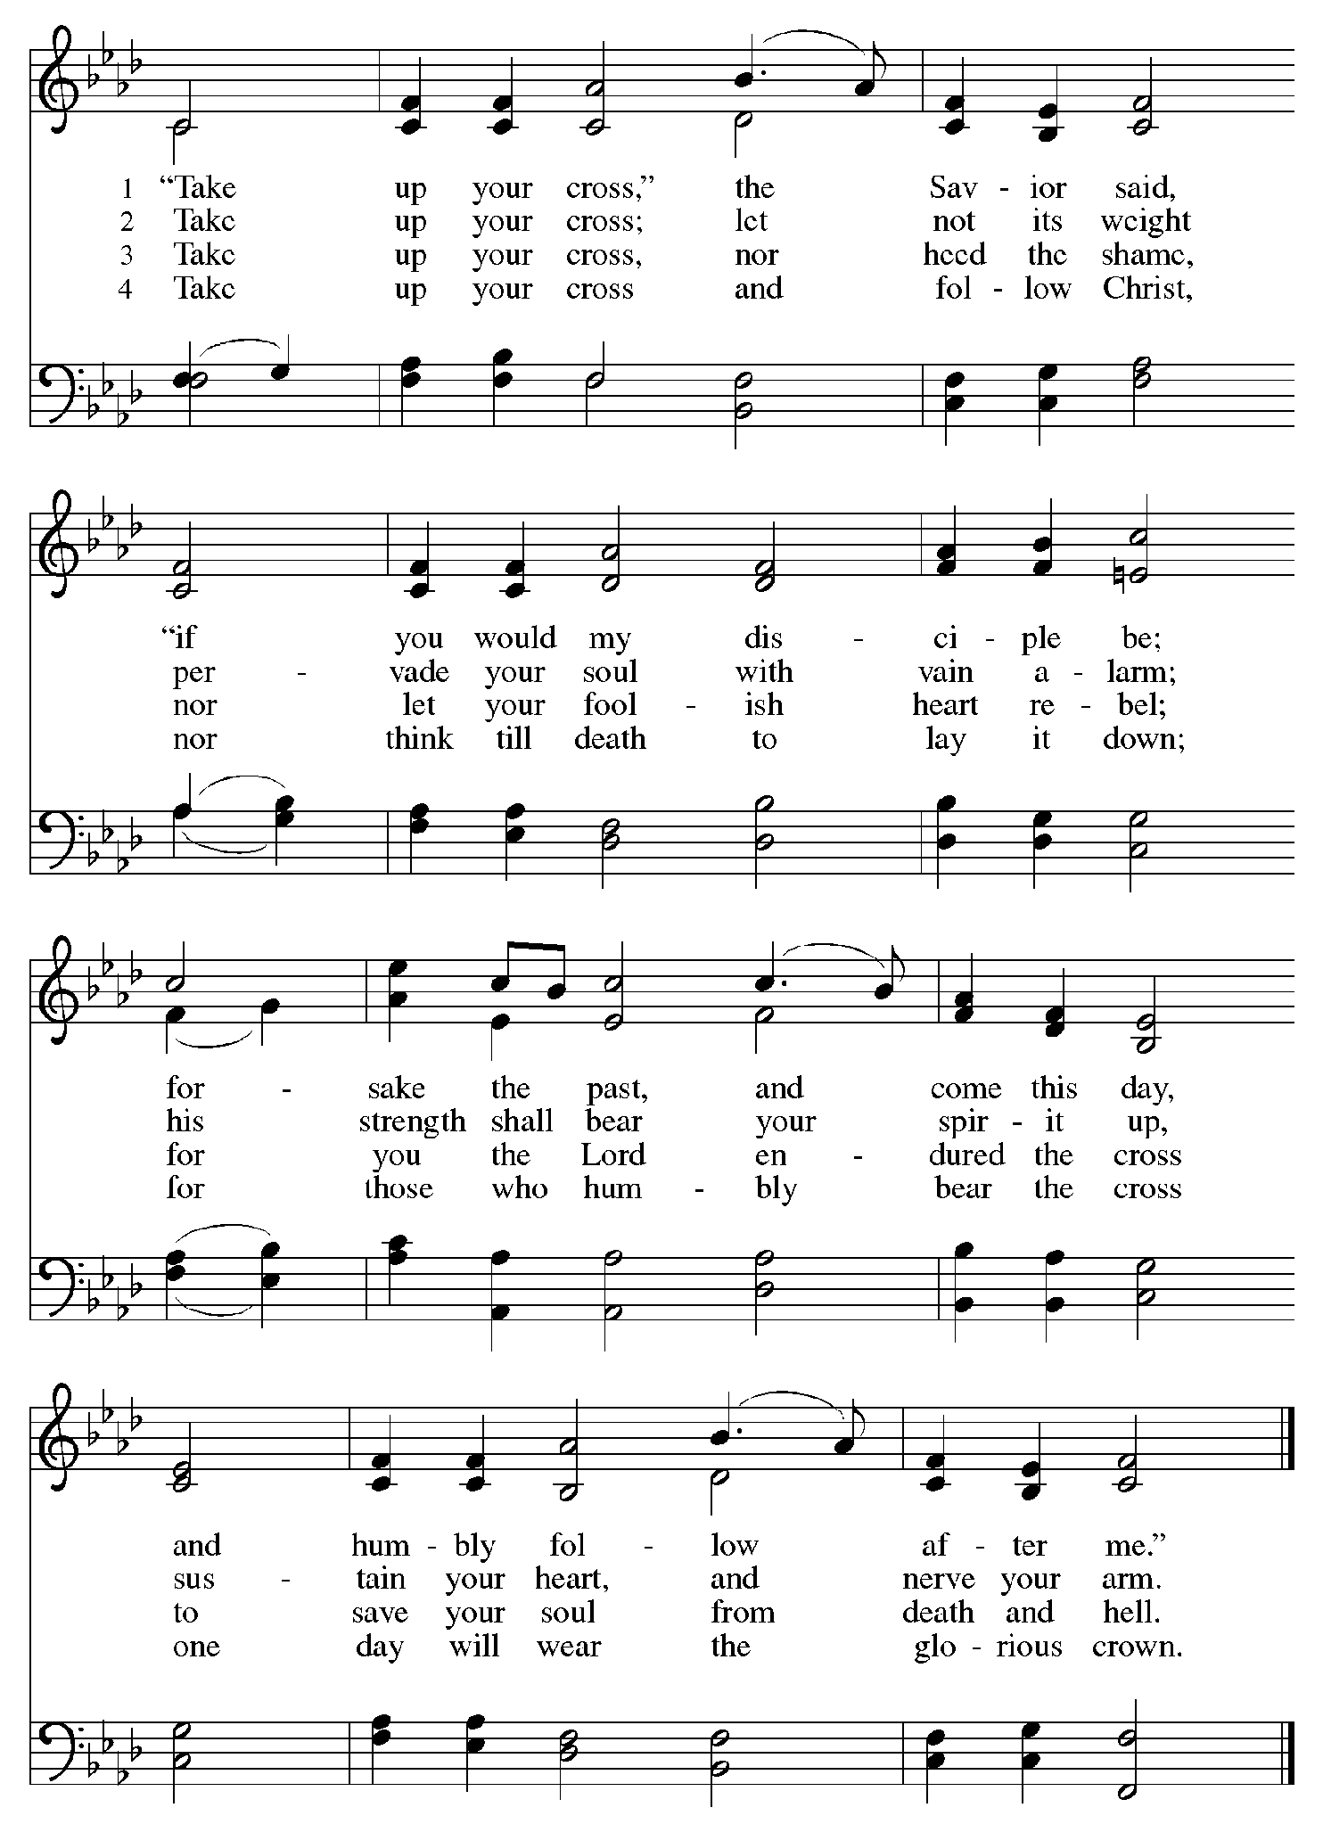

Apostles’ Creed

C: I believe in God, the Father almighty,
creator of heaven and earth.

I believe in Jesus Christ, God’s only Son, our Lord,
who was conceived by the Holy Spirit,
born of the virgin Mary,
suffered under Pontius Pilate,
was crucified, died, and was buried;
he descended to the dead.*
On the third day he rose again;
he ascended into heaven,
he is seated at the right hand of the Father,
and he will come to judge the living and the dead.

I believe in the Holy Spirit,
the holy catholic church,
the communion of saints,
the forgiveness of sins,
the resurrection of the body,
and the life everlasting. Amen.

*Or, “he descended into hell,” another translation of this text in widespread use.

Prayers of the People

A: Trusting in God’s steadfast love for all God has made,
let us pray for the church, the world, and those who are in need.

After each petition
A: Gracious God,
C: receive our prayer.

The presiding minister concludes the prayers
P: Grateful for your abundant provision and trusting in your goodness, O God,
we commend all for whom we pray, through the priceless grace of Jesus Christ.
C: Amen.

Peace

The presiding minister and the assembly greet one another in the peace of the risen Christ.
P: The peace of Christ be with you always.
C: And also with you.

The people may greet those around them with a sign of Christ’s peace and may say
Peace be with you or similar words. Please be mindful that not everyone will be comfortable with sharing the peace, so please seek consent before shaking hands or hugging. Other possible ways to share the peace include a simple bow with the verbal greeting of peace, or simply a verbal expression of peace. When the greetings of peace have concluded, please be seated.



Meal
God feeds us with the presence of Jesus Christ

Offering

We offer ourselves, our gifts, and our faithful service to God.
As the offering is gathered for the mission of the church, including the care of those in need,
the table is set for Holy Communion.

There are laminated giving cards in the pew racks that feature a QR code for anyone who would like to give online. Those who give using the QR code, as well as those who give regularly online or through their bank are encouraged to place the laminated card in the plate as an expression of your offering.

Music during the Offering M. Luther, arr. Unke
Lord, Keep Us Steadfast in Your Word

As the gifts are brought forward for presentation, please rise as you are able.

Offertory Song As the Grains of Wheat ELW 465

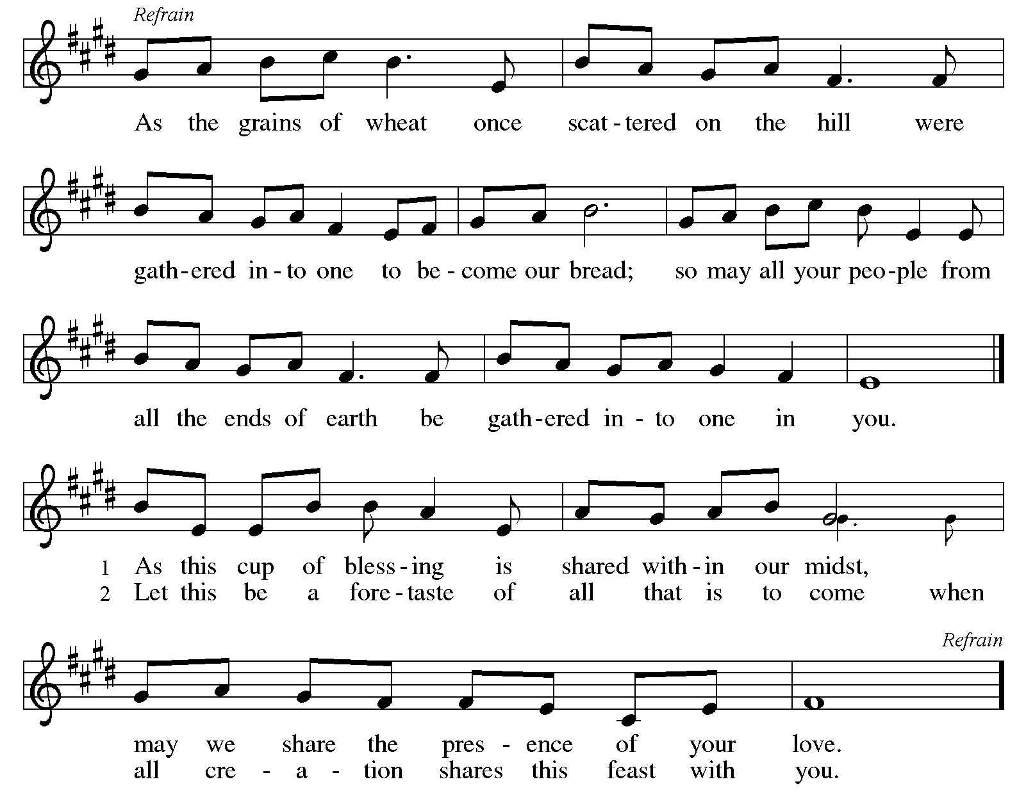

Offertory Prayer

A: Let us pray.
Merciful God,
C: everything in heaven and on earth belongs to you.
We joyfully release what you have entrusted to us.
May these gifts be signs of our whole lives returned to you,
dedicated to the healing and unity of all creation,
through Jesus Christ.
Amen.

Dialogue HS p. 14

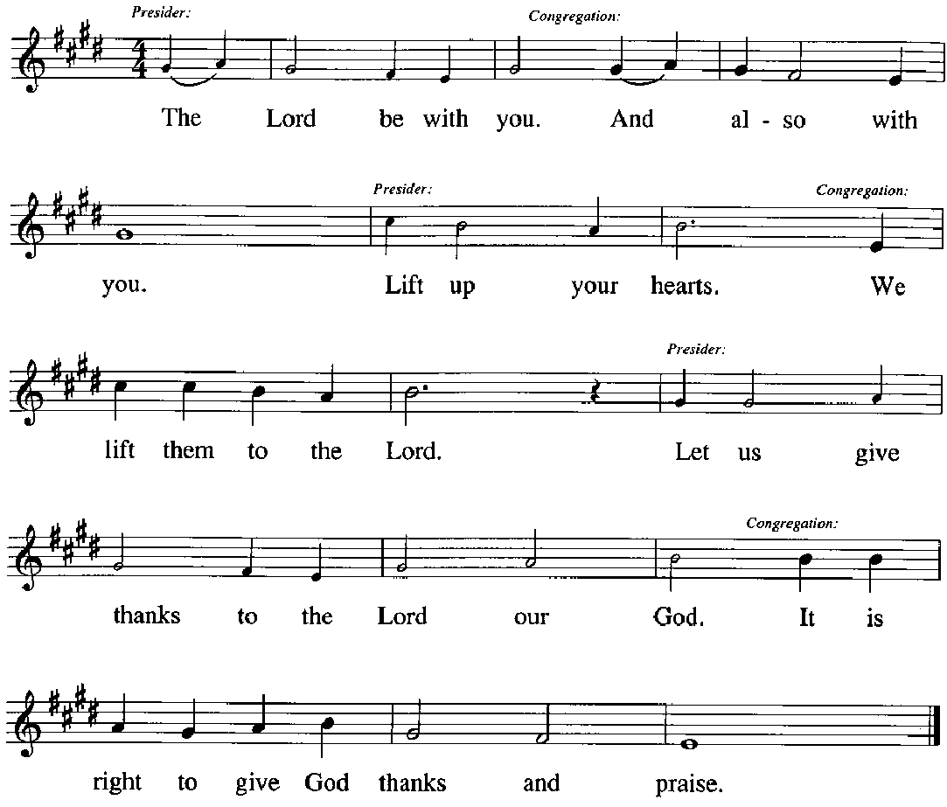

Preface (Sung by the presiding minister)

P: It is our duty and delight,
that we should everywhere and always
offer thanks and praise to you, O God,
through Jesus Christ,
who calls us to follow his way
of humble service and love,
and so with the church on earth,
all creation and the hosts of heaven,
we praise your name and join their unending hymn:

Sanctus HS p. 15

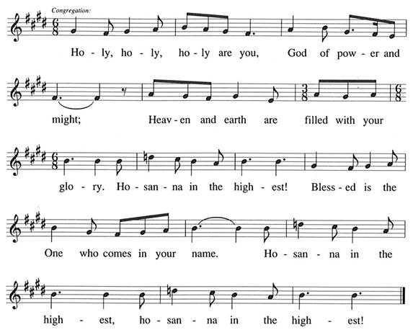

Eucharistic Prayer

P: You are indeed holy, gracious and merciful God …
… Do this for the remembrance of me.

Remembering his command to love one another,
his life and death, his resurrection and ascension,
we pray for his coming again, even as we cry:

(Sung by the presiding minister)
P: Amen. Come, Lord Jesus. Amen. Come, Lord Jesus.
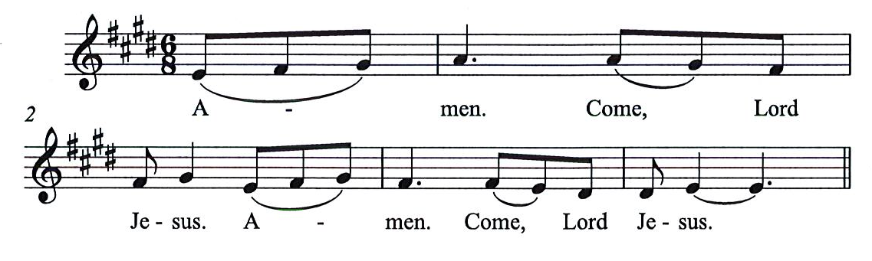
C:

P: Send now, we pray, your Holy Spirit,
that all of your promises
may come to us and your whole creation.

(Sung by the presiding minister)
P: Amen. Come Holy Spirit. Amen. Come, Holy Spirit.
C:
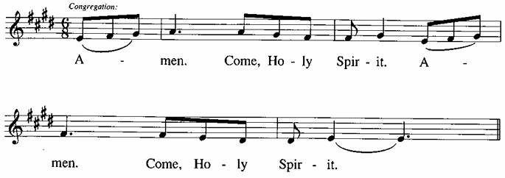

P: This we pray through Jesus Christ,
our Savor and our friend.
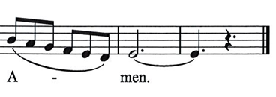
C:
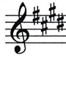

Lord’s Prayer

P: Gathered as one by the Holy Spirit, we pray as Jesus taught us.
C: Our Father in heaven,
hallowed be your name,
your kingdom come,
your will be done,
on earth as in heaven.
Give us today our daily bread.
Forgive us our sins,
as we forgive those
who sin against us;
Save us from the time of trial,
and deliver us from evil.
For the kingdom, the power,
and the glory are yours,
now and ever. Amen.

Fraction and Invitation

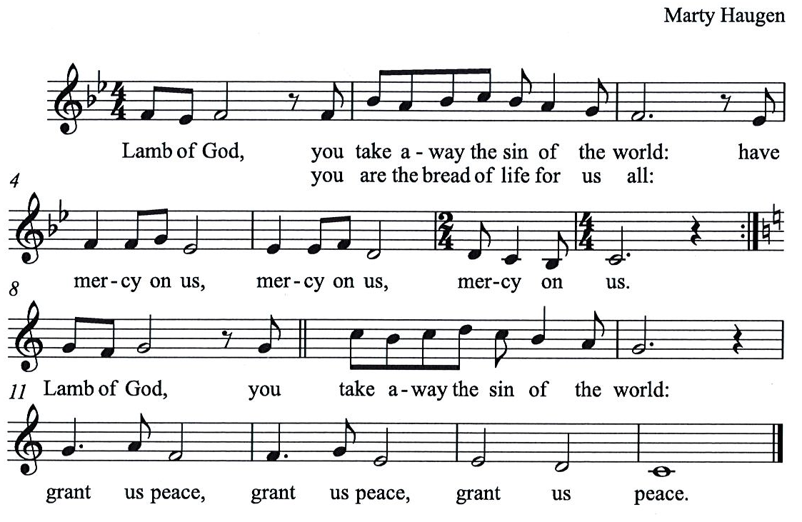
Agnus Dei / Lamb of God HS p. 18

Please be seated.

Holy Communion

- All who seek God and desire a deeper and stronger life in Christ are welcome to receive Holy Communion.
- Worshipers from the pulpit side will proceed forward first, followed by the center section, and then the lectern side.
- Please inform an usher if you would like the ministers to bring Communion to you.
- Holy Communion will be served with bread and wine (red) or grape juice (white).
- The presiding minister will first distribute the bread (host) to each communicant. Please indicate if you require a gluten-free host.
- Once you have consumed the bread, please pick up an empty glass from the tray next to the presiding minister. The Communion Assistant will pour wine or grape juice into your glass.
- Please step to the side to consume the wine or grape juice.
- Feel free to kneel at the altar rail for prayer after receiving the sacrament.
- As you return to your pew, glasses may be returned to the empty tray on the side of the center section.
- A blessing will be provided for anyone who does not yet receive the sacrament.
- All are invited to join in singing the hymns during Holy Communion.

Hymns during Holy Communion
Bread of Life from Heaven ELW 474

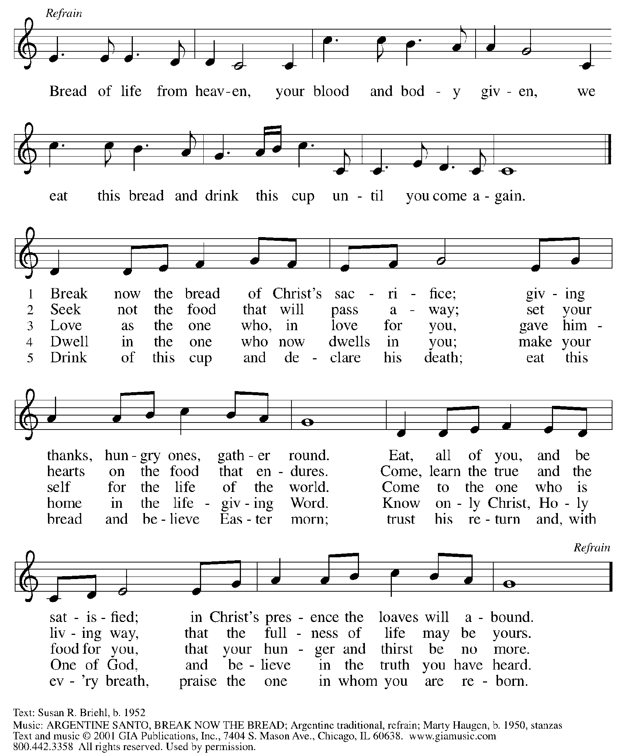
Reprinted under OneLicense.net # A-722139.

Hymns during Holy Communion
Will You Let Me Be Your Servant ELW 659

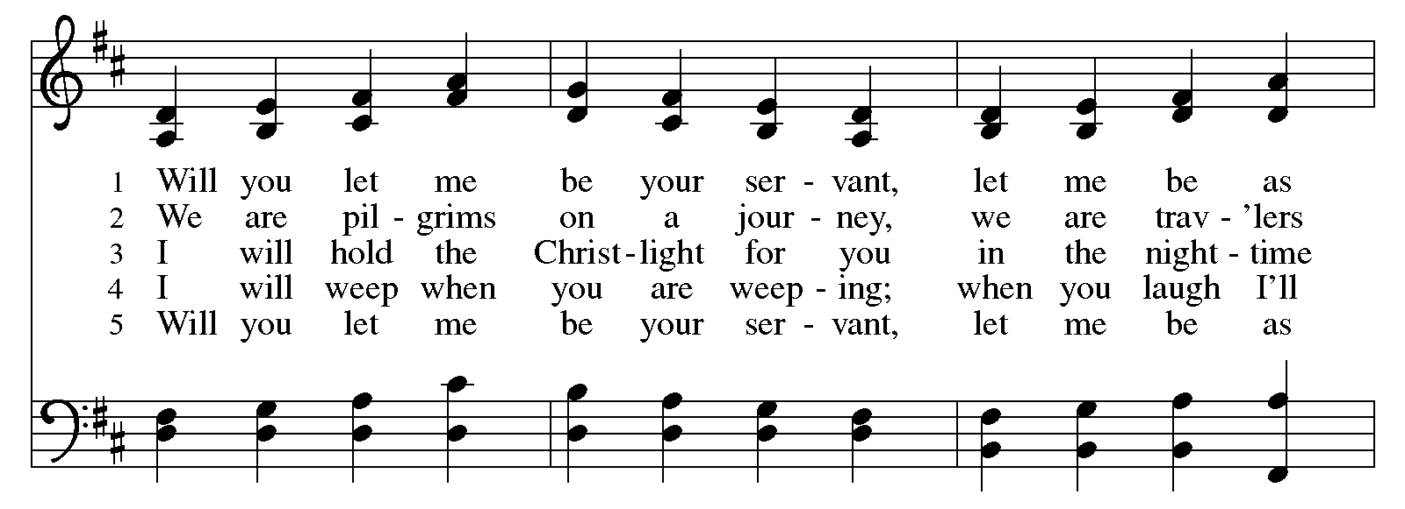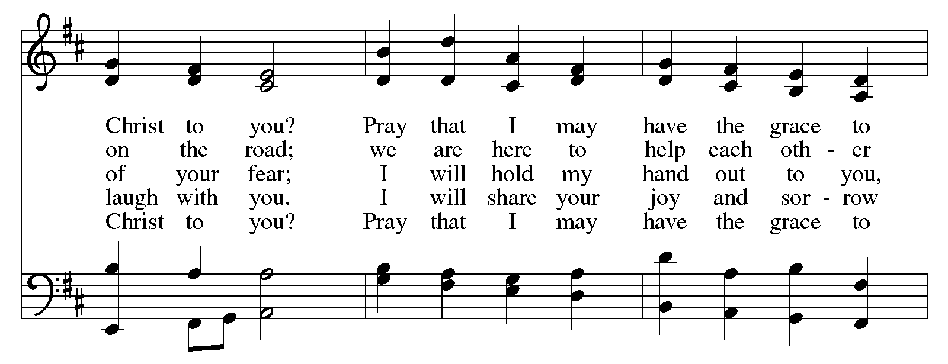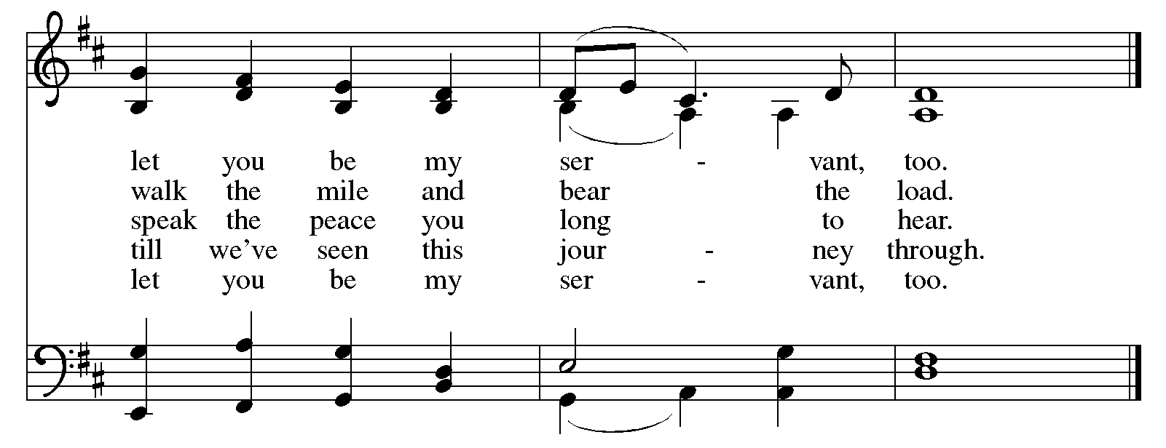
All rights reserved. Reprinted with permission under OneLicense.net # A-722139.
Hymns during Holy Communion
Eat This Bread ELW 472

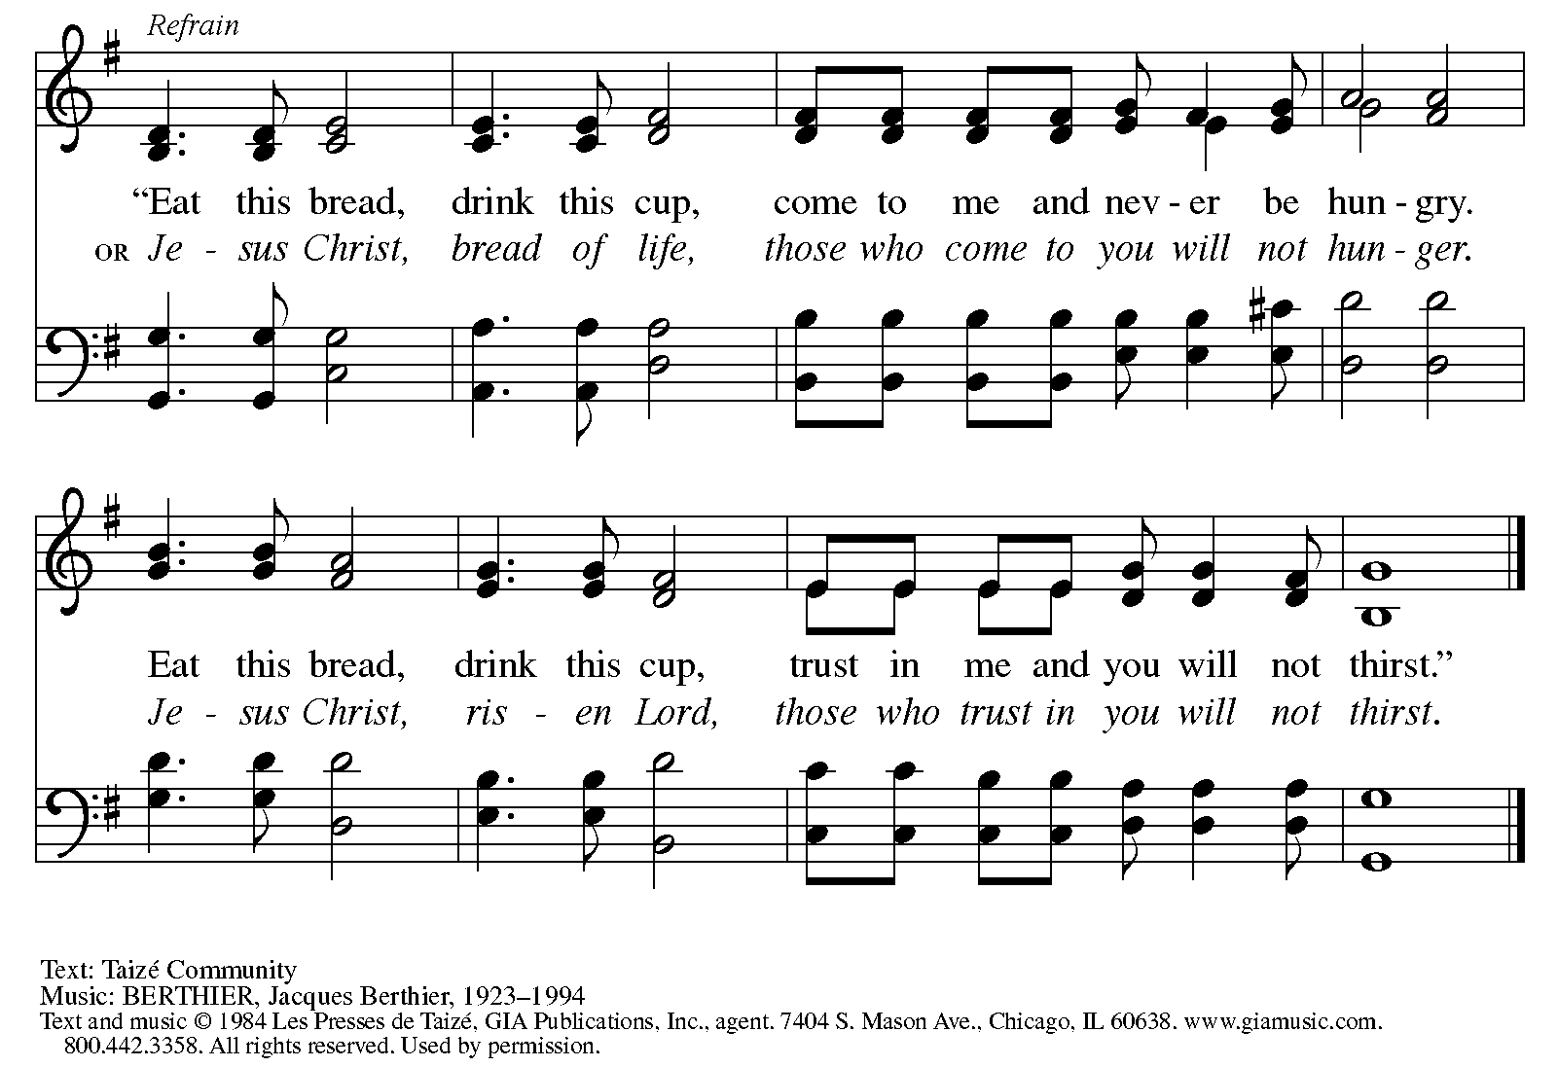
Reprinted under OneLicense.net # A-722139.

When all have returned to their places, please rise as you are able.

Blessing

P: The body and blood of our Lord Jesus Christ strengthen you and keep you in his grace.
C: Amen.

Prayer

A: Let us pray. Compassionate God,
through these gifts of bread and wine
our hearts are filled with the abundance of your love.
Strengthen us that we, through this holy meal,
may share your love freely, as you have shared with us.
We ask this in the name of Jesus,
through the Spirit nourishing us now and forever.
C: Amen.
Please be seated.

Sending
God blesses us and sends us in mission to the world

Announcements

Please rise as you are able.

Benediction

P: The love of God abound in you,
the grace of our Savior Jesus Christ fill your hearts;
and the life of the Spirit ☩ bless you and give you peace.
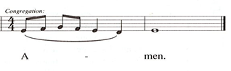
C:

Sending Hymn Following Page

Dismissal

A: Go in peace. Serve the Lord.
C: Thanks be to God!

Postlude

Sending Hymn Lift High the Cross ELW 660

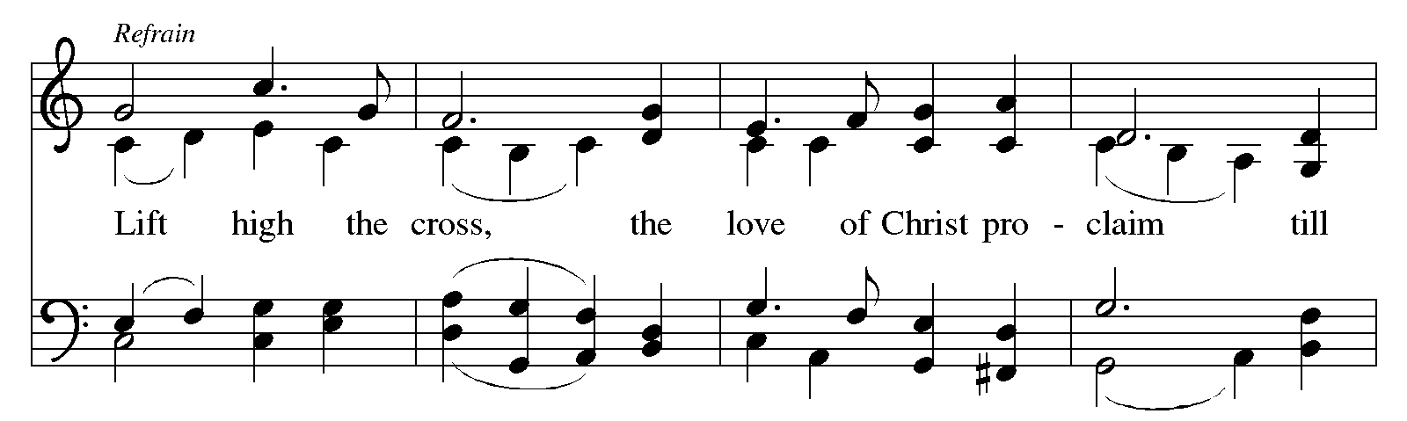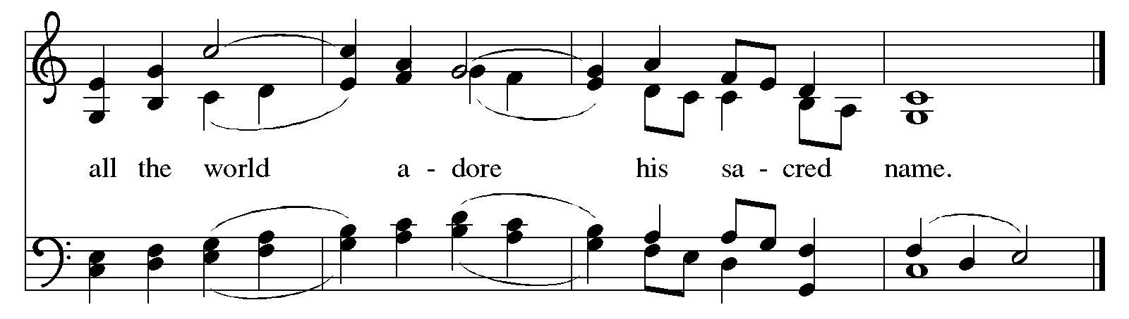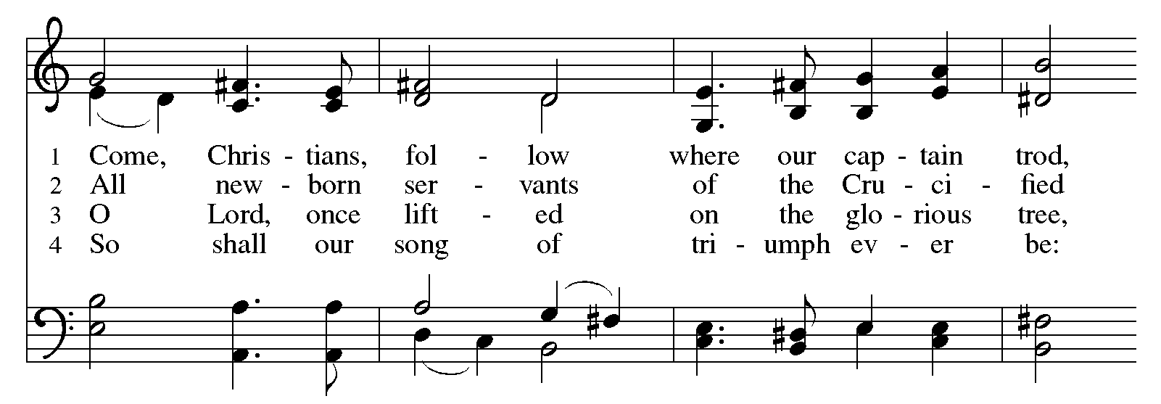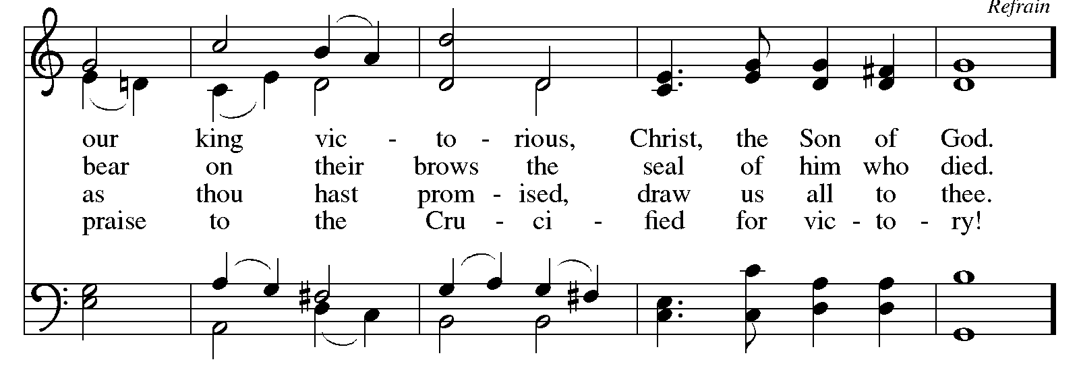
Reprinted under OneLicense.net # A-722139.
Those serving in worship today

Altar Care
Assisting Minister Christy Ruhe
Audio-Visual Ministers Tyler Rietze
Tim Jones
Cantor Jered Stratton
Lector Lindsay Baxter
Organ Jimmi Kocher-Hillmer
Minister of Music Laura Reynolds
Presiding Minister The Rev. Ross I. Carmichael

Liturgy and Hymnody Acknowledgements

From SundaysandSeasons.com. Copyright © 2026 Augsburg Fortress. All rights reserved. Reprinted under OneLicense.net # A-722139.
Used by permission of Augsburg Fortress.

From Hymnal Supplement. Copyright © 1991 GIA Publications, Inc. All rights reserved. Reprinted under OneLicense.net # A-722139.
Used by permission of GIA Publications, Inc.

The Scripture readings contained herein are from New Revised Standard Version Updated Edition of the Bible © 2021 National Council of Churches of Christ in the United States of America. Used by permission. All rights reserved worldwide.

Making Their Way – Text: Delores Dufner, OSB, b. 1939. Music: KOMT NU MET ZANG, A. Valerius, Nederlandtsch Gedenkclank, 1626; arr. Adrian Engels, 1906-2003. Text © 2011 GIA Publications, Inc., giamusic.com. All rights reserved. Arr. Gooi en Sticht, BV, Baarn, The Netherlands, admin. OCP, 5536 NE Hassalo, Portland, OR 97213. All rights reserved. Reprinted with permission under OneLicense.net # A-722139.

Take Up Your Cross, the Savior Said – Text: Charles W. Everest, 1814-1877, alt. Music: BOURBON, W. Hauser, Hesperian Harp, 1848; arr. hymnal version. Arr. © 2006 Augsburg Fortress. All rights reserved. Reprinted with permission under OneLicense.net # A-722139.

Please use the QR code below to link to St. Andrew’s Announcements online!



St. Andrew Lutheran Church Announcements
August 30th, 2026

- Welcome to Worship at St. Andrew on the Fourteenth Sunday after Pentecost – We are so glad you are here, and we offer a special welcome to all visitors and guests who are here for the first time! There are worship “toolkits” to help children engage with worship and “busy bags” for younger children available in the bookcase at the back of the sanctuary. Please feel free to take one to use with/for your children. A nursery is available through the door to the left of the worship space and across the social hall (look for a purple room).
- Help Move Furniture for Food Pantry and Little Church - Big Faith, Today, August 30th, after Worship – St. Andrew has received a grant to purchase a new industrial-sized refrigerator as we grow our ministry to address hunger in our local communities. Little Church - Big Faith and its supplies will be moving to an upstairs classroom, and we are asking for help from people who can carry large/heavy items upstairs after worship on Sunday, August 30th. Thank you for your support as we make adjustments to better facilitate our current ministries!
- September Produce Distribution, First and Third Tuesday of the Month, September 1st and 15th, 5:30-6:30 p.m. – St. Andrew partners with Greater Pittsburgh Community Food Bank to serve as a distribution site for fresh produce on the first and third Tuesday of every month. Next month’s distribution will be on Tuesday, September 1st and 15th. We invite people of the congregation to help with the distribution from 5:30 p.m. - 6:30 p.m. and/or to help with unloading and setup during the day between 10:00 a.m. and 1:00 p.m.
- Bible Book Club Returns, Wednesdays, Starting September 9th, 7:00 p.m. on Zoom – St. Andrew's weekly Bible Book Club will return on Wednesday, September 9th, at 7:00 p.m. For this new study, the group will be reading and discussing Karen Armstrong's A History of God. It can be found here: https://bookshop.org/p/books/a-history-of-god-the-4-000-year-quest-of-judaism-christianity-and-islam-karen-armstrong/277069b2cf4e39ad?ean=9780345384560. If anyone needs assistance in obtaining a book, please speak with Pastor Ross. Bible Book Club invites new participants, regardless of how often you can attend or whether or not you have read the specific material for the week. We encourage everyone to read the brief introduction before the first session! You can use this link to join the call: https://us02web.zoom.us/j/83196175976?pwd=ejdPOUYrTk4xVFdsdlhHUVJ1L3k2Zz09.
- Alternatives to Violence Project (AVP) Basic Workshop, September 12th and 19th, 9:00 a.m. - 8:00 p.m. – St. Andrew members are warmly invited to experience an Alternatives to Violence Project (AVP) Basic Workshop, hosted here at St. Andrew on Saturdays, September 12th and 19th, from 9:00 a.m. to 8:00 p.m., exploring practical ways to address conflict, strengthen relationships, communicate across differences, and discover the transforming power that can move us from aggression toward cooperation. AVP’s commitment to nonviolence, respect for every person, and building more just and peaceful communities resonates deeply with St. Andrew’s commitment to inclusion and justice. While the full two-day workshop offers the richest experience, you are also welcome to come for Day 1 — or even a portion of Day 1 — to experience AVP for yourself and see whether this work speaks to you. Experience with the basic workshop is a prerequisite for the advanced workshop, held November 6th-8th. Registration is required https://docs.google.com/forms/d/e/1FAIpQLSfW_fVUD_bkgcd4K1e9Q-t5fz-rW1mTF72C7pcAmTwfYiH50A/viewform. You can contact Martin Rafanan at 314-258-0452 or mjr9201@gmail.com with any questions.
- St. Andrew Talks about "Conscience and Conversation: A Study during Reconsideration of the Social Statement Human Sexuality: Gift and Trust" - Second Session Tuesday, September 8th, 7:00 p.m., on Zoom – The Evangelical Lutheran Church in America (ELCA) is seeking to update language from its 2009 social statement Human Sexuality: Gift and Trust, and is inviting congregations to engage in their own study and conversation in order to share feedback by September 30th. To guide these discussions, the ELCA has published Conscience and Conversation, which can be found here: https://resources.elca.org/faith-and-society/conscience-and-conversation-study/.
Pastor Ross will facilitate a conversation on the second session of this study on Zoom on Tuesday, September 8th, at 7:00 p.m. The link will be shared internally with the congregation, through the weekly email. If you cannot find it, please contact Pastor Ross.This will allow parishioners time to formulate and submit feedback to the churchwide organization by the deadline of September 30th. The ELCA has also released a five-episode podcast as a companion to the study. Individual episodes are available at elca.org/reconsiderations.
- Lutheran Campus Ministry BBQ Bash, Saturday, September 19th, 6:00 - 9:00 p.m. – Join us for an evening of good barbecue and even better friends as we gather to support the Lutheran Campus Ministry in Greater Pittsburgh. Trinity Lutheran Church (2500 Brandt School Road, Wexford, PA) are our gracious hosts this year. You can register at www.lucpgh.com or call 412-682-6886 to reserve your place.. The cost to attend is $40/adult or $100/family (2 adults and children 13 and under).
- Coffee Hour Signups – Coffee hour returns on September 13th! St. Andrew provides hospitality during a coffee hour after worship each Sunday. If you would like to participate and would like information about the duties of setting up, please sign up using the following form: https://www.signupgenius.com/go/5080B4AAFAF2CABF85-47069030-coffee#/.

