

+ Fifteenth Sunday after Pentecost
September 6, 2026



St. Andrew Lutheran Church
304 Morewood Ave.
Pittsburgh, PA 15213
St_andrewELCA@verizon.net
www.standrewpittsburgh.org

+ Fifteenth Sunday after Pentecost

Conflict is a part of relationships and life in community. Jesus’ words in today's gospel are often used in situations having to do with church discipline. The prophet Ezekiel tells of warning the wicked to turn from their ways, and Paul reminds us that love is the fulfilling of the law. We gather in the name of Christ, assured that he is present among us with gifts of peace and reconciliation.

Welcome to St. Andrew!
- St. Andrew welcomes all who are seeking a place of healing, wholeness, and acceptance in a nurturing and faith-forming spiritual home. We are striving toward racial equity worldwide
and we seek to honor the lived experience of all individuals regardless of background. Our community embraces people of all ages, ethnicities, cultures, abilities, sexual orientations,
gender identities and expressions, and family constellations. Come and See!
- Worship Services are live-streamed to multiple online platforms. By attending worship, you agree that your image and voice may be broadcast.
- Everyone is invited to make a name tag at the black bookcase in the back of the worship space if they would like. There are stickers indicating pronouns on the bookcase if you would like to include them on your name tag.
- Little Church – Big Faith, a Bible lesson and activity, for children up to sixth grade, will return next Sunday, September 13th.
- A nursery is available through the doors at the left side of the sanctuary and across from the doorway to the Social Hall. Look for a purple-colored room.
- Worship “toolkits” to help children engage with the service, along with “busy bags” for younger children, are available in the bookcase at the back of the sanctuary. Please feel free to take one to use with/for your children.
- Holy Communion is served with bread (gluten-free available) and wine or grape juice. The presiding minister will distribute the bread (host). Please consume this and then pick up an empty glass from the tray. The Communion Assistant will pour wine or grape juice into your glass. Please step to the side to consume the wine or grape juice. Feel free to kneel at the altar for prayer and reflection. As you return to your pew, glasses may be returned to the empty trays on either side of the center section.
- A restroom is available on the main level of the church, through the doors to the Social Hall and to the right in the main office.

Abbreviations
P: Pastor/Presiding Minister ELW: Evangelical Lutheran Worship hymnal
A: Assisting Minister ACS: All Creation Sings hymnal
L: Lector
C: Congregation

Musical Offering The Rev. Erin Jones

Each week, different people from the congregation make an offering of pre-service music, with singing or instrumentation, to help the assembly focus and pray in preparation for worship.

Welcome

Prelude Thy Word Michael W. Smith

Gathering
The Holy Spirit calls us together as the people of God

Please rise as you are able. All may make the sign of the cross,
the sign that is marked at Baptism, as the presiding minister begins.

Confession and Forgiveness

P: Blessed be the ☩ holy Trinity,
one God, whose compassion endures forever.
C: Amen.

P: If we say we have no sin, we deceive ourselves and the truth is not us.
Let us confess our sin to God who is faithful and just,
and who has promised to forgive sin and cleanse us from all unrighteousness.

Silence is kept for reflection.

P: Most merciful God,
C: we confess to you that we have sinned against you in thought, word, and deed,
by what we have done and by what we have left undone.
We have not trusted you with our whole heart;
we have not loved one another in deed and in truth.
In your compassion, forgive our sin and so uphold us by your Spirit
that we may live and serve you in newness of life,
through Jesus Christ, our light and our truth.
Amen.

P: With joy I proclaim to you that Almighty God,
rich in mercy, abundant in love,
forgives you all your sin and grants you newness of life
☩ in Jesus Christ.
C: Amen. Thanks be to God!

Gathering Hymn O God of Light ELW 507

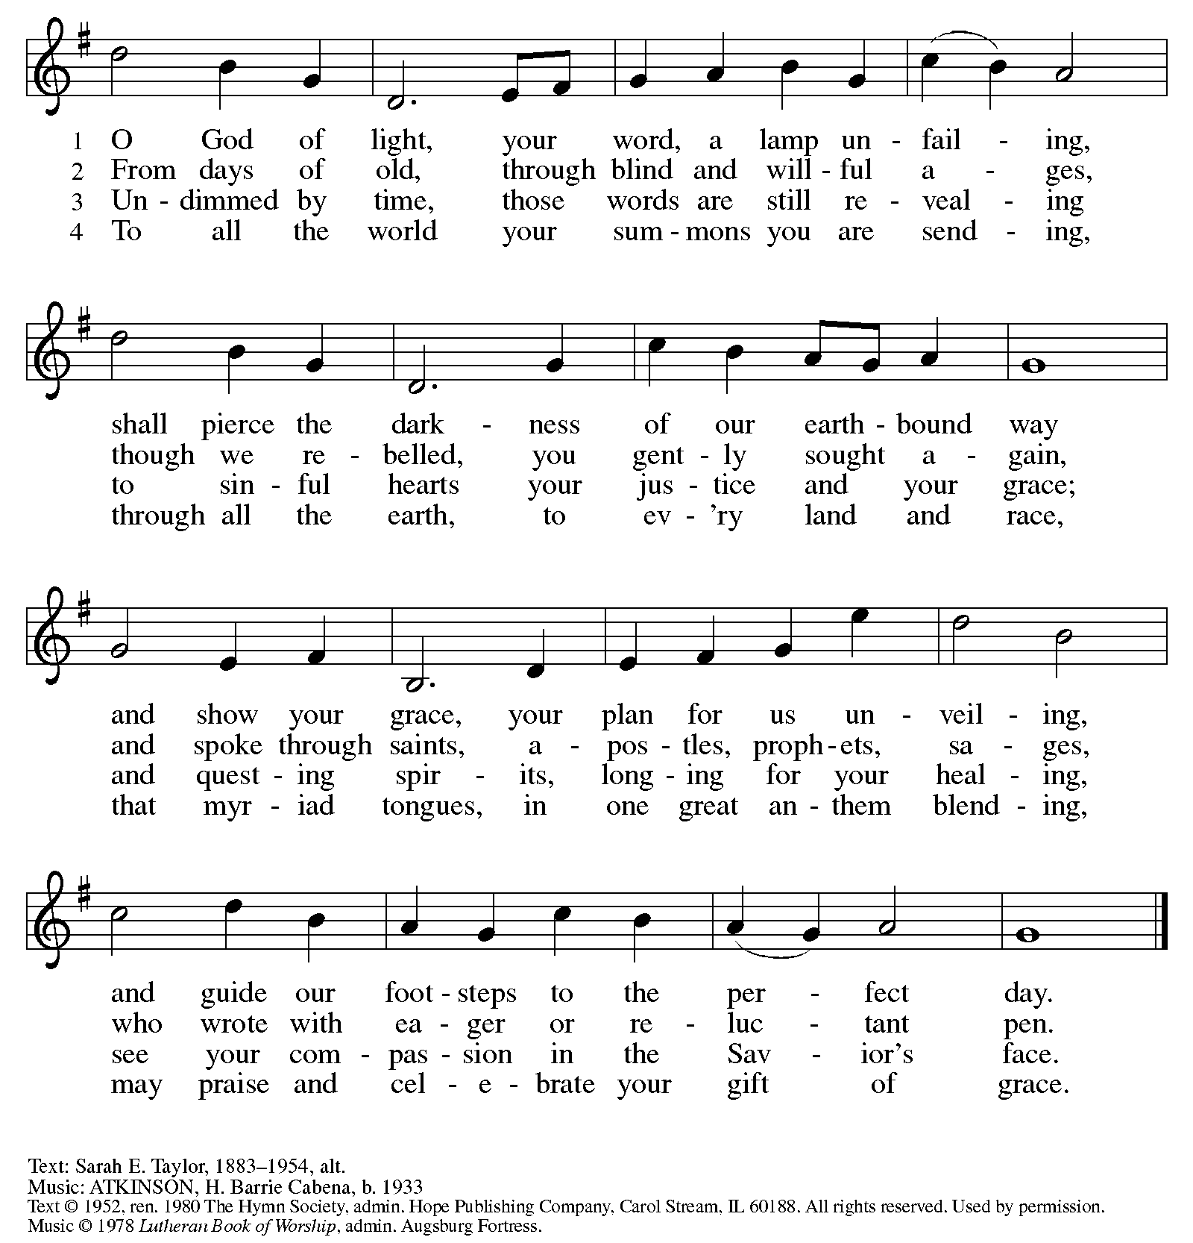
All rights reserved. Reprinted with permission under OneLicense.net # A-722139.

Greeting

P: The grace of our Lord Jesus Christ, the love of God,
and the communion of the Holy Spirit be with you all.
C: And also with you.

Hymn of Praise Glory to God HS p. 6-7

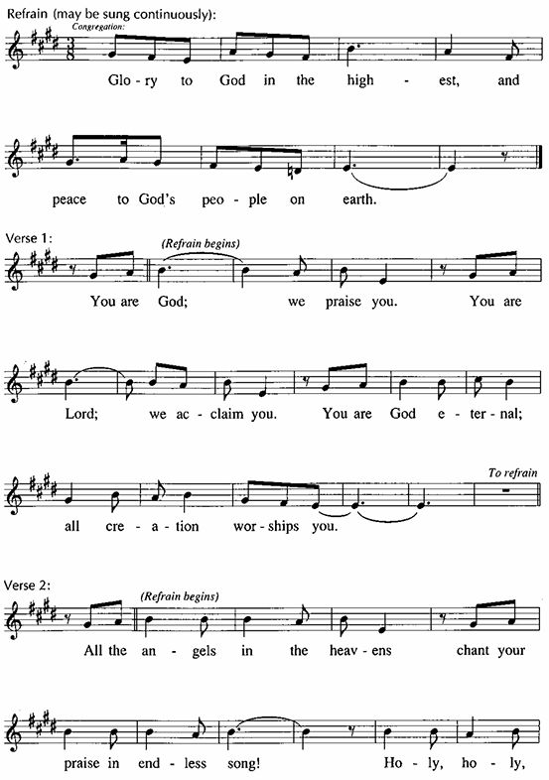

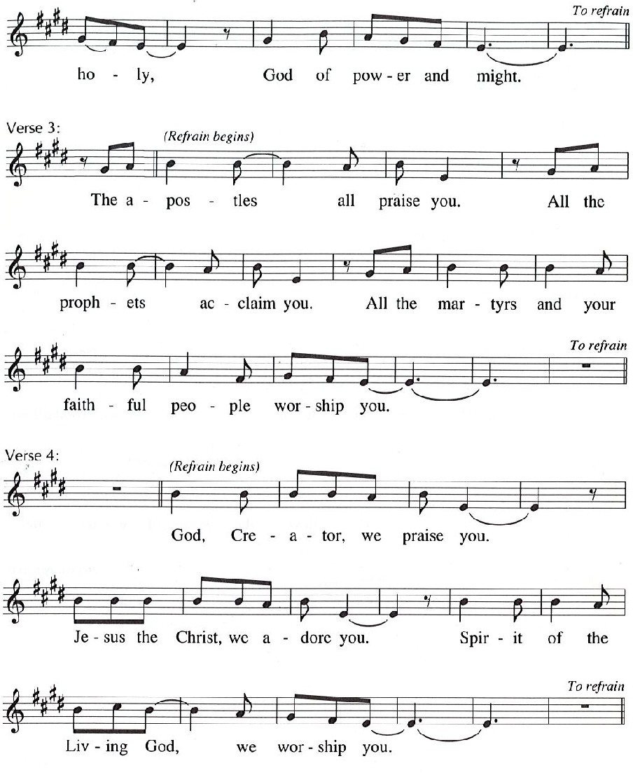

Prayer of the Day

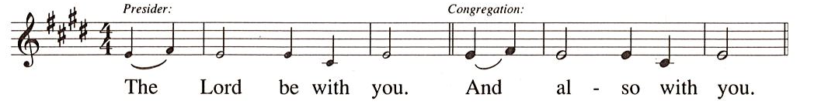
P: Let us pray.
O Lord God, enliven and preserve your church with your perpetual mercy.
Without your help, we mortals will fail;
remove far from us everything that is harmful,
and lead us toward all that gives life and salvation,
through Jesus Christ, our Savior and Lord.
C: Amen.

Please be seated.

Word
God speaks to us in Scripture reading, preaching, and song

First Reading – Ezekiel 33: 7-11

⁷ So you, mortal, I have made a sentinel for the house of Israel; whenever you hear a word from my mouth, you shall give them warning from me. ⁸ If I say to the wicked, “O wicked ones, you shall surely die,” and you do not speak to warn the wicked to turn from their ways, the wicked shall die in their iniquity, but their blood I will require at your hand. ⁹ But if you warn the wicked to turn from their ways and they do not turn from their ways, the wicked shall die in their iniquity, but you will have saved your life.
¹⁰ Now you, mortal, say to the house of Israel: Thus you have said: “Our transgressions and our sins weigh upon us, and we waste away because of them; how then can we live?” ¹¹ Say to them: As I live, says the Lord God, I have no pleasure in the death of the wicked but that the wicked turn from their ways and live; turn back, turn back from your evil ways, for why will you die, O house of Israel?

L: Word of God, word of life.
C: Thanks be to God.

Psalm 119: 33-40

The psalm will be read responsively, led by the cantor,
with the congregation responding with the verses in bold.
Psalm Tone

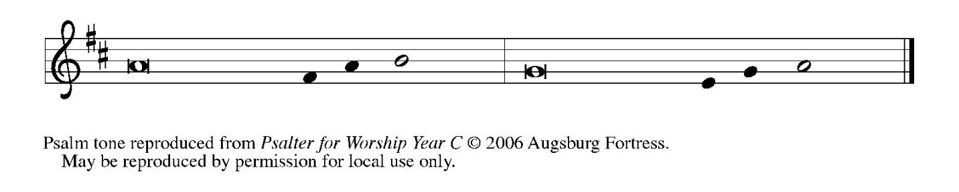

Psalm Refrain

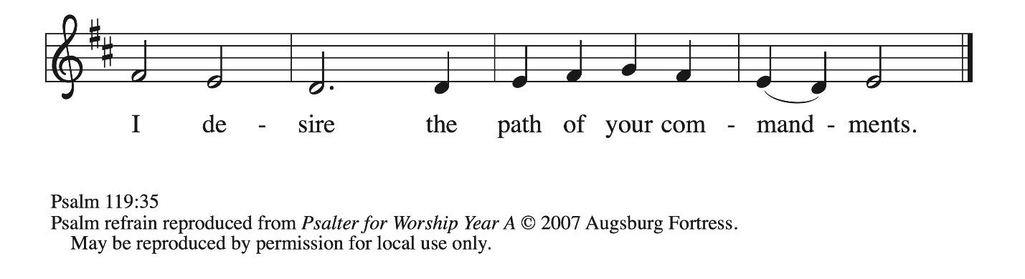

³³ Teach me, O Lord, the way | of your statutes,
and I shall keep it | to the end.
³⁴ Give me understanding, and I shall | keep your teaching;
I shall keep it with | all my heart.
³⁵ Lead me in the path of | your commandments,
for that is | my desire.
³⁶ Incline my heart to | your decrees
and not to | unjust gain. R
³⁷ Turn my eyes from be- | holding falsehood;
give me life | in your way.
³⁸ Fulfill your promise | to your servant,
which is for | those who fear you.
³⁹ Turn away the reproach | that I dread,
because your judg- | ments are good.
⁴⁰ Behold, I long for | your commandments;
by your righteousness en- | liven me. R

Second Reading – Romans 13: 8-14

⁸ Owe no one anything, except to love one another, for the one who loves another has fulfilled the law. ⁹ The commandments, “You shall not commit adultery; you shall not murder; you shall not steal; you shall not covet,” and any other commandment, are summed up in this word,
“You shall love your neighbor as yourself.” ¹⁰ Love does no wrong to a neighbor; therefore, love is the fulfilling of the law.
¹¹ Besides this, you know what time it is, how it is already the moment for you to wake from sleep. For salvation is nearer to us now than when we became believers; ¹² the night is far gone; the day is near. Let us then throw off the works of darkness and put on the armor of light; ¹³ let us walk decently as in the day, not in reveling and drunkenness, not in illicit sex and licentiousness, not in quarreling and jealousy. ¹⁴ Instead, put on the Lord Jesus Christ, and make no provision for the flesh, to gratify its desires.
L: Word of God, word of life.
C: Thanks be to God.

Please rise as you are able.

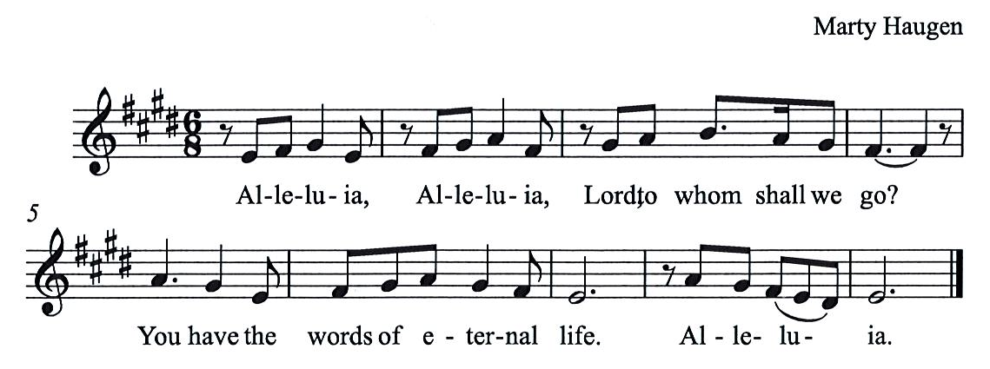
Gospel Acclamation HS p. 8

Gospel – Matthew 18: 15-20

P: The holy Gospel according to St. Matthew.
C: Glory to you, O Lord.
[Jesus said to the disciples:] ¹⁵ “If your sibling sins against you, go and point out the fault when the two of you are alone. If you are listened to, you have regained that one. ¹⁶ But if you are not listened to, take one or two others along with you, so that every word may be confirmed by the evidence of two or three witnesses. ¹⁷ If that person refuses to listen to them, tell it to the church, and if the offender refuses to listen even to the church, let such a one be to you as a gentile and a tax collector. ¹⁸ Truly I tell you, whatever you bind on earth will be bound in heaven, and whatever you loose on earth will be loosed in heaven. ¹⁹ Again, truly I tell you, if two of you agree on earth about anything you ask, it will be done for you by my Father in heaven. ²⁰ For where two or three are gathered in my name, I am there among them.”

P: The Gospel of the Lord.
C: Praise to you, O Christ.

Please be seated.

Sermon

A time of silence for prayer and reflection follows the sermon.
When the hymn of the day begins, please rise as you are able.

Hymn of the Day God, When Human Bonds Are Broken ELW 603

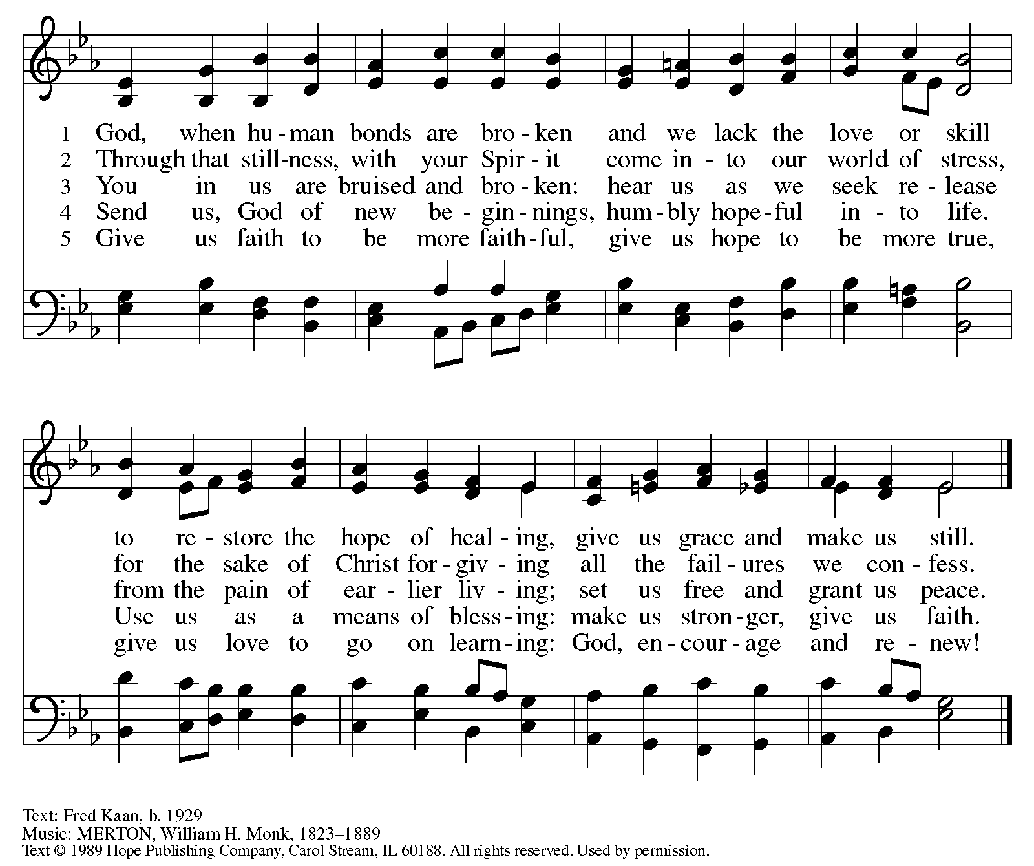
Reprinted under OneLicense.net # A-722139.

Apostles’ Creed

C: I believe in God, the Father almighty,
creator of heaven and earth.

C: I believe in Jesus Christ, God’s only Son, our Lord,
who was conceived by the Holy Spirit,
born of the virgin Mary,
suffered under Pontius Pilate,
was crucified, died, and was buried;
he descended to the dead.*
On the third day he rose again;
he ascended into heaven,
he is seated at the right hand of the Father,
and he will come to judge the living and the dead.

I believe in the Holy Spirit,
the holy catholic church,
the communion of saints,
the forgiveness of sins,
the resurrection of the body,
and the life everlasting. Amen.

*Or, “he descended into hell,” another translation of this text in widespread use.

Prayers of the People

A: Trusting in God’s steadfast love for all God has made,
let us pray for the church, the world, and those who are in need.

After each petition
A: Gracious God,
C: receive our prayer.

The presiding minister concludes the prayers
P: Grateful for your abundant provision and trusting in your goodness, O God,
we commend all for whom we pray, through the priceless grace of Jesus Christ.
C: Amen.

Peace

The presiding minister and the assembly greet one another in the peace of the risen Christ.
P: The peace of Christ be with you always.
C: And also with you.

The people may greet those around them with a sign of Christ’s peace and may say
Peace be with you or similar words. Please be mindful that not everyone will be comfortable with sharing the peace, so please seek consent before shaking hands or hugging. Other possible ways to share the peace include a simple bow with the verbal greeting of peace, or simply a verbal expression of peace. When the greetings of peace have concluded, please be seated.



Meal
God feeds us with the presence of Jesus Christ

Offering

We offer ourselves, our gifts, and our faithful service to God.
As the offering is gathered for the mission of the church, including the care of those in need,
the table is set for Holy Communion.

There are laminated giving cards in the pew racks that feature a QR code for anyone who would like to give online. Those who give using the QR code, as well as those who give regularly online or through their bank are encouraged to place the laminated card in the plate as an expression of your offering.

Reparations Offering

On the first Sunday of each month, St. Andrew invites people of the congregation to give a second offering for a reparations fund in acknowledgment of St. Andrew’s use of African American spiritual songs in our worship services. Please see the note in the announcements for more information.
Music during the Offering
Oceans Rise, Coastlands Tremble arr. Helgen

As the gifts are brought forward for presentation, please rise as you are able.
Offertory Song As the Grains of Wheat ELW 465

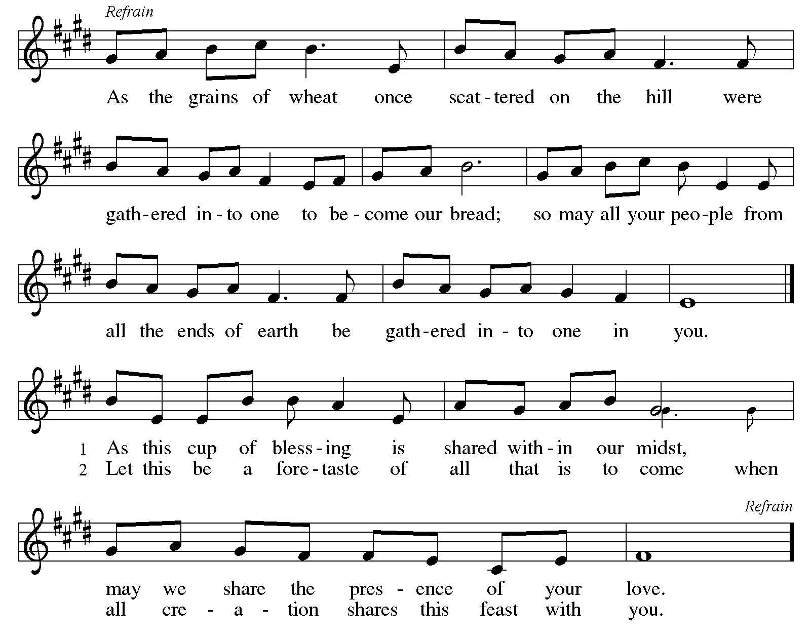

Offertory Prayer

A: Let us pray.
Merciful God,
C: everything in heaven and on earth belongs to you.
We joyfully release what you have entrusted to us.
May these gifts be signs of our whole lives returned to you,
dedicated to the healing and unity of all creation,
through Jesus Christ.
Amen.

Dialogue HS p. 14

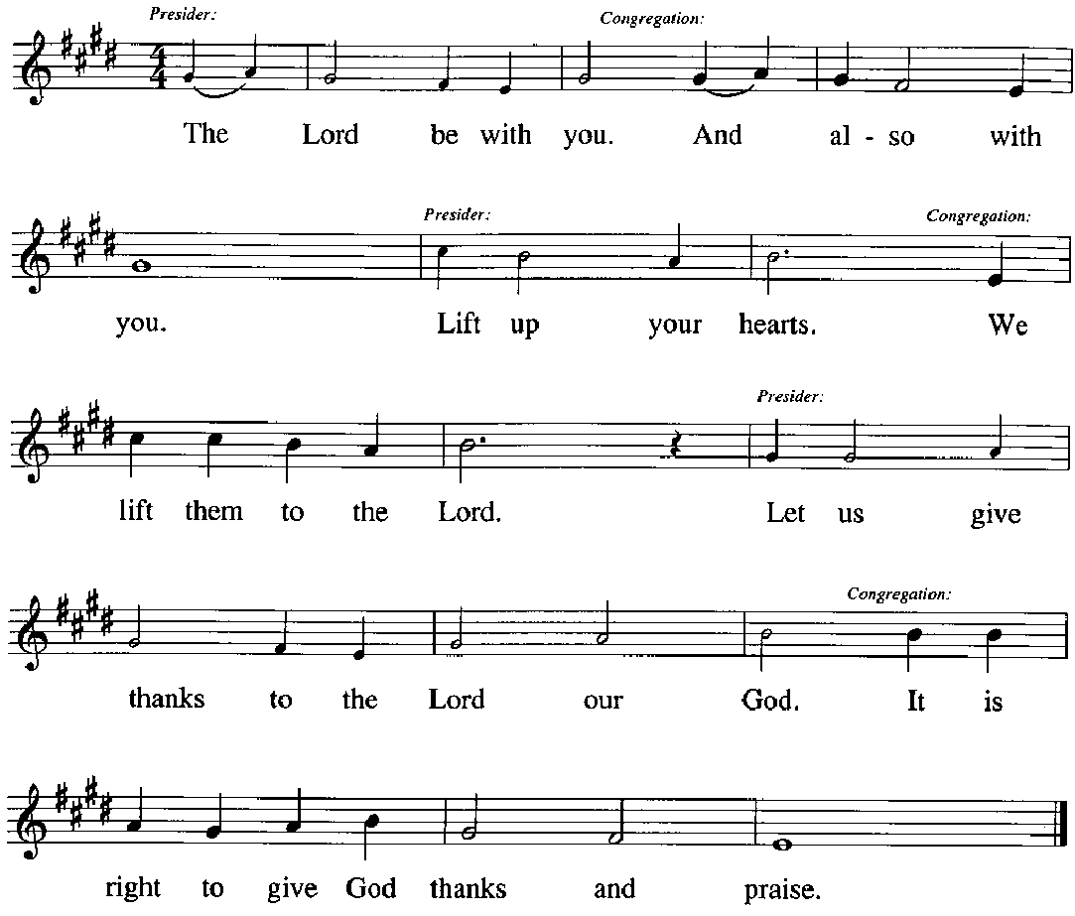

Preface (Sung by the presiding minister)

P: It is our duty and delight,
that we should everywhere and always
offer thanks and praise to you, O God,
through Jesus Christ,
who calls us to follow his way
of humble service and love,
and so with the church on earth,
all creation and the hosts of heaven,
we praise your name and join their unending hymn:
Sanctus HS p. 15

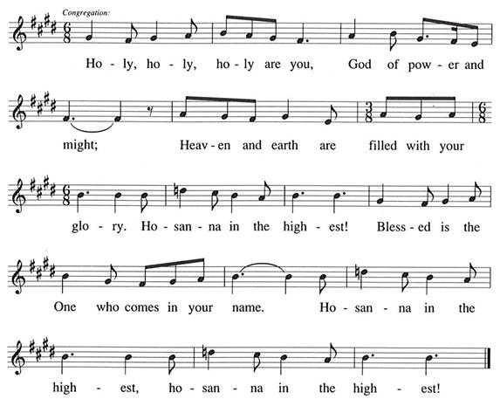

Eucharistic Prayer

P: You are indeed holy, gracious and merciful God …
… Do this for the remembrance of me.

Remembering his command to love one another,
his life and death, his resurrection and ascension,
we pray for his coming again, even as we cry:

(Sung by the presiding minister)
P: Amen. Come, Lord Jesus. Amen. Come, Lord Jesus.
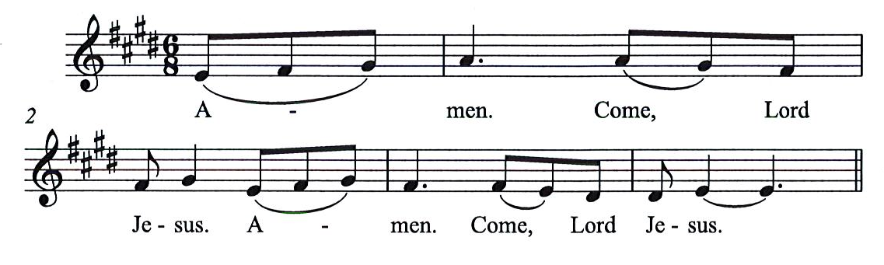
C:

P: Send now, we pray, your Holy Spirit,
that all of your promises
may come to us and your whole creation.

(Sung by the presiding minister)
P: Amen. Come Holy Spirit. Amen. Come, Holy Spirit.
C:
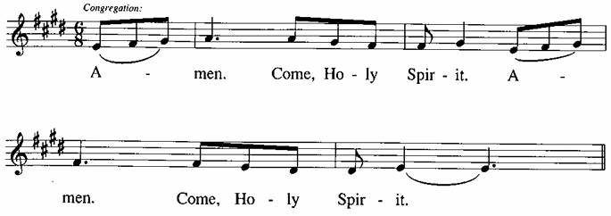

P: This we pray through Jesus Christ,
our Savior and our friend.
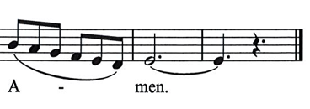
C:
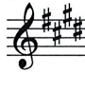

Lord’s Prayer

P: Gathered as one by the Holy Spirit, we pray as Jesus taught us.
C: Our Father in heaven,
hallowed be your name,
your kingdom come,
your will be done,
on earth as in heaven.
Give us today our daily bread.
Forgive us our sins,
as we forgive those
who sin against us;
Save us from the time of trial,
and deliver us from evil.
For the kingdom, the power,
and the glory are yours,
now and ever. Amen.

Fraction and Invitation

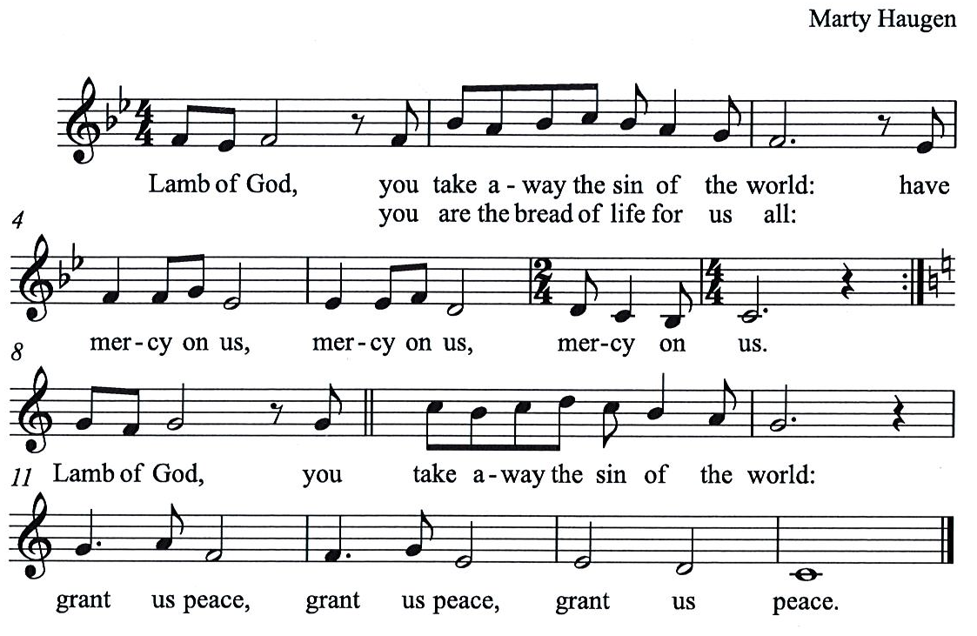
Agnus Dei / Lamb of God HS p. 18

Please be seated.

Holy Communion

- All who seek God and desire a deeper and stronger life in Christ are welcome to receive Holy Communion.
- Worshipers from the pulpit side will proceed forward first, followed by the center section, and then the lectern side.
- Please inform an usher if you would like the ministers to bring Communion to you.
- Holy Communion will be served with bread and wine (red) or grape juice (white).
- The presiding minister will first distribute the bread (host) to each communicant. Please indicate if you require a gluten-free host.
- Once you have consumed the bread, please pick up an empty glass from the tray next to the presiding minister. The Communion Assistant will pour wine or grape juice into your glass.
- Please step to the side to consume the wine or grape juice.
- Feel free to kneel at the altar rail for prayer after receiving the sacrament.
- As you return to your pew, glasses may be returned to the empty tray on the side of the center section.
- A blessing will be provided for anyone who does not yet receive the sacrament.
- All are invited to join in singing the hymns during Holy Communion.

Hymns during Holy Communion
Beloved, God’s Chosen ELW 648

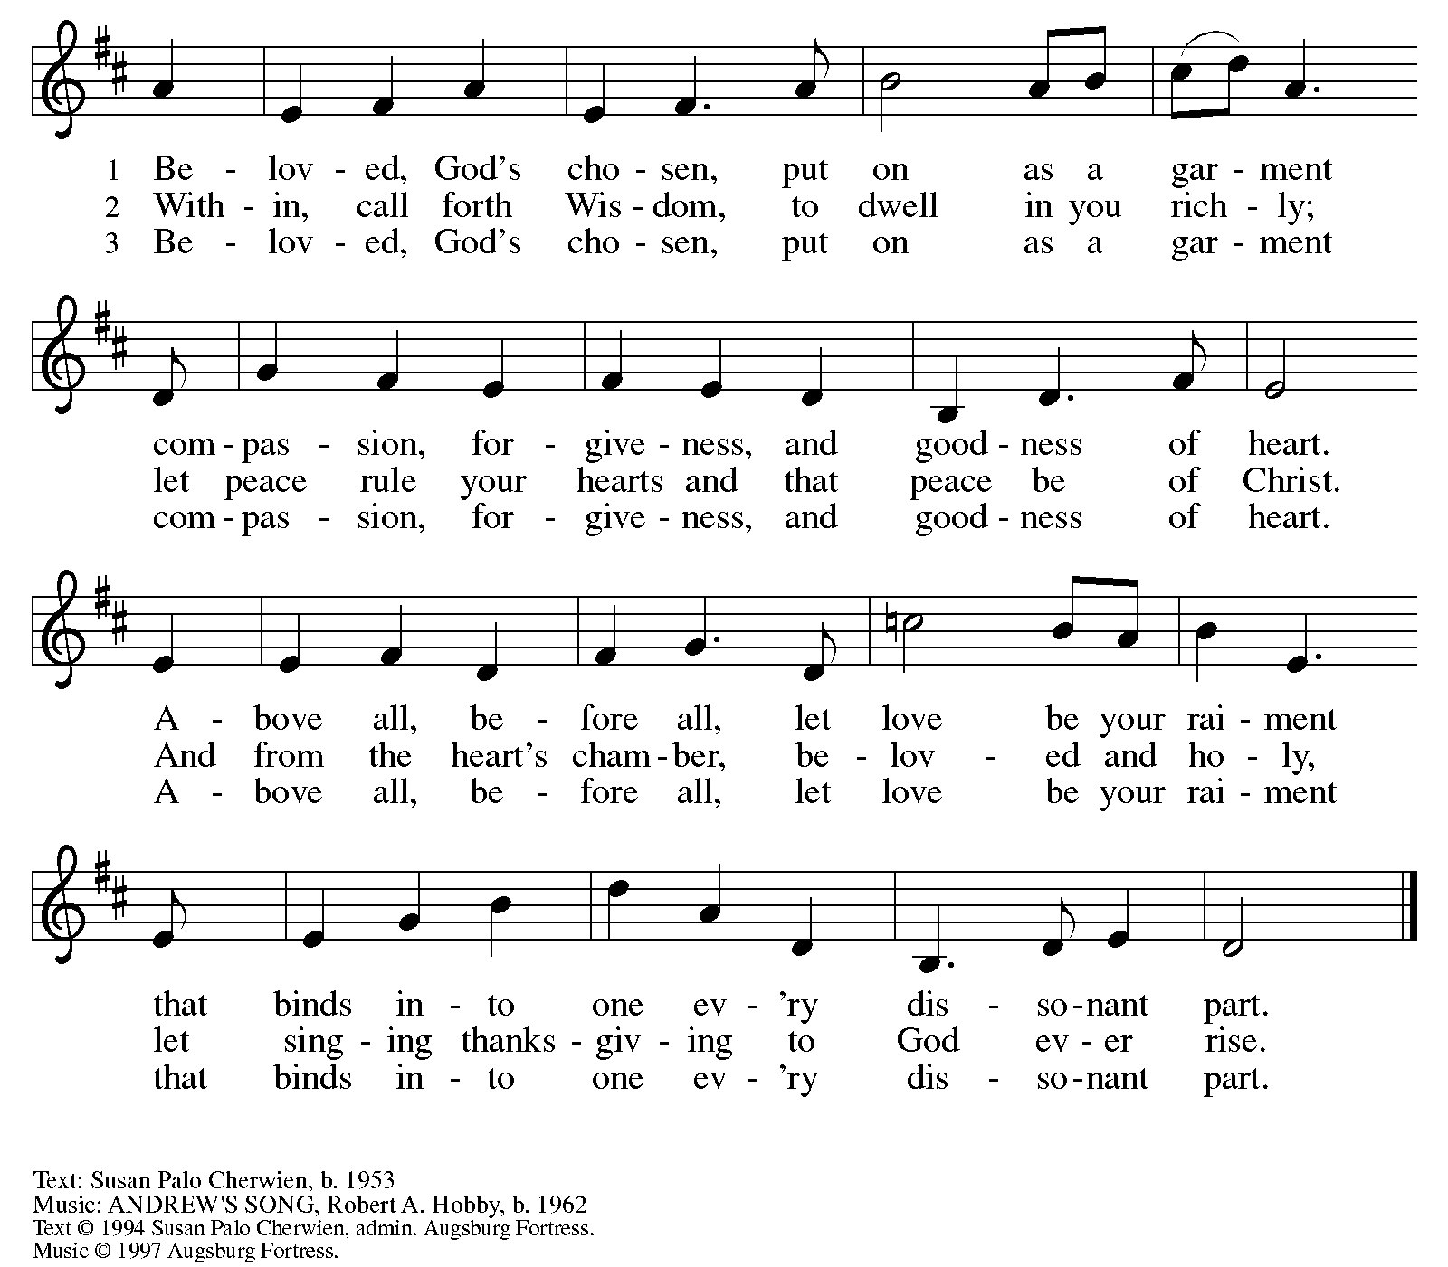
All rights reserved. Reprinted with permission under OneLicense.net # A-722139.

Hymns during Holy Communion
Search Me, O God ACS 1076

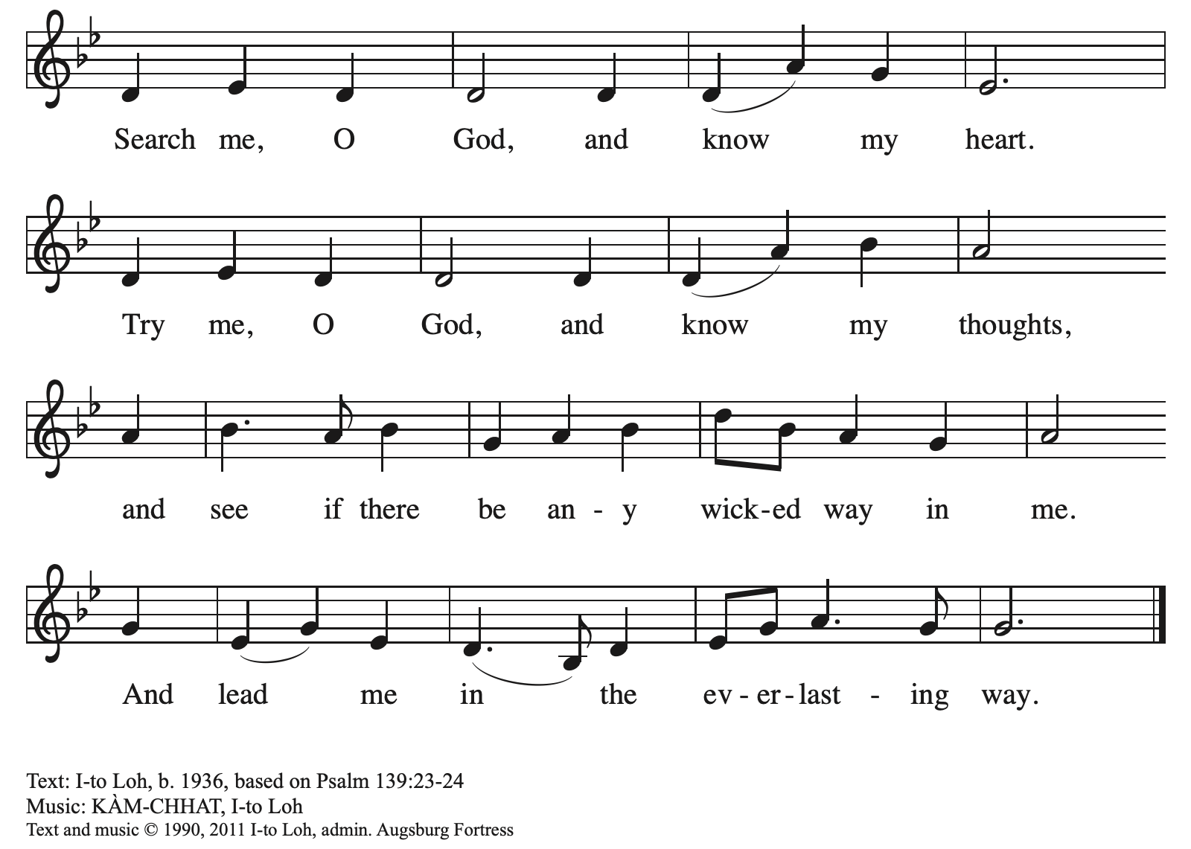
All rights reserved. Reprinted with permission under OneLicense.net # A-722139.

Hymns during Holy Communion
Faith Begins by Letting Go ACS 1004

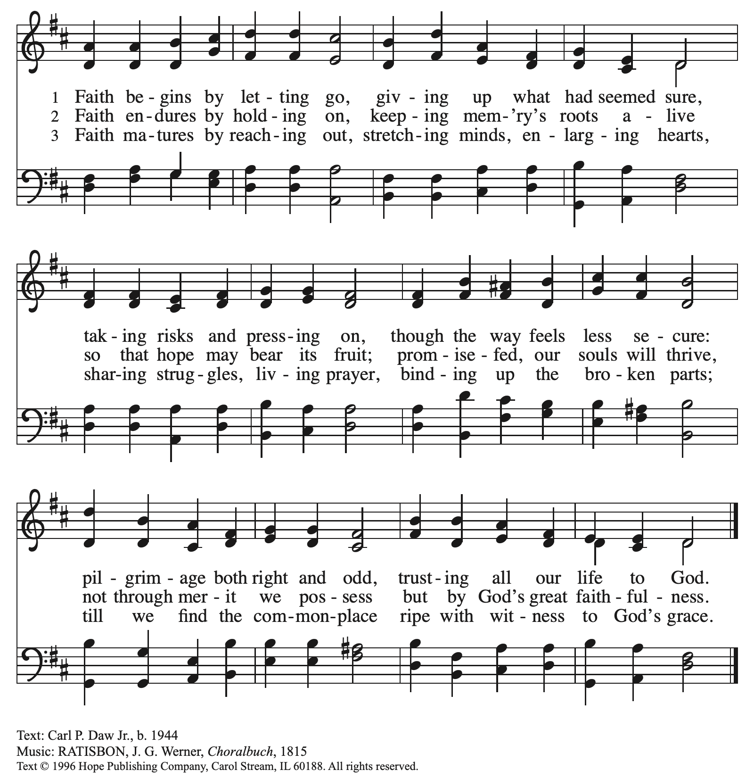
All rights reserved. Reprinted with permission under OneLicense.net # A-722139.

When all have returned to their places, please rise as you are able.

Blessing

P: The body and blood of our Lord Jesus Christ strengthen you and keep you in his grace.
C: Amen.
Prayer

A: Let us pray.
Compassionate God,
through these gifts of bread and wine
our hearts are filled with the abundance of your love.
Strengthen us that we, through this holy meal,
may share your love freely, as you have shared with us.
We ask this in the name of Jesus,
through the Spirit nourishing us now and forever.
C: Amen.

Please be seated.

Sending
God blesses us and sends us in mission to the world

Announcements

Please rise as you are able.

Benediction

P: The love of God abound in you,
the grace of our Savior Jesus Christ fill your hearts;
and the life of the Spirit ☩ bless you and give you peace.
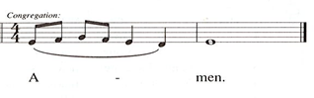
C:

Sending Hymn Following Page

Dismissal

A: Go in peace. Serve the Lord.
C: Thanks be to God!

Postlude

Sending Hymn Praise the Lord, Rise Up Rejoicing ELW 544

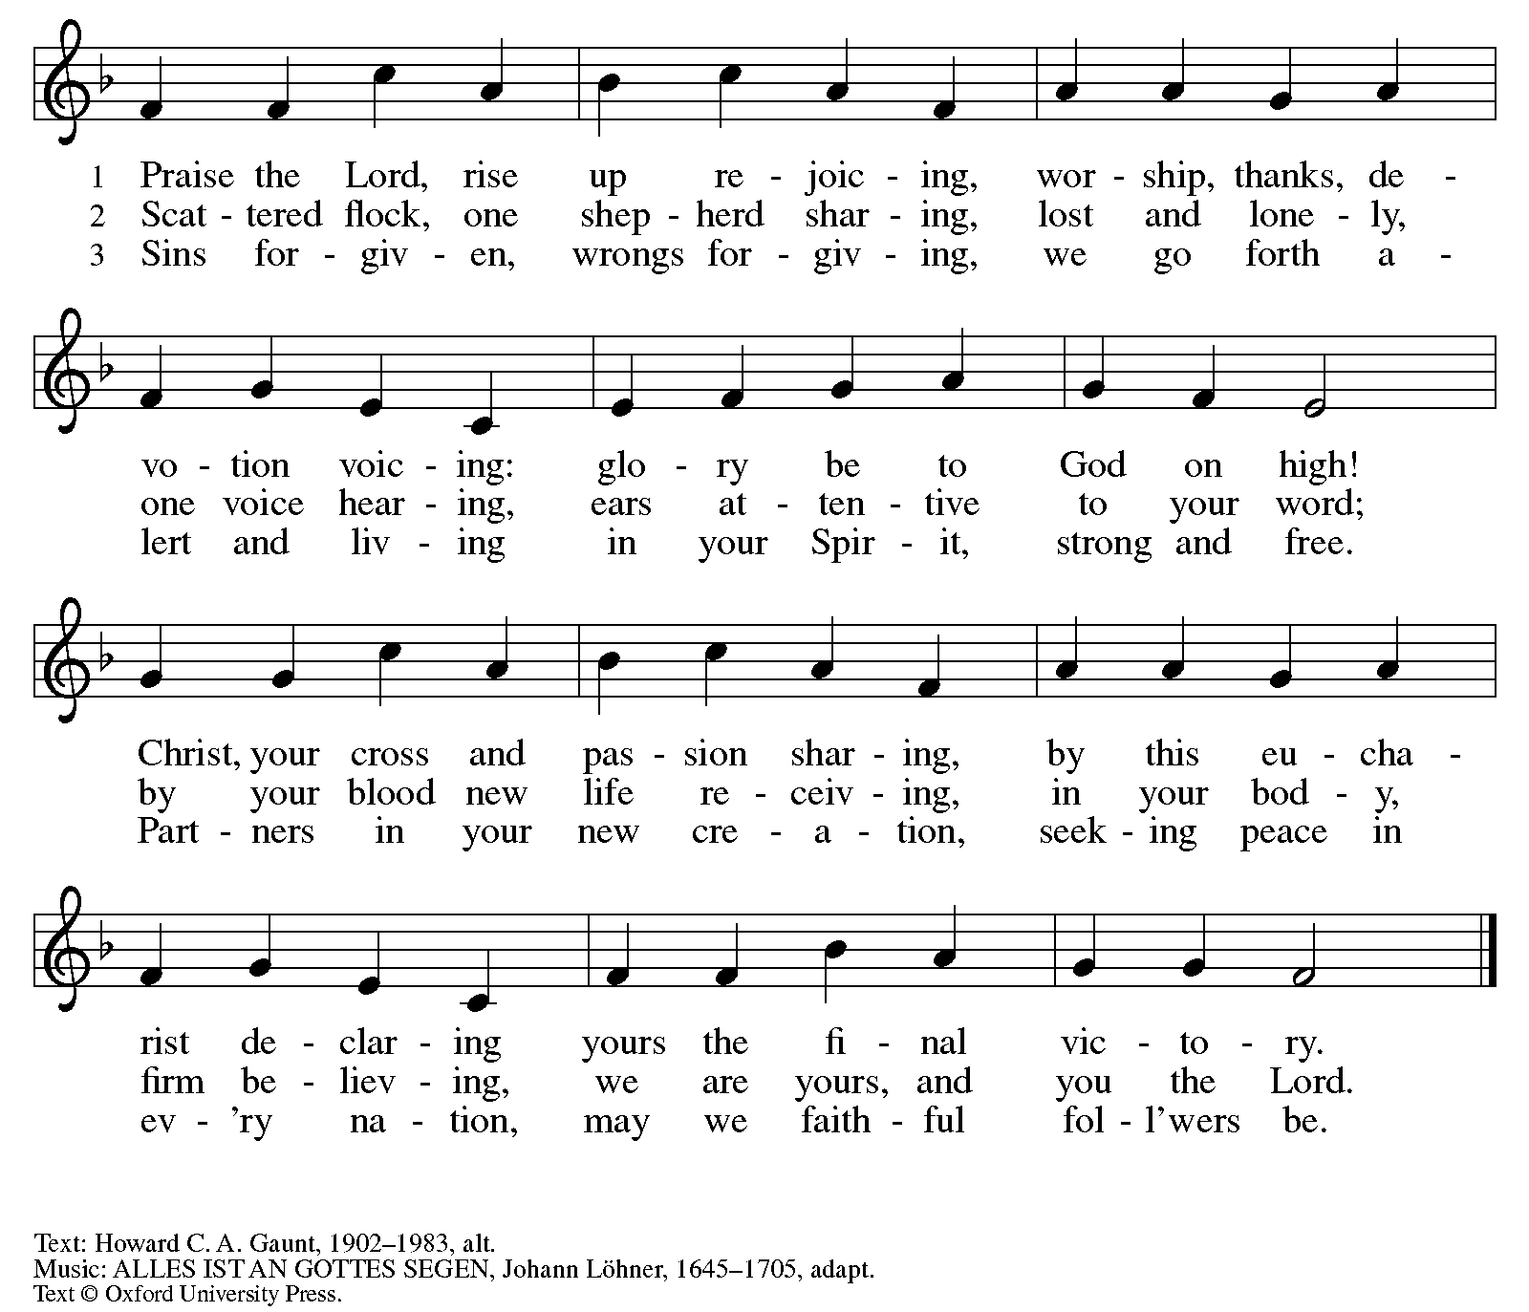
All rights reserved. Reprinted with permission under OneLicense.net # A-722139.

Those serving in worship today

Altar Care Jodie Minor
Assisting Minister Colleen Cooke
Audio-Visual Ministers Dave Rollinson
Jered Stratton
Cantor Mandy Best
Lector Lester Prince
Preservice Musical Offering
and Vocalist on Prelude The Rev. Erin Jones
Minister of Music Laura Reynolds
Presiding Minister The Rev. Ross I. Carmichael

Liturgy and Hymnody Acknowledgements

From SundaysandSeasons.com. Copyright © 2026 Augsburg Fortress. All rights reserved. Reprinted under OneLicense.net # A-722139.
Used by permission of Augsburg Fortress.

From Hymnal Supplement. Copyright © 1991 GIA Publications, Inc. All rights reserved. Reprinted under OneLicense.net # A-722139.
Used by permission of GIA Publications, Inc.

The Scripture readings contained herein are from New Revised Standard Version Updated Edition of the Bible © 2021 National Council of Churches of Christ in the United States of America. Used by permission. All rights reserved worldwide.

Please use the QR code below to link to St. Andrew’s Announcements online!



St. Andrew Lutheran Church Announcements
September 6th, 2026

- Welcome to Worship at St. Andrew on the Fifteenth Sunday after Pentecost – We are thankful you are here, and we offer a special welcome to all visitors and guests who are here for the first time! A nursery is available through the door to the left of the worship space and across the social hall (look for a purple room). Little Church – Big Faith, a Bible lesson and activity for children up to sixth grade, will take place after the prayer of the day. There are also worship “toolkits” to help children engage with worship and “busy bags” for younger children available in the bookcase at the back of the sanctuary. Please feel free to take one to use with/for your children. All are invited to stay for coffee and other drinks, food, and conversation in the Social Hall (through the side door at the left of the worship space) after the service.
- Monthly Reparations Offering Today during Worship – In Luke’s Gospel, Jesus tells a story about a compassionate Samaritan, suggesting that God’s people are called to work for healing and restoration for our neighbors, regardless of who or what caused them harm. In light of this, St. Andrew has made a commitment to reparations in regard to African American spiritual songs used in our worship. The text and music of most hymns is attributed to specific authors, with copyrights in place, usage reported, and royalties paid to those whose works are featured in worship. With African American spirituals, this is not possible. In response to many years of such uncredited use, St. Andrew invites the congregation to give a reparations offering. Funds received in worship will be donated to our siblings at Bethel AME Church, whose land and building were taken from them in the 1950s, to fund their development in the Hill District.
- St. Andrew's Capital Campaign Continues – We are thrilled to announce that this past year's construction work on a new roof and related areas for St. Andrew is complete, and the plastering and painting in the sanctuary is underway! Now that the summer is over, the time has come to renew our conversation about St. Andrew's capital campaign intended to pay for these projects. St. Andrew set a goal of $1 million for the campaign and we are 86% of the way there! We thank all who have made commitments to the campaign thus far.
- St. Andrew Talks about "Conscience and Conversation: A Study during Reconsideration of the Social Statement Human Sexuality: Gift and Trust" - Second Session Tuesday, September 8th, 7:00 p.m., on Zoom – The Evangelical Lutheran Church in America (ELCA) is seeking to update language from its 2009 social statement Human Sexuality: Gift and Trust, and is inviting congregations to engage in their own study and conversation in order to share feedback by September 30th. To guide these discussions, the ELCA has published Conscience and Conversation, which can be found here: https://resources.elca.org/faith-and-society/conscience-and-conversation-study/.
Pastor Ross will facilitate a conversation on the second session of this study on Zoom on Tuesday, September 8th, at 7:00 p.m. The link will be shared internally with the congregation, through the weekly email. If you cannot find it, please contact Pastor Ross. This will allow parishioners time to formulate and submit feedback to the churchwide organization by the deadline of September 30th. The ELCA has also released a five-episode podcast as a companion to the study. Individual episodes are available at elca.org/reconsiderations.
- Bible Book Club Returns, Wednesdays, Starting September 9th, 7:00 p.m. on Zoom – St. Andrew's weekly Bible Book Club will return on Wednesday, September 9th, at 7:00 p.m. For this new study, the group will be reading and discussing Karen Armstrong's A History of God. It can be found here: https://bookshop.org/p/books/a-history-of-god-the-4-000-year-quest-of-judaism-christianity-and-islam-karen-armstrong/277069b2cf4e39ad?ean=9780345384560. If anyone needs assistance in obtaining a book, please speak with Pastor Ross. Bible Book Club invites new participants, regardless of how often you can attend or whether or not you have read the specific material for the week. We encourage everyone to read the brief introduction before the first session! You can use this link to join the call: https://us02web.zoom.us/j/83196175976?pwd=ejdPOUYrTk4xVFdsdlhHUVJ1L3k2Zz09.
- Alternatives to Violence Project (AVP) Basic Workshop, September 12th and 19th, 9:00 a.m. - 8:00 p.m. – St. Andrew members are warmly invited to experience an Alternatives to Violence Project (AVP) Basic Workshop, hosted here at St. Andrew on Saturdays, September 12th and 19th, from 9:00 a.m. to 8:00 p.m., exploring practical ways to address conflict, strengthen relationships, communicate across differences, and discover the transforming power that can move us from aggression toward cooperation. AVP’s commitment to nonviolence, respect for every person, and building more just and peaceful communities resonates deeply with St. Andrew’s commitment to inclusion and justice. While the full two-day workshop offers the richest experience, you are also welcome to come for Day 1 — or even a portion of Day 1 — to experience AVP for yourself and see whether this work speaks to you. Experience with the basic workshop is a prerequisite for the advanced workshop, held November 6th-8th. Registration is required https://docs.google.com/forms/d/e/1FAIpQLSfW_fVUD_bkgcd4K1e9Q-t5fz-rW1mTF72C7pcAmTwfYiH50A/viewform. You can contact Martin Rafanan at 314-258-0452 or mjr9201@gmail.com with any questions.
- Coffee Hour Signups – Coffee hour returns this week! St. Andrew provides hospitality during a coffee hour after worship each Sunday. If you would like to participate and would like information about the duties of setting up, please sign up using the following form: https://www.signupgenius.com/go/5080B4AAFAF2CABF85-47069030-coffee#/.
- Produce Distribution Supplemental Food of the Month – St. Andrew is collecting supplemental food each month to accompany our produce distribution. For September, we ask for donations of rice. There are collection boxes at the back of the worship space and social hall.
- September Produce Distribution, Third Tuesday of the Month, September 15th, 5:30-6:30 p.m. – St. Andrew partners with Greater Pittsburgh Community Food Bank to serve as a distribution site for fresh produce on the first and third Tuesday of every month. We invite people of the congregation to help with the distribution from 5:30 p.m. - 6:30 p.m. and/or to help with unloading and setup during the day between 10:00 a.m. and 1:00 p.m.
- Lutheran Campus Ministry BBQ Bash, Saturday, September 19th, 6:00 - 9:00 p.m. – Join us for an evening of good barbecue and even better friends as we gather to support the Lutheran Campus Ministry in Greater Pittsburgh. Trinity Lutheran Church (2500 Brandt School Road, Wexford, PA) are our gracious hosts this year. You can register at www.lucpgh.com or call 412-682-6886 to reserve your place.. The cost to attend is $40/adult or $100/family (2 adults and children 13 and under).
- Lunch Club at Church Brew Works, Sunday, September 27th after Worship – Kelly Spanninger is organizing a renewal of St. Andrew lunch outings after Sunday worship. All are invited to gather at Church Brew Works at 3525 Liberty Ave, Pittsburgh, PA 15201 at 12:15 p.m. Please let Kelly know if you plan to attend, or contact her at pkspanninger@verizon.net.

