

+ Sixteenth Sunday after Pentecost
September 13, 2026



St. Andrew Lutheran Church
304 Morewood Ave.
Pittsburgh, PA 15213
St_andrewELCA@verizon.net
www.standrewpittsburgh.org

+ Sixteenth Sunday after Pentecost

In today’s second reading Paul questions why we judge one another, since we all stand before the judgment of God. Yet we do sin against one another, and Jesus’ challenge that we forgive seventy-seven times reveals God’s boundless mercy. When we hear the words of forgiveness in worship and sign ourselves with the cross, we are renewed in Baptism to be signs of reconciliation in the world.

Welcome to St. Andrew!
- St. Andrew welcomes all who are seeking a place of healing, wholeness, and acceptance in a nurturing and faith-forming spiritual home. We are striving toward racial equity worldwide
and we seek to honor the lived experience of all individuals regardless of background. Our community embraces people of all ages, ethnicities, cultures, abilities, sexual orientations,
gender identities and expressions, and family constellations. Come and See!
- Worship Services are live-streamed to multiple online platforms. By attending worship, you agree that your image and voice may be broadcast.
- Everyone is invited to make a name tag at the black bookcase in the back of the worship space if they would like. There are stickers indicating pronouns on the bookcase if you would like to include them on your name tag.
- Children up to sixth grade are invited to attend Little Church – Big Faith, a Bible lesson and activity, during worship (after the Prayer of the Day). The group returns to the worship space for the liturgy of Holy Communion.
- A nursery is available through the doors at the left side of the sanctuary and across from the doorway to the Social Hall. Look for a purple-colored room.
- Worship “toolkits” to help children engage with the service, along with “busy bags” for younger children, are available in the bookcase at the back of the sanctuary. Please feel free to take one to use with/for your children.
- Holy Communion is served with bread (gluten-free available) and wine or grape juice. The presiding minister will distribute the bread (host). Please consume this and then pick up an empty glass from the tray. The Communion Assistant will pour wine or grape juice into your glass. Please step to the side to consume the wine or grape juice. Feel free to kneel at the altar for prayer and reflection. As you return to your pew, glasses may be returned to the empty trays on either side of the center section.
- A restroom is available on the main level of the church, through the doors to the Social Hall and to the right in the main office.

Abbreviations
P: Pastor/Presiding Minister ELW: Evangelical Lutheran Worship hymnal
A: Assisting Minister ACS: All Creation Sings hymnal
L: Lector
C: Congregation

Musical Offering

Each week, different people from the congregation make an offering of pre-service music, with singing or instrumentation, to help the assembly focus and pray in preparation for worship.

Welcome
Prelude Great God, Your Love Has Called Us arr. Raabe

Gathering
The Holy Spirit calls us together as the people of God

Please rise as you are able. All may make the sign of the cross,
the sign that is marked at Baptism, as the presiding minister begins.

Confession and Forgiveness

P: Blessed be the ☩ holy Trinity,
one God, whose compassion endures forever.
C: Amen.

P: If we say we have no sin, we deceive ourselves and the truth is not us.
Let us confess our sin to God who is faithful and just,
and who has promised to forgive sin and cleanse us from all unrighteousness.

Silence is kept for reflection.

P: Most merciful God,
C: we confess to you that we have sinned against you in thought, word, and deed,
by what we have done and by what we have left undone.
We have not trusted you with our whole heart;
we have not loved one another in deed and in truth.
In your compassion, forgive our sin and so uphold us by your Spirit
that we may live and serve you in newness of life,
through Jesus Christ, our light and our truth.
Amen.

P: With joy I proclaim to you that Almighty God,
rich in mercy, abundant in love,
forgives you all your sin and grants you newness of life
☩ in Jesus Christ.
C: Amen. Thanks be to God!

Gathering Hymn God Is Here! ELW 526

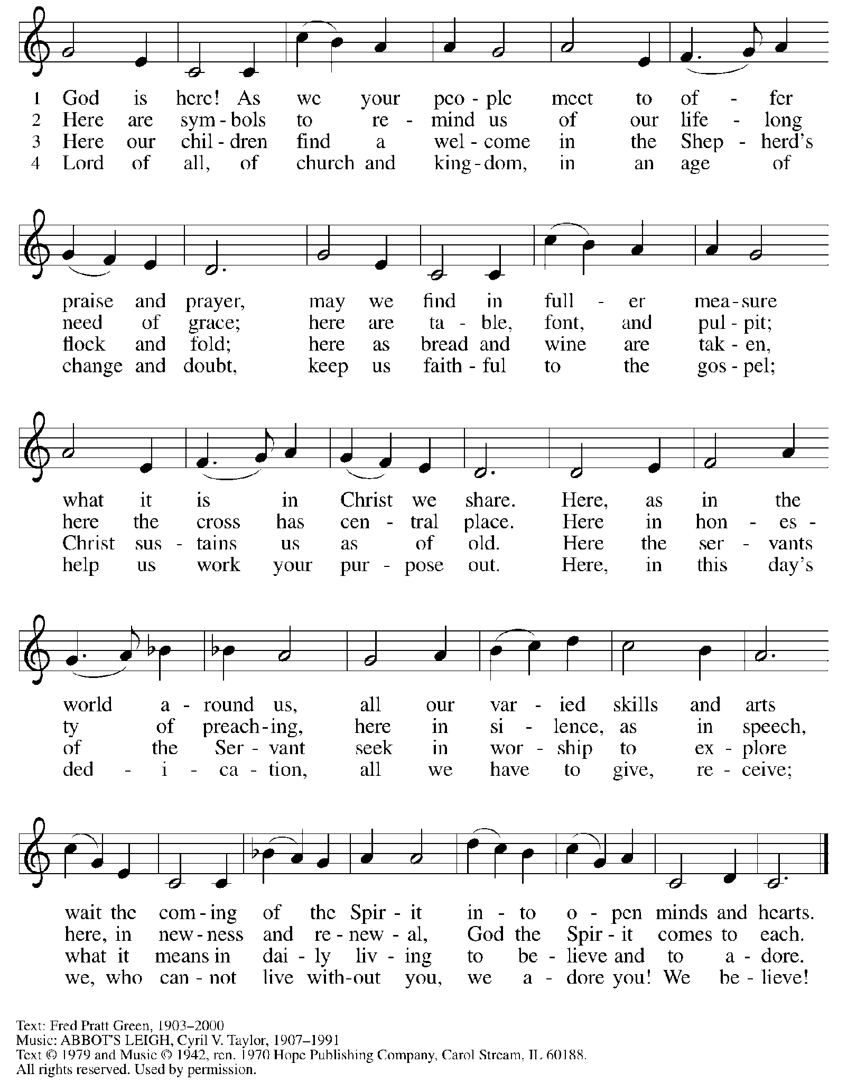
Reprinted under OneLicense.net # A-722139.
Greeting

P: The grace of our Lord Jesus Christ, the love of God,
and the communion of the Holy Spirit be with you all.
C: And also with you.

Hymn of Praise Glory to God HS p. 6-7

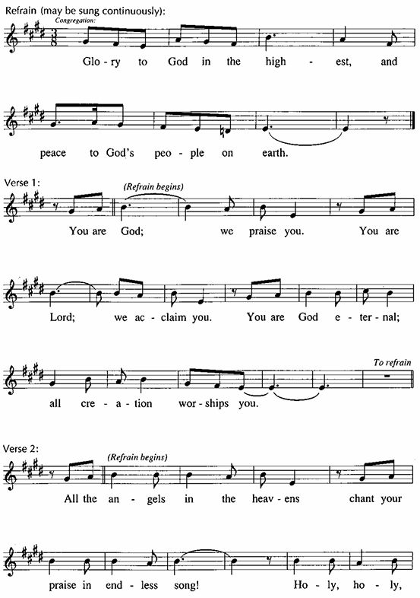

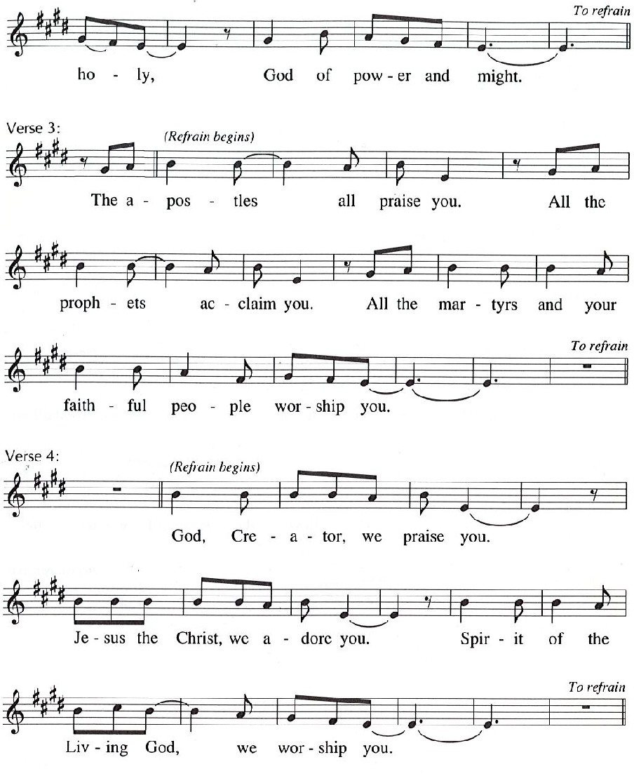

Prayer of the Day

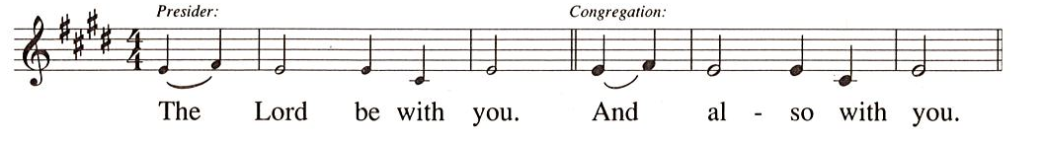
P: Let us pray.
O Lord God, merciful judge, you are the inexhaustible fountain of forgiveness.
Replace our hearts of stone with hearts that love and adore you,
that we may delight in doing your will, through Jesus Christ, our Savior and Lord.
C: Amen.

Please be seated.

Word
God speaks to us in Scripture reading, preaching, and song

First Reading – Genesis 50: 15-21

¹⁵ Realizing that their father was dead, Joseph’s brothers said, “What if Joseph still bears a grudge against us and pays us back in full for all the wrong that we did to him?” ¹⁶ So they approached Joseph, saying, “Your father gave this instruction before he died, ¹⁷ ‘Say to Joseph:
I beg you, forgive the crime of your brothers and the wrong they did in harming you.’ Now therefore please forgive the crime of the servants of the God of your father.” Joseph wept when they spoke to him. ¹⁸ Then his brothers also wept, fell down before him, and said, “We are here as your slaves.” ¹⁹ But Joseph said to them, “Do not be afraid! Am I in the place of God? ²⁰ Even though you intended to do harm to me, God intended it for good, in order to preserve a numerous people, as he is doing today. ²¹ So have no fear; I myself will provide for you and your little ones.” In this way he reassured them, speaking kindly to them.

L: Word of God, word of life.
C: Thanks be to God.

Psalm 103: [1-7] 8-13

The psalm will be sung responsively, led by the cantor,
with the congregation responding with the verses in bold.

Psalm Tone

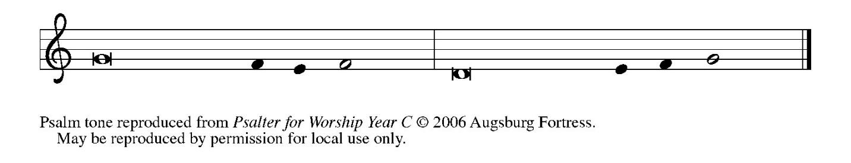

Psalm Refrain

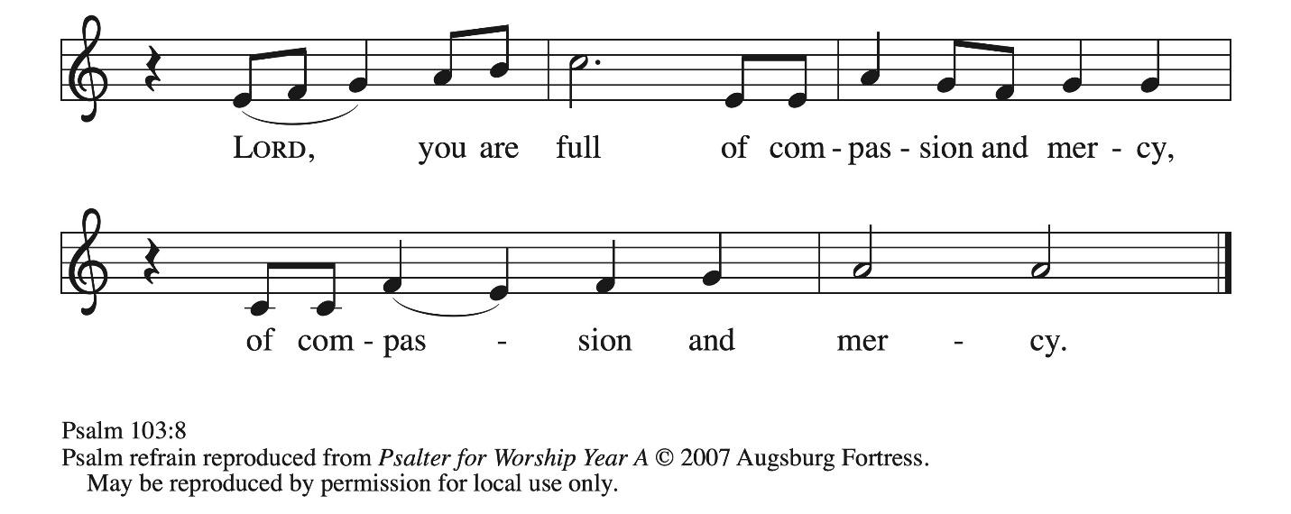

[ ¹ Bless the Lord, | O my soul,
and all that is within me, bless God’s | holy name.
² Bless the Lord, | O my soul,
and forget not | all God’s benefits—
³ who forgives | all your sins
and heals all | your diseases;
⁴ who redeems your life | from the grave
and crowns you with steadfast | love and mercy; R
⁵ who satisfies your desires | with good things
so that your youth is renewed | like an eagle’s.
⁶ O Lord, you provide | vindication
and justice for all who | are oppressed.
⁷ You made known your | ways to Moses
and your works to the chil- | dren of Israel.
] ⁸ Lord, you are full of compas- | sion and mercy,
slow to anger and abounding in | steadfast love; R
⁹ you will not al- | ways accuse us,
nor will you keep your an- | ger forever.
¹⁰ You have not dealt with us according | to our sins,
nor repaid us according to | our iniquities.
¹¹ For as the heavens are high a- | bove the earth,
so great is your steadfast love for | those who fear you.
¹² As far as the east is | from the west,
so far have you removed our transgres- | sions from us.
¹³ As a father has compassion | for his children,
so you have compassion for those who fear | you, O Lord. R

Second Reading – Romans 14: 1-12

¹ Welcome those who are weak in faith but not for the purpose of quarreling over opinions.
² Some believe in eating anything, while the weak eat only vegetables. ³ Those who eat must not despise those who abstain, and those who abstain must not pass judgment on those who eat, for God has welcomed them. ⁴ Who are you to pass judgment on slaves of another? It is before their own lord that they stand or fall. And they will be upheld, for the Lord is able to make them stand.
⁵ Some judge one day to be better than another, while others judge all days to be alike. Let all be fully convinced in their own minds. ⁶ Those who observe the day, observe it for the Lord. Also those who eat, eat for the Lord, since they give thanks to God, while those who abstain, abstain for the Lord and give thanks to God.
⁷ For we do not live to ourselves, and we do not die to ourselves. ⁸ If we live, we live to the Lord, and if we die, we die to the Lord; so then, whether we live or whether we die, we are the Lord’s. ⁹ For to this end Christ died and lived again, so that he might be Lord of both the dead and the living.
¹⁰ Why do you pass judgment on your sibling? Or you, why do you despise your sibling? For we will all stand before the judgment seat of God. ¹¹ For it is written,
“As I live, says the Lord, every knee shall bow to me,
and every tongue shall give praise to God.”
¹² So then, each one of us will be held accountable.
L: Word of God, word of life.
C: Thanks be to God.

Please rise as you are able.

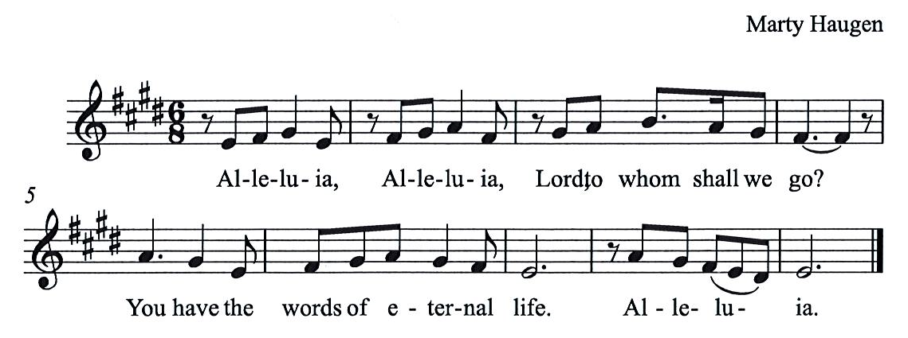
Gospel Acclamation HS p. 8

Gospel – Matthew 18: 21-35

P: The holy Gospel according to St. Matthew.
C: Glory to you, O Lord.
²³ “For this reason the kingdom of heaven may be compared to a king who wished to settle accounts with his slaves. ²⁴ When he began the reckoning, one who owed him ten thousand talents was brought to him, ²⁵ and, as he could not pay, the lord ordered him to be sold, together with his wife and children and all his possessions and payment to be made. ²⁶ So the slave fell on his knees before him, saying, ‘Have patience with me, and I will pay you everything.’ ²⁷ And out of pity for him, the lord of that slave released him and forgave him the debt. ²⁸ But that same slave, as he went out, came upon one of his fellow slaves who owed him a hundred denarii, and seizing him by the throat he said, ‘Pay what you owe.’ ²⁹ Then his fellow slave fell down and pleaded with him, ‘Have patience with me, and I will pay you.’ ³⁰ But he refused; then he went and threw him into prison until he would pay the debt. ³¹ When his fellow slaves saw what had happened, they were greatly distressed, and they went and reported to their lord all that had taken place. ³² Then his lord summoned him and said to him, ‘You wicked slave! I forgave you all that debt because you pleaded with me. ³³ Should you not have had mercy on your fellow slave, as I had mercy on you?’ ³⁴ And in anger his lord handed him over to be tortured until he would pay his entire debt. ³⁵ So my heavenly Father will also do to every one of you, if you do not forgive your sibling from your heart.”

P: The Gospel of the Lord.
C: Praise to you, O Christ.

Please be seated.

Sermon

A time of silence for prayer and reflection follows the sermon.
When the hymn of the day begins, please rise as you are able.



Hymn of the Day Forgive Our Sins as We Forgive ELW 605

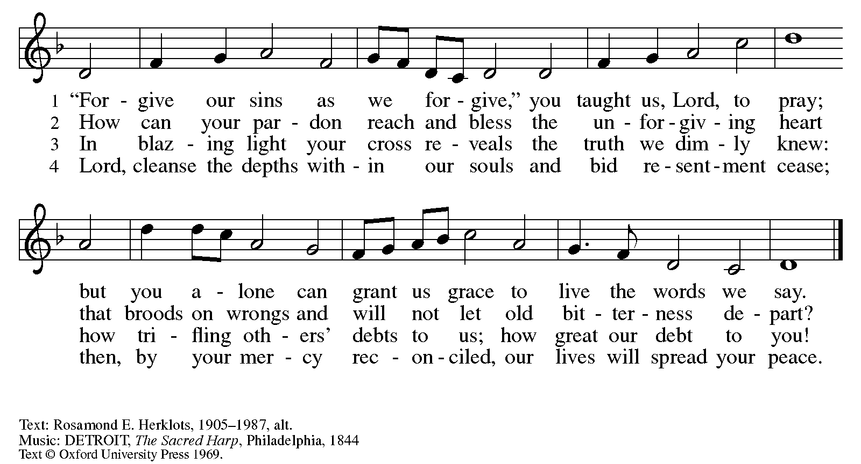

Apostles’ Creed

C: I believe in God, the Father almighty,
creator of heaven and earth.

I believe in Jesus Christ, God’s only Son, our Lord,
who was conceived by the Holy Spirit,
born of the virgin Mary,
suffered under Pontius Pilate,
was crucified, died, and was buried;
he descended to the dead.*
On the third day he rose again;
he ascended into heaven,
he is seated at the right hand of the Father,
and he will come to judge the living and the dead.

I believe in the Holy Spirit,
the holy catholic church,
the communion of saints,
the forgiveness of sins,
the resurrection of the body,
and the life everlasting. Amen.

*Or, “he descended into hell,” another translation of this text in widespread use.

Prayers of the People

A: Trusting in God’s steadfast love for all God has made,
let us pray for the church, the world, and those who are in need.

After each petition
A: Gracious God,
C: receive our prayer.

The presiding minister concludes the prayers
P: Grateful for your abundant provision and trusting in your goodness, O God,
we commend into your care all for whom we pray, through the priceless grace of Jesus Christ.
C: Amen.

Peace

The presiding minister and the assembly greet one another in the peace of the risen Christ.
P: The peace of Christ be with you always.
C: And also with you.

The people may greet those around them with a sign of Christ’s peace and may say
Peace be with you or similar words. Please be mindful that not everyone will be comfortable with sharing the peace, so please seek consent before shaking hands or hugging. Other possible ways to share the peace include a simple bow with the verbal greeting of peace, or simply a verbal expression of peace. When the greetings of peace have concluded, please be seated.

Meal
God feeds us with the presence of Jesus Christ

Offering

We offer ourselves, our gifts, and our faithful service to God.
As the offering is gathered for the mission of the church, including the care of those in need,
the table is set for Holy Communion.

There are laminated giving cards in the pew racks that feature a QR code for anyone who would like to give online. Those who give using the QR code, as well as those who give regularly online or through their bank are encouraged to place the laminated card in the plate as an expression of your offering.

Music during the Offering Amazing Grace arr. Edstrom

As the gifts are brought forward for presentation, please rise as you are able.

Offertory Song As the Grains of Wheat ELW 465

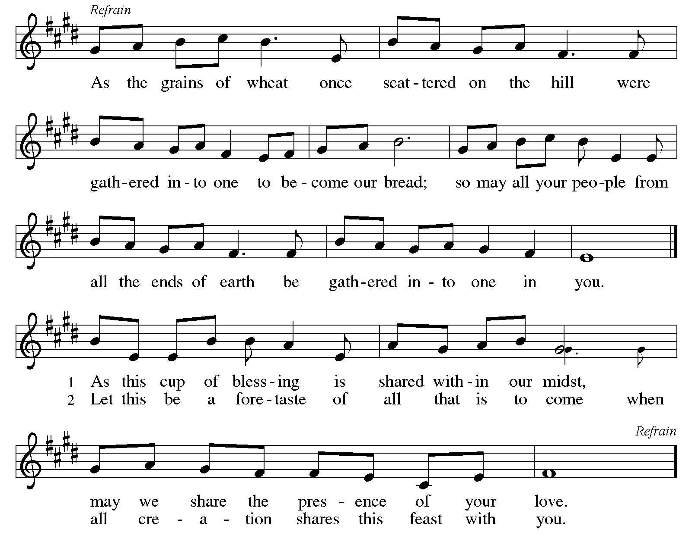

Offertory Prayer

A: Let us pray.
Merciful God,
C: everything in heaven and on earth belongs to you.
We joyfully release what you have entrusted to us.
May these gifts be signs of our whole lives returned to you,
dedicated to the healing and unity of all creation,
through Jesus Christ.
Amen.

Dialogue HS p. 14

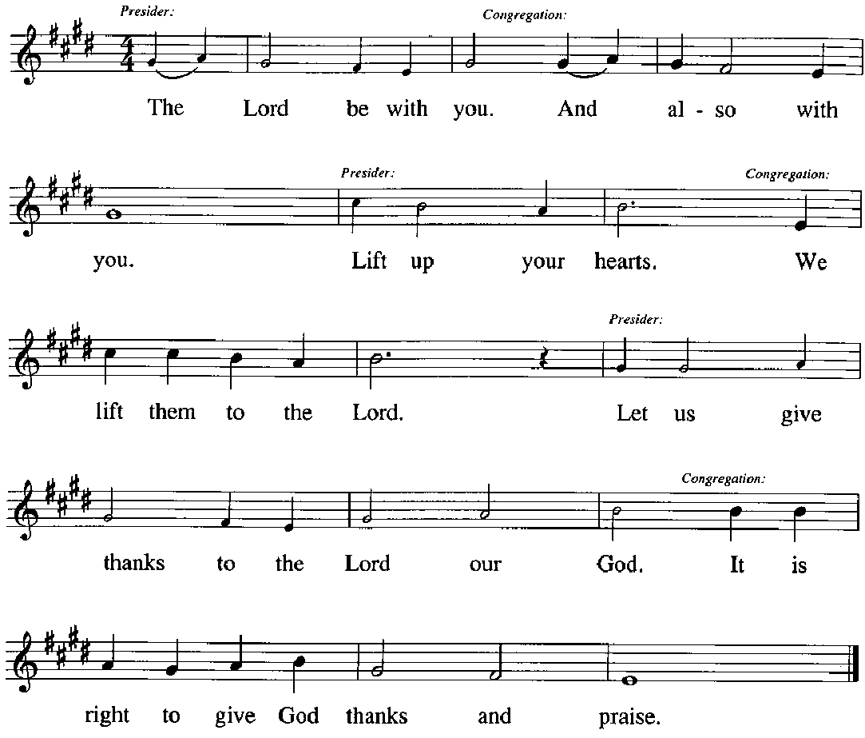

Preface (Sung by the presiding minister)

P: It is our duty and delight,
that we should everywhere and always
offer thanks and praise to you, O God,
through Jesus Christ,
who calls us to follow his way
of humble service and love,
and so with the church on earth,
all creation and the hosts of heaven,
we praise your name and join their unending hymn:
Sanctus HS p. 15

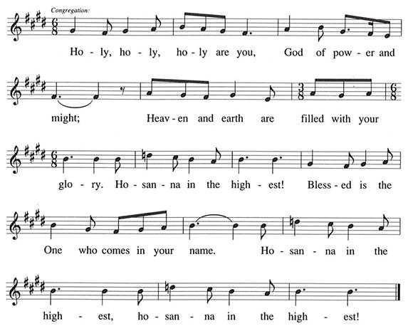

Eucharistic Prayer

P: You are indeed holy, gracious and merciful God …
… Do this for the remembrance of me.

Remembering his command to love one another,
his life and death, his resurrection and ascension,
we pray for his coming again, even as we cry:

(Sung by the presiding minister)
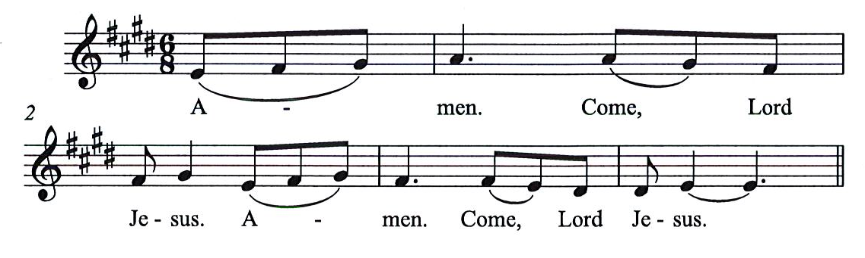
P: Amen. Come, Lord Jesus. Amen. Come, Lord Jesus.
C:

P: Send now, we pray, your Holy Spirit,
that all of your promises
may come to us and your whole creation.

(Sung by the presiding minister)
P: Amen. Come Holy Spirit. Amen. Come, Holy Spirit.
C:
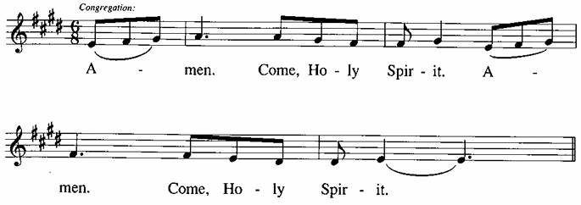

P: This we pray through Jesus Christ,
our Savior and our friend.
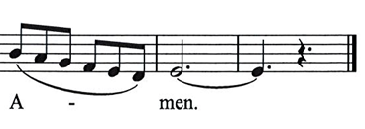
C:
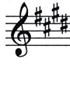

Lord’s Prayer

P: Gathered as one by the Holy Spirit, we pray as Jesus taught us.
C: Our Father in heaven,
hallowed be your name,
your kingdom come,
your will be done,
on earth as in heaven.
Give us today our daily bread.
Forgive us our sins,
as we forgive those
who sin against us;
Save us from the time of trial,
and deliver us from evil.
For the kingdom, the power,
and the glory are yours,
now and ever. Amen.

Fraction and Invitation

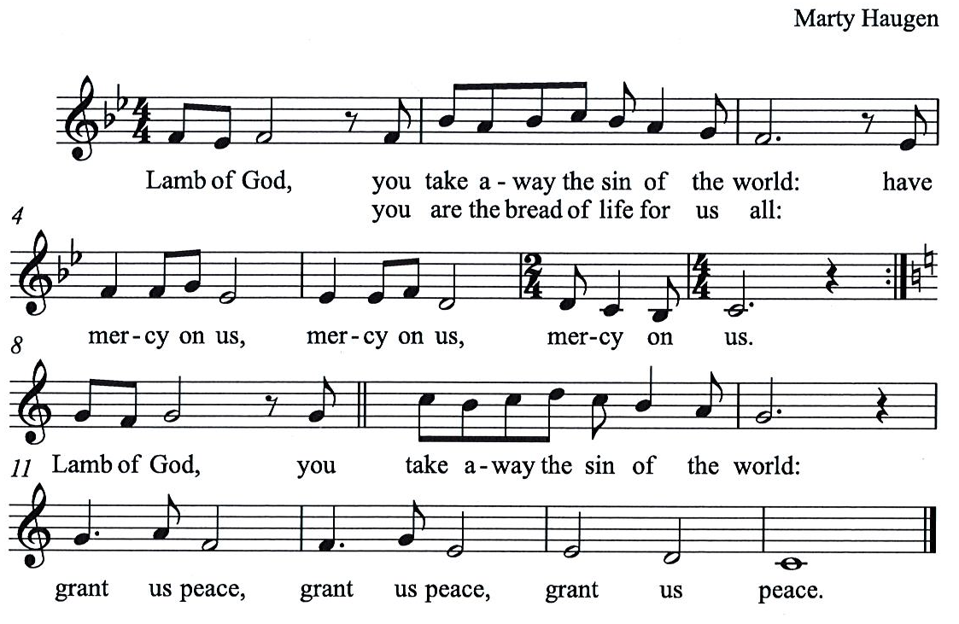
Agnus Dei / Lamb of God HS p. 18

Please be seated.

Holy Communion

- All who seek God and desire a deeper and stronger life in Christ are welcome to receive Holy Communion.
- Worshipers from the pulpit side will proceed forward first, followed by the center section, and then the lectern side.
- Please inform an usher if you would like the ministers to bring Communion to you.
- Holy Communion will be served with bread and wine (red) or grape juice (white).
- The presiding minister will first distribute the bread (host) to each communicant. Please indicate if you require a gluten-free host.
- Once you have consumed the bread, please pick up an empty glass from the tray next to the presiding minister. The Communion Assistant will pour wine or grape juice into your glass.
- Please step to the side to consume the wine or grape juice.
- Feel free to kneel at the altar rail for prayer after receiving the sacrament.
- As you return to your pew, glasses may be returned to the empty tray on the side of the center section.
- A blessing will be provided for anyone who does not yet receive the sacrament.
- All are invited to join in singing the hymns during Holy Communion.

Hymns during Holy Communion
If We Live, We Live to the Lord ACS 1025
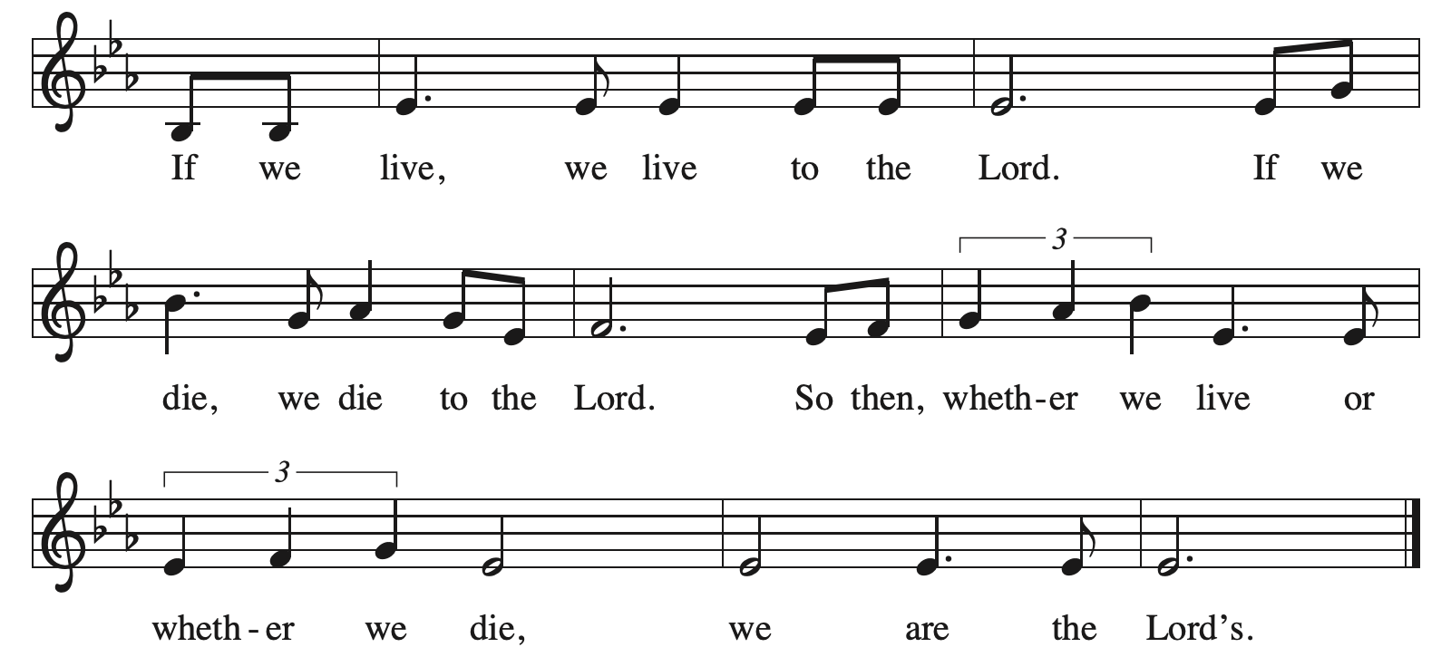

Hymns during Holy Communion
Where Charity and Love Prevail ELW 359

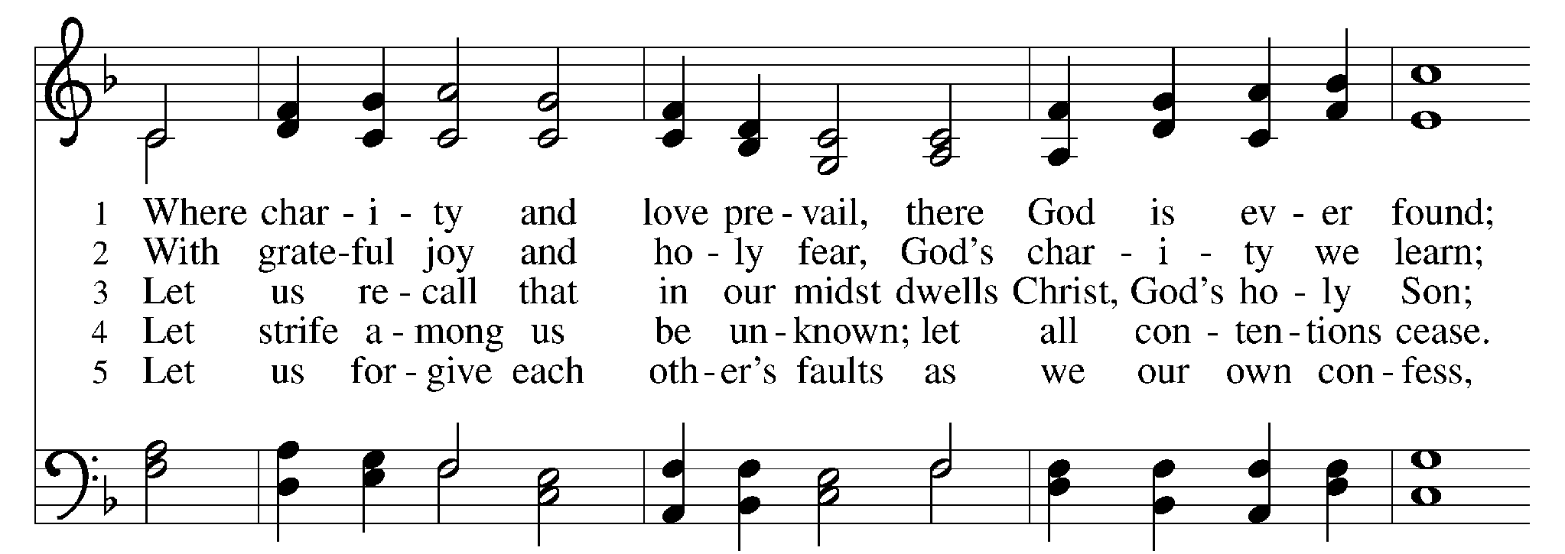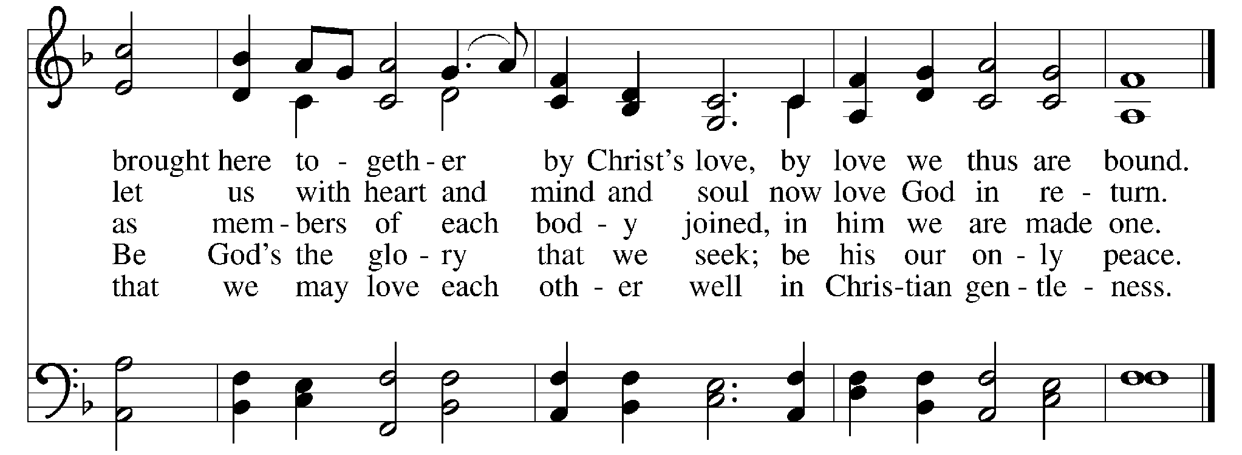

Hymns during Holy Communion
Although I Speak with Angel’s Tongue ELW 644

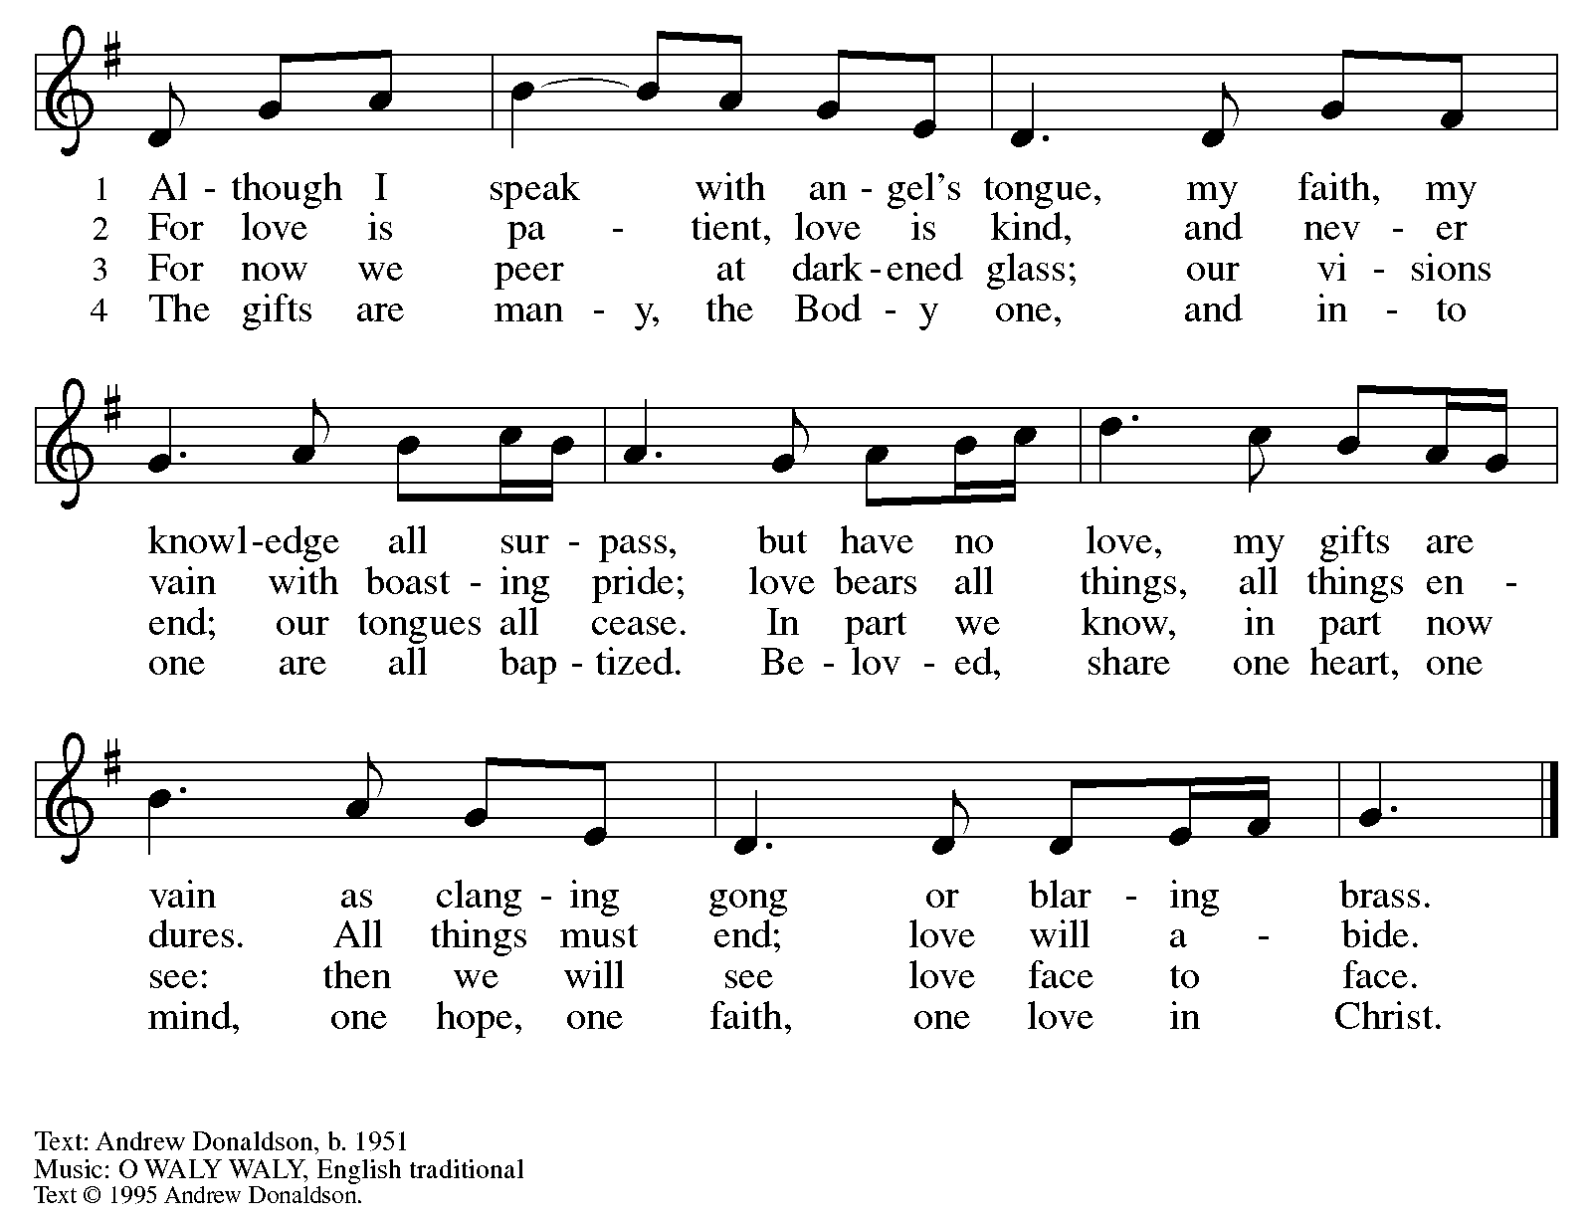
All rights reserved. Reprinted with permission under OneLicense.net # A-722139.

Hymns during Holy Communion
Spirit, Open My Heart ACS 1043

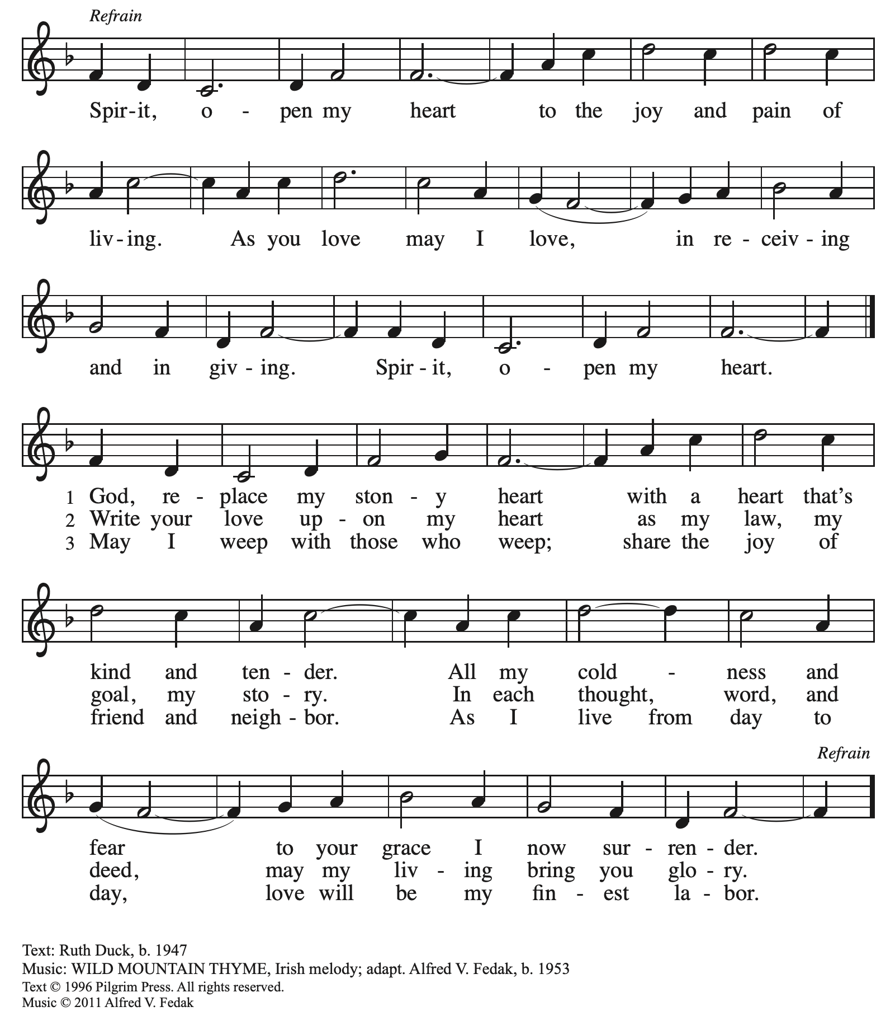
All rights reserved. Reprinted with permission under OneLicense.net # A-722139.

When all have returned to their places, please rise as you are able.

Blessing

P: The body and blood of our Lord Jesus Christ strengthen you and keep you in his grace.
C: Amen.

Prayer

A: Let us pray. Compassionate God,
through these gifts of bread and wine
our hearts are filled with the abundance of your love.
Strengthen us that we, through this holy meal,
may share your love freely, as you have shared with us.
We ask this in the name of Jesus,
through the Spirit nourishing us now and forever.
C: Amen.

Please be seated.

Sending
God blesses us and sends us in mission to the world

Announcements

Please rise as you are able.

Benediction

P: The love of God abound in you,
the grace of our Savior Jesus Christ fill your hearts;
and the life of the Spirit ☩ bless you and give you peace.
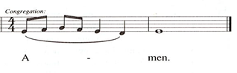
C:

Sending Hymn Following Page

Dismissal

A: Go in peace. Serve the Lord.
C: Thanks be to God!

Postlude
Sending Hymn Lord, Dismiss Us with Your Blessing ELW 545
v. 1-2
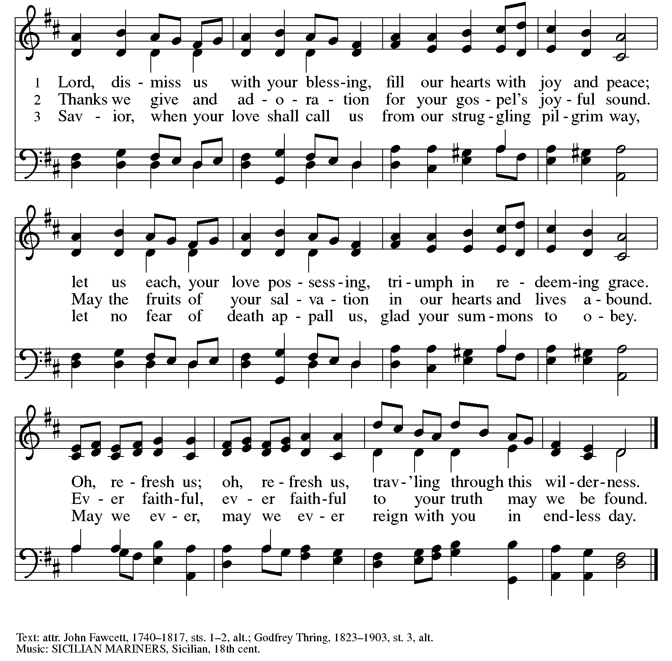
Liturgy and Hymnody Acknowledgements

From SundaysandSeasons.com. Copyright © 2026 Augsburg Fortress. All rights reserved. Reprinted under OneLicense.net # A-722139.
Used by permission of Augsburg Fortress.

From Hymnal Supplement. Copyright © 1991 GIA Publications, Inc. All rights reserved. Reprinted under OneLicense.net # A-722139.
Used by permission of GIA Publications, Inc.

The Scripture readings contained herein are from New Revised Standard Version Updated Edition of the Bible © 2021 National Council of Churches of Christ in the United States of America. Used by permission. All rights reserved worldwide.

If We Live, We Live to the Lord – Text: Rolf Vegdahl, b. 1955, based on Romans 14: 8, Psalm 103. Music: IF WE LIVE, Rolf Vegdahl. Music © 2009, 2016 Augsburg Fortress. All rights reserved. Reprinted with permission under OneLicense.net # A-722139.

Where Charity and Love Prevail – Text: Latin hymn, 9th cent.; tr. Omer Westendorf, 1916-1997, alt. Music: TWENTY-FOURTH, attr. Lucius Chapin, 1760-1842. Text © 1960 World Library Publications, 3708 River Rd., Franklin Park, IL 60131-2158. All rights reserved. Reprinted with permission under OneLicense.net # A-722139.
Those serving in worship today

Altar Care Beverley Chapman
Assisting Minister Jimmi Kocher-Hillmer
Audio-Visual Ministers Joseph Paetz
Jason Galyardt
Cantor Richard Krug
Lector Alda Maria Gonzaga
Little Church - Big Faith Teacher Emily Duque
Minister of Music Laura Reynolds
Presiding Minister The Rev. Ross I. Carmichael

Please use the QR code below to link to St. Andrew’s Announcements online!



St. Andrew Lutheran Church Announcements
September 13th, 2026

- Welcome to Worship at St. Andrew on the Sixteenth Sunday after Pentecost – We are thankful you are here, and we offer a special welcome to all visitors and guests who are here for the first time! A nursery is available through the door to the left of the worship space and across the social hall (look for a purple room). Little Church – Big Faith, a Bible lesson and activity for children up to sixth grade, will take place after the prayer of the day. There are also worship “toolkits” to help children engage with worship and “busy bags” for younger children available in the bookcase at the back of the sanctuary. Please feel free to take one to use with/for your children. All are invited to stay for coffee and other drinks, food, and conversation in the Social Hall (through the side door at the left of the worship space) after the service.
- St. Andrew's Capital Campaign Continues – We are thrilled to announce that this past year's construction work on a new roof and related areas for St. Andrew is complete, and the plastering and painting in the sanctuary is underway! Now that the summer is over, the time has come to renew our conversation about St. Andrew's capital campaign intended to pay for these projects. St. Andrew set a goal of $1 million for the campaign and we are 87% of the way there! We thank all who have made commitments to the campaign thus far. We will hear more from Capital Campaign Chair Kristen Asplin and others in the upcoming weeks in preparation for Commitment Sunday, when we dedicate our gifts during worship, on Sunday, October 11th.
- Bible Book Club, Wednesdays at 7:00 p.m. on Zoom – St. Andrew's weekly Bible Book Club meets each Wednesday at 7:00 p.m. The group is currently reading and discussing Karen Armstrong's A History of God. It can be found here: https://bookshop.org/p/books/a-history-of-god-the-4-000-year-quest-of-judaism-christianity-and-islam-karen-armstrong/277069b2cf4e39ad?ean=9780345384560. If anyone needs assistance in obtaining a book, please speak with Pastor Ross. Bible Book Club invites new participants, regardless of how often you can attend or whether or not you have read the specific material for the week. We encourage everyone to read the brief introduction before the first session! You can use this link to join the call: https://us02web.zoom.us/j/83196175976?pwd=ejdPOUYrTk4xVFdsdlhHUVJ1L3k2Zz09.
- Alternatives to Violence Project (AVP) Basic Workshop, September 19th, 9:00 a.m. - 8:00 p.m. – St. Andrew members are warmly invited to experience an Alternatives to Violence Project (AVP) Basic Workshop, hosted here at St. Andrew on Saturday, September 19th, from 9:00 a.m. to 8:00 p.m., exploring practical ways to address conflict, strengthen relationships, communicate across differences, and discover the transforming power that can move us from aggression toward cooperation. AVP’s commitment to nonviolence, respect for every person, and building more just and peaceful communities resonates deeply with St. Andrew’s commitment to inclusion and justice. While the full two-day workshop offers the richest experience, you are also welcome to come for Day 1 to experience AVP for yourself. Experience with the basic workshop is a prerequisite for the advanced workshop, held November 6th-8th. Registration is required: https://docs.google.com/forms/d/e/1FAIpQLSfW_fVUD_bkgcd4K1e9Q-t5fz-rW1mTF72C7pcAmTwfYiH50A/viewform. You can contact Martin Rafanan at 314-258-0452 or mjr9201@gmail.com with any questions.
- Coffee Hour Signups – Coffee hour returns this week! St. Andrew provides hospitality during a coffee hour after worship each Sunday. If you would like to participate and would like information about the duties of setting up, please sign up using the following form: https://www.signupgenius.com/go/5080B4AAFAF2CABF85-47069030-coffee#/.
- Produce Distribution Supplemental Food of the Month – St. Andrew is collecting supplemental food each month to accompany our produce distribution. For September, we ask for donations of rice. There are collection boxes at the back of the worship space and social hall.
- September Produce Distribution, Third Tuesday of the Month, September 15th, 5:30-6:30 p.m. – St. Andrew partners with Greater Pittsburgh Community Food Bank to serve as a distribution site for fresh produce on the first and third Tuesday of every month. We invite people of the congregation to help with the distribution from 5:30 p.m. - 6:30 p.m. and/or to help with unloading and setup during the day between 10:00 a.m. and 1:00 p.m.
- Lutheran Campus Ministry BBQ Bash, Next Saturday, September 19th, 6:00 - 9:00 p.m. – This event to support the Lutheran Campus Ministry in Greater Pittsburgh will be held at Trinity Lutheran Church (2500 Brandt School Road, Wexford, PA) this year. You can register at www.lucpgh.com or call 412-682-6886 to reserve your place. The cost to attend is $40/adult or $100/family (2 adults and children 13 and under).
- Noisy Offering, Next Sunday, September 20th During Worship – On the third Sunday of each month, St. Andrew’s children lead the congregation in a Noisy Offering, in which people are invited to throw their change into buckets that the children carry around the church and bring forward as an additional offering. Each month’s Noisy Offering supports a local, national, or international church-related or otherwise charitable organization. This month’s offering will benefit the Greater Pittsburgh Community Food Bank. GPCFB serves 11 counties over 53 million meals annually and stocks our produce distribution. You can learn more about their program and how it works here: https://pittsburghfoodbank.org/what-we-do/how-we-work/.
- Added Session - Conscience and Conversation Study, Tuesday, September 22nd, 7:00 p.m. on Zoom – St. Andrew has offered two study sessions on Conscience and Conversation, part of the Evangelical Lutheran Church in America's reconsideration of its 2009 Social Statement, Human Sexuality: Gift and Trust. The group has shared such rich conversation that we are adding a third session on Tuesday, September 22nd, at 7:00 p.m., also on Zoom. All are welcome even if you have not participated in the first two sessions. The Conscience and Conversation study guide can be found here: https://resources.elca.org/faith-and-society/conscience-and-conversation-study/. Anyone is invited to share feedback with the ELCA by the September 30th deadline. The ELCA has also released a five-episode podcast as a companion to the study. Individual episodes are available at elca.org/reconsiderations.
- Lunch Club at Church Brew Works, Sunday, September 27th after Worship – Kelly Spanninger is organizing a renewal of St. Andrew lunch outings after Sunday worship. All are invited to gather at Church Brew Works at 3525 Liberty Ave, Pittsburgh, PA 15201 at 12:15 p.m. Please let Kelly know if you plan to attend, or contact her at pkspanninger@verizon.net.

- Joseph and Anya Are Getting Married! Help with a Cookie Table, Saturday, October 3rd, 3:00 p.m. – Joseph Paetz and Anya Fredrickson are getting married at St. Andrew on Saturday, October 3rd! The wedding begins at 3:00 p.m., with a cookie table reception to follow in the social hall, and Joseph and Anya invite people of the congregation to attend both! If you would like to help set up the cookie table and/or bake and contribute cookies, please use the QR code below.

