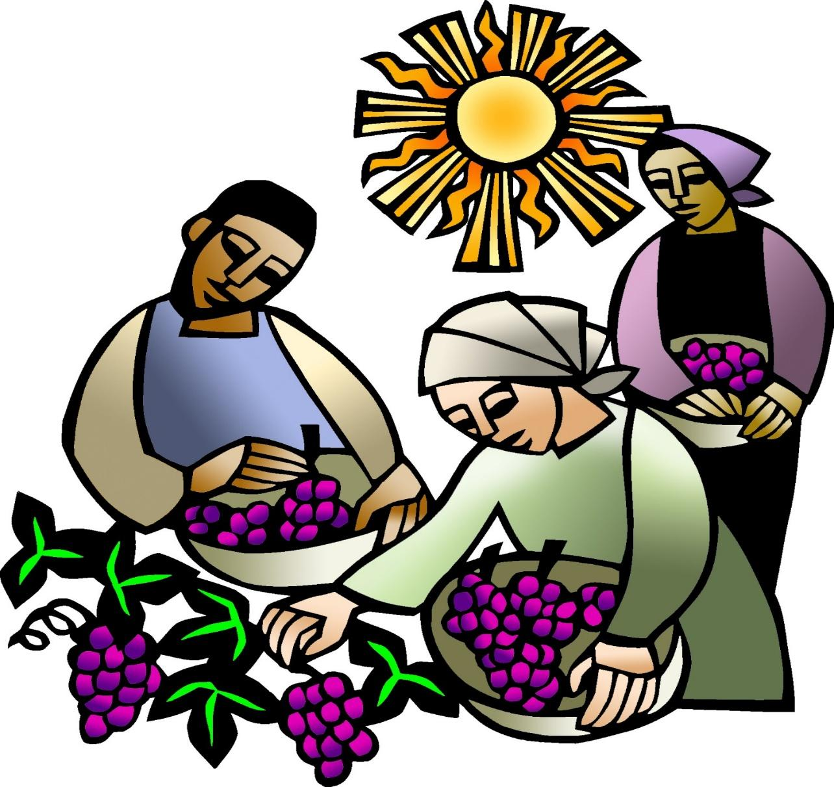

+ Seventeenth Sunday after Pentecost
September 20, 2026



St. Andrew Lutheran Church
304 Morewood Ave.
Pittsburgh, PA 15213
St_andrewELCA@verizon.net
www.standrewpittsburgh.org

+ Seventeenth Sunday after Pentecost

Matthew narrates one of Jesus’ controversial parables in which Jesus says that the reign of God is like that of a landowner who pays his workers the same wage no matter what time of day they began to work. When God changes God’s mind about punishing Nineveh for their evil ways, Jonah is angry. Yet God is gracious and merciful, abounding in steadfast love. In baptism we receive the grace of God that is freely given to all. As Martin Luther wrote, in the presence of God’s mercy we are all beggars.

Welcome to St. Andrew!
- St. Andrew welcomes all who are seeking a place of healing, wholeness, and acceptance in a nurturing and faith-forming spiritual home. We are striving toward racial equity worldwide
and we seek to honor the lived experience of all individuals regardless of background. Our community embraces people of all ages, ethnicities, cultures, abilities, sexual orientations,
gender identities and expressions, and family constellations. Come and See!
- Worship Services are live-streamed to multiple online platforms. By attending worship, you agree that your image and voice may be broadcast.
- Everyone is invited to make a name tag at the black bookcase in the back of the worship space if they would like. There are stickers indicating pronouns on the bookcase if you would like to include them on your name tag.
- Children up to sixth grade are invited to attend Little Church – Big Faith, a Bible lesson and activity, during worship (after the Prayer of the Day). The group returns to the worship space for the liturgy of Holy Communion.
- A nursery is available through the doors at the left side of the sanctuary and across from the doorway to the Social Hall. Look for a purple-colored room.
- Worship “toolkits” to help children engage with the service, along with “busy bags” for younger children, are available in the bookcase at the back of the sanctuary. Please feel free to take one to use with/for your children.
- Holy Communion is served with bread (gluten-free available) and wine or grape juice. The presiding minister will distribute the bread (host). Please consume this and then pick up an empty glass from the tray. The Communion Assistant will pour wine or grape juice into your glass. Please step to the side to consume the wine or grape juice. Feel free to kneel at the altar for prayer and reflection. As you return to your pew, glasses may be returned to the empty trays on either side of the center section.
- A restroom is available on the main level of the church, through the doors to the Social Hall and to the right in the main office.

Abbreviations
P: Pastor/Presiding Minister ELW: Evangelical Lutheran Worship hymnal
A: Assisting Minister ACS: All Creation Sings hymnal
L: Lector HS: Hymnal Supplement (GIA Publications)
C: Congregation

Musical Offering

Each week, different people from the congregation make an offering of pre-service music, with singing or instrumentation, to help the assembly focus and pray in preparation for worship.

Welcome

Prelude Guide My Feet arr. Podd
St. Andrew Choir

Gathering
The Holy Spirit calls us together as the people of God

Please rise as you are able. All may make the sign of the cross,
the sign that is marked at Baptism, as the presiding minister begins.

Confession and Forgiveness

P: Blessed be the ☩ holy Trinity,
one God, whose compassion endures forever.
C: Amen.

P: If we say we have no sin, we deceive ourselves and the truth is not us.
Let us confess our sin to God who is faithful and just,
and who has promised to forgive sin and cleanse us from all unrighteousness.

Silence is kept for reflection.

P: Most merciful God,
C: we confess to you that we have sinned against you in thought, word, and deed,
by what we have done and by what we have left undone.
We have not trusted you with our whole heart;
we have not loved one another in deed and in truth.
In your compassion, forgive our sin and so uphold us by your Spirit
that we may live and serve you in newness of life,
through Jesus Christ, our light and our truth.
Amen.

P: With joy I proclaim to you that Almighty God,
rich in mercy, abundant in love,
forgives you all your sin and grants you newness of life
☩ in Jesus Christ.
C: Amen. Thanks be to God!

Gathering Hymn God, Whose Giving Knows No Ending ELW 678

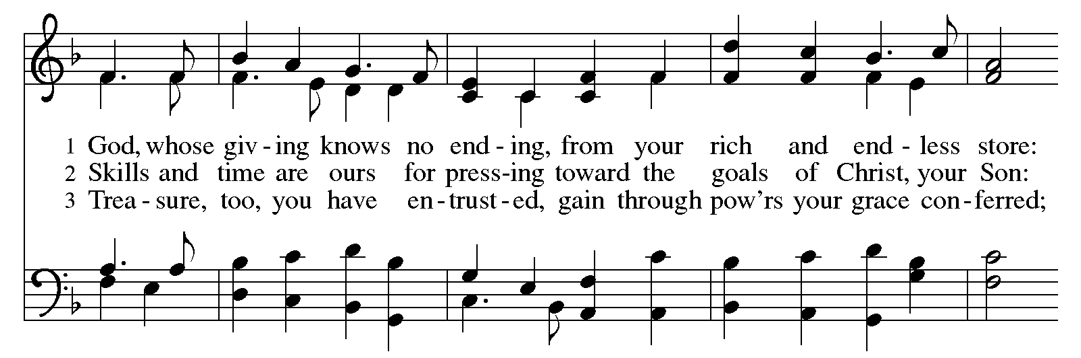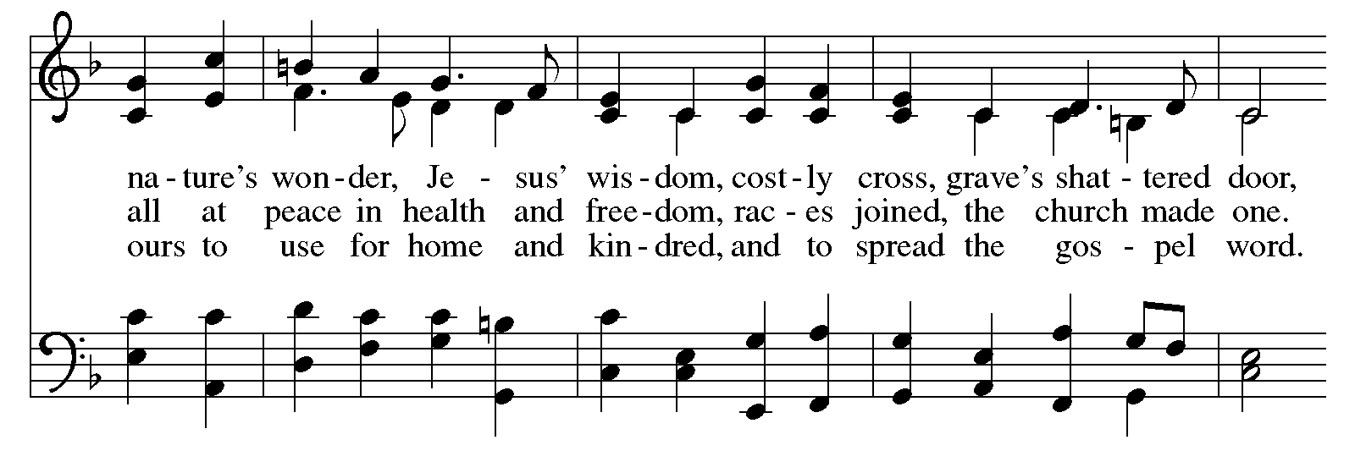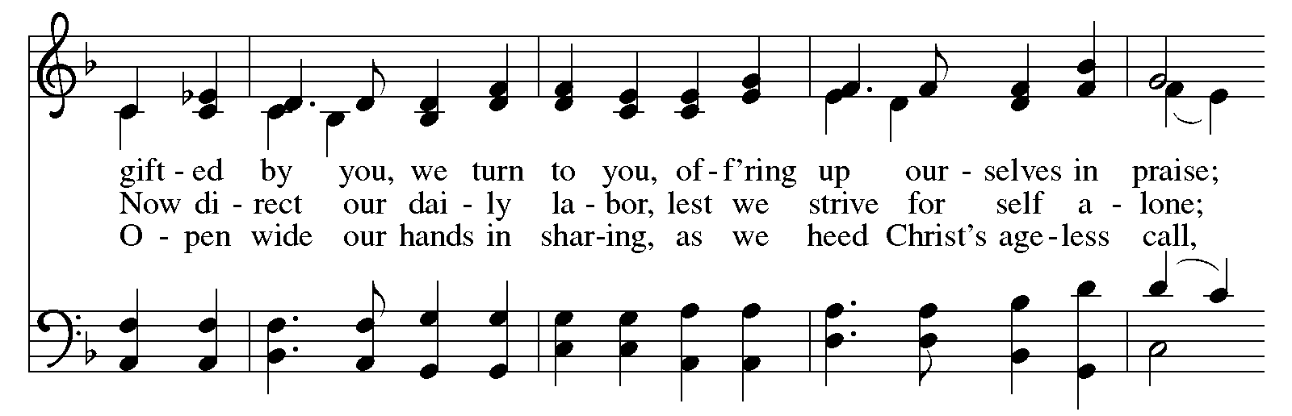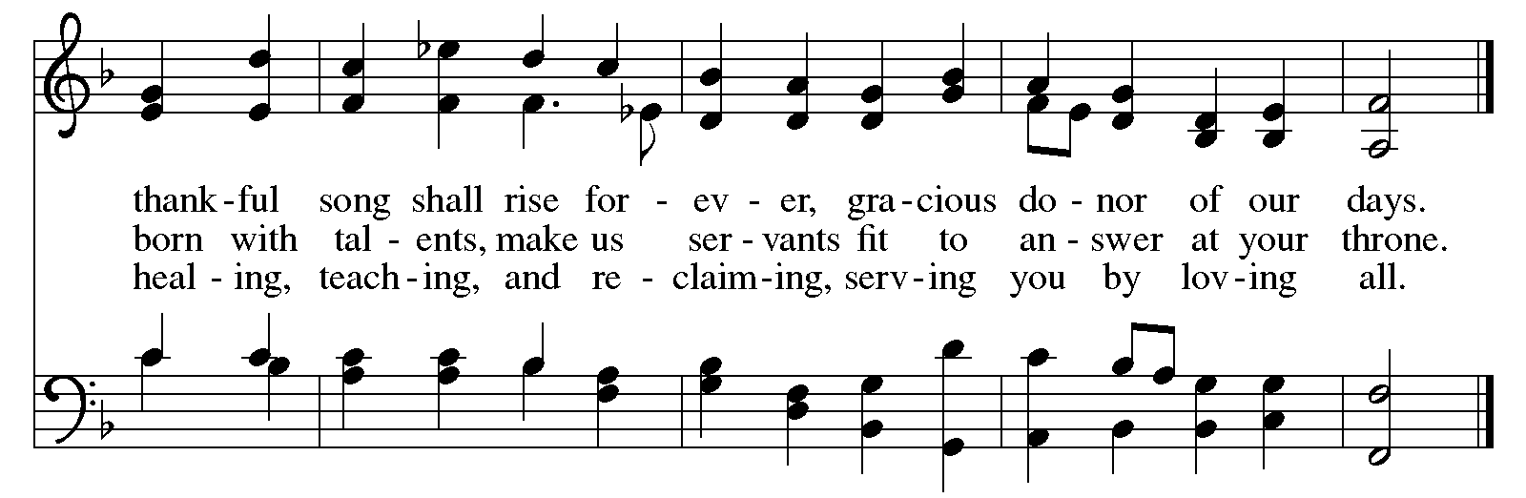
Greeting

P: The grace of our Lord Jesus Christ, the love of God,
and the communion of the Holy Spirit be with you all.
C: And also with you.

Hymn of Praise Glory to God HS p. 6-7
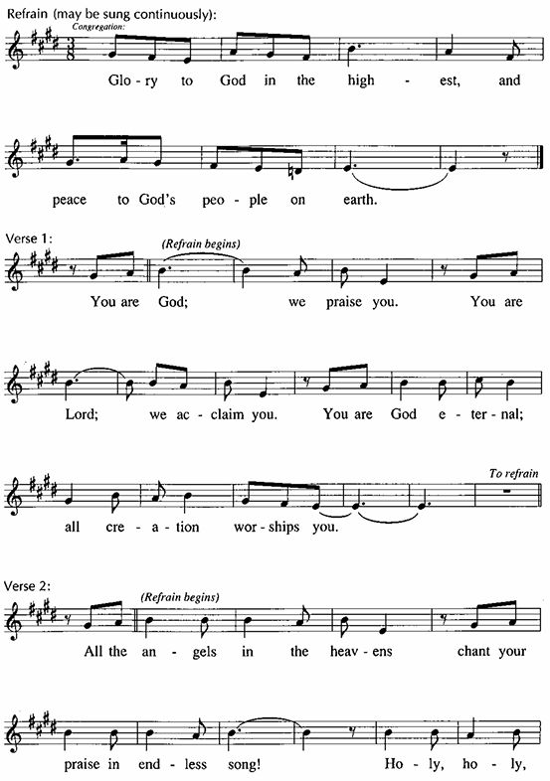
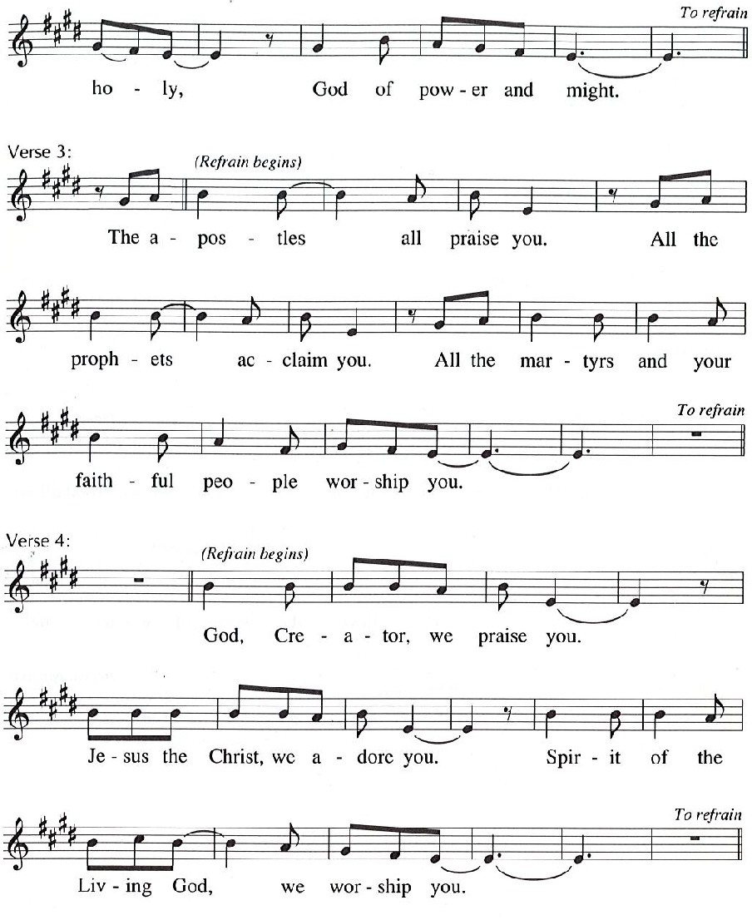

Prayer of the Day

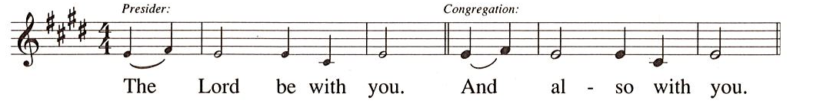
P: Let us pray.
Almighty and eternal God, you show perpetual lovingkindness to us your servants.
Because we cannot rely on our own abilities, grant us your merciful judgment,
and train us to embody the generosity of your Son, Jesus Christ, our Savior and Lord.
C: Amen.

Please be seated.

Word
God speaks to us in Scripture reading, preaching, and song

First Reading – Jonah 3: 10 – 4: 11

¹⁰ When God saw what [the people of Ninevah] did, how they turned from their evil ways, God changed God’s mind about the calamity that God had said God would bring upon them, and God did not do it.
^{4:1} But this was very displeasing to Jonah, and he became angry. ² He prayed to the Lord and said, “O Lord! Is not this what I said while I was still in my own country? That is why I fled to Tarshish at the beginning, for I knew that you are a gracious and merciful God, slow to anger, abounding in steadfast love, and relenting from punishment. ³ And now, O Lord, please take my life from me, for it is better for me to die than to live.” ⁴ And the Lord said, “Is it right for you to be angry?” ⁵ Then Jonah went out of the city and sat down east of the city and made a booth for himself there. He sat under it in the shade, waiting to see what would become of the city.
⁶ The Lord God appointed a bush and made it come up over Jonah, to give shade over his head, to save him from his discomfort, so Jonah was very happy about the bush. ⁷ But when dawn came up the next day, God appointed a worm that attacked the bush, so that it withered.
⁸ When the sun rose, God prepared a sultry east wind, and the sun beat down on the head of Jonah so that he was faint and asked that he might die. He said, “It is better for me to die than to live.”
⁹ But God said to Jonah, “Is it right for you to be angry about the bush?” And he said, “Yes, angry enough to die.” ¹⁰ Then the Lord said, “You are concerned about the bush, for which you did not labor and which you did not grow; it came into being in a night and perished in a night. ¹¹ And should I not be concerned about Nineveh, that great city, in which there are more than a hundred and twenty thousand persons who do not know their right hand from their left and also many animals?”
L: Word of God, word of life.
C: Thanks be to God.

Psalm 145: 1-8

The psalm will be sung responsively, led by the cantor,
with the congregation responding with the verses in bold and the refrain.

Psalm Tone

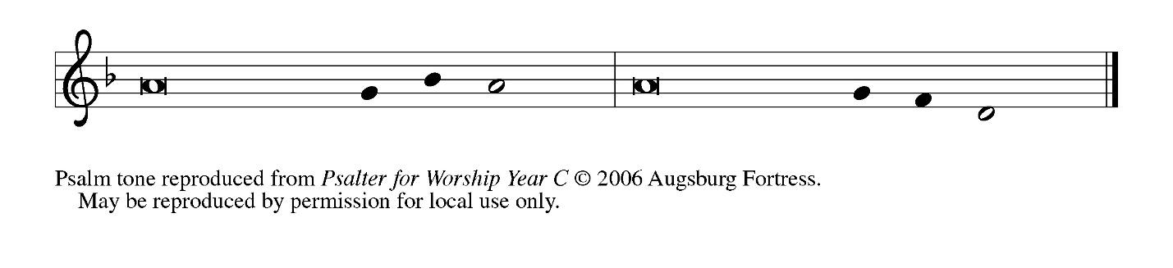
Psalm Refrain

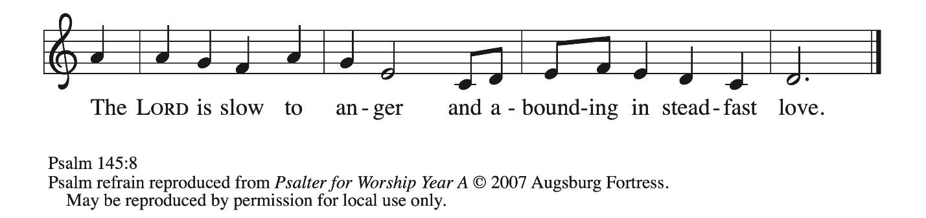

¹ I will exalt you, my | God and king,
and bless your name forev- | er and ever.
² Every day | will I bless you
and praise your name forev- | er and ever.
³ Great is the Lord and greatly | to be praised!
There is no end | to your greatness.
⁴ One generation shall praise your works | to another
and shall de- | clare your power. R
⁵ I will speak of the glorious splendor | of your majesty
and all your | marvelous works.
⁶ They shall tell of the might of your | wondrous acts,
and I will re- | count your greatness.
⁷ They shall publish the remembrance of | your great goodness;
they shall sing joyfully | of your righteousness.
⁸ The Lord is gracious and full | of compassion,
slow to anger and abounding in | steadfast love. R
Second Reading – Philippians 1: 21-30

²¹ For to me, living is Christ and dying is gain. ²² If I am to live in the flesh, that means fruitful labor for me, yet I cannot say which I will choose. ²³ I am hard pressed between the two: my desire is to depart and be with Christ, for that is far better, ²⁴ but to remain in the flesh is more necessary for you. ²⁵ Since I am convinced of this, I know that I will remain and continue with all of you for your progress and joy in faith, ²⁶ so that, by my presence again with you, your boast might abound in Christ Jesus because of me.
²⁷ Only, live your life in a manner worthy of the gospel of Christ, so that, whether I come and see you or am absent and hear about you, I will know that you are standing firm in one spirit, striving side by side with one mind for the faith of the gospel ²⁸ and in no way frightened by those opposing you. For them, this is evidence of their destruction but of your salvation. And this is God’s doing. ²⁹ For God has graciously granted you the privilege not only of believing in Christ but of suffering for him as well, ³⁰ since you are having the same struggle that you saw I had and now hear that I still have.

L: Word of God, word of life.
C: Thanks be to God.

Please rise as you are able.

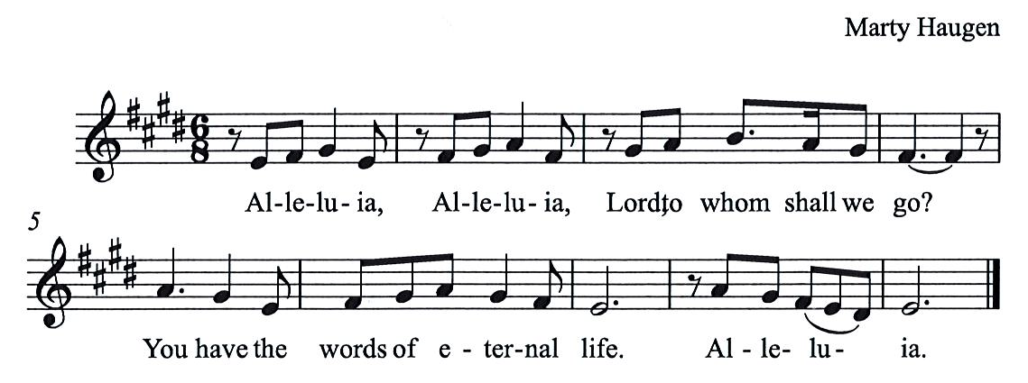
Gospel Acclamation HS p. 8

Gospel – Matthew 20: 1-16

P: The holy Gospel according to St. Matthew.
C: Glory to you, O Lord.

[Jesus said to the disciples:] ¹ “The kingdom of heaven is like a landowner who went out early in the morning to hire laborers for his vineyard. ² After agreeing with the laborers for a denarius for the day, he sent them into his vineyard. ³ When he went out about nine o’clock, he saw others standing idle in the marketplace, ⁴ and he said to them, ‘You also go into the vineyard, and I will pay you whatever is right.’ So they went. ⁵ When he went out again about noon and about three o’clock, he did the same. ⁶ And about five o’clock he went out and found others standing around, and he said to them, ‘Why are you standing here idle all day?’ ⁷ They said to him, ‘Because no one has hired us.’ He said to them, ‘You also go into the vineyard.’ ⁸ When evening came, the owner of the vineyard said to his manager, ‘Call the laborers and give them their pay, beginning with the last and then going to the first.’ ⁹ When those hired about five o’clock came, each of them received a denarius. ¹⁰ Now when the first came, they thought they would receive more; but each of them also received a denarius. ¹¹ And when they received it, they grumbled against the landowner, ¹² saying, ‘These last worked only one hour, and you have made them equal to us who have borne the burden of the day and the scorching heat.’ ¹³ But he replied to one of them, ‘Friend, I am doing you no wrong; did you not agree with me for a denarius? ¹⁴ Take what belongs to you and go; I choose to give to this last the same as I give to you. ¹⁵ Am I not allowed to do what I choose with what belongs to me? Or are you envious because I am generous?’ ¹⁶ So the last will be first, and the first will be last.”

P: The Gospel of the Lord.
C: Praise to you, O Christ.

Please be seated.

Sermon

A time of silence for prayer and reflection follows the sermon.
When the hymn of the day begins, please rise as you are able.



Hymn of the Day All Who Love and Serve Your City ELW 724

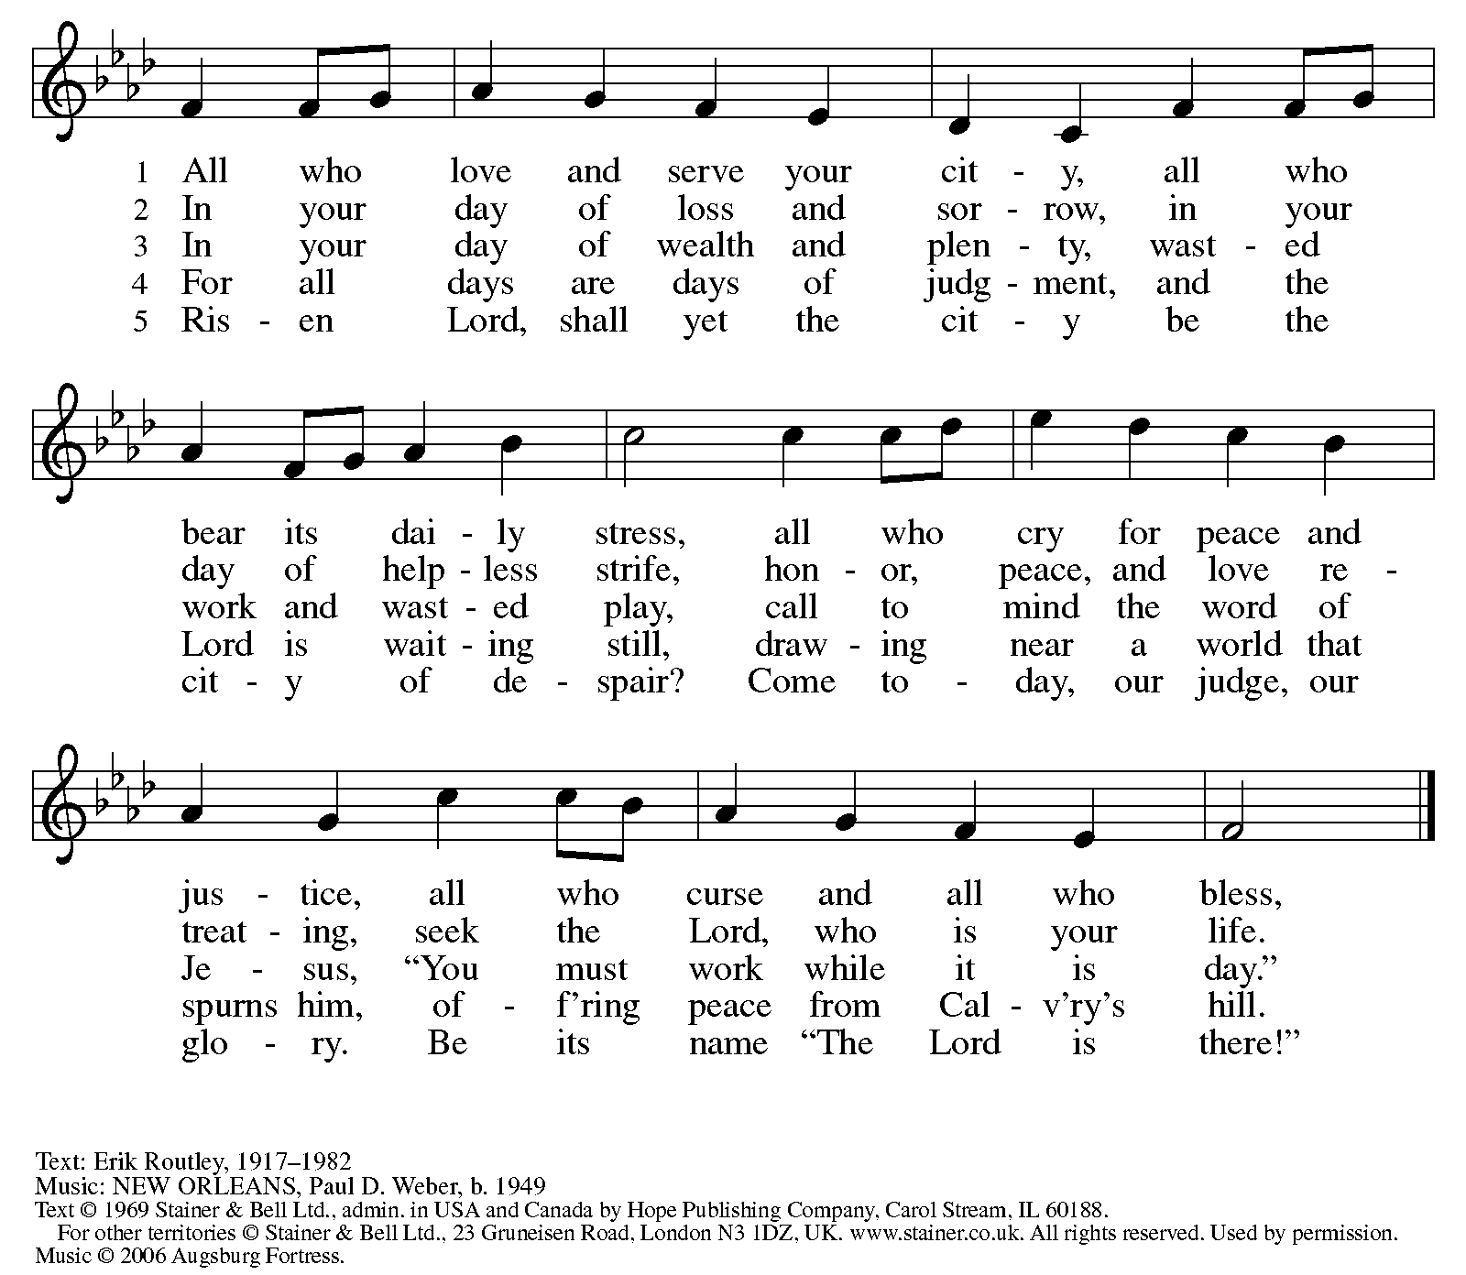
All rights reserved. Reprinted with permission under OneLicense.net # A-722139.

Apostles’ Creed

C: I believe in God, the Father almighty,
creator of heaven and earth.

I believe in Jesus Christ, God’s only Son, our Lord,
who was conceived by the Holy Spirit,
born of the virgin Mary,
suffered under Pontius Pilate,
was crucified, died, and was buried;
he descended to the dead.*
On the third day he rose again;
he ascended into heaven,
he is seated at the right hand of the Father,
and he will come to judge the living and the dead.

I believe in the Holy Spirit,
the holy catholic church,
the communion of saints,
the forgiveness of sins,
the resurrection of the body,
and the life everlasting. Amen.

*Or, “he descended into hell,” another translation of this text in widespread use.

Prayers of the People

A: Trusting in God’s steadfast love for all God has made,
let us pray for the church, the world, and those who are in need.

After each petition
A: Gracious God,
C: receive our prayer.

The presiding minister concludes the prayers
P: Grateful for your abundant provision and trusting in your goodness, O God,
we commend into your care all for whom we pray, through the priceless grace of Jesus Christ.
C: Amen.

Peace

The presiding minister and the assembly greet one another in the peace of the risen Christ.
P: The peace of Christ be with you always.
C: And also with you.

The people may greet those around them with a sign of Christ’s peace and may say
Peace be with you or similar words. Please be mindful that not everyone will be comfortable with sharing the peace, so please seek consent before shaking hands or hugging. Other possible ways to share the peace include a simple bow with the verbal greeting of peace, or simply a verbal expression of peace.

When the greetings of peace have concluded, please be seated.



Meal
God feeds us with the presence of Jesus Christ

Offering

We offer ourselves, our gifts, and our faithful service to God.
As the offering is gathered for the mission of the church, including the care of those in need,
the table is set for Holy Communion.

There are laminated giving cards in the pew racks that feature a QR code for anyone who would like to give online. Those who give using the QR code, as well as those who give regularly online or through their bank are encouraged to place the laminated card in the plate as an expression of your offering.

Noisy Offering

St. Andrew’s children lead the congregation in a special offering. As they carry buckets around the sanctuary, people of the congregation are invited to throw in their change as an offering. This month’s Noisy Offering will benefit the Greater Pittsburgh Community Food Bank. GPCFB serves 11 counties over 53 million meals annually and stocks our produce distribution. You can learn more about their program and how it works here: https://pittsburghfoodbank.org/what-we-do/how-we-work/.

Music during the Offering
Take My Life, That I May Be arr. Edstrom

As the gifts are brought forward for presentation, please rise as you are able.

Offertory Song As the Grains of Wheat ELW 465

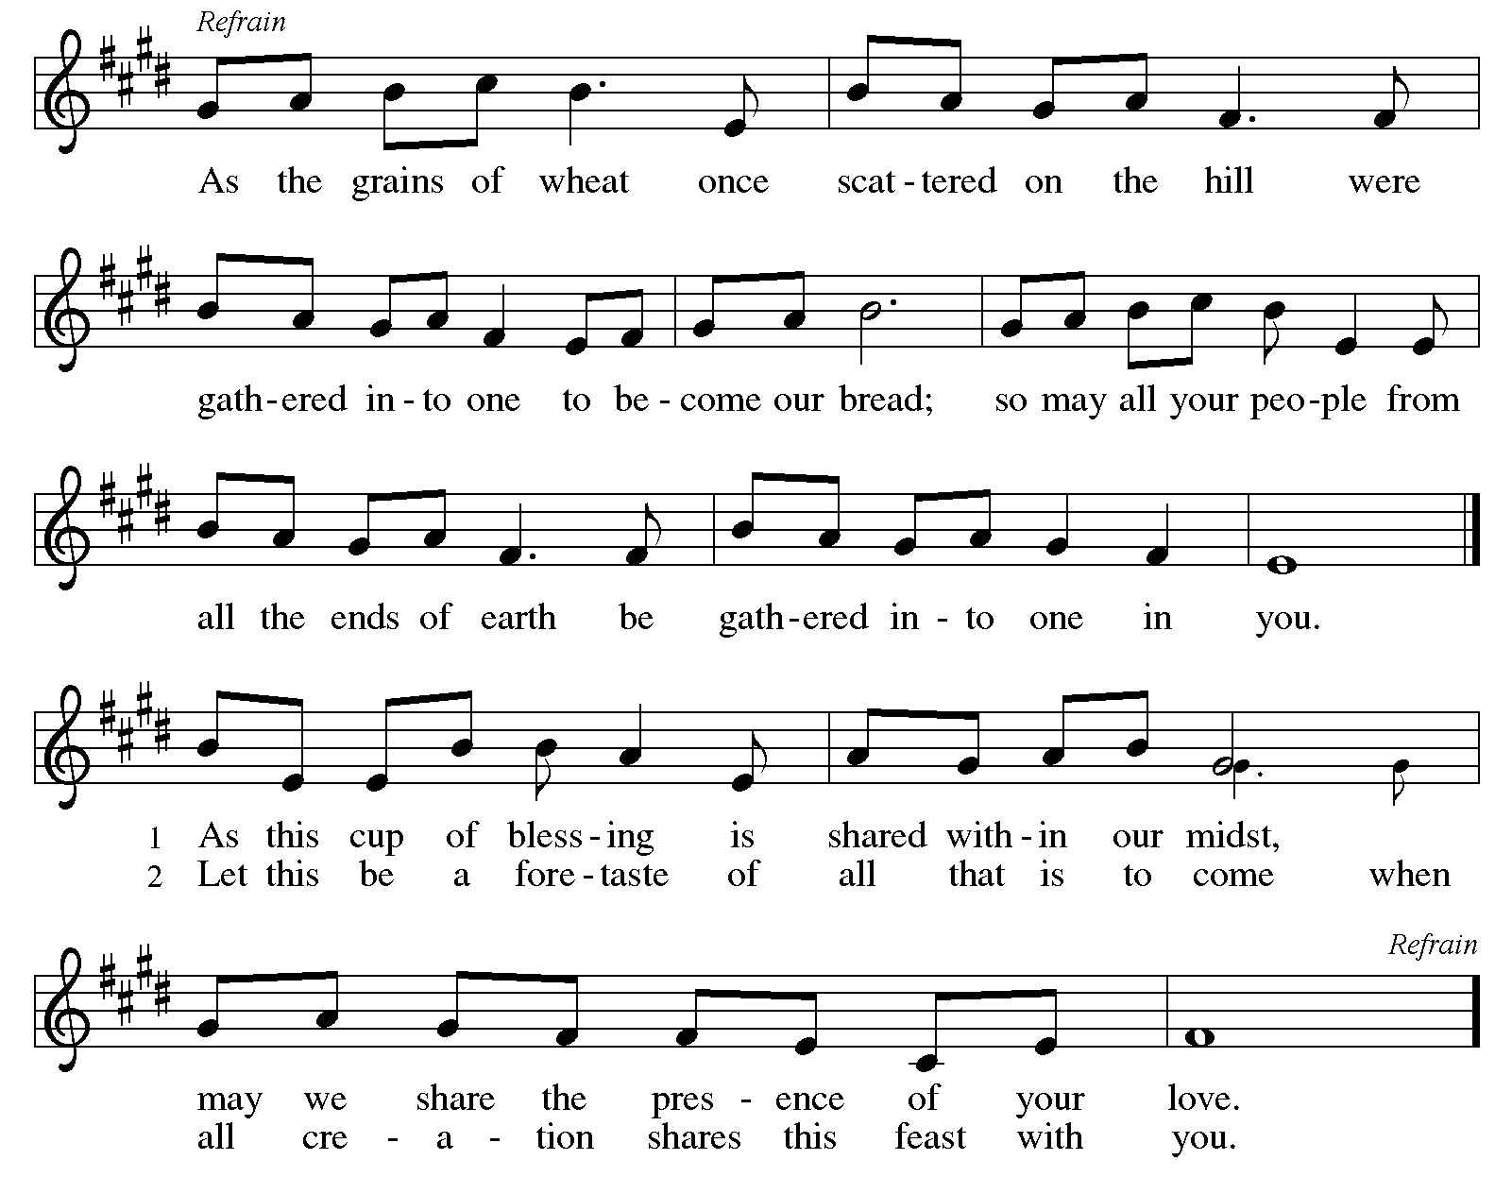

Offertory Prayer

A: Let us pray.
Merciful God,
C: everything in heaven and on earth belongs to you.
We joyfully release what you have entrusted to us.
May these gifts be signs of our whole lives returned to you,
dedicated to the healing and unity of all creation,
through Jesus Christ.
Amen.

Dialogue HS p. 14

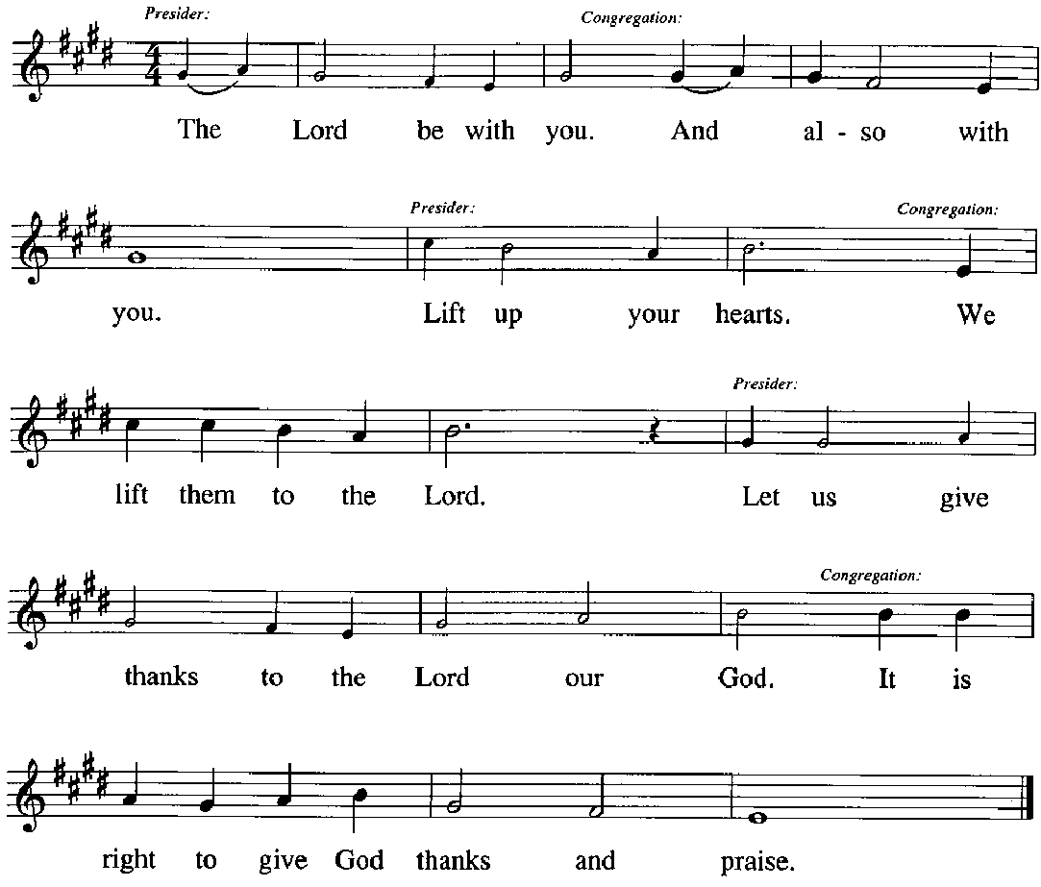

Preface (Sung by the presiding minister)

P: It is our duty and delight,
that we should everywhere and always
offer thanks and praise to you, O God,
through Jesus Christ,
who calls us to follow his way
of humble service and love,
and so with the church on earth,
all creation and the hosts of heaven,
we praise your name and join their unending hymn:

Sanctus HS p. 15

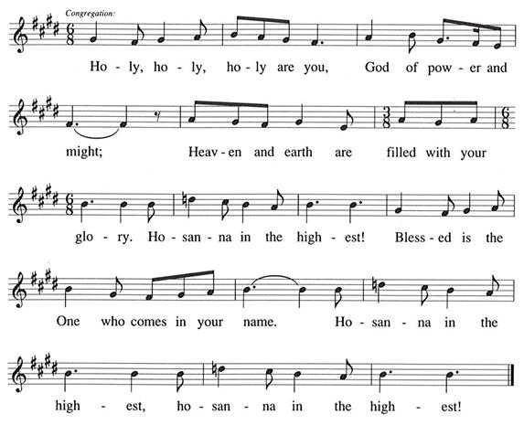

Eucharistic Prayer

P: You are indeed holy, gracious and merciful God …
… Do this for the remembrance of me.

Remembering his command to love one another,
his life and death, his resurrection and ascension,
we pray for his coming again, even as we cry:

(Sung by the presiding minister)
P: Amen. Come, Lord Jesus. Amen. Come, Lord Jesus.
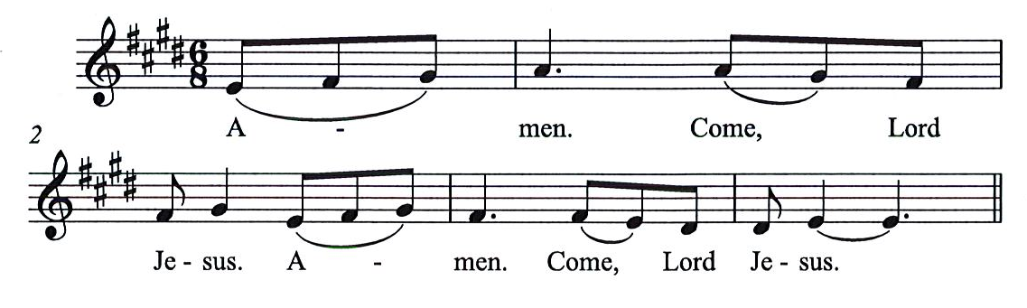
C:

P: Send now, we pray, your Holy Spirit,
that all of your promises
may come to us and your whole creation.

(Sung by the presiding minister)
P: Amen. Come Holy Spirit. Amen. Come, Holy Spirit.
C:
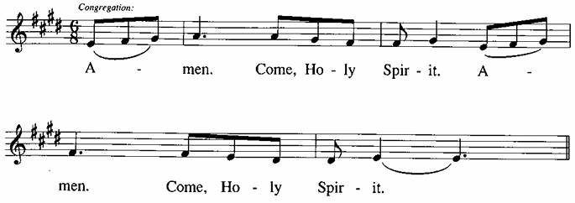

P: This we pray through Jesus Christ,
our Savior and our friend.
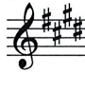
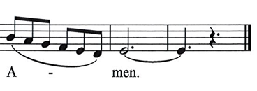
C:

Lord’s Prayer

P: Gathered as one by the Holy Spirit, we pray as Jesus taught us.
C: Our Father in heaven,
hallowed be your name,
your kingdom come,
your will be done,
on earth as in heaven.
Give us today our daily bread.
Forgive us our sins,
as we forgive those
who sin against us;
Save us from the time of trial,
and deliver us from evil.
For the kingdom, the power,
and the glory are yours,
now and ever. Amen.

Fraction and Invitation

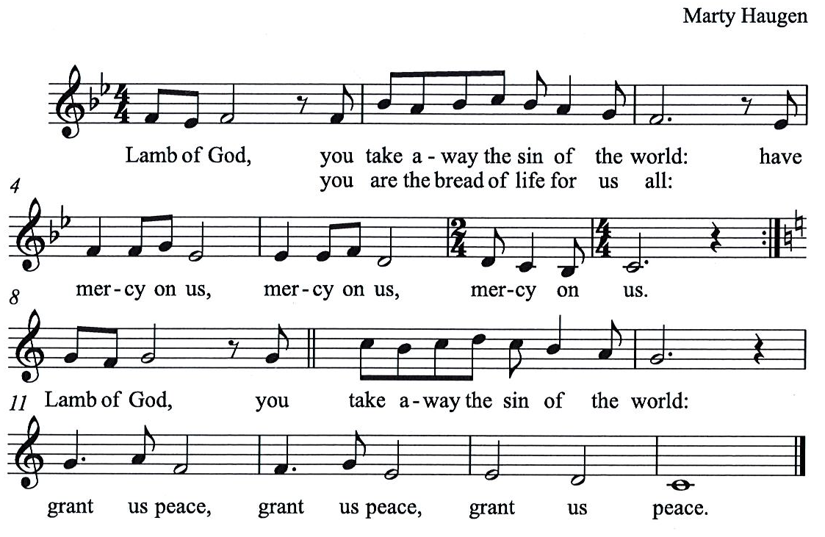
Agnus Dei / Lamb of God HS p. 18

Please be seated.

Holy Communion

- All who seek God and desire a deeper and stronger life in Christ are welcome to receive Holy Communion.
- Worshipers from the pulpit side will proceed forward first, followed by the center section, and then the lectern side.
- Please inform an usher if you would like the ministers to bring Communion to you.
- Holy Communion will be served with bread and wine (red) or grape juice (white).
- The presiding minister will first distribute the bread (host) to each communicant. Please indicate if you require a gluten-free host.
- Once you have consumed the bread, please pick up an empty glass from the tray next to the presiding minister. The Communion Assistant will pour wine or grape juice into your glass.
- Please step to the side to consume the wine or grape juice.
- Feel free to kneel at the altar rail for prayer after receiving the sacrament.
- As you return to your pew, glasses may be returned to the empty tray on the side of the center section.
- A blessing will be provided for anyone who does not yet receive the sacrament.
- All are invited to join in singing the hymns during Holy Communion.

Hymns during Holy Communion
What Is the World Like ACS 1047

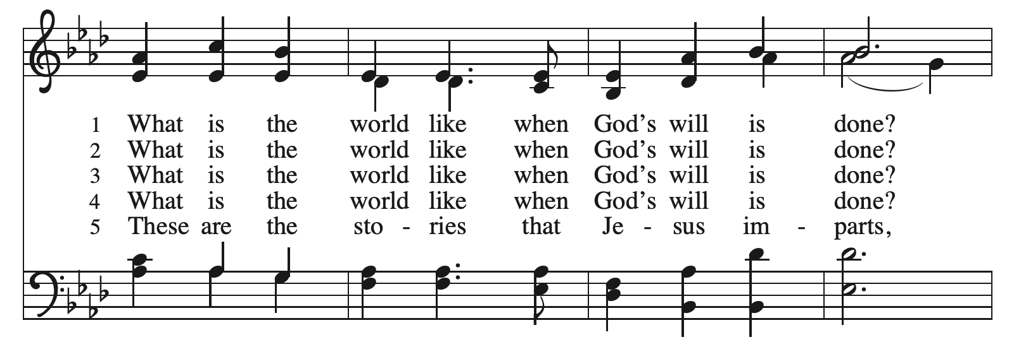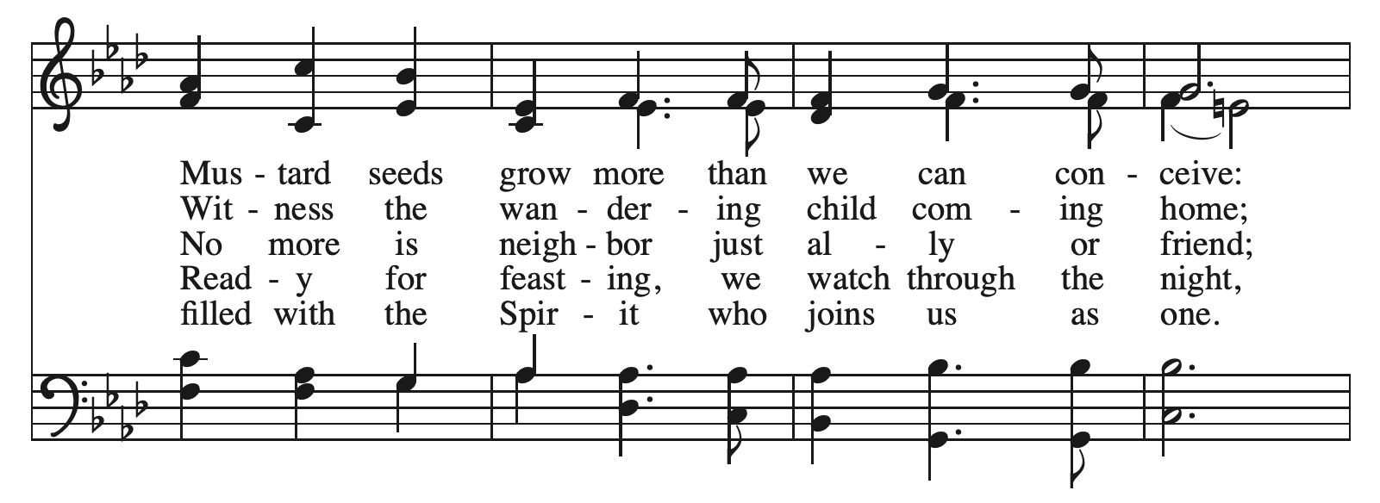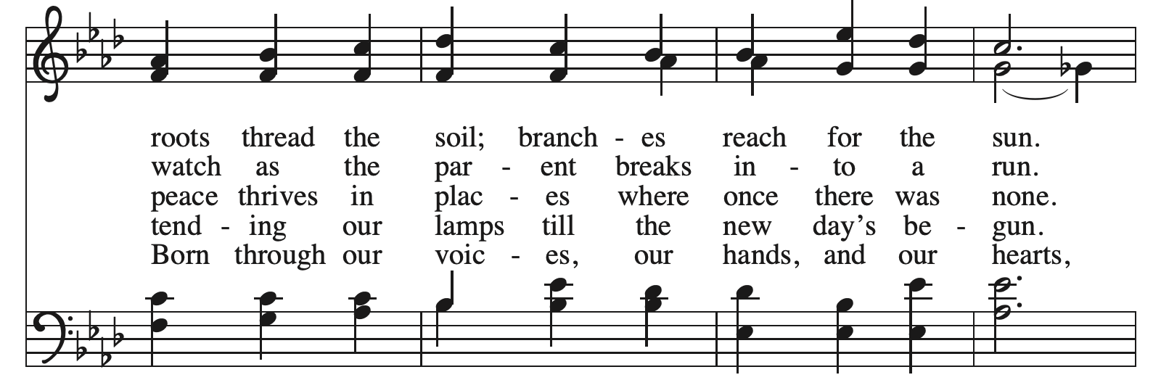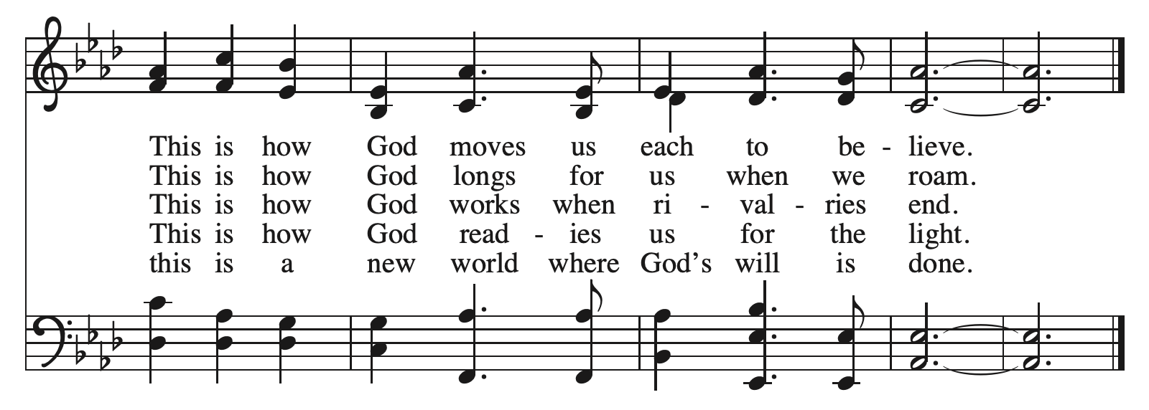
Hymns during Holy Communion
As Saints of Old ELW 695

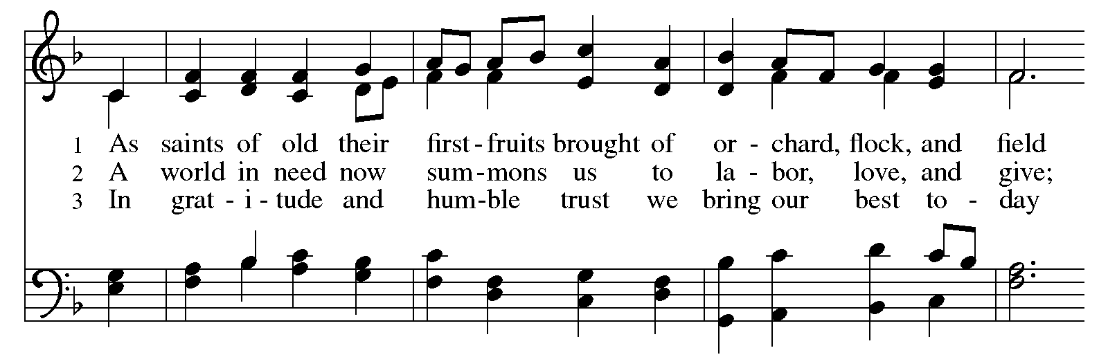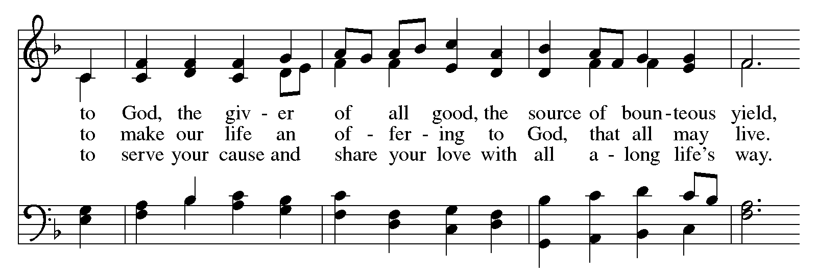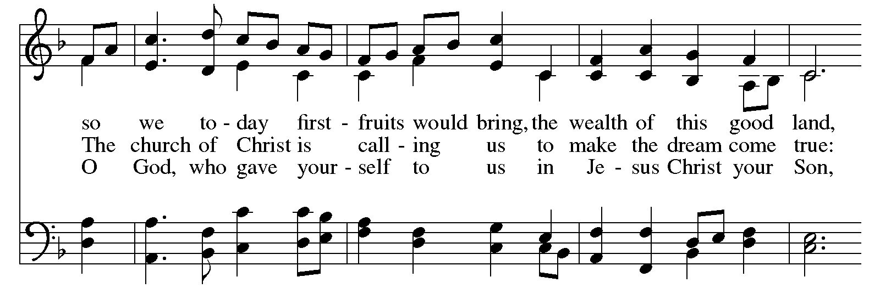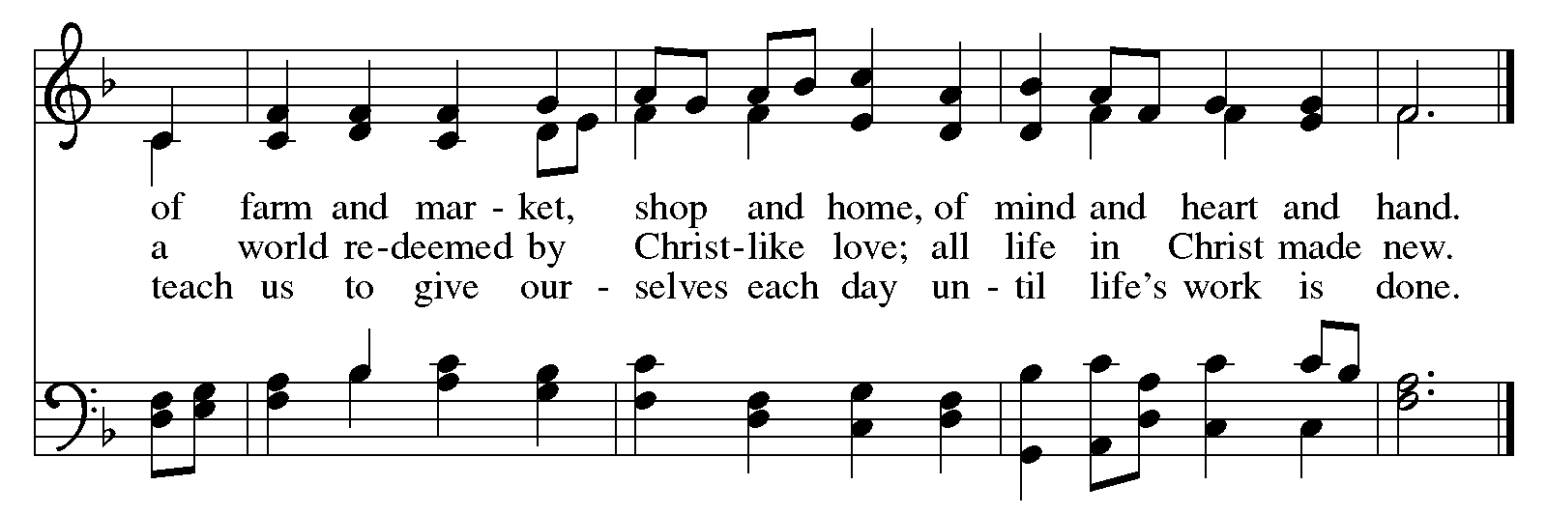
Hymns during Holy Communion
O Day of Peace ELW 711

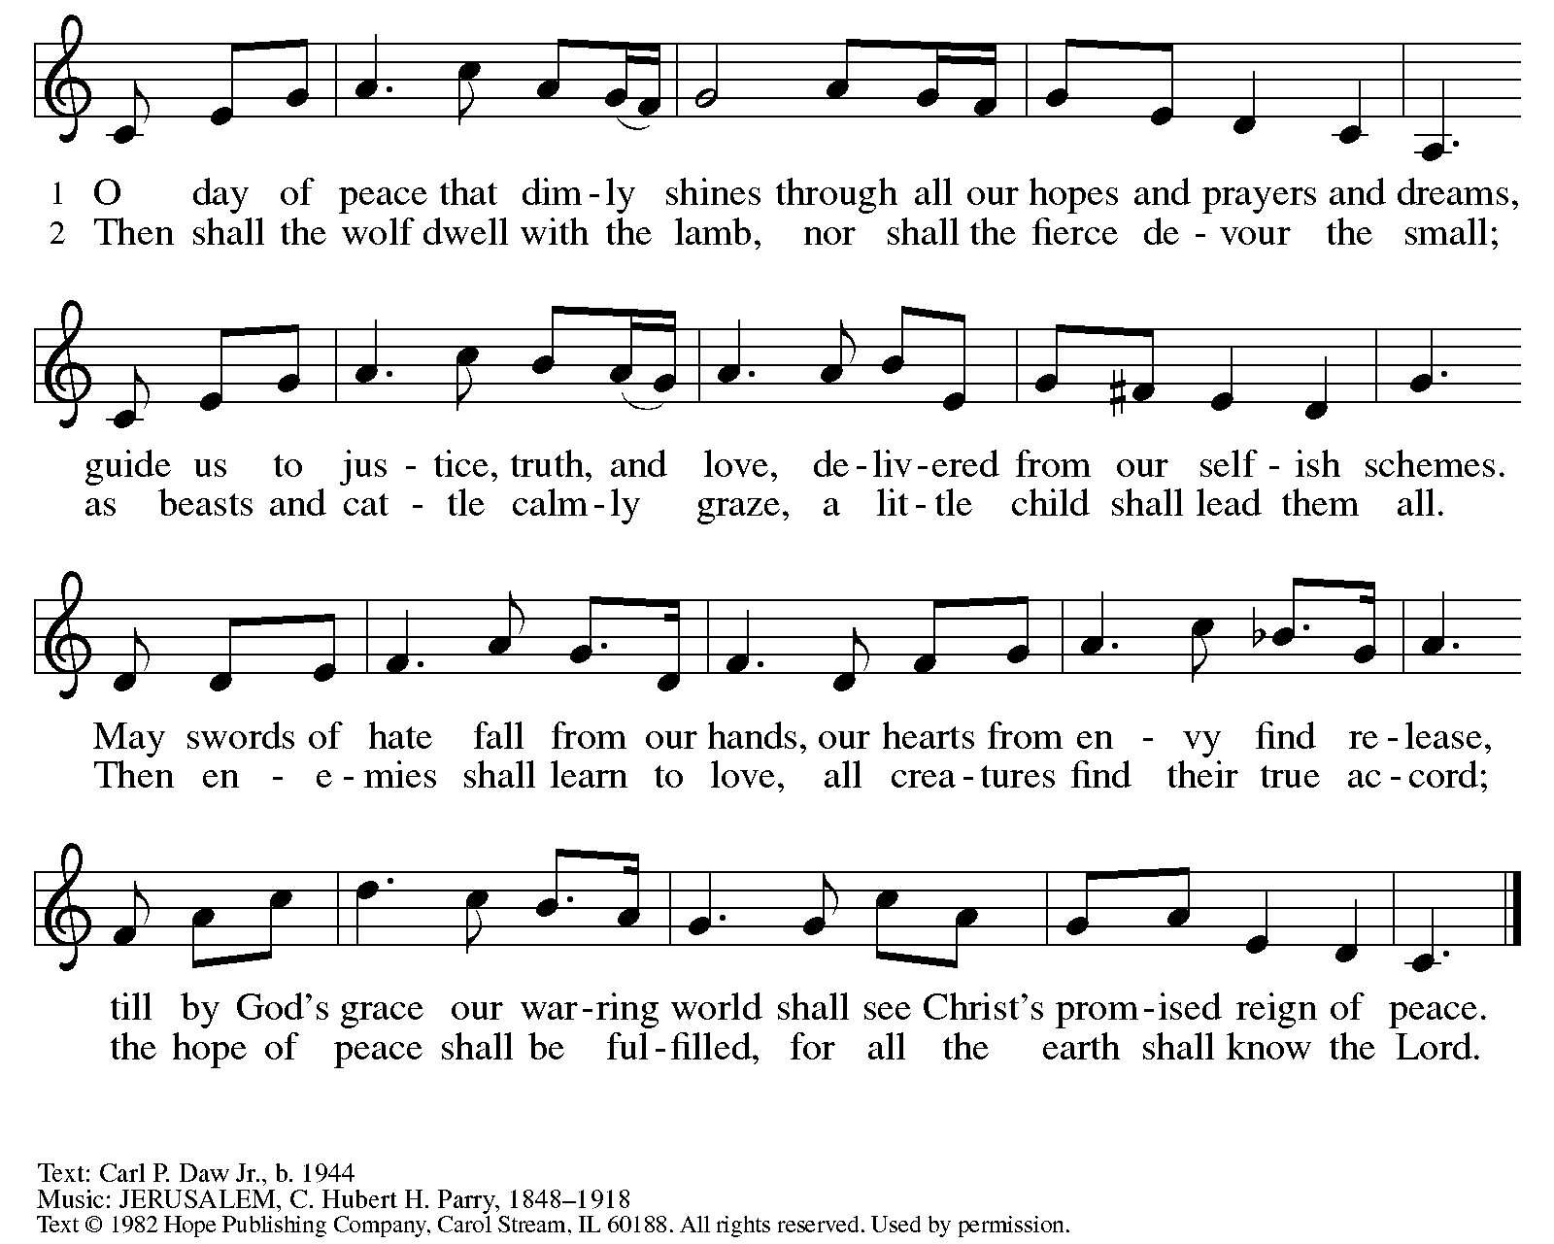
Reprinted under OneLicense.net # A-722139.

Hymns during Holy Communion
Lord of Glory, You Have Bought Us ELW 707

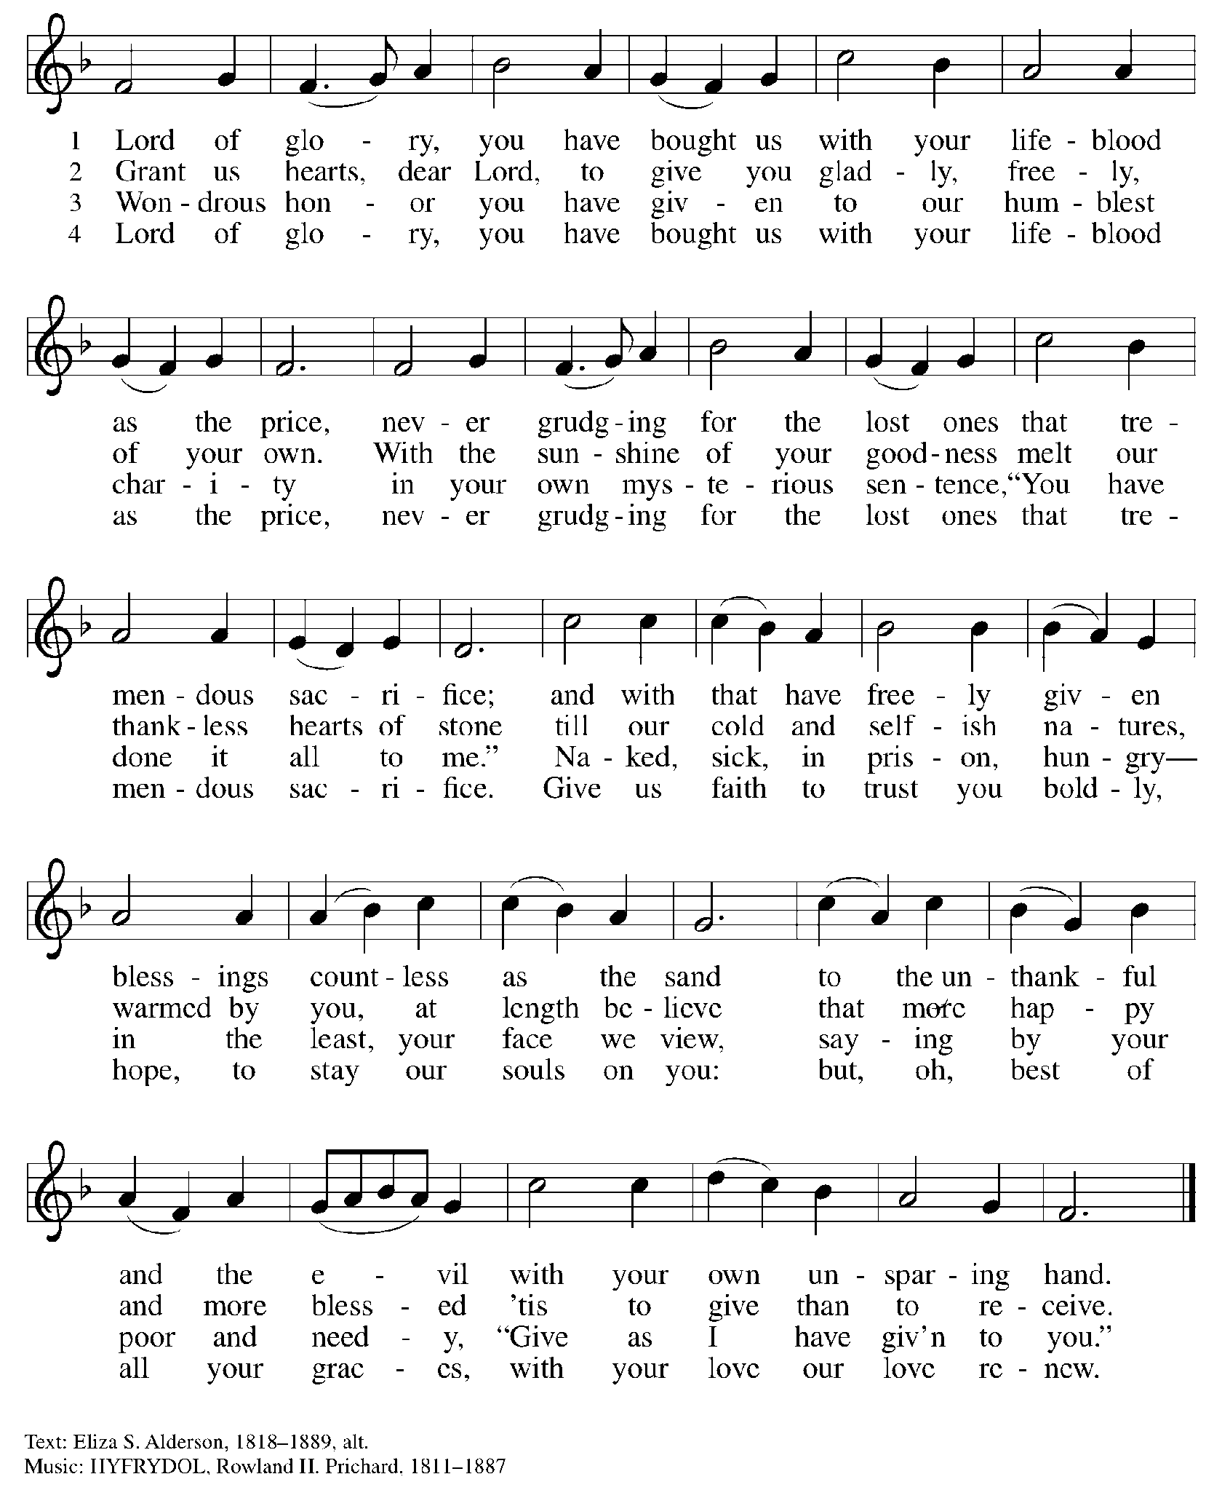

When all have returned to their places, please rise as you are able.
Blessing

P: The body and blood of our Lord Jesus Christ strengthen you and keep you in his grace.
C: Amen.

Prayer

A: Let us pray. Compassionate God,
through these gifts of bread and wine
our hearts are filled with the abundance of your love.
Strengthen us that we, through this holy meal,
may share your love freely, as you have shared with us.
We ask this in the name of Jesus,
through the Spirit nourishing us now and forever.
C: Amen.

Please be seated.

Sending
God blesses us and sends us in mission to the world

Announcements

Please rise as you are able.

Benediction

P: The love of God abound in you,
the grace of our Savior Jesus Christ fill your hearts;
and the life of the Spirit ☩ bless you and give you peace.
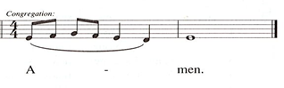
C:

Sending Hymn Following Page

Dismissal

A: Go in peace. Serve the Lord.
C: Thanks be to God!

Postlude
Sending Hymn Here I Am, Lord ELW 574
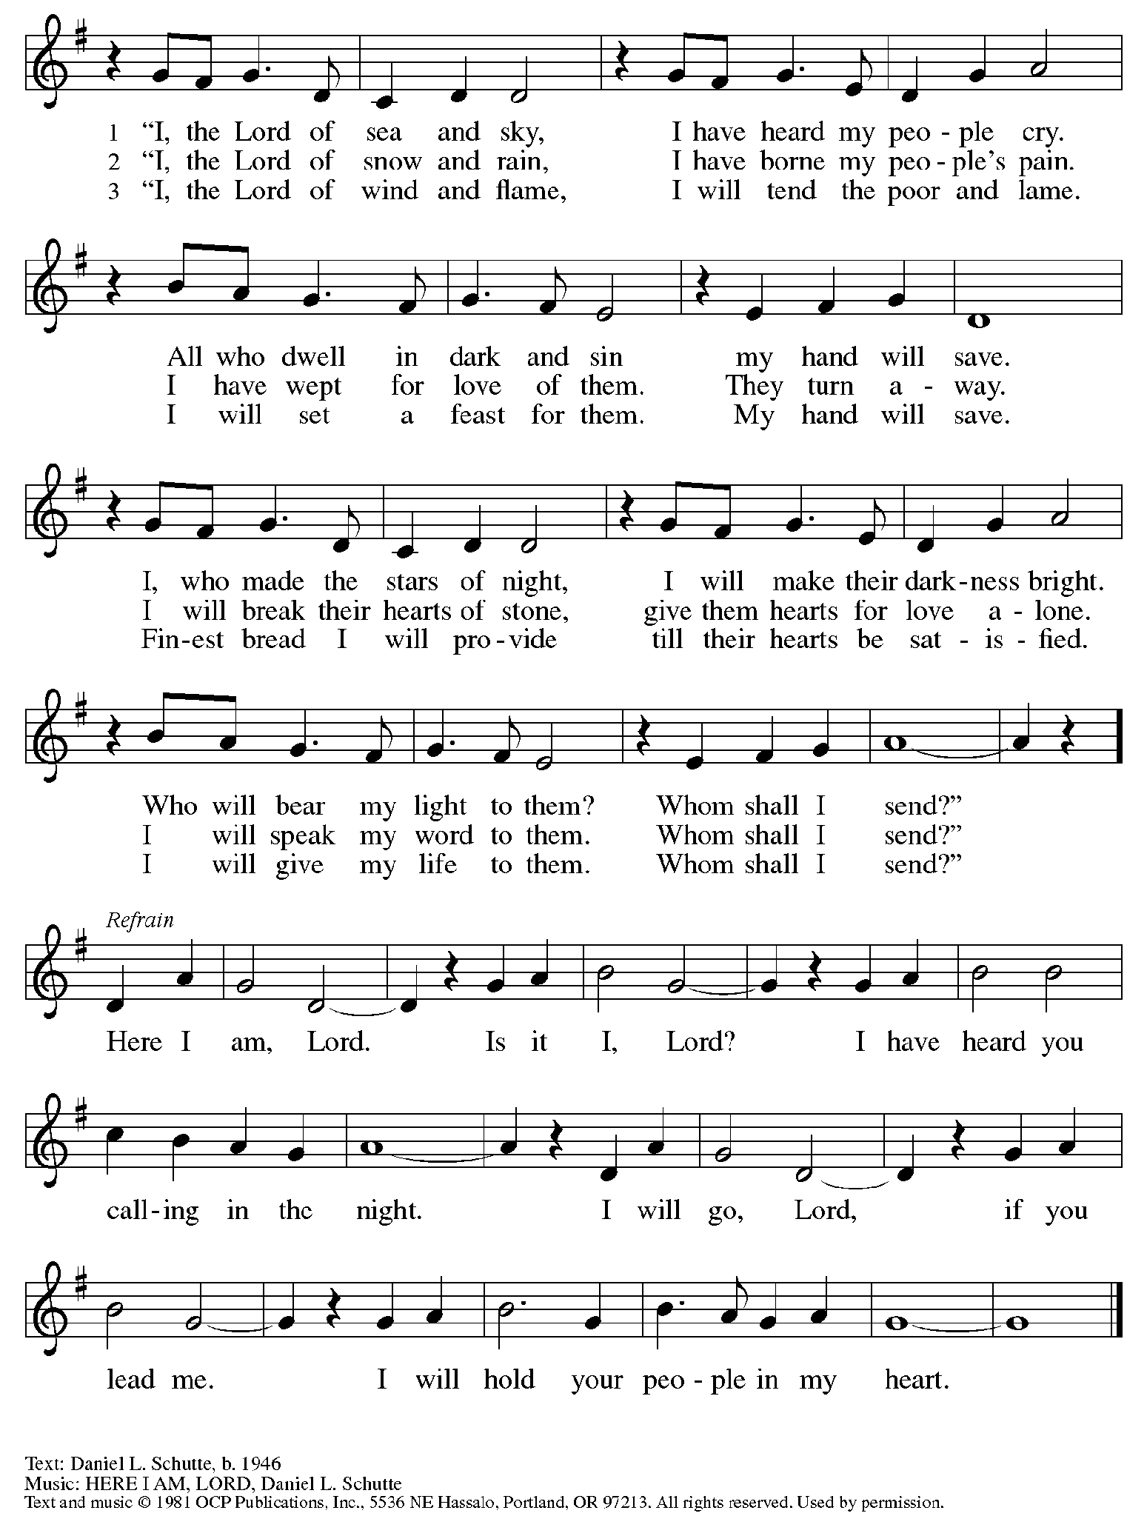
Reprinted with permission under OneLicense.net # A-722139.
Those serving in worship today

Altar Care Christy Ruhe
Assisting Minister Jeff Denlinger
Audio-Visual Ministers Kristen Asplin
Joseph Paetz Cantor Emily Duque
Lector Michael Chapman
Little Church - Big Faith Teacher Kaytlin Black
Organ Jimmi Kocher-Hillmer
Pre-Service Musical Offering Chloe Mobley
Minister of Music Laura Reynolds
Presiding Minister The Rev. Ross I. Carmichael

Liturgy and Hymnody Acknowledgements

From SundaysandSeasons.com. Copyright © 2026 Augsburg Fortress. All rights reserved. Reprinted under OneLicense.net # A-722139.
Used by permission of Augsburg Fortress.

From Hymnal Supplement. Copyright © 1991 GIA Publications, Inc. All rights reserved. Reprinted under OneLicense.net # A-722139.
Used by permission of GIA Publications, Inc.

The Scripture readings contained herein are from New Revised Standard Version Updated Edition of the Bible © 2021 National Council of Churches of Christ in the United States of America. Used by permission. All rights reserved worldwide.

God, Whose Giving Knows No Ending – Text: Robert L. Edwards, 1915-2006. Music: RUSTINGTON, C. Hubert H. Parry, 1848-1918. Text © 1961, ren. 1989 The Hymn Society, admin. Hope Publishing Company, Carol Stream, IL 60188. All rights reserved. Reprinted with permission under OneLicense.net # A-722139.

What Is the World Like – Text: Adam M. L. Tice, b. 1979. Music: NEW WORLD, Sally Ann Morris, b. 1952. Text and music © 2009 GIA Publications, Inc., giamusic.com. All rights reserved. Reprinted with permission under OneLicense.net # A-722139.

As Saints of Old – Text: Frank von Christierson, 1900-1996, alt. Music: FOREST GREEN, English folk tune; arr. Ralph Vaughan Williams, 1872-1958. Text © 1961, ren. 1989 The Hymn Society, admin. Hope Publishing Company, Carol Stream, IL 60188. All rights reserved. Reprinted with permission under OneLicense.net # A-722139.

Please use the QR code below to link to St. Andrew’s Announcements online!



St. Andrew Lutheran Church Announcements
September 20th, 2026

- Welcome to Worship at St. Andrew on the Seventeenth Sunday after Pentecost – We are thankful you are here, and we offer a special welcome to all visitors and guests who are here for the first time! A nursery is available through the door to the left of the worship space and across the social hall (look for a purple room). Little Church – Big Faith, a Bible lesson and activity for children up to sixth grade, will take place after the prayer of the day. There are also worship “toolkits” to help children engage with worship and “busy bags” for younger children available in the bookcase at the back of the sanctuary. Please feel free to take one to use with/for your children. All are invited to stay for coffee and other drinks, food, and conversation in the Social Hall (through the side door at the left of the worship space) after the service.
- Noisy Offering, This Sunday, September 20th During Worship – On the third Sunday of each month, St. Andrew’s children lead the congregation in a Noisy Offering, in which people are invited to throw their change into buckets that the children carry around the church and bring forward as an additional offering. Each month’s Noisy Offering supports a local, national, or international church-related or otherwise charitable organization. This month’s offering will benefit the Greater Pittsburgh Community Food Bank. GPCFB serves 11 counties over 53 million meals annually and stocks our produce distribution. You can learn more about their program and how it works here: https://pittsburghfoodbank.org/what-we-do/how-we-work/.
- St. Andrew's Capital Campaign Continues – We are thrilled to announce that this past year's construction work on a new roof and related areas for St. Andrew is complete, and the plastering and painting is underway! St. Andrew's capital campaign continues, and we are 88% of the way toward our $1 million goal! Over the next three weeks, we will hear stories and testimonies in worship about the ways that St. Andrew continues to reach out as a community of love, a community of justice, and a community of service. If you have not yet made a commitment to the campaign, please prayerfully consider how you can support the effort. We will dedicate our campaign gifts to God on Commitment Sunday, October 11th.
- Bible Book Club, Wednesdays at 7:00 p.m. on Zoom – St. Andrew's weekly Bible Book Club meets each Wednesday at 7:00 p.m. The group is currently reading and discussing Karen Armstrong's A History of God. It can be found here: https://bookshop.org/p/books/a-history-of-god-the-4-000-year-quest-of-judaism-christianity-and-islam-karen-armstrong/277069b2cf4e39ad?ean=9780345384560. If anyone needs assistance in obtaining a book, please speak with Pastor Ross. Bible Book Club invites new participants, regardless of how often you can attend or whether or not you have read the specific material for the week. You can use this link to join the call: https://us02web.zoom.us/j/83196175976?pwd=ejdPOUYrTk4xVFdsdlhHUVJ1L3k2Zz09.
- Coffee Hour Signups – Coffee hour returns this week! St. Andrew provides hospitality during a coffee hour after worship each Sunday. If you would like to participate and would like information about the duties of setting up, please sign up using the following form: https://www.signupgenius.com/go/5080B4AAFAF2CABF85-47069030-coffee#/.
- Produce Distribution Supplemental Food of the Month – St. Andrew is collecting supplemental food each month to accompany our produce distribution. For September, we ask for donations of rice. There are collection boxes at the back of the worship space and social hall.
- Added Session - Conscience and Conversation Study, Tuesday, September 22nd, 7:00 p.m. on Zoom – St. Andrew has offered two study sessions on Conscience and Conversation, part of the Evangelical Lutheran Church in America's reconsideration of its 2009 Social Statement, Human Sexuality: Gift and Trust. The group has shared such rich conversation that we are adding a third session on Tuesday, September 22nd, at 7:00 p.m., also on Zoom. All are welcome even if you have not participated in the first two sessions. The Conscience and Conversation study guide can be found here: https://resources.elca.org/faith-and-society/conscience-and-conversation-study/.
Anyone is invited to share feedback with the ELCA by the September 30th deadline. The ELCA has also released a five-episode podcast as a companion to the study. Individual episodes are available at elca.org/reconsiderations.
- Lunch Club at Church Brew Works, Sunday, September 27th after Worship – Kelly Spanninger is organizing a renewal of St. Andrew lunch outings after Sunday worship. All are invited to gather at Church Brew Works at 3525 Liberty Ave, Pittsburgh, PA 15201 at 12:15 p.m. Please let Kelly know if you plan to attend, or contact her at pkspanninger@verizon.net.
- “Christ in Our Home” Booklets Available – “Christ in Our Home” is a quarterly devotional resource that encourages readers to live out their faith daily. Each reflective reading is accompanied by a daily scripture reference and prayer for the day. The October-December booklets are available at the entrances. Please feel free to take one home!

- Joseph and Anya Are Getting Married! Help with a Cookie Table, Saturday, October 3rd, 3:00 p.m. – Joseph Paetz and Anya Fredrickson are getting married at St. Andrew on Saturday, October 3rd! The wedding begins at 3:00 p.m., with a cookie table reception to follow in the social hall, and Joseph and Anya invite people of the congregation to attend both! If you would like to help set up the cookie table and/or bake and contribute cookies, please use the QR code below.

