

+ Eighteenth Sunday after Pentecost
September 27, 2026



St. Andrew Lutheran Church
304 Morewood Ave.
Pittsburgh, PA 15213
St_andrewELCA@verizon.net
www.standrewpittsburgh.org

+ Eighteenth Sunday after Pentecost

Jesus’ parable about two sons who don’t do what they say they will do reveals surprises in the reign of God. In the reading from Ezekiel the people claim the ways of the Lord are unfair,
while God offers repentance and new life. Paul urges us to look to Christ as a model of humility, putting the interests of others above our own. Nourished by the broken bread and shared cup,
we offer our lives for the sake of our needy world.

Welcome to St. Andrew!
- St. Andrew welcomes all who are seeking a place of healing, wholeness, and acceptance in a nurturing and faith-forming spiritual home. We are striving toward racial equity worldwide
and we seek to honor the lived experience of all individuals regardless of background. Our community embraces people of all ages, ethnicities, cultures, abilities, sexual orientations,
gender identities and expressions, and family constellations. Come and See!
- Worship Services are live-streamed to multiple online platforms. By attending worship, you agree that your image and voice may be broadcast.
- Everyone is invited to make a name tag at the black bookcase in the back of the worship space if they would like. There are stickers indicating pronouns on the bookcase if you would like to include them on your name tag.
- Children up to sixth grade are invited to attend Little Church – Big Faith, a Bible lesson and activity, during worship (after the Prayer of the Day). The group returns to the worship space for the liturgy of Holy Communion.
- A nursery is available through the doors at the left side of the sanctuary and across from the doorway to the Social Hall. Look for a purple-colored room.
- Worship “toolkits” to help children engage with the service, along with “busy bags” for younger children, are available in the bookcase at the back of the sanctuary. Please feel free to take one to use with/for your children.
- Holy Communion is served with bread (gluten-free available) and wine or grape juice. The presiding minister will distribute the bread (host). Please consume this and then pick up an empty glass from the tray. The Communion Assistant will pour wine or grape juice into your glass. Please step to the side to consume the wine or grape juice. Feel free to kneel at the altar for prayer and reflection. As you return to your pew, glasses may be returned to the empty trays on either side of the center section.
- A restroom is available on the main level of the church, through the doors to the Social Hall and to the right in the main office.

Abbreviations
P: Pastor/Presiding Minister ELW: Evangelical Lutheran Worship hymnal
A: Assisting Minister ACS: All Creation Sings hymnal
L: Lector HS: Hymnal Supplement (GIA Publications)
C: Congregation

Musical Offering

Each week, different people from the congregation make an offering of pre-service music, with singing or instrumentation, to help the assembly focus and pray in preparation for worship.

Welcome
Prelude Savior, Like a Shepherd Lead Us arr. Keveren

Savior, like a shepherd lead us;
much we need your tender care.
In your pleasant pastures feed us,
for our use your fold prepare.
Blessed Jesus, blessed Jesus,
you have bought us; we are yours.
Blessed Jesus, blessed Jesus,
you have bought us; we are yours.

Gathering
The Holy Spirit calls us together as the people of God

Please rise as you are able. All may make the sign of the cross,
the sign that is marked at Baptism, as the presiding minister begins.

Confession and Forgiveness

P: Blessed be the ☩ holy Trinity,
one God, whose compassion endures forever.
C: Amen.

P: If we say we have no sin, we deceive ourselves and the truth is not us.
Let us confess our sin to God who is faithful and just,
and who has promised to forgive sin and cleanse us from all unrighteousness.

Silence is kept for reflection.

P: Most merciful God,
C: we confess to you that we have sinned against you in thought, word, and deed,
by what we have done and by what we have left undone.
We have not trusted you with our whole heart;
we have not loved one another in deed and in truth.
In your compassion, forgive our sin and so uphold us by your Spirit
that we may live and serve you in newness of life,
through Jesus Christ, our light and our truth.
Amen.

P: With joy I proclaim to you that Almighty God,
rich in mercy, abundant in love,
forgives you all your sin and grants you newness of life
☩ in Jesus Christ.
C: Amen. Thanks be to God!

Gathering Hymn God, Be the Love to Search and Keep Me ACS 1084

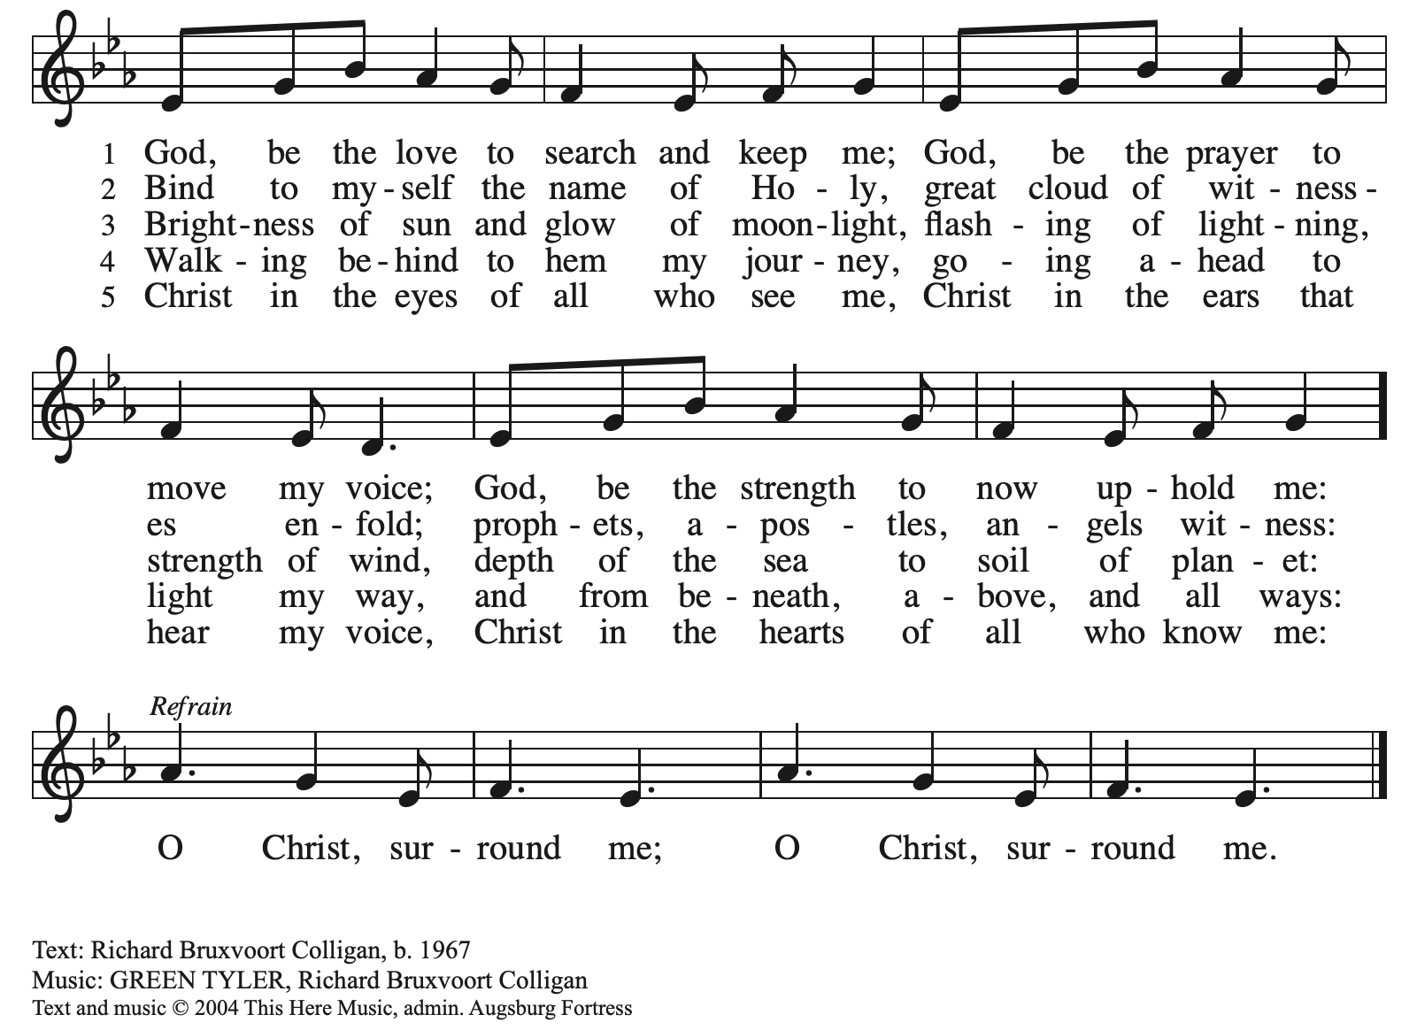
All rights reserved. Reprinted with permission under OneLicense.net # A-722139.

Greeting

P: The grace of our Lord Jesus Christ, the love of God,
and the communion of the Holy Spirit be with you all.
C: And also with you.

Hymn of Praise Glory to God HS p. 6-7

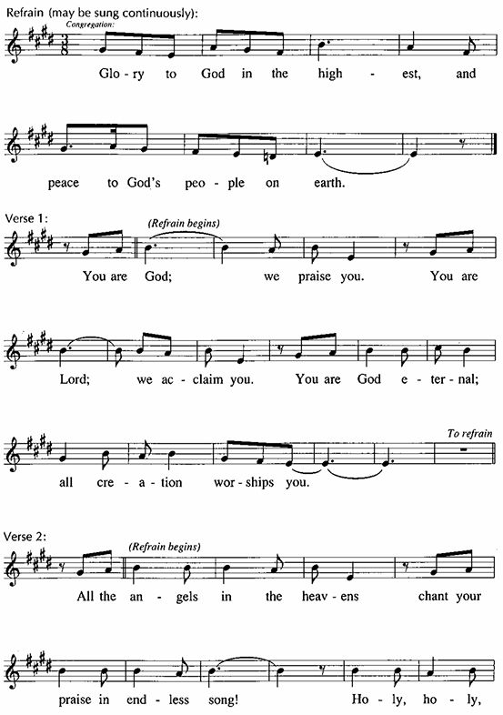

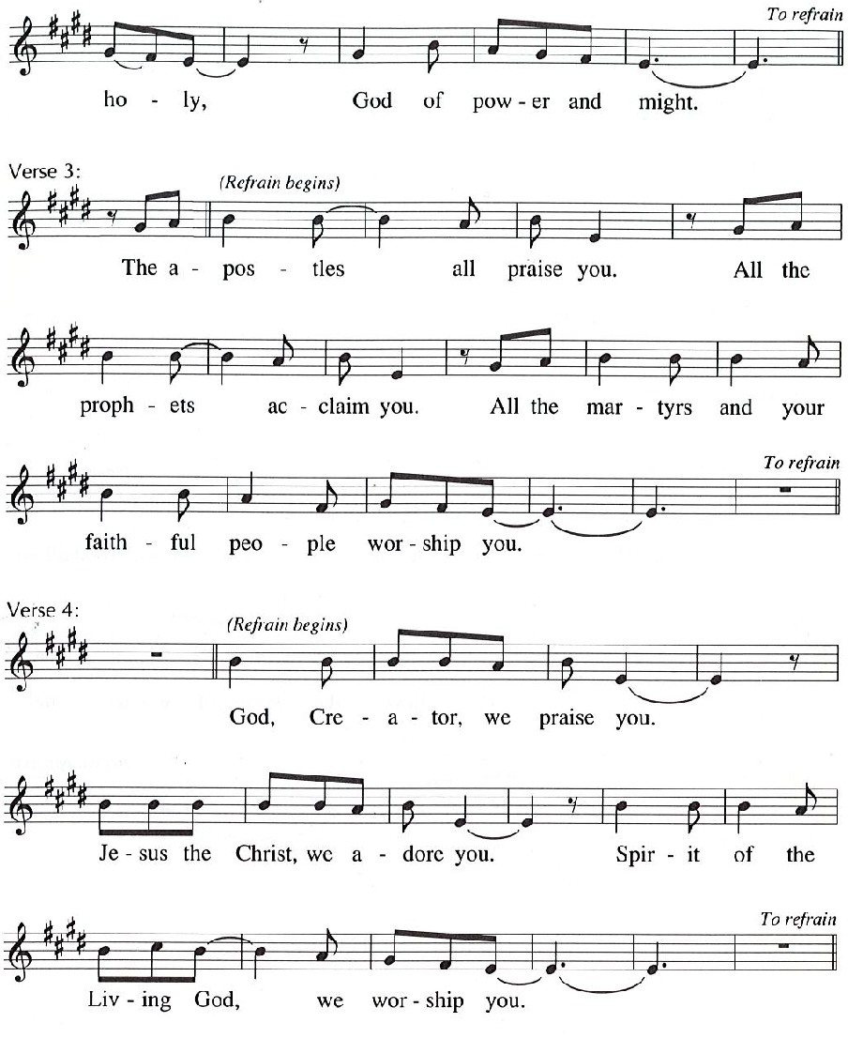

Prayer of the Day

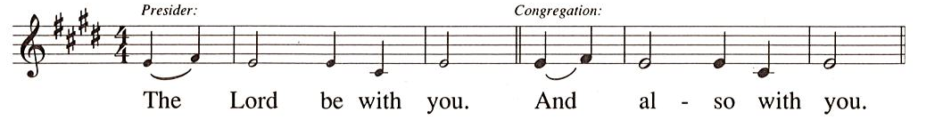
P: Let us pray.
God of love, giver of life, you know our frailties and our failings.
Give us your grace to overcome them, keep us from those things that harm us,
and guide us in the way of salvation, through Jesus Christ, our Savior and Lord.
C: Amen.

Please be seated.

Word
God speaks to us in Scripture reading, preaching, and song

First Reading – Ezekiel 18: 1-4, 25-32

¹ The word of the Lord came to me: ² What do you mean by repeating this proverb concerning the land of Israel, “The parents have eaten sour grapes, and the children’s teeth are set on edge”?
³ As I live, says the Lord God, this proverb shall no more be used by you in Israel. ⁴ Know that all lives are mine; the life of the parent as well as the life of the child is mine: it is only the person who sins who shall die.
²⁵ Yet you say, “The way of the Lord is unfair.” Hear now, O house of Israel: Is my way unfair? Is it not your ways that are unfair? ²⁶ When the righteous turn away from their righteousness and commit iniquity, they shall die for it; for the iniquity that they have committed, they shall die. ²⁷ Again, when the wicked turn away from the wickedness they have committed and do what is lawful and right, they shall save their life. ²⁸ Because they considered and turned away from all the transgressions that they had committed, they shall surely live; they shall not die. ²⁹ Yet the house of Israel says, “The way of the Lord is unfair.” O house of Israel, are my ways unfair? Is it not your ways that are unfair?
³⁰ Therefore I will judge you, O house of Israel, all of you according to your ways, says the Lord God. Repent and turn from all your transgressions; otherwise iniquity will be your ruin. ³¹ Cast away from you all the transgressions that you have committed against me, and get yourselves a new heart and a new spirit! Why will you die, O house of Israel? ³² For I have no pleasure in the death of anyone, says the Lord God. Turn, then, and live.

L: Word of God, word of life.
C: Thanks be to God.

Psalm 25: 1-9

The psalm will be sung responsively, led by the cantor,
with the congregation responding with the verses in bold and the refrain.

Psalm Tone

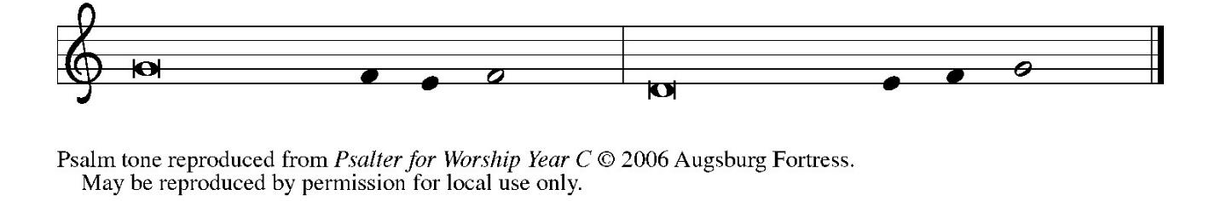

Psalm Refrain

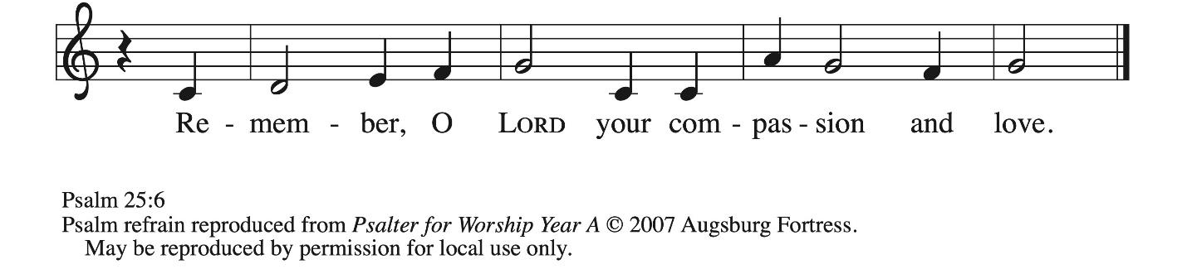

¹ To | you, O Lord,
I lift | up my soul.
² My God, I put my trust in you; let me not be | put to shame,
nor let my enemies triumph | over me.
³ Let none who look to you be | put to shame;
rather let those be put to shame | who are treacherous.
⁴ Show me your | ways, O Lord,
and teach | me your paths. R
⁵ Lead me in your | truth and teach me,
for you are the God of my salvation; in you have I trusted all | the day long.
⁶ Remember, O Lord, your compas- | sion and love,
for they are from | everlasting.
⁷ Remember not the sins of my youth and | my transgressions;
remember me according to your steadfast love and for the sake of your good- | ness, O Lord.
⁸ You are gracious and up- | right, O Lord;
therefore you teach sinners | in your way.
⁹ You lead the low- | ly in justice
and teach the low- | ly your way. R

Second Reading – Philippians 2: 1-13

¹ If, then, there is any comfort in Christ, any consolation from love, any partnership in the Spirit, any tender affection and sympathy, ² make my joy complete: be of the same mind, having the same love, being in full accord and of one mind. ³ Do nothing from selfish ambition or empty conceit, but in humility regard others as better than yourselves. ⁴ Let each of you look not to your own interests but to the interests of others. ⁵ Let the same mind be in you that was in Christ Jesus,
⁶ who, though he existed in the form of God,
did not regard equality with God
as something to be grasped,
⁷ but emptied himself,
taking the form of a slave,
assuming human likeness.
And being found in appearance as a human,
⁸ he humbled himself
and became obedient to the point of death—
even death on a cross.
⁹ Therefore God exalted him even more highly
and gave him the name
that is above every other name,
¹⁰ so that at the name given to Jesus
every knee should bend,
in heaven and on earth and under the earth,
¹¹ and every tongue should confess
that Jesus Christ is Lord,
to the glory of God the Father.
¹² Therefore, my beloved, just as you have always obeyed me, not only in my presence but much more now in my absence, work on your own salvation with fear and trembling, ¹³ for it is God who is at work in you, enabling you both to will and to work for God’s good pleasure.

L: Word of God, word of life.
C: Thanks be to God.

Please rise as you are able.

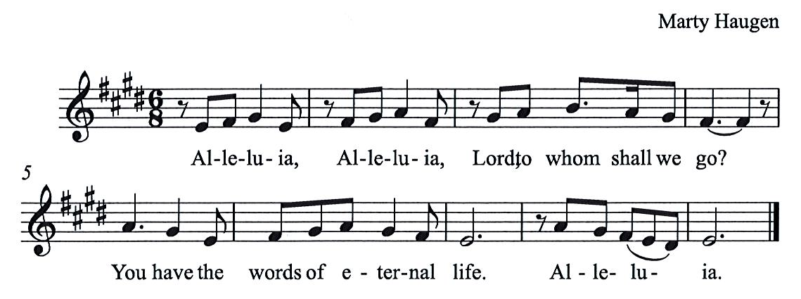
Gospel Acclamation HS p. 8

Gospel – Matthew 21: 23-32

P: The holy Gospel according to St. Matthew.
C: Glory to you, O Lord.

²³ When [Jesus] entered the temple, the chief priests and the elders of the people came to him as he was teaching and said, “By what authority are you doing these things, and who gave you this authority?” ²⁴ Jesus said to them, “I will also ask you one question; if you tell me the answer, then I will also tell you by what authority I do these things. ²⁵ Did the baptism of John come from heaven, or was it of human origin?” And they argued with one another, “If we say, ‘From heaven,’ he will say to us, ‘Why, then, did you not believe him?’ ²⁶ But if we say, ‘Of human origin,’ we are afraid of the crowd, for all regard John as a prophet.” ²⁷ So they answered Jesus, “We do not know.” And he said to them, “Neither will I tell you by what authority I am doing these things.
²⁸ “What do you think? A man had two sons; he went to the first and said, ‘Son, go and work in the vineyard today.’ ²⁹ He answered, ‘I will not,’ but later he changed his mind and went.
³⁰ The father went to the second and said the same, and he answered, ‘I go, sir,’ but he did not go. ³¹ Which of the two did the will of his father?” They said, “The first.” Jesus said to them, “Truly I tell you, the tax collectors and the prostitutes are going into the kingdom of God ahead of you. ³² For John came to you in the way of righteousness, and you did not believe him, but the tax collectors and the prostitutes believed him, and even after you saw it you did not change your minds and believe him.”

P: The Gospel of the Lord.
C: Praise to you, O Christ.

Please be seated.

Sermon

A time of silence for prayer and reflection follows the sermon.
When the hymn of the day begins, please rise as you are able.


Hymn of the Day Oh, God, My Faithful God ELW 806

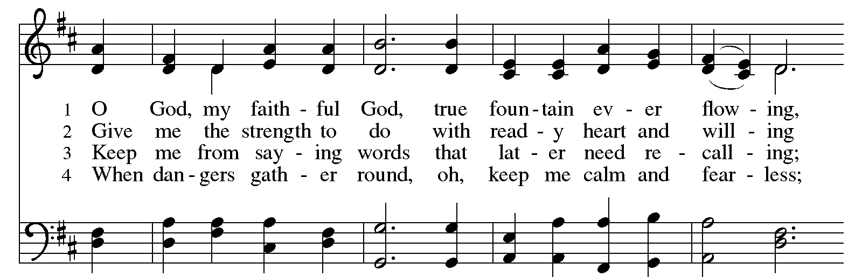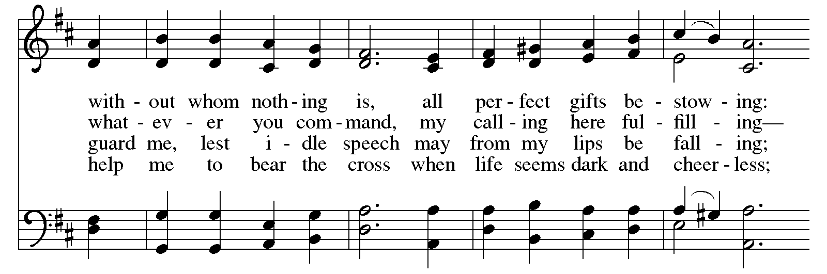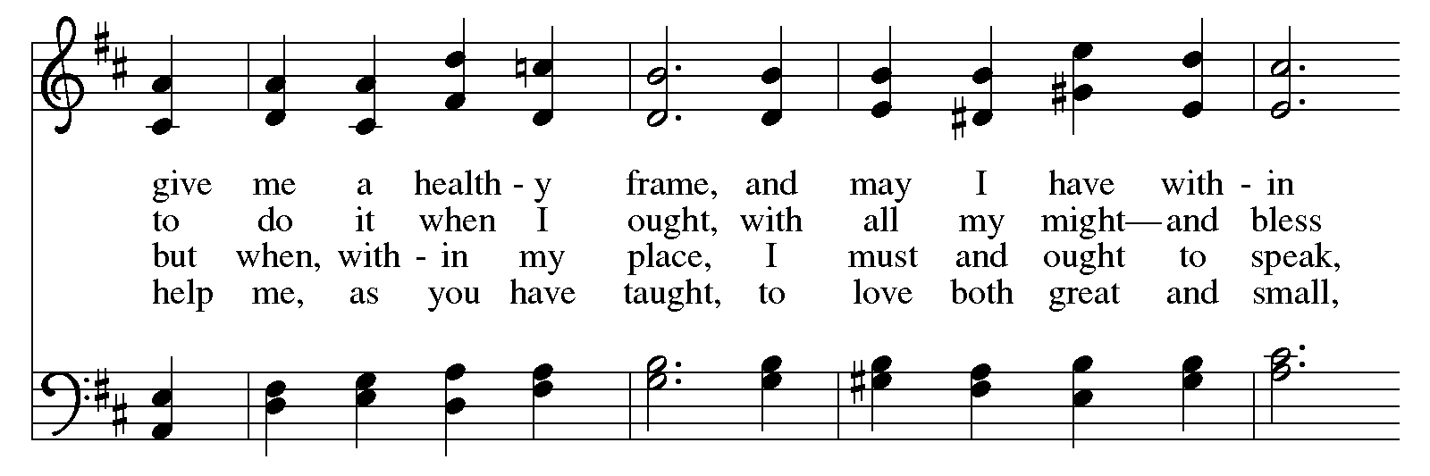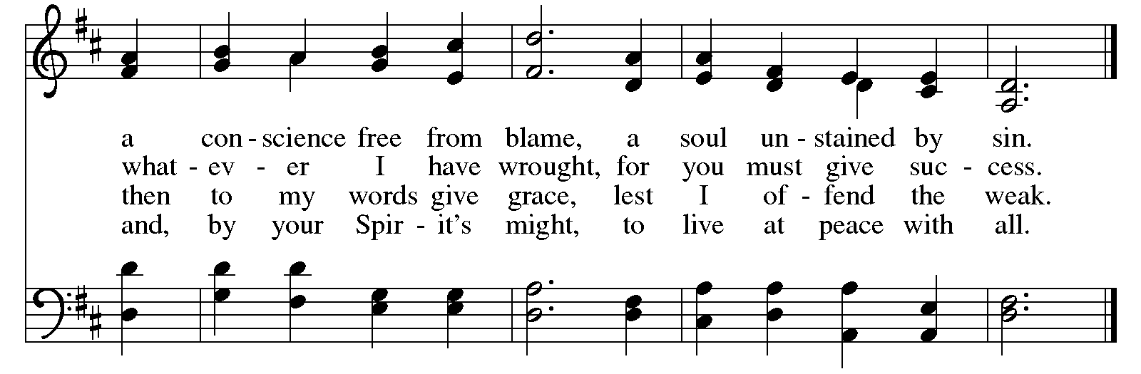

Apostles’ Creed

C: I believe in God, the Father almighty,
creator of heaven and earth.

I believe in Jesus Christ, God’s only Son, our Lord,
who was conceived by the Holy Spirit,
born of the virgin Mary,
suffered under Pontius Pilate,
was crucified, died, and was buried;
he descended to the dead.*
On the third day he rose again;
he ascended into heaven,
he is seated at the right hand of the Father,
and he will come to judge the living and the dead.

I believe in the Holy Spirit,
the holy catholic church,
the communion of saints,
the forgiveness of sins,
the resurrection of the body,
and the life everlasting. Amen.

*Or, “he descended into hell,” another translation of this text in widespread use.

Prayers of the People

A: Trusting in God’s steadfast love for all God has made,
let us pray for the church, the world, and those who are in need.

After each petition
A: Gracious God,
C: receive our prayer.

The presiding minister concludes the prayers
P: Grateful for your abundant provision and trusting in your goodness, O God,
we commend into your care all for whom we pray, through the priceless grace of Jesus Christ.
C: Amen.

Peace

The presiding minister and the assembly greet one another in the peace of the risen Christ.
P: The peace of Christ be with you always.
C: And also with you.

The people may greet those around them with a sign of Christ’s peace and may say
Peace be with you or similar words. Please be mindful that not everyone will be comfortable with sharing the peace, so please seek consent before shaking hands or hugging. Other possible ways to share the peace include a simple bow with the verbal greeting of peace, or simply a verbal expression of peace. When the greetings of peace have concluded, please be seated.



Meal
God feeds us with the presence of Jesus Christ

Offering

We offer ourselves, our gifts, and our faithful service to God.
As the offering is gathered for the mission of the church, including the care of those in need,
the table is set for Holy Communion.

There are laminated giving cards in the pew racks that feature a QR code for anyone who would like to give online. Those who give using the QR code, as well as those who give regularly online or through their bank are encouraged to place the laminated card in the plate as an expression of your offering.

Music during the Offering
Let My Spirit Always Sing arr. Kim

As the gifts are brought forward for presentation, please rise as you are able.

Offertory Song As the Grains of Wheat ELW 465

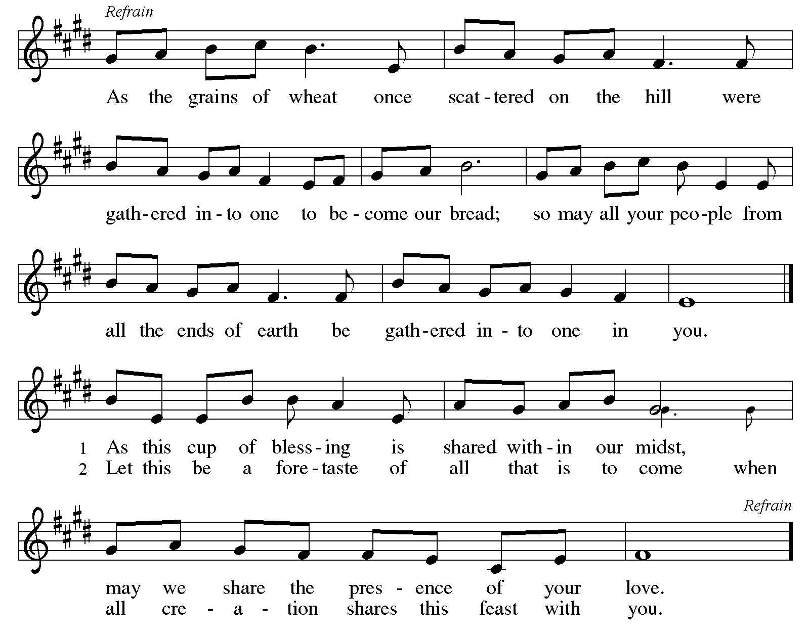

Offertory Prayer

A: Let us pray.
Merciful God,
C: everything in heaven and on earth belongs to you.
We joyfully release what you have entrusted to us.
May these gifts be signs of our whole lives returned to you,
dedicated to the healing and unity of all creation,
through Jesus Christ.
Amen.

Dialogue HS p. 14

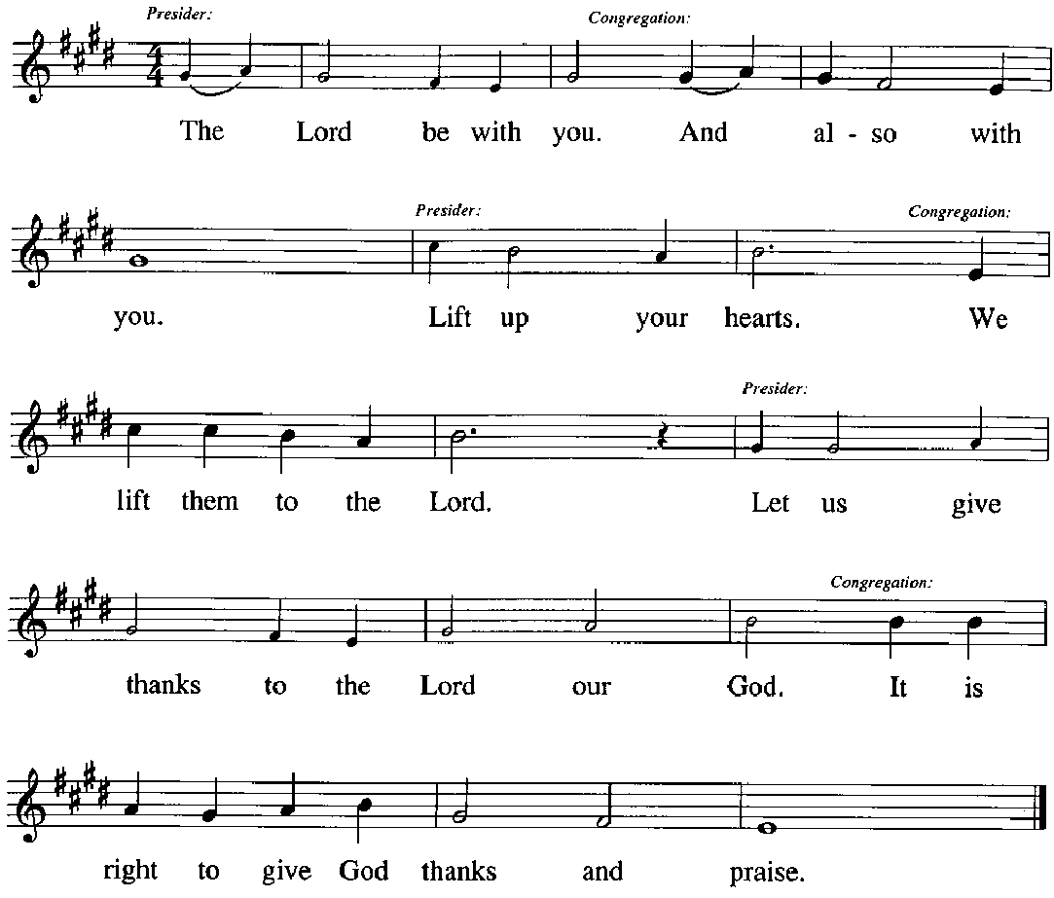

Preface (Sung by the presiding minister)

P: It is our duty and delight,
that we should everywhere and always
offer thanks and praise to you, O God,
through Jesus Christ,
who calls us to follow his way
of humble service and love,
and so with the church on earth,
all creation and the hosts of heaven,
we praise your name and join their unending hymn:

Sanctus HS p. 15

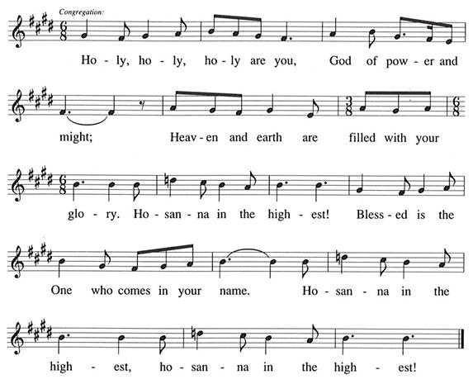

Eucharistic Prayer

P: You are indeed holy, gracious and merciful God …
… Do this for the remembrance of me.

Remembering his command to love one another,
his life and death, his resurrection and ascension,
we pray for his coming again, even as we cry:

(Sung by the presiding minister)
P: Amen. Come, Lord Jesus. Amen. Come, Lord Jesus.
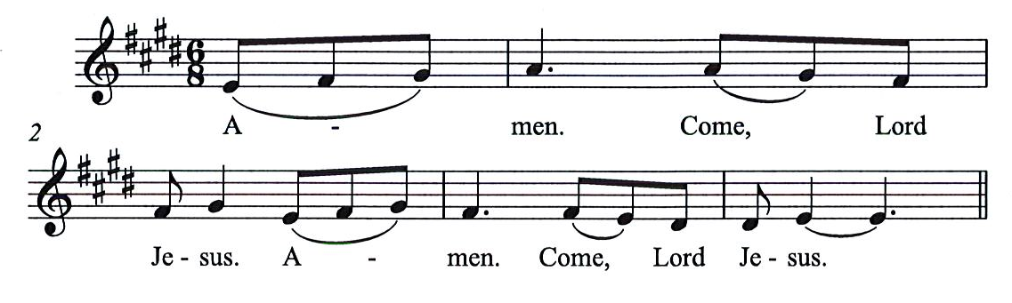
C:

P: Send now, we pray, your Holy Spirit,
that all of your promises
may come to us and your whole creation.

(Sung by the presiding minister)
P: Amen. Come Holy Spirit. Amen. Come, Holy Spirit.
C:
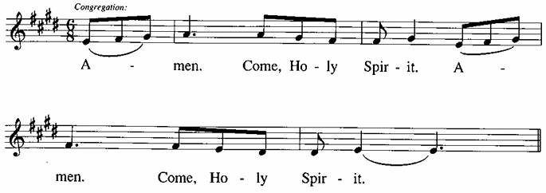

P: This we pray through Jesus Christ,
our Savior and our friend.
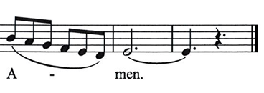
C:
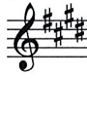

Lord’s Prayer

P: Gathered as one by the Holy Spirit, we pray as Jesus taught us.
C: Our Father in heaven,
hallowed be your name,
your kingdom come,
your will be done,
on earth as in heaven.
Give us today our daily bread.
Forgive us our sins,
as we forgive those
who sin against us;
Save us from the time of trial,
and deliver us from evil.
For the kingdom, the power,
and the glory are yours,
now and ever. Amen.

Fraction and Invitation

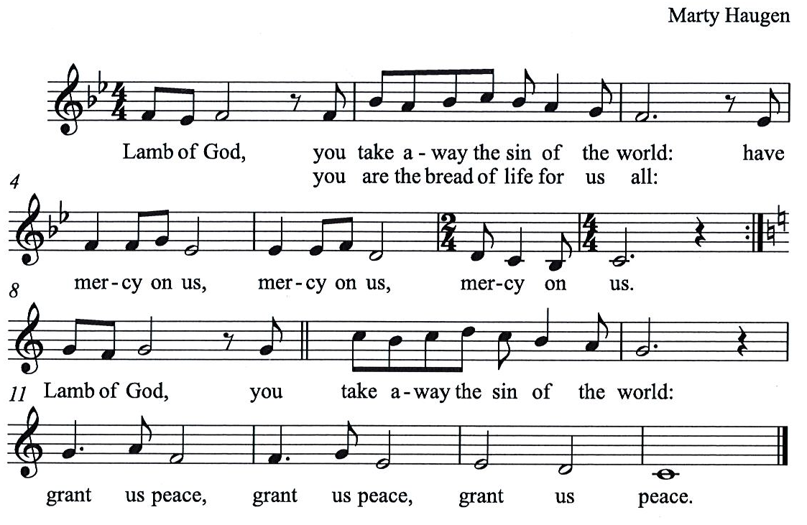
Agnus Dei / Lamb of God HS p. 18

Please be seated.

Holy Communion

- All who seek God and desire a deeper and stronger life in Christ are welcome to receive Holy Communion.
- Worshipers from the pulpit side will proceed forward first, followed by the center section, and then the lectern side.
- Please inform an usher if you would like the ministers to bring Communion to you.
- Holy Communion will be served with bread and wine (red) or grape juice (white).
- The presiding minister will first distribute the bread (host) to each communicant. Please indicate if you require a gluten-free host.
- Once you have consumed the bread, please pick up an empty glass from the tray next to the presiding minister. The Communion Assistant will pour wine or grape juice into your glass.
- Please step to the side to consume the wine or grape juice.
- Feel free to kneel at the altar rail for prayer after receiving the sacrament.
- As you return to your pew, glasses may be returned to the empty tray on the side of the center section.
- A blessing will be provided for anyone who does not yet receive the sacrament.
- All are invited to join in singing the hymns during Holy Communion.
Hymns during Holy Communion
Lord of All Nations, Grant Me Grace ELW 716

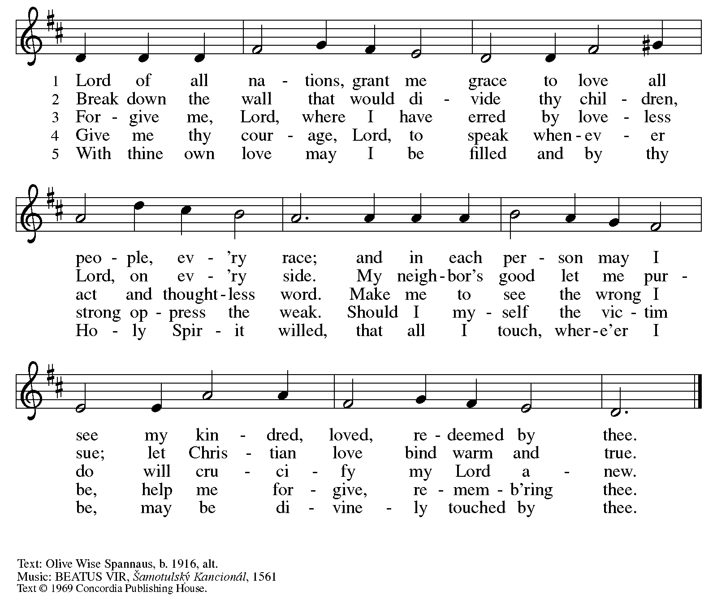
All rights reserved. Reprinted with permission under OneLicense.net # A-722139.

Hymns during Holy Communion
Take, Oh, Take Me As I Am ELW 816

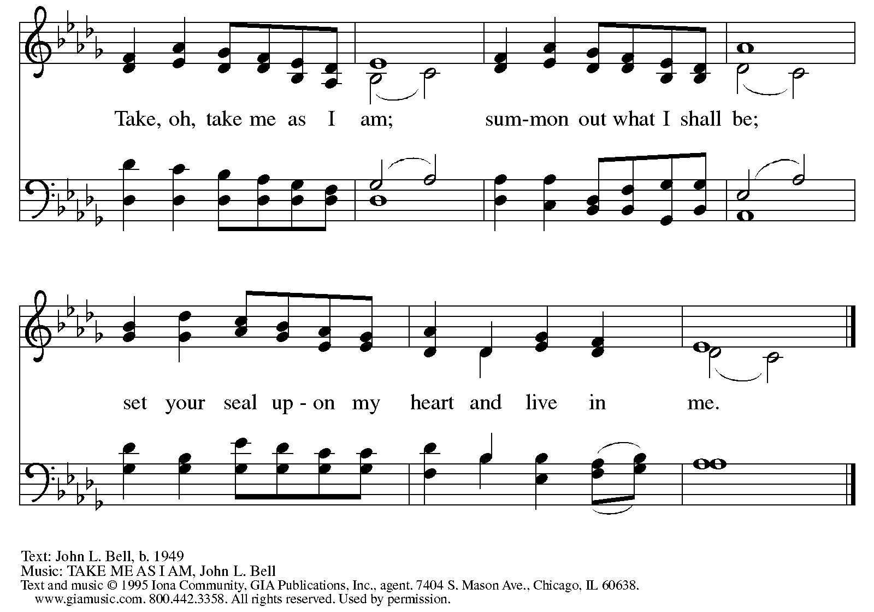
All rights reserved. Reprinted with permission under OneLicense.net # A-722139.

Hymns during Holy Communion
Lord, Whose Love in Humble Service ELW 712

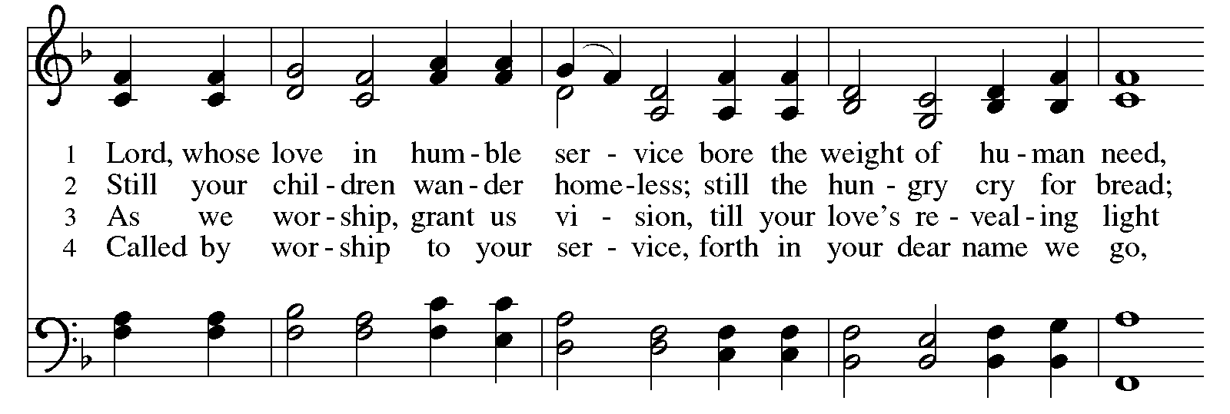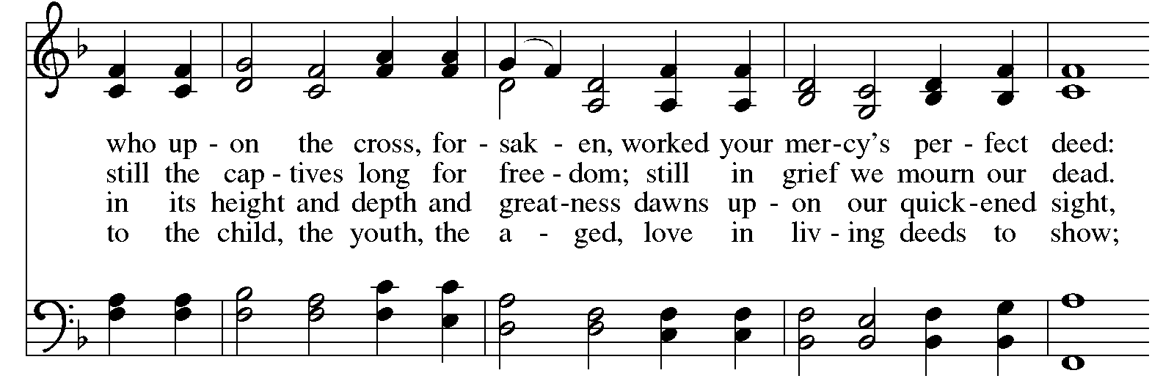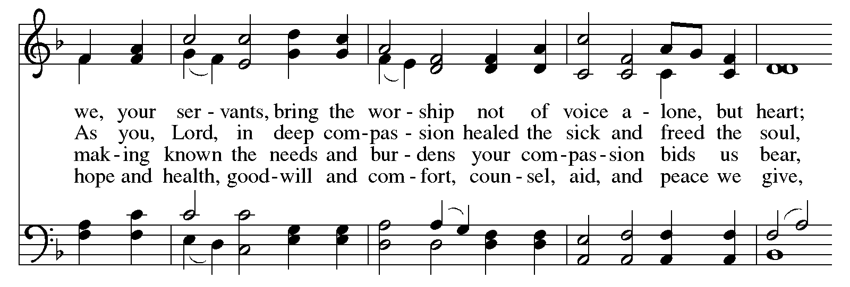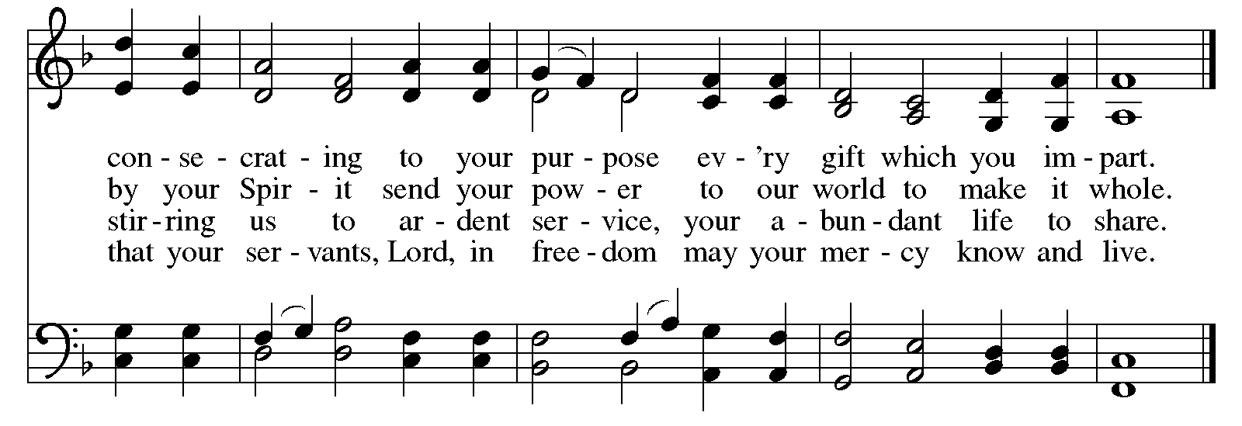
When all have returned to their places, please rise as you are able.

Blessing

P: The body and blood of our Lord Jesus Christ strengthen you and keep you in his grace.
C: Amen.

Prayer

A: Let us pray.
Compassionate God,
through these gifts of bread and wine
our hearts are filled with the abundance of your love.
Strengthen us that we, through this holy meal,
may share your love freely, as you have shared with us.
We ask this in the name of Jesus,
through the Spirit nourishing us now and forever.
C: Amen.

Please be seated.

Sending
God blesses us and sends us in mission to the world

Announcements

Please rise as you are able.

Benediction

P: The love of God abound in you,
the grace of our Savior Jesus Christ fill your hearts;
and the life of the Spirit ☩ bless you and give you peace.
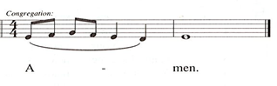
C:

Sending Hymn ELW 538
Enviado soy de Dios – The Lord Now Sends Us Forth

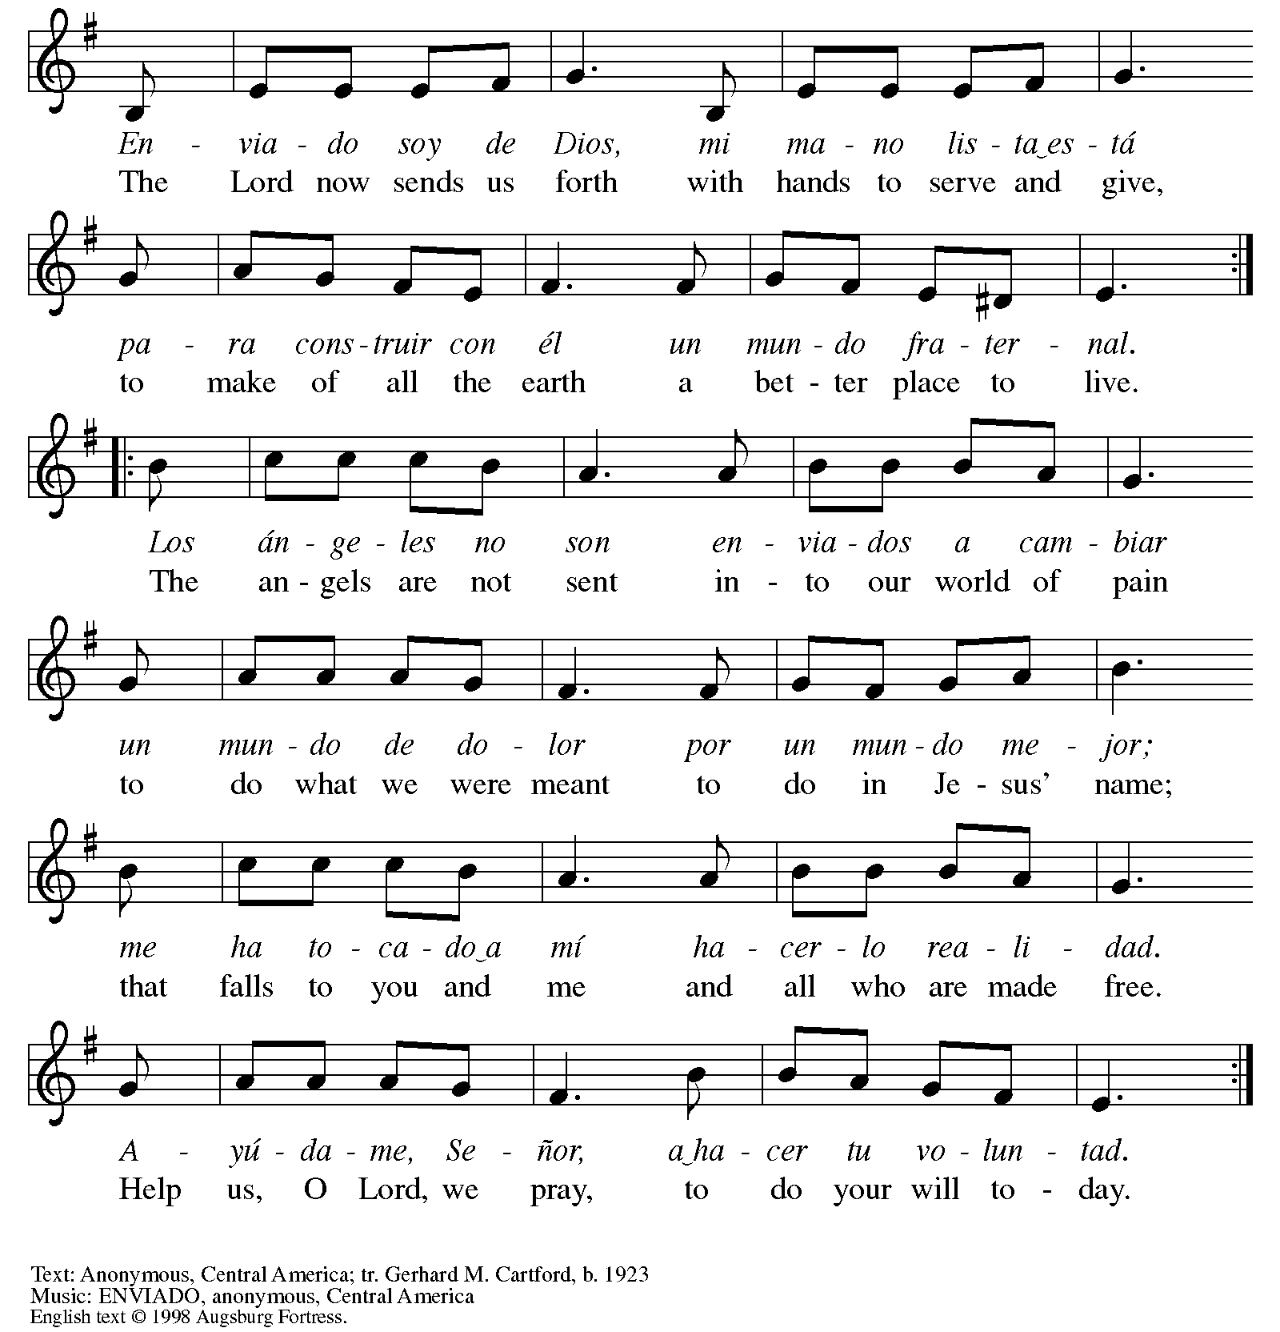
All rights reserved. Reprinted with permission under OneLicense.net # A-722139.

Dismissal

A: Go in peace. Serve the Lord.
C: Thanks be to God!

Postlude
Those serving in worship today

Altar Care Jodie Minor
Assisting Minister Lindsay Baxter
Audio-Visual Ministers Tim Jones
Joseph Paetz
Cantor Mandy Best
Lector Colleen Cooke
Organ Jimmi Kocher-Hillmer
Minister of Music Laura Reynolds
Presiding Minister The Rev. Ross I. Carmichael

Liturgy and Hymnody Acknowledgements

From SundaysandSeasons.com. Copyright © 2026 Augsburg Fortress. All rights reserved. Reprinted under OneLicense.net # A-722139.
Used by permission of Augsburg Fortress.

From Hymnal Supplement. Copyright © 1991 GIA Publications, Inc. All rights reserved. Reprinted under OneLicense.net # A-722139.
Used by permission of GIA Publications, Inc.

The Scripture readings contained herein are from New Revised Standard Version Updated Edition of the Bible © 2021 National Council of Churches of Christ in the United States of America. Used by permission. All rights reserved worldwide.

Oh God, My Faithful God – Text: Johann Heerman, 1585-1647; tr. Catherine Winkworth, 1827-1878, alt.Music: WAS FRAG ICH NACH DER WELT, Ahasuerus Fritsch, 1629-1701.

Lord, Whose Love in Humble Service – Text: Albert F. Bayly, 1901-1984. Music: BEACH SPRING, The Sacred Harp, Philadelphia, 1844; arr. Selected Hymns, 1985. Text © 1961 Oxford University Press. Arr. © 1985 Augsburg Fortress. All rights reserved. Reprinted with permission under OneLicense.net # A-722139.

Please use the QR code below to link to St. Andrew’s Announcements online!



St. Andrew Lutheran Church Announcements
September 27th, 2026

- Welcome to Worship at St. Andrew on the Eighteenth Sunday after Pentecost – We are thankful you are here, and we offer a special welcome to all visitors and guests who are here for the first time! A nursery is available through the door to the left of the worship space and across the social hall (look for a purple room). Little Church – Big Faith, a Bible lesson and activity for children up to sixth grade, will take place after the prayer of the day. There are also worship “toolkits” to help children engage with worship and “busy bags” for younger children available in the bookcase at the back of the sanctuary. Please feel free to take one to use with/for your children. All are invited to stay for coffee and other drinks, food, and conversation in the Social Hall (through the side door at the left of the worship space) after the service.
- St. Andrew's Capital Campaign Continues – We are thrilled to announce that this past year's construction work on a new roof and related areas for St. Andrew is complete, and the plastering and painting is underway! St. Andrew's capital campaign continues, and we are 89% of the way toward our $1 million goal! Over the next three weeks, we will hear stories and testimonies in worship about the ways that St. Andrew continues to reach out as a community of love, a community of justice, and a community of service. If you have not yet made a commitment to the campaign, please prayerfully consider how you can support the effort. We will dedicate our campaign gifts to God on Commitment Sunday, October 11th.
- Bible Book Club, Wednesdays at 7:00 p.m. on Zoom – St. Andrew's weekly Bible Book Club meets each Wednesday at 7:00 p.m. The group is currently reading and discussing Karen Armstrong's A History of God. It can be found here: https://bookshop.org/p/books/a-history-of-god-the-4-000-year-quest-of-judaism-christianity-and-islam-karen-armstrong/277069b2cf4e39ad?ean=9780345384560. If anyone needs assistance in obtaining a book, please speak with Pastor Ross. Bible Book Club invites new participants, regardless of how often you can attend or whether or not you have read the specific material for the week. You can use this link to join the call: https://us02web.zoom.us/j/83196175976?pwd=ejdPOUYrTk4xVFdsdlhHUVJ1L3k2Zz09.
- Lunch Club at Church Brew Works, Today, September 27th after Worship – Kelly Spanninger is organizing a renewal of St. Andrew lunch outings after Sunday worship. All are invited to gather at Church Brew Works at 3525 Liberty Ave, Pittsburgh, PA 15201 at 12:15 p.m. Please let Kelly know if you plan to attend, or contact her at pkspanninger@verizon.net.
- St. Andrew Episcopal Invites Our Congregation to "Faith, Doubt, and Reality" Discussions, Today, September 27th, 4:00 p.m. – St. Andrew's Episcopal Church has a monthly discussion group for young adults, "Faith, Doubt, and Reality," that will resume meeting on Sunday. The location for this month will be Two Frays Brewing at 5113 Penn Ave. The group will then shift to the second Sunday of the month at 4:00 p.m. - October 11th, November 8th, and December 13th.
- Monthly Reparations Offering Next Sunday, October 4th, during Worship – In Luke’s Gospel, Jesus tells a story about a compassionate Samaritan, suggesting that God’s people are called to work for healing and restoration for our neighbors, regardless of who or what caused them harm. In light of this, St. Andrew has made a commitment to reparations in regard to African American spiritual songs used in our worship. The text and music of most hymns is attributed to specific authors, with copyrights in place, usage reported, and royalties paid to those whose works are featured in worship. With African American spirituals, this is not possible. In response to many years of such uncredited use, St. Andrew invites the congregation to give a reparations offering. Funds received in worship will be donated to our siblings at Bethel AME Church, whose land and building were taken from them in the 1950s, to fund their development in the Hill District.
- Johanna’s 50th Birthday Party, October 17th, 1:00 - 5:00 p.m. – Dress code is whimsy, colorful, and comfortable! In lieu of gifts, please donate to charity. Food and drink will be provided. RSVP to johanna.matsui@gmail.com or 412-639-5254.
- Inclusive Game Night, Saturdays, October 24th, November 21st, and December 19th, 5:00 - 7:00 p.m. – People of all ages are invited to an inclusive game night on Saturday evenings over the next few months. We will share board games, conversation, and fun!
- Aluminum Can Tabs for Ronald McDonald House – You may have noticed that at coffee hour, St. Andrew is now putting out a receptacle to collect the tabs from aluminum cans. We invite people of the congregation to save their tabs, not only during coffee hour, but from other beverages throughout the week, and to drop them off in the designated drawer of the plastic in the social hall. The tabs are donated to Ronald McDonald House, which supports families with children receiving medical treatment across the country. More information is available here: https://ronaldmcdonaldhousepghmgtn.org/get-involved/pull-tabs/. The community ministry team is looking for someone to monitor the supply and bring in the tabs for periodic donations. If you are interested, please speak with Tyler Rietze or email community@standrewpittsburgh.org.
- Coffee Hour Signups – Coffee hour returns this week! St. Andrew provides hospitality during a coffee hour after worship each Sunday. If you would like to participate and would like information about the duties of setting up, please sign up using the following form: https://www.signupgenius.com/go/5080B4AAFAF2CABF85-47069030-coffee#/.
- Produce Distribution Supplemental Food of the Month – St. Andrew is collecting supplemental food each month to accompany our produce distribution. For September, we ask for donations of rice. There are collection boxes at the back of the worship space and social hall.
- “Christ in Our Home” Booklets Available – “Christ in Our Home” is a quarterly devotional resource that encourages readers to live out their faith daily. Each reflective reading is accompanied by a daily scripture reference and prayer for the day. The October-December booklets are available at the entrances. Please feel free to take one home!
- Winter Clothing Collection for Bethel AME Church Pantry – Our friends at Bethel AME Church have begun a new pantry program at which they are offering new or gently used clothing for people of the community. If you are doing any fall cleaning and have clothes or coats that you are no longer using, please bring them to St. Andrew. There will be a box on or near the donation table in the social hall.
- Joseph and Anya Are Getting Married! Help with a Cookie Table, Next Saturday, October 3rd, 3:00 p.m. – Joseph Paetz and Anya Fredrickson are getting married at St. Andrew on Saturday, October 3rd! The wedding begins at 3:00 p.m., with a cookie table reception to follow in the social hall, and Joseph and Anya invite people of the congregation to attend both! If you would like to help set up the cookie table and/or bake and contribute cookies, please use the QR code below.


