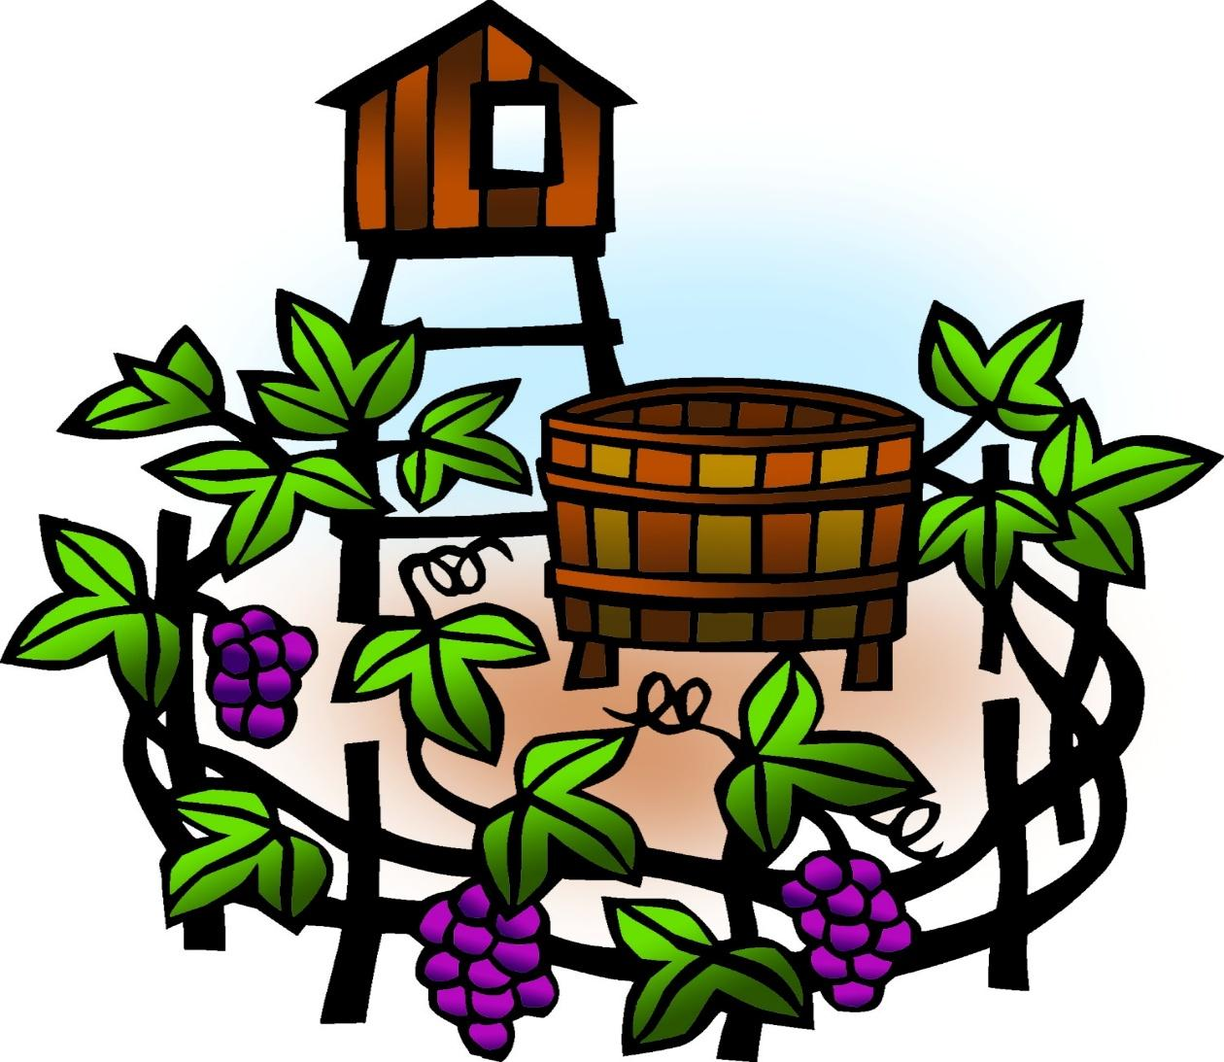

+ Nineteenth Sunday after Pentecost
October 4, 2026



St. Andrew Lutheran Church
304 Morewood Ave.
Pittsburgh, PA 15213
St_andrewELCA@verizon.net
www.standrewpittsburgh.org

+ Nineteenth Sunday after Pentecost

In today’s gospel reading, Jesus tells a parable about a vineyard, which often serves biblically as an image of Israel. The parable recalls the prophets’ mission, and for Christians, the vineyard also speaks of God’s love poured out in the blood of Christ, given to us for the forgiveness of sin. Grafted onto Christ the vine at Baptism, we are nourished with wine and bread so that we may share Christ’s sufferings and know the power of his resurrection.

Welcome to St. Andrew!
- St. Andrew welcomes all who are seeking a place of healing, wholeness, and acceptance in a nurturing and faith-forming spiritual home. We are striving toward racial equity worldwide
and we seek to honor the lived experience of all individuals regardless of background. Our community embraces people of all ages, ethnicities, cultures, abilities, sexual orientations,
gender identities and expressions, and family constellations. Come and See!
- Worship Services are live-streamed to multiple online platforms. By attending worship, you agree that your image and voice may be broadcast.
- Everyone is invited to make a name tag at the black bookcase in the back of the worship space if they would like. There are stickers indicating pronouns on the bookcase if you would like to include them on your name tag.
- Children up to sixth grade are invited to attend Little Church – Big Faith, a Bible lesson and activity, during worship (after the Prayer of the Day). The group returns to the worship space for the liturgy of Holy Communion.
- A nursery is available through the doors at the left side of the sanctuary and across from the doorway to the Social Hall. Look for a purple-colored room.
- Worship “toolkits” to help children engage with the service, along with “busy bags” for younger children, are available in the bookcase at the back of the sanctuary. Please feel free to take one to use with/for your children.
- Holy Communion is served with bread (gluten-free available) and wine or grape juice. The presiding minister will distribute the bread (host). Please consume this and then pick up an empty glass from the tray. The Communion Assistant will pour wine or grape juice into your glass. Please step to the side to consume the wine or grape juice. Feel free to kneel at the altar for prayer and reflection. As you return to your pew, glasses may be returned to the empty tray on the left side of the center section.
- A restroom is available on the main level of the church, through the doors to the Social Hall and to the right in the main office.

Abbreviations
P: Pastor/Presiding Minister ELW: Evangelical Lutheran Worship hymnal
A: Assisting Minister ACS: All Creation Sings hymnal
L: Lector MML: Making Melody to the Lord
C: Congregation

Musical Offering

Each week, different people from the congregation make an offering of pre-service music, with singing or instrumentation, to help the assembly focus and pray in preparation for worship.

Welcome
Prelude When I Survey the Wondrous Cross arr. Carter

When I survey the wondrous cross
on which the prince of glory died,
my richest gain I count but loss
and pour contempt on all my pride.

Gathering
The Holy Spirit calls us together as the people of God

Please rise as you are able. All may make the sign of the cross,
the sign that is marked at Baptism, as the presiding minister begins.

Confession and Forgiveness

P: Blessed be the ☩ holy Trinity, who pours love into our hearts
and brings healing upon the earth.
C: Amen.

P: Confident that God justifies us by grace through faith, let us confess our sin.

Silence is kept for reflection.

P: Compassionate God,
C: we confess that we struggle to embody your goodness
in the world and in our own hearts.
Creation groans from our overuse.
Jealousy and bitterness strain our relationships.
Indifference keeps us from seeking justice.
Divisions disrupt your call to show genuine love to others.
Turn our hearts back to you. Restore our world and reconcile us to one another.
Renew us to live as your holy people,
following the way of Jesus Christ. Amen.

P: Receive this good news and receive freely God’s gift of grace:
We have peace with God through ☩ Jesus Christ, in whom there is no condemnation,
but only forgiveness and the promise of eternal life.
C: Amen.
Gathering Hymn God Loved the World ELW 323

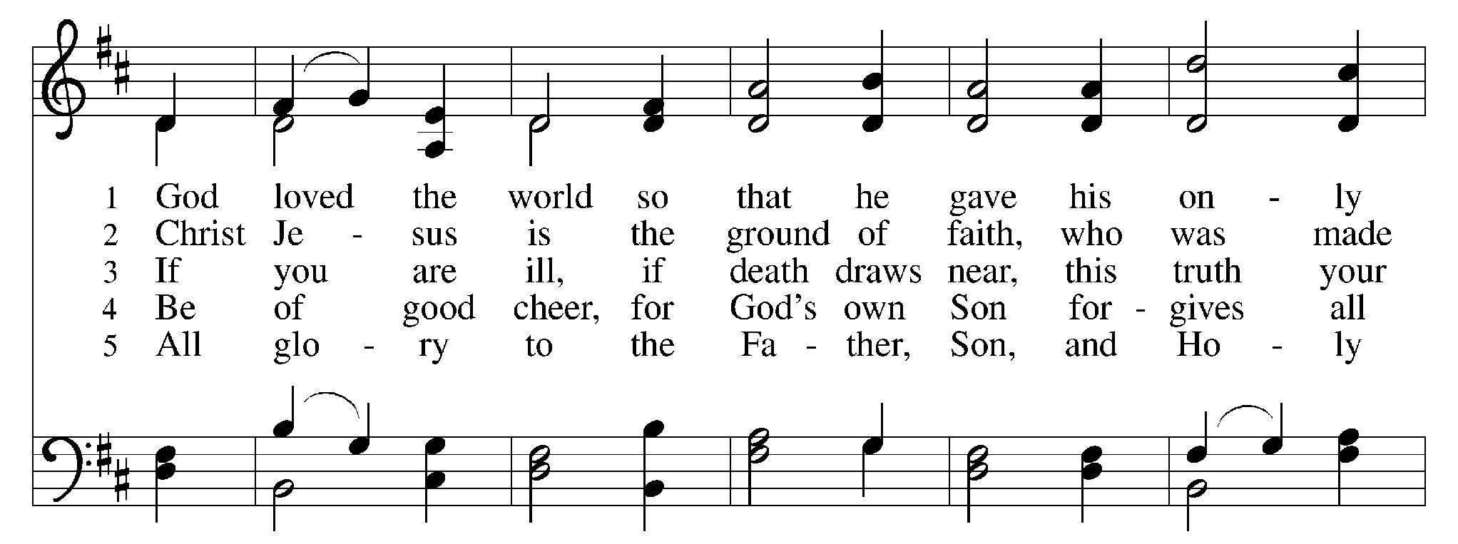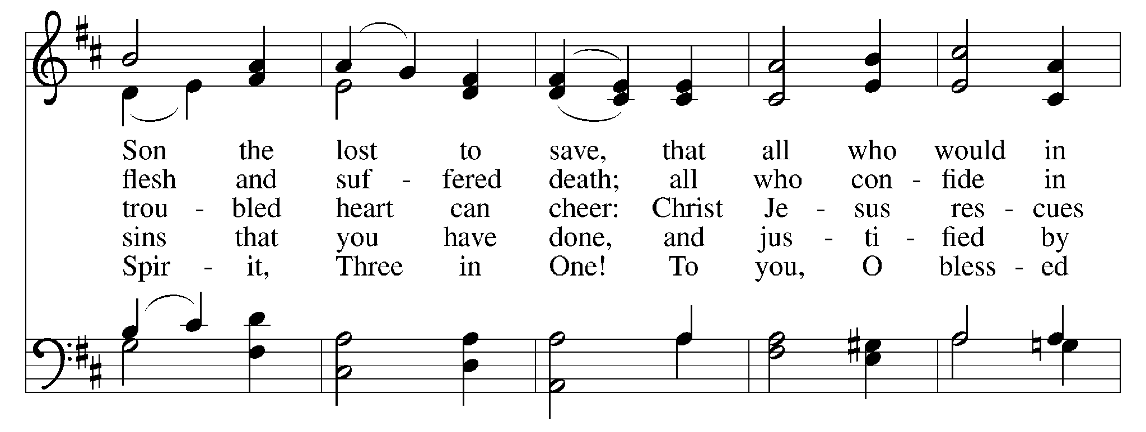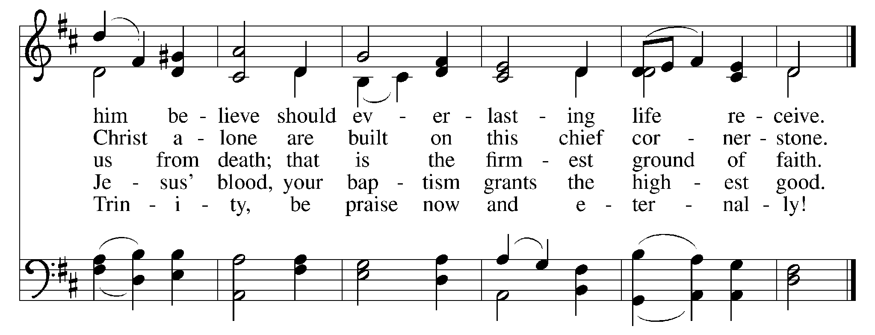

Greeting

P: The grace of our Lord Jesus Christ, the love of God,
and the communion of the Holy Spirit be with you all.
C: And also with you.

Hymn of Praise Glory to God ELW p. 167

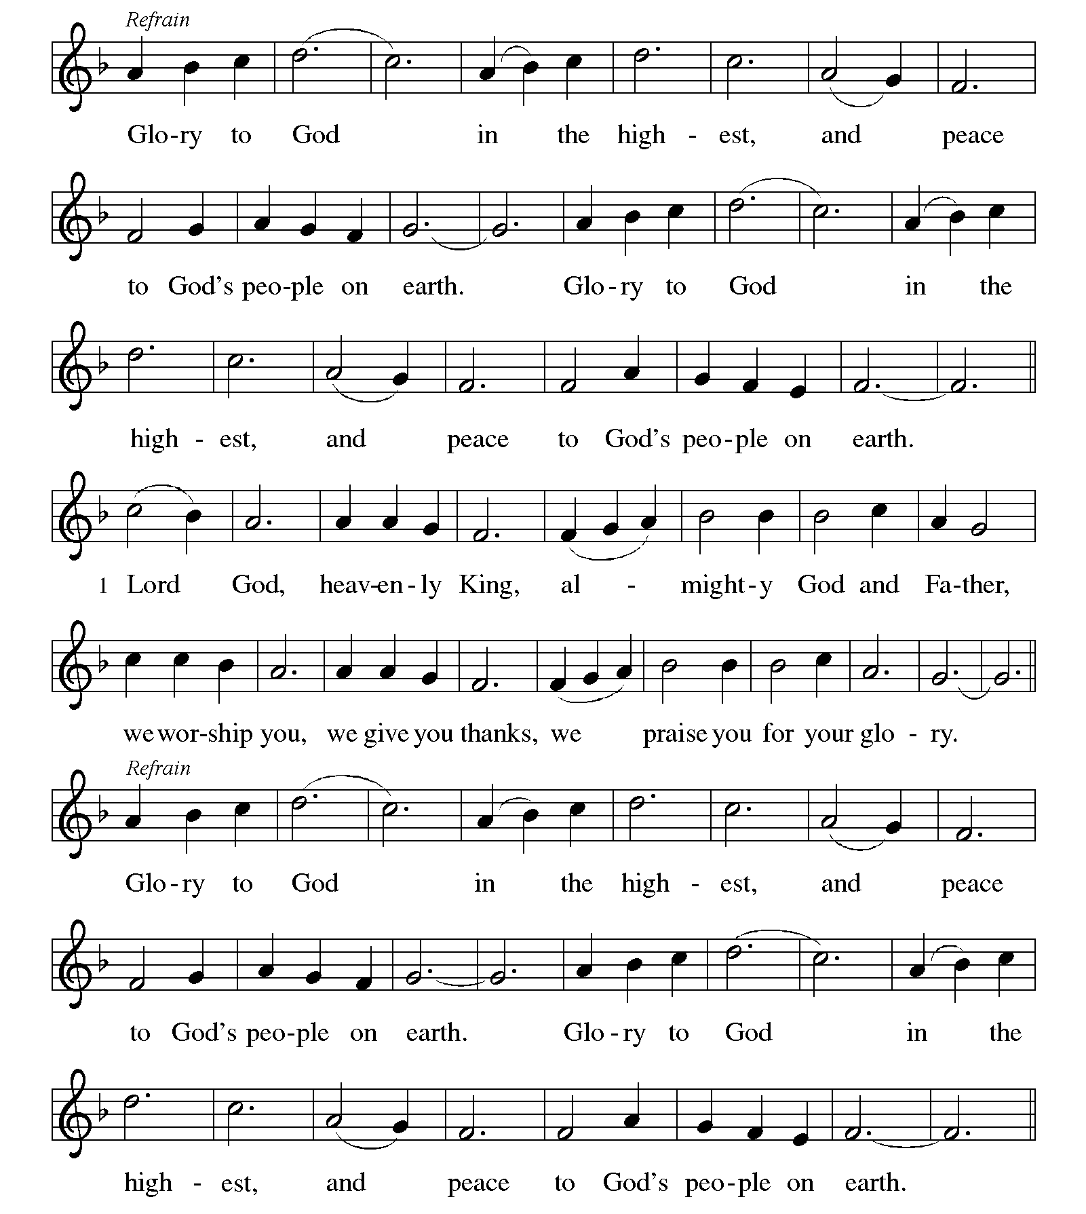
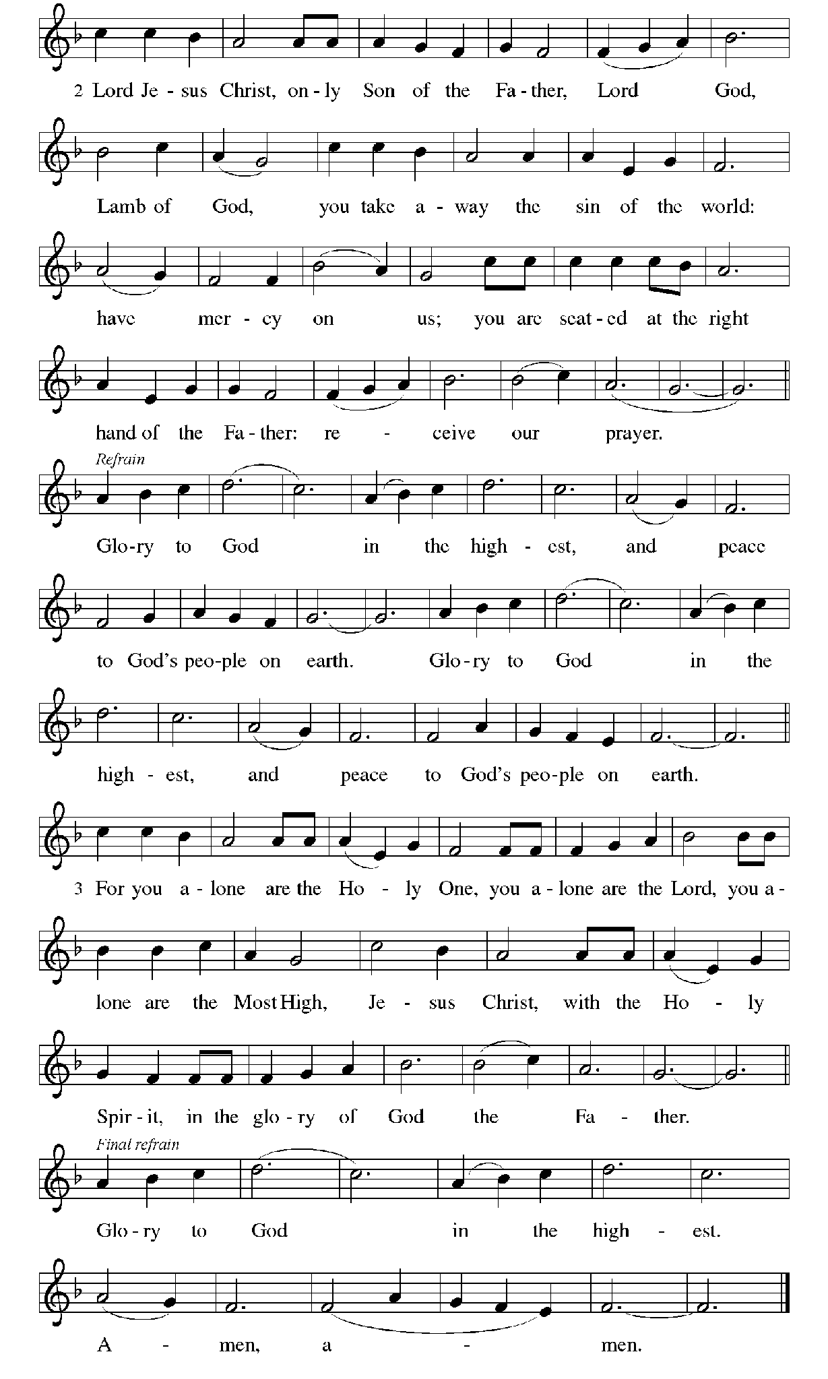
Prayer of the Day

P: The Lord be with you.
C: And also with you.

P: Let us pray.
Beloved God, from you come all things that are good.
Lead us by the inspiration of your Spirit to know those things that are right,
and by your merciful guidance, help us to do them,
through Jesus Christ, our Savior and Lord.
C: Amen.

Please be seated.

Word
God speaks to us in Scripture reading, preaching, and song

First Reading – Isaiah 5: 1-7

¹ I will sing for my beloved
my love song concerning his vineyard:
My beloved had a vineyard
on a very fertile hill.
² He dug it and cleared it of stones
and planted it with choice vines;
he built a watchtower in the midst of it
and hewed out a wine vat in it;
he expected it to yield grapes,
but it yielded rotten grapes.
³ And now, inhabitants of Jerusalem
and people of Judah,
judge between me
and my vineyard.
⁴ What more was there to do for my vineyard
that I have not done in it?
When I expected it to yield grapes,
why did it yield rotten grapes?
⁵ And now I will tell you
what I will do to my vineyard.
I will remove its hedge,
and it shall be devoured;
I will break down its wall,
and it shall be trampled down.
⁶ I will make it a wasteland;
it shall not be pruned or hoed,
and it shall be overgrown with briers and thorns;
I will also command the clouds
that they rain no rain upon it.
⁷ For the vineyard of the Lord of hosts
is the house of Israel,
and the people of Judah
are the Lord’s cherished garden;
the Lord expected justice
but saw bloodshed;
righteousness
but heard a cry!

L: Word of God, word of life.
C: Thanks be to God.

Psalm 80: 7-15

The psalm will be sung responsively, led by the cantor,
with the congregation responding with the verses in bold and the refrain.

Psalm Tone

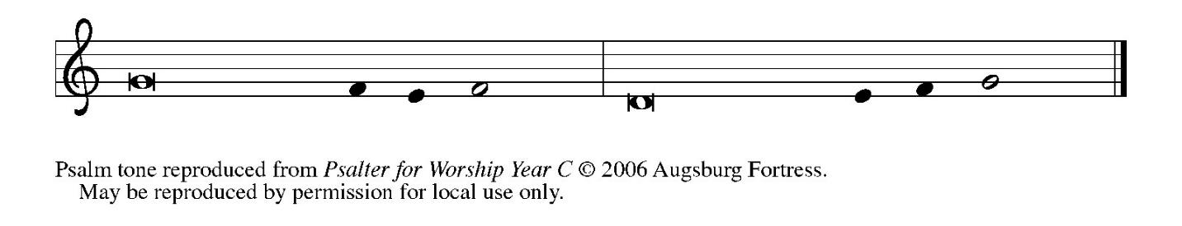

Psalm Refrain

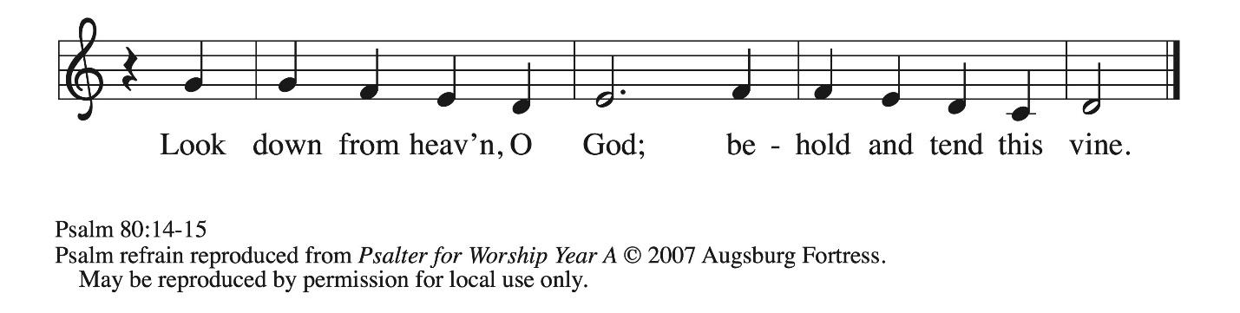

⁷ Restore us, O | God of hosts;
let your face shine upon us, and we | shall be saved.
⁸ You have brought a vine | out of Egypt;
you cast out the nations and | planted it.
⁹ You cleared the | ground for it;
it took root and | filled the land.
¹⁰ The mountains were covered | by its shadow
and the towering cedar trees | by its boughs. R
¹¹ You stretched out its tendrils | to the sea
and its branches | to the river.
¹² Why have you broken | down its wall,
so that all who pass by pluck | off its grapes?
¹³ The wild boar of the forest has | ravaged it,
and the beasts of the field have | grazed upon it.
¹⁴ Turn now, O | God of hosts,
look | down from heaven;
¹⁵ behold and | tend this vine;
preserve what your right | hand has planted. R

Second Reading – Philippians 3: 4b-14

[Paul writes:] ^{4b} If anyone else has reason to be confident in the flesh, I have more: ⁵ circumcised on the eighth day, a member of the people of Israel, of the tribe of Benjamin, a Hebrew born of Hebrews; as to the law, a Pharisee; ⁶ as to zeal, a persecutor of the church; as to righteousness under the law, blameless.
⁷ Yet whatever gains I had, these I have come to regard as loss because of Christ. ⁸ More than that, I regard everything as loss because of the surpassing value of knowing Christ Jesus my Lord. For his sake I have suffered the loss of all things, and I regard them as rubbish, in order that I may gain Christ ⁹ and be found in him, not having a righteousness of my own that comes from the law but one that comes through faith in Christ, the righteousness from God based on faith. ¹⁰ I want to know Christ and the power of his resurrection and the sharing of his sufferings by becoming like him in his death, ¹¹ if somehow I may attain the resurrection from the dead.
¹² Not that I have already obtained this or have already reached the goal, but I press on to lay hold of that for which Christ has laid hold of me. ¹³ Kindred, I do not consider that I have laid hold of it, but one thing I have laid hold of: forgetting what lies behind and straining forward to what lies ahead, ¹⁴ I press on toward the goal, toward the prize of the heavenly call of God in Christ Jesus.

L: Word of God, word of life.
C: Thanks be to God.

Please rise as you are able.

Gospel Acclamation ELW p. 171

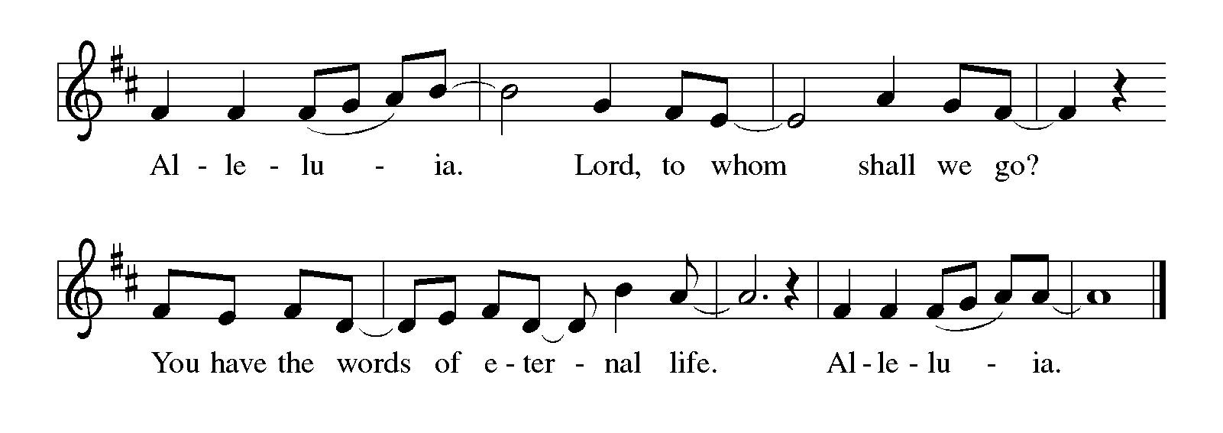
Gospel – Matthew 21: 33-46

P: The holy Gospel according to St. Matthew.
C: Glory to you, O Lord.

[Jesus said:] ³³ “Listen to another parable. There was a landowner who planted a vineyard, put a fence around it, dug a winepress in it, and built a watchtower. Then he leased it to tenants and went away. ³⁴ When the harvest time had come, he sent his slaves to the tenants to collect his produce. ³⁵ But the tenants seized his slaves and beat one, killed another, and stoned another.
³⁶ Again he sent other slaves, more than the first, and they treated them in the same way. ³⁷ Then he sent his son to them, saying, ‘They will respect my son.’ ³⁸ But when the tenants saw the son, they said to themselves, ‘This is the heir; come, let us kill him and get his inheritance.’ ³⁹ So they seized him, threw him out of the vineyard, and killed him. ⁴⁰ Now when the owner of the vineyard comes, what will he do to those tenants?” ⁴¹ They said to him, “He will put those wretches to a miserable death and lease the vineyard to other tenants who will give him the produce at the harvest time.”
⁴² Jesus said to them, “Have you never read in the scriptures:
‘The stone that the builders rejected
has become the cornerstone;
this was the Lord’s doing,
and it is amazing in our eyes’?
⁴³ “Therefore I tell you, the kingdom of God will be taken away from you and given to a people that produces its fruits. ⁴⁴ The one who falls on this stone will be broken to pieces, and it will crush anyone on whom it falls.”
⁴⁵ When the chief priests and the Pharisees heard his parables, they realized that he was speaking about them. ⁴⁶ They wanted to arrest him, but they feared the crowds, because they regarded him as a prophet.

P: The Gospel of the Lord.
C: Praise to you, O Christ.

Please be seated.

Sermon

A time of silence for prayer and reflection follows the sermon.
When the hymn of the day begins, please rise as you are able.

Hymn of the Day Christ Is Made the Sure Foundation Following Page

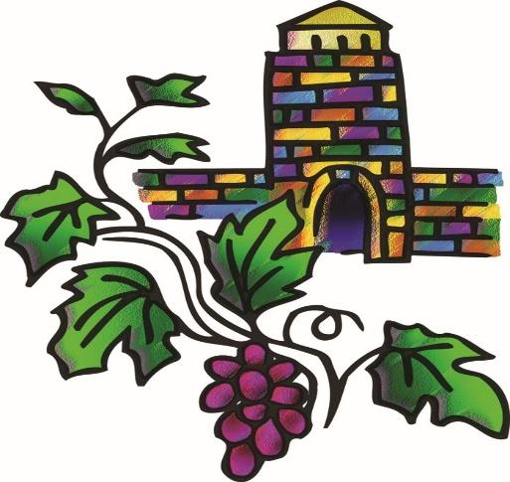

Apostles’ Creed

C: I believe in God, the Father almighty,
creator of heaven and earth.

I believe in Jesus Christ, God’s only Son, our Lord,
who was conceived by the Holy Spirit,
born of the virgin Mary,
suffered under Pontius Pilate,
was crucified, died, and was buried;
he descended to the dead.*
On the third day he rose again;
he ascended into heaven,
he is seated at the right hand of the Father,
and he will come to judge the living and the dead.

I believe in the Holy Spirit,
the holy catholic church,
the communion of saints,
the forgiveness of sins,
the resurrection of the body,
and the life everlasting. Amen.

*Or, “he descended into hell,” another translation of this text in widespread use.
Hymn of the Day Christ Is Made the Sure Foundation ELW 645

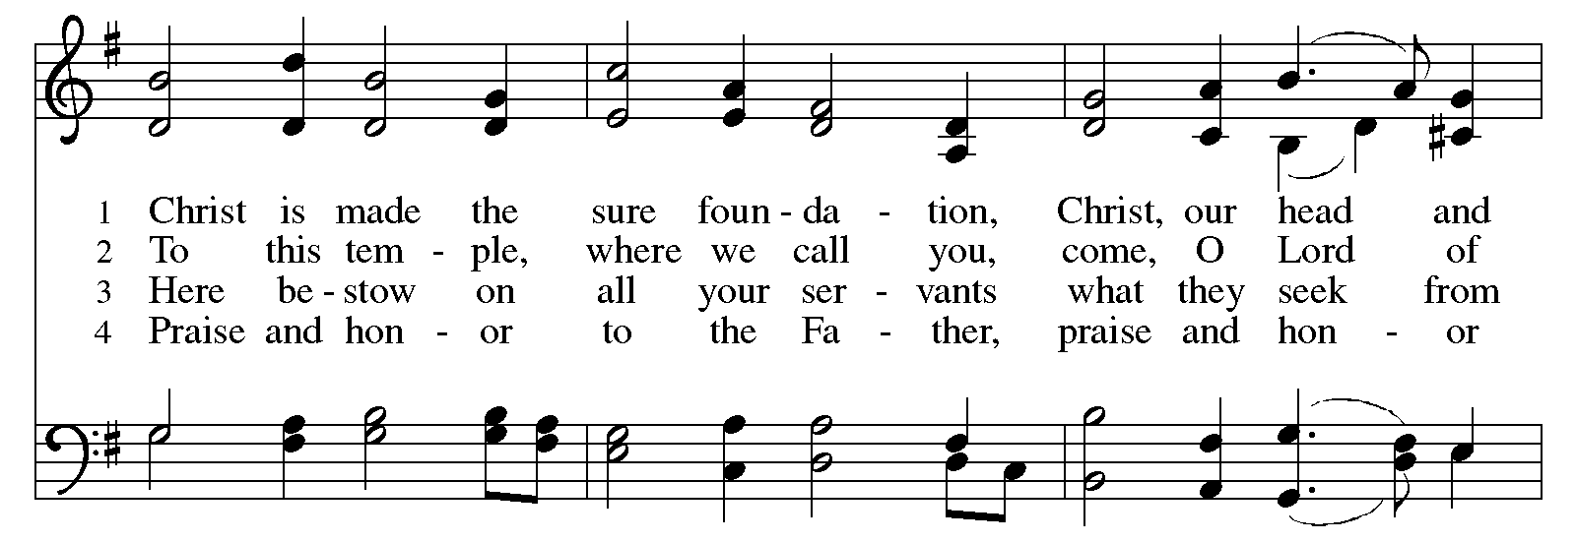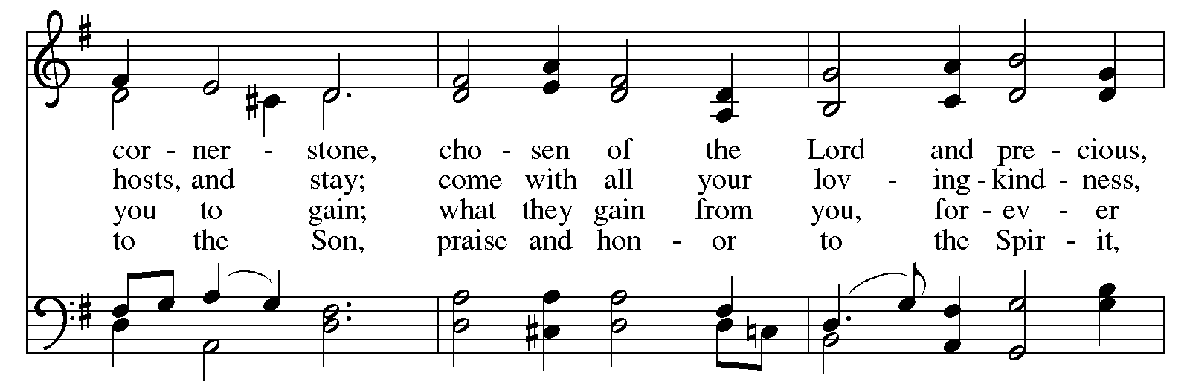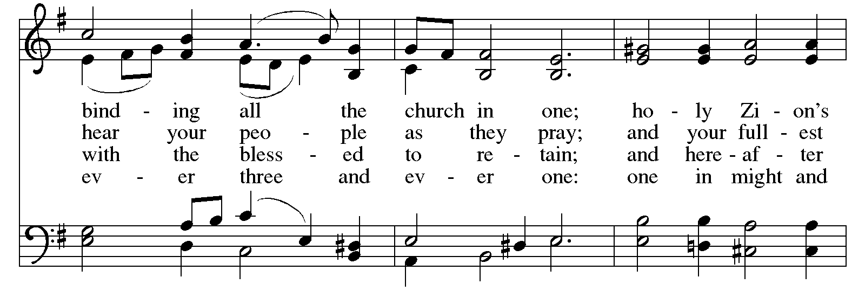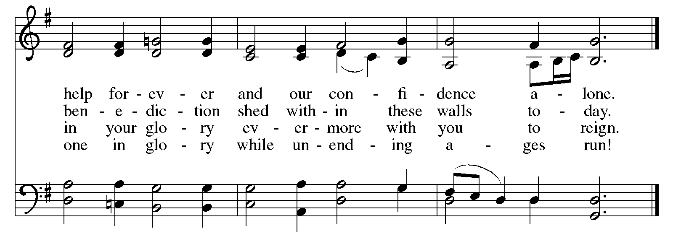
After the Apostles’ Creed, worship continues with the prayers of the people.

Prayers of the People

A: Trusting in the Spirit of God who makes all things new,
let us pray for the church, the world, and all who are in need.

After each petition
A: God of grace,
C: receive our prayer.

The presiding minister concludes the prayers
P: Trusting in your boundless grace, O God,
we lift up these spoken prayers and those in our hearts;
through Jesus Christ our Lord.
C: Amen.

Peace

The presiding minister and the assembly greet one another in the peace of the risen Christ.
P: The peace of Christ be with you always.
C: And also with you.

The people may greet those around them with a sign of Christ’s peace and may say
Peace be with you or similar words. Please be mindful that not everyone will be comfortable with sharing the peace, so please seek consent before shaking hands or hugging. Other possible ways to share the peace include a simple bow with the verbal greeting of peace, or simply a verbal expression of peace. When the greetings of peace have concluded, please be seated.

Meal
God feeds us with the presence of Jesus Christ

Offering

We offer ourselves, our gifts, and our faithful service to God.
As the offering is gathered for the mission of the church, including the care of those in need,
the table is set for Holy Communion.

There are laminated giving cards in the pew racks that feature a QR code for anyone who would like to give online. Those who give using the QR code, as well as those who give regularly online or through their bank are encouraged to place the laminated card in the plate as an expression of your offering.

Reparations Offering

On the first Sunday of each month, St. Andrew invites people of the congregation to give a second offering for a reparations fund in acknowledgment of St. Andrew’s use of African American spiritual songs in our worship services. Please see the note in the announcements for more information.

Music during the Offering
All Creatures of Our God and King arr. Keveren

As the gifts are brought forward for presentation, please rise as you are able.

Offertory Song We Give Thee but Thine Own ELW 686

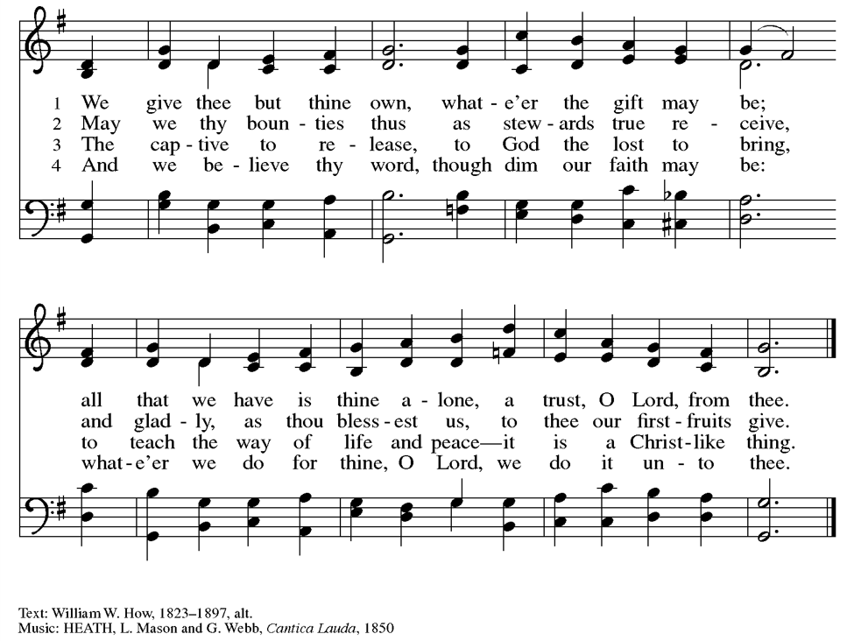

Offertory Prayer

A: Let us pray.
God of creation,
C: you send rain and the earth springs forth abundantly;
all blessings are from you.
Help us to be generous with all that you have given us,
in service to you and in love to our neighbors, today and always.
Amen.

Dialogue

P: The Lord be with you.
C: And also with you.

P: Lift up your hearts.
C: We lift them to the Lord.

P: Let us give thanks to the Lord our God.
C: It is right to give our thanks and praise.

Preface (Spoken by the presiding minister)

P: It is indeed right, our duty and our joy,
that we should at all times and in all places
give thanks and praise to you, almighty and merciful God,
through our Savior Jesus Christ;
who on this day overcame death and the grave,
and by his glorious resurrection opened to us the way of everlasting life.
And so, with all the choirs of angels,
with the church on earth and the hosts of heaven,
we praise your name and join their unending hymn:



Sanctus ELW p. 173

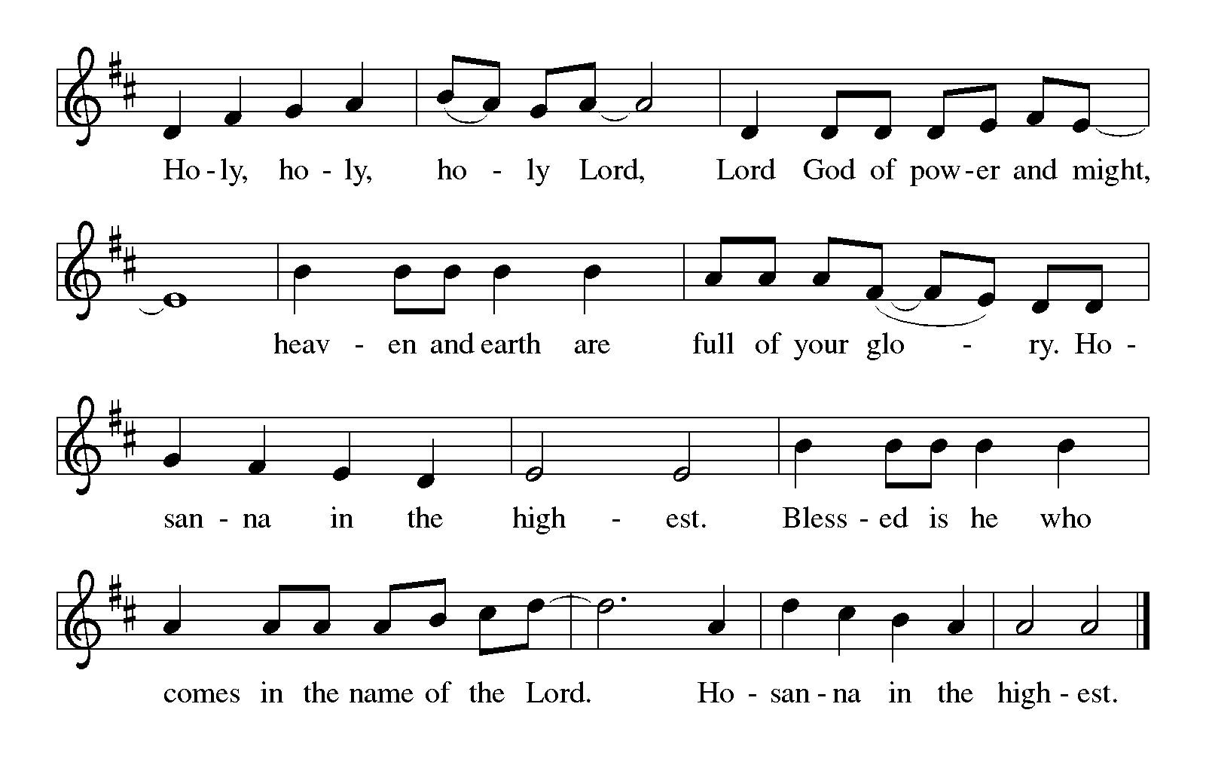

Eucharistic Prayer

P: You are indeed holy, almighty and merciful God …
… Do this for the remembrance of me.

For as often as we eat of this bread and drink of this cup,
we proclaim the Lord’s death until he comes.
C: Christ has died. Christ is risen. Christ will come again.

P: Remembering, therefore …
… and be given our inheritance with all your saints.

P: To you, O God, Father, Son, and Holy Spirit,
be all honor and glory in your holy church, now and forever.
C: Amen.

Lord’s Prayer

P: Gathered as one by the Holy Spirit, we pray as Jesus taught us.
C: Our Father in heaven,
hallowed be your name,
your kingdom come,
your will be done,
on earth as in heaven.
Give us today our daily bread.
Forgive us our sins,
as we forgive those
who sin against us;
Save us from the time of trial,
and deliver us from evil.
For the kingdom, the power,
and the glory are yours,
now and ever. Amen.

Fraction and Invitation

Agnus Dei / Lamb of God ELW p. 174

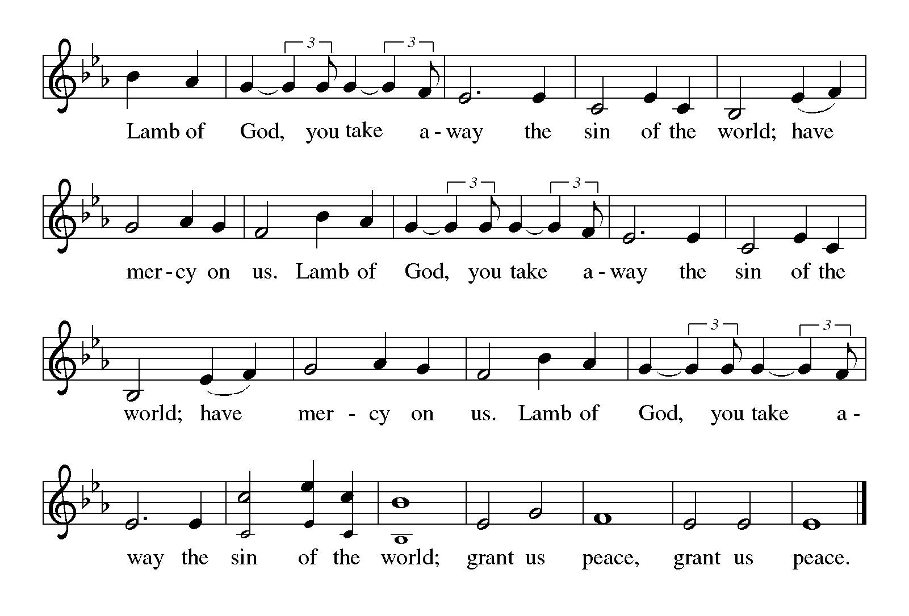
Please be seated.



Holy Communion

- All who seek God and desire a deeper and stronger life in Christ are welcome to receive Holy Communion.
- Worshipers from the pulpit side will proceed forward first, followed by the center section, and then the lectern side.
- Please inform an usher if you would like the ministers to bring Communion to you.
- Holy Communion will be served with bread and wine (red) or grape juice (white).
- The presiding minister will first distribute the bread (host) to each communicant. Please indicate if you require a gluten-free host.
- Once you have consumed the bread, please pick up an empty glass from the tray next to the presiding minister. The Communion Assistant will pour wine or grape juice into your glass.
- Please step to the side to consume the wine or grape juice.
- Feel free to kneel at the altar rail for prayer after receiving the sacrament.
- As you return to your pew, glasses may be returned to the empty tray on the side of the center section.
- A blessing will be provided for anyone who does not yet receive the sacrament.
- All are invited to join in singing the hymns during Holy Communion.

Hymns during Holy Communion
My Song Is Love Unknown ELW 343

1 My song is love unknown,
my Savior's love to me,
love to the loveless shown
that they might lovely be.
Oh, who am I that for my sake
my Lord should take frail flesh and die?

2 He came from his blest throne
salvation to bestow;
the world that was his own
would not its Savior know.
But, oh, my friend, my friend indeed,
who at my need his life did spend!

3 Sometimes we strew his way
and his sweet praises sing;
resounding all the day
hosannas to our king.
Then "Crucify!" is all our breath,
and for his death we thirst and cry.

4 We cry out; we will have
our dear Lord made away,
a murderer to save,
the prince of life to slay.
Yet cheerful he to suff'ring goes
that he his foes from thence might free.

5 In life no house, no home
my Lord on earth might have;
in death no friendly tomb
but what a stranger gave.
What may I say? Heav'n was his home
but mine the tomb wherein he lay.

6 Here might I stay and sing—
no story so divine!
Never was love, dear King,
never was grief like thine.
This is my friend, in whose sweet praise
I all my days could gladly spend!

Text: Samuel Crossman, 1624-1683, alt. Music: LOVE UNKNOWN, John Ireland, 1879-1962. Music © 1924 John Ireland, admin. The John Ireland trust.
Hymns during Holy Communion
Oh, Praise the Lord MML 56

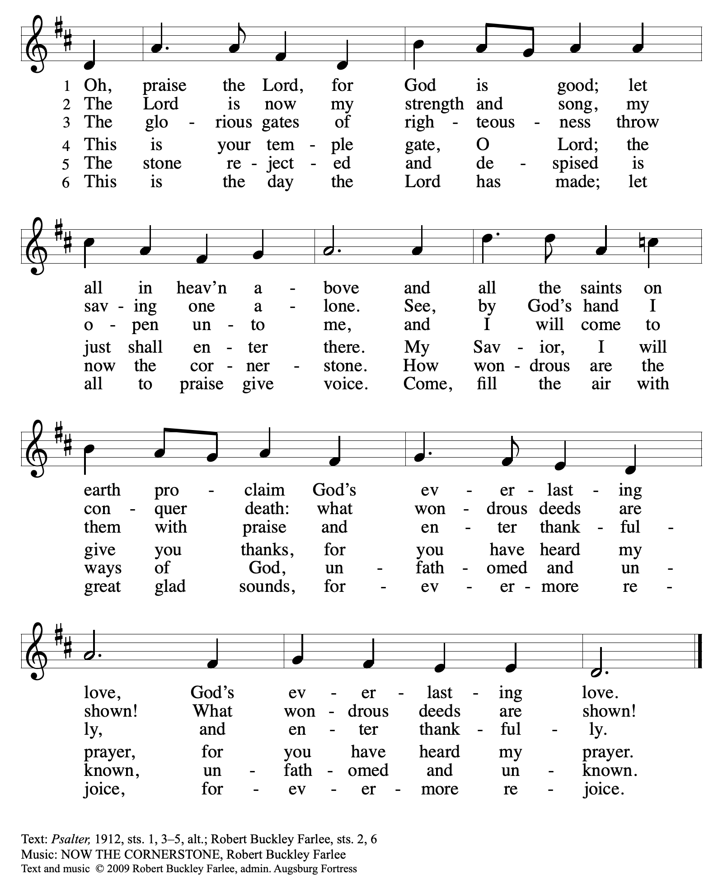
All rights reserved. Reprinted with permission under OneLicense.net # A-722139.

Hymns during Holy Communion
Come to the Table ELW 481

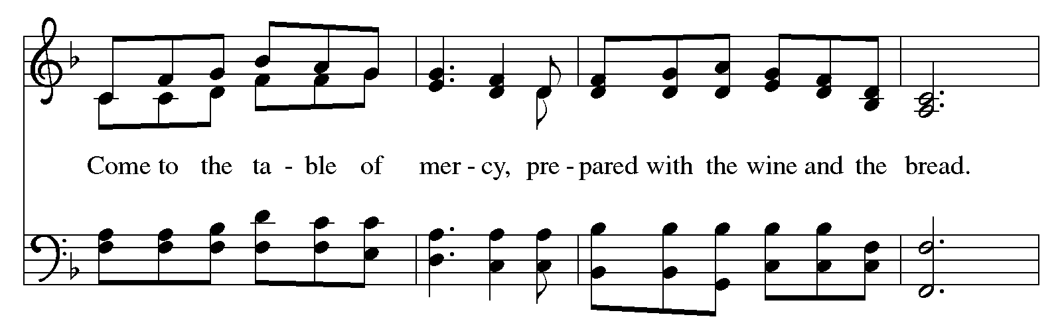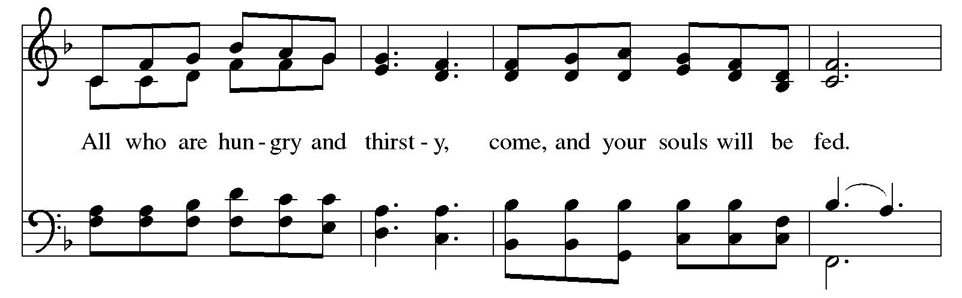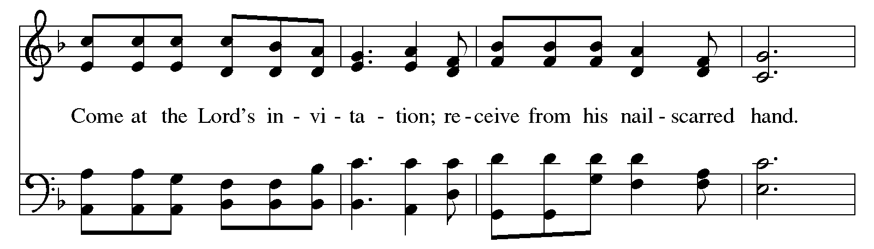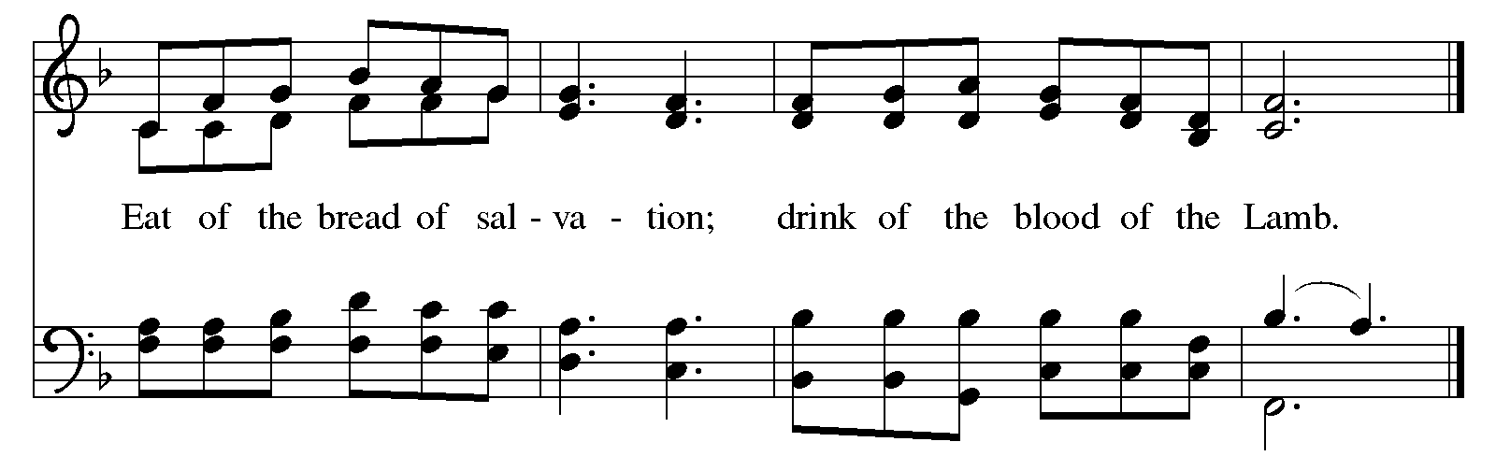

Hymns during Holy Communion
Lord Jesus, You Shall Be My Song ELW 808

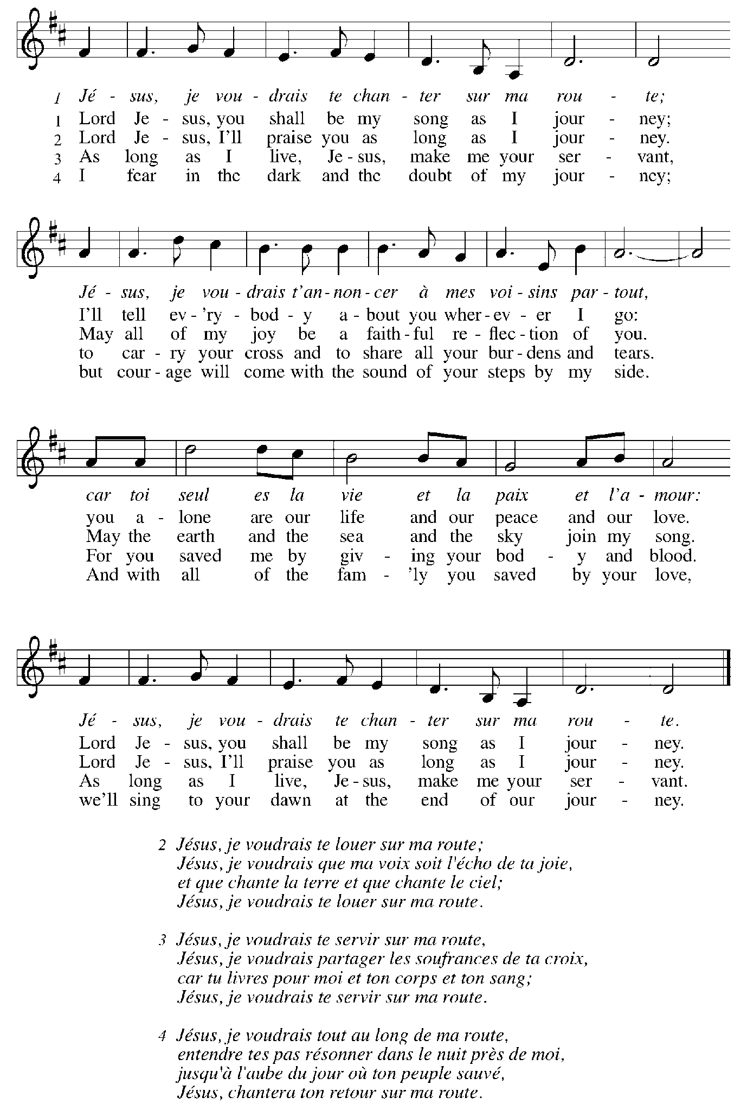
When all have returned to their places, please rise as you are able.

Blessing

P: The body and blood of our Lord Jesus Christ strengthen you and keep you in his grace.
C: Amen.

Prayer

A: Let us pray.
Sustaining God, you nourish us with mercy and abundant life.
By your Spirit, send us from this table to serve a needy world.
Make us living signs of your liberation, healing, and love,
following the way of Jesus, in whose name we pray.
C: Amen.

Please be seated.

Sending
God blesses us and sends us in mission to the world

Announcements

Please rise as you are able.

Benediction

P: The God of love draw you into full accord and one mind,
in the body of Christ Jesus.
C: Amen.

P: The God of hope
grant you strength and joy in all circumstances
through the intercession of the Spirit.
C: Amen.

P: The God of grace
☩ bless you now and forever.
C: Amen.

Sending Hymn Following Page

Sending Hymn Here on Jesus Christ I Will Stand ACS 1024

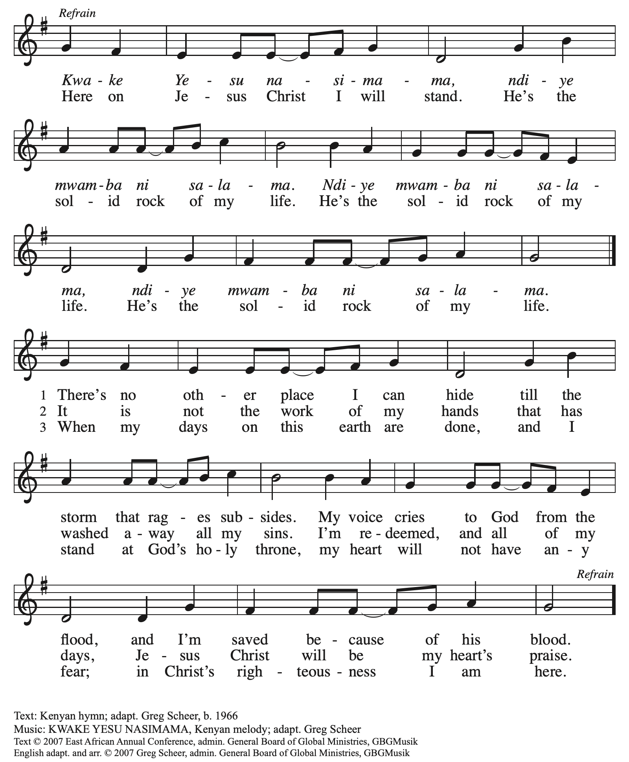
All rights reserved. Reprinted with permission under OneLicense.net #A722139.

Dismissal

A: Go in peace. Serve the Lord.
C: Thanks be to God!

Those serving in worship today

Altar Care Beverley Chapman
Assisting Minister Jimmi Kocher-Hillmer
Audio-Visual Ministers Dave Rollinson
Jered Stratton
Cantor C.E. Pino
Lector Pat Taylor
Minister of Music Laura Reynolds
Presiding Minister The Rev. Ross I. Carmichael

Liturgy and Hymnody Acknowledgements

From SundaysandSeasons.com. Copyright © 2026 Augsburg Fortress. All rights reserved. Reprinted under OneLicense.net # A-722139.
Used by permission of Augsburg Fortress.

Liturgical material reprinted with permission under Augsburg Fortress Liturgies Annual License SB124976.

The Scripture readings contained herein are from New Revised Standard Version Updated Edition of the Bible © 2021 National Council of Churches of Christ in the United States of America. Used by permission. All rights reserved worldwide.

Christ Is Made the Sure Foundation – Text: Latin hymn, c. 7th cent.; tr. John Mason Neale, 1818-1866, alt. Music: WESTMINSTER ABBEY, Henry Purcell, 1659-1695; arr. Ernest Hawkins, 1802-1868.

Come to the Table – Text: Claire Cloninger, b. 1942. Music: COME TO THE TABLE, Martin J. Nystrom, b. 1956. Text and music © 1991 Integrity’s Hosanna! Music (ASCAP), c/o Integrity Media, Inc., 1000 Cody Road, Mobile, AL 36695; and Juniper Landing Music, admin Word Music; and Word Music (ASCAP). All rights reserved. Reprinted with permission under OneLicense.net # A-722139.

Lord Jesus, You Shall Be My Song – Text: Les Petites Souers de Jesús and L’Arche Community; tr. Stephen Sommerville, b. 1931. Music: LES PETITES SOUERS, Les Petites Souers de Jesús and L’Arche Community. Text and music © 1987 Les Petites Souers de Jesús, admin. Augsburg Fortress. Tr. © 1970 Stephen Sommerville, admin. Augsburg Fortress. All rights reserved. Reprinted with permission under OneLicense.net # A-722139.

Please use the QR code below to link to St. Andrew’s Announcements online!



St. Andrew Lutheran Church Announcements
October 4th, 2026

- Welcome to Worship at St. Andrew on the Nineteenth Sunday after Pentecost – We are thankful you are here, and we offer a special welcome to all visitors and guests who are here for the first time! A nursery is available through the door to the left of the worship space and across the social hall (look for a purple room). Little Church – Big Faith, a Bible lesson and activity for children up to sixth grade, will take place after the prayer of the day. There are also worship “toolkits” to help children engage with worship and “busy bags” for younger children available in the bookcase at the back of the sanctuary. Please feel free to take one to use with/for your children. All are invited to stay for coffee and other drinks, food, and conversation in the Social Hall (through the side door at the left of the worship space) after the service.
- Monthly Reparations Offering Today, October 4th, during Worship – In Luke’s Gospel, Jesus tells a story about a compassionate Samaritan, suggesting that God’s people are called to work for healing and restoration for our neighbors, regardless of who or what caused them harm. In light of this, St. Andrew has made a commitment to reparations in regard to African American spiritual songs used in our worship. The text and music of most hymns is attributed to specific authors, with copyrights in place, usage reported, and royalties paid to those whose works are featured in worship. With African American spirituals, this is not possible. In response to many years of such uncredited use, St. Andrew invites the congregation to give a reparations offering. Funds received in worship will be donated to our siblings at Bethel AME Church, whose land and building were taken from them in the 1950s, to fund their development in the Hill District.
- World Communion Sunday, Today, October 4th at 3:00 p.m. – Each year on the first Sunday in October, many Christian congregations observe World Communion Sunday. The day is to remember that we are part of one body in Christ-united across nations, cultures, languages, traditions and denominations. World Communion Sunday began here in Pittsburgh in 1933 at Shadyside Presbyterian Church. It has become a reminder that Christ’s Church is greater than any one congregation or denomination. You, as a member of the family of believers, are invited to the table to celebrate World Communion Sunday at Hicks Chapel on the campus of Pittsburgh Theological Seminary, 616 N. Highland Ave, 15206. The service will begin at 3:00 p.m. The communion table is a sign of belonging to the body of Christ. We are reminded of Christ’s sacrifice, receive God’s grace, and recognize one another as members of a larger spiritual family. World Communion Sunday highlights the truth that no congregation stands alone.
- October Produce Distribution, First and Third Tuesday of the Month, October 6th and 20th, 5:30-6:30 p.m. – St. Andrew partners with Greater Pittsburgh Community Food Bank to serve as a distribution site for fresh produce on the first and third Tuesday of every month. We invite people of the congregation to help with the distribution from 5:30 p.m. - 6:30 p.m. and/or to help with unloading and setup during the day between 10:00 a.m. and 1:00 p.m.
- St. Andrew's Capital Campaign Commitment Sunday, Next Week, October 11th – St. Andrew's capital campaign continues, and we have received commitments equaling 89% of our $1 million goal! Over the past few weeks in worship, we have heard stories about St. Andrew as a community of love and a community of service. This week, we consider our work as a community of justice. Next Sunday, October 11th, is Commitment Sunday. If you have not yet made a commitment to the campaign, please prayerfully consider how you can support the effort. There are case statements and commitment cards available at the back of the worship space if you would like to take them before next week. We will have commitment pages available for everyone next week so that together we can all offer and dedicate our gifts to God during worship!
- Commitment Sunday, October 11th, Special Coffee Hour and Architectural History Presentation – To celebrate Commitment Sunday, St. Andrew will host a special coffee hour after worship. Jan Kurth has prepared a presentation on St. Andrew’s architectural history that she will share with the congregation and which you won’t want to miss, so please plan to stay after worship next week!
- Election Defense and Voter Protection Workshop, Wednesday, October 14th, 6:30 p.m. – In the U.S. most of us believe that voters should pick our leaders. We want every voter and every vote cast to be counted. We want to ensure that the hopes of the people are heard and the will of the people prevails. But across Pennsylvania and this nation, there is growing concern and mounting evidence that efforts are being made to prevent the votes of some people from being counted at all. Fortunately, there are things we can do to protect this system. St. Andrew invites you to a nonpartisan Hands Off Our Vote! PA workshop. Together we will evaluate election interference scenarios, build our skills of readiness and response, and choose meaningful work we can do right now to defend free and democratic elections. Gather in the social hall at St. Andrew on Wednesday, October 14th, at 6:30 p.m. as we answer our Christian calling to participate in civic life and our baptismal call to strive for justice and peace in all the earth.
- Congregation Council Meeting - Saturday, October 17th, 9:00 a.m. – St. Andrew’s congregation council is a group of elected leaders that meets regularly to plan and organize the mission and ministry of the congregation. The next council meeting will be Saturday, October 17th,at 9:00 a.m.
- Johanna’s 50th Birthday Party, October 17th, 1:00 - 5:00 p.m. – Dress code is whimsy, colorful, and comfortable! In lieu of gifts, please donate to charity. Food and drink will be provided. RSVP to johanna.matsui@gmail.com or 412-639-5254.
- Inclusive Game Night, Saturdays, October 24th, November 21st, and December 19th, 5:00 - 7:00 p.m. – People of all ages are invited to an inclusive game night on Saturday evenings over the next few months. We will share board games, conversation, and fun!
- Aluminum Can Tabs for Ronald McDonald House – You may have noticed that at coffee hour, St. Andrew is now putting out a receptacle to collect the tabs from aluminum cans. We invite people of the congregation to save their tabs, not only during coffee hour, but from other beverages throughout the week, and to drop them off in the designated drawer of the plastic in the social hall. The tabs are donated to Ronald McDonald House, which supports families with children receiving medical treatment across the country. More information is available here: https://ronaldmcdonaldhousepghmgtn.org/get-involved/pull-tabs/. The community ministry team is looking for someone to monitor the supply and bring in the tabs for periodic donations. If you are interested, please speak with Tyler Rietze or email community@standrewpittsburgh.org.
- Coffee Hour Signups – Coffee hour returns this week! St. Andrew provides hospitality during a coffee hour after worship each Sunday. If you would like to participate and would like information about the duties of setting up, please sign up using the following form: https://www.signupgenius.com/go/5080B4AAFAF2CABF85-47069030-coffee#/.
- Produce Distribution Supplemental Food of the Month – St. Andrew is collecting supplemental food each month to accompany our produce distribution. For October, we ask for donations of soup. There are collection boxes at the back of the worship space and social hall.
- “Christ in Our Home” Booklets Available – “Christ in Our Home” is a quarterly devotional resource that encourages readers to live out their faith daily. Each reflective reading is accompanied by a daily scripture reference and prayer for the day. The October-December booklets are available at the entrances. Please feel free to take one home!
- Winter Clothing Collection for Bethel AME Church Pantry – Our friends at Bethel AME Church have begun a new pantry program at which they are offering new or gently used clothing for people of the community. If you are doing any fall cleaning and have clothes or coats that you are no longer using, please bring them to St. Andrew. There will be a box on or near the donation table in the social hall.

