

+ Twentieth Sunday after Pentecost
Commitment Sunday
October 11, 2026



St. Andrew Lutheran Church
304 Morewood Ave.
Pittsburgh, PA 15213
St_andrewELCA@verizon.net
www.standrewpittsburgh.org

+ Twentieth Sunday after Pentecost
“Building Community Together” Commitment Sunday

St. Andrew’s Evangelical Lutheran Church was founded on October 12th, 1891. Its first locations were near downtown, around Fifth Avenue, Stevenson, and Colwell Streets. The congregation moved to its current location in 1901. Throughout its history, St. Andrew has been proactive in its efforts to meet our communities with the good news of the Gospel – in English, using technology with Dial-A-Prayer, reaching out to refugees, and publicly proclaiming our welcome of LGBTQIA+ siblings as a Reconciling in Christ congregation on October 6th, 1996. As we celebrate both of these anniversaries today, we give thanks for God’s faithfulness, grace, and abundance, which have sustained the congregation over these many years, and we look with hope toward future ministry as we dedicate our gifts to God for the “Building Community Together” capital campaign.

In Isaiah we are given a vision of the great feast to come, when God will wipe away death forever. At the beginning of Jesus’ ministry in Luke’s Gospel, Jesus reads from Isaiah to indicate that he comes “to bring good news to the poor, to proclaim release to the captives, recovery of sight to the blind, to set free those who are oppressed, to proclaim the year of the Lord’s favor.” In our liturgy, God graciously spreads gifts before us, and amid anxiety and hardship we rejoice in the peace of God which surpasses all understanding. With great joy we feast at the table of the Lord, and we go forth to share the wonderful invitation with others hungering and thirsting for good news, liberation, and the abundant life of God.

Welcome to St. Andrew!

- St. Andrew welcomes all who are seeking a place of healing, wholeness, and acceptance in a nurturing and faith-forming spiritual home. We are striving toward racial equity worldwide
and we seek to honor the lived experience of all individuals regardless of background. Our community embraces people of all ages, ethnicities, cultures, abilities, sexual orientations,
gender identities and expressions, and family constellations. Come and See!
- Worship Services are live-streamed to multiple online platforms. By attending worship, you agree that your image and voice may be broadcast.
- Everyone is invited to make a name tag at the black bookcase in the back of the worship space if they would like. There are stickers indicating pronouns on the bookcase if you would like to include them on your name tag.
- Children up to sixth grade are invited to attend Little Church – Big Faith, a Bible lesson and activity, during worship (after the Prayer of the Day). The group returns to the worship space for the liturgy of Holy Communion.
- A nursery is available through the doors at the left side of the sanctuary and across from the doorway to the Social Hall. Look for a purple-colored room.
- Worship “toolkits” to help children engage with the service, along with “busy bags” for younger children, are available in the bookcase at the back of the sanctuary. Please feel free to take one to use with/for your children.
- Holy Communion is served with bread (gluten-free available) and wine or grape juice. The presiding minister will distribute the bread (host). Please consume this and then pick up an empty glass from the tray. The Communion Assistant will pour wine or grape juice into your glass. Please step to the side to consume the wine or grape juice. Feel free to kneel at the altar for prayer and reflection. As you return to your pew, glasses may be returned to the empty tray on the left side of the center section.
- A restroom is available on the main level of the church, through the doors to the Social Hall and to the right in the main office.

Abbreviations
P: Pastor/Presiding Minister ELW: Evangelical Lutheran Worship hymnal
A: Assisting Minister ACS: All Creation Sings hymnal
L: Lector HS: Hymnal Supplement (GIA Publications)
C: Congregation

Musical Offering Maria Mangano

Each week, different people from the congregation make an offering of pre-service music, with singing or instrumentation, to help the assembly focus and pray in preparation for worship.

Welcome
Prelude Come to Us, Creative Spirit Mowbray and Proulx

Gathering
The Holy Spirit calls us together as the people of God

Please rise as you are able. All may make the sign of the cross,
the sign that is marked at Baptism, as the presiding minister begins.

Confession and Forgiveness

P: Blessed be the ☩ holy Trinity,
one God, whose compassion endures forever.
C: Amen.

P: If we say we have no sin, we deceive ourselves and the truth is not us.
Let us confess our sin to God who is faithful and just,
and who has promised to forgive sin and cleanse us from all unrighteousness.

Silence is kept for reflection.

P: Most merciful God,
C: we confess to you that we have sinned against you in thought, word, and deed,
by what we have done and by what we have left undone.
We have not trusted you with our whole heart;
we have not loved one another in deed and in truth.
In your compassion, forgive our sin and so uphold us by your Spirit
that we may live and serve you in newness of life,
through Jesus Christ, our light and our truth.
Amen.

P: With joy I proclaim to you that Almighty God,
rich in mercy, abundant in love,
forgives you all your sin and grants you newness of life
☩ in Jesus Christ.
C: Amen. Thanks be to God!

Gathering Hymn God, We Gather as Your People ACS 1038

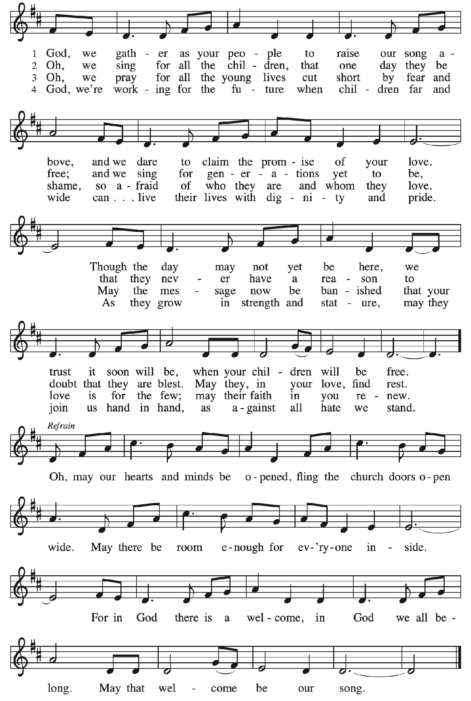
Greeting

P: The grace of our Lord Jesus Christ, the love of God,
and the communion of the Holy Spirit be with you all.
C: And also with you.

Hymn of Praise Glory to God p. 167-168

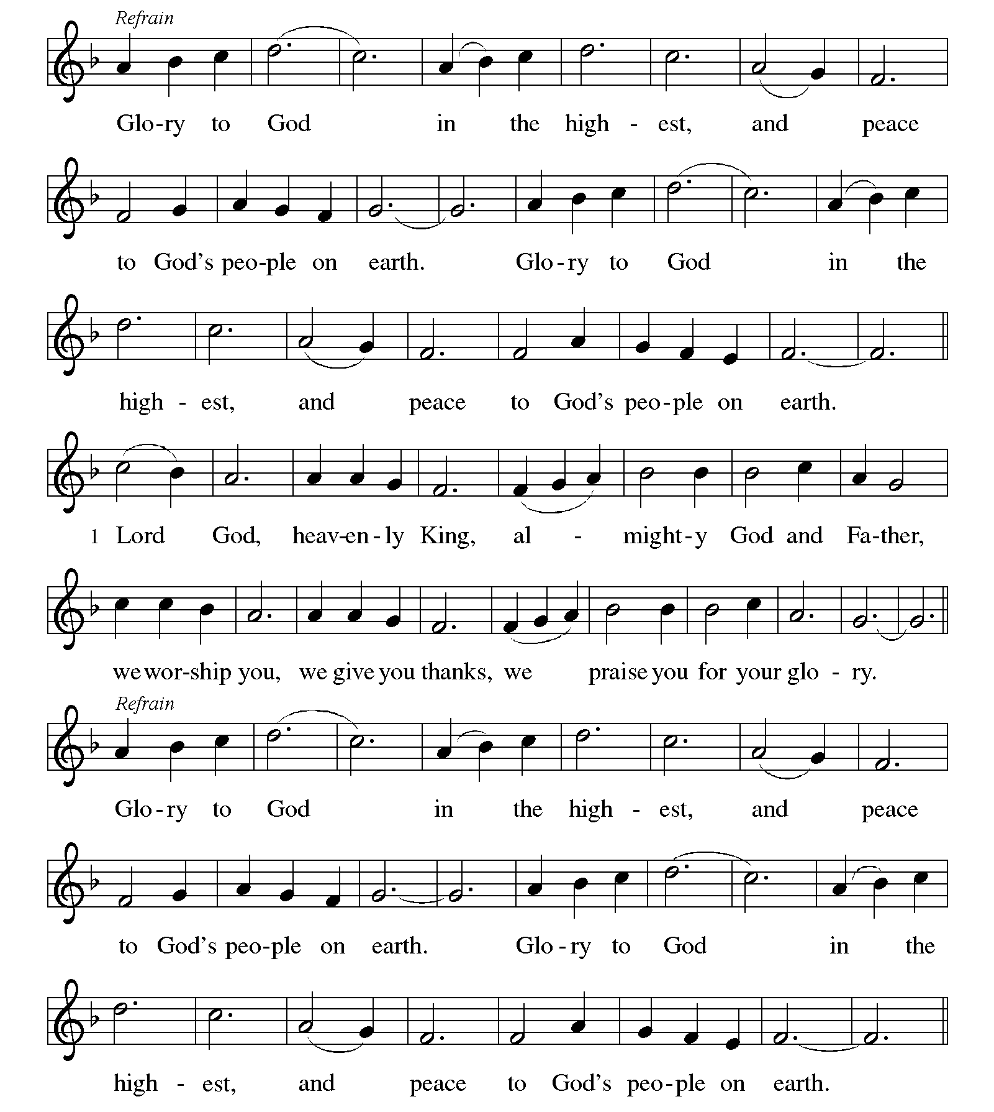
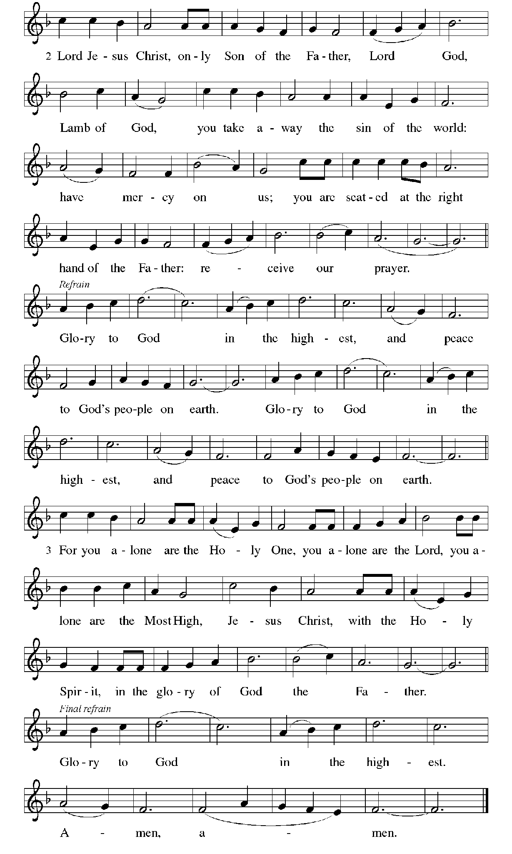
Prayer of the Day

P: The Lord be with you.
C: And also with you.

P: Let us pray.
Lord of the feast,
you have prepared a table before all peoples and poured out your life with abundance.
Call us again to your banquet. Strengthen us by what is honorable, just, and pure,
and transform us into a people of righteousness and peace,
through Jesus Christ, our Savior and Lord.
C: Amen.

Please be seated.

Word
God speaks to us in Scripture reading, preaching, and song

First Reading – Isaiah 25: 6-9
⁶ On this mountain the Lord of hosts will make for all peoples
a feast of rich food, a feast of well-aged wines,
of rich food filled with marrow, of well-aged wines strained clear.
⁷ And he will destroy on this mountain
the shroud that is cast over all peoples,
the covering that is spread over all nations;
⁸ he will swallow up death forever.
Then the Lord God will wipe away the tears from all faces,
and the disgrace of his people he will take away from all the earth,
for the Lord has spoken.
⁹ It will be said on that day,
“See, this is our God; we have waited for him, so that he might save us.
This is the Lord for whom we have waited;
let us be glad and rejoice in his salvation.”

L: Word of God, word of life.
C: Thanks be to God.

Psalm 23

The psalm will be sung responsively, led by the cantor,
with the congregation responding with the verses in bold and the refrain.

Psalm Tone

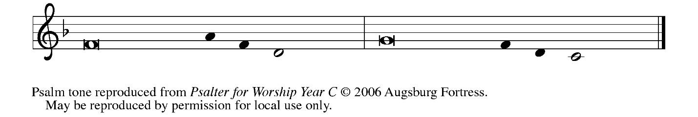

Psalm Refrain

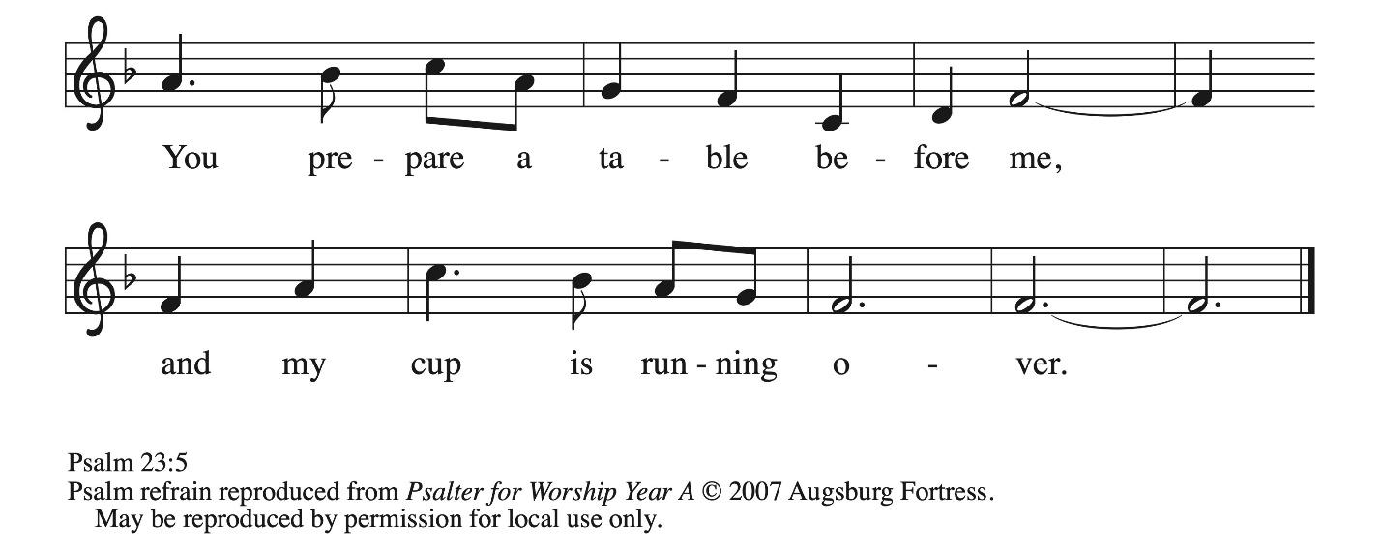

¹ The Lord | is my shepherd;
I shall not | be in want.
² The Lord makes me lie down | in green pastures
and leads me be- | side still waters.
³ You restore my | soul, O Lord,
and guide me along right pathways | for your name’s sake.
⁴ Though I walk through the valley of the shadow of death, I shall | fear no evil;
for you are with me; your rod and your staff, they | comfort me. R
⁵ You prepare a table before me in the presence | of my enemies;
you anoint my head with oil, and my cup is | running over.
⁶ Surely goodness and mercy shall follow me all the days | of my life,
and I will dwell in the house of the | Lord forever. R

Second Reading – Philippians 3: 4b-14

[Paul writes:] ^{4b} If anyone else has reason to be confident in the flesh, I have more: ⁵ circumcised on the eighth day, a member of the people of Israel, of the tribe of Benjamin, a Hebrew born of
Hebrews; as to the law, a Pharisee; ⁶ as to zeal, a persecutor of the church; as to righteousness under the law, blameless.
⁷ Yet whatever gains I had, these I have come to regard as loss because of Christ. ⁸ More than that, I regard everything as loss because of the surpassing value of knowing Christ Jesus my Lord. For his sake I have suffered the loss of all things, and I regard them as rubbish, in order that I may gain Christ ⁹ and be found in him, not having a righteousness of my own that comes from the law but one that comes through faith in Christ, the righteousness from God based on faith. ¹⁰ I want to know Christ and the power of his resurrection and the sharing of his sufferings by becoming like him in his death, ¹¹ if somehow I may attain the resurrection from the dead.
¹² Not that I have already obtained this or have already reached the goal, but I press on to lay hold of that for which Christ has laid hold of me. ¹³ Kindred, I do not consider that I have laid hold of it, but one thing I have laid hold of: forgetting what lies behind and straining forward to what lies ahead, ¹⁴ I press on toward the goal, toward the prize of the heavenly call of God in Christ Jesus.

L: Word of God, word of life.
C: Thanks be to God.

Please rise as you are able.

Gospel Acclamation ELW p. 171

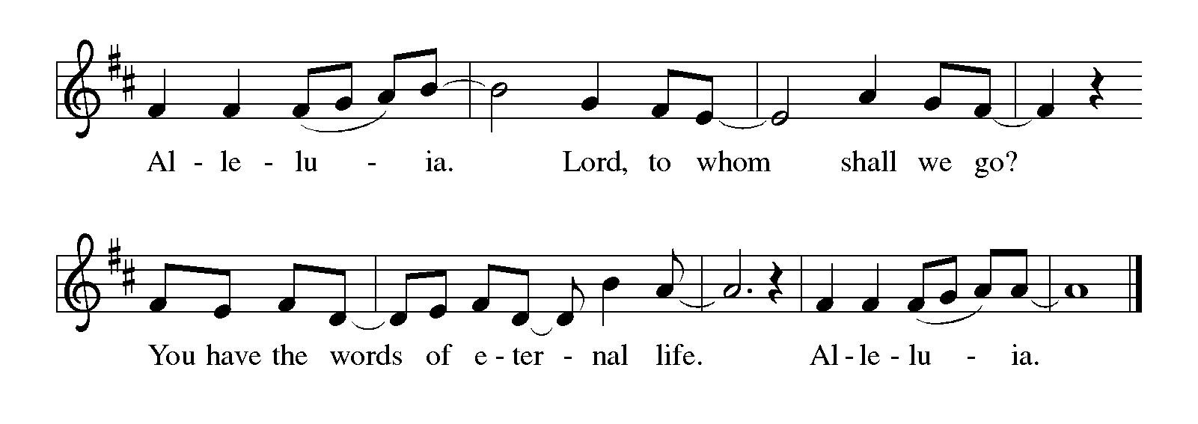

Gospel – Luke 4: 14-21

P: The holy Gospel according to St. Luke.
C: Glory to you, O Lord.

¹⁴ Then Jesus, in the power of the Spirit, returned to Galilee, and a report about him spread through all the surrounding region. ¹⁵ He began to teach in their synagogues and was praised by everyone.
¹⁶ When he came to Nazareth, where he had been brought up, he went to the synagogue on the Sabbath day, as was his custom. He stood up to read, ¹⁷ and the scroll of the prophet Isaiah was given to him. He unrolled the scroll and found the place where it was written:
¹⁸ “The Spirit of the Lord is upon me,
because the Lord has anointed me
to bring good news to the poor.
The Lord has sent me to proclaim release to the captives
and recovery of sight to the blind,
to set free those who are oppressed,
¹⁹ to proclaim the year of the Lord’s favor.”
²⁰ And he rolled up the scroll, gave it back to the attendant, and sat down. The eyes of all in the synagogue were fixed on him. ²¹ Then he began to say to them, “Today this scripture has been fulfilled in your hearing.”

P: The Gospel of the Lord.
C: Praise to you, O Christ.

Please be seated.

Sermon

A time of silence for prayer and reflection follows the sermon.
When the hymn of the day begins, please rise as you are able.



Hymn of the Day All Are Welcome ELW 641

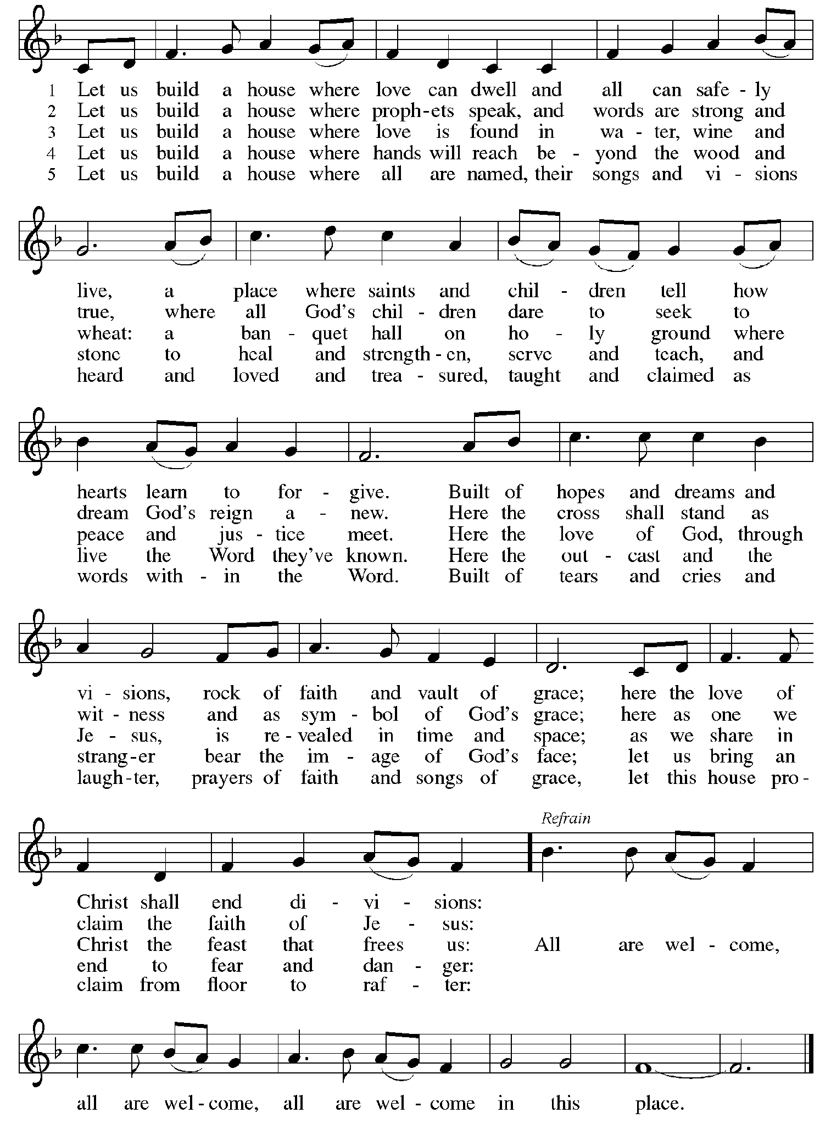
Apostles’ Creed

C: I believe in God, the Father almighty,
creator of heaven and earth.

I believe in Jesus Christ, God’s only Son, our Lord,
who was conceived by the Holy Spirit,
born of the virgin Mary,
suffered under Pontius Pilate,
was crucified, died, and was buried;
he descended to the dead.*
On the third day he rose again;
he ascended into heaven,
he is seated at the right hand of the Father,
and he will come to judge the living and the dead.

I believe in the Holy Spirit,
the holy catholic church,
the communion of saints,
the forgiveness of sins,
the resurrection of the body,
and the life everlasting. Amen.

*Or, “he descended into hell,” another translation of this text in widespread use.

Prayers of the People

A: Trusting in the Spirit of God who makes all things new,
let us pray for the church, the world, and all who are in need.

After each petition
A: God of grace,
C: receive our prayer.

The presiding minister concludes the prayers
P: Trusting in your boundless grace, O God,
we lift up these spoken prayers and those in our hearts;
through Jesus Christ our Lord.
C: Amen.

Peace

The presiding minister and the assembly greet one another in the peace of the risen Christ.
P: The peace of Christ be with you always.
C: And also with you.

The people may greet those around them with a sign of Christ’s peace and may say
Peace be with you or similar words. Please be mindful that not everyone will be comfortable with sharing the peace, so please seek consent before shaking hands or hugging. Other possible ways to share the peace include a simple bow with the verbal greeting of peace, or simply a verbal expression of peace.

When the greetings of peace have concluded, please be seated.
Worship continues with the dedication of commitments and offerings
for the Building Community Together capital campaign.

Dedication of Commitments and Offerings

P: Our God is a generous God,
C: providing manna in the wilderness.

P: Our God is a steadfast God,
C: with us even to the end of the age.

P: Our God is a God of newness and calling,
C: inviting us to follow the Spirit to honor new visions
and embrace new dreams.

P: Throughout history God has shown steadfast love and faithfulness to God’s people.
The Israelites were fed with manna from heaven. Christ invited those gathered at the feast of the five thousand to receive generosity beyond what they could imagine.
The ancient church, the people of the Way, shared all things in common,
believing that the call to communal, spiritual growth
is also a call to give back to God what God has first given us.

In keeping with this history and heritage,
trusting that God provides us with everything we need
to do what we are called to do and to be who we are called to be,
we give thanks today that God calls us to be a community of love.
C: Amen!

P: We give thanks that God calls us to be a community of service.
C: Amen!

P: We give thanks that God calls us to be a community of justice.
C: Amen!

P: Trusting in God’s immeasurable goodness and abiding love,
we now dedicate our gifts and commitments in our Building Community Together campaign.
C: Give us faith, O God, to witness your work among us! Amen.

As the hymn of thanksgiving begins, ushers will distribute a commitment sheet to all in the congregation who would like to participate. People will have an opportunity to write in their financial commitment to the three-year capital campaign. If you have not yet made a commitment, we invite you to consider how God may be calling you to support the campaign. If you have already expressed or submitted a commitment, please take this opportunity to restate it and bring it forward in the dedication. As the hymns play and as you feel moved, please bring forward your commitment to the basket at the front of the worship space.

Hymn of Thanksgiving ELW 678
God, Whose Giving Knows No Ending

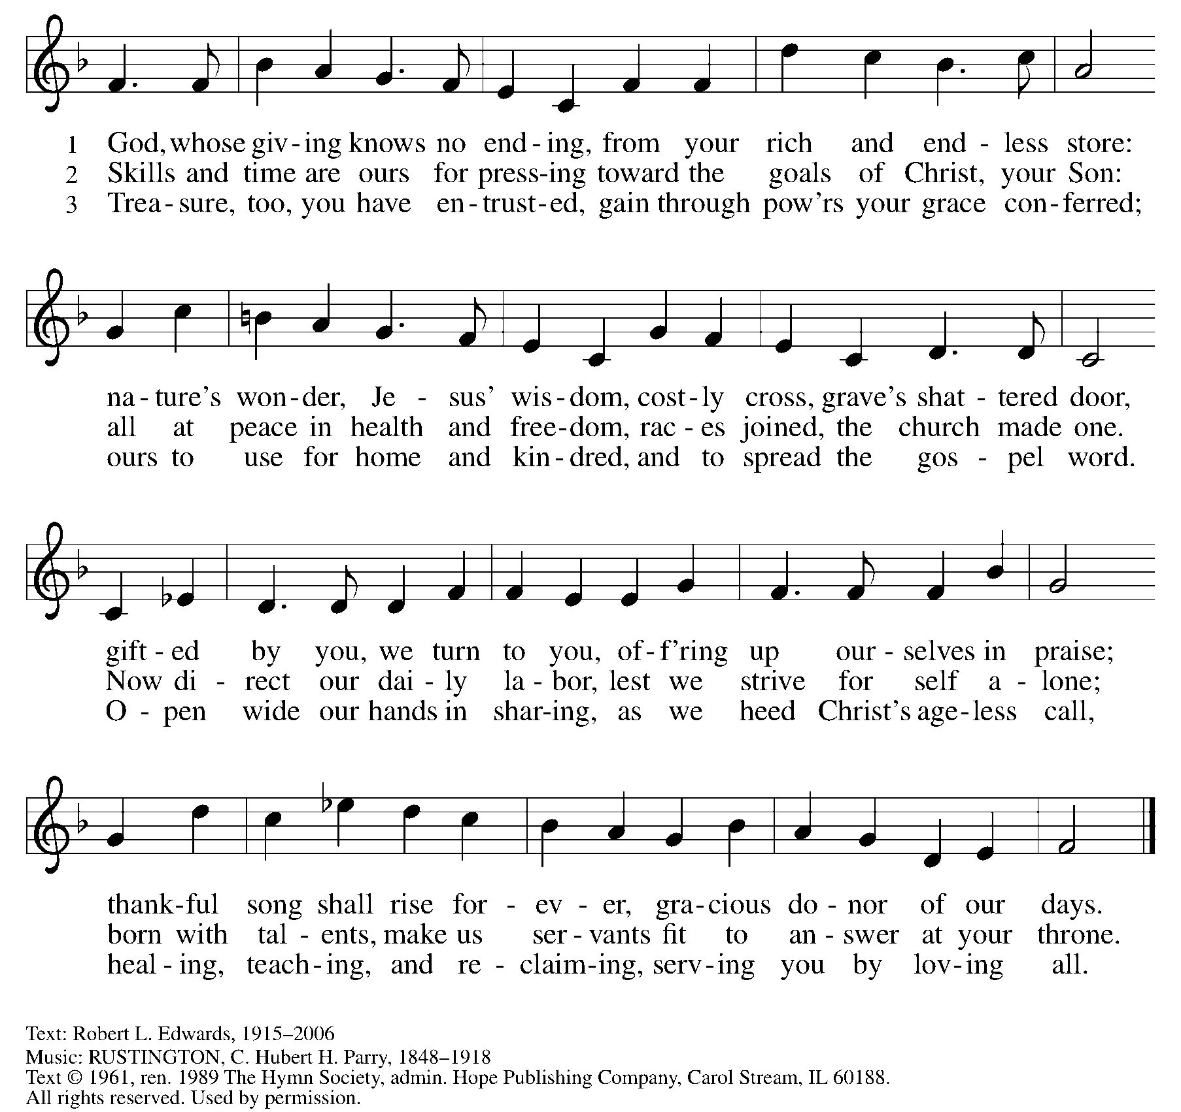
Reprinted under OneLicense.net # A-722139.

Hymn of Thanksgiving
Come, Ye Thankful People, Come ELW 693

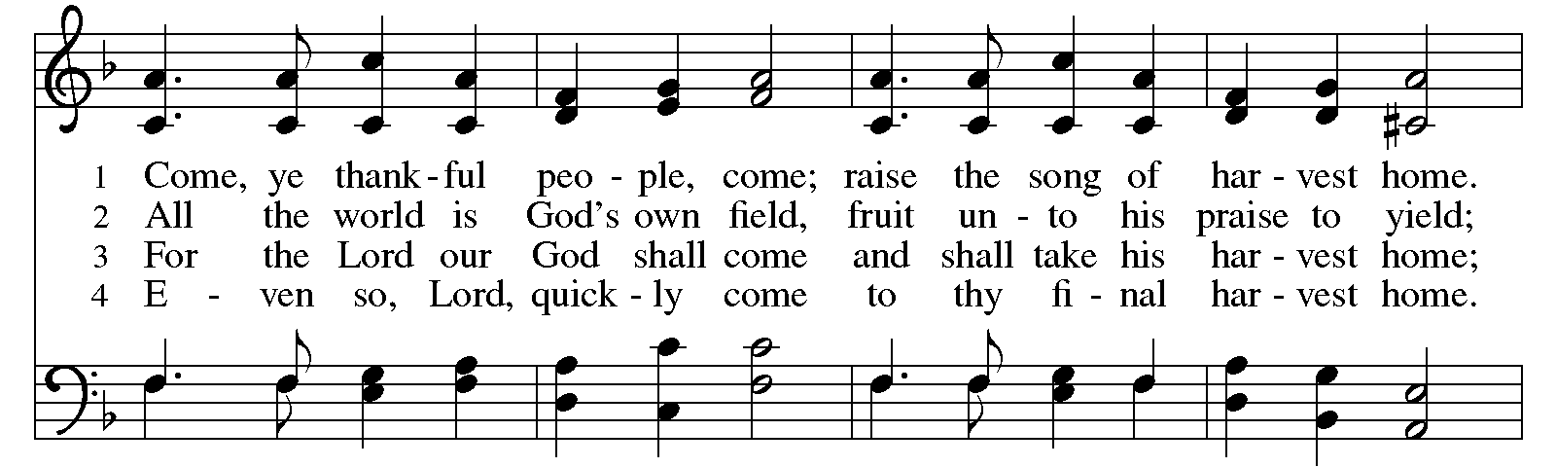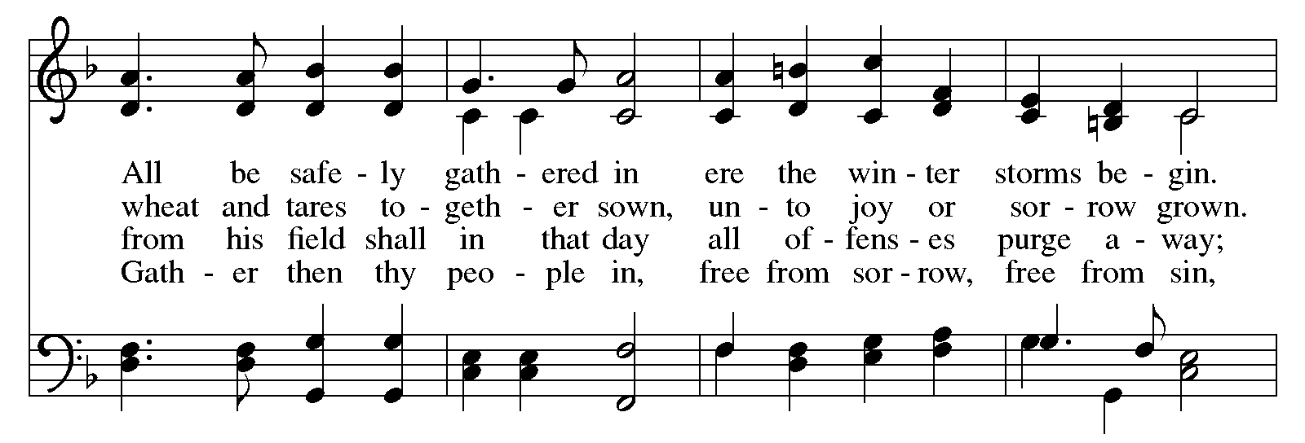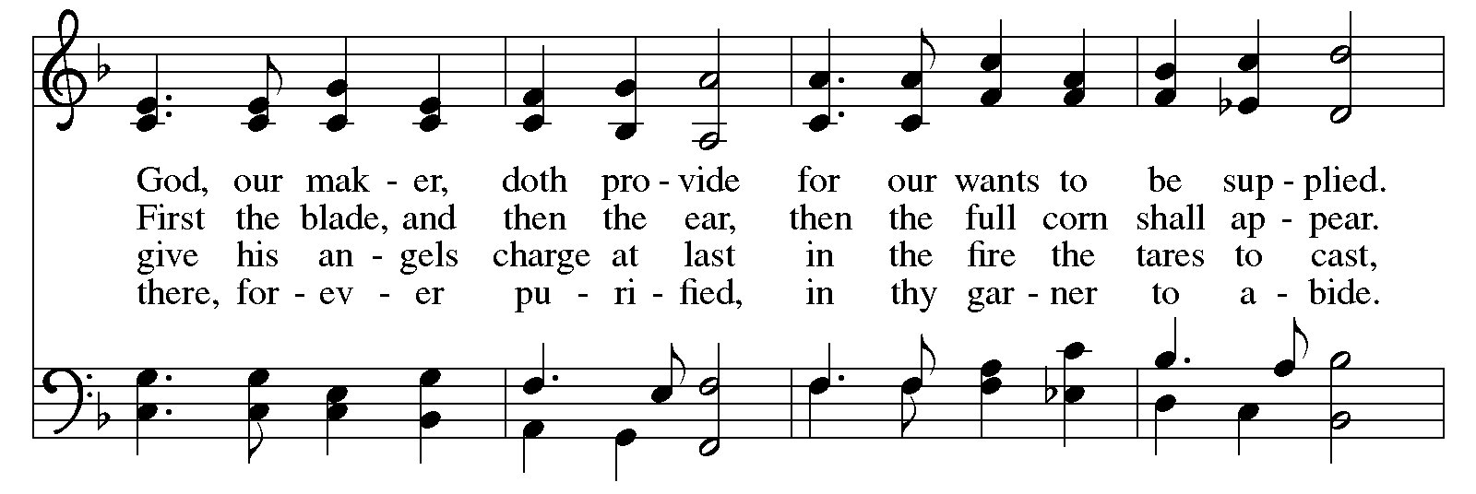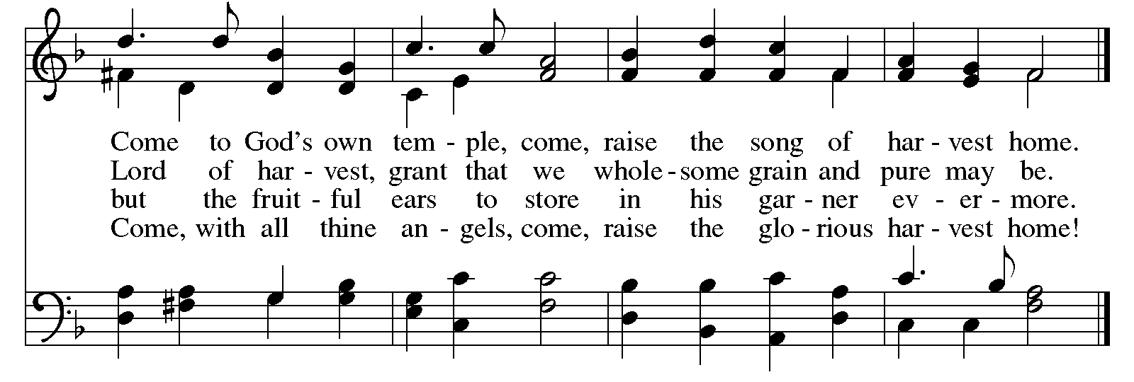
Once everyone has had an opportunity to bring forward their commitments,
the dedication concludes with prayer and the congregational refrain, which is sung on special occasions in the life of the congregation.

P: The Lord be with you.
C: And also with you.

P: Let us pray. Blessed are you, O Lord our God, ruler of the universe.
You made the whole earth for your glory; all creation praises you.
We lift our voices to join the songs of heaven and earth, of things seen and unseen.
You stretched out the heavens like a tent; you divided the day from the night;
you appointed times and seasons for work and rest, for tearing down and building up.

You blessed your people through all generations and guided them in life and death:
Abraham and Sarah; Moses and Miriam; Isaiah and all the prophets;
Mary, the Mother of our Lord; St. Andrew and Peter, James and John, and all the apostles;
all the saints and witnesses in your church of ages past, in whom your Spirit spoke and moved.
We give you thanks, O God, as we dedicate these gifts to your glory and praise.
Grant us faith to know your gracious purpose in all things, give us joy in them,
and lead us to the building up of your kin-dom of justice, service, and love;
through your Son, Jesus Christ our Savior and Lord,
who lives and reigns with you and the Holy Spirit, one God, now and forever.
C: Amen.

Congregational Refrain HS 808

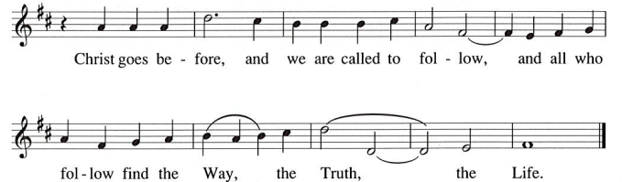

Meal
God feeds us with the presence of Jesus Christ

Offering

We offer ourselves, our gifts, and our faithful service to God.
As the offering is gathered for the mission of the church, including the care of those in need,
the table is set for Holy Communion.

There are laminated giving cards in the pew racks that feature a QR code for anyone who would like to give online. Those who give using the QR code, as well as those who give regularly online or through their bank are encouraged to place the laminated card in the plate as an expression of your offering.

Music during the Offering To God Be the Glory arr. Edstrom

As the gifts are brought forward for presentation, please rise as you are able.

Offertory Song Timothy Kocher-Hillmer

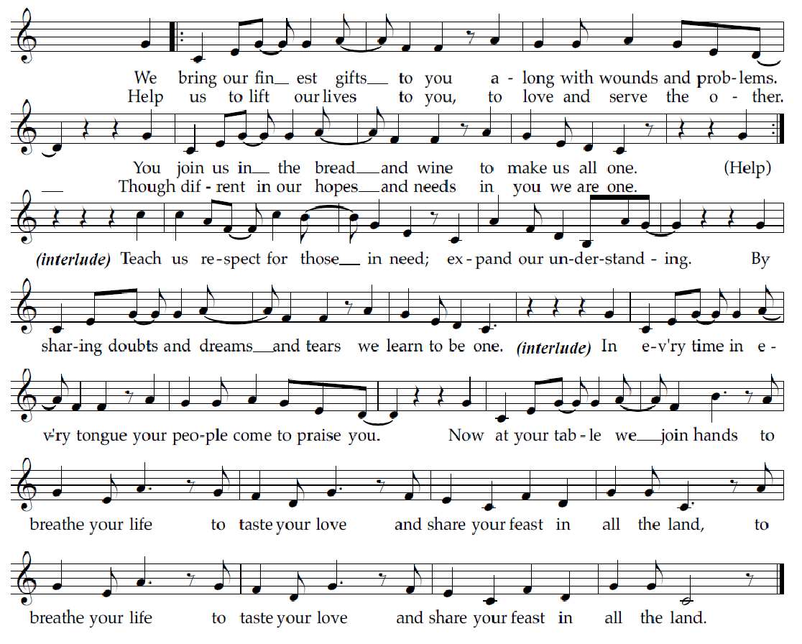

Offertory Prayer

A: Let us pray.
God of all creation,
C: you created us as your beloved children
and have given us everything we would need to have abundant life.
As we bring our varied gifts to you, strengthen us
as we celebrate the diversity you have blessed us with.
Fill us with what we need and help us to recognize
that there is more than enough for all
as we work to bring your love to all the world.
Amen.

Dialogue

P: The Lord be with you.
C: And also with you.

P: Lift up your hearts.
C: We lift them to the Lord.

P: Let us give thanks to the Lord our God.
C: It is right to give our thanks and praise.

Preface (Spoken by the presiding minister)

P: It is indeed right, our duty and our joy,
that we should at all times and in all places
give thanks and praise to you, almighty and merciful God,
through our Savior Jesus Christ;
who on this day overcame death and the grave,
and by his glorious resurrection opened to us the way of everlasting life.
And so, with all the choirs of angels,
with the church on earth and the hosts of heaven,
we praise your name and join their unending hymn:

Sanctus ELW p. 173

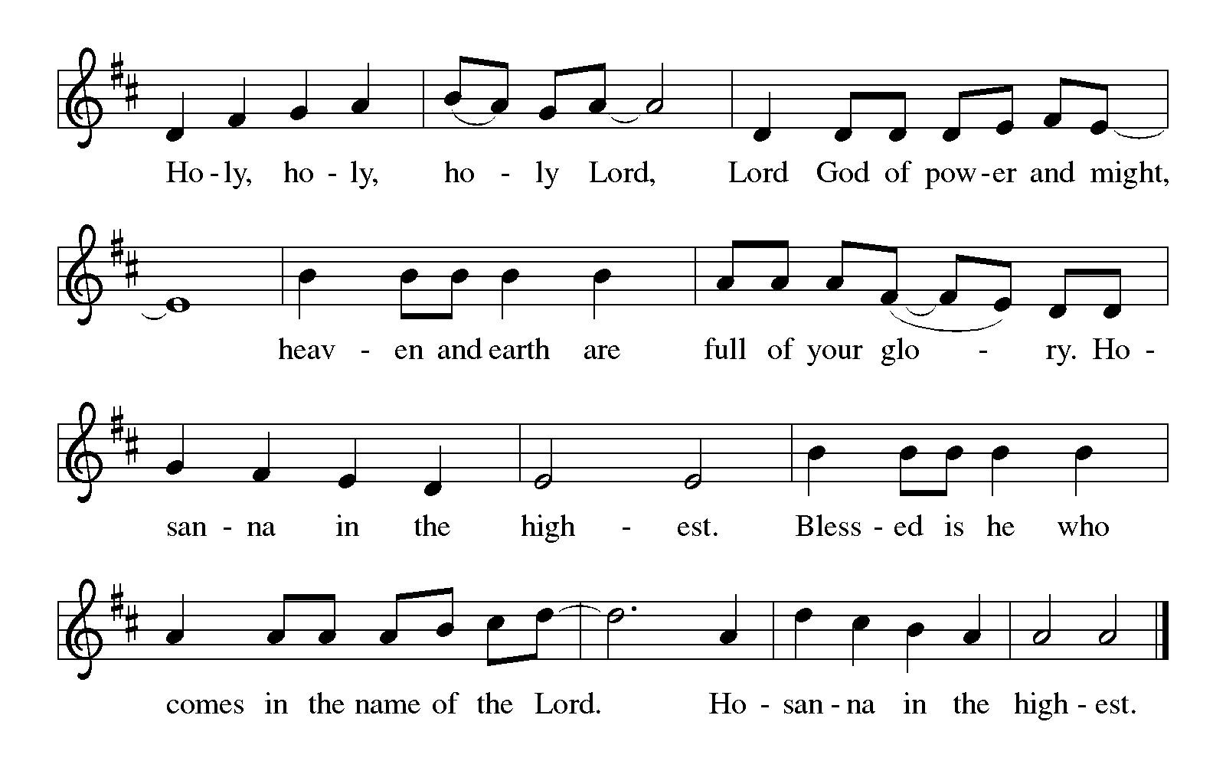

Eucharistic Prayer

P: You are indeed holy, almighty and merciful God …
… Do this for the remembrance of me.

For as often as we eat of this bread and drink of this cup,
we proclaim the Lord’s death until he comes.
C: Christ has died. Christ is risen. Christ will come again.

P: Remembering, therefore …
… and be given our inheritance with all your saints.

P: To you, O God, Father, Son, and Holy Spirit,
be all honor and glory in your holy church, now and forever.
C: Amen.

Lord’s Prayer

P: Gathered as one by the Holy Spirit, we pray as Jesus taught us.
C: Our Father in heaven,
hallowed be your name,
your kingdom come,
your will be done,
on earth as in heaven.
Give us today our daily bread.
Forgive us our sins,
as we forgive those
who sin against us;
Save us from the time of trial,
and deliver us from evil.
For the kingdom, the power,
and the glory are yours,
now and ever. Amen.

Fraction and Invitation

Agnus Dei / Lamb of God ELW p. 174

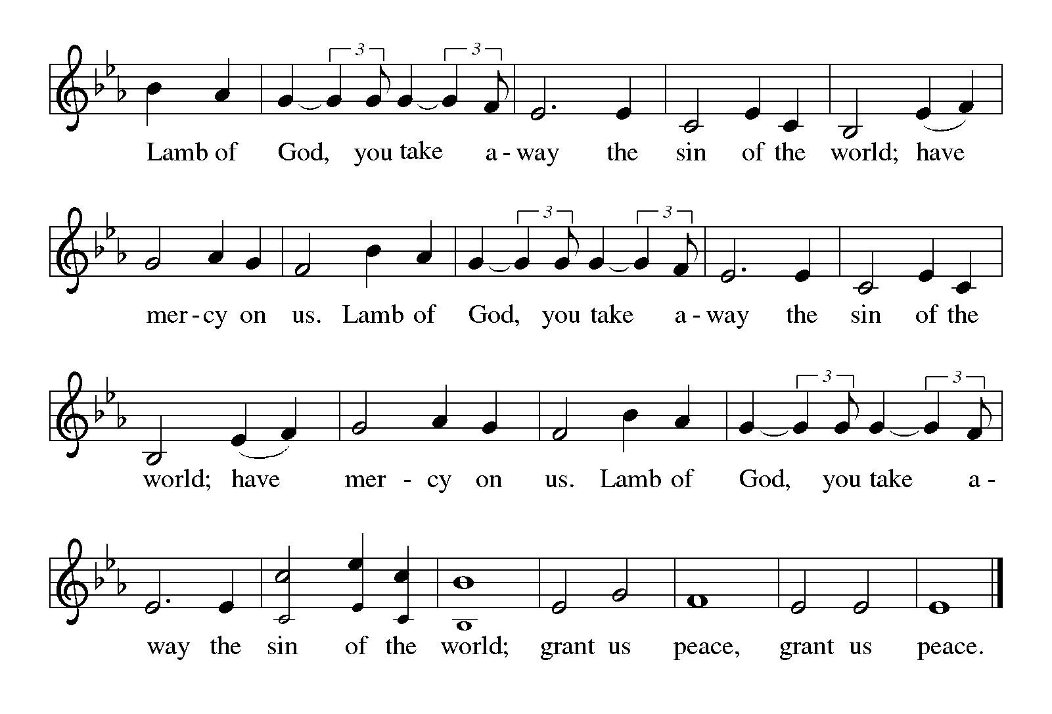

Please be seated.



Holy Communion

- All who seek God and desire a deeper and stronger life in Christ are welcome to receive Holy Communion.
- Worshipers from the pulpit side will proceed forward first, followed by the center section, and then the lectern side.
- Please inform an usher if you would like the ministers to bring Communion to you.
- Holy Communion will be served with bread and wine (red) or grape juice (white).
- The presiding minister will first distribute the bread (host) to each communicant. Please indicate if you require a gluten-free host.
- Once you have consumed the bread, please pick up an empty glass from the tray next to the presiding minister. The Communion Assistant will pour wine or grape juice into your glass.
- Please step to the side to consume the wine or grape juice.
- Feel free to kneel at the altar rail for prayer after receiving the sacrament.
- As you return to your pew, glasses may be returned to the empty tray on the side of the center section.
- A blessing will be provided for anyone who does not yet receive the sacrament.
- All are invited to join in singing the hymns during Holy Communion.

Hymns during Holy Communion
As Saints of Old ELW 695

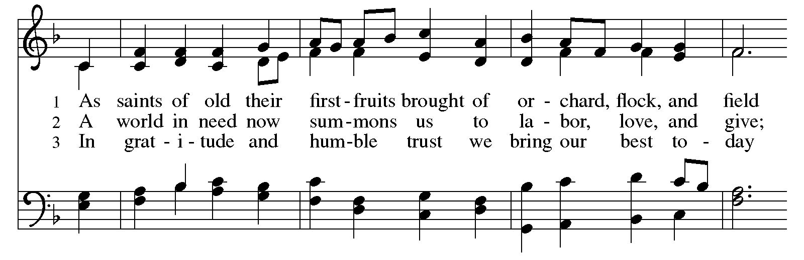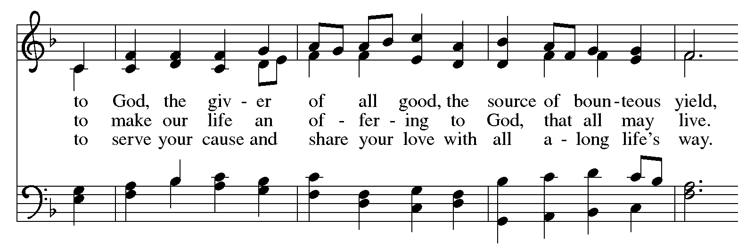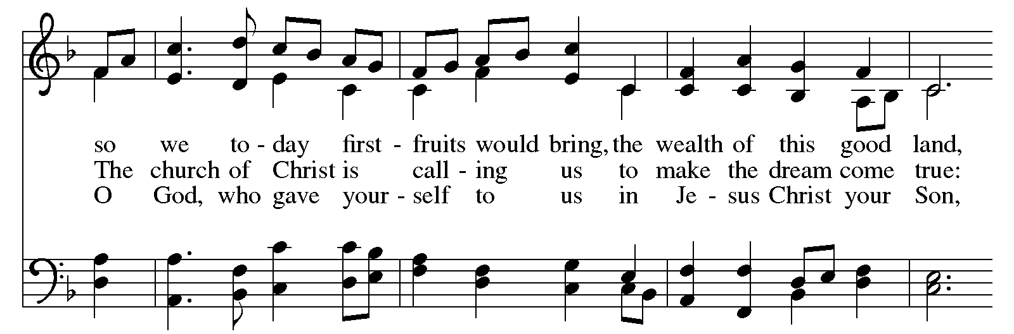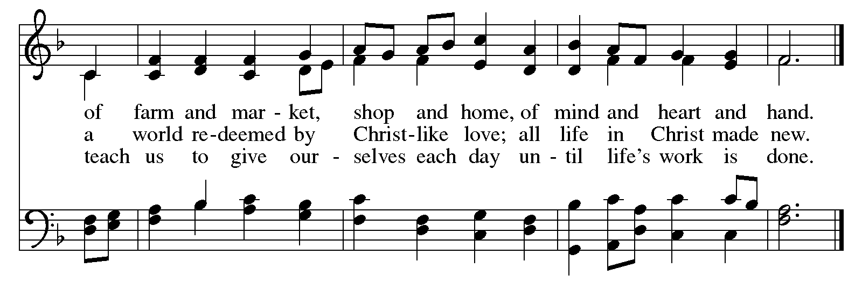
Hymns during Holy Communion
Let Us Break Bread Together ELW 471

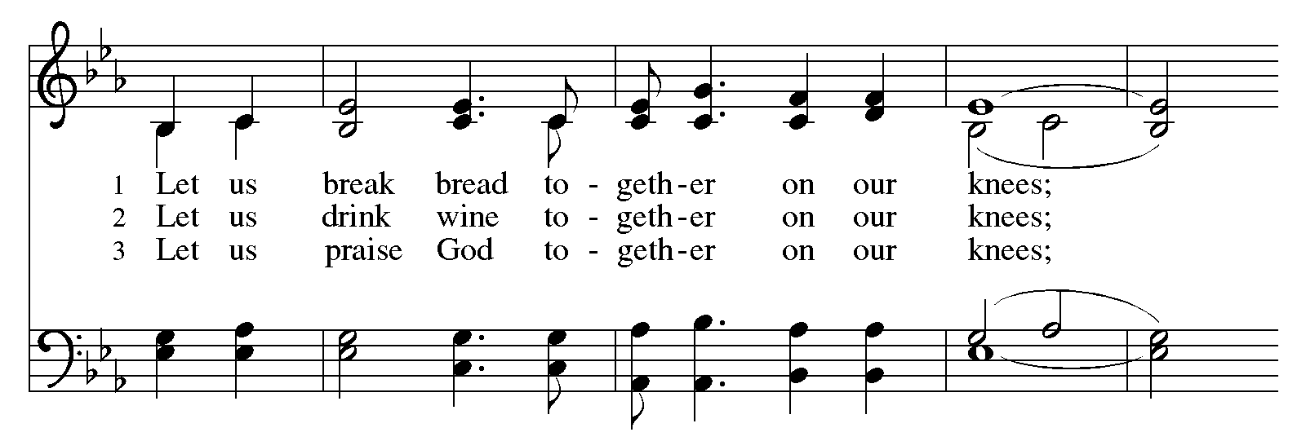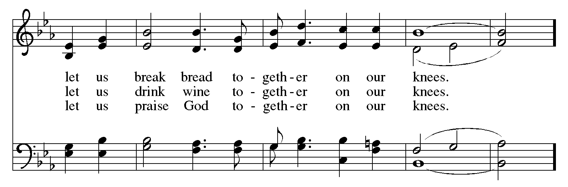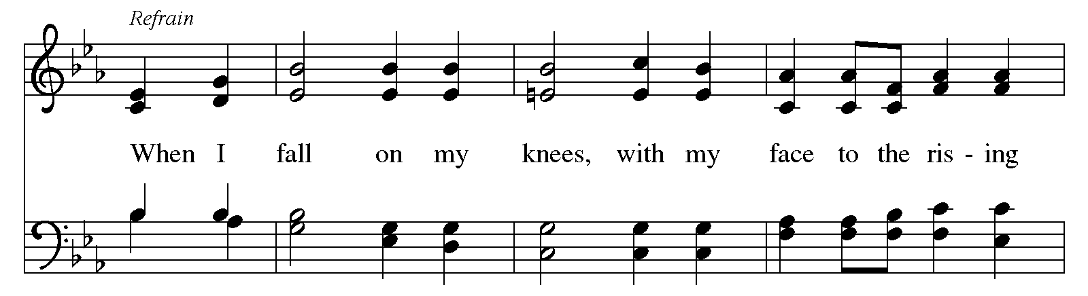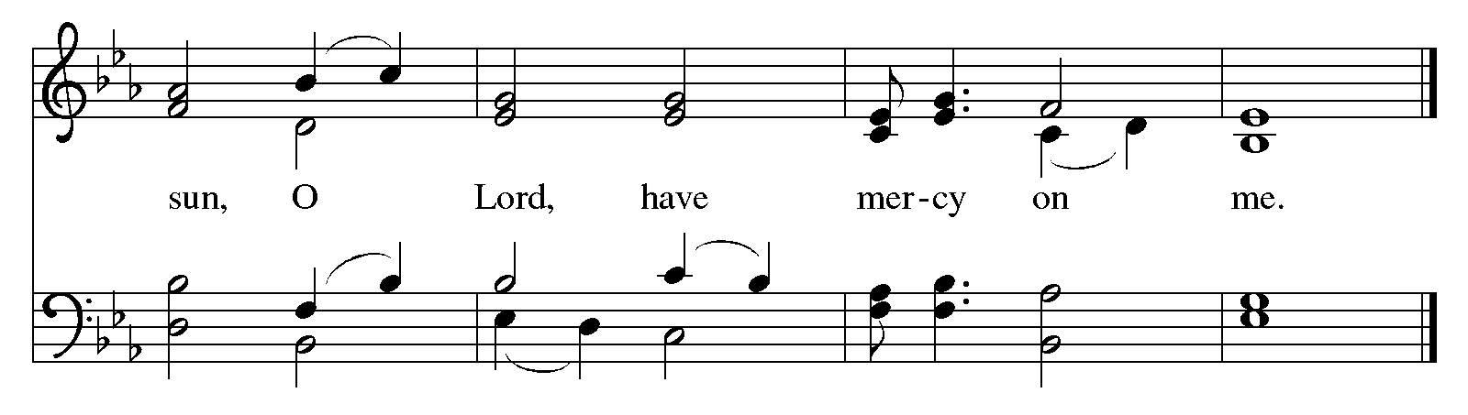
Hymns during Holy Communion
ACS 1042
May This Church Be Like a Tree – Que esta Iglesia sea un árbol

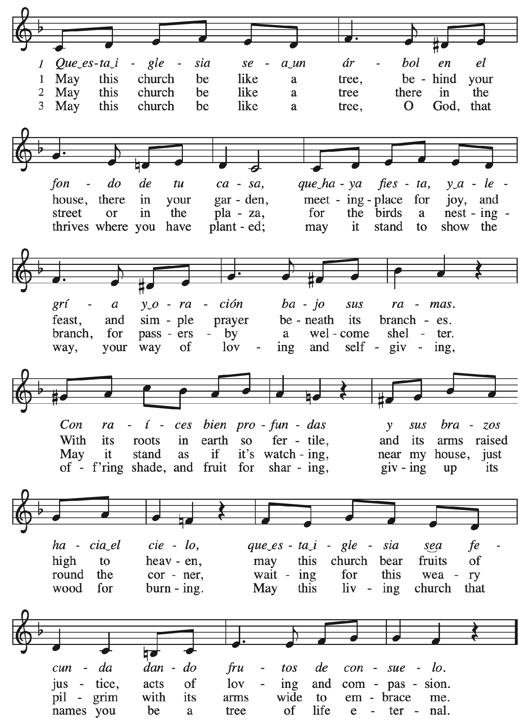

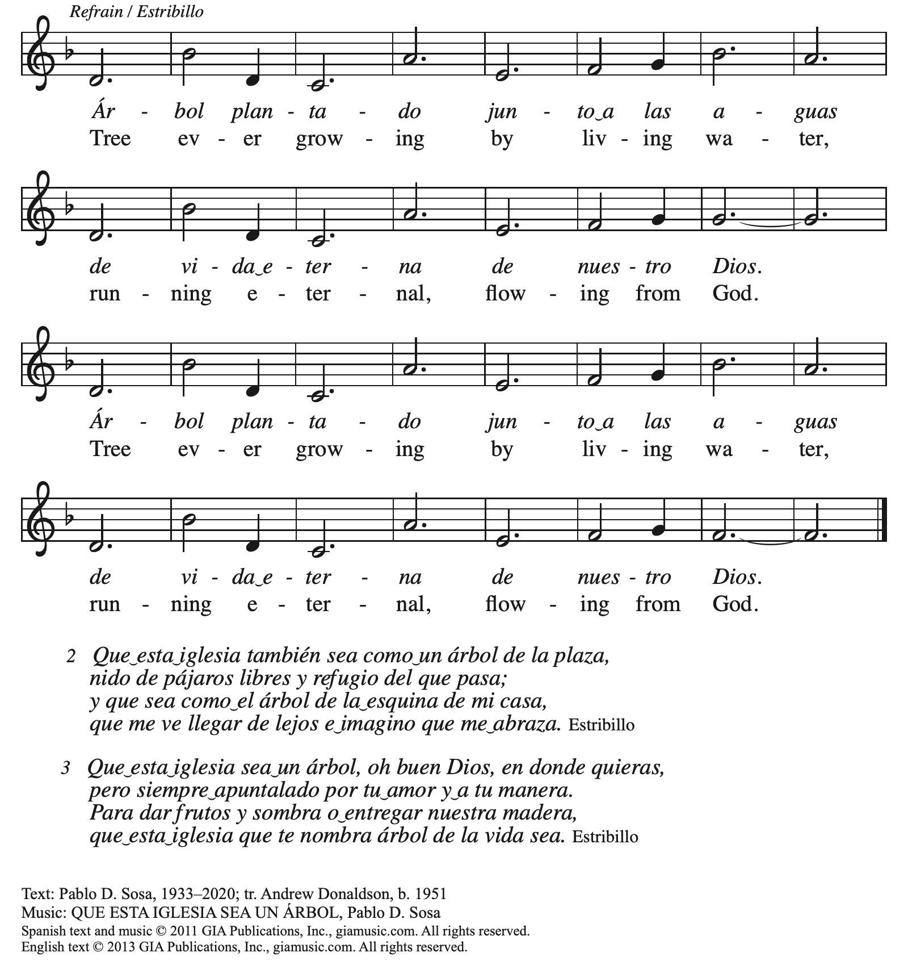
Reprinted with permission under OneLicense.net # A-722139.

Hymns during Holy Communion
God Welcomes All ACS 978

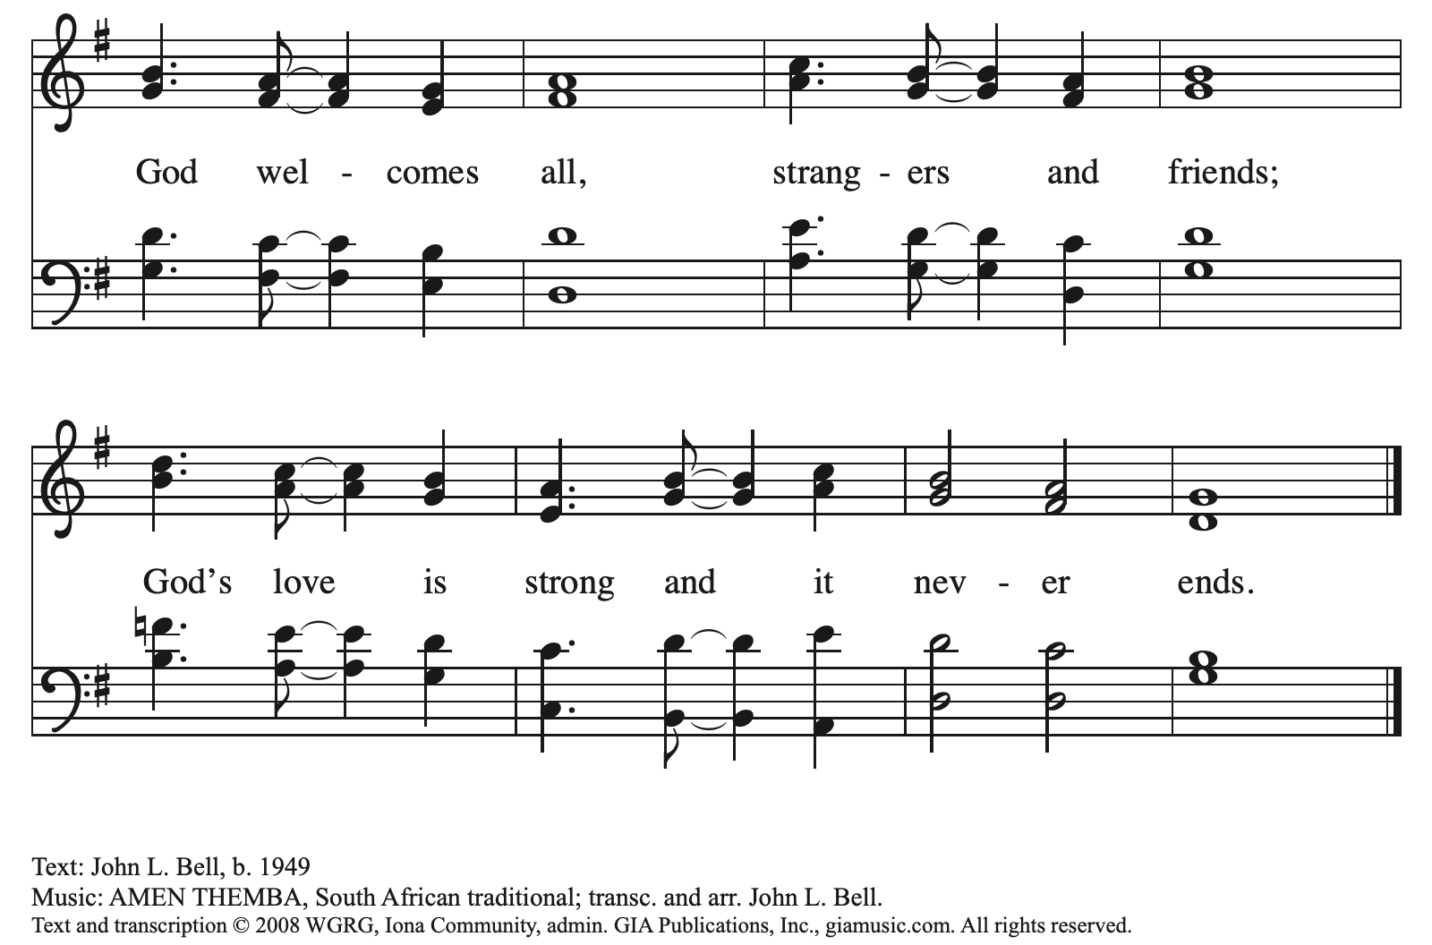
All rights reserved. Reprinted with permission under OneLicense.net # A-722139.

When all have returned to their places, please rise as you are able.

Blessing

P: The body and blood of our Lord Jesus Christ strengthen you and keep you in his grace.
C: Amen.

Prayer

A: Let us pray.
Jesus our friend and savior, your life, death, and resurrection have changed our world.
May this meal of bread and wine bless us and sustain us
in the building of a blessed community which welcomes all people,
that honors all people, and that works for justice for all people,
through Jesus Christ our Lord.
C: Amen.

Please be seated.

Sending
God blesses us and sends us in mission to the world

Announcements

Please rise as you are able.

Benediction

P: The God of love draw you together into a blessed community,
in the body of Christ Jesus.
C: Amen.

P: The God of hope
grant you strength, joy, and peace in believing,
through the Holy Spirit.
C: Amen.

P: The God of grace
☩ bless you now and forever.
C: Amen.

Sending Hymn Following Page

Dismissal

A: Go in peace. Strive for justice in all the world!
C: Thanks be to God!

Postlude

Sending Hymn Go to the World ACS 991

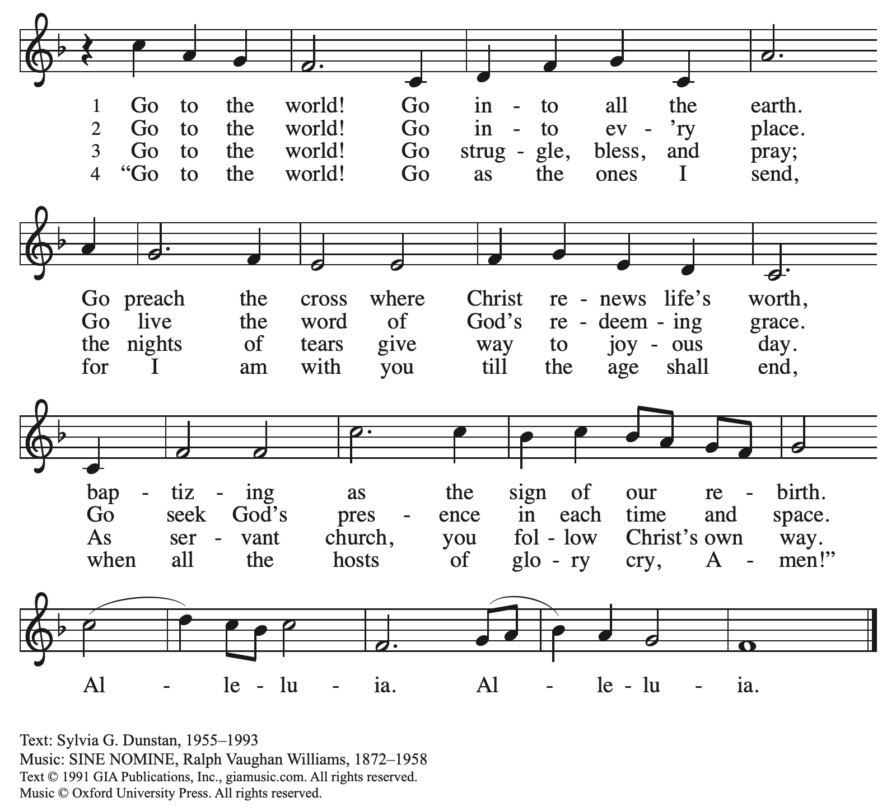
Reprinted with permission under OneLicense.net # A-722139.

Those serving in worship today

Altar Care Christy Ruhe
Assisting Minister Jeff Denlinger
Audio-Visual Ministers Kristen Asplin
Jason Galyardt
Cantor Timothy Kocher-Hillmer
Clarinet on Preservice Music Maria Mangano
Lector Lester Prince
Minister of Music Laura Reynolds
Presiding Minister The Rev. Ross I. Carmichael

Liturgy and Hymnody Acknowledgements

From SundaysandSeasons.com. Copyright © 2026 Augsburg Fortress. All rights reserved. Reprinted under OneLicense.net # A-722139.
Used by permission of Augsburg Fortress.

Liturgical material reprinted with permission under Augsburg Fortress Liturgies Annual License SB124976.

The Scripture readings contained herein are from New Revised Standard Version Updated Edition of the Bible © 2021 National Council of Churches of Christ in the United States of America. Used by permission. All rights reserved worldwide.

God, We Gather as Your People – Text: David Lohman, b. 1961. Music: WELCOME BE OUR SONG, David Lohman. Text and music © 2007 Welcome Song Music, admin. Augsburg Fortress. All rights reserved. Reprinted with permission under OneLicense.net # A-722139.

All Are Welcome Text: Marty Haugen, b. 1950. Music: TWO OAKS, Marty Haugen. Text and music © 1994 GIA Publications, Inc., 7404 S. Mason Ave., Chicago, IL 60638. www.giamusic.com. 800.442.3358. All rights reserved. Reprinted with permission under OneLicense.net # A-722139.

Come, Ye Thankful People, Come – Text: Henry Alford, 1810-1871, alt. Music: ST. GEORGE’S, WINDSOR, George J. Elvey, 1816-1893.

As Saints of Old – Text: Frank von Christiersen1900-1996, alt. Music: FOREST GREEN, English Folk Tune; arr. Ralph Vaughan Williams, 1872-1958. Text © 1960, ren. 1989 The Hymn Society, admin. Hope Publishing Company, Carol Stream, IL 60188. All rights reserved. Reprinted with permission under OneLicense.net # A-722139.

Please use the QR code below to link to St. Andrew’s Announcements online!



St. Andrew Lutheran Church Announcements
October 11th, 2026

- Welcome to Worship at St. Andrew on the Twentieth Sunday after Pentecost as we Celebrate the 135th Anniversary of the Congregation and our 30th Anniversary as a Reconciling in Christ Congregation! – We are so glad you are here, and we offer a special welcome to all visitors and guests who are here for the first time! Little Church – Big Faith, a Bible lesson and activity for children up to sixth grade, will take place after the prayer of the day. There are also worship “toolkits” to help children engage with worship and “busy bags” for younger children available in the bookcase at the back of the sanctuary. Please feel free to take one to use with/for your children. A nursery is available through the door to the left of the worship space and across the social hall (look for a purple room). All are invited to stay for coffee and other drinks, food, and conversation in the Social Hall (through the side door at the left of the worship space) after the service.
- Today Is Commitment Sunday for the Building Community Together Capital Campaign –
St. Andrew’s capital campaign, Building Community Together, was launched at the end of May, and over the past several weeks we have been sharing stories about St. Andrew as a Community of Love, Service, and Justice. Today we invite people of the congregation to dedicate their commitments to the three-year campaign in worship. After the sharing of peace, we will distribute commitment pages - if you have not yet made a commitment, we ask you to prayerfully consider how you can support the campaign, and if you have already made a verbal or written commitment, this is an opportunity to restate that commitment and bring it forward as your offering to God. After all have had an opportunity to bring their gifts forward during the hymns of thanksgiving, we conclude with prayer entrusting and consecrating these gifts to God.
- Special Coffee Hour with History and Architecture Presentation after Worship Today – To celebrate Commitment Sunday and the congregation’s anniversaries, St. Andrew will host a special coffee hour after worship. Jan Kurth has prepared a presentation on St. Andrew’s architectural history that she will share with the congregation and which you won’t want to miss, so please plan to stay after worship today!
- Election Defense and Voter Protection Workshop, This Wednesday, October 14th, 6:30 p.m. – In the U.S. most of us believe that voters should pick our leaders. We want every voter and every vote cast to be counted. We want to ensure that the hopes of the people are heard and the will of the people prevails. But across Pennsylvania and this nation, there is growing concern and mounting evidence that efforts are being made to prevent the votes of some people from being counted at all. Fortunately, there are things we can do to protect this system. St. Andrew invites you to a nonpartisan Hands Off Our Vote! PA workshop. Together we will evaluate election interference scenarios, build our skills of readiness and response, and choose meaningful work we can do right now to defend free and democratic elections. Gather in the social hall at St. Andrew on Wednesday, October 14th, at 6:30 p.m. as we answer our Christian calling to participate in civic life and our baptismal call to strive for justice and peace in all the earth.
- Congregation Council Meeting - Saturday, October 17th, 9:00 a.m. – St. Andrew’s congregation council is a group of elected leaders that meets regularly to plan and organize the mission and ministry of the congregation. The next council meeting will be Saturday, October 17th, at 9:00 a.m.
- Johanna’s 50th Birthday Party, October 17th, 1:00 - 5:00 p.m. – Dress code is whimsy, colorful, and comfortable! In lieu of gifts, please donate to charity. Food and drink will be provided. RSVP to johanna.matsui@gmail.com or 412-639-5254.
- Noisy Offering, Next Sunday, October 18th, During Worship – On the third Sunday of each month, St. Andrew’s children lead the congregation in a Noisy Offering, in which people are invited to throw their change into buckets that the children carry around the church and bring forward as an additional offering. Each month’s Noisy Offering supports a local, national, or international church-related or otherwise charitable organization. This month’s offering will benefit the ELCA Fund for Leaders. Since 2000, this fund of the Evangelical Lutheran Church in America (ELCA) has been offering full tuition scholarships, along with mission developer, synod, federal chaplaincy, and TEEM (Theological Education for Emerging Ministries) scholarships, to seminary students who are pursuing rostered ministry. For more information, please see https://www.elca.org/resources/financial-information/grants-and-scholarships/elca-scholarships.
- Produce Distribution Supplemental Food of the Month – St. Andrew is collecting supplemental food each month to accompany our produce distribution. For October, we ask for donations of soup. There are collection boxes at the back of the worship space and social hall.
- October Produce Distribution, Third Tuesday of the Month, October 20th, 5:30-6:30 p.m. – St. Andrew partners with Greater Pittsburgh Community Food Bank to serve as a distribution site for fresh produce on the first and third Tuesday of every month. We invite people of the congregation to help with the distribution from 5:30 p.m. - 6:30 p.m. and/or to help with unloading and setup during the day between 10:00 a.m. and 1:00 p.m.
- Inclusive Game Night, Saturdays, October 24th, November 21st, and December 19th, 5:00 - 7:00 p.m. – People of all ages are invited to an inclusive game night on Saturday evenings over the next few months. We will share board games, conversation, and fun!
- Aluminum Can Tabs for Ronald McDonald House – You may have noticed that at coffee hour, St. Andrew is now putting out a receptacle to collect the tabs from aluminum cans. We invite people of the congregation to save their tabs, not only during coffee hour, but from other beverages throughout the week, and to drop them off in the designated drawer of the plastic in the social hall. The tabs are donated to Ronald McDonald House, which supports families with children receiving medical treatment across the country. More information is available here: https://ronaldmcdonaldhousepghmgtn.org/get-involved/pull-tabs/.
The community ministry team is looking for someone to monitor the supply and bring in the tabs for periodic donations. If you are interested, please speak with Tyler Rietze or email community@standrewpittsburgh.org.
- Coffee Hour Signups – Coffee hour returns this week! St. Andrew provides hospitality during a coffee hour after worship each Sunday. If you would like to participate and would like information about the duties of setting up, please sign up using the following form: https://www.signupgenius.com/go/5080B4AAFAF2CABF85-47069030-coffee#/.
- “Christ in Our Home” Booklets Available – “Christ in Our Home” is a quarterly devotional resource that encourages readers to live out their faith daily. Each reflective reading is accompanied by a daily scripture reference and prayer for the day. The October-December booklets are available at the entrances. Please feel free to take one home!
- Winter Clothing Collection for Bethel AME Church Pantry – Our friends at Bethel AME Church have begun a new pantry program at which they are offering new or gently used clothing for people of the community. If you are doing any fall cleaning and have clothes or coats that you are no longer using, please bring them to St. Andrew. There will be a box on or near the donation table in the social hall.

