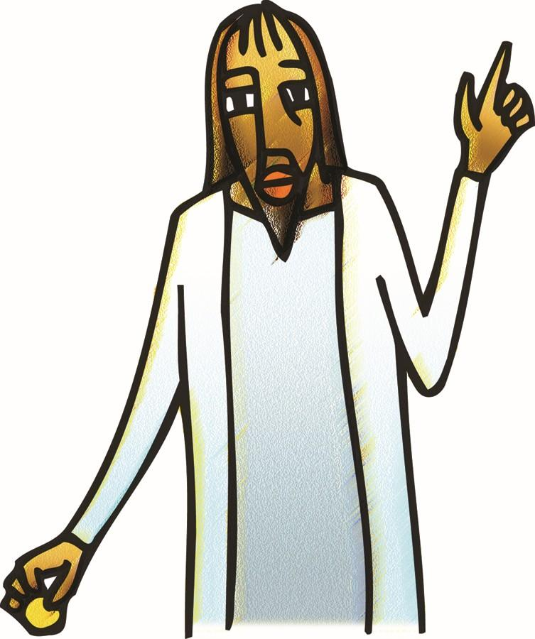

+ Twenty-first Sunday after Pentecost
October 18, 2026



St. Andrew Lutheran Church
304 Morewood Ave.
Pittsburgh, PA 15213
St_andrewELCA@verizon.net
www.standrewpittsburgh.org

+ Twenty-First Sunday after Pentecost

In this week’s first reading, God uses the Gentile ruler Cyrus to accomplish divine purposes. When the Pharisees try to trap Jesus, he tells them to give the emperor what belongs to him and to God what belongs to God. To gather for worship reminds us that our ultimate allegiance is to God rather than to any earthly authority. Created in the image of God, we offer our entire selves in the service of God and for the sake of the world.

Welcome to St. Andrew!
- St. Andrew welcomes all who are seeking a place of healing, wholeness, and acceptance in a nurturing and faith-forming spiritual home. We are striving toward racial equity worldwide
and we seek to honor the lived experience of all individuals regardless of background. Our community embraces people of all ages, ethnicities, cultures, abilities, sexual orientations,
gender identities and expressions, and family constellations. Come and See!
- Worship Services are live-streamed to multiple online platforms. By attending worship, you agree that your image and voice may be broadcast.
- Everyone is invited to make a name tag at the black bookcase in the back of the worship space if they would like. There are stickers indicating pronouns on the bookcase if you would like to include them on your name tag.
- Children up to sixth grade are invited to attend Little Church – Big Faith, a Bible lesson and activity, during worship (after the Prayer of the Day). The group returns to the worship space for the liturgy of Holy Communion.
- A nursery is available through the doors at the left side of the sanctuary and across from the doorway to the Social Hall. Look for a purple-colored room.
- Worship “toolkits” to help children engage with the service, along with “busy bags” for younger children, are available in the bookcase at the back of the sanctuary. Please feel free to take one to use with/for your children.
- Holy Communion is served with bread (gluten-free available) and wine or grape juice. The presiding minister will distribute the bread (host). Please consume this and then pick up an empty glass from the tray. The Communion Assistant will pour wine or grape juice into your glass. Please step to the side to consume the wine or grape juice. Feel free to kneel at the altar for prayer and reflection. As you return to your pew, glasses may be returned to the empty trays on either side of the center section.
- A restroom is available on the main level of the church, through the doors to the Social Hall and to the right in the main office.

Abbreviations
P: Pastor/Presiding Minister ELW: Evangelical Lutheran Worship hymnal
A: Assisting Minister ACS: All Creation Sings hymnal
L: Lector
C: Congregation

Musical Offering

Each week, different people from the congregation make an offering of pre-service music, with singing or instrumentation, to help the assembly focus and pray in preparation for worship.

Welcome
Prelude Come, Thou Fount of Every Blessing arr. Walz

Come, thou Fount of ev'ry blessing,
tune my heart to sing thy grace;
streams of mercy, never ceasing,
call for songs of loudest praise.
While the hope of endless glory
fills my heart with joy and love,
teach me ever to adore thee;
may I still thy goodness prove.

Gathering
The Holy Spirit calls us together as the people of God

Please rise as you are able. All may make the sign of the cross,
the sign that is marked at Baptism, as the presiding minister begins.

Confession and Forgiveness

P: Blessed be the ☩ holy Trinity, who pours love into our hearts
and brings healing upon the earth.
C: Amen.

P: Confident that God justifies us by grace through faith, let us confess our sin.

Silence is kept for reflection.

P: Compassionate God,
C: we confess that we struggle to embody your goodness
in the world and in our own hearts. Creation groans from our overuse.
Jealousy and bitterness strain our relationships. Indifference keeps us from seeking justice.
Divisions disrupt your call to show genuine love to others.
Turn our hearts back to you.
Restore our world and reconcile us to one another. Renew us to live as your holy people,
following the way of Jesus Christ. Amen.

P: Receive this good news and receive God’s free gift of grace:
We have peace with God through ☩ Jesus Christ, in whom there is no condemnation,
but only forgiveness and the promise of eternal life.
C: Amen.
Gathering Hymn God of Grace and God of Glory ELW 705

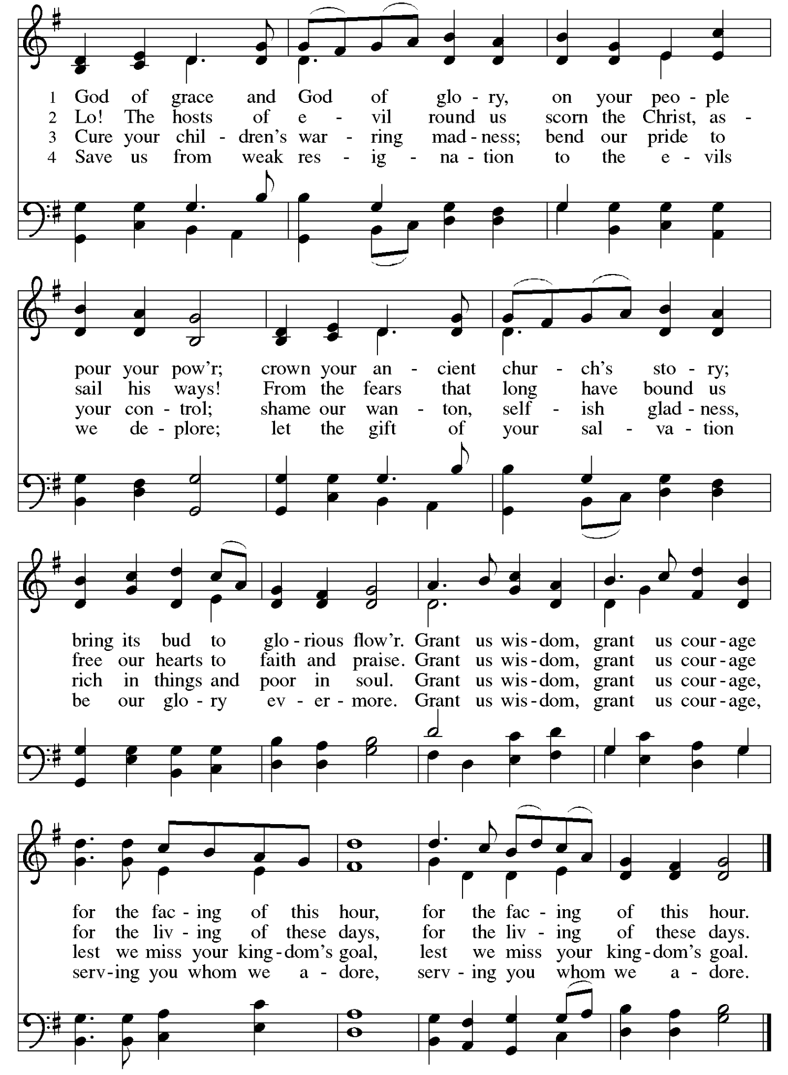
Greeting

P: The grace of our Lord Jesus Christ, the love of God,
and the communion of the Holy Spirit be with you all.
C: And also with you.

Hymn of Praise Glory to God ELW p. 167-168

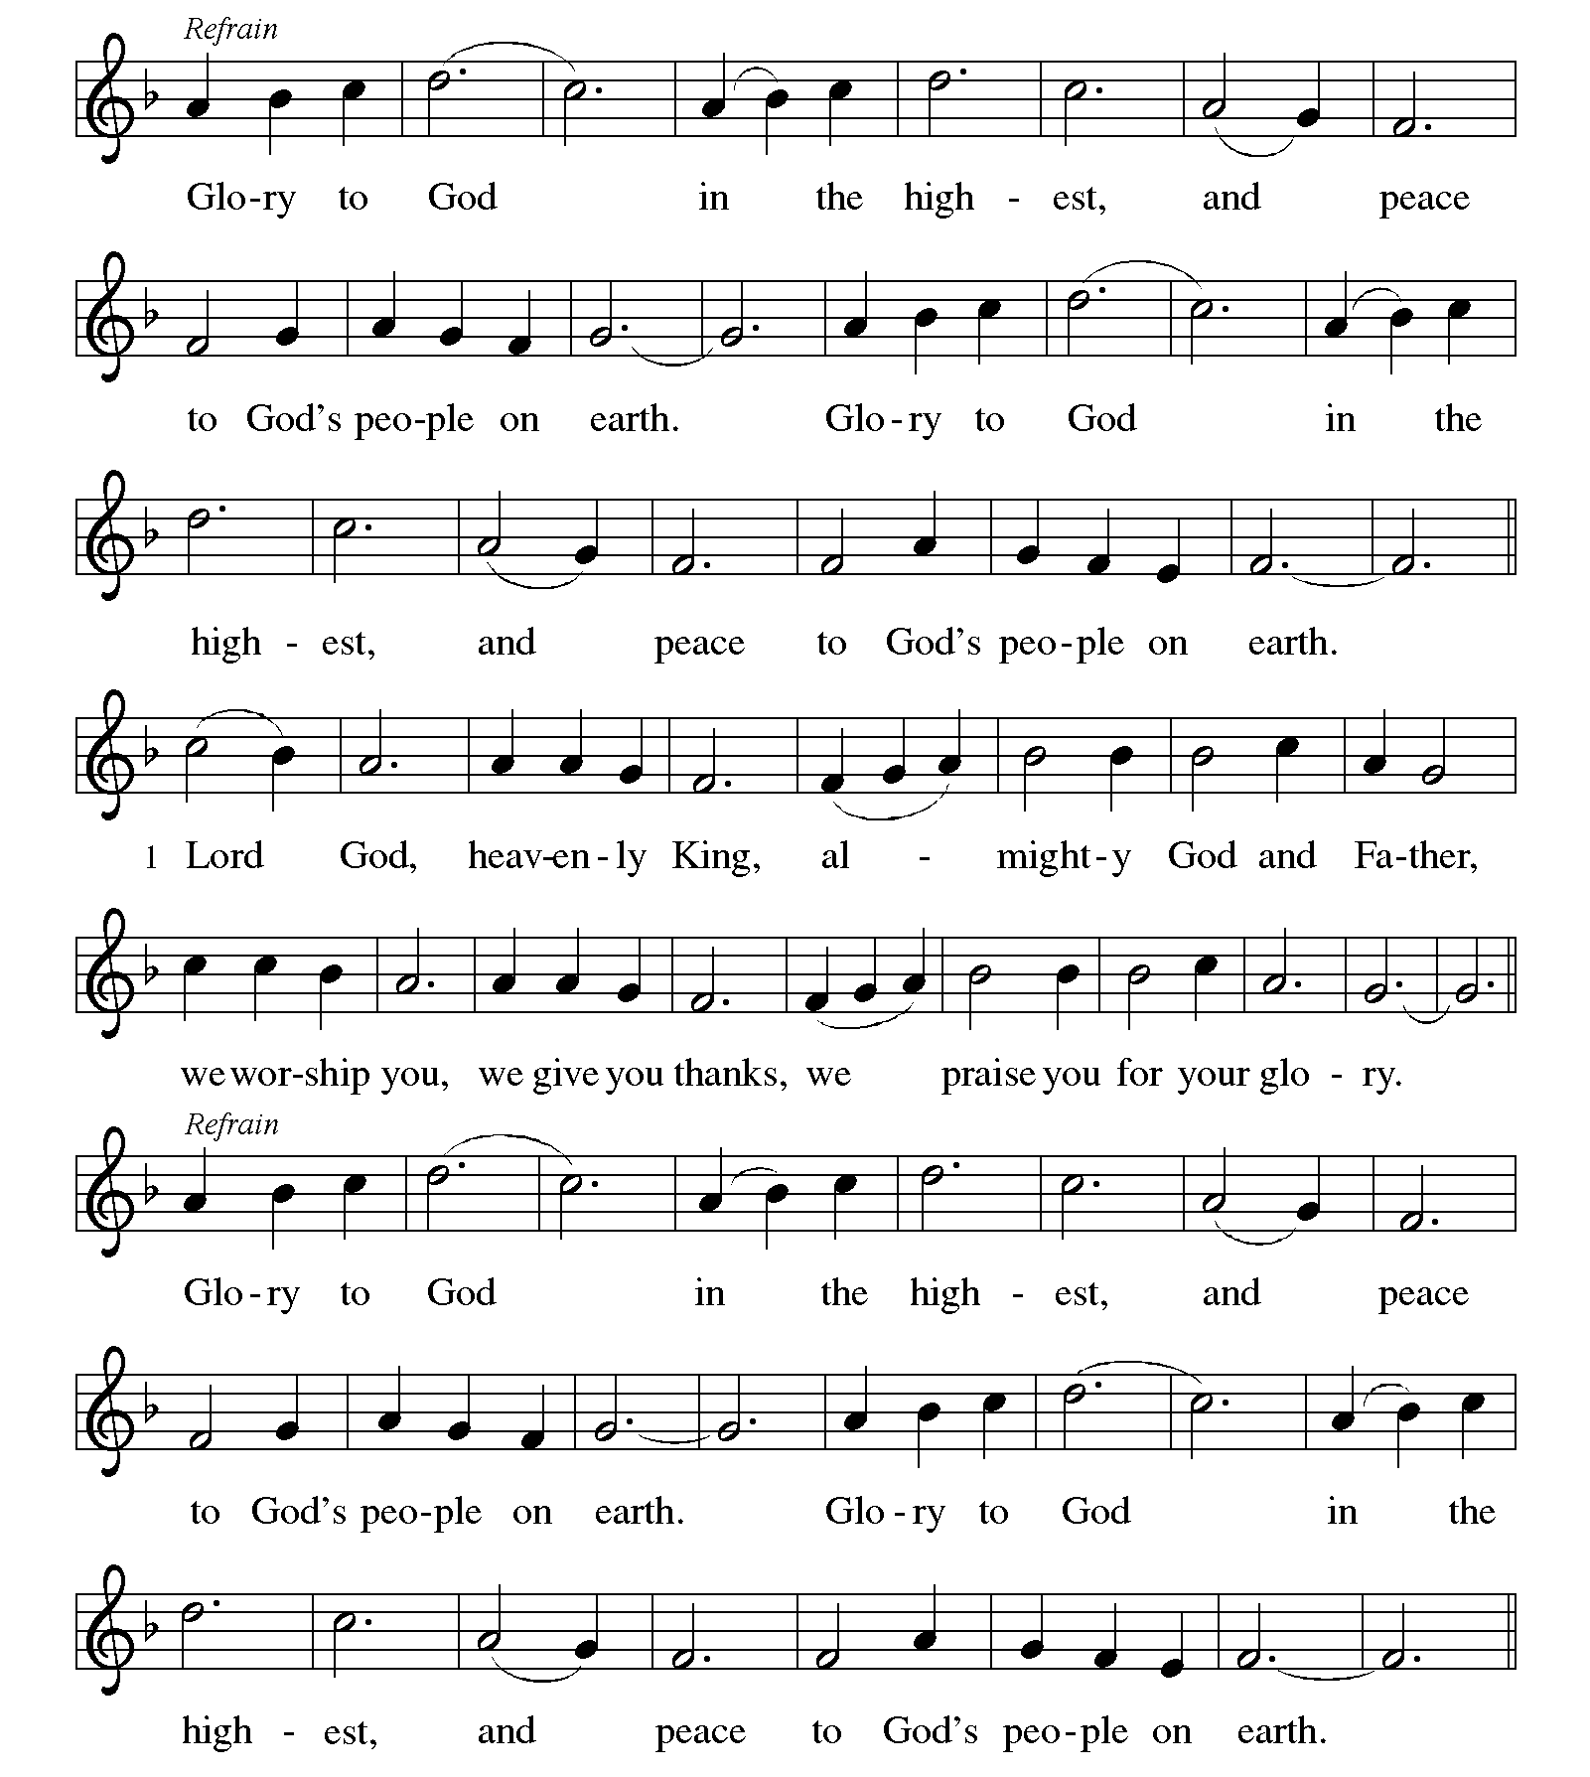
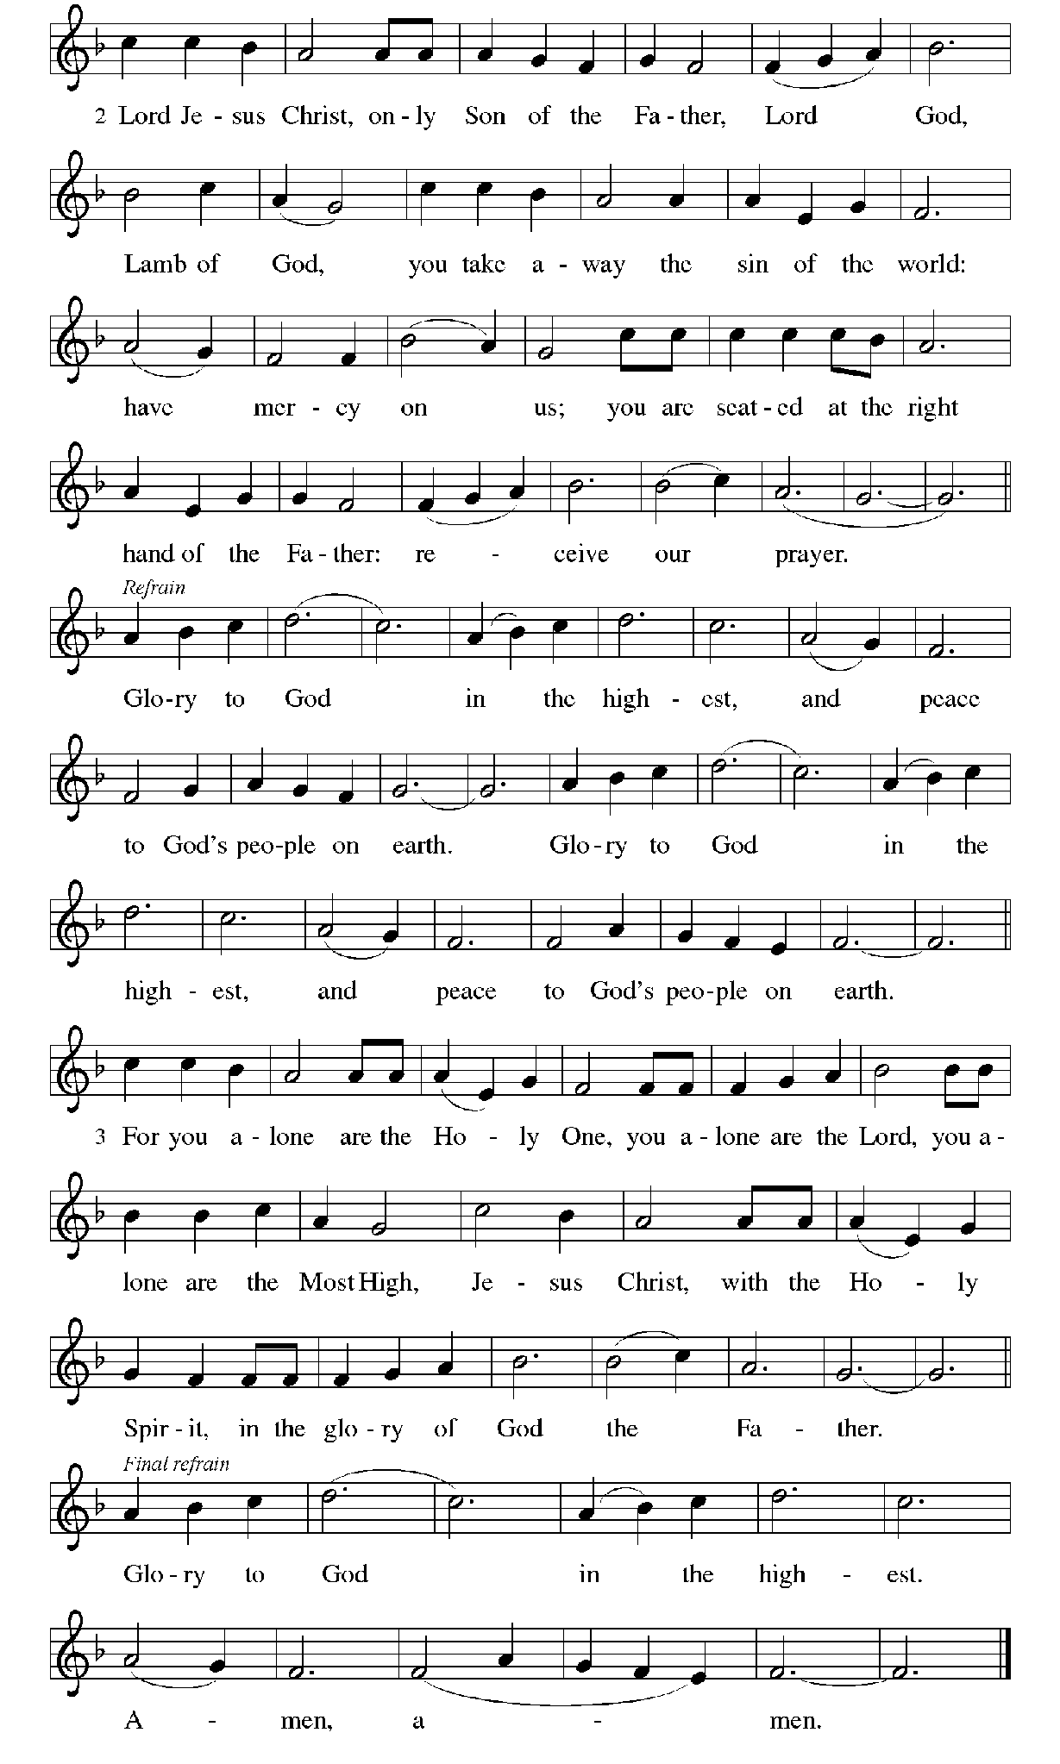
Prayer of the Day

P: The Lord be with you.
C: And also with you.

P: Let us pray.
Sovereign God, raise your throne in our hearts.
Created by you, let us live in your image; created for you, let us act for your glory;
redeemed by you, let us give you what is yours, through Jesus Christ, our Savior and Lord.
C: Amen.

Please be seated.

Word
God speaks to us in Scripture reading, preaching, and song

First Reading – Isaiah 45: 1-7

¹ Thus says the Lord to God’s anointed, to Cyrus,
whose right hand I have grasped
to subdue nations before him
and to strip kings of their robes,
to open doors before him—
and the gates shall not be closed:
² I will go before you
and level the mountains;
I will break in pieces the doors of bronze
and cut through the bars of iron;
³ I will give you the treasures of darkness
and riches hidden in secret places,
so that you may know that it is I, the Lord,
the God of Israel, who call you by your name.
⁴ For the sake of my servant Jacob
and Israel my chosen,
I call you by your name;
I give you a title, though you do not know me.
⁵ I am the Lord, and there is no other;
besides me there is no god.
I arm you, though you do not know me,
⁶ so that they may know, from the rising of the sun
and from the west, that there is no one besides me;
I am the Lord, and there is no other.
⁷ I form light and create darkness,
I make weal and create woe;
I the Lord do all these things.

L: Word of God, word of life.
C: Thanks be to God.

Psalm 96: 1-9 [10-13]

The psalm will be sung responsively, led by the cantor,
with the congregation responding with the verses in bold and the refrain.

Psalm Tone

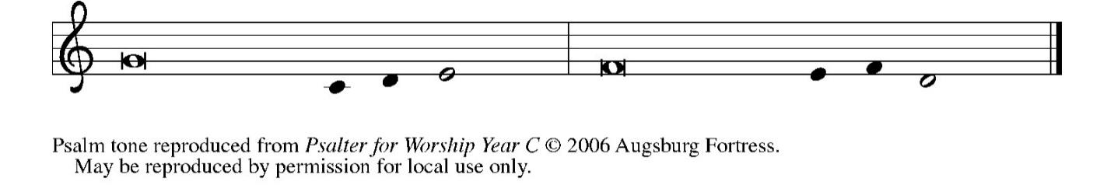

Psalm Refrain

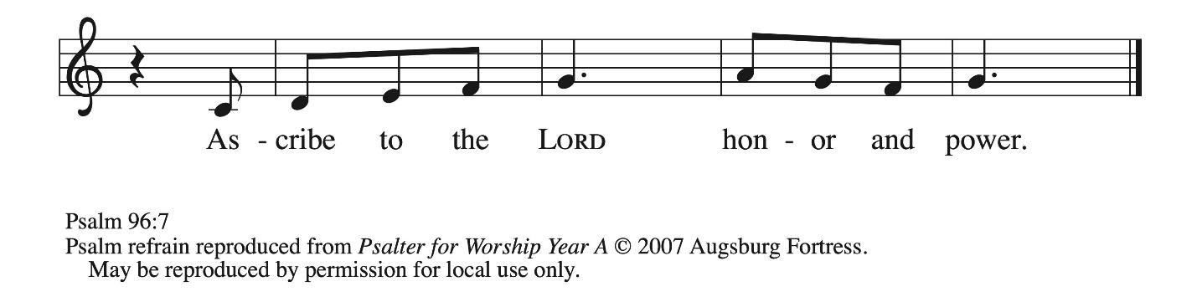

¹ Sing to the Lord | a new song;
sing to the Lord, | all the earth.
² Sing to the Lord, bless the name | of the Lord;
proclaim God’s salvation from | day to day.
³ Declare God’s glory a- | mong the nations
and God’s wonders a- | mong all peoples.
⁴ For great is the Lord and greatly | to be praised,
more to be feared | than all gods. R
⁵ As for all the gods of the nations, they | are but idols;
but you, O Lord, have | made the heavens.
⁶ Majesty and magnificence are | in your presence;
power and splendor are in your | sanctuary.
⁷ Ascribe to the Lord, you families | of the peoples,
ascribe to the Lord hon- | or and power.
⁸ Ascribe to the Lord the honor due the | holy name;
bring offerings and enter the courts | of the Lord. R
⁹ Worship the Lord in the beau- | ty of holiness;
tremble before the Lord, | all the earth.
[ ¹⁰ Tell it out among the nations: “The | Lord is king!
The one who made the world so firm that it cannot be moved will judge the peo- | ples with equity.”
¹¹ Let the heavens rejoice, and let the | earth be glad;
let the sea thunder and all that is in it; let the field be joyful and all that | is therein.
¹² Then shall all the trees of the wood shout for joy at your com- | ing, O Lord,
for you come to | judge the earth.
¹³ You will judge the | world with righteousness
and the peoples | with your truth. R ]

Second Reading – 1 Thessalonians 1: 1-10

¹ Paul, Silvanus, and Timothy,
To the church of the Thessalonians in God the Father and the Lord Jesus Christ:
Grace to you and peace.
² We always give thanks to God for all of you and mention you in our prayers, constantly ³ remembering before our God and Father your work of faith and labor of love and steadfastness of hope in our Lord Jesus Christ. ⁴ For we know, kindred beloved by God, that God has chosen you, ⁵ because our message of the gospel came to you not in word only but also in power and in the Holy Spirit and with full conviction; just as you know what kind of persons we proved to be among you for your sake. ⁶ And you became imitators of us and of the Lord, for in spite of persecution you received the word with joy from the Holy Spirit, ⁷ so that you became an example to all the believers in Macedonia and in Achaia. ⁸ For the word of the Lord has sounded forth from you not only in Macedonia and Achaia but in every place your faith in God has become known, so that we have no need to speak about it. ⁹ For they report about us what kind of welcome we had among you and how you turned to God from idols to serve a living and true God ¹⁰ and to wait for God’s Son from heaven, whom God raised from the dead—Jesus, who rescues us from the coming wrath.

L: Word of God, word of life.
C: Thanks be to God.

Please rise as you are able.

Gospel Acclamation ELW p. 171

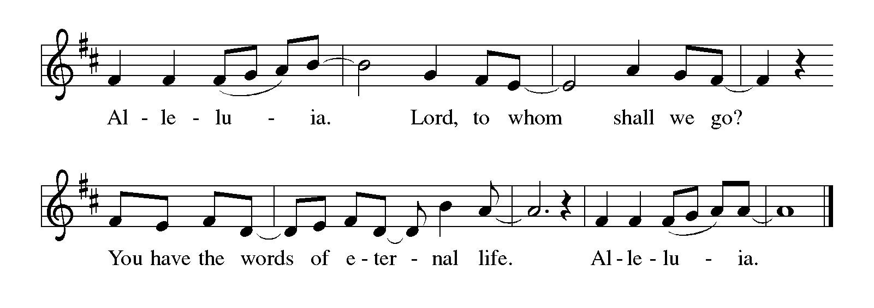
Gospel – Matthew 22: 15-22

P: The holy Gospel according to St. Matthew.
C: Glory to you, O Lord.

¹⁵ The Pharisees went and plotted to entrap [Jesus] in what he said. ¹⁶ So they sent their disciples to him, along with the Herodians, saying, “Teacher, we know that you are sincere, and teach the way of God in accordance with truth, and show deference to no one, for you do not regard people with partiality. ¹⁷ Tell us, then, what you think. Is it lawful to pay taxes to Caesar or not?” ¹⁸ But Jesus, aware of their malice, said, “Why are you putting me to the test, you hypocrites? ¹⁹ Show me the coin used for the tax.” And they brought him a denarius. ²⁰ Then he said to them, “Whose head is this and whose title?” ²¹ They answered, “Caesar’s.” Then he said to them, “Give therefore to Caesar the things that are Caesar’s and to God the things that are God’s.” ²² When they heard this, they were amazed, and they left him and went away.

P: The Gospel of the Lord.
C: Praise to you, O Christ.

Please be seated.

Sermon

A time of silence for prayer and reflection follows the sermon.
When the hymn of the day begins, please rise as you are able.

Hymn of the Day Following Page

Hymn of the Day Sing Praise to God, the Highest Good ELW 871

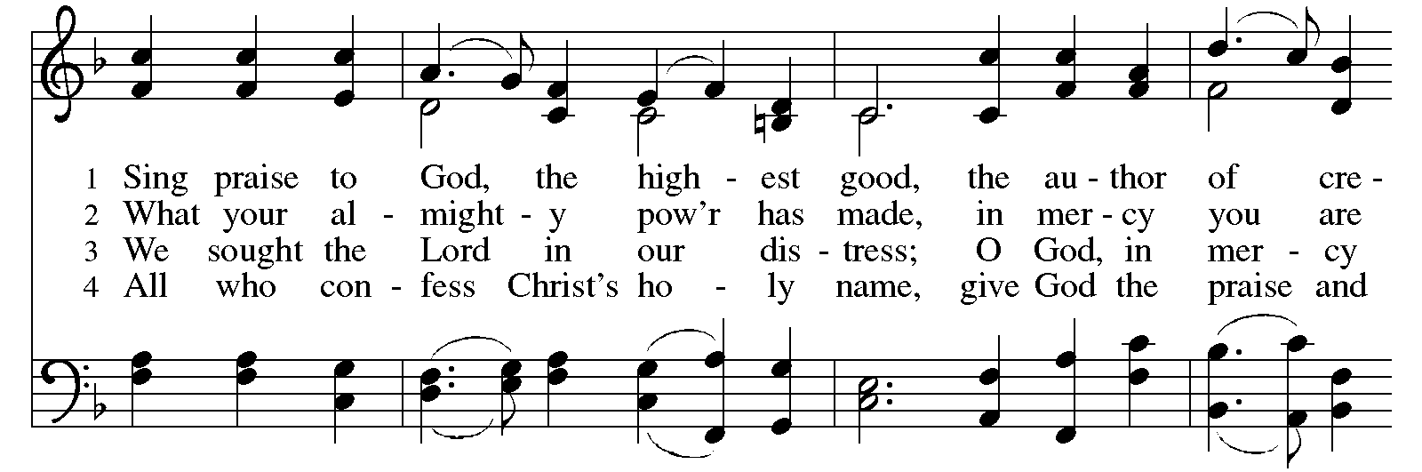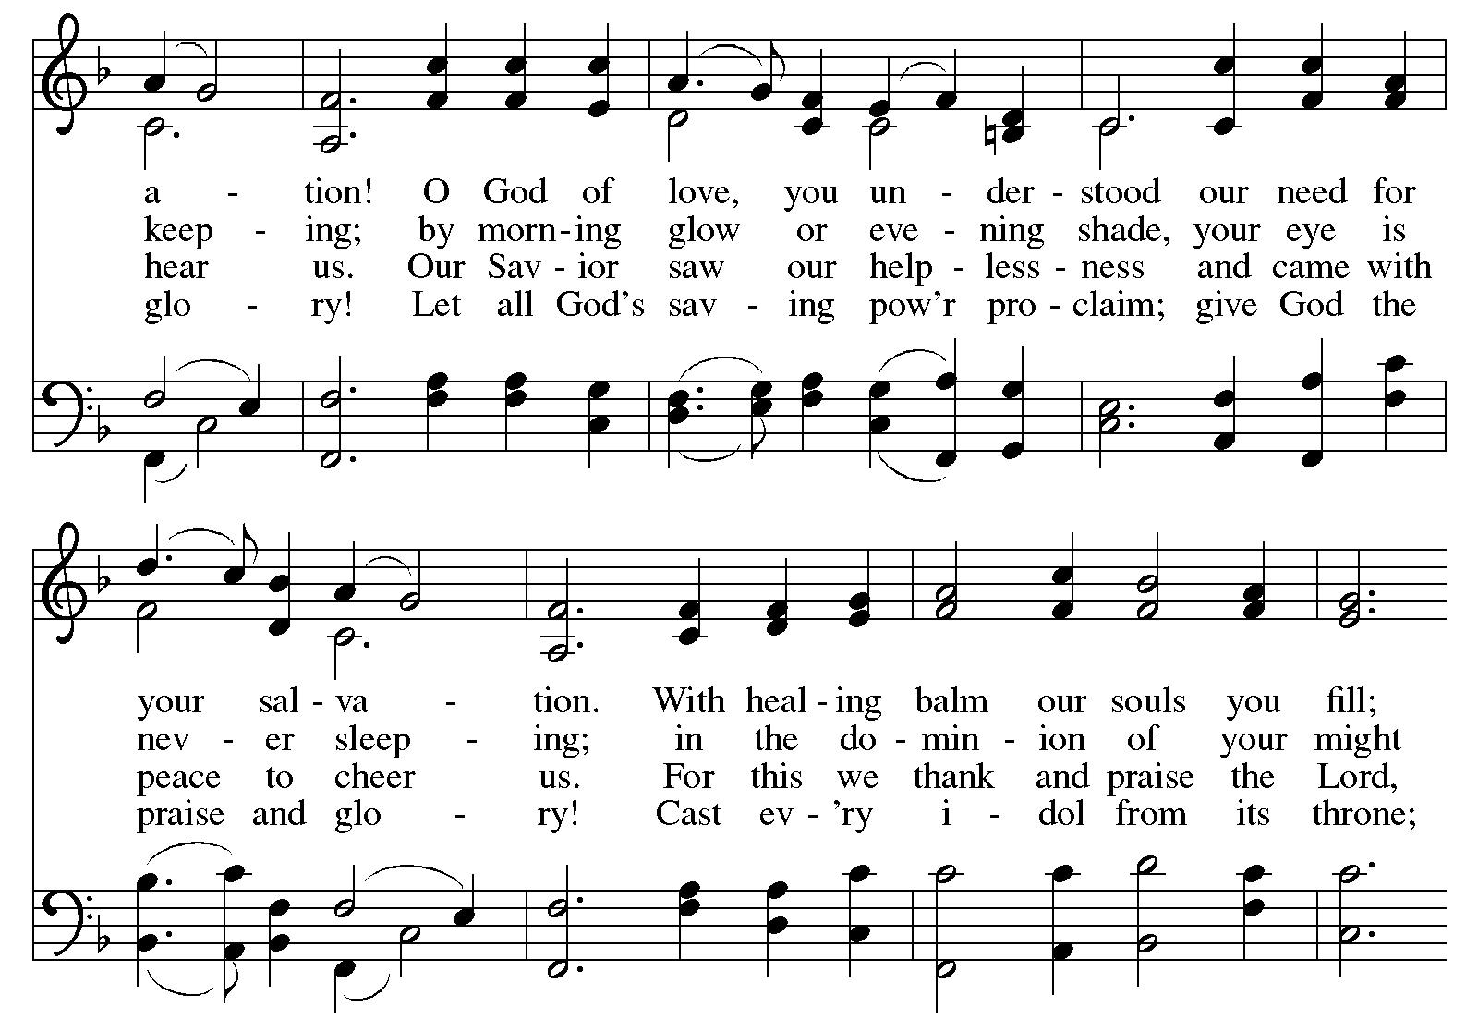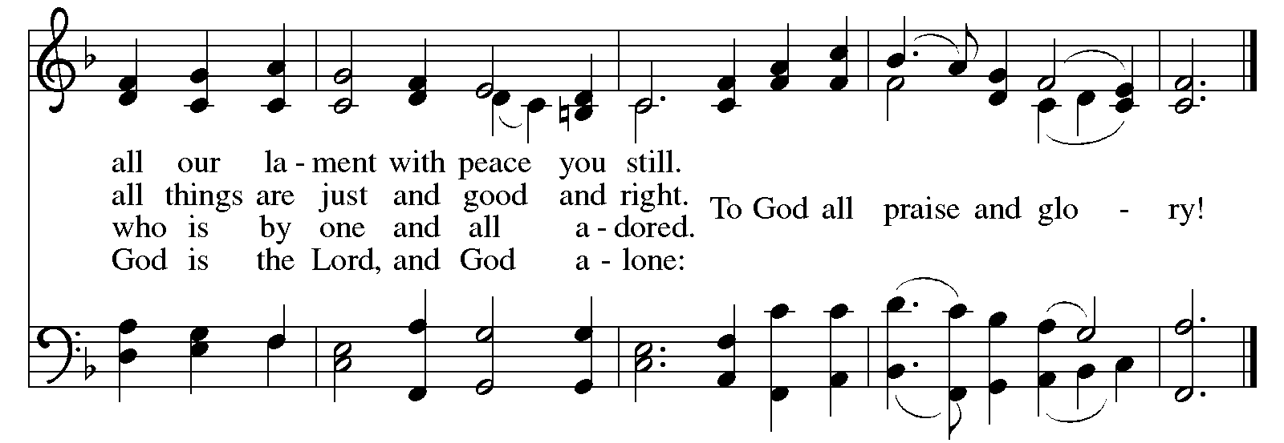
Apostles’ Creed

C: I believe in God, the Father almighty,
creator of heaven and earth.

I believe in Jesus Christ, God’s only Son, our Lord,
who was conceived by the Holy Spirit,
born of the virgin Mary,
suffered under Pontius Pilate,
was crucified, died, and was buried;
he descended to the dead.*
On the third day he rose again;
he ascended into heaven,
he is seated at the right hand of the Father,
and he will come to judge the living and the dead.

I believe in the Holy Spirit,
the holy catholic church,
the communion of saints,
the forgiveness of sins,
the resurrection of the body,
and the life everlasting. Amen.

*Or, “he descended into hell,” another translation of this text in widespread use.

Prayers of the People

A: Trusting in the Spirit of God who makes all things new,
let us pray for the church, the world, and all who are in need.

After each petition
A: God of grace,
C: receive our prayer.

The presiding minister concludes the prayers
P: Trusting in your boundless grace, O God,
we lift up these spoken prayers and those in our hearts;
through Jesus Christ our Lord.
C: Amen.

Peace

The presiding minister and the assembly greet one another in the peace of the risen Christ.
P: The peace of Christ be with you always.
C: And also with you.

The people may greet those around them with a sign of Christ’s peace and may say
Peace be with you or similar words. Please be mindful that not everyone will be comfortable with sharing the peace, so please seek consent before shaking hands or hugging. Other possible ways to share the peace include a simple bow with the verbal greeting of peace, or simply a verbal expression of peace. When the greetings of peace have concluded, please be seated.

Meal
God feeds us with the presence of Jesus Christ

Offering

We offer ourselves, our gifts, and our faithful service to God.
As the offering is gathered for the mission of the church, including the care of those in need,
the table is set for Holy Communion.

There are laminated giving cards in the pew racks that feature a QR code for anyone who would like to give online. Those who give using the QR code, as well as those who give regularly online or through their bank are encouraged to place the laminated card in the plate as an expression of your offering.

Noisy Offering

St. Andrew’s children lead the congregation in a special offering. As they carry buckets around the sanctuary, people of the congregation are invited to throw in their change as an offering. This month’s Noisy Offering will benefit the Evangelical Lutheran Church in America (ELCA)’s Fund for Leaders. Since 2000, this fund has been providing various scholarships to seminary students who are pursuing rostered ministry in the ELCA.

Music during the Offering
Take My Life and Let It Be arr. Edstrom

As the gifts are brought forward for presentation, please rise as you are able.

Offertory Song We Give Thee but Thine Own ELW 686

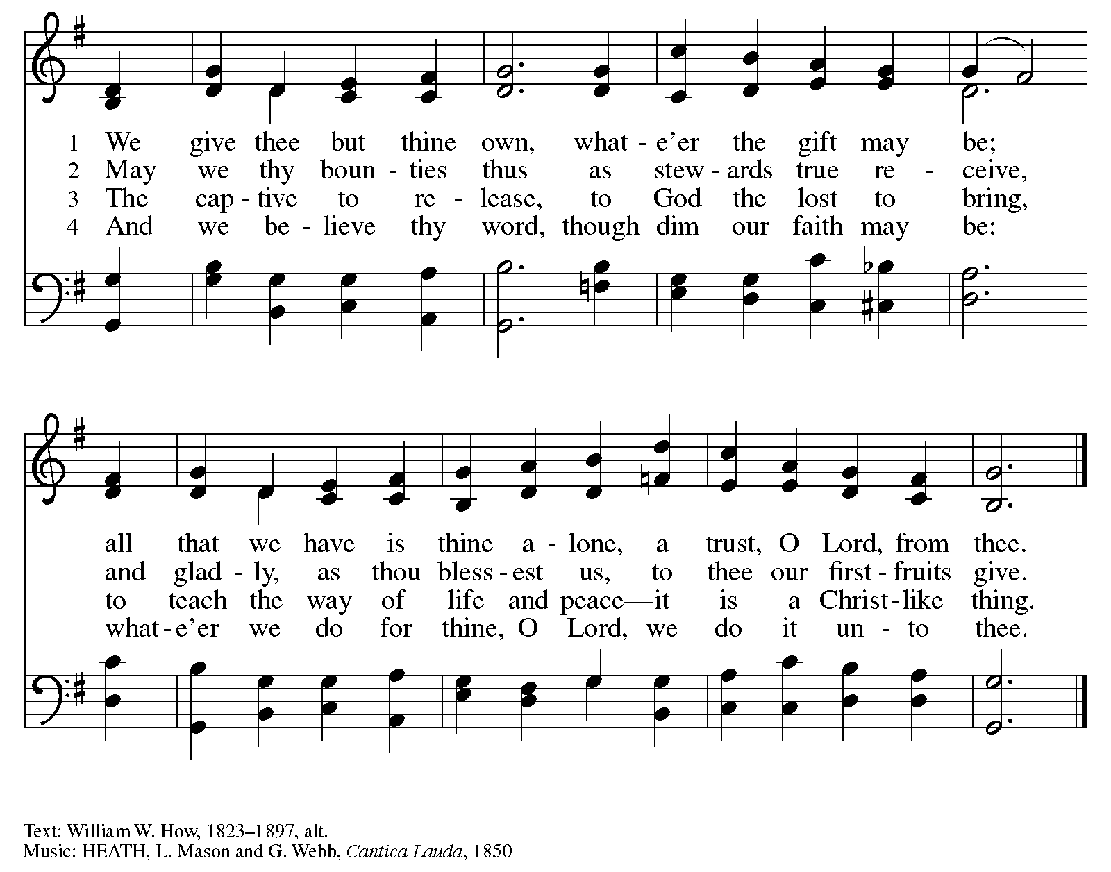

Offertory Prayer

A: Let us pray.
God of creation,
C: you send rain and the earth springs forth abundantly;
all blessings are from you.
Help us to be generous with all that you have given us,
in service to you and in love to our neighbors, today and always.
Amen.

Dialogue

P: The Lord be with you.
C: And also with you.

P: Lift up your hearts.
C: We lift them to the Lord.

P: Let us give thanks to the Lord our God.
C: It is right to give our thanks and praise.

Preface (Spoken by the presiding minister)

P: It is our duty and delight,
that we should everywhere and always
offer thanks and praise to you, O God,
through Jesus Christ,
who calls us to follow his way
of humble service and love,
and so with the church on earth,
all creation and the hosts of heaven,
we praise your name and join their unending hymn:



Sanctus ELW p. 173

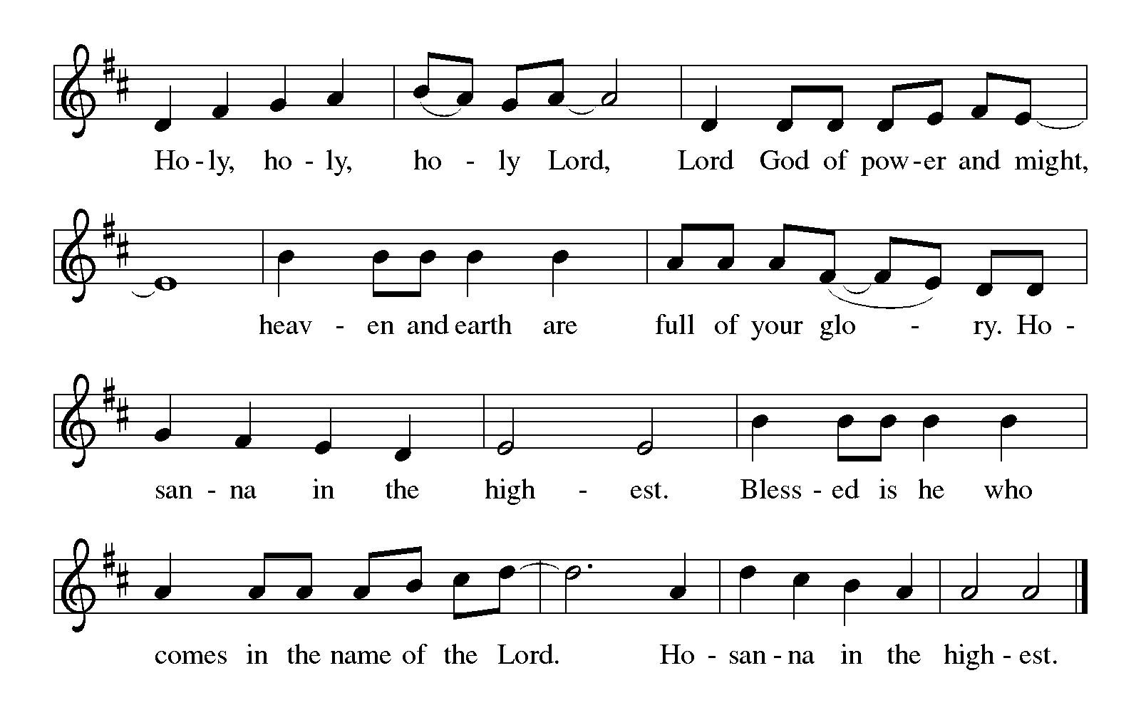

Eucharistic Prayer

P: You are indeed holy, almighty and merciful God …
… Do this for the remembrance of me.

For as often as we eat of this bread and drink of this cup,
we proclaim the Lord’s death until he comes.
C: Christ has died. Christ is risen. Christ will come again.

P: Remembering, therefore …
… and be given our inheritance with all your saints.

P: To you, O God, Father, Son, and Holy Spirit,
be all honor and glory in your holy church, now and forever.
C: Amen.

Lord’s Prayer

P: Gathered as one by the Holy Spirit, we pray as Jesus taught us.
C: Our Father in heaven,
hallowed be your name,
your kingdom come,
your will be done,
on earth as in heaven.
Give us today our daily bread.
Forgive us our sins,
as we forgive those
who sin against us;
Save us from the time of trial,
and deliver us from evil.
For the kingdom, the power,
and the glory are yours,
now and ever. Amen.

Fraction and Invitation

Agnus Dei / Lamb of God ELW p. 174

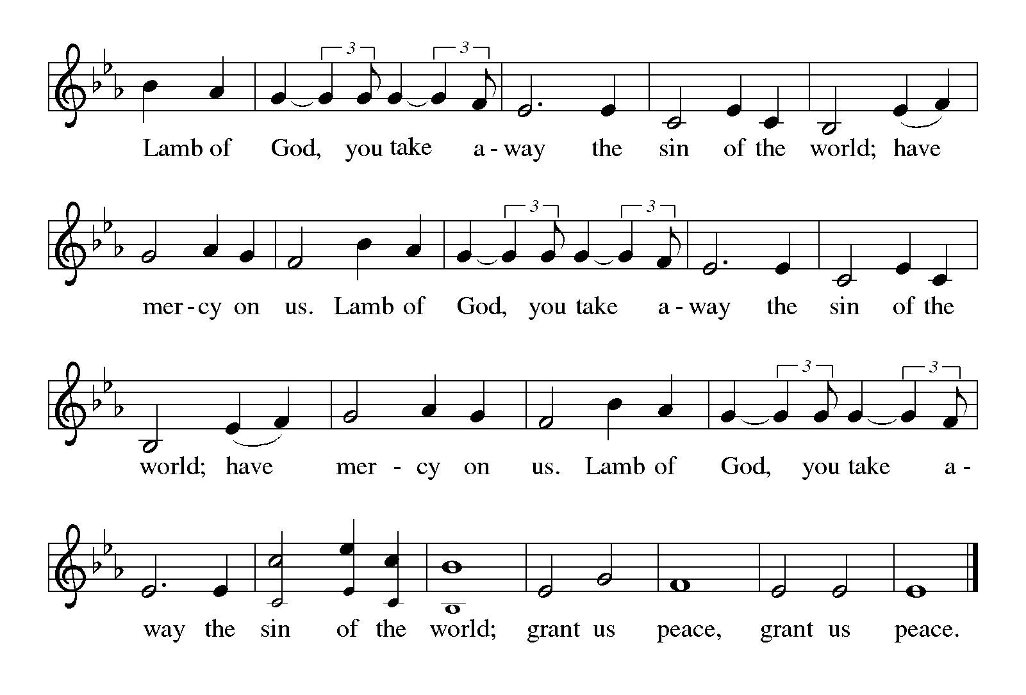
Please be seated.



Holy Communion

- All who seek God and desire a deeper and stronger life in Christ are welcome to receive Holy Communion.
- Worshipers from the pulpit side will proceed forward first, followed by the center section, and then the lectern side.
- Please inform an usher if you would like the ministers to bring Communion to you.
- Holy Communion will be served with bread and wine (red) or grape juice (white).
- The presiding minister will first distribute the bread (host) to each communicant. Please indicate if you require a gluten-free host.
- Once you have consumed the bread, please pick up an empty glass from the tray next to the presiding minister. The Communion Assistant will pour wine or grape juice into your glass.
- Please step to the side to consume the wine or grape juice.
- Feel free to kneel at the altar rail for prayer after receiving the sacrament.
- As you return to your pew, glasses may be returned to the empty tray on the side of the center section.
- A blessing will be provided for anyone who does not yet receive the sacrament.
- All are invited to join in singing the hymns during Holy Communion.

Hymns during Holy Communion
We Place upon Your Table, Lord ELW 467

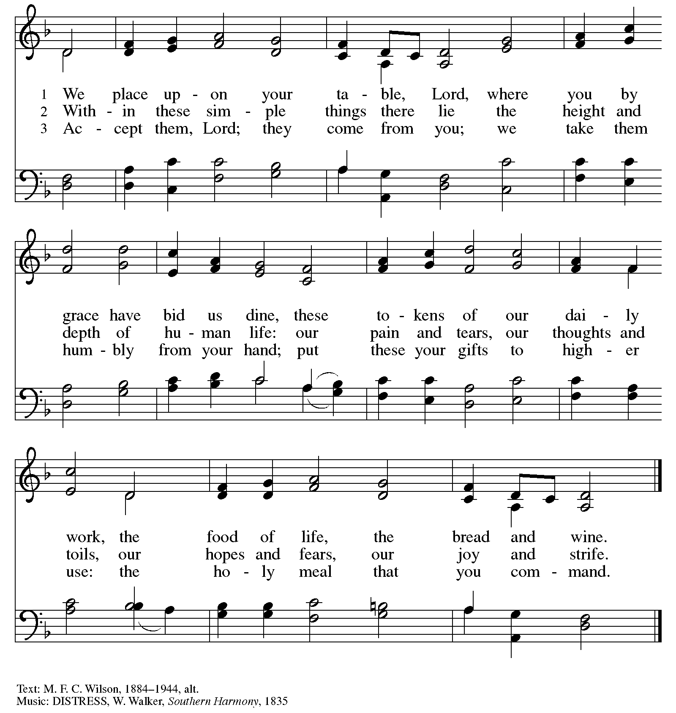

Hymns during Holy Communion
O God of Every Nation ELW 713

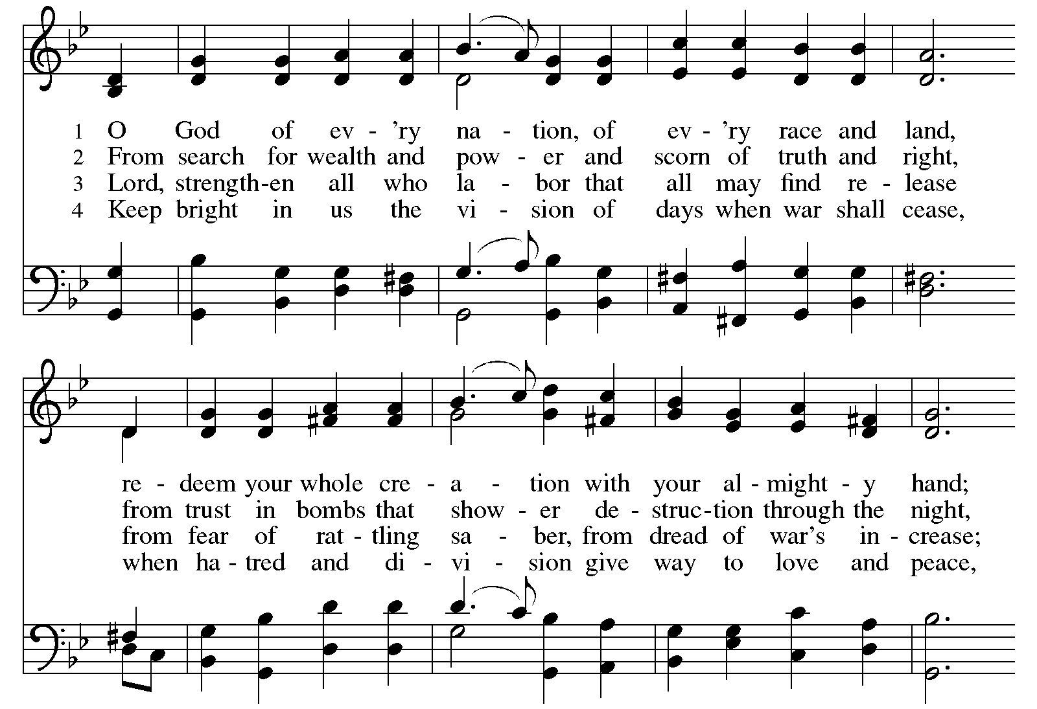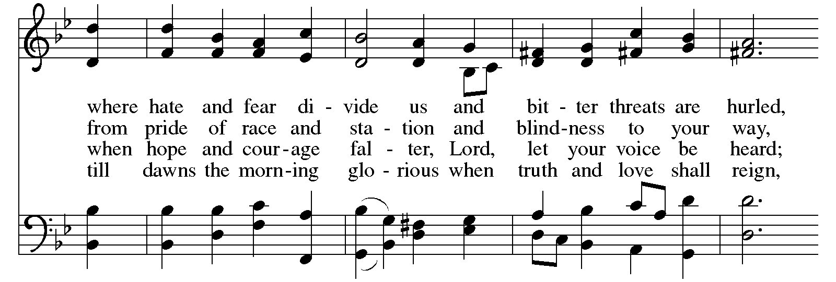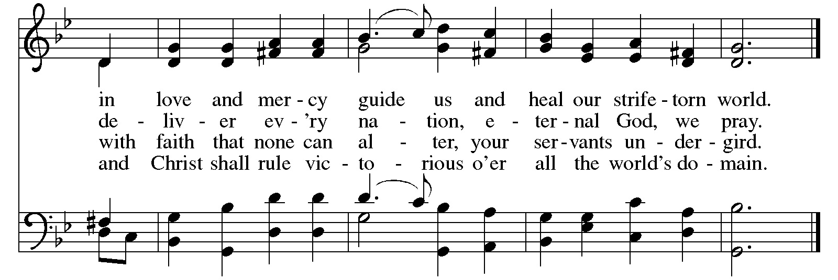
Hymns during Holy Communion
Praise to the Lord, the Almighty ELW 859

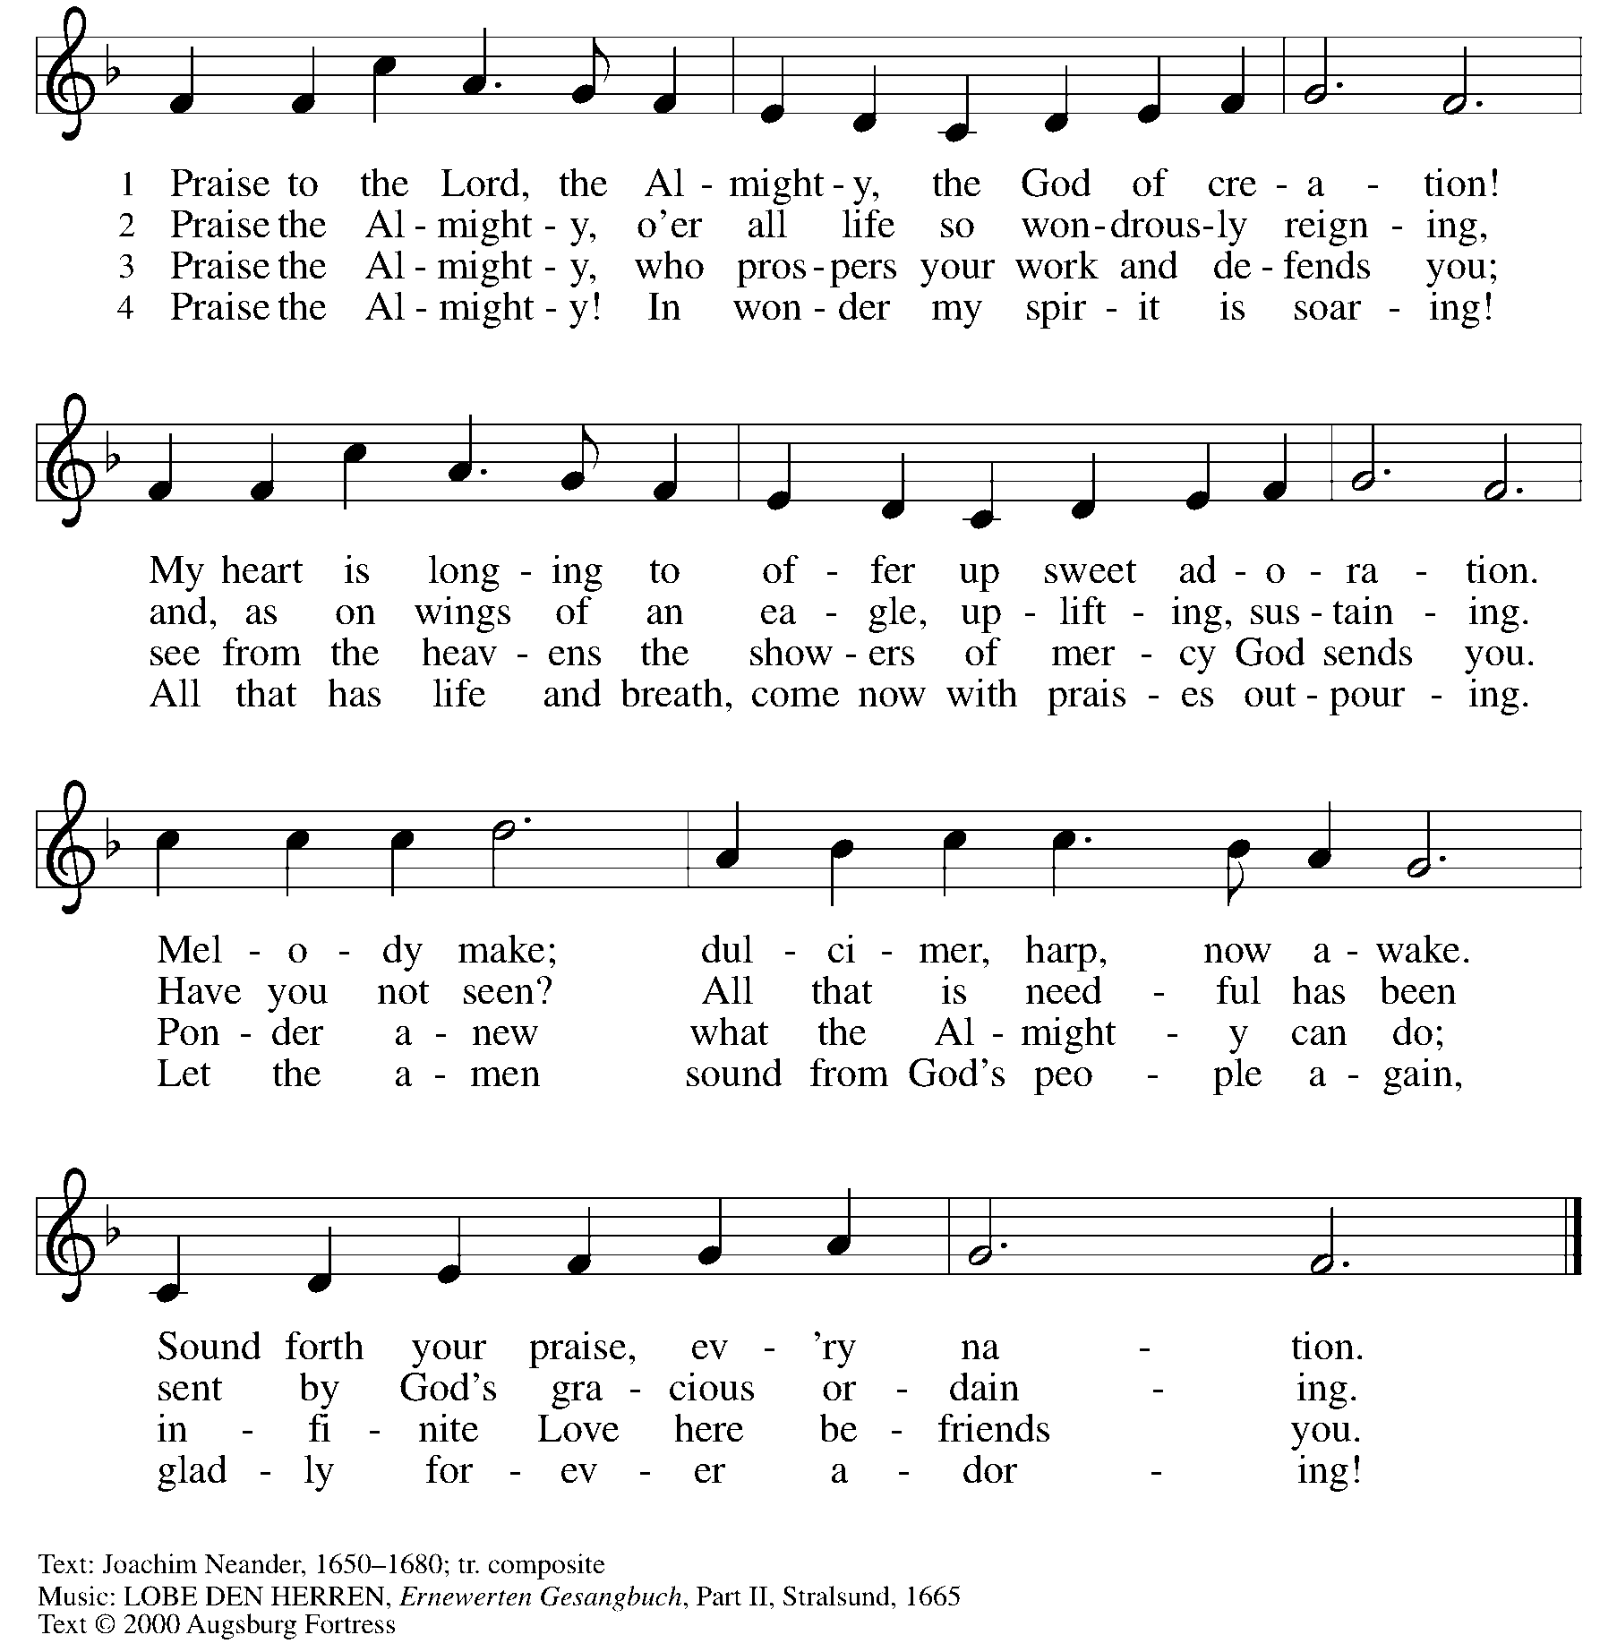
All rights reserved. Reprinted with permission under OneLicense.net # A-722139.

Hymns during Holy Communion
Commonwealth Is God’s Commandment ACS 1036

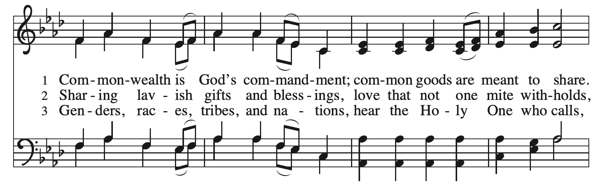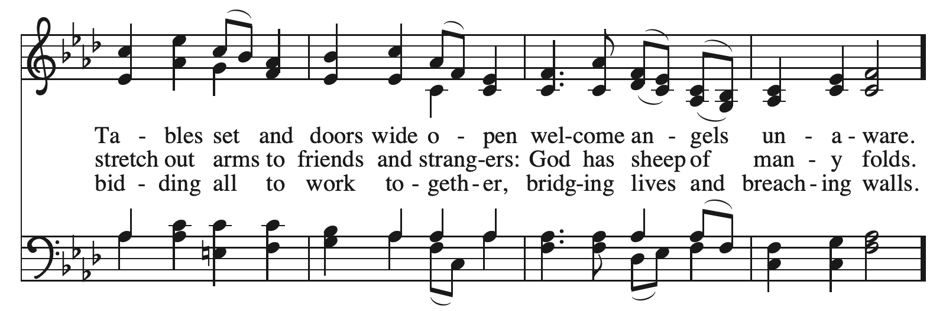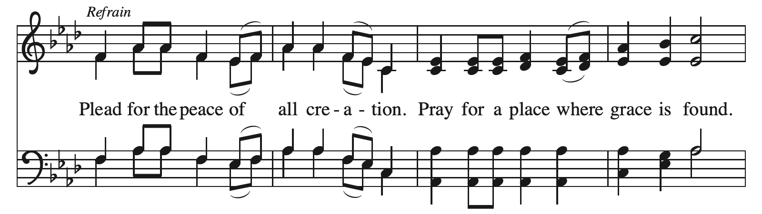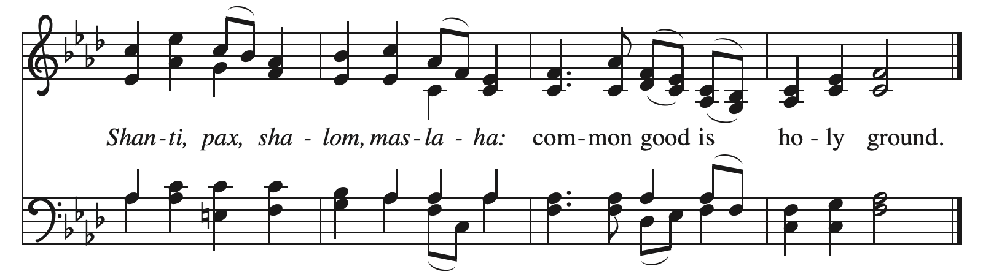
Reprinted with permission under OneLicense.net # A-722139.

When all have returned to their places, please rise as you are able.

Blessing

P: The body and blood of our Lord Jesus Christ strengthen you and keep you in his grace.
C: Amen.

Prayer

A: Let us pray.
Sustaining God, you nourish us with mercy and abundant life.
By your Spirit, send us from this table to serve a needy world.
Make us living signs of your liberation, healing, and love,
following the way of Jesus, in whose name we pray.
C: Amen.

Please be seated.

Sending
God blesses us and sends us in mission to the world

Announcements

Please rise as you are able.

Benediction

P: The God of love draw you into full accord and one mind,
in the body of Christ Jesus.
C: Amen.

P: The God of hope
grant you strength and joy in all circumstances
through the intercession of the Spirit.
C: Amen.

P: The God of grace
☩ bless you now and forever.
C: Amen.

Sending Hymn ELW 583
Take My Life, That I May Be – Toma, oh Dios, mi voluntad

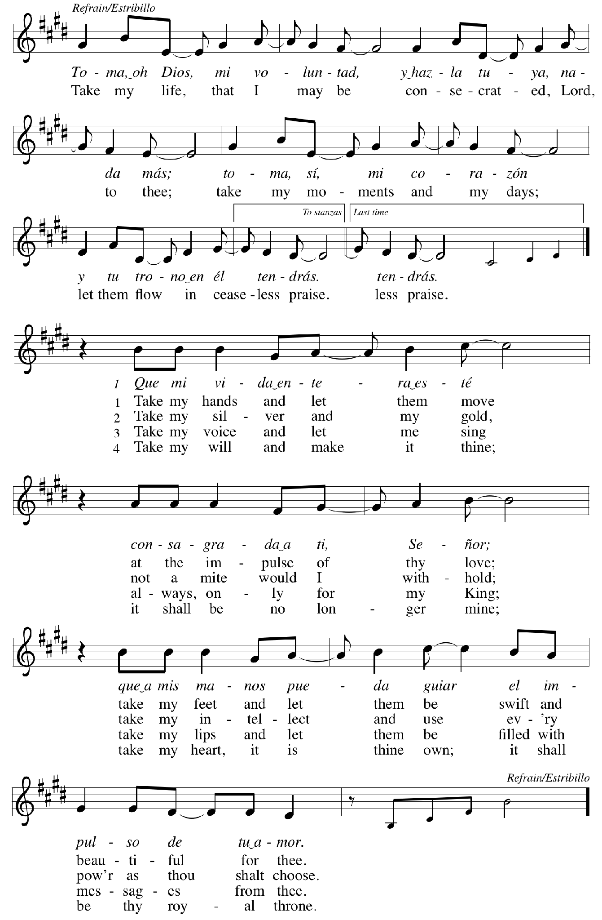
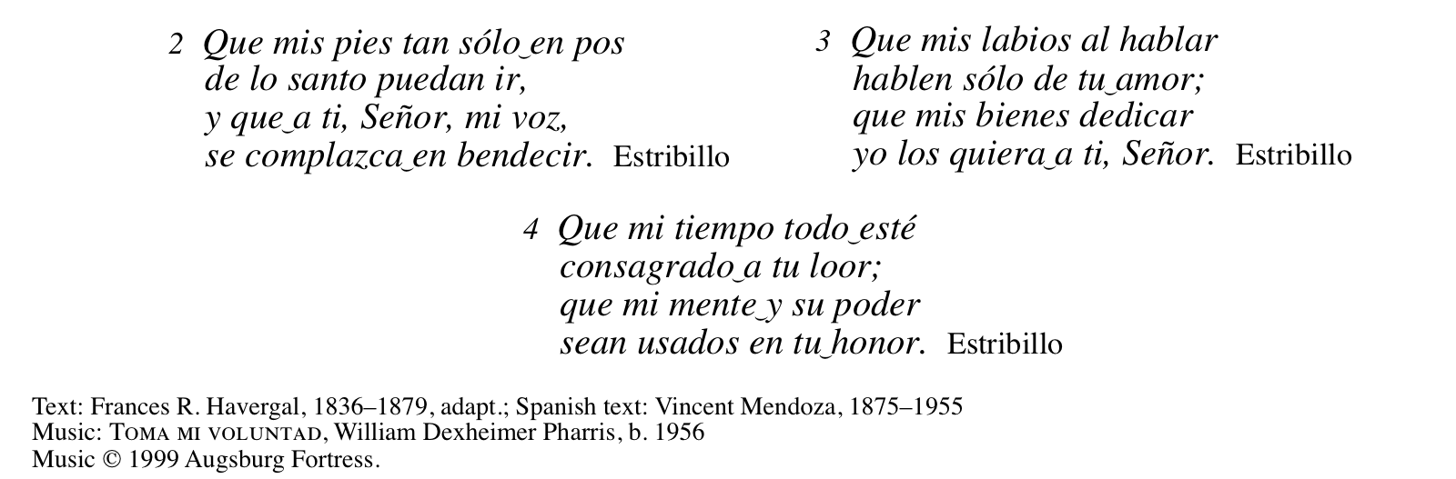
All rights reserved. Reprinted with permission under OneLicense.net #A722139.

Dismissal

A: Go in peace. Serve the Lord.
C: Thanks be to God!

Postlude

Those serving in worship today

Altar Care Jodie Minor
Assisting Minister Colleen Cooke
Audio-Visual Ministers Tyler Rietze
Tim Jones
Cantor Miriam Bohlmann Kunz
Lector Pat Taylor
Minister of Music Laura Reynolds
Presiding Minister The Rev. Ross I. Carmichael

Liturgy and Hymnody Acknowledgements

From SundaysandSeasons.com. Copyright © 2026 Augsburg Fortress. All rights reserved. Reprinted under OneLicense.net # A-722139.
Used by permission of Augsburg Fortress.

Liturgical material reprinted with permission under Augsburg Fortress Liturgies Annual License SB124976.

The Scripture readings contained herein are from New Revised Standard Version Updated Edition of the Bible © 2021 National Council of Churches of Christ in the United States of America. Used by permission. All rights reserved worldwide.

God of Grace and God of Glory – Text: Harry E. Fosdick, 1878-1969. Music: CWM RHONDA, John Hughes, 1873-1932.

Sing Praise to God, the Highest Good – Text: Johann J. Schütz, 1640-1690; tr. Frances E. Cox, 1812-1897, adapt. Music: LOBT GOTT DEN HERREN, IHR, Melchior Vulpius, 1570-1615.

O God of Every Nation – Text: William W. Reid, Jr., b. 1923. Music: LANGLOFFAN, Welsh tune, 19th cent. Text © 1958, ren. 1986 The Hymn Society, admin. Hope Publishing Company, Carol Stream, IL 60188. All rights reserved. Reprinted with permission under OneLicense.net # A-722139.

Please use the QR code below to link to St. Andrew’s Announcements online!



St. Andrew Lutheran Church Announcements
October 18th, 2026

- Welcome to Worship at St. Andrew on the Twenty-first Sunday after Pentecost – We are so glad you are here, and we offer a special welcome to all visitors and guests who are here for the first time! Little Church – Big Faith, a Bible lesson and activity for children up to sixth grade, will take place after the prayer of the day. There are also worship “toolkits” to help children engage with worship and “busy bags” for younger children available in the bookcase at the back of the sanctuary. Please feel free to take one to use with/for your children. A nursery is available through the door to the left of the worship space and across the social hall (look for a purple room). All are invited to stay for coffee and other drinks, food, and conversation in the Social Hall (through the side door at the left of the worship space) after the service.
- Noisy Offering, This Sunday, October 18th, During Worship – On the third Sunday of each month, St. Andrew’s children lead the congregation in a Noisy Offering, in which people are invited to throw their change into buckets that the children carry around the church and bring forward as an additional offering. Each month’s Noisy Offering supports a local, national, or international church-related or otherwise charitable organization. This month’s offering will benefit the ELCA Fund for Leaders. Since 2000, this fund of the Evangelical Lutheran Church in America (ELCA) has been offering full tuition scholarships, along with mission developer, synod, federal chaplaincy, and TEEM (Theological Education for Emerging Ministries) scholarships, to seminary students who are pursuing rostered ministry. For more information, please see https://www.elca.org/resources/financial-information/grants-and-scholarships/elca-scholarships.
- Produce Distribution Supplemental Food of the Month – St. Andrew is collecting supplemental food each month to accompany our produce distribution. For October, we ask for donations of soup. There are collection boxes at the back of the worship space and social hall.
- October Produce Distribution, Third Tuesday of the Month, October 20th, 5:30-6:30 p.m. – St. Andrew partners with Greater Pittsburgh Community Food Bank to serve as a distribution site for fresh produce on the first and third Tuesday of every month. We invite people of the congregation to help with the distribution from 5:30 p.m. - 6:30 p.m. and/or to help with unloading and setup during the day between 10:00 a.m. and 1:00 p.m.
- Fall Fun and Fellowship, Saturday, October 24th, 9:00 a.m. – Please join us for a day of fun and fellowship as we tackle our growing Fall Chore List here at St. Andrew. As the seasons change, it is a good time to reflect on the past year and all that has gone on within our church home. It is encouraging and exciting to have the roof project completed now, and to be able to plan for future use with much more confidence. We will have coffee and donuts ready by 9:00 a.m. and plan to continue working until at least 2:00 p.m. on that day. Please feel free to drop in for fellowship anytime, even if you only stay for a short visit. We do God's Work with Our Hands everyday. See you on Saturday October 24th for Fall Fun and Fellowship!
- Inclusive Game Night, Saturdays, October 24th, November 21st, and December 19th, 5:00 - 7:00 p.m. – People of all ages are invited to an inclusive game night on Saturday evenings over the next few months. We will share board games, conversation, and fun!
- All Saints Day - Invitation to Bring Photos of Loved Ones, Sunday, November 1st, 10:00 a.m. – On All Saints Day, the church remembers people of the congregation and those we have prayed for who have died since last All Saints Day. We invite the congregation to bring photographs of loved ones you would like to remember that day, to be placed near the baptismal font as we give thanks for the communion of all the saints who are one with us in the Body of Christ. We will also offer a place in the service where everyone can light candles in remembrance of the saints.
- Join us for a Re-imagined Hearts and Hands, November 14th and December 5th, 10:00 a.m. to 2:00 p.m. – For many years, St. Andrew has had a prayer shawl ministry providing shawls, blankets and scarves to those celebrating life’s transitions or in need of comfort, care and love. As our congregation continues to build community together, it’s time to grow this ministry. In addition to those who knit or crochet (beginner to expert), we need anyone who does handiwork they want to share with our community! Join us for one or more of the dates below to help us re-imagine this ministry. We’ll have blankets to tie and all the materials needed for knitting or crocheting as well as pew cushions with buttons we can reattach. If you have something else you wish to share, we will welcome anything that does not require power tools. Knit/Crochet/Quilt or…and cannot attend? You are still welcome to contribute. We always need hats, mittens, and scarves for those less fortunate during the winter!
- Aluminum Can Tabs for Ronald McDonald House – You may have noticed that at coffee hour, St. Andrew is now putting out a receptacle to collect the tabs from aluminum cans. We invite people of the congregation to save their tabs, not only during coffee hour, but from other beverages throughout the week and drop them off in the designated drawer in the social hall. The tabs are donated to Ronald McDonald House, which supports families with children receiving medical treatment across the country. More information is available here: https://ronaldmcdonaldhousepghmgtn.org/get-involved/pull-tabs/. The community ministry team is looking for someone to monitor the supply and bring in the tabs for periodic donations. If you are interested, please speak with Tyler Rietze or email community@standrewpittsburgh.org.
- Coffee Hour Signups – St. Andrew’s coffee hour takes place after worship each Sunday. If you would like to participate and would like information about the duties of setting up, please sign up using the following form: https://www.signupgenius.com/go/5080B4AAFAF2CABF85-47069030-coffee#/.
- Winter Clothing Collection for Bethel AME Church Pantry – Our friends at Bethel AME Church have begun a new pantry program at which they are offering new or gently used clothing for people of the community. If you are doing any fall cleaning and have clothes or coats that you are no longer using, please bring them to St. Andrew. There will be a box on or near the donation table in the social hall.

